A Preliminary Report on the Moth Diversity of Silarigaon, Kalimpong, West Bengal, India

ABSTRACT
Moths (Lepidoptera: Heterocera) represent one of the most taxonomically and ecologically diverse groups of insects on Earth, playing pivotal roles as pollinators, herbivores, prey, and bioindicators of ecosystem health. Despite their ecological significance, many regions in the Indian subcontinent remain poorly studied with respect to moth diversity. Silarigaon, a forested locality in the Kalimpong district of West Bengal, is one such underexplored region. A week-long light trap survey conducted from 15 to 21 October 2025 documented the moth fauna of this area. A total of 101 species belonging to 87 genera under 8 families were recorded during the study period. The most species-rich family was Geometridae (32 species), followed by Erebidae (24 species), Crambidae (11 species), and Noctuidae (21 species). Other families including Drepanidae, Nolidae, and Pyralidae were represented by fewer species. The results provide a valuable baseline for future ecological and conservation-oriented studies in the region. Most recorded species were categorized as “Not Evaluated” under current IUCN assessments, highlighting substantial knowledge gaps in moth conservation within the eastern Himalayan region. This study represents the first systematic documentation of moth diversity from Silarigaon and contributes to the growing body of knowledge on Lepidoptera in the eastern Himalayas.
Keywords: Moth diversity, Lepidoptera, Silarigaon, Geometridae, Kalimpong, biodiversity, nocturnal pollinators, IUCN status

INTRODUCTION
Moths (order Lepidoptera: suborder Heterocera) are among the most diverse and ecologically significant groups of insects globally. With over 160,000 described species and many more yet to be documented, moths play integral roles in ecosystems as herbivores, pollinators, decomposers, and prey for higher trophic levels (Scoble, 1995; Wagner et al., 2021). In addition to their ecological functions, moths are also valuable bioindicators, sensitive to habitat quality, climate change, and anthropogenic disturbances (Fox et al., 2014; Dar et al., 2021). Monitoring moth populations can therefore yield important insights into ecosystem health and biodiversity dynamics.
India, with its diverse climatic zones and varied vegetation, is estimated to support more than 15,000 moth species belonging to numerous taxonomic families. belonging to more than 75 families (Sidhu, 2023; Singh et al., 2020). Among these, approximately 10,694 species have been formally recorded (Zhang, 2011). The country’s northeastern region, encompassing the eastern Himalayas and adjoining foothills, is particularly rich in moth biodiversity, owing to its diverse habitats ranging from subtropical forests to temperate montane ecosystems (Chakraborty & Saha, 2022). However, despite this richness, systematic surveys of moth fauna remain sparse in many areas.
Silarigaon, located in the Kalimpong district of West Bengal, is one such underexplored site. Nestled within the eastern Himalayan foothills and surrounded by lush vegetation, Silarigaon represents a mosaic of forest patches, agricultural landscapes, and riparian zones. Such ecotonal environments are known to harbour high species richness and serve as corridors for insect movement and gene flow (Kitching et al., 2000). Yet, until now, no comprehensive documentation of moth diversity from this region has been undertaken.
This study aims to fill this knowledge gap by providing the first systematic checklist of moth species from Silarigaon. Using light traps as the primary sampling method, we surveyed the moth fauna over a seven-day period in October 2025. The objectives of the study were:
- To document the diversity of moth species occurring in Silarigaon.
- To describe the family-level composition of the moth fauna.
- To identify species of potential conservation concern based on available IUCN assessments.
By establishing a baseline inventory of moths from this locality, we aim to contribute to regional biodiversity knowledge and support future conservation, monitoring, and ecological research efforts.

Study Site
The study was conducted in Silarigaon (27.14°N, 88.58°E), a small, forested settlement located in the Kalimpong district of West Bengal, India. Situated at the foothills of the eastern Himalayas, the region features a subtropical climate characterized by cool, humid winters and mild summers. During the study period in October 2023, the area experienced temperatures ranging from 10°C to 16°C at night, with occasional mist and low winds, creating favourable conditions for nocturnal insect activity.
Silarigaon’s landscape comprises mixed broadleaf forest interspersed with cultivated fields, shrubs, and riparian vegetation. The vegetation includes numerous native and exotic plant species, many of which serve as larval host plants for Lepidoptera. The combination of forest canopy, understory vegetation, and anthropogenic habitats likely contributes to the high moth diversity observed in the region. 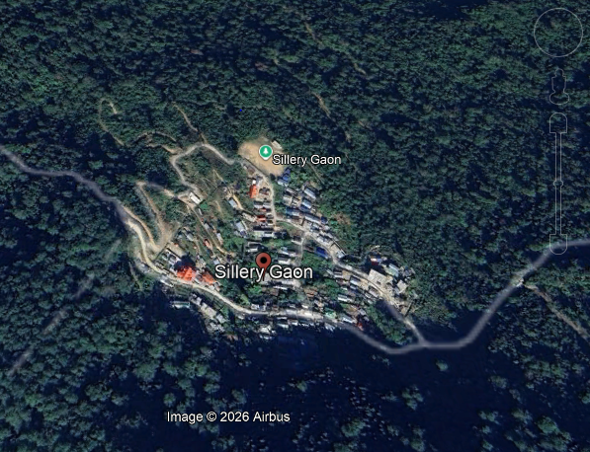
Figure-1: Map of the study site

MATERIALS AND METHODS

Field Sampling
Moth collection was conducted from 15 to 21 October 2025, spanning seven consecutive nights. Sampling was performed using a standard box-type light trap, which emits light to attract nocturnal Lepidoptera. The trap was set up each evening at 18:00 hours and operated until 01:00 hours. The site was chosen to minimize the influence of artificial light sources, which can interfere with moth attraction and skew sampling results.
Collected specimens were euthanized using ethyl acetate and subsequently pinned and spread on insect-stretching boards for proper preservation. All specimens were stored in airtight insect boxes containing naphthalene balls to prevent mold and secondary infestation.
Sampling effort totaled approximately 49 trap hours over seven consecutive nights. Surveys were conducted under relatively low wind conditions and intermittent mist, which are considered favorable for nocturnal Lepidoptera activity in subtropical Himalayan ecosystems.
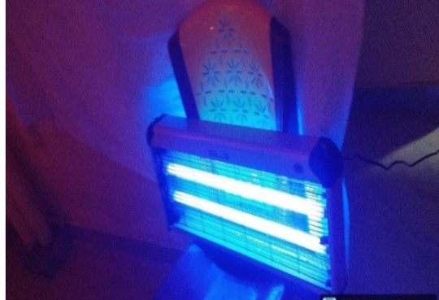Figure 2: box-type light trap used for recording moths

Identification
Specimens were identified to the species level wherever possible, using the ‘Moths of India’ website (Sondhi et al., 2023) and other available taxonomic keys, reference monographs, and regional Lepidoptera checklists (Hampson, 1892–1896; Holloway, 1987–2003).

Data Recording
For each species, the following information was recorded: family, scientific name, IUCN status, and known geographic distribution within India. These data are presented in Table 1.

Data Analysis
Family-wise species richness and relative percentage composition were calculated using Microsoft Excel 2021. Species percentages were determined by dividing the number of species within each family by the total number of species recorded during the survey period.

RESULTS & DISCUSSION

Species Composition
A total of 101 species belonging to 87 genera under 8 families were recorded during the study period. Geometridae was the most dominant family, represented by 32 species (31.7% of total recorded species), followed by Erebidae with 24 species (23.8%), Noctuidae with 21 species (20.8%), and Crambidae with 11 species (10.9%). Drepanidae accounted for 5 species, while Nolidae and Pyralidae were represented by 3 and 4 species, respectively. The relatively high species richness recorded within a short sampling duration indicates that Silarigaon supports a diverse moth assemblage associated with eastern Himalayan foothill ecosystems.
The dominance of Geometridae observed during the survey aligns with previous studies from forested habitats of northeastern India and the eastern Himalayas, where geometrid moths frequently constitute one of the most species-rich groups due to their ecological adaptability and host-plant diversity (Holloway, 1997; Scoble, 1995).
The dominance of Geometridae is consistent with patterns observed in other tropical and subtropical moth communities, as members of this family are highly speciose and occupy a wide range of ecological niches (Scoble, 1995; Holloway, 1997). The substantial representation of Noctuidae and Erebidae further reflects the generalist feeding habits and ecological adaptability of these groups (Kitching et al., 2000).

Table 1. Checklist of moth species recorded from Silarigaon, Kalimpong district, West Bengal during October 2025.
Sl. no | Family | Scientific name | IUCN status | Geographic distribution
1 | Arctiidae | Lyclene undulosa (Linnaeus, 1758) | Not evaluated | Namdafa, Arunachal Pradesh, Miao
2 | Crambidae | Cydalima laticostalis (Guenée, 1854) | Not evaluated | Assam, Meghalaya, west Bengal, Arunachal Pradesh.
3 |  | Earias cupreoviridis (Walker, 1862) | Endangered | Arunachal Pradesh, Bihar, orisha, Andaman Nagar. Nicobar, Maharashtra, Assam, Manipur Himachal Pradesh.
4 |  | Earias sp. (Hübner, 1825) | Not evaluated | Andhra Pradesh, Assam, Bihar, Chhattisgarh, Gujarat, Haryana, Himachal Pradesh, Karnataka, Kerala, Madhya Pradesh, Maharashtra, Orissa, Punjab, Rajasthan, Tamil Nadu, Telangana, Uttar Pradesh, West Bengal.
5 |  | Elophila sp. (Hübner, 1822) | Not evaluated | Andhra Pradesh, Maharashtra, West Bengal, Assam, Bihar, Gujrat, Karnataka, Kerala, Madhya Pradesh, Odisha, Tamil Nadu, Telangana, Uttar Pradesh.
6 |  | Glyphodes stolalis (Guenée, 1854) | Not evaluated | Throughout India
7 |  | Herpetogramma basalis (Walker, 1866) | Not evaluated | Northern regions of India
8 |  | Palpita vitrealis (Rossi, 1794) | Not evaluated | Darjeeling chera punji, Damali, Tirap, Arunachal Pradesh.
9 |  | Pardomima sp. (Francis Walker, 1858) | Not evaluated | Andhra Pradesh, Maharashtra, West Bengal.
10 |  | Pygospila costiflexalis (Guenée, 1854) | Not evaluated | Andhra Pradesh, Maharashtra, Mahalaya, Karnataka, West Bengal.
11 |  | Pyraustra sp. (Schrank, 1802) | Not evaluated | Andhra Pradesh, Chhattisgarh, Gujrat, Karnataka, Kerala, Madhya Pradesh, Maharashtra, Rajasthan, Tamil Nadu, West Bengal.
12 |  | Vamura remelana (Dumont, 1931) | Not evaluated | Maharashtra, Gujrat, Madhya Pradesh, Uttar Pradesh.
13 | Drepanidae | Agnidra discispilaria (Moore, 1862) | Not evaluated | Assam, Meghalaya, West Bengal, Arunachal Pradesh, Sikkim.
14 |  | Drepana pallida (Moore, 1879) | Not evaluated | Arunachal Pradesh, Assam, Meghalaya, Mizoram, Nagaland, Sikkim, Tripura, west Bengal, Uttarakhand, Himachal Pradesh.
15 |  | Drepana sp. (Schrank, 1802) | Not evaluated | Assam, Meghalaya, west Bengal, Sikkim, Arunachal Pradesh, Manipur, Mizoram, Nagaland, Tripura, Kerala, Tamil Nadu.
16 |  | Horithyatira sp. (Moore, 1881) | Not evaluated | Assam, Meghalaya, Arunachal Pradesh, Sikkim, West Bengal, Kerala, Tamil Nadu, Karnataka, Andhra Pradesh, Maharashtra, Uttarakhand, Himachal Pradesh.
17 |  | Piarosoma sp (Moore, 1888) | Not evaluated | Assam, Meghalaya, West Bengal, Arunachal Pradesh, Eastern Himalayas, Northeast India
18 | Erebidae | Arctornis sp. (Ernst Friedrich Germar, 1810) | Not evaluated | Throughout India
19 |  | Artena sp. (Walker, 1858) | Not evaluated | Andhra Pradesh, Maharashtra, West Bengal, Assam, Bihar, Gujrat, Karnataka, Kerala, Madhya Pradesh, Odisha, Tamil Nadu, Telangana, Uttar Pradesh.
20 |  | Bamra sp. (Moore, 1882) | Not evaluated | Assam, Meghalaya, West Bengal, Arunachal Pradesh, Kerala, Maharashtra.
21 |  | Barsine sp. (Walker, 1854) | Not evaluated | Arunachal Pradesh, assam, Madhya Pradesh, Jammu Kashmir, Karnataka, Maharashtra, Meghalaya, Uttarakhand, west Bengal.
22 |  | Calliteara sp. (Butler, 1865) | Not evaluated | Arunachal Pradesh, West Bengal, Uttarakhand.
23 |  | Calonola argyrina (Argyrias Turner, 1906) | Not evaluated | Meghalaya, Himalaya, northeast Bengal.
24 |  | Catocola macula (Hampson, 1891) | Least concern | Assam, Meghalaya, Arunachal Pradesh Sikkim, West Bengal, Kerala, Tamil Nadu, Karnataka, Andhra Pradesh, Maharashtra.
25 |  | Catocola sp. (Schrank, 1802) | Not evaluated | Himachal Pradesh, Kashmir, West Bengal, Darjeeling.
26 |  | Hydrillodes sp. (Guenée, 1854) | Not evaluated | Darjeeling, West Bengal
27 |  | Hypena sp. (Fabricius, 1775) | Not evaluated | Andhra Pradesh, Maharashtra, West Bengal, Assam, Bihar, Gujrat, Karnataka, Kerala, Madhya Pradesh, Odisha, Tamil Nadu, Telangana, Uttar Pradesh.
28 |  | Hypocala sp (Guenée, 1852) | Critically endangered | Arunachal Pradesh, Andhra Pradesh, Karnataka, Goa, Chhattisgarh, Sikkim, Tamil Nadu, Uttarakhand, West Bengal.
29 |  | Hypocala subsatura (Guenée, 1852) | Threatened | Arunachal Pradesh, Andhra Pradesh, Himachal Pradesh, Goa, Chhattisgarh, Sikkim, tamil nadu, Uttarakhand.
30 |  | Hypocala substrata (Guenée, 1852) | Not evaluated | Andhra Pradesh, Assam, Bihar, Chhattisgarh, goa, Gujrat, Karnataka, Kerala, Madhya Pradesh, Maharashtra, Odisha, Tamil Nadu, Telangana, Uttar Pradesh, west Bengal.
31 |  | Leucoma salicis (Linnaeus, 1758) | Not evaluated | Almost everywhere.
32 |  | Lophoptera sp. | Least concern | Chhattisgarh, Delhi, Gujrat, Karnataka, Uttar Pradesh, Kerala, Maharashtra
33 |  | Miltochrista undulosa (Walker, 1854) | Not evaluated | Assam, Meghalaya, West Bengal, Arunachal Pradesh, and Sikkim.
34 |  | Mocis sp. (Jacob Hübner, 1823) | Not evaluated | Northeast Bengal
35 |  | Nyctemera adversata (Schaller, 1788) | Not evaluated | Arunachal Pradesh, Assam, Meghalaya, Manipur, Mizoram, Nagaland, west Bengal.
36 |  | Odontopera sp. (Stephens, 1831) | Not evaluated | Dharmsala, Jalauri Pass, Himachal Pradesh, Kassaoli; Kulu, west Bengal
37 |  | Pareuchaetes pseudoinsulata (Rego Barros, 1956) | Not evaluated | Andhra Pradesh, Arunachal Pradesh, Kerala, Karnataka.
38 |  | Perina nuda (Fabricius, 1787) | Not evaluated | Gujrat, Maharashtra, Meghalaya, Manipur,
39 |  | Phygospila tyres (Cramer, 1780) | Not evaluated | Andhra Pradesh, Maharashtra, West Bengal, Assam, Bihar, Gujrat, Karnataka, Kerala, Madhya Pradesh, Odisha, Tamil Nadu, Telangana, Uttar Pradesh.
40 |  | Simplicia sp. (Guenée, 1854) | Not evaluated | Arunachal Pradesh, Chhattisgarh, Kerala, Odisha, Tripura, West Bengal.
41 |  | Spilarctia sp. (Butler, 1875) | Not evaluated | Andhra Pradesh, Arunachal Pradesh, Assam, Chhattisgarh, Chandigarh, Gujarat, Himachal Pradesh, Jammu and Kashmir. Karnataka, Kerala, Maharashtra, Meghalaya. Rajasthan, Tamil Nadu, Tripura, Uttarakhand, West Bengal.
42 | Geometridae | Abraxas leucostola (Hampson, 1893) | Not evaluated | Karnataka, Kerela, Maharastra,
43 |  | Abraxas sp. (Scopoli, 1763) | Not evaluated | Northeast India, Indo-Nepal region
44 |  | Alcis sp (Treitschke, 1825) | Not evaluated | Assam, Meghalaya, West Bengal, Arunachal Pradesh, Eastern Himalayas, Northeast India
45 |  | Aplochlora dentisignata (Moore 1968) | Not evaluated | Andhra Pradesh, Arunachal Pradesh, West Bengal, Sikkim.
46 |  | Argyrocosma inductaria (Guenée, 1858) | Threatened | Arunachal Pradesh, Andhra Pradesh, Assam, Karnataka, Meghalaya, West Bengal.
47 |  | Calluga costalis (Moore, 1887) | Not evaluated | Uttarakhand, Nepal, Sri Lanka
48 |  | Catoria sublavaria (Guenee[1858]) | Not evaluated | Assam, Meghalaya, West Bengal, Arunachal Pradesh, Sikkim.
49 |  | Chorodna sp. (Guenée, 1858) | Not evaluated | Uttarakhand, west Bengal.
50 |  | Dalima acuta (Warren, 1899) | Not evaluated | Assam, Meghalaya, West Bengal, Arunachal Pradesh, Sikkim.
51 |  | Ecliptopera silaceata (Michael Denis and Ignaz Schiffermüller 1775) | Least concern | Almost everywhere
52 |  | Ectropis sp. (Hübner, 1825) | Endangered | Arunachal Pradesh, Andaman Nicobar Assam, Jammu Kashmir, Maharashtra, Meghalaya, Uttar Pradesh, Kerela. West Bengal
53 |  | Eupithecia sp. (Curtis, 1825) | Not evaluated | Andhra Pradesh, Maharashtra, West Bengal, Assam, Bihar, Gujrat, Karnataka, Kerala, Madhya Pradesh, Odisha, Tamil Nadu, Telangana, Uttar Pradesh.
54 |  | Harutalcis vialis (Moore, 1888) | Not evaluated | Darjeeling, west Bengal
55 |  | Hemithea sp. (Dupont, 1832) | Not evaluated | Throughout India
56 |  | Hypochrosis abstractaria (Walker, 1863) | Not evaluated | Eastern Himalaya, Nepal
57 |  | Hypochrosis hyadaria (Guenée, [1858]) | Not evaluated | Andhra Pradesh, Assam, Meghalaya, West Bengal, Arunachal Pradesh, Sikkim, Karnataka, Kerala, Tamil Nadu.
58 |  | Idaea sp. (Treitschke, 1825) | Not evaluated | Darjeeling, West Bengal.
59 |  | Krananda sp. (Moore, 1868) | Not evaluated | Assam, Meghalaya, West Bengal, Arunachal Pradesh, Eastern Himalayas, Northeast India
60 |  | Maxates sp. (Walker, 1861) | Not evaluated | Maharashtra, Karnataka, Gujarat, Kolkata. Khandala. Raised Bengal. Nilgiris. Meghalaya.
61 |  | Ourapteryx sambucaria (Linnaeus, 1758) | Not evaluated | Assam, Meghalaya, West Bengal, Arunachal Pradesh, Eastern Himalayas, and Western Himalayas.
62 |  | Ozola sp. (Warren, 1894) | Not evaluated | Andhra Pradesh, Maharashtra, West Bengal, Assam, Bihar, Gujrat, Karnataka, Kerala, Madhya Pradesh, Odisha, Tamil Nadu, Telangana, Uttar Pradesh.
63 |  | Pelagodes sp. (Guenée, 1858) | Not evaluated | Assam Meghalaya, West Bengal, Uttarakhand, Karnataka
64 |  | Perizoma maculata (Moore, 1888) | Not evaluated | Darjeeling, west Bengal
65 |  | Petelia sp. (Herrich Schaffer, 1855) | Not evaluated | Meghalaya, Arunachal Pradesh, Sikkim.
66 |  | Pingasa ruginaria (Guenée, 1858) | Not evaluated | Assam, goa, Karnataka, Kerala, Maharashtra, Meghalaya, Mizoram, Tripura, West Bengal.
67 |  | Qurapteryx margaritata (Walker, 1860) | Not evaluated | Himalayan states, northeast India.
68 |  | Sauris sp. (Guenée, 1857) | Not evaluated | Andra Pradesh, Arunachal Pradesh, Assam, Bihar, Chhattisgarh, Goa, Gujarat, Himachal Pradesh, Jharkhand, Karnataka, Kerala, Madhya Pradesh, Maharashtra, Manipur Meghalaya, Mizoram, Nagaland, Odisha, Rajasthan, Sikkim, Tamil Nadu, Telangana, Tripura, Uttarakhand. West Bengal.
69 |  | Sauris abnormis (Guenée, 1857) | Not evaluated | Darjeeling, West Bengal, Khasi hills, Cherrapunji, Meghalaya.
70 |  | Scopula immutata (Schrank, 1802) | Not evaluated | Haryana, Jharkhand, Himachal Pradesh, Jammu Kashmir
71 |  | Scopula sp. (Schrank, 1802) | Least concern | Andhra Pradesh, Arunachal, Chandigarh, Chhattisgarh,72Delhi, Gujrat, Hariyanka, Himachal Pradesh, Jammu Kashmir.
72 |  | Xerodes sp. (Guenée, 1857) | Not evaluated | Arunachal Pradesh, Meghalaya, West Bengal
73 |  | Xerodes ypsaria (Guenee[1858]) | Not evaluated | Andhra Pradesh, Karnataka, Kerala, Tamil Nadu, west Bengal.
74 | Noctuidae | Argyrogramma signata (Fabricius, 1795) | Not evaluated | Throughout India
75 |  | Chrysodeixis acuta (Walker, 1854) | Not evaluated | Andhra Pradesh, Assam, Bihar, Chhattisgarh, Gujarat, Haryana, Himachal Pradesh, Jharkhand, Karnataka, Kerala, Madhya Pradesh, Maharashtra, Orissa, Punjab, Rajasthan, Tamil Nadu, Telangana, Uttar Pradesh, Uttarakhand, West Bengal.
76 |  | Condica sp. (Walker, 1856) | Not evaluated | Andhra Pradesh, Assam, Chhattisgarh, Goa, Gujrat, Karnataka, Kerala, Madhya Pradesh, Maharashtra, Meghalaya, Tripura, Sikkim, West Bengal.
77 |  | Eulocastra sp. (Hampson, 1910) | Not evaluated | Andhra Pradesh, Maharashtra, West Bengal, Assam, Bihar, Gujrat, Karnataka, Kerala, Madhya Pradesh, Odisha, Tamil Nadu, Telangana, Uttar Pradesh.
78 |  | Gaurena florens (Walker, 1865) | Not evaluated | West Bengal, Sikkim, Uttar Pradesh, Himachal Pradesh, Arunachal Pradesh
79 |  | Helicoverpa sp. (Hardwick, 1965) | Not evaluated | Andhra Pradesh, Maharashtra, West Bengal, Assam, Bihar, Gujrat, Karnataka, Kerala, Madhya Pradesh, Odisha, Tamil Nadu, Telangana, Uttar Pradesh.
80 |  | Hermonassa sp. (Walker, 1865) | Threatened | Southern west Himalayas.
81 |  | Ipimorpha sp. (Hübner, 1821) | Not evaluated | Karnataka., Tamil Nadu, West Bengal, Karnataka, Tamil Nadu, Kerala, Maharashtra, Uttarakhand.
82 |  | Leucania sp. (Ochsenheimer, 1816) | Not evaluated | Andhra Pradesh, Maharashtra, West Bengal, Assam, Bihar, Gujrat, Karnataka, Kerala, Madhya Pradesh, Odisha, Tamil Nadu, Telangana, Uttar Pradesh.
83 |  | Mythimna separata (Walker, 1865) | Not evaluated | Andhra Pradesh, Assam, Bihar, Chhattisgarh, Gujarat, Haryana, Himachal Pradesh, Jharkhand, Karnataka, Kerala, Madhya Pradesh, Maharashtra, Orissa, Punjab, Rajasthan, Tamil Nadu, Telangana, Uttar Pradesh, Uttarakhand, and West Bengal.
84 |  | Mythimna separata (Walker, 1865) | Least concerned | Almost everywhere
85 |  | Mythimna unipuncta (Francis Walker, 1865) | Not evaluated | Throughout India
86 |  | Mythimna sp. (Walker, 1865) | Not evaluated | Assam, Meghalaya, West Bengal, Arunachal Pradesh, Eastern Himalayas, Northeast India
87 |  | Oxyodes scrobiculata (Fabricius, 1775) | Not evaluated | Kumaon Himalaya, Arunachal Pradesh, Assam, Kerala.
88 |  | Sesamia inferens(Walker, 1856) | Not evaluated | Andhra Pradesh, Maharashtra, West Bengal, Assam, Bihar, Gujrat, Karnataka, Kerala, Madhya Pradesh, Odisha, Tamil Nadu, Telangana, Uttar Pradesh.
89 |  | Spodoptera litura (Fabricius, 1775) | Least concern | Andhra Pradesh, Maharashtra, West Bengal, Assam, Bihar, Gujrat, Karnataka, Kerala, Madhya Pradesh, Odisha, Tamil Nadu, Telangana, Uttar Pradesh.
90 |  | Chadisra sp. (Walker, 1862) | Not evaluated | Jammu and Kashmir, Karnataka, Tamil Nadu, Kerala, West Bengal, Odisha, Bihar.
91 |  | Harpyia longipennis (Walker, 1855) | Not evaluated | Arunachal Pradesh, Himachal Pradesh, West Bengal
92 |  | Netria sp. (Walker, 1855) | Not evaluated | Assam, Meghalaya, West Bengal, Arunachal Pradesh, Sikkim.
93 |  | Syntypistis pallidifascia (Hampson, [1893]) | Not evaluated | Sikkim, NE India, Maharashtra, Myanmar; Nepal, and Sri Lanka
94 |  | Syntypistis sp. (Alfred Jefferis Turner, 1907) | Not evaluated | Arunachal Pradesh, Himachal Pradesh, Meghalaya, Tripura, West Bengal.
95 | Nolidae | Ariolica pulchella (Elwes, 1890) | Not evaluated | Sikkim, Meghalaya, Arunachal Pradesh, Assam West Bengal, Myanmar.
96 | Nolidae | Meganola sp. (Jacob Hübner, 1825) | Critically endangered | Himalayas, West Bengal.
97 | Nolidae | Westermannia superba (Hübner, 1823) | Not evaluated | Andhra Pradesh, Assam, Bihar, Goa, Gujarat, Karnataka, Kerala, Madhya Pradesh, Maharashtra, Orissa, Tamil Nadu, Telangana, Uttar Pradesh, West Bengal
98 | Pyralidae | Galleria sp. (Mario Cristiani, 1990) | Not evaluated | Almost every northern area.
99 | Pyralidae | Lamoria sp. (Walker, 1863) | Not evaluated | Andhra Pradesh, Maharashtra, West Bengal, Assam, Bihar, Gujrat, Karnataka, Kerala, Madhya Pradesh, Odisha, Tamil Nadu, Telangana, Uttar Pradesh.
100 | Pyralidae | Plodia sp. (Hübner, 1809) | Not evaluated | Andhra Pradesh, Maharashtra, West Bengal, Assam, Bihar, Gujrat, Karnataka, Kerala, Madhya Pradesh, Odisha, Tamil Nadu, Telangana, Uttar Pradesh.
101 | Pyralidae | Pyralis sp. (Linnaeus, 1758) | Not evaluated | Andhra Pradesh, Maharashtra, West Bengal, Assam, Bihar, Gujrat, Karnataka, Kerala, Madhya Pradesh, Odisha, Tamil Nadu, Telangana, Uttar Pradesh.

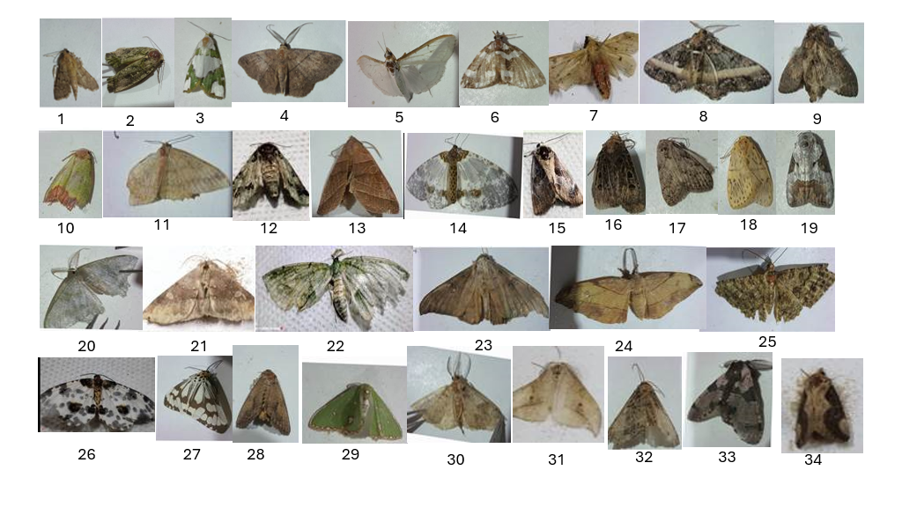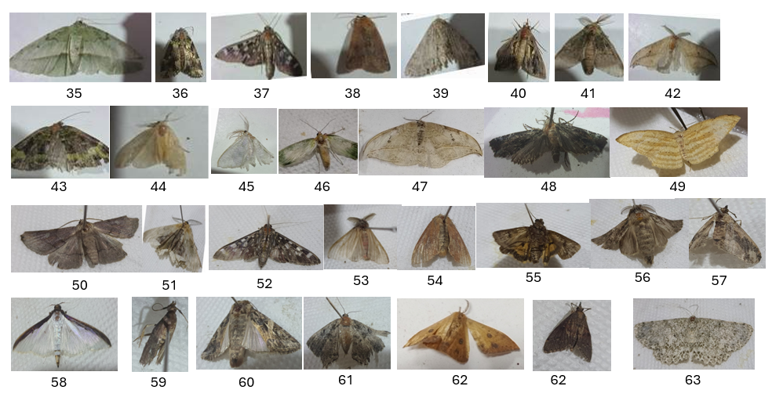

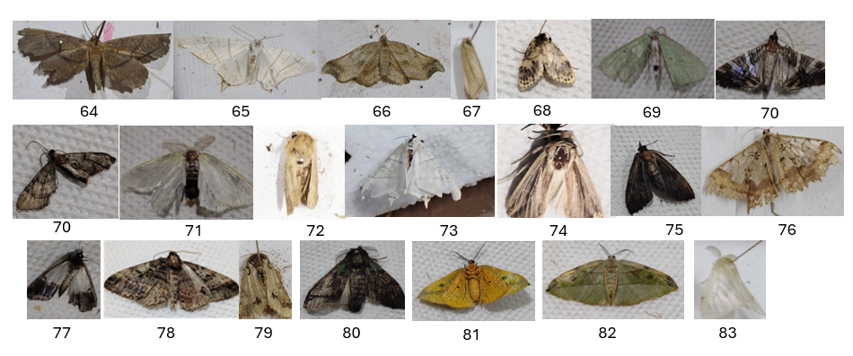
Figure 3: Photographs of representative moth species
1) Herpetogramma basalis, 2) Galleria sp. 3) Ariolica pulchella 4) Petelia sp. 5) Palpita vitrealis 6) Perizoma maculata 7) Spilarctia sp. 8) Harutalcis vialis 9) Syntypistis sp. 10) Earias cupreoviridis 11) Scopula sp. 12) Chadisra sp. 13) Ipimorpha sp. 14) Abraxas sp. 15) Westermannia superba 16) Hermonassa sp. 17) Meganola sp. 18) Lyclene undulosa 19) Lyclene undulosa 20) Maxates sp. 21) Mocis sp. 22) Sauris sp. 23) Oxyodes scrobiculata 24) Hypochrosis abstractaria 25) Calluga costalis 26) Abraxas leucostola 27) Nyctemera adversata 28) Hypocala subsatura 29) Argyrocosma inductaria 30) Hypocala sp. 31) Drepana sp. 32) Condica sp. 33) Harpyia longipennis 34) Hypocala substrata
35) Aplochlora dentisignata 36) Gaurena florens 37) Pygospila costiflexalis 38) Mythimna sp. 39) Ectropis sp. 40) Argyrogramma signata 41) Syntypistis pallidifascia 42) Drepana pallida 43) Sauris sp. 44) Pareuchaetes pseudoinsulata 45) Pelagodes sp. 46) Earias sp. 47) Idaea sp. 48) Chrysodeixis acuta 49) Chrysodeixis acuta 50) Scopula sp. 51) Chorodna sp. 52) Pyraustra sp. 53) Perina nuda 54) Mythimna separata 55) Catacola sp. 56) Calliteara sp. 57) Elophila sp.58) Cydolima laticostalis. 59) Spodoptera litura 60) Eupithecia sp. 61) Agnidra discispilaria 62) Hypena sp. 63) Catoria sublavaria
64) Xerodes ypsaria 65) Ourapteryx sambucaria 66) Ozola sp. 67) Sesamia inferens 68) Hemithea sp. 69) Glyphodes stolalis 70) Pyralis sp. 71) Arctornis sp. 72) Leucania sp. 73) Qurapteryx margaritata 74) Mythimna hobe 75) Lamoria sp. 76) Krananda sp. 77) Eulocastra sp. 78) Alcis sp., 79) Bamra sp., 80) Netria sp., 81) Dalima acuta, 82) Hypochrosis hyadaria, 83) Leucoma salicis
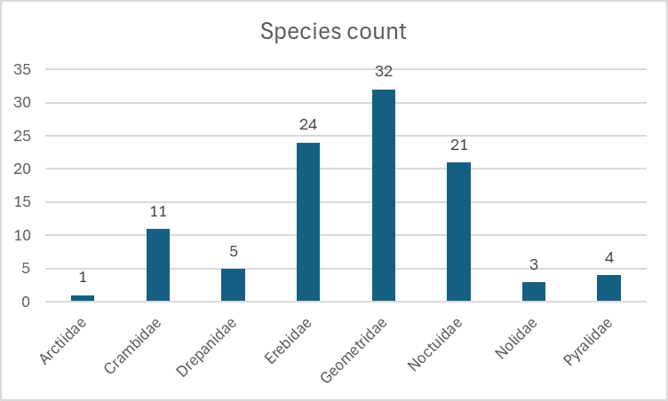
Figure 4: Family-wise species distribution of moths collected from Silarigaon.

Comparison with Previous Studies
The moth diversity documented from Silarigaon is comparable to reports from other regions of the eastern Himalayas and northeastern India. The dominance of Geometridae, followed by Erebidae and Noctuidae, is consistent with observations from subtropical forest ecosystems where vegetation heterogeneity and favorable climatic conditions support diverse Lepidopteran assemblages. The high representation of geometrid moths may be associated with the availability of diverse larval host plants and structurally complex vegetation within the study area.
The dominance of Geometridae aligns with findings from other forest ecosystems, where geometrid moths are often among the most speciose families due to their larval host plant specialization and adaptability to varied forest structures (Holloway, 1997; Scoble, 1995). The substantial representation of Noctuidae and Erebidae reflects their ecological versatility, as many species are polyphagous and capable of exploiting disturbed habitats, including agroforestry landscapes (Wagner et al., 2021; Mondol et al., 2025).

Conservation Significance
All the collected specimens were later submitted to the Applied Entomology laboratory of Post Graduate Department of Zoology, Vidyasagar College, Salt Lake Campus.
Most species recorded during the present survey fall under the “Not Evaluated” category of the IUCN Red List, emphasizing the limited conservation assessment available for moth fauna in India. This highlights significant knowledge gaps regarding the ecological status and population trends of tropical Lepidoptera. Nevertheless, the presence of diverse moth assemblages within a relatively short survey duration suggests that Silarigaon constitutes an ecologically important habitat for nocturnal insects within the eastern Himalayan foothills. (Fox et al., 2014; Sánchez-Bayo & Wyckhuys, 2019).
Moths are particularly sensitive to changes in vegetation structure, microclimate, and light pollution (Conrad et al., 2006). The high diversity recorded during this brief survey suggests that Silarigaon retains substantial habitat integrity. However, anthropogenic pressures such as deforestation, agricultural expansion, and artificial lighting could pose future threats. Continuous monitoring and habitat management are therefore essential to ensure the persistence of local moth diversity.

CONCLUSION
This study represents the first systematic survey of moth diversity from Silarigaon, Kalimpong district, West Bengal. A total of 101 species belonging to 87 genera and 8 families were documented during a seven-day light-trapping survey conducted in October 2025. Geometridae emerged as the most dominant family, followed by Erebidae and Noctuidae, indicating substantial Lepidopteran diversity within the eastern Himalayan foothill ecosystem.
The results provide a critical baseline for future biodiversity assessments and conservation planning in the eastern Himalayas. Sustained long-term monitoring, combined with broader geographic coverage and ecological analyses, will be essential to safeguard the diverse moth assemblages of this region in the face of accelerating environmental change.

REFERENCES
Chakraborty, P., & Saha, A. (2022). Plant diversity of Rango Forest of Kalimpong district at India-Bhutan border, with reference to medicinal importance. NDC EBIOS, 2, 18–31.
Conrad, K. F., Warren, M. S., Fox, R., Parsons, M. S., & Woiwod, I. P. (2006). Rapid declines of common, widespread British moths provide evidence of an insect biodiversity crisis. Biological Conservation, 132(3), 279–291.
Dar, A. A., Jamal, K., Alhazmi, A., El-Sharnouby, M., Salah, M., & Sayed, S. (2021). Moth diversity, species composition, and distributional pattern in Aravalli Hill Range of Rajasthan, India. Saudi Journal of Biological Sciences, 28(9), 4884–4890.
Fox, R., Oliver, T. H., Harrower, C., Parsons, M. S., Thomas, C. D., & Roy, D. B. (2014). Long-term changes to the frequency of occurrence of British moths are consistent with opposing and synergistic effects of climate and land‐use changes. Journal of Applied Ecology, 51(4), 949–957.
Hampson, G. F. (1892–1896). The Fauna of British India, Including Ceylon and Burma: Moths (Vols. 1–4). London: Taylor & Francis.
Holloway, J. D. (1987–2003). The Moths of Borneo (Vols. 1–17). Kuala Lumpur: Malayan Nature Society.
Holloway, J. D. (1997). The Lepidoptera: Form, function, and diversity. Oxford University Press.
Kitching, R. L., Orr, A. G., Thalib, L., Mitchell, H., Hopkins, M. S., & Graham, A. W. (2000). Moth assemblages as indicators of environmental quality in remnants of upland Australian rain forest. Journal of Applied Ecology, 37(2), 284–297.
Macgregor, C. J., Pocock, M. J. O., Fox, R., & Evans, D. M. (2019). Pollination by nocturnal Lepidoptera, and the effects of light pollution: A review. Ecological Entomology, 44(6), 731–743.
Mondal, S., Jamal, A., Biswas, P., & Mondal, S. (2025). A preliminary study on the moth diversity in Rongo Forest, West Bengal, India. International Journal of Zoological Investigations, 11(2), 762–773.
Sánchez-Bayo, F., & Wyckhuys, K. A. G. (2019). Worldwide decline of the entomofauna: A review of its drivers. Biological Conservation, 232, 8–27.
Scoble, M. J. (1995). The Lepidoptera: Form, Function and Diversity. Oxford University Press.
Sidhu, A. K. (2023). Lepidoptera of India: A review. Journal of Entomology and Zoology Studies, 11(2), 105–114.
Singh, S., Choudhury, A., & Gogoi, M. (2020). Diversity and abundance of moths in the Khasi Hills of Meghalaya, India. Journal of Insect Biodiversity, 12(4), 237–255.
Sondhi S., Sondhi Y., Singh R.P., Roy P. & Kunte K. (2023). Moths of India, v. 3.52. Indian Foundation for Butterflies. https://www.mothsofindia.org.
Wagner, D. L., Fox, R., Salcido, D. M., & Dyer, L. A. (2021). A window to the world of global insect declines: Moth biodiversity trends are complex and heterogeneous. Proceedings of the National Academy of Sciences, 118(2), e2002549117.
Zhang, Z.-Q. (2011). Animal biodiversity: An outline of higher-level classification and survey of taxonomic richness. Zootaxa, 3148(1), 7–237.

