Non- Infectious Visceral Gout In Chicken: A Pathological and Epidemiological Study

Abstract
Gout is a metabolic disorder in poultry characterized by hyperuricemia and deposition of urate crystals in tissues, which occurs primarily due to renal dysfunction. The present study was conducted to assess the occurrence, pathological features, and epidemiological pattern of non-infectious visceral gout in chicken over a period of one year. A total of 5280 poultry carcasses were examined by postmortem, and detailed gross and histopathological evaluations were performed. Out of 5280 birds analyzed, 867 cases were found positive for visceral gout with an overall prevalence of 16.42%. The highest incidence was recorded in birds of the second week of age (35.46%), followed by the third week (18.18%) and first week (7.27%), while minimal occurrence was observed in birds older than three weeks (2.47%). Clinical signs observed were reduced feed and water intake, lethargy, ruffled feathers, weight loss, and abnormal droppings. Chalky white urate deposits on visceral organs, enlarged kidneys, and distended ureters were noticed grossly during necropsy. Histopathological examination of kidney sections revealed tubular degeneration, necrosis, urate crystal deposition, glomerular alterations, and inflammatory changes. The disease showed higher prevalence during colder months, indicating a strong influence of environmental factors. The findings confirm that dietary imbalance, particularly high protein and calcium levels, along with managemental stress, play a significant role in the development of visceral gout.
keywords: Visceral gout, Chicken, Hyperuricemia, Urate crystal deposition, Renal pathology, Non-infectious metabolic disorder
- Introduction
Gout is a disease, that occurs due to abnormal metabolism of uric acid and it is characterized by hyperuricemia and deposition of uric acid or urate crystals in tissues and joints. Avian urolithiasis, also called gout, results from kidney damage caused by infectious or nutritional diseases, toxin ingestion, or a combination of factors. Growing layer birds are given with high-protein and high-calcium diets, which may predispose them to gout (Eldaghayes et al., 2010). An imbalanced calcium to phosphorus ratio at 3.5:1 contribute to the development of gout (Mir et al., 2005). Vitamin A deficiency, excess vitamin D3, dehydration, high sodium carbonate, copper sulfate, and mycotoxins in feed can cause renal failure and lead to gout (Sandhyarani et al., 2022). Management factors such as high brooding temperature reduce the water intake and increasing the risk of gout (Sandhyarani et al., 2022). Routine use of antibiotics, anticoccidials, chemicals, and pesticides may also cause toxicity and contribute to the development of gout in poultry (Sandhyarani et al., 2022).
Elevated uric acid levels lead to the formation of monosodium or calcium urate crystals in various sites, especially in the kidneys and on the serosal surfaces of the liver, heart, air sacs, and joints. These insoluble, sharp crystals cause mechanical injury to tissues and trigger a progressive inflammatory response (Sandhyarani et al., 2022).
In birds, uric acid is the final end product of protein and purine metabolism and is normally excreted by the kidneys. It is insoluble in water, and because the birds lack the uricase enzyme, it is not get converted into the more soluble allantoin as seen in mammals. Instead, uric acid binds with specific proteins in the proximal convoluted renal tubules, which helps to keep it in a soluble form and prevents the crystal formation. When renal function is impaired or uric acid production increases, the uric acid accumulates in the blood, leading to hyperuricemia. Although uric acid itself is not toxic, its crystallized form can cause significant mechanical damage to tissues (Lakshmi Namratha et al., 2019).
The present study was undertaken to evaluate the occurrence, pathological features, and epidemiological pattern of non-infectious visceral gout in chicken, with special emphasis on age susceptibility, seasonal variation, and histopathological changes.
- Materials and Methods
The study was conducted in the Department of Veterinary Pathology, College of Veterinary Science, Rajendranagar, Hyderabad. Over a period of one year (April 2025 to March 2026). During this period, 5280 poultry carcasses were presented for postmortem examination. The necropsy was carried out following standard protocols under clean conditions (King et al., 2014), and gross lesions were recorded. Tissue samples from the kidney and heart were collected and fixed in 10% neutral buffered formalin. Histopathological examination was carried out using routine paraffin embedding techniques. Sections were stained with Hematoxylin and Eosin (Luna, 1968), Gomori Methenamine Silver staining was done to confirm urate crystals as per the procedure (Van Aken et al., 2025). Data on age and season were recorded and analyzed descriptively.
- Result & Discussion

3.1 Prevalence:
A total of 5280 poultry carcasses were examined during the study period. Out of these, 867 birds showed visceral gout lesions, giving an overall prevalence of 16.42%. The highest occurrence was recorded in second week birds (35.46%), followed by third week (18.18%) and first week (7.27%). Birds older than three weeks showed the lowest incidence (2.47%) (Table 1).
Table 1. Age-wise occurrence of visceral gout in chicken
Age group | Total examined | Gout positive | Percentage of prevalence
Young 1st week | 1100 | 80 | 7.27
2nd week | 1300 | 461 | 35.46
3rd week | 1623 | 295 | 18.18
Adults > 3weeks | 1257 | 31 | 2.47
Total | 5280 | 867 | 16.42
The highest incidence was recorded during colder months that is 69.90 % (606/867), followed by summer 25.60 % (222/867), and the lowest in the rainy season 4.50 % (39/867). Cold stress showed a clear association with increased mortality due to gout (Fig. 1).
Fig. 1. season- wise occurrence of visceral gout in chicken

3.2 Clinical signs:
Affected birds showed reduced feed intake, reduced water intake, lethargy, ruffled feathers, weight loss, and abnormal droppings. Mortality was more frequent in young chicks.
3.3 Gross pathology:
Gross examination revealed widespread deposition of chalky white urates on visceral organs. Urate deposits were seen on the peritoneal membrane, heart (Fig 2a), liver (Fig 2b), and intestinal serosa. The kidneys were enlarged and pale. Ureters were markedly distended and filled with semi-fluid to semi-solid chalky white urates, producing a cord-like appearance (Fig 2c). whitish streaks were visible through the intestinal wall (Fig 2d). In severe cases, urate deposits were also observed in subcutaneous tissues.
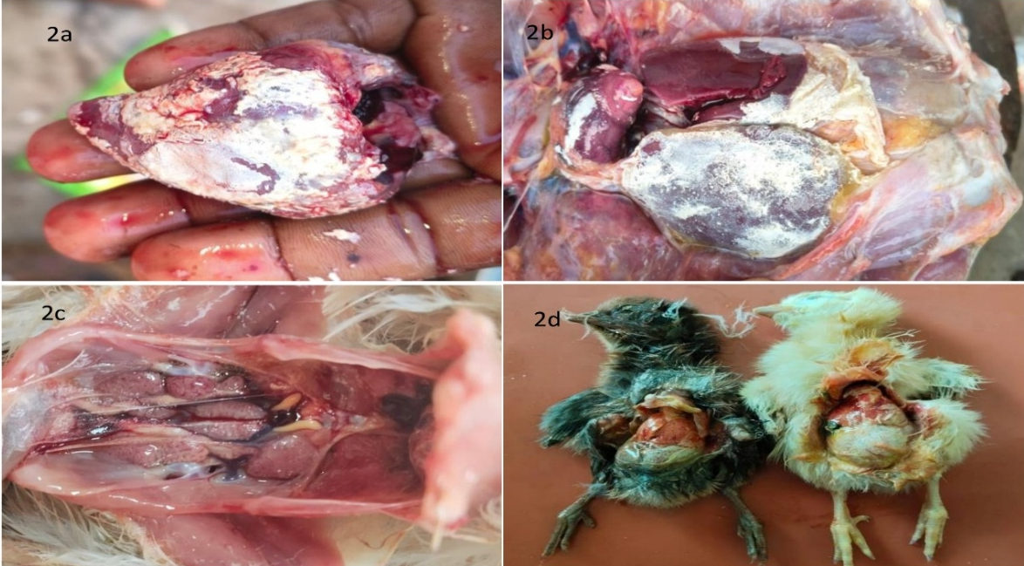
Fig 2. Gross pathological lesions observed in chicken affected with gout
Fig 2a. Urate deposits on heart; Fig 2b. Urate deposits on liver; Fig 2c. Enlarged, pale kidneys with the deposition of urates and bilateral enlargement of ureters; Fig 2d. White, semi-solid, granular coatings on the serosal surface of internal organs, including the intestinal mesentery.
3.4 Histopathology:
Microscopic examination of kidney sections showed moderate to severe tubular degeneration and necrosis. There was desquamation of tubular epithelial cells along with extensive deposition of fine, needle-shaped urate crystals in interstitial space (Fig 3a). Necrotic and atrophic glomeruli, dilation of Bowman’s space and inflammatory cell infiltration was also noted in affected renal tissue (Fig 3b).
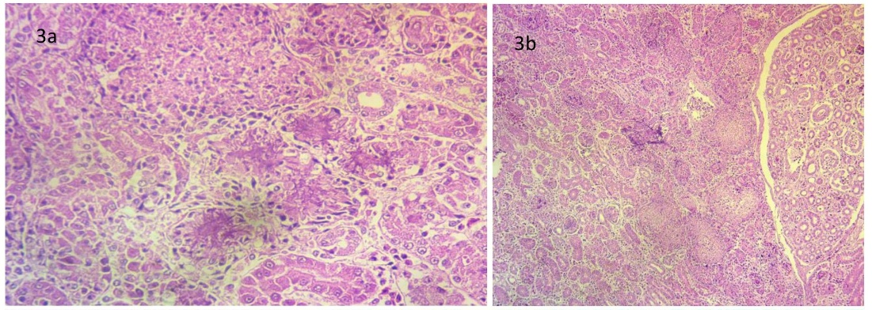
Figure. 3. Histopathological lesions in kidneys of chicken affected with gout. Fig 3a. Kidney section showing presence of urates in interstitial space, degeneration and desquamation of tubular epithelium (H &E x 400); Fig 3b. Kidney section showing necrotic glomeruli, atrophic glomeruli & tubules and increased bowman’s space (H &E x100)
Heart tissue sections examined with H&E revealed degenerative changes, mild inflammatory cell infiltration and disrupted myofibers (Fig 4).
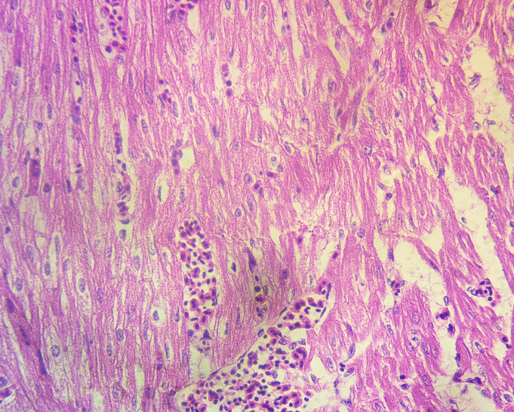
Fig 4. Heart section showing disruption of myofibers and infiltration of inflammatory cells in chicken affected with gout (H &E x 400)
Gomori methenamine silver (GMS) staining clearly demonstrated urate crystal deposits as black to dark brown radiating needle-like structures between myocardial fibers (Fig 5a) and around the blood vessels (Fig 5b). The stain enhanced visualization of crystal aggregates and confirmed their distribution within affected heart tissue.
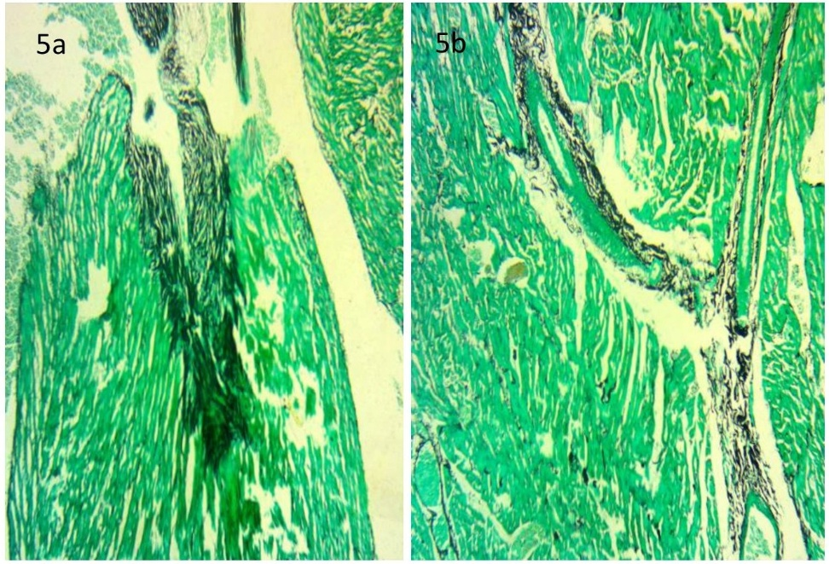
Fig 5. Histopathological lesions in heart of chicken affected with gout with Gomori methenamine silver stain. Fig 5a. Heart section depicting accumulation of urate crystals in between the muscle fibers (GMS x100). Fig 5b. Heart section showing deposition of urate crystals around the capillaries (GMS x100)

Present study revealed the highest prevalence of the disease during colder months, followed by summer, with the lowest incidence in the rainy season. Similar results were earlier reported by Srivastava et al., 2002; Jana et al., 2008; Panigrahi, 2017; Lakkawar et al., 2018; Yadav et al., 2020. Cold temperatures may promote increased production and reduced solubility of uric acid, leading to cold stress and higher mortality due to gout.
Young chicks show higher susceptibility and mortality due to visceral gout compared to adult birds (Mallinson et al., 1984; Wideman, 1988; Wideman et al., 1994; Jana et al., 2008; Singh et al., 2013; Panigrahi, 2017; Yadav et al., 2020). In current experiment, most cases of mortality occurred in birds under 2 weeks of age, followed by those aged between 2 to 3 weeks, and then in birds below 1 week. Only few cases of mortality were observed in birds older than 3 weeks. Similar findings have been reported by Singh et al., 2013. Difference in incidence based on age is due to the inclusion of calcium in diet (Singh et al., 2013). At sexual maturity, pullets are shifted to high-calcium diets to support egg production. If the kidneys are already damaged, they may fail to handle the increased calcium load, which can lead to the development of gout (Mitchell, 2015). Urate crystal deposition in the tubular lumen occurs, particularly during peak production (Al-Hamadani and Mohammed, 2009).
In current investigation, gross examination revealed diffuse uric acid deposits on various visceral organs, peritoneal membrane, and in subcutaneous tissues. Whitish streaks were visible on the intestines through the serosal surface. These findings were in correlation with Fitz-Coy et al., 1988. Enlargement of the kidneys, distension of ureters with semi-fluid to semi-solid chalky white urates were also observed. similar lesions were earlier reported by Mir et al., 2005.
Histopathological examination of the kidneys revealed degeneration, necrosis and desquamation of tubular epithelium, and extensive deposits of radiating, fine, needle-shaped urate crystals. Similar microscopic findings have been reported in earlier studies (Eldaghayes et al., 2010 & Ravikumar et al., 2019). Glomerular alterations included thickening of Bowman’s capsule, proliferative glomerulonephritis and dilation of Bowman’s space. These were in agreement with Eldaghayes et al., 2010.
- Conclusion
Non-infectious visceral gout in chicken is strongly associated with nutritional imbalance, renal dysfunction, and environmental stress. This study concluded that young birds, especially during early weeks of age, are more susceptible to the gout. Seasonal variation plays a critical role, with higher incidence observed during colder months. Gross and histopathological findings confirmed severe renal damage due to urate crystal deposition, leading to impaired kidney function. Proper regulation of dietary protein, calcium, and mineral balance, along with improved management practices such as adequate water supply and temperature control, are essential to prevent the occurrence of gout in poultry flocks.
References
Al-Hamadani, A. H., & Mohammed, M. H. (2009). The relationship between the lesions of kidneys and the different production stages in layers. Iraqi Journal of Veterinary Sciences, 23(Suppl 1), 211–217.
Eldaghayes, I. M., Hamid, M. A., El-Attar, S. R., & Kammon, A. M. (2010). Pathology of gout in growing layers attributed to high calcium and protein diet. E-International Science Research Journal, 2 (4), 297-302.
Fitz-Coy, S. H., Edgar, S. A., & Hoerr, F. J. (1988). An outbreak of urolithiasis in single-comb White Leghorn pullets. Avian Diseases, 32(3), 563-566.
Jana, S., Niyogi, D., Mandal, S., Ganguly, S., & Mukhopadhaya, S. K. (2008). Haematological and Serum biochemical alteration in gout of broiler birds. Indian Journal of Animal Health, 47(2), 113-115.
King, J.M., Roth-Johnson, L., Dodd, D.C., & Newsom, M.E. (2014). The Necropsy Book: A guide for veterinary students, residents, clinicians, pathologists, and biological researchers. The Internet-First University Press.
Lakkawar, A. W., Kumar, R., Venugopal, S., Uma, S., Sathiyaseelan, M., Nair, M. G. et al., (2018). Pathology and management of gout in Giriraja breeder chicks. Journal of Entomology and Zoology Studies, 6(1), 550-554.
Lakshmi Namratha, M., Kumar, Y. R., & Lakshman, M. (2019). Pathology of visceral gout in layer chicken. International Journal of Recent Scientific Research, 10, 35546-35548.
Luna G L H T. 1968. Manual of histological and special staining techniques. 2nd ed., The Blakistone Divison McGraw-Hill Book Company, Inc. NewYork, Toronto London: 1-5 and 9-34.
Mallinson, E. T., Rothenbacher, H., Wideman, R. F., Snyder, D. B., Russek, E., Zuckerman, A. I. et al., (1984). Epizootiology, pathology, and microbiology of an outbreak of urolithiasis in chickens. Avian Diseases, 25-43.
Mir, M. S., Darzi, M. M., Khan, A. A., Ganaie, N. A., Gupta, S., Nashiruddullah, N. et al., (2005). Investigation of an outbreak of gout in Kashmir Favorella poultry. Indian Journal of Veterinary Pathology, 29(1), 35-37.
Mitchell, A. (2015). Gout management in poultry. The Poultry Site. https://www.thepoultrysite.com/articles/gout-management-in-poultry
Panigrahi, S. (2017). Epidemiological studies on chicken astroviruses in gout affected broiler chicken flocks (Doctoral dissertation, LUVAS).
Ravikumar, Y., Sawale, G. K., Ramesh, G., Mahesh, B., Madhuri, D., & Lakshman, M. (2019). Visceral gout in ducks. The Pharma Innovation Journal, 8(1), 256-257.
Sandhyarani, K., Madhuri, D., & Ravikumar, Y. (2022). Review-gout in chicken. Advances in Animal and Veterinary Sciences, 10(3), 702-711.
Singh, N., Ghosh, R. C., & Singh, A. (2013). Prevalence and haemato-biochemical studies on naturally occurring gout in Chhattisgarh. Advances in Animal and Veterinary Sciences, 1(3S), 9–11.
Srivastava, N., Joshi, B. P., Jani, P. B., & Prajapati, K. S. (2002). Epidemiological studies on visceral gout in broiler chicks. In National symposium on Recent Advance in Diagnosis of: Livestock, Poultry and Wildlife with special Emphasis on Hill Area Diseases and XIX Annual Conference of Indian Association of Veterinary Pathologists. Palampur, Hamnchal Pradesh, India.
Van Aken, L., Bielli, A., & Esposito, J. A. (2025). Preservation of tophi in the modified Gomori methenamine silver procedure for urates. Journal of Histotechnology, 1-3.
Wideman, R. F. (1988). Avian kidney anatomy and physiology. Critical Reviews in Poultry Biology, 1(2), 133-176.
Wideman, R. F., Ford, B. C., May, J. D., & Lott, B. D. (1994). Acute heat acclimation and kidney function in broilers. Poultry science, 73(1), 75-88.
Yadav, B. S., Niyogi, D., Gupta, R. K., Singh, S. V., Saif, M., & Jaiswal, S. K. (2020). Incidence and clinicopathological study of gout in broiler birds of Faizabad and Sultanpur districts of eastern Uttar Pradesh. Exploratory Animal and Medical Research, 10(1), 88-91.

