Qualitative assessment of phytoplankton diversity from Lonar Crater Lake, Buldhana (M.S.) India

ABSTRACT
Aim: Phytoplankton diversity is a crucial bioindicator of aquatic health. Hence, the present study was carried out to assess the phytoplankton diversity in Lonar Carter Lake, which helps to indicate the overall health of the corresponding aquatic ecosystem.
Study design: Lonar Crater Lake, Buldhana, M.S. India.
Place and Duration of Study: The present study assessed phytoplankton diversity in Lonar Lake during the pre-monsoon and post-monsoon seasons, i.e., June 2024 and December 2024 respectively. The samples were collected from four different designated sampling stations in the periphery of the Lonar Crater Lake.
Methodology: The standard methods APHA (2017); Kodarkar (2006) were used for the analysis of phytoplankton study. A V-shaped plankton net, attached to a sampling bottle at the end was used to collect phytoplankton samples, and the bucket-rope too mechanism was used at certain sampling stations. The samples were stored in plastic bottles containing 4% formalin solution, kept in a cool, dark place. The phytoplankton samples were photographed under the microscope and were identified using standard taxonomic keys.
Results: The phytoplankton species were assessed, belonging to three major classes, Bacillariophyceae, Cyanophyceae, and Chlorophyceae, across four sampling stations (S1, S2, S3, and S4) during June 2024 and December 2024. A total of 36 species were recorded, of which Cyanophyceae contributed the highest number (21 species), followed by 8 species of Bacillariophyceae and 7 species of Chlorophyceae. Among the recorded groups, Cyanophyceae was found to be the dominant class, represented by genera such as Spirulina, Arthrospira, Anabaena, Anabaenopsis, Microcystis, Oscillatoria, Raphidiopsis, and Pseudoanabaena. Bacillariophyceae (diatoms) formed the second major group, represented by species such as Navicula amphirhynchus, Navicula cryptocephalas, Navicula radiosa, Navicula sphaerophora, Pinnularia divergens and Pleurosigma sp. Similarly, Chlorophyceae (green algae) was represented by species such as Chlorella vulgaris, Oocystis sp., Pediastrum integrum, Tetraedron duospinum, Palmella mucosa, Kirchneriella obesa, and Quadrigula lacustris.
Conclusion: With an increasing number of phytoplankton species and a corresponding decrease in zooplankton species, this imbalance in the prey-predator relationship showed abnormal shifts. Hence, regulating nutrient inputs, frequent monitoring of the primary producer; and thorough, regular scientific studies are essential steps towards restoring the sustainability of this unique ecological marvel.
Keywords: Diversity, Lonar Crater, Phytoplankton, Pre – Post Monsoon

INTRODUCTION:
Lonar Lake is located in the Buldhana district of Maharashtra State in India. It was discovered in 1823 by a British officer named Cornet J.E. Alexander. This Lake is third largest natural saltwater body in the world, with the diameter of 1.8 kilometres and 150 meters depth (Taiwade,1994). As it is one of the known meteoritic saltwater crater lakes in the world, Lonar Lake supports and harbours specialized single-celled microorganisms, including bacteria, fungi, protozoa, viruses, and algae. They are key to understanding the potential life in extreme environments. Phytoplankton respond quickly to environmental changes, making them better indicators of rapid change in the aquatic environment (Sahoo, 2024). Hence, the study of phytoplankton diversity in Lonar Lake became essential as it supports a unique, saline and alkaline ecosystem that serves as a natural laboratory for Researchers.
Phytoplankton are crucial food source for aquatic animals, from tiny fish to whales, supporting the entire aquatic food chain. Some common groups of phytoplankton, such as Cyanophyceae (Blue-green algae), Bacillariophyceae (diatoms) and Chlorophyceae (green algae) are found in nutrient-rich water. Cyanobacteria form thick colonies or filaments that have been known to grow well at high biomass density. The green algae (Chlorophyta) are growing in heavily polluted lakes, wastewater lagoons and nutrient-rich ponds, resulting in high biomass density. Diatoms (Bacillariophyta) are the dominant plankton in turbid lakes, providing a significant portion of the biomass because they rely on the supply of most of the silica (Kalff, 2002).
Their community structure, diversity and species composition directly reflect nutrient levels, toxic contaminants and environmental factors like temperature and pH (Ragi et al., 2017). They have short life cycles and reproduce rapidly, they respond quickly to environmental changes, making them better indicators of rapid change. High phytoplankton diversity generally indicates good ecological status, while low diversity and high dominance of a few tolerant species indicate environmental stress (Ma et al., 2024). Biomonitoring of phytoplankton is essential to assess the health of aquatic ecosystems which involves tracking changes in species composition with sensitive species declining and tolerant species thriving in polluted environments, where over 1,000 types of algae survive (Palmer, 1969). The presence of phytoplankton can indicate nutrient richness, eutrophication or pollution (Ragi et al., 2017).
Lonar Lake's unique biota is under threat as its high salinity and alkalinity levels decrease, due continuous inflow of freshwater stream, thereby impacting the diversity of species adapted to this extreme environment (Khobragade et al., 2016). Therefore, identifying the diversity of primary producers, i.e., phytoplankton, which can serve as a bioindicator of the healthy state of any water body can provide relevant details on the degree of eutrophication and pollution of the aquatic ecosystem. Their presence and absence informed the prey–predator relationship and the overall diversity of aquatic microorganisms (Dembowska et al., 2018). Thus, in the current study, a qualitative assessment of the phytoplankton population in the lake was conducted in 2024 across four selected sites to derive viable data on how water quality affects the biodiversity of this special crater lake. Continuous monitoring of phytoplankton diversity provides valuable insights into the health of Lonar lake's ecosystem, informing management and conservation efforts. Investigating the lake's unique microbial flora and fauna could highlight its wetland value, supporting its recognition as a Ramsar site in India.
MATERIAL AND METHODS:
STUDY AREA: Blue signs mark the sampling stations on the study map: S1, S2, S3, and S4. The phytoplankton were sampled at the sampling stations that were mentioned above, viz.;
S1 = Kamalajadevi temple,
S2 = Mor Mahadev temple,
S3 = Wagh Mahadev temple,
S4 = Vishnu temple,
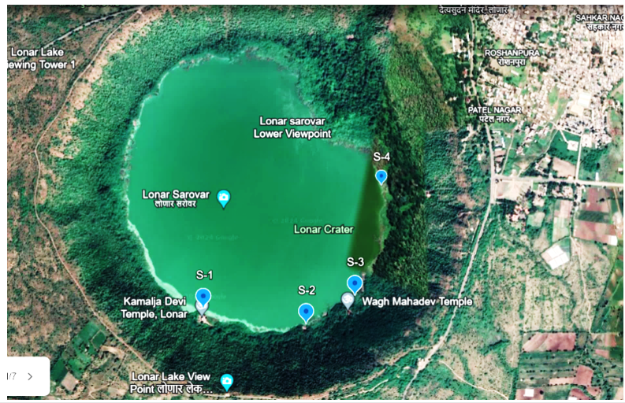

Fig. 1. Image created in Google Earth of sampling stations at Lonar Lake

Water samples were collected twice in the year 2024 from four selected sampling sites during the pre-monsoon (June) and post-monsoon (December) periods. They were collected at times prescribed under the standard methodology; A, V-shaped plankton net, attached with a sampling bottle at the end, was used to collect the phytoplankton samples, and bucket-rope too mechanism was used at certain sampling stations. The samples were stored in plastic bottles containing 4% formalin solution, kept in a cool, dark place. The phytoplankton samples were photographed under the microscope and were identified using standard taxonomic keys given by Prescott (1951), Karacaoglu et al. (2004), Roy et al. (2015), Seu-Anoi et al. (2017), Werner (2009), Suthers (2009), Shivakumara (2015), Kumari et al. (2018), Rafiullah (2018).
RESULTS & DISCUSSION:
In the present study, a total of 36 phytoplankton species were reported from the four selected sites in the periphery of Lonar crater lake, representing 3 families: Cyanophyceae, Bacillariophyceae and Chlorophyceae as summarized in Table 1.
Table. 1. Family and Class-wise Distribution of Phytoplankton Species at the Lonar Lake
Sr. No | Family | Class | Species
 | Naviculaceae | Bacillariophyceae | Navicula amphirhynchus
 | Pinnulariaceae | Bacillariophyceae | Pinnularia divergens
 | Naviculaceae | Bacillariophyceae | Navicula cryptocephalas
 | Pleurosigmataceae | Bacillariophyceae | Pleurosigma normanii
 | Naviculaceae | Bacillariophyceae | Navicula cuspidata
 | Naviculaceae | Bacillariophyceae | Navicula radiosa
 | Naviculaceae | Bacillariophyceae | Navicula sphaerophora
 | Pleurosigmataceae | Bacillariophyceae | Pleurosigma angulatum
 | Nostocaceae | Cyanophyceae | Raphidiopsis mediterranea
 | Pseudanabaenaceae | Cyanophyceae | Pseudoanabaena catenata
 | Oscillatoriaceae | Cyanophyceae | Spirulina labyrinthiformis
 | Chroococcaceae | Cyanophyceae | Rhabdogloea rhaphidioides,
 | Nostocaceae | Cyanophyceae | Anabaena circinalis
 | Nostocaceae | Cyanophyceae | Anabaenopsis circularis
 | Nostocaceae | Cyanophyceae | Anabaenopsis arnoldii
 | Nostocaceae | Cyanophyceae | Anabaenopsis tanganyikae
 | Oscillatoriaceae | Cyanophyceae | Athrospira platensis
 | Oscillatoriaceae | Cyanophyceae | Spirulina gigantea
 | Chroococcaceae | Cyanophyceae | Rhabdoderma lineare
 | Microcystaceae | Cyanophyceae | Microcystis aeruginosa
 | Microcystaceae | Cyanophyceae | Microcystis ichtyoblabe
 | Chroococcaceae | Cyanophyceae | Chroococcus minutus
 | Oscillatoriaceae | Cyanophyceae | Arthrospira gomontiana
 | Oscillatoriaceae | Cyanophyceae | Spirulina Nordstedtii
 | Oscillatoriaceae | Cyanophyceae | Arthrospira spirulina
 | Oscillatoriaceae | Cyanophyceae | Oscillaoria brevis
 | Nostocaceae | Cyanophyceae | Anabaenopsis raciborskii
 | Oscillatoriaceae | Cyanophyceae | Spirulina subtilissima.
 | Pseudanabaenaceae | Cyanophyceae | Pseudoanabaena galeata
 | Hydrodictyaceae | Chlorophyceae | Quadrigula lacustris
 | Hydrodictyaceae | Chlorophyceae | Tetraedron duospinum
 | Palmellaceae | Chlorophyceae | Palmella mucosa
 | Chlorellaceae | Chlorophyceae | Chlorella vulgaris
 | Oocystaceae | Chlorophyceae | Oocystis sp.
 | Hydrodictyaceae | Chlorophyceae | Pediastrum integrum
 | Selenastraceae | Chlorophyceae | Kirchneriella obesa

Table 2. Spatial and Temporal Diversity of Phytoplankton at the Lonar Lake
Class | Species | Pre-monsoon |  |  |  | Post-monsoon
Class | Species | S1 | S2 | S3 | S4 | S1 | S2 | S3 | S4
Bacillariophyceae | Navicula amphirhynchus | ✓ | ✓ | ✓ | ✓ | ✓ | ✓ | ✓ | ✓
Bacillariophyceae | Pinnularia divergens | ✓ | ✓ | X | ✓ | ✓ | ✓ | ✓ | ✓
Bacillariophyceae | Navicula cryptocephalas | ✓ | ✓ | ✓ | ✓ | ✓ | ✓ | ✓ | ✓
Bacillariophyceae | Pleurosigma normanii | ✓ | ✓ | ✓ | X | ✓ | ✓ | ✓ | ✓
Bacillariophyceae | Navicula cuspidata | ✓ | ✓ | ✓ | ✓ | ✓ | ✓ | ✓ | ✓
Bacillariophyceae | Navicula radiosa | ✓ | ✓ | ✓ | ✓ | ✓ | ✓ | ✓ | ✓
Bacillariophyceae | Navicula sphaerophora | ✓ | ✓ | ✓ | ✓ | ✓ | ✓ | ✓ | ✓
Bacillariophyceae | Pleurosigma angulatum | ✓ | ✓ | ✓ | ✓ | ✓ | ✓ | ✓ | ✓
Cyanophyceae | Spirulina labyrinthiformis | ✓ | ✓ | ✓ | ✓ | ✓ | ✓ | ✓ | ✓
Cyanophyceae | Raphidiopsis mediterranea | ✓ | ✓ | ✓ | ✓ | ✓ | ✓ | ✓ | ✓
Cyanophyceae | Pseudoanabaena catenata | ✓ | ✓ | ✓ | ✓ | ✓ | ✓ | ✓ | ✓
Cyanophyceae | Rhabdogloea rhaphidioides | ✓ | ✓ | ✓ | ✓ | ✓ | ✓ | ✓ | ✓
Cyanophyceae | Anabaena circinalis | ✓ | ✓ | ✓ | ✓ | ✓ | ✓ | ✓ | ✓
Cyanophyceae | Anabaenopsis circularis | ✓ | ✓ | ✓ | ✓ | ✓ | ✓ | ✓ | ✓
Cyanophyceae | Anabaenopsis arnoldii | ✓ | ✓ | ✓ | ✓ | ✓ | ✓ | ✓ | ✓
Cyanophyceae | Anabaenopsis tanganyikae | ✓ | ✓ | ✓ | ✓ | ✓ | ✓ | ✓ | ✓
Cyanophyceae | Arthrospira platensis | ✓ | ✓ | ✓ | ✓ | ✓ | ✓ | ✓ | ✓
Cyanophyceae | Spirulina gigantea | ✓ | ✓ | ✓ | ✓ | ✓ | ✓ | ✓ | ✓
Cyanophyceae | Rhabdoderma lineare | ✓ | ✓ | ✓ | ✓ | ✓ | ✓ | ✓ | ✓
Cyanophyceae | Microcystis aeruginosa | ✓ | ✓ | ✓ | ✓ | ✓ | ✓ | ✓ | ✓
Cyanophyceae | Microcystis ichtyoblabe | ✓ | ✓ | ✓ | ✓ | ✓ | ✓ | ✓ | ✓
Cyanophyceae | Chroococcus minutus | ✓ | ✓ | ✓ | ✓ | ✓ | ✓ | ✓ | ✓
Cyanophyceae | Arthrospira gomontiana | ✓ | ✓ | ✓ | ✓ | ✓ | ✓ | ✓ | ✓
Cyanophyceae | Spirulina Nordstedtii | ✓ | ✓ | ✓ | ✓ | ✓ | ✓ | ✓ | ✓
Cyanophyceae | Arthrospira spirulina | ✓ | ✓ | ✓ | ✓ | ✓ | ✓ | ✓ | ✓
Cyanophyceae | Oscillatoria brevis | ✓ | ✓ | ✓ | ✓ | ✓ | ✓ | ✓ | ✓
Cyanophyceae | Anabaenopsis raciborskii | ✓ | ✓ | ✓ | ✓ | ✓ | ✓ | ✓ | ✓
Cyanophyceae | Spirulina subtilissima | ✓ | ✓ | ✓ | ✓ | ✓ | ✓ | ✓ | ✓
Cyanophyceae | Pseudoanabaena galeata | ✓ | ✓ | ✓ | ✓ | ✓ | ✓ | ✓ | ✓
Chlorophyceae | Chlorella vulgaris | ✓ | ✓ | ✓ | ✓ | ✓ | ✓ | ✓ | ✓
Chlorophyceae | Oocystis sp. | ✓ | ✓ | ✓ | ✓ | ✓ | ✓ | ✓ | ✓
Chlorophyceae | Kirchneriella obesa | ✓ | ✓ | ✓ | ✓ | ✓ | ✓ | ✓ | ✓
Chlorophyceae | Quadrigula Lacustris | ✓ | ✓ | ✓ | ✓ | ✓ | ✓ | ✓ | ✓
Chlorophyceae | Tetraedron duospinum | ✓ | ✓ | ✓ | ✓ | ✓ | ✓ | ✓ | ✓
Chlorophyceae | Palmella mucosa | ✓ | ✓ | ✓ | ✓ | ✓ | ✓ | ✓ | ✓
Chlorophyceae | Pediastrum integrum | ✓ | ✓ | ✓ | ✓ | ✓ | ✓ | ✓ | ✓

The present table shows the distribution of phytoplankton species belonging to three major classes, Bacillariophyceae, Cyanophyceae and Chlorophyceae across four sampling stations (S1, S2, S3, and S4) during June 2024 and December 2024. A total of 36 species were recorded, of which Cyanophyceae contributed the highest number (21 species), followed by 8 species of Bacillariophyceae and 7 species of Chlorophyceae. The data revealed that most species were consistently present across all stations in both seasons, indicating a relatively stable and homogeneous aquatic environment. Bacillariophyceae (diatoms) formed the second major group, represented by species such as Navicula amphirhynchus, Navicula cryptocephalas, Navicula radiosa, Navicula sphaerophora, Pinnularia divergens and Pleurosigma sp. Among the recorded groups, Cyanophyceae was found to be the dominant class, represented by genera such as Spirulina, Arthrospira, Anabaena, Anabaenopsis, Microcystis, Oscillatoria, Raphidiopsis, and Pseudoanabaena.
Similarly, Chlorophyceae (green algae) were represented by species such as Chlorella vulgaris, Oocystis sp., Pediastrum integrum, Tetraedron duospinum, Palmella mucosa, Kirchneriella obesa, and Quadrigula Lacustris. Chlorophyceae species like Chlorella vulgaris, Pediastrum and Oocystis also showed continuous occurrence, supporting the presence of favourable growth conditions. Slight spatial variation was observed among Bacillariophyceae, where a species such as Navicula sp. were absent at certain stations in June, possibly due to minor environmental fluctuations. Overall, the negligible seasonal variation and widespread distribution of most species indicate ecological stability, while the dominance of Cyanophyceae points toward a high nutrient status and potential eutrophication of the study area.

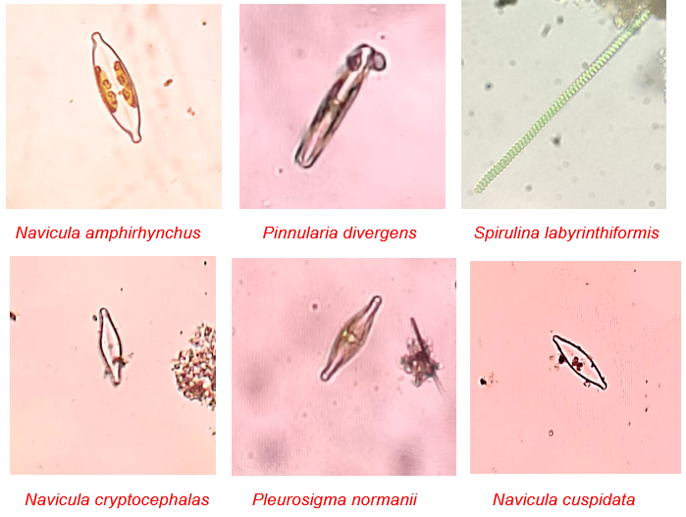
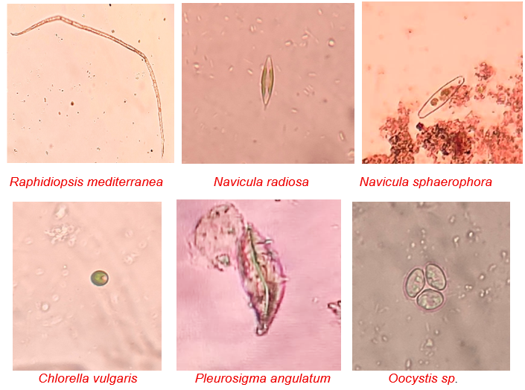
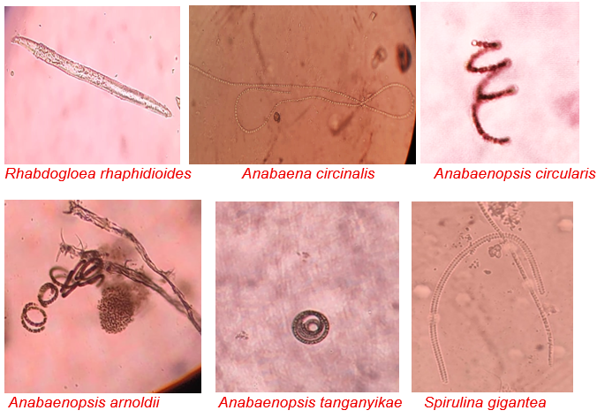
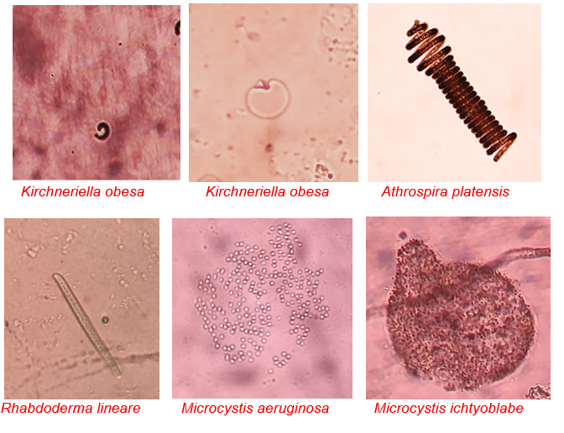
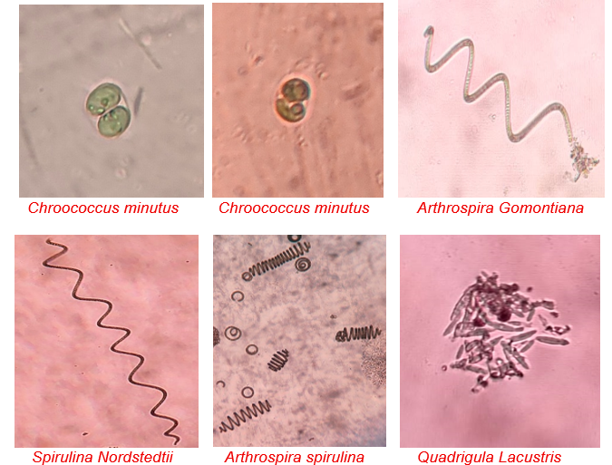
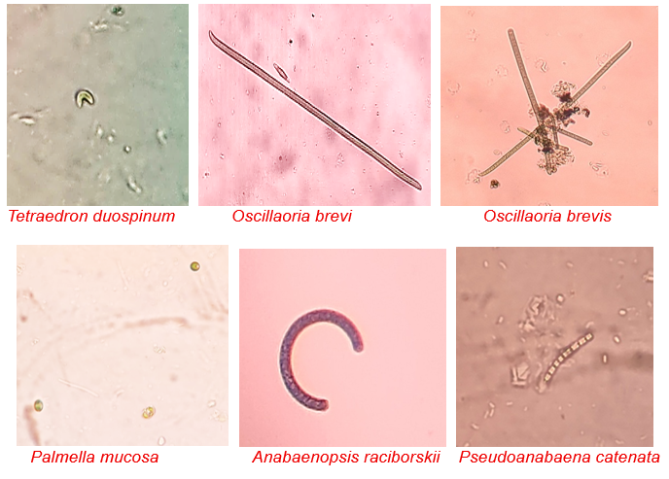
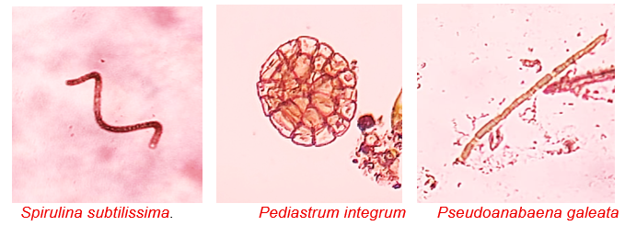

Fig. 2. Photo Plate of Identified Phytoplankton at Lonar Lake

The study indicated that the aquatic ecosystem was under environmental stress, as demonstrated by low species diversity and the dominance of a few phytoplankton species. This observation aligned with earlier findings by Tavares et al. (2010) reported that a high abundance of Cyanophyceae was characteristic of eutrophic conditions. Similarly, Reynolds (2006) and Smith & Schindler (2009) emphasized that cyanobacterial dominance was a key indicator of eutrophication, often associated with elevated nutrient levels. Furthermore, Whitton & Potts (2000) highlighted that Spirulina and Arthrospira could bloom under harsh environmental conditions like high temperature, low oxygen levels and high organic matter, reflecting their high adaptive capacity. In addition, Devi et al. (2007) noted that shifts in phytoplankton composition, particularly the increased dominance of Cyanophyceae, indicated declining water quality and rising pollution levels.
The phytoplankton community of Lonar Lake was predominantly composed of Cyanophyceae, reflecting its highly saline and alkaline environment. Tandale & Talwankar (2023) reported that Cyanophyceae (blue-green algae) dominated the phytoplankton of Lonar Lake. Bacillariophyceae (diatoms), such as Fragillaria, Navicula, and Cyclotella, were more tolerant of the lake’s saline-alkaline conditions than Chlorophyceae (green algae), which were the most vulnerable. The dominant species included Cyanophyceae (Spirulina, Anabaena, Arthrospira), Bacillariophyceae (Navicula, Fragillaria, Cyclotella), and Chlorophyceae (Chlamydomonas, Oedogonium), which were present in low abundance. In 2020, Tandale reported that Cyanophyceae dominated the phytoplankton community, with Spirulina being the most abundant species. Other recorded species included Chlorophyceae (Chlamydomonas, Oedogonium, Rhizoclonium), Cyanophyceae (Anabaena, Arthrospira, Nostoc), and Bacillariophyceae (Fragillaria, Navicula, Cyclotella). The study further indicated that algal growth varied with dilution at some sampling stations, supporting higher diversity, whereas high salinity restricted sensitive groups.
Similarly, Dabhade (2015) reported that Cyanophyceae, particularly Spirulina, dominated the phytoplankton community. The study found Chlorophyceae (Chlamydomonas, Dunaliella salina, Oedogonium) as the second most abundant group, along with Cyanophyceae (Anabaena, Oscillatoria) and Bacillariophyceae (Navicula, Nitzschia, Synedra). In summary, these findings confirmed that Cyanophyceae prevailed due to their high tolerance, followed by moderately tolerant Bacillariophyceae, whereas Chlorophyceae remained the most vulnerable and least dominant class.
CONCLUSION:
Lonar Lake's unique ecosystem requires careful management to maintain its ecological balance. The study emphasized the urgent need for integrated water management strategies to ensure the sustainability of this unique aquatic ecosystem. The present study showed the distribution of phytoplankton across the four sampling stations (S1, S2, S3, and S4). To ensure the lake's sustainability, it was crucial to implement regular monitoring of plankton populations and to engage local communities and tourists in conservation efforts. The study confirmed that the phytoplankton community of Lonar Lake was a sensitive and reliable indicator of its ecological status. The shifts in species composition observed during pre-monsoon and post monsoon periods also reflects the underlying changes in nutrient load. Therefore, regulation of nutrient inputs, frequent monitoring of the primary producer along with detailed and regular scientific studies are essential steps towards restoring the sustainability of this unique ecological marvel.

COMPETING INTERESTS DISCLAIMER:
Authors have declared that they have no known competing financial interests OR non-financial interests OR personal relationships that could have appeared to influence the work reported in this paper.

REFERENCES:
- American Public Health Association (2017). Standard methods for the examination of water and wastewater (23rd ed.), 10–22.
- Dabhade, D. S. (2015). Lonar saline lake: A case study. International Journal of Research in Biosciences, Agriculture and Technology, 3(2), 249–251.
- Dembowska, E. A., Mieszczankin, T., & Napiórkowski, P. (2018). Changes in the phytoplankton community as symptoms of deterioration of water quality in a shallow lake. Environmental Monitoring and Assessment, 190(2), 95.
- Devi, A., & Singaracharya, M. A. (2007). Phytoplankton in Lower Manair Dam and Kakatiya Canal, Karimnagar, A.P., India. Nature Environment and Pollution Technology, 6(1), 643–648.
- Kalff, J. (2002). Limnology: Inland water ecosystems. Prentice Hall, 309–322.
- Karacaoglu, D., Dere, S., & Dalkiran, N. (2004). A taxonomic study on the phytoplankton of Lake Uluabat (Bursa). Turkish Journal of Botany, 28, 473–485.
- Khobragade, K. S., & Pawar, V. B. (2016). Physico-chemical analysis of Lonar Lake with reference to bacteriological study. International Journal of Modern Sciences and Engineering Technology, 3(7), 15–22.
- Kodarkar, M. S. (2006). Methodology for water analysis (Physico-chemical, biological and microbiological). IAAB, 1–49.
- Kumari, S., Khan, J. A., & Thakur, M. S. (2018). Study on phytoplankton, zooplankton and ichthyofauna of Motia Lake. Research & Reviews: Journal of Zoological Sciences, 6(2), 25–49.
- Ma, M., Li, J., Lu, A., Zhu, P., & Yin, X. (2024). Effects of phytoplankton diversity on resource use efficiency in a eutrophic urban river of Northern China. Frontiers in Environmental Science, 12.
- Palmer, C. M. (1969). A composite rating of algae tolerating organic pollution. Phycology, 5, 78–82.
- Prescott, G. W. (1951). Algae of the Western Great Lakes Area (Bulletin No. 31). Cranbrook Institute of Science, 661–933.
- Rafiullah, M. K. (2018). Eco-biodiversity studies on algae of Lonar Crater Lake. Doctoral Dissertation, Dr. Babasaheb Ambedkar Marathwada University, Aurangabad, India, 20–57.
- Ragi, M. S., Jaya, D. S., & Moses, S. A. (2017). Influence of water quality on plankton in tropical ponds: A multivariate analysis approach. Lakes and Reservoirs: Research and Management, 22(3), 221–230.
- Reynolds, C. S. (2006). The ecology of phytoplankton. Cambridge University Press, 1–385.
- Sahoo, D., Bera, S. K., Pal, P. P., Tamili, D. K., Sarkar, B., Madhu, N. R., et al. (2024). Plankton as key indicators of the health and stability of aquatic ecosystems: A review. Basic Overview of Environment and Sustainable Development, 3(6), 257–272.
- Seu-Anoï, N. M., Ouattara, A., Cocquyt, C., & Gourène, G. (2017). Study of planktonic cyanobacteria taxa of the Aby lagoon system (Southern Ivory Coast). Journal of Biodiversity and Environmental Sciences, 11(2), 40–51.
- Shivakumara, L. V., & Pattar, P. V. (2015). Diversity of phytoplankton in rice fields of Davangere Taluk, Karnataka. Journal of Marine Science Research and Development, 5(3), 1–4.
- Singha Roy, A., & Pal, R. (2015). Planktonic cyanoprokaryota and bacillariophyta of East Kolkata Wetlands ecosystem: Diversity and taxonomic study. Journal of Algal Biomass Utilization, 6(3), 47–59.
- Smith, V. H., & Schindler, D. W. (2009). Eutrophication science: Where do we go from here? Trends in Ecology & Evolution, 24(4), 201–207.
- Suthers, I. M., & Rissik, D. (Eds.). (2009). Plankton: A guide to their ecology and monitoring for water quality. CSIRO Publishing, 1–155.
- Taiwade, V. S. (1995). A study of Lonar Lake: A meteorite impact crater in basalt rock. Bulletin of the Astronomical Society of India, 23, 105–111.
- Tandale, M. (2020). Highly saline water tolerant plankton community in Lonar Crater, India. International Research Journal of Science and Engineering, 77–82.
- Tandale, M. R., & Talwankar, D. S. (2023). Lonar Crater: A case study. Acta Scientific Microbiology, 6(5), 3–6.
- Tavares, L. H. S., Milan, R. N., & Santeiro, R. M. (2010). Characterization of a plankton community in a fish farm. Acta Limnologica Brasiliensia, 22, 60–69.
- Werner, V. R., & Laughinghouse IV, H. D. (2009). Bloom-forming and other planktonic Anabaena morphospecies from Brazil. Nova Hedwigia, 89 (1,2), 17–47.

