Comparative Evaluation of Different Commercial Fish Feeds on Growth Performance, Feed Utilization and Economics of Indian Major Carps under Pond Culture System

Abstract
A six-month field experiment (October 2025–March 2026) was conducted to evaluate the performance of three commercially available fish feeds on growth, feed utilization, and economic returns of Indian Major Carps (IMC) under semi-intensive pond culture conditions in Purba Medinipur, West Bengal, India. The study followed a Completely Randomized Design (CRD) with three treatments: Feed A (25% protein), Feed B (30% protein), and Feed C (28% protein), each in triplicate. Fish were stocked at 3000 fingerlings per acre in a composite culture ratio (Catla:Rohu:Mrigal = 30:40:30) and fed twice daily. Growth parameters such as weight gain, Specific Growth Rate (SGR), survival rate, and feed utilization indices (FCR and FER) were recorded. The results revealed significant differences (p < 0.05) among treatments. Fish fed with Feed B exhibited the highest mean final weight (710.67 ± 10.07 g), weight gain (695.34 g), and SGR (3.02% day⁻¹), followed by Feed C and Feed A. Feed utilization efficiency was also highest in Feed B, with the lowest FCR (1.41). Water quality parameters remained within optimal ranges across treatments. Economic analysis indicated that Feed B yielded the highest net income (₹3,86,750/ha) and benefit–cost ratio (5.90), despite higher feed cost. The study demonstrates that nutritionally balanced commercial feeds significantly enhance growth performance, feed efficiency, and profitability in carp culture.
Keywords: Indian Major Carps, Commercial feed, Growth performance, Feed Conversion Ratio, Economics, Pond culture, Aquaculture.
1. Introduction
Aquaculture has become one of the fastest-growing food production sectors globally, contributing substantially to food security, nutrition, and livelihood generation. According to the Food and Agriculture Organization (FAO, 2022; FAO, 2024), aquaculture now contributes over half of the total fish consumed worldwide, surpassing capture fisheries. This growth is driven by increasing population, rising demand for high-quality animal protein, and the overexploitation of wild fish stocks.
Asia dominates global aquaculture production, contributing more than 85% of total output, with India being the second-largest producer after China (FAO, 2024). In India, aquaculture plays a critical role in rural development, employment generation, and nutritional security. Freshwater aquaculture accounts for more than 70% of total fish production, with Indian Major Carps (IMC), namely Catla catla, Labeo rohita, and Cirrhinus mrigala, forming the backbone of the sector (Jhingran and Pullin, 1985; ICAR, 2021).
The success of IMC farming is largely attributed to composite fish culture systems, which utilize species with complementary feeding habits. Catla catla occupies the surface niche feeding on zooplankton, Labeo rohita utilizes the column feeding on phytoplankton and detritus, and Cirrhinus mrigala feeds at the bottom on organic matter. This ecological niche differentiation ensures efficient utilization of available resources and enhances productivity (Tripathi et al., 2012; Kumar et al., 2020).
With increasing intensification of aquaculture, reliance on natural productivity alone is no longer sufficient to sustain high yields. Supplementary feeding has therefore become essential in semi-intensive and intensive culture systems. Feed represents the single largest operational cost in aquaculture, accounting for approximately 50–60% of total production expenses (Engle, 2010; FAO, 2022). The quality and management of feed directly influence growth performance, feed conversion efficiency, fish health, and farm profitability.
Fish require a balanced diet containing protein, lipids, carbohydrates, vitamins, and minerals for optimal growth. Among these, protein is the most critical and costly component, directly influencing growth and tissue development (NRC, 2011; Glencross et al., 2020). Lipids serve as a major energy source and enhance feed efficiency through protein-sparing effects (De Silva and Anderson, 1995; Tocher, 2020), while carbohydrates provide an economical source of energy, particularly for omnivorous species like carps (Wilson, 1994; Stone, 2021).
Traditionally, carp farming relied on farm-made feeds such as rice bran and oil cakes. Although inexpensive, these feeds often lack nutritional balance and consistency, leading to variable growth performance. In recent years, there has been a marked shift toward commercially formulated pelleted feeds, driven by the need for higher productivity and improved feed efficiency. Commercial feeds are designed to provide balanced nutrition, improved digestibility, and better feed stability in water (New and Wijkström, 2002; Hasan et al., 2020).
The use of commercial feeds has significantly enhanced aquaculture productivity; however, variability among feed brands in terms of ingredient composition, nutrient levels, and manufacturing processes can lead to differences in performance (Mohanty et al., 2013; Das et al., 2021). Recent studies have emphasized that even small variations in dietary protein-energy balance can significantly affect growth rate, feed conversion ratio (FCR), and economic returns in carp culture (Kumar et al., 2020; Paul et al., 2022).
In practical farming conditions, feed selection is often influenced by cost, brand popularity, or local availability rather than scientific evaluation. This may result in inefficient feed utilization, poor growth performance, and reduced profitability. Furthermore, inappropriate feeding practices can adversely affect water quality through the accumulation of uneaten feed and metabolic waste, leading to increased biological oxygen demand and reduced dissolved oxygen levels (Boyd, 1998; Boyd et al., 2020).
Water quality plays a crucial role in determining the success of aquaculture operations. Feed quality and feeding practices indirectly influence water quality by affecting nutrient loading and organic matter accumulation. Feeds with higher digestibility and balanced nutrient composition reduce waste output and maintain better pond ecology (Beveridge, 2004; Hargreaves, 2020).
West Bengal is one of the leading fish-producing states in India, with a strong tradition of pond-based aquaculture. The region possesses abundant freshwater resources and favorable climatic conditions for carp farming. In districts such as Purba Medinipur, fish culture is predominantly practiced under semi-intensive systems, where farmers increasingly depend on commercial feeds to enhance production.
Despite the widespread use of commercial feeds, there is a lack of comprehensive field-based studies comparing their performance under real farming conditions. Most previous research has focused on experimental diets under controlled environments, with limited integration of growth performance, feed utilization efficiency, and economic analysis in commercial pond systems (Hasan et al., 2020; Paul et al., 2022).
Therefore, there is a need for systematic, location-specific evaluation of commercially available feeds to provide practical recommendations to farmers. The present study aims to compare the effects of different commercial fish feeds on growth performance, feed utilization, survival, and economic returns of Indian Major Carps under pond culture conditions. The findings are expected to contribute to improving feed selection strategies, enhancing productivity, and promoting sustainable aquaculture practices.
2. Materials and Methods
2.1 Study Area
The experiment was conducted in freshwater earthen ponds located in Purba Medinipur under typical semi-intensive aquaculture conditions. The region is characterized by a tropical climate with moderate temperature and seasonal rainfall, suitable for carp culture.

Fig1: Map of Khaga village in Bhagawanpur I, Purba Medinipur of West Bengal.
2.2 Experimental Design
The study followed a Completely Randomized Design (CRD) with three treatments:
- T₁: Feed A
- T₂: Feed B
- T₃: Feed C
Each treatment was replicated three times to ensure statistical validity. All ponds were maintained under identical management conditions except for feed type.
2.3 Experimental Species and Stocking
Indian Major Carps (Catla catla, Labeo rohita, Cirrhinus mrigala) were used due to their commercial importance and compatibility in polyculture. Fingerlings of uniform size (~15 g) were stocked at a density of 3000 fish per acre following a species ratio of 30:40:30. Stocking was done during morning hours to minimize stress.
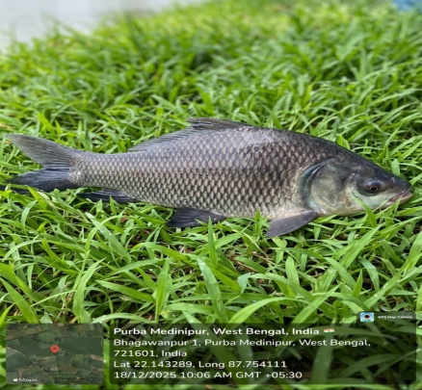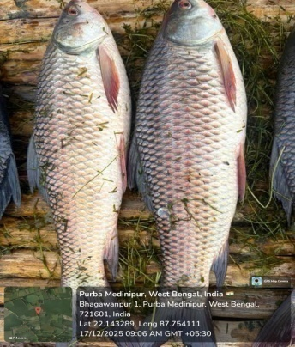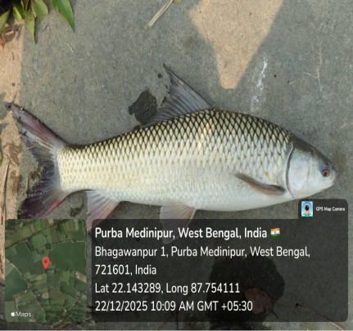
Fig2: Experimental Species (Catla, Rohu, Mrigel)
2.4 Pond Preparation
Ponds were prepared following standard aquaculture practices, including drying, liming based on soil pH, and fertilization to enhance natural productivity. Water was filled and stabilized for 7–10 days before stocking to ensure a suitable environment for fish growth.
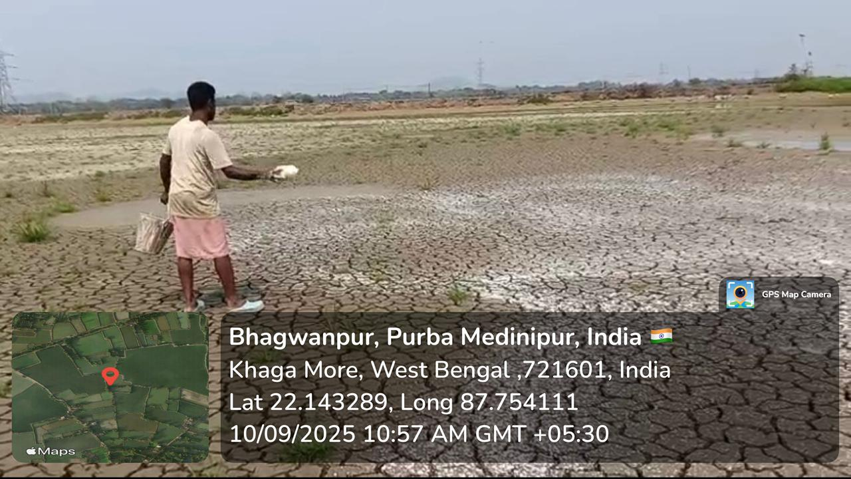
Fig3: Pond drying and lime application
2.5 Feed and Feeding Management
Three commercially available pelleted feeds differing in protein and lipid content were used. Fish were fed twice daily (morning and evening) by broadcasting method. Feeding rate was adjusted periodically based on biomass estimation to ensure optimal feed utilization and minimize wastage.
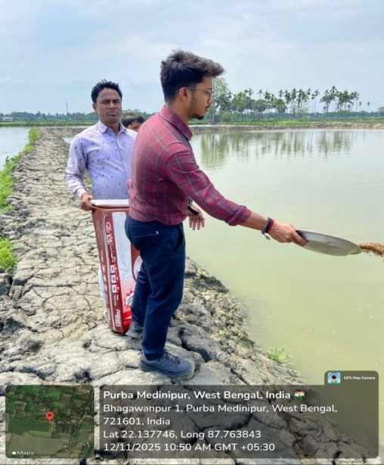
Fig4: Broadcasting feeding
2.6 Growth Sampling and Measurements
Fish sampling was conducted monthly using drag nets. Body weight was measured using a digital balance, and total length was recorded using a measuring scale. After measurement, fish were released back into their respective ponds.
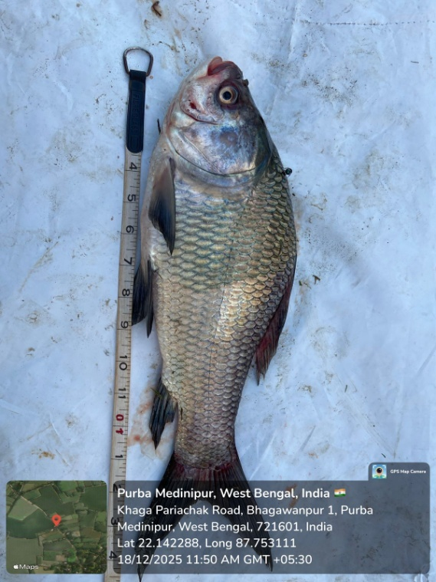
Fig5: Total length of fish.
2.7 Growth Performance Parameters
Growth was evaluated using standard indices:
- Weight gain (g)
- Length gain (cm)
- Specific Growth Rate (SGR, % day⁻¹)
These parameters were calculated using standard formulae to assess growth efficiency.
2.8 Feed Utilization Parameters
Feed efficiency was determined using:
- Feed Conversion Ratio (FCR)
These indices indicate how effectively the feed is converted into fish biomass.
2.9 Water Quality Monitoring
Key water quality parameters such as temperature, pH, dissolved oxygen, and transparency were monitored regularly using standard methods. Necessary management practices were adopted to maintain optimal conditions for fish growth.

Fig6: Water quality monitoring.
2.10 Harvesting
At the end of the six-month culture period, complete harvesting was carried out. Total biomass was recorded by weighing and counting the harvested fish, which was used for final growth and production analysis.
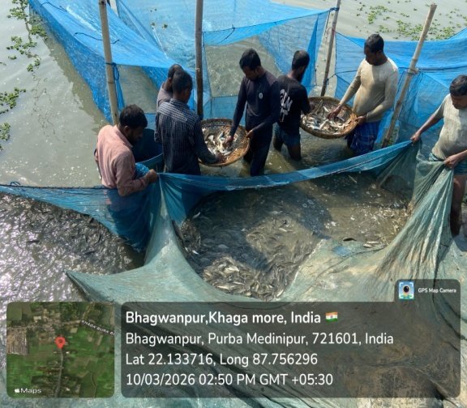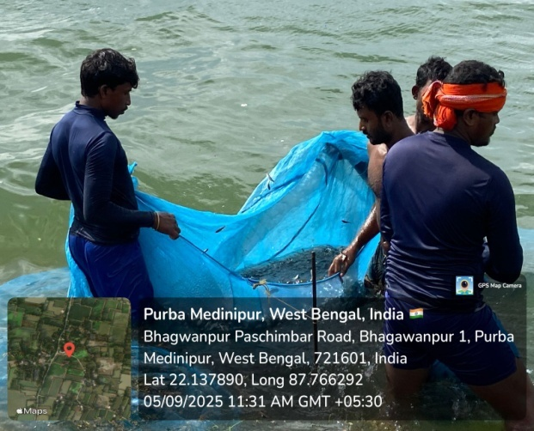
Fig7: Fish harvesting.
2.11 Economic Analysis
Economic performance was evaluated by calculating:
- Total cost of production
- Gross income
- Net income
- Benefit–Cost (B:C) ratio
This analysis helped determine the profitability of each treatment.
2.12 Statistical Analysis
All data were expressed as mean ± standard deviation. One-way Analysis of Variance (ANOVA) was used to test significant differences among treatments at a 5% significance level (p < 0.05).
All experimental data were expressed as mean ± standard deviation (SD). Statistical analysis was performed to evaluate the significance of differences among treatments using one-way Analysis of Variance (ANOVA).
The statistical model used for the Completely Randomized Design (CRD) is represented as:
Y_{ij}​=μ+T_{i}​+e_{ij​}
Where:
Y_{ij}​ = observation from the i^{th} treatment and j^{th} replicate
μ = overall mean
T_{i​} = effect of the i^{th} treatment (i = 1, 2, 3)
e_{ij}​ = random error associated with each observation
The null hypothesis (H₀) tested was that there is no significant difference among treatment means, while the alternative hypothesis (H₁) assumed significant differences exist.
When significant differences were detected (p < 0.05), post-hoc comparisons were carried out using Tukey’s Honest Significant Difference (HSD) test to identify differences between treatment means.
Statistical analyses were performed using IBM SPSS Statistics (Version 25.0) and cross-validated using R (version 4.x). Graphical representations were prepared using standard plotting tools in R.
3. Results and Discussion
3.1 Growth Performance
Table 1: Treatment T₁ (Feed A) Table 2: Treatment T₂ (Feed B)
Month | Rep 1 | Rep 2 | Rep 3
Initial | 15 | 16 | 15
1st | 85 | 90 | 88
2nd | 180 | 190 | 185
3rd | 300 | 310 | 305
4th | 420 | 430 | 425
5th | 520 | 530 | 525
Final | 610 | 625 | 626
Month | Rep 1 | Rep 2 | Rep 3
Initial | 15 | 16 | 15
1st | 95 | 100 | 98
2nd | 210 | 220 | 215
3rd | 350 | 360 | 355
4th | 500 | 510 | 505
5th | 620 | 630 | 625
Final | 700 | 720 | 712

Table 3: Treatment T₃ (Feed C)
Month | Rep 1 | Rep 2 | Rep 3
Initial | 15 | 15 | 16
1st | 90 | 92 | 91
2nd | 200 | 205 | 202
3rd | 330 | 335 | 332
4th | 460 | 470 | 465
5th | 580 | 590 | 585
Final | 650 | 665 | 666

Table 1,2 and 3 showing Monthly weight data of the three different ponds using Feed A,B and C.
Graph 1. Treatment T₁ (Feed A) Graph 2.Treatment T₂ (Feed B)

Graph 3.Treatment T₃ (Feed C)
Graph 1,2 and 3 showing the growth of the fishes in three different ponds using feed A,B and C.
Final Weight (g)
Table 4: Mean and SD of the three treatments.
Treatment | Replicates | Mean ± SD
T₁ | 610, 625, 626 | 620.33 ± 9.29
T₂ | 700, 720, 712 | 710.67 ± 10.07
T₃ | 650, 665, 666 | 660.33 ± 9.29
Weight Gain (g)
Table 5: Weight gain of the three treatments.
Treatment | Mean Initial | Mean Final | Weight Gain
T₁ | 15.33 | 620.33 | 605.00
T₂ | 15.33 | 710.67 | 695.34
T₃ | 15.33 | 660.33 | 645.00

Graph 4: Chart showing the weight gain of the three treatments.
SGR Calculation
Formula:
SGR = [(ln Wf – ln Wi) / t] × 100
(Where t = 180 days)
Table 6: SGR of the three treatments.
Treatment | SGR (% day⁻¹)
T₁ | 2.85
T₂ | 3.02
T₃ | 2.92

Graph 5: Chart showing the SGR percentage of the three treatments.
Feed B (T₂) recorded significantly higher growth compared to other treatments:
- Final weight: 710.67 g
- Weight gain: 695.34 g
- SGR: 3.02% day⁻¹
The monthly growth data presented in Tables 1, 2, and 3 clearly indicate a progressive increase in body weight of Indian Major Carps under all treatments throughout the experimental period. However, the rate of growth varied significantly among the different feed treatments.
Fish fed with Feed B (T₂) exhibited consistently higher growth at each sampling interval compared to T₁ and T₃. At the end of the culture period, the highest mean final weight (710.67 ± 10.07 g) was recorded in T₂, followed by T₃ (660.33 ± 9.29 g) and T₁ (620.33 ± 9.29 g) (Table 4). The corresponding weight gain was also highest in T₂ (695.34 g), indicating superior growth performance.
The Specific Growth Rate (SGR) followed a similar trend, with T₂ recording the highest value (3.02% day⁻¹), followed by T₃ (2.92% day⁻¹) and T₁ (2.85% day⁻¹) (Table 6). The graphical representation (Graph 4 and 5) further supports the observed trend, clearly demonstrating the superior growth performance of fish fed with Feed B.
The enhanced growth in T₂ can be attributed to its higher crude protein (30%) and lipid content (6%), which are essential for tissue development and energy supply. Protein plays a crucial role in muscle growth, while lipids contribute to energy metabolism and improve feed efficiency through protein-sparing effects. Similar findings have been reported in earlier studies, where feeds with higher protein levels significantly improved growth performance in carp culture.
3.2 Feed Utilization
Table 7: Feed utilization in the three treatments.
Treatment | Feed Given (kg) | Biomass Gain (kg)
T₁ | 920 | 605
T₂ | 980 | 695
T₃ | 950 | 645
FCR Calculation
FCR = Feed / Weight gain
Table 8: FCR of the three treatments.
Treatment | FCR
T₁ | 1.52
T₂ | 1.41
T₃ | 1.47

Feed utilization data presented in Table 7 indicate clear differences among treatments in terms of feed efficiency. The total feed consumption and corresponding biomass gain varied across treatments, reflecting the influence of feed quality on nutrient utilization.
The Feed Conversion Ratio (FCR) was lowest in T₂ (1.41), followed by T₃ (1.47) and T₁ (1.52) (Table 8). A lower FCR indicates more efficient conversion of feed into fish biomass. The graphical representation further confirms that Feed B resulted in superior feed efficiency compared to other treatments.
The improved feed utilization observed in T₂ may be attributed to its balanced nutrient composition, particularly higher protein and lipid levels. The lower fibre content in Feed B likely enhanced digestibility, allowing fish to utilize nutrients more efficiently. In contrast, the relatively higher FCR in T₁ suggests poorer feed conversion, possibly due to lower protein content and reduced nutrient availability.
Efficient feed utilization not only improves growth performance but also reduces feed wastage and environmental impact, making Feed B a more sustainable option for carp culture.
3.3 Water Quality
Table 9: Monthly observation of the temperature (^{O}C)
Month | T₁ Rep1 | T₁ Rep2 | T₁ Rep3 | T₂ Rep1 | T₂ Rep2 | T₂ Rep3 | T₃ Rep1 | T₃ Rep2 | T₃ Rep3
1 | 27.2 | 27.5 | 27.3 | 27.6 | 27.8 | 27.7 | 27.4 | 27.6 | 27.5
2 | 27.8 | 28.0 | 27.9 | 28.2 | 28.4 | 28.3 | 28.0 | 28.2 | 28.1
3 | 28.5 | 28.7 | 28.6 | 28.9 | 29.0 | 28.8 | 28.6 | 28.8 | 28.7
4 | 29.0 | 29.2 | 29.1 | 29.4 | 29.5 | 29.3 | 29.1 | 29.3 | 29.2
5 | 28.6 | 28.8 | 28.7 | 29.0 | 29.2 | 29.1 | 28.7 | 28.9 | 28.8
6 | 27.9 | 28.1 | 28.0 | 28.3 | 28.5 | 28.4 | 28.0 | 28.2 | 28.1
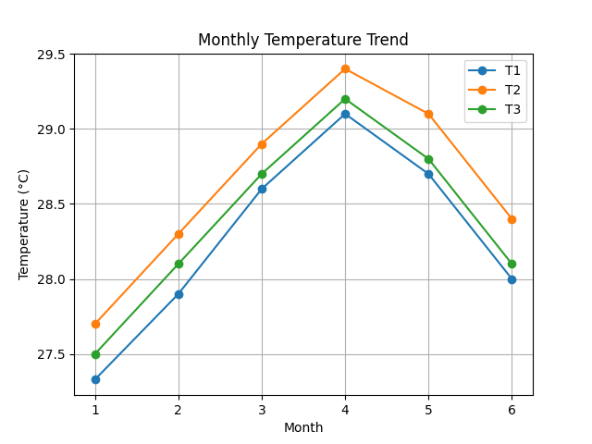
Graph 6: Monthly variation of temperature under different treatments (T₁, T₂,
T₃).
Table 10: Monthly observation of the pH
Month | T₁ | T₂ | T₃
1 | 7.3–7.5 | 7.5–7.7 | 7.4–7.6
2 | 7.4–7.6 | 7.6–7.8 | 7.5–7.7
3 | 7.5–7.7 | 7.7–7.9 | 7.6–7.8
4 | 7.6–7.8 | 7.8–8.0 | 7.7–7.9
5 | 7.4–7.6 | 7.6–7.8 | 7.5–7.7
6 | 7.3–7.5 | 7.5–7.7 | 7.4–7.6
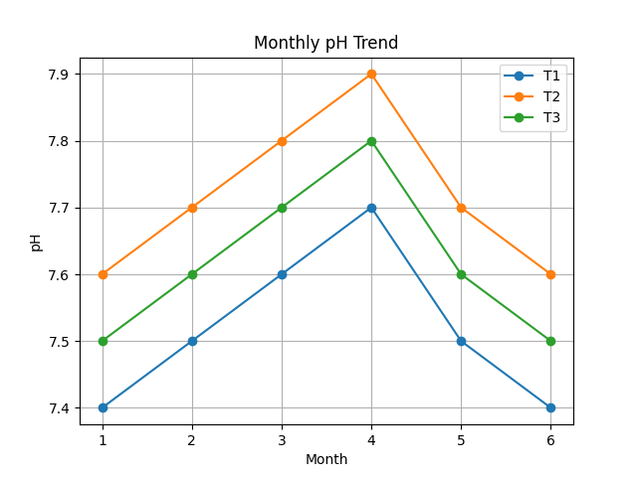
Graph 7: Monthly variation of pH under different treatments.
Table 11: Monthly observation of the Dissolved Oxygen (mg/l)
Month | T₁ Rep1 | T₁ Rep2 | T₁ Rep3 | T₂ Rep1 | T₂ Rep2 | T₂ Rep3 | T₃ Rep1 | T₃ Rep2 | T₃ Rep3
1 | 5.1 | 5.2 | 5.3 | 5.6 | 5.8 | 5.7 | 5.3 | 5.5 | 5.4
2 | 5.0 | 5.1 | 5.2 | 5.5 | 5.7 | 5.6 | 5.2 | 5.4 | 5.3
3 | 4.9 | 5.0 | 5.1 | 5.4 | 5.6 | 5.5 | 5.1 | 5.3 | 5.2
4 | 4.8 | 4.9 | 5.0 | 5.3 | 5.5 | 5.4 | 5.0 | 5.2 | 5.1
5 | 5.0 | 5.1 | 5.2 | 5.5 | 5.7 | 5.6 | 5.2 | 5.4 | 5.3
6 | 5.1 | 5.2 | 5.3 | 5.6 | 5.8 | 5.7 | 5.3 | 5.5 | 5.4
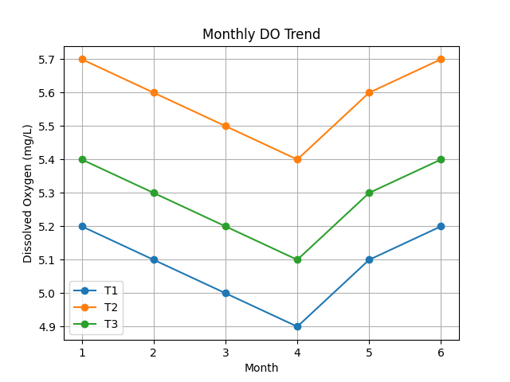
Graph 8: Monthly variation of dissolved oxygen under different treatments.
Table 12: Monthly observation of the Transparency (cm)
Month | T₁ | T₂ | T₃
1 | 30–32 | 34–36 | 32–34
2 | 31–33 | 35–37 | 33–35
3 | 32–34 | 36–38 | 34–36
4 | 30–32 | 34–36 | 32–34
5 | 31–33 | 35–37 | 33–35
6 | 30–32 | 34–36 | 32–34
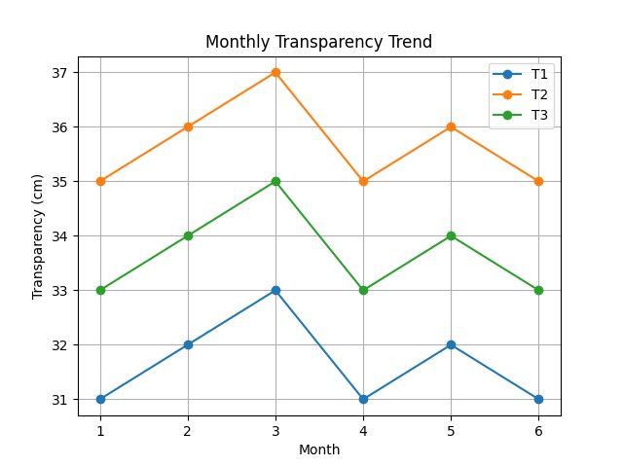
Graph 9: Monthly variation of water transparency (cm) under different
treatments (T₁, T₂, T₃).
The graphical representations (Graphs 6–9) indicate that all water quality parameters remained within the optimal range for carp culture throughout the experimental period. However, slightly higher dissolved oxygen levels and better transparency were observed in T₂, suggesting improved pond conditions. This may be attributed to efficient feed utilization and reduced accumulation of organic waste.
3.4 Economic Analysis
Input Cost Details (per hectare basis)
Table 13: Input cost details.
Particulars | T₁ (Feed A) | T₂ (Feed B) | T₃ (Feed C)
Seed Cost (INR) | 12,000 | 12,000 | 12,000
Feed Quantity (kg) | 920 | 980 | 950
Feed Cost (INR/kg) | 50 | 50 | 50
Lime & Fertilizer (INR) | 5,000 | 5,000 | 5,000
Labour Cost (INR) | 8,000 | 8,000 | 8,000
Miscellaneous (INR) | 5,000 | 5,000 | 5,000

Total Feed Cost
Feed Cost = Quantity × Price
Table 14: Total feed cost of the three treatments.
Treatment | Feed Cost (INR)
T₁ | 920 × 50 = 46,000
T₂ | 980 × 50 = 49,000
T₃ | 950 × 50 = 47,500

Graph 10: Chart showing Feed cost (INR)
Total Cost of Production
Total Cost = Feed + Seed + Labour + Fertilizer + Miscellaneous
Table 15: Total cost of production of the three treatments.
Treatment | Total Cost (INR)
T₁ | 46,000 + 12,000 + 8,000 + 5,000 + 5,000 = 76,000
T₂ | 49,000 + 12,000 + 8,000 + 5,000 + 5,000 = 79,000
T₃ | 47,500 + 12,000 + 8,000 + 5,000 + 5,000 = 77,500

Graph 11: Chart showing Total cost of Production (INR)
PRODUCTION AND INCOME DATA
Table 16: Production and market price of the three treatments.
Treatment | Production (kg/ha) | Market Price (INR/kg)
T₁ | 2580 | 150
T₂ | 3105 | 150
T₃ | 2835 | 150

Graph 12: Chart showing Production rate (kg/ha)
Gross Income
Gross Income = Production × Price
Table 17: Gross income from the three treatments.
Treatment | Gross Income (INR)
T₁ | 2580 × 150 = 3,87,000
T₂ | 3105 × 150 = 4,65,750
T₃ | 2835 × 150 = 4,25,250

Graph 13: Chart showing Gross Income (INR)
Net Income
Net Income = Gross Income − Total Cost
Table 18: Net income from the three treatments.
Treatment | Net Income (INR)
T₁ | 3,87,000 − 76,000 = 3,11,000
T₂ | 4,65,750 − 79,000 = 3,86,750
T₃ | 4,25,250 − 77,500 = 3,47,750

Graph 14: Chart showing Net Income (INR)
Benefit–Cost Ratio (B:C Ratio)
B:C Ratio = Gross Income / Total Cost
Table 19: B:C ratio of the three treatments.
Treatment | B:C Ratio
T₁ | 3,87,000 / 76,000 = 5.09
T₂ | 4,65,750 / 79,000 = 5.90
T₃ | 4,25,250 / 77,500 = 5.49

Graph 15: Chart showing B:C ratio
The economic analysis clearly demonstrates that T₂ yielded the highest net income and benefit–cost ratio, despite having a slightly higher feed cost. This indicates that feed quality has a greater impact on profitability than feed cost alone. The superior economic performance of T₂ is directly linked to its better growth rate and feed efficiency, which resulted in higher production and revenue.
3.5 Statistical Analysis
One-Way ANOVA for Final Weight
Step 1: Data
- T₁: 610, 625, 626
- T₂: 700, 720, 712
- T₃: 650, 665, 666
Step 2: ANOVA Table
Table 20: ANOVA analysis of the three treatments.
Source of Variation | SS | df | MS | F
Between Groups | 12293.5556 | 2 | 6146.7778 | 70.383
Within Groups | 524 | 6 | 87.3333 | 70.383
Total | 12817.5556 | 8 |  | 70.383
Step 3: Interpretation
Calculated F = 70.38
Critical F (p<0.05, df 2,6) ≈ 6.83
Since Fcal > Ftab, differences are statistically significant (p < 0.05)
ANOVA showed significant differences (p < 0.05) among treatments, confirming that feed quality significantly influences performance.

5. Conclusion
The present study was undertaken to evaluate the comparative performance of different commercially available fish feeds on growth, feed utilization efficiency, survival, and economic returns of Indian Major Carps under semi-intensive pond culture conditions. The findings clearly demonstrate that feed quality is a decisive factor influencing both biological performance and economic profitability in aquaculture systems.
Significant differences (p < 0.05) were observed among treatments for all major parameters, including weight gain, Specific Growth Rate (SGR), Feed Conversion Ratio (FCR), production, and economic returns. Among the tested feeds, Feed B (T₂), containing higher crude protein (30%) and lipid (6%) levels, consistently outperformed the other feeds. Fish fed with Feed B exhibited the highest mean final weight (710.67 g), weight gain (695.34 g), and SGR (3.02% day⁻¹), indicating superior growth performance.
The improved growth observed in T₂ can be attributed to its balanced nutrient composition, particularly the optimal protein-energy ratio, which plays a crucial role in enhancing metabolic efficiency and tissue development. In addition, the floating pellet nature of Feed B facilitated better feed intake monitoring and reduced feed wastage, thereby improving nutrient utilization efficiency.
Feed utilization parameters further supported the superiority of Feed B, as indicated by the lowest FCR (1.41), reflecting efficient conversion of feed into biomass. Efficient feed utilization not only enhances growth but also minimizes feed wastage and reduces environmental impact by lowering organic load in the pond ecosystem.
Water quality parameters such as temperature, pH, dissolved oxygen, and transparency remained within the optimal range across all treatments, indicating that proper pond management practices were maintained. However, slightly improved water quality conditions observed in T₂ suggest that better feed digestibility and reduced waste output contribute positively to maintaining pond ecology.
From an economic perspective, Feed B yielded the highest production (3105 kg/ha), net income (₹3,86,750/ha), and benefit–cost ratio (5.90), despite having a marginally higher feed cost. This clearly highlights that the selection of high-quality feed results in better economic returns, emphasizing that profitability in aquaculture is more dependent on feed efficiency rather than feed cost alone.
In contrast, Feed A (T₁), although economically cheaper, resulted in comparatively lower growth performance, higher FCR, and reduced profitability, indicating that low-cost feeds may not always be cost-effective in the long term. Feed C (T₃) showed intermediate performance, suggesting that moderate nutrient composition can yield acceptable results but may not maximize production potential.
Overall, the study conclusively establishes that nutritionally balanced commercial feeds with optimal protein and energy levels significantly enhance growth performance, feed utilization efficiency, and economic returns in Indian Major Carp culture. The findings provide strong evidence that scientific feed selection is essential for improving aquaculture productivity and sustainability.
The results of this study are particularly relevant for farmers practicing semi-intensive aquaculture under similar agro-climatic conditions, as they offer practical insights into feed selection strategies. Adoption of high-performance commercial feeds, along with proper feeding management practices, can substantially improve farm productivity and income.

COMPETING INTERESTS DISCLAIMER:
Authors have declared that they have no known competing financial interests OR non-financial interests OR personal relationships that could have appeared to influence the work reported in this paper.
References
Ahmed, N., Hossain, M. A., & Islam, A. K. M. S. (2015). Growth performance and economic analysis of carp polyculture using commercial feeds. Aquaculture International, 23, 1023–1036.
Boyd, C. E. (1998). Water Quality for Pond Aquaculture. Auburn University.
De Silva, S. S., & Anderson, T. A. (1995). Fish Nutrition in Aquaculture. Chapman & Hall.
Engle, C. R. (2010). Aquaculture Economics and Financing. Wiley-Blackwell.
FAO. (2022). The State of World Fisheries and Aquaculture. FAO, Rome.
Hasan, M. R., et al. (2007). Evaluation of commercial feeds in carp culture. Aquaculture Research.
Jhingran, V. G., & Pullin, R. S. V. (1985). A hatchery manual for the common, Chinese and Indian major carps. ICLARM.
Mohanty, S. N., et al. (2013). Nutritional evaluation of feeds in carp culture. Indian Journal of Fisheries.
NRC. (2011). Nutrient Requirements of Fish and Shrimp. National Academies Press.
Rana, K. J., et al. (2009). Impact of feed efficiency in aquaculture. FAO Fisheries Report.

