Original Research Article
Assessment of Caelifera (Orthoptera) Representation in BOLD Systems: A DNA Barcode Gap Analysis with Emphasis on India

ABSTRACT
Aims: To assess the representation of Caelifera (Orthoptera) in BOLD Systems with special emphasis on India, and to identify taxonomic, geographic, and metadata gaps in barcode coverage. Study Design: Database gap analysis using publicly available DNA barcode records. Place and Duration of Study: BOLD Systems V4 public data portal and NCBI GenBank Nucleotide database, accessed during 14–15 May 2026. Methodology: Family-level taxonomic queries supplemented by dataset-level analysis were performed for ten Caelifera families. India-specific records were retrieved using geographic filters. The Indian national barcoding dataset DS-ININD20 was additionally queried. Downloaded TSV files were analysed using Python 3.13 with the pandas library. Results: Globally, 46,136 Caelifera specimens representing 1,714 species across nine families and 2,354 BINs were retrieved. Global records were dominated by Acrididae (84.3%). India contributed only 89 specimens (0.19% of global records) and 40 species across four families. Within Acrididae, only 33 of approximately 285 known Indian species were represented, indicating an 88.4% barcoding deficit. Six of ten queried families had zero Indian records. A total of 64.3% of Indian Orthoptera records were mined from GenBank, and 89.9% of Indian Caelifera records lacked province- or state-level metadata. Conclusion: These findings reveal a severe quantitative, taxonomic, and metadata gap in Indian Caelifera barcode representation. Targeted national barcoding initiatives are urgently needed to strengthen species identification, pest surveillance, biodiversity monitoring, and conservation planning.
Keywords: DNA barcoding, Caelifera, Acrididae, BOLD Systems, biodiversity informatics, India, gap analysis, Orthoptera
1. INTRODUCTION
DNA barcoding, based primarily on standardized sequences of the mitochondrial cytochrome c oxidase subunit I gene (COI, also referred to as COX1), has transformed biodiversity documentation and species identification globally (Hebert et al., 2003). The Barcode of Life Data Systems (BOLD), maintained by the Centre for Biodiversity Genomics, University of Guelph, serves as a major global repository for DNA barcode data and associated specimen metadata (Ratnasingham and Hebert, 2007). In addition to storing barcode sequences, BOLD provides tools for taxonomic assignment, sequence comparison, and Barcode Index Number (BIN) analysis, which support species-level identification and biodiversity assessment (Ratnasingham and Hebert, 2013). Despite considerable progress in global barcoding, representation in BOLD remains uneven across taxonomic groups, insect orders, and geographic regions (Timm et al., 2022), with similar metadata and representation gaps documented for Tetrigidae (Kasalo et al., 2023).
Orthoptera, comprising grasshoppers, locusts, crickets, katydids, and their allies, includes approximately 28,000 described species globally (Cigliano et al., 2024). Within Orthoptera, the suborder Caelifera comprises short-horned grasshoppers and related groups. Caelifera includes major families such as Acrididae, Tetrigidae, Pyrgomorphidae, Pamphagidae, Tridactylidae, Eumastacidae, Chorotypidae, Lentulidae, Tristiridae, and Ommexechidae. Among these, Acrididae is the most diverse and economically important family, including serious agricultural pests such as the desert locust Schistocerca gregaria (Forskål, 1775) and the migratory locust Locusta migratoria (Linnaeus, 1758) (FAO, 2020). Beyond their pest status, caeliferan orthopterans are important primary consumers in grassland ecosystems, useful bioindicators of habitat quality, and significant prey items in terrestrial food webs (Bazelet and Samways, 2011; Samways et al., 2020).
India supports rich orthopteran diversity across varied biogeographic zones, including forests, grasslands, agroecosystems, wetlands, dry zones, the Western Ghats, Northeast India, and island ecosystems. Indian Acrididae alone is represented by approximately 285 species, distributed across more than 130 genera (Shishodia et al., 2010). Despite this diversity and the ecological and agricultural importance of Caelifera, systematic DNA barcoding of Indian Caelifera remains limited. This is particularly significant because a reliable barcode reference library can support rapid species identification, pest surveillance, biodiversity monitoring, taxonomic verification, and detection of regional faunal gaps. Existing global biodiversity databases show strong taxonomic and geographic biases, with tropical and megadiverse regions often underrepresented relative to their actual species richness (Lobo et al., 2020; Mora et al., 2011).
Although DNA barcoding has expanded rapidly as a tool in biodiversity informatics, and earlier studies have assessed COI barcode performance and Orthoptera representation in BOLD at a global level (Timm et al., 2022), no focused assessment has quantified the representation of Indian Caelifera in BOLD at the family, species, BIN, geographic, and metadata levels. Such an assessment is necessary to determine whether Indian Caelifera are adequately represented in the global barcode reference library and to identify the taxa and regions requiring priority attention.
The present study therefore undertakes a comprehensive family-level assessment of Caelifera representation in BOLD with explicit emphasis on India. The objectives were: (i) to quantify the global representation of each queried Caelifera family in BOLD; (ii) to assess India-specific representation and identify taxonomic, geographic, and metadata gaps; and (iii) to contextualize these gaps within India’s national barcoding efforts and identify priority areas for future barcode library development.
2. METHODOLOGY
2.1 Data Retrieval from BOLD Systems
Data were retrieved from the BOLD Systems public data portal, Version 4, available at https://portal.boldsystems.org, during 14–15 May 2026. Family-level taxonomic queries using the [tax] scope tag were performed independently for ten Caelifera families: Acrididae, Tetrigidae, Pyrgomorphidae, Pamphagidae, Tridactylidae, Eumastacidae, Chorotypidae, Lentulidae, Tristiridae, and Ommexechidae. India-specific records were retrieved by combining family-level taxonomic filters with the geographic filter India[geo].
To improve retrieval completeness, family-level searches were supplemented with order-level queries using Orthoptera[tax] + India[geo]. In addition, the Indian national barcoding dataset DS-ININD20 was queried using the recordset filter DS-ININD20[recordsetcode] together with family-level filters to assess the representation of Caelifera within India’s national barcode dataset. Summary statistics were recorded from BOLD portal result pages and cross-checked, wherever possible, using downloaded TSV files.
Because BOLD is a dynamic database, all counts reported in this study represent a snapshot of publicly available records retrieved during 14–15 May 2026.
2.2 Data Analysis
Downloaded TSV files were analysed using Python 3.13 with the pandas library. Analyses included family-level and subfamily-level record counts, number of sequences, records with Barcode Index Numbers (BINs), unique species counts, BIN enumeration, institutional contributions, geographic metadata availability, collection-date information, and marker-code verification. Records identified only as “unidentified”, “sp.”, or with blank species-level identification fields were excluded from species-level counts.
India-specific representation was calculated as the number of Indian specimens for a family divided by the global number of specimens for the same family and expressed as a percentage. Families were categorized as ABSENT when no Indian records were retrieved, CRITICAL when India-specific representation was below 1% of global family-level records, and PARTIAL when representation was 1% or higher.
2.3 Assessment of Taxonomic and Metadata Consistency
To assess possible inconsistencies in taxonomic retrieval and metadata completeness in BOLD, selected genus-level searches were conducted for key Indian genera, including Chrotogonus Audinet-Serville, 1838 and Oxya Audinet-Serville, 1831. The results of these genus-level searches were compared with family-level retrieval totals. Metadata fields, including country, province or state, GPS coordinates, institution, collection date, and marker code, were examined to assess the quality and completeness of available records.
Known Indian species richness estimates were primarily based on Shishodia et al. (2010) for Acrididae and related Orthoptera, supplemented by relevant published literature where necessary.
3. RESULTS AND DISCUSSION
3.1 Global Representation of Caelifera in BOLD
A total of 46,136 Caelifera specimens with sequences were retrieved globally from BOLD Systems across nine families with public records, representing 1,714 species and 2,354 Barcode Index Numbers (BINs) (Table 1). Ommexechidae was additionally queried but returned no public BOLD records.
Acrididae was the most strongly represented family, accounting for 38,880 specimens, 1,293 species, and 1,779 BINs. This family alone contributed 84.3% of the total global Caelifera specimen records retrieved in the present analysis. Tetrigidae ranked second, with 4,660 specimens, 128 species, and 274 BINs, representing 10.1% of the global Caelifera specimen records. Pyrgomorphidae was represented by 1,385 specimens and 124 species, followed by Pamphagidae with 499 specimens and 118 species, and Tridactylidae with 421 specimens and 12 species.
The remaining families were poorly represented in comparison. Eumastacidae, Chorotypidae, Lentulidae, and Tristiridae collectively contributed only 291 specimens and 39 species. Thus, global Caelifera representation in BOLD was highly uneven, with Acrididae and Tetrigidae together accounting for 43,540 specimens, corresponding to 94.4% of all retrieved Caelifera records.
Table 1. Global representation of queried Caelifera families in BOLD Systems, accessed 14–15 May 2026.
Family | Specimens | Sequences | Rec. w/BINs | Species | BINs | Countries | Institutions
Acrididae | 38,880 | 38,880 | 22,521 | 1,293 | 1,779 | 120 | 116
Tetrigidae | 4,660 | 4,660 | 4,381 | 128 | 274 | 65 | 42
Pyrgomorphidae | 1,385 | 1,385 | 1,053 | 124 | 83 | 36 | 35
Pamphagidae | 499 | 499 | 352 | 118 | 131 | 20 | 11
Tridactylidae | 421 | 421 | 394 | 12 | 43 | 25 | 15
Eumastacidae | 115 | 115 | 94 | 13 | 20 | 4 | 4
Chorotypidae | 58 | 58 | 54 | 9 | 13 | 7 | 3
Lentulidae | 76 | 76 | 49 | 8 | 7 | — | —
Tristiridae | 42 | 42 | 29 | 9 | 4 | — | —
Ommexechidae | 0 | 0 | 0 | 0 | 0 | 0 | 0
Total | 46,136 | 46,136 | 28,927 | 1,714 | 2,354 | — | —
Note: Rec. w/BINs = records with Barcode Index Numbers assigned; — = data not separately available from the BOLD portal summary.
Fig. 1. Global representation of Caelifera families in BOLD Systems, accessed 14–15 May 2026. Specimen counts are presented on a logarithmic scale to accommodate the large difference among families, ranging from Acrididae with 38,880 specimens to Tristiridae with 42 specimens. Values above bars indicate actual specimen counts. Ommexechidae was queried but returned no public BOLD records and is therefore not shown.

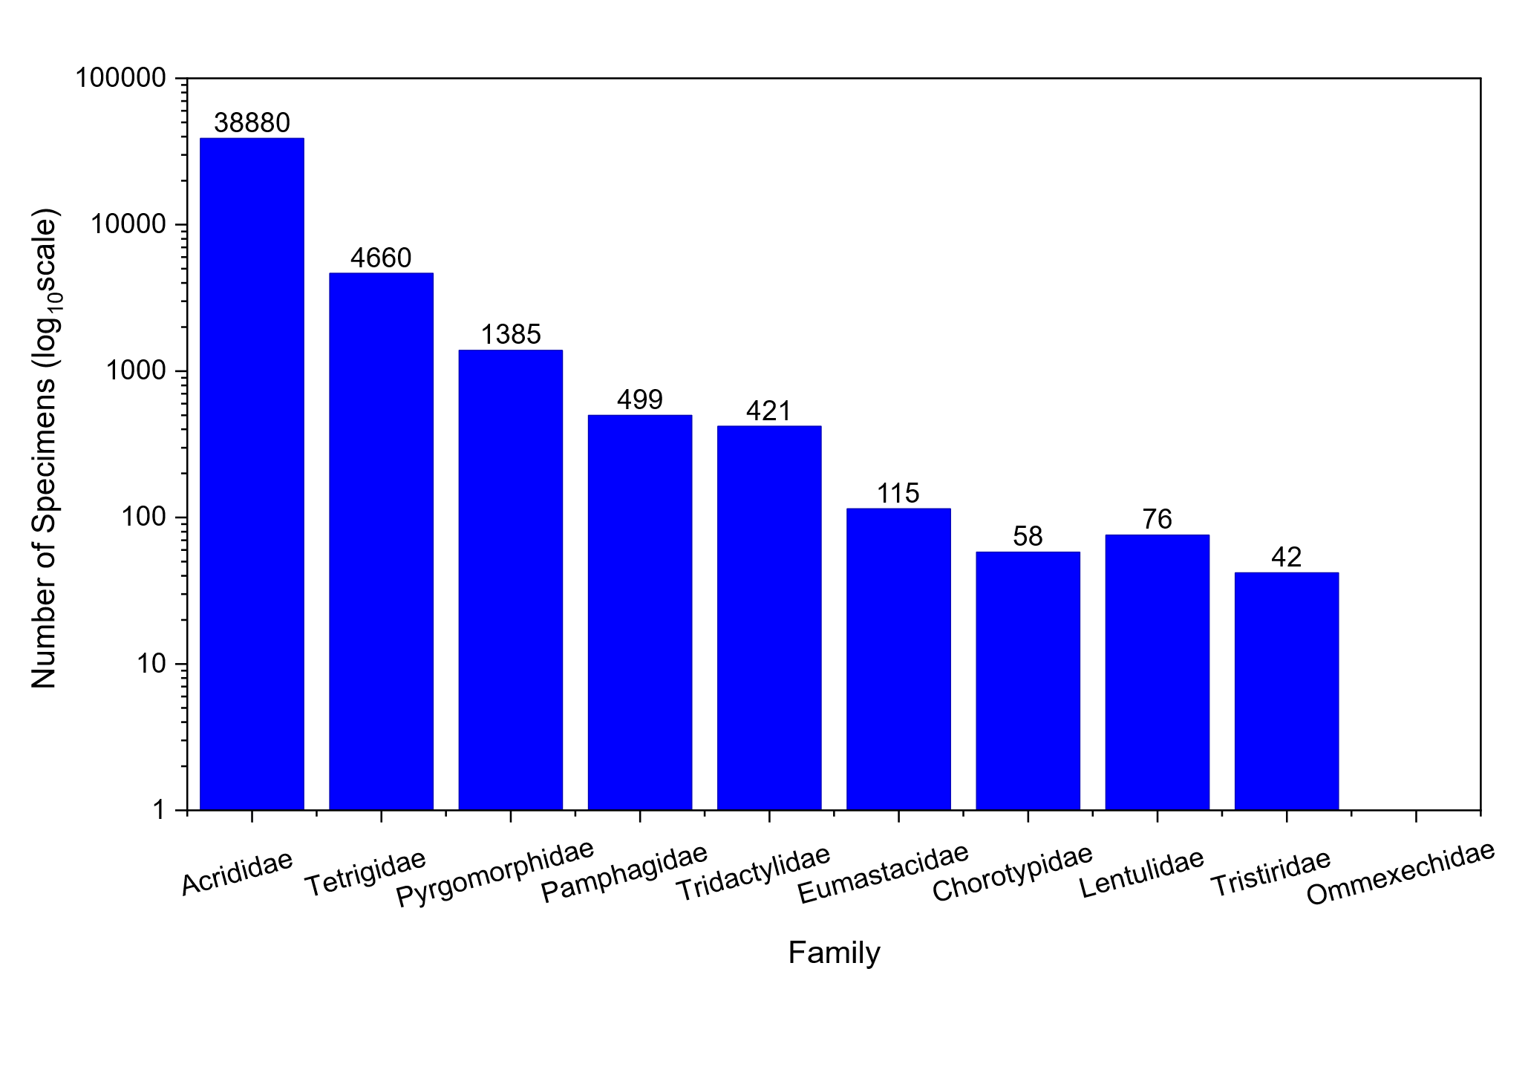
3.2 India-specific Representation
India contributed only 89 Caelifera specimens to BOLD Systems, representing 0.19% of the 46,136 global Caelifera records retrieved in the present analysis. These Indian records represented 40 species across four families: Acrididae, Pyrgomorphidae, Tetrigidae, and Tridactylidae (Table 2).
Acrididae accounted for the majority of Indian Caelifera records, with 77 specimens, representing 86.5% of the Indian total. Pyrgomorphidae was represented by 10 specimens, accounting for 11.2% of Indian records. Tetrigidae and Tridactylidae were represented by only one specimen each. Six of the ten queried Caelifera families had no Indian records in BOLD Systems: Pamphagidae, Eumastacidae, Chorotypidae, Lentulidae, Tristiridae, and Ommexechidae.
Of the 89 Indian Caelifera records, 68 records had Barcode Index Numbers (BINs) assigned, while 80 records had species-level identifications. The sole Tetrigidae record, Tetrix bipunctata GenBank MN814439, was based on the COI-3P marker rather than the standard COI-5P barcode region and therefore had no BIN assignment. Overall, India-specific representation remained below 1% of global family-level records for all represented families, indicating a critical barcode representation gap.
Fig. 2. Comparison of global and India-specific Caelifera specimen records in BOLD Systems, accessed 14–15 May 2026. Specimen counts are presented on a logarithmic scale to accommodate large differences among families. Data labels indicate actual India-specific specimen counts. Families with zero Indian records are shown without India-specific bars. India contributed only 89 of 46,136 global Caelifera specimens, representing 0.19% of the total records retrieved.
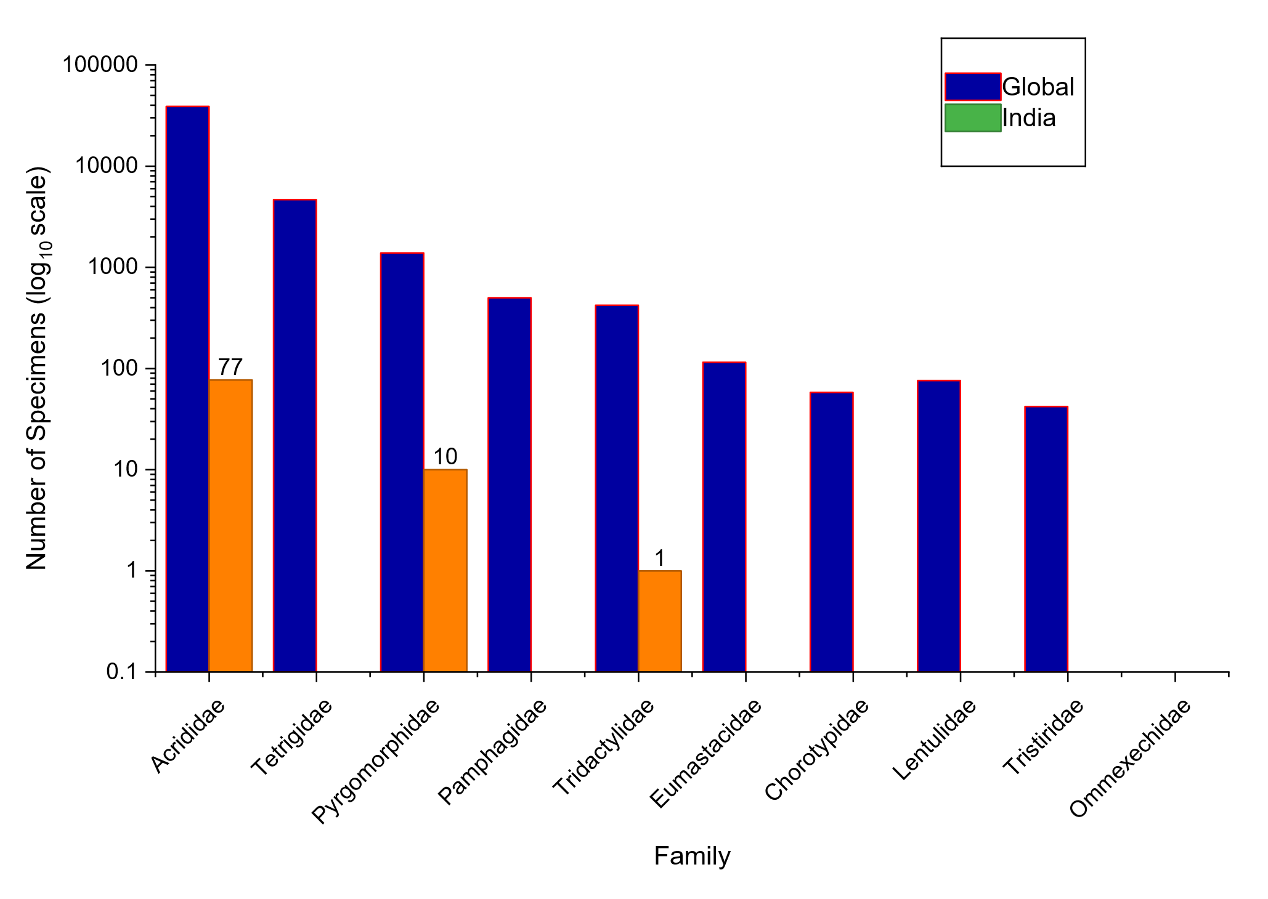
Table 2. India-specific representation of queried Caelifera families in BOLD Systems.
Family | Specimens | Sequences | Rec. w/BINs | Rec. w/Spp. | Species | BINs | India% Global | Status
Acrididae | 77 | 77 | 60 | 69 | 33 | 29 | 0.198 | CRITICAL
Pyrgomorphidae | 10 | 10 | 7 | 10 | 6 | 4 | 0.722 | CRITICAL
Tetrigidae | 1ᵃ | 1 | 0 | 1 | 1 | 0 | 0.021 | CRITICAL
Tridactylidae | 1 | 1 | 1 | 0 | 0 | 1 | 0.238 | CRITICAL
Pamphagidae | 0 | 0 | 0 | 0 | 0 | 0 | 0.000 | ABSENT
Eumastacidae | 0 | 0 | 0 | 0 | 0 | 0 | 0.000 | ABSENT
Chorotypidae | 0 | 0 | 0 | 0 | 0 | 0 | 0.000 | ABSENT
Lentulidae | 0 | 0 | 0 | 0 | 0 | 0 | 0.000 | ABSENT
Tristiridae | 0 | 0 | 0 | 0 | 0 | 0 | 0.000 | ABSENT
Ommexechidae | 0 | 0 | 0 | 0 | 0 | 0 | 0.000 | ABSENT
Total | 89 | 89 | 68 | 80 | 40 | 34 | 0.193 | —
ᵃ COI-3P marker used; no BIN assignment.
Note: Rec. w/BINs = records with Barcode Index Numbers assigned; Rec. w/Spp. = records with species-level identification; India% Global = Indian specimens as a percentage of global BOLD specimens for that family. ABSENT = zero records from India; CRITICAL = India-specific representation below 1% of global BOLD records for that family.
Fig. 3. India-specific contribution to global Caelifera barcoding in BOLD Systems, expressed as the percentage of global specimen records per family. The dashed horizontal line at 1% indicates the threshold used in the present study to define critical underrepresentation. No Caelifera family from India reaches or exceeds this threshold. Families with zero Indian records are not represented by bars.
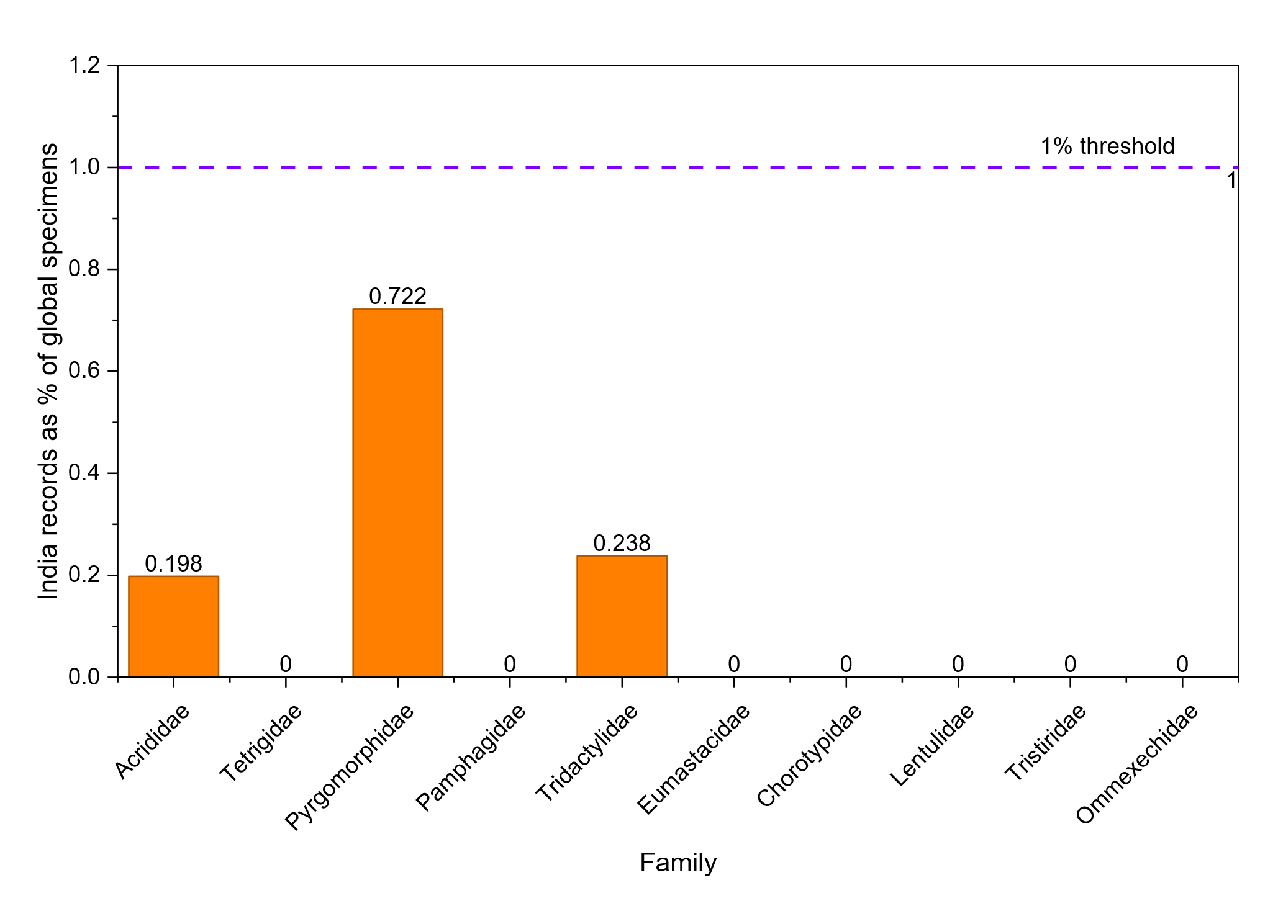
3.3 Species-level Representation
A total of 40 species-level names were retrieved from Indian Caelifera records in BOLD Systems, comprising 33 species of Acrididae, six species of Pyrgomorphidae, and one species of Tetrigidae (Table 3). The single Tridactylidae record was identified only to an unidentified species level and was therefore excluded from species counts.
Among Indian Acrididae records, Phlaeoba sikkimensis Bolívar, 1902 had the highest representation, with eight records, followed by Aulacobothrus luteipes (Walker, 1871) and Acrida exaltata (Walker, 1859), each with seven records. Other represented acridid species included Trilophidia annulata, Schistocerca gregaria, Hieroglyphus banian, Oxya fuscovittata, Ceracris nigricornis, Heteropternis respondens, and Xenocatantops humilis, but most of these were represented by only one to three records.
Economically important pest taxa were poorly represented. Schistocerca gregaria had only three Indian records, Hieroglyphus banian had three records, and Oxya fuscovittata had three records. Within Pyrgomorphidae, six species were represented: Aularches miliaris, Atractomorpha crenulata, Atractomorpha burri, Neorthacris acuticeps, Poekilocerus pictus, and Pyrgomorpha bispinosa. Among these, Poekilocerus pictus and Pyrgomorpha bispinosa had no BIN assignment in the retrieved BOLD records.
Against approximately 285 known Indian Acrididae species, the 33 Acrididae species represented in BOLD indicate that only about 11.6% of Indian Acrididae species are currently represented, corresponding to an estimated 88.4% barcoding deficit for this family.
Table 3. Species-level representation of Indian Caelifera records in BOLD Systems with BIN assignment details.
Family | Subfamily | Species | No of Records | Records with BINs | Unique BIN Code(s)
Acrididae | Acridinae | Phlaeoba sikkimensis | 8 | 8 | BOLD:ADT1418; BOLD:ACV3345
Acrididae | Gomphocerinae | Aulacobothrus luteipes | 7 | 7 | BOLD:AAP6094; BOLD:AAP6113
Acrididae | Acridinae | Acrida exaltata | 7 | 6 | BOLD:ADL5716
Acrididae | Oedipodinae | Trilophidia annulata | 6 | 6 | BOLD:AAP6105; BOLD:ACD8502
Acrididae | Cyrtacanthacridinae | Schistocerca gregaria | 3 | 2 | BOLD:AAI0822
Acrididae | Hemiacridinae | Hieroglyphus banian | 3 | 2 | BOLD:AGK6138
Acrididae | Oxyinae | Oxya fuscovittata | 3 | 3 | BOLD:AAP6093
Acrididae | Oedipodinae | Ceracris nigricornis | 3 | 3 | BOLD:ADC4497
Acrididae | Oedipodinae | Heteropternis respondens | 2 | 2 | BOLD:AAZ5810
Acrididae | Catantopinae | Xenocatantops humilis | 2 | 2 | BOLD:AAW5356
Acrididae | Oxyinae | Oxya japonica | 2 | 2 | BOLD:ACX4817
Acrididae | Cyrtacanthacridinae | Cyrtacanthacris tatarica | 2 | 2 | BOLD:AAW0375
Acrididae | Acridinae | Acrida willemsei | 1 | 1 | BOLD:AAJ1691
Acrididae | Acridinae | Phlaeoba infumata | 1 | 1 | BOLD:AFB0021
Acrididae | Oedipodinae | Acrotylus patruelis | 1 | 1 | BOLD:ACY5818
Acrididae | Oedipodinae | Morphacris fasciata | 1 | 1 | BOLD:AEN4342
Acrididae | Oedipodinae | Oedaleus abruptus | 1 | 1 | BOLD:AAP7735
Acrididae | Oedipodinae | Pusana laevis | 1 | 0 | —
Acrididae | Oxyinae | Oxya nitidula | 1 | 1 | BOLD:ACX4817
Acrididae | Gomphocerinae | Aulacobothrus socius | 1 | 1 | BOLD:AAW0378
Acrididae | Gomphocerinae | Aulacobothrus taeniatus | 1 | 1 | BOLD:AAP6113
Acrididae | Gomphocerinae | Dociostaurus maroccanus | 1 | 1 | BOLD:AAX8673
Acrididae | Eyprepocnemidinae | Eyprepocnemis alacris | 1 | 0 | —
Acrididae | Catantopinae | Diabolocatantops innotabilis | 1 | 0 | —
Acrididae | Spathosterninae | Spathosternum prasiniferum | 1 | 0 | —
Acrididae | Calliptaminae | Calliptamus italicus | 1 | 0 | —
Acrididae | Melanoplinae | Kingdonella bicollina | 1 | 0 | —
Acrididae | Cyrtacanthacridinae | Schistocerca damnifica | 1 | 0 | —
Acrididae | Hemiacridinae | Hieroglyphus nigrorepletus | 1 | 1 | BOLD:AGK6137
Acrididae | Oedipodinae | Aiolopus thalassinus | 1 | 1 | BOLD:AAZ1689
Acrididae | Acridinae | Metaleptea brevicornis | 1 | 0 | —
Pyrgomorphidae | Pyrgomorphinae | Aularches miliaris | 2 | 2 | BOLD:AAP8399
Pyrgomorphidae | Pyrgomorphinae | Atractomorpha crenulata | 2 | 2 | BOLD:AAP6092
Pyrgomorphidae | Pyrgomorphinae | Atractomorpha burri | 2 | 2 | BOLD:ADV2684
Pyrgomorphidae | Orthacridinae | Neorthacris acuticeps | 2 | 2 | BOLD:ACS5929
Pyrgomorphidae | Pyrgomorphinae | Poekilocerus pictus | 1 | 0 | —
Pyrgomorphidae | Pyrgomorphinae | Pyrgomorpha bispinosa | 1 | 0 | —
Tetrigidae | Tetriginae | Tetrix bipunctata | 1 | 0 | —ᵇ
Tridactylidae | — | Unidentified sp. | 1 | 1 | BOLD:ACP1388
ᵇ COI-3P marker used; no BIN assignment.
Note: Species names listed as “unidentified”, “sp.”, or blank were excluded from species counts. “Records with BINs” indicates the number of records assigned to a Barcode Index Number. “Unique BIN code(s)” lists the BIN codes associated with each species. — indicates no BIN assignment for the corresponding record(s).
3.4 Subfamily-level Representation
Subfamily-level analysis showed that Indian Caelifera records in BOLD Systems were unevenly distributed across represented subfamilies (Table 4). Among Acrididae, Acridinae was the most represented subfamily, with 18 records, accounting for 20.7% of records included in the subfamily-level analysis. Oedipodinae ranked second, with 17 records, followed by Gomphocerinae with 12 records and Oxyinae with nine records.
Other Acrididae subfamilies were represented by very few records. Cyrtacanthacridinae had six records, Catantopinae had five records, Hemiacridinae had four records, and Eyprepocnemidinae had two records. Spathosterninae, Calliptaminae, and Melanoplinae were represented by only one record each. Among Pyrgomorphidae, Pyrgomorphinae was represented by eight records, while Orthacridinae was represented by two records. Tetriginae was represented by a single COI-3P record of Tetrix bipunctata.
Several Acrididae subfamilies known from India, including Tropidopolinae, Dericorythinae, Coptacrinae, and Euryphyminae, were not represented among the retrieved Indian BOLD records. This indicates that underrepresentation is not limited to family-level gaps but also extends to subfamily-level coverage within Acrididae.
Table 4. Subfamily-level distribution of Indian Caelifera records in BOLD Systems.
Subfamily | Records | % of Total | Representative Species (count)
Acridinae | 18 | 20.7 | Phlaeoba sikkimensis (8), Acrida exaltata (7), Phlaeoba infumata (1), Acrida willemsei (1)
Oedipodinae | 17 | 19.5 | Trilophidia annulata (6), Ceracris nigricornis (3), Heteropternis respondens (2), others (6)
Gomphocerinae | 12 | 13.8 | Aulacobothrus luteipes (7), A. socius (1), A. taeniatus (1), Dociostaurus maroccanus (1)
Oxyinae | 9 | 10.3 | Oxya fuscovittata (3), Oxya japonica (2), Oxya nitidula (1), unidentified (3)
Cyrtacanthacridinae | 6 | 6.9 | Schistocerca gregaria (3), Cyrtacanthacris tatarica (2), Schistocerca damnifica (1)
Catantopinae | 5 | 5.7 | Xenocatantops humilis (2), Diabolocatantops innotabilis (1), unidentified (2)
Hemiacridinae | 4 | 4.6 | Hieroglyphus banian (3), Hieroglyphus nigrorepletus (1)
Eyprepocnemidinae | 2 | 2.3 | Eyprepocnemis alacris (1), Eyprepocnemis sp. (1)
Spathosterninae | 1 | 1.1 | Spathosternum prasiniferum (1)
Calliptaminae | 1 | 1.1 | Calliptamus italicus (1)
Melanoplinae | 1 | 1.1 | Kingdonella bicollina (1)
Pyrgomorphinae | 8 | 9.2 | Aularches miliaris (2), Atractomorpha crenulata (2), Atractomorpha burri (2), others (2)
Orthacridinae | 2 | 2.3 | Neorthacris acuticeps (2)
Tetriginae | 1 | 1.1 | Tetrix bipunctata (1)ᵇ
ᵇ COI-3P marker used; no BIN assignment.
Note: Percentages are calculated from records with assignable subfamily information. Records lacking subfamily-level assignment were excluded from this table.
3.5 Geographic and Metadata Coverage
Geographic metadata associated with Indian Caelifera records in BOLD Systems were highly incomplete. Of the 89 Indian Caelifera records retrieved, only nine records, representing 10.1% of the Indian total, contained province- or state-level metadata. These records were assigned to Gujarat (six records), Assam (one record), Karnataka (one record), and Punjab (one record). The remaining 80 records, representing 89.9%, lacked sub-national geographic information.
Precise geographic coordinates were absent for most records, limiting the use of the available dataset for fine-scale biogeographic interpretation, distribution mapping, and species distribution modelling. Because of this metadata limitation, many records could be assigned only to the country level and not to specific Indian states, regions, or biogeographic zones.
Based on available province- or state-level metadata, records could not be confidently assigned to several major Indian biogeographic regions, including the Western Ghats, Andaman and Nicobar Islands, much of Northeast India, the Eastern Ghats, and the Deccan Plateau. This indicates that the Indian Caelifera barcode dataset is limited not only by low specimen and species representation, but also by incomplete geographic metadata.
Collection dates, where available, ranged from 1947 to 2025, with records concentrated mainly during 2013–2019. The presence of older records and the absence of detailed locality metadata in many entries suggest that a large proportion of the available data may have originated from legacy or secondary database-mined records rather than from systematic, recent, field-based barcoding surveys.
3.6 Institutional Contributions and Data Source Analysis
Analysis of institutional attributions within the 89 Indian Caelifera records revealed contributions from a limited number of Indian research organizations representing scattered rather than coordinated barcoding efforts. The dominant source was sequences "Mined from GenBank, NCBI" (64 records, 71.9%), indicating that most Indian Caelifera sequences originated from broader molecular studies deposited in GenBank rather than dedicated systematic barcoding initiatives.
Among direct institutional contributors, the Gujarat Biodiversity Gene Bank (GBGB), part of the Gujarat State Biotechnology Mission, was most active with five records (2015–2016). The National Bureau of Agricultural Insect Resources (NBAIR), Bengaluru, contributed three records through collaboration with the Wellcome Sanger Institute, United Kingdom (2017–2019), as part of systematic agricultural pest barcoding. IISER Mohali contributed one recent record (2025), while single-record contributions came from the University of Mysore (2024), Tamil Nadu Agricultural University, and the Smithsonian Institution.
Individual field contributors could be traced for only nine of 89 records (10.1%). Praveshika Dubey (Gujarat Biodiversity Gene Bank) was the most active collector with four specimens (2015–2016). Other named collectors included Melwin Haris (IISER Mohali, 2025), and Amit Yadav, Nitish Dave, and Ashish Desai (Gujarat). Species identification was attributed to named taxonomists in only 14 records (15.7%), with Dave Sanjay and Snehal Bagatharia as primary identifiers for Gujarat records. Notably, seven records (7.9%) were identified solely by the BOLD Machine Learning Toolkit without expert verification, raising reliability concerns.
Temporal analysis revealed peak Indian Caelifera barcoding during 2017–2019 (25 records, 28.1%), coinciding with the NBAIR–Wellcome Sanger collaboration reflected in the MT325xxx GenBank accession series. This effort contributed records of economically important species including Phlaeoba sikkimensis, Trilophidia annulata, Aulacobothrus spp., Oxya spp., Ceracris nigricornis, and Heteropternis respondens. Activity declined substantially during 2020–2022, possibly reflecting COVID-19 pandemic impacts, before modest recovery in 2023–2025.
The Zoological Survey of India (ZSI), through its Centre for DNA Taxonomy, has been a key player in Indian Orthoptera barcoding. Under the National Mission on Himalayan Studies (NMHS) project (grant NMHS/LG2016/0011/8509), ZSI researchers led by Dr. Vikas Kumar generated 20 COI sequences for six Acrididae species from the Indian Himalayan regions (2015–2020), published by Kundu et al. (2020). However, representation of this effort in the publicly accessible BOLD portal remains limited, suggesting substantial Indian Caelifera barcode data may exist in GenBank or institutional repositories without integration into BOLD's searchable database.
Shashank et al. (2022) reported that despite India being megadiverse, only 3.97% of described insect species have been barcoded, with critical gaps in institutional capacity, funding, and coordination. The review identified few institutions actively engaged in systematic insect barcoding: ZSI, Forest Research Institute (FRI), Indian Agricultural Research Institute (IARI), NBAIR, and select universities. The dominance of GenBank-mined records (71.9% of Indian Caelifera records) corroborates this finding, indicating that Indian Caelifera representation in BOLD results from dispersed molecular systematics studies rather than coordinated national barcode library development.
3.7 DS-ININD20 Dataset Analysis
The DS-ININD20 dataset, representing one of the largest India-focused barcode datasets in BOLD Systems, contained 12,986 specimens representing 2,823 species from 86 institutions. Within this dataset, Orthoptera was represented by 140 records, accounting for 1.08% of the total specimen records. Orthoptera ranked tenth among the 18 insect orders represented in the dataset.
Among insect orders in DS-ININD20, Hemiptera was the most strongly represented, with 2,765 specimens, accounting for 21.3% of the dataset. Lepidoptera ranked second, with 2,103 specimens, representing 16.2%, followed by Diptera with 1,959 specimens, representing 15.1%. In contrast, Caelifera comprised approximately 89 specimens, representing only about 0.69% of the total DS-ININD20 dataset.
Marker-code analysis showed that most Indian Orthoptera records in the dataset were generated using the standard COI-5P barcode marker. Specifically, 95.7% of Indian Orthoptera records employed COI-5P, indicating that the limited representation of Caelifera is not primarily due to use of non-standard markers, but rather to low taxonomic and sampling coverage.
These results indicate that Caelifera are strongly underrepresented even within India’s major national barcode dataset. Therefore, the Indian Caelifera barcode gap reflects not only low global representation in BOLD but also insufficient prioritization within India-focused barcode library development.
3.8 Cross-validation with NCBI GenBank Nucleotide Database
To assess whether additional Caelifera COI records were available in the primary nucleotide archive, a parallel cross-validation search was conducted in the NCBI GenBank Nucleotide database, accessed in May 2026. For each Caelifera family, searches were performed using family names combined with alternative COI gene annotations, including COI, COX1, cytochrome c oxidase subunit 1, cytochrome c oxidase subunit I, cytochrome oxidase subunit 1, and cytochrome oxidase subunit I.
The search strategy was designed to retrieve records annotated under different commonly used names for the mitochondrial COI gene. Total COI-containing records, unique species, and barcode-length sequences of approximately 550–750 bp were recorded where downloadable search results were available. It should be noted that NCBI records include both standard barcode-length COI sequences and complete mitochondrial genome sequences containing the COI region. Therefore, NCBI counts are not directly equivalent to BOLD specimen-level barcode records.
Cross-database comparison showed that BOLD Systems returned a larger number of specimen-level Caelifera barcode records than the corresponding NCBI COI searches for most families (Table 5). Globally, BOLD contained 46,136 Caelifera specimen records, whereas the applied NCBI searches retrieved 12,676 COI-containing records. For Acrididae, BOLD returned 38,880 specimen records, while NCBI returned 10,703 COI-containing records. Similarly, BOLD returned higher record numbers for Tetrigidae, Pyrgomorphidae, Tridactylidae, Eumastacidae, Chorotypidae, Lentulidae, and Tristiridae.
However, BOLD and NCBI are not fully independent data sources, because BOLD incorporates records mined from GenBank and other primary nucleotide repositories. Therefore, the comparison should be interpreted as a difference in retrievable specimen-level barcode representation rather than as a direct comparison between independent databases.
Analysis of NCBI sequence-length distributions showed that barcode-length records formed a major proportion of records in some families, including Tetrigidae, Lentulidae, and Tristiridae. In contrast, Pamphagidae had a lower proportion of barcode-length records, suggesting that a substantial fraction of available COI-containing records for this family may be derived from complete or partial mitochondrial genome studies rather than standard barcode surveys.
India-specific COI records could not be reliably retrieved for several Caelifera families using the applied NCBI query strategy, largely because country-level metadata were inconsistently available or not uniformly searchable. This limitation reinforces the importance of structured geographic metadata in barcode databases. BOLD’s geographic filtering is useful for regional barcode gap analyses, although the present study also shows that BOLD records themselves frequently lack sub-national locality information.
Table 5. Cross-database comparison of global Caelifera COI sequence representation between BOLD Systems V4 and NCBI GenBank Nucleotide (accessed May 2026). NCBI counts include both barcode-length and complete mitogenome sequences containing COI.
Family | NCBI Total Sequences | NCBI Barcode-length (550–750 bp) | NCBI Unique Species | BOLD Specimens | BOLD Species | BOLD BINs | BOLD/NCBI Ratio
Acrididae | 10,703 | N/A† | N/A† | 38,880 | 1,293 | 1,779 | 3.6×
Tetrigidae | 1,097 | 884 | 139 | 4,660 | 128 | 274 | 4.2×
Pyrgomorphidae | 436 | 251 | 65 | 1,385 | 124 | 83 | 3.2×
Pamphagidae | 292 | 90 | 107 | 499 | 118 | 131 | 1.7×
Tridactylidae | 41 | 28 | 8 | 421 | 12 | 43 | 10.3×
Eumastacidae | 46 | 36 | 9 | 115 | 13 | 20 | 2.5×
Chorotypidae | 20 | 11 | 6 | 58 | 9 | 13 | 2.9×
Lentulidae | 19 | 17 | 2 | 76 | 8 | 7 | 4.0×
Tristiridae | 22 | 17 | 4 | 42 | 9 | 4 | 1.9×
Ommexechidae | 0 | 0 | 0 | 0 | 0 | 0 | N/A
TOTAL | 12,676 | 1,334 | — | 46,136 | 1,714 | 2,354 | 3.6×
† Acrididae GenBank file not downloaded; total count from NCBI portal query. N/A = not applicable; — = sum not meaningful.
3.9 Scale of the Barcoding Gap
The present study reveals that Indian Caelifera are severely underrepresented in the global DNA barcode reference library. Although 46,136 Caelifera specimen records were retrieved globally from BOLD Systems, only 89 specimens were from India, representing just 0.19% of the global Caelifera records analysed. This low representation is striking given India’s high orthopteran diversity and the ecological and agricultural importance of grasshoppers and locusts.
The gap is particularly evident in Acrididae, the most diverse and economically important family of Caelifera. Although India is known to harbour approximately 285 Acrididae species, only 33 species were represented in the retrieved Indian BOLD records. This indicates that only about 11.6% of known Indian Acrididae species are currently represented, corresponding to an estimated 88.4% barcoding deficit for this family.
The taxonomic gap is not restricted to Acrididae. Six of the ten queried Caelifera families had no Indian records in BOLD Systems, including Pamphagidae, Eumastacidae, Chorotypidae, Lentulidae, Tristiridae, and Ommexechidae. Even among represented families, the number of Indian records was extremely low, with Pyrgomorphidae represented by only ten specimens and Tetrigidae and Tridactylidae by only one specimen each. These findings suggest that the Indian Caelifera barcode gap is systematic rather than incidental.
The observed underrepresentation has implications for molecular identification, pest surveillance, ecological monitoring, and biodiversity documentation. A sparse and taxonomically uneven barcode library limits the reliability of DNA-based species identification, especially for poorly sampled taxa and regions (Ward et al., 2005; Timm et al., 2022). Therefore, the current Indian Caelifera representation in BOLD should be considered insufficient for comprehensive taxonomic or biogeographic applications.
3.10 Taxonomy Annotation Inconsistencies
Discrepancies were observed between family-level and genus-level BOLD searches for some taxa. For example, genus-level searches for Chrotogonus retrieved 33 specimens with 31 BIN assignments, whereas fewer records were captured through broader family-level retrieval. This suggests possible inconsistencies in taxonomic indexing, hierarchical retrieval, or metadata annotation within BOLD. Such inconsistencies may cause family-level searches to underestimate barcode representation. Therefore, barcode gap analyses should supplement family-level queries with genus- and species-level searches for regionally important taxa.
3.11 Data Quality and Metadata Gaps
The Indian Caelifera records in BOLD showed substantial metadata limitations. Most records lacked province- or state-level information, and precise geographic coordinates were unavailable for the majority of entries. This restricts their usefulness for biogeographic analysis, distribution mapping, and species distribution modelling. The high proportion of GenBank-mined records further suggests that many entries were not generated through dedicated barcode-library projects with standardized metadata capture. Future Indian Caelifera barcoding efforts should therefore prioritize not only sequence generation but also complete voucher, locality, coordinate, collection-date, and institutional metadata.
3.12 Ecological and Economic Significance
The barcoding deficit has direct practical consequences. Rapid species identification is critical for acridid pest management, yet Schistocerca gregaria had only 3 BOLD records from India despite being a species of national biosecurity concern (FAO, 2020). Rice grasshoppers Oxya spp., major paddy pests, had only 6 combined records. Beyond pest species, Caelifera serve as bioindicators of grassland health (Samways et al., 2020). As India advances biodiversity monitoring under the Kunming-Montreal Global Biodiversity Framework, the absence of a functional barcode reference library for Caelifera represents a significant impediment.
3.13 Priority Areas for Future Barcoding
Based on the gap analysis, priority areas for systematic Indian Caelifera barcoding include: (i) all Tetrigidae (~80 Indian species with zero standard barcodes); (ii) Pamphagidae, Eumastacidae, and Chorotypidae (entirely unrepresented); (iii) Acrididae subfamilies with zero coverage including Tropidopolinae, Dericorythinae, and Coptacrinae; (iv) biogeographically critical regions including the Western Ghats, Andaman and Nicobar Islands, and Northeast India; and (v) economically important genera including Locusta, Nomadacris, Patanga, and Hieroglyphus. Ongoing barcoding efforts by the authors have generated COI-5P sequences for six Pyrgomorphidae species from India (data in preparation), demonstrating the feasibility of expanding Indian Caelifera barcoding through targeted institutional initiatives.
Institutionally, there is an urgent need for coordinated national-level barcoding initiatives that build on the scattered efforts of NBAIR, ZSI, state biodiversity boards, and university research laboratories. A collaborative framework integrating agricultural research institutions, the Zoological Survey of India, state universities, and biodiversity gene banks could accelerate systematic barcode library development while ensuring taxonomic coverage, geographic representation, and metadata standardization. Such coordination would address the current reliance on GenBank-mined records and ensure that future Indian contributions include complete voucher, locality, GPS coordinate, collection-date, and institutional metadata, enabling biogeographic analysis, distribution mapping, and species distribution modelling.

4. CONCLUSION
The present study provides an India-focused assessment of Caelifera representation in BOLD Systems and reveals a severe barcode reference-library gap. India contributed only a small fraction of global Caelifera records, with representation limited to four families and six of the ten queried families lacking Indian records. The gap was especially evident in Acrididae, where only a small proportion of known Indian species were represented. In addition to low taxonomic coverage, the dataset showed major metadata limitations, particularly the absence of province/state-level locality information in most records. These findings indicate that Indian Caelifera remain poorly represented in global barcode resources despite their ecological and agricultural importance. Targeted national barcoding efforts with verified morphology, voucher deposition, COI-5P sequencing, and complete metadata submission are necessary to strengthen species identification, pest surveillance, biodiversity monitoring, and conservation planning. This baseline assessment provides the foundation for coordinated national barcoding efforts that can contribute meaningfully to India's biodiversity documentation goals and international reporting obligations.
ETHICAL APPROVAL
This study was based entirely on publicly available database records and did not involve the collection, handling, or experimentation of live animals. Therefore, ethical approval was not required.
DATA AVAILABILITY STATEMENT
The data analyzed in this study were retrieved from the public BOLD Systems V4 portal and NCBI GenBank Nucleotide database during May 2026. The analyzed summary tables are available from the corresponding author upon reasonable request.
AI USE DECLARATION
The authors used an AI-assisted language tool for grammar correction and editorial improvement. All scientific content, data interpretation, and final manuscript decisions were reviewed and approved by the authors.

COMPETING INTERESTS DISCLAIMER:
Authors have declared that they have no known competing financial interests OR non-financial interests OR personal relationships that could have appeared to influence the work reported in this paper.
Disclaimer (Artificial intelligence)

Author(s) hereby declare that NO generative AI technologies such as Large Language Models (ChatGPT, COPILOT, etc.) and text-to-image generators have been used during the writing or editing of this manuscript.

REFERENCES
1. Bazelet, C. S., & Samways, M. J. (2011). Identifying grasshopper bioindicators for ecological assessment of grassland management. Ecological Indicators, 11(2), 731–739. https://doi.org/10.1016/j.ecolind.2010.07.014
2. BOLD Systems. (2026). Barcode of Life Data Systems public data portal (Version 4). Centre for Biodiversity Genomics, University of Guelph. https://portal.boldsystems.org
3. Cigliano, M. M., Braun, H., Eades, D. C., & Otte, D. (2024). Orthoptera Species File (Version 5.0/5.0). http://Orthoptera.SpeciesFile.org
4. FAO. (2020). Desert Locust crisis: Appeal for rapid response and anticipatory action in Eastern Africa, Yemen and South-West Asia. Food and Agriculture Organization of the United Nations.
5. Government of India. (2023). India's National Biodiversity Targets aligned to the Kunming-Montreal Global Biodiversity Framework. Ministry of Environment, Forest and Climate Change, New Delhi.
6. Hebert, P. D. N., Cywinska, A., Ball, S. L., & deWaard, J. R. (2003). Biological identifications through DNA barcodes. Proceedings of the Royal Society B: Biological Sciences, 270(1512), 313–321. https://doi.org/10.1098/rspb.2002.2218
7. Kasalo, N., Skejo, J., & Husemann, M. (2023). DNA barcoding of pygmy hoppers—The first comprehensive overview of the BOLD Systems' data shows promise for species identification. Diversity, 15(6), 696. https://doi.org/10.3390/d15060696
8. Kundu, S., Kumar, H., Tyagi, K., Chandra, K., & Kumar, V. (2020). DNA barcoding of selected short-horned grasshoppers (Orthoptera: Acrididae) from Indian Himalayan region. Mitochondrial DNA Part B, 5(3), 3618–3623. https://doi.org/10.1080/23802359.2020.1830725
9. Lobo, J. M., Hortal, J., Yela, J. L., Millán, A., Sánchez-Fernández, D., García-Roselló, E., et al. (2020). An assessment of the diversity of insect orders in global biodiversity databases. PLOS ONE, 15(5), e0233216. https://doi.org/10.1371/journal.pone.0233216
10. Mora, C., Tittensor, D. P., Adl, S., Simpson, A. G., & Worm, B. (2011). How many species are there on earth and in the ocean? PLOS Biology, 9(8), e1001127. https://doi.org/10.1371/journal.pbio.1001127
11. Ratnasingham, S., & Hebert, P. D. N. (2007). BOLD: The Barcode of Life Data System. Molecular Ecology Notes, 7(3), 355–364. https://doi.org/10.1111/j.1471-8286.2007.01678.x
12. Ratnasingham, S., & Hebert, P. D. N. (2013). A DNA-based registry for all animal species: The Barcode Index Number (BIN) system. PLOS ONE, 8(7), e66213. https://doi.org/10.1371/journal.pone.0066213
13. Samways, M. J., Barton, P. S., Birkhofer, K., Chichorro, F., Deacon, C., Fartmann, T., et al. (2020). Solutions for humanity on how to conserve insects. Biological Conservation, 242, 108427. https://doi.org/10.1016/j.biocon.2020.108427
14. Shashank, P. R., Naveena, N. L., Rajgopal, N. N., Elliott, T. A., Sreedevi, K., Sunil, S., & Meshram, N. M. (2022). DNA barcoding of insects from India: Current status and future perspectives. Molecular Biology Reports, 49(11), 8429–8443. https://doi.org/10.1007/s11033-022-07628-2
15. Shishodia, M. S., Ghate, H. V., & Bhargavan, P. (2010). An annotated catalogue of Orthoptera (Insecta) in India. Records of the Zoological Survey of India, Occasional Paper No. 314.
16. Timm, V. F., Gonçalves, L. T., Valente, V. L. S., & Deprá, M. (2022). The efficiency of the COI gene as a DNA barcode and an overview of Orthoptera (Caelifera and Ensifera) sequences in the BOLD System. Canadian Journal of Zoology, 100, 1–9. https://doi.org/10.1139/cjz-2022-0041
17. Ward, R. D., Zemlak, T. S., Innes, B. H., Last, P. R., & Hebert, P. D. N. (2005). DNA barcoding Australia's fish species. Philosophical Transactions of the Royal Society B, 360(1462), 1847–1857. https://doi.org/10.1098/rstb.2005.1716

