Original Research Article

Colour Preference of Thrips, Aphids and Beneficial Insects to Coloured Sticky Traps in Chrysanthemum and Rose in West Bengal,India

ABSTRACT

Floriculture in India is flourishing with rising demand, yet the productivity and quality of chrysanthemum and rose in West Bengal are hindered by thrips and aphids. Indiscriminate use of insecticides further compromises flower quality, underscoring the need for sustainable pest management strategies.
Aims: The present study was conducted to determine the colour preference of insect pests and beneficial insects using sticky traps of different colours, viz., blue, yellow, white and fluorescent green.
Study design: Randomized Complete Block Design (RCBD) with five replications
Place and Duration of Study: AINP on Floriculture, Mondouri, Nadia, West Bengal during rabi season of 2022-23. Observations were recorded up to 35 days after installation (DAI), corresponding to the peak flowering stage.
Methodology: Thrips and aphids infesting both flower crops, stuck on coloured sticky traps, were recorded within eight selected square grids using a handheld magnifying lens. Beneficial insects glued on the traps were also counted. Observations were taken weekly from 7 DAI to 35 DAI.
Results: The maximum number of thrips, Microcephalothrips abdominalis (Crawford) in chrysanthemum and Frankliniella occidentalis (Pergande) in rose, was recorded on blue sticky traps (6.7 no. sq. inch⁻¹ at 7 DAI and 8.23 no. sq. inch⁻¹ at 28 DAI, respectively). In contrast, the maximum aphid populations, Macrosiphoniella sanborni (Gillette) in chrysanthemum and Aphis gossypii Glover in rose, were captured on yellow traps (6.88 no. sq. inch⁻¹ at 7 DAI and 10.98 no. sq. inch⁻¹ at 21 DAI, respectively). Beneficial insects belonging to Hemiptera, Coleoptera and Hymenoptera were also recorded. Coccinellids showed maximum attraction towards yellow traps, while Orius sp. preferred blue traps. Honey bees were more abundant in rose showed greater attraction towards yellow sticky traps.
Conclusion: Blue and yellow sticky traps proved most effective for monitoring thrips and aphids, respectively. Their judicious use ensures sustainable pest management with minimal impact on beneficial insects.

Keywords: colour preference, sticky traps, thrips, aphids, beneficial insects, chrysanthemum, rose and sustainable pest management.

1. INTRODUCTION

Modern agriculture involves the cultivation of flowers and ornamental plants with intensive and scientific ways. In terms of national significance, cultivation of flowers, known as floriculture is of great importance, enriching the nation’s economy, generating employment, supporting cultural traditions and enhancing environmental beauty. India has built the largest
flower-based industry in the world. The flower industry in India has been designated as a "Sunrise Industry" by the Government of India (Biswas et al., 2013). Roses (Rosa sp.) and chrysanthemums (Chrysanthemum sp.) are two of the five major cut flowers farmed for commercial purposes in India (Vandana et al., 2024). In 2024-25, India has generated Rs.749.17 cores from the export of 21024.41 MT of floriculture products to the different parts of the world (https://apeda.gov.in). West Bengal alone produced 67.889 crore chrysanthemum sticks and 112.300 crore rose sticks during 2023-24 (WBFPIH Annual report 2023-24). Chrysanthemum and rose production are constrained by several biotic and abiotic stresses; the most significant of which is damage from insect pests such as aphids and thrips (Pal and Sarkar, 2009; Gurung et al., 2019). Use of pesticides on a regular basis can lead to habitat loss, climate change and adverse resistance concerns that reduce biological diversity. They have toxic effects in the short term in directly exposed organisms or long-term effects by causing changes in habitat and the food chain (Isenring, 2010). It is necessary to assess several non-chemical measures in order to prevent pests from developing resistance. Hence, sticky traps, as a tool of pests’ population monitoring and surveillance as well as cultural control, can be employed as an indispensable component of integrated pest management. Identifying the colour preferences of crop pests may help in developing more effective traps and facilitate their incorporation into crop management practices for improved pest control. This aids in preventing the buildup of pesticide residues in food and environment by lowering the use of synthetic pesticides (Devi and Roy, 2007).

2. material and methods

2.1. Experimental site

An experiment was carried out to compare the specificity of thrips and aphids towards different coloured sticky traps in two different flower crops like chrysanthemum and rose at AINP on Floriculture, Mondouri, Nadia, West Bengal (Latitude 22.948°N, Longtitude 88.529°E and 13m above msl) (Figs. 1-2).

2.2. Experimental procedure

The chrysanthemum seedlings were planted on 25th of November 2022 in raised flat beds with a spacing of 50 cm x 50 cm. The size of the plot was 1m x 1m. On the other hand, an established 5-year-old rose garden, with plants spaced at 50 cm × 50 cm in plots measuring 2 m × 2 m, was used for the study. Both the trials were planned in Randomized Complete Block Design (RCBD) with five replications. During this experiment no pesticides were applied to the field of chrysanthemums and roses. Four coloured sticky traps viz. blue, yellow, white and fluorescent green were used to determine the preference of adult thrips and aphids. The traps were installed during the first week of January, coinciding with the flowering stage of the crops (Figs. 3-6).
2.3. Setting up coloured sticky traps

Sticky traps were prepared by laminating the different coloured cards (Devi and Roy, 2007). Each card was attached to the wooden stick and placed at the crop canopy level. Petroleum jelly was uniformly smeared on the surface of each coloured card. The petroleum jelly on the card replaced at weekly interval after recording insects (especially thrips, aphids and beneficial insects) population. Each trap was consisted of 8×12 square grids measuring 1 square inch per grid.
2.4. Observations
Thrips and aphids of both the flower crops stuck on coloured sticky traps were counted from 8 square boxes using handheld magnifying lens. Observation on beneficial insects that glued on the traps was also counted. Observations were taken at weekly interval starting from 7DAI (days after installation) till 35 DAI. The observation period was extended up to 35 DAI as it coincided with the peak flowering phase, during which maximum flower yield and export potential were observed.
2.5. Statistical analysis
The data were analysed following Randomized Complete Block Design (RCBD) to work out in ANOVA in OPSTAT (Sheoran et al., 1998). Square root transformation of data was made for uniform distribution of the data (Gomez and Gomez, 1984). The least significant differences (LSD) were estimated by F-test and the mean value of thrips and aphid population were compared at (P= .05) (Gomez and Gomez, 1984).

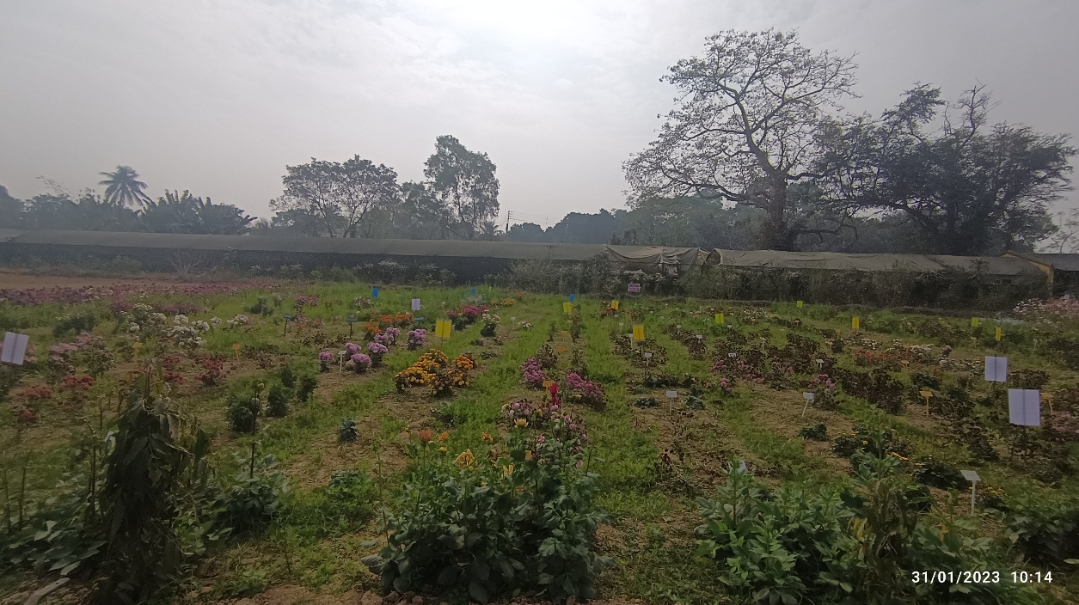

Fig 1: Field trial of different coloured sticky traps for monitoring thrips, aphids and other beneficial insects population in chrysanthemum

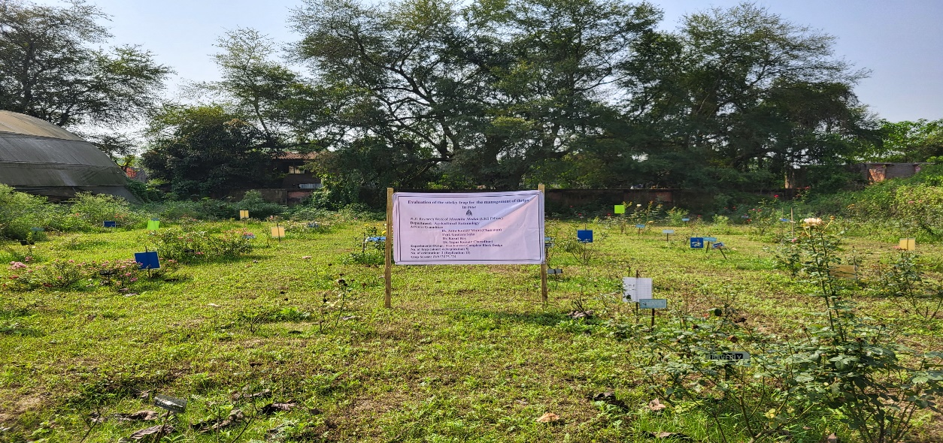
Fig 2: Field trial of different coloured sticky traps for monitoring thrips, aphids and other beneficial insects in rose

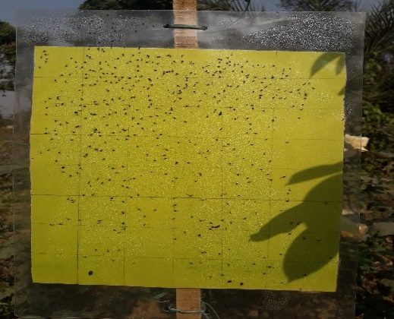
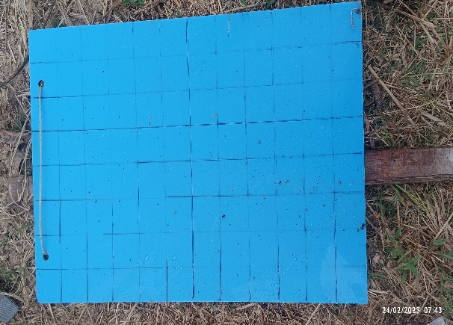
Fig. 4. Yellow trap
Fig. 3. Blue trap

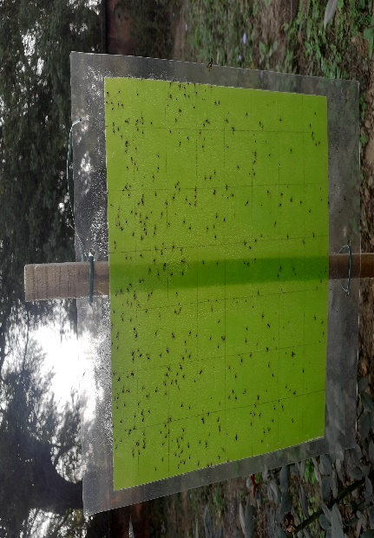
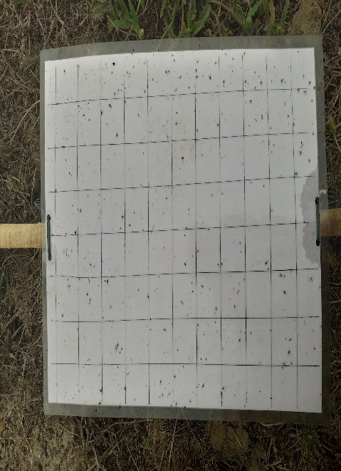
Fig. 6. Fluorescent green
Fig. 5. White trap

3. results and discussion

3.1. Efficacy of different coloured sticky trap against thrips in chrysanthemum and rose
In chrysanthemum, maximum number of thrips, Microcephalothrips abdominalis (Crawford) (6.7/ sq. inch area) was recorded on blue trap followed by white (5.5/ sq. inch area), yellow (4.5/ sq. inch area) and fluorescent green (4.1/ sq. inch area) at 7 DAI (Table 1). Similar trend was also observed at 14, 21 and 28 DAI. On the other hand, in rose, 7 DAI the maximum number of thrips, Frankliniella occidentalis (Pergande) was trapped in blue sticky trap (2.95/ sq. inch area) followed by white sticky trap (2.63/ sq. inch area), yellow sticky trap (2.07/ sq. inch area) and fluorescent green (1.66/ sq. inch area) (Table 2). In rose, after blue traps, white traps attracted the maximum number of thrips, whereas yellow and fluorescent green traps captured comparatively fewer thrips. However, maximum number of thrips was trapped at 28 DAI on blue sticky trap (8.23/ sq. inch area).
A distinct variation was observed between the two crops with respect to thrips trapping. In chrysanthemum, the highest thrips population was recorded at 7 DAI, whereas in rose, the maximum number of thrips was trapped at 28 DAI. The effectiveness of coloured traps in capturing thrips followed the order: blue > white > yellow > fluorescent green.
Table 1. Efficacy of different coloured sticky traps against thrips of chrysanthemum

Type of coloured  sticky trap | Population of thrips per square inch area of trap of Chrysanthemum
Type of coloured  sticky trap | 7DAI | 14DAI | 21DAI | 28DAI | 35DAI
T1: Blue | 6.7 ± 0.28  (45) | 5.6 ± 0.27 (32) | 5.3 ± 0.2 (28) | 4.9 ± 0.2  (24) | 5.2 ± 0.08 (27)
T2: Yellow | 4.5 ± 0.22 (20) | 4.8 ± 0.21 (23) | 2.7 ± 0.3  (8) | 2.6 ± 0.13  (7) | 3.0 ± 0.06  (8)
T3: White | 5.5 ± 0.26 (31) | 5.2 ± 0.17 (28) | 3.5 ± 0.2 (13) | 3.0 ± 0. 06 (9) | 2.1 ± 0.12  (5)
T4: Fluorescent green | 4.1 ± 0.25 (17) | 3.2 ± 0.08 (10) | 2.4 ± 0.15 (6) | 1.7 ± 0.11  (3) | 1.4 ± 0.16  (2)
SEm (±) | 0.28 | 0.21 | 0.27 | 0.14 | 0.13
CD (P=.05) | 0.88 | 0.67 | 0.84 | 0.42 | 0.41
F-Stat Value | 17.29 | 25.55 | 23.18 | 97.73 | 160.96
Note: DAI denotes days after installation of trap, data in parentheses indicate original values.
Table 2. Efficacy of different coloured sticky traps against thrips of rose
Type of coloured  sticky trap | Population of thrips per square inch area of trap of Rose
Type of coloured  sticky trap | 7DAI | 14DAI | 21DAI | 28DAI | 35DAI
T1: Blue | 2.95 ± 0.06  (8.7) | 3.41 ± 0.12  (11.71) | 6.09 ± 0.166  (37) | 8.23 ± 0.18  (68) | 5.55 ± 0.27  (31.1)
T2: Yellow | 2.07 ± 0.09  (4.3) | 1.21 ± 0.12  (1.54) | 2.68 ± 0.18  (7) | 4.49 ± 0.22  (20) | 3.29 ± 0.26  (11.1)
T3: White | 2.63 ± 0.13  (6.9) | 1.74 ± 0.21  (3.20) | 3.87 ± 0.26  (15) | 4.07 ± 0.25  (17) | 3.35 ± 0.15  (11.3)
T4: Fluorescent green | 1.66 ± 0.11  (2.8) | 1.39 ± 0.11  (1.997) | 3.45 ± 0.16  (12) | 3.64 ± 0.16  (13) | 3.44 ± 0.20  (12)
SEm (±) | 0.34 | 0.16 | 0.21 | 0.22 | 0.21
CD (P=.05) | 0.34 | 0.51 | 0.65 | 0.70 | 0.65
F-Stat Value | 26.58 | 37.25 | 48.58 | 86.07 | 27.26
Note: DAI denotes days after installation of trap, data in parentheses indicate original values.

3.2. Efficacy of different coloured sticky traps against aphids in chrysanthemum and rose

In chrysanthemum, maximum numbers of aphids, Macrosiphoneilla sanborni (Gillette) were trapped in the yellow trap (6.88/ sq. inch area) followed by white trap (4.83/ sq. inch area), fluorescent green (3.91/ sq. inch area) and blue trap (3.22/ sq. inch area) at 7 DAI (Table 3). Similar trend was observed at 14 DAI and 35 DAI. However, at 21 and 28 DAI, a slight variation in the trend was recorded, although yellow traps consistently remained the most effective, followed by white, fluorescent green and blue traps. Naxiumum number of aphids has been trapped at 7 DAI of trap (6.88/ sq. inch area).
In the case of rose, the efficacy of sticky traps in monitoring aphids, Aphis gossypii Glover was evaluated following the same procedure by taking five observations. At 7 DAI, the maximum number of aphids was observed on yellow trap (8.23/ sq. inch area) followed by fluorescent green (6.67/ sq. inch area), white (2.63/ sq. inch area) and blue trap (2.60/ sq. inch area) (Table 4). Similar trend was followed at 14 DAI, 21 DAI, 28 DAI and 35 DAI as well. Maximum numbers of aphids were found at 21 DAI on yellow trap (10.98/ sq. inch area).
A slight variation in the efficacy of coloured sticky traps for aphid management was observed between chrysanthemum and rose. In chrysanthemum, the maximum number of aphids was recorded on sticky traps at 7 DAI (6.88/sq. inch area), whereas in rose, the highest aphid population was trapped at 21 DAI (10.98/sq. inch area). In both crops, yellow sticky traps consistently exhibited the highest efficacy in trapping aphids, while the performance of other coloured traps varied across observation periods.
Table 3. Efficacy of different coloured sticky traps against aphids of chrysanthemum

Type of coloured sticky trap | Population of aphids per square inch area of trap of chrysanthemum
Type of coloured sticky trap | 7DAI | 14DAI | 21DAI | 28DAI | 35DAI
T1: Blue | 3.22 ± 0.14 (10.4) | 1.9 ± 0.47 (4.4) | 1.89 ± 0.10 (3.6) | 1.11 ± 0.10  (1) | 1.1 ± 0.08  (1)
T2: Yellow | 6.88 ± 0.65 (46.3) | 5.2 ± 0.37 (27.4) | 3.64 ± 0.30 (13.6) | 3.62 ± 0.10 (13) | 2.4 ± 0.13 (6)
T3: White | 4.83 ± 0.20 (23.5) | 4.9 ± 0.40 (25.0) | 2.02 ± 0.19 (4.22) | 1.82 ± 0.14  (3) | 2 ± 0.19  (4)
T4: Fluorescent green | 3.91 ± 0.32 (15.7) | 4.3 ± 0.15 (19.0) | 2.98 ±0.16  (9) | 2.6 ± 0.11  (7) | 1.8 ± 0.16 (3)
SEm (±) | 0.36 | 0.36 | 0.19 | 0.12 | 0.13
CD (P=.05) | 1.11 | 1.12 | 0.58 | 0.37 | 0.39
F-Stat Value | 17.86 | 18.26 | 19.65 | 81.66 | 17.92
Note: DAI denotes days after installation of trap, data in parentheses indicate original values.

Table 4. Efficacy of different coloured sticky traps against aphids of rose

Type of coloured  sticky trap | Population of aphids per square inch area of trap of rose
Type of coloured  sticky trap | 7 DAI | 14 DAI | 21DAI | 28 DAI | 35 DAI
T1: Blue | 2.60 ± 0.11  (7) | 2.09 ± 0.12  (4) | 1.77 ± 0.13  (3) | 1.93 ± 0.94  (5) | 2.41 ± 0.14  (6)
T2: Yellow | 8.23 ± 0.12  (70) | 8.64 ± 0.16  (75) | 10.98 ± 0.47  (121) | 9.38 ± 0.37  (96) | 8.89 ± 0.30  (79)
T3: White | 2.63 ± 0.35  (7) | 2.18 ± 0.16  (5) | 3.22 ± 0.23  (11) | 4.55 ±0.32  (31) | 2.43 ± 0.52  (7)
T4: Fluorescent green | 6.67 ± 0.11  (45) | 6.95 ± 0.34  (49) | 7.26 ± 0.27  (53) | 6.47 ± 0.35  (41) | 5.04 ± 0.55  (27)
SEm (±) | 0.21 | 0.23 | 0.26 | 0.32 | 0.37
CD (P=.05) | 0.66 | 0.72 | 0.80 | 0.99 | 1.16
F-Stat Value | 183.83 | 208.18 | 262.81 | 98.64 | 67.33
Note: DAI denotes days after installation of trap, data in parentheses indicate original values.
Box-and-whisker plot analysis of data on insects captured on coloured sticky traps revealed distinct patterns in the distribution and variability of thrips and aphid populations in chrysanthemum and rose (Figs. 7-10). In the case of thrips, blue sticky traps recorded the highest median values along with comparatively wider interquartile ranges (IQR), indicating greater attraction as well as higher variability in population capture across observation periods. Yellow and white traps showed moderate median values with relatively narrower IQRs, reflecting consistent but lower trapping efficiency, while fluorescent green traps recorded the lowest median and least variability in both chrysanthemum and rose.
Aphids also exhibited clear differences among trap colours. In chrysanthemum, yellow traps showed higher median values and a broader spread, indicating their greater effectiveness and variability in aphid capture. Blue traps recorded the lowest median values with minimal spread, suggesting poor attraction. In rose, yellow traps again exhibited the highest median along with a wide IQR and presence of upper outliers, reflecting strong attraction and occasional population peaks. White and fluorescent green traps showed intermediate performance, while blue traps remained least effective.

Fig.7. Box-and-whisker plot analysis of data showing distribution and variability of thrips trapped in coloured sticky traps in chrysanthemum
Fig.8. Box-and-whisker plot analysis of data showing distribution and variability of thrips trapped in coloured sticky traps in in rose

Fig.10. Box-and-whisker plot analysis of data showing distribution and variability of aphids trapped in coloured sticky traps in rose

Fig.9. Box-and-whisker plot analysis of data showing distribution and variability of aphids trapped in coloured sticky traps in chrysanthemum

The study was also taken up to assess the attraction of beneficial insects to different coloured sticky traps in chrysanthemum and rose. Three orders of beneficial insects were identified: Coleoptera, Hemiptera and Hymenoptera. Coccinellids (Coccinella transversalis Fab., Cheilomenes sexmaculata Fab. and Brumoides suturalis Fab.) predominated among coleopterans, with C. transversalis holding a commanding position throughout the period of investigation. The most coccinellids were caught in yellow traps, followed by blue, white and fluorescent green (Fig. 12). The nitidulid beetle (Haptoncus sp.) was found trapped in smaller quantities in rose, indicating a comparatively greater attraction to white and blue traps (Fig. 13). The most prevalent beneficial predatory insect in both crops was the minute pirate bug Orius sp., which was mostly captured on blue traps, followed by white, yellow and fluorescent green (Fig. 12, 13). Honey bees (Apis dorsata Fab.) were observed in both of the crops; however, their abundance was higher in rose, and among the coloured sticky traps the maximum were recorded in yellow traps (Fig. 12, 13). The distribution pattern revealed Hemiptera as the most abundant order, followed by Coleoptera and Hymenoptera. In chrysanthemum, a total of 850 Hemipteran, 157 Coleopteran and 30 Hymenopteran beneficial insects were recorded throughout the study period, whereas in rose the corresponding numbers of beneficial insects were 555, 138 and 60, respectively (Fig.11).
Orders
No. of beneficial insects

Fig. 11. Beneficial insects of different orders found in chrysanthemum and rose

Trap-wise analysis in chrysanthemum indicated that Orius sp. was the dominant beneficial insect, with maximum capture in blue traps (400 individuals), followed by white
(320 individuals), yellow (80 individuals) and fluorescent green (50 individuals). Among coccinellids, C. transversalis and C. sexmaculata showed higher attraction towards yellow and blue traps, while B. suturalis was least recorded (Fig.12).
In rose, Orius sp. again dominated with highest attraction to blue traps (300 individuals), followed by white (140 individuals), yellow (75 individuals) and fluorescent green (40 individuals). Haptoncus sp. occurred in relatively lower numbers but was more associated with blue and white traps (Fig. 13). Coccinellids were recorded in low abundance, with C. transversalis showing comparatively higher attraction to yellow and blue traps, whereas C. sexmaculata and B. suturalis were not recorded in rose trap catches. Honey bees were more frequently observed on rose and exhibited a greater preference for yellow traps (Fig. 13).

Species
Fig.12. Trap-wise data of beneficial insects in chrysanthemum

Fig.13. Trap-wise data of beneficial insects in rose

The present study demonstrated that thrips exhibited a clear preference for blue
coloured sticky traps over yellow, white and fluorescent green traps in chrysanthemum and rose, with higher median captures and wider interquartile ranges (IQR) indicating greater attraction. These findings agree with earlier reports (Chen et al., 2004; Sridhar et al., 2015; Devi and Roy, 2017; Hossain et al., 2020; Pobozanaik et al., 2020 and Amutha, 2023). Although attraction to other colours such as white (van Tol et al., 2021), yellow (Blumthal et al., 2015; Rajput et al., 2020) and fluorescent green (Rehling et al., 2025) had been noted, their effectiveness was comparatively lower. The visual physiology of Frankliniella occidentalis, which shows trichromatic vision with peak sensitivity at blue wavelengths and a blue-green opponent mechanism, is thought to be responsible for this predilection (Dearden et al., 2024). Maximum attraction has been found at 440-460 nm (Sampson et al., 2021). In contrast, aphids showed a strong preference for yellow coloured sticky traps, with higher captures indicating greater efficiency. This is consistent with previous findings (Shrestha and Tiwari, 2021; Hussain et al., 2022). According to recent research, aphid (Myzus persicae) preferentially reacts to yellow because of its phototactic behaviour (Shang et al., 2025). Yellow traps have been shown to produce noticeably greater field captures (Baig et al., 2025). Yellow traps are therefore widely used in IPM programmes as they mimic host plant cues (Nagaraj et al., 2025). Overall, these results highlight the importance of species-specific colour selection for effective pest monitoring.
A period of high thrips and aphid abundance in the chrysanthemum and rose field coincided with the 35-days long sticky trap experiment, which took place between the third week of January to the third week of February. With an early peak at 7 DAI in chrysanthemum and a later peak at 28 DAI in rose, the temporal distribution revealed crop wise diversity in thrips and aphid population dynamics. This discrepancy may be attributed to variations in floral phenology, since roses bloom throughout February and March while chrysanthemums flower sooner in January. The decline in thrips population with reduced flower availability further supports the close association between pest abundance and floral resources, in agreement with Zlesak (2007). The findings were also in line with earlier research on the variety of beneficial insects in flower crops (Bashir et al., 2014 and Piyasena et al., 2023). The results of Kemp and Cottrell (2015) and Matra et al. (2024) reported that the observed preference of coccinellids for yellow traps. Similarly, the finding of Vuts et al. (2022) was supported by the attraction of Haptoncus sp. to white and blue traps. Notably, Orius sp. exhibited a considerable attraction to blue traps, which was consistent with the findings of Furihata et al. (2019). Under field conditions, Orius sp. was an effective predator of thrips, able to consume about 20-30 individuals every day. Laboratory studies had reported mean consumption rates of about 30-32 thrips per day, with maximum predation exceeding 50 individuals depending on prey density and species (Silva et al., 2023). Therefore, natural biological control may suffer if these predators are unintentionally eliminated through trapping. Therefore, in order to preserve beneficial insect populations and improve biological control within the flower crop ecosystem, the usage of sticky traps, especially in the flowering zone during times of high activity of natural enemies, should be restricted. The main limitation of this study is its 35-day monitoring window within a single season, which makes it impossible to capture multi-generational population fluctuations or long-term seasonal trends. Trap efficiency may be complicated by uncontrollable environmental conditions such as microclimate and solar irradiation. Therefore, to validate these results, multi-seasonal research across various locations is recommended.

4. Conclusion
Thrips and aphids remain significant pests of flower crops in West Bengal, posing challenges for timely detection and management due to the cryptic nature of thrips. The present findings highlight that blue and yellow sticky traps are effective tools for monitoring thrips and aphid populations, respectively, enabling early detection and informed decision making in pest management programmes. Their role is particularly valuable in flower crops where timely intervention is critical to prevent yield losses. and reduce the risk of virus transmission. However, the present study indicates that sticky traps may also capture non target beneficial arthropods, including predatory insects such as Orius sp., coccinellids and pollinators, although their incidence is comparatively low. Considering the ecological significance of these natural enemies, particularly Orius sp., which is effective predators of thrips, their conservation is critical for sustaining natural biological control within agro-ecosystems. Therefore, the indiscriminate deployment of sticky traps, especially within the flowering zone during periods of peak activity of beneficial insects, should be avoided to minimize adverse effects on natural enemy populations and to promote sustainable pest management.
COMPETING INTERESTS DISCLAIMER:
Authors have declared that they have no known competing financial interests OR non-financial interests OR personal relationships that could have appeared to influence the work reported in this paper.

Disclaimer (Artificial intelligence)

Author(s) hereby declare that NO generative AI technologies such as Large Language Models (ChatGPT, COPILOT, etc.) and text-to-image generators have been used during the writing or editing of this manuscript.

5. REFERENCES

- Amutha, M. (2023). Efficacy of coloured sticky traps against thrips in cotton. Indian Journal of Entomoly, published online, Ref. No. e21212, https://doi.org/10.55446/IJE.2021.380
- Baig, I. A., More, D. G., Bhamare, V. K., Gaikwad, S. G., & Thite, N. G. (2025). Evaluation of different coloured sticky traps and trap heights against cotton aphid (Aphis gossypii). International Journal of Advanced Biochemistry Research, 9 (1), 296-299. https://doi.org/10.33545/26174693.2025.v9.i1d.3485
- Bashir, M. A., Alvi, A. M., & Naz, H. (2014). Effectiveness of sticky traps in monitoring insects. Journal of Environmental and Agricultural Sciences, 1 (5), 1-2.
- Biswas, N. K. (2013). Floriculture in Chapra village in Ranaghat-II block, Nadia district, West Bengal. Journal Of Humanities and Social Science (IOSR-JHSS), 7 (1),17-23.
- Blumthal, M. R., Cloyd R. A., Art Spomer, L., & Warnock, D. F. (2015). Flower colour preference to western flower thrips. Hort Technology, 15 (4), 846-853. https://doi.org/10.21273/HORTTECH.15.4.0846
- Chen, T. Y., Chu, C. C., Fitzgerald, G., Natwick, E. T., & Henneberry, T. J. (2004). Trap evaluations for thrips (Thysanoptera: Thripidae) and hoverflies (Diptera: Syrphidae). Environmental Entomology, 33 (5), 1416-1420. https://doi.org/10.1603/0046-225X-33.5.1416
- Dearden, A. E., Wood, M. J., Frend, H. O., Butt, T. M., & Allen, W. L. (2024). Visual modelling can optimise the appearance and capture efficiency of sticky traps used to manage insect pests. Journal of Pest Science, 97 (1), 469-479. https://doi.org/10.1007/s10340-023-01604-w
- Devi, M. S., & Roy, K. (2017). Comparable study on different coloured sticky traps for catching of onion thrips, Thrips tabaci Lindeman. Journal of Entomology and Zoology Studies, 5 (2), 669-671.
- Furihata, S., Tabuchi, K., Okudera, S., Takahashi, A., Hinomoto, N., Shimoda, M., & Yamaguchi, T. (2019). An efficient method for monitoring predatory minute pirate bugs Orius spp. (Hemiptera: Anthocoridae) populations using blue-colored sticky traps. Environmental entomology, 48 (2), 426-433. https://doi.org/10.1093/ee/nvz001
- Gomez, K. A., & Gomez, A. A. (1984). Statistical procedures for agricultural research. In John Wiley & Sons (Eds.) New York, (2nd Ed., pp. 684).
- Gurung, B., Ponnusamy, N., & Pal, S. (2019). Species diversity of predaceous coccinellids in different crop ecosystems under the hilly and terai region of West Bengal (India). Ecology, Environment and Conservation, 25 (2), 636-642.
- Hossain, M. M., Khalequzzaman, K. M., Alam, M. S., Mondal, M. T. R., & Islam, M. M. (2020). Efficacy of different coloured sticky traps against thrips of chilli. International Journal of Applied Sciences and Biotechnology, 8 (2), 187-190. https://doi.org/10.3126/ijasbt.v8i2.29580
- Hussain, K., Abbas, M., Hussain, N., Irshad, M., Khaliq, M., Parveen, Z., & Ghaffar, A. (2022). Study on species richness of aphid through Integrated Pest Management. Pakistan Journal of Agricultural Research, 35 (3), 483- 489. https://creativecommons.org/licenses/by/4.0/
- Isenring, R (2010). Pesticides and the loss of biodiversity. Pesticide Action Network Europe, London, 26p.
- Kemp, E. A., & Cottrell, T. E. (2015). Effect of lures and colors on capture of lady beetles (Coleoptera: Coccinellidae) in tedders pyramidal traps. Environmental Entomology, 44(5), 1395-1406. https://doi.org/10.1093/ee/nvv108
- Matra, N. G., Bantewad, S. D., Khan, S. A., Kadawla, K., & Kadam, K. V. (2024). Orientation of natural enemies towards various color sticky traps. Journal of Entomological Research, 48(2), 242-245. https://dx.doi.org/10.5958/0974-4576.2024.00048.2
- Nagaraj, S., Namachivayam, V., & Nagarajan, M. (2025). Advances and limitation of yellow sticky traps in integrated pest management. Uttar Pradesh Journal of Zoology,
46 (12), 274-284.https://doi.org/10.56557/upjoz/2025/v46i125064
- Pal, S., & Sarkar, I (2009). Pests infesting ornamental plants in hilly region of West Bengal. The Journal of Plant Protection Sciences, 1 (1), 98-101.
- Piyasena, M. A. R., Weligamage, S. S., Warnasooriya, P. G. A. S., & Hemachandra, K. S. (2023). Attraction of pest insects, neutral insects and natural enemies to coloured sticky traps in vegetable eco-systems. Journal of Agricultural Sciences, Sri Lanka,
18 (2), 261 -272. https://doi.org/10.4038/jas.v18i2.10258
- Pobozniak, M., Tokarz, K., & Musynov, K. (2020). Evaluation of sticky trap colour for thrips (Thysanoptera) monitoring in pea crops (Pisum sativum L.). Journal of Plant Diseases and Protection, 127 (3), 307-321. https://doi.org/10.1007/s41348-020-00301-5
- Rajput, A., Baloch, A. L., Soomro, J. A., & Junejo, G. Q. (2020). Performance of various colored sticky traps in monitoring against insects of maize crop. Pure and Applied Biology., 10 (2), 348-359. https://dx.doi.org/10.19045/bspab.2021.100038
- Rehling, L., Stukenberg, N., & Döring, T. F. (2025). Effects of different visual modifications of yellow sticky traps on the attractiveness to Trialeurodes vaporariorum, Bemisia tabaci, Frankliniella occidentalis and Thrips tabaci. Journal of Plant Diseases and Protection, 132 (1), 1-13. https://doi.org/10.1007/s41348-024-01037-2
- Sampson, C., Turner, R., & Ali, A. (2021). Monitoring and trapping with sticky traps, what’s new. International Pest Control, 63 (3), 166-169.
- Shang F., Xu QQ., Xie QP., Liu YJ., & Wang JJ. (2026). microRNA modulates aphid phototaxis in response to yellow sticky traps. Pest Management Science, 82 (2), 1805-1814. https://doi.org/10.1002/ps.70325
- Sheoran, O. P., Tonk, D. S., Kaushik, L. S., Hasija, R. C., & Pannu, R. S. (1998). Statistical software package for agricultural research workers. In recent advances in information theory, statistics and computer applications by D. S. Hooda & R. C. Hasija Department of Mathematics Statistics, CCS HAU, Hisar,139 -143 p.
- Shrestha, A., & Tiwari, S. (2021). Aphid monitoring using yellow and blue sticky trap in sweet pepper field. Nepal Journal of Agricultural Sciences, 21, 137-143.
- Silva, L. P., Souza, I. L., Marucci, R. C., & Guzman-Martinez, M. (2023). Doru luteipes (Dermaptera: Forficulidae) and Orius insidiosus (Hemiptera: Anthocoridae) as nocturnal and diurnal predators of thrips. Neotropical Entomology, 52 (2), 263-272. https://doi.org/10.1007/s13744-022-00982-7
- Sridhar, V., & Naik, O. (2015). Efficacy of colour sticky traps for monitoring chilli thrips, Scirtothrips dorsalis Hood (Thysanoptera: Thripidae) on rose. Pest Management in Horticultural Ecosystem, 21 (1), 101-103.
- Vandana, K., Bhaskar, V. V., Dorajeerao, A. V. D., Subbaramamma, P., Rao, M. P., & Sekhar, V. (2024). Genetic variability, heritability and genetic advance in chrysanthemum (Dendranthema grandiflora) genotypes evaluated for loose flower production. Electronic Journal of Plant Breeding, 15 (4), 885. https://doi.org/10.37992/2024.1504.106.
- Van Tol, R. W., Tom, J., Roher, M., Schreurs, A., & Van Dooremalen, C. (2021). Haze of glue determines preference of western flower thrips (Frankliniella occidentalis) for yellow or blue traps. Scientific Reports, 11 (1), 6557. https://doi.org/10.1038/s41598-021-86105-5
- Vuts, J., Szarukán, I., Marczali, Z., Csonka, É. B., Szilágyi, A., Imrei, Z., & Tóth, M. (2022). Differences in colour preference among pollen beetle species (Coleoptera: Nitidulidae). Journal of Applied Entomology, 146 (3), 301-309. https://doi.org/10.1111/jen.12969
- Zlesak, D. C. (2007). Rose: Rosa x hybrida. In Flower breeding and genetics: Issues, challenges and opportunities for the 21st century, 695-740p.
- https://apeda.gov.in/apedawebsite/SubHead_Products/Floriculture.htm accessed on 02.05.2026.
- WBFPIH Annual report 2023-24. https://www.wbfpih.gov.in accessed on 7.05.2026.

