Original Research Article

The prevalence of disease-causing parasites in eight wild fish species from urban rivers

Abstract
Parasitic infections in fishes cause significant economic losses and severely affect public health. The high prevalence of parasites in urban rivers has been increasingly reported in the literature. We investigated the prevalence of ectoparasites and endoparasites in eight minor wild fishes (Glossogobius giuris, Chanda nama, Labeo calbasu, Puntius sophore, Parambassis ranga, Garra mullya, Sperata seenghala, Gymnostomus fulungee) from five rivers flowing through urban region of Pune metropolitan area. A total of 126 fishes were investigated for disease causing parasite infections on the body surface/scales, gills, intestine, and liver. We observed a total of eleven parasites (five ectoparasites and six endoparasites). Both small and large-sized fishes were highly infected. The prevalence of both ectoparasites and endoparasites was high in large-sized fishes. The prevalence of ectoparasites and endoparasites vary in different species and at different collection sites. The occurrence of endoparasites was high in column feeder fishes while ectoparasites were predominantly present in bottom feeder fishes. The prevalence of endoparasites was slightly higher in herbivorous and omnivorous fishes while the proportion of both ectoparasites and endoparasites was similar in carnivorous fishes. The present study provides preliminary data on the prevalence of parasites in minor fishes that could be useful for designing strategies for monitoring parasite prevalence in urban rivers.
Keywords: Fish parasites, Urban River, Fish size, Herbivorous fish, Fish microhabitat, prevalence
Introduction
Fish parasites severely affect fish health and sometimes cause mortality which directly influences economy and health of the society (Amer 2014; Mustafa et al. 2024; Patil et al. 2025). Parasitic infections in fishes have dire consequences on fish development, physiology, growth, and survival (Rock et al. 2022; Abbaci et al. 2023; Fuentes-Lopez et al. 2025). The fishes infested by parasites can become contagious and spread infections that could lead to mass mortality (Fahmy et al. 2021; Tadiri et al. 2021; Vollset et al., 2023; Islam et al. 2024). For example, Hernández et al. (2024) reported the mass mortality in wild fishes during winter season due to infection by Chilodonella sp. The mass mortality in common food fishes eventually cause significant economic loss of local community (Fahmy et al. 2021; Radwan et al. 2023). Moreover, the consumption of infected fish, especially poorly cooked or raw fish can severely affect human health (Cong and Elsheikha, 2021; Ziarati et al. 2022). For instance, common Southeast Asian liver fluke Opisthorchis viverrini infection can cause cholangiocarcinoma or bile duct cancer, a major health issue in Thailand (Sripa et al. 2011). The prevalence of fish parasites in water bodies may vary spatially and temporally and can be influenced by several environmental and hydrological factors (Chapman et al. 2021; Yadav et al. 2022). Therefore, monitoring of parasitic infections in fish is necessary, especially in the rivers flowing through urban settlements, as their hydrological parameters fluctuate drastically (Biswas et al. 2023).
Rivers are a major source of fish food for local communities around the globe. Unfortunately, rivers flowing through urban areas are increasingly becoming polluted as they receive sewage water and industrial effluents that drain diverse pollutants including pharmaceuticals, agrochemicals, etc. which lead to degradation of water quality. The pollutants present in the river water severely affect fish immunity and health (Xu et al., 2021; Mustafa et al. 2024). Importantly, several studies have reported the high prevalence of fish parasites in polluted waters (Galli et al. 2001; Biswas et al. 2023; El-Khayat et al. 2024; Ito and Egwunyenga, 2024). Recent reports suggest that the highest prevalence of parasites in water bodies in urban regions, as compared to nonurban water bodies (Moreira et al.2015; Taglioretti et al., 2018).
India is the fourth largest producer of capture fisheries with an average of 1 ton per kilometre of riverine systems. Minor fishery in India plays a significant role in supporting the livelihood and economy of the local community (McIntyre et al. 2016; Jena et al. 2022). Also, minor fishes are an important component of the ecosystem and a part of the food web (Peel et al. 2019; Pacheco et al. 2021; Guo et al. 2023). Moreover, minor fishes serve as reservoirs of parasites or alternate hosts for parasites (Mofasshali et al. 2012; Shamsi et al. 2021; Ondračková et al. 2025). Previous studies on the prevalence of parasites were mainly focused on the major fishes including Indian major carps (Paul et al. 2021; Hazarika and Bordoloi 2022; Paul and Sahoo 2022; Sahoo et al. 2022; Banu et al. 2024; Mustafa et al. 2024) except one study on the Channa punctata from polluted river
(Biswas et al. 2023). Further investigations need to be undertaken on the prevalence of parasites in minor fishes.
India is also home to some of the world’s fastest-growing cities. Major rivers flowing through cities in India carry urban sewage water and industrial wastewater. Pune metropolitan city is India’s fastest-growing urban area situated around five rivers originating in the northern Western Ghats. Although the water of these rivers is polluted, the local community is dependent on minor fishes in these rivers for food. In the present study, we investigated the prevalence of parasites in the fish captured from these urban rivers. In the present cross sectional study, we report the prevalence of disease causing ectoparasites and endoparasites in eight minor fishes and correlate their occurrences with feeding habits and microhabitats.

Materials and Methods

Study area and sample collection
Fish samples were collected from Mula River, Mutha River, Pawana River, Indrayani River, Shivganga River and local markets on the banks of these rivers (Figure 1). The fishes were collected with the help of local fishermen or from vendors. The fishes were collected during winter and summer months (January – April) of the year 2023 from eight collection sites. Each location was visited 3 – 5 times during the study period. A total of
126 fishes belonging to eight species (Glossogobius giuris, Chanda nama, Labeo calbasu, Puntius sophore,
Parambassis ranga, Garra mullya, Sperata seenghala, Gymnostomus fulungee) were collected (Table 1).
Among these G. giuris, G. mullya, G. fulungee, S. seenghala, and L. Calbasu are bottom feeders and P. sophore, C, nama, and P. ranga are column feeders. Feeding habits of the fishes were determined based on the gut content analysis of some individuals and the information available in the literature. The fish G. giuris, S. seenghala, C. nama, and P. ranga are carnivorous, G. fulungee and L. calbasu are omnivorous, and G. mullya and P. sophore are herbivorous. Details of the collection sites of different fishes are given in Table 1. After recording their length and weight on site using a digital calliper (Mitutoyo) and portable weighing balance (Contech CTL), respectively, the fishes were transported to Disease Diagnostic and Quality Testing Laboratory for Aquatic Animals, Department of Zoology, Modern College Ganeshkhind, Pune.
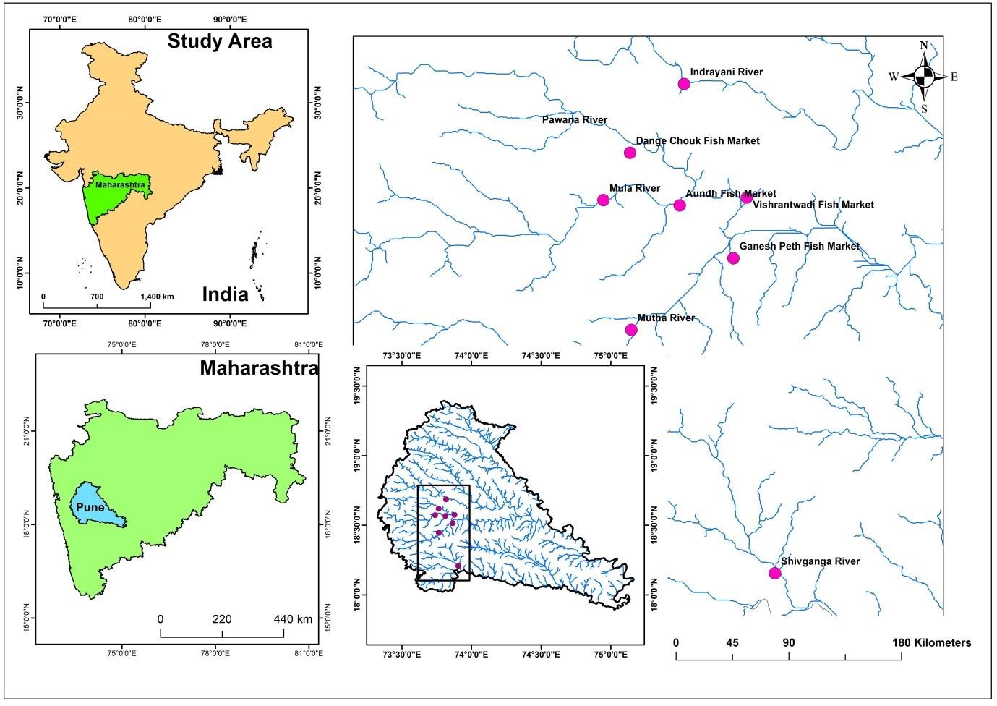

Fig 1 Fish collection locations in Pune urban area. Inset showing the map of Pune city and rivers passing through. Collection sites are highlighted in pink dots.

Table 1 Details of the fish collection at different locations.
Fish species | Collection sites
Glossogobius giuris | Aundh fish market, Mula river, Mutha river,
Garra mullya | Aundh fish market, Mula river, Mutha river
Gymnostomus fulungee | Dange chowk fish market, Vishrantwadi fish market
Sperata seenghala | Aundh fish market ShivGanga river, Mula river
Puntius sophore | Vishrantwadi fish market, Indrayani River
Labeo calbasu | Dange chowk fish market, Ganesh peth fish market, Indrayani River
Chanda nama | Aundh fish market, Ganeshpeth fish market, shivganga river
Parambassis ranga | Ganeshpeth fish market, Shivganga river

The fishes were examined with naked eyes and using magnifying glass or stereo microscope (Mechanic
MC 75T) to assess general health status and the presence of parasites. Body surface/scales and tail of the fish wear examined under stereoscope. A blunt scalpel was used to scrap the body surface. Operculum was dissected out and gills were scrapped using blunt scalpel. After scrapping permanent of wet mounts were prepared to analyse the parasites on the body surface and gills (Puzach, 2006; Sahoo et al. 2020).
To examine internal organs (liver, kidney, and intestine), lateral incisions were made to open body cavity. Intestine, liver, and kidney were removed and placed in saline (0.7% NaCl). A few drops of intestinal fluid were placed on the glass slides and observed under stereo microscope. To observe Trematode parasites in gills, kidneys, intestine, and liver, muscle compression technique and Pepsin-HCl artificial digestion techniques were used following the protocols described previously (Shafiq et al. 2023). The parasites were observed under stereo microscope and light microscope (Zeiss Primostar). Disease causing parasites were identified based on the morphological characteristics described by Dash (2012).
Numbers of parasites in different tissues and fishes were recorded. The data were presented in tabular and graphical format using Microsoft Excel. Association between fish length and parasite abundance was analysed by Pearson correlation. Chi square test of independence was performed to examine the difference in the ectoparasites and endoparasites between bottom feeder and column feeder fishes. Similarly, the difference in the ectoparasites and endoparasites among fishes from different tropic levels was analysed by chi square test.
Significance level (alpha) was set at 0.05. Statistical analysis was performed in GraphPad Prism.

Results
Among 126 fishes a total of 58 fishes were infected with parasites (Table 2). We observed a total of five ectoparasites (Trichodina, Dactylogyrus, Gyrodactylus, Ichthyophthirius multifiliis, and Chilodonella) and six endoparasites (Acanthocephala, Contracaecum, Myxobolus, metacercariae, Isospora, and Eimeria) in different fishes (Figure 2). The highest proportion of Glossogobius giuris fish (64.4%) was infected with parasites followed by Parambassis ranga (61.53%), Chanda nama (56.25%), and Garra mullya (55.55%; Table 2). A few individuals of Sperata seenghala and Gymnostomus fulungee were found to be infected (Table 2). G. mullya were the longest and heaviest fish recorded followed by G. giuris. P. ranga while C. nama were the smallest fish recorded (Table 2).

Fig 2 Representative microscopic images of endoparasites (a-e) and ectoparasites (f-k) observed in the present study. (a: Trichodina, b: Dactylogyrus , c: Gyrodactylus d: Ichthyophthirius multifiliis e: Myxobolus f: Chilodonella g: Acathocephala
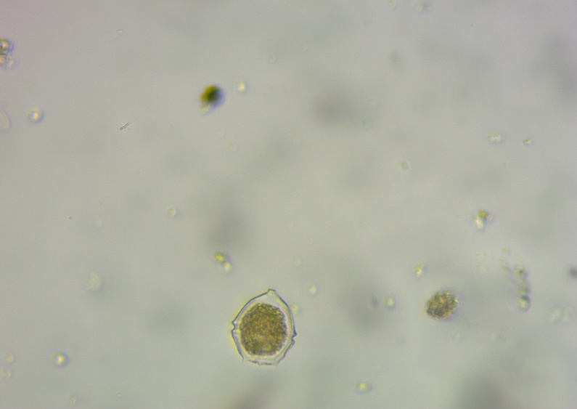
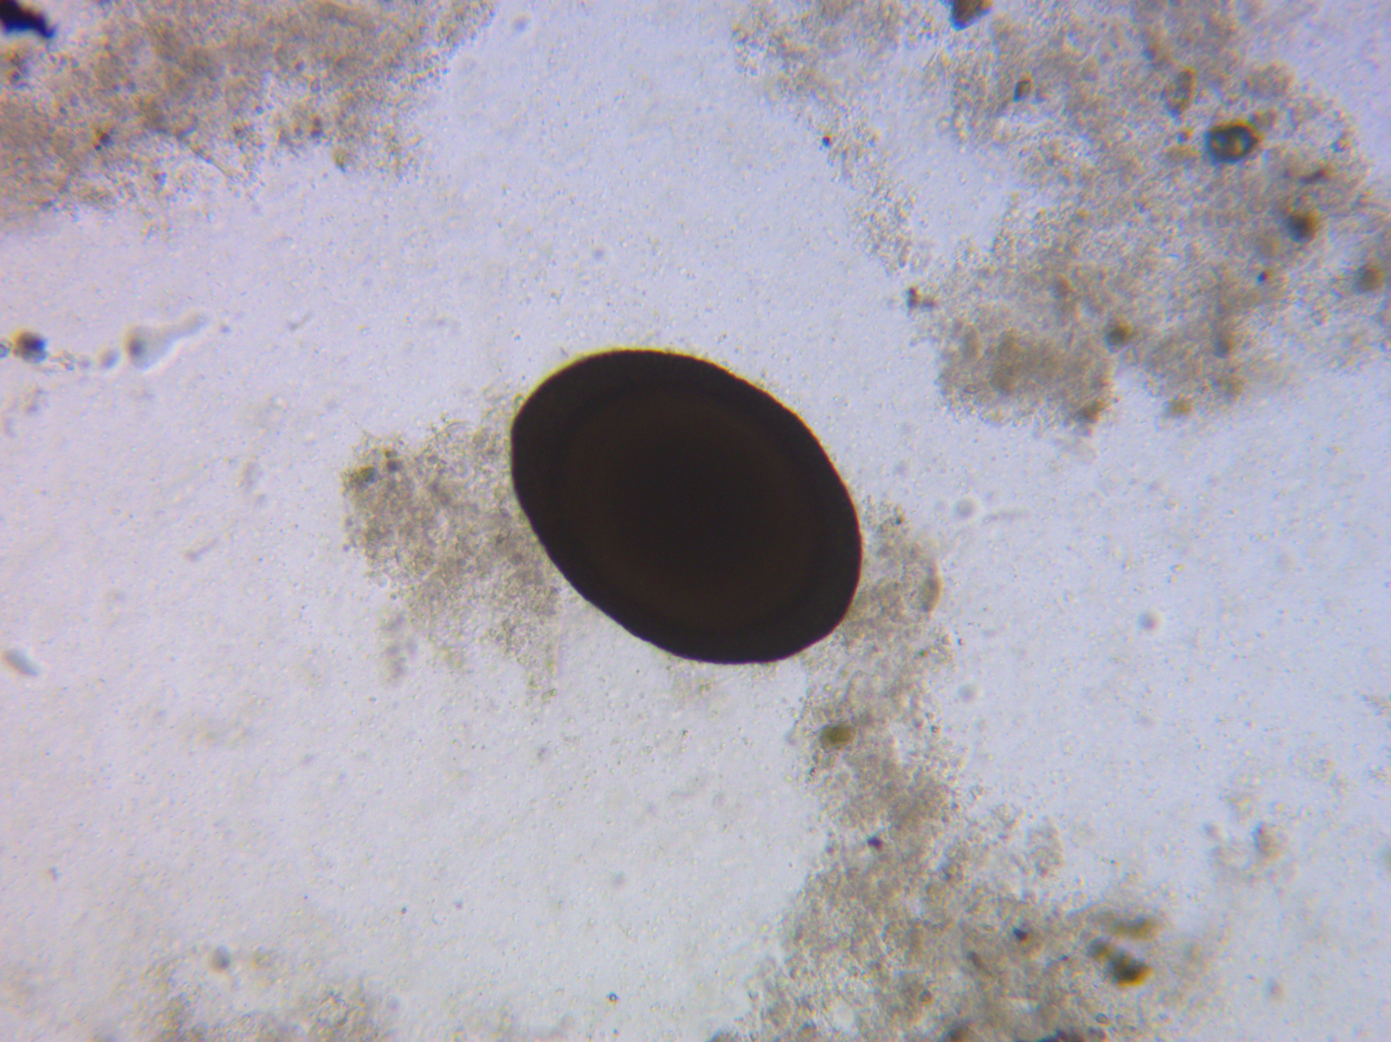
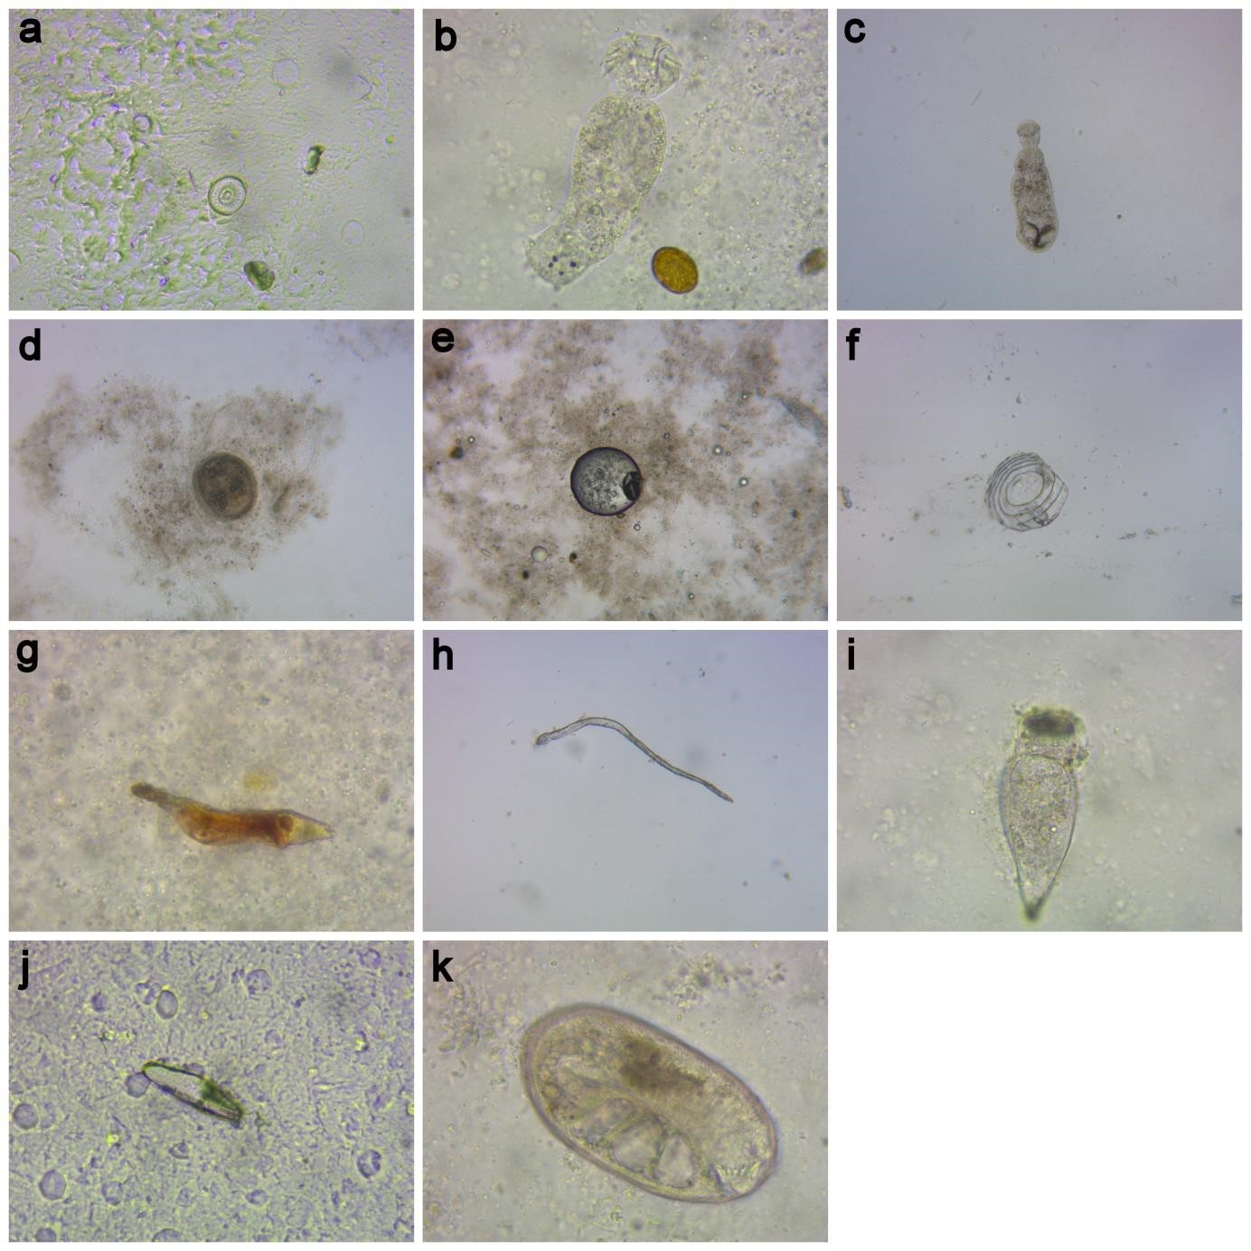
h: Contracaecum i:Metacercariae j: Isospora k: Eimeria)
j
k

Table2
Length and weight of the fish species analysed for parasite infections.
Species | Individuals screened | Infected | Total length (cm) | Weight (gm)
Glossogobius giuris | 17 | 11 (64.7) | 13.55 (12-14.5) | 23.79 (19.26-28.56)
Garra mullya | 18 | 10 (55.55) | 14.02 (10.4-17.3) | 38.71 (16.54-70.2)
Gymnostomus fulungee | 15 | 4 (26.66) | 8.11 (7.2-9) | 6.4 (5.6-8.77)
Sperata seenghala | 15 | 3 (20) | 11.43 (11-11.8) | 8.40 (8.25-8.59)
Puntius sophore | 17 | 8 (47.05) | 9.58 (8.3-10.2) | 6.72 (5.52-7.99)
Labeo Calbasu | 15 | 5 (33.33) | 9.75 (7.8-12.6) | 11.96 (8.22-15.91
Chanda nama | 16 | 9 (56.25) | 5.7 (4.2-6.5) | 4.03 (3.403-4.885
Parambassis ranga | 13 | 8 (61.53) | 5.75 (4.9-6.7) | 2.53 (1.235-3.155)

A total of 317 parasites were recorded in the present study. The highest number of parasites was observed in G. giuris (83) followed by G. mullya (49), and G. fulungee (35; Table 3). Pearson correlation analysis revealed positive association between fish length and the abundance of parasites (r = 0.44, p = 0.0005; Figure 3).

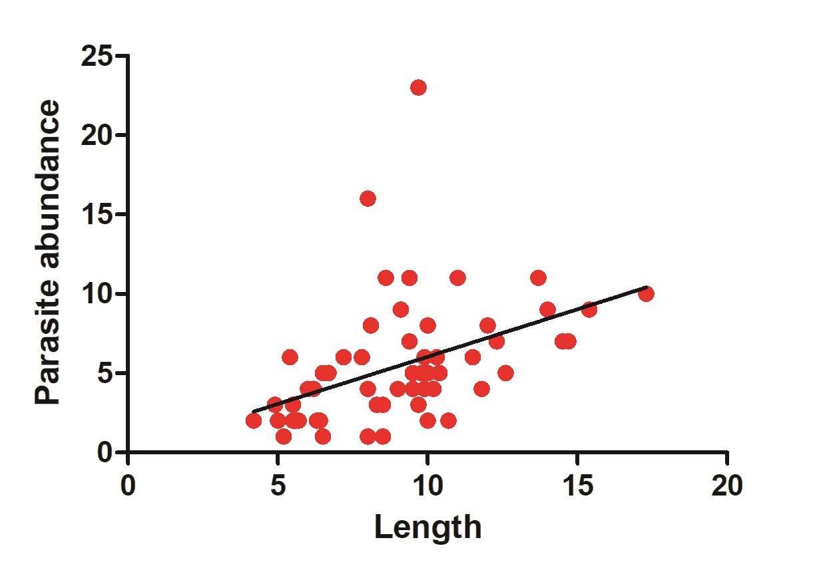
Figure 3 Pearsion correlations of total length of all infected fishes in the present study and the abundance of parasites.
The highest proportion of ectoparasites was observed in G. giuris (68.37%) and S. seenghala (61.90%; Table 3). The lowest proportion of ectoparasites was observed in P. ranga (16%) and C. nama (17.39%). The highest proportion of endoparasites was observed in P. ranga (84%), C. nama (82.60%), Labeo calbasu (60.52%), and Puntius sophore (60.46%; Table 3). The lowest proportion of endoparasites was observed in G. giuris (31.32%) and S. seenghala (38.09%; Table 3)
Table 3 Prevalence of ectoparasites and endoparasites the fishes collected from Pune urban region. Values in the table are number of parasites observed in different fish species and the numbers in the parenthesis are percentile.
Fish species | Total parasites | Ectoparasites | Endoparasites
Glossogobius giuris | 83 | 57 (68.37) | 26 (31.32)
Garra mullya | 49 | 24 (48.97) | 25 (51.02)
Gymnostomus fulungee | 35 | 15 (42.85) | 20 (57.14)
Sperata seenghala | 21 | 13 (61.90) | 8 (38.09)
Punitus sophore | 43 | 17 (39.53) | 26 (60.46)
Labeo calbasu | 38 | 15 (39.47) | 23 (60.52)
Chanda nama | 23 | 4 (17.39) | 19 (82.60)
Parambiassis ranga | 25 | 4 (16) | 21 (84)

The prevalence of parasites varied in different fish species (Table 4). For example, Dactylogyrus was highly prevalent in G. giuris (55.42%) while it was absent in C. nama and P. ranga. Isopora was present in two fishes G. fulungee (5.71%) and P. sophore (6.97%) while Eimeria was present in G. fulungee (8.57%), P. sophore (9.30%), and C. nama (4.34%). The parasites metacercariae, Acanthocephala spp, and Contracaeum spp were present in all fishes. The prevalence of individual parasite in different species of fishes is given in Table 4.

Table 4 Prevalence of parasites in different fish species. Numbers given in the tables are actual numbers of the parasites recorded and the numbers in the parenthesis are percentile.
Parasite | Glossogobius giuris | Garra mullya | Gymnostomus fulungee | Sperata seenghala | Puntius sophore | Labeo Calbasu | Chanda nama | Parambassis ranga
Trichodina | 2 (2.40) | 0 | 3 (8.57) | 2 (9.52) | 0 | 0 | 2 (8.69) | 2 (8)
Dactylogyrus | 46 (55.42) | 15 (30.61) | 6 (17.14) | 2 (9.52) | 10 (23.25) | 8 (23.25) | 0 | 0
Gyrodactylus | 7 (8.43) | 6 (12.24) | 3 (8.57) | 7 (33.33) | 3 (6.97) | 3 (7.89) | 0 | 0
Myxobolus | 7 (8.43) | 6 (12.24) | 9 (25.71) | 0 | 4 (9.30) | 6 (15.78) | 3 (13.04) | 2 (8)
Metacercariae | 5 (6.02) | 12 (24.48) | 1 (2.85) | 5 (23.80) | 8 (18.60) | 10 (26.31) | 6 (26.08) | 4 (16)
Ichtyophthirius multifiliis | 1 (1.20) | 3 (6.12) | 0 | 2 (9.52) | 0 | 3 (7.89) | 2 (8.69) | 1 (4)
Chilodonella | 1 (1.20) | 0 | 3 (8.57) | 0 | 4 (9.30) | 1 (2.63) | 0 | 1 (4)
Isospora | 0 | 0 | 2 (5.71) | 0 | 3 (6.97) | 0 | 0 | 2 (8)
Eimeria | 0 | 0 | 3 (8.57) | 0 | 4 (9.30) | 0 | 1 (4.34) | 0
Acanthocephala | 5 (6.02) | 3 (6.12) | 2 (5.71) | 1 (4.76) | 2 (4.65) | 4 (10.52) | 4 (17.39) | 6 (24)
Contracaecum | 9 (10.84) | 4 (8.16) | 3 (8.57) | 2 (9.52) | 5 (11.62) | 3 (7.89) | 5 (21.73) | 7 (28)

The highest number of gill parasites (57.41%) was recorded in the study followed by intestine (21.45%) and skin (18.29%) parasites (Figure 4A). Tissue specific prevalence of different parasites varied in different fish species (Figure 4B). Gill parasites were abundantly present in all fishes except C. nama and P. ranga. The highest proportion of intestinal parasites was observed in C. nama and P. ranga fishes. Skin parasites were prevalent in S. seenghala and G. mullya (Figure 4).
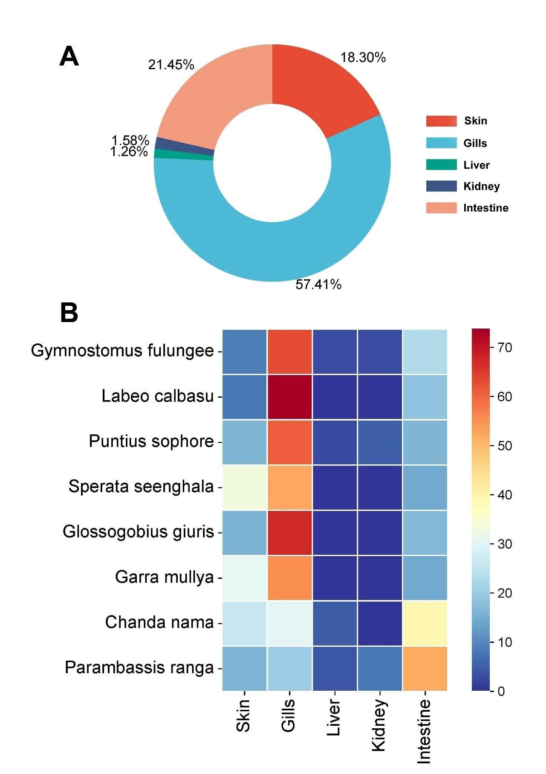
Figure 4 Tissues specific prevalence of total parasites (A). The prevalence of parasites in gills, skin, liver, kidney, and intestine of different fish species (B). Colour bar indicates the percentage of the parasites observed in different tissues of particular fish species.
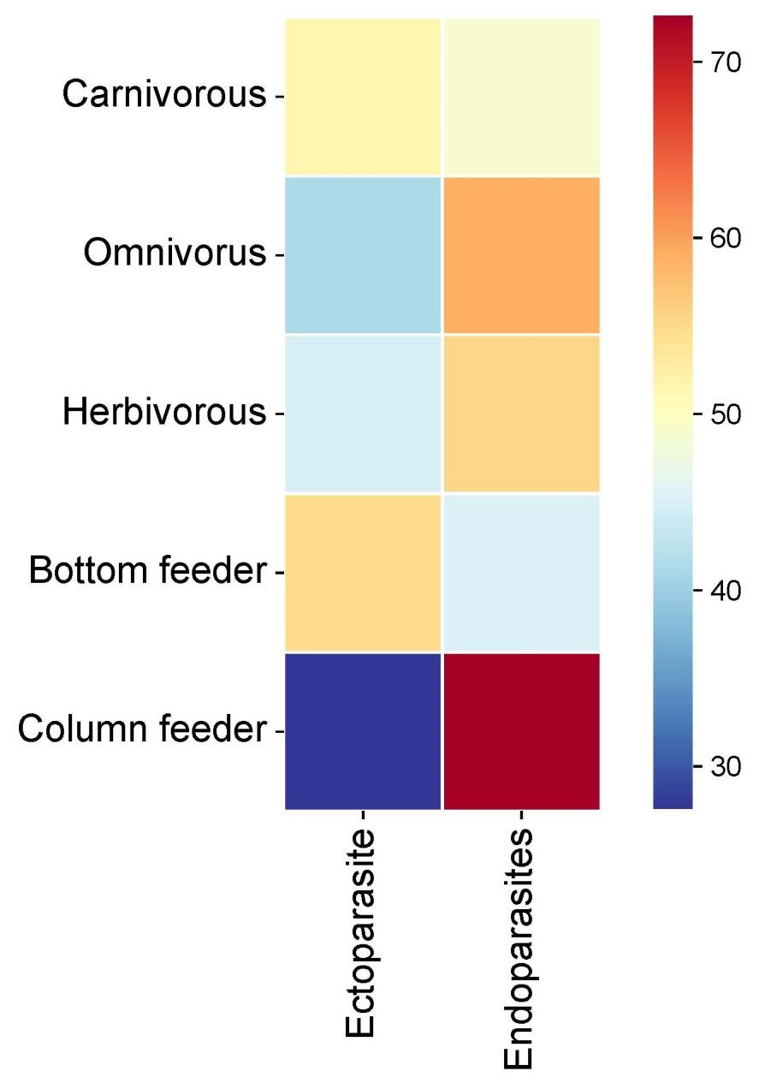

Figure 5 Prevalence of ectoparasites and endoparasites in the fishes at different tropic levels (carnivorous, omnivorous, and herbivorous) and the fishes from different microhabitat (bottom feeder and column feeder).
Colour bar indicates the percentage of the parasites observed in different tissues of particular fish species.

The prevalence of ectoparasite and endoparasites was similar in carnivorous fishes (ꭓ² =0.76, p=0.43 Figure 5).Although the prevalence of endoparasites was low in omnivorous and herbivorous fishes (Figure 5), the difference was not statistically significant (ꭓ² =2.37, p=0.30) The highest prevalence off endoparasite was recorded in in column feeder fishes as compared to bottom feeder fishes Contrastingly, the prevalence of ectoparasite was higher in bottom feeder fishes than column feeder fishes (ꭓ²=19.54,p=0.001 Figure 5)
The highest diversity of parasites was recorded at Aundh fish market where all parasites were present (Table 5). Indrayani River site was represented by only four parasites while SR, GPFM, and DCFM sites were represented by five parasites. The parasite metacercariae was present at all collection sites. The parasites Trichodina, Isospora, and Chiliodonella were present at three sites (Table 5). Details of the collection sitespecific prevalence of parasites are given in Table 5.

 | AFM | VFM | DCFM | MKR | MTR | SR | GPFM | IR
Trichodina | 5 (6.49) | 0 | 0 | 2 (4.16) | 0 | 0 | 4 (14.28) | 0
Dactylogyrus | 13 (16.88) | 11 (22.91) | 0 | 22 (45.83) | 12 (35.29) | 0 | 18 (64.28) | 11 (33.33)
Gyrodactylus | 10 (12.98) | 2 (4.16) | 0 | 11 (22.91) | 6 (17.64) | 0 | 0 | 4 (12.12)
Myxobolus | 13 (16.88) | 0 | 9 (37.5) | 4 (8.33) | 8 (23.52) | 0 | 0 | 3 (9.09)
Metacercariae | 5 (6.49) | 10 (20.83) | 4 (16.66) | 7 (14.58) | 4 (11.76) | 6 (24) | 2(7.14) | 13
Ichthyopthirius multifiliis | 1 (1.29) | 0 | 3 (12.5) | 2 (4.16) | 1 (2.94) | 3 (12) | 0 | 2 (6.06)
Chiliodonella | 3 (3.89) | 2 (4.16) | 5 (20.83) | 0 | 0 | 0 | 0 | 0
Isospora | 3 (3.89) | 2 (4.16) | 0 | 0 | 0 | 2 (8) | 0 | 0
Eimeria | 3 (3.89) | 2 (4.16) | 0 | 0 | 0 | 8 | 1(3.57) | 0
Acanthocephala | 8 (10.38) | 10 (20.83) | 3 (12.5) | 0 | 0 | 3 (12) | 0 | 0
Contracaecum | 13 (16.88) | 9 (18.75) | 0 | 0 | 3 (8.82) | 9 (36) | 3 (10.71) | 0
Table 5 Prevalence of parasite at different locations. Numbers given in the tables are actual numbers of the parasites recorded and the numbers in the parenthesis are percentile. (AFM: Aundh fish market, VFM: vishrantwadi fish market, DCFM: Dange chowk fish market, MLR: Mula river, MTR: Mutha river, SR: Shivganga river, GPFM: Ganesh peth fish market, IR: Indrayani River)

Discussion
The evaluation of parasitic infection in wild, minor fishes, especially from degrading habitats is necessary to understand the impact on public health, parasite-pollution interactions, and urban ecology. In the present study, we evaluated the prevalence of ectoparasites and endoparasites in eight wild minor fishes. We observed a significant variation in the prevalence of parasites in different-sized fishes. We observed a high prevalence and diversity of parasites in large fishes (Garra mullya and Glossogobius giuris) and a low prevalence of parasites in smaller fishes (Parambassis ranga and Chanda nama). Many previous studies have shown a positive association between the abundance/prevalence of the parasite’s host body size (Lo et al. 1998; Oghenochuko et al., 2020; Poulin, 2000, 1999). For example, Lo et al. (1998) reported a high abundance of ectoparasites and endoparasites in the large-sized individuals of three coral-reef fishes. Large surface area in large-sized fishes provides extra space and habitats for parasites to explore resources (Kuris et al. 1980; Poulin, 2007; Sasal et al. 1999). Moreover, the abundance of parasites in different-sized fishes can also be influenced by several factors such as host range, host ecology, host diversity, refugee area, etc. (Guégan et al., 1992; Poulin, 2000).
In the present study, we observed eleven parasites in different body parts. The prevalence of parasites can be tissue-specific as some parasites have adapted to specific microhabitats such as gills and intestine. Monogeneans and copepods parasites infect fish gills using their special attachment structures such as haptor and hooks (Sproston and Hartley 1941; Ramasamy et al. 1985; Buchmann 2002). Trematodes of the Opisthorchiidae family (liver fluke) are typically found in the liver and bile duct of small fishes (Hung et al.
2013). We observed Acanthocephala and Contracaecum (nematode) parasites only in the intestine while

Isospora and Eimeria Protozoan parasites were found in the kidneys. We also observed Eimeria in the liver of Gymnostomus fulungee, Ppuntius sophore, and C. nama. Dactylogyrus parasites were found in gills only while Gyrodactylus were specific to skin. Although the prevalence of some parasites is tissue-specific, many parasites can be found in multiple tissues (Scheifler et al. 2019). For example, blood flukes and Myxosporean parasites can be found in various tissues (Nowak et al. 2021; Yunus et al. 2024; Rahmati‐Holasoo et al. 2025). Moreover, some parasites are specific to host fish species while others are generalists (Randhawa and Burt 2008; Šimková et al. 2022 Šimková, 2024). For instance, Santhosh and Radhakrishnan (2009) showed the presence of one monogenean and three digenean species of parasites specific to single host species of mullet fish. Interestingly, in the same study, a single species of monogenean and two digenean species were found in eight mullet fish species suggesting the differences in the host specificity of parasites (Santhosh and Radhakrishnan, 2009). In the present study, we observed Acanthocephala, Contracaecum, and metacercariae parasites in all fishes. Dactylogyrus and Gyrodactylus parasites were predominantly present in all fishes except P. ranga and C. nama. Intestinal parasites were highly prevalent in P. ranga and C. nama. Both P. ranga and C. nama which are the small fishes evaluated in the present study and have minute transparent scales on their body. Previous studies also reported the low prevalence of ectoparasites in smooth-bodied fishes (Afolabi et al. 2020). We observed high prevalence of ectoparasites, mainly gill parasites in smooth-bodied catfish Sperata seenghala. Contrastingly, Shafiq et al. (2023) reported no infection of parasites in S. seenghala. Interestingly, Batool et al. 2022 reported ectoparasite infections in closely related fish S. sarwari from Pakistan. Host specificity of parasites is determined by several host-associated factors (immune system, developmental stage, genetics, etc.) that can be influenced by environmental factors (Overstreet 1992; Poulin 2007; Randhawa and Burt 2008; Santoro et al. 2020; Willis and Reinke 2022; Ye et al. 2023).
The trophic level and microhabitat of the host can also determine the parasite diversity and abundance (Garrido-Olvera et al. 2012; Kadlec et al. 2003). Moreover, the prevalence of ectoparasite and endoparasite can be partly explained by the host fish diet (Garrido-Olvera et al. 2012). The increase in host tropic levels is associated with parasite abundance (Poulin and Leung 2011; Valtonen et al. 2010). Simková et al. (2001) demonstrated that the prevalence of endoparasites increases from herbivorous to carnivorous fishes. Baia et al. (2018) reported the highest prevalence of parasites, especially endoparasites in carnivorous and omnivorous fishes. Contrastingly, we observed similar proportion of ectoparasites and endoparasites in carnivorous fishes and slightly higher (but not statistically significant) proportion of endoparasites in omnivorous fishes. Endoparasites accumulate in carnivorous and omnivorous fishes through predator-prey interaction (Bell and Burt 1991). Furthermore, Marcogliese (2002) proposed that the fishes in the middle of the food web harbour more endoparasites accumulated through trophic transmission. In the present study, we observed high prevalence of endoparasites in column feeder fishes. Baia et al. (2018) reported the strong association between ectoparasite abundance and length of the host. Interestingly, the prevalence of ectoparasites does not have an influence on the feeding, habitat, and ontogenic changes of the host (Salgado-Maldonado et al. 2016; Valtonen et al. 2010).
The prevalence of fish parasites reflects environmental quality and can serve as biological indicators (Moreira et al. 2015; Taglioretti et al. 2018, Jerônimo et al. 2022 Biswas et al. 2023). Combined parasitic infection and pollution affect the fish population (Bailey et al. 2018). The hydrological properties of urban rivers fluctuate as they receive diverse chemical contaminants (Jain et al. 2022; Sawant et al. 2023). The rivers originating in the northern Western Ghats receive water from the monsoon due to which hydrological properties change significantly (Saha et al. 2022 Ramachandra and Shivamurthy 2023; Liji et al. 2024). The fluctuations in the water flow also have a significant influence on the prevalence of parasites (Kadlec et al. 2003). In the present study, we observed uneven distribution of parasites at collection sites possibly due to differences in the hydrological properties of the waters in different rivers. The fish community in the rivers flowing through Pune city changes in different seasons (Dahanukar et al. 2012; Kharat et al. 2003, 2001). Moreover, sampling locality, seasonal change and local environment can influence the prevalence of fish parasites (Santoro et al. 2020; Vigneault et al. 2025). In the present study, we observed variations in the prevalence of parasites in the fishes collected from different localities. Notably, high parasite diversity was recorded at Aundh fish market that could have influenced by the aggression of specimens from various points along the river or post capture conditions, and this should be considered when interpreting site specific data. Therefore, in continuous monitoring of fish parasites along with water quality parameters in different seasons may provide a better understanding of their prevalence, population dynamics, and host compatibility. Further, the quantity of the fish collected/sold from these urban rivers by local fishermen during different seasons and prevalence of parasites could help in understanding the impact on the public health in the study area.
Conclusion
This study is novel attempt to study fish parasites in fishes from freshwater urban region of Pune. During this study high level of parasite burden found in fish Glossogobius giuris and garra mullya, exhibiting relationship between parasite abundance and host size. High prevalence and diversity of parasite diseases observed among minor wild freshwater fish in polluted urban waterways in Pune. Eleven parasite species found in the gills, skin, liver, kidney, and intestine. Greater parasite burdens were found in larger fish, Glossogobius giuris and Garra mullya, demonstrating a link between host size and parasite abundance. Gill parasites predominated, and feeding patterns had a major impact on parasite distribution, with column feeders having a higher endoparasite frequency and bottom feeders having a larger ectoparasitic infection.
Conflict of Interest
Authors declare no conflict of interest regarding the publication of this article.

COMPETING INTERESTS DISCLAIMER:
Authors have declared that they have no known competing financial interests OR non-financial interests OR personal relationships that could have appeared to influence the work reported in this paper.
Disclaimer (Artificial intelligence)

Author(s) hereby declare that NO generative AI technologies such as Large Language Models (ChatGPT, COPILOT, etc.) and text-to-image generators have been used during the writing or editing of this manuscript.

References
Abbaci S, Mezni A, Brahmia S, Hamouda B, Bensouilah M, AL-mekhlaf FA, Al-Khalifa MS, Wadaan MA,
Boulkenafet F (2023) Assessment of the physiological markers, oxidative stress and neurotoxic effects
of nematode Anisakis sp. on the Luciobarbus callensis (Teleosts, Cyprinids) in northeast of Algeria. J
King Saud Univ Sci 35(1):102386. https://doi.org/10.1016/j.jksus.2022.102386
Afolabi OJ, Olususi FC, Odeyemi OO (2020) Comparative study of African catfish parasites from cultured and
natural habitats. Bull Natl Res Cent 44:163. https://doi.org/10.1186/s42269-020-00419-4
Amer OSA (2014) The impact of fish parasites on human health (Review article). J Egypt Soc Parasitol
44(1):249–274. https://doi.org/10.12816/0006465
Baia RRJ, Florentino AC, Silva LMA, Tavares-Dias M (2018) Patterns of the parasite communities in a fish
assemblage of a river in the Brazilian Amazon region. Acta Parasitol 63(2):304–316.
https://doi.org/10.1515/ap-2018-0035
Bailey C, Rubin A, Strepparava N, Segner H, Rubin JF, Wahli T (2018) Do fish get wasted? Assessing the
influence of effluents on parasitic infection of wild fish. PeerJ 6:e5956. https://doi.org/10.7717/peerj.5956
Banu H, Swain HS, Das PC, Nandanpawar P, Dash SP (2024) First report of Dactylogyrus formosus from India:
A case of co-existence with Paradactylogyrus catlaius causing mass mortality in Indian major carp,
Catla catla. Parasitol Res 123:32. https://doi.org/10.1007/s00436-023-08030-y
Batool T, Abdul Latif A, Sarwar S (2022) Study of various ectoparasites from Sperata Sarwari (Singharee)
obtained from various areas of Lahore, Pakistan. Markhor 3(2):11–14. https://doi.org/10.54393/mjz.v3i02.54
Bell, G, Burt, A (1991) The Comparative Biology of Parasite Species Diversity: Internal Helminths of
Freshwater Fish. The Journal of Animal Ecology 60, 1047-1064. https://doi.org/10.2307/5430 Biswas, J.K, Pramanik, S, Kumar, M (2023). Fish parasites as proxy bioindicators of degraded water quality of
River Saraswati, India. Environ Monit Assess 195, 818. https://doi.org/10.1007/s10661-023-11411-6
Buchmann, K, (2002). Interactions between monogenean parasites and their fish hosts. International Journal for
Parasitol 32, 309–319. https://doi.org/10.1016/S0020-7519(01)00332-0
Chapman, J.M, Kelly, L.A, Teffer, A.K, Miller, K.M, Cooke, S.J (2021). Disease ecology of wild fish:
opportunities and challenges for linking infection metrics with behaviour, condition, and survival. Can.
J. Fish. Aquat. Sci. 78, 995–1007. https://doi.org/10.1139/cjfas-2020-0315
Cong, W, Elsheikha, H.M (2021). Biology, Epidemiology, Clinical Features, Diagnosis, and Treatment of
Selected Fish-borne Parasitic Zoonoses. Yale J Biol Med 94, 297–309.
Dahanukar, N, Paingankar, M, Raut, R.N, Kharat, S.S, (2012). Fish fauna of Indrayani River, northern Western
Ghats, India. J. Threat. Taxa 4, 2310–2317. https://doi.org/10.11609/JoTT.o2771.2310-7
Dash, G, (2012). Freshwater Fish Parasites, 1st ed. ed. New India Publishing Agency, New Delhi.
El-Khayat, H.M.M, Sayed, S.S.M, Mohammed, W.A, Sadek, A.-S.M, (2024). Protozoan and helminths
infestation of Nile tilapia Oreochromis niloticus and its correlation with certain water quality variables along river Nile in the area of Greater Cairo. Environmental Pollution 345, 123459. https://doi.org/10.1016/j.envpol.2024.123459
Fahmy, M, E. Mahmoud, N, R. Mousa, M, M. Zaki, M, Ismael, E, Abuowarda, M, (2021). Influence of Parasite
Infestation and Water Quality Deterioration During Mass Fish Mortality Event in Manzala Lake and its
Corresponding Fish Farms. AAVS 10. https://doi.org/10.17582/journal.aavs/2022/10.5.955.966 Fuentes-Lopez, K, Olivero-Verbel, J, Caballero-Gallardo, K, (2025). Presence of Nematodes, Mercury
Concentrations, and Liver Pathology in Carnivorous Freshwater Fish from La Mojana, Sucre,
Colombia: Assessing Fish Health and Potential Human Health Risks. Arch Environ Contam Toxicol 88,
189–209. https://doi.org/10.1007/s00244-025-01117-w
Galli, P, Crosa, G, Mariniello, L, Ortis, M, D’Amelio, S, (2001). Water quality as a determinant of the
composition of fish parasite communities. Hydrobiologia 452, 173–179. https://doi.org/10.1023/A:1011958422446
Garrido-Olvera, L, Arita, H.T, Pérez-Ponce De León, G, (2012). The influence of host ecology and
biogeography on the helminth species richness of freshwater fishes in Mexico. Parasitol 139, 1652–
1665. https://doi.org/10.1017/S003118201200100X
Guégan, J.F, Lambert, A, Lévêque, C, Combes, C, Euzet, L, (1992). Can host body size explain the parasite
species richness in tropical freshwater fishes? Oecologia 90, 197–204. https://doi.org/10.1007/BF00317176
Guo, C, Li, S, Ke, J, Liao, C, Hansen, A.G, Jeppesen, E, Zhang, T, Li, W, Liu, J, (2023). The feeding habits of
small-bodied fishes mediate the strength of top-down effects on plankton and water quality in shallow subtropical lakes. Water Research 233, 119705. https://doi.org/10.1016/j.watres.2023.119705
Hazarika, A.K, Bordoloi, B, (2022). Ichthyo-parasitological studies in northeastern India. J. Threat. Taxa 14,
21019–21024. https://doi.org/10.11609/jott.7583.14.5.21019-21024
Hernández, D.R, Aichino, D.R, Santinón, J.J, Ruiz Díaz, F.J, Aguilera, J.N, Roux, J.P, Sánchez, S, 2024. Winter
mortality of freshwater fish associated with parasitic infection. Rev. vet. 35, 22–28. https://doi.org/10.30972/vet.3517475
Hung, N., Madsen, H, Fried, B, (2013). Global status of fish-borne zoonotic trematodiasis in humans. Acta
Parasitologica 58. https://doi.org/10.2478/s11686-013-0155-5
Islam, S.I, Rodkhum, C, Taweethavonsawat, P, (2024). An overview of parasitic co-infections in tilapia culture.
Aquacult Int 32, 899–927. https://doi.org/10.1007/s10499-023-01198-1
Ito, E.E, Egwunyenga, A.O, (2024). Impact of water quality and morphometric indices on the spatio-temporal
prevalence of fish endo-parasites and diversity in the Ase River, Niger-Delta, Nigeria. J Parasit Dis 48,
439–449. https://doi.org/10.1007/s12639-024-01668-0
Jain, N., Yevatikar, R, Raxamwar, T.S, 2022. Comparative study of physico-chemical parameters and water
quality index of river. Materials Today: Proceedings 60, 859–867. https://doi.org/10.1016/j.matpr.2021.09.508
Jena, J, Gopalkrishnan, A, Ravishankar, C, Lal, K, Das, P, Panigrahi, A, Shinoj, P, Madhu, V, (2022). Achievements in Fisheries and Aquaculture in Independent India, in: Indian Agriculture after
Independence. Indian Council of Agricultural Research, New Delhi, pp. 168–208.
Jerônimo, G.T, Da Cruz, M.G, Bertaglia, E.D.A, Furtado, W.E, Martins, M.L, (2022). Fish parasites can reflect
environmental quality in fish farms. Reviews in Aquaculture 14, 1558–1571. https://doi.org/10.1111/raq.12662
Kadlec, D, Šimková, A, Jarkovský, J, Gelnar, M, (2003). Parasite communities of freshwater fish under flood
conditions. Parasitol Res 89, 272–283. https://doi.org/10.1007/s00436-002-0740-2
Kharat, S, Dahanukar, N, Raut, R, (2001). Decline of fresh-water fish of Pune urban area. Journal of the
Ecological Society 13–14, 46–51.
Kharat, S, Dahanukar, N, Raut, R, Mahabaleshwarkar, M, (2003). Long-term changes in freshwater fish species
composition in North Western Ghats, Pune District. Current Science 84, 816–820.
Kuris, A.M, Blaustein, A.R, Alio, J.J, 1980. Hosts as Islands. The American Naturalist 116, 570–586.
https://doi.org/10.1086/283647
Liji, T.M, Sreelesh, R, Upendra, B, Sreelash, K, Maya, K, Padmalal, D, (2024). Assessment of the hydro-
geochemical characteristics of a Tropical River catchment in the southern Western Ghats, India. J Earth
Syst Sci 133, 221. https://doi.org/10.1007/s12040-024-02419-8
Lo, C.M, Morand, S, Galzin, R, (1998). Parasite diversity\host age and size relationship in three coral-reef fishes
from French Polynesia. International Journal for Parasitology 28, 1695–1708. https://doi.org/10.1016/S0020-7519(98)00140-4
Marcogliese, D.J, (2002). Food webs and the transmission of parasites to marine fish. Parasitology 124, 83–99.
https://doi.org/10.1017/S003118200200149X
McIntyre, P.B, Reidy Liermann, C.A, Revenga, C, (2016). Linking freshwater fishery management to global
food security and biodiversity conservation. Proc. Natl. Acad. Sci. U.S.A. 113, 12880–12885.
https://doi.org/10.1073/pnas.1521540113
Mofasshali, M.S, Bashar, M.A, Alam, M.M, Alam, G.M, Moumita, D, Mazlan, A.G, Simon, K.D, (2012).
Parasites of Three Indian Minor Carps of Rajshahi, Bangladesh. Asian J. of Animal and Veterinary
Advances 7, 613–620. https://doi.org/10.3923/ajava.2012.613.620
Moreira, L.H.D.A, Takemoto, R.M, Pavanelli, G.C, (2015). Urbanization effects on the host/parasite
relationship in fishes from tributary streams of Pirapó River, Paraná State: assessment of potential environmental bioindicators. Acta Sci. Biol. Sci. 37, 319. https://doi.org/10.4025/actascibiolsci.v37i3.27201
Mustafa, R.A, Rather, S.A, Kousar, R, Ashraf, M.V, Shah, A.A, Ahmad, S, Khan, M.A.H, (2024).
Comprehensive review on parasitic infections reported in the common fish found in UT of Jammu and
Kashmir, India. J Parasit Dis 48, 736–761. https://doi.org/10.1007/s12639-024-01697-9
Mustafa, S.A., Al-Rudainy, A.J., Salman, N.M, (2024). Effect of environmental pollutants on fish health: An
overview. Egyptian Journal of Aquatic Research 50, 225–233. https://doi.org/10.1016/j.ejar.2024.02.006
Nowak, B.F, Dang, M, Webber, C, Neumann, L, Bridle, A, Bermudez, R, Evans, D, (2021). Changes in the Splenic Melanomacrophage Centre Surface Area in Southern Bluefin Tuna (Thunnus maccoyii) Are
Associated with Blood Fluke Infections. Pathogens 10, 79. https://doi.org/10.3390/pathogens10010079
Oghenochuko, O.M., G. N. Ezeri, O., M. Takeet, I, I. Adeosun, F, Disu, I, F. Ogbia, C, (2020). Endo and ecto
parasite prevalence and abundance in some fish species from Akomoje, Ogun River South-west
Nigeria. MJS 39, 1–16. https://doi.org/10.22452/mjs.vol39 no3.1
Ondračková, M, Kvach, Y, Tkachenko, M.Yu, Pravdová, M, Seifertová, M, Bartáková, V, Jurajda, P, (2025). The
role of North American bullhead catfish as parasite reservoirs in central European fishing grounds.
Aquaculture 599, 742100. https://doi.org/10.1016/j.aquaculture.2024.742100
Overstreet, R.M, (1992). Parasitic Diseases of Fishes and Their Relationship with Toxicants and Other
Environmental Factors, in: Pathobiology of Marine and Estuarine Organisms. CRC Press.
Pacheco, J.P, Aznarez, C, Meerhoff, M, Liu, Y, Li, W, Baattrup-Pedersen, A, Yu, C, Jeppesen, E, (2021). Small-
sized omnivorous fish induce stronger effects on food webs than warming and eutrophication in experimental shallow lakes. Science of The Total Environment 797, 148998. https://doi.org/10.1016/j.scitotenv.2021.148998
Patil, P.K, Geetha, R, Mishra, S.S, Abraham, T.J, Solanki, H.G, Krupesha Sharma, S.R, Pradhan, P.K, Manna,
S.K, Avunje, S, Abhinaya, D, Felix, K.T, Vinay, T.N, Paniprasad, K, Paria, A, Raja, S.A, Saraswathy,
R., Sahoo, S.N., Rathod, R., Rameshkumar, P., Baitha, R., Thomas, S., Dev, A.K., Jayanthi, M., Swain, P., Sanil, N.K., Jena, J.K., (2025). Unveiling the economic burden of diseases in aquatic animal food production in India. Front. Sustain. Food Syst. 9, 1480094. https://doi.org/10.3389/fsufs.2025.1480094
Paul, A, Mohanty, J, Rajendran, K.V, Tripathi, G, Sahoo, P.K, (2021). First report of Dactylogyrus scorpius
infection in Indian major carp, Labeo rohita from India: Host specificity and kinetics of immune gene expression in gills. Aquaculture 536, 736453. https://doi.org/10.1016/j.aquaculture.2021.736453
Paul, A, Sahoo, P.K, (2022). Prevalence, molecular identification and host preference of Dactylogyrus, an
ectoparasite in Indian major carps. JEB 43, 536–543. https://doi.org/10.22438/jeb/43/4/MRN-2017
Peel, R.A, Hill, J.M, Taylor, G.C, Weyl, O.L.F, (2019). Food Web Structure and Trophic Dynamics of a Fish
Community in an Ephemeral Floodplain Lake. Front. Environ. Sci. 7, 192. https://doi.org/10.3389/fenvs.2019.00192
Poulin, R, (2007). Evolutionary ecology of parasites, 2nd ed. ed. Princeton university press, Princeton.
Poulin, R, (2000). Variation in the intraspecific relationship between fish length and intensity of parasitic
infection: biological and statistical causes. Journal of Fish Biology 56, 123–137.
https://doi.org/10.1111/j.1095-8649.2000.tb02090.x
Poulin, R, (1999). Body Size vs Abundance among Parasite Species: Positive Relationships? Ecography 22,
246–250.
Poulin, R, Leung, T.L.F, (2011). Body size, trophic level, and the use of fish as transmission routes by parasites.
Oecologia 166, 731–738. https://doi.org/10.1007/s00442-011-1906-3
Puzach, C, (2006). National wild fish health survey-Laboratory procedures manual. 4th ed. U.S. Fish and
Wildlife Service, Onalaska, WI.
Radwan, M, El-Sharkawy, M.A, Alabssawy, A.N, Ghanem, S.F, Mohammadein, A, Al Malki, J.S, Al-Thomali, A.W, Manaa, E.A, Soliman, R.A, Yassir, S, Mekky, A.E, Bashar, M.A.E, Darweesh, K.F, 2023. The synergy between serious parasitic pathogens and bacterial infestation in the cultured Nile tilapia (Oreochromis niloticus): a severe threat to fish immunity, causing mass mortality and significant economic losses. Aquacult Int 31, 2421–2449. https://doi.org/10.1007/s10499-023-01093-9
Rahmati‐Holasoo, H, Marandi, A, Ebrahimzadeh Mousavi, H, Shokrpoor, S, Arabkhazaeli, F, Ziafati Kafi, Z,
2025. Morphological, Histological, and Phylogenetic Characterization of Myxobolus branchioepidermis n. sp. (Myxosporea: Myxobolidae) Infecting the Gills and Skin of the Oranda
Goldfish ( Carassius auratus ). Journal of Fish Diseases 48, e14040. https://doi.org/10.1111/jfd.14040
Ramachandra, T.V, Shivamurthy, V, 2023. Ecohydrological Footprint and Climate Trends in Lotic Ecosystems
of Central Western Ghats. Water 15, 3169. https://doi.org/10.3390/w15183169
Ramasamy, P., Ramalingam, K., Hanna, R.E.B., Halton, D.W, 1985. Microhabitats of gill parasites (Monogenea
and copepoda) of teleosts (Scomberoides spp.). International Journal for Parasitology 15, 385–397. https://doi.org/10.1016/0020-7519(85)90023-2
Randhawa, H.S, Burt, M.D.B, (2008). Determinants of Host Specificity and Comments on Attachment Site
Specificity of Tetraphyllidean Cestodes Infecting Rajid Skates from the Northwest Atlantic. Journal of
Parasitology 94, 436–461. https://doi.org/10.1645/GE-1180.1
Rock, S.L, Watz, J, Nilsson, P.A., Österling, M, (2022). Effects of parasitic freshwater mussels on their host
fishes: a review. Parasitology 149, 1958–1975. https://doi.org/10.1017/S0031182022001226
Saha, A., Paul, T.T, Sudheesan, D, Sharma, S.K, Suresh, V.R, Das, B.K, Manoharan, S, Vijaykumar, M.E,
Samanta, S, Jana, C, (2022). Assessment of Spatial and Temporal Changes in Water Quality of a
Tropical River in Southern Western Ghats, Kerala, India, Using Physicochemical Quality Indices and
Multivariate Analysis. Nat Resour Res 31, 1375–1401. https://doi.org/10.1007/s11053-022-10040-z
Sahoo, A.K, Sadhukhan, D, Meena, D.K, Das, T, Raman, R.K, Udgata, S.K, Shashikala, K.B, Mitra, S, Das, B.K, (2022). Wild fish of aquaculture importance, as new host for isopod Tachaea spongillicola
Stebbing, 1907 infestation with emphasis on prevalence and histopathology: A case report. Aquaculture
547, 737436. https://doi.org/10.1016/j.aquaculture.2021.737436
Sahoo, P., Paul, A, Sahoo, M, Pattanayak, S, Kumar, R, Das, B, (2020). Incidences of Infectious Diseases in Freshwater Aquaculture Farms of Eastern India: A Passive Surveillance based Study from 2014-2018.
Journal of Aquaculture Research & Development 11, 579. https://doi.org/10.35248/2155-
9546.20.10.579
Salgado-Maldonado, G, Novelo-Turcotte, M.T, Caspeta-Mandujano, J.M, Vazquez-Hurtado, G, QuirozMartínez, B, Mercado-Silva, N, Favila, M, (2016). Host specificity and the structure of helminth parasite communities of fishes in a Neotropical river in Mexico. Parasite 23, 61.
https://doi.org/10.1051/parasite/2016073
Santhosh, B, Radhakrishnan, S, (2009). Host-specificity of metazoan parasites infecting mullets of Kerala,
India. Indian Journal of Fisheries 56, 293–296.
Santoro, M, Iaccarino, D, Bellisario, B, (2020). Host biological factors and geographic locality influence
predictors of parasite communities in sympatric sparid fishes off the southern Italian coast. Sci Rep 10,
13283. https://doi.org/10.1038/s41598-020-69628-1
Sasal, P, Trouvé, S, Müller‐Graf, C, Morand, S, (1999). Specificity and host predictability: a comparative
analysis among monogenean parasites of fish. Journal of Animal Ecology 68, 437–444.
https://doi.org/10.1046/j.1365-2656.1999.00313.x
Sawant, R, Deepa A. Joshi, Menon, R, (2023). Case Study on River Pollution of Pune City and Waste
Management. Evergreen 10, 2620–2631. https://doi.org/10.5109/7160918
Scheifler, M, Ruiz-Rodríguez, M, Sanchez-Brosseau, S, Magnanou, E, Suzuki, M.T, West, N, Duperron, S, Desdevises, Y, (2019). Characterization of ecto- and endoparasite communities of wild Mediterranean teleosts by a metabarcoding approach. PLoS ONE 14, e0221475. https://doi.org/10.1371/journal.pone.0221475
Shafiq, A., Abbas, F., Hafeez-ur-Rehman, M., Khan, B.N., Aihetasham, A., Amin, I., Hmidullah, Mothana, R.A., Alharbi, M.S., Khan, I., Khalil, A.A.K., Ahmad, B., Mubeen, N., Akram, M., (2023). Parasite Diversity in a Freshwater Ecosystem. Microorganisms 11, 1940. https://doi.org/10.3390/microorganisms11081940
Shamsi, S, Day, S, Zhu, X, McLellan, M, Barton, D.P, Dang, M., Nowak, B.F, (2021). Wild fish as reservoirs of
parasites on Australian Murray cod farms. Aquaculture 539, 736584. https://doi.org/10.1016/j.aquaculture.2021.736584
Šimková, A, (2024). Host-specific monogeneans parasitizing freshwater fish: The ecology and evolution of
host-parasite associations. Parasite 31, 61. https://doi.org/10.1051/parasite/2024058
Simková, A, Morand, S, Matejusová, I, Jurajda, P.V, Gelnar, M, (2001). Local and regional influences on
patterns of parasite species richness of central European fishes. Biodiversity and Conservation 10, 511–
525. https://doi.org/10.1023/A:1016658427730
Šimková, A, Řehulková, E, Choudhury, A., Seifertová, M, (2022). Host-Specific Parasites Reveal the History
and Biogeographical Contacts of Their Hosts: The Monogenea of Nearctic Cyprinoid Fishes. Biology
11, 229. https://doi.org/10.3390/biology11020229
Sproston, N.G., Hartley, P.H.T, (1941). The ecology of some parasitic copepods of gadoids and other fishes. J.
Mar. Biol. Ass. 25, 361–392. https://doi.org/10.1017/S0025315400054771
Sripa, B., Bethony, J.M., Sithithaworn, P., Kaewkes, S., Mairiang, E., Loukas, A., Mulvenna, J., Laha, T., Hotez, P.J., Brindley, P.J, (2011). Opisthorchiasis and Opisthorchis-associated cholangiocarcinoma in Thailand and Laos. Acta Tropica 120, S158–S168. https://doi.org/10.1016/j.actatropica.2010.07.006
Tadiri, C.P, Fussmann, G.F, Scott, M.E, (2021). Parasite spread in experimental metapopulations: resistance,
tolerance and host competence. Oikos 130, 1562–1571. https://doi.org/10.1111/oik.07837
Taglioretti, V, Rossin, M.A, Timi, J.T, (2018). Fish-trematode systems as indicators of anthropogenic
disturbance: Effects of urbanization on a small stream. Ecological Indicators 93, 759–770.
https://doi.org/10.1016/j.ecolind.2018.05.039
Valtonen, E.T., Marcogliese, D.J, Julkunen, M, (2010). Vertebrate diets derived from trophically transmitted fish
parasites in the Bothnian Bay. Oecologia 162, 139–152. https://doi.org/10.1007/s00442-009-1451-5
Vigneault, J., Binning, S.A, Harvey, É, (2025). Local environment and sampling bias drive parasite prevalence
estimates in freshwater fish communities. Oikos e11196. https://doi.org/10.1002/oik.11196
Vollset, K.W, Lennox, R.J, Skoglund, H, Karlsen, Ø, Normann, E.S, Wiers, T, Stöger, E, Barlaup, B.T, (2023). Direct evidence of increased natural mortality of a wild fish caused by parasite spillback from domestic conspecifics. Proc. R. Soc. B. 290, 20221752. https://doi.org/10.1098/rspb.2022.1752
Willis, A.R., Reinke, A.W., (2022). Factors That Determine Microsporidia Infection and Host Specificity, in:
Weiss, L.M., Reinke, A.W. (Eds.), Microsporidia, Experientia Supplementum. Springer International
Publishing, Cham, pp. 91–114. https://doi.org/10.1007/978-3-030-93306-7_4
Xu, Z, Cao, J, Qin, X, Qiu, W, Mei, J, Xie, J, (2021). Toxic Effects on Bioaccumulation, Hematological
Parameters, Oxidative Stress, Immune Responses and Tissue Structure in Fish Exposed to Ammonia
Nitrogen: A Review. Animals 11, 3304. https://doi.org/10.3390/ani11113304
Yadav, A, Kapoor, N, Jaiswal, N, Malhotra, S.K, (2022). Parasites : futuristic indicators of an altered aquatic environment, in: Advances in Animal Experimentation and Modeling. Elsevier, pp. 441–454. https://doi.org/10.1016/B978-0-323-90583-1.00027-1
Ye, C, Zhang, L, Tang, L, Duan, Y, Liu, J, Zhou, H, (2023). Host genetic backgrounds: the key to determining
parasite-host adaptation. Front. Cell. Infect. Microbiol. 13, 1228206. https://doi.org/10.3389/fcimb.2023.1228206
Yunus, M, Sunarso, A, Wijaya, A, (2024). The characteristic of myxosporean infection in several organs of nile
tilapia cultivation. IOP Conf. Ser.: Earth Environ. Sci. 1292, 012036. https://doi.org/10.1088/1755-
1315/1292/1/012036
Ziarati, M, Zorriehzahra, M.J, Hassantabar, F, Mehrabi, Z, Dhawan, M, Sharun, K, Emran, T.B, Dhama, K.,
Chaicumpa, W, Shamsi, S, (2022). Zoonotic diseases of fish and their prevention and control.
Veterinary Quarterly 42, 95–118. https://doi.org/10.1080/01652176.2022.2080298

