Comparative gross morphology and morphometry study of Pancreas in Persian cats (Felis catus) and French Lop rabbits (Oryctolagus cuniculus)

Abstract:

The purpose of the current research work was to characterize the gross anatomy and morphometry of the pancreas of Persian cats (Felis catus) and French Lop rabbits (Oryctolagus cuniculus). For the study, five healthy adult animal from each species were used. Induction of general anesthesia was performed using the intramuscular administration of xylazine and ketamine: were cat received xylazine at 1 mg/kg and ketamine at 10 mg/kg, where rabbits received at xylazine 5 mg/kg and ketamine at 35 mg/kg. The abdomen of the animals was opened via midline laparotomy, and the Pancras was analyzed with respect to gross anatomy and morphometry. The pancreas was located in the cranial part of the abdomen and exhibited significant associations with the stomach, duodenum, spleen, and other organs in the abdomen. The pancreas of the Persian cat had a compact, well-defined lobulated appearance, which consisted of two lobes – the right and left lobes that were connected by a central portion representing the pancreatic body near the pylorus of the stomach. The right lobe was closely associated with the duodenum while the left lobe was found to extend towards the greater curvature of the stomach and the spleen. The pancreas of the rabbit had a non-compact appearance and was characterized by thin, flattened, scattered diffuse glandular tissues spread within the mesentery that were mostly associated with the duodenum, stomach and spleen. The surface of the pancreas was smooth, soft, and pinkish in appearance. In view of morphometric analysis results, the presence of greater length in the right pancreatic lobe was found in both Persian cats and rabbits in comparison with the left lobe, while the left lobe was relatively wider. The pancreas in Persian cats exhibited an organized form, consisting of right and left pancreatic lobes united by a pancreatic body, being the typical form of the compact pancreas in carnivores. On the other hand, the pancreas in rabbits had a diffuse mesenteric appearance without an organized compact structure present in Persian cats.

Keywords: Pancreas, Persian Cats, French Lop Rabbits, gross anatomy, morphometry, comparative anatomy

Introduction
The pancreas is an important mixed gland in mammals with both exocrine and endocrine functions. The secretory portion represent by (exocrine portion) responsible for secrete digestive enzyme necessary for protein, carbohydrate, and lipid digestion. The endocrine cell, on the other hand responsible for secretes hormones such as insulin and glucagon responsible for regulating glucose homestasis (Dyce et al., 2010; König & Liebich, 2014). This structure is in agreement with the normal description of the pancreas in veterinary histology textbooks (Banks, 1993; Bacha & Bacha, 2012; Eurell & Frappier, 2006).
Embryologically, the pancreas arises from the endodermal lining of the anterior foregut, and the embryological development of the pancreas follows a common pattern amongst mammals. Nonetheless, considerable variation may exist regarding the morphological organization, size, shape, lobation, and positional association of the organ with neighboring abdominal organs within different species. This variation may reflect the unique digestive physiology, body form, and regional anatomy of the species (Eurell & Frappier, 2013; Tsuchitani et al., 2016).
The pancreas of most domestic mammals is often described as comprising two lobes (right and left) joined together by the pancreatic body. Nevertheless, its gross morphology differs among species, ranging from a compact and well-defined gland to diffuse glandular tissue distributed within the mesentery. Therefore, it is critical to have knowlodge of the morphology of pancreas on the veterinary anatomy, clinical interpretation and comparative anatomical studies (Dyce et al., 2010; König & Liebich, 2014).
Comparative studies between the cat and rabbit concerning the pancreas have also shown species-specific variations in pancreatic structure (Al-Kadher & Al-khuzae, 2024).
In cats, The pancreas is often referred to as an organ that is made up of a well-defined and condensed mass with lobes formed predominantly by right and left parts connected by a body of the pancreas. The right part is associated with the duodenum, while the left part is found extending to the stomach and the spleen. This lobulated formation is often seen in carnivorous animals (Evans & de Lahunta, 2012; Al-Saffar & Al-Zuhairy, 2017; König & Liebich, 2020).
In carnivorous such as domestic cats with a diet rich in protein and fat, the exocrine pancreas plays an important role in enzymatic digestion. knowledge of the feline pancreas provides useful basic information for comparative studies (Banks, 2013; Dyce et al., 2010).
In herbivorous pancreas such as of rabbits shows a different gross arrangement. In rabbits, the pancreas is commonly described as a diffuse mesenteric gland, with glandular tissue distributed within the mesentery, particularly in relation to the duodenum and stomach. This arrangement causes rabbit pancreas to appear less compact and makes it harder to distinguish grossly than the feline pancreas (Al-Saffar & Al-Hasnawy, 2014; ; Meredith & Lord, 2014; Maher et al., 2020; Al-Kadher & Al-khuzae, 2024).
Thus, comparison between Persian cats and French Lop rabbits provides a useful model for demonstrating interspecific differences in pancreatic morphology between a carnivorous species and a herbivorous species. In cats, the pancreas is compact, lobated, and relatively well defined, whereas in rabbits it is more diffuse and mesenteric in distribution. These anatomical differences may be related to interspecific variation in digestive strategy, gastrointestinal organization, and topographical relationships of the pancreas with adjacent abdominal organs (Davies & Rees Davies, 2003; Dyce et al., 2010; Tsuchitani et al., 2016).
Therefore, the present study aimed to investigate the gross morphology and morphometry of the pancreas in Persian cats (Felis catus) and French Lop rabbits (Oryctolagus cuniculus), with emphasis on its anatomical position, lobation, topographical relationships, and measurable gross parameters.

MATERIALS AND METHODS
Five healthy animals from each species, including Persian cats (Felis catus) aged (1-2) years and French Lop rabbits (Oryctolagus cuniculus) aged (4-6)months all males, were used in the present study to investigate the gross anatomy and morphometry of the pancreas. The animals were obtained from local sources in Babylon Province, Iraq. All animals were subjected to routine clinical examination before selection to confirm their general health and the absence of systemic or pancreatic disorders. The experimental protocol was approved by the Research Ethics Committee of Al-Qasim Green University, Iraq, under Certificate No. qgec/80/2026, dated 12 April 2026.
General anesthesia was induced by intramuscular administration of xylazine and ketamine. Cats received xylazine at 1 mg/kg body weight and ketamine at 10 mg/kg body weight, whereas rabbits received xylazine at 5 mg/kg body weight and ketamine at 35 mg/kg body weight (Henke et al., 2005). Adequate depth of anesthesia was confirmed by the absence of pedal and palpebral reflexes before exsanguination and euthanasia
After confirmation of deep anesthesia, euthanasia and complete blood drainage, a ventral cervical incision was made in the jugular groove region. The common carotid artery was exposed by careful blunt dissection, isolated, and cannulated. Controlled exsanguination was then performed under deep anesthesia to remove circulating blood and reduce intravascular blood residues.
After euthanasia, the abdominal cavity was opened through a midline abdominal incision. The pancreas was examined in situ, and its anatomical position and topographical relationships with the stomach, duodenum, spleen, liver, and adjacent abdominal organs were recorded. The gross anatomical characterization of the pancreas, including own shape, surface, lobulation include the right lobe, left lobe and pancreatic body, and its relationship with surrounding organs and structure, its done under the degree of studied veterinary anatomical descriptions (Evans & de Lahunta, 2012; König & Liebich, 2020).
Then the pancreas was dissected from the abdominal cavity then from mesentery and adjacent organs. Body weight was measured before dissection of the gland using an electronic balance, and pancreatic weight was measured after removal and trimming of surrounding mesentery. The linear dimensions were determined with the help of a digital caliper. Measurements performed included; body weight, weight of the pancreas, length and width of right and left lobes of the pancreas, and width of the pancreatic body. For each pancreatic lobe, its length was determined by measuring along the greatest axis, whereas its width was measured from the widest part. The pancreas-to-body weight ratio was calculated as pancreas weight (g) divided by body weight (g) multiplied by 100 and expressed as a percentage. Data are presented as means ± SE, and the difference between the two species was analyzed with an independent samples t-test at P < 0.05.

Results
The pancreas of the Persian cat (Felis catus) and French Lop rabbit (Oryctolagus cuniculus) was located in the cranial abdominal region and showed close anatomical relations with the stomach, duodenum, spleen, kidneys, and adjacent abdominal organs. Gross examination revealed clear interspecific differences in pancreatic morphology. In Persian cats, the pancreas appeared as a compact, well-defined gland with distinct lobes, whereas in rabbits, it appeared mainly as a diffuse mesenteric gland scattered within the mesentery.
In Persian cats, the pancreas was made up of three major regions, namely the right lobe, left lobe, and pancreatic body. The pancreatic body served as the point where the right lobe and left lobe met and was found near the pyloric region of the stomach (Fig. 1). The right lobe originated from the pyloric opening of the stomach and continued through the duodenum. It was situated on the right side of the abdomen and adhered to the duodenum. The posterior aspect of the lobe was connected to the liver and right kidney, while the anterior aspect was covered by the colon. The right lobe had an L-shaped appearance, and its terminal part formed a clear hook-like projection (Fig. 2).
Morphometric analysis showed that the mean length and width of the right pancreatic lobe in Persian cats were 71.61 ± 6.06 mm and 31.10 ± 0.28 mm, respectively. The left lobe originated from the pancreatic body and extended toward the left side of the abdominal cavity, reaching the greater curvature of the stomach and splenic region. Its dorsal surface was related to the cranial pole of the left kidney and adrenal gland, whereas its ventral surface was covered by adipose tissue related to the stomach. The left lobe appeared as a relatively straight structure. The mean length and width of the left pancreatic lobe were 57.10 ± 3.89 mm and 41.22 ± 3.35 mm, respectively. These findings indicated that the right lobe was longer than the left lobe, whereas the left lobe was wider than the right lobe (Table 1).
In rabbits, the pancreas appeared as a pinkish, smooth, soft, thin, and flattened gland scattered within the mesentery. It lacked the well-defined compact arrangement observed in Persian cats. The rabbit pancreas was composed of a diffuse mesenteric portion and a more recognizable glandular portion, both of which were located within the abdominal cavity and showed close relations with the adjacent organs .
The diffuse mesenteric portion was very thin, flattened, branched, and closely attached to the mesentery. It appeared light pink to whitish in color and was scattered between the ascending and descending parts of the duodenum, with close attachment to the descending duodenum. This portion represented the right pancreatic lobe in rabbits (Fig. 4). Morphometric analysis showed that the mean length and width of the right pancreatic lobe in rabbits were 60.04 ± 6.34 mm and 5.24 ± 0.47 mm, respectively (Table 1).
The glandular portion of the rabbit pancreas was more easily recognized as a separate part from the surrounding tissues. It appeared as a thin, flattened, ribbon-like structure located along the greater curvature and visceral surface of the stomach, extending between the two ends of the spleen. This portion represented the left pancreatic lobe (fig. 3). The mean length and width of the left pancreatic lobe in rabbits were 46.48 ± 4.29 mm and 7.30 ± 0.49 mm, respectively. The gross and morphometric findings confirmed marked anatomical differences between the compact pancreatic type in Persian cats and the diffuse mesenteric arrangement in rabbits (Table 1).
The general morphometric parameters showed that the mean body weight was 2.465 ± 0.396 kg in Persian cats and 1.007 ± 0.047 kg in rabbits, with a significant difference between the two species. The mean pancreas weight was 6.018 ± 2.034 g in cats and 3.312 ± 1.007 g in rabbits, with no significant difference. The pancreas-to-body weight ratio was 0.237 ± 0.060% in cats and 0.324 ± 0.089% in rabbits, also showing no significant difference between the two species (Table 2).

Table (1): Morphometric measurements of the pancreatic lobes of Persian cats and French Lop rabbits

Animal | pancreatic lobe | Lobe length  (mm)  mean±SE | Lobe width  (mm)  mean±SE
Cats | Right lobe | 71.61 ± 6.06ᵃ | 31.10 ± 0.28ᵃ
 | Left lobe | 57.10 ± 3.89ᵃ | 41.22 ± 3.35ᵃ
Rabbits | Right lobe | 60.04 ± 6.34ᵃ | 5.24 ± 0.47ᵇ
 | Left lobe | 46.48 ± 4.29ᵃ | 7.30 ± 0.49ᵇ
Values are presented as mean ± SE The small letters within the same column indicate significant differences (P < 0.05) between animal species.

Table (2): Morphometric measurements of body weight, pancreas weight, and pancreas-to-body weight ratio in Persian cats and French Lop rabbits.
Animal | Animal weight  (Kg)  mean±SE | Pancreas weight  (g)  mean±SE | pancras-to-body  Weight ratio (%)  mean±SE
Cats | 2.465±0.396ᵃ | 6.018±2.034ᵃ | 0.237 ± 0.060ᵃ
Rabbits | 1.007±0.047ᵇ | 3.312 ± 1.007ᵃ | 0.324 ± 0.089ᵃ
Values are presented as mean ± SE The small letters within the same column indicate significant differences (P < 0.05) between animal species.

Discussion
The gross anatomical findings of the present study showed clear interspecific differences between the pancreas of the Persian cat and the rabbit. In Persian cats, the pancreas appeared as a compact and well-defined gland composed of a right lobe, left lobe, and pancreatic body. This finding agrees with the standard anatomical descriptions of the pancreas in domestic cats and other carnivores, where the gland is described as a compact lobulated organ with distinct lobes joined by a body (Evans & de Lahunta, 2012; König & Liebich, 2020). The position of the pancreatic body adjacent to the pyloric area of the stomach is also agree with the anatomical topographic of the feline pancreas.
The current finding regarding the extent of the right lobe of the pancreas of Persian cats being along the duodenum and adherent to it is in agreement with earlier studies on the anatomy of the right lobe being associated with the duodenal loop and mesoduodenum. In addition, its topographic relationships to the liver, right kidney, and large intestine also reflect the known position of the pancreas in carnivores. Likewise, the left lobe’s projection towards the greater curvature of the stomach and spleen is consistent with earlier studies describing the cat pancreas (Dyce et al., 2010; König & Liebich, 2020).
In morphometry, the right lobe of the pancreas of Persian cats was longer than the left lobe, while the left lobe of the pancreas was wider than the right lobe. These results correlate with the macroscopic anatomy of the pancreas of Persian cats, but shows asymmetry between its lobes. Similar variations in pancreatic lobe sizes have been documented by comparative anatomy studies of domestic animals. However, direct comparison with other studies may be limited because pancreatic measurements can vary according to breed, age, body size, fixation, and method of measurement.
In rabbits, the pancreas appeared as a diffuse, thin, flattened, and mesenteric gland scattered within the mesentery. This finding agrees with previous descriptions of the rabbit pancreas as a diffuse mesenteric organ rather than a compact gland (Al-Saffar & Al-Hasnawy, 2014; Maher et al., 2020). The observation that the right pancreatic lobe was represented by a thin, branched mesenteric part located between the ascending and descending parts of the duodenum is also consistent with earlier reports describing the rabbit pancreas as being distributed within the mesoduodenum and closely related to the duodenal loops. The left pancreatic lobe in rabbits appeared as a more recognizable ribbon-like glandular portion located along the greater curvature of the stomach and extending toward the splenic region. This observation agrees with previous anatomical descriptions that reported the close association of rabbit pancreatic tissue with the stomach, duodenum, spleen, and mesenteric attachments (Al-Saffar & Al-Hasnawy, 2014; Maher et al., 2020). The diffuse arrangement observed in the present study also supports the classification of the rabbit pancreas as a mesenteric type (Al-Saffar & Al-Hasnawy, 2014; König & Liebich, 2020).
The morphometric findings in rabbits showed that the right lobe was longer but very narrow, while the left lobe was shorter and slightly wider. This result agrees with the gross appearance of the rabbit pancreas as a thin and diffuse gland rather than a compact organ (Al-Saffar & Al-Hasnawy, 2014; Maher et al., 2020). Compared with Persian cats, rabbits showed a marked reduction in the width of both pancreatic lobes, which confirms the gross difference between the compact pancreatic type in cats and the diffuse mesenteric pancreatic type in rabbits (Evans & de Lahunta, 2012; König & Liebich, 2020).
In general, the present findings agree with previous anatomical reports that describe the pancreas of carnivores as compact and well-defined, while the rabbit pancreas is diffuse and mesenteric (Evans & de Lahunta, 2012; Al-Saffar & Al-Hasnawy, 2014; König & Liebich, 2020; Maher et al., 2020). This interpretation is also supported by recent comparative observations on pancreatic organization in cats and rabbits (Al-Kadher & Al-khuzae, 2024).
Conclusion
The pancreas of adult domestic cats (Felis catus) and French lop rabbit (Oryctolagus cuniculus) follows the typical mammalian pattern but clear interspecific differences were observed in its gross morphology and morphometric parameters. In Persian cats, the pancreas is compact, well-defined, and composed of a right lobe, left lobe, and pancreatic body, whereas in rabbits, it is diffuse, thin, and mesenteric in arrangement. The right pancreatic lobe is longer in both species, while the left lobe is relatively wider, especially in Persian cats. Morphometric measurements provide baseline anatomical data for pancreatic lobe dimensions and confirm the gross difference between the compact pancreatic type in Persian cats and the diffuse mesenteric pancreatic type in rabbits. These findings may be useful for comparative veterinary anatomy, gross anatomical identification, and future diagnostic or morphometric studies of the pancreas in these species.
The present study had some limitations. First, the study was conducted on a limited number of animals and included only one breed from each species; therefore, the findings may not represent all feline and rabbit breeds. Second, only gross anatomical and morphometric features were evaluated, without histological, histochemical, functional, or radiological assessment. Third, possible variations related to age, sex, breed, and body condition were not fully investigated. Therefore, further studies using different breeds, both sexes, and additional histological, or functional approaches are recommended.

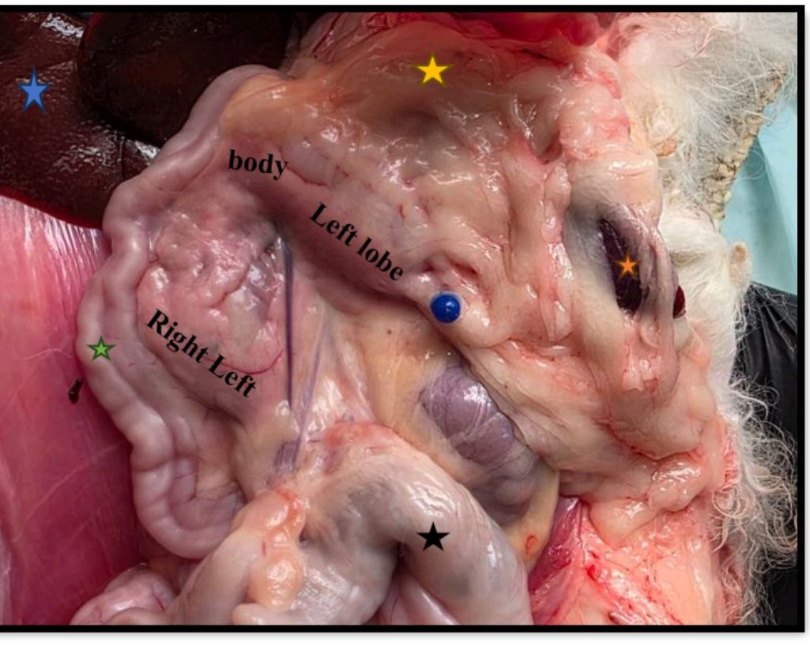
Figure (1): Photomacrograph in abdominal region of adult cat pancreas in situ showing: stomach (yellow star), left pancreatic lobe, pancreatic body, Right pancreatic lobe, ascending duodenum (green star), and spleen (orange star)

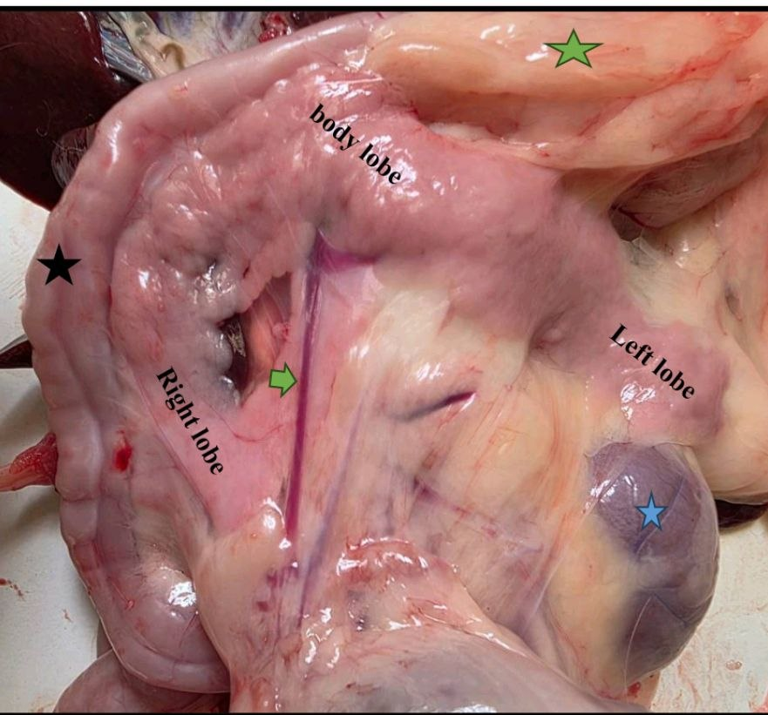
Figure (2): Photomacrograph in abdominal region of adult cat showing the pancreas in situ: stomach (green star), Right pancreatic lobe, pancreatic body, Left pancreatic lobe, Left kidney (blue star), ascending duodenum (black star).

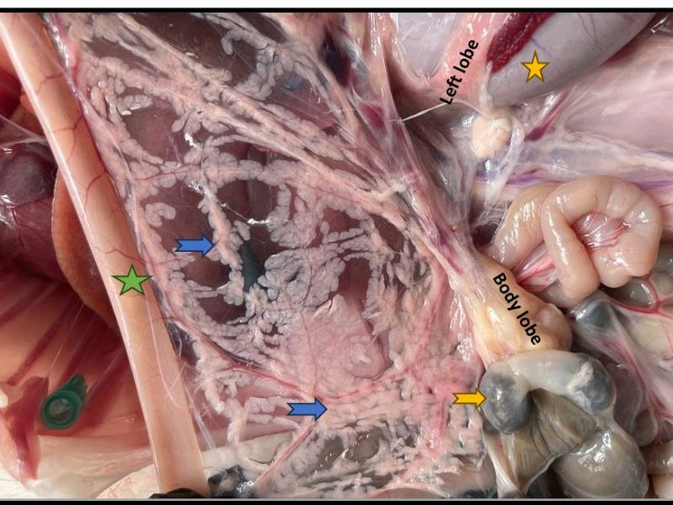
Figure (3): Photomacrograph in the abdominal region of Right lobe of pancreas of adult rabbit showing: stomach (yellow star), Left pancreatic lobe, pancreatic Body (glandular structure), right pancreatic lobe, and ascending duodenum (green star).

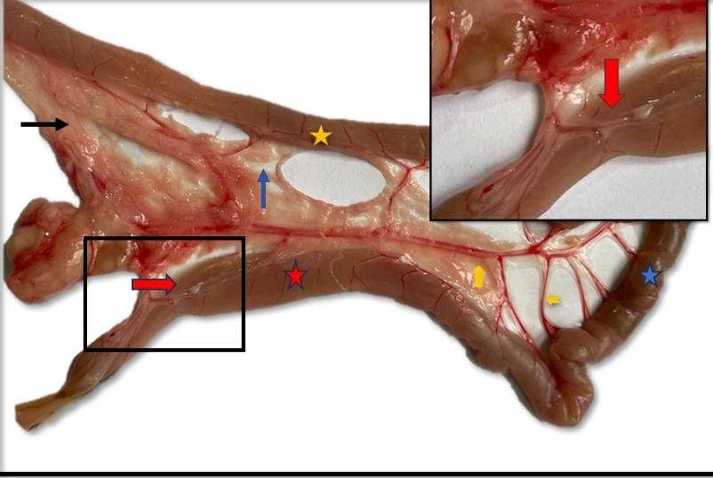

Figure (4): Photomacrograph of the Right pancreatic lobe of an adult rabbit showing: right pancreatic lobe (black arrow), pancreatico-duodenal blood vessels (yellow arrow), ascending duodenum (red star), descending duodenum (yellow star), and transverse duodenum (blue star), mesentery (blue arrow), and major pancreatic duct (red arrow).

COMPETING INTERESTS DISCLAIMER:
Authors have declared that they have no known competing financial interests OR non-financial interests OR personal relationships that could have appeared to influence the work reported in this paper.
Authors have declared that they have no known competing financial interests or non-financial interests or personal relationships that could have appeared to influence the work reported in this paper
Disclaimer (Artificial intelligence)

Author(s) hereby declare that NO generative AI technologies such as Large Language Models (ChatGPT, COPILOT, etc.) and text-to-image generators have been used during the writing or editing of this manuscript.
The authors state that AI-based technologies have been utilized exclusively for language refinement and grammatical corrections. All the scientific material, information, analysis, and final decision on the manuscript lie solely with the authors.
References
- Abdulkhalek, A. S. (2021). Comparative morphohistological study of pancreatic ducts in rabbits and guinea pigs. Egyptian Journal of Veterinary Sciences, 52(2), 139–146. https://doi.org/10.21608/ejvs.2021.51288.1205
- Al-Kadher, Z. S. J., & Al-khuzae, B. A. J. (2024). Histological comparative study of pancreas gland between indigenous rabbit (Oryctolagus cuniculus) and cat (Felis catus domesticus). Obstetrics and Gynaecology Forum, 34(3s), 2272–2277.
- Al-Saffar, F. J., & Al-Hasnawy, A. H. A. (2014). Histomorphological developmental study of advanced postnatal of the pancreas of local rabbit. Journal of Biological Sciences, 14, 387–402. https://doi.org/10.3923/jbs.2014.387.402
- Al-Saffar, F. J., & Al-Zuhairy, M. F. (2017). Postnatal developmental histomorphological and histochemical study of the pancreas in the domestic cat (Felis catus). International Journal of Advanced Research, 5(2), 55–71. https://doi.org/10.21474/IJAR01/3115
- Bacha, W. J., Jr., & Bacha, L. M. (2012). Color atlas of veterinary histology (3rd ed.). Wiley-Blackwell.
- Banks, W. J. (1993). Applied veterinary histology (3rd ed.). Mosby-Year Book.
- Brewer, N. R. (2006). Biology of the rabbit. Journal of the American Association for Laboratory Animal Science, 45(1), 8–24.
- Davies, R. R., & Rees Davies, J. A. E. (2003). Rabbit gastrointestinal physiology. Veterinary Clinics of North America: Exotic Animal Practice, 6(1), 139–153. https://doi.org/10.1016/S1094-9194(02)00024-5
- Dyce, K. M., Sack, W. O., & Wensing, C. J. G. (2010). Textbook of veterinary anatomy (4th ed.). Saunders/Elsevier.
- Eurell, J. A., & Frappier, B. L. (Eds.). (2006). Dellmann’s textbook of veterinary histology (6th ed.). Blackwell Publishing.
- Evans, H. E., & de Lahunta, A. (2012). Miller’s anatomy of the dog (4th ed.). Elsevier Saunders.
- Harkness, J. E., Turner, P. V., VandeWoude, S., & Wheler, C. L. (2010). Harkness and Wagner’s biology and medicine of rabbits and rodents (5th ed.). Wiley-Blackwell.
- Henke, J., Astner, S., Brill, T., Eissner, B., Busch, R., & Erhardt, W. (2005). Comparative study of three intramuscular anaesthetic combinations: Medetomidine/ketamine, medetomidine/fentanyl/midazolam, and xylazine/ketamine in rabbits. Veterinary Anaesthesia and Analgesia, 32(5), 261–270. https://doi.org/10.1111/j.1467-2995.2005.00242.x
- König, H. E., & Liebich, H.-G. (Eds.). (2014). Veterinary anatomy of domestic mammals: Textbook and colour atlas (6th ed.). Schattauer.
- König, H. E., & Liebich, H.-G. (Eds.). (2020). Veterinary anatomy of domestic animals: Textbook and colour atlas (7th ed.). Thieme. https://doi.org/10.1055/b-007-167437
- Maher, M. A., Farghali, H. A. M., Elsayed, A. H., & Reem, R. T. (2020). Gross anatomy and ultrasonography of spleen and pancreas in rabbit (Oryctolagus cuniculus) and cat (Felis catus domesticus). International Journal of Veterinary Science, 9(1), 58–65.
- Meredith, A., & Lord, B. (Eds.). (2014). BSAVA manual of rabbit medicine. British Small Animal Veterinary Association. https://doi.org/10.22233/9781910443217
- Mohammed, Y. A. (2019). Histological and ultrastructural studies of the pancreas of native rabbits (Oryctolagus cuniculus). Iraqi Journal of Veterinary Sciences, 33(2), 371–378. https://doi.org/10.33899/ijvs.2019.163082
- Tsuchitani, M., Sato, J., & Kokoshima, H. (2016). A comparison of the anatomical structure of the pancreas in experimental animals. Journal of Toxicologic Pathology, 29(3), 147–154. https://doi.org/10.1293/tox.2016-0016

