ORIGINAL RESEARCH ARTICLE

CYTOPATHOLOGICAL CHARACTERIZATION OF MALIGNANT PENILE HEMANGIOSARCOMA IN BULLS OF NATIVE BREEDS

ABSTRACT
Clinical presentation varies with tumour location and metastatic spread. Cutaneous lesions typically appear as vascular nodular or diffuse swellings prone to hemorrhage, whereas visceral tumors often present with nonspecific signs such as anemia, weight loss and organ dysfunction, making diagnosis difficult. Two bulls affected with cutaneous hemangiosarcoma were presented to Veterinary Clinical Complex, VCRI, Orathanadu. The Umbalacherry cross bred and non-descript bulls of 14 years and 8 years old, respectively were presented with diffuse hard swelling originating from cranial region of the scrotum till preputial orifice, for past 8 months and 1 year of history, respectively. The swelling had dimensions of approximately 8 × 9 × 6 cm, and encircled the glans penis and body of the penis causing phimosis and paraphimosis signs. The animals were reported to have dysuria due to compression of urethra by the large tumoral mass. Both the cases were subjected to ultrasonography of the preputial swelling. The ultrasonographic findings revealed multiple anechoic cystic cavities and hyperechoic parenchymal masses in the preputial swelling. Hematological examination revealed a leukocytosis with total WBC count elevated to 19.6 × 10³ cells/µL. Samples were collected by Fine needle aspiration cytology (FNAC) in which cytological findings revealed moderate cellularity, blood cells, round, polygonal, or slightly spindle-shaped pleomorphic epithelioid tumor cells arranged as pseudopapillary isolated cells with oval to elongated, vesicular nuclei and mitotic figures. Histopathological examination revealed vascular spaces containing red blood cells lined by elongated, plumpy neoplastic endothelial cells with oval to elongated vesicular nuclei and prominent nucleoli. Based on the above findings, the tumour was diagnosed as cutaneous hemangiosarcomas in bulls of native breeds. They appear frequently in the ventro-abdominal, preputial, and pelvic limb regions in animals. The cutaneous form of penile hemangiosarcoma in the bovine is a rare condition and its prognosis is very poor. As a challenging neoplasm in bulls, accurate earlier diagnosis is required using USG imaging, cytological and histopathological profiling to determine the invasiveness of the cancer.
KEYWORDS: Native breed, Bulls, cutaneous hemangiosarcoma, penile and preputial mass, Diagnostic cytology.
INTRODUCTION
Hemangiosarcoma (HSA) is a highly malignant mesenchymal neoplasm arising from vascular endothelial cells and characterized by aggressive biological behaviour, rapid progression with strong tendency for metastasis. It may develop in any organ due to the ubiquitous distribution of blood vessels, although it predominantly affects the spleen, liver, heart, lungs and skin in domestic animals (De Nardi et al., 2023). Histologically, the tumor is typified by irregular, blood-filled vascular channels lined by pleomorphic, proliferating endothelial cells, often accompanied by haemorrhage and necrosis (Hargis et al., 1992). Among domestic animals, hemangiosarcoma is most frequently reported in dogs, whereas its occurrence in large ruminants, particularly cattle, is exceedingly rare and largely restricted to isolated case reports. Epidemiological observations indicate an extremely low prevalence in bovines, with reports documenting incidences as low as 0.3%–1.5% in surveyed cattle populations (Pereira et al., 2018). This rarity may partly reflect underdiagnosis, early culling practices, and the paucity of comprehensive oncological surveillance in food animals (Vasconcelos et al., 2023). Hemangiosarcoma in cattle occurs in both visceral and non-visceral forms, including cutaneous, subcutaneous and muscular types. Clinical presentation varies with tumour location and metastatic spread. Cutaneous lesions typically appear as vascular nodular or diffuse swellings prone to hemorrhage, whereas visceral tumors often present with nonspecific signs such as anemia, weight loss and organ dysfunction, making diagnosis difficult. Urogenital involvement is extremely rare in bovine hemangiosarcoma, with only sporadic reports affecting the uterus, urinary bladder, and vulvovaginal regions (Warren and Summer, 2007). Penile or preputial hemangiosarcoma is therefore an exceptionally uncommon condition, often leading to functional disturbances such as phimosis, paraphimosis, dysuria, and urethral obstruction due to local invasion (Stephan et al., 2022). Diagnosis remains challenging in large animals. Fine needle aspiration cytology (FNAC) is often inconclusive because of blood contamination and difficulty in identifying neoplastic endothelial cells. Histopathology remains the gold standard, demonstrating irregular vascular channels lined by atypical endothelial cells. Ancillary techniques such as ultrasonography and immunohistochemical markers (CD31, von Willebrand factor) can aid in confirming the diagnosis. Despite advances in diagnostic modalities, the prognosis of hemangiosarcoma in cattle is generally poor due to its aggressive nature, delayed detection and limited therapeutic options (Stock et al., 2011). Early and accurate diagnosis through a combination of imaging, cytology and histopathology is therefore crucial for appropriate case management and prognostication. In this context, the present study aims to describe the cytopathological and histopathological characteristics of malignant penile hemangiosarcoma in bulls of native breed, thereby contributing to the limited literatures on this rare neoplasm in bovines and emphasizing the importance of early diagnostic approaches in such atypical presentations.
MATERIALS AND METHODS
Two bulls of native breeds, aged 14 years (Umbalacherry crossbred) and 8 years (non-descript), were presented to the Veterinary Clinical Complex, Veterinary College and Research Institute, Orathanadu, with a history of progressive preputial swelling of 8 months and 1 year duration, respectively (Fig. 1). The swellings were gradually increasing in size and were associated with difficulty in normal protrusion of the penis and intermittent serosanguineous discharge. Regional lymph nodes were also palpated to evaluate possible enlargement or metastatic involvement. Ultrasonographic examination of the preputial region was performed using a linear transducer to assess the internal architecture, vascular nature and extent of the lesion. Blood samples were collected aseptically from the jugular vein into EDTA-coated vacutainer tubes for hematological evaluation. Hematological parameters, particularly total leukocyte count were analyzed to assess the presence of inflammatory or neoplastic alterations. For cytological evaluation, fine needle aspiration cytology (FNAC) was performed from different regions of the preputial mass using sterile disposable needles and syringes under aseptic precautions. The aspirated material was gently smeared onto clean glass slides, air dried and stained using routine cytological stains for microscopic examination. Cytological assessment was undertaken to identify the cellular morphology, pleomorphism, vascular characteristics and evidence of malignancy associated with the lesion. Representative tissue samples from the affected preputial region were collected by surgical biopsy and immediately fixed in 10% neutral buffered formalin for histopathological examination. The tissues were processed by routine paraffin embedding technique, sectioned at 4–5 µm thickness using a rotary microtome and stained with hematoxylin and eosin (H&E) for microscopic evaluation following standard histopathological procedures described by Bancroft and Layton.
RESULT AND DISCUSSION
The bulls presented with diffuse, firm swelling extending from the cranial scrotal region to the preputial orifice, measuring approximately 8 × 9 × 6 cm, involving the glans penis and body of the penis that resulted in phimosis and paraphimosis. Dysuria was observed due to urethral compression by the tumoral mass. Ultrasonographic examination of the preputial swelling revealed multiple anechoic cystic cavities interspersed with hyperechoic parenchymal areas, indicating a heterogeneous and vascular tumor architecture (Fig. 2). Hematological evaluation showed leukocytosis, with total leukocyte count elevated to 19.6 × 10³ cells/µL. Fine needle aspiration cytology (FNAC) smears revealed moderate cellularity with numerous erythrocytes in the background. The neoplastic cells were arranged in pseudopapillary clusters as well as in isolated forms. The cells were round to polygonal and occasionally spindle-shaped (epithelioid type) with basophilic, vacuolated cytoplasm. Marked malignant features were evident, including anisocytosis, anisokaryosis, binucleation, multinucleation, karyomegaly and frequent mitotic figures. A pale eosinophilic extracellular matrix was also observed (Fig. 3). Histopathological examination of the biopsy revealed irregular and tortuous pseudo-vascular spaces filled with blood, forming cavernous cavities. These spaces were lined by proliferating endothelial-like fusiform cells arranged in erratic streams and, in some areas, forming solid sheets, consistent with a malignant vascular neoplasm (Fig. 4).
Hemangiosarcoma is a malignant neoplasm of endothelial origin characterized by aggressive growth and high metastatic potential. Although widely reported in dogs, its occurrence in cattle is rare, with only sporadic case reports available, indicating a very low prevalence in bovines (Pereira et al., 2018). The present cases therefore contribute valuable data to the limited literature, particularly because of the unusual penile-preputial localization. The clinical presentation observed in the present study were consistent with the oncological nature of hemangiosarcoma. Clinical signs in cattle are generally variable and depend on tumor location, often being nonspecific in visceral forms (Stephan et al., 2022). In contrast to previously reported cases involving visceral organs such as lung, spleen or liver that show systemic signs like weight loss, hemoptysis or reduced productivity , the present cases showed predominantly localized obstructive signs due to external tumor growth (Pereira et al., 2018). This difference emphasizes the role of anatomical site in determining clinical manifestation. Ultrasonographic findings of multiple anechoic cystic spaces with hyperechoic areas observed in this study correlate well with the vascular and hemorrhagic nature of hemangiosarcoma. Similar descriptions of blood-filled vascular spaces and heterogeneous architecture have been documented in vascular tumors reflecting irregular angiogenesis and hemorrhage within the tumor mass (De Nardi et al., 2023). Thus, ultrasonography serves as a useful adjunct tool for identifying the vascular pattern and internal structure of such neoplasms, although it is not definitive. Leukocytosis observed in the present cases is nonspecific and may reflect inflammation, necrosis or secondary infection. In contrast, disseminated hemangiosarcoma in cattle is often associated with more severe hematological changes such as regenerative anemia, thrombocytopenia and hemorrhagic tendencies due to extensive visceral involvement and chronic blood loss (Stock et al., 2011) . These differences likely reflect the localized nature of the present tumors compared to systemic disease.
Cytologically, the presence of pleomorphic endothelial cells arranged in pseudopapillary clusters and isolated forms with vesicular nuclei and mitotic figures is characteristic of malignant vascular tumors (Schultheiss, 2004). However, FNAC often yields hemorrhagic samples with moderate cellularity, making interpretation difficult due to blood contamination. Histopathologically, the findings of irregular blood-filled vascular channels lined by pleomorphic endothelial cells are consistent with classical descriptions of hemangiosarcoma. Similar features, including epithelioid to spindle-shaped endothelial cells and marked nuclear atypia, have been reported in bovine cases confirming the malignant vascular origin of the tumor (Pires et al., 2010). In the current study, the anatomical position of the tumour in the penile/preputial area is very significant. Hemangiosarcoma in cattle has been reported in organs such as the spleen, liver, lungs, and urinary bladder, with vascular tumors of the bovine urinary bladder being well documented, including epithelioid variants showing characteristic endothelial proliferation (Panchal et al., 2023). However, involvement of the external genitalia is extremely rare and poorly documented, indicating that the present cases represent an unusual manifestation and expand the known anatomical distribution of bovine hemangiosarcoma.
CONCLUSION
In conclusion, the present study confirms that hemangiosarcoma in cattle is a rare but highly aggressive vascular neoplasm with variable clinical manifestations depending on the anatomical location and extent of metastasis. The diagnosis was achieved through a combination of clinical examination, ultrasonography, cytology and histopathology with histopathological evaluation serving as the definitive diagnostic tool for confirmation of the vascular origin of the tumor. The neoplasm showed rapid progression and poor clinical outcome, consistent with previous reports in bovines. Although surgical excision may be attempted in localized cases, the prognosis remains guarded to poor because of the infiltrative nature, high metastatic potential and late clinical presentation of the disease. Therefore, early diagnostic evaluation and histopathological confirmation are essential for accurate diagnosis and prognostic assessment of hemangiosarcoma in cattle.
COMPETING INTERESTS DISCLAIMER:
Authors have declared that they have no known competing financial interests OR non-financial interests OR personal relationships that could have appeared to influence the work reported in this paper.
Disclaimer (Artificial intelligence)

Author(s) hereby declare that NO generative AI technologies such as Large Language Models (ChatGPT, COPILOT, etc.) and text-to-image generators have been used during the writing or editing of this manuscript.

REFERENCES
Bancroft, J. D., & Layton, C. (2019). The hematoxylins and eosin. In S. K. Suvarna, C. Layton, & J. D. Bancroft (Eds.), Theory and practice of histological techniques (8th ed.). Elsevier.
De Nardi, A. B., de Oliveira Massoco Salles Gomes, C., Fonseca-Alves, C. E., de Paiva, F. N., Linhares, L. C. M., Carra, G. J. U., Dos Santos Horta, R., Ruiz Sueiro, F. A., Jark, P. C., Nishiya, A. T., de Carvalho Vasconcellos, C. H., Ubukata, R., Batschinski, K., Sobral, R. A., Fernandes, S. C., Biondi, L. R., De Francisco Strefezzi, R., Matera, J. M., Rangel, M. M. M., Dos Anjos, D. S., & Dagli, M. L. Z. (2023). Diagnosis, prognosis, and treatment of canine hemangiosarcoma: A review based on a consensus organized by the Brazilian Association of Veterinary Oncology (ABROVET). Cancers, 15(7), 2025. https://doi.org/10.3390/cancers15072025
Hargis, A. M., Ihrke, P. J., Spangler, W. L., & Stannard, A. A. (1992). A retrospective clinicopathologic study of 212 dogs with cutaneous hemangiomas and hemangiosarcomas. Veterinary Pathology, 29(4), 316–328. https://doi.org/10.1177/030098589202900406
Panchal, J. H., Bhatt, R. H., Raval, R. J., Kalaria, V. A., & Vadalia, J. V. (2023). Diagnosis and surgico-therapeutic management of bovine tumours. Indian Journal of Veterinary Sciences and Biotechnology, 20(1), 70–76. https://doi.org/10.48165/ijvsbt.20.1.15
Pereira, G. O., Carvalho, N. da S., Retamero, P. D., Oliveira, M. C., de Lorenzo, C., Brito, M. de F., & Ubiali, D. G. (2018). Metastatic hemangiosarcoma in a cow. Acta Scientiae Veterinariae, 46, 5. https://doi.org/10.22456/1679-9216.86589
Pires, I., Silva, F., Queiroga, F. L., et al. (2010). Epithelioid hemangiosarcomas of the bovine urinary bladder: A histologic, immunohistochemical, and ultrastructural examination of four tumors. Journal of Veterinary Diagnostic Investigation, 22(1), 116–119. https://doi.org/10.1177/104063871002200124
Schultheiss, P. C. (2004). A retrospective study of visceral and nonvisceral hemangiosarcoma and hemangiomas in domestic animals. Journal of Veterinary Diagnostic Investigation, 16(6), 522–526. https://doi.org/10.1177/104063870401600606
Stephan, F., Sharun, K., Varghese, E., Hamza, P., & George, A. J. (2022). Vulvar and vestibulovaginal hemangiosarcoma in a cow: Morphological and histopathological observations. Iranian Journal of Veterinary Research, 23(4), 375–379. https://doi.org/10.22099/IJVR.2022.43412.6343
Stock, M. L., Smith, B. I., & Engiles, J. B. (2011). Disseminated hemangiosarcoma in a cow. Canadian Veterinary Journal, 52(4), 409–413.
Vasconcelos, J., Pires, M. A., Alves, A., Vieira-Pinto, M., Saraiva, C., & Cardoso, L. (2023). Neoplasms in domestic ruminants and swine: A systematic literature review. Veterinary Sciences, 10(2), 163. https://doi.org/10.3390/vetsci10020163
Warren, A. L., & Summers, B. A. (2007). Epithelioid variant of hemangioma and hemangiosarcoma in the dog, horse, and cow. Veterinary Pathology, 44(1), 15–24.
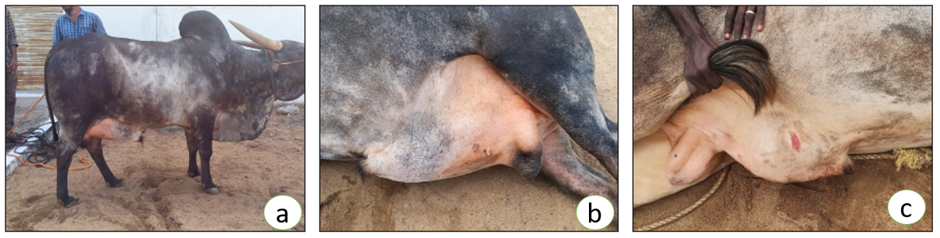
Fig. 1. Preputial swelling observed in affected bulls. (a, b) Umbalachery crossbred bull showing diffuse enlargement of the preputial region; (c) non-descript bull exhibiting similar preputial swelling with associated lesion
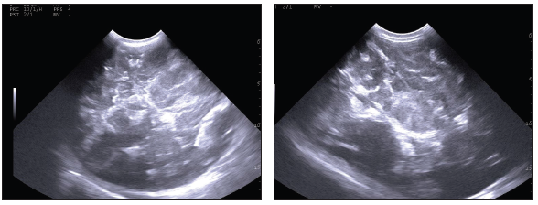
Fig. 2. Ultrasonographic image of the preputial swelling showing multiple anechoic cystic cavities interspersed with hyperechoic parenchymal areas.
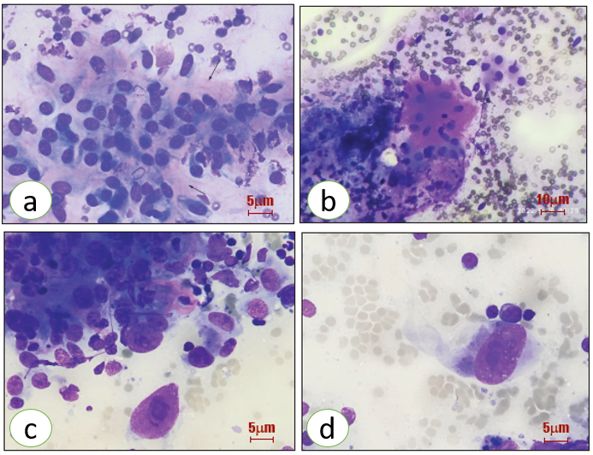
Fig. 3. Cytological features of hemangiosarcoma (HSA) in FNAC smears. (a) Round to polygonal pleomorphic cells with pink homogeneous background material (Giemsa, 400×); (b) Spindle-shaped cells with elongated nuclei in association with blood cells and extracellular matrix (Giemsa, 100×); (c) Marked anisokaryosis and karyomegaly (Giemsa, 1000×); (d) Polygonal pleomorphic cells exhibiting karyomegaly and prominent nucleoli (Giemsa, 1000×)
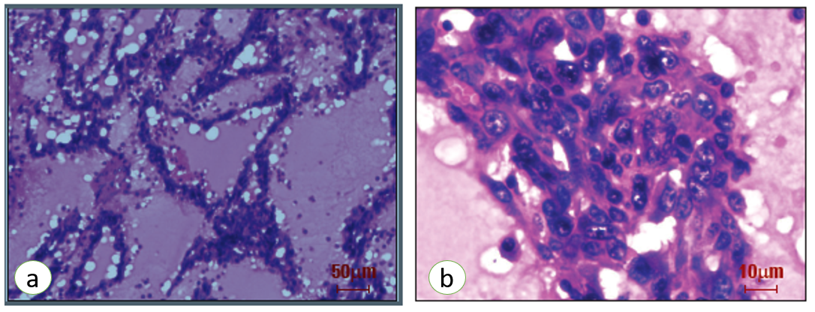
Fig. 4. Histopathological features of preputial hemangiosarcoma in a bull. (a) Numerous blood-filled cavernous pseudo-vascular spaces (H&E, 100×); (b) pseudopapillary proliferation of pleomorphic endothelial cells (H&E, 400×)

