Original Research Article
Proximate Composition of Selected Aquatic Macrophytes from Dandua beel and Their Ecological Significance

Abstract
Aquatic macrophytes play a crucial role in wetland ecosystems by contributing to nutrient cycling, primary productivity, and supporting aquatic food webs. Aquatic macrophytes were collected from selected sites of Dandua beel. Proximate analysis was carried out in the laboratory following standard AOAC protocols. The present study evaluates the proximate composition of selected macrophytes, including Eichhornia crassipes, Pistia stratiotes, Salvinia natans, Lemna minor, Azolla pinnata, Hydrilla verticillata, Vallisneria spiralis, Ceratophyllum demersum, Typha elephantina, Ipomoea aquatica, and Alternanthera philoxeroides collected from Dandua beel. The analysis focused on key nutritional parameters such as moisture, crude protein, lipid, and fibre content to understand their ecological significance and potential application in aquaculture.
The results revealed considerable variation among species, largely influenced by their growth forms and habitat conditions. Free-floating macrophytes exhibited higher moisture content, while emergent and amphibious species showed comparatively higher fibre and protein levels. Notably, Ipomoea aquatica recorded the highest protein content, indicating its suitability as a potential supplementary feed in aquaculture systems, whereas Eichhornia crassipes showed lower protein levels but may contribute indirectly to aquatic productivity through detrital pathways. Submerged species displayed moderate nutrient composition, reflecting environmental constraints such as light availability and nutrient uptake mechanisms.
Overall, the study highlights the importance of aquatic macrophytes as valuable biological resources in wetland ecosystems and their potential role in sustainable aquaculture practices. The findings suggest that selective utilization of nutrient-rich species can enhance fish production while promoting ecological balance in wetland environments.
Keywords: Nutrient analysis, Proximate composition, peak growth season, species specificity,temporal variation

INTRODUCTION
Aquatic vegetation, often referred to as macrophytes, forms a vital component of freshwater ecosystems, particularly within wetlands and floodplain environments. These plants occur in a variety of growth forms, including submerged, floating, and emergent types, and contribute substantially to the structural complexity and functioning of aquatic habitats. By acting as primary producers, macrophytes support food web dynamics, regulate nutrient cycling, and influence the physicochemical characteristics of water bodies. In nutrient-rich tropical systems, their growth is often pronounced, reflecting both the productivity of the ecosystem and its capacity to sustain diverse biological communities (Kumar et al., 2022).
The floodplain wetlands (beels) of Assam represent one such highly productive ecosystem, shaped by the seasonal hydrology of the Brahmaputra River. Periodic flooding and subsequent recession create fluctuating environmental conditions that strongly influence the distribution and abundance of aquatic vegetation. Within these systems, macrophytes serve multiple ecological functions, including sediment stabilization, nutrient retention, and the provision of shelter and breeding habitats for fish and invertebrates. Previous studies have highlighted the positive role of submerged vegetation in maintaining fish diversity and enhancing overall ecosystem functioning in floodplain wetlands (Das et al., 2024; Mandal et al., 2011; Rather et al., 2022).
Beyond their ecological significance, aquatic weeds have attracted attention for their biochemical composition and potential utility. Many freshwater macrophytes contain appreciable levels of proteins, carbohydrates, and lipids, which vary across species and environmental conditions. Such variability is often linked to nutrient availability, seasonal changes, and habitat characteristics. For instance, earlier investigations have documented moderate to high protein content in several wetland plant species, along with measurable quantities of carbohydrates and lipids, suggesting their potential as supplementary feed resources in aquaculture and livestock systems (Mandal et al., 2011; Rather et al., 2022). These attributes also indicate their role in energy transfer within aquatic food webs.
At the same time, the ecological balance maintained by aquatic vegetation can be disrupted when certain species proliferate excessively. Dense growth can reduce light penetration, alter dissolved oxygen regimes, and interfere with water movement, thereby affecting aquatic life. This issue is particularly evident in the spread of invasive species such as Eichhornia crassipes, which has been widely reported in Indian wetlands. Rather than viewing these plants solely as a problem, recent approaches emphasize their controlled utilization, recognizing their potential in nutrient recovery, waste management, and biomass-based applications (Aalam et al., 2022).
Although many studies have reported the diversity and ecological importance of aquatic macrophytes in Indian wetlands, most of the available research has mainly concentrated on large or economically important wetlands, whereas several smaller freshwater wetlands are still poorly documented. In Assam, detailed information on macrophyte diversity, distribution patterns, and ecological roles in many wetlands remains limited. Dandua beel is one such wetland that supports local fisheries, aquatic biodiversity, and the livelihood of nearby communities, yet scientific information on its macrophyte composition is largely unavailable. In recent years, factors such as human interference, nutrient enrichment, habitat alteration, and seasonal environmental changes may have affected the ecological condition of the wetland and its aquatic vegetation. However, the extent and nature of these changes have not been adequately studied. Therefore, documenting the diversity and distribution of aquatic macrophytes in Dandua beel is important for understanding the ecological status of the wetland and for developing suitable strategies for its conservation and sustainable management.
In the specific context of Dandua beel, a floodplain wetland of Assam, aquatic macrophytes play an important role in regulating ecosystem processes and supporting fisheries productivity. The seasonal connectivity of this wetland with surrounding water bodies promotes continuous nutrient exchange and influences vegetation dynamics. Understanding the biochemical composition of these aquatic weeds, particularly in terms of protein, carbohydrate, and lipid content, is therefore essential for evaluating their ecological contribution and exploring their potential applications. This study was based on the assumption that different groups of aquatic macrophytes may vary in their nutritional composition because of differences in their growth habit, environmental conditions, and adaptive characteristics. Submerged, floating, and emergent macrophytes were expected to show noticeable differences in moisture, protein, lipid, ash, and carbohydrate content. In this regard, the present study aims to assess the nutritional composition of selected aquatic macrophytes in Dandua beel, with a view to linking their biochemical properties to wetland productivity and sustainable resource management.
MATERIALS AND METHODS
Collection and Preparation of Samples
Aquatic macrophytes were collected from Dandua beel, a floodplain wetland of Assam, covering different microhabitats to capture representative species diversity. Sampling was carried out at selected locations of Dandua beel following a systematic seasonal sampling design. Samples were collected monthly during the study period covering pre-monsoon, monsoon, post-monsoon, and winter seasons to account for seasonal variation. A total number of 11 macrophytes samples representing different species were collected and analyzed. Species were selected based on their abundance, ecological importance, availability throughout the study period, and relevance to the wetland ecosystem. Representative samples were collected randomly from different parts of the wetland to ensure adequate coverage and minimize sampling bias. The samples were washed thoroughly with tap water followed by distilled water to remove extraneous materials such as sediments and epiphytes. Cleaned samples were shade-dried at ambient temperature until a constant weight was achieved. The dried plant material was then powdered using a laboratory grinder and preserved in airtight containers for biochemical analyses.

Study Area
The study was carried out in Dandua beel of Assam. The Dandua beel is a significant wetland located in the Sadar area of Morigaon District of Assam, with a total area of 52.36 hectares. This is a registered beel under the administrative control of the Assam Fisheries Development Corporation (AFDC), Guwahati and are leased to local fishers’ cooperative society i.e. Meen Somabai Samiti for five-year terms. Samples were collected on the site of Dandua beel in four different stations viz. station 1 (S1), Station 2 (S2), Station 3 (S3) and Station 4(S4) on monthly basis. Samples were collected during morning hours at 6-8 am in the first and second week of every month.

Estimation of Crude Protein
The protein content was determined using the Folin–Ciocalteu method as described by Lowry et al. (1951), with slight modifications to suit plant samples. A known quantity of dried sample was homogenized in buffer solution and centrifuged to obtain a clear extract. The extract was reacted sequentially with alkaline copper reagent and Folin–Ciocalteu reagent, leading to the development of a blue-colored complex. The absorbance was recorded at 660 nm using a spectrophotometer, and protein concentration was calculated using a standard curve prepared with bovine serum albumin (BSA).
The protein content was calculated using the following expression:
$${\text{Protein (mg g}}^{-1}\text{)}=\frac{C×V}{W}$$
Where:
- $C$= concentration obtained from the standard curve (mg mL⁻¹)
- $V$= volume of extract (mL)
- $W$= weight of sample (g)
Estimation of Lipid Content
Total lipid content was estimated by solvent extraction using a Soxhlet apparatus, following the classical method developed by Hans Soxhlet (1879). A known weight of dried sample was extracted with petroleum ether (40–60°C) for several cycles until complete extraction was achieved. The solvent was then evaporated, and the lipid residue was dried to a constant weight.
Lipid content was calculated gravimetrically using the equation:
$$\text{Lipid (\%)}=\frac{W_{2}-W_{1}}{W}×100$$
Where:
- $W_{1}$= weight of empty extraction flask (g)
- $W_{2}$= weight of flask after extraction (g)
- $W$= weight of sample (g)

Estimation of Crude Fibre
Crude fiber content of the samples was determined using the standard acid–base digestion method following established protocols (AOAC, 2019; Van Soest et al., 1991). After digestion, the residual material was dried and subsequently incinerated in a muffle furnace at 500 °C for 3 hours to obtain the ash content. The crude fiber percentage was calculated based on the difference between the weights of the dried residue and the ash residue using the following formula:
$$\text{Crude Fiber (\%)}=\frac{\text{Weight of dry residue}-\text{Weight of ash residue}}{\text{Weight of sample}}×100$$
Estimation of Total Moisture Content
The moisture content of the samples was determined using the standard oven-drying method described by Hart and Fisher (1971). Fresh (wet) samples were placed in pre-weighed, clean, and dry Petri dishes, and the initial weight was recorded. The samples were then dried in a hot air oven at 105°C for 24 hours, or until a constant weight was achieved, ensuring complete removal of moisture.
After drying, the samples were transferred to a desiccator and allowed to cool for approximately 30 minutes to prevent moisture absorption from the atmosphere. The final dry weight was then recorded. The loss in weight during the drying process was considered as the moisture content of the sample.
The percentage moisture content was calculated using the following equation:
$$\text{Moisture (\%)}=\frac{\text{Wet weight of sample}-\text{Dry weight of sample}}{\text{Wet weight of sample}}×100$$
Results and Discussion
Proximate comparision of aquatic macrophytes from Dandua beel is presented in Table 1.
Table 1:Nutrient content analysis of selected Microphytes of Dandua beel of Assam
Plant Name | Crude Protein (%) | Crude Lipid (%) | Crude Fibre(%) | Moisture (%)
Eichhornia crassipes | 6.71±0.17 | 1.89±0.04 | 19.71±0.11 | 85.20±0.21
Pistia stratiotes | 16.18±0.09 | 2.21±0.03 | 15.02±0.12 | 93.52±0.09
Salvinia molesta | 15.78±0.9 | 2.36±0.2 | 20.54±1.2 | 89.67±0.9
Lemna minor | 24.75±1.7 | 1.87±0.3 | 9.81±0.8 | 83.78±1.1
Azolla pinnata | 22.62±1.8 | 2.84±0.5 | 14.65±0.9 | 92.31±1.1
Hydrilla verticillata | 13.45±1.2 | 1.2±0.2 | 18.61±1.2 | 87.21±2.22
Vallisneria spiralis | 14.67±1.2 | 0.92±0.1 | 24.51±1.6 | 83.45±1.5
Ceratophyllum demersum | 15.76±0.8 | 2.1±0.3 | 20.18±1.3 | 79.61±1.8
Typha elephantina | 10.82±0.7 | 1.67±0.2 | 28.26±1.9 | 81.89±1.91
Ipomoea aquatica | 27.31±2.51 | 3.11±0.4 | 14.52±1.4 | 87.51±1.3
Alternanthera philoxeroides | 19.62±2.1 | 2.91±0.4 | 16.61±1.3 | 85.23±1.5

The present study demonstrated noticeable variation in moisture content, ash content, crude protein, crude fiber, and lipid levels among the nine aquatic weed species collected from the three study sites. The results of the proximate composition analysis are summarized in Table 1.
Crude protein

Fig.1:Crude Protein content of the studied plant species
In the present study, crude protein content of aquatic macrophytes ranged from 6.71% to 27.31%, which may be attributed to variations in microhabitat conditions across the sampling sites. The variation in protein content within the same species at different locations can be linked to differences in physicochemical characteristics of the water. Active plant growth promotes the formation of new tissues, thereby enhancing protein accumulation. The highest crude protein content was recorded in Ipomea aquatica species (27.31 ± 2.51%), whereas the lowest value was observed in Eichhornia crassipes(6.71 ± 0.05%)(Fig.1).
The observed variation in crude protein content among the studied macrophytes highlights their differing nutritional value and functional importance in wetland ecosystems, particularly in the context of aquaculture. The highest protein content recorded in Ipomoea aquatica can be attributed to its rapid growth rate, high metabolic efficiency, and ability to absorb nutrients from both sediment and the water column. As an amphibious species, it benefits from better light exposure and carbon availability, which enhances photosynthetic activity and promotes protein synthesis. In contrast, the lowest protein content observed in Eichhornia crassipes may be due to its high moisture and fibre content, which dilutes its overall protein concentration despite its prolific biomass production.
Other macrophytes such as Azolla pinnata and Lemna minor are known to contain relatively high protein levels due to their association with nitrogen-fixing microorganisms and efficient nutrient assimilation mechanisms. Submerged species like Hydrilla verticillata, Vallisneria spiralis, and Ceratophyllum demersum typically exhibit moderate protein content due to limited light penetration and carbon availability in underwater conditions. Emergent and amphibious plants such as Typha elephantina and Alternanthera philoxeroides show variable protein levels depending on nutrient availability and environmental conditions.
From an aquaculture perspective, these differences are highly significant because protein is a key factor influencing fish growth, feed efficiency, and overall health. Macrophytes such as Ipomoea aquatica, Azolla pinnata, and Lemna minor can serve as cost-effective and sustainable alternative feed resources in aquaculture systems. For instance, studies have shown that inclusion of Azolla in fish diets can improve growth performance and nutrient utilization when used at appropriate levels (Rahmah et al., 2022). Similarly, duckweed (Lemna minor) has been reported to enhance growth, immunity, and feed efficiency in cultured fish species, making it a promising substitute for conventional feed ingredients (Song et al., 2026). Moreover, aquatic macrophytes are recognized as rich sources of proteins, essential amino acids, and fatty acids, which are crucial for fish nutrition and cannot be synthesized endogenously (Bakrim et al., 2022).
In addition, the utilization of macrophytes in aquaculture contributes to sustainability by reducing feed costs and recycling nutrients within the system. Floating macrophytes, in particular, can be easily harvested and integrated into fish diets, while also improving water quality by absorbing excess nutrients (Sikarwar, 2025). Therefore, the higher protein content observed in species like Ipomoea aquatica highlights their potential as valuable feed resources, whereas low-protein species such as Eichhornia crassipes may play a more indirect role in supporting detritus-based food chains and ecosystem functioning.

Crude lipid

Fig.2: Crude Lipid content of the studied plant species
In the present study, lipid content varied among aquatic macrophytes across all sampling sites. The highest lipid percentage was recorded inIpomea aquatica (3.11 ± 0.4%), , while the lowest value was observed in Vallisneria spiralis(0.92 ± 0.1%) (Fig.2). Variations in proximate composition among plant species may be attributed to differences in processing methods, soil and water chemistry, species-specific characteristics, and climatic conditions (Conforti et al., 2008).
The higher lipid content observed in Ipomoea aquatica compared to Vallisneria spiralis can be explained by differences in their growth form, physiological characteristics, and nutrient acquisition strategies. As an emergent or amphibious macrophyte, Ipomoea aquatica has direct access to atmospheric carbon dioxide and higher light availability, which enhances photosynthetic efficiency and promotes the synthesis of energy-rich compounds such as lipids. In contrast, Vallisneria spiralis, being a fully submerged species, experiences reduced light penetration and limited carbon availability, which can restrict metabolic activity and lipid accumulation. Additionally, Ipomoea aquatica can utilize nutrients from both the sediment and the surrounding water, thereby supporting greater biochemical production, whereas Vallisneria spiralis primarily depends on sediment-derived nutrients (Reddy and DeBusk, 1985). Recent studies have further shown that differences in macrophyte growth forms significantly influence nutrient uptake efficiency and metabolic processes, with amphibious species often exhibiting higher adaptive capacity under varying environmental conditions (Manolaki et al., 2020). Structural differences also contribute to this variation, as submerged plants tend to invest more in fibrous tissues, while emergent species allocate more resources toward storage compounds such as lipids (Boyd, 1970). Moreover, recent reviews highlight that anatomical and physiological adaptations of aquatic macrophytes play a key role in determining their biochemical composition under different environmental conditions (González-Méndez et al., 2025) . These variations are further influenced by nutrient availability, seasonal growth patterns, and environmental factors (Esteves & Suzuki, 2010).
Crude Fibre

Fig.3: Crude Fibre content of the studied plant species
Crude fibre content varied considerably among the studied macrophytes, with the highest value recorded in Typha elephantina (28.26±1.9) and the lowest inLemna minor (9.81±0.8). This variation may be attributed to differences in plant morphology and ecological adaptations. Aquatic macrophytes generally exhibit lower fibre content compared to terrestrial plants, as reduced structural rigidity is sufficient for survival in aquatic environments where buoyancy is supported by water (Boyd, 1970). Consequently, less investment in fibrous tissues is required, allowing greater allocation of resources toward metabolic and physiological functions (Esteves & Suzuki, 2010).
A comparative analysis of crude fibre content among the selected aquatic macrophytes revealed clear variation across different growth forms and ecological adaptations. Emergent species such as Typha elephantina exhibited relatively higher fibre content, which can be attributed to the presence of well-developed supportive tissues required for vertical growth above the water surface. In contrast, free-floating species including Lemna minor, Pistia stratiotes, Salvinia natans, Eichhornia crassipes, and Azolla pinnata generally showed lower fibre content, as these plants rely on water for buoyancy and therefore require less structural reinforcement. Submerged macrophytes such as Hydrilla verticillata, Vallisneria spiralis, and Ceratophyllum demersum exhibited moderate fibre levels, reflecting a balance between flexibility and minimal structural support necessary for underwater conditions. Amphibious species like Ipomoea aquatica and Alternanthera philoxeroides showed intermediate values, likely due to their ability to adapt to both aquatic and semi-terrestrial environments. Recent studies have highlighted that macrophyte biochemical composition, including fibre content, is strongly influenced by growth form, environmental conditions, and nutrient dynamics, with structural investment decreasing from emergent to submerged and floating species (Manolaki et al., 2020; Bakrim et al., 2022; González-Méndez et al., 2025). These findings support the observed pattern and emphasize the role of ecological adaptation in determining fibre allocation in aquatic plants.

Moisture

Fig.4: Moisture content of the studied plant species
The analysis revealed that the moisture content of the studied macrophytes ranged from 93.52% to 79.61%. The highest moisture content was recorded in Pistia stratiotes (93.52±0.09), followed by Azolla pinnata (92.31±1.1)), whereas the lowest value was observed in Ceratophyllum demersum(79.61±1.8). The generally high moisture content observed across these macrophytes can be attributed to their aquatic habitat and physiological adaptations for maintaining cellular hydration and buoyancy. Similar findings have been reported in previous studies, where aquatic plants typically exhibit high moisture levels due to continuous water availability and efficient water absorption mechanisms (Boyd, 1970; Manolaki et al., 2020; Bakrim et al., 2022).
The variation in moisture content among the studied macrophytes reflects differences in their growth forms, anatomical structure, and ecological adaptations. The highest moisture content recorded in Pistia stratiotes, followed by Azolla pinnata, can be attributed to their free-floating nature. These plants possess soft, spongy tissues with well-developed aerenchyma that facilitate buoyancy and enhance water retention capacity. In contrast, the lowest moisture content observed in Ceratophyllum demersum may be due to its submerged habit and relatively compact tissue organization, which contains comparatively less free water. Other floating species such as Eichhornia crassipes, Salvinia natans, and Lemna minor also exhibited high moisture content, whereas submerged species like Hydrilla verticillata and Vallisneria spiralis showed comparatively moderate values. Emergent and amphibious plants such as Typha elephantina, Ipomoea aquatica, and Alternanthera philoxeroides displayed relatively lower moisture content due to the development of supportive tissues required for aerial exposure. Similar patterns of macrophyte distribution and adaptive variation have been reported from wetlands of Assam, where diverse aquatic plants exhibit distinct structural and ecological traits influenced by habitat conditions and water quality (Kutum et al., 2022; Doimari et al., 2024; Morang and Roy, 2025). These findings support the present observations and emphasize that moisture content in aquatic macrophytes is largely governed by their ecological niche and adaptive strategies within wetland ecosystems.
Conclusion
This study highlights that aquatic macrophytes found in the wetlands of Assam differ notably in their nutritional composition, which reflects their unique biological characteristics and environmental adaptations. The observed variations in moisture, protein, lipid, ash, and fiber content indicate that each species plays a distinct role within the wetland ecosystem.
Macrophytes with relatively higher protein and lipid content can act as important natural food sources for fish and other aquatic organisms, while those with higher fiber and mineral content contribute to decomposition processes and nutrient recycling. The generally high moisture content of these plants also supports microbial activity and helps maintain the overall ecological balance of wetland environments.
These findings underline the ecological importance of aquatic macrophytes as key components in energy flow, nutrient dynamics, and habitat formation. In addition, their capacity to absorb and store nutrients suggests that they may be useful in managing water quality and controlling pollution through natural means.
In conclusion, aquatic macrophytes are not only essential for maintaining the health and productivity of wetland ecosystems but also hold potential for sustainable utilization. Protecting and managing these plant communities is therefore crucial, especially in regions where wetlands are increasingly affected by human activities. Further research on seasonal changes and their interactions within the food web would help in better understanding their overall ecological role.
Acknowledgements
Authors are thankful to HOD, FRM Division and Dean, College of Fisheries, Assam Agricultural University, Raha for providing all the necessary facilities needed for conducting the study.
Compliance With Ethical Standards
Authors’ Contributions:
This research includes Ph.D. thesis work of first author. The chronology of author list reflects the contribution level of different author
Conflict of Interest
The authors declare that there is no conflict of interest.

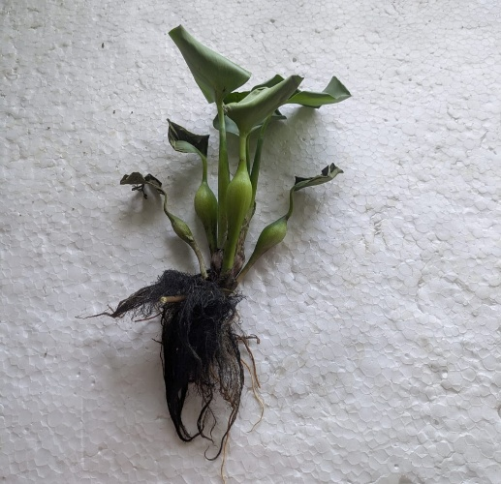
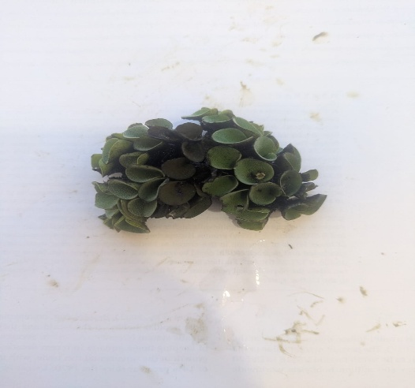
Salvinia natans
Eichhornia crassipes

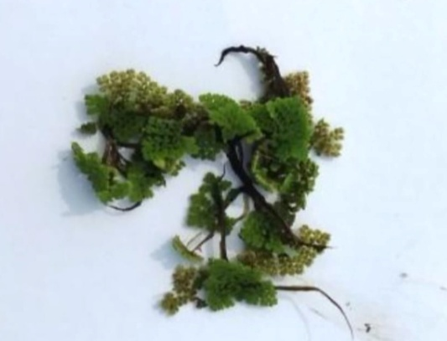
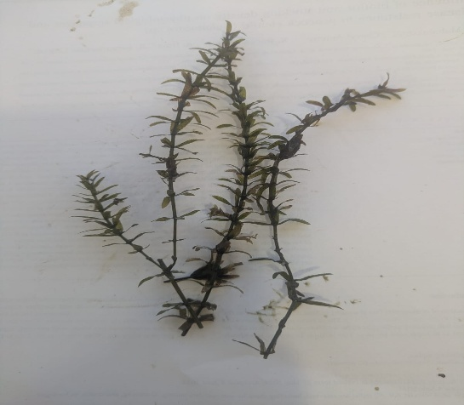
Hydrilla verticillata
Azolla pinnata

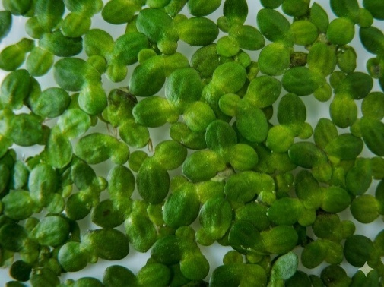
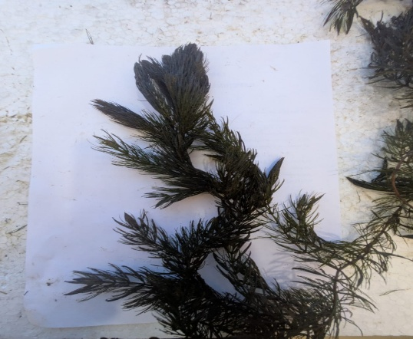
Ceratophyllum demersum
Lemna minor
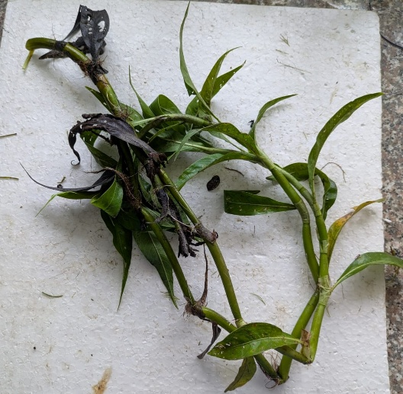
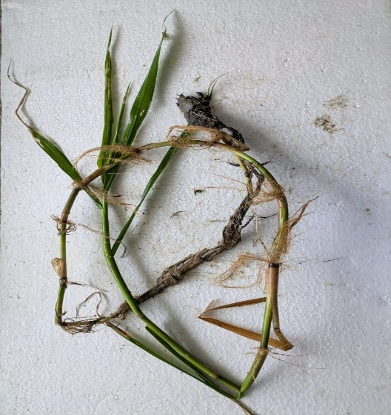
Typha elephantina
Ipomoea aquatica

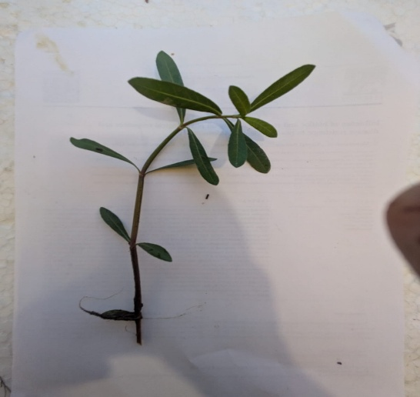
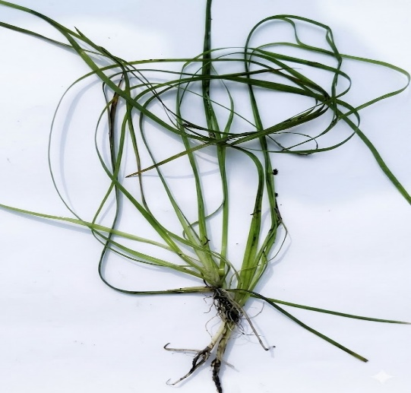
Vallisneria spiralis

Alternanthera philoxeroides
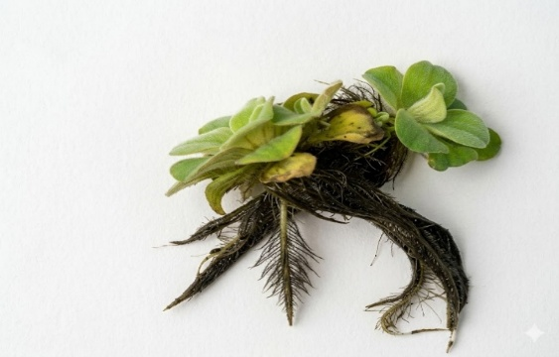
Pistia stratiotes
Plate 1. Collected Aquatic Macrophytes

Disclaimer (Artificial intelligence)
Author(s) hereby declare that NO generative AI technologies such as Large Language Models (ChatGPT, COPILOT, etc.) and text-to-image generators have been used during the writing or editing of this manuscript.

REFERENCES
- Aalam, T., Arias, C. A., & Khalil, N. (2022). Physicochemical and biological contribution of native macrophytes in constructed wetlands. Recycling, 7(1), 8
- Association of Official Analytical Chemists (AOAC). (2019). Official methods of analysis (21st ed.). AOAC International, Rockville, MD, USA
- Bakrim, W., Nurcahyanti, A. D. R., Dmirieh, M., El Omari, N., Errachidi, F., & Bnouham, M. (2022). Chemical composition and therapeutic potential of aquatic plants: A review. Frontiers in Pharmacology, 13, 869425.
- Boyd, C. E. (1970). The role of vascular aquatic plants in removing mineral nutrients from polluted waters. Economic Botany, 24(1), 95–103
- Conforti, F., Sosa, S., Marrelli, M., Menichini, F., Statti, G.A., Uzunov, D., Tubaro, A., Menichini, F., Loggia, R.D. (2008). In vivo anti-inflammatory and in vitro antioxidant activities of Mediterranean dietary plants. Journal of Ethnopharmacology, 116, 144-151
- Das, B. K., Manna, R. K., Kumari, S., Lianthuamluaia, & Majhi, P. (2024). Role of aquatic macrophytes in controlling fish diversity of wetlands. Advances in Agricultural Technology & Plant Sciences, 7(2), 1–7.
- Doimari, R., Boro, S., & Kalita, M. (2024). Distribution and ecological role of aquatic macrophytes in relation to water quality in Assam wetlands. Journal of Environmental Biology, 45(1), 45–53
- Esteves, F. A., & Suzuki, M. S. (2010). Influence of environmental factors on aquatic macrophytes in tropical wetland ecosystems. Brazilian Journal of Biology, 70(3), 601–612
- González-Méndez, L. M., Martínez-Amador, S. Y., Ríos-González, L. J., Pérez-Rodríguez, P., Perez-Rodríguez, M. A., Reyes-Acosta, A. V., & Rodríguez-De la Garza, J. A. (2025). A review on anatomical and physiological traits of aquatic macrophytes coupled to bioelectrochemical systems. Processes, 13(5),1545
- Hart, F. L., & Fisher, H. J. (1971). Modern food analysis. Springer-Verlag. (pp. 45–48).
- Kumar, G., Sharma, J. G., Goswami, R. K., Shrivastav, A. K., Tocher, D. R., Kumar, N., & Chakrabarti, R. (2022). Freshwater macrophytes: A potential source of minerals and fatty acids for fish, poultry, and livestock. Frontiers in Nutrition, 9, 869425.
- Kutum, A., Bhattacharjee, S., & Deka, P. (2022). Assessment of aquatic macrophyte diversity and their ecological significance in selected wetlands of Assam, India. International Journal of Ecology and Environmental Sciences, 48(2), 123–132
- Lowry, O. H., Rosebrough, N. J., Farr, A. L., & Randall, R. J. (1951).
Protein measurement with the Folin phenol reagent. Journal of Biological Chemistry, 193(1), 265–275.
- Mandal, R. N., Datta, A. K., Sarangi, N. and Mukhopadhyay, P. K. (2011). Diversity of aquatic macrophytes as food and feed components to herbivorous fish – A review. Indian Journal of Fisheries, 57(3), 65–73.
- Manolaki, P., Mouridsen, M. B., Nielsen, E., Olesen, A., Jensen, S. M., Lauridsen, T. L., Baattrup-Pedersen, A., Sorrell, B. K., & Riis, T. (2020). A comparison of nutrient uptake efficiency and growth rate between different macrophyte growth forms. Journal of Environmental Management, 274,111181
- Morang, A., & Roy, D. (2025). Seasonal variation of aquatic vegetation and its relationship with physicochemical parameters in floodplain wetlands of Assam, India. Environmental Monitoring and Assessment, 197,112
- Rahmah, S., Nasrah, U., Lim, L. S., Ishak, S. D., Rozaini, M. Z. H., & Liew, H. J. (2022). Aquaculture wastewater-raised Azolla as partial alternative dietary protein for Pangasius catfish. Environmental Research, 208,112718
- Rather, Z. A., Sharma, P., & Dar, N. A. (2022). Macrophytes and their nutrient content analysis: A study of Dal Lake, Kashmir. Sustainability and Biodiversity Conservation,1(1), 12-24.
- Reddy, K. R., & DeBusk, W. F. (1985). The potential of selected aquatic macrophytes for nutrient removal in aquatic systems. Journal of Environmental Quality, 14(4), 459–462.
- Sikarwar, A. S. (2025). Application of aquatic macrophytes in aquaculture: A review on aquatic macrophytes in aquafeed and their effects on fish. Journal of Aquaculture Research & Development, 16(1), 948
- Song, Y., Hu, Z., Yang, X., An, Y., & Lu, Y. (2026). Duckweed as a sustainable aquafeed: Effects on growth, muscle composition, antioxidant and immune markers in grass carp. Animals, 16(1), 53
- Soxhlet, F. (1879). The gravimetric determination of fat.Dingler’s Polytechnisches Journal, 232, 461–465
- Van Soest, P. J., Robertson, J. B., & Lewis, B. A. (1991). Methods for dietary fiber, neutral detergent fiber, and nonstarch polysaccharides in relation to animal nutrition. Journal of Dairy Science, 74(10), 3583–3597

