Original Research Article

Metazoan Parasite Assemblages in Oriental Flying Gurnard Dactyloptena orientalis (Cuvier, 1829) From Kerala, Southwest Coast of India

ABSTRACT
The Oriental flying gurnard, Dactyloptena orientalis (Cuvier, 1829) (Dactylopteridae), of southwest coast of India were examined for metazoan parasites. These by-catch species are beneficial in studying benthic ecosystem dynamics and are also utilised as a raw material in fish meal industry. Reports on parasites of this species are scarce. The main objective of this study was to investigate and document the diversity, prevalence, and intensity of metazoan parasite assemblages infecting the Oriental flying gurnard, Dactyloptena orientalis, collected from the southwest coast of India (Kerala). During the present study, 42 fishes were examined for metazoan parasites. The study examined metazoan parasites using standard parasitological techniques, including microscopic analysis, staining, mounting, and taxonomic identification following established literature and WoRMS guidelines. Altogether six species of parasites were encountered from infected fishes, with an overall prevalence of 95.2%; comprises of two species of digenea, Anisoporus orientalis and Stephanostomum sp. (larval stage); one each of monogenea, Amphibdelloides sp.; nematode, Hysterothylacium sp. (larval stage); acanthocephala, Serrasentis sp. and Praniza larvae, Gnathia sp. Among the total 1983 parasites collected, monogenea was the most prevalent parasite (71.4%). The present report forms the first record of Anisoporus orientalis and Praniza larvae from the southwest coast of India. The Acanthocephala Serrasentis sp. forms a new host record, and the generic diagnosis of the monogenea, Amphibdelloides is proposed to emend as “Parasites of fishes” instead of “Parasites of elasmobranchs” as given by Yamaguti (1963). A detailed long-term study of metazoan parasites of D. orientalis along the maritime states of India would likely reveal additional new taxa and provide further insights into infection dynamics in marine ecosystems.

Keywords: Metazoan parasites, Oriental flying gurnard, Dactyloptena orientalis, prevalence, mean intensity

- INTRODUCTION
The Oriental Flying gurnard, Dactyloptena orientalis (Cuvier, 1829) (Dactylopteridae), is found throughout the tropical waters of the Indo-Pacific oceans at depths of 10 to 100m. The family Dactylopteridae is largely found in tropical and subtropical seas and is of limited commercial importance (Mahé et al., 2013). Members of this family, commonly known as flying gurnards or helmet gurnards, are characterised by their elongated, fan-shaped pectoral fins and heavily armoured bodies; however, they do not exhibit true flight for locomotion. Dactyloptena orientalis species has attracted considerable attention from ichthyologists and ecologists due to its distinctive morphology and behaviour (Ray et al., 2024). The body is characterised by having a box-like body with wing-like pectoral fins. Adults are marine, inhabit benthic waters with sandy substrates (Nelson et al. 2016). They are solitary, well camouflaged and slow movers, which feed on small fishes, bivalves and crustaceans. They can reach upto 40cm in length (Froese and Pauly, 2026). Although flying gurnard are not utilised as food fish, they constitute an important link in the transfer of energy through the marine food web (Roul et al., 2016; Karuppasamy et al., 2018, 2022; Nihal et al., 2024). The species constitute a source of raw material for the fish meal industry.

Few reports are available on the metazoan parasites of this species worldwide. Indian reports on parasites of Dactyloptena orientalis are those of Unnithan (1972) Shahul Hameed (1977), Vijaya Raju and Hanumanth Rao (1978), Madhavi (1979) and Uma Devi and Shyamasundari (1981). From New Zeland coast, Brunson (1956) reported two species of nematodes from spotted gurnard, Lepidotrigla brachyoptera. Tong (1984) reported a digenetic trematode, Anisoporus cobraeformis from Daicocus peterseni along the Chinese coast. A monogenean parasite, Protancyrocephalus strelkowi was reported by Dyer et al. (1989) from Dactyloptena orientalis off Okinawa coast, Japan. Cordeiro and Luque (2005), reported 15 species of digeneans, 4 nematodes, 2 each of cestodes and acanthocephalans and 1 each of monogenea, branchiuran, aspidogastrean and isopod from D. volitans along Brazilian coast. El-Labadi et al. (2006) also reported a new genus Tormopsolus; a digenetic trematode from D. peterseni off Red sea. From D. pterseni, a copepod species, Caligus dactylus was reported by Ho et al. (2007) along Taiwan waters. The present paper reports on the occurrence of metazoan parasite assemblages in Oriental flying gurnard, Dactyloptena orientalis along southwest coast of India.

- MATERIALS AND METHODS
A total of 42 fishes were collected from November 2021 to July 2022 from Neendakara and Sakthikulangara regions of Arabian sea (8° 56’19.18” N 76° 32’25.19” E). The collected fishes were iced properly and were brought to the laboratory for further parasitological examination. Individual fishes were weighed (18.7 – 322.4 g), measured (TL, 98 -177 mm) and examined for metazoan parasites. Sex of the fish was noted during parasitological dissections. Methods suggested by Kennedy (1979) were followed for parasitological studies. Dissected body parts were examined with hand lens, and later on under a stereo dissecting microscope (SDM – Olympus stereozoom SZ-ST), and with a high-power transmission light microscope (TLM-Olympus TRM BX50). The isolated parasites were appropriately preserved. Wherever necessary, stained and whole mounts were prepared. Camera lucida sketches were made, and measurements were taken by using a calibrated ocular micrometer.
All encountered parasites were identified to the lowest taxon possible, and were evaluated through WoRMS (2026). Parasite identification was done following the standard literature and original descriptions (Yamaguti, 1961, 1975; Gibson et al., 2002; Jones et al., 2005; Bray et al., 2008; Anderson et al., 2009; Gibson, 2010). Fish identification was based on FishBase (Froese and Pauly, 2026). Data on the nature of infection were analysed following Bush et al. (1997).
- RESULTS AND DISCUSSION
Of the total 42 fishes examined, 40 were infected (Prevalence = 95.2%). Prevalence of infection was higher in females (96.3%) than in males (93.3%). Mean intensity of infection was 49.6; with infected males registered higher mean intensity (68.6) than females (39.3). Altogether 6 species of parasites were encountered from the infected fishes, which comprises two species of digenea, one each of Monogenea, Nematoda, Acanthocephala and Praniza larva. The results of the analysis of prevalence and mean intensity of each infection are presented in Table 1. The Monogenea, Amphidbelloides sp. was the most prevalent parasite (Prevalence = 71.4%). Among the total 1983 parasites collected, the maximum representation was by Monogenea (1869), followed by Nematoda (94).

Table 1 Nature of metazoan parasitic infection in Dactyloptena orientalis off the southwest coast of India: Prevalence (%) and mean intensity of each species of parasite.
Host Species | Number of fish examined |  |  | Number of fish infected @ |  |  | TI | Parasite group/species | Prevalence (%) |  |  | Number of parasites from |  |  | Mean intensity
Host Species | ♂ | ♀ | T | ♂ | ♀ | T | TI | Parasite group/species | ♂ | ♀ | T | ♂ | ♀ | T | ♂ | ♀ | T
Dactyloptena orientalis | 15 | 27 | 42 | 13 | 17 | 30 | 40 | Monogenea | 86.7 | 63.0 | 71.4 | 936 | 933 | 1869 | 72.0 | 54.9 | 62.3
 |  |  |  |  |  |  |  | Amphibdelloides sp.
 |  |  |  | 3 | 2 | 5 | 40 | Digenea | 20.0 | 7.4 | 11.9 | 3 | 2 | 5 | 1.0 | 1.0 | 1.0
 |  |  |  |  |  |  |  | Anisoporus orientalis
 |  |  |  | 0 | 1 | 1 | 40 | Stephanostomum sp. 1 metacercaria | 0 | 3.7 | 2.4 | 0 | 1 | 1 | 0 | 1.0 | 1.0
 |  |  |  | 5 | 16 | 21 | 40 | Nematoda | 33.3 | 59.3 | 50.0 | 20 | 74 | 94 | 4.0 | 4.6 | 4.5
 |  |  |  |  |  |  |  | Hysterthylacium sp. larva
 |  |  |  | 2 | 9 | 11 | 40 | Acanthocephala | 13.3 | 33.3 | 26.2 | 2 | 11 | 13 | 1.0 | 1.2 | 1.2
 |  |  |  |  |  |  |  | Serrasentis sp.
 |  |  |  | 0 | 1 | 1 | 40 | Isopoda | 0 | 3.7 | 2.4 | 0 | 1 | 1 | 0 | 1.0 | 1.0
 |  |  |  |  |  |  |  | Praniza
@ Number of each host species infected with each parasite species; T = Total; TI = Total number of each host species infected; # Total number of males and females infected.

  - Systematic account of parasites collected
    - Monogenea
Class: Monogenea Order: Dactylogyridea
Family: Amphibdellatidae Genus: Amphidbelloides sp. (Fig. 1)
Material: 1869 specimens from Dactyloptena orientalis Location: Gills
Description: Body long, narrowing towards both ends and then feebly expanding into noticeable pro and posthaptors. Prohaptor with 3 distinct pairs of cephalic glands; anterior two pairs consolidated, spherical, posterior most pair diffused with irregular lobes. Two pairs of anchors, ventral pair of anchors provided with connective bar; bar inverted boat shaped with medial longitudinal cleft on the convex outer aspect. Marginal hooks 14, eye spots two pairs. Vaginal complex absent (?).
Measurements: Length, 1.506 (1.201-1.805); Breadth, 0.268 (0.209-0.277); anchor length, 0.056 (0.053-0.057); bar width, 0.033; depth of bar at centre, 0.005; marginal hook length, 0.015 (0.013-0.018); length of copulatory organ, 0.013; length of accessory piece, 0.027; width of accessory piece, 0.014; ovary (excluding small anterior lobe), 0.222×0.114; small anterior lobe of ovary, 0.042; testis, 0.228×0.060.
Remarks: The present material very closely resembles Glandulocephalus brunni Unnithan, 1972, described from Dactyloptena orientalis off Phuket and Chittagong in the Indian Ocean by Unnithan (1972). Even though the present material very closely resembles G. brunni, there are significant differences between the two, as describes below.
- In G. brunni, there is only one pair of cephalic glands, which are irregularly lobbed, whereas in the present material, there are three pairs of cephalic glands of which the posterior most alone is diffuse.
- G. brunni lacks a connecting bar in the haptor, whereas in the present material a distinct bar is discernible.
- Intestinal crura in G. brunni are confluent behind the testicular zone, whereas in the present material intestinal crura are not confluent and extend upto the haptorial zone.
- In the present material, the anterior aspect of the ovary is turned back on itself giving a bilobed appearance, which is not so in the G. brunni.
Furthermore, the present material is nearly twice as long as G. brunii and the bifurcating intestine betrays its affinity to Tetroncoidea. It is to emphasized here that Unnithan (1972) had rightly pointed out that there are very close resemblances among the three genera: Amphibdella Chatin, 1874; Ancyrocephaloides Yamaguti, 1938 and Glandulocephalus Unnithan, 1972. But the diffuse single pair of cephalic glands was a distinct character of Glandulocephalus. In the generic characters, the present material is more similar to the genus Amphibdelloides Price, 1937; the major differences between the two are the presence of eye spots and absence of vagina in the present material. Considering (i) the very close similarity between Amphibdelloides and the present material it is proposed to assign it to the genus Amphibdelloides and (ii) in view of the recovery of the present material from a teleost, it is proposed to emend the generic diagnosis of Amphibdelloides as “Parasites of fishes” instead of “Parasites of elasmobranchs” as given by Yamaguti (1963).

    - Digenea
Class: Trematoda Order: Plagiorchiida
Family: Opecoelidae Genus: Anisoporus
Species: Anisoporus orientalis Madhavi, 1975 (Fig. 2)

Material: 5 specimens from Dactyloptena orientalis
Description: Body elongate, almost of even throughout except at anterior part. Oral sucker terminal, almost globular. Ventral sucker larger than oral sucker, pedunculate with peripheral papillae. Testes unequal, being posterior elongated, ovary much smaller than testes.
Measurements: Length, 4.14; width, 0.49; oral sucker, 0.108×0.110; ventral sucker, 0.135×0.144; prepharynx, 0.036; pharynx, 0.081×0.100; oesophagus, 0.081; anterior testes, 0.270×0.207; posterior testes, 0.387×0.171; ovary, 0.162×0.147.
Remarks: The genus is previously known by its type species, Anisoporus cobraeformis Ozaki, 1928. A. orientalis is characterised by more anterior position of the genital pore and long hind body. A. orientalis differs from A. cobraeformis in the absence of a genital sucker and somewhat smaller eggs. The present material agrees with the original description by Madhavi (1975) from Dactyloptena orientalis off Waltair coast. The present report is the first record of A. orientalis from the southwest coast of India.

      - Digenea (Larval stage)
Family: Acanthocolpidae Genus: Stephanostomum sp. (Fig. 3, 4)
Material: 3 specimens from Dactyloptena orientalis

Description: Body elongate, flattened, broader posteriorly. Oral sucker terminal with single circlet of 24 circumoral spines. Vental sucker prominent, almost circular, at midbody. Testes and ovary primordial. A smaller specimen, which is more or less similar to the above-described material was also encountered (Fig. 4). The body is elongated, flattened and broad at posterior region. Circum oral spines are clearly visible, but their number could not be ascertained. Internal organs not visible. Vental sucker not prominent.
Measurements: Length, 3.57; width (at posterior region), 0.85; oral sucker, 0.23×0.30; ventral sucker, 0.46×0.37; pharynx, 0.25×0.20. Smaller specimen, length, 0.456; width at posterior region, 0.088.
Remarks: Stephanostomum is a genus of species possessing a crown of spines around the oral opening. This genus is one of the largest in the number of described species (Saoud et al., 2002; Bray and Cribb, 2003). The important taxonomic characters are the number and arrangement and extent of the vitellarium, the presence or absence of a uroproct and the arrangement of gonads. As the present specimens are immature, these characters could not be ascertained with certainty, handicapping species level identification of the materials.

    - Nematoda (Larval stage)
Class: Chromadorea Order: Rhabditida
Family: Raphidascarididae Genus: Hysterothylacium sp. (Fig. 5)
Material: 94 specimens from Dactyloptena orientalis
Remarks: The ascaridoid genus Hysterothylacium Ward and Magath, 1917 was revised by Deardorff and Overstreet (1981), who established that most species that mature in fish are species of Hysterothylacium. It forms the most common and diverse category of ascaridoid marine nematode (Bijukumar, 1995; Moravec et al., 2012; Gerones et al., 2018; Gaber et al., 2024). Among the encountered larval forms, the third stage larvae bear terminal spike on tail, and the fourth stage larvae with developed lips. Due to the poor condition of the specimens, the identification of worms to species level was not possible.

    - Acanthocephala
Class: Palaeacanthocephala Order: Echinorhynchida
Family: Isthmosacanthidae Genus: Serrasentis sp. (Fig. 6)
Material: 13 specimens from Dactylopteni orientalis
Description: Trunk with ventral transverse rows of spines which are fused to form 25 transverse plates. Anterior end of trunk with a collar of 6-7 circlets of spines. Proboscis not long, almost club-shaped with 13-14 longitudinal rows of 9-11 sheathed hooks. Hooks similar in shape, but slightly broader and marginally longer distally. Neck short, spineless. Since juveniles, other details are not clear.
Measurements: Length, 5.928 (5.577-7.121); width (at trunk region), 0.483 (0.371-0.488); proboscis, 0.096×0.038 (0.091-0.111×0.029-0.39).
Remarks: The members of the genus Serrasentis are common parasites of marine fishes (Gupta, 2021; Martínez-Aquino et al., 2023; Amin et al., 2024). The present material agrees only with the number of transverse rows of spine plates (22-26) as described by Bannai (2028); but it differs from the rest of the morphological measurements. The present specimen from Dactyloptena orientalis forms a new host record for Serrasentis sp.

    - Isopoda
Family: Gnathiidae Praniza larva (Fig. 7)
Material: 1 specimen from Dactyloptena orientalis
Remarks: There are twelve genera in the family Gnathiidae and most of the species belong to the genus Gnathia (Smit and Davis, 2004; Hadfield and Smith, 2008; Hadfield et al., 2016; Botha et al., 2025). The praniza larvae, which are temporary ectoparasites, feed intermittently on the blood and tissues of fishes. Apparently, Praniza larvae are not host specific and have been reported from a number of hosts world-wide (Bayoumy et al., 2013; Chelladurai and Subbulakshmi, 2017; Boyko et al., 2026). The present material was collected from the gills of Dactyloptena orientalis, which forms a new host record from southwest coast of India.

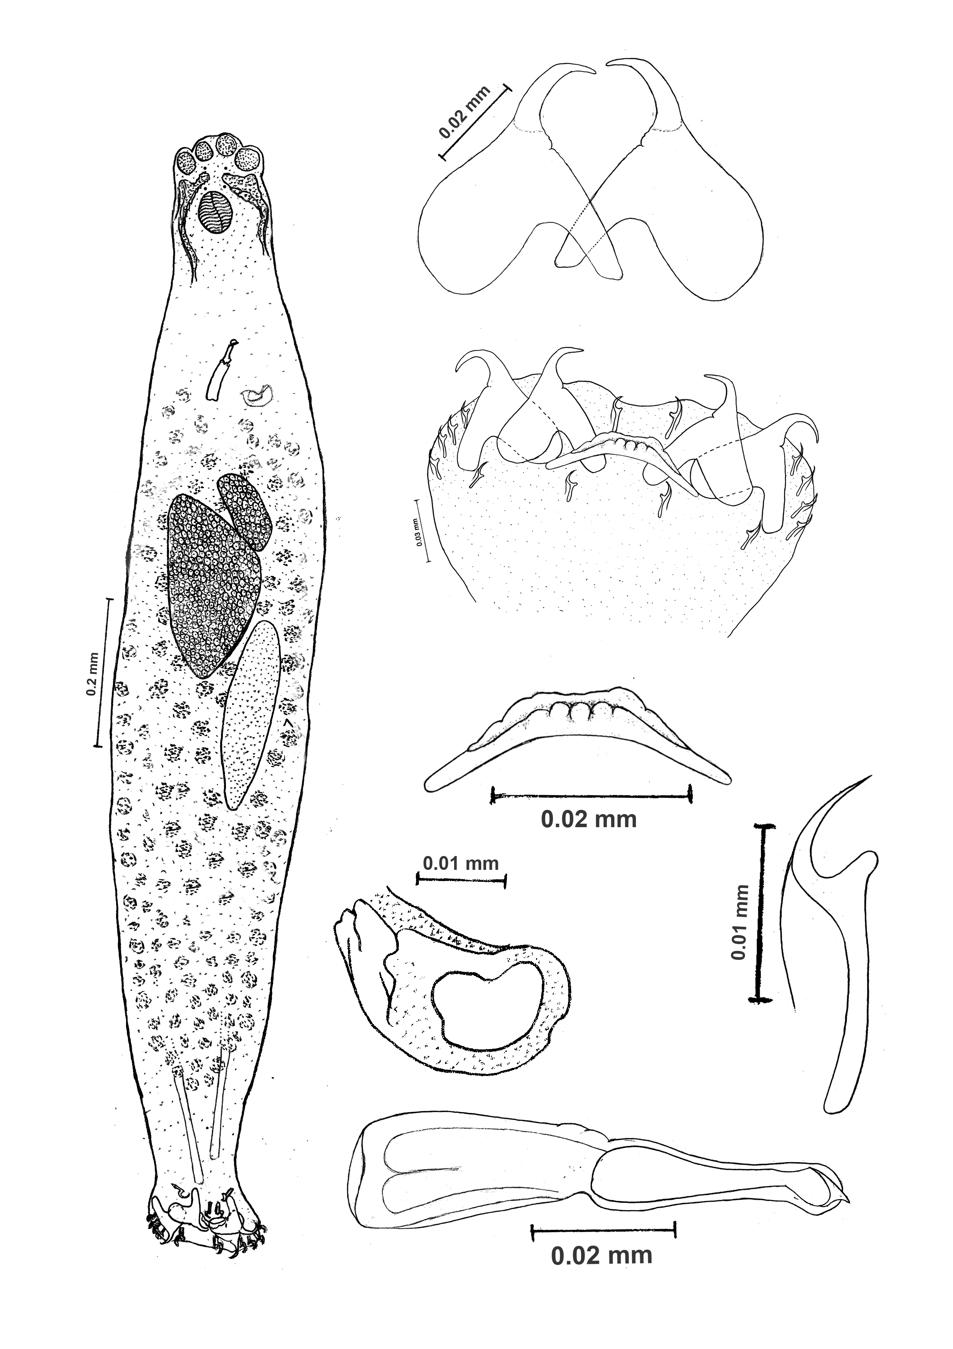

Fig. 1: Amphidbelloides sp.

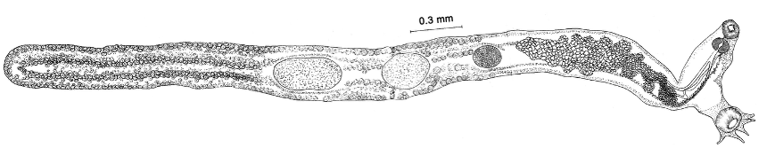
Fig. 2: Anisoporus orientalis Madhavi, 1975
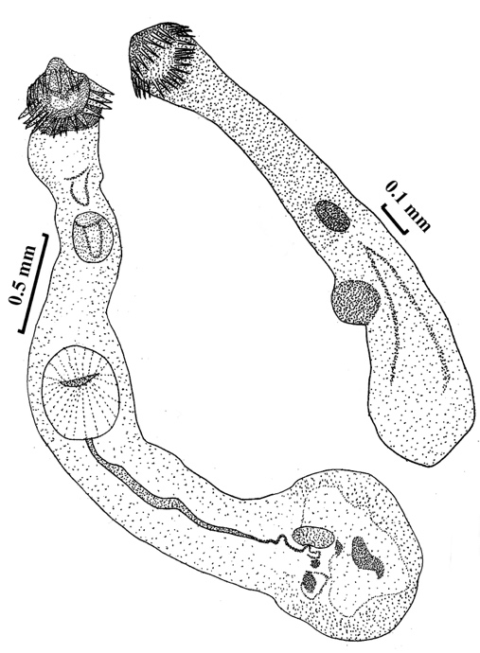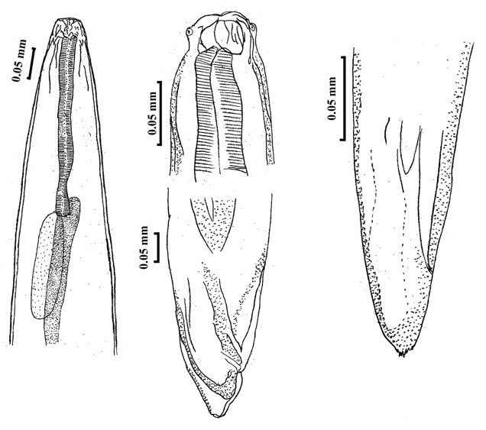
Fig. 3, 4 Stephanostomum sp. Fig. 5 : Hysterothylacium sp.

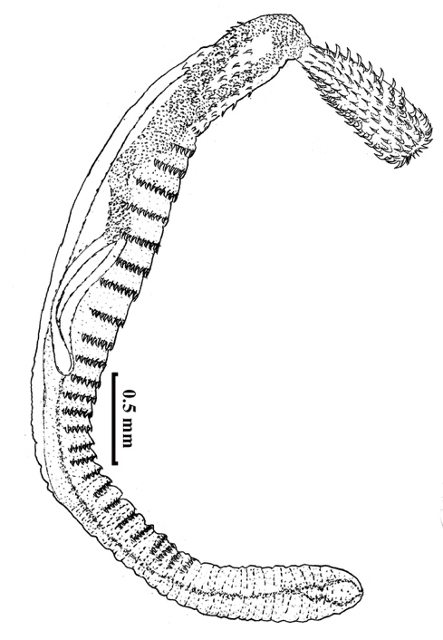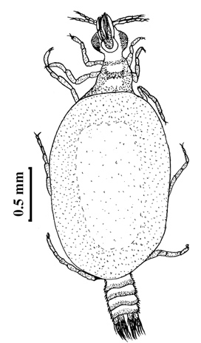
Fig. 6 : Serrasentis sp. Fig. 7: Praniza larva

- CONCLUSION
The results of the present study indicate that Dactyloptena orientalis harbours a diverse metazoan parasitic fauna. From the host fishes examined, six species of parasites were collected during the present study. The present record of Anisoporus orientalis forms the first report of this digenean off the southwest coast of India. The only report on nematode infection of dactylopterids is that of Brunson (1956), who described the larvae of Anisakis sp. And Contracaecum sp. In the stomach, intestine and body cavity of the spotted gurnard, Lepidotrigla brachyoptera from New Zeland. During the present study, Hysterothylacium sp. was recorded from D. orientalis, which forms a new host record for this parasite. Though Shahul Hameed (1977) recorded Pseudocaligus sp. from Kerala coast and Uma Devi and Shyamasundari (1981) reported Caligus dactylopteni from Waltair coast from D. orientalis, during the present study, no copepods were encountered in this species. A detailed, long-term study of metazoan parasites of Dactyloptens orientalis along the maritime states of India would not only bring to light many new life forms but also would serve to gain knowledge on the infection dynamics in the marine ecosystem.

DISCLAIMER (ARTIFICIAL INTELLIGENCE)
Author hereby declares that NO generated AI technologies such as Large Language Models (ChatGPT, COPILOT, etc.,) and text-to-image generators have been used during writing or editing of this manuscript.

COMPETING INTERESTS DISCLAIMER:
Authors have declared that they have no known competing financial interests OR non-financial interests OR personal relationships that could have appeared to influence the work reported in this paper.

REFERENCES
Amin, O. M., Chaudhary, A., Badri, M., Eslahi, A. V. & Singh, H. S. (2024). Studies of Serrasentis sagittifer (Linton, 1889) Van Cleave, 1923 from cobia Rachycentron canadum (Linn.) in the Arabian Gulf; with molecular analysis and optical microscopy. International Journal of Zoology and Animal Biology, 7(4), 000602. DOI: https://doi.org/10.23880/izab-16000602
Anderson, R. C., Chabaud, A. G. & Willmott, S. (2009). Keys to the Nematode Parasites of Vertebrates: Archival Volume. CABI, Wallingford. DOI: https://doi.org/10.1186/1756-3305-2-42
Bannai, M. A. A. (2018). Serrasentis sp. Acanthocephalans parasite of some Iraqi marine water fishes with observation of the pathology, feeding habits and infection of Upeneus sulphureus fishes. Iraqi Journal of Sciences, 59, 2173-2178. https://ijs.uobaghdad.edu.iq/index.php/eijs/article/view/559
Bayoumy, E. M., Baghdadi, H. B. & Hassanain, M. A. (2013). New record of parasitic praniza larva of Gnathia pantherina Smit and Basson, 2002 from Arabian Gulf greasy grouper Epinephelus tauvina caught from Saudi coastal water of Dammam. Global Veterinaria, 11(4), 414-419. DOI:10.5829/idosi.gv.2013.11.4.76137
Botha, H., Smit, N. J., Erasmus, A. & Hadfield, K. A. (2025). A redescription and two new descriptions of gnathiid isopods (Isopoda, Gnathiidae) from South African museum collections (1898–1976). ZooKeys, 1256, 115-140. DOI: 10.3897/zookeys.1256.162445
Boyko, C. B., Bruce, N. L., Hadfield, K. A., Merrin, K. L., Ota, Y., Poore, G. C. B., et al. (Eds.) (2020). World marine, freshwater and terrestrial isopod crustaceans database. Gnathiidae Leach, 1814. World Register of Marine Species at https://www.marinespecies.org (Accessed 29 March., 2026).
Bray, R. A. & Cribb, T. H. (2003). Species of Stephanostomum Loss, 1899 (Digenea: Acanthocoplidae) from fishes of Australian and South Pacific waters, including five new species. Systematic Parasitology, 55, 159-197. DOI:10.1023/A:1024655818783
Bray, R. A., Gibson, D. I. & Jones, A. (2008). Keys to the Trematoda. Vol. 3. CABI, Wallingford. DOI:10.2478/s11686-009-0021-7
Brunson, R. V. (1956). Studies on nematode parasites of New Zealand fishes. 2 Vols. Ph. D. Thesis, Victoria University. Wellington Library, New Zealand.
Bush, A. O., Lafferty, K. D., Lotz, J. M. & Shostak, A. W. (1997). Parasitology meets ecology on its own terms: Margolis et al. revisited. Journal of Parasitology, 83, 575-583. https://doi.org/10.2307/3284227
Chelladurai, G. & Subbulakshmi, S. (2017). Effect of the temporary parasite of praniza larvae of gnathiidae isopod, a gillchamber parasite of the coral reef fishes, gulf of mannar. Journal of Fisheries and Aquaculture Development, 1, 1-4. DOI: 10.29011/JFAD-104/100004
Cordeiro, A. & Luque, J. L. (2005). Metazoan parasites of flying gurnards, Dactylopterus volitans (Linnaeus, 1758) (Osteichthyes: Dactylopteridae) from the coastal zone of the State of Rio de Janeiro, Brazil. Acta Scientiarum. Biological Sciences, 27, 119-123. DOI: 10.4025/actascibiolsci.v27i2.1320
Dyer, W. G., Williams, E. H. & Williams, L. B. (1989). Monogeneans from marine fishes of Okinawa, Japan. Proceedings of the Helminthological Society of Washington, 56, 64-68.
El-Labadi, S. N., Ismail, N. S. & Khalaf, M. (2006). Intestinal digenetic trematodes of some marine fishes from the Gulf of Aqaba, Red Sea. Pakistan Journal of Zoology, 38, 43-48.
Froese, R. & Pauly. D. (2026). FishBase. Dactyloptena orientalis (Cuvier, 1829). Accessed through: World Register of Marine Species at: https://www.marinespecies.org/aphia.php?p=taxdetails&id=218158 on 2026-03-21
Gaber, R. A., Alojayri, G., Al Quraishy, S., Al Shabi, E. M. & Mohammed, O. B. (2024). Morphological and molecular studies of Hysterothylacium thalassini third-stage larvae (Ascaridida, Raphidascarididae) in the greater lizardfish Saurida tumbil. Arquivo Brasileiro de Medicina Veterinária e Zootecnia, 76, 4, e13206. https://doi.org/10.1590/1678-4162-13206
Gerones, X. R., Fisa, R. & Montolin, I. (2018). Biogeography of Anisakis (Anisakidae) and Hysterothylacium (Raphidascarididae) nematode species in consumed fish. Recent Advances in Pharmaceutical Sciences, VIII, 95, 118. https://hdl.handle.net/2445/128131
Gibson, D. I., Jones, A. & Bray, R. A. (2002). Keys to the Trematoda. Vol. 1. CABI, Wallingford.
Gibbons, L. M. (2010). Keys to the Nematode Parasites of Vertebrates: Supplementary Volume. CABI, Wallingford.
Gupta, S. (2021). Prevalence, morphology and taxonomical study of an acanthocephalan parasite Serrasentis synagrisi sp. nov. from marine fish Synagris japonicus (Day) new to animal world”. Uttar Pradesh Journal of Zoology, 42 (5), 16-19.
Hadfield, K. A., Bruce, N. L. & Smit, N. J. (2016). Redescription of poorly known species of Ceratothoa Dana, 1852 (Crustacea, Isopoda, Cymothoidae), based on original type material. ZooKeys, 592, 39–91. https://doi.org/10.3897/zookeys.592.8098
Hadfield, K. A. & Smit, N. J. (2008). Description of a new gnathiid, Afrignathia multicavea gen. et sp. n. (Crustacea: Isopoda: Gnathiidae), from South Africa. African Zoology, 43, 81–89. DOI:10.1080/15627020.2008.11407410
Ho, J. S., Lin, C. L. & Chang, W. B. (2007). Four species of Caligus Muller, 1785 (Copepoda, Siphonostomatoida, Caligidae) parasitic on marine fishes of Taiwan. Journal of Natural History, 41, 401-417. DOI: 10.1023/a:1006342120411
Jones, A., Bray, R. A. & Gibson, D. I. (2005). Keys to Trematoda. Vol. II. CABI International, Wallingford.
Karuppasamy, K., Davidkingston, S., Jawahar, P., Ranjith, L. & Kathirvelpandian, A. (2018). New record of the starry flying gurnard, Dactyloptena peterseni (Scorpaeniformes; Dactylopteridae); from Wadge Bank, Southwest coast of India. National Academy Science Letters, 42 (3), 209–213. https://doi.org/10.1007/s40009-018-0726-y
Karuppasamy, K., Ranjith, L., Sureandiran, B., Jawahar, P. & Vidhya, V. (2022). First Record of Spotwing Flying Gunard, Dactyloptena macracantha (Bleeker, 1854) (Dactylopteriformes; Dactylopteridae) from Indian coastal waters. Thalassas: An International Journal of Marine Sciences, 38, 331–336. https://doi.org/10.1007/s41208-021-00374-5
Kennedy, M. J. (1979). Basic methods of specimen preparation in parasitology. IDRC Manual Report, 8, 44 pp.
Madhavi, R. (1975). Digenetic trematodes from marine fishes of Waltair Coast, Bay of Bengal. Family Opecoelidae. Rivista di Parassitologia, 36, 153–164.
Madhavi, R. (1979). Digenetic trematodes from marine fishes of Waltair Coast, Bay of Bengal. Families Haplosplanchnidae and Haploporidae. Rivista di Parassitologia, 40, 237–248. https://doi.org/10.2307/3278073
Martínez-Aquino, A., García-Teh, J. G., Ceccarelli, F. S., Aguirre-Macedo, M. L. & Vidal-Martínez, V. M. (2023). Integrative taxonomy of Serrasentis gibsoni n. sp. (Acanthocephala: Isthmosacanthidae) from flatfishes in the Gulf of Mexico. Journal of Helminthology, 97, e96. DOI: 10.1017/S0022149X23000822
Moravec, F., Sheeba, S. & Bijukumar, A. (2012). Rhabdochona keralensis sp. Nov. and some other nematodes in the Indian mottled eel Anguilla bengalensis from India. Acta Parasitologica, 57, 74-82. DOI: 10.2478/s11686-012-0013-x
Nelson, J. S., Grande, T. C. & Wilson, M. V. H. (2016). Fishes of the World, 5th Edn, Wiley, Hoboken.
Nihal, D., Rajeeshkumar, M., Saha, P., Kumar, K.V. & Manjebrayakath, H. (2024). New Record of Plain Helmet Gurnard fish Dactyloptena tiltoni (Teleostei: Dactylopteriformes) from the Northern Indian Ocean. Thalassas: An International Journal of Marine Sciences, 40, 601-606. DOI:10.1007/s41208-024-00672-8
Roul, S. K., Ratheesh, T. B., Gireesh, R., Prakasan, D. & Abdussamad, E. M. (2016). Unusual heavy landings of flying gurnards at Munambam Fishing Harbour. Marine Fisheries Information Service Technical and Extension Series, No. 228, 21-22. http://eprints.cmfri.org.in/id/eprint/11423
Saoud, M. F. A., Nahhas, F. M., Al Kuwari, K. S. R. & Ramadan, M. M. (2002). Helminth parasites of fishes from the Arabian Gulf: 10. Trematodes of the genus Stephanostomum Loss, 1899 (Digenea: Acanthocolpidae Luhe, 1901), with descrition of Stephanostomum qatarense n. sp. and redescription of Stephanostomum triacanthid Madhavi, 1976. Rivista di Parassitologia, 29, 87-103.
Shahul Hameed, M. (1977). Description of two new species of Pseudocaligus (Copepoda, Caligidae) from Kerala, India. Crustaceana, 33, 61-69. https://doi.org/10.1163/156854077X00241
Smit, N. J. & Davies, A. J. (2004). The curious lifestyle of the parasitic stages of gnathiid isopods. Advances in Parasitology, 58, 289–391. DOI: 10.1016/S0065-308X(04)58005-3
Tong, Y. (1984). A new record of trematode from marine fish in China. Acta Zootaxonomica Sinica, 9, 117.
Uma Devi, D. V. & Shyamasundari, K. (1981). A new species of the genus Caligus Muller, 1785 from fish Dactyloptena orientalis, at Waltair. Indian Journal of Parasitology, 5, 91-94.
Unnithan, R. V. (1972). Trematode gill parasites from the flying gurnard, Dactyloptena orientalis (Cuv.) of the Indian Ocean. The Journal of Bombay Natural History Society, 69, 217-220. http://drs.nio.org/drs/handle/2264/5870
Vijaya Raju, V. & Hanumantha Rao, K. (1978). Monogenetic trematodes from marine fishes of Waltair coast, Bay of Bengal, subfamily Ancyrocephalinae. Rivista di Parassitologia, 39, 79-89.
WoRMS Editorial Board (2026). World Register of Marine Species. Checklist dataset https://doi.org/10.14284/170 accessed via GBIF.org on 2026-04-09.
Yamaguti, S. (1961). Systema Helminthum. Volume III. The Nematodes of Veterbrates. New York, Interscience Publishers.
Yamaguti, S. (1963). Systema Helminthum. Volume IV. Monogenea and Aspidocotylea. Interscience Publishers, London.
Yamaguti, S. (1975). A synoptical review of life histories of digenetic trematodes of vertebrates with special reference to the morphology of their larval forms. Tokyo, Keigaku Publishing Company.
Ray, D., Mishra, S. S., Roy, S., Khatua, T., Mohanty, S. R., Acharya, S., & Mohapatra, A. (2024). Taxonomic review of the genus Dactyloptena Jordan & Richardson, 1908 (Syngnathiformes: Dactylopteridae) from the east coast of India with four new records from West Bengal state. Indian Journal of Geo-Marine Sciences, 53(6), 443–449. https://doi.org/10.56042/ijms.v53i06.8501
Mahé, K., Foucher, E., Elleboode, R., Iglesias, S. P., & Tétard, A. (2013). First record of Dactylopterus volitans (Dactylopteridae) in the eastern English Channel. Cybium, 37, 307–308. https://sfi-cybium.fr/sites/default/files/pdfs-cybium/19-Mahe840N.pdf

