Current Status of the Amphibian Fauna of the Arboretum of Jean Lorougnon Guédé University of Daloa (Ivory Coast)

Abstract
In the setting of the conservation's work of the site housing the arboretum of Jean Lorougnon Guédé University in Daloa (6°54’43’’N, 6°26’20’’W) a survey of the amphibians at this site was conducted. The objective of this study was to evaluate the ecological health of the arboretum through the amphibian populations in this environment. Specifically, the goal was to conduct a survey of amphibian populations and identify the various pressures these animals face there. To achieve these objectives, two amphibian sampling techniques were used from April to August 2025; i.e. 2 sampling campaigns (10 field visits). The visual sampling technique combined with catches, the acoustic sampling technique and the assessment of anthropogenic pressure were therefore used. The results obtained reveal 15 species (Afrixalus dorsalis, Amnirana galamensis, Hoplobatrachus occipitalis, Hyperolius concolor, Hyperolius picturatus, Kassina senegalensis, Leptopelis viridis, Phrynobatrachus francisci, Phrynobatrachus latifrons, Phrynomantis microps, Ptychadena bibroni, Ptychadena mascareniensis, Ptychadena pumilio, Sclerophrys maculata et Sclerophrys regularis)
of amphibians belonging to 8 families and 10 genera. The results obtained reveal that the area is subject to significant human pressure from agricultural activities and the use of pesticides. Restoring the habitats in the arboretum would require raising awareness among the local community about the risks of unregulated farming practices. The implementation of reforestation campaigns and monitoring the quality of the arboretum’s pond.

Keywords
Arboretum, amphibians, ecological health, Ivory Coast and pressures

Introduction
The restoration and management of antropised habitats require several means, including reforestation, the restoration of wetlands, certain harmful practices and continuous monitoring of human activities (Viginal & Andrieu, 2017 ; Dibié et al., 2018). It is with this vision that Jean Lorougnon Guédé University has established an arboretum, the primary aim of which is to restore and preserve the original vegetation of this site in order to make a space for education, biodiversity conservation, ecotourism and fight against climate change. Like the Haut-Sassandra area, the arboretum’s area is characterised by a diversity of habitats (Viginal &
Andrieu, 2017; Dibié et al., 2018). This situation has a significant impact on the presence of certain animal species.
Amphibians, through their biological and physiological characteristics, are recognised as being among the most abundant vertebrates at this site (Bourgeois, 2008). These vertebrates are an important part of Ivory Coast’s wildlife. This is confirmed by several studies conducted in various protected areas across the country. These include the National Park of Mont Sangbé (45 species, Rödel, 2003), from the reserve of Lamto (40 species, Adeba et al., 2010), of the National Park Mont Péko (33 species, Rödel & Ernst, 2003), of the National Park Comoé (33 species, Rödel & Spieler, 2000), of the Integral Reserve of the Mont Nimbe (53 species, Kanga et al., 2021) and Tai National Park (58 species, Rödel & Ernst, 2004 ; Oussou et al., 2022). To date, a total of 100 amphibian species belonging to two orders, 27 genera, and 14 families have been recorded in Ivory Coast. These animals are used in the majority of environmental impact studies and ecological monitoring studies. They are also used as biological materials at universities and research centers. The lack of a database on the amphibians found on the arboretum site, their role as a bioindicator species and their usefulness for students’ experimental work justify ecological monitoring of the population of this class of vertebrates on this site (Kouman et al., 2025).
The aim of this study is therefore to monitor the ecological health of the arboretum’s ecosystems
through the amphibian populations found in our field of study. Specifically, the aim is to carry out a survey of the amphibian populations in the Jean Lorougnon Guédé University Arboretum and to identify the various pressures to which these species are subjected there.

Materials and Methods
Study Area
This study was conducted at the arboretum of Jean Lorougnon Guédé University in Daloa , Ivory Coast. The arboretum covers 60 hectares and is divided into two sections, South and North, separated by a lake. The southern and northern sections cover 14 and 40 hectares respectively, whilst the lake covers 6 hectares (Kouman et al., 2025). This region has a humid tropical climate and is characterised by two seasons of unequal length. These are a dry season, which runs from November to February, and a rainy season, which lasts from March to October, with the highest rainfall recorded in September (168.22 mm); the average monthly rainfall ranges from 10.33 mm to 172.08 mm per year ; as for the average temperature, it is 28.53°C and varies annually between 25.14 and 28.56°C (Goly, 2023). The soil at the study site is of the ferralitic type (Kouman et al., 2025). This area was previously used for food crops, rubber trees, an old sand quarry and fallow land. The site is characterised by typical, well-developed ferralitic soils with good depth, which promote plant growth (Kouman et al., 2025). From a hydrographic perspective, the arboretum is characterised by a large area of wetland bordered by a permanent body of water (lake). It is an environment that offers benefits in scientific, educational, sociological, ecological and ecotourism terms (Kouman et al., 2025).

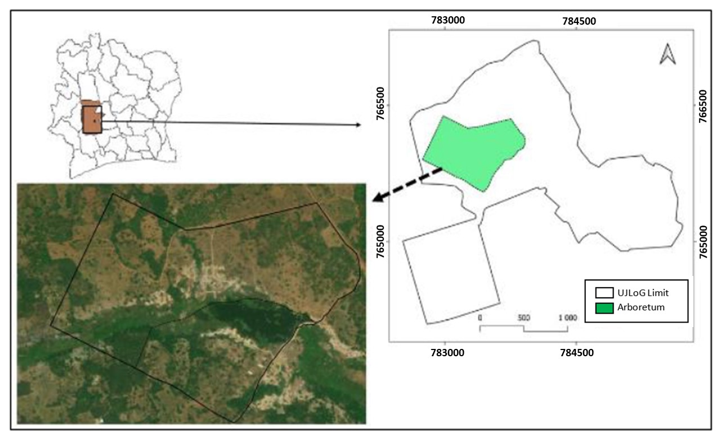
Figure 1: Location of the study area (Kouman et al., 2025)
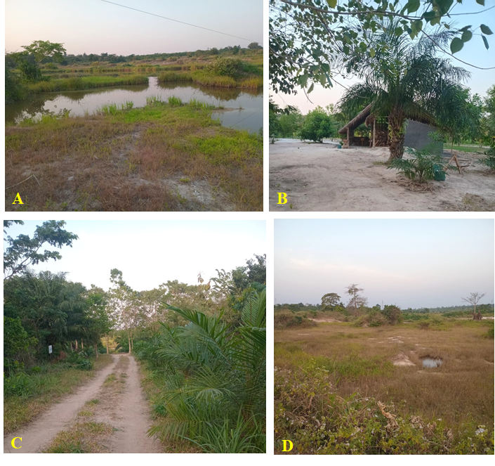
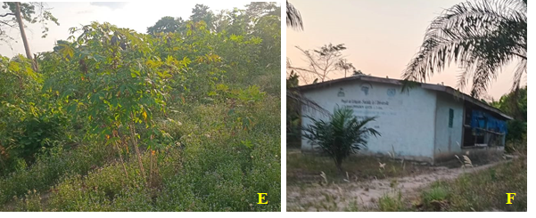

Figure 2: partial view of some areas of Jean Lorougnon Guédé University Arboretum
A: marshy area D : a former sand quarry
B: recreational area E : cassava cultivation
C: road F: livestock building

Sampling techniques
Following a preliminary survey, several habitats likely to harbour amphibians were selected within the arboretum for the purpose of sampling amphibians. Taking into account the ecology of amphibians, two types of sampling campaign were carried out during each visit: daytime campaigns (from 7.30 am to 10.00 am) and night-time campaigns (from 6.30 pm to 10.00 pm)
(Zimmerman, 1994; Rödel, 2000; Zingbe, 2024). In each survey, two amphibian sampling techniques were used: visual sampling combined with trapping, and acoustic sampling (Zimmerman, 1994; Rödel, 2000).
Sampling (omnidirectional sampling) involved searching habitats and microhabitats to record the various amphibian species based on visual observations and their calls. The specimens observed were caught by hand or using dip nets. In hard-to-reach habitats, certain species have been identified based on their distinctive calls (Zimmerman, 1994; Rödel, 2000). These various campaigns took place from April to August 2025 with two sampling campaigns per month, making a total of 10 field visits. After being caught, the specimens were identified with amphibian identification guide (Channing &Rödel ,2019) and then released back into the environment where they were caught.

Assessment of human pressure on amphibian habitats
According to Bourgeois (2008), human activities such as agricultural practices and infrastructure development significantly reduce amphibian habitats, thereby affecting their abundance and species richness. Based on this, we have identified the main activities that pose threats to amphibians in the arboretum at Jean Lorougnon Guéde University in Daloa.

Results
Survey of amphibian population in the arboretum
The various sampling techniques used identified 15 species of amphibians, all belonging to the order of anurans. These species are divided into 8 families and 10 genera. Hyperoliidae family is the most abundant (4 species). This is followed by the Ptychadenidae family (3 species). Next come the Phrynobachidae and Bufonidae families, each with 2 species. Monospecific families are : Arthroleptidae, Dicroglossidae, Microhylidae and Ranidae (Table 1 and Appendix).

Table 1: List of amphibians recorded in the various habitats of the arboretum
Family | Genera | Species
Arthroleptidae Mivart, 1869 | Leptopeli Smith, 1849 | Leptopelis viridis (Günther, 1869)
Bufonidae Gray, 1825 | Sclerophrys Tschudi, 1838 | Sclerophrys maculata (Hallowell, 1854)  Sclerophrys regularis (Reuss, 1833)
Dicroglossidae Anderson, 1871 | Hoplobatrachus Peters, 1863 | Hoplobatrachus occipitalis (Günther, 1858)
Hyperoliidae Laurent, 1943 | Afrixalus Laurent, 1944 | Afrixalus dorsalis (Peters, 1875)
 | Hyperolius Rapp, 1842 | Hyperolius concolor (Hallowell, 1844)
 |  | Hyperolius picturatus (Peters, 1875)
 | Kassina Girard, 1858 | Kassina senegalensis (Duméril & Bibron, 1841)
Microhylidae Günther, 1858 | Phrynomantis Peters, 1867 | Phrynomantis microps (Peters, 1875)
Phrynobatrachidae Laurent, 1941 | Phrynobatrachus Günther, 1862 | Phrynobatrachus francisci (Boulenger, 1912)
 |  | Phrynobatrachus latifrons (Ahl, 1924)
Ptychadenidae Dubois, 1987 | Ptychadena Boulenger, 1917 | Ptychadena bibroni (Hallowell, 1845)
Ptychadena mascareniensis (Guibé & Lamotte 1953)
Ptychadena pumilio (Boulenger, 1920)
Ranidae Batsch, 1796 | Amnirana Dubois, 1992 | Amnirana galamensis (Duméril & Bibron, 1841)

Based on their preferred habitats Amnirana galamensis, Kassina senegalensis, Leptopelis viridis, Phrynobatrachus francisci and Phrynomantris microps accounts for 33.33% of the species found exclusively in savannah areas. Nine (9) species, accounting for 60% are typical of degraded forests and tolerate land cleared for agricultural purposes. They can also be found in savannah habitats. One (1) species, namely Hyperolius picturatus, accounts for 6.67% of the species inhabiting dense forests, but it may also be found in degraded forests (Table 2).

Table 2: List of amphibian species found in the arboretum, categorised by their preferred habitats.
 |  | Preferred habitats
Species | Savannah | Cleared land (degraded forests and agricultural areas) |  |  | Forest
Afrixalus dorsalis | X |  | X
Amnirana galamensis | X
Hoplobatrachus occipitalis | X |  | X
Hyperolius concolor | X |  | X
Hyperolius picturatus |  |  | X |  | X
Kassina senegalensis | X
Leptopelis viridis | X
Phrynobatrachus francisci | X
Phrynobatrachus latifrons | X |  | X
Phrynomantis microps | X
Ptychadena bibroni | X |  | X
Ptychadena mascareniensis | X |  | X
Ptychadena pumilio | X |  | X
Sclerophrys maculata | X |  | X
Sclerophrys regularis | X |  | X

X : presence

Table 3: Types and forms of pressure affecting amphibian habitats in the arboretum
Nature of pressures | Presence of pressure | Pressure level
Presence of human habitation | x | Significant human pressure
Presence of track | x | Moderate human pressure
Presence of field | x | Significant human pressure
Recent human traces | x | Moderate human pressure
Old human traces | x | low human impact

X : presence

Discussion
By observing the number of orders, families, and genera of amphibians inventoried in the different habitats of the Jean Lorougnon Guédé University arboretum, we can affirm that this specific wealth is representative of that of the Daloa area and its surrounding environments. Indeed, these results are virtually identical to those of Kouame et al. (2015) and Goly (2023) (Table III). It should be noted that after a study relating to the inventory of amphibians in the district of Daloa and its surrounding areas, the first authors identified a community of amphibians subdivided into one (1) order, eleven (11) families and thirteen (13) genera. These results are similar to those of the second author, whose work relates to amphibians in wetlands of urban and peri-urban forests of Daloa made it possible to identify nine (9) families of amphibians distributed among eleven (11) genera and one (1) order. Relatively to specific richness, it should be noted that of the arboretum is low (15 species). This number could be explained by several factors: the extent of the study area and the duration of this study. Indeed, unlike authors mentioned above whose work was carried out on several sites in the Daloa area and even in some neighboring localities, the present study was limited to the arboretum, which covers an area of 60 hectares. This difference in area could explain the nature of the amphibian species richness in the arboretum. This observation is confirmed by Bourgeois (2008), who states that amphibian richness increases with the size of the sampling area.
Among the data collection sites selected by Kouame et al. (2015) in their work, , the habitats of the Zaïbo agroforestry zone, an area located in the middle peri-urban areas alone are home to twenty (20) species of amphibians (Kouame et al., 2015; Zingbé, 2016). Amphibian activities are significantly influenced by climatic seasons (Acemav, 2003), extending the present study to include both climatic seasons could to contribute to the identification of a specific wealth similar to that of these authors. Indeed, the sampling campaigns carried out by Goly (2023) ran from July 2019 to June 2020, i.e. twelve months of campaigns. Even though those of Kouame et al. (2015) are four months, it is important to point out that they were carried out in the middle of the rainy season; which has significant consequences for the dynamics of amphibians. Several authors have offered an explanation for this observation: According to Tohé (2008), all the sexual activities of amphibians, namely reproduction, croaking, mating, and egg-laying, are maximized during the rainy season. Dietoa (2002) goes on to state that, unlike the dry season, Amphibians have abundant food resources during the rainy season, which makes them easier to detect (Storfer, 2003; Blaustein et al., 2003).

Table 4: Comparative table of amphibian richness from studies carried out in the Daloa area

 | Amphibian diversity recorded in the habitats of the Jean Lorougnon Guédé University arboretum | Amphibian abundance recorded in the lowlands and forests of urban and peri-urban areas of Daloa | Amphibian abundance in the Daloa area and surrounding environments
Orders | 1 | 1 | 1
Families | 8 | 9 | 11
Genuses | 10 | 11 | 13
Species | 15 | 20 | 28

The affinity of most species for savanna habitats and cleared areas associated with agricultural activities. This observation highlights the indicator role of amphibians and confirms the description original vegetation characteristic of the area where the arboretum is located. Indeed, according to the note relating to the arboretum development plan (Kouman et al., 2025), It appears that the arboretum site was occupied by food crops, rubber trees and fallow land. The low percentage of species dependent on forest habitats could be explained by the resulting forest loss through the planting of cash crops, the remains of which can be seen within some fallow areas of the arboretum. Indeed, many amphibian species are vulnerable to disturbances in forest cover and are unable to survive long-term when it is destroyed (Rödel et Branch, 2002; Ofori-Boateng et al., 2013; Kouamé et al., 2014 a,b).
The quality of amphibians as indicator species for ecosystem health is recognized by several authors (Storfer, 2003; Blaustein et al., 2003). Not only can these vertebrates reveal contamination in a natural environment, they also succeed in predicting habitat quality in terms of disturbances (Semlitsch and Rothermel, 2003). Furthermore, a majority of amphibian species require both terrestrial and aquatic habitats to complete their life cycle (Silva et al., 2003; Baldwin et al., 2006). Due to this use of two functionally different environments, They are effective candidates for assessing the effects of habitat fragmentation (Weseloh et al., 1994; Spears et al., 2007), and can serve as indicators of the risks of contamination of a wetland environment.
The threats faced by amphibians in the arboretum's various habitats contribute to the degradation of their habitats and significantly affect them during their dispersal to breeding sites. Indeed, the main breeding site for these animals is the point where runoff water converges from cultivated and residential areas located upstream of the arboretum. As a result, this site would be exposed to household waste and chemicals; this would significantly affect amphibian populations because according to Ouellet et al. (1997) The skin permeability of amphibians explains their particular sensitivity to exposure to chemicals. Furthermore, herbicides and insecticides used in agriculture reduce the presence of algae, phytoplankton, and zooplankton
and can therefore have a negative impact on the growth rate of tadpoles long after their application (Semlitsch, 1998). Eigenbrod et al.(2009) for their part, they highlight the dangers of tracks and roads for amphibians by reporting that just like areas of cultivation and logging, roads and tracks significantly degrade habitats and influence amphibian population dynamics through the fragmentation of habitats into a mosaic this also leads to the isolation of certain populations and the crushing of certain individuals during migratory movements towards breeding sites.

Conclusion
Our work has allowed us to identify 15 species of anuran amphibians on the site of the arboretum of the Jean Lorougnon Guédé University of Daloa. Its species are divided into eight families and 10 genera. The composition of this amphibian population reveals that the study area is degraded, however, the presence of certain tree species indicates the presence of formerly primary forests in this area. To restore this forest, it would be beneficial to raise awareness among the surrounding population about uncontrolled agricultural practices such as the excessive use of pesticides, slash-and-burn agriculture, tree felling, and carrying out reforestation campaigns all while reducing human activities within the perimeter of this zone. Monitoring the water quality of the arboretum's pond is essential, as this habitat constitutes a valuable resource in terms of reproduction and supply for many animal species.

COMPETING INTERESTS DISCLAIMER:
Authors have declared that they have no known competing financial interests OR non-financial interests OR personal relationships that could have appeared to influence the work reported in this paper.
Disclaimer (Artificial intelligence)
Author(s) hereby declare that NO generative AI technologies such as Large Language Models (ChatGPT, COPILOT, etc.) and text-to-image generators have been used during the writing or editing of this manuscript.

References
Acemav C., Duguet R. & Melki F. (2003). The Amphibians of France, Belgium, and Luxembourg. Parthénope Collection, Biotope Editions, Mèze (France), 480 p.

Baldwin R.F., Calhoun A.J.K., & deMaynadier P.G. (2006). Conservation planning for amphibian species with complex habitat requirements: a case study using movements and habitat selection of the wood frog *Rana sylvatica*. J. Herpetol. 40: 442-453.

Blaustein A.R. & Belden L.K. (2003). Amphibian defenses against ultraviolet-B radiation. Evol. Dev. 5: 89-97.

Bourgeois P.A. (2008). The Importance of Amphibians for the Conservation of Small Forest Fragments in Tropical Rainforests. 153 p.

Channing A., Rödel M.O., (2019). Field Guide to Frogs & other Amphibians of Africa. Struik Nature, Penguin Randon house, Cape Town, South Africa. 408 pages

Dibié E.T., Vroh B.T.A., Adou C.Y., & N’guessan K.E. (2018). Diversity of herbaceous and lianescent species in the Haut-Sassandra Classified Forest (Center-West, Côte d’Ivoire) following several years of logging. European Scientific Journal, Vol. 14, No. 18. ISSN: 1857-7881 (Print); e-ISSN: 1857-7431.

Dietoa Y.M. (2002). Entomofauna and Feeding Strategies of Fish of the Genus *Brycinus* (Characidae) in Fluvial and Lacustrine Environments (Bia and Agnébi Basins; Côte d’Ivoire). Doctoral Thesis, University of Abobo-Adjamé, Côte d’Ivoire, 261 p.

Eigenbrod F., Stephen J. Hecnar, & Fahrig L. (2009). Accessible habitat: an improved measure of the effects of habitat loss and roads on wildlife populations. Landscape Ecology 23: 159-168. Goly N.S. (2023).

Goly N.S. (2023). Assessment of the Ecological Quality of Wetlands, Urban, and Peri-urban Forests in Daloa (Côte d’Ivoire) through the Study of Anuran Amphibian Assemblages and Associated Parasitic Helminths. Doctoral Thesis, UFR Environment, Jean Lorougnon Guédé University (UJLOG), (Daloa, Côte d'Ivoire), 180 p.

Kouamé N.G., Ofori-Boateng C., Adum G. B., Gourène G. & Rödel M.O. (2015). The anuran fauna of a West African urban area. Amphibian and Reptile Conservation, 9: 1-14 (e106).

Kouamé N.G., Konan J.C.B.Y.N., Adepo-Gourène A.-B., Gourène G., Rödel M.-O., (2014a). The amphibians of Yakassé-Mé village forest, a threatened rainforest of south-eastern Ivory Coast. Herpetology Notes, 7: 657–665.

Kouamé N.G., Adepo-Gourène A.B., Konan J.C.B.Y.N., Emmrich M., Penner J., Rödel M.-O., (2014b). Second record of Hyperolius laurenti Schiøtz, 1967 (Anura: Hyperoliidae) in south-eastern Ivory Coast, with observations on the species’ variability, call characteristics and habitat. Herpetology Notes, 7: 59–65.

Ofori-Boateng C., Oduro W., Hillers A., Norris K., Oppong S.K., Adum G.B., Rödel M.-O., (2013). Differences in the effects of selective logging on amphibian assemblages in three West African forest types. Biotropica, 45: 94–101.

Ouellet M., Mikaelian, I., Pauli B.D., Rodrigue J., et Green D.M. (2005). Historical
evidence of widespread chytrid infection in North American amphibian populations.
Conserv. Biol. 19, 1431-1440.

Oussou K.H., Assemian N.G., Kouadio A.L., Tiédoué R & Rödel M.O. (2022). The anuran fauna in a protected West African rainforest and surrounding agricultural systems. Amphibian & Reptile Conservation, 16 (1) : 1–13 (e298).

Rödel M O. (2000). Herpetofauna of West Africa, Vol. I : Amphibians of the West African savanna. Edition Chimaira, Frankfurt/M., 335 p.

Rödel M.O. & Spieler M. (2000). Trilingual keys to the savannah-anurans of the Comoé National Park, Ivory Coast. - Stuttgarter Beiträge zur Naturkunde, Serie A, Nr.620: 1-31.

Rödel M.O & Branch W R. (2002). Herpetological survey of the Haute Dodo and Cavally forest, western Ivory Coast.Salamandra, 38 : 245–268.

Rödel M.O. (2003). The amphibians of Mont Sangbé National Park, Ivory Coast.
Salamandra, 39 : 91-110.

Rödel M.O. & Ernst R. (2004). Measuring and monitoring amphibian diversity in tropical forests. I. An evaluation of methods with recommendations for standardization. Ecotropica, 10: 1-14.

Semlitsch R D., et Rothermel, B B. (2003). A foundation for conservation and management of amphibians. Dans Amphibian conservation, R.D. Semlitsch, ed. (Washington:
Smithsonian Books), pp. 242-259.

Semlitsch R.D., et Bodie J.R. (1998). Are small, isolated wetlands expandable? Conserv.
Biol. 12, 1129-1133

Silva M., Hartling, L.A., Field, S.A., et Teather, K. (2003). The effects of habitat
fragmentation on amphibian species richness of Prince Edward Island. Can. J. Zool.
81, 563-573.

Spears B L., Hansen, J.A., et Audet, D.J. (2007). Blood lead concentrations in waterfowl
utilizing lake Coeur d’Alene, Idaho. Archives Environ. Contaminat. Toxicology 52,121-128.

Storfer A. (2003). Amphibian declines: future directions. Divers. Distrib. 9, 151-163.

Tohé B., Assemian N E., Kouamé N G., Gourène G. & Rödel M.O. (2008). Déterminisme des coassements des Anoures de la ferme piscicole du Parc National du Banco (Côte d’Ivoire). Sciences and Nature, 5: 71–79.

Viginal M. and Andrieu J. (2017). Prospective modeling of the landscapes of the Haut Sassandra forest (Côte d’Ivoire) following the end of conflicts. Tropicultura, NS, 178–191.
Weseloh D.V.C., Struger J., and Hebert C. (1994). White Pekin ducks (*Anas platyrhynchos*) as monitors of organochlorine and metal contamination in the Great Lakes. J. Great Lakes Res. 20, 277–288.
Zimmerman B.L. (1994). Audio strip transects. In: Heyer W.R., Donnelly M.A., McDiarmid R.W., Hayek L.-A.C., & Foster M.S. (Eds.): *Measuring and Monitoring Biological Diversity: Standard Methods for Amphibians*. Smithsonian Institution Press, Washington and London, pp. 92–97.
Zingbé G.U. (2024). Diversity and spatiotemporal dynamics of amphibians in the Marahoué National Park (Center-West, Côte d’Ivoire). Doctoral Thesis, UFR Environment, Jean Lorougnon Guédé University (UJLOG), (Daloa, Côte d'Ivoire), 180 p.
Zingbé G.U. (2016). Amphibian diversity in an agroforestry zone (case study of the locality of Zaibo; Center-West, Côte d’Ivoire). Master’s Thesis, UFR Environment, Jean Lorougnon Guédé University (UJLOG), (Daloa, Côte d'Ivoire), 180 p.

Appendix
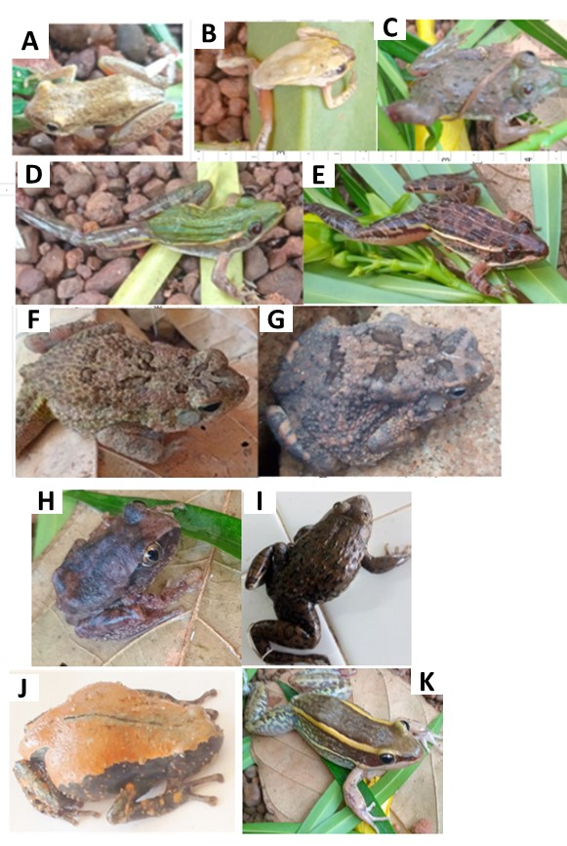
Figure 3 : Photographs of anuran amphibians captured at the site of Daloa University's Arboretum. Hyperoliidae Family: Hyperolius picturatus (A), Hyperolius concolor (B); Phrynobatrachidae Family: Phrynobatrachus latifrons (C); Ptychadenidae Family: Ptychadena mascareniensis (D), Ptychadena pumilio (E); Bufonidae Family: Sclerophrys maculata (F), Sclerophrys regularis (G); Arthroleptidae Family: Leptopelis viridis (H); Dicroglossidae Family: Hoplobatrachus occipitalis (I); Microhylidae Family: Phrynomantis microps (J); Ranidae Family: Amnirana galamensis (K).

