Preventive and Recovery Effects of Flaxseed on BPA-Exposed Fish: A Histopathological Study

Abstract
Bisphenol A (BPA), a widely used compound in the production of plastics and epoxy resins, is recognized for its endocrine-disrupting effects on both human and aquatic health. BPA leaches into aquatic environments from plastic waste and enters fish through gill absorption, contaminated water, and dietary intake, leading to physiological and structural damage. Flaxseed, rich in omega-3 fatty acids and lignans, has shown promise in enhancing fish health when included in the diet. This study investigates the potential protective and restorative effects of dietary flaxseed against BPA-induced toxicity in Labeo rohita, a commercially important freshwater food fishappen. Three experimental groups included, a control group, a BPA-exposed group, fed with a standard diet, and a BPA-exposed group supplemented with flaxseed rich diet over a 21-day period. The LC₅₀ of BPA was calculated as 32 ppm, and a sub-lethal concentration of 8 ppm (¼ LC₅₀) was used in the study. flaxseed was incorporated into the formulated diet at a concentration of 30 g per 100 g. Histopathological analysis of liver and kidney tissues revealed significant damage in the BPA-only group, while the flaxseed-supplemented group exhibited comparatively reduced alterations. During a subsequent 21-day recovery phase, fish receiving flaxseed showed improved tissue regeneration and faster healing. These results suggest that flaxseed supplementation can mitigate BPA-induced histopathological damage and support recovery, highlighting its potential as a functional dietary additive in aquaculture. Further long-term and multi-species studies are recommended to confirm these findings and establish flaxseed as a reliable dietary intervention against BPA toxicity in aquaculture.
Key Words- Bisphenol A, flaxseed, omega-3, histopathology, toxicity, Labeo rohita.

Introduction
Bisphenol A (BPA) is a synthetic organic compound extensively employed in the production of polycarbonate plastics and epoxy resins. Beyond its industrial utility, BPA is recognized as a potent endocrine-disrupting chemical (EDC) (Rubin and Soto, 2009) capable of mimicking or interfering with hormonal signaling, particularly via estrogen receptors. Such disruption has been associated with reproductive toxicity, developmental malformations, neurotoxicity (Santoro et al., 2019, Heredia-Gracia et al., 2023), immunotoxicity (Li et al., 2018), mutagenicity, genotoxicity (Lee et al., 2013), hepatotoxicity (Kamel et al., 2018), and carcinogenic potential (Richter et al., 2007; Prins et al., 2017) in humans and wildlife. The Asia-Pacific region currently represents the fastest-growing and most dominant market for BPA due to expanding industrial applications and consumer demand (Modar Intelligence). However, escalating production and utilization have raised environmental concerns, as BPA readily releases (Staples et al. 1998; Flint et al. 2012) & leaches from discarded polymer matrices (Teuten et al. 2009; Flint et al. 2012) under conditions of elevated temperature (Kitahara et al., 2010), pH variation, pressure, and acidity, thereby contaminating aquatic ecosystems. Once released, BPA accumulates in sediments and biota, enters fish (Basheer et al., 2004) through gill membranes, diet, and water, and undergoes biomagnification, leading to histopathological damage in vital organs. Elevated concentrations have been reported in Indian rivers (Lalwani et al., 2020) and estuarine fish species (Kundu S. et al., 2024), and in soil (Kamaraj, et al., 2013), underscoring its ecological risk.
Flaxseed (Linum usitatissimum), a functional food rich in lignans and omega-3 fatty acids (Soni et al., 2016), has demonstrated therapeutic potential in human health (Imran S., et al., 2024 Prasad, 2000 LeAnne T., et al., 2004 Bhathena et al., 2002) and promising benefits in aquaculture, including improved growth performance and protein content (Nishiyama et al., 2014, Satyakov Y.et al., 2015, Li X., et al., 2012, Septiyani A., et al., 2025). The present study investigated the preventive effects of dietary flaxseed against BPA-induced toxicity in Labeo rohita (rohu). While previous studies have primarily explored the general health benefits of flaxseed in fish, our work is the first to investigate its protective role against bisphenol A (BPA)-induced toxicity. As a major Indian carp species, L. rohita holds significant economic and nutritional value across India and neighbouring countries. Therefore, maintaining its health is critical—not only for sustainable aquaculture but also for ensuring the safety and quality of fish consumed by humans. Histopathological analysis of liver and kidney tissues was employed to assess toxicological impacts.

Materials and Method
Chemicals and Feed Preparation: Bisphenol A (BPA) [2,2-di-(4-hydroxyphenyl) propane; CAS No. 80-05-7] was procured from LABOGENS Fine Chem Industry, Ludhiana, Punjab, India. The LC 50 was found 32ppm. 1/4th sublethal dose was selected for experiment, that is 8ppm. Due to its low aqueous solubility, a stock solution of 1000ppm was prepared in ethanol following confirmation of water safety parameters. High-quality flaxseed was sourced locally and incorporated into the fish feed at a concentration of 30 g per 100 g of diet. All experimental fish were fed twice daily throughout the study.
Experimental Design and Fish Maintenance: The study was conducted in the Department of Zoology, Deva Nagri College, C.C.S. University, Meerut. All experimental procedures were conducted in accordance with the C.C.S. university’s approved protocols and academic regulations Healthy L. rohita specimens (average body weight ~25 g) were collected from a local pond and acclimatized for seven days in 25 L plastic tanks equipped with aeration and filtration systems, using dechlorinated tap water. To prevent microbial infections, fish were treated with a 0.1% potassium permanganate (KMnO₄) bath for 2–3 minutes prior to the experiment. Water quality was maintained by renewing tank water every 24 hours.
Grouping and Exposure Protocol: Fish were randomly assigned to three experimental groups (n = 12 per group), each housed in 25 L tanks: Group I (Control): Dechlorinated water + standard commercial diet, Group II- BPA dose (8ppm) + standard commercial diet, Group III- BPA (8ppm) + flaxseed-enriched diet. The exposure and feeding regimen were maintained for a period of 21 days under controlled laboratory conditions. Next 21 days were designated as recovery phase. During which neither BPA nor flaxseed was administered; the fish were provided solely with standard marketable fish diet.
Water parameter: L. rohita fish are highly sensitive to environmental conditions. Therefore, maintaining optimal water quality was critical for the success of the experiment. The water pH was recorded at 7.4 ±0.05 using a Thermo Scientific pH meter, temperature 29 ± 1.5 ⁰C by Thermos Scientific, dissolved oxygen levels were maintained at approximately (DO) 3 ± .5 mg/l Hanna Instrument, was observed through the study.

Histological examinations: For histological analysis, tissue samples were collected by sacrificing fish from each experimental group. The excised tissues were fixed in 10% buffered formalin, following fixation, standard histological processing was carried out, including dehydration, paraffin embedding, and block preparation. Sectioning was performed using a microtome. The tissue section was stained with haematoxylin and eosin to enhance structural visibility for microscopic evaluation.

Results
The liver serves as a primary site of physiological dysfunction under toxic stress, particularly from xenobiotic exposure. Given its involvement in the biotransformation and clearance of environmental contaminants, hepatic tissue is a critical target for assessing pollutant-induced toxicity Microscopic examination of liver sections from the group I (control) revealed normal histoarchitecture, including uniformly arranged hepatocytes, intact biliary epithelial lining, and well-defined tubule lumens, with no observable pathological features (Fig.1. A). In contrast, Group II fish exposed to Bisphenol A (BPA) exhibited progressive hepatic damage over the 21-day exposure period. On day 7, early histological alterations were evident, including hepatocyte degeneration, disorganization of central veins, nuclear pyknosis, and initial vacuolization (Fig.1. B). By day 14, the severity of damage increased, with prominent blood congestion, portal vein degeneration, haemorrhagic zones, dilated sinusoidal spaces, and vascular occlusion (Fig.1. C). On day 21, liver sections displayed extensive pathological changes, characterized by pronounced vacuolization, marked blood pooling, and disruption of the structural integrity between hepatocytes and adjacent pancreatic tissue, accompanied by intensified sinusoidal congestion. (Fig.1. D).
Bcc
HV
V
np
LHP
e
N
np
DSs

V
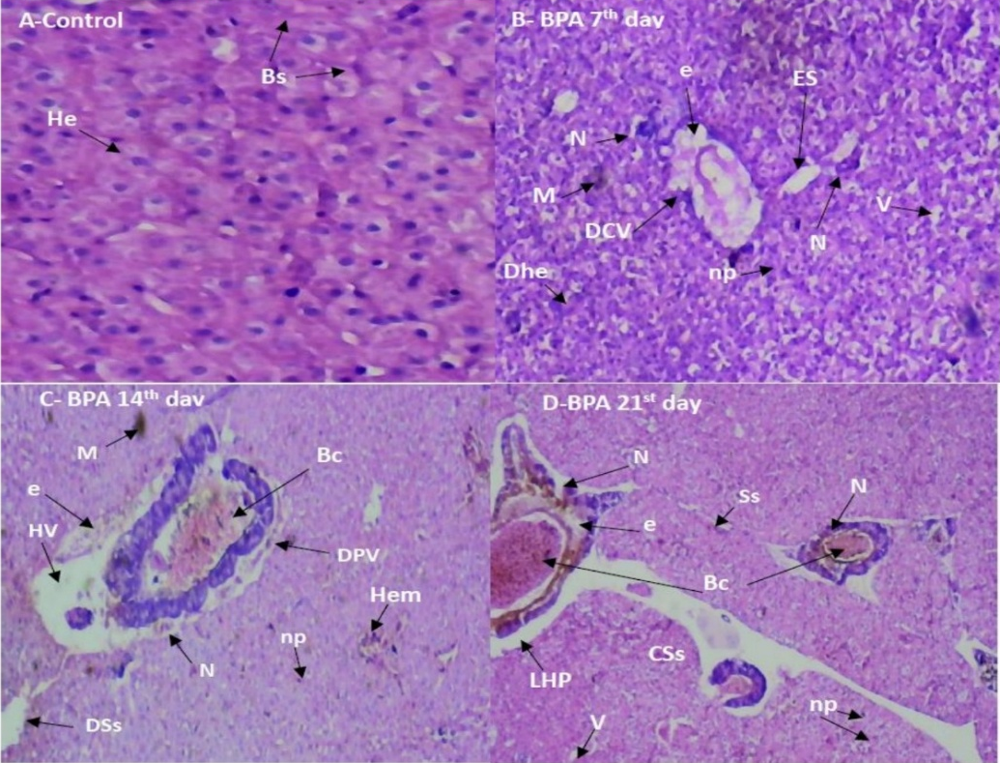
Fig-1. (A-D) : histology of liver of Labeo rohita exposed to sub lethal concentration of BPA-only for 7, 14 and 21 day. A- showing control. B- Damaged central vein(DCV), nuclear pyknosis(np), damaged hepatocyte(Dhe), edema(e), enlarged sinusoids (es), necrosis(N) and vacuolization(v). C- blood congestion(BC), damaged portal vein (DPV), heavy vacuolization(HV), heamorrahge (Hem), dilated sinusodial space(Dss), edema, necrosis, and nuclearpyknosis. D- blood congestion, necrosis, edema, nuclear pyknosis, vacoules, sinusodial spaces, loss of contact between hepatocytes and pancerocytes(LHP), congestion in sinusodial space(Css).
Liver tissues from group III also exhibited noteworthy histopathological alterations. On the 7th day of observation, mild hepatocyte degeneration was evident, along with sinusoidal vacuolisation and the formation of cluster nuclei (Fig.1. E) By the 14th day, deformation of central vein becomes superficial, primarily due to continued nuclear clustering and progressing hepatocyte damage (Fig.1. F). By the 21st day, the liver section showed marked pathological changes, including blood congestion, edema, and hepatic impairment (Fig.1. G).
Following the 21-day recovery phase, all experimental groups exhibited evidence of partial hepatic tissue regeneration. Nonetheless, complete architectural restoration of hepatic structures was not attained within this timeframe. Notably, Group II (exposed exclusively to BPA) (Fig.1. H) displayed pronounced histopathological alterations and a markedly slower rate of hepatic recovery relative to the group receiving BPA exposure with concurrent flaxseed supplementation (Fig.1. I). While regenerative activity was apparent in both groups, the extent of tissue repair in the flaxseed-supplemented cohort suggests an enhanced recuperative response.
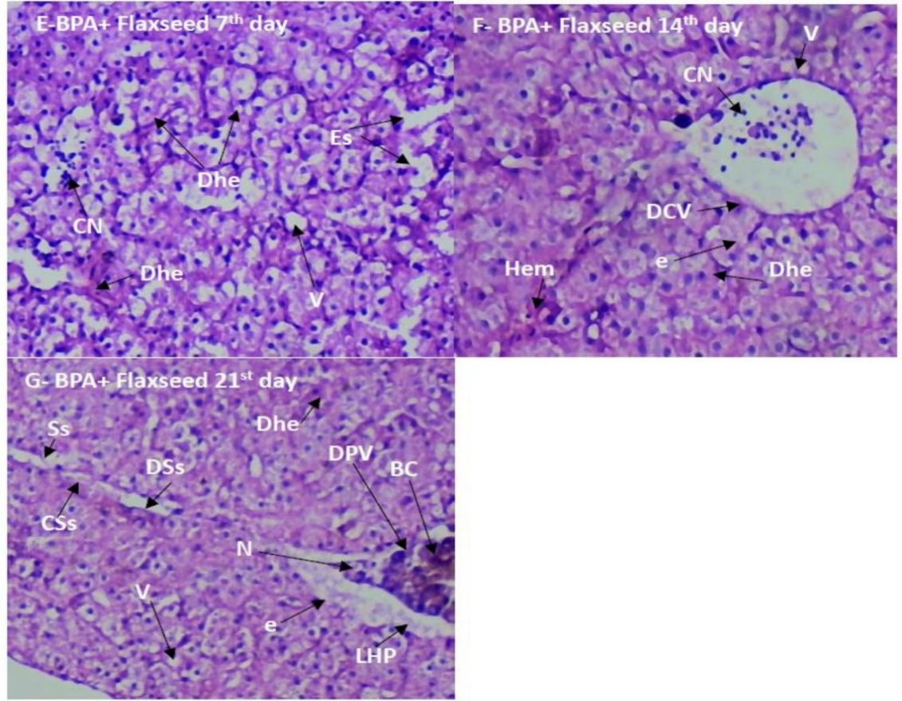
Fig-1 (E-G).: histology of liver of Labeo rohita exposed to sub lethal concentration of BPA and flaxseed for 7, 14 and 21 day. E- damaged hepatocyte(Dhe), enlarged sinusoids (es), vacuolization(v), formation of cluster nuclei(cn). F- damaged central vein (DCV), heamorrahge (Hem), edema, formation of cluster nuclei(cn) and damaged hepatocyte(Dhe) G- blood congestion, necrosis, edema, vacuoles, sinusodial spaces, loss of contact between hepatocytes and pancreocytes(LHP), congestion in sinosodial space(Css), dilation of sinusodial space(Dss).
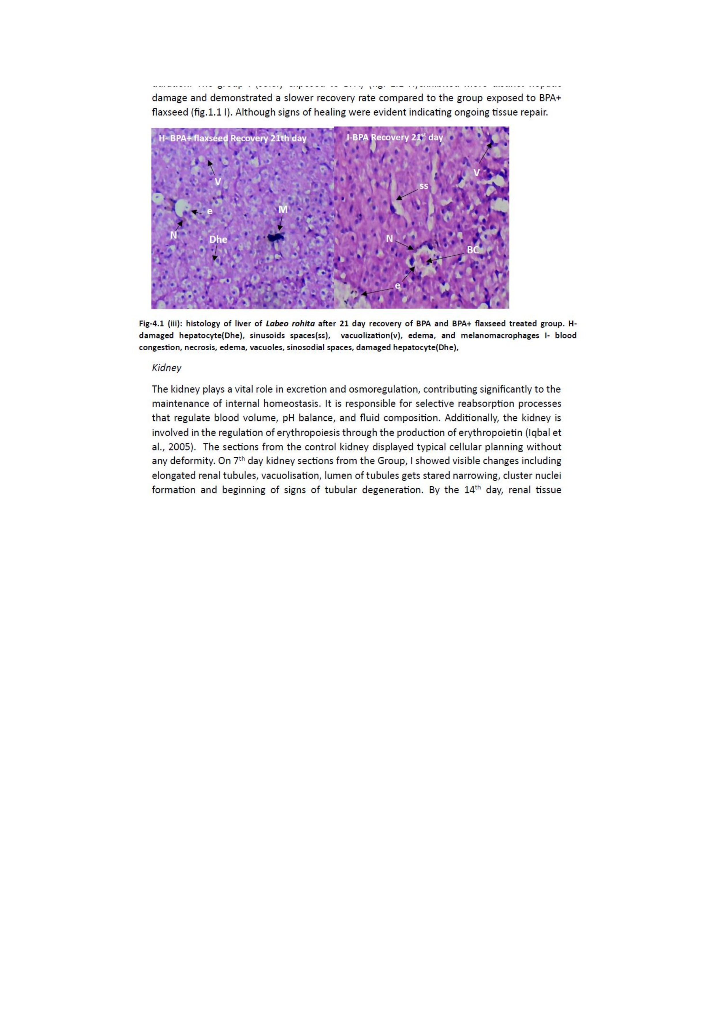
Fig-1.(H-I): histology of liver of Labeo rohita after 21 day recovery of BPA and BPA+ flaxseed treated group. H- damaged hepatocyte(Dhe), sinusoids spaces(ss), vacuolization(v), edema, and melanomacrophages I- blood congestion, necrosis, edema, vacuoles, sinosodial spaces, damaged hepatocyte(Dhe).
Histological analysis of renal tissues from the control group revealed normal cytoarchitecture, with well-organized nephrons and no observable pathological alterations (Fig.2 A). In contrast, Group II (exposed solely to BPA) exhibited progressive renal deterioration over the experimental timeline. On day 7, kidney sections showed elongation of renal tubules, cytoplasmic vacuolization, narrowing of tubular lumens, clustered nuclear formations, and initial signs of tubular degeneration (Fig.2 B). By day 14, these changes intensified, with evident cellular necrosis, persistent interstitial edema, extensive vacuolization, and marked luminal constriction (Fig.2 C). By day 21, the degenerative pathology was further exacerbated, characterized by severe vascular congestion, and continued compromise of renal function (Fig.2 D).
Group III (BPA + flaxseed supplementation) demonstrated comparatively attenuated histopathological changes. On day 7, renal tissues displayed condensed tubular lumens, melanomacrophages infiltration, and clustered nuclei (Fig.2 E). By day 14, moderate edema and degeneration of both tubular and glomerular structures were observed (Fig.2 F). These pathological features persisted through day 21, though the severity remained lower than in Group II, suggesting a protective effect of flaxseed against BPA-induced nephrotoxicity (Fig.2 G).

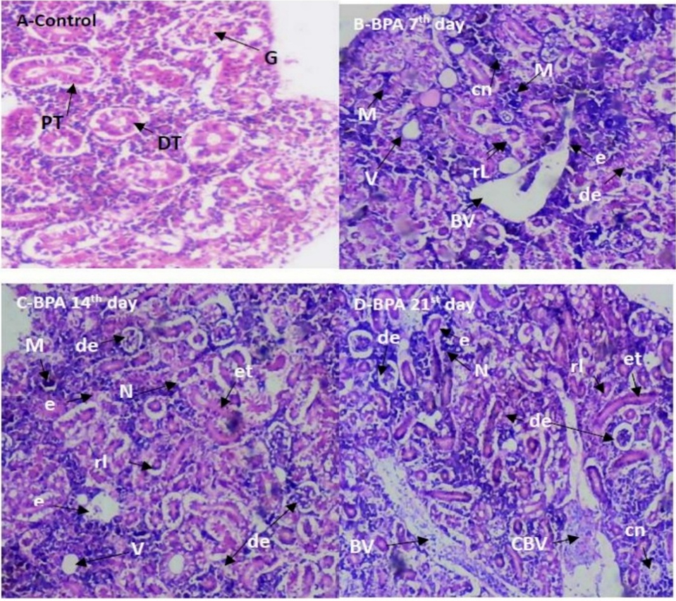

BV
Fig-2(A-D): histology of kidney of Labeo rohita exposed to sub lethal concentration of BPA-only for 7, 14 and 21 days. A- showing control. B- vacuolization (v), reduced lumen(rl), melanogenic macrophage(M), formation of cluster nuclei(cn)and degeneration of tubules. C- vacuolization (V), edema(e), elongated tubules (et), necrosis(N), reduced lumen(rl), melanomacrophages (M), formation of cluster nuclei(cn)and degeneration of glomerulus and brush border. D- elongated tubule, necrosis, edema, vacuoles, enlarged sinusoidal spaces, congestion in blood vessel, vacuolization (v), reduced lumen(rl), and melanomacrophages (M), degeneration in glomerulus and tubules.
E-BPA+ flaxseed 7th day
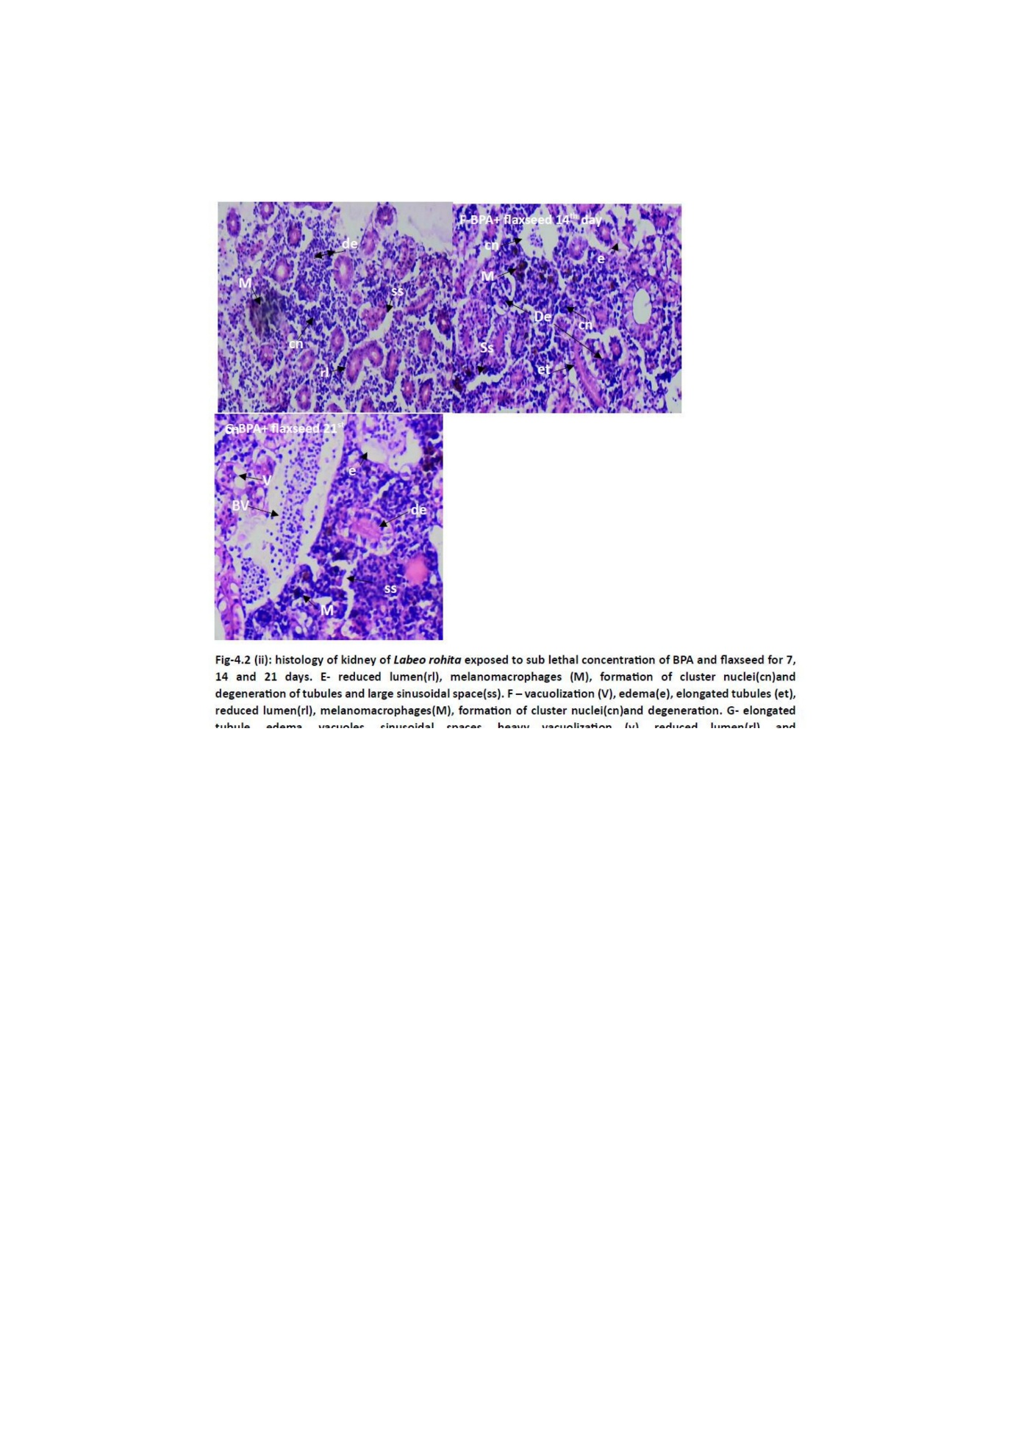
Fig-2 (E-G): histology of kidney of Labeo rohita exposed to sub lethal concentration of BPA and flaxseed for 7, 14 and 21 days. E- reduced lumen(rl), melanomacrophages (M), formation of cluster nuclei(cn)and degeneration of tubules and large sinusoidal space(ss). F – vacuolization (V), edema(e), elongated tubules (et), reduced lumen(rl), melanomacrophages(M), formation of cluster nuclei(cn)and degeneration. G- elongated tubule, edema, vacuoles, sinusoidal spaces, heavy vacuolization (v), reduced lumen(rl), and melanomacrophages(M).
Following the 21-day recovery period, both treatment groups demonstrated evidence of partial renal tissue regeneration. However, the cohort exposed exclusively to Bisphenol A (BPA) (Fig.2 H) exhibited more pronounced histopathological damage and a comparatively slower rate of recovery than the group co-treated with flaxseed (Fig.2 I). Although reparative processes were evident in both groups, moderate structural abnormalities—including persistent tubular degeneration and interstitial alterations—remained detectable, indicating incomplete restoration of renal architecture within the observed timeframe.
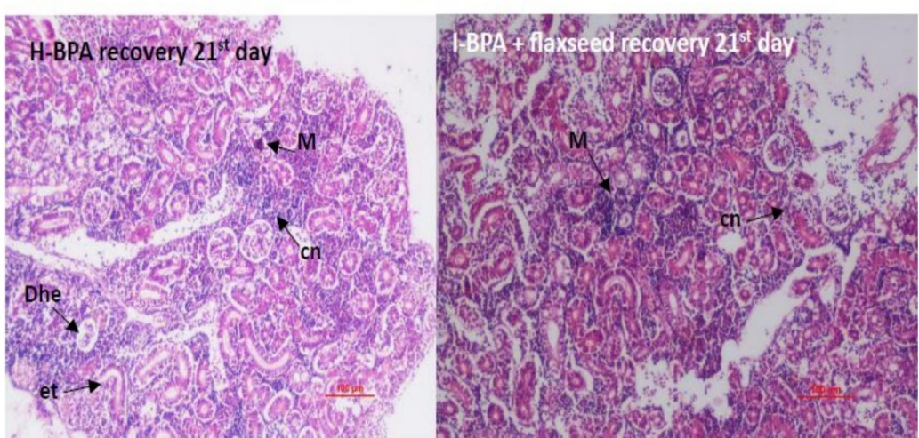
Fig-2 (H -I): histology of kidney of L. rohita after 21 day recovery period of BPA (H) and BPA+ flaxseed treated group. (I)- degenation of tissues (Dhe), sinusoids spaces(ss), melanomacrophages, elongated tubules(el) and formation of cluster nuclei.

Discussion
BPA contamination in water bodies has escalated globally, with fish being among the most vulnerable organisms due to their direct and prolonged exposure. Histopathological alterations in fish tissues serve as sensitive biomarkers for assessing the sublethal and chronic effects of environmental pollutants, including endocrine-disrupting compounds like BPA (Van der Oost et al. 2003). The present study offers novel insights into the organ-specific toxicity of BPA and the ameliorative potential of dietary flaxseed, focusing on histopathological changes in the liver and kidney of L. rohita. BPA exposure resulted in progressive hepatic damage, characterized by hepatocyte degeneration, nuclear pyknosis, sinusoidal dilation, and vascular congestion. These findings are consistent with previous reports indicating that BPA disrupts hepatic architecture through oxidative stress and inflammatory pathways (Rochester, 2013; Kabuto et al., 2004; Bindhumol et al., 2003). Similar hepatic lesions, including sinusoidal dilation and nuclear condensation, have been documented in C. catla (Fahim, 2016), H. fossilis (Sisodiya et al., 2018), and L. rohita (Chiplunkar & Andhare, 2023), reinforcing the compound’s hepatotoxic potential across species. The investigation done by Xueyou Li, et al., (2022) that BPA along with BPF and BPAF cause liver damage and oxidative stress on marine medaka Oryzias melastigma.
Mild vacuolization in hepatocytes is often considered a nonspecific response to toxic insult; however, pronounced vacuolization typically reflects intracellular accumulation of lipids and glycogen due to sustained contaminant exposure (Chitra & Maiby, 2014). The presence of melanomacrophages centres further indicates ongoing degenerative processes and early necrotic changes (Pacheco & Santos, 2002). Central vein obstruction and sinusoidal dilation, as observed in this study, may result from compromised hepatic circulation and degradation of structural proteins, leading to localized hypoxia and exacerbated cellular injury (Faheem et al., 2019). Under BPA-induced stress, fish allocate substantial metabolic resources toward detoxification, which can impair hepatic regenerative capacity and delay recovery (Hasan et al., 2022). This heightened energy expenditure can compromise the liver’s regenerative functions, thereby recovery process gets slow and negligible. In contrast, fish co-treated with flaxseed exhibited notably milder hepatic alterations. Although signs of cellular stress, such as vacuolization and nuclear clustering, were present, the severity was significantly reduced. This suggests that bioactive compounds present in flaxseed are known to enhance cellular defense mechanisms, attenuate oxidative damage, and support tissue repair and reduce oxidative stress (Prasad, 2000; Touré & Xueming, 2010, Musazadeh et al., 2021, Salem et al., 2023).
L. rohita exposed solely to BPA exhibited progressive renal deterioration over the 21-day period. Initial signs of damage included vacuolization, tubular elongation, and nuclear clustering, which escalated to necrosis, interstitial edema, and vascular congestion. These findings are consistent with previous reports indicating that BPA induces oxidative stress and disrupts renal architecture (Bindhumol et al., 2003; Kabuto et al., 2004). The observed narrowing of tubular lumens and increased cellular aggregation suggest compromised filtration and reabsorption functions—processes essential for osmoregulatory balance in aquatic organisms. The similar results were documented in various fish species, including C. punctatus (Bharti & Rasool, 2021), and Aristichthys Nobils (Akram et al., 2021), Heteropneustes fossilis (Pal & Reddy, 2018) when exposed to BPA. Alesci et al., (2022) also reported comparable histological disruption in renal tissues of B. boops upon exposure heavy metals. These pathological changes are primarily attributed to oxidative damage, epithelial cell injury, inflammatory responses, and impaired vascular integrity, collectively contributing to the disruption of renal architecture and functional decline. However, kidney sections from the group III displayed comparatively milder histopathological changes and delayed onset of tissue damage. The anti-inflammatory property of flaxseed due to omega-3 protects kidneys from damage (Kaur et al., 2018). Although signs of edema and degeneration were present, the severity was reduced. Flaxseed’s constituents may enhance cellular resilience, attenuate oxidative stress, and stabilize membrane integrity, thereby mitigating BPA-induced renal toxicity (Prasad, 2000; Touré & Xueming, 2010, Panaite et al., 2017, Barthet at al., 2014).
The partial tissue regeneration observed following the 21-day recovery period underscores the therapeutic potential of flaxseed in mitigating Bisphenol A (BPA)-induced organ toxicity. Although complete histoarchitectural restoration was not achieved. Fish supplemented with flaxseed exhibited markedly improved histological profiles in both hepatic and renal tissues compared to those exposed to BPA alone. Notably, while both experimental groups displayed signs of regeneration, the BPA-only group showed delayed recovery and persistent histopathological damage, particularly within renal structures—highlighting the insufficiency of spontaneous repair in the absence of dietary intervention. The recovery groups findings of the present study align with previous research demonstrating the protective efficacy of flaxseed oil against chemically induced organ toxicity. Makawy et al. (2018) reported that flaxseed oil significantly ameliorated hepatic and testicular damage caused by Bisphenol A (BPA) in male mice. Similarly, Abdel-Moneim et al. (2011) observed that flaxseed oil reduced lead-induced liver injury in rats by limiting inflammatory cell infiltration and hepatocellular degeneration. Karaca and Eraslan (2013) further documented its role in mitigating cadmium-induced oxidative stress in the testes of male rats.
The protective mechanism of flaxseed is largely attributed to its high content of polyunsaturated fatty acids (PUFAs), which enhance membrane fluidity and reduce cellular susceptibility to lipid peroxidation (Best et al., 2003). Additionally, flaxseed contains lignans such as secoisolariciresinol diglucoside (SDG), known for their estrogen-modulating and antioxidant properties (Anand & Garg 2025). Moreover, flaxseed’s dietary fibre and phytoestrogenic compounds, which possess potent antioxidant activity and support its overall protective role in maintaining tissue integrity (Kajla et al., 2015; Nowak & Jeziorek 2023, Zanwar et al., 2010). In aquaculture research, flaxseed has been primarily been used as a dietary protein source to enhance fish health. The novelty of current study reinforces the role of flaxseed as a functional dietary additive capable of enhancing detoxification pathways and supporting structural recovery in aquatic organisms subjected to environmental pollutants.
Conclusion
The present investigation confirms that exposure to Bisphenol A (BPA) induces marked histopathological alterations in both hepatic and renal tissues of L. rohita. In contrast, fish co-administered with BPA and a flaxseed-enriched diet displayed significantly reduced tissue injury and enhanced recovery, highlighting the potential of flaxseed as a dietary intervention. Importantly, the study contributes to the growing body of evidence supporting nutritional interventions in environmental toxicology and aquaculture health management. Future investigations exploring varied concentrations and durations of flaxseed supplementation are warranted to optimize its protective dosage and application.
Limitations of the study
This study was conducted on a single species (Labeo rohita) under controlled laboratory conditions, with both groups exposed to the same high dose of BPA, it does not reflect the variability of natural environments or different exposure levels. Future investigations should include quantitative analyses, varied concentrations and durations of flaxseed supplementation, and comparative studies across multiple fish species to strengthen the general applicability of flaxseed-based interventions.
COMPETING INTERESTS DISCLAIMER:
Authors have declared that they have no known competing financial interests OR non-financial interests OR personal relationships that could have appeared to influence the work reported in this paper.
Disclaimer (Artificial intelligence)

Author(s) hereby declares that NO generative AI technologies such as Large Language Models (ChatGPT, COPILOT, etc.) and text-to-image generators have been used during the writing or editing of this manuscript.

References
Abdel-Moneim AE, Dkhil MA., Al-Quraishy S. (2011). The redox status in rats treated with flaxseed oil and lead-induced hepatotoxicity. Biol Trace Element Res 143:457–467
Ahmad S, Akmal Hasnain., Shahzad K., Khan MKA., and Jabeen F. (2024). Evaluating the Toxicity Induced by Bisphenol F in Labeo rohita Fish Using Multiple Biomarker Approach. Scientifica. Article ID 8646751 https://doi.org/10.1155/2024/8646751
Akram R, Iqbal R, Hussain R. & Ali M. (2021). New Insights into Hematological, Serum Biochemical and Histopathological Toxicity of Bisphenol A on Bighead Carp (Aristichthys Nobils) Under Long-Term Exposure. Research Square. DOI: https://doi.org/10.21203/rs.3.rs-186716/v1
Alesci A, Cicero N, Fumia A, Petrarca C, Mangifesta R, Nava V, Lo Cascio P, Gangemi S, Di Gioacchino M, Lauriano E.R. (2022). Histological and Chemical Analysis of Heavy Metals in Kidney and Gills of Boops boops: Melanomacrophages Centers and Rodlet Cells as Environmental Biomarkers. Toxics, 10, 218. https://doi.org/10.3390/toxics10050218
Anand B. & Garg V. (2025). Dietary Flaxseed Supplementation Protects Against Bisphenol A toxicity: Evidence from Biochemical Assessments In Fish. International Journal of Life Sciences, Biotechnology and Pharma Research 14: 1184-1189.
Barthet V J, Klensporf-Pawlik D, Przybylski R. (2014). Antioxidant activity of flaxseed meal components. Can. J. Plant Sci. 94, 593–602
Basheer C, Lee, K H, Tan S K. (2004). Endocrine disrupting alkylphenols and bisphenol-A in coastal waters and supermarket seafood from Singapore. Marine Pollution Bulletin 48 :1145–1167
Best CA, Cluette-Brown JE, Teruya M, Teruya A, Laposata M. (2003). Red blood cell fatty acid ethyl esters: a significant component of fatty acid ethyl esters in the blood. J Lipid Res 44:612–620
Bharti S, & Rasool F, (2021). Analysis of the biochemical and histopathological impact of a mild dose of commercial malathion on Channa punctatus (Bloch) fish. Toxicology Reports 8; 443–455
Bhathena S J, Ali AA, Mohamed AI, Hansen C.T. and Velasquez M.T, (2002). Differential effects of dietary flaxseed protein and soy protein on plasma triglyceride and uric acid levels in animal models. Journal of Nutritional Biochemistry, 13: 684–689.
Bindhumol V, Chitra K C, & Mathur P P. (2003). Bisphenol A induces reactive oxygen species generation in the liver and kidney of male rats. Toxicology, 188(2–3), 117–124. https://doi.org/10.1016/S0300-483X(03)00190-2
Bourre JM, Dumont O, Durand G. (2004). Dose-effect of dietary oleic acid: oleic acid is conditionally essential for some organs. Reprod Nutr Dev 44(4):371–38
Chiplunkar S. & Andhare V. (2023). Effects of Bisphenol A on the liver histopathology of Indian major carp, Labeo rohita (Hamilton, 1822). IJCRT, 11;39-44
Chitra KC. & Maiby S. (2014). Oxidative stress of Bisphenol-A and its adverse effects on liver of fresh water fish Oreochromis mossambicus. IJSR ;3(7):221-224
Faheem M, and Lone K.P. (2017). Oxidative stress and histopathologic biomarkers of exposure to bisphenol-A in the freshwater fish Ctenopharyngodon idella. Braz. J. Pharm. Sci.;53(3): e17003 https://doi.org/10.1590/s2175-97902017000317003
Faheem M, Khaliq S. and Lone K.P. (2019). Effect of Bisphenol-A on serum biochemistry and liver function in the freshwater fish, Catla catla. Pakistan Veterinary Journal. 39(1):71-75.
Farzana K F, Abubacker SF, Ruckmani A, Vijayalakshmi K, Karunya L G, Shri Rajni S, & Duraivel M, (2015). Effects of Flax Seeds Supplementation in Polycystic Ovarian Syndrome. Int. J. Pharm. Sci. Rev. Res., 31(1): 113-119. ISSN 0976 – 044X
Flint S, Markle T, Thompson S, Wallace E. (2012). Bisphenol A exposure, effects, and policy: a wildlife perspective. J Environ Manage 104:19–34.
Hasan J, Ferdous S R, Rabiya S B A, Hossain M F, Hasan AKM, and Shahjahan M. (2022). Histopathological responses and recovery in gills and liver of Nile tilapia (Oreochromis niloticus) exposed to diesel oil. Toxicology Reports 9 1863–1868.
Herdia-Garcia G., Elizalde-Velazquez G A., Gomez-Olivian L M., Islas-Flores H., Garcia-Medina S., et al., (2023). Realistic concentrations of Bisphenol-A trigger a neurotoxic response in the brain of zebrafish: Oxidative stress, behavioral impairment, acetylcholinesterase inhibition, and gene expression disruption. Chemosphere, 330:138729
Iqbal F, Qureshi I Z & Ali M. (2005). Histopathological Changes in the Liver of a Farmed Cyprinid Fish, Cyprinus Carpio, Following Exposure to Nitrate. Pak. J. Zool. 37: 297–300.
Iqbal M, Sharma S D, & Okazaki Y. (2005). Erythropoietin production and regulation in fish kidneys. Fish Physiology and Biochemistry, 31(2):103–110.
Kabuto H, Amakawa M, & Shishibori T. (2004). Exposure to bisphenol A during embryonic/fetal life and adulthood increases oxidative injury and causes underdevelopment of the brain and kidney in mice. Life Sciences, 74(24): 2931–2940. https://doi.org/10.1016/j.lfs.2003.07.060
Kajla P, Sharma A, & Sood D R (2015). Flaxseed- a potential functional food source. J Food Sci Technol. 52(4):1857–1871.
Kamel H A, Foaud A M, and Moussa M H. (2018). The adverse effects of bisphenol A on male albino rats. The Journal of basic and Applied Zoology. 79:6. DOI 10.1186/s41936-018-0015-9
Karaca S, & Eraslan G. (2013). The effects of flaxseed oil on cadmium-induced oxidative stress in rats. Biol Trace Elem Res 155:423–430
Kundu S, Biswas A, Ray A, Roy S, Gupta S D, Ramteke M H, Kumar V, and Das B K. (2024). Bisphenol A contamination in Hilsa shad and assessment of potential hazard: A pioneering investigation in the national river Ganga, India. Elsevier, journal of Hazardous Materials, 461. 132532
Lalwani D, Ruan Y. Taniyasu S, Yamazaki E, Kumar N J I, Lam P K S, Wang X, and Yamashitaet N. (2020). Nationwide distribution and potential risk of bisphenol analogues in Indian waters. Ecotoxicology and Environmental Safety, Vol 200, 110718
LeAnne, T., Bloedon, M.S., R.D., and Philippe, O., Szapary, M.D., (2004). Flaxseed and Cardiovascular Risk. Nutrition Reviews, 62(1): 18-27
Lee S, Liu X, Takeda S, & Choi K. (2013). Genotoxic potentials and related mechanisms of bisphenol A and other bisphenol compounds: a comparison study employing chicken DT40 cells. Chemosphere. 93:434-440. 30.
Li J, Bach A, Crawford R B, Phadnis-Moghe A S, Chen, W, D’Ingillo S, Kovalova N, Suarez-Martinez J E, Zhou J, Kaplan B L F. (2018). CLARITY-BPA: Effects of chronic Bisphenol A exposure on the immune system: Part 1—Quantification of the relative number and proportion of leukocyte populations in the spleen and thymus. Toxicology. 396–397:46–53
Li X, et al. (2021). Effects of High Levels of Dietary Linseed Oil on the Growth Performance, Antioxidant Capacity, Hepatic Lipid Metabolism, and Expression of Inflammatory Genes in Large Yellow Croaker (Larimichthys crocea). Front. Physiol. 12:631850. Doi: 10.3389/fphys.2021.631850
Makawy A E, Eissa F, El-Bamby M, and Elhamalawy O. (2018). Flaxseed oil as a protective agent against bisphenol-A deleterious effects in male mice. Bulletin of the National Research Centre 42:5 https://doi.org/10.1186/s42269-018-0007-4
Michalowitz J. (2014). Bisphenol A–sources, toxicity and biotransformation. Environmental toxicology and pharmacology, 37(2): 738-758. https://doi.org/10.1016/j.etap.2014.02.003
Modar Intelligence https://www-mordorintelligence-com.webpkgcache.com/doc/-/s/www.mordorintelligence.com/industry-reports/bisphenol-a-bpa-market
Mohammadi- Sartang M, Mazloom Z, Raeisi- Dehkordi H, Barati- Bldaji R, Bellissimo N, and Totosy de Zepetnek J.O. (2017). The effect of flaxseed supplementation on body weight and body composition: A systemic review and meta- analysis of 45 randomized placebo- controlled trials. Obesity reviews, doi: 10.1111/obr.12550
Musazadeh V, Jafarzadeh J, Keramati M, Zarezadeh M Ahmadi M.; Farrokhian, Z Ostadrahimi A. (2021). Flaxseed Oil Supplementation Augments Antioxidant Capacity and Alleviates Oxidative Stress: A Systematic Review and Meta-Analysis of Randomized Controlled Trials. Evid. Based Complement. Alternat. Med. 4438613.
Nishiyama et al. (2014). Chemometrics applied to the incorporation of omega-3 in tilapia fillet feed flaxseed flour. Food Sci. Technol, Campinas, 34(3): 449-455. DDOI: http://dx.doi.org/10.1590/1678-457X.6341
Nowak A D, Synder D C, Brown A L, & Wahnefried W D. (2007) The effect of Flaxseed AnnexAppenlementation on Hormonal Levels Associated with Polycystic Ovarian Syndrome: A Case study. Curr Top Nutraceutical Res. 5(4): 177–181
Nowak W, & Jeziorek M. (2023). The Role of Flaxseed in Improving Human Health. Healthcare, 11, 395. https://doi.org/10.3390/
Pacheco M, and Santos M A (2002). Biotransformation, genotoxic and histopathological effects of environmental contaminants in European eel, Anguilla anguilla L. Ecotoxicology and Environmental Safety, 53: 331-347.
Pal S, and Reddy P B, (2018). Bisphenol A(BPA) induced histopathological and biochemical alterations in liver and kidney of stinging cat fish Heteropneustes fossilis. Trends in Fisheries Research. ISSN: 2319–474X, 7(1): 2319–4758 (e)
Poleksic V, Lenhardt M, Jaric I, Djordevic D, Gacic Z, Cvijanovic G, & Raskovic B. (2010). Liver, gills, and skin histopathology and heavy metal content of the Danube sterlet (Acipenser ruthenus Linnaeus, 1758). Environ. Toxicol. Chem. 29, 515–521. https:// doi. org/ 10. 1002/ etc. 82
Prasad K. (2000). Flaxseed: A source of hypocholesterolemic and antiatherogenic agents. Drug News & Perspectives, 13(2): 99–104.
Prins G S, Ye S H, Birch L, Zhang X, Cheong A, Lin H, Calderon-Gierszal E, Groen J, Hu W Y, Ho S.M, et al., (2017). Prostate Cancer Risk and DNA Methylation Signatures in Aging Rats following Developmental BPA Exposure: A Dose-Response Analysis. Environ. Health Perspect. 125: 077007.
Richter C A, Birnbaum L S, Farabollini F, Newbold R R, Rubin B S, Talsness C E, Vandenbergh J G, Walser-Kuntz D R, Vom Saal F S. (2007). In vivo effects of bisphenol A in laboratory rodent studies. Reprod. Toxicol. 24: 199–224.
Rochester J.R. (2013). Bisphenol A and Human Health: A review of literature. Reproductive toxicology, 42:132-15
Salem M O A, Tastan Y, Bilen S, Terzi E., & Sonmez A Y. (2023). Dietary flaxseed (Linum usitatissimum) oil supplementation affects growth, oxidative stress, immune response, and diseases resistance in rainbow trout (Oncorhynchus mykiss). Fish & Shellfish Immunology, 138: 108798
Santoro A, Chianese R., Troisi J, Richards S, Nori S L, Fasano S, Guida M, Plunk E, Viggiano A, Pierantoni R. et al. (2019). Neuro-toxic and Reproductive Effects of BPA. Curr. Neuropharmacol. 17: 1109–1132.
Satyakov Y, G. Zhelyazkov and S. Stoyanova (2015). Effect of substitution of sunflower meal with flaxseed meal on the growth performance and chemical composition of meat in common carp (Cyprinus carpio L.). Bulg. J. Agric. Sci., Supplement 1, 21: 169–174
Septiyani, A., Ridwanudin A., Pangestu, L. D., Mahariawan, I. M. D., Nurdiani, R., & Hariati, A. M. (2025). Effect of Guanosine 5-Monophosphate Supplementation to Flaxseed Oil-Based Diet on Growth and Intestinal Morphology of Juvenile Nile Tilapia (Oreochromis sp.). Trends in Sciences, 22(11), 10652. https://doi.org/10.48048/tis.2025.10652
Sisodiya M, Khare M, and Kanhere R R. (2018). Hepatotoxic Effects of Bisphenol A on H. fossilis. TFR. 7(3): 2319–4758 ISSN: 2319–474X
Soni P R, Katoch M, Kumar A, and Verma P, (2016). Flaxseed- composition and its health benefits, Res. Environ. Life Sci., 9 (3), 310-316, ISSN: 0974-4908
Staples CA, Dome PB, Klecka GM, Oblock ST, Harris LR. (1998). A review of the environmental fate, effects, and exposures of bisphenol A. Chemosphere 36:2149–2173
Touré A, & Xueming X. (2010). Flaxseed lignans: Source, biosynthesis, metabolism, antioxidant activity, bio-active components, and health benefits. Comprehensive Reviews in Food Science and Food Safety, 9(3): 261–269. https://doi.org/10.1111/j.1541-4337.2010.00112.x
Van der Oost R Beyer J, Vermeulen NPE (2003) Fish bioaccumulation and biomarkers in environmental risk assessment: a review. Environ Toxicol Pharmacol 13:57–149
Xueyou Li , Yue Liu, Yuebi Chen, Xinlin Song , Xiaotian Chen, Ning Zhang , Huichen Li , Yusong Guo , Zhongduo Wang , Zhongdian Dong. (2022). Long-term exposure to bisphenol A and its analogues alters the behavior of marine medaka (Oryzias melastigma) and causes hepatic injury. Science of Total Environment, 841:156950. https://doi.org/10.1016/j.scitotenv.2022.156590
Yu J, Li S, Niu H. et al. (2019). Influence of dietary linseed oil as substitution of fish oil on whole fish fatty acid composition, lipid metabolism, and oxidative status of juvenile Manchurian trout, Brachymystax lenok. Sci Rep 9, 13846 https://doi.org/10.1038/s41598-019-50243-8

