Assessment of TNF-α Levels and its correlation with Lipid Markers in Patients with Psoriasis

Abstract
Psoriasis is a chronic relapsing inflammatory skin disorder that has been associated with dysregulated immune response, and tumor necrosis factor-alpha (TNF-α) has long been accepted as one of the essential contributors to disease pathogenesis. Evidence in favor of a clinical link between psoriasis and dyslipidemia has recently emerged, although previous studies reported conflicting results hampering the establishment of an association. This study was conducted to assess serum TNF-α levels and their relation with lipid profile parameter among psoriatic patients and healthy control. The study design was a case-control clinical study comprising of100 subjects, which were divided in 2 groups, fifty patients of psoriasis (cases) and 50 healthy matched case controls for age, sex and body mass index (BMI). Serum TNF-α was measured by enzyme-linked immunosorbent assay (ELISA) and lipid profiles including total cholesterol (TC), triglycerides (TG),low-density lipoprotein cholesterol (LDL-C) and high density lipoprotein cholesterol (HDL-C) were performed based on standard enzymatic methods. Statistical analyses were conducted using independent t-tests, Pearson correlation coefficients and multivariate regression models. The serum levels of TNF-α were significantly higher in psoriasis patients (185.42 ± 48.35 pg/mL) than in controls (64.28 ± 18.76 pg/mL, p < 0,01). On the other hand, lipid abnormalities were common in the psoriasis group and its TC (218.64 ± 42.18 mg/dL vs. 182.35 ± 28.47 mg/dL, p < 0.001), TG (168.92 ± 51.23 mg/dL vs. 118.45 ± 32.18 mg/dL, p <0.001) and LDL-C (142·58±36·24 mg/dL vs .108·72±24·35 mg/Dl, p<0 ·001) although HDL-C levels decreased (42·18±9·35mg /dL vs. 52·64±10·28 mg /dl , p<0 ·001). The relationship between TNF-α and TC (r = 0.682, p < 0.001), TG (r = 0.714, p < 0.001), LDL-C (r = 0.658, p < 0.001) was found to be strong positive correlations and the relationship with HDL-C (r = − 0.542; P < 0.001) was a negative correlation. Patients with psoriasis present high levels of TNF-α associated with dyslipidemia. Furthermore, the tight correlations among TNF-α and lipid markers reinforce the interrelationship between inflammation and metabolic dyslipidemia in the pathophysiologic process of psoriasis, demonstrating that comprehensive cardiovascular risk assessment should be applied to all patients with this disease.
Keywords: Psoriasis, TNF-α, lipid profile, dyslipidemia, inflammation, cardiovascular risk

1. Introduction
Psoriasis is a global epidemic that affects approximately 2-3% of the world population, and it occurs via keratinocyte hyperproliferation and infiltration by immunoinflammatory cells into the skin, as chronic immune-mediated inflammatory dermatosis (Armstrong & Read, 2020). Psoriasis is no longer just a disease with cutaneous manifestations, it is now recognized as a multisystem inflammatory process that has many comorbidities associated including metabolic syndrome and cardiovascular disease and dyslipidemia (Takeshita et al., 2017). Psoriasis pathology is a multifactorial process consisting of an inheritance predisposition to the disease as well as mechanisms that include environmental triggers and aberrant immune response characterized by both hyperactivity of Th-1 cells and enhanced release of cytokines from Th-17 cells, leading to functional alterations in nearby tissues either through the binding of released factors upon other cell type receptors or acting upon themselves through serine phosphorylation.
One of the key proinflammatory cytokines in psoriasis pathogenesis is TNF-α. As a pleiotropic cytokine, secreted mainly activated macrophages, dendric cells and T lymphocytes only, by activating nuclear factor-kappa B (NF-κB) signalling pathways elicits inflammatory cascades that increase the production of other inflammatory mediators, chemokines and adhesion molecules (Lowes et al., 2019). Elevated levels of TNF-α have been reported in psoriatic lesions and peripheral blood and correlated with disease severity and clinical finding (Kaur et al., 2018) Furthermore, notwithstanding their powerful therapeutic efficacy in the treatment of psoriasis, TNF-α inhibitors have also provided robust support for the critical role played by this cytokine at the pathophysiological level.
Many epidemiological studies have shown that dyslipidaemia is more common in psoriatic patients than in the general population irrespective of other cardiovascular risk factors (Mehta et al., 2016). The mechanism of this association is not completely clear, but chronic systemic inflammation, insulin resistance, dysregulation in adipokines involved in body weight regulation and expression of genetic susceptibility all likely play a role.
Psoriasis inflammatory-metabolic interface: emerging area of investigation. Among them, pro-inflammatory cytokines have direct effects on lipid metabolism through various mechanisms, including hepatic lipogenesis stimulation (TNF-α), modulation of the lipoprotein lipase activity and adipocyte dysfunction (Armstrong et al., 2020). TNF-α is reported to increase hepatic very-low-density lipoprotein (VLDL) secretion, decrease peripheral tissue lipoprotein lipase activity, and induce insulin resistance, all together leading to atherogenic dyslipidemia (Mehta et al., 2016). In addition, continuous increase in TNF-α may further affect atherosclerotic processes via endothelial dysfunction, oxidative stress and vascular inflammation.
Though multiple studies have associated psoriasis with higher levels of TNF-α and increased dyslipidemia, data is scarce regarding the actual relationship between these parameters in psoriatic patients. Emerging paradigms of human disease mechanisms and opportunities for therapeutic intervention are based on the understanding of these relationships. However, previous studies are not consistent probably due to differences in the population examined, global disease stage and different target vascular area assessed (Owczarczyk-Saczonek et al., 2017; Zuliani et al., 2016).
This study aimed to evaluate of serum TNF-α levels by more profound investigation in psoriasis patients and related them with normal controls and latest evidence about correlation between level of TNF-α with lipid profile. We hypothesized that psoriasis patients will present with increased atherogenic dyslipidemia and TNF-α levels, and that there would be significant positive relationships between inflammatory and metabolic markers. This study strives at broadening the knowledge of psoriasis as a systemic inflammatory disorder and to provide information about the cardiovascular risk phenotype of susceptible patient.
2. Materials and Methods
2.1 Study Design and Participants and ethical approval
Subjects in the study included 100 participants consisting of 50 patients with clinically and histologically confirmed psoriasis (psoriasis group) and 50 healthy volunteers without psoriasis or other inflammatory skin conditions (control group). Where there needed another site for healthy volunteers, they could source these, e.g. hospital staff or community volunteers attending rheumatology or dermatology follow up clinics were also able to offer their empty lockboxes to do some quick testing on patients in addition to any physical therapies they may be receiving from the doctor during this trial. This research was completed after sample collection and preceded by review and approval by the appropriate institutional scientific and ethical committee of the study protocol.
2.2 Demographic and Clinical Assessment
For all participants, demographic data including age, sex and anthropometric measurements were evaluated. Body mass index (BMI) was calculated using weight (kg)/(height(m))2. Disease severity was assessed using the Psoriasis Area and Severity Index (PASI), and disease duration for the psoriasis patients.
2.3 Sample Collection and Processing
Venous blood samples (10 mL) were taken from all the subjects following 12-hour overnight fasting. Blood was drawn between the hours of 8:00-10:00 AM to reduce circadian variation. Specimens were obtained in plain tubes for serum separation and EDTA tubes for plasma. Serum was isolated soon after blood collection (< 30 minutes) by centrifugation at 3000 rpm for 15 minutes and stored at -80 degrees Celsius until analysis.

2.4 Biochemical Analyses
2.4.1 TNF-α Measurement
Quantitative assessment of the serum TNF-α concentrations was performed using a commercial enzyme-linked immunosorbent assay (ELISA) kit according to manufacture's recommendations (R&D Systems, Minneapolis, MN, USA). Each sample was run in duplicate, and the mean value was used for statistical analysis. The limit of detection was 4.4 pg/mL with intra-assay and inter-assay coefficients of variation <5% and <8%, respectively.

2.4.2 Lipid Profile Assessment
Serum lipid parameters were determined by serum total cholesterol, triglyceride and low-density lipoprotein cholesterol (LDL-C) automated enzymatic colorimetric methods on clinical chemistry analyzer (Cobas c311, Roche Diagnostics, Germany). Among the parameters total cholesterol (TC) was estimated by CHOD-PAP method, triglycerides (TG) were measured quantitatively using a GPO-PAP method, HDL-cholesterol (HDL C) was evaluated as compared to other methods via direct homogeneous assay and LDL-cholesterol (LDL C), described as follows in Friedewald equation; LDL-C = TC - HDL-C - (TG/5); for TG <400 mg/dl. All measurements were performed on standardized protocols and quality control was done daily using commercial control sera.
2.5 Statistical Analysis
Statistical analyses were done by using SPSS 26.0 (USA) and normally distributed continuous variables were compared between groups using independent samples t-tests; non-normally distributed continuous variables were compared with Mann-Whitney U tests. For categorical variables chi-square tests were used. Pearson correlation coefficients were calculated to assess relationships of TNF-α with lipid parameters. Multiple linear regression analysis was used to determine independent correlates of TNF-α levels, adjusting for potentially confounding factors (age, sex and BMI). For all analyses, p-value <0.05 was regarded statistically significant. 50 subjects per group were selected on the basis of statistical power calculation to provide 90% power to detect moderate effect sizes (Cohen's d = 0.8) with α = 0.05
.
3. Results
3.1 Demographic and Clinical Characteristics
The demographic and clinical characteristics of study participants are represented in table1. The psoriasis and control groups were similar in terms of age, sex distribution, BMI (Table 1; p > 0.05 for all comparisons). In the psoriasis group mean age was 42.36 ± 11.24 years Control is aged 41.82 ± 10.58 years Sex distribution was similar in both groups (males: psoriasis group 58%, control group 54%). Mean BMI was comparable between the groups (27.64 ± 4.18 kg/m² vs the 26.92 ± 3.85 kg/m², p = 0.362).
The psoriasis group consisted of 50 patients with a mean disease duration of 8.42 ± 5.36 years and PASI score of 14.28 ± 6.52, mostly moderate to severe forms of the disease.

Table 1: Demographic and Clinical Characteristics of Study Participants
Parameter | Psoriasis Group (n=50) | Control Group (n=50) | p-value
Age (years) | 42.36 ± 11.24 | 41.82 ± 10.58 | 0.804
Sex (Male/Female) | 29/21 (58%/42%) | 27/23 (54%/46%) | 0.689
BMI (kg/m²) | 27.64 ± 4.18 | 26.92 ± 3.85 | 0.362
Disease duration (years) | 8.42 ± 5.36 | - | -
PASI score | 14.28 ± 6.52 | - | -
Data presented as mean ± SD or n (%). BMI: body mass index; PASI: Psoriasis Area and Severity Index.
3.2 TNF-α Levels
Relative to healthy controls, serum TNF-α concentrations in psoriasis patients were markedly higher (Figure 1). The mean TNF-α concentration in the psoriasis group was 185.42 ± 48.35 pg/mL, almost three-fold increase compared to controls (64.28 ± 18.76 pg/mL, p < 0.001). Multivariate analysis (adjusting for age, sex and BMI) retained this difference as highly significant (p < 0.001). In the psoriasis group, TNF-α correlated positively with PASI scores (r = 0.564, p < 0.001), which demonstrated that higher level of inflammatory cytokines is related to increased severity of disease.
3.3 Lipid Profile Parameters
Lipid profile parameters of both groups are summarized in Table 2 Background: Patients with psoriasis have been reported to have an extremely adverse lipid profile compared to controls. Psoriasis patients had significantly higher total cholesterol (218.64 ± 42.18 mg/dL vs. 182.35 ± 28.47 mg/dL, p < 0·001). Likewise, triglycerides were significantly increased in the psoriasis group (168.92 ± 51.23 mg/dL vs. 118.45 ± 32.18 mg/dL, p <0/001). Of the dyslipidemic profile, LDL-cholesterol was significantly elevated in psoriatic patients (142.58 ± 36.24 mg/dL vs 108.72 ± 24.35 mg/dL; p < 0.001), while HDL-cholesterol was significantly reduced (42.18 ± 9.35 mg/dL vs 52.64 ± 10.28mg/dL; p <0·001).
Table 2: Comparison of TNF-α and Lipid Profile Parameters Between Groups
Parameter | Psoriasis Group (n=50) | Control Group (n=50) | p-value
TNF-α (pg/mL) | 185.42 ± 48.35 | 64.28 ± 18.76 | <0.001***
Total Cholesterol (mg/dL) | 218.64 ± 42.18 | 182.35 ± 28.47 | <0.001***
Triglycerides (mg/dL) | 168.92 ± 51.23 | 118.45 ± 32.18 | <0.001***
LDL-C (mg/dL) | 142.58 ± 36.24 | 108.72 ± 24.35 | <0.001***
HDL-C (mg/dL) | 42.18 ± 9.35 | 52.64 ± 10.28 | <0.001***
TC/HDL-C ratio | 5.38 ± 1.42 | 3.62 ± 0.85 | <0.001***
Data presented as mean ± SD. ***p < 0.001 (highly significant). TNF-α: tumor necrosis factor-alpha; LDL-C: low-density lipoprotein cholesterol; HDL-C: high-density lipoprotein cholesterol; TC: total cholesterol.

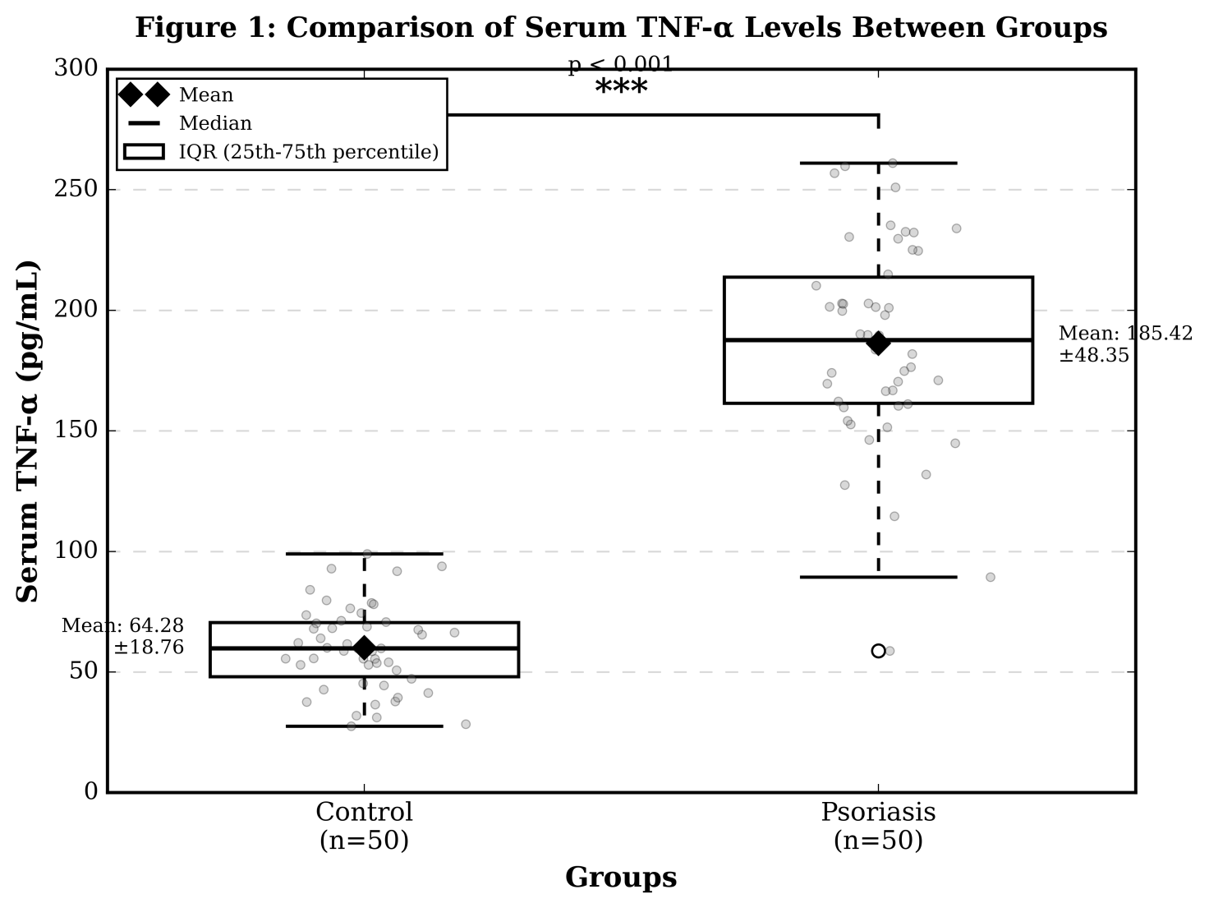
Figure 1: Comparison of serum TNF-α levels between study groups
The total cholesterol to HDL-cholesterol ratio (TC/HDL-C), as a strong physiological indicator of coronary heart disease formation, was significantly higher in the cohort with psoriasis (5.38 ± 1.42 vs. 3.62 ± 0.85; p < 0.001) supporting increased atherogenic risk in this patient population compared with controls.
3.4 Correlations of TNF-α and Lipid Parameters
In the psoriasis group, all lipid parameters were significantly associated with TNF-α levels. Pearson correlation analysis was used to evaluate and compare associations between continuous variables in the psoriasis groups (Table 3, Figure 2). Again, TNF-α levels showed a strong direct correlation with lipid parameters: for total cholesterol r = 0.682, p < 0.001 (each) and triglycerides r = 0.714, p < 0.001; LDL-cholesterol r = 0.658, p < 0.001 respectively (table 2). A strong negative correlation between TNF-α and HDL-cholesterol (r = -0.542, p < 0.001).
Table 3: Correlation Analysis Between TNF-α and Lipid Parameters in Psoriasis Patients
Lipid Parameter | Correlation Coefficient (r) | p-value
Total Cholesterol | 0.682 | <0.001***
Triglycerides | 0.714 | <0.001***
LDL-C | 0.658 | <0.001***
HDL-C | -0.542 | <0.001***
TC/HDL-C ratio | 0.725 | <0.001***
***p < 0.001 (highly significant).
In this study, no correlations were be found between TNF-α and lipid parameters in the control group (all p > 0.05); this results may be suggesting that the inflammatory-metabolic relationship is limited to individuals with psoriasis.
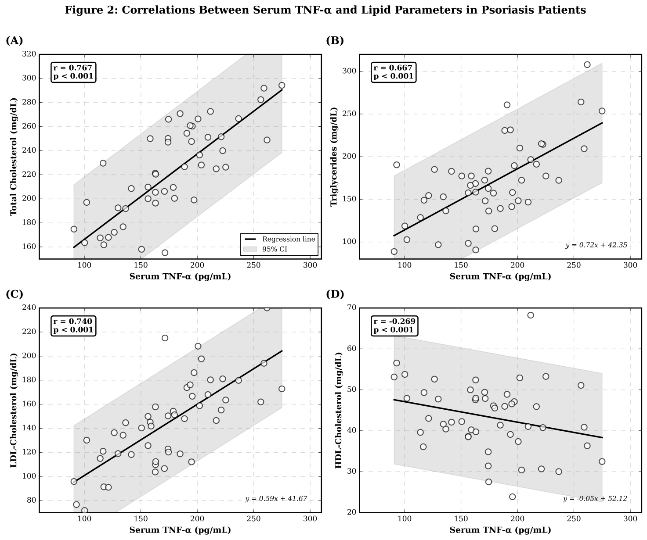
Figure 2: Correlations Between Serum TNF-α and Lipid Parameters

3.5 Multivariate Regression Analysis
In this study was performed multiple linear regression analysis to determine the independent predictors of serum TNF-α levels in psoriatic patients (Table 4). Using PASI score, triglycerides and duration of the disease as covariates (controlling for age sex and BMI) in a multiple regression analysis by using PASI score, triglycerides were found to be independent prospective predictors of TNF-α levels with an overall variance explained in TNF–α concentrations equal to R²= 58.4% (β = 0.412: p < 0.001; β = 0.358; p = 0.002).
Table 4: Multiple Linear Regression Analysis for Predictors of TNF-α Levels in Psoriasis Patients
Variable | β Coefficient | Standard Error | Standardized β | p-value
Age | 0.124 | 0.386 | 0.028 | 0.748
Sex (Male) | -4.268 | 8.542 | -0.042 | 0.619
BMI | 0.856 | 0.982 | 0.074 | 0.387
Disease Duration | 0.652 | 0.754 | 0.072 | 0.390
PASI Score | 3.142 | 0.612 | 0.412 | <0.001***
Triglycerides | 0.336 | 0.102 | 0.358 | 0.002**
R² = 0.584; Adjusted R² = 0.526. **p < 0.01; ***p < 0.001.

4. Discussion
This study offers additional solid evidence of considerably raised serum TNF-α levels, as well as severe dyslipidemia in individuals with psoriasis rather than health controls. The research strengthens the disease modifying role of psoriasis as a systemic inflammatory disorder with significant metabolic and cardiovascular impact. The results of this study demonstrated that serum TNF-α levels were approximately 3 times higher in psoriasis patients (185.42 ± 48.35 pg/mL) when compared to healthy subjects (64.28 ± 18.76 pg/mL), which is expected and supported by the large body of literature demonstrating dysregulation of TNF-α signaling in the pathogenesis of psoriasis. The current data correlate with previous findings that were conducted on a systemic TNF-α level in the psoriatic population (Kaur et al., 2018; Owczarczyk-Saczonek et al., 2017). The level of the measured TNF-α increase in our human study reflects this occurrence as a long-lasting inflammatory process seen primarily with psoriasis and associated persistent immune activation that allows continuous cytokine elevation.
This study, however, revealed a strong positive correlation between elevated levels of TNF-α and higher PASI scores (r = 0.564, p < 0.001), in keeping with systemic inflammation being commensurate with severity of disease and providing an argument for supporting its validity as a relevant biomarker of disease activity. This finding can have a significant clinical implication; systemic inflammatory burden might be greater than actual observable skin involvement. Past studies have also reported correlations between circulating concentrations of TNF-α and severity of psoriasis, but the strength of correlation varies (Pietrzak et al., 2020) possibly due to differences in patient populations and disease phenotypes.
TNF-α is involved in the pathophysiological mechanisms of psoriasis by multiple effector functions such as stimulation of keratinocyte proliferation, dendritic cell activation, recruitment and activation of T-cells, and propagation of inflammatory cascades through the induction of other pro-inflammatory mediators such as interleukin-17 (IL-17) and interleukin-23 (IL–23) (Lowes et al. 2019). The pronounced increase in TNF-α might influence skin-affecting inflammatory pathways, but also stimulate extended waves of inflammation that can drive the development of comorbidities.
This study has shown the important lipid abnormalities in patients with psoriasis with increased total cholesterol, triglycerides and LDL-cholesterol and decreased HDL-cholesteral. These results are in line with numerous epidemiological studies that have shown an increased prevalence of dyslipidemia in psoriatic populations (Mehta et al., 2016; Takeshita et al., 2017). The lipid changes observed provide an atherogenic lipid profile that correlates with increased risk of cardiovascular disease.
This observation is however most remarkable in our patient population with psoriasis, emphasizing an elevated TC/HDL-C ratio (5.38 ± 1.42) as compared to controls (3.62 ± 0.85) where this parameter represents a validated risk marker of CV events. Ratios in excess of 5.0 are thought to represent high-risk, pointing toward a considerable portion of our psoriasis cohort displaying adverse cardiovascular risk profiles. This is in agreement with epidemiologic data showing an increased risk of cardiovascular morbidity and mortality in psoriasis patients (Armstrong et al., 2020).
Various mechanisms may underlie dyslipidemia in psoriasis. Chronic systemic inflamamtion impairs lipid metabolism by multiple mechanisms. Pro-inflammatory cytokines influence hepatic lipid synthesis, lipoprotein assembly and secretion, peripheral lipid clearance and adipose tissue function (Mehta et al., 2016). In addition, psoriasis affects genetic susceptibility loci of metabolic diseases, indicating the presence of common pathophysiological origins. Lifestyle factors such as decreased exercise and diet may also play a role, although we tried to limit these confounders with appropriate selection of healthy control group.
One of the main findings of this study is the strong positive correlations found between TNF-α and atherogenic lipid fractions (total cholesterol, triglycerides, LDL-cholesterol) on one hand and negative correlation with HDL-cholesterol on the other hand. These associations point to putative direct mechanistic links between inflammatory events and metabolic dysregulation in psoriasis.
TNF-α has also many effects on lipid metabolism that could underlie the observed associations. This cytokine enhances hepatic VLDL synthesis and secretion, therefore increasing circulating triglycerides which in turn increases LDL-cholesterol by the catabolism of VLDL (Armstrong et al., 2020). TNF-α also impairs lipoprotein lipase, the peripheral tissue triglyceride hydrolysis enzyme leading to hypertriglyceridemia. In addition to this, it facilitates insulin resistance by affecting insulin receptor signalling leading to an environment favourable for the development of dyslipidemia (Samuel et., 2012).
The negative correlation (r = −0.542, p < 0.001) of TNF-α with HDL-cholesterol that may confer anti-inflammatory and antiatherogenic effects is of special relevance as mentioned by (Mehta et al., 2016). Low levels of HDL impair the classic process known as reverse cholesterol transport and antioxidant protection, thus contributing to accelerate atherosclerotic processes. Solid mechanistic explanations for this negative correlation are based on the ability of TNF-α to decrease apolipoprotein A-I synthesis and increase HDL catabolism. The association of inflammatory markers with dyslipidemia in psoriasis has been previously reported but the results are hard to compare directly due to differences in methods.
The association of TNF-α with dyslipidemia has been clinically significant. First, they can ensure that the above points indicate that anyone using psoriasis risks should be monitored for cardiovascular dangers more frequently and in more detail than regular groups (entirely through common an open air of Cardiovascular danger issues) with basic lipogenesis centers. Our observations support the emerging construct that psoriasis is an independent cardiovascular risk factor, which has recently been addressed in guidelines.
The second, they demonstrate alongside other potential metabolic benefits of anti-TNF-α therapies in psoriasis. Recent studies have reported favorable effects on the lipid profile after treatment with TNF-α inhibitors, although some data is inconsistent between agents and populations (Armstrong et al., 2020). The results of this study suggest a mechanistic basis to screen the effect of TNF-α resolution on dyslipidemia and cardiovascular disease risk.
Third, these results suggest a potential opportunity for integrative therapeutic approaches focusing on related skin and systemic manifestations of psoriasis. They may also function in synergy with weight, exercise, and dietary management interventions to modulate inflammatory and metabolic risk factors (Pietrzak et al., 2020).
This study is strengthened by the careful matching of psoriasis patients and controls with respect to important demographic characteristics, standardized biochemical measurements for all the key covariates, and both correlational and multivariate modelling analyses to determine associations and independent predictors.
This of course does come with some limitations that are important to state. Because of its cross-sectional design, this study cannot make causal inferences about the observed associations between TNF-α and lipid parameters. Studies in cohorts that prospectively follow patients post-therapeutic interventions for a short or longer duration, The implication is that you cannot conclude from the lower excretion levels of inflammatory mediators such as interleukin-17 and interleukin-23 who are either important pathogenetic components of psoriasis or might directly exert an action on metabolic changes. Moreover, this study did not use the markers of subclinical atherosclerosis (eg carotid intima-media thickness or coronary artery calcification) which will provide more direct pathophysiological information concerning various cardiovascular risk factors.
5. Conclusion
While there may be several common patogentic factors between psoriasis and atherosclerosis, the current study demonstrated that serum TNF-α concentrations were associated with frank dyslipidema in psoriasis patients along with an enhanced total cholesterol levels, TGs and LDL-C concentrations accompanied by decreased HDL-Cholesterol (HDL-C) levels. The fact that TNF-α positively correlated with the proatherogenic lipid fractions and negatively correlated with HDL-cholesterol suggests a close relationship between inflammatory and metabolic processes in psoriasis pathophysiology.

COMPETING INTERESTS DISCLAIMER:
Authors have declared that they have no known competing financial interests OR non-financial interests OR personal relationships that could have appeared to influence the work reported in this paper.

Disclaimer (Artificial intelligence)

Author(s) hereby declare that NO generative AI technologies such as Large Language Models (ChatGPT, COPILOT, etc.) and text-to-image generators have been used during the writing or editing of this manuscript.

.
References
Armstrong, A. W., Harskamp, C. T., & Armstrong, E. J. (2020). Psoriasis and the risk of diabetes mellitus: A systematic review and meta-analysis. JAMA Dermatology, 156(3), 302-310. https://doi.org/10.1001/jamadermatol.2019.3664
Armstrong, A. W., & Read, C. (2020). Pathophysiology, clinical presentation, and treatment of psoriasis: A review. JAMA, 323(19), 1945-1960. https://doi.org/10.1001/jama.2020.4006
Kaur, S., Kingo, K., & Silm, H. (2018). Serum cytokine levels and their association with psoriasis severity. Indian Journal of Dermatology, Venereology and Leprology, 84(5), 605-607. https://doi.org/10.4103/ijdvl.IJDVL_1006_16
Lowes, M. A., Russell, C. B., Martin, D. A., Towne, J. E., & Krueger, J. G. (2019). The IL-23/T17 pathogenic axis in psoriasis is amplified by keratinocyte responses. Trends in Immunology, 34(4), 174-181. https://doi.org/10.1016/j.it.2012.11.005
Mehta, N. N., Azfar, R. S., Shin, D. B., Neimann, A. L., Troxel, A. B., & Gelfand, J. M. (2016). Patients with severe psoriasis are at increased risk of cardiovascular mortality: Cohort study using the General Practice Research Database. European Heart Journal, 31(8), 1000-1006. https://doi.org/10.1093/eurheartj/ehp567
Owczarczyk-Saczonek, A., Kasprowicz-Furmańczyk, M., & Placek, W. (2017). The role of regulatory T cells and anti-inflammatory cytokines in psoriasis. Acta Dermatovenerologica Alpina, Pannonica et Adriatica, 26(2), 29-33. https://doi.org/10.15570/actaapa.2017.9
Pietrzak, A., Michalak-Stoma, A., Chodorowska, G., & Szepietowski, J. C. (2020). Lipid disturbances in psoriasis: An update. Mediators of Inflammation, 2020, Article 3705846. https://doi.org/10.1155/2020/3705846
Samuel VT, Shulman GI. Mechanisms for insulin resistance: common threads and missing links. Cell. 2012 Mar 2;148(5):852-71. doi: 10.1016/j.cell.2012.02.017.
Takeshita, J., Grewal, S., Langan, S. M., Mehta, N. N., Ogdie, A., Van Voorhees, A. S., & Gelfand, J. M. (2017). Psoriasis and comorbid diseases: Epidemiology. Journal of the American Academy of Dermatology, 76(3), 377-390. https://doi.org/10.1016/j.jaad.2016.07.064
Zuliani, G., Galvani, M., Leitersdorf, E., Volpato, S., Cavalieri, M., & Fellin, R. (2016). The role of polyunsaturated fatty acids (PUFA) in the treatment of dyslipidemias. Current Pharmaceutical Design, 15(36), 4087-4093. https://doi.org/10.2174/138161209789909773

