MALIGNANT EPITHELIOID MESOTHELIOMA IN MALE DOGS: CLINICAL, CYTOLOGICAL AND HISTOPATHOLOGICAL STUDY

ABSTRACT
Two Dalmatian dogs aged 9 and 12 years and one 12-year-old non-descript male dog were presented to the Veterinary Clinical Complex, VC & RI, Orathanadu with dyspnoea, vomiting and rapid weight loss. Clinical examination revealed severe respiratory distress due to pleural effusions and ventral abdominal oedema. Haematological findings included severe anaemia, hemoconcentration and neutrophilic leucocytosis, while serum biochemical analysis showed hypoproteinemia, hypoalbuminemia, hypoglycemia and elevated hepatic enzyme levels. Thoracic and abdominal radiography revealed pleural and peritoneal effusions with diffuse nodular serosal thickening. Cytological examination of pleural and peritoneal effusions demonstrated pleomorphic epithelioid mesothelial cells with knobby borders, pseudo-acinar arrangements, multinucleation and numerous mitotic figures suggestive of malignant epithelioid mesothelioma. Histopathology of ultrasound guided biopsy sample confirmed papillary and pseudo-acinar malignant mesothelial proliferation with marked cytologic atypia and abundant eosinophilic cytoplasm. The study highlights the occurrence of malignant epithelioid mesothelioma in older male dogs with associated paraneoplastic syndromes including anaemia, hypoglycemia, paraneoplastic hepatopathy and wasting syndrome.
KEYWORDS: Malignant epithelioid mesothelioma, Pleural effusion, Cytology, Histopathology, Paraneoplastic syndrome, Dog
INTRODUCTION
Malignant mesothelioma is a rare, highly invasive and fatal neoplasm arising from mesothelial cells lining the serosal membranes of the pleura, peritoneum, pericardium and tunica vaginalis. In dogs, mesothelioma is considered an uncommon tumour, predominantly affecting older animals, with pleural mesothelioma being the most frequently reported form (Garrett, 2019). Histologically, mesothelioma is classified into epithelioid, sarcomatoid and biphasic types, among which the epithelioid variant is most commonly encountered and is characterized by papillary, glandular or pseudo-acinar proliferations of neoplastic mesothelial cells. The tumour is often associated with extensive serosal thickening and accumulation of pleural or peritoneal effusions, leading to severe respiratory distress, ascites and progressive cachexia (Nabeta et al., 2019). Clinical diagnosis of mesothelioma remains challenging because of its nonspecific clinical manifestations and resemblance to metastatic adenocarcinoma or chronic inflammatory lesions (Sun et al., 2023). Affected dogs commonly present with dyspnoea, anorexia, lethargy, vomiting, abdominal distension and rapid weight loss due to recurrent pleural or peritoneal effusions (Reggeti et al., 2005). Cytological evaluation of serosal fluids, advanced imaging techniques and histopathological examination are essential diagnostic tools for confirmation of the disease. Cytologically, malignant epithelioid mesothelioma is characterized by clusters of polygonal cells with abundant eosinophilic cytoplasm, increased nuclear to cytoplasmic ratio, multinucleation, prominent nucleoli and characteristic knobby cell borders (Di Tommaso et al.,2015; Garrett, 2019). Histopathology typically demonstrates papillary or pseudoacinar proliferation of pleomorphic mesothelial cells exhibiting marked cellular atypia and frequent mitotic figures. Environmental exposure to asbestos has been considered an important etiological factor for mesothelioma in humans and has also been implicated in canine cases (Harbison and Godleski, 1983), although the exact pathogenesis in dogs remains poorly understood. Previous studies have indicated increased occurrence in older male dogs, with certain breeds possibly exhibiting higher susceptibility (Allen and Moran, 2006). In addition to serosal involvement, malignant mesothelioma may also induce various paraneoplastic syndromes including anaemia, thrombocytosis, hypoglycemia, paraneoplastic hepatopathy and wasting syndrome, which contribute to the poor prognosis associated with this tumour. The present manuscript describes the clinical signs, haematobiochemical changes, radiographic, cytological and histopathological findings of malignant epithelioid mesothelioma in male dogs and highlights the important diagnostic findings, associated paraneoplastic changes and the occurrence of this rare and aggressive tumour in older male dogs.
MATERIALS AND METHODS
Three male dogs comprising two Dalmatians aged 9 and 12 years and one non-descript dog aged 12 years were presented to the Veterinary Clinical Complex, Veterinary College and Research Institute, Orathanadu with the history of inappetance, respiratory distress, abdominal distension, vomiting and progressive weight loss for 10–15 days (Fig. 1). Detailed clinical examination was performed in all the cases and vital parameters were recorded. Blood samples were collected aseptically for haematological and serum biochemical analysis. Thoracic and abdominal radiography was carried out to assess the presence of pleural and peritoneal effusions and associated serosal abnormalities. Ultrasonographic examination of thoracic and abdominal cavities was performed to evaluate fluid accumulation and serosal thickening. Ultrasound-guided thoracocentesis and abdominocentesis were performed for collection of pleural and peritoneal fluids under aseptic conditions. Fine needle aspiration cytology (FNAC) smears were prepared from the collected fluids, air dried and stained with Giemsa stain for cytological evaluation. Pleural biopsy samples were collected from the affected serosal membranes for histopathological examination. Tissue samples were fixed in 10% neutral buffered formalin, processed routinely, embedded in paraffin wax and sectioned at 4–5 µm thickness. The sections were stained with Haematoxylin and Eosin (H&E) stain (Bancroft and Layton, 2019).
RESULT
Clinical examination of all three dogs revealed severe dyspnoea, abdominal distension, chronic inappetance and progressive weight loss. Thoracic and abdominal radiography showed marked pleural and peritoneal effusions along with diffuse circumferential nodular serosal thickening and branching soft tissue opacities (Fig. 2). Ultrasonographic examination confirmed the presence of fluid accumulation within the thoracic and abdominal cavities with irregular thickening of serosal surfaces (Fig. 3). Haematological evaluation revealed severe macrocytic hypochromic anaemia, hemoconcentration and lymphocytic leucocytosis in all the affected dogs. Serum biochemical analysis demonstrated hypoglycaemia, hypoproteinaemia, hypoalbuminaemia and elevated levels of alanine aminotransferase (ALT), alkaline phosphatase (ALP), blood urea nitrogen (BUN), creatinine and total bilirubin (Table. 1). The peritoneal fluid analysis revealed a highly cellular exudative effusion with increased protein concentration and acidic pH, suggestive of malignant serosal involvement (Table. 2).
Cytological examination of pleural and peritoneal effusions revealed numerous clusters and sheets of pleomorphic multinucleated mesothelial cells (Fig. 5a, 5b) exhibiting abundant eosinophilic cytoplasm, prominent nucleoli, karyomegaly, increased nuclear to cytoplasmic ratio and characteristic knobby cell borders. Frequent bizarre mitotic figures and pseudoacinar arrangements of neoplastic cells (Fig. 5c, 6a) were also observed suggestive of malignant epithelioid mesothelioma. Histopathological examination of pleural biopsy sections stained with Haematoxylin and Eosin (H&E) revealed malignant epithelioid mesothelioma characterized by sheets of papillary and pseudoacinar mesothelial proliferation with marked cytologic atypia, pleomorphism and frequent mitotic figures (Fig. 6b). Neoplastic cells possessed abundant eosinophilic cytoplasm with prominent nuclei and showed invasive proliferation along the serosal membranes, confirming the diagnosis of malignant epithelioid mesothelioma in all the cases.
DISCUSSION
Malignant mesothelioma is an uncommon but highly aggressive neoplasm originating from mesothelial cells lining the pleura, peritoneum, pericardium and tunica vaginalis. In dogs, the pleural form is reported more frequently than peritoneal or pericardial forms and is usually observed in middle-aged to older animals. The present study recorded malignant epithelioid mesothelioma in two Dalmatian dogs and one non-descript male dog aged between 9 and 12 years, which is in agreement with earlier reports indicating that mesothelioma predominantly affects older dogs (Vural et al., 2007). The affected dogs in the present study exhibited severe dyspnoea, pleural and peritoneal effusions, abdominal distension, vomiting, anorexia and progressive weight loss. Similar clinical manifestations have been consistently reported in canine mesothelioma due to excessive accumulation of serosal effusions and diffuse involvement of serosal membranes (Choi, 2023). Pleural effusion result in respiratory compromise and reduced pulmonary expansion, while peritoneal involvement contributes to ascites and abdominal enlargement. Previous reports also described lethargy, anorexia, dyspnoea and wasting syndrome as common presenting signs in dogs affected with mesothelioma (Nabeta et al., 2019) Radiographic examination in the present cases revealed pleural and peritoneal effusions with circumferential nodular serosal thickening and branching opacities. Similar imaging findings have been documented in thoracic mesothelioma, where diffuse pleural thickening, subpleural nodules and fluid accumulation were considered characteristic diagnostic features (Harbison and Godleski, 1983). Mesothelioma often lacks a single discrete mass and instead presents as diffuse proliferative lesions involving the serosal surfaces, making imaging interpretation challenging.
Haematological evaluation revealed severe macrocytic hypochromic anaemia, hemoconcentration and lymphocytic leucocytosis, which could be associated with chronic disease, malignant effusions and paraneoplastic syndromes. Serum biochemical alterations including hypoglycaemia, hypoproteinaemia, hypoalbuminaemia and elevated ALT, AST, ALP, BUN, creatinine and bilirubin indicated systemic involvement and possible paraneoplastic hepatopathy. Similar findings have been reported in dogs with advanced mesothelioma (Nabeta et al., 2023). Pleural and peritoneal fluid analyses revealed highly cellular exudative effusions with increased protein concentration, acidic pH and numerous malignant mesothelial cells. Cytology demonstrated pleomorphic multinucleated cells with abundant eosinophilic cytoplasm, increased nuclear to cytoplasmic ratio, karyomegaly, bizarre mitotic figures and characteristic knobby borders arranged in clusters and pseudoacinar structures, which are typical features of malignant epithelioid mesothelioma (Martins et al., 2011). Histopathological examination revealed papillary and pseudoacinar proliferation of pleomorphic mesothelial cells with marked cytologic atypia, abundant eosinophilic cytoplasm and frequent mitotic figures, confirming malignant epithelioid mesothelioma. Similar histopathological patterns have been previously reported in canine epithelioid mesothelioma (Vural et al., 2007).
Environmental asbestos exposure has been implicated as a major etiological factor in mesothelioma in humans and has also been suggested in dogs. Harbison and Godleski (1983) reported increased ferruginous and asbestos bodies in dogs affected with mesothelioma, supporting the possible association between airborne asbestos exposure and tumour development. Inhaled asbestos fibres may become deposited within the pleural cavity and persist for prolonged periods because of their poor biodegradability (Glickman et al., 1983). Continuous irritation and chronic inflammation induced by these fibres stimulate mesothelial cell injury, oxidative stress, cytokine release and repeated cycles of cellular repair, eventually leading to DNA damage, uncontrolled cellular proliferation and neoplastic transformation of mesothelial cells. Translocation of asbestos fibres through lymphatic drainage may also contribute to peritoneal involvement and development of malignant effusions. In the present study, although definite asbestos exposure history could not be established, the occurrence of malignant mesothelioma in older male dogs may indicate prolonged environmental exposure to airborne pollutants, industrial dust or asbestos-containing materials. Urban environments, old building materials, insulation products and industrial waste may serve as potential sources of exposure for companion animals living in close association with humans. The present cases also demonstrated paraneoplastic manifestations including anaemia, hypoglycaemia, hepatopathy and wasting syndrome, which further indicated the aggressive nature of the tumour. Mesothelioma generally carries a poor prognosis because of diffuse serosal dissemination, recurrent malignant effusions and limited therapeutic success. Early diagnosis using imaging, effusion cytology and histopathology may aid in clinical management; however, most cases are detected during advanced stages of disease.

COMPETING INTERESTS DISCLAIMER:
Authors have declared that they have no known competing financial interests OR non-financial interests OR personal relationships that could have appeared to influence the work reported in this paper.

REFERENCES
Allen TC and Moran C (2006) Synchronous pulmonary carcinoma and pleural diffuse malignant mesothelioma. Archives of Pathology and Laboratory Medicine 130:721–724.
Bancroft JD and Layton C (2019) The hematoxylins and eosin. In: Suvarna SK, Layton C and Bancroft JD (eds) Theory and practice of histological techniques (8th ed). Elsevier.
Choi EW (2023) Pericardial malignant mesothelioma diagnosed in a dog by immunocytochemistry of the pericardial fluid: A case report. BMC Veterinary Research 19:89. https://doi.org/10.1186/s12917-023-03655-8
Di Tommaso M, Rocconi F, Marruchella G, et al. (2015) Invasive pleural malignant mesothelioma with rib destruction and concurrent osteosarcoma in a dog. Acta Veterinaria Scandinavica 57:85. https://doi.org/10.1186/s13028-015-0176-1
Garrett LD (2013) Mesothelioma. In: Withrow SJ, Vail DM and Page RL (eds) Withrow and MacEwen's small animal clinical oncology (5th ed). Elsevier, Amsterdam, pp 696–700.
Glickman LT, Domanski LM, Maguire TG, Dubielzig RR and Churg A (1983) Mesothelioma in pet dogs associated with exposure of their owners to asbestos. Environmental Research 32(2):305–313.
Harbison ML and Godleski JJ (1983) Malignant mesothelioma in urban dogs. Veterinary Pathology 20(5):531–540. https://doi.org/10.1177/030098588302000504
Martins DB, Souza GS, Pedrozo JCSR, et al. (2011) Thoracic and abdominal mesothelioma in a dog: A cytologist’s view. Comparative Clinical Pathology 20:289–293. https://doi.org/10.1007/s00580-011-1177-8
Nabeta R, Kanaya A, Elbadawy M, Usui T, Furuya T, Suzuki K and Uchide T (2023) Chemosensitivity of three patient-derived primary cultures of canine pericardial mesothelioma by single-agent and combination treatment. Frontiers in Veterinary Science 10:1267359. https://doi.org/10.3389/fvets.2023.1267359
Nabeta R, Nakagawa Y, Chiba S, Xiantao H, Usui T, Suzuki K, Furuya T and Uchide T (2019) Pericardial mesothelioma in a dog: The feasibility of ultrasonography in monitoring tumor progression. Frontiers in Veterinary Science 6:121. https://doi.org/10.3389/fvets.2019.00121
Reggeti F, Brisson B, Ruotsalo K, Southorn E and Bienzle D (2005) Invasive epithelial mesothelioma in a dog. Veterinary Pathology 42(1):77–81. https://doi.org/10.1354/vp.42-1-77
Sun L, Li C and Gao S (2023) Diffuse malignant peritoneal mesothelioma: A review. Frontiers in Surgery 9:1015884. https://doi.org/10.3389/fsurg.2022.1015884
Vural SA, Ozyildiz Z and Ozsoy SY (2007) Pleural mesothelioma in a nine-month-old dog. Irish Veterinary Journal 60:30. https://doi.org/10.1186/2046-0481-60-1-30

Table. 1. Haematological and Serum Biochemical Findings in Dogs with Malignant Epithelioid Mesothelioma
Parameter | Observed Values | Interpretation
Total RBC (×10⁶ cells/µL) | 3.1–4.4 | Anaemia
Haemoglobin (g/dL) | 4.4–5.2 | Anaemia
PCV (%) | 15–20 | Anaemia
Total WBC (×10³ cells/µL) | 28–32.9 | Lymphocytic leucocytosis
Neutrophils (%) | 43 - 45 | Lymphocytic leucocytosis
Lymphocytes (%) | 69 - 71 | Lymphocytic leucocytosis
Monocytes (%) | 4 - 6 | Lymphocytic leucocytosis
Eosinophils (%) | 8 - 10 | Lymphocytic leucocytosis
Basophils (%) | 0 - 1 | Lymphocytic leucocytosis
Glucose (mg/dL) | 39–45 | Hypoglycaemia
Total Protein (g/dL) | 2.5–3.8 | Hypoproteinemia and hypoalbumiemia
Albumin (g/dL) | 1.1–2.3 | Hypoproteinemia and hypoalbumiemia
BUN (mg/dL) | 120–137 | Increased
Creatinine (mg/dL) | 3.6–4.03 | Increased
ALT (IU/L) | 134–156 | Increased
AST (IU/L) | 357–416 | Increased
Total Bilirubin (mg/dL) | 1.11–2.56 | Increased

Table. 2. Pleural Fluid Analysis in Dogs with Malignant Epithelioid Mesothelioma
Criteria | Result | Inference
Colour of effusion | Red (blood mixed) | Exudate with malignancy
Volume of effusion | 350–600 mL | Exudate with malignancy
Pleural fluid pH | 4.6–5.4 | Acidic pH associated with malignancy
Pleural fluid protein | 8.5–11.5 g/dL | Exudative effusion
Pleural fluid LDH | 450–600 IU/mL | Exudate
Nucleated cell count (Total) | 12,000–14,700 cells/µL | Highly cellular exudate
Differential cell count | Lymphocytosis with malignant mesothelial cells | 25% lymphocytes, 6% neutrophils, 5% macrophages, 64% mesothelial cells
Effusion cytology | Pleomorphic malignant cell clusters observed | Malignant epithelioid mesothelioma

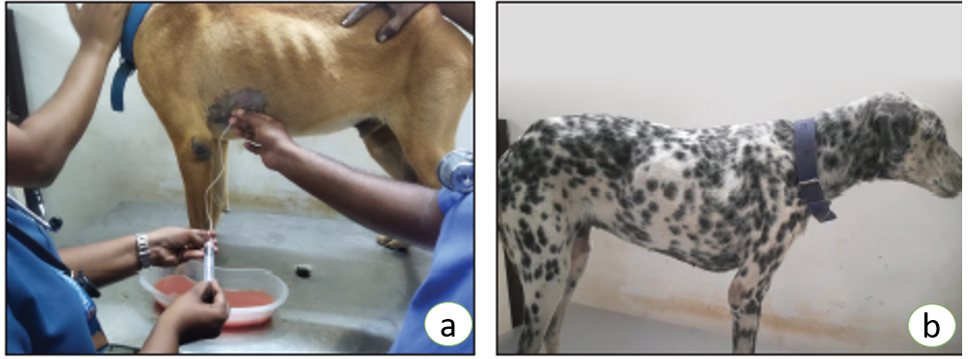
Fig. 1. (a) Non-descript male dog, 12 years old, showing pleural effusion; (b) Dalmatian male dog, 12 years old, showing severe dyspnoea associated with malignant mesothelioma.
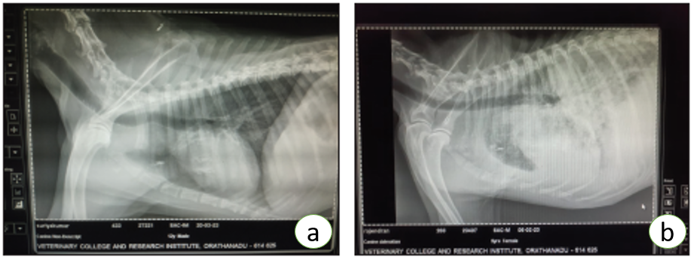
Fig. 2. (a) Thoracic radiograph of a non-descript dog showing circumferential nodular serosal thickening with branching opacities. (b) Thoracic radiograph of a Dalmatian dog showing pleural and peritoneal effusions.
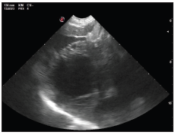 | 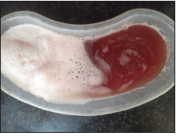
Fig. 3. Ultrasonographic image of a Dalmatian dog showing ascites with irregular thickening of the peritoneal surfaces. | Fig. 4. Serosanguinous pleural effusion collected from the dog by thoracocentesis affected with malignant epithelioid mesothelioma.
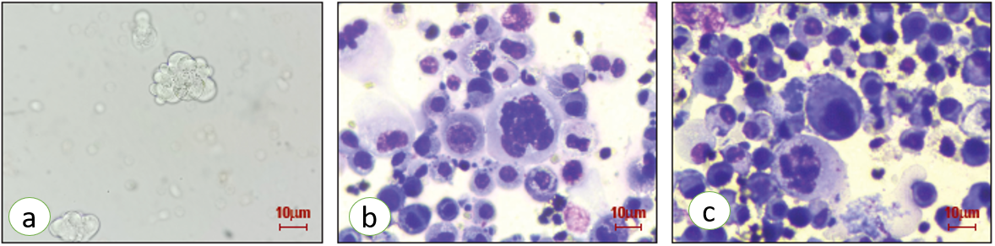
Fig. 5. (a) Wet film preparation of pleural effusion showing pleomorphic malignant cell clusters (400×). (b) Pleural effusion cytology with mesothelioma showing multinucleated giant cells, Giemsa stain (400×). (c) Pleural effusion cytology showing pleiomorphism and atypical mitotic figures, Giemsa stain (400×).
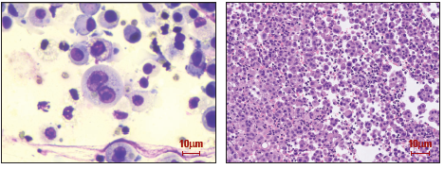
Fig. 6. (a) Pleural effusion cytology showing meganucleoli, Giemsa stain (400×). (b) Pleural biopsy section showing malignant epithelioid mesothelioma characterized by round and binucleated cells with cytoplasmic vacuolation, H&E stain (400×)

