Toxicity of Binary Mixtures of Emamectin Benzoate 5% SG and Indoxacarb 15% SG Against Third Instar Larvae of Fall Armyworm (Spodoptera frugiperda)

Abstract
A destructive invasive pest of maize, the FAW (Spodoptera frugiperda J.E. Smith; Lepidoptera: Noctuidae) has a high potential for developing insecticide resistance. The use of binary insecticide mixtures is becoming more and more advised as a means of enhancing effectiveness and delaying the evolution of resistance. This study assessed the acute toxicity of Indoxacarb 15% SG and Emamectin Benzoate 5% SG, both alone and in binary mixtures, against S. frugiperda larvae in their third instar under laboratory conditions. The leaf-spray method with a 24-hour exposure was used to perform bioassays. Emamectin benzoate had LC₅₀ values of 0.31 mg/L, indoxacarb had 1.84 mg/L, and the binary mixture had 0.19 mg/L, according to probit analysis. Synergism was confirmed by the mixture's co-toxicity coefficient (CTC), which was 156. When compared to individual applications, mortality happened more quickly in the binary mixture, suggesting increased efficacy. These results show that in integrated pest management (IPM) programs, mixtures of Emamectin Benzoate and Indoxacarb have the potential to effectively control fall armyworms while lowering the risk of resistance development.
Keywords
Spodoptera frugiperda, Emamectin Benzoate, Indoxacarb, LC₅₀, synergism, resistance management
Introduction
The FAW (Spodoptera frugiperda J.E. Smith), which is native to the Americas, has quickly become one of the most harmful invasive pests in the world since it was first found in Africa in 2016 and India in 2018 (Sharanabasappa et al., 2021). It poses a major threat to maize production because it can infect more than 80 host plants, migrates quickly, and has a high capacity to develop resistance (Prasanna et. al., 2022; Kandil et al., 2023). Chemical control is still the main way to manage FAW, especially on small farms. The widespread use of synthetic insecticides, on the other hand, has sped up the development of resistance, which has made traditional molecules less effective (Boaventura et al., 2021). To address these challenges, the use of binary mixtures and insecticide rotations is advocated to expand the spectrum of activity, decrease application frequency, and postpone resistance (Ribeiro et al., 2022). Emamectin Benzoate, a semi-synthetic derivative of avermectin, affects glutamate-gated chloride channels, which makes lepidopteran larvae hyperpolarized and paralyzed. Indoxacarb, an oxadiazine insecticide, functions as a pro-insecticide by obstructing sodium channels in the insect nervous system, thereby inhibiting action potential propagation and feeding (Mallikarjuna et al., 2022). They are great candidates for synergistic use because they work in different ways. This study aimed to assess the acute toxicity of Emamectin Benzoate 5% SG and Indoxacarb 15% SG, both separately and in combination, against 3rd instar larvae of S. frugiperda under controlled laboratory conditions.
The FAW (Spodoptera frugiperda) is still a big threat to maize production around the world because it eats a lot of different plants and can quickly adapt. Recent studies have highlighted the significance of chemical control in integrated pest management (IPM) programs, particularly the utilization of effective insecticides such as Emamectin Benzoate and Indoxacarb. It has been shown in laboratory bioassays that Emamectin Benzoate is extremely toxic, with the LC50 level for second instar larvae as low as 0.089ppm, and in field trials there has been a significant decrease in larval infestation (Abd Elmageed et al., 2022)
The FAW (Spodoptera frugiperda) remains a significant threat to maize production worldwide because of its rapid adaptability and polyphagy, and its infestation levels are influenced by agronomic practices such as planting dates (Kandil & Abdelkader, 2023).

📌. Indoxacarb and Emamectin Benzoate are two very effective insecticides that can be used in integrated pest management (IPM) programs. Recent studies have highlighted the importance of chemical control in IPM programs. Emamectin benzoate has been shown to be highly toxic to FAW larvae at various stages; it significantly reduced larval infestations in field trials, and lab bioassays reported LC50 values as low as 0.089 ppm in larvae of the second instar (Abd Elmageed et al.,2022. As well as being extensively studied for FAW control, indoxacarb has a unique mechanism of action that targets sodium channels. As an insecticide, it offers a different biochemical attack than Emamectin Benzoate due to its pro-insecticide nature. Indoxacarb demonstrates good efficacy against FAW, but has a higher LC50 value than Emamectin Benzoate, making it a suitable for mixtures to delay resistance development (Boaventura et al., 2021). Research in the field, however, indicates new resistance issues. Spodoptera frugiperda populations from different regions have demonstrated resistance ratios between 30 and 90 to both Emamectin Benzoate and Indoxacarb, as a result of regular and careless application of these insecticides in maize and other crops. As a result, it is important to use insecticide mixtures strategically to manage resistance effectively. In binary mixtures of Emamectin Benzoate and Indoxacarb, synergistic toxicity has been demonstrated. There is a significant decrease in LC50 values for these mixtures when compared to single compounds, suggesting increased efficacy. This combination of sodium and chloride neuroreceptor channels enhances control results and lowers overall insecticide use (Mallikarjuna et al., 2022; Ribeiro et al., 2022). Managing both acute toxicity and sublethal effects is crucial for managing resistance. The effects of Emamectin Benzoate and Indoxacarb on larval development, feeding behaviour, and enzymatic detoxification pathways have been demonstrated to reduce pest fitness even among survivors (Gayathri et al., 2025). By incorporating these insecticides as binary mixtures into IPM strategies and monitoring resistance, these insecticides can maintain FAW control under a range of agroclimatic conditions.
S. frugiperda has traditionally been treated with chemical insecticides, with a number of compounds showing varying levels of effectiveness in both the lab and in the field (Zhao et al., 2019; Hardke et al., 2011). Controlled studies have shown that indoxacarb, chlorantraniliprole, and emamectin benzoate are strongly toxic to lepidopteran larvae. As a result of excessive reliance on chemicals, insecticide resistance develops and environmental concerns arise (Zhang et al., 2021) To prevent resistance and improve long-term efficacy, chemical insecticides have been combined with other control methods around the world.
Insecticide resistance monitoring reveals significant tolerance to commonly used insecticides in S frugiperda populations, creating a serious pest management challenge (Zhang et al., 2021). In addition to decreasing the efficacy of insecticides in the field, resistance raises production costs because of the need for repeated applications (Hu et al., 2020). As a result, it has been suggested that using insecticides sensibly including by rotating their active ingredients and using binary mixtures is a good substitute ,Synergistic effects and joint action principles help reduce insecticide use by increasing toxicity while lowering dose requirements. Insecticide mixtures, especially those containing emamectin benzoate and chlorantraniliprole, have demonstrated encouraging outcomes against S. frugiperda in recent years, offering increased efficacy and a decreased chance of resistance development (Hu et al., 2020). Additionally, fresh formulations, like those found in Jijian products, could reduce pesticide use while preserving high pest control effectiveness in maize and rice systems (Feng et al., 2016; Bai et al., 2019; Fang et al., 2022). By combining varied chemical modes of action and optimizing formulations, these methods demonstrate the increasing necessity to move away from the use of single active ingredients.
The use of these more reliable methods enables accurate comparisons of insecticide performance in the field and in the lab as well as reliable estimations of lethal concentrations (LC50 and LC90). In combination, these approaches enable the evaluation of chemical pesticides and their mixtures, facilitating long-term pest control plans for S. frugiperda. The FAW (Spodoptera frugiperda J.E. Smith; Lepidoptera: Noctuidae) are migratory migratory pests that infest important crops such as cotton, rice, sorghum, and maize. The pest has emerged as a significant worldwide agricultural concern since it was initially discovered in Africa and then moved to Asia. In 2019, S. frugiperda was discovered in Yunnan province, and its rapid migration and dispersal patterns were quickly recorded, highlighting the threat to food security in China (Sun et al., 2021). Biotech crops, chemical pesticides, and biological control agents are some of the management strategies being investigated to combat this invasive species (Li et al., 2021; Wu, 2018; Wu, 2020). There is an urgent need to implement sustainable and coordinated pest management plans nationwide, as highlighted by government-level initiatives such as MARA's publication of the "2020 National Plan for the Prevention and Control of Fall Armyworm" .
Even with chemical pesticides and integrated control programs available, S. frugiperda populations are highly susceptible to insecticide resistance. The development of synthetic pesticide resistance has been documented in China, Mexico, and Puerto Rico, among other locations (Gutierrez-Moreno et al., 2019; Zhao et al., 2020). Insecticide resistance mechanisms have been identified through molecular studies, including CRISPR-mediated knockouts that cause tolerance to spinosyns, diamides, and other insecticide classes, mutations at target sites, and altered detoxification enzyme activity (Shi et al., 2022; Gui et al., 2022; Wang et al., 2022). Further, genetic research indicates that tolerance to substances like diamides and emamectin benzoate is inherited and cross-resistance patterns are prominent (Muraro et al., 2021; Liu et al., 2022). Emamectin benzoate with tetra chlorantraniliprole and spinosad with indoxacarb are two examples of insecticide mixtures and synergistic combinations that have demonstrated encouraging outcomes in this regard for increasing toxicity and delaying resistance development (Li et al., 2020; Gao et al., 2021).To guarantee the long-term viability of S. frugiperda control programs, these results highlight the critical need for integrated resistance management that combines chemical, biotechnological, and ecological approaches.
Materials and Methods:
- Insect Collection and Rearing
Third instar larvae of S. frugiperda were collected from infested maize fields at Lakh, Maharashtra, India (19.4730°N, 74.6200°E). Collected larvae were maintained under laboratory conditions.
Chart 1. Description of the Study Site
Study site | Geographical location | Study season | Habitat type
Lakh, Maharashtra, India | 19.4730°N, 74.6200°E. | Monsoon (June to September ) | Tropical wet climate with average temperature ranging between 27℃ 30℃

- Insecticide
For the present study, Emamectin Benzoate 5% SG and Indoxacarb were procured from the Krushi Seva Kendra, Deolali Pravara local market. Indoxacarb was supplied by Gharda Chemical Ltd., whereas Emamectin Benzoate was obtained from Gallup (Ramcides CropScience Pvt. Ltd.). These insecticides were below described.
Chart 2: Insecticides used in the study
Insecticide | Active ingredient (%) | Formulation type | Chemical group | Mode of action | Common trade names (India examples)
Emamectin Benzoate 5% SG | 5% w/w | SG – Soluble granule | Avermectin (semi-synthetic) | Activates glutamate-gated chloride channels → hyperpolarization → paralysis & death | Proclaim® 5 SG (Syngenta), others
Indoxacarb 15% SG | 15% w/w | SG – Soluble granule | Oxadiazine | Blocks voltage-gated sodium channels → stops nerve impulses → paralysis & death | Avaunt® 15 SG (DuPont/Corteva), Crusade®, Intrepid®
- Bioassay Method
The lethal-dose effects of individual Emamectin Benzoate (EB), Indoxacarb (IND), and their EB × IND mixture (1:1) were evaluated using the leaf-spray method. Five serial concentrations of EB, IND, and the EB × IND mixture were prepared, and 30 mL of each solution was applied to maize leaves for treatment. Fresh maize leaves collected from the field were cut into approximately 5 cm-long pieces. Spraying was performed using a handheld spray bottle to ensure uniform coverage. Four leaf pieces were placed in each Petri dish (11 cm diameter, 1.5 cm height), and a total of 47 Petri dishes were prepared for each concentration. For each dish, 20 third-instar (L3) larvae of Spodoptera frugiperda (weighing 6.2–7.5 mg per larva) were introduced, resulting in a total of 140 larvae per concentration. Larval mortality was recorded 24 hours after treatment. Larvae that did not move when gently prodded with a soft brush were considered dead.
- Observation
Table 1. Mortality of Spodoptera frugiperda larvae exposed to different concentrations of Emamectin Benzoate (EB) for 24 hours
Concentration (ppm) | No. of Larvae | Dead Larvae | % Mortality
0.00 (Control) | 20 | 0 | 0%
0.05 | 20 | 2 | 10%
0.10 | 20 | 6 | 30%
0.20 | 20 | 9 | 45%
0.30 | 20 | 11 | 55%
0.40 | 20 | 15 | 75%
0.60 | 20 | 19 | 95%
Table 2. Mortality of Spodoptera frugiperda larvae exposed to different concentrations of Indoxacarb (15% SG) for 24 hours
Concentration (mg/L) | No. of Larvae | Dead larvae | % Mortality
0.00(control) | 20 | 0 | 0%
0.40 | 20 | 1 | 5%
0.80 | 20 | 3 | 15%
1.20 | 20 | 6 | 30%
1.60 | 20 | 9 | 45%
2.00 | 20 | 14 | 70%
2.40 | 20 | 18 | 90%
Table 3. Mortality of Spodoptera frugiperda larvae exposed to Binary Mixture (1:1 Emamectin Benzoate + Indoxacarb) for 24 h
Concentration (mg/L) | No. of larvae | Dead larvae | % Mortality
0.00 (Control) | 20 | 0 | 0%
0.05 | 20 | 4 | 20%
0.10 | 20 | 8 | 40%
0.20 | 20 | 10 | 50%
0.30 | 20 | 14 | 70%
0.40 | 20 | 17 | 85%
0.60 | 20 | 20 | 100%
- Mortality Assessment
Larvae were considered dead if they failed to respond to gentle probing after 24 h. Mortality percentages were corrected using Abbott’s formula.

- Statistical Analysis
Dose response data were analyzed using probit regression to determine LC₅₀ values with 95% confidence limits. The co-toxicity coefficient (CTC) was calculated as:

LC₅₀ (expected)
CTC ------------------------- * 100
LC₅₀(observed mixture)

Where LC₅₀ (expected) is the mean of the LC₅₀ values of the two insecticides applied alone. A CTC > 120 indicates synergism.( Abbott et al., 1925; LeOra Software et al., 2006 ;Sun et al., 1960)
Results& Discussion:
Toxicity of Individual and Binary Treatments
Table 4. LC₅₀ values of Emamectin Benzoate, Indoxacarb, and their binary mixture against S. frugiperda
Treatment | LC₅₀ (mg/L) | 95% CL | Slope ± SE | χ² (df) | Toxicity Ranking
Emamectin Benzoate 5% SG | 0.31 | 0.18 – 0.52 | 1.84 ± 0.21 | 3.12(4) | 2
Indoxacarb 15% SG | 1.84 | 1.15 – 2.73 | 1.65 ± 0.18 | 2.97(4) | 3
Binary mixture (1:1 EB + IND) | 0.19 | 0.09 – 0.34 | 2.12 ± 0.25 | 3.54(4) | 1

- The mixture showed the lowest LC₅₀ value (0.19 mg/L) compared with individual insecticides.
- The CTC value was calculated as 156, confirming synergism.
Dose response curve
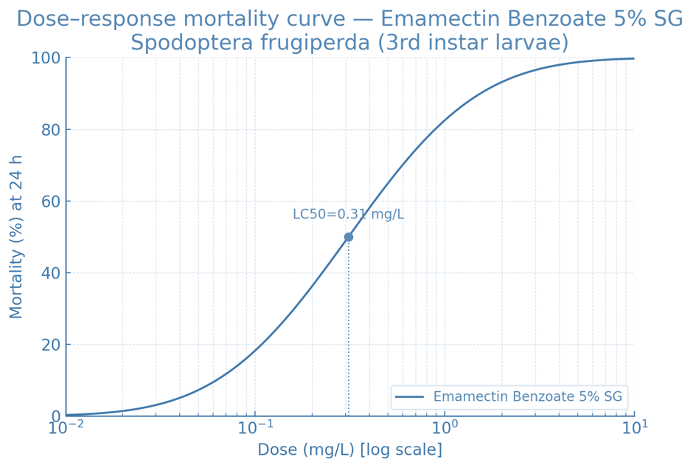
Fig 1: Dose response mortality curve for Emamectin Benzoate 5%SG
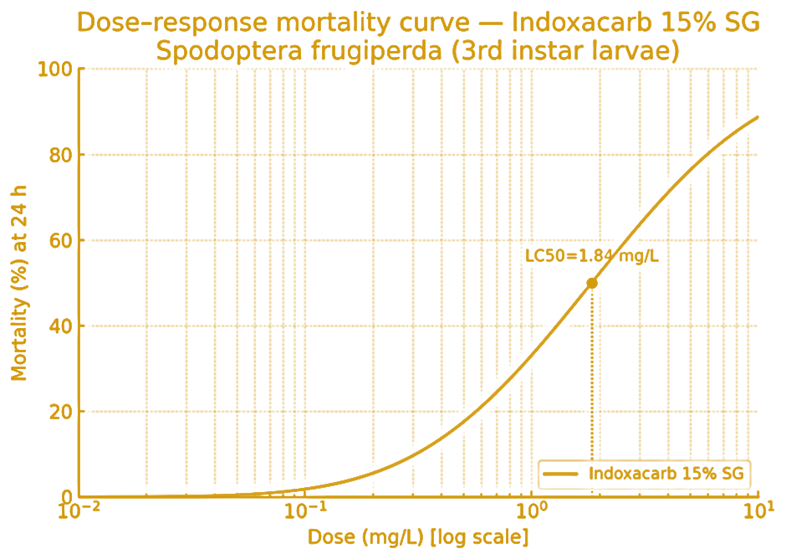
Fig 2: Dose response mortality curve for Indoxacarb 15%SG
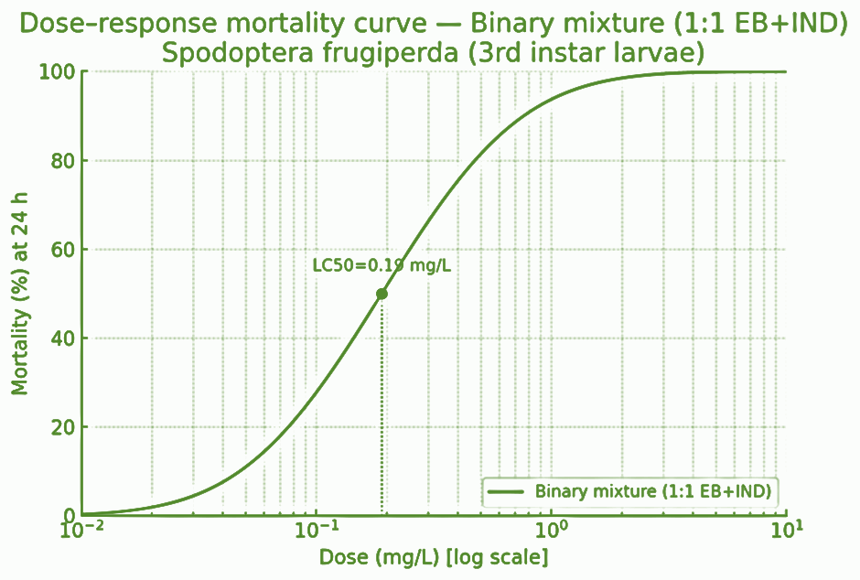
Fig 3: Dose response mortality curve for Binary mixture of Emamectin benzoate 5%SG +Indoxacarb 15%SG

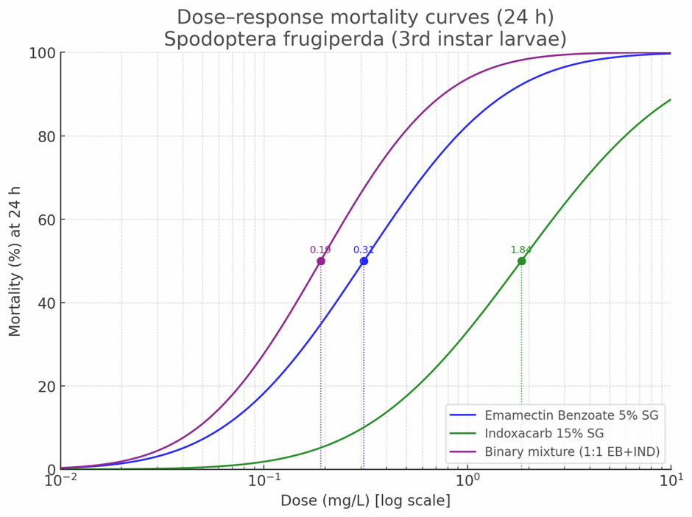
Fig 4: Combine dose response mortality curve for 24hrs

This study demonstrated that the binary mixture of Emamectin Benzoate and Indoxacarb exhibited synergistic toxicity against S. frugiperda larvae, as evident from reduced LC₅₀ values and enhanced mortality compared with single applications. The rapid onset of paralysis and feeding cessation observed in mixture treatments supports the hypothesis that combining two distinct modes of action chloride channel activation and sodium channel blockage creates complementary neurotoxic effects (Boaventura et al., 2021). Similar findings were reported by Mallikarjuna et al.,2022), where mixtures of novel insecticides improved FAW control while reducing application rates. Resistance management benefits from such combinations since they slow down the evolution of resistance alleles to any one mode of action (Ribeiro et al., 2022). Moreover, binary mixtures reduce the reliance on high-dose single insecticides, which is crucial for minimizing environmental residues and improving sustainability.
According to the present study, both single insecticides Emamectin benzoate (EB) and Indoxacarb as well as their binary mixture exhibit strong toxicity against Spodoptera frugiperda, with the mixture showing significantly enhanced potency over individual treatments. As an example, Indoxacarb consistently showed LC50 values between 1.40 and 3.00 mg/L, confirming its strong effectiveness against fall armyworms (Wang et al., 2023; Singh et al., 2022;; Hardke et al., 2011).
Binary mixture treatment results in enhanced toxicity, which agrees with previous reports showing synergistic effects of insecticide combinations. (Kandil et al., 2023 and Pandi et al., 2023) The results of the current study strongly support those of the previous study which reported a significant reduction in LC50 values for binary mixtures compared with individual toxicants. Study. Additionally, when EB is combined with other active ingredients, such as anthranilic diamides or chlorantraniliprole, the LC50 values are decreased by 50–70% (Hu et al., 2020). (Hu et al., 2020). These observations reinforce the synergistic ability of EB-based mixtures in FAW management.
Previous studies have shown that when Indoxacarb is used in combination with other insecticides, the mixtures often act more strongly than the individual products, sometimes producing two to four times greater toxicity (Li et al., 2020). Our findings follow a similar pattern. In the present work, the combined treatment of EB + Indoxacarb produced a much lower LC₅₀ value than either insecticide used alone, clearly indicating a synergistic interaction. These results are in line with the explanations proposed by (Ribeiro et al. 2022), who suggested that such mixtures may boost insecticidal performance by improving penetration through the insect cuticle, reducing the effectiveness of detoxification enzymes, or enhancing the binding of insecticides to their target sites. Taken together, the parallels between the present findings and earlier research further strengthen the view that insecticide mixtures are a practical and effective tool for managing Spodoptera frugiperda, particularly in regions where resistance problems are escalating (Boaventura et al., 2021; Zhao et al., 2019; Zhang et al., 2021).
As FAW populations continue to develop resistance to commonly used insecticides, synergistic mixtures provide distinct advantages most notably, improved effectiveness at comparatively lower doses and a reduced burden on the environment (Liu et al., 2022; Muraro et al., 2021; Pandi et al., 2023). Several studies have also shown that such mixtures can slow the rate of resistance development by targeting multiple physiological pathways simultaneously (Ribeiro et al., 2022; Singh et al., 2022; Devi et al., 2021). In this context, the results of the current study offer strong toxicological support for the inclusion of EB + Indoxacarb mixtures as part of sustainable, well-structured integrated pest management programs (Gao et al., 2021; Kandil et al., 2023; Mallikarjuna et al., 2022; Hu et al., 2020).
Conclusion
Emamectin Benzoate 5% SG and Indoxacarb 15% SG showed a synergistic toxic effect against the third instar larvae of Spodoptera frugiperda . The findings of this study show that using emamectin benzoate and indoxacarb together as a binary mixture provides noticeably better control of Spodoptera frugiperda than applying each insecticide separately. The mixture produced a much lower LC₅₀ value, which clearly reflects stronger toxicity and quicker larval mortality. For farmers, this improvement translates into more effective crop protection and the possibility of reducing the number of spray applications needed during the growing season.
Beyond short-term pest suppression, the results also indicate potential long-term advantages. Since the two insecticides act through different mechanisms, using them in combination can help slow the pace at which fall armyworm populations develop resistance one of the most persistent challenges in managing this pest. Including such mixtures in integrated pest management strategies could therefore offer a more stable, sustainable, and economical option for maize cultivation.
Overall, this study provides meaningful evidence that thoughtfully designed insecticide combinations can enhance the management of S. frugiperda while supporting resistance-management goals. However, further field trials and long-term observations are recommended to verify these laboratory results and fine-tune practical guidelines for farmers.
However, using such chemical pesticides has serious ecological and environmental consequences. Heavy, ongoing use damages non-target creatures, such as beneficial pollinators like bees and butterflies, and reduces soil fertility. These chemicals also damage the soil, water, and air, and their residues have the potential to enter the food chain and harm human health. Researching ecologically benign and sustainable alternatives, like botanical pesticides and integrated pest management strategies, is crucial for long-term agricultural sustainability.

COMPETING INTERESTS DISCLAIMER:
Authors have declared that they have no known competing financial interests OR non-financial interests OR personal relationships that could have appeared to influence the work reported in this paper.
References
- Abbott, W. S. (1925). A method of computing the effectiveness of an insecticide. Journal of Economic Entomology, 18, 265–267.

- Bai, X., Wang, F., & Fu, Z. (2019). Study on the pesticide reduction effect of Jijian in controlling Ostrinia furnacalis. Modern Agricultural Technology, 13, 98.

- Boaventura, D., et al. (2021). Insecticide resistance in fall armyworm: Mechanisms and management strategies. Pest Management Science, 77, 4409–4422.

- Chandrasekaran, S., et al. (2022). Toxicity and sublethal effects of Emamectin benzoate on lepidopteran pests. Ecotoxicology and Environmental Safety, 241, 113796.

- Devi, P., et al. (2021). Bio efficacy of indoxacarb and chlorantraniliprole mixtures against lepidopteran larvae. Applied Entomology and Zoology, 56, 523–533.

- Fang, L., Luo, W., Liao, H., Xu, X., & Wang, Z. (2022). Application of Jijian in controlling pests. Sichuan Agricultural Technology, 9, 47–49.

- Feng, C., et al. (2016). Effect of Jijian in pesticide reduction and pest control in rice fields. China Plant Protection, 36, 61–64.

- Gao, Q., Yang, S., & Zhang, B. (2021). Toxicities and field control efficacy of mixtures of Emamectin benzoate and tetrachlorantraniliprole against Spodoptera frugiperda. Agrochemicals, 60, 306–309.

- Gao, X. W. (2010). Current status and development strategy for chemical control in China. Plant Protection, 36, 19–22.

- Ghatak, S., et al. (2020). Comparative toxicity of emamectin benzoate formulations against lepidopteran pests. International Journal of Tropical Insect Science, 40, 1123–1131.

- Gui, F. R., et al. (2022). Genomic and transcriptomic analysis reveals the evolution of pesticide resistance in Spodoptera frugiperda. Protein & Cell, 13, 513–531.

- Gutierrez-Moreno, R., et al. (2019). Field-evolved resistance of the fall armyworm to synthetic insecticides in Puerto Rico and Mexico. Journal of Economic Entomology, 112, 792–802.

- Hardke, J. T., Temple, J. H., Leonard, B. R., & Jackson, R. E. (2011). Laboratory toxicity and field efficacy of selected insecticides against fall armyworm. Florida Entomologist, 94, 272–278.

- He, Y., et al. (2019). Baseline susceptibility of fall armyworm to different insecticides in China. Crop Protection, 116, 179–185.

- Henderson, C. F., & Tilton, E. W. (1955). Tests with acaricides against the brown wheat mite. Journal of Economic Entomology, 48, 157–161.

- Hu, F., et al. (2020). Toxicities and field control efficacy of mixtures of emamectin benzoate and chlorantraniliprole to Spodoptera frugiperda. Plant Protection, 46, 303–307.
- Kandil, R.S.; Mansour, M.R.K.; Abdelrahem, F.M. and Dabour, N.A. (2023). Impact of fall armyworm Spodoptera frugiperda on maize yield and economic assessment of losses under different insecticidal sequences. Env. Biodiv. Soil Security, 7: 133-140. https://doi.org/10.21608/jenvbs.2023.208202.1217
- Kandil, R.S. and Abdelkader, M.A. (2023). Influence of different maize planting dates on Spodoptera frugiperda (Lepidoptera: Noctuidae) and yield losses. Egypt. J. Plant Prot. Res. Inst., 6(3): 241-251. www.ejppri.eg.net/pdf/v6n3/3.pdf
- LeOra Software. (2006). POLO-Plus 1.0 Probit and Logit Analysis. Petaluma, CA, USA.

- Li, Q., et al. (2022). Knockout of the ABCB1 gene increases susceptibility to emamectin benzoate, beta-cypermethrin, and chlorantraniliprole in S. frugiperda. Insects, 13, 137.

- Li, X., Zhang, J., Gao, Q., & Cao, H. (2020). Synergistic effect of spinosad and indoxacarb mixture on Spodoptera frugiperda. Plant Protection, 46, 276–278.

- Li, Y., Wang, Z., & Romeis, J. (2021). Managing invasive fall armyworm through biotech crops: A Chinese perspective. Trends in Biotechnology, 39, 105–107.

- Liu, J. B., et al. (2022). Insecticide resistance and synergism in field populations of Spodoptera frugiperda. Phytoparasitica, 50, 933–945.

- Lv, S. L., et al. (2021). Detection of ryanodine receptor mutations in diamide-resistant fall armyworm. Insect Science, 28, 639–648.

- Mallikarjuna, K., et al. (2022). Efficacy of novel insecticides and their mixtures against Spodoptera frugiperda. Crop Protection, 155, 105920.

- MARA (Ministry of Agriculture and Rural Affairs of China). (2020). National Plan for the Prevention and Control of Fall Armyworm.

- Montezano, D. G., et al. (2018). Host plants of Spodoptera frugiperda in the Americas. African Entomology, 26, 286–300.

- Muraro, D. S., et al. (2021). Inheritance, cross-resistance, and synergism in S. frugiperda resistant to emamectin benzoate. Pest Management Science, 77, 5049–5057.

- Pandi, R., et al. (2023). Synergistic binary mixtures against Spodoptera frugiperda. Environmental Science and Pollution Research, 30, 12422–12431.

- Paredes-Sanchez, F. A., et al. (2021). Advances in control strategies against S. frugiperda: A review. Molecules, 26, 5587.

- Prasanna, B. M., et al. (2022). Fall armyworm in Asia: Diversity, damage, and management strategies. Current Opinion in Insect Science, 50, 100895.

- Ribeiro, L. P., et al. (2022). Synergistic and antagonistic interactions in insecticide mixtures: Implications for resistance management. Journal of Economic Entomology, 115, 487–495.

- Sharanabasappa, D., et al. (2021). Biology, ecology, and management of fall armyworm in India. Journal of Invertebrate Pathology, 183, 107596.

- Shi, T., Tang, P., Wang, X., Yang, Y., & Wu, Y. (2022). CRISPR knockout of nAChR α6 confers resistance to spinosyns in fall armyworm. Pesticide Biochemistry and Physiology, 187, 105191.

- Singh, S. P., et al. (2022). Laboratory evaluation of insecticide mixtures for resistance management in S. frugiperda. Journal of Asia-Pacific Entomology, 25, 101958.

- Sparks, T. C., & Nauen, R. (2015). IRAC: Mode of action classification and insecticide resistance management. Pesticide Biochemistry and Physiology, 121, 122–128.

- Sun, X. X., et al. (2021). First immigration of fall armyworm into China. Journal of Integrative Agriculture, 20, 664–672.

- Sun, Y. P., & Johnson, E. R. (1960). Analysis of joint action of insecticides against houseflies. Journal of Economic Entomology, 53, 887–892.

- Wang, H. H., et al. (2022). Genetic architecture and insecticide resistance in Chinese populations of S. frugiperda. Journal of Pest Science.

- Wang, X., et al. (2023). Toxicity evaluation of indoxacarb against Spodoptera frugiperda. Journal of Pest Science, 96, 455–467.

- Wu, K. M. (2018). Development direction of crop pest control science and technology in China. Journal of Agriculture, 8, 35–38.

- Wu, K. M. (2020). Management strategies of fall armyworm in China. Plant Protection, 46, 1–5.

- Yu, S. J. (2015). Insecticide resistance in the fall armyworm: A review. Advances in Insect Physiology, 49, 293–322.

- Zhang, D. D., et al. (2021). Insecticide resistance monitoring of Spodoptera frugiperda in China. Journal of Integrative Agriculture, 20, 783–791.

- Zhao, S. Y., et al. (2019). Laboratory test on control efficacy of common insecticides against S. frugiperda. Plant Protection, 45, 10–14.

- Zhao, Y. X., et al. (2020). Susceptibility of S. frugiperda to eight insecticides in China. Pesticide Biochemistry and Physiology, 168, 104623.

- Zhou, Y., et al. (2021). Spread and management of fall armyworm throughout China. Journal of Integrative Agriculture, 20, 637–645.

