Detection of Echinococcosis in Sheep in Al-Najaf prevalence.

Abstract
Cystic echinococcosis (CE) is a zoonotic infection caused by species of tapeworms belonging to the Echinococcus granulosus complex. It is caused by hydatid cysts, usually involving the liver and lungs, with a potentially fatal outcome in untreated patients. The World Health Organization lists CE among 17 neglected tropical diseases, and prevalence is estimated at up to 200 cases per 100,000 population annually.
The study was conducted at the Al-Najaf slaughterhouse from September 2023 to December 2023. Fifteen livers containing hydatid cysts were obtained for examination of macroscopic and microscopic findings, as well as the number and size of the cysts. Twenty-three cysts were identified in the gross examination of the livers. The external wall of the hydatid cysts revealed hydatid sand similar to free protoscoleces and/or brood capsules, which appeared as multiple small white particles varying in size.
Microscopic examination of hematoxylin and eosin-stained sections showed cysts containing a thick wall and many irregularly interwoven folds, extending into the lumen of the cyst, whose contents appeared laminated; it was translucent to white, yellow gelatinous. The adjacent hepatic parenchyma exhibited a chronic inflammatory response with a peripheral fibrous membrane wrapping the cyst, characterized by cellular infiltration by mononuclear inflammatory cells, including eosinophils and neutrophils, as well as macrophages and fibrocytes. Moreover, Masson’s trichrome staining was performed to evaluate fibrous tissue hyperplasia and visualize collagen fibers in the infected liver tissue.
In conclusion, the presence of multiple lesions involving different hepatic lobes in individual sheep was observed at necropsy, which was confirmed as a hallmark finding in diagnosis through gross and microscopic examination. The present study also recommends the application of molecular techniques to identify circulating Echinococcus genotypes in sheep, thereby achieving a higher degree of characterization of local epidemiology.
Introduction:
Cystic echinococcosis (CE) is one of the most significant worldwide zoonotic helminth diseases and is caused by cestode parasites within the Echinococcus granulosus complex. It is characterized by the formation of hydatid cysts in the liver and lungs that can lead to severe morbidity and life-threatening consequences if not diagnosed and treated in time (Hasbahceci, 2019)- this reference is not found in the bibliography with Hasbahceci as the first author!. In veterinary medicine, Echinococcus spp. are also considered parasites of high economic importance, causing losses through organ condemnation and reduced livestock productivity. Gastrointestinal parasitoses: Al-Salihi (2016); OIE (2010) the citation is not found in the bibliography!”. The OIE classification of gastrointestinal parasitoses in camelids reports that this disease is caused by multiple parasites, including Trichostrongylus, Haemonchus spp., Tinea, and Echinococcus, all of which have significant economic implications.
The World Health Organization has classified CE as one of 17 neglected tropical diseases, and in endemic settings, the disease burden can be as high as 200 cases per 100,000 person-years (Carabin, 2013). Hydatid cysts display a much stronger tendency to infect the liver and lungs in the clinical setting, as evidenced by a significant series from India, which observed hepatic involvement (approximately 75%) as compared to pulmonary (15%) involvement of hydatid cysts4. As part of the natural history of the disease, a number of complications can develop, such as secondary bacterial infection of cysts, referred to as infected hepatic echinococcosis (IHE), which can manifest by hepatic hydatid abscesses or superinfection of pre-existing liver hydatid cysts (Sanhueza, 2009).
The life cycle of the parasite begins with eggs being excreted in the faeces of the definitive host (usually dogs). Following ingestion by intermediate hosts, usually humans and domestic animals, the eggs hatch in the intestine to release oncospheres, which penetrate the intestinal wall and enter the portal circulation, reaching mainly the liver but also other tissues, leading to the development of hydatid cysts (Khanam 2011). Economic losses due to Echinococcus are significant and are mainly driven by animal carcass and organ condemnation, treatment costs, and control expenditures (Gessese, 2020). The infection in dogs is acquired by ingestion of protoscoleces present within Cysts in infected organs; these attach to the mucosa of the intestine, mature to adult worms, which then pass embryonated eggs into the environment through faeces (Gessese, 2020).
Both abattoir-based and epidemiological investigations in Iraq, as well as in border countries, such as sheep, goats, cattle, and camels, documented the incidence rates of hydatid cyst so far (Al-Abbassy, 2016- the reference is not found in the bibliography!; Al-Salihi, 2016; Romig, 2014- the citation is not found in the bibliography!; Rostami et al., 2012- the citation is not found in the bibliography!; Jarwean et al., 1992- the citation is not found in the bibliography!; Al-Janabi et al.,1983- see the references!). For these reasons, the objective of this work was to assess the susceptibility of sheep liver to hydatid cyst infection at the Al-Najaf abattoir, based on the prevalence of associated pathological features in a local setting.
Al-Abbassy (2016) - the reference is not found in the bibliography! reported an epidemiological investigation conducted in the Kurdistan Region (July 2013–June 2014) that found a 9.07% prevalence in sheep in an enzootic area. This decrease was attributed to interventions including stray dog control, meat inspection, and improvements in socioeconomic conditions (AL. Bosely, 2014).

Materials and Methods
Sampling of Specimens
Between September 2023 and December 2023, slaughter sheep were sourced from various parts of Al-Najaf Province and dispatched to the Al-Najaf abattoir. All animals were checked for general health and readiness for slaughter by official veterinarians immediately before the act of slaughtering according to Islamic rules and relevant legislation.
Liver samples were carefully excised from carcasses after slaughter, a few minutes postmortem, for histological examination. The liver samples were examined macroscopically for visible morphological changes, and histopathological evaluations of microscopic sections were performed on a total of 15 sheep liver specimens.
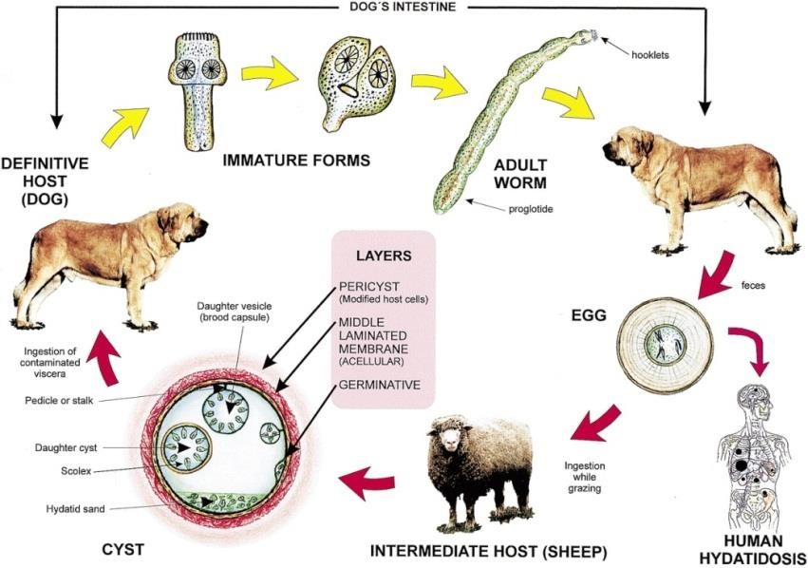
Figure (1): Life Cycle of Echinococcosis (Derbel,2012)

Specimen Processing
The sheep liver was examined grossly to determine cyst morphology. Organ lesions were noted and transported to the University of Kufa, Faculty of Veterinary Medicine, microbiology laboratory, where they were examined.
Macroscopic Examination to detect:
- Liver abnormalities were considered when the color or the shape of organs became noticeably different from that of normal hepatic tissue.
- Moreover, gross lesions of the liver surface and parenchyma were identified and recorded.
- Lesions that are abnormal in the organ.
Microscopic Examination
1-The survival of the protoscolices might be assessed by adding 1% eosin dye to the cyst fluid, which has been highlighted using a microscope to look for diacritical protoscolices. Live protoscolices eliminate the stain, whilst dead protoscolices retain it (Torgerson and Budke, 2003; Salari et al., 2011- the reference is not found in the bibliography!).
2-Histopathological Technique
Liver tissue processing: Histological processing of liver samples was performed as described by Bancroft and Gamble (2008). The tissues were washed with distilled water to get rid of the residual formalin, and small tissue blocks (1 cm × 1cm) cut off from different areas of intestine, were placed in plastic containers filled with 10% neutrally-buffered formalin for fixation.
The fixed samples were subsequently processed for routine histopathological examination using hematoxylin and eosin (H&E) staining to evaluate general tissue architecture, and Masson's trichrome staining, as described by Luna (1968), to demonstrate and assess collagen fibers within hepatic tissue.
Results and Discussion
Macroscopic examination (Grossly):
Macroscopically, the livers of slaughtered sheep at Al-Najaf abattoir were examined, and for the total number of cysts (n = 15 livers), twenty-three cysts were found. These cysts measured from less than 1 cm up to over 5 cm in diameter (Table 1).
Ahmedullah et al. (2007). It is known that various chemical, physical, and biological factors, as well as histological features of the liver, are involved in the growth and development of hydatid cysts.
Table (1):- Hydatid Cysts in Liver of Slaughtered Sheep in the Present Study.
 | Animal | organ | Cyst (%)
 | sheep | liver | 23(1.5 % )
Number | 15 | 15 | 23(1.5 % )
The compacted tissue prevents the growth of large cysts and resisted cyst calcification, dependent on the host's immunological competence. Torgerson., (2003).
The present study showed different size of cyst in different lobes characterized by a thick wall and containing many irregular interlacing folds protruding from the wall into the cavity with a thick white-yellow translucent, laminated, gelatinous substance as in figure( 2).
Ibrahim. and Sara Elgaili (2014) concluded that the number of cysts in the liver was higher of slaughtered sheep than all tested cattle (0.5%) .while(Gasser ,2001) identified (4.38%) in sheep. Those results were significantly different in the Kirkuk area. While in Diwaniyah city, the prevalence rate was (21.3%) according to a report by Romig (2014).These differences in infection rates could be due to several factors. Differences in the numbers of samples will influence the result, with larger numbers giving more representative results, as will the duration of the study, as a longer study period will present a more comprehensive picture of the disease in the study region. In addition, the geographical location of the area and its environmental conditions will play a role Ibrahim., and Sara Elgaili (2014).

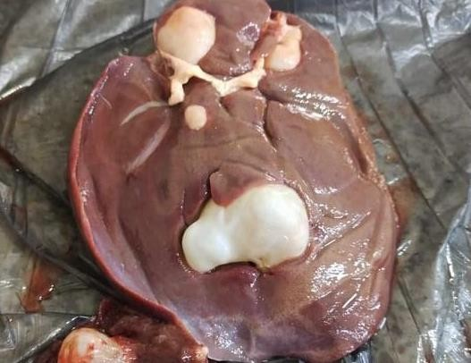
Figure 2:- Different Size of Cyst in Different lobes

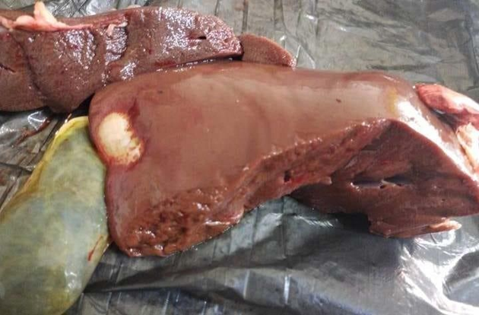
Figure 3: Haydatd Cyst in Lobe in the Infected Sheep
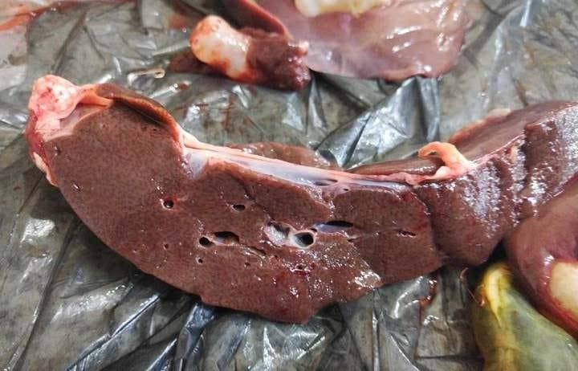
Figure 4: Different number and Size of Haydatid Cyst in Different lobes of Infected Sheep
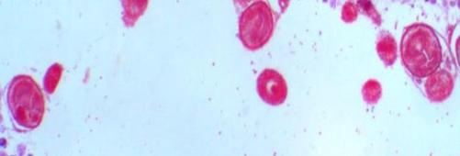
Figure 5: Eosin Dye to the Cyst Fluid

Histopathologically, a chronic inflammation pattern was observed in the liver tissue of sheep naturally infected with CE. The hydatid cysts were surrounded by a peripheral fibrous tissue with infiltration of mononuclear cells, eosinophils, neutrophils, macrophages, and fibrocytes (more evident in the adventitial layer and around the fibrous capsule (Figures 6_and_7). Hydatid dehydration in liver Hydatid cysts microscopically showed scolices inside the lumen of the cyst and degenerative changes in adventitial layer on exposure to Masson trichrome stain as illustrated Composition for dehydrating Echinococcus within ingredients Layer Peptic cells Histopathological examination also showed fibrous tissue hyperplasia, atrophy and necrosis of adjacent hepatocytes and cellular infiltration along with significant eosinophilia, a reaction seen with parasitic infection, as has been described previously by Sevimli et al. (2015). Scolices were more commonly found in different parts of liver sections, but this was not observed in infected lung sections.
The adventitial layer enclosing the cyst in hydatid was a layer of connective tissue produced mainly by the intermediate host as a reaction to parasitic invasion; it had different thickness and fibrotic foci due to local immunological recognition, which is consistent with characteristics described by da Silva (2011) and Sakamoto and Cabrera (2003). Microscopically, the lumen of the hydatid cyst was filled with hydatid fluid and surrounded by several layers of parasitically produced tissue. The germinal layer, the innermost cellular part of the tegument, was located peripherally next to the acellular laminated layer, which in turn bordered the adventitial layer. The germinal layer, which consists of embryonic cells and is responsible for producing all the structural components of the hydatid cyst, matures to form buds that develop into protoscoleces (PSC), the infective stage in the parasite's life cycle. This germinative layer gives rise to the laminated layer, a specific extracellular matrix in the genus Echinococcus, as shown by Forster et al. (2010) and Silva (2011).
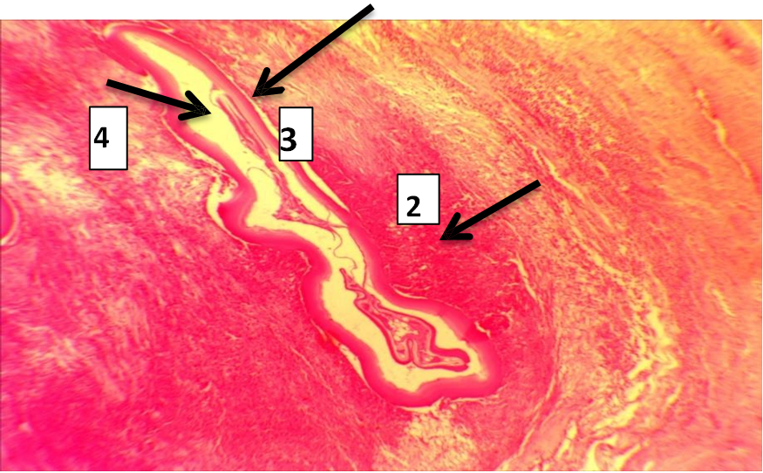
Fig 6:Microscopic section from the hydatid cyst of liver of infected sheep showing three-layered structure of cystic wall with marked inflammatory cell infiltration, was more prominent in adventitial layer (H & E X10).A hydatid cyst consists of three layers: (1) the outer pericyst;(2) adventitial layer 3)the middle laminated membrane; and (4) the inner germinal layer. The pericyst, being the outermost zone of the hydatid cyst, and also known as the ectocyst or adventitial layer, consists almostentirely of host cells. (please justify!)
Parasitic helminths were detected in hepatic sections in variable numbers in most fields examined. Cellular infiltration was frequently severe. minor (scanty) or localized; however, some areas tended to develop granulomas with giant cell formation. Mononuclear cells and neutrophils were the most common types of infiltrating inflammatory cells (Bhutani and Kajal, 2018).

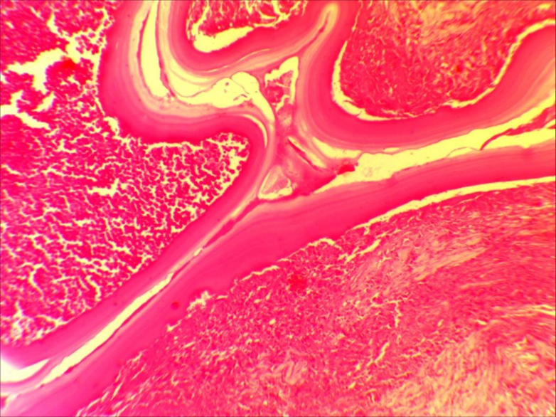
Figure 7: Microscopic section of a hydatid cyst in the liver of a sheep with a three-layered characteristic cyst wall, along with severe content of inflammatory cells, notably in the adventitia layer (H and E).

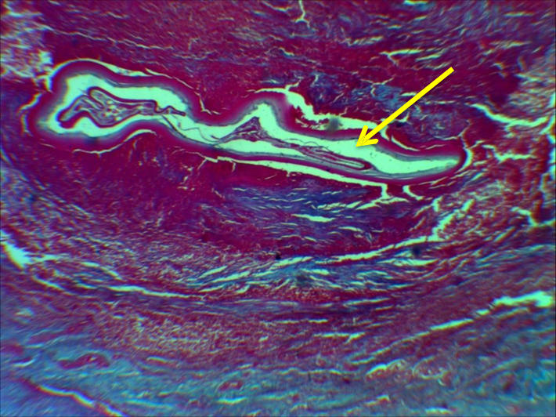
Figure 8: Microscopic Section of Hydatid Cyst in Liver of infected Sheep: scolices were found inside the cyst, degenerative region in adventitial layer (Masson stain,10x) the arrow represented that haydtid cyst(larval stage). The histopathology results, reveled that fibrous tissue reaction, atrophy and necrosis of hepatocytes, cellular infiltration adjacent.

References (please justify!)
Ahmedullah, F., M. Akbor, M. G. Haider, M. M. Hossain, MAHNA
Khan, M. I. Hossain, and I. S. Shanta. 2007. “Pathological
Investigation of Liver of the Slaughtered Buffaloes in Barisal
District.” B. J of Vet. Med 81–85.
AL._Bosely, A. R. I. (2014): Studies on epidemiology of hydatid cysts
isolated from different intermediate hosts in zakho, Duhok province.
Kurdistan region/Iraq, M.Sc. Thesis; Faculty of Science-Univ. of
Zakho, Kurdistan region, Iraq.
Al-Nassir H.S., Al-Abbasssy S.N., Kawan M.H., Jarwean A.F. 1992.
Bovine hydatidosis in the governorate of Babylon. Ibn Al-Haitham
Journal for Pure and Applied Science 3: 13-21. - the reference is not found in the text!
Akhtar MJ, Khanam Akhtar MJ, N, Rao S. Clinico epidemiological profile of hydatid
diseases in Central India, a retrospective and prospective study. Int J
Biol Med Res. 2011;2:603–6.
Bancroft, John D., and Marilyn Gamble. 2008. Theory and Practice of
Histological Techniques. Elsevier health sciences.
Bhutani N and Kajal P. Hepatic echinococcosis: a review. Ann
Med Surg 2018; 36: 99–105.
Budke, H. Carabin Budke, H., P.C. Ndimubanzi, H. Nguyen, E. Rainwater,M. Dickey, . A systematic review of the literature on cystic echinococcosis frequency worldwide and its associated clinical manifestations Am J Trop Med Hyg, 88 (2013), pp. 1011-1027. 16
Castillo, C. Manterola Morphological characteristics of liver
abscesses according its etiology Int J Morphol, 38 (2020), pp. 406-414
Eckert J., Schantz P., Gasser R.,. 2001. Geographic distribution and
prevalence. In: WHOI/OIE manual on echinococcosis in humans and
animals: apublic health problem of global concern. (Eds. J. Eckert,
M.A. Gemmell, F.X. Meslin, Z.S. Pawlowski). World Organization
for Animal Health, Paris, France: 100-141. - the reference is not found in the text!
Fethi Derbel Fethi , Mohamed Ben Mabrouk, Mehdi Ben Hadj Hamida, Jaafar
Mazhoud, Sabri Youssef, Ali Ben Ali, Hela Jemni, Nadia Mama,
Hasni Ibtissem, Arifa Nadia, Chedia El Ouni, Walid Naija, Moncef
Mokni and Ridha Ben Hadj Hamida Hydatid Cysts of the Liver -
Diagnosis, - the reference is not found in the text!
Gessese AT (2020) Review on Epidemiology and Public Health
https://doi.org/10.1155/2020/8859116
Ibrahim, Sara Elgaili Ali. 2014. “Pathological, Histochemical and
Immunohistochemical Studies of Lungs and Livers of Cattle and
Sheep Infected with Hydatid Disease.”
Manterola C, Vial M, Pineda P, Sanhueza A. Systematic review of
literature with different type of designs. Int J Morphol 2009;27:1179–
86. - the reference is not found in the text!
Manterola, A. Sanhueza Manterola, A., M. Vial, J. Moraga Liver abscess of hydatid origin as a risk factor for postoperative complications in hydatidosis
Rev Chil Cir, 61 (2009),. 333-338 17 MRVSA 5 (Special issue) 1 st Iraqi colloquium on camel diseases and management 2016 / College of Veterinary Medicine/ Al Muthanna University 16-17 March, 2016, http://mrvsa.com/ ISSN 2307-8073 1 Mirror of Research in Veterinary Sciences and Animals (MRVSA)
Original article Observations on dromedary (Arabian camel) and its
diseases Karima Al-Salihi Al Muthanna University/ College of
veterinary medicine Email address: mrvsa59@gmail.com- the citation is not correctly edited!
Mahmoud S.S., Al-Janabi B.M. (Is Janabi the primary author!) 1983. Hydatid disease in children and
youth in Mosul. Annals of Tropical Medicine and Parasitology 77:
327-329.
Koul, Parvaiz A., Ajaz N. Koul, A. Wahid, and Farhad A. Mir. 2000. “CT
in Pulmonary Hydatid Disease: Unusual Appearances.” Chest
118(6):1645–47 . . - the reference is not found in the text!
Kagendo D., Magambo J., Agola E.L., Romig T. 2014. A survey for
Echinococcus spp. of carnivores in six wild life conservation area in
Kenya. Parasitology International 63: 604-611 . doi:10.1016/j.parint.2014.04.001 - the reference is not found in the text!
-Khan A, Naz K, Ahmed H, Simsek S, Afzal MS, Haider W, Ahmad SS,
Farrakh S, Wu W, Guan Y (2018)Knowledge, attitudes and practices
related to cystic echinococcosis endemicity in Pakistan. InfectDis
Poverty 7(01):79–93- the reference is not found in the text!
Larrieu, E., M. Del Carpio, M. Costa, and Z. Yadon. 2002. “Risks Factors
for Hydatidosis in Children of Rio Negro Province. A Study of Cases
and Control.” Ann Trop Med Parasitol 96:43–52.18- the reference is not found in the text!
Lucio-Forster Lucio, Araceli, Jeffrey K. Griffiths, Vitaliano A. Cama, Lihua
Xiao, and Dwight D. Bowman. 2010. “Minimal Zoonotic Risk of
Cryptosporidiosis from Pet Dogs and Cats.” Trends in Parasitology
26(4):174–79.
Luna, L. G. 1968. “Manual of Histologic Staining Methods. Institute of
Pathology, Armed Forces.World Health Organization Framework for
control and prevention of soil-transmitted helminthiases in the WHO
European Region 2016–2020. 2016;1:40.
Sakamoto, Tsukasa, and Perla A. Cabrera. 2003. “Immunohistochemical
Observations on Cellular Response in Unilocular Hydatid Lesions
and Lymph Nodes of Cattle.” Acta Tropica 85(2):271–79.
Sevimli, A., F. K. Sevimli, E. Şeker, A. Ulucan, and H. H. Demirel. 2015.
“Acute-Phase Responses in Cattle Infected with Hydatid Cysts and
Microbial Agents.” Journal of Helminthology 89(4):471–79.
Silva, Menezes A. 2011. “Hydatid Cyst/Cystic Echinococcosis:
Anatomical and Surgical Nomenclature and Method to Quantify the
Cyst Content Solidification.” Chinese Medical Journal 124(18):2806–12.
Schantz, Peter M. 1988. “Echinococcosis (Hydatid Disease).” Pp. 836–49
in Laboratory Diagnosis of Infectious Diseases. Springer. - the reference is not found in the text!
Torgerson, P. R. 2003. “Economic Effects of Echinococcosis.” Acta
Tropica 85(2):113–18.
Huseyin Kazim Bektasoglu, Mustafa Hasbahceci, Yunus Tasci, Ibrahim
Aydogdu, Fatma Umit Malya, Enver Kunduz, Kemal DolayComparison
of laparoscopic and conventional cystotomy/partial cystectomy in
treatment of liver hydatidosis 2019 BioMed research international19- the reference is not found in the text!
Torgerson, P. R., and C. M. Budke. 2003. “Echinococcosis–an
International Public Health Challenge.” Research in
Veterinary Science 74(3):191–202 (TNR 14 not 15.5).

