Review Article
HARNESSING TRANSCRIPTOMICS FOR LIVESTOCK AND POULTRY IMPROVEMENT

ABSTRACT
The demand for efficient and sustainable livestock production is increasing due to global population growth and changing dietary preferences. Conventional breeding methods, although successful, are often limited in addressing complex traits controlled by multiple genes and environmental interactions. Transcriptomics, which focuses on the comprehensive analysis of RNA expression, has emerged as a transformative approach for understanding functional genomics in livestock species. With the advancement of high-throughput sequencing technologies such as RNA sequencing and single-cell transcriptomics, researchers can now investigate gene expression patterns with high precision. This review provides an overview of transcriptomic technologies, highlighting their applications in improving disease resistance, productivity, reproduction, and environmental adaptability in livestock. The integration of transcriptomics with advanced computational tools and multi-omics approaches holds great promise for next-generation livestock improvement strategies.
Keywords: Transcriptomics, RNA-Seq, Livestock Improvement, Gene Expression, Single-cell Transcriptomics, Multi-omics.
1. INTRODUCTION
Livestock production is a vital component of the global agricultural economy, supplying essential products such as meat, milk, and eggs. Improving the efficiency and sustainability of livestock systems is increasingly important in the face of climate variability, disease outbreaks, and resource constraints. Beyond serving as a cornerstone of local livelihoods, it significantly bolsters the national economy. Traditional genetic improvement programs have primarily relied on phenotypic selection and pedigree-based methods are often slow and limited in their ability to dissect complex traits influenced by many genes and environmental factors. Many economically important traits, such as fertility, disease resistance, and feed efficiency are complex and influenced by numerous genes. As a result, there is a growing need for molecular-level approaches to understand the biological basis of these traits better.
In response, molecular approaches that link genetic variation with functional expression are increasingly central to livestock improvement strategies. Among these, transcriptomics, the comprehensive study of all RNA transcripts expressed in cells or tissues has emerged as a pivotal tool for understanding the biological mechanisms that underlie economically important traits in farm animals (Maru & Kumar, 2024). Transcriptomics provides insight into gene activity by analysing RNA molecules expressed in specific tissues or conditions. Unlike static genomic information, transcriptomic data reflect dynamic biological processes, making it particularly useful for studying functional responses to environmental and physiological changes.
With the rapid advancements in molecular biotechnology, numerous studies have been conducted to explore the metabolic and genetic mechanisms that govern the regulation of genes linked to various traits. Researchers have extensively explored gene expression, for example, in chickens, targeting key areas such as Adipose tissue and fat deposition revealing differentially expressed genes involved in lipid metabolism, Immune response to Salmonella exposure, regulation of adrenal function and feed efficiency, response to roxarsone, used as a growth promoter, Marek’s disease vaccination, mapping gene pathways involved in host responses and susceptibility to Marek’s disease, helping identify protective immune factors (Kano et al., 2009). Together, these diverse studies highlight how genomic tools are uncovering the genetic architecture of economically important traits.
Transcriptomic analysis of early B-cell development in the chicken embryo has been performed to assess gene expression across B-cell development in response to differentiation factors within the bursal microenvironment (Nuthalapati et al., 2019). Transcriptomic technologies, particularly RNA sequencing (RNA-Seq) and related high-throughput platforms, enable researchers to quantify gene expression patterns across tissues and developmental stages with unprecedented depth and accuracy. By identifying differentially expressed genes and regulatory networks associated with production traits such as feed efficiency, fertility, disease resistance, and stress adaptation, transcriptomics provides functional insights that complement genomic and phenotypic data. For example, liver transcriptome analyzes in dairy cattle have revealed candidate genes and pathways linked to feed efficiency, offering molecular targets for more precise selection (Salleh et al., 2017).
The integration of transcriptomic data into breeding programs not only enhances marker discovery and functional annotation of genomes but also supports the development of advanced selection models that improve breeding accuracy and efficiency. Moreover, combining transcriptomics with other “omics” layers, such as genomics, proteomics, and metabolomics, creates a systems-level understanding of complex traits that drives innovative approaches to livestock improvement (Shashank et al., 2024). Numerous studies have been undertaken to delve into the intricate regulation of various genes linked with different traits in livestock and poultry. The transcriptomic response under heat stress in chickens has revealed the heat stress environment regulates heat shock protein genes to protect the cells and proteins from an altered metabolism and observed that the response to heat stress led to a more pronounced variation in expression levels across the entire transcriptome in 6-week-old chickens compared to their younger counterparts. A positive correlation between genes with elevated expression estimates in microarray data and their expression levels in RNA sequencing results was also discovered (Kim et al., 2022).
Chicken pituitary transcriptomic responses to acute heat stress have revealed that heat-stressed birds displayed altered gene expression in their pituitaries in response to hyperthermia. These changes were associated with variations in genes responsible for regulating the cell cycle, transcription factors, as well as secreted peptide hormones, including prolactin (Pritchett et al., 2023). Functional genomics studies have been extensively used to identify genes associated with several production traits, immunogenetic mechanisms, host-pathogen interactions, and pathogen biology in livestock and poultry.
Various functional genomics studies have been devoted to identifying the genes associated with the function and regulation of the oviduct, shell gland and egg shell proteins. Recent studies have associated the prolactin promoter polymorphism and gene expression with egg production, egg quality and sexual maturity in different breeds of chicken (Cui et al., 2006; Bhattacharya et al., 2011). Differential gene signalling towards innate and adaptive immune response stimulated with Salmonella enteritidis and Campylobacter jejuni was studied (Chiang et al., 2008; Duerkop et al., 2009), paving the way for the utilisation of such information for the development of commercially important broiler and layer strains with reduced susceptibility to bacterial or viral diseases (Ask et al., 2006; Cavero et al., 2009). The epithelial and erythropoietic cells of the yolk sac, showed a significant up-regulation of the epithelial genes involved in lipid synthesis and metabolism from the 13th to 19th day of incubation. Genes associated with cytoskeletal structure and haemoglobin synthesis showed down-regulation as the days reached near hatch, supporting the degradation of the yolk sac, which occurs during hatch (Yadgary et al., 2014).
Whole transcriptome analysis has determined that feed restriction, fasting and delayed feeding significantly alters gene networks associated with hepatic lipogenic metabolism, energy metabolism, signal transduction and cholesterol synthesis in broiler (Dèsert et al., 2008; Richards et al., 2010; Wang et al., 2010). Using global cDNA array analysis, genes participating in neuronal plasticity, neuropeptides, lipid metabolism, DNA metabolism, repair, induction of apoptosis and metabolism were found to be differentially expressed among different lines (Ka et al., 2011). In addition to the transcriptomic analysis, a proteomic approach using two-dimensional electrophoresis has been performed to elucidate mechanisms underlying the abdominal adipose tissue fat deposition in broiler chicken. A total of 20 differentially expressed proteins were found to be involved in lipid metabolism, signal transduction and fatty acid transport (Wang et al., 2009). Hence, large amounts of information have been gathered on functional genomics, which facilitates the exploration of molecular mechanisms involved in productivity, disease resistance and better feed conversion efficiency.
The whole transcriptomic approach following stimulation with Salmonella endotoxins identified genes involved in cell-to-cell cross-talk, haematological systems development and function, immune cell trafficking, consistent expression of NFκB, IL-1B, IL-8, and CCL4 genes (Ciraci et al., 2010). The differentially expressed genes for aggressive behaviour were identified in a high feather pecking selection line developed from White Leghorn layer strain and the genome-wide profiles of brain samples from aggressive and receiver hens were used to identify the number of genes involved in aggressive behavioural processing, including genes coding for synaptosomes and proteins engaged in the regulation of the excitatory postsynaptic membrane potential (Buitenhuis et al., 2009). Another similar study on Lohmann selected Leghorn hens was performed (Brunberg et al., 2011), revealing that the genes involved in feather pecking are associated with some disorders like intestinal inflammation and insulin resistance. The molecular processes that are different among the two layer lines of Lohmann selected Leghorn and Lohmann Brown layer lines were characterized using whole genome RNA expression profiles (Habig et al., 2012). The repertoire of functional genes involved in egg formation through transcriptome analysis of the ovary and three oviduct segments (magnum, isthmus and uterus) was elucidated (Yin et al., 2020). Apart from these, the transcriptional studies of yolk sac and its involvement in embryonic development have been analyzed by various researchers.
2. TRANSCRIPTOMIC TECHNOLOGIES
2.1 Evolution from Microarrays to RNA Sequencing
Initial efforts to study gene expression in livestock relied heavily on microarray-based platforms, which function by hybridizing RNA samples to a set of predefined probes. While these systems enabled simultaneous measurement of thousands of genes, their dependence on prior sequence knowledge limited their ability to detect unknown transcripts or novel splice variants. Additionally, microarrays often suffer from issues such as background noise, cross-hybridization, and a restricted dynamic range, which can affect the accuracy of expression quantification.
The introduction of RNA sequencing (RNA-seq), driven by next-generation sequencing technologies, has fundamentally transformed transcriptomic research. Unlike microarrays, RNA-seq does not rely on predefined probes; instead, it sequences cDNA fragments derived from RNA, enabling an unbiased and comprehensive assessment of the transcriptome. This allows researchers to capture both known and previously unannotated transcripts across different biological conditions (Wang et al., 2009).
Due to its high sensitivity, reproducibility, and declining cost, RNA-seq has become the preferred method for transcriptomic analysis in livestock species, supporting both basic research and applied breeding programs (Mortazavi et al., 2008). Recent studies highlight that RNA-seq can identify alternative splicing events, low-abundance transcripts, and regulatory non-coding RNAs, all of which play crucial roles in controlling complex traits in livestock (JiaYu et al., 2025). It provides precise quantification of gene expression across a wide dynamic range, enabling the detection of both highly abundant and rare transcripts. Furthermore, it facilitates the identification of alternative splicing events, gene fusions, allele-specific expression, and post-transcriptional modifications. These capabilities are particularly valuable in livestock research, where complex traits such as growth, milk production, reproduction, and disease resistance are regulated by intricate gene networks (Pertea et al., 2016).
2.2 Single-Cell Transcriptomics
Traditional transcriptomic approaches typically analyze RNA extracted from bulk tissue samples, producing an average gene expression profile across a heterogeneous population of cells. However, tissues are composed of diverse cell types, each with distinct functional roles. Bulk analysis can therefore mask important differences between individual cells.
Single-cell RNA sequencing (scRNA-seq) has emerged as a transformative technology that overcomes this limitation by enabling gene expression profiling at the resolution of individual cells. This approach allows researchers to dissect cellular heterogeneity, identify rare or previously unknown cell populations, and reconstruct lineage relationships and developmental trajectories (Tang et al., 2009; Luecken & Theis, 2019).
In livestock research, scRNA-seq is increasingly being applied to investigate immune responses, reproductive biology, and tissue development. For example, it enables detailed characterization of immune cell subsets involved in disease resistance, providing insights into host–pathogen interactions. Similarly, in reproductive studies, single-cell analysis has been used to examine gene expression patterns during early embryonic development, improving understanding of fertility and developmental success.
Another important application is in disease research, where scRNA-seq helps identify cell-type-specific responses to infections or stress conditions. This level of resolution enhances the ability to pinpoint critical regulatory genes and pathways that may serve as targets for genetic improvement or therapeutic intervention (Tang et al., 2009). Recent advances in scRNA-seq technologies, such as droplet-based platforms and improved computational pipelines—have significantly increased throughput and reduced costs, making large-scale single-cell studies more feasible. In livestock research, scRNA-seq is increasingly applied to investigate immune system dynamics, reproductive biology, and tissue development.
Despite its advantages, scRNA-seq also presents challenges, including technical noise, dropout events, and the complexity of data analysis. Nevertheless, continuous improvements in experimental design and computational methods are enhancing its robustness and applicability in livestock systems.
2.3 Emerging Approaches: Spatial and Integrative Transcriptomics
While single-cell transcriptomics provides detailed information on gene expression at the cellular level, it often lacks spatial context because tissues must be dissociated into individual cells. Spatial transcriptomics addresses this limitation by preserving the physical organization of tissues while simultaneously measuring gene expression. This technology enables researchers to map where specific genes are expressed within a tissue, thereby linking molecular data with histological structure. In livestock species, spatial transcriptomics is particularly useful for studying complex organs such as the mammary gland, liver, and muscle, where cellular interactions play a critical role in determining function and productivity.
In parallel, integrative transcriptomics involves combining transcriptomic data with other layers of biological information, such as genomics, proteomics, metabolomics, and epigenomics. This multi-omics approach provides a more holistic understanding of biological systems by capturing interactions across different molecular levels. For example, integrating transcriptomic and genomic data can enhance the identification of expression quantitative trait loci (eQTLs) and functional genetic variants associated with economically important traits. Similarly, combining transcriptomics with metabolomics can reveal how gene expression regulates metabolic pathways influencing feed efficiency, growth performance, and milk composition (Hasin et al., 2017).
Recent advancements in spatially resolved transcriptomics, including high-resolution imaging-based methods and sequencing-based platforms, have improved sensitivity and resolution, allowing near-single-cell or even subcellular analysis. These approaches are being used to study tissue-specific gene regulation, cellular interactions, and microenvironmental effects in livestock production systems.
2.4 Data Processing and Bioinformatics
The analysis of transcriptomic data involves a series of computational steps that transform raw sequencing reads into biologically meaningful insights. The workflow typically begins with quality control and preprocessing, including the removal of low-quality reads and adapter sequences using tools such as FastQC and Trimmomatic. High-quality reads are then aligned to a reference genome or transcriptome using efficient alignment algorithms such as HISAT2 or STAR. Alternatively, pseudo-alignment tools like Salmon and Kallisto are increasingly used due to their speed and accuracy (Patro et al., 2017).
Following alignment, gene expression levels are quantified using normalized metrics such as fragments per kilobase of transcript per million mapped reads (FPKM) or transcripts per million (TPM). Differential gene expression analysis is then performed using statistical packages such as DESeq2, edgeR, or limma, which identify genes that show significant changes between experimental conditions (Love et al., 2014; Robinson et al., 2010).
To interpret biological significance, functional enrichment and pathway analyzes are conducted using databases such as Gene Ontology (GO), KEGG, and Reactome. Network-based approaches are also employed to identify key regulatory genes and interaction pathways underlying complex traits. Recent developments in bioinformatics include the application of machine learning and artificial intelligence to transcriptomic data, enabling improved prediction of gene function, trait associations, and disease outcomes (Libbrecht & Noble, 2015; Eraslan et al., 2019). Cloud computing and high-performance computing platforms are also facilitating the analysis of large-scale datasets.
Despite these advances, several challenges remain, particularly in livestock species with incomplete or poorly annotated reference genomes. Issues such as batch effects, data integration across studies, and reproducibility continue to require careful consideration. Ongoing improvements in genome annotation, standardized pipelines, and data-sharing initiatives are essential for maximizing the utility of transcriptomics in livestock research (Conesa et al., 2016).
3. TRANSCRIPTOMIC APPLICATIONS IN LIVESTOCK IMPROVEMENT

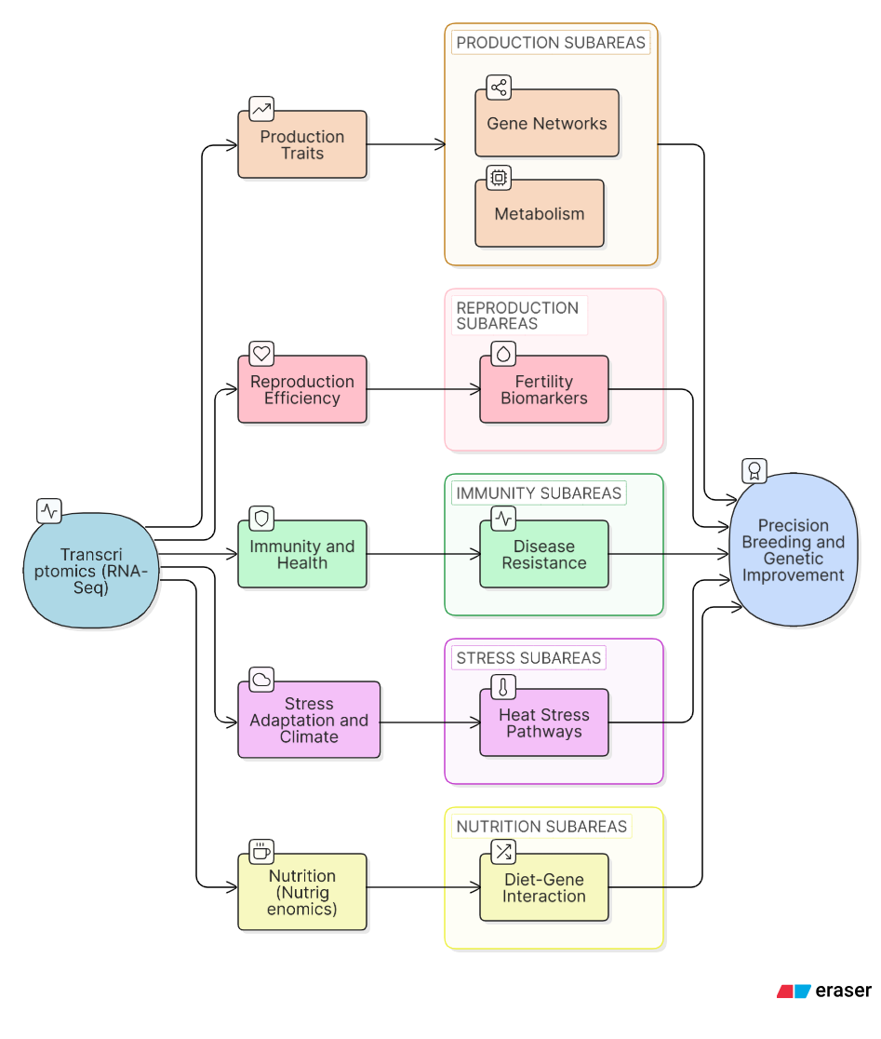
Fig.1. Transcriptomics based Livestock Improvement Framework or Integration of transcriptomic data for livestock improvement showing key application areas
3.1 Production Traits
Transcriptomic approaches have become indispensable for understanding the molecular architecture of key production traits in livestock, including feed efficiency, growth rate, muscle development, milk yield, and meat quality. High-throughput technologies such as RNA sequencing (RNA-Seq) allow comprehensive profiling of gene expression across tissues, facilitating the identification of differentially expressed genes (DEGs) and regulatory pathways associated with phenotypic variation (Wang et al., 2009; Conesa et al., 2016).
In ruminants, particularly cattle, transcriptomic analyzes of metabolically active tissues such as the liver have revealed distinct expression patterns between animals with divergent residual feed intake (RFI). Genes involved in mitochondrial activity, lipid metabolism, and energy utilization are often differentially regulated, indicating their central role in feed efficiency (Alexandre et al., 2015; Salleh et al., 2017). Similarly, transcriptomic studies in skeletal muscle across species such as cattle, pigs, and poultry have identified genes controlling myogenesis, muscle fiber differentiation, and intramuscular fat deposition which are the key determinants of meat quality traits like tenderness, marbling, and water-holding capacity (Hocquette et al., 2010; Zhao et al., 2011).
3.2 Reproduction and Fertility
Reproductive performance is a complex trait with low heritability and strong environmental influence. Transcriptomic profiling has significantly improved understanding of the biological mechanisms underlying fertility and reproductive success (Walsh et al., 2011). Gene expression studies in reproductive tissues—including ovaries, uterus, and follicles—have identified critical genes and signaling pathways involved in folliculogenesis, steroidogenesis, oocyte maturation, and embryo implantation (Hatzirodos et al., 2014; Mamo et al., 2011). These pathways include TGF-β, Wnt, and IGF signaling, which are essential for reproductive regulation. Comparative transcriptomic analyzes between high- and low-fertility animals have revealed differential expression of genes associated with immune response, metabolic balance, and endocrine signaling, demonstrating the multifactorial nature of fertility (Diskin & Morris, 2008). Additionally, RNA-Seq studies on early embryos have provided insights into genome activation and developmental competence (Graf et al., 2014).
3.3 Stress Adaptation and Climate Resilience
Climate change poses significant challenges to livestock systems through heat stress, drought, and environmental variability. Transcriptomics has become a key tool for investigating molecular responses to these stressors (Renaudeau et al., 2012). Exposure to heat stress leads to substantial changes in gene expression across livestock species, affecting pathways related to heat shock proteins, oxidative stress, apoptosis, immune regulation, and metabolism (Collier et al., 2017; Sejian et al., 2018; Akbarian et al., 2016). These responses are essential for maintaining cellular homeostasis under stressful conditions.
Transcriptomic studies of tissues such as liver, skin, and mammary glands have identified adaptive mechanisms that help animals cope with thermal stress (Tao & Dahl, 2013).
These findings are crucial for developing breeding strategies aimed at improving climate resilience and ensuring sustainable livestock production.
3.4 Immune Function and Health
Improving disease resistance and immune competence is essential for sustainable livestock production. Transcriptomic approaches have been widely applied to study host–pathogen interactions, immune responses, and vaccine efficacy (Jenner & Young, 2005). Bulk RNA-Seq studies have identified key immune-related genes involved in cytokine signaling, antigen presentation, and innate immune responses during infections (Everts et al., 2005). These findings provide insights into the genetic basis of disease resistance.
Recent advances in single-cell transcriptomics have revolutionized this field by enabling high-resolution characterization of immune cell populations. This approach allows identification of distinct immune cell subsets and their functional states, which are often masked in bulk transcriptomic analyzes (Lu et al., 2024). For example, single-cell RNA sequencing studies in cattle have revealed immune cell heterogeneity and key transcriptional signatures associated with vaccine response and pathogen resistance (Wilson et al., 2025).
3.5 Enhancing Disease Resistance
Transcriptomic approaches have substantially advanced our understanding of how livestock respond to infectious diseases at the molecular level. By comparing gene expression profiles between healthy and infected animals, researchers can identify differentially expressed genes (DEGs) and signaling pathways involved in innate and adaptive immune responses (Jenner & Young, 2005; Everts et al., 2005). These include pathways related to cytokine signaling, toll-like receptor (TLR) pathways, antigen processing, and interferon responses, which are critical for pathogen recognition and clearance.
Recent RNA-Seq studies have enabled the identification of host genetic factors associated with resistance to economically important diseases such as mastitis, foot-and-mouth disease, and parasitic infections. Furthermore, integration of transcriptomics with genome-wide association studies (GWAS) has facilitated the discovery of expression quantitative trait loci (eQTLs), linking gene expression variation to disease resistance phenotypes.
Advancements in single-cell transcriptomics have further refined this understanding by enabling the characterization of immune cell heterogeneity and cell-specific responses during infection. For instance, distinct transcriptional profiles of macrophages, T cells, and B cells have been identified in response to pathogens, providing insights into immune regulation and vaccine responsiveness (Lu et al., 2024). These findings have practical implications for developing molecular markers for disease resistance, improving vaccine strategies, and reducing reliance on antibiotics, thereby promoting sustainable livestock production.
3.6 Improving Reproductive Efficiency
Reproductive efficiency is a key determinant of livestock productivity, yet it is influenced by complex interactions among genetic, physiological, and environmental factors. Transcriptomic analyzes of reproductive tissues like ovaries, testes, uterus, and early embryos, have enabled the identification of genes regulating gametogenesis, fertilization, implantation, and embryonic development (Mamo et al., 2011; Graf et al., 2014). Additionally, transcriptomic profiling of embryos has provided insights into early developmental competence and pregnancy establishment.
The emergence of single-cell RNA sequencing (scRNA-Seq) has revolutionized reproductive biology by enabling high-resolution analysis of cellular heterogeneity within reproductive tissues. This approach has uncovered distinct cell populations and their functional roles in spermatogenesis, follicular development, and embryo–maternal interactions (Lu et al., 2024). Such insights facilitate the identification of molecular biomarkers for fertility, supporting improved reproductive management and genetic selection strategies.
3.7 Increasing Productivity and Feed Efficiency
Feed efficiency is a crucial trait affecting both economic returns and environmental sustainability in livestock production systems. Transcriptomic studies have identified key genes and metabolic pathways involved in nutrient utilization, energy metabolism, and growth regulation (Alexandre et al., 2015; Salleh et al., 2017). RNA-Seq analyzes of liver, muscle, and adipose tissues have revealed that animals with superior feed efficiency exhibit distinct expression patterns of genes associated with mitochondrial function, oxidative phosphorylation, and lipid metabolism. These findings highlight the importance of metabolic efficiency in determining feed conversion ratios. Recent advancements in transcriptomic technologies have enabled large-scale and cost-effective gene expression profiling, making it feasible to integrate transcriptomic data into livestock breeding programs.
Moreover, the integration of transcriptomics with other omics approaches, such as metabolomics and proteomics, provides a systems-level understanding of feed efficiency, facilitating the development of precision breeding strategies.
3.8 Meat Quality and Product Characteristics
Meat quality traits, including tenderness, juiciness, flavor, and fat composition, are influenced by complex molecular processes that occur during muscle development and postmortem metabolism. Transcriptomic profiling of muscle tissue has identified genes involved in myogenesis, lipid metabolism, and proteolytic pathways that contribute to these traits (Hocquette et al., 2010; Zhao et al., 2011). Gene expression studies have revealed the role of regulatory pathways such as insulin signaling, adipogenesis, and oxidative metabolism in determining intramuscular fat deposition and muscle fiber characteristics. These factors directly influence marbling, tenderness, and water-holding capacity, which are critical for consumer acceptance. Recent RNA-Seq studies have further identified novel candidate genes and non-coding RNAs associated with meat quality traits, providing new targets for genetic improvement. The integration of transcriptomic data into breeding programs enables more precise selection for desirable product characteristics, enhancing both product quality and market value.
3.9 Adaptation to Environmental Stress
Livestock are increasingly exposed to environmental stressors such as heat, humidity, and water scarcity, which can adversely affect productivity and welfare. Transcriptomic analyzes have provided valuable insights into the molecular mechanisms underlying stress responses and adaptation (Renaudeau et al., 2012; Collier et al., 2017). Exposure to heat stress induces the expression of genes encoding heat shock proteins (HSPs), antioxidant enzymes, and stress-responsive transcription factors, which play crucial roles in maintaining cellular homeostasis (Sejian et al., 2018). Additionally, genes involved in immune function, apoptosis, and energy metabolism are differentially regulated under stress conditions.

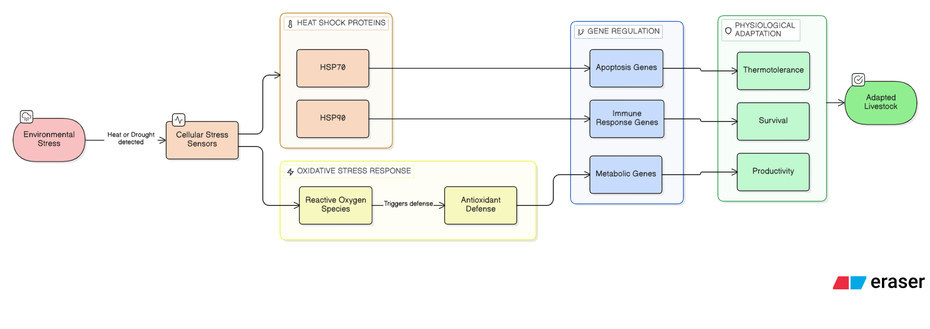

Fig.2. Stress Response and Climate Adaptation Pathway or Molecular response of livestock to environmental stress based on transcriptomic studies
Recent studies using RNA-Seq and single-cell transcriptomics have identified genetic markers associated with thermal tolerance and environmental resilience in livestock species. These findings support the development of breeding strategies aimed at enhancing climate resilience, ensuring sustainable production under changing environmental conditions.
3.10 Nutritional Genomics (Nutrigenomics)
Nutritional genomics, or nutrigenomics, focuses on the interaction between diet and gene expression, providing insights into how nutrients influence metabolic pathways and physiological functions. Transcriptomic approaches have been widely used to investigate the effects of different diets on gene expression in livestock.
Studies have shown that dietary components can modulate the expression of genes involved in lipid metabolism, immune function, and growth regulation. For example, variations in dietary energy and protein levels can influence the expression of genes associated with feed efficiency and milk production. Recent advances in transcriptomics have enabled more precise characterization of diet–gene interactions, supporting the development of optimized feeding strategies tailored to specific genetic backgrounds.
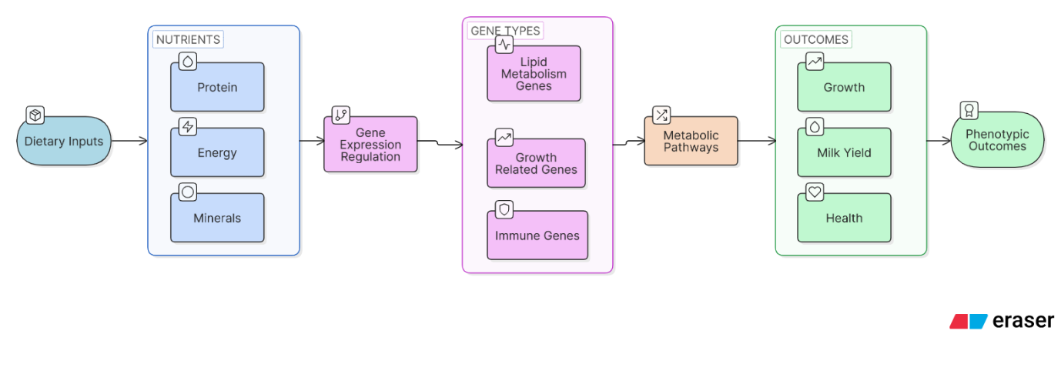
Fig.3. Interaction between diet and gene expression in livestock (nutrigenomics)
Nutrigenomics thus plays a critical role in precision livestock nutrition, contributing to improved animal health, productivity, and sustainability.
CONCLUSION
Transcriptomics has emerged as a transformative tool in livestock research, offering valuable insights into the functional regulation of genes underlying economically important traits. By enabling comprehensive analysis of gene expression across tissues, transcriptomic approaches have significantly enhanced our understanding of complex traits such as production efficiency, reproductive performance, disease resistance, meat quality, and environmental adaptation. The integration of RNA sequencing technologies with advanced bioinformatics has allowed the identification of key regulatory genes, pathways, and molecular networks that directly influence phenotypic variation in livestock populations. The application of transcriptomics in areas such as immune response, nutrigenomics, and stress physiology has further strengthened its role in addressing contemporary challenges, including disease outbreaks, climate change, and the need for sustainable production systems.
Looking ahead, the incorporation of transcriptomic data into genomic selection frameworks and precision breeding strategies holds great promise for accelerating genetic improvement. As sequencing technologies become more cost-effective and accessible, transcriptomics is expected to play a central role in the development of resilient, productive, and sustainable livestock systems. Ultimately, harnessing transcriptomics in a holistic and integrated manner will be key to meeting the growing global demand for animal-derived products while ensuring animal health, welfare, and environmental sustainability.

COMPETING INTERESTS DISCLAIMER:
Authors have declared that they have no known competing financial interests OR non-financial interests OR personal relationships that could have appeared to influence the work reported in this paper.

REFERENCES
Akbarian, A., Michiels, J., Degroote, J., Majdeddin, M., Golian, A., & De Smet, S. (2016). Association between heat stress and oxidative stress in poultry: Mitochondrial dysfunction and dietary interventions with phytochemicals. Poultry Science, 95(7), 1471–1480. https://doi.org/10.1186/s40104-016-0097-5
Alexandre, P. A., Kogelman, L. J. A., Santana, M. H. A., Passarelli, D., Pulz, L. H., Fantinato-Neto, P., Silva, P. L., Leme, P. R., Strefezzi, R. F., Coutinho, L. L., & Ferraz, J. B. S. (2015). Liver transcriptomic networks reveal main biological processes associated with feed efficiency in beef cattle. BMC Genomics, 16(1), 1073. https://doi.org/10.1186/s12864-015-2292-8
Ask, B., van der Waaij, E. H., Stegeman, J. A., & van Arendonk, J. A. (2006). Genetic variation among broiler genotypes in susceptibility to colibacillosis. Poultry Science, 85(3), 415–421. https://doi.org/10.1093/ps/85.3.415
Bhattacharya, T. K., Chatterjee, R. N., Sharma, R. P., Niranjan, M., Rajkumar, U., & Reddy, B. L. N. (2011). Polymorphism in the prolactin promoter and its association with growth traits in chickens. Biochemical Genetics, 49(5–6), 385–394. https://doi.org/10.1007/s10528-010-9415-3
Brunberg, E., Jensen, P., Isaksson, A., & Keeling, L. (2011). Feather pecking behavior in laying hens: Hypothalamic gene expression in birds performing and receiving pecks. Poultry Science, 90(6), 1145–1152. https://doi.org/10.3382/ps.2010-00961
Buitenhuis, B., Hedegaard, J., Janss, L., & Sørensen, P. (2009). Differentially expressed genes for aggressive pecking behaviour in laying hens. BMC Genomics, 10(1), 544. https://doi.org/10.1186/1471-2164-10-544
Cavero, D., Schmutz, M., Philipp, H. C., & Preisinger, R. (2009). Breeding to reduce susceptibility to Escherichia coli in layers. Poultry Science, 88(10), 2063–2068. https://doi.org/10.3382/ps.2009-00168
Chiang, H. I., Swaggerty, C. L., Kogut, M. H., Dowd, S. E., Li, X., Pevzner, I. Y., & Zhou, H. (2008). Gene expression profiling in chicken heterophils with Salmonella enteritidis stimulation using a chicken 44 K Agilent microarray. BMC Genomics, 9(1), 526. https://doi.org/10.1186/1471-2164-9-526
Ciraci, C., Tuggle, C. K., Wannemuehler, M. J., Nettleton, D., & Lamont, S. J. (2010). Unique genome-wide transcriptome profiles of chicken macrophages exposed to Salmonella-derived endotoxin. BMC Genomics, 11(1), 545. https://doi.org/10.1186/1471-2164-11-545
Collier, R. J., Renquist, B. J., & Xiao, Y. (2017). A 100-year review: Stress physiology including heat stress. Journal of Dairy Science, 100(12), 10367–10380. https://doi.org/10.3168/jds.2017-13676
Conesa, A., Madrigal, P., Tarazona, S., Gómez-Cabrero, D., Cervera, A., McPherson, A., Szcześniak, M. W., Gaffney, D. J., Elo, L. L., Zhang, X., & Mortazavi, A. (2016). A survey of best practices for RNA-Seq data analysis. Genome Biology, 17(1), 13. https://doi.org/10.1186/s13059-016-0881-8
Cui, J. X., Du, H. L., Liang, Y., Deng, X. M., Li, N., & Zhang, X. Q. (2006). Association of polymorphisms in the promoter region of chicken prolactin with egg production. Poultry Science, 85(1), 26–31. https://doi.org/10.1093/ps/85.1.26
Desert, C., Duclos, M., Blavy, P., Lecerf, F., Moreews, F., Klopp, C., Aubry, M., Herault, F., Leroy, P., Berri, C., Douaire, M., Diot, C., & Laggarrigue, S. (2008). Transcriptome profiling of the feeding-to-fasting transition in chicken liver. BMC Genomics, 9(1), 611. https://doi.org/10.1186/1471-2164-9-611
Diskin, M. G., & Morris, D. G. (2008). Embryonic and early foetal losses in cattle and other ruminants. Reproduction in Domestic Animals, 43(s2), 260–267. https://doi.org/10.1111/j.1439-0531.2008.01171.x
Duerkop, B. A., Vaishnava, S., & Hooper, L. V. (2009). Immune responses to the microbiota at the intestinal mucosal surface. Immunity, 31(3), 368–376. https://doi.org/10.1016/j.immuni.2009.08.009
Eraslan, G., Avsec, Ž., Gagneur, J., & Theis, F. J. (2019). Deep learning: New computational modelling techniques for genomics. Nature Reviews Genetics, 20(7), 389–403. https://doi.org/10.1038/s41576-019-0122-6
Everts, R. E., Band, M. R., Liu, Z. L., Kumar, C. G., Liu, L., Loor, J. J., Oliveira, R., Lewin, H. A., & Drackley, J. K. (2005). A 7872 cDNA microarray and its use in bovine functional genomics. Veterinary Immunology and Immunopathology, 105(3–4), 235–245. https://doi.org/10.1016/j.vetimm.2005.02.003
Graf, A., Krebs, S., Heininen-Brown, M., Zakhartchenko, V., Blum, H., & Wolf, E. (2014). Genome activation in bovine embryos: Review of the literature and new insights from RNA sequencing. Animal Reproduction Science, 149(1–2), 46–58. https://doi.org/10.1016/j.anireprosci.2014.05.016
Habig, C., Geffers, R., & Distl, O. (2012). Differential gene expression from genome-wide microarray analyzes distinguishes Lohmann Selected Leghorn and Lohmann Brown layers. PLOS ONE, 7(10), e46787. https://doi.org/10.1371/journal.pone.0046787
Hasin, Y., Seldin, M., & Lusis, A. (2017). Multi-omics approaches to disease. Genome Biology, 18(1), 83. https://doi.org/10.1186/s13059-017-1215-1
Hatzirodos, N., Irving-Rodgers, H. F., Hummitzsch, K., Harland, M. L., Morris, S. E., & Rodgers, R. J. (2014). Transcriptome profiling of granulosa cells of bovine ovarian follicles during growth from small to large antral sizes. BMC Genomics, 15(1), 24. https://doi.org/10.1186/1471-2164-15-24
Hocquette, J. F., Gondret, F., Baéza, E., Médale, F., Jurie, C., & Pethick, D. W. (2010). Intramuscular fat content in meat-producing animals: development, genetic and nutritional control, and identification of putative markers. Animal, 4(2), 303–319. https://doi.org/10.1017/S1751731109991091
Jenner, R. G., & Young, R. A. (2005). Insights into host responses against pathogens from transcriptional profiling. Nature Reviews Microbiology, 3(4), 281–294. https://doi.org/10.1038/nrmicro1126
JiaYu, C., Lili, S., Dawei, W., ZhiLin, L., Xin, Z., Zelin, J., Yuhang, Z., Huisheng, X. and Xueli, W., (2025). Current status of transcriptome sequencing technology in ruminants. Frontiers in Veterinary Science, 12, p.1558799. https://doi.org/10.3389/fvets.2025.1558799
Ka, S., Markljung, E., Ring, H., Albert, L., Hallböök, F., & Andersson, L. (2011). Differentially expressed genes in hypothalamus in relation to genomic regions under selection in two chicken lines resulting from divergent selection for high or low body weight. Neurogenetics, 12(3), 211–221. https://doi.org/10.1007/s10048-011-0290-9
Kano, R., Konnai, S., Onuma, M., & Ohashi, K. (2009). Microarray analysis of host immune responses to Marek's disease virus infection in vaccinated chickens. Journal of Veterinary Medical Science, 71(5), 603–610. https://doi.org/10.1292/jvms.71.603.
Kim, H. S., Kim, J., Kim, J., & Choi, Y. H., (2022). Characterization of differential gene expression of broiler chicken to thermal stress in discrete developmental stages. Animal Cells and Systems, 26(2), 62–69. https://doi.org/10.1080/19768354.2022.2059566
Libbrecht, M. W., & Noble, W. S. (2015). Machine learning applications in genetics and genomics. Nature Reviews Genetics, 16(6), 321–332. https://doi.org/10.1038/nrg3920
Love, M. I., Huber, W., & Anders, S. (2014). Moderated estimation of fold change and dispersion for RNA-seq data with DESeq2. Genome Biology, 15(12), 550. https://doi.org/10.1186/s13059-014-0550-8
Lu, Y., Li, M., Gao, Z., Ma, H., Chong, Y., Hong, J., Wu, J., Wu, D., Xi, D. & Deng, W., (2024). Innovative insights into single-cell technologies and multi-omics integration in livestock and poultry. International Journal of Molecular Sciences, 25(23), 12940. https://doi.org/10.3390/ijms252312940
Luecken, M. D., & Theis, F. J. (2019). Current best practices in single-cell RNA-seq analysis. Molecular Systems Biology, 15(6), e8746. https://doi.org/10.15252/msb.20188746
Mamo, S., Mehta, J. P., McGettigan, P., Fair, T., Spencer, E.T., Bazer, F.W., & Lonergan, P., (2011). RNA sequencing reveals novel gene clusters in bovine Conceptuses Associated with Maternal Recognition of Pregnancy and Implantation. Biology of Reproduction, 85(6), 1143–1151. https://doi.org/10.1095/biolreprod.111.092643
Maru, D., & Kumar, A. (2024). Applications of omics technologies in livestock production, improvement and sustainability. In V. Kumar Yata, A. K. Mohanty, & E. Lichtfouse (Eds.), Sustainable Agriculture Reviews (Vol. 62, pp. 245–268). Springer. http://doi.org/10.1007/978-3-031-54372-2_1
Mortazavi, A., Williams, B. A., McCue, K., Schaeffer, L., & Wold, B. (2008). Mapping and quantifying mammalian transcriptomes by RNA-seq. Nature Methods, 5(7), 621–628. https://doi.org/10.1038/nmeth.1226
Nuthalapati, N. K., Evans, J. D., Taylor Jr, R. L., Branton, S. L., Nanduri, B., & Pharr, G. T. (2019). Transcriptomic analysis of early B-cell development in the chicken embryo. Poultry Science, 98(11), 5342–5354. https://doi.org/10.3382/ps/pez354
Patro, R., Duggal, G., Love, M. I., Irizarry, R. A., & Kingsford, C. (2017). Salmon provides fast and bias-aware quantification of transcript expression. Nature Methods, 14(4), 417–419. https://doi.org/10.1038/nmeth.4197
Pertea, M., Kim, D., Pertea, G. M., Leek, J. T., & Salzberg, S. L. (2016). Transcript-level expression analysis of RNA-seq experiments with HISAT, String tie and Ball gown. Nature Protocols, 11(9), 1650–1667. https://doi.org/10.1038/nprot.2016.095
Pritchett, E.M., Van Goor, A., Schneider, B.K., Young, M., Lamont, S.J. and Schmidt, C.J., (2023). Chicken pituitary transcriptomic responses to acute heat stress. Molecular Biology Reports, 50(6), 5233-5246. https://doi.org/10.1007/s11033-023-08464-8
Renaudeau, D., Collin, A., Yahav, S., de Basilio, V., Gourdine, J. L., & Collier, R. J. (2012). Adaptation to hot climate and strategies to alleviate heat stress. Animal, 6(5), 707–728. https://doi.org/10.1017/S1751731111002448
Richards, M. P., Proszkowiec-Weglarz, M., Rosebrough, R. W., McMurtry, J. P., & Angel, R. (2010). Effects of early neonatal development and delayed feeding immediately post-hatch on the hepatic lipogenic program in broiler chicks. Comparative Biochemistry and Physiology Part B: Biochemistry and Molecular Biology, 157(4), 374–388. https://doi.org/10.1016/j.cbpb.2010.08.007
Robinson, M. D., McCarthy, D. J., & Smyth, G. K. (2010). edgeR: A Bioconductor package for differential expression analysis. Bioinformatics, 26(1), 139–140. https://doi.org/10.1093/bioinformatics/btp616
Salleh, M. S., Mazzoni, G., Höglund, J. K., Olijhoek, D. W., Lund, P., & Løvendahl, P. (2017). RNA-Seq transcriptomics and pathway analyzes reveal potential regulatory genes and molecular mechanisms in high- and low-residual feed intake in Nordic dairy cattle. BMC Genomics, 18(1), 258. https://doi.org/10.1186/s12864-017-3622-9
Sejian, V., Bhatta, R., Gaughan, J. B., Dunshea, F. R., & Lacetera, N. (2018). Review: Adaptation of animals to heat stress. Animal, 12(s2), s431–s444. https://doi.org/10.1017/S1751731118001945
Shashank, C. G., Sejian, V., Silpa, M. V., Devaraj, C., Madhusoodan, A. P., Rebez, E. B., Kalaignazhal, G., Sahoo, A., & Dunshea, F. R. (2024). Climate resilience in farm animals: Transcriptomics-based alterations in differentially expressed genes and stress pathways. Biotech, 13(4), 49. https://doi.org/10.3390/biotech13040049
Tang, F., Barbacioru, C., Wang, Y., Nordman, E., Bao, C., Xu, N., Wang, X., Bodeau, J., Tuch, B. B., Siddiqui, A., Lao, K., & Surani, M. A. (2009). mRNA-Seq whole-transcriptome analysis of a single cell. Nature Methods, 6(5), 377–382. https://doi.org/10.1038/nmeth.1315
Tao, S., & Dahl, G. E. (2013). Heat stress effects during late gestation on dry cows and calves. Journal of Dairy Science, 96(1), 407–421. https://doi.org/10.3168/jds.2012-6278
Walsh, S. W., Williams, E. J., & Evans, A. C. O. (2011). A review of the causes of poor fertility in high milk producing dairy cows. Animal Reproduction Science, 123(3–4), 127–138. https://doi.org/10.1016/j.anireprosci.2010.12.001
Wang, H. B., Wang, Q. G., Zhang, X. Y., Gu, X. F., Wang, N., Wu, S. B., & Li, H. (2010). Microarray analysis of genes differentially expressed in the liver of lean and fat chickens. Animal, 4(4), 513–522. https://doi.org/10.1017/S1751731109991388
Wang, Z., Gerstein, M., & Snyder, M. (2009). RNA-Seq: A revolutionary tool for transcriptomics. Nature Reviews Genetics, 10(1), 57–63. https://doi.org/10.1038/nrg2484
Wilson, A., Alexandre, P.A., Brice, A.M., Hine, B.C., Ingham, A., Legrand, T.P., Royle, C., Niemeyer, D., Reverter, A., Denman, S.E. & Farr, R.J., (2025). Single-cell transcriptomics uncovers key immune drivers of vaccine efficacy in cattle. BMC genomics, 26(1), 750. https://doi.org/10.1186/s12864-025-11915-0
Yadgary, L., Wong, E. A., & Uni, Z. (2014). Temporal transcriptome analysis of the chicken embryo yolk sac. BMC Genomics, 15(1), 1090. https://doi.org/10.1186/1471-2164-15-690
Yin, Z., Lian, L., Zhu, F., Zhang, Z. H., Hincke, M., Yang, N., & Hou, Z. C. (2020). The transcriptome landscapes of the ovary and three oviduct segments during chicken (Gallus gallus) egg formation. Genomics, 112(1), 243–251. https://doi.org/10.1016/j.ygeno.2019.02.003
Zhao, X., Mo, D., Li, A., Gong, W., Xiao, S., Zhang, Y., Qin, L., Niu, Y., Guo, Y., Liu, X. and Cong, P., (2011). Comparative analyses by sequencing of transcriptomes during skeletal muscle development between pig breeds differing in muscle growth rate and fatness. PloS one, 6(5), p.e19774. https://doi.org/10.1371/journal.pone.0019774

