Review Article

Sustainable aquaculture-livestock integrated systems: A Review

Abstract
Aquaculture has developed into the fastest expanding food production industry because it provides vital food supplies for international nutritional needs. The intensive methods used in aquaculture operations result in environmental damage and resource exhaustion while increasing operational expenses. The farming methods of aquaculture–livestock integrated systems have emerged as sustainable solutions which use resources efficiently. The systems combine fish farming with various livestock operations including poultry duck farming pig farming and cattle grazing because livestock waste serves as a natural resource which boosts fish production through nutrient recycling.
This review presents the various aspects of aquaculture–livestock integrated systems which include their main concepts and different system types and ecological principles and sustainable advantages. The study evaluates fish–duck systems and fish–poultry systems and fish–pig systems and fish–cattle systems based on their production efficiency and financial performance and environmental benefits. The study investigates the ecological principles which support these systems through their processes of nutrient recycling and waste management and energy conservation and biodiversity restoration. The review analyzes how Integrated Multi-Trophic Aquaculture (IMTA) and Recirculating Aquaculture Systems (RAS) and aquaponics and biofloc technology and digital aquaculture have turned traditional integrated systems into modern production methods which achieve higher efficiency and better sustainability.
The paper identifies main obstacles which include disease spread and water quality decline and system complexity and financial demands and policy restrictions that prevent organizations from using integrated systems. Future technological advancements and climate-adaptive system development will determine the future of technology.
Keywords: Aquaculture–livestock integration, Sustainable aquaculture, Nutrient recycling, and Aquaponics
1. Introduction
The aquaculture industry has developed into the fastest expanding food production industry throughout the world which provides essential fish supplies while supporting people and driving economic growth (Kobayashi, et al., 2015). Aquaculture currently supplies more than 50 percent of global fish consumption according to worldwide data which shows its importance in meeting the growing need for animal protein that results from population growth and urban expansion and changes in eating habits. In Asia developing countries consider aquaculture to be their main source of food which also helps small and marginal farmers earn income, (Frost, 2001).
The growth of conventional and intensive aquaculture methods creates environmental problems while producing negative socio-economic effects (Boyd, et al., 2022). The aquatic environment suffers from water pollution which results from excess feed and waste accumulation together with eutrophication and biodiversity loss and the spread of fish diseases and the increased need for artificial feed and chemical substances (Malik, et al., 2020). The intensive systems of operation face challenges because their operational expenses and ecological impact make it difficult to sustain their operations for extended periods (Tiwari and Pal, 2022). The establishment of environmentally sustainable aquaculture systems requires resource-efficient methods that generate economic benefits while enabling production processes to maintain their environmental standards (Ninawe, et al., 2026).
Sustainable aquaculture systems receive extensive research interest because they provide a complete solution which achieves effective output while protecting environmental resources and fulfilling social obligations (Costa-Pierce, 2010). The sustainable systems of operations focus on effective resource management together with nutrient recycling and reduced waste production and their connection to other agricultural operations. The integrated aquaculture-livestock farming system provides a sustainable farming solution which serves as an effective operational model for smallholder farming systems (Kremsa, 2021).
Integrated aquaculture–livestock farming establishes a production system which creates synergy through the combination of aquaculture and livestock operations including poultry and pig farming and dairy and duck and goat operations (Rani, et al., 2026). The system uses organic inputs from livestock waste which includes dung and urine and leftover feed to fish ponds. The waste material functions as fertilizer which promotes phytoplankton and zooplankton growth which fish use as natural food sources (Gebru, et al., 2021). The system decreases artificial feed requirements together with chemical fertilizer usage which leads to lower production expenses and reduced environmental contamination (Serge, 2021).
The practice of combining aquaculture with livestock operations increases nutrient recycling while enhancing both resource efficiency and overall farm output (Farrant, 2021). The system establishes a closed-loop design where one system component generates output which another component uses as input therefore producing minimal waste. The systems create various income sources while they enable farms to develop multiple activities which help to decrease dangers that come with operating a single business. The solution provides crucial support to small and marginal farmers because it secures their livelihoods and helps them cope with climate and market changes (Verma, and Sudan, 2021).
Integrated farming systems have been used by farmers in Asian countries through their development of native knowledge-based systems which combine fish and livestock for centuries (Nandeesha, et al., 2021). In rural areas, fish–duck and fish–poultry systems show high productivity and sustainability because they have become common agricultural practices Gangwar, et al., 2013). The traditional practices require scientific modernization because people now realize the need for sustainable food production systems to handle climate change issues and resource depletion problems (Singh, and Singh 2017).
The integrated aquaculture–livestock systems help climate-smart agricultural practices because they decrease greenhouse gas emissions (Bhattacharyya, 2020). These systems operate according to circular economy principles which promote sustainable intensification through resource-efficient production methods that protect natural ecosystems (Munguti, et al., 2021).
Integrated aquaculture–livestock farming provides an effective solution for sustainable agricultural practices and food security because natural resources become limited and production expenses rise and environmental issues become more severe (Ahmed, et al., 2020). The system helps maintain ecological balance while it generates job opportunities and boosts nutritional security and drives rural development through sustainable methods (Richardson, 2010). The successful adoption of integrated aquaculture–livestock systems requires people to gain knowledge about the system's abilities and its operational methods and existing problems.
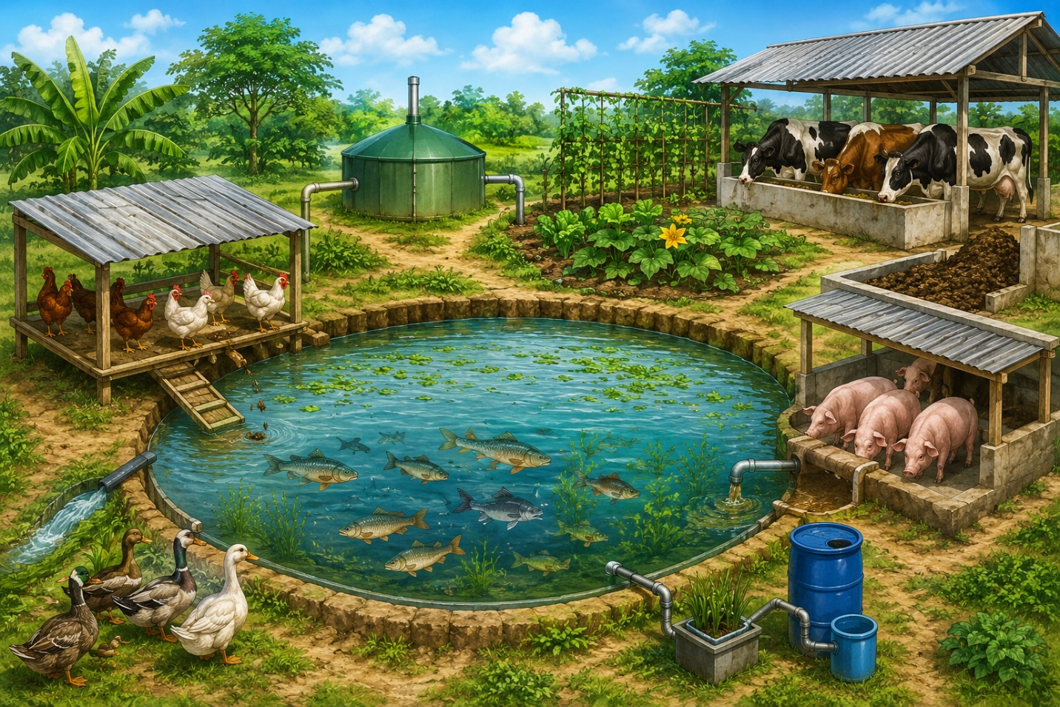
FIGURE 1. Integrated aquaculture–livestock farming

2. Concept of Aquaculture–Livestock Integrated Systems
Aquaculture–livestock integrated systems function as a sustainable farming method which uses fish farming and livestock breeding to create an interconnected system that efficiently uses resources (Wardani, and Yasin 2024). The integrated model establishes direct connections between aquaculture and livestock business operations which enable livestock waste to function as a resource that supports fish production activities (Osei, et al., 2025). The integrated system increases productivity while it uses existing farm resources to achieve maximum efficiency which reduces environmental impact.
The fundamental principle underlying aquaculture–livestock integration is nutrient recycling (Prein, 2002). The livestock enterprises which include poultry operations, piggery operations, dairy farms, duckery operations, and goat farms generate large amounts of organic waste which consists of dung, urine, and leftover feed (Parihar, et al., 2019). The organic waste from livestock operations gets used in fish ponds where it either enters directly or undergoes partial decomposition before application. The organic materials which people introduce into water bodies release essential nutrients that include nitrogen and phosphorus and carbon which activate phytoplankton and zooplankton development (Pachiappan, et al., 2018). The tiny organisms provide natural fish food which boosts fish growth rates while decreasing the need for extra feeding.
The farm operational system enhancement comes from integrated systems which provide both nutrient recycling and their additional benefits. Farmers achieve better resource utilization through interconnecting multiple businesses within one production facility. The same land area enables fish ponds and nearby livestock sheds to be built above or adjacent to the ponds. This method achieves optimal land utilization while decreasing expenses related to waste disposal and necessary outside materials. Farmers who practice this method achieve better results because their system produces more output for each cultivated area than traditional single-crop agricultural practices (Altieri, et al., 2012).
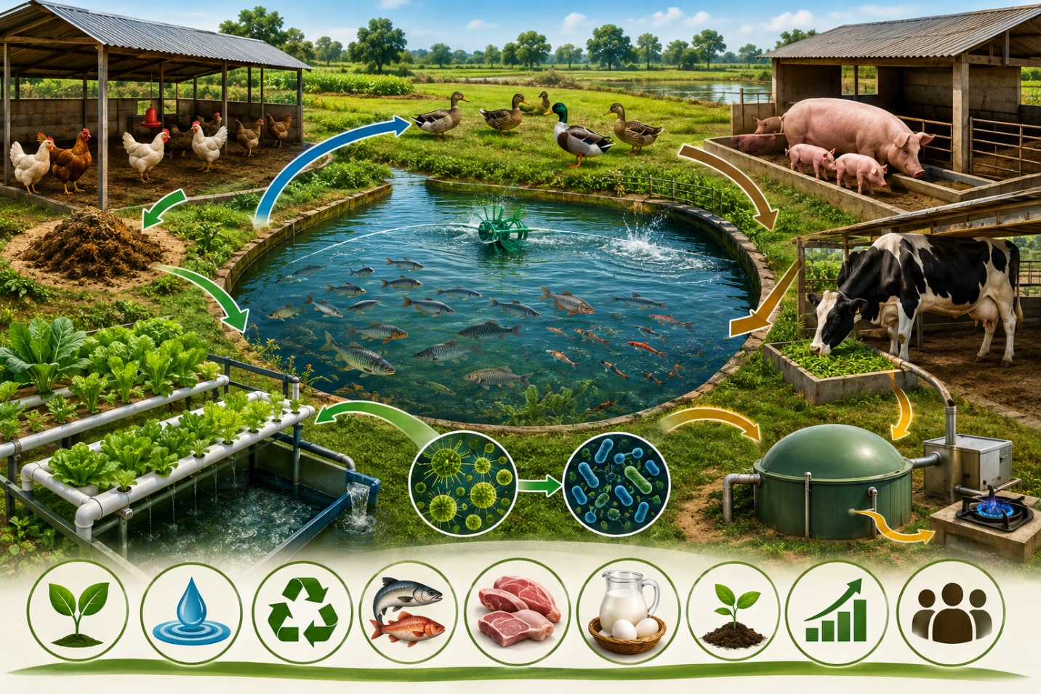
FIGURE 2. The Cycle of aquaculture–livestock integration

Income diversification stands as another essential component of aquaculture–livestock integrated systems (Sarangi, et al., 2016). The system generates multiple income streams for farmers because it produces several commodities which include fish and meat together with milk and eggs. The risk which market prices and crop failures bring to farming households reduces through this diversification method which helps maintain their economic stability (Gill, et al., 2009). The different food products available in the market enhance nutritional security because they provide a wholesome diet which contains essential proteins and vitamins and nutrients needed for good health (WHO, 2021).
The system which combines different components together functions as an essential element which supports environmental sustainability efforts. The system achieves two environmental benefits through its organic waste recycling process which decreases pollution levels while decreasing the need for chemical fertilizers and commercial fish feeds (Murshed-E-Jahan, and Pemsl, 2011). This process improves both soil and water quality while sustaining the natural ecosystem balance. The system achieves economic viability for small and marginal farmers because it requires fewer external inputs which decrease production costs (Saha, et al., 2022).
Aquaculture–livestock integration operates on the concept of a circular economy, where the output or waste of one enterprise becomes the input for another, thereby forming a closed-loop system (Osei, et al., 2025). The integrated systems of today create a continuous process which enables resources to be recycled and reused throughout their entire duration instead of following the pattern which existing farming systems use to consume resources and create waste. The process begins with livestock waste which serves as a fertilizer for fish ponds, yielding nutrient-rich water that functions as an irrigation source for crops (Das, et al., 2023). The system achieves sustainable development through its process which uses crop residues as livestock feed to complete the nutrient cycle.
The success of such integrated systems largely depends on the proper management of interactions between different components. The direct integration method enables livestock units to build facilities which include poultry and duck houses above fish ponds, which then allows waste material to drop directly into the water (Pakhira, et al., 2023). The method of indirect integration involves the collection and processing of livestock waste through composting or biogas production before its application to ponds (Barman,and Rajkhowa 2018). These different modes of integration provide flexibility to farmers in adopting the system based on their resources, environmental conditions, and management capacity.
Overall, aquaculture–livestock integrated systems offer a highly efficient, sustainable, and economically viable approach to farming. By promoting nutrient recycling, enhancing productivity, diversifying income sources, and reducing environmental impact, these systems serve as an important model for sustainable agricultural development (Lundeba, et al., 2023). Their adoption can play a significant role in improving rural livelihoods, ensuring food and nutritional security, and addressing the challenges of resource scarcity and environmental degradation.
3. Types of Aquaculture–Livestock Integrated Systems
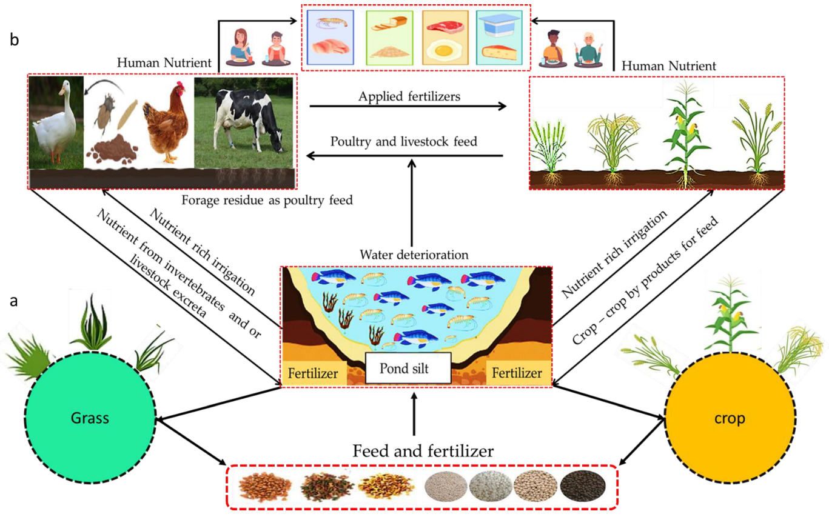
Different types of aquaculture-livestock integrated systems exist because fish farming needs to be combined with specific livestock operations (Little, and Edwards 2003). The different integration methods show distinct characteristics which provide different benefits that need different management approaches. The systems operate through effective nutrient recycling and biological interactions to achieve their goals of maximum resource efficiency which results in increased farm productivity (Serge, 2021).
(Source, Ibrahim, et al., 2023)
FIGURE 3. Types of aquaculture-livestock integrated systems
3.1 Fish–Duck Farming
The integrated farming system which achieves the highest success rate in Asian countries operates through fish-duck farming. The system allows ducks to walk on fish ponds because they create multiple advantages for the farming operation (Sapcota, and Begum 2022). The pond water receives continuous organic manure through duck droppings which increases essential nutrient levels for the aquatic ecosystem. The nutrient enrichment process increases phytoplankton and zooplankton populations which serve as natural fish food sources (Rajput, et al., 2014).
Ducks assist with nutrient delivery while creating natural biological and physical control methods for pond ecosystems. Ducks swim continuously through the water which creates natural aeration that increases dissolved oxygen levels and prevents water body stratification (Saikia, et al., 2020). Ducks eat aquatic plants and insects and larvae and other pests which helps to control biological populations and clean the pond environment. Manual weeding and chemical control measures require less effort because of this situation (Barash, et al., 1982).
The integration of fish and ducks offers multiple economic benefits together with various ecological advantages that result from their combined existence. The system achieves cost savings because duck droppings provide most of the necessary nutrients while decreasing the need for external fish feed and fertilizers (Kumar, et al., 2020). The presence of natural food sources enhances fish productivity simultaneously farmers gain additional revenue through duck egg and meat production. The system maintains effective nutrient recycling processes which help establish environmentally sustainable agricultural methods (Kumar, et al., 2012).
The system includes common fish species which people raise through aquaculture that includes carps tilapia and catfish because these fish thrive in waters with abundant nutrients. The Khaki Campbell and Indian Runner duck breeds serve as popular ducks for integration because they produce many eggs and function well in pond environments (Kumar, et al., 2012).
3.2 Fish–Poultry Farming
The fish–poultry farming system establishes an efficient integrated framework that raises chickens together with fish ponds. The system requires poultry sheds to be built either directly above the pond area or alongside the pond banks. The droppings of poultry birds fall directly into the pond or are collected and applied to the water, where they act as organic fertilizers (Sahoo, and Singh 2015).
Poultry manure provides high nitrogen content together with phosphorus and other vital nutrients which enhance plankton growth in the pond (Oben, et al., 2015). The artificial feeding system uses plankton as natural fish feed which cuts down commercial fish feed needs. The system leads to substantial fish growth and yield increases while production expenses decrease.
The integrated system delivers multiple advantages through its ability to produce more fish while managing waste effectively and increasing farm revenue (Gangwar, et al., 2013). The system achieves environmental pollution reduction through its implementation of poultry waste, which results in decreased nutrient loss. Farmers gain financial stability through the production of fish and poultry products, which include meat and eggs, that provide them with two sources of income (Shoko, et al., 2019).
The system uses broiler and layer chickens as its main poultry breeds, which farmers select based on their specific goals (Debnath, et al., 2013). Small and medium-scale farmers find this system advantageous because it requires basic operational skills and delivers substantial financial benefits (Ramanathan, et al., 2020).
3.3 Fish–Pig Farming
The integrated system of fish-pig farming combines piggery with aquaculture to create a highly productive farming system that uses nutrients effectively (Li, et al., 2017). Fish farmers benefit from pig manure because it contains high organic matter levels and essential nutrients. Farmers build pig pens next to fish ponds because this setup allows them to collect and transport pig waste to the pond system (Sahoo, and Singh 2015).
Through the application of pig manure, pond water fertility increases, which results in greater production of natural fish food organisms that include phytoplankton and zooplankton (Bhagawati, et al., 2020). Fish growth and yield outcomes achieve better results through this method compared to traditional fish farming methods. The system achieves high nutrient recycling efficiency because pig waste decomposes rapidly, which enables fast nutrient release (Haobijam, and Ghosh, 2020).
The integration of fish and pig farming provides several advantages, including high fish productivity, efficient utilization of livestock waste, and increased economic returns (Debnath, et al., 2013). Farmers can generate income from both fish and pig production, thereby improving their financial security. However, proper management is essential in this system to prevent excessive nutrient loading, which may lead to water pollution, oxygen depletion, and disease outbreaks. Therefore, maintaining an appropriate balance between waste input and pond carrying capacity is crucial for the success of this system, (Choudhury, et al., 2021).
3.4 Fish–Cattle Integration
Fish–cattle integration is a traditional and widely adopted system in rural areas where mixed farming practices are common. In this system, cattle such as cows and buffaloes are reared alongside fish farming, and their dung and urine are utilized as organic inputs in fish ponds. Cattle dung is either directly applied to ponds or first composted and then used as fertilizer to improve pond productivity (Little, and Edwards, 2003).
The use of cattle waste in fish ponds enhances nutrient availability and promotes the growth of natural fish food organisms. This reduces the need for chemical fertilizers and artificial feeds, making the system more environmentally sustainable and cost-effective. Additionally, the integration of cattle provides farmers with additional products such as milk, manure, and draught power, contributing to overall farm efficiency (Pierezan, and Verruck, 2024).
This system is particularly suitable for smallholder farmers who practice subsistence agriculture and have access to livestock resources (Majhi, 2018). It supports sustainable nutrient cycling, improves soil and water health, and reduces the environmental impact of farming activities. By integrating fish and cattle farming, farmers can achieve better resource utilization and long-term sustainability, (Kumar, et all., 2012).
4. Ecological Principles of Integrated Systems
The integrated aquaculture–livestock systems operate according to ecological principles which require sustainable resource management and ecological waste recycling and environmental equilibrium preservation. The systems operate as interconnected biological systems which depend on their different parts to establish a self-sustaining system that produces an operational biological system. The integrated systems achieve sustainable agricultural production through their ability to copy natural ecological patterns which lead to resource optimization and waste reduction (Zajdband, 2011).
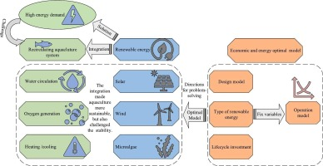

FIGURE 4. Ecological Principles of aquaculture–livestock Integrated Systems

(Source, Zhang et al., 2023)
4.1 Nutrient Recycling
Nutrient recycling serves as the fundamental element that supports aquaculture–livestock integrated systems (Zhang, et al., 2023). The systems depend on livestock waste products which include dung and urine and leftover feed to provide essential nutrients that contain nitrogen and phosphorus and organic carbon. Microorganisms decompose waste materials in fish ponds which leads to nutrient release from the waste into the surrounding water. The released nutrients support phytoplankton and zooplankton development because these organisms establish the basic aquatic food chain which provides natural food sources to fish, (Dong, et al., 2023).
The system achieves complete nutrient recycling which results in only minimal element loss from the system. The system decreases its dependence on outside resources which include chemical fertilizers and artificial feeds and this reduction leads to decreased production expenses and environmental damage (Soussana, et al., 2015). Effective nutrient cycling processes lead to increased pond productivity which enables continuous sustainable fish production throughout the entire period (Aubin, et al., 2014).
4.2 Waste Utilization
Integrated systems achieve their major ecological benefit through their successful process of handling organic waste. The conventional farming system leads to environmental pollution because livestock waste creates pollution which results in water contamination and greenhouse gas emissions and unpleasant odors. Integrated aquaculture systems recognize waste materials as resources which enable them to operate their systems, (Dong, et al., 2022).
Pond ecosystems use biological methods to transform organic material from livestock waste into valuable biomass. Microorganisms decompose waste material into less complex substances which plankton and aquatic organisms will use as their food source (Metachew, 2025). Fish eat these organisms, which transform waste material into fish biomass that contains high-quality protein. This method decreases environmental pollution while improving resource efficiency and increasing productivity, Wong, et al., 2016).
4.3 Energy Efficiency
Integrated aquaculture–livestock systems produce their energy requirements through natural biological systems which do not need external resources (Prein, 2002). The systems use livestock waste as their main nutrient source, which leads to decreased reliance on commercial fish feed and synthetic fertilizers and energy-intensive inputs. The organization results in decreased energy needs and lower costs for production (Gupta, et al., 2012).
The various business operations on the farm work together to optimize resource distribution, which includes both labor and infrastructure resources (Edwards, 1988). Livestock feed energy gets partially used for fish production through waste recycling processes, which leads to better overall energy efficiency. Advanced integrated models include biogas production systems which convert livestock waste into energy, Angel, et al., 2019).
4.4 Biodiversity Enhancement
Integrated systems promote biodiversity through the cultivation of various plant species and agricultural operations within a single farming system. The ecosystem functions as a complex system through its various life forms which include fish, livestock, plankton, microorganisms, and aquatic plants (Sara, et al., 2025). The diverse species in the ecosystem create a system that maintains ecological stability because it protects against failures caused by pests and diseases and environmental changes (Dumont, et al., 2020).
The various species in the ecosystem create multiple functions which result in better system resilience. Plankton functions as primary producers while fish consume them and microorganisms enable decomposition and nutrient recycling, (Lemaire, et al., 2014). The pond needs different fish species which include carps tilapia and catfish to achieve maximum effectiveness in different ecological areas. The balanced ecosystem of the system achieves two objectives through its resource management and continuous output, (Rahman, 2016).
Biodiversity expansion leads to decreased chemical pesticide and disease treatment requirements, which results in better environmental sustainability for agricultural practices. The system supports essential ecosystem which includes water purification and nutrient cycling and biological control.
5. Sustainable Benefits of Aquaculture–Livestock Integration
Aquaculture–livestock integrated systems provide multiple sustainable advantages which include environmental protection and economic growth and social advancement and climate change mitigation, (Serge, 2021) The system achieves resource efficiency through its integrated operation of different agricultural activities which leads to decreased environmental harm and improved performance of agricultural operations. The system achieves sustainability through its capacity to produce results while protecting natural ecosystems and ensuring social and economic development.
5.1 Environmental Sustainability
Integrated aquaculture–livestock systems promote environmental sustainability through their efficient nutrient recycling system which eliminates waste discharge. Traditional farming systems accumulate livestock waste which results in environmental pollution through water contamination and soil degradation. Integrated systems use livestock waste as fish production resources which decreases the environmental damage caused by waste, Thomas, et al., 2021).
The use of livestock manure in fish ponds improves nutrient content which benefits the development of natural fish food organisms including phytoplankton and zooplankton. The process decreases chemical fertilizer requirements and artificial feed needs which results in reduced nutrient runoff and lower rates of eutrophication in nearby water ecosystems. The system maintains soil fertility and water quality through its organic waste recycling process which supports ecological stability over an extended period. functions and these functions protect the sustainability of integrated farming systems.
The integrated systems achieve sustainable resource management and environmental protection by decreasing their need for synthetic materials and enhancing their capacity to function through natural biological mechanisms. The system contributes to climate change mitigation by decreasing greenhouse gas emissions that result from waste decomposition and the production of chemical inputs, Olesen, et al., 2023).
5.2 Economic Sustainability
Aquaculture-livestock integration stands out as an economically viable solution because it generates high financial returns. The system enables farmers to cultivate various products which include fish and meat and eggs and milk and organic manure by using the same land and water resources. The practice of diversifying production activities across multiple fields enables farmers to achieve increased financial returns while establishing stable income sources, Zhang, et al., 2025).
The businesses combine forces to decrease manufacturing expenses by reducing their dependence on external resources which include commercial fish feed and inorganic fertilizers. Farmers gain financial advantages through using livestock waste because it functions as a cost-saving solution that replaces expensive commercial fish feed and inorganic fertilizers. Farmers who produce multiple products can sell to various markets which helps them build multiple income streams that protect their business from price changes and their crops from potential losses, Thomas, et al., 2021).
Integrated systems achieve better resource efficiency because they deliver greater agricultural output for every land unit compared to traditional monoculture systems. The integrated farming system enables farmers to attain higher financial benefits while they practice sustainable farming methods. The small and marginal farmers who want to improve their livelihoods should use integrated aquaculture-livestock farming methods because these systems match their needs better than other approaches, Gupta, et al., 2012).
5.3 Social Sustainability
Social sustainability receives strong support from aquaculture and livestock integrated systems because these systems create employment opportunities which benefit rural communities. The system creates permanent job openings because the system needs workers for its various farm operations which include livestock management and fish culture and feed preparation and product marketing. The program helps decrease both rural unemployment and urban migration, Garlock, et al., 2024).
The integrated systems create job opportunities which also enhance food security and nutritional health for the community. Farm families and local communities receive access to protein-rich and nutrient-dense foods through the production of diverse food items which include fish and milk and eggs and meat. Developing countries need these foods because malnutrition and food insecurity continue to create major problems, Thomas, et al., 2021).
Integrated farming provides various farm tasks which enable all family members including women and youth to participate in their work. Poultry rearing and dairy management and fish harvesting activities create skill development and income generation possibilities which empower rural households while promoting social equity.
6. Recent Innovations in Sustainable Integrated Systems
The recent scientific and technological advancements of today enable aquaculture systems which integrate livestock production with sustainable operations to achieve better environmental performance and climate change resistance. The system design improvements and water management solutions and nutrient recycling methods together with digital monitoring systems enable operational efficiency growth while environmental damage remains limited. The resource shortage and environmental destruction and growing food demand problems in modern society get solved through the combination of traditional wisdom and modern technology used in these contemporary methods.
6.1 Integrated Multi-Trophic Aquaculture (IMTA)
Integrated Multi-Trophic Aquaculture (IMTA) functions as an ecological aquaculture system which enables multiple species from different trophic levels to exist together in a single aquatic environment. The system uses fed species which include fish together with extractive species that include shellfish and algae and aquatic plants which consume the waste nutrients produced by the fed species. The system establishes a relationship between species which enables one species to use the waste materials from another species as its resources.
IMTA enables efficient nutrient recycling together with diminished waste buildup inside aquatic environments which represents its primary benefit. Algae and aquatic plants absorb dissolved nutrients which include nitrogen and phosphorus, while filter feeders such as shellfish consume the particulate wastes produced by fish culture. The process leads to improved water quality, and reduced environmental pollution, and increased system productivity. IMTA enables multiple valuable products to be produced through ecological sustainable practices which include fish and seaweed and shellfish.
6.2 Recirculating Aquaculture Systems (RAS)
Recirculating Aquaculture Systems (RAS) stand as an advanced fish production method which uses complete water recycling between its mechanical and biological filtration systems to maintain optimal environmental conditions. The systems operate to achieve minimum water consumption requirements while sustaining the best possible water quality conditions which support fish development. RAS technologies involve the removal of solid wastes, conversion of toxic ammonia into less harmful compounds through biofiltration, and oxygenation of water before it is recirculated back into the culture tanks.

Recent innovations in RAS have further improved system efficiency and management. The system now achieves controlled precision through its artificial intelligence and automation components which regulate feeding operations and water quality measurements and fish health assessments. Advanced biofilters and microbial technologies enable efficient nutrient removal processes as microalgae systems work to absorb nutrients and generate oxygen. RAS systems function as ideal solutions for aquaculture in urban and peri-urban areas which face restrictions on water access and need to protect against potential biosecurity threats.
6.3 Aquaponics
Aquaponics represents a pioneering farming method which establishes an environmentally sustainable agricultural system through its combination of fish farming and hydroponic plant production. The system operates through fish cultivation in tanks which produce wastewater that contains nutrients to support growth of soil-free plant life. The plants absorb these nutrients, which enables them to clean the water that gets returned to the fish tanks.
The closed-loop system guarantees complete water and nutrient recycling through its operation, which makes aquaponics an ideal solution for regions that suffer from resource shortages. The system uses fish waste to supply plant nutrients, which eliminates the requirement for synthetic fertilizers. The plants function as natural water purification systems, which enhance the water conditions needed by fish. Aquaponics enables growers to farm both fish and fresh vegetables, which helps increase food availability while supporting environmentally friendly farming practices in cities.
6.4 Biofloc Technology
Biofloc technology presents an aquaculture solution which uses microbial communities to transform waste nutrients into productive biomass. The system decomposes organic wastes through heterotrophic bacteria which break down uneaten feed and fish excreta to create biofloc aggregates. Fish can use these bioflocs which contain high protein content as additional food.
Biofloc technology application enables better feed efficiency because it recycles nutrients throughout the system while decreasing the requirement for outside food sources. The system improves water quality by controlling dangerous substances which include ammonia and nitrite to stay below harmful levels. Biofloc systems operate with low water exchange requirements which enables them to use water resources efficiently while protecting natural environments. This technology supports intensive aquaculture systems because these systems need effective solutions to sustain water quality.
6.5 Digital and Smart Aquaculture
Digital technologies enable modern aquaculture to conduct precise monitoring together with operational management of all farming activities. Smart aquaculture systems use artificial intelligence and Internet of Things (IoT) sensors together with automation and data analysis tools to improve production efficiency while minimizing operational hazards.
The system uses sensors to perform continuous monitoring of vital water quality indicators which include temperature and dissolved oxygen and pH and ammonia levels. The farmers utilize real-time data to make decisions which help them implement necessary changes at appropriate times. Artificial intelligence together with machine learning algorithms now serve as essential tools for detecting diseases and forecasting growth and managing precise feeding operations which help organizations use resources efficiently.
Automation systems manage feeding operations together with aeration processes and water distribution systems which leads to decreased workforce needs and better productivity. The new technologies lead to increased production levels while they create sustainable practices through their ability to decrease resource waste and harmful environmental effects. Digital aquaculture systems will establish themselves as essential components for creating sustainable fish farming practices through their ability to develop climate-resilient and precision-based production systems.
7. Challenges of Integrated Aquaculture–Livestock Systems
The integrated aquaculture-livestock systems provide various sustainable advantages but face multiple challenges which hinder their implementation and operational performance. The existing challenges stem from multiple biological environmental technical economic and institutional elements. The success of integrated farming system implementation depends on overcoming these challenges which affect especially emerging nations.
7.1 Disease Transmission
The integrated aquaculture-livestock systems face their most critical challenge through disease transmission between different species. The application of livestock waste as fertilizer within fish ponds creates a pathway for pathogenic microorganisms which include bacteria and viruses and parasites to enter the water system. The increased disease outbreak potential in fish populations results in major financial damages.
The farm system needs to establish proper waste management protocols which include proper waste handling and maintaining hygiene standards and biosecurity practices. The established waste handling procedures together with inadequate hygiene measures and insufficient biosecurity protocols create an elevated contamination risk. Composting of manure and health monitoring together with maintenance of stocking densities at suitable levels comprise essential management activities which help decrease disease transmission.
7.2 Water Quality Deterioration
The success of integrated aquaculture systems depends on maintaining water quality at its highest possible standards. Fish ponds become overwhelmed with organic matter because farmers apply excessive amounts of livestock waste which leads to dissolved oxygen depletion and the build-up of hazardous materials like ammonia and hydrogen sulfide. Fish experience stress which leads to decreased growth rates and death in extreme situations.
The imbalance between nutrient input and pond carrying capacity is a common issue in poorly managed systems. The combination of temperature fluctuations and seasonal changes with improper feeding methods creates additional challenges for water quality. The solution requires continuous monitoring of important water quality indicators while maintaining controlled manure application which depends on pond dimensions and fish species and stocking density.
7.3 Technical Complexity
Integrated aquaculture–livestock systems require a good understanding of the interactions between different components, which makes their management more difficult than single-enterprise systems. Farmers need adequate knowledge of nutrient cycling, species compatibility, feeding strategies, and pond management practices to ensure system efficiency.
Designing and maintaining an integrated system requires detailed planning because operators must decide on livestock unit locations and choose species that can coexist and control waste material that enters the system. The absence of technical expertise together with inadequate training results in improper system operation which decreases production output while harming natural surroundings. The successful implementation of integrated systems requires capacity building together with extension services and farmer training programs.
7.4 Initial Investment
The cost of traditional integrated systems remains low to some degree but modern advanced systems like recirculating aquaculture systems and integrated multi-trophic aquaculture demand high upfront expenditures. The construction of infrastructure requires high financial investments which include tanks and filtration units and aeration systems and sensors and monitoring equipment that small and marginal farmers cannot afford.
The business requires both initial capital expenditures and ongoing operating expenses which include system maintenance and energy requirements and technical assistance. Advanced integrated systems face limited adoption because of insufficient access to credit and financial resources and institutional support. The financial barrier can be resolved through the provision of financial help and subsidies and the establishment of affordable credit options.
7.5 Regulatory and Policy Constraints
The development of integrated aquaculture–livestock systems faces obstacles because there are no established regulatory frameworks together with supportive policies. Developing nations currently possess insufficient guidelines which govern the secure handling of livestock waste for aquaculture purposes and establish environmental requirements and biosecurity protocols. The current situation creates uncertainty for farmers which leads to decreased funding for integrated systems.
The slow adoption of these systems results from three factors which include weak institutional support together with inadequate extension services and limited research and development capacity. The implementation of sustainable agricultural practices together with integrated farming systems and resource recycling programs requires agricultural policies to promote these practices among farmers. The implementation of integrated aquaculture–livestock systems requires three actions which include strengthening institutional frameworks and developing common operational standards and raising public understanding.
9. Conclusion
Sustainable aquaculture–livestock integrated systems represent a highly efficient agricultural production method which conserves resources and protects the environment. Aquaculture systems which operate with livestock enterprises produce synergies which boost nutrient recycling and resource efficiency while generating less waste. The recycling of livestock wastes into fish ponds enables farmers to operate their businesses with decreased need for external resources which include chemical fertilizers and commercial feeds while achieving better financial results.
Integrated systems enable farms to produce different products which results in one of their main benefits. The farm produces fish and meat and milk and eggs and organic manure which creates various income sources that help farming households achieve better financial stability. The systems deliver vital benefits to food and nutritional security because they provide protein-rich and nutrient-dense food products especially to rural areas which lack resources.
Aquaculture–livestock integration enables environmental protection through its development of ecological sustainability which decreases nutrient discharge and enhances soil and water quality while sustaining biodiversity. Integrated Multi-Trophic Aquaculture (IMTA) and Recirculating Aquaculture Systems (RAS) and aquaponics and biofloc technology represent advanced innovative methods which increase system sustainability through their ability to boost productivity while decreasing environmental damage. The technologies assist integrated systems to follow circular economy principles and climate-smart agriculture principles which enables them to handle future obstacles.
The integrated aquaculture–livestock systems face multiple obstacles which prevent their widespread implementation although they provide some beneficial aspects. The farming community faces severe operational difficulties because disease transmission issues and water quality control requirements and high system initial costs and advanced system operational needs create multiple challenges which need to be solved. The implementation of their programs faces multiple obstacles because of insufficient governmental policies and restricted financial resources and inadequate agricultural extension support.

The appropriate management practices and technological solutions and institutional backing enable organizations to tackle their existing problems. The farmer training programs together with the creation of affordable technologies which match specific areas and the development of supporting policies will drive better adoption rates. The research and extension connection needs strengthening because it serves as the main method to transfer knowledge and best farming practices to agricultural communities.

The agricultural field needs aquaculture–livestock integrated systems because they provide a sustainable method which increases production while protecting the environment and improving the quality of life for rural areas. The world needs these integrated methods because they will create sustainable food systems which will safeguard agricultural practices for many years. The agricultural sector needs to adopt these practices because innovation and policy actions will help create a more sustainable and secure agricultural system for the future.

Future prospect
The future of aquaculture–livestock integrated systems shows great potential because people today require sustainable food production methods which need environmentally friendly agricultural systems. People today accept integrated farming systems because they provide solutions to resource depletion and climate change and environmental degradation problems while following circular economy principles and sustainable agricultural growth. The systems enable agricultural development strategies to achieve their dual objectives of boosting productivity and decreasing environmental impact.
Integrated aquaculture–livestock systems will undergo development through scientific and technological advancements which will provide new ways to enhance these systems. The combination of artificial intelligence (AI) and Internet of Things (IoT) and sensor-based monitoring and automation technologies provides farm management with a powerful solution that allows farmers to make real-time decisions while precisely controlling their production processes. The system uses tools for optimizing feeding methods and monitoring water conditions and discovering diseases at their initial stage which leads to better operational performance. The use of biofloc technology and microbial bioremediation and integrated multi-trophic aquaculture systems provides operators with new ways to improve nutrient recycling and waste management which results in increased operational efficiency while decreasing environmental damage.
The integration of renewable energy sources such as solar and biogas into aquaculture–livestock systems also holds great potential for enhancing sustainability. Biogas production from livestock waste creates a renewable energy source which provides clean energy for farm operations, while solar-powered aeration and water pumping systems decrease the need for traditional energy sources. The methods generate savings for companies, while they also help decrease greenhouse gas emissions which lead to climate change.
Future research and development efforts should focus on designing climate-resilient integrated systems that can withstand the impacts of extreme weather events, temperature fluctuations, and water scarcity. Successful adoption requires the development of location-specific models which account for environmental conditions and resource availability and socio-economic factors. The field needs to develop precision nutrient management strategies which will optimize organic input usage while safeguarding against environmental harm.
Research will maintain its focus on disease management because this area remains essential for integrated systems which depend on close species interactions. The system stability and disease risks can be reduced by using innovative approaches which include probiotics and immunostimulants together with better biosecurity procedures. The agricultural sector in developing countries requires affordable technologies which small and marginal farmers can adopt easily because these farmers represent a significant portion of the workforce.
The adoption of integrated aquaculture-livestock systems requires governmental and institutional support which will function as the system's main driving forces. The government together with development organizations should establish supporting policies which include financial incentives and enhanced extension services to assist farmers. Farmers must receive training and capacity-building programs to develop essential skills which enable them to manage integrated systems.
The evaluation process requires complete assessment of integrated systems through life cycle assessment (LCA) tools which measure their environmental impacts and economic effects and social consequences. The assessments will identify best practices while they enhance system design through their support of evidence-based policymaking.

COMPETING INTERESTS DISCLAIMER:
Authors have declared that they have no known competing financial interests OR non-financial interests OR personal relationships that could have appeared to influence the work reported in this paper.

Reference

Ahmed, N., Thompson, S., & Turchini, G. M. (2020). Organic aquaculture productivity, environmental sustainability, and food security: insights from organic agriculture. Food Security, 12(6).
Altieri, M. A., Funes-Monzote, F. R., & Petersen, P. (2012). Agroecologically efficient agricultural systems for smallholder farmers: contributions to food sovereignty. Agronomy for sustainable development, 32(1), 1-13.
Angel, D., Jokumsen, A., & Lembo, G. (2019). Aquaculture production systems and environmental interactions. In Organic aquaculture: Impacts and future developments (pp. 103-118). Cham: Springer International Publishing.
Aubin, J., Rey-Valette, H., Mathe, S., Wilfart, A., Legendre, M., Slembrouck, J., ... & Fontaine, P. (2014). Guide for implementing ecological intensification of aquaculture systems.
Barash, H., Plavnik, I., & Moav, R. (1982). Integration of duck and fish farming: experimental results. Aquaculture, 27(2), 129-140.
Barman, J., & Rajkhowa, D. J. (2018). Integrated fish farming system for enhancing livelihood of the farmers. Model Training Course on Recent Advances in Natural Resource Management for Doubling Farmers Income under Changing Climate Scenario, Aug28-Sep4. ICAR-National Research Centre on Mithun, Medziphema, Nagaland, 88-94.
Bhagawati, K., Tamuli, K. K., & Saharia, P. K. (2020). Integrated Fish cum Pig Farming System for Enhancing Farm Income in Assam. KrishiVigyan, 2020(Special Issue), 209-213.
Bhattacharyya, P., Pathak, H., & Pal, S. (2020). Livestock and aquaculture management for climate-smart agriculture. In Climate Smart Agriculture: Concepts, Challenges, and Opportunities (pp. 113-127). Singapore: Springer Singapore.
Boyd, C. E., McNevin, A. A., & Davis, R. P. (2022). The contribution of fisheries and aquaculture to the global protein supply: Aquaculture and global protein. Food security, 14(3), 805-827.
Choudhury, J., Kashyap, D., Kikon, P. L., Devi, R. R., & Devi, H. A. (2021). Comparative economic analysis of fish cum pig and fish cum dairy integrated farming systems.
Costa-Pierce, B. A. (2010). Sustainable ecological aquaculture systems: the need for a new social contract for aquaculture development. Marine Technology Society Journal, 44(3), 88-112.
Das, S. K., Mondal, B., Sarkar, U. K., Das, B. K., & Borah, S. (2023). Understanding and approaches towards circular bio‐economy of wastewater reuse in fisheries and aquaculture in India: an overview. Reviews in Aquaculture, 15(3), 1100-1114.
Debnath, C., Sahoo, L., Yadav, G. S., Datta, M., & Ngachan, S. V. (2013). Integrated fish farming. Indian Farming, 62(10), 18-21.
Dong, S. L., Tian, X. L., Gao, Q. F., & Dong, Y. W. (Eds.). (2023). Aquaculture ecology (pp. 161-217). Singapore: Springer.
Dong, S., Shan, H., Yu, L., Liu, X., Ren, Z., & Wang, F. (2022). An ecosystem approach for integrated pond aquaculture practice: Application of food web models and ecosystem indices. Ecological Indicators, 141, 109154.
Dumont, B., Puillet, L., Martin, G., Savietto, D., Aubin, J., Ingrand, S., ... & Thomas, M. (2020). Incorporating diversity into animal production systems can increase their performance and strengthen their resilience. Frontiers in Sustainable Food Systems, 4, 109.
Edwards, P., Pullin, R. S., & Gartner, J. A. (1988). Research and education for the development of integrated crop-livestock-fish farming systems in the tropics (Vol. 16). WorldFish.
Farrant, D. N., Frank, K. L., & Larsen, A. E. (2021). Reuse and recycle: Integrating aquaculture and agricultural systems to increase production and reduce nutrient pollution. Science of the total environment, 785, 146859.
Frost, A. R. (2001). An overview of integrated management systems for sustainable livestock production. BSAP Occasional Publication, 28, 45-50.
Gangwar, L. S., Saran, S., & Kumar, S. (2013). Integrated poultry-fish farming systems for sustainable rural livelihood security in Kumaon Hills of Uttarakhand. Agricultural Economics Research Review, 26, 181-188.
Garlock, T. M., Asche, F., Anderson, J. L., Eggert, H., Anderson, T. M., Che, B., ... & Tveteras, R. (2024). Environmental, economic, and social sustainability in aquaculture: the aquaculture performance indicators. Nature Communications, 15(1), 5274.
Gebru, T. (2021). Integrated aquaculture with special reference to fish integration with animal husbandry to enhance production and productivity. Journal of Agriculture and Aquaculture, 3(2), 1-6.
Gill, M. S., Singh, J. P., & Gangwa, K. S. (2009). Integrated farming system and agriculture sustainability. Indian Journal of Agronomy, 54(2), 128-139.
Gupta, V., Rai, P. K., & Risam, K. S. (2012). Integrated crop-livestock farming systems: A strategy for resource conservation and environmental sustainability. Indian Research Journal of Extension Education, Special Issue, 2, 49-54.
Haobijam, J. W., & Ghosh, S. (2018). Integrated pig-fish farming: a case study in imphal west district of Manipur. The Pharma Innovation Journal, 7(1), 495-499.
Ibrahim, L. A., Abu-Hashim, M., Shaghaleh, H., Elsadek, E., Hamad, A. A. A., & Alhaj Hamoud, Y. (2023). A comprehensive review of the multiple uses of water in aquaculture-integrated agriculture based on international and national experiences. Water, 15(2), 367.
Kobayashi, M., Msangi, S., Batka, M., Vannuccini, S., Dey, M. M., & Anderson, J. L. (2015). Fish to 2030: the role and opportunity for aquaculture. Aquaculture economics & management, 19(3), 282-300.
Kremsa, V. Š. (2021). Sustainable management of agricultural resources (agricultural crops and animals). In Sustainable resource management (pp. 99-145). Elsevier.
Kumar, J. Y., Chari, M. S., & Vardia, H. K. (2012). Effect of integrated fish-duck farming on growth performance and economic efficiency of Indian major carps. Live. Res. Rural Dev, 24(12), 15-19.
Kumar, R., Monobrullah, M., Samal, S. K., & Sen, A. R. (2020). Fish-cum-duck integrated farming in floodplain ecosystems: technology assessment and refinement. Food and Scientific Reports, 1(7), 27.
Lemaire, G., Franzluebbers, A., de Faccio Carvalho, P. C., & Dedieu, B. (2014). Integrated crop–livestock systems: Strategies to achieve synergy between agricultural production and environmental quality. Agriculture, Ecosystems & Environment, 190, 4-8.
Li, K., Liu, L., Zhan, J., Scippo, M. L., Hvidtfeldt, K., Liu, Y., & Dalsgaard, A. (2017). Sources and fate of antimicrobials in integrated fish-pig and non-integrated tilapia farms. Science of the Total Environment, 595, 393-399.
Little, D., & Edwards, P. (2003). Integrated livestock-fish farming systems. Food & Agriculture Org..
Lundeba, M., Mudege, N. N., & Siamudaala, V. (2023). Climate-smart aquaculture for smallholder fish farmers: Integrated fish and small livestock farming. WorldFish Report.
Majhi, A. (2018). Integrated duck cum fish farming and its economic efficiency: A study in Purulia district, West Bengal.
Malik, D. S., Sharma, A. K., Sharma, A. K., Thakur, R., & Sharma, M. (2020). A review on impact of water pollution on freshwater fish species and their aquatic environment. Advances in environmental pollution management: wastewater impacts and treatment technologies, 1, 10-28.
Metachew, K. (2025). Integrated Waste Management Strategies for Sustainable Livestock Production Systems. National Journal of Animal Health and Sustainable Livestock, 3(1), 42-49.
Munguti, J. M., Kirimi, J. G., Kariuki, C. M., Mbaabu, P., Liti, D., Obiero, K. O., ... & Musalia, L. M. (2021). Role of aquaculture in climate-smart food production systems: A review.
Murshed-E-Jahan, K., & Pemsl, D. E. (2011). The impact of integrated aquaculture–agriculture on small-scale farm sustainability and farmers’ livelihoods: experience from Bangladesh. Agricultural Systems, 104(5), 392-402.
Nandeesha, M. C., Halwart, M., Gómez, R. G., Alvarez, C. A., Atanda, T., Bhujel, R., ... & Yuan18, D. (2010). Supporting farmer innovations, recognizing indigenous knowledge and disseminating success stories. Farming the waters for people and food, 823.
Ninawe, A. S., Shakir, C., Subhash, S. K., & John, R. (2026). The Future of Aquaculture: Sustainable Development, Economic Growth, and Environmental Protection. International Journal of Aquaculture, 16.
Oben, B. O., Molua, E. L., & Oben, P. M. (2015). Profitability of small-scale integrated fish-rice-poultry farms in Cameroon. Journal of Agricultural Science, 7(11), 232.
Olesen, I., Bonaldo, A., Farina, R., Gonera, A., Hughes, A. D., Navrud, S., ... & Zornoza, R. (2023). Moving beyond agriculture and aquaculture to integrated sustainable food systems as part of a circular bioeconomy. Frontiers in Marine Science, 10, 1178014.
Osei, S. A., Ayisi, C. L., Boamah, G. A., & Mensah, G. D. (2025). The circular economy in aquaculture and fisheries: enhancing sustainability and food security. Circular Economy and Sustainability, 1-50.
Pachiappan, P., Santhanam, P., Begum, A., & Balaji Prasath, B. (2018). An introduction to plankton. In Basic and applied phytoplankton biology (pp. 1-24). Singapore: Springer Singapore.
Pakhira, M. C. (2023). Advances in poultry farming for pond based integrated farming system (ifs) on empowerment of stakeholders. Entrepreneurship Development through Integrated Farming Practices [E-book] Hyderabad: WB University of Animal & Fishery Sciences, 109.
Parihar, S. S., Saini, K. P. S., Lakhani, G. P., Jain, A., Roy, B., Ghosh, S., & Aharwal, B. (2019). Livestock waste management: A review. Journal of Entomology and Zoology Studies, 7(3), 384-393.
Pierezan, M. D., & Verruck, S. (2024). Cattle, swine, poultry, and fish cells for meat production: addressing challenges of co-culture and the innovative approaches for muscle and fat integration. Current Opinion in Food Science, 60, 101230.
Prein, M. (2002). Integration of aquaculture into crop–animal systems in Asia. Agricultural systems, 71(1-2), 127-146.
Rahman, M. A. (2016). Integration of aquaculture with rice farming: A way to increase farm productivity, food security, livelihood improvement and better environment. Agric. Syst, 8(10).
Rajput, D. S., Singh, S. P., Sudipta, G., & Nema, R. P. (2014). Duck farming, fascinating option in India. Journal of Veterinary Science and Technology, 5(3), 181.
Ramanathan, K., Sangeeviraman, V., Chandrahasan, P., Chaudhary, B. N., & Ramachandra, S. S. (2020). Integration of fish culture and poultry rearing in transplanted rice for nutritional security in smallholder farms. Scientific Reports, 10(1), 10566.
Rani, P., Khati, A., Sharma, L., & Upadhyay, D. K. (2026). Integrated Fish Farming Systems for Sustainable Aquaculture: A Review. Journal of Fisheries and Zoological Sciences, 1(02).
Richardson, R. B. (2010). Ecosystem services and food security: Economic perspectives on environmental sustainability. Sustainability, 2(11), 3520-3548.
Saha, P., Hossain, M. E., Prodhan, M. M. H., Rahman, M. T., Nielsen, M., & Khan, M. A. (2022). Profit and loss dynamics of aquaculture farming. Aquaculture, 561, 738619.
Sahoo, U. K., & Singh, S. L. (2015). Integrated fish-pig and fish-poultry farming in East Kalcho, Saiha District of Mizoram, North-East India: An economic analysis. International Journal of Agriculture and Forestry, 5(5), 281-286.
Saikia, P., Nath, K. D., Kalita, D. N., & Hussain, S. M. (2020). Integrated fish-cum-duck farming system: A tool for increasing Farmer’s income. Journal of Krishi Vigyan, 9(si), 162-167.
Sapcota, D., & Begum, K. (2022). Integrated duck farming. In Duck Production and Management Strategies (pp. 247-264). Singapore: Springer Nature Singapore.
Sara, G., Mangano, M. C., Helmuth, B., Wang, J., Berlino, M., Botero, A., & Dong, Y. (2025). Biodiversity integration drives sustainable and restorative aquaculture. Aquaculture, 743165.
Sarangi, S. K., Maji, B., Mahanta, K. K., Burman, D., Mandal, S., Mandal, U. K., ... & Sharma, D. K. (2016). Integrated farming system: a holistic approach for farm income optimization and risk minimization in coastal region of India.
Serge, N. (2021). Integrated crop-livestock-aquaculture farming systems: synergistic approaches for balancing agriculture’s biophysical requirements and environmental supply: a systematic review. African Journal of Rural Development, 6(3), 167-190.
Shoko, A. P., Limbu, S. M., Lamtane, H. A., Kishe-Machumu, M. A., Sekadende, B., Ulotu, E. E., ... & Mgaya, Y. D. (2019). The role of fish-poultry integration on fish growth performance, yields and economic benefits among smallholder farmers in sub-Saharan Africa, Tanzania. African Journal of Aquatic Science, 44(1), 15-24.
Singh, R., & Singh, G. S. (2017). Traditional agriculture: a climate-smart approach for sustainable food production. Energy, Ecology and Environment, 2(5), 296-316.
Soussana, J. F., Tichit, M., Lecomte, P., & Dumont, B. (2015). Agroecology: integration with livestock. FAO.
Thomas, M., Pasquet, A., Aubin, J., Nahon, S., & Lecocq, T. (2021). When more is more: taking advantage of species diversity to move towards sustainable aquaculture. Biological reviews, 96(2), 767-784.
Tiwari, A. K., & Pal, D. B. (2022). Nutrients contamination and eutrophication in the river ecosystem. In Ecological significance of river ecosystems (pp. 203-216). Elsevier.
Verma, S., & Sudan, F. K. (2021). Impact of climate change on marginal and small farmers' livelihood and their adaptation strategies-a review. Regional Economic Development Research, 96-112.
Wardani, M. S., & Yasin, K. (2024). Integrated Approaches in Complex Agro: A Comprehensive Review of Agricultural, Livestock and Fisheries Research. Journal of Agro Complex Development Society, 43-50.
Wong, M. H., Mo, W. Y., Choi, W. M., Cheng, Z., & Man, Y. B. (2016). Recycle food wastes into high quality fish feeds for safe and quality fish production. Environmental pollution, 219, 631-638.
World Health Organization. (2021). The State of Food Security and Nutrition in the World 2021: Transforming food systems for food security, improved nutrition and affordable healthy diets for all (Vol. 2021). Food & Agriculture Org..
Zajdband, A. D. (2011). Integrated agri-aquaculture systems. In Genetics, biofuels and local farming systems (pp. 87-127). Dordrecht: Springer Netherlands.
Zhang, R., Chen, T., Wang, Y., & Short, M. (2023). Systems approaches for sustainable fisheries: A comprehensive review and future perspectives. Sustainable production and consumption, 41, 242-252.
Zhang, W., Yu, C., Wang, Z., Hu, Y., Han, C., & Long, M. (2025). Analysis and Prospects of the Economic, Social and Environmental Sustainability Benefits of the Integrated Rice–Aquaculture Farming System in China. Sustainability, 17(21), 9372.

