Chronological morphogenesis, histogenesis and Scanning Electron Microscope of spleen in local Awassi Sheep: postnatal study

Abstract
The spleen plays a crucial role in the immune system during early life. The present study was designed to investigate the postnatal development of the spleen in local Awassi sheep through morphological, histological, and scanning electron microscopic (SEM) approaches. Tenth spleen specimens were collected from healthy lambs at 2-3 month of age, where the age approximate the animals that are determined depending on formula of milk teeth and eruption age of teeth using the following formula: [2(0\3 + 0\1 + 3\3) = 20], while the formula for the permanent teeth is [2(0\3 + 0\1 + 3\3 + 3\3) =32]. Moreover, the information attainable from the owner are regarded to detect the exact age. Gross morphological examination was conducted to evaluate the location, shape, color, and biometric parameters of the spleen. Histological analysis was performed using routine staining techniques to describe the structural organization of the spleen, including the capsule, trabecula, white pulp, red pulp, lymphocyte, reticular cell, and macrophages. In addition, scanning electron microscopy was employed to elucidate the surface architecture and ultrastructural characteristics of the splenic tissue.
The results revealed that the spleen in postnatal Awassi sheep is well-developed during early life, exhibiting clear formation of capsule and parenchyma. Histologically, the spleen appears large and highly active, consist of stroma and parenchyma where the first portion composed of capsule and trabeculae while the second one composed of white and red splenic pulp. The scanning electron microscope observations spleen exhibited a highly organized and mature surface architecture, thick fibrous capsule surrounding the development organs and the trabeculae. fully develop of splenic pulp. Progressive structural changes were observed with increasing postnatal age, indicating gradual splenic involution.
In conclusion, this study provides comprehensive morphological, histological, and ultrastructural data on the postnatal spleen in Awassi sheep, contributing valuable baseline information for comparative anatomy, veterinary histology, and immunological studies in small ruminants.
Keywords | spleen, postnatal development, SEM, Fetuses, Awassi sheep’

Introduction
The unique architecture of the spleen enables it to play a key role in the interactions between the circulatory, reticulo-endothelial and immune systems. The spleen is the largest secondary lymphoid organ in the body and it is situated in the left hypogastric region (Cesta, 2006). Functionally, Spleen plays an important role in the hemopoietic function in embryo. During the hepatic stage, spleen produces blood cells along with liver. In myeloid stage, it produces the blood cells along with liver and bone marrow. Destruction of blood cells Older RBCs, lymphocytes and thrombocytes are destroyed in the spleen. When the RBCs become old (120 days), the cell membrane becomes more fragile. Destruction occurs mostly in the capillaries of spleen because the splenic capillaries have a thin lumen. So, the spleen is known as ‘graveyard of RBCs. In animals, spleen stores large amount of blood. spleen filters the blood by removing the microorganisms. The macrophages in splenic pulp destroy the microorganisms and other foreign bodies by phagocytosis. (Sembulingam and Sembulingam ,2012)
Histologically, the spleen capsule consists of smooth muscle, collagen and elastic fibers with fibrocytes, and extends to form the supporting framework for the parenchyma, which is divided into red and white splenic pulp. White pulp contains lymphatic follicles, together with dense accumulations of T-lymphocytes arranged around arteries to form the periarterial lymphatic sheaths. Red pulp, so called because of the large number of erythrocytes it contains in the reticular framework, is a loose arrangement of blood filled, fenestrated sinusoids, opening into venules and draining into the splenic vein to leave at the hilus (Aughey and Frye,2001)
The aim of the present study was to describe the histological and microstructural characteristics of the spleen in postnatal Awassi sheep, with emphasis on scanning electron microscopy (SEM) features, in order to provide a comprehensive understanding of thymic organization and functional maturation after birth.
Materials and Methods
Ten spleen samples were collected from postnatal Awassi lambs. The lambs were clinically healthy postnatal age (2-3) months. Immediately after slaughter, the spleen was carefully excised, rinsed with normal saline to remove blood residues and processed for histological and scanning electron microscopic examinations. For light microscopy, spleen samples were fixed in 10% neutral buffered formalin, dehydrated through a graded series of ethanol, cleared in xylene, and embedded in paraffin wax. Paraffin blocks were sectioned at 5–6 µm thickness using a rotary microtome. The sections were stained by Hematoxylin and Eosin for general architecture, Masson’s Trichrome for connective tissue components and Periodic Acid–Schiff (PAS) for detection of basement membranes (Bancroft et al. 2018).
For scanning electron microscopy (SEM), small spleen specimens approximately 1 mm³ in size were fixed in 2.5% glutaraldehyde prepared in phosphate buffer (pH 7.4) at 4°C for 24 hours. The samples were washed in phosphate buffer and post-fixed in 1% osmium tetroxide for 2 hours. Subsequently, specimens were dehydrated through a graded ethanol series (30–100%), subjected to critical point drying, mounted on aluminum stubs, and sputter-coated with a thin layer of gold–palladium. The prepared samples were examined using a scanning electron microscope at different magnifications to study the surface ultrastructure of the postnatal spleen. All procedures were conducted in accordance with ethical guidelines for the use of animal tissues in scientific research (Bancroft et al. 2018).
Results and Discussion
Morphological study
The body weight of sheep lambs aged 2–3 months was approximately (13990±265) g (Table 1). Grossly, The spleen was located in the left hypochondriac region of thorasic part of abdominal cavity behind the diaphragm, on the lateral surface of the dorsocrnial sac of rumen and extends slightly obliquely from the posterior to the anterior direction of longitudinal axis of animal body, with its cranial end (apex) directed toward the diaphragm (thoracic region) and its caudal end (base) toward the left flank or lumbar region (figure 1 ). The spleen appears triangular irregular flattened organ or human hand in shape, exhibiting a dark purplish-blue coloration, indicative of its rich blood content (figure 2). It was enclosed by a thin, smooth, and glistening capsule, with remnants of connective tissue strands representing splenic ligaments attached to its surface, the phrenicosplenic ligament and gastro-splenic ligament (figure,1) and the spleen was widest at the level of hilus caudally at the base and gradually decreased thereafter and become blunt and rounded ventrally at the apex.
Two surfaces were distinguished: a convex parietal surface, which appeared smooth and regular to contact with medial surfaces of ribs, and a relatively flat to slightly concave visceral surface, adapted for contact with adjacent abdominal organs. The lower half of visceral surface was firmly attached to the rumen. The parietal surface was lying against the diaphragm and ribs where its anterior third was attached to diaphragm and the two-third caudally contact with ribs (figure 3). Two borders; lateral border was thin and relatively sharp, whereas the medial border was thicker and nearly straight. The hilus was in the form of rounded depression on the visceral surface close to the dorsal end of the medial border at the caudoventrally angles, serving as the site for the passage of splenic vessels. The spleen showed two extremities: a thick rounded caudal extremity and a narrower, elongated cranial extremity. Overall, the spleen appeared firm in consistency (figure,2) In cross section of spleen, there are a white spot in the parenchyma, these are lymphoid nodules which are a part of white pulp (figure, 4)
The current study agreement with Armbrust (2009) reported that the spleen was located in the left hypogastric region in domestic animals. The spleen in sheep which exhibited two surfaces, three borders and three angles as reported by (Suri et al., 2017). Thanvi et al. (2021) The color of spleen in sheep was bluish red to dark purple, the thickness was highest in upper 3^{rd,} it extended downward and forward. Mehta et al. (2016) observed roughly triangular shape spleen in postnatal sheep. Khalel (2010) Spleen in awassi sheep visceral surface was concave and its anterior half was firmly attached to the dorsal curvature of the rumen and white spots in the parenchyma these are lymphoid nodules in cross section.
Histological Study
1. Scanning Electron Microscope Description
Scanning electron microscopic observations, the sheep spleen exhibited a highly organized and mature surface architecture and exhibited a well-defined three-dimensional architecture. The spleen by scanning electron microscope examination appears enclosed by a thick fibrous capsule surrounding the development organs and the trabeculae were that observed originated and extending from the inner layer of capsule to invasion direct to spleen parenchyma and the cutting examination surfaces appear wrinkles as aggregation of cellular components (figure, 5).
The splenic capsule exhibits a thick, compact, and rough texture that serves as a protective and supportive framework to give origin to trabeculae with presence of obvious subcapsular sinus, The trabeculae appeared as irregular fibrous bands, differ in thickness extend from the capsule to the splenic parenchyma (figure 5&6).
The splenic parenchyma was clearly differentiated into red pulp and white pulp regions. The red pulp displayed a sponge-like network characterized by numerous irregular spaces corresponding to venous sinusoids, separated by splenic cords forming a reticular framework. In contrast, the white pulp appeared as rounded or nodular elevations representing lymphoid aggregations surrounding central arteries (figure 7).
Balasundaram et. al (2021), in goats the white pulp of the spleen is made of non-lymphoid and lymphoid cells. lymphoid cells are T and B lymphocytes, plasma cells and lymphoblasts whereas non lymphoid cells included Reticular cells, Dendritic cells, Interdigitating cells and macrophages.Schmidt et. al (1993) in mammals, the splenic white pulp generally includes cylindrical sheaths of lymphoid tissue (PALS) envelope central arteries after they leave trabeculae, with thickenings in places to form lymphatic nodules.

2. Histological Description
Histologically, the spleen is relatively large and highly active. consist of stroma and parenchyma where the first portion composed of capsule and trabeculae while the second one composed of white and red splenic pulp. In present study the spleen consists of thick capsule, the thickness was (43.2±0.78) um (Table 1). The capsule was invested by outer layer, serous peritoneal covering simple squamous mesothelial cells of peritoneum. The inner layer of splenic capsule was divided into layers smooth muscle fibers interwoven with collagen and elastic Fibers with fibroblast. where smooth muscle fiber seems parallel along in the longitudinal section and in some regions arranged in three layers; outer, middle and inner and has a subcapsular sinus engorged with blood cells mainly lymphocytes and erythrocytes (figure, 8) These finding agreement with Das et al. (2005) in dog, Shringi et al. (2018) in pig, Gnanadevi et al. (2019) in sheep and goat, and Rahmoun et al. (2020) in lamb, report that smooth muscle fibers, elastic fibers and collagenous fibers were important structural components of capsule of spleen. The primary, secondary, and tertiary trabeculae were surrounded by peritrabecular sinuses. A marked increase in the number of tertiary trabeculae was observed. The subcapsular blood sinuses were continuous with the peritrabecular sinuses, forming an interconnected vascular network (figure 9: A and B). The majority of trabeculae identified in the lamb spleen were avascular, with rarely vascular trabeculae are notice (figure, 10). This result similar to spleen of camel had vascular trabeculae and avascular trabeculae according to (Jaji et al.,2019). while this result contrast to Elhussieny et al (2022) in sheep who mention vascular trabeculae were not evident.
In the present study, the white pulp is composed of lymphatic nodes of varying sizes were observed as ovoid lymphoid masses and periarteriolar lymphoid sheaths (PALS). Each node consisted of aggregated lymphoid tissue arranged along the course of a small pulp artery. The central artery was located eccentrically within the nodule, representing a characteristic feature of splenic white pulp organization. A pale-staining germinal center was identified within the splenic nodule, positioned eccentrically inside the lymphoid sheath and representing a fully developed follicle (figure, 11). The cellular composition of germinal center included lymphocytes, plasma cells, macrophages, reticular cells, dendritic cell and occasional red blood cells (figure, 12 A& B).
The red pulp of the spleen consists of splenic cords and venous sinusoids supported by reticular connective tissue and populated by macrophages, erythrocytes, lymphocytes, and plasma cells. The red pulp sinusoids are lined by flattened endothelial cells, indicating progressive maturation of the splenic vascular structures (figur,13). This result agreement with Mirhish (2017) in gazelle, khalel (2010) and Thanvi et al (2020) in sheep mention that the red pulp appear as consist of sinusoids and pulp cord.

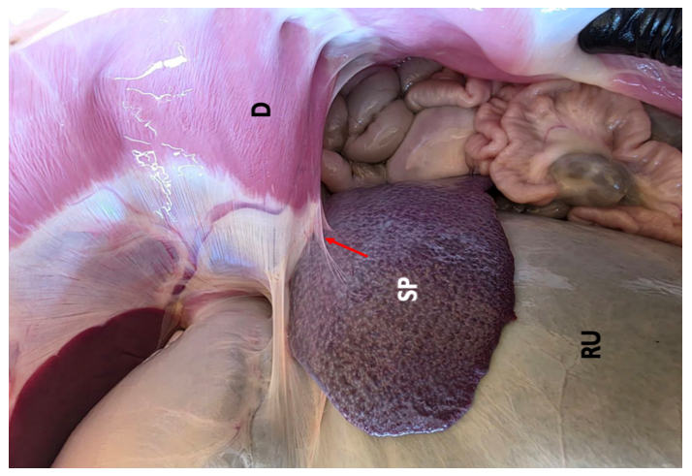
Figure (1) spleen in postnatal stage location in abdominal cavity show rumen (RU) and relationship with diaphragm(D) by phrenicosplenic ligament (red arrow).

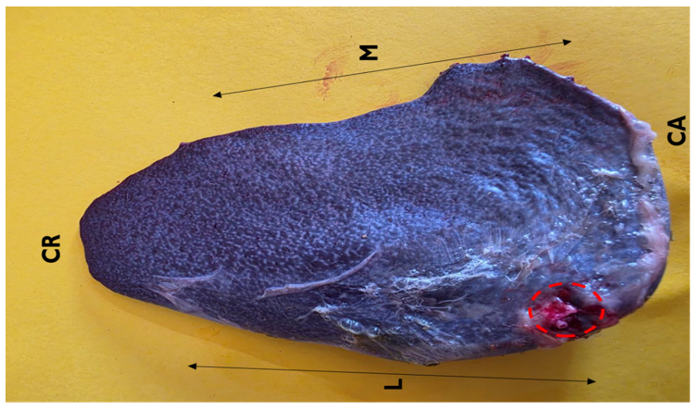
Figure (2) spleen in postnatal stage, visceral surface explains the hilus (red arrow), cranial extremity (CR), caudal extremity (CA), lateral border (L) and medial border (M).
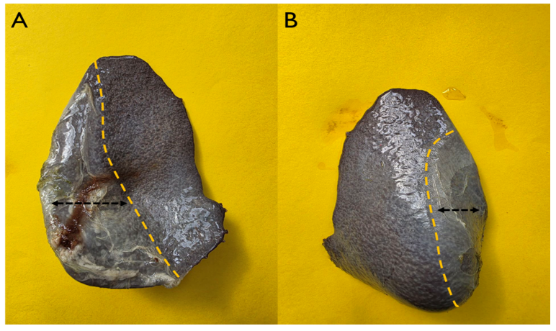
Figure (3) show spleen in postnatal stage (A) Visceral surface had a part attached to the rumen (black arrow), (B) parietal surface had a part attached to diaphragm (black arrow).

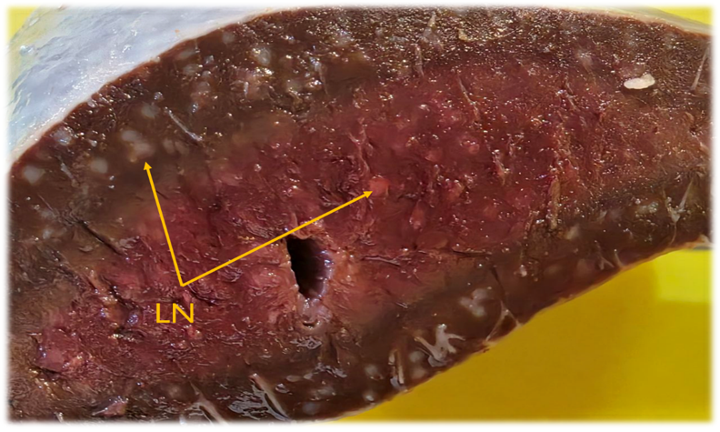
Figure (4) cross section of spleen in postnatal stage show lymphoid nodules (LN).

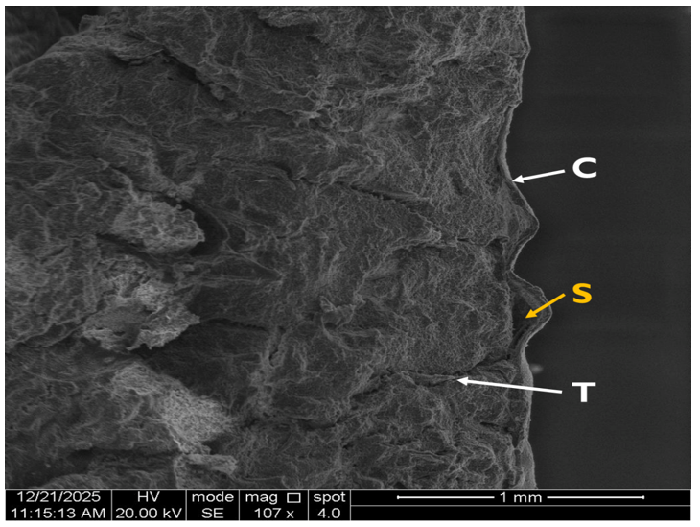
Figure (5) scanning electron microscope of spleen at 2-3 months postnatally (lambs) showing: capsule (C), sub capsular sinus (S), splenic trabeculae (T).

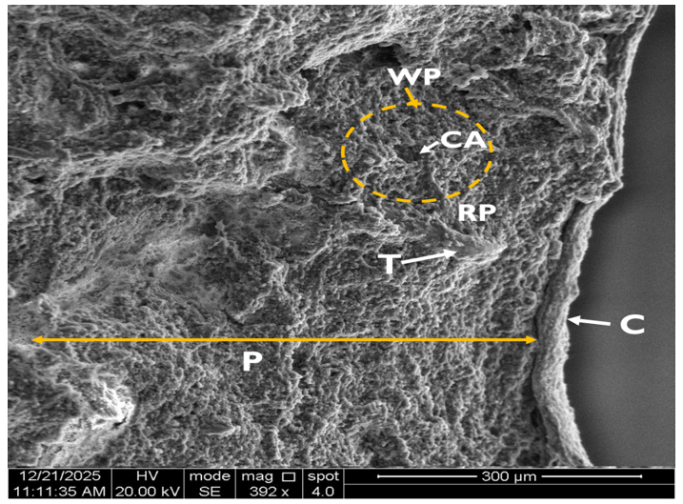
Figure (6 )scanning electron microscope at 2-3 months postnatally (lamb) showing thick layer of capsule(C), trabeculae(T), parenchyma(P), red pulp (RP) and white pulp (WP) with central artery (CA).
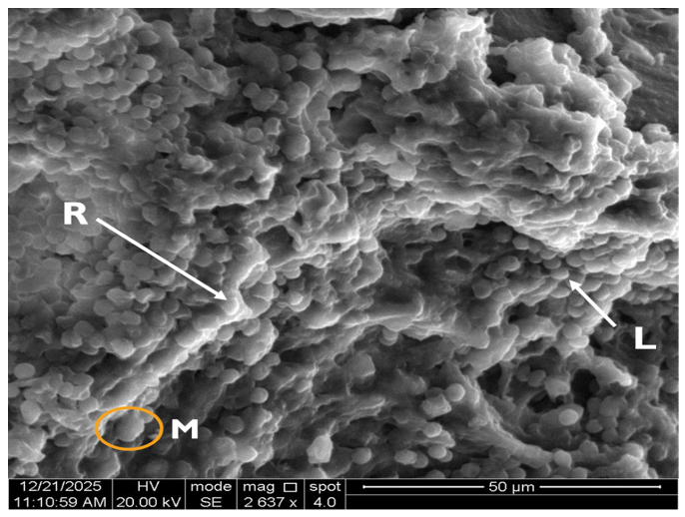
Figure (7) Scanning electron microscope of spleen parenchyma of 2-3 month in lamb showing different size of Lymphocytes (L), large macrophage (M)with distributed of Reticular cell, (R) using high magnification.

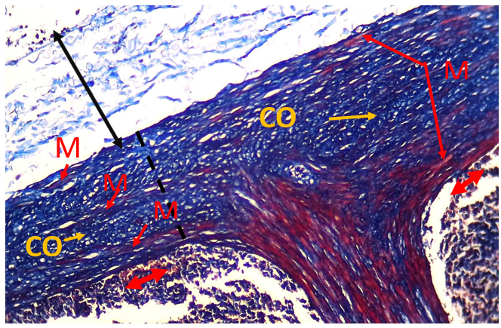

Figure( 8) cross histological section of spleen at postnatal stage explain the outer layer (solid line) and the inner layer of splenic capsule (Dashed line) has connective tissue fiber (CO) with smooth muscle fiber (M) subcapsular sinuses (red arrow). (Masson trichome stain ,10X)

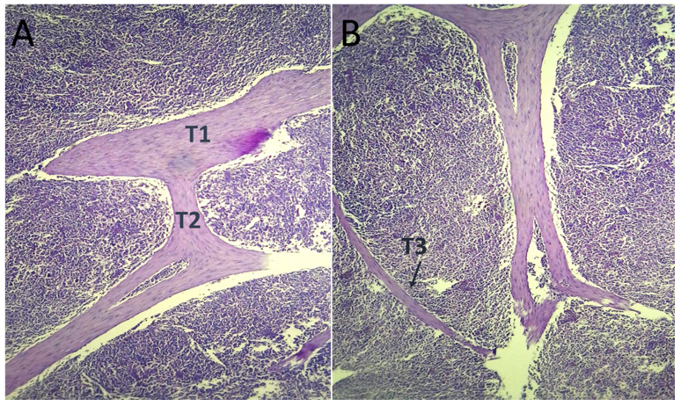
Figures( 9) cross histological section of spleen show the trabeculae in postnatal stage: A/ shows the primary (T1) and secondary trabecula(T2), B /shows the tertiary trabeculae(T3). (PAS stain, 4X).

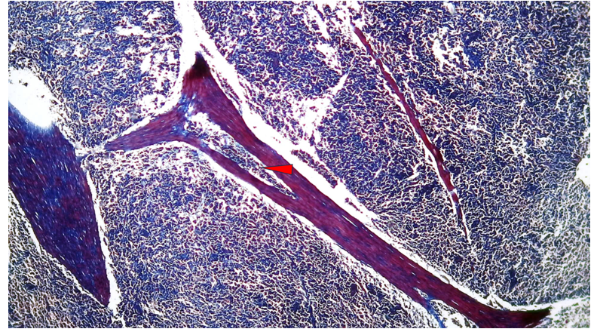
Figure( 10) cross histological section of spleen at postnatal stage explain the vascular trabeculae (red arrow) (Masson trichome stain: 4X)

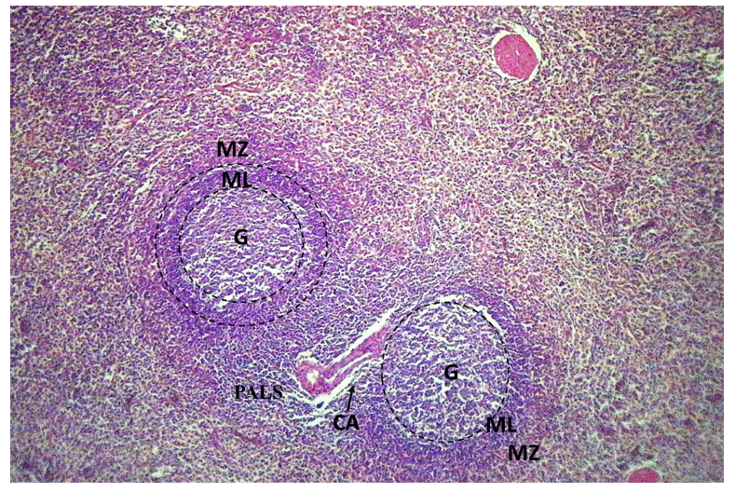
Figure (11) spleen in postnatal stage show white pulp: germinal center (G), mantle layer (ML), marginal zone (MZ) and periarteriolar lymphoid sheath (PALS) with central artery (CA) (H&E stain ,4X)

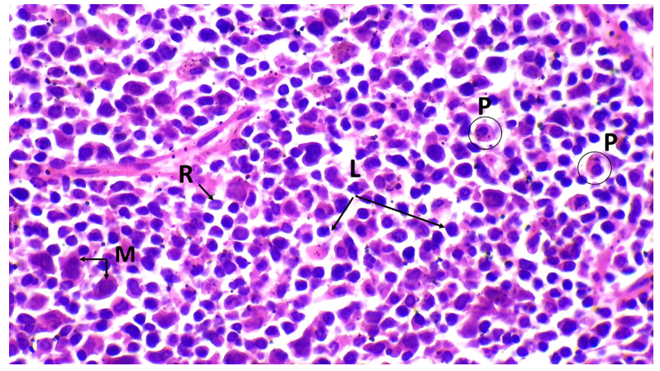
Figure (12 A) cross histological section of spleen at postnatal stage explain the cellular composition of germinal center, show lymphocytes(L), macrophages(M) and reticular cells(R). (H&E stain ,40X)

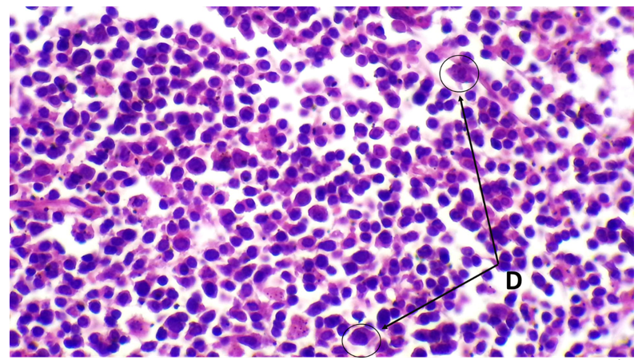
Figure (12 B) cross histological section of spleen at postnatal stage explain the cellular composition of germinal center: dendritic cell (D).(H&E stain ,40X)

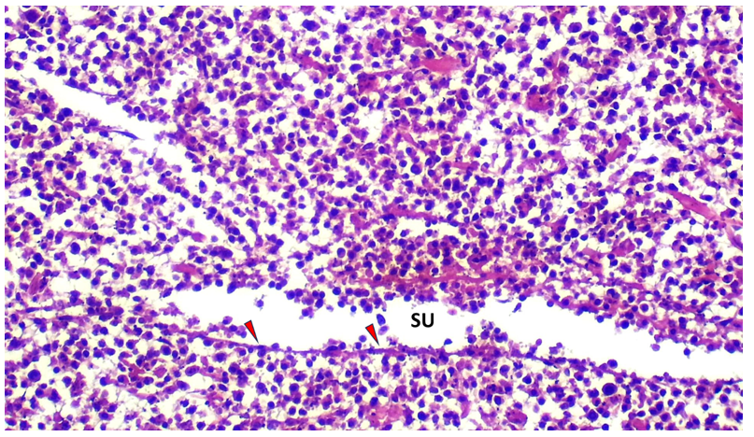
Figure( 13) cross histological section of spleen at postnatal stage explain the sinusoids of red pulp (SU) are lined by flattened endothelial cells (red arrow). (H&E stain ,20X)

Table 1. Morphometric and Histomorphometric Parameters of the Spleen During Postnatal Development in Lambs (Mean ± SD)
Postnatal Stage | Body Weight (g) | Spleen Weight (g) | Spleen Length (mm) | Spleen Width (mm) | Spleen  Thickness (mm) | Spleen Volume (cm³) | Capsule Thickness (µm) | Trabeculae Thickness (µm)
2–3 Months | 13990 ± 265ᴰ | 126 ± 4.43ᴰ | 129 ± 2.19ᴰ | 77 ± 2.6ᴰ | 40.4 ± 1.8ᴰ | 100 ± 4.4ᴰ | 43.2 ± 0.7ᴰ | 51.46 ± 1.1ᴰ
Different superscript letters within the same column indicate significant differences at P < 0.05 according to Tukey’s multiple comparison test.

Conclusions
The postnatal spleen plays a crucial role in the immune system during early life. The spleen in postnatal Awassi sheep shows clear morphological differentiation, with a well-defined structure that reflects its functional maturation after birth. Histological observations revealed distinct stroma and parenchyma regions, where the first portion composed of capsule and trabeculae while the second one composed of white and red splenic pulp. The scanning electron microscope observations spleen exhibited a highly organized and mature surface architecture, thick fibrous capsule surrounding the development organs and the trabeculae. fully develop of splenic pulp. Progressive structural changes were observed with increasing postnatal age, indicating gradual splenic involution.

COMPETING INTERESTS DISCLAIMER:
Authors have declared that they have no known competing financial interests OR non-financial interests OR personal relationships that could have appeared to influence the work reported in this paper.

References
Armbrust, L. (2009). The spleen. In BSAVA Manual of Canine and Feline Abdominal Imaging (pp. 167-176). BSAVA Library.‏
Aughey, E., & Frye, F. L. (2001). Comparative veterinary histology with clinical correlates. CRC Press.‏
Balasundaram, K., Sivagnanam, S., & Paramasivan, S. (2021). Scanning Electron Microscopic Study of the White Pulp of Spleen in Adult Goats. Indian Journal of Animal Research, 55(9).‏
Bancroft, J.D., Suvarna, K.S. and Layton, C. (2018). Bancroft’s theory and practice of histological techniques. 8th ed. London: Elsevier Health Sciences
Cesta, M. F. (2006). Normal structure, function, and histology of the spleen. Toxicologic Pathology, 34, 455–465.
Das SK, Alam MS, Islam MN, Awal MA (2005). Histology of the spleen of indigenous dog (Canis familiaris) of Bangladesh. Bangl J Vet Med, 3 (1), 59-61.
Elhussieny, O., Abdelaziz, M., & Khalifa, E. (2022). New insights into the splenic stroma of the Barki sheep: a histological, immunohistochemical, ultrastructural and morphometrical study. Matrouh Journal of Veterinary Medicine, 2(1), 1-8.
Gnanadevi R, Senthilkumar S, Ta K, Ramesh G (2019). Comparative histoarchitectural study of splenic components in sheep and goat. Int J Curr Microbiol App Sci, 8 (5), 1387-1394.
Jaji, A. Z., Saidu, A. S., Mahre, M. B., Yawulda, M. P., Girgiri, I. A., Tomar, P., & Da'u, F. (2019). Morphology, morphometry and histogenesis of the prenatal dromedary (Camelus dromedarius) spleen. Macedonian Veterinary Review, 42(2).‏
Khalel, E. M. (2010). Anatomical and histological study of the spleen in Iraqi Sheep (Awasi sheep). Bas. J. Vet. Res. Vol. 10, No.2: 163 – 171
Mehta, S., Deshmuhk, S. K., Minj, A. P., Kumar, K., Kumari, L., & Shahi, J. K. (2016). Gross morphometrical postnatal developmental studies on spleen of Chotanagpuri sheep (Capra ovis). Veterinary Science Research Journal, 7(2), 83-86.‏
Mirhish, S. M. (2017). Histomorphological study of the spleen in indigenous Gazelle (Gazella subgutturosa): MH Abed Muslih and SM Mirhish. The Iraqi Journal of Veterinary Medicine, 41(2), 100-105.‏
Rahmoun DE, Fares MA, Hafiane M, Khaoula M and Lieshchova M (2020) Morpho-histological study of spleen ontogenesis in lambs during antenatal and posnatal period. J. Anim. Feed Res. 10: 12-16.
Schmidt, E.E., MacDonald, I.C., Groom, A.C. (1993). Comparative aspects of splenic microcirculatory pathways in mammals: the region bordering the white pulp. Scanning Microscopy. 7: 613-28.
Sembulingam, K., & Sembulingam, P. (2012). Essentials of medical physiology (6th ed.). New Delhi: Jaypee Brothers Medical Publishers.
Shringi N, Mathur R, Kumar V, Rohlan K and Ganguly S (2018) Histological studies on the spleen of large white Yorkshire Pig (Sus scrofa). J. Entomo. Zool. Stud. 6: 1142-1144.
Suri, S., Sasan, J. S., Sarma, K., & Chakraborty, D. (2017). Comparative gross and histomorphological studies on the spleen of sheep and goat of Jammu region of India. Explor. Anim. Med. Res, 7(2), 179-183.‏
Thanvi, P. K. (2021). Gross Morphological Peculiarities of Spleen of Sheep (Ovis aries). Indian Journal of Veterinary Anatomy, 33(2).‏
Thanvi, P. K., Joshi, S., & Singh, D. (2020). Histomorphological studies on spleen of sheep (Ovis aries). Veterinary Practitioner, 21(1).‏

