Case report

CLINICO-PATHOLOGICAL CHARACTERIZATION OF CUTANEOUS GIANT-CELL SARCOMA OF SOFT TISSUE (GCT-ST) IN A PERSIAN CAT

ABSTRACT
This study aimed to characterize the clinical signs, cytological and pathomorphological aspects of a rare case of Giant Cell tumour of soft tissue (GCT-ST) in a 6 years old male Persian cat presented to Veterinary Clinical Complex, Veterinary College and Research Institute, Orathanadu, with the history of hair loss, continuous itching and multiple raised skin lesions all over the body. On clinical examination, generalized alopecia and erythematic elevated skin lumps (≥3cm diameter) were present in right lateral thorax, limbs and left inguinal regions. Haematology revealed anaemia and eosinophilic leucocytosis. Serum biochemistry showed all parameters within normal range. Ultrasonography of abdomen was normal with no impression of metastasis. Cytological analysis revealed high cellularity of pleomorphic multinucleated tumour giant cells that possessed more than 10 nuclei per cell, oval to round shaped nuclei, large prominent nucleoli and tapering cytoplasm that were admixed with numerous neutrophils, lymphocytes and few spindled fibroblasts in the eosinophilic extracellular matrix indicative of reactive inflammation. Histopathologically, it was characterized by presence of numerous large multinucleated giant cells with pleomorphic multiple nuclei arranged in botryose or rosette-like formations among spindle shaped cells. Hence, the case was diagnosed as Giant Cell Sarcoma of Soft Tissue (GCT-ST), which is a rare entity in animals and should be considered in the differential diagnosis of aspirates containing osteoclast-like giant cells.
KEYWORDS: Giant cell tumour, osteoclast-like giant cells, fibro-histiocytic tumour, Sarcoma, Cat
INTRODUCTION
Giant cell tumour of soft tissue (GCT-ST) is an uncommon mesenchymal neoplasm first recognized as bone-derived giant cell tumours based on its occurrence in extra-osseous soft tissues and unique histomorphological characteristics. Recent human pathological reviews describe GCT-ST as a distinct soft tissue neoplasm that, although histologically similar to giant cell tumours of bone represents a separate clinicopathological category among fibro-histiocytic soft tissue tumours (Mavrogenis et al., 2019). In human clinical pathology, GCT-ST typically presents as a painless, slowly enlarging mass located in superficial or deep soft tissues, most commonly involving the extremities and trunk. Histologically, these tumours characteristically consist of a mixture of mononuclear stromal cells and numerous osteoclast-like multinucleated giant cells uniformly distributed throughout the lesion (Wakely, 2022). Such features help distinguish GCT-ST from other soft tissue lesions that contain giant cells, including tenosynovial giant cell tumours and pleomorphic sarcomas with giant cell components. In contrast to the human literature, comprehensive veterinary documentation of true GCT-ST is lacking. Reported giant cell–rich soft tissue tumours in animals, including cats are typically classified under broad categories such as soft-tissue sarcomas with giant cell components or pleomorphic fibro histiocytic tumours rather than a specific GCT-ST designation. Historical reports of giant cell tumours of soft tissue in veterinary species pre-date modern immunohistochemical and molecular classification criteria, making it challenging to directly compare them with defined human GCT-ST cases. Nonetheless, isolated reports of giant cell tumour presentations in diverse anatomical sites in human patients underscore the morphological consistency of GCT-ST across different soft tissues (Novrial and Yamsun, 2022). The present report describes the clinical presentation, cytological findings, and histopathological features of an unusual cutaneous giant cell tumour of soft tissue in a Persian cat.
CASE PRESENTATION
A 6-year-old male Persian cat was referred to the Veterinary Clinical Complex, Veterinary College and Research Institute, Orathanadu, with a history of generalized hair loss, persistent pruritus, and multiple raised cutaneous nodules over the body. On physical examination, alopecia and erythematous elevated skin masses (≥3 cm diameter) were observed on the right lateral thorax, limbs and left inguinal region (Fig. 1). Fine-needle aspiration cytology (FNAC) was performed from representative cutaneous nodules under aseptic precautions for preliminary cytological evaluation. Based on clinical progression and cytological findings suggestive of a neoplastic process, surgical excision of the accessible masses was undertaken under local anaesthesia. The excised tissue samples were fixed in 10% neutral buffered formalin and submitted for histopathological examination.
CLINICAL AND HISTOPATHOLOGICAL FINDINGS
Fine-needle aspirates from skin nodules exhibited high cellularity with numerous multinucleated giant cells containing >10 nuclei per cell, each with oval to round nuclei and prominent nucleoli (Fig. 2). These were intermixed with spindled fibroblasts, neutrophils and lymphocytes against a reactive eosinophilic extracellular matrix suggesting reactive inflammation accompanying neoplastic cells. Histological examination of excised masses revealed a proliferation of fibroblasts and mononuclear cells admixed with abundant large, multinucleated giant cells arranged in rosette-like and botryoid formations (Fig. 3). There was moderate pleomorphism, with marked atypia and high mitotic index. Based on the combined cytological features observed on fine-needle aspiration and the characteristic histomorphological findings on histopathology, the cutaneous masses were diagnosed as a giant cell tumour of soft tissue (GCT-ST).
DISCUSSION
Giant cell tumour of soft tissue (GCT-ST) is a rare primary mesenchymal neoplasm first reported in human in 1972, originally described under umbrella terms such as “giant cell tumour of soft parts”. Subsequent pathological studies clarified that GCT-ST is clinically and histologically distinct from other giant cell-rich lesions and significantly differs from giant cell tumour of bone, despite morphological similarities (Chopra et al., 2020). In modern classification schemes, GCT-ST is considered a soft tissue neoplasm of intermediate malignancy with low metastatic potential but a propensity for local recurrence when excision is incomplete (Mavrogenis et al., 2019). Human GCT-ST typically presents as a slow-growing, painless mass located predominantly in the superficial soft tissues of the extremities, though cases have been documented in atypical sites including the trunk, head and neck, mediastinum and abdomen. Histologically, these tumours comprise numerous osteoclast-like multinucleated giant cells often arranged in nodular or multinodular patterns within a fibrovascular stroma (Nishio et al., 2024). Such histopathological architecture closely resembles giant cell tumour of bone, but the absence of characteristic bone matrix and radiologic features distinguishes GCT-ST as a soft tissue entity. Cytologically, fine-needle aspiration and core biopsy specimens of GCT-ST characteristically demonstrate multinucleated giant cells with bland nuclei interspersed among fibroblast stromal cells. This pattern has been described in rare case reports, and when interpreted alongside clinical context it can support a presumptive diagnosis prior to surgical excision. Reported cases emphasize the value of FNAC in preliminary diagnosis, particularly in distinguishing GCT-ST from other giant cell-rich lesions such as tenosynovial giant cell tumours, malignant fibrous histiocytomas, or giant cell-rich sarcomas (Asotra and Sharma, 2009). While the majority of GCT-ST cases occur in humans, veterinary reports are exceedingly scarce and no comprehensive case series specifically focused on feline cutaneous GCT-ST exist in indexed veterinary literature. A review of human pathology (Oliveira et al., 2000) and isolated case reports in other species like equine (Ford et al., 1975; Bush and Powers, 2008) suggests that soft tissue giant cell tumours may arise in diverse anatomical sites and across a wide age range, but standardized terminology in veterinary pathology remains limited.
Histopathologically, GCT-ST in humans is characterized by uniform osteoclast-like giant cells with atypia and high mitotic activity variable but often moderate (Dobromylskyj, 2022). Unlike high-grade sarcomas, GCT-ST frequently shows significant cellular pleomorphism and atypical mitotic figures. In deep or anatomically unusual sites like retroperitoneum (Kishi et al., 2018) have demonstrated local invasion and larger size, but distant metastasis remains uncommon. In the present feline case, FNAC revealed a high proportion of multinucleated giant cells with numerous nuclei and bland nuclear features, consistent with descriptions in human GCT-ST cytology reports (Mavrogenis et al., 2019). Histopathology, similarly demonstrated multinodular aggregates of mononuclear spindle cells admixed with multinucleated giant cells, having significant pleomorphism and atypia aligning with the high malignant potential phenotype described in human cases (De Cecco and Bianca, 2021). Although feline GCT-ST as a defined entity remains rare, this case demonstrates clinical and morphological alignment with the human condition. The findings support the inclusion of GCT-ST in the differential diagnosis of giant cell-rich cutaneous tumours in cats and underscore the value of integrative cytological and histopathological assessment to distinguish it from other sarcomas with overlapping morphology.

COMPETING INTERESTS DISCLAIMER:
Authors have declared that they have no known competing financial interests OR non-financial interests OR personal relationships that could have appeared to influence the work reported in this paper.

REFERENCES
Asotra, S., & Sharma, S. (2009). Giant cell tumor of soft tissue: Cytological diagnosis of a case. Journal of cytology, 26(1), 33–35. https://doi.org/10.4103/0970-9371.54866
Bush, J. M., & Powers, B. E. (2008). Equine giant cell tumor of soft parts: a series of 21 cases (2000-2007). Journal of veterinary diagnostic investigation : official publication of the American Association of Veterinary Laboratory Diagnosticians, Inc, 20(4), 513–516. https://doi.org/10.1177/104063870802000418
Chopra, A., Kinsella, M., Edwards, S., Smith, I., & Robinson, P. (2020). Giant cell tumour of soft tissue—A rare presentation of a common pathology. BJR | Case Reports, 6(3), 20200012. https://doi.org/10.1259/bjrcr.20200012

De Cecco and Bianca, S. (2021). Feline giant-cell pleomorphic sarcoma: cytologic, histologic and immunohistochemical characterization. Journal of feline medicine and surgery, Vol. 23 (8): 738-744.
Dobromylskyj M. (2022). Feline Soft Tissue Sarcomas: A Review of the Classification and Histological Grading, with Comparison to Human and Canine. Animals (Basel).12 (20) :27-36.
Ford, G. H., Empson, R. N., Jr, Plopper, C. G., & Brown, P. H. (1975). Giant cell tumor of soft parts. A report of an equine and a feline case. Veterinary pathology, 12(5-6), 428–433. https://doi.org/10.1177/0300985875012005-00609
Kishi, S., Monma, H., Hori, H., Kinugasa, S., Fujimoto, M., & Nakamura, T. (2018). First Case Report of a Huge Giant Cell Tumor of Soft Tissue Originating from the Retroperitoneum. The American journal of case reports, 19, 642–650. https://doi.org/10.12659/AJCR.909261
Mavrogenis, A. F., Tsukamoto, S., Antoniadou, T., Righi, A., & Errani, C. (2019). Giant Cell Tumor of Soft Tissue: A Rare Entity. Orthopedics, 42(4), e364–e369. https://doi.org/10.3928/01477447-20190624-04
Nishio, J., Nakayama, S., Koga, K., & Aoki, M. (2024). Giant Cell Tumor of Soft Tissue: An Updated Review. Journal of Clinical Medicine, 13(10), 2870. https://doi.org/10.3390/jcm13102870
Novrial, D., & Yamsun, M. (2022). Primary Giant Cell Tumor of Soft Tissue in The Female Breast. Jurnal Profesi Medika : Jurnal Kedokteran Dan Kesehatan, 16(1). https://doi.org/10.33533/jpm.v16i1.3204
Oliveira, A. M., Dei Tos, A. P., Fletcher, C. D., & Nascimento, A. G. (2000). Primary giant cell tumor of soft tissues: a study of 22 cases. The American journal of surgical pathology, 24(2), 248–256. https://doi.org/10.1097/00000478-200002000-00011
Wakely P. E., Jr (2022). Giant cell tumor of soft tissue: FNA cytopathology of 4 cases, review of the literature, and comparison with giant cell tumor of bone. Cancer cytopathology, 130(2), 120–127. https://doi.org/10.1002/cncy.22517

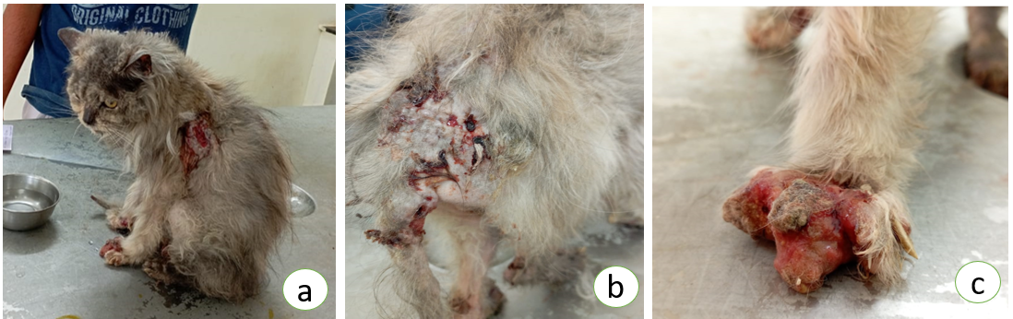
Fig. 1. Clinical presentation of Persian cat: (a) generalized alopecia with prominent ulcerative lesion over the shoulder region, (b) ulcerated, erythematous, elevated nodular skin mass with crusting and exudation, (c) severe proliferative and ulcerative lesion involving the distal limb with erythema and ulceration.
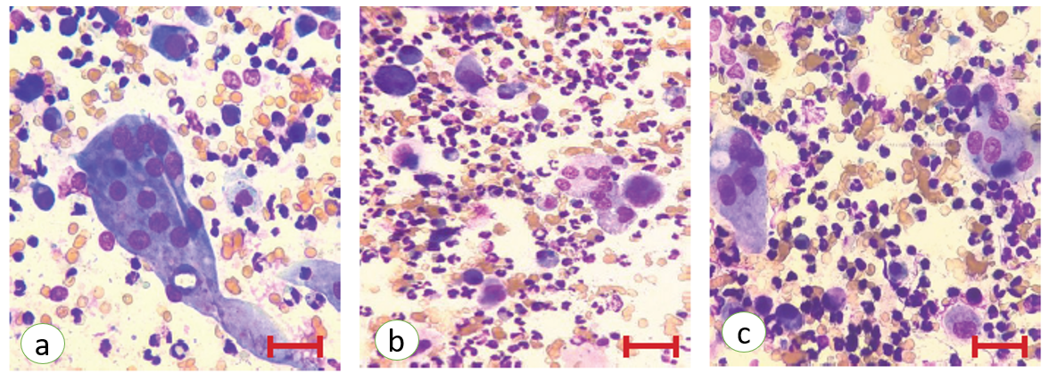
Fig. 2. Fine needle aspiration cytology (FNAC) smear from the skin lesions showing multiple pleomorphic multinucleated giant cells with tapering cytoplasm; Wright–Giemsa stain (×1000)
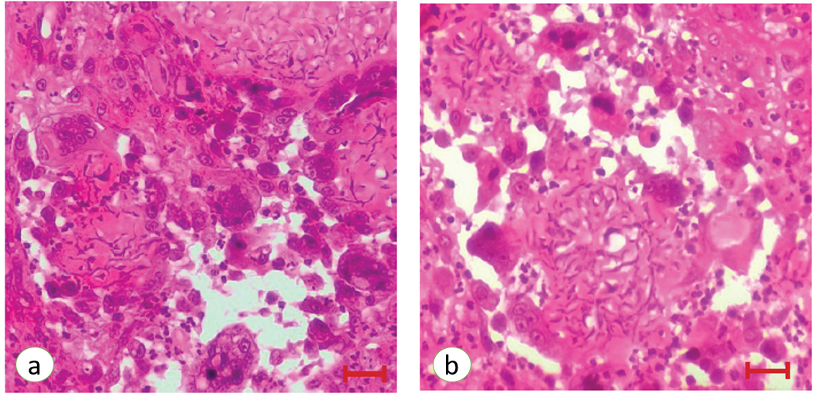
Fig. 3. Histopathology of skin mass in a cat (a & b): well-circumscribed, multinodular sheets of numerous large multinucleated giant cells with pleomorphic nuclei arranged in botryoid (botryose) and rosette-like formations. H&E (×400)

