Original Research Article
Assessment of Dragonfly Diversity in Relation to Conservation Roles of Sacred groves of Bankura District, West Bengal, India

ABSTRACT
Aim: Sacred grove represents one of the age-old community linked conservation traditions, in which ecological protection has been historically maintained through belief systems, ritual practices, and social restrictions on resource use. The study tries to capture the conservation role of the sacred grove through organism diversity, using dragonflies as an indicator group.
Study design: To evaluate the conservation role of sacred groves, sampled sacred groves are compared with equivalent non-sacred control sites that are approximately similar in atmospheric conditions.
Place and duration of the study: The study was conducted from April 2024 to March 2025 in 6 sacred groves and 6 associated control sites in six administrative blocks of Bankura district.
Methodology: Species were documented through transect-walk following the line-transect principles. To compare biodiversity between the sacred grove and control sites, the Shannon–Wiener diversity index, evenness index, and Berger–Parker dominance index were calculated. To compare species richness between sacred groves and control sites, the study used rarefaction analysis.
Result: The study recorded 25 dragonfly species. Among these 25 species, 18 were found in both sacred and control sites, 6 were found exclusively in sacred groves, and 1 was found exclusively on control sites. Diversity indices indicate that sacred groves support more dragonfly species than control sites, a finding supported by the rarefaction curve.
Conclusion: This shows that sacred areas are more diverse in dragonfly species and provide a steady supply of food and shelter.
Keywords: Sacred grove, Conservation, Biodiversity, Dragonfly, Bankura district.

1. INTRODUCTION
Sacred groves are small patches of vegetation protected by local communities through religious belief, traditional rules, and age-old social practices. In India, sacred groves are widely recognised as biocultural areas where protection is linked to faith, ritualistic practices, and a shared commitment to conserve resources (Sharma & Kumar, 2021; Devi Khumbongmayum et al., 2005; Singh et al., 2017). Many of the sacred groves persist outside the formal protected area network. They serve as locally maintained areas for native biodiversity and also preserve cultural tradition and traditional ecological knowledge (Sharma & Kumar, 2021; Devi Khumbongmayum et al., 2005). The conservation value of the sacred grove has been discussed in relation to vegetation cover, habitat protection, soil and water conservation, and the persistence of rare, threatened, endemic, and useful species in many literatures (Sharma & Kumar, 2021; Devi Khumbongmayum et al., 2005). Sacred groves are important because they are among the last remaining natural areas in rural regions. It shows how a community can work together to protect nature (Sharma & Kumar, 2021; Singh et al., 2017). Studies show that different sacred sites protect different types of animals and plants. As a result, one needs to study each site individually to understand its true value (Avtzis et al., 2018).
Among faunal groups, dragonflies are especially useful for biodiversity assessment because they are indicators of water-related habitats (Clausnitzer et al., 2017). In West Bengal, and particularly in Bankura district, earlier studies have documented the presence of sacred groves and highlighted their floristic, ethnobotanical, and conservation importance (Mitra et al., 2015; Nayak et al., 2018). These studies make it clear that the sacred groves of this region retain biological and cultural significance, but they also indicate that many of them are insufficiently studied from a faunal and community-ecological perspective (Mitra et al., 2015; Nayak et al., 2018). In that context, dragonfly community diversity can signify whether a sacred grove supports richer and more stable communities of a particular taxon than nearby non-sacred habitats, thereby proving their role in conservation (Avtzis et al., 2018; Mitra et al., 2015; Nayak et al., 2018).
In the present study, dragonfly diversity of selected sacred groves and control sites was analysed and compared to evaluate the conservation role of sacred groves.
2. MATERIALS AND METHODS
The study was conducted from April 2024 to March 2025 in 6 administrative blocks of Bankura district (Figure 1). 6 sacred groves were selected along with their associated 6 control sites. These sites were selected for their long-standing traditional culture, maintenance, and community involvement. This, in turn, made them mostly ideal candidates for biodiversity studies. A nearby waterbody is associated with most of the sites. The association of water bodies are essential for dragonfly findings. Every site was visited 3 times. The survey time usually falls between 7:00 am and 10:00 am, and sometimes between 3:30 pm and 4:45 pm. The biodiversity assessment compared the species and numbers present in the sacred grove with those in its non-sacred control areas. Species were documented primarily through transect-walk surveys (Pollard, 1977) based on established line-transect principles (Emlen, 1971; Buckland et al., 2001).

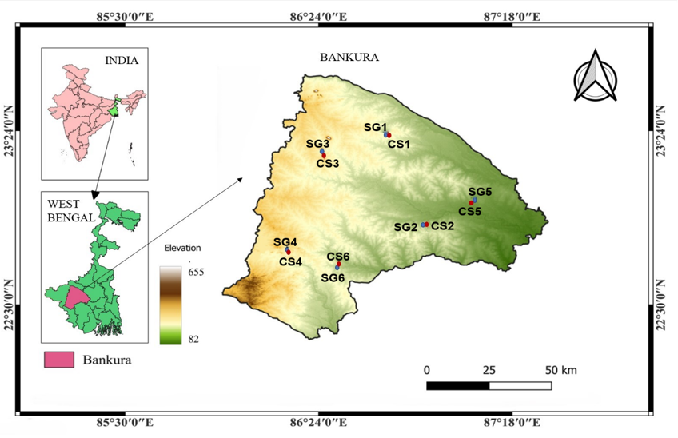

Fig. 1. Location map of the study area (Bankura district), West Bengal, India, showing district-level topography (elevation range: 82–655 m above mean sea level) and geographic position [SG: Sacred Groves (blue), CS: Control Sites (red)].
Species identification was based on field observation, photographs, and cross-checking with and taxonomic references (Subramanian, 2005). High-resolution photographs were taken whenever possible to support accurate identification and later verification during post-field review. To measure the conservation value of these sacred groves, each one was paired with a nearby control site in the same block. These 6 control sites were non-sacred habitats with similar environmental conditions (Table 1, Figure 2).
Table 1. Six sampled sacred groves and associated six control sites of Bankura District (SG: Sacred Groves; CS: Control Sites)
Block | Site | Code | Area (m²) | Location
Barjora | Khanrari Burial Grove | SG1 | 7371.73 | 23°22'42.8"N 87°14'17.2"E
Barjora | Control site 1 | CS1 | 2891.31 | 23°22'55.8"N 87°14'58.5"E
Bishnupur | Shiromanipur Bhairab Than | SG2 | 2152.52 | 23°03'06.9"N 87°21'02.9"E
Bishnupur | Control site 2 | CS2 | 1119.39 | 23°03'02.3"N 87°21'18.8"E
Chhatna | Hausibad Gram Than | SG3 | 3963.99 | 23°21'28.5"N 86°57'44.9"E
Chhatna | Control site 3 | CS3 | 2420.14 | 23°21'26.0"N 86°57'50.8"E
Khatra | Kubasol Village Grove | SG4 | 6172.29 | 23°01'40.7"N 86°51'06.3"E
Khatra | Control site 4 | CS4 | 4618.61 | 23°01'20.2"N 86°51'06.7"E
Patrasayer | Patit Dommahal Bhairab Than | SG5 | 1239.00 | 23°09'42.6"N 87°33'46.8"E
Patrasayer | Control site 5 | CS5 | 992.64 | 23°13'42.5"N 87°31'57.2"E
Simlapal | Harintuli Goram Than | SG6 | 476.33 | 22°52'46.5"N 87°02'31.3"E
Simlapal | Control site 6 | CS6 | 638.34 | 22°52’48.5”N 87°02’27.1”E
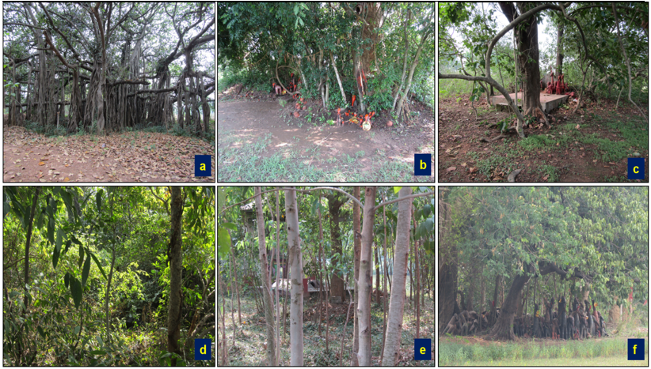

Fig.2. Six sampled sacred groves of Bankura district. [a: Khanrari burial grove (SG1); b: Shiromanipur Bhairab Than (SG2); c: Hausibad Gram Than (SG3); d: Kubasol Village Grove (SG4); e: Patit Dommahal Bhairab Than (SG5); & f: Harintuli Goram Than (SG6)]
Data analysis was done to assess biodiversity patterns in SGs and their corresponding non-sacred control sites. To compare and assess biodiversity between the sacred grove and control sites, three diversity indices were calculated, viz. the Shannon-Wiener diversity index, evenness Index, and Berger-Parker dominance Index. These indices collectively reflect species richness, relative abundance, and dominance, facilitating an assessment of community organisation.
2.1 Shannon–Wiener Diversity Index (H′)
The Shannon–Wiener diversity Index, initially developed in information theory and later applied in ecology by Shannon and Weaver, quantifies overall species diversity by accounting for both species richness and relative abundance.
$$H'=\sum_{i=1}^{S}{p_{i} ln p_{i}}​$$
where: H′ = Shannon–Wiener diversity index; S = total number of species; $p_{i}$ = proportion of individuals belonging to the i^{th} species; and ln = natural logarithm. Higher values of H′ indicate greater species diversity and community complexity, whereas lower values reflect species dominance, reduced richness, or ecological stress.

2.2 Pielou’s evenness index (J)
Pielou’s evenness index (J) measures how close each species is in numbers in a given environment. It is going by the following formula:
$$J = H’/H_{max}$$
$$[H_{max}= ln(S)]$$
Where H’ is the number derived from the Shannon diversity index, and $Hmax$is the maximum possible value of H’. S is the number of species recorded. Evenness values approaching 1 indicate similar abundances among species, while lower values reflect uneven distribution and dominance patterns often associated with disturbance (Magurran, 2004).
2.3 Berger–Parker Dominance Index
The Berger–Parker Dominance Index was employed to assess the proportional dominance of the most abundant species in a community (Berger & Parker, 1970).
$$\text{D=}N_{max}\text{/N}$$
where: D = Berger–Parker dominance index; $N_{max}$ = number of individuals of the most abundant species; N = total number of individuals recorded
It measures how equally individuals are distributed across species. Values close to 1 indicate species have similar abundances, while lower values indicate uneven distribution or disturbance.
2.4 Rarefaction Analysis
To compare species richness between SGs and control sites under equivalent sampling effort, the study used rarefaction following Sanders and the Hurlbert standardisation framework to generate rarefaction curves. Rarefaction is useful here because it adjusts richness comparisons for differences in sample size, allowing site-wise and taxon-wise comparisons on a more comparable basis. In interpreting the curves, both shape and the tendency toward an asymptote were considered to assess relative richness and whether sampling effort was approaching adequacy. In general, curves that remain higher and remain clearly separated across the sampling range indicate greater expected richness under comparable effort (Gotelli & Colwell, 2001).
3. RESULTS AND DISCUSSION
3.1 Dragonfly diversity
A total of 25 dragonfly species belonging to 2 families were recorded in the present study. Among them, 22 species belonged to Libellulidae and 3 species belonged to Gomphidae (Table 2). Among these 25 species, 18 were found in both sacred and control sites, 6 were found exclusively in sacred groves, and 1 was found exclusively on control sites. Most of the recorded species were under the Least Concern category, while Macrogomphus annulatus was listed as Data Deficient. Libellulidae was the dominant family in the present study, with a much higher number of species than Gomphidae. This indicates that the dragonfly in the sample was mainly composed of the Libellulidae family (Figure 3). Among the sacred groves, SG1 (Khanrari Burial Grove) recorded the highest species richness, with 18 species. SG4 (Kubasol Village Grove) also showed comparatively high richness with 17 species, followed by SG3 and SG6 with 14 species each. SG2 supported 13 species. In contrast, lower richness was noted in SG5 (Patit Dommahal Bhairab Than), which supported 9 species. At the control sites, the highest richness was recorded in CS4 (12 species), followed by CS1 and CS6 (11 species each), whereas CS5 showed the lowest richness (7 species; Table 3).

Fig. 3. Family wise distribution of dragonflies in six sampled sacred groves and six associated control sites in Bankura district.
Even where the control sites supported common dragonfly species, the overall species pool remained narrower than that of the paired sacred groves. Overall, this pattern indicates that sacred groves supported a broader dragonfly assemblage than the control sites. Thus, sacred groves appear to act as small but important habitats for local dragonfly diversity in the Bankura district. Some dragonflies of sacred and control sites are displayed in Figure 4. At the site level, dragonfly richness in sacred groves ranged from 9 to 18 species, whereas in the control sites it ranged from 7 to 12 species. 6 of the 25 species are reported only from sacred groves. The number of individuals in sacred groves ranged from 30 to 61, while in the control sites it ranged from 22 to 33. In general, the results suggest higher dragonfly richness and abundance in sacred groves than in control sites.
Table 2. Name of the dragonflies that were observed in the sampled sacred groves and control sites in Bankura District.
Family: LIBELLULIDAE
Sl. No. | Scientific Name | Common Name | IUCN Status
1 | Brachydiplax chalybea (Brauer, 1868) | Rufous-backed Marsh Hawk | Least Concern
2 | Brachydiplax sobrina (Rambur, 1842) | Blue Marsh Hawk | Least Concern
3 | Brachythemis contaminata (Fabricius, 1793) | Ditch Jewel | Least Concern
4 | Crocothemis erythraea (Brullé, 1832) | Broad Scarlet | Least Concern
5 | Diplacodes trivialis (Rambur, 1842) | Chalky Percher / Ground Skimmer | Least Concern
6 | Cratilla lineata (Schneider, 1845) | Emerald-banded Skimmer | Least Concern
7 | Crocothemis servilia (Drury, 1770) | Scarlet Skimmer | Least Concern
8 | Neurothemis fulvia (Drury, 1773) | Fulvous Forest Skimmer | Least Concern
9 | Tholymis tillarga (Fabricius, 1798) | Coral-tailed Cloudwing | Least Concern
10 | Orthetrum migratum (Selys, 1878) | Rosy Skimmer | Least Concern
11 | Neurothemis tullia (Drury, 1773) | Pied Paddy Skimmer | Least Concern
12 | Potamarcha congener (Rambur, 1842) | Yellow-tailed Ashy Skimmer | Least Concern
13 | Rhodothemis rufa (Rambur, 1842) | Common Redbolt | Least Concern
14 | Rhyothemis variegata (Linnaeus, 1763) | Common Picture Wing | Least Concern
15 | Aethriamanta brevipennis (Rambur, 1842) | Scarlet Marsh Hawk | Least Concern
16 | Orthetrum sabina (Drury, 1770) | Slender Skimmer | Least Concern
17 | Orthetrum luzonicum (Brauer, 1868) | Tricolored Marsh Hawk | Least Concern
18 | Trithemis aurora (Burmeister, 1839) | Crimson Marsh Glider | Least Concern
19 | Lathrecista asiatica (Fabricius, 1798) | Asian blood tail | Least Concern
20 | Macrodiplax cora (Brauer, 1867) | Coastal glider | Least Concern
21 | Pantala flavescens (Fabricius, 1798) | Globe skimmer | Least Concern
22 | Tramea limbata (Desjardins, 1832) | Black marsh trotter | Least Concern
Family: GOMPHIDAE
23 | Gomphus vulgatissimus (Linnaeus, 1758) | Common Clubtail | Least Concern
24 | Macrogomphus annulatus (Selys,1854) | Keiser's forktail | Data Deficient
25 | Paragomphus lineatus (Selys, 1850) | Lined hooktail | Least Concern

Table 3. Site-wise dragonfly distribution from 6 sacred groves and 6 control sites in Bankura district (SG: sacred grove; CS: control site)
Block | Site | Code | Area (m²) | No. of species | No. of individuals
Barjora | Khanrari Burial Grove | SG1 | 7029.33 | 18 | 61
Barjora | Control site 1 | CS1 | 2891.31 | 11 | 29
Bishnupur | Shiromanipur Bhairab Than | SG2 | 2152.52 | 13 | 31
Bishnupur | Control site 2 | CS2 | 1119.39 | 9 | 22
Chhatna | Hausibad Gram Than | SG3 | 3544.34 | 14 | 50
Chhatna | Control site 3 | CS3 | 2420.14 | 10 | 29
Khatra | Kubasol Village Grove | SG4 | 3037.86 | 17 | 55
Khatra | Control site 4 | CS4 | 4618.61 | 12 | 33
Patrasayer | Patit Dommahal Bhairab Than | SG5 | 1239.00 | 9 | 31
Patrasayer | Control site 5 | CS5 | 992.64 | 7 | 22
Simlapal | Harintuli Goram Than | SG6 | 476.33 | 14 | 30
Simlapal | Control site 6 | CS6 | 638.34 | 11 | 24
3.2 Assessment of dragonfly diversity, richness, evenness, dominance and butterfly accumulation in selected sacred grove and control sites
In the present study, species richness, Shannon diversity, Pielou’s evenness, and Berger–Parker dominance were used to compare dragonfly community structure between sacred groves and control sites (Tables 4 & 5). Dragonflies recorded from 6 sacred groves and 6 control sites were analysed using these diversity indices. Mean species richness also remained higher in sacred groves (14.17 ± 3.19) than in control sites (10.00 ± 1.79). Shannon diversity was clearly higher in sacred groves (2.470 ± 0.276) than in control sites (2.173 ± 0.221), indicating a more diverse dragonfly assemblage in sacred groves. Evenness values were slightly lower in sacred groves (0.939 ± 0.024) than in control sites (0.949 ± 0.020), suggesting a comparatively more even distribution of individuals among species in the control habitats. In contrast, Berger–Parker dominance was lower in sacred groves (0.174 ± 0.092) than in control sites (0.209 ± 0.072), which indicates that dragonfly assemblages in control sites were more strongly dominated by a few common species. At the site level, the highest Shannon diversity among sacred groves was recorded in SG1 (2.800), followed by SG4 (2.646), whereas the lowest was recorded in SG5 (1.979). Among the control sites, the highest Shannon diversity was observed in CS4 (2.399), while the lowest was in CS5 (1.794). Overall, the diversity indices indicate that sacred groves supported richer, more diverse, and less dominance-driven dragonfly assemblages than the paired control sites.
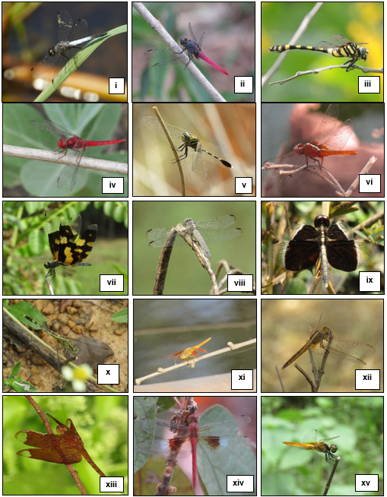

Fig. 4. Some of the dragonflies recorded from 6 sacred groves and from 6 control sites in Bankura district. i. Brachydiplax chalybea, ii. migratum, iii. Gomphus vulgatissimus, iv. Crocothemis servilia v. Orthetrum sabina vi. Rhodothemis rufa vii. Rhyothemis variegate viii. Orthetrum luzonicum ix. Neurothemis tullia x. Orthetrum Diplacodes trivialis xi. Brachythemis contaminate (male) xii. Brachythemis contaminate, xiii. Neurothemis fulvia, xiv. Tholymis tillarga, xv. Aethriamanta brevipennis
Table 4. Site-wise dragonfly diversity indices in sampled sacred grove and associated control sites (SG: sacred grove; CS: control site)
Site code | Individuals (N) | Species richness (S) | Shannon diversity (H') | Evenness (J') | Berger-Parker dominance (d)
SG1 | 61 | 18 | 2.800 | 0.969 | 0.098
CS1 | 29 | 11 | 2.273 | 0.948 | 0.207
SG2 | 31 | 13 | 2.453 | 0.956 | 0.161
CS2 | 22 | 9 | 2.035 | 0.926 | 0.273
SG3 | 50 | 14 | 2.493 | 0.945 | 0.120
CS3 | 29 | 10 | 2.232 | 0.969 | 0.138
SG4 | 55 | 17 | 2.646 | 0.934 | 0.145
CS4 | 33 | 12 | 2.399 | 0.966 | 0.152
SG5 | 31 | 9 | 1.979 | 0.901 | 0.355
CS5 | 22 | 7 | 1.794 | 0.922 | 0.318
SG6 | 30 | 14 | 2.451 | 0.929 | 0.167
CS6 | 24 | 11 | 2.304 | 0.961 | 0.167

Table 5. Mean ± SD of butterfly diversity indices in sampled sacred grove and control sites
Habitat | Species richness (S) | Shannon diversity (H') | Evenness (J') | Berger-Parker dominance (d)
Sacred groves | 14.17 ± 3.19 | 2.470 ± 0.276 | 0.939 ± 0.024 | 0.174 ± 0.092
Control sites | 10.00 ± 1.79 | 2.173 ± 0.221 | 0.949 ± 0.020 | 0.209 ± 0.072
3.3 Comparative species accumulation and biodiversity potential of the sampled sacred grove and sampled control sites
The rarefaction curve shows a clear difference between the sacred groves and the control sites. In general, most sacred grove curves remained above the control-site curves, which means the sacred groves supported broader dragonfly diversity (Figure 5). Among the sacred groves, SG1 (Khanrari Burial Grove) showed the highest expected species richness, followed by SG4 (Kubasol Village Grove). SG6 (Harintuli Goram Than) also showed a comparatively strong curve and remained close to the higher sacred grove curves. SG3 (Hausibad Gram Than) also showed good richness, although its curve remained slightly below SG1 and SG4. SG2 (Shiromanipur Bhairab Than) remained in the middle position. SG5 (Patit Dommahal Bhairab Than) showed the lowest curve among the sacred groves and remained close to some control-site curves. The control-site curves were generally shorter and lower. Among them, CS4 (Khatra) showed the highest richness, followed by CS6 (Simlapal) and CS1 (Barjora). CS3 (Chhatna) and CS2 (Bishnupur) remained in the middle position, while CS5 (Patrasayer) showed the lowest curve among the control sites. Overall, the rarefaction pattern supports the same result as the diversity indices, i.e. sacred groves generally supported higher dragonfly richness than the paired control sites, although some variation was observed at the site level.
The present result suggests that the sacred groves were not just holding more dragonfly individuals; they were also supporting a broader, more balanced dragonfly community. Dragonflies usually respond quickly to local habitat conditions, especially to the conditions of freshwater, surrounding vegetation, and disturbance. So, when sacred groves show higher richness, diversity, and lower dominance than the control sites, it generally indicates better habitat quality in the sacred area. Sacred groves are often small in size, but they still work as a protected area in rural land. That broader role of sacred groves as biodiversity sites has already been discussed in conservation literature (Bhagwat & Rutte, 2006). At the same time, these systems are at risk. They are threatened by new construction, modern lifestyles, fading local traditions, and a loss of respect for sacred characters (Sharma & Kumar, 2021; Singh et al., 2017).
Dragonflies respond strongly to variables of local habitat and the surrounding atmosphere. So, this kind of difference between sacred groves and control sites is ecologically justified (Adu et al., 2022; Balzan, 2012). The strong dominance of Libellulidae in the present study is also not unusual. In many odonate surveys, Libellulidae is the major family because many of its members are widespread, active fliers, and able to use a wide range of habitats. So, their dominance is usual. Rather, it shows that even within a fauna largely made up of common libellulid dragonflies, the sacred groves still supported more species than the control sites. Similar dominance of Libellulidae has been reported in other studies from Kerala and West Bengal (Dharan & Greeshma, 2023; Saha et al., 2023).

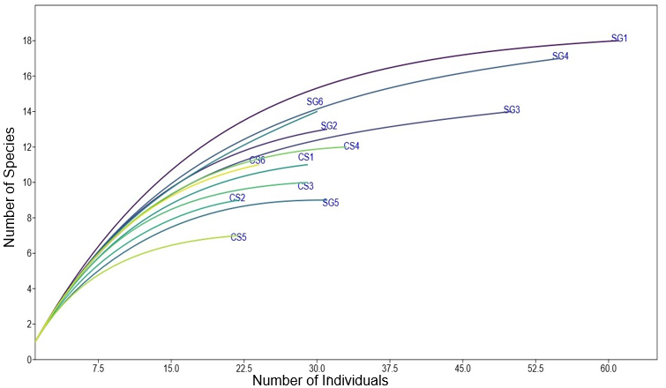

Fig. 5. Individual rarefaction curves of dragonflies recorded from the sacred grove and the corresponding control sites in Bankura district.
Another interesting fact is that a few species are found only in sacred groves. It indicates that the habitat of the sacred groves offers something extra that the nearby controls do not. It may be better vegetation, more moisture, disturbance-free sites, and more places to rest and perch. Dragonflies do not respond only to water. They also respond to the surrounding vegetation and the condition of the terrestrial zone around breeding places. Studies have shown that odonate communities are affected by vegetation type, vegetation height, and the physical condition of the habitat (Balzan, 2012). Work on adult dragonflies has also shown that habitat structure, including shade and perch availability, directly affects habitat selection (Remsburg et al., 2008). So, the exclusive species of sacred groves probably reflect habitat advantage rather than pure chance.
The diversity indices also clarify the pattern. Higher Shannon diversity and lower Berger–Parker dominance in sacred groves mean that the dragonfly community was not built around just one or two very common species. At the control sites, the higher dominance values suggest that a smaller set of species accounted for a larger percentage. That usually happens when habitat options become narrower. In simple terms, the control sites were still usable for dragonflies, but mainly for the more common ones. The sacred groves, on the other hand, could host both common and additional species, making the community more even and diverse. Since dragonflies are widely used as indicators of environmental quality, this difference could be taken seriously (Sahlén & Ekestubbe, 2001; Adu et al., 2022).
The rarefaction result supports the same interpretation. The sacred grove curves remained above the control curves across the sampling range, so the difference is not solely due to more individuals being counted in one or two sites. It suggests a richness advantage in the sacred groves. At the same time, all sacred groves were not equally strong. Larger and better-performing sites such as Khanrari Burial Grove (SG1), Kubasol Village Grove (SG4), and Hausibad Gram Than (SG3) stood out prominantly, while Patit Dommahal Bhairab Than (SG5) remained lower. That unevenness is also important. It means sacred status alone does not automatically produce the same ecological outcome everywhere. Local conditions matter, such as vegetation cover, habitat, moisture conditions, and the surrounding area. Studies on sacred groves and other insect communities have also shown that better vegetation and ground conditions are associated with higher insect diversity, even within the same region (Bhagwat & Rutte, 2006; Imam et al., 2016).
Finally, the result suggests that the sacred groves in Bankura are more than the ‘preservers of cultural markers’. They carry ecological value. For dragonflies, these places have habitat characteristics that are weaker or missing in the control sites. The control sites support some common dragonflies. But their community is smaller, less even, and more dominant. So, the sacred groves function as local refuges for dragonfly diversity. In rural areas, such small sites are important for maintaining biodiversity (Bhagwat & Rutte, 2006; Balzan, 2012).
4. CONCLUSION
The study indicates that sacred groves play an important role in maintaining dragonfly diversity in Bankura district. Compared with the nearby control sites, these sacred groves supported higher species richness, greater abundance, and higher overall diversity. They also contained a broader species pool, suggesting that these habitats provide conditions not available in the surrounding control sites. The lower dominance values of sacred groves further show that the dragonfly community there was less distributed among a few common species. At the same time, the rarefaction pattern suggests that this advantage was not exactly equal across all sites. Some sacred groves performed better than others. Still, the overall trend remained clear. Sacred groves supported a more favourable dragonfly assembly than the corresponding control sites. This is important because dragonflies respond to habitat conditions, moisture levels, vegetation structure, and local disturbances. So, their pattern reflects the ecological value of these culturally protected areas. The findings, therefore, suggest that sacred groves, even when small, contribute to biodiversity conservation at the local scale. Their role is not only symbolic. It is ecological and measurable. Protection of these sacred groves and reduction of disturbance in and around them may help not only dragonflies, but also other species.

COMPETING INTERESTS DISCLAIMER:
Authors have declared that they have no known competing financial interests OR non-financial interests OR personal relationships that could have appeared to influence the work reported in this paper.

REFERENCES
Adu, B., Dada, O., & Tunwase, V. (2022). An ecological study of freshwater ecosystem and its colligation to odonates assemblages in Ipogun, Southwest Nigeria. Bulletin of the National Research Centre, 46, Article 72.
Avtzis, D. N., Stara, K., Sgardeli, V., Betsis, A., Diamandis, S., Healey, J. R., et al. (2018). Quantifying the conservation value of Sacred Natural Sites. Biological Conservation, 222, 95–103.
Balzan, M. V. (2012). Associations of dragonflies (Odonata) to habitat variables within the Maltese Islands: A spatio-temporal approach. Journal of Insect Science, 12(87), 1–18.
Berger, W. H., & Parker, F. L. (1970). Diversity of planktonic foraminifera in deep-sea sediments. Science, 168, 1345–1347.
Bhagwat, S. A., & Rutte, C. (2006). Sacred groves: Potential for biodiversity management. Frontiers in Ecology and the Environment, 4(10), 519–524.
Buckland, S. T., Anderson, D. R., Burnham, K. P., & Laake, J. L. (2001). Introduction to distance sampling. Oxford: Oxford University Press.
Clausnitzer, V., Simaika, J. P., Samways, M. J., & Daniel, B. A. (2017). Dragonflies as flagships for sustainable use of water resources in environmental education. Applied Environmental Education & Communication, 16(3), 196-209.
Devi Khumbongmayum, A., Khan, M. L., & Tripathi, R. S. (2005). Sacred groves of Manipur, northeast India: Biodiversity value, status and strategies for their conservation. Biodiversity and Conservation, 14, 1541–1582.
Dharan, D. T., & Greeshma. (2023). Preliminary studies on the diversity and abundance of odonates in the selected sites of southern Kerala. Applied Journal of Conservation Biology, 12(1), 82–89.
Emlen, J. T. (1971). Population densities of birds derived from transect counts. The Auk, 88, 323–342.
Gaude, K., & Janarthanam, M. K. (2015). The butterfly (Insecta: Lepidoptera) diversity of four sacred groves of Goa, India. Journal of Threatened Taxa, 7(12), 7927–7932.
Gotelli, N. J., & Colwell, R. K. (2001). Quantifying biodiversity: Procedures and pitfalls in the measurement and comparison of species richness. Ecology Letters, 4, 379–391.
Hurlbert, S. H. (1971). The nonconcept of species diversity: A critique and alternative parameters. Ecology, 52, 577–586.
Imam, I., Mazumder, A., Mallick, K., Mitra, S., & Das, P. (2016). Diversity of ground dwelling insect fauna in the sacred groves of Purulia district, West Bengal. Journal of Entomology and Zoology Studies, 4(1), 474–478.
Magurran, A. E. (2004). Measuring biological diversity. Oxford: Blackwell Publishing.
Mitra, B., Das, P., Ghosh, S., & Mishra, P. (2015). Sacred groves of Barjora, Chhatna and Saltora Blocks of Bankura District, West Bengal. Indian Forester, 141(8), 861–865.
Nayak, A., Dey, A., & Bhakat, R. K. (2018). Conservation of ethno-medicinal plants through sacred groves of Bankura district, West Bengal. Indian Journal of Biological Sciences, 24, 60–68.
Pielou, E. C. (1977). Mathematical ecology (2nd ed.). New York: Wiley.
Pollard, E. (1977). A method for assessing changes in the abundance of butterflies. Biological Conservation, 12, 115–134.
Remsburg, A. J., Olson, A. C., & Samways, M. J. (2008). Shade alone reduces adult dragonfly (Odonata: Libellulidae) abundance. Journal of Insect Behavior, 21, 460–468.
Saha, S., Chowdhury, S., & Raychaudhuri, D. (2023). Diversity and distribution of dragonflies and damselflies (Order: Odonata) in forested and urban areas of North and South 24 Parganas and Kolkata districts of West Bengal, India. World Scientific News, 184, 103–129.
Sahlén, G., & Ekestubbe, K. (2001). Identification of dragonflies (Odonata) as indicators of general species richness in boreal forest lakes. Biodiversity and Conservation, 10, 673–690.
Sanders, H. L. (1968). Marine benthic diversity: A comparative study. The American Naturalist, 102, 243–282.
Shannon, C. E., & Weaver, W. (1949). The mathematical theory of communication. Urbana: University of Illinois Press.
Sharma, S., & Kumar, R. (2021). Sacred groves of India: Repositories of a rich heritage and tools for biodiversity conservation. Journal of Forestry Research, 32, 899–916.
Singh, S., Youssouf, M., Malik, Z. A., & Bussmann, R. W. (2017). Sacred groves: Myths, beliefs, and biodiversity conservation: A case study from Western Himalaya, India. International Journal of Ecology, 2017, Article ID 3828609.
Smetacek, P. (2018). A naturalist’s guide to the butterflies of India. Oxford: John Beaufoy Publishing.
Subramanian, K. A. (2005). Dragonflies and damselflies of peninsular India. Indian Academy of Sciences.

