Deltamethrin and E.coli concomitant exposure produces deleterious and evidence based pathological effects in Poultry Birds: Pathological insight into Hepatic, Nephro and Cerebral Alterations

Abstract
Present study was done to evaluate the concomitant deleterious effect of deltamethrin with E.coli infection. 230 seven-day-old chicks were randomly allocated into three groups: Group A (70 birds), Group B (80 birds), and Group C (80 birds). Prior to the experiment, the maximal tolerated dose (MTD) of deltamethrin was determined. Birds in Group B received 1/5th of the MTD orally, while those in Group C were administered 1/10th of the MTD throughout the study period. Group A served as the untreated control. At 14 days of age, each group was further subdivided as follows: Group A into A1 (30 birds) and A2 (40 birds), Group B into B1 and B2 (40 birds each), and Group C into C1 and C2 (40 birds each). Birds in subgroups A2, B2, and C2 were inoculated intraperitoneally with 10⁷ CFU of Escherichia coli in 1 ml of normal saline. The experiment was conducted over a period of 42 days. Gross pathological examination of infected subgroups revealed characteristic lesions of colibacillosis, including fibrinous perihepatitis. Birds exposed to deltamethrin alone exhibited pale carcasses, hepatomegaly with mottling, and congestion of the liver, kidneys, and brain. These lesions were comparatively milder in subgroup C1 than in B1. Histopathological findings in colibacillosis-infected birds included vascular congestion, fibrinous perihepatitis with fibrin deposition, mononuclear cell infiltration in the kidneys with focal interstitial nephritis, and cerebral congestion accompanied by meningitis and encephalitis. In birds treated with deltamethrin alone, lesions included mild hepatic congestion with focal necrosis, focal interstitial nephritis, and cerebral congestion. Thus, it is concluded from the present study that the severe pathomorphological alterations were induced following concomitant exposure of deltamethrin with E.coli infection in poultry birds at the dose i.e. 1/5th of MTD as compared to 1/10th of MTD. And the GLS and HLS indicated that dose dependent toxicity of deltamethrin.
Keywords: Deltamethrin, Broiler chickens, Escherichia coli, Toxicity, Colibacillosis

- Introduction
India holds second rank in terms of farm output throughout the world. Indian economic survey (2020-21) stated that in India, more than 50 % of the population strives on agriculture and contributed around 20.2% to the Gross domestic product of the country. As a developing country and one of the fastest growing economies in the world, agriculture farming is of utmost importance in terms of economy. Indiscriminate use of pesticides, herbicides and other agrochemicals in the farm land imposes great threat to human and animal health. Use of these agrochemicals have to be reduced and replaced with other alternatives as suggested by the reports of Weston and Lydy (2010).
Deltamethrin is proclaimed as one of the most commonly used agrochemical in the poultry industry (Soderlund,et al., 2002, Khater et.al., 2013). Deltamethrin is classified as broad spectrum agrochemical of synthetic pyrethroids class (Tomlin, 2006). Synthetic pyrethroids are anthropogenic analogues of naturally occurring pyrethrin found in the flowers of Chrysanthemum cinerariaefolium. Alpha cyano group in deltamethrin contributes in the long-lasting inhibition of sodium channel activation resulting in event full of repetitive nerve signals in sensory nerves and muscles (Johnson et al., 2010). Poultry industry has expanded immensely in the last few decades and overall advancement has been noted in terms of use of feed additives, growth promoters and feed supplement etc. Despite these improvements, frequent disease outbreaks remain a major challenge hindering the growth of the poultry. Escherichia coli infection is one of the commonest infection among poultry birds and serve as a causative agent for various diseases viz. pericarditis, perihepatitis, airsacculitis, peritonitis, salpingitis, panophthalmitis, omphalitis, cellulitis, colisepticemia, coligranuloma, and Swollen-Head Syndrome. Colibacillosis, in particular, is a major contributor to economic losses in the global poultry industry in India. (Ewers et al., 2003). Moreover, slaughterhouse rejection of carcass is also attributed to the infection of E.coli. The concomitant exposure of pesticide or agrochemicals along with E. coli infection significantly impairs growth performance and feed conversion ratio (FCR) in the poultry birds (Abbas, 2016).. Furthermore, the deposition of pesticide residues in the meat and other secretions of animals produces deleterious effect on the health of human and animals. array of adverse effects is adjudged with various ailments viz.endocrine disruption, teratogenicity, embryo toxicity immunosuppression, mutagenicity and carcinogenic effects etc. (Brouwer et al.,1999). As per the reports of Guerrero et al. (2012) even the direct exposure of these agrochemicals could result into mortality in birds and animals. Present study was aimed to abridge the gap in the finding of concomitant exposure of deltamethrin with infection of E.coli in poultry birds with special reference to pathological alterations.
2. Methodology
Present study was done in 270 healthy day-old broiler chicks. The day old 270 healthy broiler chicks were obtained from a local hatchery and reared under strict hygienic conditions in the departmental animal house, following the cage rearing system. Optimum housing condition with proper ventilation and ad lib water and feed supply was ensured through out the experimental period. Deltamethrin (Decis 2.5% E.C. India) was used in the present study for determination of maximal tolerated dose (MTD) as well as for toxicity study in which 1/5th and 1/10th of MTD of deltamethrin was used in the different experimental groups. Maximum tolerated dose (MTD) of deltamethrin was determined after screening various doses of deltamethrin, following standard methods (Turner, 1965). 40 chicks were used to calculate the MTD and MTD value was found to be 43.75 mg/kg body weight on the basis of clinical signs and mortality. All the research work were carried out following the ethical approval from ethical approval from Institutional Animal Ethics committee (IAEC) of LUVAS, Hisar with permission order number TVCC/IAEC/2017/223151; dated 27/01/2017.

Experimental design
Remaining 230 birds were divided into six different groups as follows:
Group A1 (n=30) = Negative control group i.e. without Deltamethrin and infection
Group A2 (n=40) = 10⁷ CFU E. coli/ ml, intraperitoneally on day 14
Group B1 (n=40) = 1/5th MTD of Deltamethrin on day 7
Group B2 (n=40) = 1/5th MTD of Deltamethrin on day 7 + 10⁷ CFU E. coli / ml, intraperitoneally on day 14
Group C1 (n=40) = 1/10th MTD of Deltamethrin on day 7
Group C2 (n=40) = 1/10th MTD of Deltamethrin on day 7+ 10⁷ CFU E. coli / ml, intraperitoneally on day 14
Infective dose of E. coli.
O₇₈ serotype of E. coli isolated from natural cases was inoculated into Brain Heart Infusion Broth (BHIB) and incubated at 37⁰C for 24 hours. Viable count of E. coli organism per ml of BHIB was determined by surface spread method with minor modification as prescribed by Cruickshank et al. (1975). Infective dose @ 10⁷ CFU of E. coli /0.5 ml was prepared for the experiment as E. coli inoculums (Jindal et al., 2003).
Gross pathology
Birds were humanely sacrificed to assess the pathological changes induced by deltamethrin plus E.coli concomitant infection on different time intervals i.e. on day 3, 11, 21 and 28 days of post infection (DPI). Gross pathological lesions were recorded to undermine the deleterious effect on organs viz. liver, kidney and brain. Per cent mean gross and histopathological lesions were calculated as per method described by Witter (1982) with slight modifications with following formula.

Per cent mean gross/histopathological lesion score (GLS/HLS) of organs
Mean GLS/HLS of an organ
= X 100
Maximum GLS/HLS of an organ

Overall per cent mean GLS/HLS of organs irrespective of post infection period
Sum of per cent mean GLS/HLS of an organ at different post infection period
=
Total number of post infection periods

Overall per cent mean GLS/HLS irrespective of post infection period and organs
Sum of overall per cent mean GLS/HLS of organs irrespective of post infection period
=
Total number of organs

Per cent severity effect due to 1/5th deltamethrin intoxication in E. coli infected chicken
Overall per cent mean GLS/HLS in group B₂ – Overall per cent mean GLS/HLS in group A₂
= ×100
Overall per cent mean GLS/HLS in group B₂

Per cent severity effect due to 1/10th deltamethrin intoxication in E. coli infected chicken
Overall per cent mean GLS/HLS in group C₂ – Overall per cent mean GLS/HLS in group A₂
= –––––––––––––––––––––––––––––––––––––––––––––––––––––––––––––––––––––––––×100
Overall per cent mean GLS/HLS in group C₂

Hematoxylin and eosin (H&E) staining
Representative tissue samples of liver, kidney and brain of group A2,B2 and C2 were collected from the birds of each group and samples were fixed in 10% buffered formalin, and tissue samples were sectioned to 5 μm size using microtome and stained with H&E as described previously (Luna, 1968).
Lesion score
The gross lesion score (GLS) and histopathological lesion score (HLS) in different experimental groups were calculated for different organs/tissues at scale of 0 to 4 as detailed below:
0 = No lesion
1 = Mild lesions
2 = Moderate lesions
3 = moderately severe lesions
4 = Severe lesions
Statistical Analysis
Results are expressed as Mean ± SEM with ‘n’ equal to the number of animals. The mean values were statistically compared by student’s t-test and/or analysis of variance (ANOVA) depending on experimental design as per the method described earlier (Snedecor and Cochran 1989).
3. Results
Gross representative images of different organs viz. Liver, kidney and brain at different time intervals were depicted as Figure 1. None of the bird from control group A1 at different intervals showed any pathologically significant changes. Thin layer of fibrin deposit was noticed in birds of group A2. Birds of group B1 exhibited anaemic carcass with mottled enlarged liver and congestion was observed in liver and kidney. However the group B2 and C2 shows severe gross lesion compare to the group B1 and C1. Majority of symptoms were recorded at 11 day of DPI in brain with severe congestion along with fibrinous perihepatitis in liver in birds of group B2. The birds of group B2 showed the deleterious gross observable fibrin layer and pathological changes upto day 28 DPI as compared to other groups.
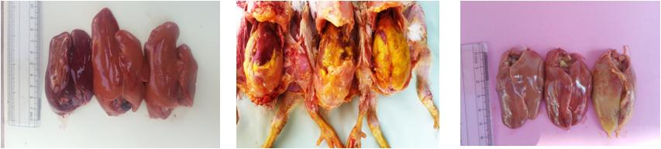
A2 B2 C2
A2 B2 C2
A1 B1 C1
Figure 1: Gross images representing enlarged liver in Group B2 and C2 compared to other groups with fibrinous Layer deposition (Marked as Star).

Histopathological changes in Liver
Histopathological changes in the liver are represented as Figure 2. The birds from group A2 from 3 DPI revealed congestion in the portal vein along with mononuclear cell infiltration in the portal area. Fibrinous perihepatitis characterised by deposition of fibrin and leucocytic infiltration extending up to parenchyma till 11 day of infection were noticed. The severity of lesions was reduced after 21 DPI and become almost normal at 28 days.
Birds from group B2 showed more severe lesion compare to birds of Group A2. On 11 DPI, it showed severe fibrinous perihepatitis along with infiltration of the mononuclear cells .In some cases there were also lymphoid aggregations in liver parenchyma.
Birds from the group C2 showed lesion in the liver with similar pathological alteration but were of lesser magnitude as compared to the group B2. The lesions were observed till 28th DPI with mild congestion in hepatic sinusoids.

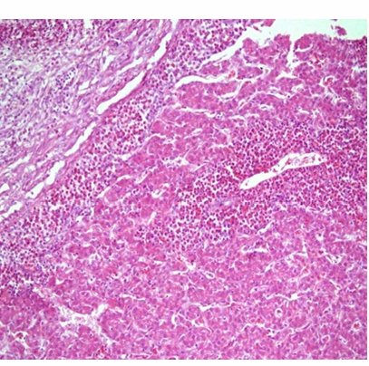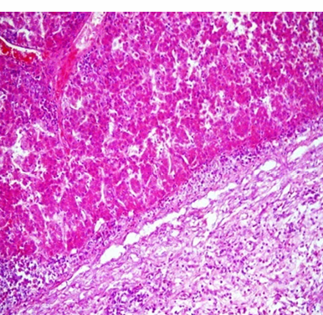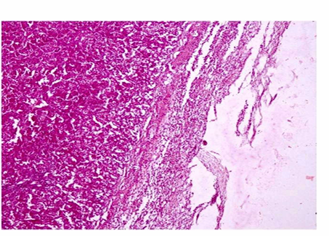
B2
C2
A2
Figure 2: Liver histopathological microphotographs showed severe fibrinous perihepatitis along with infiltration of mononuclear cells in Group A2 11 DPI , group B2 showed Severe fibrinous perihepatitis along with congestion of blood vessels, sinusoids and infiltration of the mononuclear cells in parenchyma and group C2 showed marked sinusoidal congestion H&E x100).

Histopathological changes in Kidney
Histopathological changes in the kidney are represented as Figure 3. On 3 DPI onwards, birds of group A2 revealed congestion in the blood vessels and renal parenchyma along with the haemorrhages in the intertubular area. On 11 DPI, tubular necrosis and mononuclear cells infiltration were observed. On 21 DPI, Kidneys revealed congestion, degenerative changes in the renal tubules and lymphocytic infiltration in the interstitial tissue. Whereas, on 28th of DPI, no significant changes were noticed in the kidneys.
Group B2, revealed congested and haemorrhagic area in the intertubular space along with mild leucocytic infiltration. Focal interstitial nephritis characterized by the mild leucocytic infiltration and degenerative changes in the tubules were also observed. On 11 DPI, kidneys revealed focal interstitial nephritis characterized by degenerative changes in the tubules and severe infiltration of mononuclear cells in the parenchyma.
Group C2 showed congestion and focal necrosis of the renal tubule with infiltration of mononuclear cells and fibroblast proliferation including glomerular capillaries from 11 DPI onwards. On 21 DPI onwards, there were degenerative changes in renal tubular epithelium along with severe necrotic changes in few tubules. Congestion and focal interstitial nephritis characterized by mononuclear cells infiltration along with degeneration of renal tubules was also observed from 21 DPI onwards in the birds of group C1.
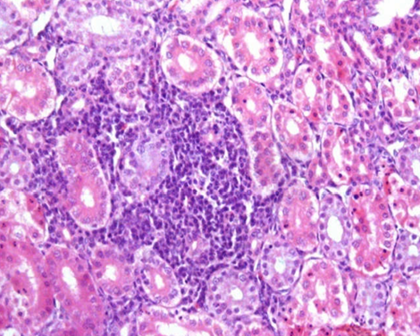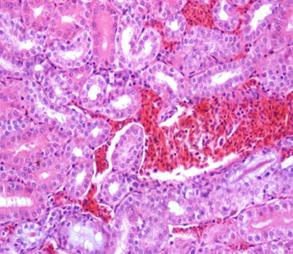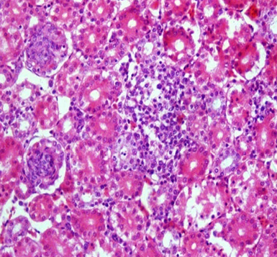
A2
C2
B2
Figure 3: Kidney histopathological microphotographs showed Congestion and haemorrhages in the intertubular area along with mild leukocytic infiltration in Group A2, Focal interstitial nephritis characterized by the severe leukocytic infiltration and degenerative changes in the tubules in group B2 with intertubular hemorrhage and Focal interstitial nephritis characterized by the mild leukocytic infiltration and degenerative changes in the tubules in group C2 (H&E x200).

Histopathological changes in Brain
Histopathological changes in the brain are represented as Figure 4. Birds from group A2 revealed congested blood vessels with mild degenerative changes in cerebrum from 11 to 21 DPI. Birds of group B2 showed similar lesion as birds of group A2 and group C2 but found more severe and appeared at earlier time period. On 3 DPI, group B2 birds exhibited meningitis characterized by infiltration of mononuclear cells in cerebrum. On 11 DPI, presence of marked mononuclear cell infiltration and focal area of gliosis was noticed. Degenerative changes in neurons along with vacuolation in the parenchyma were recorded from 3 to 21 DPI. Group C2 revealed congested cerebral blood vessels on 21 DPI. Group C1 showed mild congestion of blood vessels in cerebrum on 28 DPI.

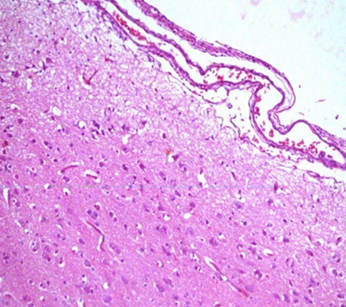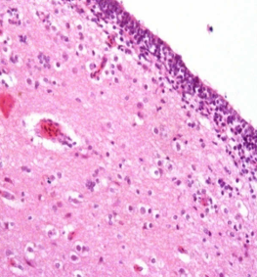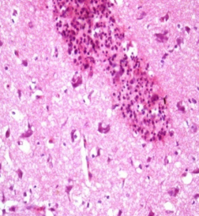
A2
C2
B2
Figure 4: Brain histopathological microphotographs showed Mild congestion in group A2, Congestion and meningitis characterized by marked mononuclear cell infiltration in group B2 and focal area of gliosis in group C2 (H&E x100).

Overall per cent mean scores in different organs irrespective of post infection period in different Escherichia coli infected groups
Present study showed that birds of group B2 showed significant increase in the overall per cent mean GLS and HLS score as compared to birds of A2, and C2 groups as shown in Table 1.
Table 1: Overall per cent mean scores in different organs irrespective of post infection period in different Escherichia coli infected groups
Lesion score | Groups
Lesion score | Groups | Liver | Kidneys | Brain
GLS | Group A₂ | 38.50 | 32.25 | 20.81
GLS | Group B₂ | 47.81 | 45.81 | 31.63
GLS | Group C₂ | 42.63 | 37.25 | 27.50
HLS | Group A₂ | 38.50 | 37.50 | 24.88
HLS | Group B₂ | 53.63 | 50.75 | 36.44
HLS | Group C₂ | 43.50 | 42.88 | 32.19

Per cent severity effect due to 1/5th MTD of deltamethrin and 1/10th MTD of deltamethrin intoxication in Escherichia coli infected groups
Present study revealed overall significant increase in the mean lesion score scores respective of post infection periods and organs in the birds of group B2 as compared to A2 and C2 and showed increased per cent severity effect due to 1/5th dose of MTD as compared to 1/10th dose of MTD as shown in Table 2.
Table 2: Per cent severity effect due to 1/5th MTD of deltamethrin and 1/10th MTD of deltamethrin intoxication in Escherichia coli infected groups
Lesion Score | Groups | Overall per cent mean  lesion scores respective of  post infection periods  and organs | Per cent severity effect  due to 1/5th MTD of  deltamethrin | Per cent severity effect  due to 1/10th MTD of  deltamethrin
GLS | Group A₂ | 28.91 | 28.88 | 12.58
GLS | Group B₂ | 40.65 | 28.88 | 12.58
GLS | Group C₂ | 33.07 | 28.88 | 12.58
HLS | Group A₂ | 32.87 | 29.02 | 14.62
HLS | Group B₂ | 46.31 | 29.02 | 14.62
HLS | Group C₂ | 38.50 | 29.02 | 14.62

4. Discussion
Perusal of data mined from the study revealed significant gross changes inclusive of fibrinous perihepatitis, cloudy air sac, and congestion in visceral organs along with peritonitis. Increase in the severity of gross lesions in groups B2 and C2 could be attributed to immunosuppressive effect of deltamethrin treatment. Deltamethrin alone treated groups showed mottled enlarged liver, congestion in various organs such as liver and kidney.These changes in the birds of group C1 were of lesser severity as compared to the birds of group B1 chicks. Similar findings were also noticed by the study of Tewari et al. (2018).
Histopathological examination revealed fibrinous perihepatitis characterized by fibrin deposition and infiltration of heterophils during the early stages, followed by macrophages and lymphocytes in the later stages in colibacillosis-infected groups. The liver of affected birds also exhibited fibrinous perihepatitis and hepatitis, along with degenerative alterations such as hydropic and fatty changes in hepatocytes and sinusoidal dilatation at various post-infection intervals. The results were in accordance with the findings of other researchers (Peighambari et al., 2000; Mishra et al., 2002; Manimaran et al., 2003; Srinivasan et al., 2003, Jindal et al., 2003; Saini, 2004). Mansour et al. (2017) and Tewari et al. (2018) also documented marked cellular infiltration and focal necrosis in hepatocytes following deltamethrin intoxication in rats. Similarly, Grewal et al. (2010) also reported disorganization in histoarchitecture of hepatic tissue with increased sinusoidal gaps and necrosis in liver following exposure to synthetic pyrethroids.
Congestion and haemorrhages was observed in the intertubular site of kidney with mild leucocytes infiltration. Focal interstitial nephritis and degenerative changes in the renal tubules was evident in infected and infected plus intoxicated groups. Severity of lesions was comparatively mild in groups B1 and C1 than in B2, C2, and A2. These observations are consistent with the findings of Ayaz (2017) who reported similar degenerative changes in the renal tissue following deltamethrin toxicity in rats. Alden and Frith (1991) also advocated that leakage of lysosomal enzyme triggers the nephrotoxic potential of renotoxic substances with loss of structural integrity of glomeruli and renal tubules.
Brain exhibited encephalitis in group B2 characterized by congestion of blood vessels and focal area of necrosis along with infiltration of mononuclear cell in cerebrum and focal area of gliosis. Grewal et al. (2010) also reported the degenerative changes in the neurons and vacuolization with marked increment in glial cell following toxicity of pyrethroids. Gupta (1988) also reported the proliferation of glial cell and neuronal changes following cypermethrin toxicity, similar synthetic pyrethroids. Moreover, many pesticides are reported to produce hypoxia, hypoglycaemia and disturbed cellular ion homeostasis mediated neurological changes on repeated exposure (Anthony et al., 1996).
Severity of lesions were mild in other groups i.e. B1 and C1 suggested the conjunctional role of deltamethrin and colibacillosis in young poultry birds to produce severe lesions.
5. Summary and Conclusion
Thus, it is concluded from the present study that the severe pathomorphological alterations were induced following concomitant exposure of deltamethrin with E.coli infection in poultry birds at the dose i.e. 1/5th of MTD as compared to 1/10th of MTD. And the GLS and HLS indicated that dose dependent toxicity of deltamethrin.

Ethical Approval
Experimental study was undertaken following ethical approval from the competent authority and all the trial have been conducted as per the regulations and norms of Institutional Animal Ethics committee (IAEC) of LUVAS, Hisar with permission order number(TVCC/IAEC/2017/223151 dated 27/01/2017).

COMPETING INTERESTS DISCLAIMER:
Authors have declared that they have no known competing financial interests OR non-financial interests OR personal relationships that could have appeared to influence the work reported in this paper.

References
Abbas, O. S. (2016). Detection of deltamethrin residues in poultry egg and meat in Dyala province. Al-Anbar Journal of Veterinary Sciences, 9(2), 41–46.
Alden, C.L. & Frith, C.H. Urinary system. In: Haschetk WM, Rousseaux CG, editors. Handbook of Toxicologic Pathology, San Diaego, Academic Press Inc. 1991. 316-379.
Anthony DC, Montine TJ, Graham DG. Toxic response of the nervous system. In: Klaassen CD, editor. Casarett and Doull’s Toxicology: The Basic Science of Poisons. Vol. 5. New York: McGraw-Hill; 1996. p. 463-86.
Brouwer, A., Longnecker, M. P., Birnbaum, L. S., Cogliano, J., Kostyniak, P., Moore, J., Schantz, S., &Winneke, G. (1999). Characterization of potential endocrine-related health effects at low dose levels of exposure to PCBs. Environmental Health Perspectives, 107(Suppl 639). https://doi.org/10.1289/ehp.99107s1639.
Cruickshank, R., Duguid, J. P., Marsion, B. P., & Swain, R. H. A. (1975). Medical microbiology (Vol. II, 12th ed.). Churchill Livingstone.
Ewers, C., Janseen, T., &Wieler, L. H. (2003). Avian pathogenic Escherichia coli (APEC). Berliner und MünchenerTierärztlicheWochenschrift, 116(9–10), 381–395.
Grewal, K.K., Sandhu, G.S., Kaur, R., Brar R.S. & Sandhu, H.S. (2010). Toxic Impacts of Cypermethrin on Behavior and Histology of Certain Tissues of Albino Rats. Toxicology International, 17 (2), 94-98.
Guerrero, I., Morales, M. B., Oñate, J. J., Geige, F., Berendse, F., Snoo, G. D., &Tscharntke, T. (2012). Response of ground-nesting farmland birds to agricultural intensification across Europe: Landscape and field level management factors. Biological Conservation, 152, 74–80. https://doi.org/10.1016/j.biocon.2012.04.001.
Gupta P.K. (1988). Cypermethrin- A pyrethroid insecticide. In: Gupta PK, Raviprakash V, editors. Advances in Toxicology and Environmental Health. New Delhi: Jadmander Book Agency; 81-130.
Jindal, N., Kumar, A., Shukla, C. L., Pal, Y., Ledoux, D. R., &Rottinghaus, G. E. (2003). Effect of ochratoxin A on Escherichia coli challenged broiler chicks. Avian Diseases, 47(2), 415–424. https://doi.org/10.1637/0005-2086(2003)047[0415:EOAOEC]2.0.CO;2.
Johnson, M., Luukinen, B., Buhl, K., & Stone, D. (2010). Deltamethrin technical fact sheet. National Pesticide Information Center, Oregon State University Extension Services. http://npic.orst.edu/factsheets/archive/Deltatech.html.
Khater, H. F., Seddiek, S. A., El-Shorbagy, M. M., & Ali, A. M. (2013). The acaricidal efficacy of peracetic acid and deltamethrin against the fowl tick, Argaspersicus, infesting laying hens. Parasitology Research, 112(1), 259–269. https://doi.org/10.1007/s00436-012-3133-1.
Luna, L. G. (1968). Manual of histologic staining method of armed forces institute of pathology (3rd ed.). McGraw Hill Book Company.
Manimaran, K., Singh, S. D., &Shivachandra, S. B. (2003). Haematobiochemical and pathological changes in experimental Escherichia coli infection in broiler chicks. Indian Journal of Animal Sciences, 73(9), 960–962.
Mansour, S. A., Mohamed, R. I., & Ali, A. R. (2017). Ameliorating effect of selenium against deltamethrin-induced hepato-renal dysfunction and oxidative stress to pregnant rats and their offspring. Journal of Toxicology and Pharmacology, 1(2), 1–7.
Mishra, A., Sharda, R., Chhabra, D., &Tanwani, S. K. (2002). Antibiogram of Escherichia coli isolates from domestic poultry. Indian Veterinary Journal, 79(8), 863–864.
Peighambari, S. M., Julian, R. J., &Gyles, C. L. (2000). Experimental Escherichia coli respiratory infection in broilers. Avian Diseases, 44(4), 759–769. https://doi.org/10.2307/1593103
Saini, V. (2004). Studies on the effect of neem (Azadirachtaindica) leaf extract on the pathology and pathogenesis of Escherichia coli infection in broiler chicks (M.V.Sc. thesis). Chaudhary Charan Singh Haryana Agricultural University, Hisar, India.
Snedecor, G.W. & Cochran, W.G. (1989). Arc sine transformation for proportions. Statistical Methods.8th ed. Iowa State University Press, Ames, 289-290.
Soderlund, D. M., Clark, J. M., Sheets, L. P., Mullin, L. S., Piccirillo, V. J., Sargent, D., et al. (2002). Mechanisms of pyrethroid neurotoxicity: Implications for cumulative risk assessment. Toxicology, 171(1), 3–59. https://doi.org/10.1016/S0300-483X(01)00569-8.
Srinivasan, P., Rao, G. V. S., & George, V. T. (2003). Survey of spontaneous cases of colibacillosis in chicken. Indian Veterinary Journal, 80(1), 93–94.
Tewari, A., Banga, H. S., & Gill, J. P. S. (2018). Sublethal chronic effects of oral dietary exposure to deltamethrin in Swiss albino mice. Toxicology and Industrial Health, 34(6), 423–432. https://doi.org/10.1177/0748233718766152.
Tomlin, C. D. S. (2006). The pesticide manual: A world compendium (14th ed., pp. 286–287). British Crop Protection Council.
Turner, R. A. (1965). Screening methods in pharmacology (pp. 101–118). Academic Press.
Weston, D. P., & Lydy, M. J. (2010). Focused toxicity identification evaluations to rapidly identify the cause of toxicity in environmental samples. Chemosphere, 78(3), 368–374. https://doi.org/10.1016/j.chemosphere.2009.11.017.

