Original Research Article

Protein, Glycogen, and Lipid Composition of Moniezia sp. (Anoplocephalidae) from Deccani Sheep (Ovis aries): A Host-Parasite Biochemical Comparison from Ahilyanagar District, Maharashtra

ABSTRACT
Gastrointestinal cestode parasites are one of the most adverse things that can happen to Deccani sheep in tropical and subtropical areas, especially in the Ahilyanagar district of Maharashtra. This study seems that the biochemical analysis of the total protein, glycogen, and lipid levels in whole cestode parasites (Moniezia sp.) that were taken from naturally infected Deccani sheep (Ovis aries) in the Ahilyanagar district. The research provides essential understanding of the nutritional requirements and metabolic functions of the parasites, probably helping in the development of effective control measures. The results showed that the parasite's biochemistry and the host's intestinal tissues were very different. Moniezia sp. had more lipids (12.58 mg/g) than either normal host intestinal tissues (11.64 mg/g) or infected host intestinal tissues (11.05 mg/g). But the parasite had less protein and glycogen than the host's intestine. These results show that lipids are creating up and that the parasite needs the host's energy stores to stay alive.

KEYWORDS: Biochemistry; Cestode parasites; Moniezia sp.; Deccani Sheep; Ahilyanagar.

INTRODUCTION
Livestock suffer from a lot of parasitic diseases, especially in India's tropical and subtropical areas. Gastrointestinal cestodes are one of the most economically important illnesses that afflict sheep and goats, along with other forms of parasites (Soulsby, 1966). In the state of Maharashtra, there is a district named Ahilyanagar. It used to be called Ahmednagar. It is an excellent area for parasitological research since it has a lot of sheep farms. In Maharashtra, the Deccani sheep is one of the most important local breeds. It thrives in the semi-arid environment of the Deccan plateau and is valued for its meat and wool (Ghanekar, 1983; Gokhale, 2003; Bhatia and Arora, 2005). Previous studies have examined the prevalence of helminthic infections, such as Moniezia spp., in the Ahmednagar district of Maharashtra throughout several seasonal periods (Shaikh et al., 2010). Further studies in the rural areas of Ahmednagar district have shown that gastrointestinal parasites are prevalent among local sheep populations (Sutar and Khan, 2011).
Cestode parasites that live in the intestines of their hosts get nutrition from the gastrointestinal system to help them grow, develop, and stay alive. The metabolic activities of these cestodes are tightly linked to the eating behaviors of the host and the nutrient-rich environment inside the gut. Metabolic and in vitro investigations have shown the existence of a complicated nutritional interaction between cestodes and their hosts (Smyth and McManus, 2007). Some cestodes are known for their ability to fix carbon dioxide (CO2), which shows how well they use waste metabolic materials from the host's intestinal mucosa (Von Brand, 1966).
Proteins are present in many different places and are very important for living things. Enzymes are the most common kind of protein. They make the biochemical environment right for cestodes to live. Studies show that parasites have adapted to living as parasites, mostly because of how they break down proteins. For example, protein makes up 20–40% of the dry weight of cestodes (Barrett, 1981). Biochemical investigations of gastrointestinal cestode parasites from the Marathwada district of Maharashtra, which included both Capra hircus and Ovis bharal, found that protein, glycogen, and lipid were distributed in comparable ways (Humbe et al., 2011).
There is less information on the biochemical composition of cestode parasites from the Ahilyanagar area, despite the significant financial impact of parasitic disorders in sheep. Research at the district level is important, as indicated by the study of Cotugnia jadhavii in poultry from Nashik (Patil and Mukesh, 2023) and the biochemical analysis of Anaplocephalidean cestodes from Ovis bharal (Thosar et al., 2014). The present research investigates at the levels of protein, glycogen, and lipids in entire cestode parasites (Moniezia sp.) that were found in sheep that had been sick on the animals in the Ahilyanagar area. The goal is to fix the gaps in what we already know. This will provide researchers important information that they may use in future experiments that will include medicines.

MATERIALS AND METHODS

Study Area and Sample Collection
The study was done in Ahilyanagar, Maharashtra, India, from 2023 to 2024. We saw Deccani sheep (Ovis aries) at the slaughterhouses in different tehsils around Ahilyanagar. The intestines of the dead sheep were quickly sent to the lab in cold physiological saline (0.9% NaCl). We slowly opened the intestines all the way down and saw that they were full of cestode parasites. These specimens are part of the Moniezia sp. group because of well-known morphological criteria that have been used in earlier studies (Yamaguti, 1959; Skrjabin and Schulz, 1937; Soulsby, 1966).
Sample Preparation
We washed the whole cestode worms with normal saline (0.9% NaCl) to get rid of mucus and debris from the host. To get rid of surface moisture, worms were blotted dry on filter paper, put on pre-weighed watch glasses, and weighed on a calibrated analytical balance to get their fresh (moist) weight. After that, the samples were dried in a hot air oven at 60°C for 24 hours and then weighed again to find out how much they weighed when they were dry. We ground the dried material into a fine powder with a mortar and pestle and kept it at 4°C until we did the biochemical assay. We took samples of intestinal tissue from both infected and healthy (control) sheep and processed them in the same way so that we could compare them.
Biochemical Estimations
Protein Estimation: The Lowry et al. (1951) method was used to find out how much protein was in the sample. Tissue powder was mixed with 0.1N sodium hydroxide, and the concentration of protein was measured using a spectrophotometer at 660 nm with bovine serum albumin as a standard. The results are shown as mg of protein per gram of wet tissue weight.
Glycogen Estimation: Using the method described by Kemp et al. (1954), we estimated the amount of glycogen. We put tissue powder in a boiling water bath with 30% potassium hydroxide, then added ethanol to make glycogen settle out. once it, we dissolved it again and added anthrone reagent. We used a spectrophotometer to find the blue-green colour at 620 nm. The results are expressed in milligrams of glycogen per 100 millilitres of solution.
Lipid Estimation: To find out how much total lipid there was, we utilised the Folch et al. (1957) technique. To verify the total lipid amount in animal tissues, we used the sulpho-phospho-vanillin method established by Barnes and Blackstock (1973). A combination of chloroform and methanol (2:1 v/v) was used to collect tissue samples. After that, the extract was washed with a 0.88% potassium chloride solution. We dried the chloroform layer and weighed all of the material. Results are expressed in milligrams of lipid per gram of tissue.
Statistical Analysis
All biochemical measurements were conducted in triplicate (n = 10 per group). Results are shown as mean ± standard error (SE). Standard statistical methods were used to check the data for correctness and repeatability.
RESULTS
The biochemical examination of complete cestode parasites (Moniezia sp.) found in Deccani sheep in the Ahilyanagar area showed that the concentrations of proteins, glycogen, and lipids were very different from those in the host's intestinal tissues. Table 1 shows the findings.
Table 1. Biochemical Composition of Moniezia sp. and Host Intestinal Tissues of Ovis aries (Deccani Sheep) in Ahilyanagar District
Biochemical Parameter | Host Intestine (Normal) | Host Intestine (Infected) | Moniezia sp. (Whole Cestode)
Protein (mg/g wet wt.) | 19.85 ± 0.42 | 17.12 ± 0.38 | 13.10 ± 0.31
Glycogen (mg/100 ml) | 18.22 ± 0.29 | 17.47 ± 0.33 | 14.12 ± 0.27
Lipid (mg/g tissue) | 11.64 ± 0.21 | 11.05 ± 0.19 | 12.58 ± 0.24
Values are expressed as Mean ± SE; n = 10 per group; all estimations performed in triplicate.

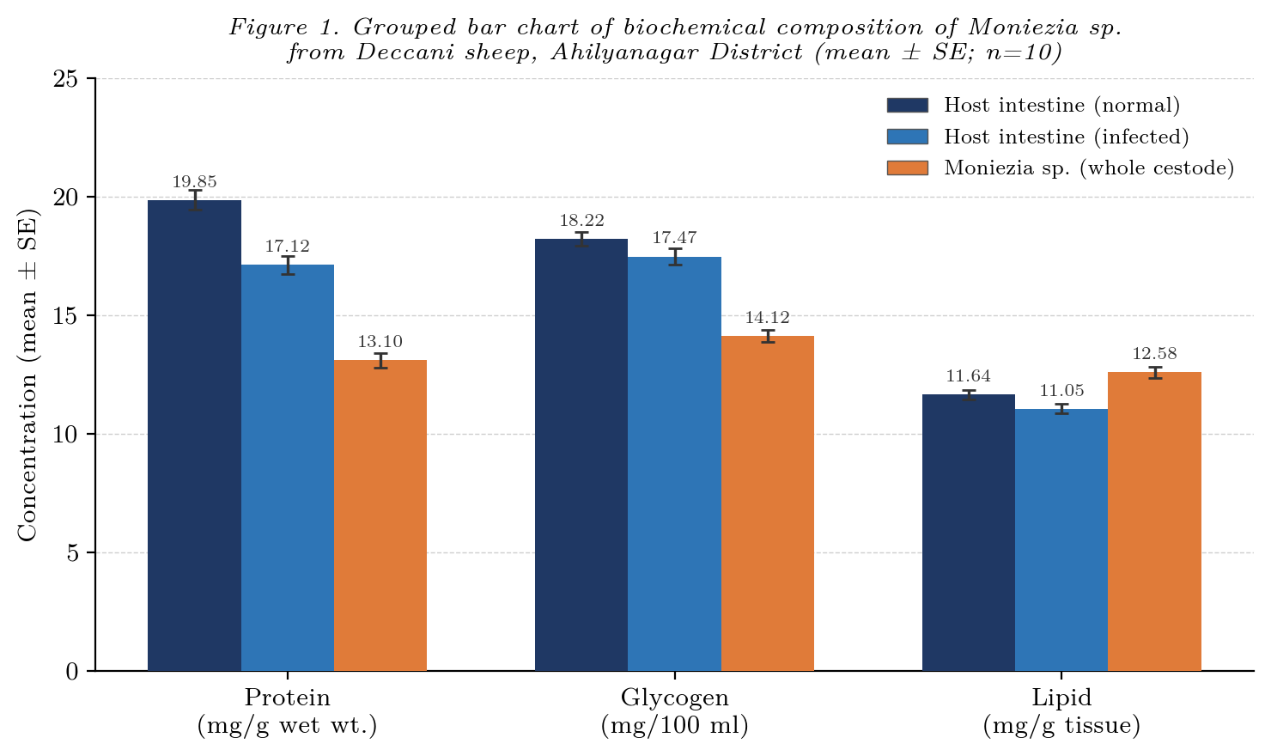

Figure 2.
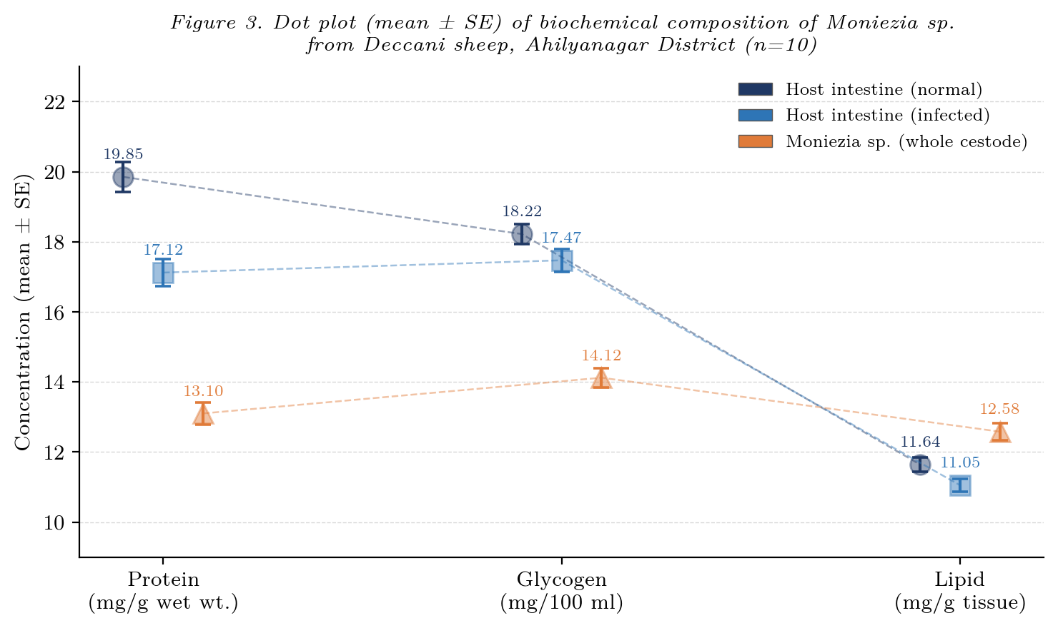
Protein Content
The total protein content of whole Moniezia sp. was 13.10 ± 0.31 mg/g wet weight. This was much lower than the amounts found in the normal host intestine (19.85 ± 0.42 mg/g) and the infected host intestine (17.12 ± 0.38 mg/g). The fact that infected animals have less protein in their intestines than healthy animals shows that the parasite uses host protein stores to meet its metabolic and structural needs. Proteins are necessary for the reproductive organs and body wall of the cestode to work and be strong. This is in line with the fact that proteins make up 20–40% of the dry weight of cestodes (Barrett, 1981).
The moderate protein levels in Moniezia sp. from the Ahilyanagar district align with previous studies in the Marathwada region of Maharashtra, which indicated that cestode parasites from Capra hircus and Ovis bharal exhibited lower protein concentrations relative to the host intestine (Humbe et al., 2011). Patil and Mukesh (2023) saw similar patterns in Cotugnia jadhavii in birds from the Nashik district of Maharashtra. Moniezia sp. is rich in protein, which is important for enzymes and structure. The parasite has changed over time, and now it gets most of its energy from fats and sugars.
Glycogen Content
The amount of glycogen in whole Moniezia sp. was 14.12 ± 0.27 mg/100 ml. In normal host intestine, it was 18.22 ± 0.29 mg/100 ml, and in infected host intestine, it was 17.47 ± 0.33 mg/100 ml. Glycogen is the major source of energy for anaerobic metabolism, which is what occurs most commonly in the intestines where there isn't much oxygen. The reduction in intestinal glycogen in infected hosts indicates that the parasite is aggressively utilising the host's glucose reserves.
The glycogen content in Moniezia sp. in this research comparisons that seen in cestode parasites from the Marathwada area of Maharashtra (Humbe et al., 2011). This supports with the hypothesis that intestinal cestodes use glycogen as a way to store energy. Moniezia can store adequate glycogen even while it's living in a parasite, which suggests that it has adapted successfully to the host's metabolic cycles.
Lipid Content
The lipid content of entire Moniezia sp. (12.58 ± 0.24 mg/g) was higher than that of both the normal host intestine (11.64 ± 0.21 mg/g) and the infected host intestine (11.05 ± 0.19 mg/g). This was the most crucial thing that came out of this investigation. The parasite accumulated more lipids per gram of tissue than the intestinal cells of the host. This means that it actively takes in and stores lipids from the host.
Cestodes have a number of tasks for lipids. They store energy, keep cell membranes strong, and are building blocks for reproductive processes (Smyth and McManus, 2007). There is a lot of evidence in cestode biology that lipids tend to build up more than other types of molecules (Von Brand, 1952). Anaplocephalidean cestode parasites from Ovis bharal in Maharashtra have also been found to have higher levels of lipids (Thosar et al., 2014). The fact that the infected host intestine has less lipid (11.05 mg/g) than normal tissue (11.64 mg/g) is strong evidence that the parasite uses up the host's lipid stores, which could make it harder for the host to absorb nutrients and fight off infections.
Comparative Biochemical Profile
In Moniezia sp. from the Ahilyanagar district, the absolute concentrations of the three biochemical components are as follows: glycogen (14.12 mg/100 ml) > protein (13.10 mg/g) > lipid (12.58 mg/g). But when you compare it to host tissues, only the amount of lipids was higher than both groups of host tissues. This pattern shows that Moniezia sp. prefers to store lipids over the host environment and keeps its protein and glycogen levels a little lower than those of the host.
The biochemical characteristics of Moniezia sp. from Ahilyanagar district closely resemble those identified in other cestode species from Maharashtra (Humbe et al., 2011; Thosar et al., 2014; Patil and Mukesh, 2023). But the exact values may be different because of the host's diet, the quality of the local forage, and environmental factors that are specific to the Ahilyanagar district.
DISCUSSION
This study established a complete biochemical baseline for all Moniezia sp. found in Deccani sheep in the Ahilyanagar district of Maharashtra. There are three main results that stand out. The parasite has less protein and glycogen than the host's intestinal tissue, which means it is taking nutrients from the host. Second, and most importantly, Moniezia sp. has more lipids than the host intestinal tissue, which shows that lipids are being stored. Third, infection always removes all three biochemical fractions from the host's intestines. The biggest drop is in protein, which goes from 2.73 mg/g in a normal intestine to 2.73 mg/g in an infected intestine.
Cestodes are made up of 20–40% protein by dry weight (Barrett, 1981). This protein is used for enzymes, structures, and reproduction. Moniezia sp. has a modest quantity of protein, which corresponds with the theory that intestinal cestodes balance their demand for structural protein with their need for energy from lipids. In a place with a lot of nutrients, this works nicely. Studies have demonstrated that both avian and bovine cestodes from Maharashtra produce the same amount of protein loss in the intestines of their hosts (Humbe et al., 2011; Patil and Mukesh, 2023).
Glycogen is the main source of energy for anaerobic metabolism in intestinal cestodes. These organisms do not have a working tricarboxylic acid cycle in normal conditions (Smyth and McManus, 2007). Invertebrate parasites use glycogen as their main source of energy when there isn't enough oxygen in the gut lumen (De Zwaan and Zandee, 1972; Smyth and McManus, 2007). This study found that Moniezia sp. has a lot of glycogen (14.12 mg/100 ml), which is enough to keep the parasite's energy levels up. The fact that the infected host's intestine has 17.47 mg/100 ml of glycogen compared to 18.22 mg/100 ml in normal tissue shows that the host is using carbohydrates. These results are in line with what other studies have found about how cestodes break down glycogen in other ruminant hosts from the Marathwada region (Humbe et al., 2011).
Moniezia sp. has a lot of lipids (12.58 mg/g) compared to the tissues of the host's intestines. This demonstrates the significance of lipid metabolism in a biological characteristic of this cestode. Cestodes accumulate lipids due to the lipid-rich intestinal lumen, allowing the parasite to directly absorb fatty acids and lipoproteins from the host's surface (Von Brand, 1952; Smyth and McManus, 2007). The fact that Deccani sheep live in an environment rich in lipids may explain why their intestines have a lot of lipids. This could be because of how people in the Ahilyanagar district eat and how good the food is. There have also been reports of Anaplocephalidean cestodes from Ovis bharal in Maharashtra following this pattern (Thosar et al., 2014).
From a veterinary point of view, Moniezia sp.'s net loss of host protein, glycogen, and lipid stores has serious effects for infected sheep. These metabolic deficiencies correspond with the growth retardation, reduced productivity, and immunosuppression seen in helminthiasis in small ruminants (Humbe et al., 2011). This biochemical knowledge may assist make preparations for providing Deccani sheep in the Ahilyanagar district additional food and medicine to kill worms that are peculiar to that area.
CONCLUSIONS
A biochemical study of Moniezia sp. from Deccani sheep (Ovis aries) that fell sick spontaneously in the Ahilyanagar region revealed significant metabolic connections between the cestode and its host. The parasite contains 12.58 ± 0.24 mg/g of lipids, surpassing the levels seen in the intestinal tissue of both a healthy host (11.64 ± 0.21 mg/g) and an infected host (11.05 ± 0.19 mg/g). This means that the parasite eats lipids from its host. The parasite's total protein (13.10 ± 0.31 mg/g) and glycogen (14.12 ± 0.27 mg/100 ml) are both lower than those of the host tissue. This implies that the parasite requires the host's large molecules to receive the nutrition it needs.
The infection with cestodes caused a significant reduction in all three biochemical fractions in the host's intestinal tissue. The protein % fell the highest, going from 19.85 mg/g of wet weight to 17.12 mg/g. When the immune system is weak and development is slow, this pattern is similar to what occurs in ovine helminthiasis (Humbe et al., 2011). The biochemical profile delineated in this work is similar to that observed in cestode parasites from various districts of Maharashtra (Humbe et al., 2011; Thosar et al., 2014; Patil and Mukesh, 2023). This shows how important the data is for this place.
This study provides a biochemical reference for Moniezia sp. in Deccani sheep. The studies show that lipid metabolism might be a very important way to make new drugs that kill worms. We need to perform further research to learn more about how biochemistry changes with the seasons (Kalwaghe et al., 2019; Nirmale et al., 2023) and how this cestode's molecular mechanisms help it store lipids. This might help medical professionals come up with better ways to treat ovine cestodosis.

COMPETING INTERESTS DISCLAIMER:
Authors have declared that they have no known competing financial interests OR non-financial interests OR personal relationships that could have appeared to influence the work reported in this paper.

REFERENCES
Barnes, H. and Blackstock, J. (1973). Estimation of lipids in marine animals. Detailed investigations of sulphos phosphovanillin method for (total) lipid. Journal of Experimental Marine Biology and Ecology, 12: 103–118.
Barrett, J. (1981). Biochemistry of parasitic helminths. Macmillan Press, London.
Bhatia, S. and Arora, R. (2005). Biodiversity and conservation of Indian sheep genetic resources — an overview. Asian-Australasian Journal of Animal Sciences, 18: 1387–1402.
De Zwaan, A. and Zandee, D. I. (1972). The utilization of glycogen and accumulation of some intermediates during anaerobiosis in Mytilus edulis L. Comparative Biochemistry and Physiology, 43B: 47–54.
Folch, J., Lees, M. and Sloane-Stanley, G. H. (1957). A simple method for the isolation and purification of total lipids from animal tissues. Journal of Biological Chemistry, 226: 497–509.
Ghanekar, V. M. (1983). Deccani sheep — a study in retrospect. Part-II. Wool and Woolens of India, 20: 51–63.
Gokhale, S. B. (2003). Survey, evaluation and characterization of Deccani sheep breed. Network Project Report, NBAGR, Karnal and BAIF Development Research Foundation, Pune. p. 5.
Humbe, A., Jadhav, S. and Borde, S. N. (2011). Biochemical studies of gastrointestinal cestode parasites in Capra hircus (L.) and Ovis bharal (L.) from Marathwada region. International Multidisciplinary Research Journal, 1(12): 08–10.
Kalwaghe, S. T., Palampalle, H. Y., Narladkar, B. W., Zende, R. J., Gandge, R. S. and Ingle, S. A. (2019). Influence of prevailing weather parameters on population dynamics of gastrointestinal parasites in different geographical regions of Maharashtra. Journal of Entomology and Zoology Studies, 7(6): 767–771.
Kemp, A. and Kits Van Heijningen, A. J. M. (1954). A colorimetric micro-method for the determination of glycogen in tissues. Biochemical Journal, 56(4): 646–648. DOI: 10.1042/bj0560646
Lowry, O. H., Rosebrough, N. J., Farr, A. L. and Randall, R. J. (1951). Protein measurement with the Folin phenol reagent. Journal of Biological Chemistry, 193: 265–275.
Nirmale, M., Shaikh, K., Bhure, D. and Pathan, A. (2023). Seasonal analysis of gastrointestinal helminthic fauna in Ovis bharal. International Education and Research Journal (IERJ), 9(4). Retrieved from https://ierj.in/journal/index.php/ierj/article/view/2671.
Patil, S. and Mukesh, M. (2023). Studies on biochemical contents of Stilesia sp. (Cestoda: Anaplocephalidea) in Capra hircus (L.) from Nashik region. International Journal of Science and Research (IJSR), 12(7): 289–291. doi: 10.21275/sr23626111300.
Shaikh, K. M., Nirmale, M. S., Bhure, D. B. and Chaudhari, H. S. (2010). Seasonal variation of Moniezia (Blanchard, 1891) (Cestoda) in Capra hircus. Proceedings: Recent Trends in Environmental Science, 1: 51–54.
Skrjabin, K. J. and Schulz, R. I. (1937). Helminthology, 2nd Ed. Moscow. pp. 418.
Smyth, J. D. and McManus, D. P. (2007). The physiology and biochemistry of cestodes. Cambridge University Press, Cambridge.
Soulsby, E. J. L. (1966). Biology of parasites. Academic Press, New York and London. pp. 185–196.
Sutar, A. U. and Khan, M. R. (2011). Seasonal prevalence of gastrointestinal parasites in sheep of rural areas of Ahmednagar district of Maharashtra. The Asian Journal of Animal Science, 6(1): 21–22.
Thosar, A., Misal, G., Gaware, A. and Borde, S. (2014). Some biochemical aspects of Anaplocephalidean cestode parasites in Ovis bharal (L.). The Ecoscan, Special Issue, Vol. V: 01–04.
Von Brand, T. (1952). Chemical physiology of endoparasitic animals. Academic Press, New York.
Von Brand, T. (1966). Biochemistry of parasites. Academic Press, New York.
Yamaguti, S. (1959). Systema Helminthum, Vol. II, The Cestodes of Vertebrates. Interscience Publishers, New York and London. pp. 1–860.

