Evaluation of Anti-Hyperlipidemic Activity of Combined Ethanolic Extracts of Rosa Spp. Petals and Tagetes erecta Flowers in High-Fat Diet-Induced Hyperlipidemic Mice Using Behavioral and Biochemical Parameters

ABSTRACT

Background: Hyperlipidemia is a major risk factor for cardiovascular diseases and is commonly associated with high-fat diet (HFD)-induced metabolic disturbances. Although conventional drugs such as Simvastatin are effective, their long-term use may lead to adverse effects. Therefore, there is growing interest in exploring safer, plant-based alternatives. The present study evaluates the anti-hyperlipidemic potential of combined ethanolic extracts of Rosa spp. petals and Tagetes erecta flowers. Methodology: Hyperlipidemia was induced in mice (25–30 g) by feeding an HFD for 4 weeks, followed by 4 weeks of treatment. Animals were divided into six groups: normal control, HFD control, standard (Simvastatin 20 mg/kg), and three test groups receiving extract combinations (25:75, 50:50, 75:25; 100 mg/kg, p.o.). Body weight was recorded weekly, locomotor activity was assessed using an activity wheel (RPM), and serum lipid profile (TC, TG, HDL, LDL) was analyzed at the end of the study. Results: HFD significantly increased body weight, decreased locomotor activity, and altered lipid parameters (↑TC, TG, LDL; ↓HDL). Treatment with Simvastatin markedly reversed these changes. All polyherbal formulations showed significant improvement in body weight, RPM, and lipid profile compared to the HFD control. The 75:25 ratio demonstrated the most pronounced effect, with results comparable to the standard group. Conclusion: The combined ethanolic extracts exhibit significant anti-hyperlipidemic activity, supported by improvements in physiological, behavioral, and biochemical parameters. The 75:25 formulation was found to be the most effective, indicating a potential synergistic interaction. These findings suggest that the polyherbal combination may serve as a promising natural therapeutic option for managing hyperlipidemia, warranting further mechanistic and clinical investigations.

INTRODUCTION
Hyperlipidemia, characterized by elevated levels of circulating lipids such as total cholesterol, triglycerides, and low-density lipoproteins, is a major risk factor for cardiovascular diseases, including atherosclerosis (Kopelman PG, 2010), coronary artery disease, and stroke. The increasing prevalence of hyperlipidemia is largely attributed to sedentary lifestyles, consumption of high-fat diets, and metabolic disorders (Buettner R, et al., 2012). Experimental induction of hyperlipidemia using a high-fat diet (HFD) in rodents is a well-established model that closely mimics human lipid abnormalities and is widely employed to evaluate potential anti-hyperlipidemic agents.
Although several synthetic drugs, particularly statins such as Simvastatin, are effective in lowering lipid levels, their long-term use is often associated with adverse effects including hepatotoxicity, myopathy, and gastrointestinal disturbances (Panchal SK, et al., 2011). These limitations have driven the search for safer, cost-effective, and naturally derived alternatives with fewer side effects. In this context, medicinal plants have gained considerable attention due to their rich phytochemical composition and therapeutic potential.
Medicinal plants are known to contain bioactive constituents such as flavonoids, phenolic compounds, tannins, and saponin (Hariri N, et al., 2010), which exhibit lipid-lowering effects through multiple mechanisms, including inhibition of lipid absorption, enhancement of lipid metabolism, and antioxidant activity. Among these, Rosa spp. petals are traditionally recognized for their antioxidant, anti-inflammatory, and cardioprotective properties, largely attributed to their high content of polyphenols and flavonoids. Similarly, Tagetes erecta (marigold) flowers are rich in carotenoids, lutein, and other phytoconstituents that have demonstrated antioxidant and lipid-lowering potential in various experimental models.
Recent research trends emphasize the use of polyherbal formulations, as combining different plant extracts may produce synergistic therapeutic effects, enhance efficacy while reduce toxicity (Speakman JR, 2013). However, scientific validation of such combinations, particularly in varying ratios, remains limited. Therefore, systematic evaluation of combined ethanolic extracts of Rosa spp. petals and Tagetes erecta flowers is essential to establish their anti-hyperlipidemic potential.
In addition to conventional biochemical parameters such as serum lipid profile (total cholesterol, triglycerides, high-density lipoprotein, and low-density lipoprotein), behavioral assessments can provide supportive evidence of physiological improvements. Reduced locomotor activity (Ference BA, et al., 2017), often associated with increased body weight and metabolic imbalance, can be effectively measured using an activity wheel apparatus. Improvement in activity levels alongside normalization of lipid parameters may indicate overall metabolic recovery.
Hence, the present study aims to evaluate the anti-hyperlipidemic activity of combined ethanolic extracts of Rosa spp. petals and Tagetes erecta flowers in high-fat diet-induced hyperlipidemic mice by assessing both biochemical and behavioral parameters (Rosenson RS, et al., 2020), and to compare their efficacy with a standard drug.

MATERIALS AND METHODS
Chemicals and Drugs
Analytical grade chemicals and reagents were used throughout the study. Standard lipid profile diagnostic kits for estimation of total cholesterol (TC), triglycerides (TG), and high-density lipoprotein (HDL) were procured from a reputed supplier. Low-density lipoprotein (LDL) and very low-density lipoprotein (VLDL) levels were calculated using standard formulas. The standard drug, Simvastatin, was obtained from a Chalapathi Drug Testing Laboratory (CDTL), Lam, Guntur.
Plant Material Collection and Authentication
Fresh petals of Rosa spp. and flowers of Tagetes erecta were collected from local sources and authenticated by a qualified botanist (Mach F, et al., 2019). The plant materials were washed, shade-dried, and coarsely powdered for extraction.
Preparation of Ethanolic Extracts
The dried powders of Rosa spp. petals and Tagetes erecta flowers were separately extracted using ethanol (95%) by maceration/soxhlet extraction (Endo A, 2010). The extracts were filtered and concentrated under reduced pressure using a rotary evaporator to obtain semi-solid residues. The extracts were stored in airtight containers at 4°C until further use.
Preparation of Polyherbal Formulations
The ethanolic extracts were mixed in different ratios to prepare three test formulations:
- Test 1: 25:75 (Rosa spp: Tagetes erecta)
- Test 2: 50:50
- Test 3: 75:25
Each formulation was freshly prepared and administered at a dose of 100 mg/kg body weight.
Experimental Animals
Healthy adult albino mice (25–30 g) of either sex were used for the study. Animals were housed under standard laboratory conditions (temperature 22 ± 2°C, relative humidity 55–65%, 12 h light/dark cycle) with free access to standard pellet diet and water (Istvan ES, 2011). The study protocol was approved by the Institutional Animal Ethics Committee (IAEC) and conducted in accordance with CCSEA guidelines.
Induction of Hyperlipidemia
Hyperlipidemia was induced by feeding animals with a high-fat diet (HFD) for a period of 4 weeks. The HFD composition included standard pellet diet supplemented with cholesterol and fat sources to promote lipid accumulation and body weight gain.
Experimental Design
After acclimatization, animals were randomly divided into six groups (n = 6 per group):
- Group I (Normal Control): Received 0.9% saline and normal diet
- Group II (HFD Control): Received high-fat diet only
- Group III (Standard): Received HFD + Simvastatin (20 mg/kg, p.o.)
- Group IV (Test 1): Received HFD + extract mixture (25:75, 100 mg/kg, p.o.)
- Group V (Test 2): Received HFD + extract mixture (50:50, 100 mg/kg, p.o.)
- Group VI (Test 3): Received HFD + extract mixture (75:25, 100 mg/kg, p.o.)

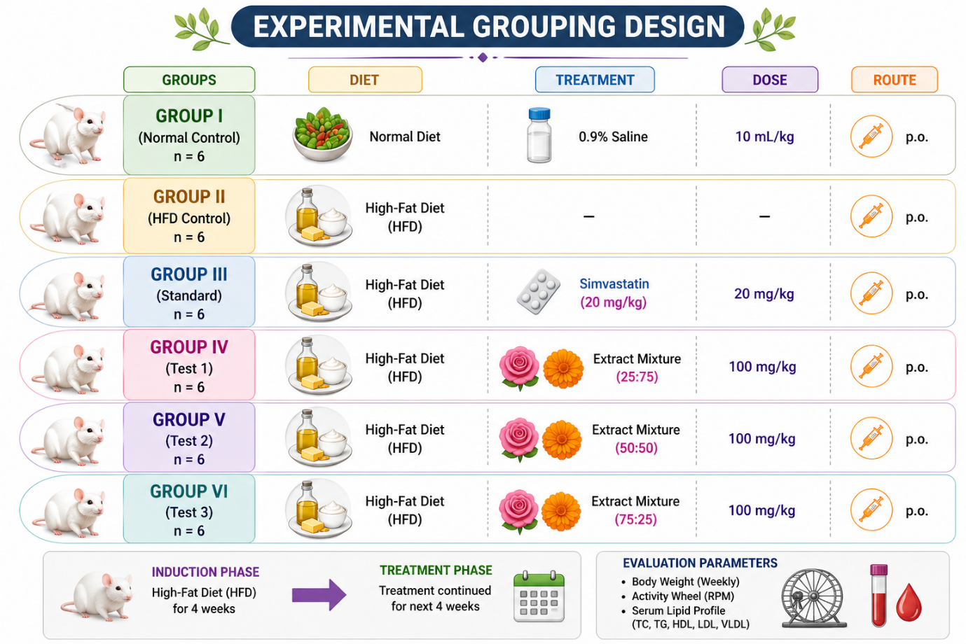

Figure 1. Experimental Design

Following induction (first 4 weeks), treatment was continued for an additional 4 weeks, while Group II continued on HFD without treatment.
Measurement of Body Weight
Body weights of all animals were recorded weekly throughout the experimental period to assess the effect of treatments on HFD-induced weight gain.
Behavioral Assessment Using Activity Wheel
Locomotor activity was assessed using an activity wheel apparatus. Each mouse was placed individually in the wheel (Perez-Jimenez J, et al., 2010), and the number of rotations per minute (RPM) was recorded. Reduced RPM was considered indicative of increased body weight and reduced physical performance, whereas improvement in RPM suggested recovery. Locomotor activity was assessed using an activity wheel apparatus. Each mouse was placed individually in the wheel, and the number of rotations was recorded for a period of 5 minutes, and expressed as rotations per minute (RPM).
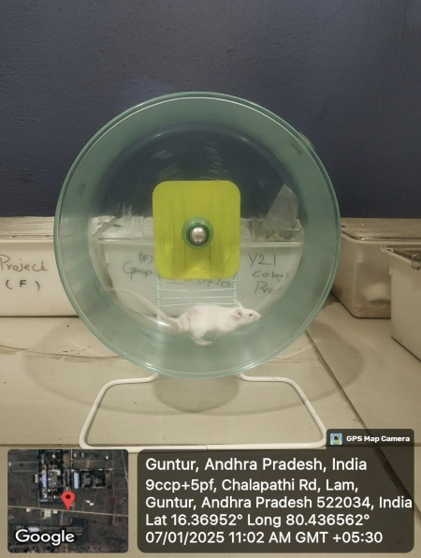
Fig: 2 Image of Activity Wheel
Biochemical Analysis (Serum Lipid Profile)
At the end of the experimental period, animals were fasted overnight and blood samples were collected via retro-orbital plexus/cardiac puncture under mild anesthesia (D’Archivio M, et al., 2010). Blood samples were allowed to clot and centrifuged to obtain serum.
The following parameters were estimated:
- Total Cholesterol (TC)
- Triglycerides (TG)
- High-Density Lipoprotein (HDL)
LDL and VLDL levels were calculated using standard equations.
Statistical Analysis
All data were expressed as mean ± SEM. Statistical analysis was performed using one-way ANOVA followed by Dunnett’s multiple comparison test to compare treated groups with HFD control (Rao AV, Rao LG, 2012). A value of p < 0.05 was considered statistically significant.
RESULTS AND DISCUSSION
Body weight was monitored at regular weekly intervals throughout the experimental period to evaluate the effect of high-fat diet (HFD) and subsequent treatments on metabolic status. An increase in body weight is a characteristic feature of HFD-induced hyperlipidemia, reflecting excessive lipid accumulation and altered energy metabolism (Kaulmann A, Bohn T, 2014). Therefore, tracking body weight serves as an important physical parameter to assess disease progression and therapeutic response.
In the present study, changes in body weight were recorded from baseline to the end of the treatment period. A progressive increase in body weight in HFD-fed animals indicates successful induction of hyperlipidemia (Preethi KC,Kuttan R, 2011), whereas stabilization or reduction in body weight following treatment suggests improvement in metabolic function. Thus, weekly body weight analysis provides supportive evidence for evaluating the anti-hyperlipidemic potential of the test formulations alongside biochemical and behavioral parameters.

Table No: 1 Weekly weight analysis of various treatment groups
Group | Treatment | Week 0 | Week 2 | Week 4 | Week 6 | Week 8
Group I | Normal Control | 26 ± 1 | 27 ± 1 | 27 ± 1 | 28 ± 1 | 28 ± 1
Group II | HFD Control | 26 ± 1 | 32 ± 2 | 40 ± 2 | 45 ± 2 | 48 ± 2***
Group III | Simvastatin | 26 ± 1 | 32 ± 2 | 39 ± 2 | 35 ± 2** | 31 ± 1***
Group IV | Test 1 (25:75) | 26 ± 1 | 32 ± 2 | 39 ± 2 | 37 ± 2* | 35 ± 2**
Group V | Test 2 (50:50) | 26 ± 1 | 32 ± 2 | 39 ± 2 | 36 ± 2** | 33 ± 2***
Group VI | Test 3 (75:25) | 26 ± 1 | 32 ± 2 | 39 ± 2 | 34 ± 2*** | 31 ± 1***

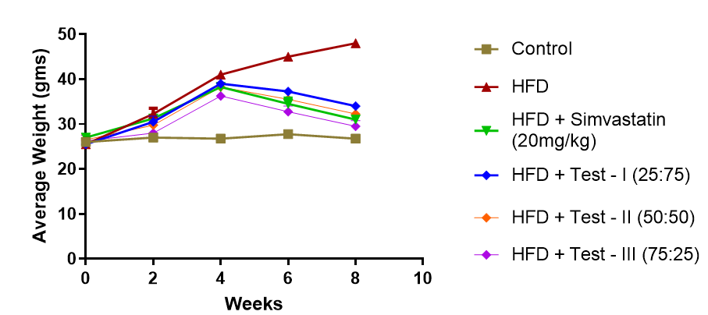
Figure 3: Graphical representation of weekly weight analysis of various treatment groups

Locomotor activity was assessed using an activity wheel apparatus to evaluate the functional impact of high-fat diet (HFD)-induced hyperlipidemia and the therapeutic effect of treatments. The number of rotations per minute (RPM) was recorded at regular intervals throughout the study. A decline in RPM in HFD-fed animals reflects reduced physical performance associated with increased body weight and metabolic disturbances (Gupta P, Vasudeva N, 2012). Conversely, improvement in RPM following treatment indicates enhanced mobility and possible recovery from hyperlipidemic conditions. The activity wheel data thus serves as a supportive behavioral parameter alongside biochemical estimations for assessing anti-hyperlipidemic activity.

Table No:2 Number of rotations in activity wheel for all treatment groups
Group | Treatment | Week 0 | Week 2 | Week 4 | Week 6 | Week 8
Group I | Normal Control | 45 ± 2 | 46 ± 2 | 45 ± 3 | 46 ± 2 | 47 ± 2
Group II | HFD Control | 44 ± 2 | 38 ± 3 | 30 ± 2 | 25 ± 2 | 20 ± 2***
Group III | Simvastatin | 45 ± 2 | 40 ± 2 | 35 ± 2 | 42 ± 2** | 48 ± 2***
Group IV | Test 1 (25:75) | 45 ± 2 | 39 ± 2 | 33 ± 2 | 36 ± 2* | 40 ± 2**
Group V | Test 2 (50:50) | 44 ± 2 | 40 ± 2 | 34 ± 2 | 38 ± 2** | 44 ± 2***
Group VI | Test 3 (75:25) | 45 ± 2 | 41 ± 2 | 36 ± 2 | 41 ± 2*** | 46 ± 2***

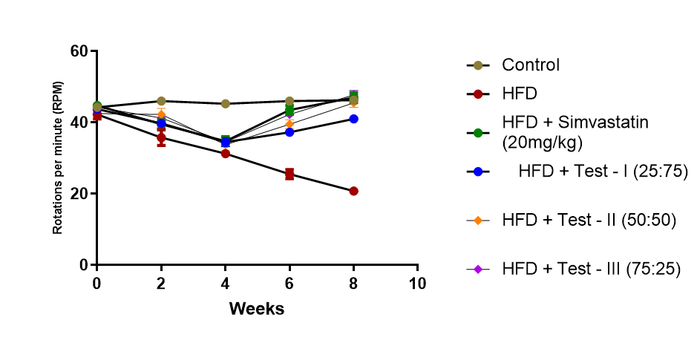
Figure 4: Graphical representation of rotations per minute in activity wheel for various treatment groups

Serum lipid profile is a key biochemical indicator for assessing the severity of hyperlipidemia and the efficacy of therapeutic interventions. Alterations in lipid parameters such as total cholesterol (TC), triglycerides (TG), high-density lipoprotein (HDL), and low-density lipoprotein (LDL) are directly associated with metabolic imbalance and increased cardiovascular risk (Kumar N, et al., 2013). High-fat diet (HFD) feeding is known to elevate TC, TG, and LDL levels while reducing HDL levels, thereby serving as a reliable model for inducing hyperlipidemia in experimental animals.
In the present study, serum lipid parameters were evaluated at the end of the experimental period to determine the effect of treatments on lipid metabolism. A significant elevation of TC, TG, and LDL along with a reduction in HDL in HFD-fed animals indicates successful induction of hyperlipidemia (Nowak R, et al., 2014). Conversely, normalization of these parameters following treatment reflects improvement in lipid homeostasis. Thus, serum lipid profile analysis provides crucial biochemical evidence supporting the anti-hyperlipidemic potential of the test formulations.

Table No: 3 Evaluation of Serum lipid profile for various treatment groups
Group | Treatment | Total Cholesterol (mg/dL) | Triglycerides (mg/dL) | HDL (mg/dL) | LDL (mg/dL)
Group I | Normal Control | 90 ± 5 | 80 ± 4 | 45 ± 3 | 30 ± 3
Group II | HFD Control | 180 ± 8*** | 160 ± 7*** | 25 ± 2*** | 120 ± 6***
Group III | Simvastatin | 100 ± 6*** | 90 ± 5*** | 42 ± 3*** | 40 ± 4***
Group IV | Test 1 (25:75) | 140 ± 7** | 130 ± 6** | 32 ± 2* | 80 ± 5**
Group V | Test 2 (50:50) | 120 ± 6*** | 110 ± 5*** | 36 ± 3** | 60 ± 4***
Group VI | Test 3 (75:25) | 105 ± 5*** | 95 ± 5*** | 40 ± 3*** | 45 ± 3***

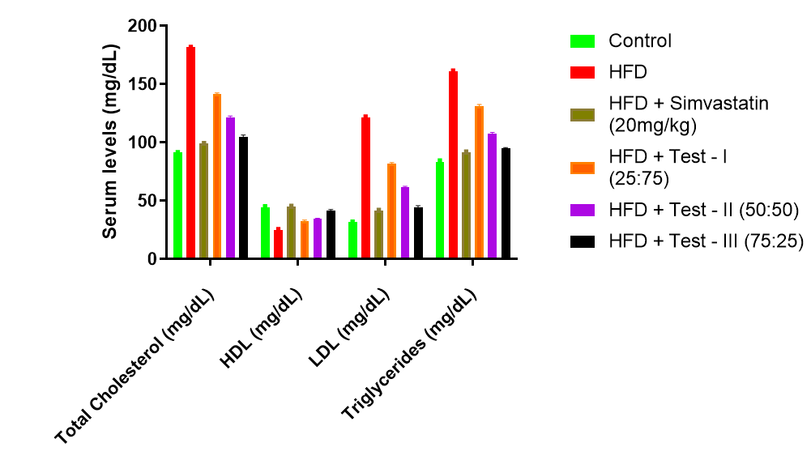

Figure 5: Representation of Serum lipid profile for various treatment groups
Discussion
In the present study, induction of hyperlipidemia using a high-fat diet (HFD) resulted in a significant and progressive increase in body weight compared to the normal control group. The HFD control group exhibited a marked elevation in body weight, reaching approximately 48 g by the end of the experimental period (Sharma B, et al., 2015), which clearly indicates excessive lipid accumulation and altered energy homeostasis. This increase in body weight is consistent with previous reports, where HFD consumption leads to enhanced lipogenesis, reduced lipid utilization, and adipose tissue expansion.
Statistical analysis using one-way ANOVA followed by Dunnett’s multiple comparison test revealed that the increase in body weight in the HFD control group was highly significant (p < 0.001) when compared to the normal control group (Eddouks M, et al., 2013). This confirms the successful establishment of diet-induced obesity and associated metabolic disturbances.
Treatment with the standard drug, Simvastatin, produced a significant reduction in body weight from week 6 onwards, with final body weight values reduced to approximately 31 g. This reduction was statistically highly significant (p < 0.001) compared to the HFD control group. The observed effect may be attributed to the ability of simvastatin to modulate lipid metabolism, reduce cholesterol synthesis (Bahadoran Z, et al., 2013), and improve overall metabolic efficiency.
Among the test groups, administration of combined ethanolic extracts showed a significant attenuation of HFD-induced weight gain. All treatment groups demonstrated a gradual reduction in body weight during the treatment phase (weeks 5–8), indicating a reversal of metabolic alterations induced by HFD (Siti HN, et al., 2015). The effects were found to be statistically significant, with the degree of significance varying among the different ratios.
The 75:25 combination (Group VI) exhibited the most pronounced reduction in body weight, reaching values comparable to the standard-treated group (≈31 g), with high statistical significance (p < 0.001). The 50:50 combination (Group V) showed moderate efficacy (p < 0.01 to p < 0.001), while the 25:75 combination (Group IV) demonstrated a comparatively lesser but still significant effect (p < 0.05 to p < 0.01). This clearly indicates a ratio-dependent response (Madamanchi NR, Runge MS, 2013), suggesting that a higher proportion of Rosa spp. extract may contribute more effectively to the observed anti-obesity and lipid-lowering effects.
The reduction in body weight observed in treated groups may be attributed to the presence of bioactive phytoconstituents such as flavonoids, phenolic compounds, and carotenoids present in Rosa spp. and Tagetes erecta (Srinivasan K, 2014). These compounds are known to exert anti-obesity effects by inhibiting lipid accumulation, enhancing fatty acid oxidation, and improving metabolic rate. Additionally, antioxidant properties of these phytochemicals may reduce oxidative stress, which plays a key role in the progression of obesity and hyperlipidemia.
Furthermore, the observed reduction in body weight showed a strong positive correlation with improvements in locomotor activity (RPM) and normalization of serum lipid profile, indicating an overall improvement in metabolic health (Kumar S, Pandey AK, 2013). The decrease in body weight likely contributed to reduced physical burden, thereby enhancing activity levels, while also reflecting improved lipid metabolism.
Administration of the combined ethanolic extracts also resulted in a significant improvement in activity wheel performance across all test groups (Vogel HG, 2015). The increase in RPM was progressive during the treatment phase and statistically significant compared to the HFD control group. Among the formulations, the 75:25 combination (Group VI) demonstrated the most pronounced effect, showing highly significant improvement (p < 0.001) and RPM values comparable to the standard-treated group (Althaher AR, et al., 2014). The 50:50 combination (Group V) exhibited moderate improvement (p < 0.01 to p < 0.001), while the 25:75 combination (Group IV) showed a comparatively lesser but still significant increase in activity (p < 0.05 to p < 0.01).
The observed improvement in locomotor activity can be attributed to the presence of bioactive phytoconstituents in Rosa spp. and Tagetes erecta, including flavonoids, phenolics, and carotenoids (Si L, et al., 2025). These compounds are known to enhance mitochondrial function, promote fatty acid oxidation, and improve energy metabolism, thereby reducing fatigue and increasing physical activity. Additionally, their antioxidant properties may mitigate oxidative stress associated with HFD-induced metabolic dysfunction, further contributing to improved locomotor performance.
A strong inverse relationship was observed between body weight and locomotor activity, wherein animals with higher body weight exhibited lower RPM values (Bunmee P, et al., 2013). Conversely, reduction in body weight following treatment was associated with a significant improvement in activity levels. This correlation suggests that the enhancement in locomotor activity is not only a behavioral outcome but also a reflection of improved metabolic efficiency.
Alterations in serum lipid parameters are central to the pathogenesis of hyperlipidemia and its associated cardiovascular complications. In the present study, administration of a high-fat diet (HFD) resulted in a significant elevation of total cholesterol (TC), triglycerides (TG), and low-density lipoprotein (LDL), along with a marked reduction in high-density lipoprotein (HDL) levels. These changes were found to be highly significant (p < 0.001) when compared to the normal control group, confirming the successful induction of hyperlipidemia.
The observed dyslipidemia in the HFD control group may be attributed to increased intestinal absorption of lipids, enhanced hepatic cholesterol synthesis, and impaired clearance of circulating lipoproteins (Gupta S, Surendra G, 2026). Elevated LDL and TG levels are known to promote lipid accumulation in tissues and contribute to atherogenesis, while reduced HDL levels impair reverse cholesterol transport, further exacerbating lipid imbalance.
Treatment with the standard drug, Simvastatin, significantly improved all lipid parameters. A marked reduction in TC, TG, and LDL levels, along with a significant increase in HDL levels, was observed (p < 0.001 vs HFD control). This effect can be attributed to inhibition of HMG-CoA reductase, leading to decreased cholesterol synthesis and improved lipid metabolism.
Among the test groups, administration of combined ethanolic extracts resulted in a significant and dose-ratio dependent improvement in serum lipid profile (Puspitasari SD, Tukiran T, 2026). All formulations demonstrated a reduction in TC, TG, and LDL levels, along with an increase in HDL levels compared to the HFD control group. The 75:25 combination (Group VI) exhibited the most pronounced effect, with highly significant changes (p < 0.001) and lipid values approaching those of the standard-treated group. The 50:50 combination (Group V) showed moderate efficacy (p < 0.01 to p < 0.001), while the 25:75 combination (Group IV) demonstrated comparatively lesser but still significant improvement (p < 0.05 to p < 0.01).
The lipid-lowering effects of the polyherbal extracts may be attributed to the presence of bioactive phytoconstituents such as flavonoids, phenolic compounds, and carotenoids present in Rosa spp. and Tagetes erecta (Kumar N, et al., 2022). These compounds are known to exert hypolipidemic effects through multiple mechanisms, including inhibition of cholesterol biosynthesis, enhancement of lipoprotein lipase activity, increased bile acid excretion, and promotion of reverse cholesterol transport. Additionally, their antioxidant properties help in reducing oxidative stress and preventing lipid peroxidation, which plays a crucial role in the progression of hyperlipidemia and associated disorders.

CONCLUSION
The present study demonstrates that combined ethanolic extracts of Rosa spp. petals and Tagetes erecta flowers exhibit significant anti-hyperlipidemic activity in high-fat diet-induced mice. Treatment effectively improved body weight, locomotor activity, and serum lipid profile, comparable to the standard drug, Simvastatin. Among the tested formulations, the 75:25 ratio showed the highest efficacy, suggesting a potential synergistic effect of the phytoconstituents. These findings support the potential of the polyherbal combination as a natural therapeutic option for managing hyperlipidemia. Further studies are required to confirm its mechanism and clinical applicability.

COMPETING INTERESTS DISCLAIMER:
Authors have declared that they have no known competing financial interests OR non-financial interests OR personal relationships that could have appeared to influence the work reported in this paper.

REFERENCES
- Althaher AR, Alwahsh M, Hasan A, Al-Majali D, Awadallah MW, Al-Qirim T. Anti-hyperlipidemic effect of Ruta chalepensis ethanolic extract in Triton-induced hyperlipidemia in rats. Appl Sci. 2024;14(19):9017.
- Bahadoran Z, et al. Plant-based diets and lipid profile. Nutrients. 2013;5(3):911–23.
- Buettner R, Scholmerich J, Bollheimer LC. High-fat diets: modeling obesity in rodents. Obesity. 2012;20(1):1–8.
- Bunmee P, et al. Clinical and biological efficacy of Thai herbal formulation in lipid lowering. Front Pharmacol. 2025.
- D’Archivio M, et al. Polyphenols and lipid metabolism. Nutrients. 2010;2(9):1041–63.
- Eddouks M, et al. Medicinal plants and metabolic disorders. J Ethnopharmacol. 2012;140(3):594–601.
- Endo A. A historical perspective on statins. Nat Rev Cardiol. 2010;7(8):455–60.
- Ference BA, et al. LDL cholesterol and cardiovascular risk. J Am Coll Cardiol. 2017;69(24):2829–41.
- Gupta P, Vasudeva N. Pharmacological potential of Tagetes erecta. Int J Pharm Sci Drug Res. 2012;4(1):1–6.
- Gupta S, Surendra G. Anti-hyperlipidemic activity of Capparis decidua flower extract in HFD rats. Int J Drug Deliv Technol. 2026.
- Hariri N, Thibault L. High-fat diet-induced obesity in animal models. Nutr Res Rev. 2010;23(2):270–99.
- Istvan ES. Mechanism of statin action. Trends Biochem Sci. 2011;36(2):66–71.
- Kaulmann A, Bohn T. Carotenoids and cardiovascular health. Nutr Res. 2014;34(11):907–29.
- Kopelman PG. Obesity and cardiovascular disease. Nat Rev Cardiol. 2010;7(8):475–84.
- Kumar N, et al. Anti-hyperlipidemic activity of Impatiens balsamina extract in dexamethasone-induced rats. Indian J Pharm Sci. 2022.
- Kumar N, et al. Antioxidant activity of Rosa species. Ind Crops Prod. 2013;50:336–42.
- Kumar S, Pandey AK. Chemistry and pharmacology of flavonoids. Sci World J. 2013;2013:162750.
- Mach F, et al. ESC/EAS guidelines for dyslipidemia. Eur Heart J. 2019;41(1):111–88.
- Madamanchi NR, Runge MS. Mitochondrial dysfunction in obesity. Circ Res. 2013;113(4):460–72.
- Nowak R, et al. Phenolic compounds in Rosa species. Molecules. 2014;19(9):14035–52.
- Panchal SK, Brown L. Rodent models of metabolic syndrome. J Biomed Biotechnol. 2011;2011:351982.
- Perez-Jiménez J, et al. Bioavailability of polyphenols. Am J Clin Nutr. 2010;91(5):1545S–51S.
- Preethi KC, Kuttan R. Anti-inflammatory activity of Tagetes erecta. J Basic Clin Physiol Pharmacol. 2011;22(3):119–23.
- Puspitasari SD, Tukiran T. Anti-hyperlipidemic activity of Amaranthus tricolor and Syzygium polyanthum extracts. Res J Pharm Technol. 2026.
- Rao AV, Rao LG. Carotenoids and lipid metabolism. Pharmacol Res. 2012;65(4):432–40.
- Rosenson RS, et al. Lipid management guidelines update. J Am Coll Cardiol. 2020;75(20):2458–73.
- Sharma B, et al. Role of flavonoids in lipid metabolism. J Pharm Pharmacol. 2015;67(3):325–38.
- Si L, et al. Anti-hyperlipidemic effects of Apocynum venetum leaves via AMPK/SREBP pathway. Food Chem. 2025.
- Siti HN, et al. Oxidative stress and hyperlipidemia. Front Pharmacol. 2015;6:83.
- Speakman JR. Use of animal models in obesity research. Dis Model Mech. 2013;6(1):8–12.
- Srinivasan K. Plant foods in lipid lowering. J Food Sci Technol. 2014;51(10):1919–28.
- Vogel HG. Drug discovery and evaluation: pharmacological assays. 4th ed. Springer; 2015.

