Utility of Sanger Sequencer based Fragment Analysis for sex identification in Vultures

Abstract:
Background:
Accurate sex determination is fundamental to avian ecology, conservation genetics, and ex-situ breeding programs. Sex differentiation is altogether difficult among monomorphic bird species owing to high resemblance and limited morphological distinguishing features. Molecular methods are the last resort as morphological and behavioural traits fail to distinguish sexes in monomorphic species.
Aim:
Utility of Sanger Sequencer based Fragment Analysis for sex identification in Vultures
Methods:
The ZW-ZZ sex determination pattern in aves provides an opportunity to utilise the CHD (Chromodomain Helicase DNA-binding) gene as a reliable marker for the sex determination of birds. In this study, fluorescently labelled P2–P8 primers were used to amplify the CHD gene in Indian Vultures (Gyps indicus) and White-rumped Vultures (Gyps bengalensis) to identify the sex and were resolved by Capillary Gel Electrophoresis (CGE) on a Sanger Sequencer.
Results:
The males (ZZ); whereas females (ZW) sex chromosome composition. The limit of resolution of the Agarose Gel Electrophoresis (AGE) is 10 bp, and in certain species of monomorphic birds, the existing slender difference between the CHD-Z & CHD-W is beyond the resolution capacity of the AGE. The conventional PCR-AGE failed to allocate sex identities to birds, whereas the Sanger Sequencer-based fragment analysis identified the CHD-Z and CHD-W fragments sized at 381.09 ± 0.04 bp and 385.75 ± 0.06 bp, respectively, revealing a 4 bp difference sufficient for accurate sexing. Males displayed a single CHD-Z peak, while females exhibited both peaks. The assay’s precision was further validated in Sarus Crane (Grus antigone) and Common Crane (Grus grus) samples, where a 1 bp difference between fragments was successfully resolved.
Conclusion:
The Sanger-based CGE fragment analysis is a robust, sensitive and high-throughput approach for sexing in birds, with significant implications for conservation breeding and population management.

Key Words: Fragment analysis, P2-P8 primers, Sanger sequencer, sex identification, Vulture.

Introduction
Avifauna is known to have inspired humanity through its diversity and complex ecological roles. The services they render make them an important indicator of ecosystem health. However, in recent years, numerous avian populations have faced significant declines, largely attributed to escalating anthropogenic pressures. In South Asia, and particularly in India, habitat loss poses a major threat to wild bird populations (Sodhi & Brook, 2006). Deforestation, pollution, forest fires and rapid infrastructure development have collectively driven the local extinction of several bird species (Okorondu et al., 2022). In India, the last decade has seen a sharp decline in many bird species, including the Great Indian Bustard, Vultures, and lesser florican, to name a few. Vultures, in particular, are ecologically indispensable as scavengers and are recognised as flagship species for conservation in South Asia. Once numbering in millions, the vulture population has declined rapidly in the past few decades. Diclofenac, an NSAID (Non-steroidal Anti-inflammatory Drug), has been attributed to have caused a decline of vultures by 90% (Cuthbert et al., 2007; Galligan et al., 2021). A second school of thought attributed it to avian malaria among the vultures as a cause of rapid population decline (Poharkar et al., 2009). Recent detection of H5N1 in vulture has raised concerns among conservation workers. In response, multiple conservation strategies, including ex-situ conservation through captive breeding and reintroduction programs, have been initiated by both governmental and non-governmental organizations. The success of these programs critically depends on the appropriate procurement, sex identification, and scientific management of individual birds.
Sex identification forms the fundamental basis for avian research, conservation breeding and reintroduction initiatives. In monomorphic bird species, due to the unambiguous resemblance between the male and the female birds, molecular sex identification becomes obligatory. Unlike mammals, which follow a XY-XX sex determination system; birds have a unique ZW-ZZ sex determination system wherein the males (ZZ) are homogametic, while the females (ZW) are heterogametic. Molecular methods target regions of the sex chromosomes to detect the sex in birds. CHD is a marker widely used for sex identification in birds (Ellegren, 2000; Griffiths et al., 1998). Using the PCR assay targeting the CHD gene that is present on both the Z and W chromosomes, amplicons are generated using the PCR assay and resolved using AGE (Fridolfsson & Ellegren, 1999; Vucicevic et al., 2013). The CHD-Z and CHD-W fragments may vary from fifty base pairs to a single base pair among different species of birds. Among monomorphic birds, the CHD fragments differ from 20 bp to a single base pair; the resolution using 3% AGE may be overwhelming (Morinha et al., 2012). The poor resolution at times provides only one band and leads to misidentification of the sex of individual birds.
Capillary Gel Electrophoresis (CGE) in conjunction with the Sanger sequencer has emerged as an important tool for the detection of marked DNA fragments (Sanger et al., 1977). The Fragment analysis tools on-board modern Sanger sequencers like ABI 3500 provide sensitive and accurate detection of fragments, enabling sensitive and reproducible resolution of fragments that differ even by 1 base pair. Considering the opportunity, an assay with marked primers was developed and validated for the sex determination of vultures using the fragment analysis tool on a Sanger sequencer. The study seeks to establish a scalable model for sex identification, especially in monomorphic birds.

Materials and Methods
1. Sample Collection:
With the prior permission and request from the authorities identified in Wildlife Protection Act, 1972 blood and cloacal samples were collected from vultures under the project ‘Jatayu’ aimed at reintroduction of vultures in the natural habitat in the state of Maharashtra, India. A total of fifty six samples were collected from Indian Vultures (Gyps indicus, n=20) and White-rumped Vultures (Gyps bengalensis, n=36). Detailed of the samples collected under the study are provided under Table 1. All the sample collection procedures were carried out using aseptic technique and adhered to the ethical guidelines. The vultures were physically restrained and approximately 4 ml blood was drawn from the vultures following aseptic technique from the medial metatarsal vein using 23G scalp. The blood was transferred to EDTA vacutainers and shipped to the lab in a cool box. Blood samples from sarus cranes (Grus Antigone, n=2) and common cranes (Grus grus, n=2) were collected from Balasaheb Thackeray Gorewada International Zoological Park, Nagpur for the identification of the sex.
2. Sample Transport and Storage:
Blood samples were stored on ice and transported in cold condition to the lab within 4 hours of the collection. The samples were immediately processed on receipt in the lab to ensure DNA integrity.
3. DNA Extraction and Quantification: Genomic DNA was extracted from 10 µL of whole blood using the DNeasy Blood and Tissue Kit (Mfg. Qiagen, Germany) following the manufacturer’s standard protocol for nucleated blood. The concentration and purity of the extracted DNA were measured using a Qubit 4 Fluorometer (Mfg. Thermo Fisher Scientific, USA) with the dsDNA HS Assay Kit.
4. PCR Amplification for Sex Determination: Sex determination was carried out using a molecular marker approach targeting the Chromodomain-Helicase-DNA-binding 1 (CHD1) gene, a sex-linked gene found on both Z and W chromosomes. The primer pair P2 (5′-TCTGCATCGCTAAATCCTTT-3′) and P8 (5′-CTCCCAAGGATGAGRAAYTG-3′), as described by Griffiths et al. (1998), was used for the conventional PCR approach. For fragment analysis approach, the forward primer (P2) was labelled with a fluorescent dye (6-FAM) to enable downstream fragment analysis. In both cases, PCR was performed in a 20 µL reaction volume containing approximately 2 ng of genomic DNA, 25 pM of each primer (P2 and P8), 10 µL of 2× PCR Master Mix (including Taq DNA polymerase, 1.5 mM MgCl₂, and 200 µM of each dNTP; Thermo Scientific), and nuclease-free water to adjust the final volume. Amplification was carried out in a Veriflex® thermal cycler (Mfg. Applied Biosystems) with the following conditions: initial denaturation at 94°C for 5 minutes; followed by 35 cycles of denaturation at 94°C for 30 seconds, annealing at 50°C for 30 seconds, and extension at 72°C for 30 seconds; concluding with a final extension at 72°C for 10 minutes and a hold at 4°C.
5. Gel Electrophoresis and Visualization: Conventional PCR products were initially resolved on a 3% high-resolution agarose gel prepared in 1× TBE buffer. Gels were stained with ethidium bromide and run at 100 V for 90 minutes. Visualization was performed under a gel documentation system to confirm amplification and estimate fragment sizes.
6. Fragment Analysis and Sex Identification: For precise fragment size determination, fluorescently labelled PCR products were subjected to capillary electrophoresis using a Sanger DNA sequencer (e.g., ABI 3500 Genetic Analyzer). LIS 460 a fluorescent size marker was used for accurate sizing. Output chromatograms were analyzed using GeneMapper® (Mfg. Applied Biosystems) software to distinguish between male and female genotypes based on fragment sizes.
7. Statistical Analysis and Documentation:
Data were analyzed using standard statistical tests, including t-tests for comparison of CHD fragment sizes. Descriptive statistics (mean, standard deviation, range, and standard error) were computed, and results were documented systematically for interpretation and presentation.
Results:
Sr. No. | Code | Species | Origin | Blood/  Tissue | DNA Conc. (ng/µl) | P2-P8 method with AGE | Detection by Fragment Analysis (P2-P8 method) |  | Sex ID
 |  |  |  |  |  |  | Fragment 1 | Fragment 2 | Sex ID
1 | V-1 | Indian Vulture | Gondia | Blood | 12 | UD | 381.13 | 385.88 | Female
2 | V-2 | Indian Vulture | Gondia | Blood | Too high | UD | 381.13 | 385.92 | Female
3 | V-3 | Indian Vulture | Gondia | Blood | 0.526 | UD | 381.05 | --- | Male
4 | V-16 | Indian Vulture | Pench | Blood | 11.6 | UD | 381 | 385.87 | Female
5 | V-17 | Indian Vulture | Pench | Blood | 1.6 | UD | 381.26 | --- | Male
6 | V-19 | Indian Vulture | Pench | Blood | 0.984 | UD | 381.74 | --- | Male
7 | V-20 | Indian Vulture | Pench | Blood | 0.634 | UD | 381.14 | 385.96 | Female
8 | V-21 | Indian Vulture | Pench | Blood | 12 | UD | 381.17 | 385.98 | Female
9 | V-22 | Indian Vulture | Pench | Blood | Too high | UD | 381.27 | --- | Male
10 | V-23 | Indian Vulture | Pench | Blood | 11.8 | UD | 381.27 | --- | Male
11 | V-24 | Indian Vulture | Pench | Blood | 10.8 | UD | 381.15 | --- | Male
12 | V-25 | Indian Vulture | Pench | Blood | Too high | UD | 381.15 | 385.99 | Female
13 | V-31* | Indian Vulture | Sadar police case | Lung DNA | 1.28 | UD | 381.27 | 386.08 | Female
14 | V-34* | Indian Vulture | TTC Chandrapur | Liver DNA | 12 | UD | 381.28 | --- | Male
15 | Z33 | White Rumped Vulture | Pench | Blood | 2.30 | UD | 381.06 | --- | Male
16 | N14 | White Rumped Vulture | Pench | Blood | 18.2 | UD | 381.18 | 385.96 | Female
17 | N19 | White Rumped Vulture | Pench | Blood | Too high | UD | 381.14 | 385.97 | Female
18 | N37 | White Rumped Vulture | Pench | Blood | 6.14 | UD | 381 | --- | Male
19 | N45 | White Rumped Vulture | Pench | Blood | 2.30 | UD | 381.06 | 385.97 | Female
20 | N76 | White Rumped Vulture | Pench | Blood | 22.1 | UD | 381.03 | --- | Male
21 | J101 | White Rumped Vulture | Pench | Blood | Too high | UD | 380.89 | --- | Male
22 | J102 | White Rumped Vulture | Pench | Blood | 10.23 | UD | 380.96 | 386.49 | Female
23 | J103 | White Rumped Vulture | Pench | Blood | 4.3 | UD | 381.05 | --- | Male
24 | F45 | Indian Vulture | Pench | Blood | Too high | UD | 380.95 | 385.77 | Female
25 | F22 | Indian Vulture | Pench | Blood | 8.60 | UD | 380.95 | 385.74 | Female
26 | XX82 | Indian Vulture | Pench | Blood | 5.5 | UD | 381.10 | 385.63 | Female
27 | X97 | Indian Vulture | Pench | Blood | 0.52 | UD | 381.0 | --- | Male
28 | E98 | Indian Vulture | Pench | Blood | Too high | UD | 381.18 | --- | Male
29 | XX72 | Indian Vulture | Pench | Blood | 0.89 | UD | 381.10 | 385.77 | Female
30 | V-14 | White Rumped Vulture | Pench | Cloacal Swab | 20.22 | UD | 381.22 | --- | Male
31 | V-11 | White Rumped Vulture | Pench | Cloacal Swab | 18.03 | UD | 381.09 | --- | Male
32 | V-10 | White Rumped Vulture | Pench | Cloacal Swab | 14.02 | UD | 381.11 | 385.89 | Female
33 | V-9 | White Rumped Vulture | Pench | Cloacal Swab | 9.12 | UD | 381.47 | --- | Male
34 | V-8 | White Rumped Vulture | Pench | Cloacal Swab | 14.32 | UD | 381.06 | 386.29 | Female
35 | V-6 | White Rumped Vulture | Pench | Cloacal Swab | 12.0 | UD | 381.47 | --- | Male
36 | V-35 | White Rumped Vulture | Pench | Cloacal Swab | 14.32 | UD | 381.11 | 386.08 | Female
37 | V-36 | White Rumped Vulture | Pench | Cloacal Swab | 12.0 | UD | 381.47 | 386.22 | Female
38 | V-37 | White Rumped Vulture | Pench | Cloacal Swab | 14.32 | UD | 381.06 | 385.89 | Female
39 | V-38 | White Rumped Vulture | Pench | Cloacal Swab | 12.0 | UD | 381.22 | 386.19 | Female
40 | V-39 | White Rumped Vulture | Pench | Cloacal Swab | 14.32 | UD | 381.06 | --- | Male
41 | V-40 | White Rumped Vulture | Pench | Cloacal Swab | 12.0 | UD | 381.45 | --- | Male
42 | X-67 | White Rumped Vulture | Melghat | Blood | 16.3 | UD | 380.58 | 384.38 | Female
43 | Z-21 | White Rumped Vulture | Melghat | Blood | Too high | UD | 381.63 | --- | Male
44 | E-96 | White Rumped Vulture | Melghat | Blood | 8.0 | UD | 380.59 | --- | Male
45 | X-74 | White Rumped Vulture | Melghat | Blood | 11.2 | UD | 380.60 | --- | Male
46 | Z-29 | White Rumped Vulture | Melghat | Blood | 28.3 | UD | 380.14 | --- | Male
47 | F-12 | White Rumped Vulture | Melghat | Blood | Too high | UD | 381.33 | 384.85 | Female
48 | X-94 | White Rumped Vulture | Melghat | Blood | 7.0 | UD | 381.63 | 385.05 | Female
49 | X-52 | White Rumped Vulture | Melghat | Blood | 34.1 | UD | 380.71 | --- | Male
50 | Z-16 | White Rumped Vulture | Melghat | Blood | 14.0 | UD | 381.62 | --- | Male
51 | X-65 | White Rumped Vulture | Melghat | Blood | 27.6 | UD | 380.59 | --- | Male
52 | X-54 | White Rumped Vulture | Melghat | Blood | 22.8 | UD | 380.74 | --- | Male
53 | F-16 | White Rumped Vulture | Melghat | Blood | Too high | UD | 380.89 | --- | Male
54 | X-64 | White Rumped Vulture | Melghat | Blood | 27.8 | UD | 380.59 | --- | Male
55 | X-59 | White Rumped Vulture | Melghat | Blood | 23.1 | UD | 380.74 | 384.45 | Female
56 | F-14 | White Rumped Vulture | Melghat | Blood | 26.7 | UD | 380.74 | 385.15 | Female
57 | SC-1 | Sarus Crane | BTGIZP | Blood | Too high | UD | 380.63 | --- | Male
58 | SC-2 | Sarus Crane | BTGIZP | Blood | Too high | UD | 379.25 | 380.75 | Female
59 | E0881 | Common Crane | BTGIZP | Blood | Too high | UD | 383.75 | 384.75 | Female
60 | E0401 | Common Crane | BTGIZP | Blood | Too high | UD | 383.73 | 384.72 | Female
Table 1: Results of Molecular Sex Identification in Vultures and Cranes Using labelled P2–P8 Primer-Based PCR Fragment Analysis on Sanger Sequencer (Applied Biosystems 3500 Genetic Analyzer).

This table summarizes species-wise molecular sexing results based on DNA extracted from blood, tissue, and cloacal swab samples. The amplification was initially assessed by agarose gel electrophoresis (AGE), and confirmed by capillary electrophoresis (fragment analysis). Two distinct fragments indicate a female (ZW), and a single fragment indicates a male (ZZ).
(UD = Undetermined; BTGIZP= Balasaheb Thackeray Gorewada International Zoological Park, Nagpur; *= PM sample’, Pench = Pench Tiger Reserve, Maharashtra; Melghat = Melghat Tiger Reserve, Amravati, Maharashtra)

Parameter | Indian Vulture (Gyps indicus) | White-rumped Vulture (Gyps bengalensis) | Overall (Both species)
Total samples analyzed | 20 | 36 | 56
Mean DNA concentration (ng/µl) | 8.9 ± 7.6  (range 0.52–28.3)* | 15.8 ± 9.3  (range 0.52–34.1)* | —
Sex identified (n) | Female = 11 (55%)  Male = 9 (45%) | Female = 15 (42%)  Male = 21 (58%) | Female = 26  Male = 30
Sex ratio (M : F) | 0.82 : 1 | 1.4 : 1 | 1.15 : 1
Fragment 1 (CHD-Z) mean ± SD (bp) | 381.16 ± 0.17 | 381.04 ± 0.35 | 381.09 ± 0.29
Fragment 1 range (bp) | 380.95 – 381.74 | 380.14 – 381.63 | 380.14 – 381.74
Fragment 1 Mean ± SE (bp) | 381.16 ± 0.04 | 381.04 ± 0.06 | 381.09 ± 0.04
Fragment 2 (CHD-W) mean ± SD (bp) | 385.87 ± 0.13 | 385.66 ± 0.69 | 385.75 ± 0.46
Fragment 2 range (bp) | 385.63 – 386.08 | 384.38 – 386.49 | 384.38 – 386.49
Fragment 2 Mean ± SE (bp) | 385.87 ± 0.03 | 385.66 ± 0.11 | 385.75 ± 0.06
T-test (Fragment 1) | t = 1.86, p = 0.068 | — | NS
T-test (Fragment 2) | t = 1.19, p = 0.253 | — | NS

Table 2: Summary statistics of CHD (P2–P8) fragment analysis in Indian Vulture (Gyps indicus) and White-rumped Vulture (Gyps bengalensis)

The initial quality control assessment using Qubit based quantification proved that the extracted DNA was of good quality and quantity. As the DNA concentrations were found to be considerably high, the samples were diluted between 1:10 to 1:30 to have a final concentration of 2 ng / µl. The conventional PCR followed by Agarose Gel Electrophoresis (AGE) failed to resolve the CHD-Z and CHD-W fragments, resulting into a single band of approximately 400 bp in all the samples. Also, two non-specific bands were noticed (Fig. 1). In contrast, fragment analysis performed on Sanger sequencer clearly resolved two distinct peaks in female samples (corresponding to CHD-W and CHD-Z), whereas male samples consistently produced (CHD-Z) peaks. The fragment sizes corresponding to CHD-Z and CHD-W were determined to be 381.09 ± 0.04 bp and 385.75 ± 0.06 bp (Mean ± SE), respectively, indicating a size difference of approximately 4 bp between the two fragments (Fig. 2 & 3). Additionally, samples from two sarus cranes and two common cranes provided by the Balasaheb Thackeray Gorewada International Zoological Park, Nagpur, were successfully sexed, as summarized in Table 1 (Fig. 4).
Analysis of CHD gene fragments revealed that the mean size of the CHD-Z fragment (Fragment 1) was 381.16 ± 0.17 bp for G. indicus (range = 380.95–381.74 bp) and 381.04 ± 0.35 bp for G. bengalensis (range = 380.14–381.63 bp), with an overall mean of 381.09 ± 0.29 bp. The mean size of the CHD-W fragment (Fragment 2) was 385.87 ± 0.13 bp for G. indicus (range = 385.63–386.08 bp) and 385.66 ± 0.69 bp for G. bengalensis (range = 384.38–386.49 bp), with an overall mean of 385.75 ± 0.46 bp. Statistical analysis using the independent t-test showed no significant difference in fragment sizes between the two species for either CHD-Z (t = 1.86, p = 0.068) or CHD-W (t = 1.19, p = 0.253) fragments (Table 2).
Discussion:
Sex identification and an optimum sex ratio are crucial in the conservation breeding of endangered wildlife. Vulture population declines across south-east Asia has been a great concern from wildlife conservation point of view. The sex identification in the monomorphic bird species is greatly dependent on the utilisation of PCR based assay. P2-P8 primers have been widely used in the sex identification in an array of bird species including wild birds (García et al., 2009; Fridolfsson & Ellegren, 1999; Vucicevic et al., 2013; Purwaningrum et al., 2019; Dawson et al., 2001; Griffiths et al., 1996). In monomorphic birds the CHD-Z and CHD-W fragment that is generated by the above primer pair differs in size from each other by a few base pairs. Sometimes the difference is only a few base pair and thus downstream AGE using ethidium bromide may not be able to resolve the bands. While polyacrylamide gel electrophoresis (PAGE) can provide higher resolution, it remains labour-intensive, requires toxic reagents, and demands specialized infrastructure. Under such circumstances the CGE is a very powerful, reproducible and efficient tool for accurate sex identification in birds. In conjunction with Sanger sequencer’s Fragment analysis tool, CHD fragment differing by as much as 1 base pair can be easily resolved.
In the current study, the reliability of the Sanger-based fragment analysis system was evaluated using samples from Indian Vulture (Gyps indicus) and White-rumped Vulture (Gyps bengalensis). The species is under tremendous threat due to anthropogenic activities and habitat loss. In a conservation breeding programme underway in various parts of Maharashtra, India under project ‘Jatayu’, efforts were made to detect the sex ratio in the flocks of vultures. The conventional PCR-AGE failed to resolve the sex of the birds. Further investigation pointed out the narrow difference between the CHDZ & CHDW fragments. Hence a Sanger based approach was employed to identify the sex in these bird species. The approach screened fifty-six birds and it was found that sex identification was achieved in all the samples. The overall male: female ratio in the screened population was found to be 1.15:1, indicating a slight male bias. The CHD-Z fragment exhibited mean size of 381.16±0.17bp and 381.04±0.35 bp for G. indicus and G. bengalensis, respectively. The CHD-W fragment measured 385.87±0.13 bp and 385.66±0.69 bp. The size variation between species for both fragments was minimal and statistically non-significant (p>0.05). These findings confirm the reliability and reproducibility of the Sanger based approach for sex identification of birds having a negligible difference between the amplified fragments. An alternative approach would also be targeting the genes located W chromosome for the identification of sex in birds. A few primers targeting the CHD gene located on the W chromosome (Ellegren, 1996; van der Velde et al., 2017; Liu et al., 2011; Chang et al., 2008). The approach circumvents the size difference limitation of the CHD primers; however, failure of amplification due to technical errors, poor quality or degraded DNA may lead to the misidentification of the individual as a male. In contrast, the CHD approach has a built in confirmation of reaction success that has been widely validated across diverse avian taxa including raptors and vultures (Vucicevic et al., 2013). CHD primers like P2/P8, 2550F/2718R is highly conserved and widely standardised (Griffiths et al., 1998; Fridolfsson & Ellegren, 1999; Gruszczynska et al., 2019). Hence the approach has definite implications in sex identification in diverse taxa of birds.
In the current study, samples from two crane species- Sarus Crane (G. antigone) and the Common Crane (G. grus) were also sex identified to validate the system. The cranes are known to possess an exceptionally small difference between their CHD fragments. The current study confirms the previous work asserting one base pair difference between the fragments. The system was able to discriminate between the males and females in all four crane samples. Interestingly, two G. grus individuals, presumed to be a pair, were both identified as males. Thus, underscoring the accuracy and practicability of the developed approach for molecular sexing. In addition, P2-P8 primers have been widely used in the sex identification of many avian species (Cerit & Avanus, 2007; Mishra et al., 2023). The labelling of primers with fluorescent dyes and using a Sanger based approach can increase accuracy and reliability of the assay manifolds.
Overall, the study affirms that traditional morphological approaches have limited utility in the sex identification of monomorphic species. Traditional PCR-AGE assay can be limited due to limited capability to resolve fragments that differ by less than 10 bp. Integration of Sanger-based fragment analysis provides a robust and reliable framework for precise sex identification by enhancing sensitivity and throughput, making it a valuable tool in both research and conservation contexts.
The study did not involve any human participants or experimental use of live animals. Ethical approval was therefore not required. All field observations and sample collections, wherever applicable, were conducted in accordance with the prevailing guidelines of the Maharashtra Forest Department and relevant wildlife protection regulations of India. The samples were collected for health assessment of the vultures and no experiments were carried out on the birds.

Conflict of interest
The author(s) declared no potential conflicts of interest with respect to the research, authorship, and/or publication of this article.

Use of Generative AI and AI-assisted Technologies Statement
No use of AI in drafting or modifying the images has been made in the current manuscript.

COMPETING INTERESTS DISCLAIMER:
Authors have declared that they have no known competing financial interests OR non-financial interests OR personal relationships that could have appeared to influence the work reported in this paper.

References:
- Griffiths, R., Double, M.C., Orr, K. and Dawson, R.J. (1998). A DNA test to sex most birds. Mol. Ecol., 7(8): 1071–1075.
- Morinha, F., Cabral, J.A. and Bastos, E. (2012). Molecular sexing of birds: A comparative review of polymerase chain reaction (PCR)-based methods. Theriogenology, 78(4): 703–714.
- Sanger, F., Nicklen, S. and Coulson, A.R. (1977). DNA sequencing with chain-terminating inhibitors. Proc. Natl. Acad. Sci. U.S.A., 74(12): 5463–5467.
- Jensen, T., Pernasetti, F.M. and Durrant, B. (2003). Conditions for rapid sex determination in 47 avian species by PCR of genomic DNA from blood, shell-membrane blood vessels, and feathers. Zoo Biol., 22(6): 561–571.
- García, C.B., Insausti, J.A., Gil, J.A., de Frutos, Á., Alcántara, M., González, J., Cortés, M.R., Bonafonte, J.I. and Arruga, M.V. (2009). Comparison of different procedures of DNA analysis for sex identification in the endangered bearded vulture (Gypaetus barbatus). Eur. J. Wildl. Res., 55(3): 309–312.
- Purwaningrum, M., Nugroho, H.A., Asvan, M., Karyanti, K., Alviyanto, B., Kusuma, R. and Haryanto, A. (2019). Molecular techniques for sex identification of captive birds. Vet. World, 12(9): 1506–1511.
- Dawson, D.A., Darby, S., Hunter, F.M., Krupa, A.P., Jones, I.L. and Burke, T. (2001). A critique of avian CHD-based molecular sexing protocols illustrated by a Z-chromosome polymorphism detected in auklets. Mol. Ecol. Notes, 1(3): 201–204.
- Griffiths, R., Daan, S. and Dijkstra, C. (1996). Sex identification in birds using two CHD genes. Proc. R. Soc. Lond. B, 263(1374): 1251–1256.
- Fridolfsson, A.K. and Ellegren, H. (1999). A simple and universal method for molecular sexing of non-ratite birds. J. Avian Biol., 30(1): 116–121.
- van der Velde, M., Haddrath, O., Verkuil, Y.I., Baker, A.J. and Piersma, T. (2017). New primers for molecular sex identification of waders. Wader Study, 124(2): 147–151.
- Ellegren, H. (2000). Evolution of the avian sex chromosomes and their role in sex determination. Trends Ecol. Evol., 15(5): 188–192.
- Vucicevic, M., Stevanov-Pavlovic, M., Stevanovic, J., Bosnjak, J., Gajic, B., Aleksic, N. and Stanimirovic, Z. (2013). Sex determination in 58 bird species and evaluation of CHD gene as a universal molecular marker in bird sexing. Zoo Biol., 32(3): 269–276.
- Liu, H., Li, J., Yang, F. and Cai, Y. (2011). Molecular sexing of endangered cranes based on CHD-W gene. J. Appl. Anim. Res., 39(3): 212–217.
- Gruszczynska, J., Alama, A., Miasko, M., Florczuk-Kolomyja, P. and Grzegrzólka, B. (2019). Molecular identification of sex in the monomorphic breed of pigeons. Indian J. Anim. Res., 53(12): 1577–1582.
- Chang, H.W., Cheng, C.A., Gu, D.L., Chang, C.C., Su, S.H., Wen, C.H., Chou, Y.C., Chou, T.C., Yao, C.T., Tsai, C.L. and Cheng, C.C. (2008). High-throughput avian molecular sexing by SYBR Green-based real-time PCR combined with melting curve analysis. BMC Biotechnol., 8: 12.
- Cerit, H. and Avanus, K. (2007). Sex identification in avian species using DNA typing methods. World’s Poult. Sci. J., 63(1): 91–100.
- Mishra, A., Kolangath, S., Upadhye, S., Pawshe, M. and Mulmule, P. (2023). P2/P8 primer PCR effective in sex determination in domestic birds. J. Entomol. Zool. Stud., 11(2): 136–141.
- Galligan, T.H., Mallord, J.W., Prakash, V.M., Bhusal, K.P., Alam, A.S., Anthony, F.M., Dave, R., Dube, A., Shastri, K., Kumar, Y. and Prakash, N. (2021). Trends in the availability of the vulture-toxic drug diclofenac and other NSAIDs in South Asia, as revealed by covert pharmacy surveys. Bird Conserv. Int., 31(3): 337–353.
- Cuthbert, R., Parry-Jones, J., Green, R.E. and Pain, D.J. (2007). NSAIDs and scavenging birds: Potential impacts beyond Asia’s critically endangered vultures. Biol. Lett., 3(1): 91–94.
- Okorondu, J., Umar, N.A., Ulor, C.O., Onwuagba, C.G., Diagi, B.E., Ajiere, S.I. and Nwaogu, C. (2022). Anthropogenic activities as primary drivers of environmental pollution and loss of biodiversity: A review. Int. J. Trend Sci. Res. Dev., 6: 621–643.
- Sodhi, N.S. and Brook, B.W. (2006). Southeast Asian biodiversity in crisis. Cambridge University Press, Cambridge.
- Poharkar, A., Reddy, P.A., Gadge, V.A., Kolte, S., Kurkure, N. and Shivaji, S. (2009). Is malaria the cause for decline in the wild population of the Indian white-backed vulture (Gyps bengalensis)? Curr. Sci., 96(4): 553–558.

Fig. 1: Agarose Gel Electrophoresis on 3% agarose gel showing a single band of approximately 390 bp (NSB = Non-Specific Bands). Thus unable to resolve the sex identity of the vulture samples.

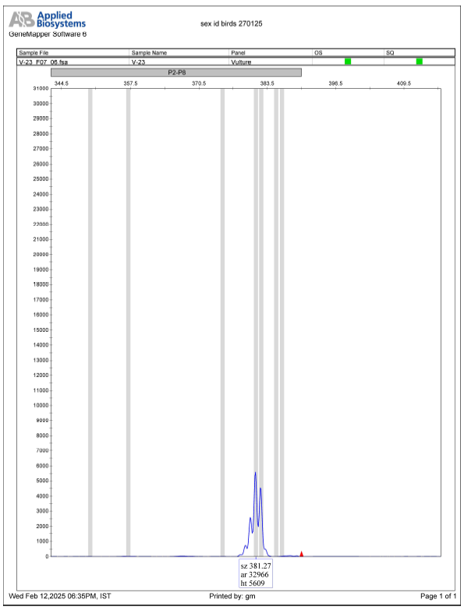
Fig. 2: Fragment analysis of vulture samples showing a single band corresponding to CHD1-Z indicating a male individual.

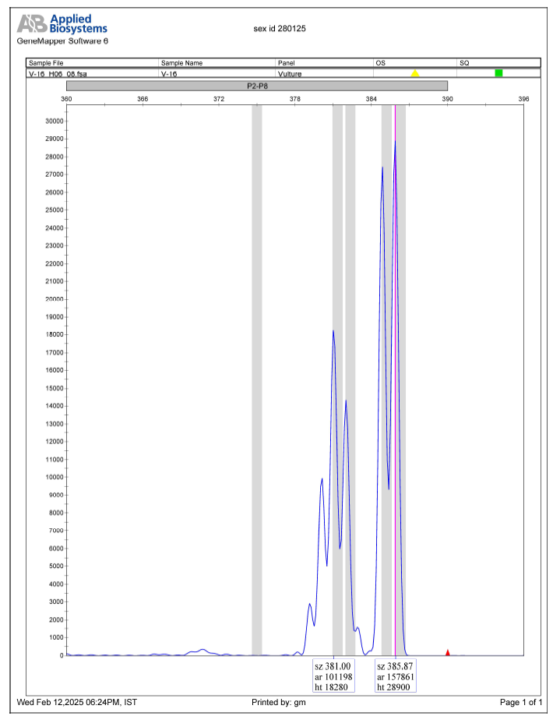
Fig. 3: Fragment analysis of vulture samples showing a two bands corresponding to CHD1-Z and W indicating a female individual.

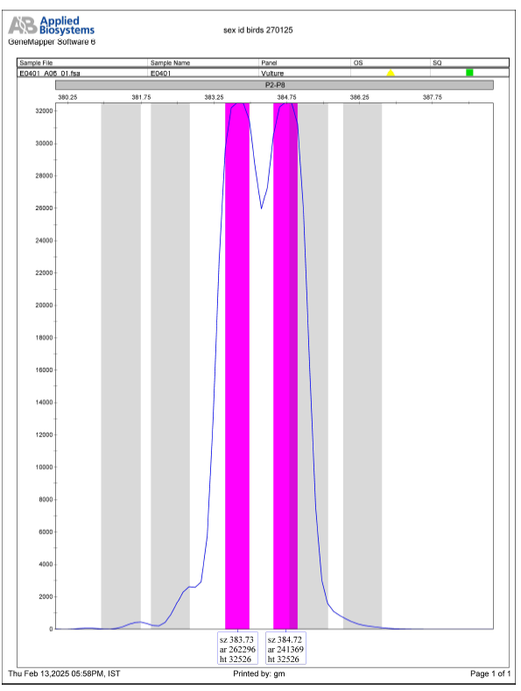
Fig. 4: Fragment analysis of Common crane sample showing a two bands corresponding to CHD1-Z and W indicating a female individual.

