Original Research Article
Comprehensive Pathomorphological Evaluation of Systemic Bacterial Infection Leading to Multi-Organ Dysfunction in a Panthera leo

ABSTRACT
This study aimed to investigate the clinicopathological and pathomorphological alterations associated with systemic bacterial septicaemia in a captive lion. The study was designed as a single-case observational investigation conducted at Rajgir Zoo Safari, Nalanda, Bihar, encompassing the period from initial clinical presentation to post-mortem examination in a 14-year-old male Panthera leo. The animal exhibited nonspecific clinical signs such as anorexia, depression, respiratory distress and progressive systemic deterioration, which are often indicative of underlying severe systemic infection. Methodologically, a comprehensive evaluation was carried out including detailed haematological analysis along with thorough gross and histopathological examinations to assess multi-organ involvement. Haematological findings revealed marked neutrophilic leucocytosis, relative lymphopenia, thrombocytopenia and mild inflammatory anaemia, suggesting an acute septic and endotoxaemic state. Gross pathological examination showed hepatomegaly with friable pale-yellow parenchyma, severe pulmonary congestion and edema with petechial haemorrhages and bilateral renal congestion with loss of corticomedullary demarcation. Histopathological observations substantiated these findings, revealing extensive hepatocellular necrosis with intralesional rod-shaped bacteria, diffuse alveolar damage characterized by emphysema, fibrin deposition and inflammatory cell infiltration, marked lymphoid depletion in the spleen and renal tubular degeneration and necrosis with bacterial colonies within tubular lumina. These lesions are consistent with septicaemic nephropathy and early multi-organ dysfunction. The results underscore the rapid and fulminant progression of bacterial septicaemia in lions, mediated by systemic inflammatory response syndrome, endotoxemia and microvascular injury. In conclusion, early haematological screening, rapid diagnostic intervention and vigilant clinical monitoring are essential to mitigate mortality in captive wild felids, and systematic documentation of such cases will improve disease understanding and management strategies in zoological institutions.

Keywords: Glomerular congestion; Hepatocellular necrosis; Petechial haemorrhages; Septicaemia.

1. Introduction
Septicaemia is a severe systemic condition characterized by the presence and proliferation of pathogenic microorganisms or their toxins in the bloodstream, resulting in a dysregulated host immune response and multi-organ dysfunction (Kumar et al. 2020; Singer et al. 2016). It represents a critical clinical entity in both human and veterinary medicine, often associated with systemic inflammatory response syndrome (SIRS) and progression to multi-organ dysfunction syndrome (MODS), leading to high morbidity and mortality (Singer et al. 2016; Cortellini et al. 2019). In animals, septicemia is commonly caused by bacterial agents such as Escherichia coli, Salmonella spp., Staphylococcus spp., and Pasteurella multocida, which gain entry through various portals including wounds, respiratory tract, and gastrointestinal system (Quinn et al. 2011; Greene et al. 2012).
Large felids such as the African lion (Panthera leo) are particularly susceptible to infectious diseases under captive conditions due to stress, confinement, and altered environmental dynamics (Miller et al. 2015; Terio et al. 2018). Captivity imposes multiple physiological and psychological stressors including restricted movement, altered social hierarchy, dietary fluctuations, and increased exposure to environmental pathogens, all of which can compromise immune competence (Fowler et al. 2015; Thompson et al. 2010). Infectious diseases are recognized as one of the leading causes of morbidity and mortality in zoo-managed wildlife, yet comprehensive clinicopathological documentation in large felids remains limited compared to domestic animals (Terio et al. 2018; Stephen et al. 2014).
The pathogenesis of septicaemia involves complex host–pathogen interactions including endotoxin release, cytokine storm, oxidative stress, and microvascular injury, which ultimately lead to impaired tissue perfusion and cellular hypoxia (Kumar et al. 2020; Singer et al. 2016). Endotoxins derived from Gram-negative bacteria play a crucial role in triggering systemic inflammation and vascular damage, while Gram-positive organisms contribute through exotoxin-mediated effects (Quinn et al. 2011; Greene et al. 2012). In carnivores, septicemia is often associated with predisposing factors such as trauma, gastrointestinal barrier disruption, parasitic infestations, and environmental contamination, which facilitate bacterial translocation and systemic dissemination (Fowler et al. 2015; Miller et al. 2015).
In wild felids, early clinical detection of septicemia is often challenging due to their inherent tendency to mask signs of illness, resulting in delayed diagnosis and poor therapeutic outcomes (Fowler et al. 2015; Stephen C. 2014). Clinical manifestations, when evident, may include anorexia, lethargy, fever, respiratory distress, mucous membrane congestion, and progressive systemic deterioration, often culminating in death if not promptly managed (Greene et al. 2012; Cortellini et al. 2019). Such delayed recognition significantly limits the effectiveness of therapeutic interventions in captive wildlife populations (Terio et al. 2018).
Pathologically, septicaemia predominantly affects highly vascular organs such as the liver, spleen, lungs, and kidneys, producing characteristic lesions including congestion, haemorrhages, necrosis, and inflammatory infiltrates (Maxie et al. 2016; Zachary et al. 2017). Hepatic lesions commonly include hepatocellular degeneration and necrosis, while splenic changes involve lymphoid depletion and congestion (Maxie et al. 2016). Pulmonary lesions are characterized by edema, congestion, and inflammatory cell infiltration, whereas renal lesions often include tubular degeneration and necrosis (Zachary et al. 2017). Histopathological findings such as bacterial emboli, vascular damage, and inflammatory responses reflect systemic dissemination of infection and are essential for definitive diagnosis (Kumar et al. 2020).
Despite the clinical importance of septicaemia in captive carnivores, detailed studies integrating haematological, gross, and histopathological findings in lions are scarce, with most reports focusing on isolated aspects of disease (Terio et al. 2018; Thompson et al. 2010). A comprehensive clinicopathological approach is therefore essential to improve diagnostic accuracy, enhance disease surveillance, and develop effective preventive and therapeutic strategies in zoological medicine (Miller et al. 2015; Stephen C. 2014).
The present study was undertaken to investigate the clinicopathological and pathomorphological alterations associated with systemic bacterial septicemia in a captive lion, with emphasis on correlating hematological findings with gross and microscopic lesions to better understand the multisystemic impact of the disease.
2. MATERIALS AND METHODS
2.1 Case History and Study Location
The present study was conducted on an adult 14-year-old male African lion (Panthera leo) maintained at Rajgir Zoo Safari, Nalanda, Bihar, India. The animal was reported with progressive deterioration in health characterized by reduced appetite, lethargy and gradual weight loss over several days. Despite administration of symptomatic treatment, the condition worsened and the animal eventually succumbed.
2.2 Clinical History and Ante-mortem Findings
Detailed clinical evaluation prior to death revealed signs of dehydration, lethargy, mild dyspnoea and intermittent abdominal discomfort. Clinical examination showed pale mucous membranes, tachypnoea, weak pulse quality and mild abdominal distension. Haematological analysis revealed marked neutrophilic leucocytosis with a left shift, lymphopenia and thrombocytopenia (Table no. 1). Serum biochemical analysis indicated elevated levels of alanine aminotransferase (ALT) and aspartate aminotransferase (AST), mild azotemia and hypoalbuminemia, suggestive of systemic inflammatory response and early septic shock (Table no. 2).
Table no. 1- Haematological profiles of Asiatic Lion suffering from Septicaemia.
Parameter | Observed Value | Reference Range | Interpretation
Haemoglobin (g/dL) | 9.2 | 12–18 | ↓ Mild–moderate anaemia
Packed Cell Volume (%) | 26 | 35–48 | ↓ Normocytic, normochromic anaemia
RBC Count (×10⁶/µL) | 4.7 | 6.0–9.0 | ↓ Anaemia
WBC Count (×10³/µL) | 28.5 | 6–15 | ↑ Marked leucocytosis
Neutrophils (%) | 86 | 40–75 | ↑ Neutrophilia with left shift
Bands (%) | 8 | 0–3 | ↑ Left shift (toxic response)
Lymphocytes (%) | 6 | 20–45 | ↓ Lymphopenia
Monocytes (%) | 3 | 2–10 | WNL
Eosinophils (%) | 0 | 2–10 | ↓ Stress leukogram
Platelets (×10³/µL) | 85 | 150–400 | ↓ Thrombocytopenia

Table no. 2.- Biochemical profiles of Asiatic Lion suffering from Septicaemia.
Parameter | Observed Value | Reference Range | Interpretation
ALT (U/L) | 165 | 20–70 | ↑ Hepatocellular injury
AST (U/L) | 290 | 35–120 | ↑ Hepatic/muscle damage
ALP (U/L) | 210 | 30–150 | ↑ inflammation
Total Bilirubin (mg/dL) | 1.8 | 0.1–0.5 | ↑ Impaired hepatic clearance
BUN (mg/dL) | 48 | 20–35 | ↑ Azotaemia
Creatinine (mg/dL) | 2.1 | 0.8–1.6 | ↑ Renal involvement (sepsis-related)
Total Protein (g/dL) | 5.3 | 6.0–8.0 | ↓ Hypoproteinaemia
Albumin (g/dL) | 2.0 | 3.2–4.2 | ↓ Hypoalbuminemia
Globulin (g/dL) | 3.3 | 2.5–4.0 | WNL
A/G Ratio | 0.60 | 0.8–1.2 | ↓ Inflammation
Glucose (mg/dL) | 58 | 70–120 | ↓ Hypoglycaemia (sepsis)
Sodium (mmol/L) | 138 | 140–154 | Slightly ↓
Potassium (mmol/L) | 5.8 | 3.5–5.0 | ↑ Hyperkalaemia (renal compromise)
Chloride (mmol/L) | 102 | 110–125 | Slightly ↓

2.3 Post-mortem Examination (Necropsy Procedure)
Following death, a detailed post-mortem examination was conducted immediately under strict biosafety precautions following standard necropsy procedures. The carcass was placed in dorsal recumbency and examined for external abnormalities. A midline incision was made extending from the mandibular region to the pubis, and the skin along with subcutaneous tissues was reflected to assess any superficial lesions. The thoracic and abdominal cavities were opened systematically, and all visceral organs were carefully examined for evidence of septicaemic and inflammatory changes (Fig. 1).
2.4 Gross Pathological Findings
External examination of the carcass revealed poor body condition, dehydration, and pale mucous membranes. On internal examination, hepatomegaly with friable parenchyma and multifocal necrotic areas was observed. The lungs showed severe congestion, edema and multiple petechial and ecchymotic haemorrhages. The spleen was moderately enlarged with marked congestion and diffuse lymphoid depletion. Both kidneys appeared congested with loss of corticomedullary demarcation and presence of scattered cortical petechiae, indicative of septicaemic involvement.
2.5 Sample Collection for Histopathology
Representative tissue samples from the liver, lungs, spleen and kidneys showing gross lesions were collected immediately after necropsy and fixed in 10% neutral buffered formalin for histopathological examination.
2.6 Histopathological Processing and Staining
The formalin-fixed tissue samples were processed using routine paraffin embedding techniques. The tissues were dehydrated in ascending grades of alcohol, cleared in xylene and embedded in paraffin wax. Sections of 4–6 µm thickness were cut using a microtome and mounted on glass slides. The sections were subsequently stained with Haematoxylin and Eosin (H&E) following standard staining procedures as described by Luna (1968).
2.7 Microscopic Examination and Imaging
The stained sections were examined under a light microscope to evaluate histopathological alterations. Representative lesions were documented and photomicrographs were captured using a digital microscope imaging system for detailed analysis and record keeping.
3. RESULTS AND DISCUSSION
3.1 Haematological Findings
The haematological evaluation of the affected lion revealed mild to moderate normocytic, normochromic anaemia, as evidenced by decreased haemoglobin concentration, packed cell volume and erythrocyte count. Such a pattern is consistent with anaemia of inflammatory disease which commonly accompanies acute or chronic septicaemic conditions due to altered iron metabolism and suppression of erythropoiesis (Kumar et al., 2020). A marked leucocytosis characterized by pronounced neutrophilia with toxic changes and relative lymphopenia was observed, indicating an acute systemic inflammatory response. This leukogram is typical of bacterial septicaemia and reflects activation of innate immune mechanisms in response to endotoxemia (Singer et al., 2016; Cortellini et al., 2024).
The presence of neutrophilic left shift and toxic granulation further supports severe bacterial infection and overwhelming inflammatory stimulation. Additionally, significant thrombocytopenia was recorded, likely resulting from consumptive coagulopathy associated with sepsis-induced disseminated intravascular coagulation (DIC). Such haematological alterations are well-documented in septic conditions where widespread endothelial damage and activation of coagulation pathways lead to platelet consumption and increased risk of haemorrhage (Kumar et al., 2020; Zachary, 2017). The observed haematological profile is therefore indicative of acute septicaemia with systemic inflammatory and coagulopathic manifestations.
3.2 Gross Pathological Findings
Necropsy examination revealed marked hepatomegaly with friable, pale-yellow parenchyma and multifocal necrotic areas, suggesting severe hepatic involvement. Similar hepatic changes are frequently reported in septicaemia due to hypoxic injury, endotoxin-mediated damage and bacterial dissemination (Maxie, 2015). The lungs exhibited severe congestion, edema and widespread petechial to ecchymotic haemorrhages, consistent with increased vascular permeability and endothelial injury associated with systemic inflammatory response (Kumar et al., 2020).
Heart showed marked congestion and enlargement with visible epicardial surface changes suggestive of circulatory disturbance associated with septicaemic conditions (Fig. 2). Spleen showing marked congestion with multiple petechial haemorrhages on the capsular surface, indicative of septicaemic involvement and vascular damage (Fig. 3). Splenic alterations in septicaemia reflect both increased phagocytic activity and depletion of immune cells due to systemic infection (Zachary, 2017). The kidneys showed bilateral congestion, indistinct corticomedullary demarcation and cortical petechiae, which are characteristic of septicaemic nephropathy and circulatory disturbances (Fig.4) (Maxie, 2015). These gross findings collectively indicate multisystemic involvement and are consistent with previously described septicaemic lesions in domestic and wild animals (Terio et al., 2018; Miller et al., 2014).
3.3 Histopathological Findings
Histopathological examination of the liver revealed extensive hepatocellular necrosis with infiltration of neutrophils and numerous intralesional rod-shaped bacteria within sinusoids and necrotic areas (Fig. 5). These findings confirm active bacterial dissemination and inflammatory response within hepatic tissue. Sinusoidal congestion, haemorrhages and fibrin deposition further indicate vascular injury and coagulopathy, which are hallmarks of sepsis (Kumar et al., 2020).
The spleen exhibited marked lymphoid depletion, loss of follicular architecture, and sinusoidal congestion, along with erythrophagocytosis and bacterial presence within the red pulp (Fig. 6). Such findings suggest severe immunosuppression and systemic bacterial spread which are typical in advanced septicaemia (Terio et al., 2018).
Pulmonary sections demonstrated severe congestion, diffuse alveolar edema, fibrin deposition and infiltration of neutrophils within alveoli and interstitium (Fig. 7). Multifocal haemorrhages and diffuse alveolar damage (DAD) were also observed. These changes are consistent with acute lung injury secondary to systemic inflammation and endotoxemia which impair gas exchange and contribute to respiratory distress (Kumar et al., 2020; Singer et al., 2016). The presence of bacterial clusters within alveoli and blood vessels further confirms septicaemic dissemination.
Renal sections showed acute tubular degeneration and necrosis, glomerular congestion, and interstitial edema, along with bacterial colonies within tubular lumina (Fig. 8). These lesions are indicative of septicaemic nephropathy and are commonly associated with hypoperfusion, endotoxemia and direct bacterial invasion (Zachary, 2017; Maxie, 2015).
3.4 Overall Interpretation and Significance
The combined haematological, gross and histopathological findings in the present study confirm acute bacterial septicaemia resulting in multisystemic organ dysfunction involving the liver, lungs, spleen and kidneys. The observed lesions are consistent with the classical pathophysiological mechanisms of sepsis, including systemic inflammation, endothelial damage, coagulopathy and organ failure (Singer et al., 2016).
In captive wildlife, particularly large felids, septicaemia poses a significant diagnostic and management challenge due to nonspecific clinical signs and delayed detection. Stress, environmental factors and immunosuppression further exacerbate susceptibility to systemic infections in zoo animals (Fowler, 2008; Stephen, 2014). Additionally, opportunistic bacterial pathogens play a crucial role in disease progression, especially under compromised health conditions (Quinn et al., 2011; Greene, 2011).
The present findings emphasize the importance of integrating clinical, haematological and pathological evaluations for accurate diagnosis of septicaemia in wildlife species. Such comprehensive approaches are essential for improving disease surveillance, guiding therapeutic interventions and enhancing health management strategies in captive carnivores (Terio et al., 2018; Miller et al., 2014).
4. CONCLUSION
This article documents a fatal case of acute bacterial septicaemia leading to multisystemic organ dysfunction in an adult captive African lion. The combined haematological, gross and histopathological findings illustrate the fulminant nature of septicaemia in large felids, characterized by rapid hepatic, pulmonary, renal and splenic deterioration. The presence of widespread necrosis, haemorrhage, bacterial colonization and inflammatory damage within vital organs underscores the severity of systemic bacterial infections in wild carnivores maintained under captive conditions. Given the nonspecific clinical presentation and the difficulty of timely diagnosis in zoological environments, this report highlights the critical importance of routine health monitoring, early haematological screening and prompt intervention for suspected infectious conditions. Further studies on the epidemiology, predisposing factors and early diagnostic markers of septicaemia in captive felids are essential to enhance clinical outcomes, strengthen preventive health programs and support evidence-based management practices in wildlife and conservation medicine.

Disclaimer (Artificial Intelligence)
Author(s) hereby declare that NO generative AI technologies such as Large Language Models (ChatGPT, COPILOT, etc) and text-to-image generators have been used during writing or editing of this manuscript.
Competing Interests
Authors have declared that they have no known competing financial interests OR non-financial interests OR personal relationships that could have appeared to influence the work reported in this paper.
COMPETING INTERESTS DISCLAIMER:
Authors have declared that they have no known competing financial interests OR non-financial interests OR personal relationships that could have appeared to influence the work reported in this paper.

REFERENCES
Kumar, V., Abbas, A. K. & Aster, J. C. (2020). Robbins and Cotran Pathologic Basis of Disease. 10th edn. Elsevier.
Singer, M., Deutschman, C. S., Seymour, C. W., Hari, M. S., Annane, D., Bauer, M., Bellomo, R., Bernard, G. R., Chiche, J. D., Coppersmith, C. M., Hotchkiss, R. S., Levy, M. M., Marshall, J. C., Martin, G. S., Opal, S. M., Rubenfeld, G. D., Poll, T. V., Vincent, J. L. & Angus, D. C. (2016). The Third International Consensus Definitions for Sepsis and Septic Shock (Sepsis-3). JAMA, 315(8), 801–810.
Miller, R. E, Fowler, M. E, editors. (2014). Fowler’s Zoo and Wild Animal Medicine, Volume 8. Elsevier.
Terio, K. A., McAloose, D. & Leger, J. S. (2018). Pathology of Wildlife and Zoo Animals. Academic Press.
Quinn, P. J, Markey, B. K, Leonard, F. C., FitzPatrick, E. S., Fanning, S. & Hartigan, P. J. (2011). Veterinary Microbiology and Microbial Disease. 2nd ed. Oxford: Wiley-Blackwell.
Thompson, R. C. A., Lymbery, A. J. & Smith A. (2010). Parasites, emerging disease and wildlife conservation. International Journal for Parasitology, 40: 10, 1163-1170, ISSN 0020-7519. https://doi.org/10.1016/j.ijpara.2010.04.009.
Cortellini, S., DeClue, A. E., Giunti, M., Goggs, R., Hopper, K., Julie, M., Rabelo, R. C., Rozanski, E. A., Sharp, C. R., Silverstein, D. C., Stutzman, V. S., Stanzani, G. (2024). Defining sepsis in small animals. J Vet Emerg Crit Care, 34:97–109. https://doi.org/10.1111/vec.13359
Greene, C. E, editor. (2011). Infectious Diseases of the Dog and Cat. 4th ed. Elsevier.
Fowler, M. E. (2008). Restraint and Handling of Wild and Domestic Animals. 3rd ed. Wiley-Blackwell.
Zachary, J. F. (2017). Pathologic Basis of Veterinary Disease. 6th ed. Elsevier.
Maxie, M. G., editor. (2015). Jubb, Kennedy & Palmer’s Pathology of Domestic Animals. 6th ed. Elsevier.
Stephen C. (2014). Toward a modernized definition of wildlife health. Journal of Wildlife Diseases, 50(3), 427-430.

FIGURES
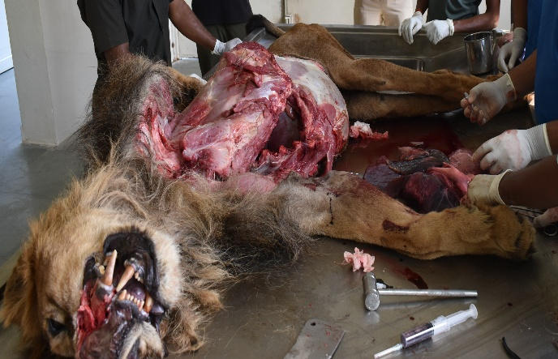  1. | 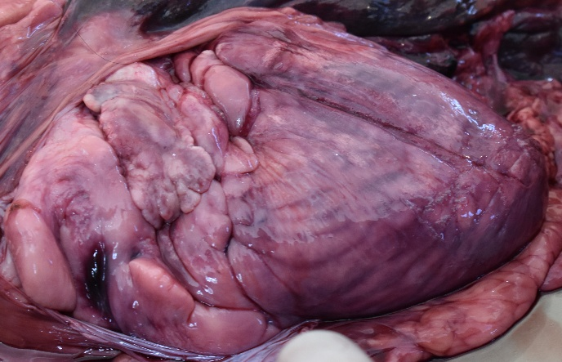  2.
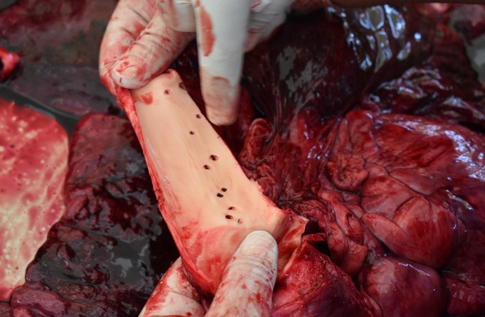  3. | 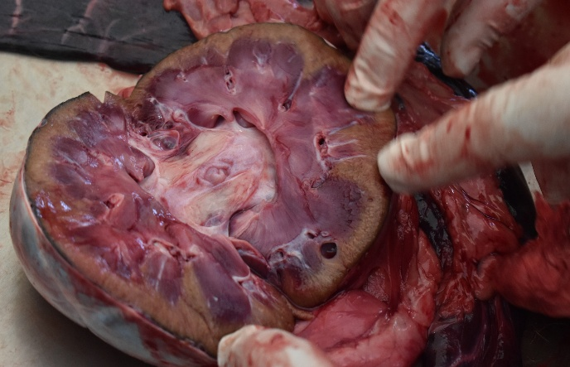  4.
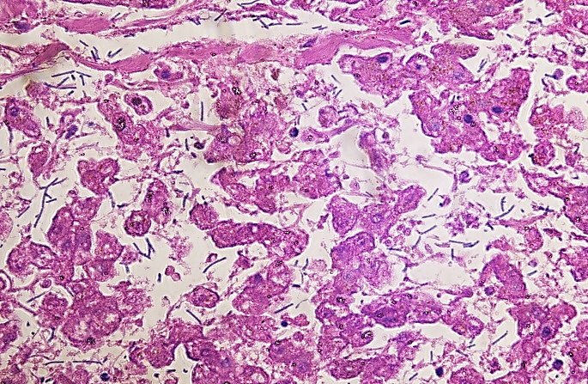  5. | 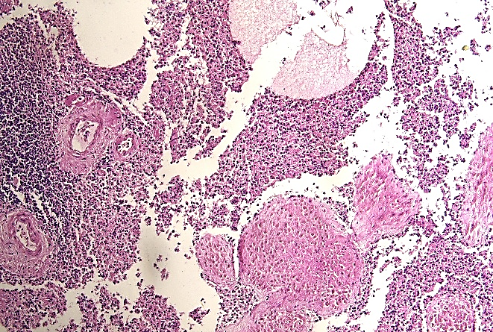  6.
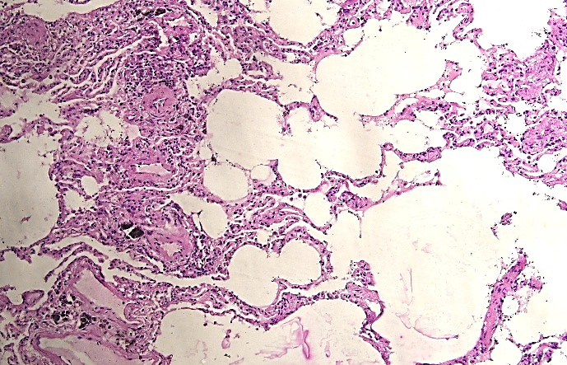  7. | 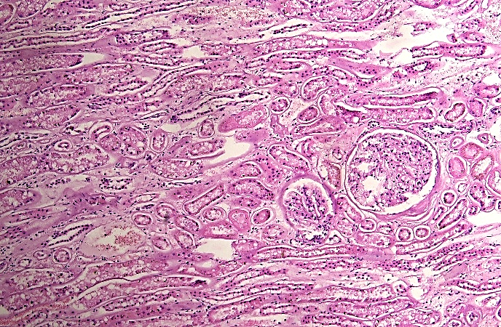  8.
Fig.1. Post-mortem examination of an adult male African lion (Panthera leo) showing carcass positioned in dorsal recumbency with thoracic and abdominal cavities opened, revealing extensive internal examination for systemic pathological lesions;
Fig.2. Heart showing marked congestion and enlargement with visible epicardial surface changes, suggestive of circulatory disturbance associated with septicaemic conditions;
Fig. 3. Spleen showing marked congestion with multiple petechial haemorrhages on the capsular surface, indicative of septicaemic involvement and vascular damage;
Fig.4. Cut surface of the kidney showing marked congestion with loss of corticomedullary demarcation and presence of cortical petechial haemorrhages, suggestive of septicaemic nephropathy.,
Fig.5. Histological section of Liver of Lion (H&E, x40) showing extensive hepatocellular necrosis with disruption of hepatic architecture, marked sinusoidal congestion and infiltration of neutrophils. Numerous intralesional rod-shaped bacteria were observed within sinusoids and necrotic areas, confirming septicaemic involvement.,
Fig. 6. Histological section of Spleen of Lion (H&E, x10) showing marked lymphoid depletion with loss of follicular architecture, severe sinusoidal congestion and multifocal necrotic areas. Numerous macrophages exhibited erythrophagocytosis, along with presence of bacterial aggregates within the red pulp, consistent with septicaemic splenitis.,
Fig. 7. Histological section of Lung of Lion (H&E, x10) showing severe congestion, diffuse alveolar edema with accumulation of proteinaceous exudate, and inflammatory cell infiltration within alveoli and interstitium.,
Fig. 8. Histological section of Kidney of Lion (H&E, x10) showing tubular degeneration and necrosis with vacuolar changes, luminal casts, glomerular congestion, and interstitial edema, consistent with septicemic nephropathy.

