Surgical Excision Wound Model in Male Rats: Histopathological Evaluation of Proliferative Phase Healing Using Sesame and Morinda officinalis Oils Extract

Abstract
The aim of this study was to evaluate the effects of Morinda officinals and Sesame oil on wound healing in Rats based on clinical, macroscopical and histopathological parameters. wound healing , Morinda officinals , Sesame oil
For the assay, 2 cm wounds were performed on the back of 20 male rats, assigned into four groups (n = 5): C (NaCl 0.9% ), treated groups (MO, SO and SO+MO) .On days 3, 7, 11 and 14 days post operation. , wound closure rates were assessed, and the healing wounds were subjected to histological analysis at 14 day post operation. s. Based on the results of the present study, a significant relationship was observed between the group treated with Morinda officinals extract and the group treated with Sesame oil in terms of wound area in rats (p < .05). During the study, the wound area of the group treated with Morinda officinals extract was significantly smaller than that of the group treated with Sesame oil, combination and the control groups.
The research results revealed that Morinda officinals can increase collagen synthesis, reduce the number of inflammatory cells, accelerate the process of coagulation, and accelerate the regeneration of epithelium, thus accelerating the healing process. Hence, it can be an appropriate option for the treatment of skin wounds.

1-Introduction
Wound healing is a complex process that involves the coordinated actions of many different tissues and cell lineages (Oscar A Peña and Paul Martin, 2024). The skin is constantly exposed to potential injuries, like acute injuries or chronic wounds, which interfere with and disrupt the skin’s integrity, change its physiologic condition and result in wound formation(André Oliveira et al., 2022). Wound healing is an organized, four-phased system involving hemostasis, inflammation, proliferation and maturation) fig. 1) (Ly Hai Trieu et al., 2023 ). Whereas small skin wounds heal in days, larger injuries resulting from trauma, acute illness or major surgery can take several weeks to heal, generally leaving behind a fibrotic scar that can impact tissue function ( Amjadian S. et al., 2024 ; LI Can and SUN Deqing, 2023) Development of therapeutics to prevent scarring and successfully repair chronic wounds requires a fuller knowledge of the cellular and molecular mechanisms driving wound healing(Kuan et al., 2024) There are many strategies studied and applied in the treatment of wound healing. In recent years, there is an increasing demand for the use of herbal extracts in treatments.( Givol et al., 2019 )
1.1 Morinda officinalis (MO)
(MO) is a perennial vine of the genus Rubidium coba and is one of the “Four Major Southern Medicines” in China, together with areca nuts and Alopecia solanum. Modern pharmacological studies have reported a variety of bioactivities associated with Morinda officinalis, such as protecting the liver (Zhu et al., 2024) and strengthening the bones (Cao et al., 2024) The main medicinal part of MO is its root, which is flat-cylindrical with a grayish-yellow surface and a bitter taste . As a traditional Chinese medicine (TCM), The main components of MO include oligosaccharides, anthraquinones, iridoid glycosides, organic acids, trace elements, amino acids, and sterols(Zhang et al., 2022) Previous studies have suggested that oligosaccharides in MO can improve immunity, promote angiogenesis, enhance reproduction, and exert anti-osteoporosis, antioxidative, antidepressant, and antidementia effects (Chi et al., 2020).
1-1-1 Antioxidant activities of M. officinalis
The aqueous excerpts of M. officinalis can enhanced the activity of Superoxide Dismutase (SOD) and Glutathione Peroxidase (GSH-Px), Calcium ATPase (PMCA) and Na+/K+-ATPase of the major muscles of the forced swimming test mice, and enhanced the antioxidant activity of major muscles in the rats (Thanh et al., 2023). Previous studies have suggested that oligosaccharides in MO can improve immunity, promote angiogenesis, enhance reproduction, and exert anti-osteoporosis, antioxidative, antidepressant, and antidementia effects (Chi et al., 2020). The Nrf2 is a crucial transcription factor that controls the intracellular antioxidant response and is an arising focus for the treatment and prevention of illnesses caused by oxidative stress (Satta et al., 2017). MO could reduce H₂O₂-induced oxidative stress, increases Nrf2 production detoxification mechanism to activate antioxi- dant enzymes and superoxide dismutase (SOD) and Catalase (CAT) activities(Syed et al., 2021)
1-1-2 Anti-inflammatory activity
The root of (MO) was reported to contain monotropeins, which exhibited higher anti-inflammatory and antinociceptive activities. It has been reported that the monotropein isolated from the root of (MO) can lengthen the action time, decrease stretching episodes, writhing antinociceptive assays and significantly diseased acute paw edema at the dosage of 20 and 30 mg/kg(Choi et al., 2005). In vivo anti-inflammatory potential of (MO) essential oil was previously confirmed via significant reduction and inhibition of carrageenan-induced paw edema in rats, with citrals being the components mostly mediating this effect via TNF-α inhibition (Luo et al., 2021). In other study the Iridoid Glycosides: These compounds in Morinda officinalis inhibit GSK-3β, alleviating RA symptoms by suppressing the NF-κB and JAK2/STAT3 signaling pathways (Yi et al.,2024 )
1-1-3 Antibacterial Effects:
Several studies have indicated that (MO) extracts have antibacterial properties, particularly against common pathogens like Staphylococcus aureus, Escherichia coli, and Pseudomonas aeruginosa. These properties are often attributed to the presence of bioactive compounds such as flavonoids, phenolics, and terpenoids, which have been shown to disrupt microbial cell membranes or inhibit essential enzymatic activities in the bacteria (Adesokan et al., 2010, Selvi et al ., 2023).
1-2-4 Production Process of Extract From the Root M. officinalis
Highly concentrated extracts, known as extracted preparations, are collected by evaporating or drying solutions containing biologically active substances (BASs) found in herbs or animal parts through a leaching process with the assistance of appropriate solvents (Dung et al., 2024). Generally, highly concentrated extracts derived from the herbs are produced through two primary stages: (1) leaching BASs from the herbs using suitable solvents, and (2) evaporating or drying the prepared solution to obtain the final product (Abdullahi R Abubakar and Mainul Haque.,2020). The leaching process is acrucial step that significantly influences recovery efficiency, product quality, and production costs. In this work, the operating conditions of a leaching system were investigated to extract BASs from MO’s root.

1-2- 5 Toxicity
The toxicological profile of Morinda officinalis (MO) is not reported. In the present study, the toxicological characteristics of (MO) were assessed for the first time. MO did not show any genotoxicity based on the Ames test, mammalian erythrocyte micronucleus test, and mouse primary spermatocyte chromosome aberration test. MO administered by gavage in mice and rats at a dose of 20 g/kg BW did not induce death or toxicity based on acute study, indicating that FMO could be regarded as non-toxic at the tested dose.( Qian et al., 2022 , LI. C. and SUN. D. 2023)
1-2 sesame oil (Sesamum indicum L ).
Sesame oil (SO), obtained from the sesame plant seeds (Sesamum indicum L., Pedaliaceae family)( Naseem et al., 2023). The oil was extracted from sesame seed with two extraction methods. Traditional (Ardeh oil) and industrial method (cold pressing method: virgin and refined sesame oil) oil extraction was studied to compare the quality and heavy metal content of extracted oils (Razani et al .,2024). The chemical properties (fatty acid composition, peroxide, anisidine, acid values, and totox) and heavy metal contents were investigated this makes it has been long utilized in traditional medicine due to its anti-inflammatory and analgesic activities) Somayeh et al., 2021). Also, in recent trials, SO has been a focus of interest to prevent or treat skin injuries and inflammatory conditions such as phlebitis ( Nasiri. M and Farsi. Z., 2017). The anti-inflammatory properties of this herbal product are attributed to its chemical compositions, which are assumed to play an action similar to that of opioids and non-steroidal anti-inflammatory medications. It has considerable portions of unsaturated fatty acids, which induce anti-inflammatory consequences on prostaglandins and leukotrienes and inhibit pain transmission pathways( Érika et al., 2024). Likewise, SO contains various lignans, which should be accountable for this product’s anti-inflammatory, anti-swelling, and analgesic properties by preventing the release of pro-inflammatory indices (i.e., interleukin-8 and endothelin-1)( Wei et al., 2022). Topical application is particularly effective in accelerating the healing process of second-degree burns by promoting collagen synthesis and reducing inflammation(Valizadeh et al., 2020).
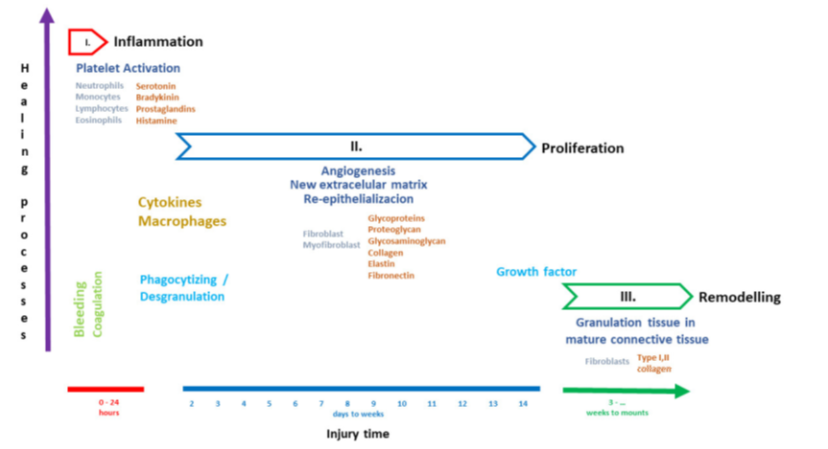
Fig 1. Wound-healing stages (Mayra et al 2024)

2. Materials and Methods
2. 1. Materials and Chemical Solutions
The materials and solutions that were used in the present study well listed Table
 | Company
  Origin
  Materials and chemical solutions
Belgium | V.M.D. | Xylazine (2%)
Netherland
  kepo
  Ketamine(10%)
indonesia | Uni-pharma | Formalin
Switzerland | - | Hematoxylin and eosin stain
Switzerland | - | Masson trichrome stain
Turkey | Diagnokim | povidone iodine
Indian Mulberry | Hawaii Pharm© | Morindae Officinalis Root Extract
Netherlands | Flora | Sesame Oil
Table 1. Materials and solutions:

2. 2. Experimental Animals
Thirty clinically healthy adult male albino rats, weighting 180-200g were used in the present study. They were housed in plastic cages of 50 ×30 ×18 cm dimensions. three rats /cage placed in a special housing room for acclimatization before starting the experiment. Standard diet (Commercial feed pellets) and water from the tap were freely accessible. The conditions of housing were 20-25 °C in conditioned room and the room quality was changed constantly by ventilation vacuum utilizing. All animals were received anti-parasitic drug (Ivermectin/ Ivermectin 200 mcg/kg to 400 mcg/kg (0.2 mg/kg to 0.4 mg/kg), PO a preventive treatment against internal and external parasites (Mitra, 2014).
2. 3. Experimental Design
For cutting surgery, at first, all rats were given a small dose of anesthesia injection of xylazine (10 mg/kg and ketamine 60 mg/kg)( Oh, S. S., & Narver, H. L., 2024). The dorsal neck skin was cleaned by an electrical shaver and wiped with povidone iodine 2%. A determined area on the back of the rats was shaved, creating a wound by using sharp, sterilized laboratory tools (fig.1) with a diameter of 2.00 cm and 0.5-1.0 mm depth in all experimental groups by using an even and round seal as seen in. After 24 hours of wound creation, gently applied an adequate amount of test samples was to cover the wounded area twice a day, in the morning and After afternoon, with Sterile cotton swab (fig.2) for the at 3^{ed}, 7th ,11th and 14th days duration of the experiment as follows:

experimental Rats were randomly divided into four equal groups:
A. Control group: In which subjected to 1ml applied with NaCl 0.9%

B. MO group : Same procedure of the control group was done but after induced the wound, suspension of (MO) was added directly on the site of wound

C. SO group: Same procedure of the control group was done but after induced the wound, suspension of (SO) was added directly on the site of wound

D. SO+MO: Same procedure of the other groups was done but after induced the wound, suspension of (SO) was added directly on the site of wound
Experimental design

2. 4 . Assessment of surgical wound
2. 4. 1. Morphological Features
Animals were observed for detection of clinical signs which include, swelling and redness of the surgical site, Appetite and dehiscence of wound up to 14 days post operation.
2. 4. 2. Pathological Evaluation
2. 4. 2. 1. Macroscopic Examination
The macroscopic examination of the wound dimeter by digital Caliper (fig.2) was achieved at 3^{ed}, 7th ,11th and 14th days post operation and compared with the wound area on day zero. The degree of wound healing was calculated as percentage closure in wound area from original wound area using the formula (Anand et al., 2012., Tarsizio S Santos et al., 2021):

$$\% closure= \frac{Wound area on zero day _ wound area on the corresponding day}{Wound area on zero day}×100$$

2. 4. 3. 2 . Histopathological examination
After euthanasia of animal with over dose of ketamine-hydrochloride, Skin tissue specimens after wound formation were collected after 14 days of treatment and transferred into 10% Neutral Buffered Formalin, according to the experimental design. The Skin tissue specimens were kept in 10% buffered formalin solution for 72 hours (Luna, 1968). the specimens of skin were washed with tap water and transferred to following steps dehydration, clearing, impregnation with paraffin wax, blocking, 5 μm thick sections were taken, they were stained with H&E and Masson trichrom stains. The sections were examined under light microscopy to observe the differences of wonud healing between the groups. In the current study, the scoring system of six histological parameters described by (Masson-Meyers et al. 2020), that included the most relevant morphological features that characterize granulation tissue and scar formation/maturation(Table 2) , was selected and applied to assess wound healing progression.

Table 2 .Criteria for collagen assessment and re-epithelialization in wound healing in mice after 14 days.
Score | Collagen Pattern & Morphology | Collagen Orientation | Re-Epithelialization
0 | No collagen deposition | No organization | No epidermal coverage
1 | Sparse, thin collagen fibers | Disorganized, random | Partial epidermal coverage (<50%)
2 | Moderate collagen bundles | Partially organized | Nearly complete (>50%)
3 | Thick, dense collagen fibers | Well-aligned, mature collagen | Fully restored epidermis with normal thickness

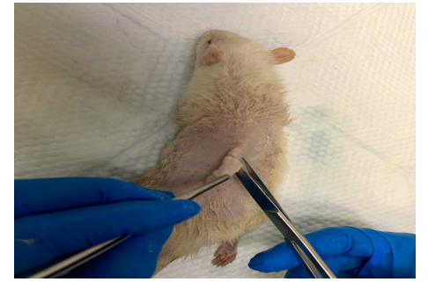
Fig. 2.. Show creating a wound area on the back of the rats
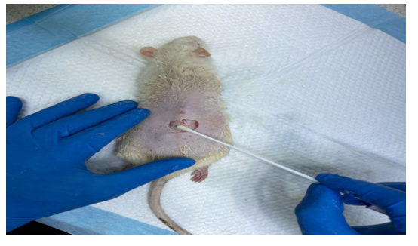
Fig. 3. with Sterile cotton swab applied an adequate amount of test samples was to cover the wounded area
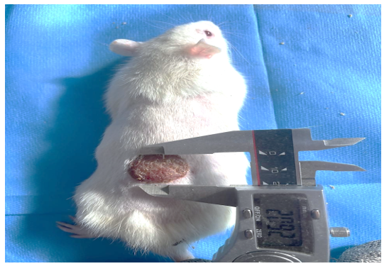
Fig.4. Show the examination of the wound dimeter by digital Caliper

3. Results
3. 1. Clinical Observations
Clinical observations of each groups of MO&SO revealed no signs of drainage or wound dehiscence at the site of operation, while in control observed slight drainage, swelling and redness at the surgical area. These signs were gradually disappeared 4 - 5 post-operative days, in the control group respectively. Appetite was altered postoperative and gradually return normal after 2 days post operation. Three rats (two in control and one in SO group) were be died after one week post operation so that these rats were totally discarded.
3. 2. Macroscopic Examination
During the healing period, the wounds were regularly measured on the 3nd, 7th, 11th and 14th days, which showed the evolution of the wound surfaces closure.
3. 2. 1. Three days Post Operation
Initially, it was noted the control group(G4) had any changes in the wound diameter, while a slight change in wound diameter was noted in the groups treated with SO(G1), MO(G2) and MO&SO(G3) This shows no significant (P value > 0.05) between the four groups (Fig.5 A&B)
3. 2. 2. Seven day Post-Operation
In the MO (G2) group, it showed decreased in dimeter of the wound, Compared to the group treated with SO (G1) and the group treated with the mixture of MO&SO, there was a slight decrease in dimeter of the wound (Fig.5.A). Statistically, shows that the SO(G1) has a significantly lower value (P value < 0.05) compared to MO (G2) and MO&SO (G3), with no significant (P value > 0.05) when compared to C (G4). MO(G2) has a significantly higher value (P value < 0.05) than both SO (G1) and C (G4), but there is no significant (P value > 0.05) when compared to SO&MO(G3). SO&MO (G3) shows a significantly higher value (P value < 0.05) than both SO (G1) and C (G4), with no significant (P value > 0.05) when compared to MO (G2). Finally, C (G4) has a significantly lower value (P value < 0.05) compared to both MO (G2) and SO& MO (G3), but no significant (P value > 0.05) when compared to SO (G1)( Fig.5B).
3. 2. 3. 11th day Post-Operation
In the MO (G2) group it show highly retraction Of the dimeter of the wound, Compared to the rest of the treatment groups showed different changes in wound diameters gradually as well as in the control group ( Fig.6.A). Statistically, In SO (G1) shows that (G1) has a significantly lower value (P value < 0.05) compared to MO (G2), but there is no significant (P value >0.05) when compared to SO&MO (G3) and C (G4). (G2) shows a significantly higher value (P value < 0.05) compared to G1, G3, and G4. (G3) is significantly lower (P value < 0.05) than G2, but there is no significant (P value > 0.05) when compared to G1 or G4. Finally, (G4) shows no significant (P value >0.05) when compared to G1 and G3, but is significantly lower (P value < 0.05) than G2 (Fig.6.B).

3. 2. 4. Fourteenth day Post-Operation
In the MO (G2) group it show highly retraction Of the dimeter of the wound, Compared to the rest of the treatment groups showed different changes in wound diameters gradually as well as in the control group ( Fig.7.A). Statistically, In that SO(G1) has no significant (P value > 0.05) when compared to MO(G2) and C(G4), but is significantly higher (P value < 0.05) than SO+MO (G3). MO (G2) shows a significantly higher value (P value < 0.05) compared to both SO+MO(G3) and C(G4), with no significant (P value > 0.05) when compared to SO(G1). SO+MO (G3) is significantly lower (P value < 0.05) than both SO(G1) and MO (G2), but shows no significant (P value > 0.05) when compared to G4. Finally, (G4) shows no significant (P value > 0.05) when compared to G1 and G3, but is significantly lower (P value < 0.05) than G2(Fig.7B).

3. 3. Microscopic Examination
During the healing period, at14th day post operation, which showed pathological evolution of the wound surfaces closure.
3. 3. 1 control group at 14 day Post-Operation:
Microscopic View of Skin Wound Site 14 Days After Surgery in Control Group show , existence of Clot on the Surface of Epithelium, existence of Inflammatory Cells fig. 8(A) H&E.100×.,Existence of Edema in Tissue Formation of Fine Collagen Fibers (fig. 8B) MT stain, 4000x
3. 3. 2. SO group at 14 day Post-Operation:
Microscopic View of Skin Wound Site 14 Days After Surgery in SO Group show, re-epithelialization of the tissue and shows mild infiltration of inflammatory cells (mononuclear cells) (Fig. 9A). H&E, 100 and deposition of collagen fibers (Fig.9B) MT stain, 4000x
3. 3. 3. MO group at 14 day Post-Operation:
Microscopic View of Skin Wound Site 14 Days After Surgery in MO Group show, mild infiltration of inflammatory cells (mononuclear cells) on day 14 (Fig. 10A). H&E stain, 100x, and shows the deposition of collagen fibers (Fig.10B ) MTstain, 4000x.

3. 3. 4. MO+SO group at 14 day Post-Operation
Microscopic View of Skin Wound Site 14 Days After Surgery in MO+SO Group show, mild infiltration of inflammatory cells (mononuclear cells) and regeneration of epithelial tissue (Fig. 11A). H&E stain, 100x and shows the deposition of collagen fibers (Fig.11B) MTstain, 4000x.
3.3.5 Histological parameters assessed to calculate f wound healing state.
The impact of the different treatments on tissue repair is demonstrated here in this bar chart. Clearly, the highest sum of scores were with Sesame oil and Morinda, as they had the most effective influence on tissue healing. MO scored higher than SO, proving its greater efficiency in repairing the tissue Conversely, the Combination therapy had a visibly lower efficiency in comparison to the single treatments, indicating that the combined action of these compounds would not be so positive as in the case when they are taken separately The Control group without any treatment attained the lowest value. This establishes that without an external factor intervening, the inherent healing process takes much longer and is less effective. Overall, the findings reveal promising potentiality for Sesame oil and Morinda to boost tissue regeneration, with the technique demonstrating potential in revalidation through adequate analysis (Fig.13).

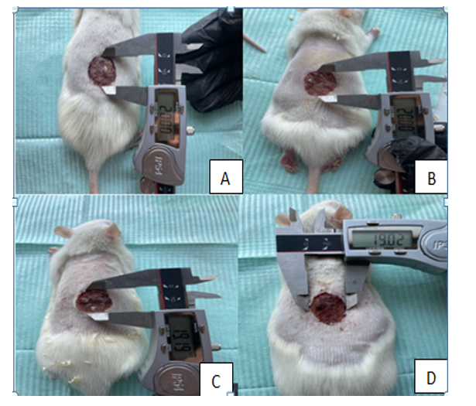
Fig.5A Macroscopic evaluation at Three days Post Operation shows control group had no any changes in the wound diameter (A), while a slight change in wound diameter was noted in the groups treated with SO(B), MO&SO(C) and MO(D)
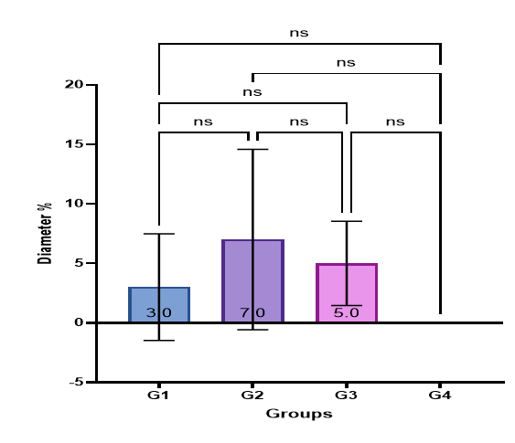
Fig.5B. shows no significant (P value > 0.05) bet

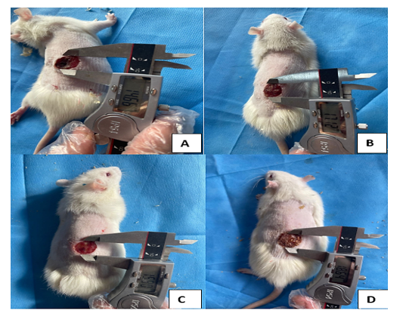
Fig. 6A. In the MO (A) group, it showed decreased in dimeter of the wound, Compared to dimeter of wound in the groups treated with SO(B), MO&SO(C) and Control group (D)

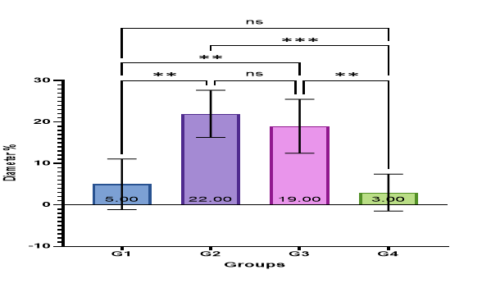
Fig.6B. shows that the SO (G1) has a significantly lower value (P value < 0.05) compared to MO (G2) and MO&SO (G3), with no significant (P value > 0.05) when compared to C (G4). (G2) has a significantly higher value (P value < 0.05) than both SO (G1) and C (G4), but there is no significant (P value > 0.05) when compared to SO&MO(G3). SO&MO (G3) shows a significantly higher value (P value < 0.05) than both SO (G1) and C (G4), with no significant (P value > 0.05) when compared to MO (G2). Finally, C (G4) has a significantly lower value (P value < 0.05) compared to both MO (G2) and SO& MO (G3), but no significant (P value > 0.05) when compared to SO (G1).

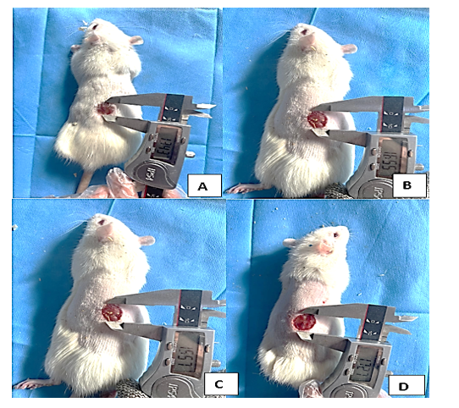
Fig.7A. In the MO (A) group it show highly retraction Of the diameter of the wound, Compared to the rest of the treatment groups showed different changes in wound diameters gradually (B&C) as well as in the control group(D).

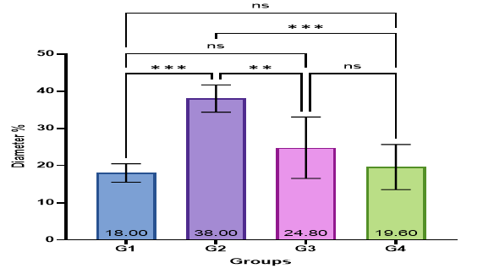
Fig.7B. In SO (G1) shows that (G1) has a significantly lower value (P value < 0.05) compared to (G2), but there is no significant (P value >0.05) when compared to (G3) and (G4). (G2) shows a significantly higher value (P value < 0.05) compared to G1, G3, and G4. (G3) is significantly lower (P value < 0.05) than G2, but there is no significant (P value > 0.05) when compared to G1 or G4. Finally, (G4) shows no significant (P value >0.05) when compared to G1 and G3, but is significantly lower (P value < 0.05) than G2.

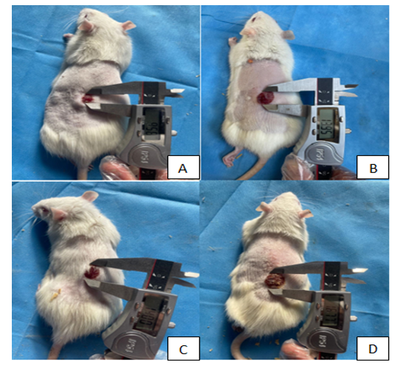
Fig.8A. In the MO (A) group it show highly retraction Of the dimeter of the wound,Compared to the rest of the treatment groups showed different changes in wound diameters gradually (B&C) as well as in the control group(D).

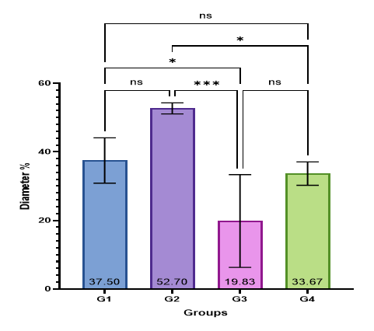
Fig.8B. shows that (G1) has no significant (P value > 0.05) when compared to (G2) and (G4), but is significantly higher (P value < 0.05) than (G3). (G2) shows a significantly higher value (P value < 0.05) compared to both G3 and G4, with no significant (P value > 0.05) when compared to G1. (G3) is significantly lower (P value < 0.05) than both G1 and G2, but shows no significant (P value > 0.05) when compared to G4. Finally, (G4) shows no significant (P value > 0.05) when compared to G1 and G3, but is significantly lower (P value < 0.05) than G2

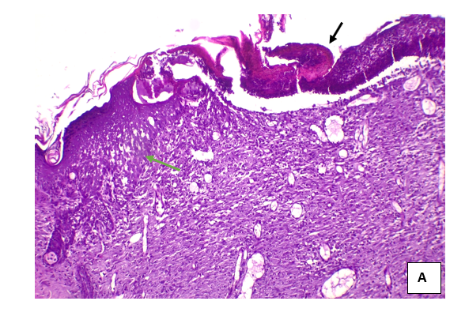

Fig.9(A) Microscopic View of Skin Wound Site 14 Days After Surgery in Control Group show , existence of Clot on the Surface of Epithelium(Black Arrow), existence of Inflammatory Cells(Green Arrow) H&E stain.100×.

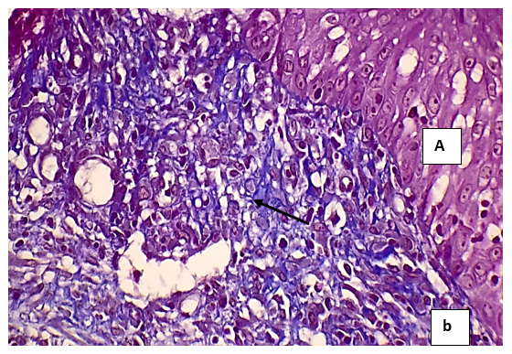
Fig.9(b) Microscopic View of Skin Wound Site 14 Days After Surgery in Control Group show Edema in Tissue Formation of Fine Collagen Fibers(Black Arrow) (fig. 3.3.1b) MT stain, 4000x

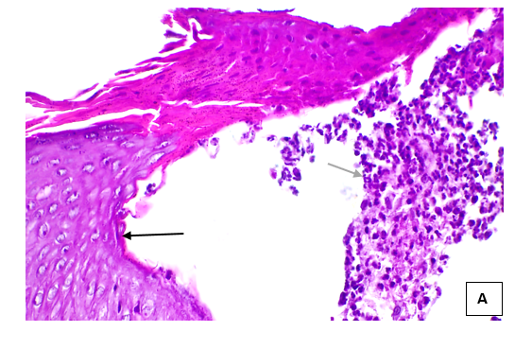

Fig. 10 A. Microscopic View of Skin Wound Site at 14 Days After Surgery in SO Group show re-epithelialization of the tissue (black arrow) and mild infiltration of inflammatory cells (mononuclear cells )(green arrow).H&E stain, 100x
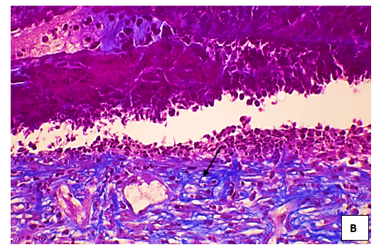
Fig. 10 B. Microscopic View of Skin Wound Site at 14 Days After Surgery in SO Group show the deposition of collagen fibers (black arrow). MTS, 4000x
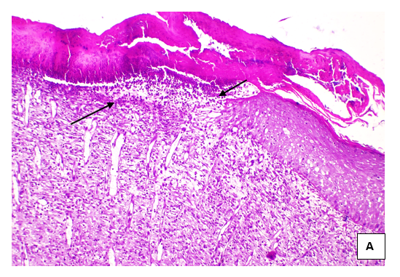

Fig. 11A. Microscopic View of Skin Wound Site at 14 Days After Surgery in MO Group show mild infiltration of inflammatory cells (mononuclear cells)(Blak Arrow) H&E stain100x.
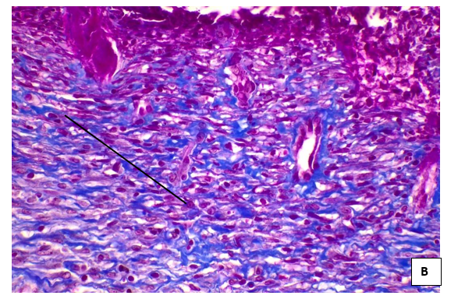
Fig. 11B. Microscopic View of Skin Wound Site at 14 Days After Surgery in MO Group show the deposition of collagen fibers (black arrow). MTS, 4000x

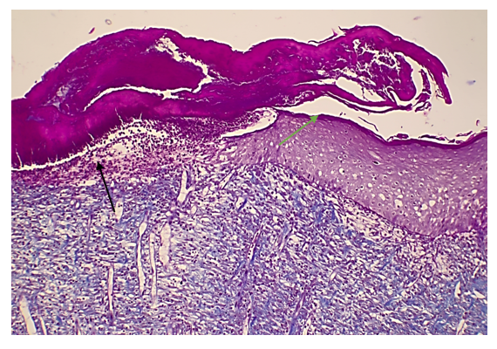
Fig. 12A. Microscopic View of Skin Wound Site 14 Days After Surgery in MO+SO Group show, mild infiltration of inflammatory cells (mononuclear cells)(Black arrow) and regeneration of epithelial tissue(Green arrow) H&E stain, 100x .
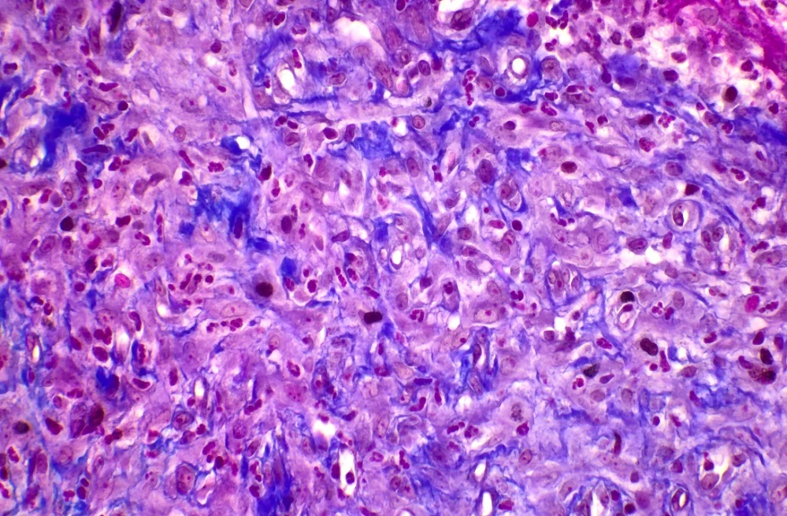
Fig.12B. Microscopic View of Skin Wound Site 14 Days After Surgery in MO+SO Group show shows the deposition of collagen fibers(Black Arrow) MT stain, 4000x

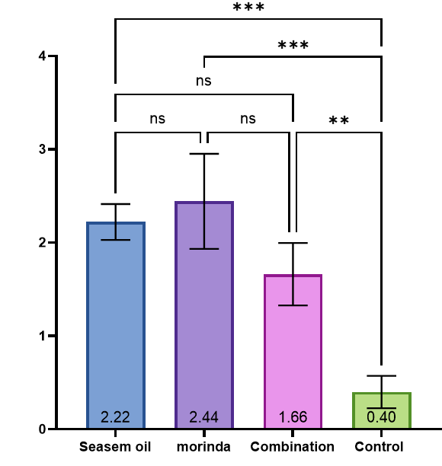
Fig.13. . in this figure shows that highest sum of scores were with Sesame oil and Morinda, as they had the most effective influence on tissue healing. MO scored higher than SO, proving its greater efficiency in repairing the tissue Conversely, the Combination therapy had a visibly lower efficiency in comparison to the single treatments, indicating that the combined action of these compounds would not be so positive as in the case when they are taken separately. The Control group without any treatment attained the lowest value.

Discussion
In recent decades, the subject of herbal medicine and the use of chemical plant extracts in wound healing have drawn the attention of researchers all around the world. Increasing the speed of wound healing involves numerous effects on the economy and health sectors, With increasing speed of wound healing, the level of wound infection will decrease, and accordingly, the whole process of wound healing will be accelerated. Previous studies have indicated that the wound healing process may be accelerated by oligosaccharides, anthraquinones, iridoid glycosides and fatty acids (Fatma Bouaziz et al., 2024, Tae-Young Kim et al., 2024 )
The present study was conducted to examine the effect of SO and MO l on the healing process of skin wound caused by injury in rats. In general, based on the results of the present study, a significant relationship was observed between the avocado oil and phenytoin groups in terms of wound area in rats.

On all days of study , the wound area of the MO group was slightly smaller than that of the SO group, and significantl smaller than that of the control group. It suggests that MO was very effective in wound healing and was more effective than SO . The properties of composition of MO, have been investigated in several studies, because they seem to be involved in wound healing (Zhang et al ., 2020). The healing process can be assessed by evaluating the rate of wound changes, the level of collagen fibers, tensile strength, and histopathology in different wound models.
A histological evaluation in the present study revealed that the animals treated with MO showed a significant increase in epithelial tissue formation. Possible medicinal effects attributed to MO in terms of the healing process can be associated with compounds of its phytochemicals.( Rong et al.,2022)

Topical application of MO extract decreased the number of inflammatory cells in the wound tissue and shows anti-inflammatory activity ( Huan-Huan et al., 2022) The present study showed a significant reduction of bleeding in animals treated with MO extract than SO oil , and scar tissue maturation (regeneration stage) in the tissue. It is argued that in the physiological healing process, collagen accumulates in the wound area for up to 14 days after injury. After this period, the balance between collagen synthesis and degradation is restored with the rapid disappearance of fibroblast cells (apoptosis) (Zhang Q et al., 2020)

6. 1. Conclusions
1. the MO contains substances effective in wound healing more than SO and can be used in the wound healing process.
2. The results of the present study revealed that using MO naturally or in drug formulations topically can increase collagen synthesis, reduce the number of inflammatory cells, accelerate the coagulation process, accelerate epithelial regeneration during the wound healing process, and accelerate the skin wound healing process, reducing the time taken for wound healing.
6.2. Recommendations
1. Detaction the effects of combined with plasma rich protein, low level laser therapy, on the promoting of the wound healing.
2. Evaluation of role of combined with Nano zinc oxide for wound healing.
3. Study the effects of MO and SO on hematology and liver function tests in experimentally induced wound

References
Adesokan. I.A., Ekanola. Y. A. and Okanlawon. B. M (2010) Influence of cultural conditions on hydrogen peroxide production by lactic acid bacteria isolated from some Nigerian traditional fermented foods. J. Afr. Microbiol Res. 4(19): Pp 1991-1996.
Amjadian. S.; Fatemi. M.J.; Moradi S, Hesaraki. M and Mohammadi P.(2024). mir-182-5p regulates all three phases of inflammation, proliferation, and remodeling during cutaneous wound healing. J. Arch Dermatol Res., 316(6): Pp274.
Anand. K. J.; Ashish. D and Swaroop C Mehta. (2012). Wound Healing activity of aqueous extracts of leaves and roots of Coleus aromaticus in rats. J. Acta Paloniae Pharmaceutica – Drug Research., 69(6): Pp1119-1123.
André. O.; Sandra. S.; Andreia A. and Catarina P. R (2022). Therapeutic advances in wound healing. J. Dermatolog Treat., 33(1): Pp2-22.
Chang. J., Yang. H., Shan. X., Zhao. L., Li. Y. and Zhang, Z. (2024). Bergamot essential oil improves CUMS-induced depression-like behaviour in rats by protecting the plasticity of hippocampal neurons. J. Cell. Mol. Med. 28: Pp18178.
Chi, L., Khan, I., Lin, Z., Zhang, J., Lee, M. Y. S. and Leong, W.(2020). Fructo oligosaccharides from Morinda officinalis remodeled gut microbiota and alleviated depression features in a stress rat model. J. Phytomedicine, 67: Pp 248-263.
Choi, J; Lee, K. T; Choi, M. Y; Nam, J. H and Jung H. J. (2005) Antinociceptive anti-inflammatory effect of Monotropein isolated from the root of Morinda officinalis. J. Biol Pharm Bul.,l 28(10): Pp1915-1918.
Dung. T.; Hang. T and Van H. P. (2024). A Production Process of Extract From the Root of Vietnamese Purple Morinda Officinalis How. J. Technical Education Science., 19(3): Pp24-31
Érika. M. H. M.; 1 , Lucas. A. C.; Célia. H. Y. and Mônica C. S. P. (2024) Antinociceptive and Anti-Inflammatory Activities of the Sesame Oil and Sesamin. J. Nutrients., 6(5):Pp1931-1944.
Fatma B.; Molka B. R. a , Claire B.; He.; Laurine B. b .; Fatma B.; Sana B. c .; Dorra. D.; a , Mohamed Koubaa a , Akram Fakhfakh a , Zouhair Sahnoun c , Fatma Kallel a , Najiba Zghal d , Semia Ellouz Chaabouni. (2024) .Healing efficiency of oligosaccharides generated from almond gum (Prunus amygdalus) on dermal wounds of adult rats. J.of Tissue Viability., 23: Pp98-108
s

Kuan C.H.; Tai .K. Y.; Lu S. C.; Wu .Y. F.; Wu. P. S.; Kwang. N.; Wang. W. H.; Mai-Yi Fan. S.; Wang. S.H.; Chien. H.F.; Lai. H. S.; Lin. M.H.; Plikus. M. V and Lin S.J (2024) .Delayed Collagen Production without Myofibroblast Formation Contributes to Reduced Scarring in Adult Skin Microwounds. J. Invest Dermatol. 144(5):1124-1133.
LI. C. and SUN. D.(2023). Study on Pharmacokinetics and Safety of Etoricoxib Tablets in Chinese Healthy Subjects. J. Chinese Journal of Modern Applied Pharmacy., 40(18): Pp 2569-2575
Luo. H.; Wang. Y.; Qin. Q.; Wang. Y.; Xu. J.; He. X. Anti-inflammatory naphthoates and anthraquinones from the roots of Morinda officinalis.Bioorg Chem. 2021
Mayra . C., Luis Ruben M. C ., Jesús. A., Márquez. L., Ingrid L., Barrera. L., Samantha E. P.and Vera L. P.(2024). Use of Medicinal Plants in the Process ofWound Healing: A Literature Review. J. pharmaceuticals., 17: Pp 303-331.
Masson-Meyers, D.S.; Andrade, T. A. M.; Caetano, G.F.; Guimaraes, F.R.; Leite, M.N.; Leite, S.N.; Frade, M.A.C.(2020). Experimental models and methods for cutaneous wound healing assessment. Int. J. Exp. Pathol.,101: Pp21–37.
Naseem. S.; Khan. A. A.; Uddin. Q.; Jabeen. A.; Ahmad. K. and Asad. M.(2023). A comprehensive review on applicability and bioactivity of Rogan-I-Kunjad (Sesamum indicum L-Oil): Unani prospective. J. Ann Natl Acad Med Sci. .,59(04):Pp175–185.
Nasiri. M and Farsi. Z. (2017).Effect of light pressure stroking massage with sesame (Sesamum indicum L.) oil on alleviating acute traumatic limbs pain: a triple-blind controlled trial in emergency department. J. Complement Ther Med., 32: Pp41–48.
Oh, S. S., and Narver, H. L. (2024). Mouse and rat anesthesia andanalgesia. J. Current Protocols., (4): Pp 995.
Oscar. A. P. and Paul. M. (2024). Cellular and molecular mechanisms of skin wound healing. J. Nat Rev Mol Cell Biol., 25(8):Pp 599-616.
Piras. C.; Tilocca. B.; Castagna. F.; Roncada. P.; Britti. D. and Palma, E.(2022). Plants with Antimicrobial Activity Growing in Italy: A Pathogen-Driven Systematic Review for Green Veterinary Pharmacology Applications. J.Antibiotics 11(7): Pp 910- 919
Qian. T.; Dong. P.; Pan. L.; Lanyu. L.; Wenzhi. L .and Bing. D (2022). Genotoxicity, acute and subchronic toxicity evaluation of fermented Morinda officinalis. J. Food Chem Toxicol., 163(4):Pp 537-558.
Razani. O.; Nasiri. M and Yarahmadi. F. (2024). Alleviating severity of limb trauma pain with coadministration of topical sesame oil and standard treatments: a GRADE-assessed systematic review and meta-analysis of randomised controlled trials. J. Int Wound., 21(6): Pp14907.
Rong, K., Chen, P., Lang, Y., Zhang, Y., Wang, Z., Wen, F., Lu, L., (2022). Morinda officinalis polysaccharide attenuates osteoporosis in rats underwent bilateral ovariectomy by suppressing the PGC-1α/PPARγ pathway. J. Orthop. Surg. (Hong Kong)., 30(3): 10225536221130824
Satta. S.; Mahmoud A. M. ; Wilkinson F.L; Yvonne Alexander M and White S. J.(2017). The Role of Nrf2 in Cardiovascular Function and Disease. J. Oxidative Medicine and Cellular Longevity., 14: Pp 9237– 9263.
Selvi. F.; Campetella. G.; Canullo R.; Chelli. S.; Domina. G.; Farris. E.; Gasperini. C.; Rosati. L.; Wellstein. C. and Carrari. E.(2023). The Italian endemic forest., plants: an annotated inventory and synthesis of knowledge. Plant Ecol. Evol., 156(1): 29–45.
Somayeh. K. R.; Fateme. A. M.; Hamdollah. M. B.; Fatemeh P.; Sara. J.; Hossein. K. and Elham. K.S.(2021). The chemical composition and heavy metal content of sesame oil produced by different methods: A risk assessment study. J. Food Sci Nutr.,9(6): Pp2886–2893.
Syed. A. M; Ram, C; Murty, U.S and Sahu, B.D. (2021). A review on herbal Nrf2 activators with preclinical evidence in cardiovascular diseases. J. Phytotherapy Research, 35: Pp5068–5102.
Tarsizio. S. S.; , Izabella. D. D.; Rose. N. P.; Silvana. V. F G.; Isabel. B. L.; Maria. N.M.; Juliana. C. C.; Patricia S.; Eliana. B. S.; Ricardo. L. C. (2021). Histological Evidence of Wound Healing Improvement in Rats Treated with Oral Administration of Hydroalcoholic Extract of Vitis labrusca. J. Curr Issues Mol Biol., 43(1): Pp335–352.
Thanh P. h.; , Thi. Y. V.; Minh. D.T .; Dien. D.; Thi. H. Q. H. and Nam T. T. (2023). Anti-inflammatory and Antioxidant Activities of Root Extract of Morinda officinalisfromQuang Binh Province,Vietnam. J. Trop Nat Prod Res., 7(9): Pp3932-3935.
Tae. Y. K.; Bum .S. L.; , Beom-G. .; Seong . P. H. and Young. S. J.(2024). Iridoid Glycosides and Coumarin Glycoside Derivatives from the Roots of Nymphoides peltata and Their In Vitro Wound Healing Properties .nt. J. Mol. Sci., 25(2): Pp 1268
Valizadeh. A.; Shirzad, M .; Pourmand, M . R.; Farahmandfar, M .; Sereshti. H., and Amani, A. (2020). Prep aration and comp arison of effects of different herbal oil ointments as wound-healing agents. J. Cells Tissues Organs., 207(34): Pp177-186.
Wei. P.; Zhao. F.and Wang. Z. (2022). Sesame (Sesamum indicum L.): a comprehensive review of nutritional value, phytochemical composition, health benefits, development of food, and industrial applications. J. Nutrients.,14(19): Pp 4079.
Xiao H. X and Pan. S. L. (2003). Review of the chemistry, biological activ-ity and clinical use of the plants in Genus Morinda. J. World Phytomed, 18: Pp 243-248.
Yi. S.; Ronghua. B.; Xinyuan. Y.; Heming. L.; Yiqi. S.; Qiuru. R.; Jinman. D.; Tianwen. Y.; Quanlong. Z.; Qiming. Z.; Ting. H.; Luping. Q. and Qiaoyan Z.(2024). Morinda officinalis iridoid glycosides, as an inhibitor of GSK-3β, alleviates rheumatoid arthritis through inhibition of NF-κB and JAK2/STAT3 pathway. J.Frontiers in Pharmacology., 9(15): Pp 166-182.
Yu HH, Zhao W, Zhang BX, Wang Y, Li J, Fang YF. Morinda officinalis extract exhibits protective effects against atopic dermatitis by regulating the MALAT1/miR-590-5p/CCR7 axis. J Cosmet Dermatol. 2023 May;22(5):1602-1612.
Zhao. J., Sun. Y., Feng. Y. and Rong, J. (2024). Brain specific RagA overexpression triggers depressive-like behaviors in mice via activating ADORA2A signaling pathway. J. Adv Sci (Weinh)11: Pp240 -266.
Zhang, D.; Zhang, S., Jiang, K., Li, T. and Yan, C., (2020). Bioassay-guided isolation and evaluation of anti-osteoporotic polysaccharides from Morinda officinalis. J. Ethnopharmacol., 261: Pp 113113.
Zhang Q, Z.; JH, He Y.; Zhang QL .; Zhu B, Shen Y.; Liu MQ, Zhu LL, Xin HL, Qin LP, Zhang QY.(2020). Iridoid glycosides from Morinda officinalis How. exert anti-inflammatory and anti-arthritic effects through inactivating MAPK and NF-κB signaling pathways. BMC Complement. J. Med Ther. Jun., 20(1): Pp172.

