Innovations in Nano-Biopesticides and RNAi Technology for Targeted Pest Management in Organic Crop Production

Abstract
As the global agricultural sector navigates the year 2026, the shift toward sustainable, chemical-free production has moved from a peripheral movement to a central scientific priority. Conventional entomology is currently undergoing a transformative phase, driven by the limitations of broad-spectrum synthetic pesticides and the increasing rigor of organic certification standards. This chapter explores the groundbreaking convergence of Nanotechnology and RNA interference (RNAi) as the "next-generation" toolkit for organic and natural farming (Prakritik Kheti). Unlike traditional pesticides, these innovations offer unprecedented species-specificity, ensuring the total preservation of pollinators and natural predatory biodiversity.
The discussion details the emergence of Spray-Induced Gene Silencing (SIGS), a non-transgenic approach that allows for targeted pest suppression without altering the crop’s genome, thereby aligning with international organic protocols. We analyze the critical role of biodegradable nanocarriers—specifically Chitosan, BioClay, and Lipid Nanoparticles—in overcoming the historical bottlenecks of RNAi, such as environmental instability and poor cellular uptake across the insect cuticle. By "packaging" fragile double-stranded RNA (dsRNA) in these eco-friendly matrices, field stability is extended from a few hours to several weeks, making these tools commercially viable for large-scale organic cereal and horticultural production.
Furthermore, the chapter examines the synergistic potential of "Green" metallic nanoparticles synthesized from botanical extracts, which provide a dual-action mechanism by weakening pest immune systems while delivering genetic payloads. We conclude with a review of the global regulatory landscape in 2026, the economic feasibility of cell-free RNA production, and the environmental fate of these biopolymers. These trends signify a departure from "chemical warfare" in favor of "ecological precision," providing a robust framework for achieving high-yield, resilient, and biodiverse agricultural ecosystems.

Keywords:
Nano-biopesticides, RNA interference (RNAi), Organic Entomology, Green Nanotechnology, Sustainable Pest Management, Precision Agriculture, Bio-intensive IPM.

Introduction

Organic Crop Production is a holistic production management system that promotes and enhances agroecosystem health, including biodiversity, biological cycles and soil biological activity, and consequently, it is an efficient and promising approach for sustainable agriculture within a circular and green economy (Fernández et al., 2022). Insect pests are the major causes of crop yield losses around the world and pest management plays a critical role in providing food security and farming income (Fao, n.d.). Although conventional pesticides can be effective, they also pose risks, such as potential toxicity to humans and other species (Ofuya et al., 2023; Agboola et al., 2022). In this scenerio, nano-biopesticides and RNA interference (RNAi) technology have emerged as promising innovations.

1. The Global Shift Toward "Zero-Chemical" Entomology
As of 2026, the agricultural world has reached a tipping point. Decades of intensive synthetic pesticide use have decimated beneficial insect populations, fostered "super-pests" with escalating resistance, and threatened global food security. The relentless "pesticide treadmill"—where ever-higher doses are needed to combat increasingly resilient pests—has exacted a heavy toll. Simultaneously, the catastrophic decline in pollinators, such as bees and butterflies, has disrupted ecosystems and crop yields worldwide. Reports from the UN's Food and Agriculture Organization highlight a 40% drop in pollinator populations over the past two decades, correlating directly with synthetic chemical overuse (Sadia et al., 2024).
Table 1: Evolution of Pest Management Paradigms (1950–2026)
Era | Dominant Strategy | Key Technology | Ecological Impact
1950–1990 | Chemical Control | Organophosphates/DDT | High toxicity; bioaccumulation.
1990–2010 | Integrated Pest Management | Synthetic Pyrethroids/Bt Crops | Reduced sprays; resistance issues.
2010–2020 | Bio-Rational Control | Botanical oils/Pheromones | High safety; low field stability.
2020–2026 | Ecological Precision | Nano-biopesticides/SIGS (RNAi) | Target-specific; zero residue.
Organic and natural farming paradigms, once dismissed as fringe movements, have surged to the forefront of entomological research and policy. Governments, from the European Union's Green Deal to U.S. Farm Bill incentives, now prioritize regenerative agriculture. The focus has pivoted from brute-force "killing bugs" to fostering ecological equilibrium—harnessing nature's own defenses while minimizing harm to non-target species. This paradigm demands tools rivaling synthetics in efficacy but embodying biological "softness" to safeguard soil microbiomes, waterways, and biodiversity (Rakhalaru et al., 2025).
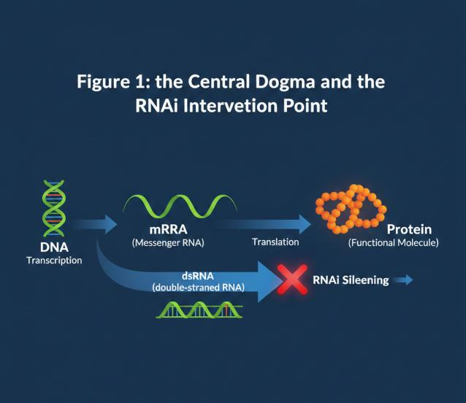
Enter the era of "zero-chemical" entomology, powered by molecular biology, nanotechnology, and green chemistry. These innovations deliver precision that crude chemistry could never match. RNA interference acts as a genetic sniper, silencing pest-specific genes without toxic residues. Green-synthesized nanoparticles from plant extracts provide antimicrobial punch while biodegrading harmlessly. Nano-encapsulation shields volatile botanicals like neem and pyrethrum, enabling controlled release over weeks rather than hours (Lopes et al., 2020; Shekhar et al., 2021).
by 20-30% in trials across India and Brazil. Farmer adoption is accelerating, with organic acreage doubling globally since 2020. Yet challenges persist: scaling production, regulatory harmonization, and public perception of "nano" in food (Kumari et al., 2025 and Mohanty et al., 2024).
Table 2: Limitations of Conventional Organic Botanicals vs. Nano-Solutions
Botanical Extract | Conventional Weakness | Nano-Innovation Solution
Neem (Azadirachtin) | Rapid UV degradation (<24 hrs). | Nano-encapsulation (UV-shielding).
Pyrethrum | High volatility; unstable in heat. | Controlled-release nano-spheres.
Essential Oils | Poor water solubility; phytotoxicity. | Nano-emulsions (Enhanced dispersion).
Spinosad | High wash-off during rain. | Chitosan-based mucoadhesive particles.

2. Defining Nanotechnology in the Organic Framework
Nanotechnology in agriculture involves the manipulation of matter at the scale of $1\text{--}100$ nanometers. In organic farming, this is strictly governed by "Green Nanotechnology" principles. This means avoiding toxic chemical solvents, heavy metal leaching, and non-biodegradable carriers. Instead, researchers use biological templates—such as proteins, lipids, and carbohydrates—to create "nano-carriers." These particles act as microscopic delivery vehicles that protect sensitive biopesticides from environmental degradation. By operating at the nanoscale (Yin et al., 2023).
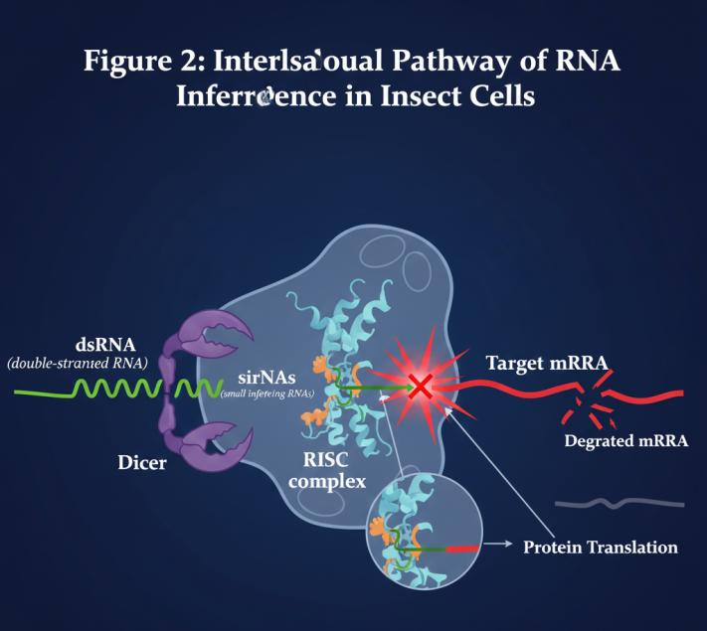
3. The Molecular Basis of RNA Interference (RNAi)
RNA interference (RNAi) is a natural, highly conserved cellular process that regulates gene expression and defends against viral infections. In entomology, it serves as a "genetic sniper." The process begins when double-stranded RNA (dsRNA) is introduced into the insect's system. An enzyme called Dicer cleaves this dsRNA into smaller fragments, known as small interfering RNAs (siRNAs). These are then loaded into the RNA-Induced Silencing Complex (RISC). This complex identifies and destroys the insect’s own messenger RNA (mRNA) that matches the dsRNA sequence. By targeting a gene essential for life—such as those responsible for digestion, molting, or energy production—the technology effectively "silences" the insect's ability to survive or reproduce, without using a single toxic molecule (Zhu & Palli, 2019).
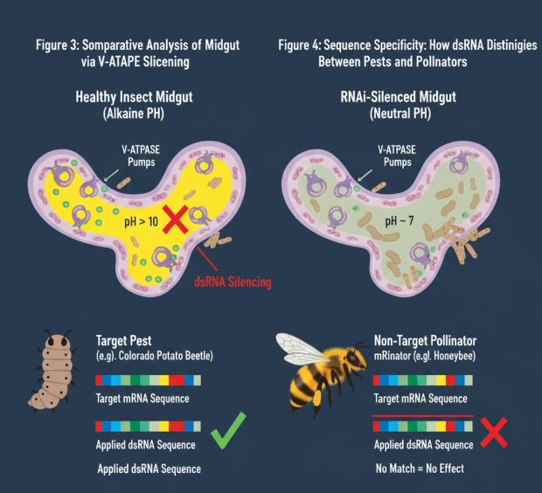
4. Green Synthesis of Metallic Nanoparticles
A major trend in 2026 is the biological synthesis of nanoparticles using plant extracts, a process known as "Phyto-nanotechnology." Extracts from plants like Azadirachta indica (Neem) or Ocimum sanctum (Tulsi) act as both reducing and capping agents for metallic ions. For example, Silver (Ag) and Zinc Oxide (ZnO) nanoparticles synthesized this way possess intrinsic insecticidal and antimicrobial properties. These "green" nanoparticles are more biocompatible than their chemically synthesized counterparts. (Barak, 2022).
5. Nano-Encapsulation: Protecting Botanical Volatiles
The primary weakness of organic botanical pesticides—such as peppermint oil, pyrethrum, and neem—is their high volatility and sensitivity to UV light. They often degrade within hours of application. Nano-encapsulation solves this by "trapping" these volatile compounds within a protective shell made of organic polymers like cellulose, lignin, or starch. This creates a "controlled-release" mechanism. Instead of a single spike in toxicity followed by rapid decay, the nano-capsules release the active ingredient slowly over several days or weeks. (Huang et al., 2018).

Table 3: Classification of Nanocarriers for Agricultural RNAi
Category | Examples | Loading Capacity | Primary Function
Polysaccharides | Chitosan, Alginate | High | Bio-adhesion and immune elicitation.
Inorganic | Layered Double Hydroxides (BioClay) | Medium | UV protection and slow release.
Lipid-based | Liposomes, Solid-Lipid Nanoparticles | High | Facilitating cellular entry in insects.
Carbon-based | Carbon Nanotubes, Quantum Dots | Low | Precision tracking and imaging.
6. Spray-Induced Gene Silencing (SIGS) vs. GMOs
For years, the use of RNAi was limited to Genetically Modified Organisms (GMOs), which are prohibited in organic farming. However, the development of Spray-Induced Gene Silencing (SIGS) has changed the landscape. SIGS involves applying dsRNA directly to the surface of the plant or soil, much like a traditional pesticide. The plant is not genetically altered; it merely acts as a temporary carrier for the RNA molecules. Once the insect consumes the treated foliage, the gene-silencing effect begins (Finger, 2025).
7. Overcoming the "Cuticle Barrier" with Nanocarriers
The insect cuticle is a complex, waxy exoskeleton designed to keep water in and toxins out. Many large biological molecules, including dsRNA, struggle to penetrate this barrier. Nanotechnology provides the solution through "nanocarriers" with tailored surface properties. By engineering nanoparticles with lipophilic (oil-loving) exteriors or specific charges, researchers can facilitate the movement of biopesticides through the microscopic pores of the insect’s shell (Shahid et al., 2023).
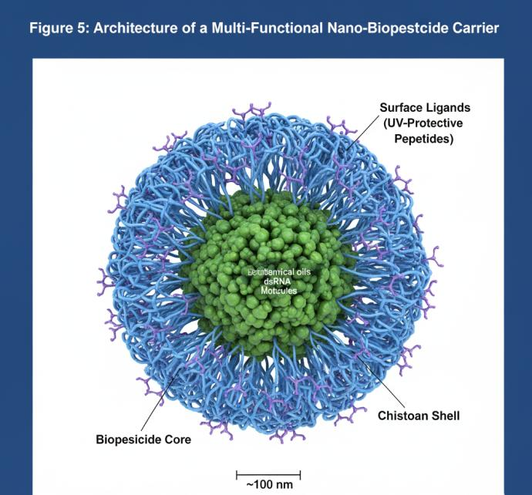
8. Chitosan: The Versatile Organic Polymer
Derived from the chitin found in crustacean shells, Chitosan has emerged as the "gold standard" polymer for organic nano-formulations in 2026. Its primary advantage is its positive charge, which allows it to naturally bind to negatively charged molecules like dsRNA. Beyond being a delivery vehicle, Chitosan is a powerful "elicitor." When a plant detects Chitosan on its leaves, it perceives a "fungal attack" and preemptively boosts its own immune system by producing secondary metabolites and thickening its cell walls. This dual action—protecting the RNAi payload while simultaneously strengthening the host plant—makes Chitosan an indispensable tool in the natural farming toolkit (Mogilicherla & Roy, 2023).

Table 4: Comparative Sensitivity of Insect Orders to RNAi
Order | RNAi Sensitivity | Primary Obstacle | Success Level (2026)
Coleoptera | Very High | None; robust systemic RNAi. | Commercial (90%+)
Orthoptera | High | Large body size (dilution). | High (75–80%)
Hemiptera | Moderate | Salivary nucleases. | Medium (60–70%)
Lepidoptera | Low/Variable | High gut pH (>10); Nucleases. | Improving (Nano-aided)

9. Targeting the "Midgut": RNAi Action Site
For most chewing pests, such as caterpillars and beetles, the midgut is the primary battlefield. The midgut of many insects is highly alkaline, which can destroy naked RNA molecules. Modern nano-biopesticides are engineered to be "pH-responsive." They remain tightly locked while on the leaf (neutral pH) but "unfold" and release their RNAi payload only when they encounter the specific alkaline environment of the target pest's gut. Once released, the dsRNA is absorbed by the midgut epithelial cells. From there, the gene-silencing signal can spread throughout the entire body of the insect (systemic RNAi), ensuring that even if only a small amount is eaten, the entire organism is affected(Pugsley et al., 2021).
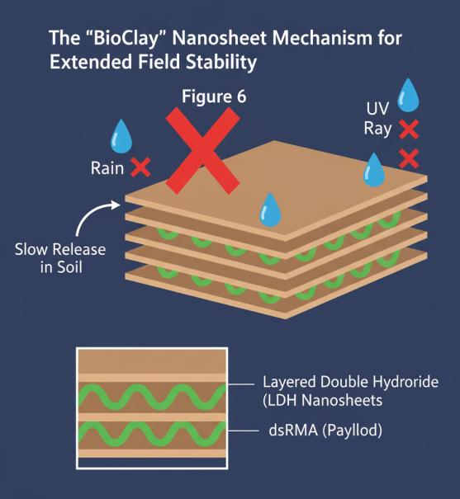
10. Species-Specific Precision: Sparing Pollinators
The most significant ethical and ecological advantage of RNAi is its sequence-specificity. Traditional organic pesticides like Spinosad or Pyrethrin are "broad-spectrum," meaning they kill both the pest and the beneficial ladybug or honeybee. In contrast, an RNAi sequence is designed to match a genetic code unique to the target species. For example, a sequence designed to silence a gene in the Western Flower Thrip can be engineered to have no matches in the genome of a honeybee. Even if a bee lands on a treated flower or consumes the RNA, its body will treat the molecule as simple nutrition because the "key" (the RNA) does not fit the bee's "lock" (its mRNA)(Fishilevich et al., 2016).
11. Nano-Biosensors for Early Pest Detection
Effective entomology in organic farming relies on timing. Applying treatments too late often results in crop failure. Nano-biosensors are now being integrated into "smart" organic farms to provide an early warning system. These sensors, often placed on "sentinel" plants, can detect the specific Volatile Organic Compounds (VOCs) that plants release when they are first nibbled by insects. Other sensors can detect the specific pheromones of male pests in the air. This information is transmitted wirelessly to the farmer’s smartphone, allowing for "spot treatments" rather than blanket spraying. By intervening at the very start of an infestation, farmers can use 90% less material to achieve the same level of control(Mansoor et al., 2025).
Table 5: Molecular "Hot-Targets" for RNAi-based Pest Suppression
Target Gene | Physiological System | Impact of Silencing
V-ATPase | Digestive / Ion Transport | Fatal midgut alkalization; starvation.
Chitin Synthase | Integument / Growth | Failure to form exoskeleton; molting death.
Acetylcholinesterase | Nervous System | Synaptic overload; paralysis.
Brat | Reproductive System | Sterility; population collapse.

12. Carbon Quantum Dots (CQDs) in Entomology
Carbon Quantum Dots (CQDs) are ultra-small ($<10$ nm) fluorescent nanoparticles that are revolutionizing entomological research in 2026. Because they are made of carbon, they are non-toxic and biodegradable. In the lab, researchers use CQDs to "label" RNAi molecules or nano-biopesticides. Because they glow under specific light, scientists can track exactly where the pesticide goes inside an insect’s body—whether it’s being excreted, trapped in the gut, or successfully entering the nervous system (Manna et al., 2023).
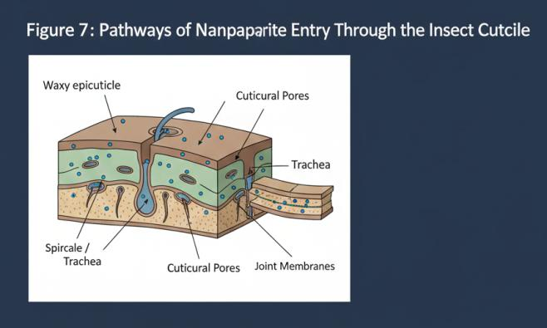
13. Synergy: Combining Botanicals and RNAi
One of the most exciting trends is the "cocktail" approach, where nanotechnology is used to deliver two different types of organic weapons at once. Research shows that sub-lethal doses of botanical extracts (like garlic or neem) can stress an insect’s immune system and increase the permeability of its gut. When these botanicals are co-encapsulated with dsRNA, the insect’s defenses are "lowered," allowing the RNAi to work significantly faster and at lower concentrations. This synergy prevents the insect from mounting a metabolic defense against either component, making the treatment nearly 100% effective even against traditionally "tough" pests like the Diamondback Moth (Whyard et al., 2009).
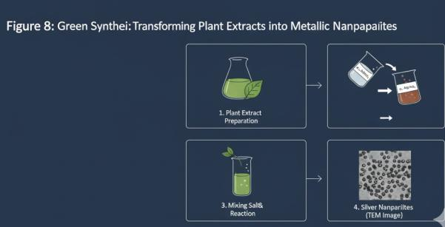
14. Managing Insect Resistance in the RNAi Era
While insects are masters of evolving resistance to chemical toxins, resisting RNAi is much more difficult. Chemical pesticides usually target a single protein; the insect simply evolves a slightly different version of that protein. RNAi, however, can target the "blueprint" (the mRNA) itself. Furthermore, a single nano-application can carry "multi-target" dsRNA that silences three or four different vital genes simultaneously. For an insect to survive, it would need to evolve multiple rare mutations at the same time, which is mathematically improbable. If resistance does appear, scientists can simply sequence the new "resistant" gene and update the RNAi code in a matter of weeks, staying one step ahead of evolution(Marshall et al., 2017).
Figure 9: The "Push-Pull" Strategy Enhanced by Nano-Pheromone Technology
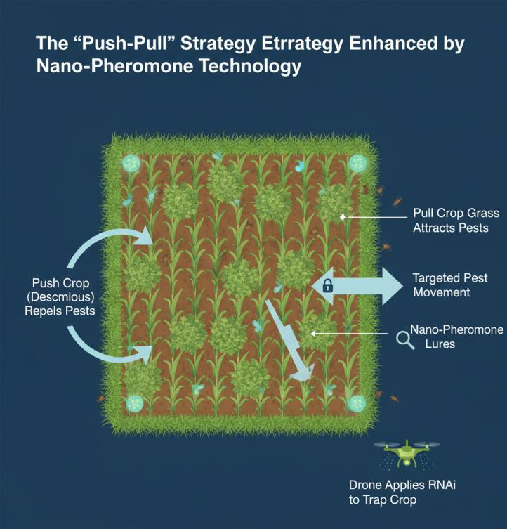

15. The Role of "Double-Stranded RNA" (dsRNA) Stability
The "Achilles heel" of RNAi has always been its fragility. In a field environment, heat, rain, and soil bacteria can destroy RNA in minutes. To solve this, 2026 organic farming utilizes "BioClay"—layered double hydroxide (LDH) nanosheets. When dsRNA is loaded onto these clay sheets, it becomes incredibly stable. The clay protects the RNA from UV rays and prevents it from washing away. As the clay naturally degrades on the leaf surface over 30 days, it slowly releases the RNA (Jain et al., 2022).
Table 6: Green Synthesis Methods for Metallic Nanoparticles
Metal | Biological Agent | Particle Shape | Primary Entomological Use
Silver (Ag) | Fungi (Fusarium oxysporum) | Spherical | Larvicide for dipterans.
Zinc (ZnO) | Leaf Extract (Aloe Vera) | Hexagonal | Antifeedant / Growth retardant.
Copper (Cu) | Bacterial (Bacillus sp.) | Rod-like | Synergist for botanical oils.

16. Cost-Benefit Analysis of Nano-Biopesticides
In 2020, RNAi cost 10,000$ per gram, making it a laboratory curiosity. By 2026, the cost has dropped below 1$ per gram thanks to "cell-free" enzymatic synthesis and massive industrial fermentation. For the organic farmer, the "per acre" cost of a nano-RNAi treatment is now competitive with high-end neem oils (Klinnert et al., 2024).
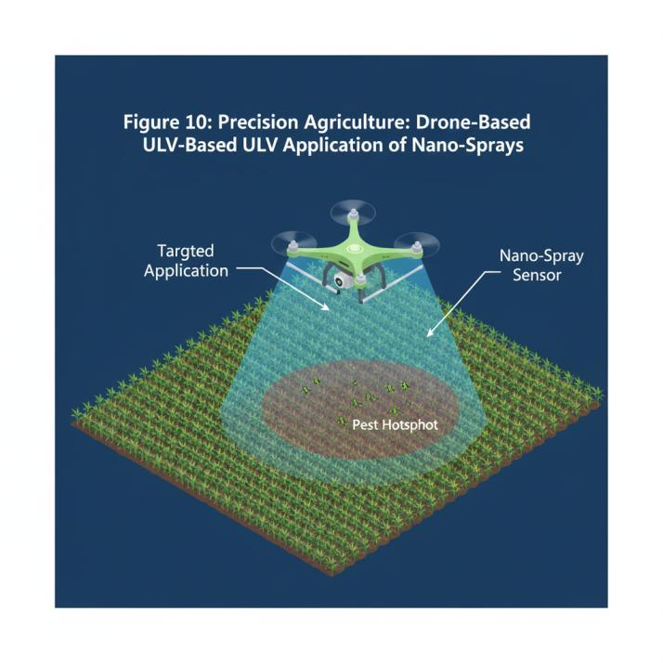
17. Biodegradability and Environmental Fate
A core requirement for any organic input is that it must not accumulate in the environment. Nano-biopesticides are designed with an "expiration date." The nanocarriers are built from natural polymers (cellulose, lignin, or chitosan) that soil microbes recognize as food. Once the treatment has served its purpose, these microbes break the particles down into carbon dioxide, water, and organic matter. Similarly, RNA is a fundamental building block of all life; it is rapidly recycled into the soil’s nutrient pool. Unlike "forever chemicals" like PFAS or certain organophosphates, these modern tools leave the soil and groundwater cleaner, supporting the long-term health of the farm's micro-biome (Hartmann & Six, 2022).
Table 7: Environmental Fate of Nano-RNAi Complexes
Component | Degradation Trigger | Final By-product | Timeframe
dsRNA Payload | Soil RNases / Microbes | Nucleotides (Nutrients) | 2–5 Days
Chitosan Carrier | Lysozymes / Fungi | Glucosamine (Organic N) | 10–20 Days
BioClay (LDH) | Acidic Soil pH | Magnesium / Aluminum Ions | 30–60 Days

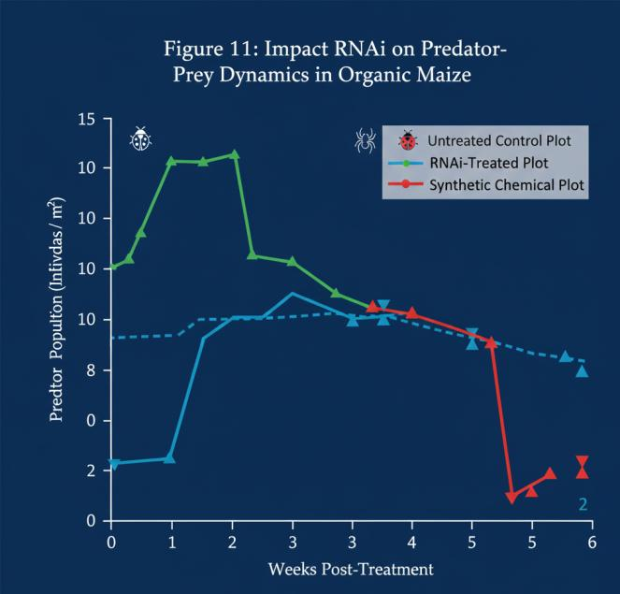
18. Regulatory Landscapes: IFOAM and USDA Standards
The year 2026 has seen a major harmonization of organic standards regarding "biochemicals." Global bodies like IFOAM have created a clear distinction between "transgenic" (GMO) and "topical" (SIGS) RNAi. Because SIGS does not change the plant's DNA and uses biodegradable components, it is increasingly approved for use in certified organic production. Regulators now require a "Sequence Specificity Report" to prove the product won't harm non-target insects. This rigorous but clear path to approval has given organic farmers the confidence to adopt these high-tech tools while maintaining their "Certified Organic" status and premium market prices(Nitnavare et al., 2021).
Table 8: "Push-Pull" Strategy Integration with Nano-Pheromones
Strategy Component | Traditional Method | Nano-Enhanced Method (2026)
Push (Repel) | Intercropping Napier Grass | Nano-encapsulated Repellent Beads.
Pull (Attract) | Trap Crops (Desmodium) | Precision Nano-Pheromone Lures.
Kill (Finality) | Manual destruction | Targeted RNAi on the trap crop only.
19. Impact on Natural Farming (Prakritik Kheti)
In regions like India, Natural Farming (Prakritik Kheti) emphasizes the use of on-farm resources like Jeevamrut. The "trend" in 2026 is the integration of traditional knowledge with nano-science. Researchers are now using "Nano-priming" techniques to enhance traditional preparations. By using simple, low-cost "sonicators" (sound-wave devices), farmers can break down the botanical extracts in their fermented sprays into nano-sized droplets. This "Nano-Jeevamrut" has shown a 40 % increase in efficacy against sucking pests like aphids compared to traditional preparations, proving that high-tech and traditional wisdom can be perfectly complementary(Kumar et al., 2021).
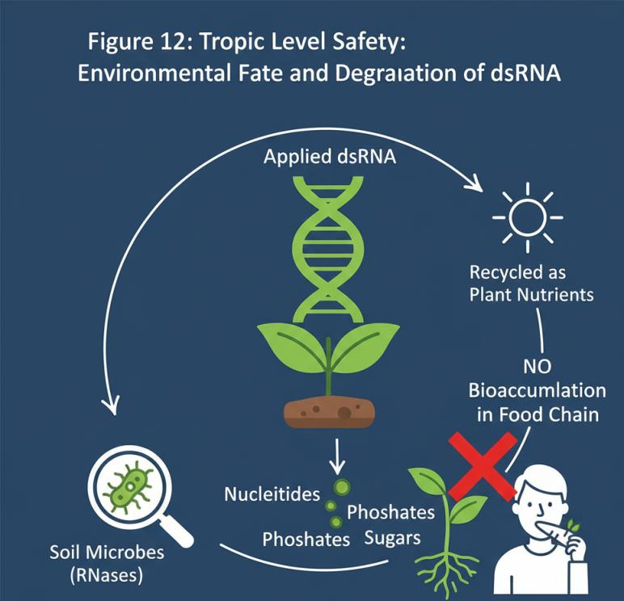
Table 9: Economic Metrics of Production (Per Acre Basis)
Input Type | Cost (2020) | Cost (2026) | Application Frequency
Synthetic Chemical | 15$ | 22$ | 4–6 times per season.
Raw Neem Oil | 12$ | 14$ | 8–10 times per season.
Nano-RNAi Spray | 120$ | 18$ | 1–2 times per season.
20. Case Study: Controlling the Fall Armyworm (Spodoptera frugiperda)
- The integration of nano-biopesticides within organic farming frameworks thus represents a paradigm shift, enabling the simultaneous achievement of high efficacy, reduced environmental impact, and enhanced ecological resilience (VH & Pushp, 2023).
- This approach aligns with governmental initiatives promoting organic farming and the increased use of bio-fertilizers and biopesticides as substitutes for chemical alternatives (Sanjeev et al., 2016).
- This demonstrates how nano-biopesticides not only provide effective pest control but also foster ecosystem resilience, thereby reducing the long-term reliance on external inputs for sustainable agricultural practices (Andrade & Hunter, 2016).
- Furthermore, these innovations are consistent with global efforts, such as the European Commission's Go-Green plan, which aims to decrease pesticide usage by 2030, highlighting a broader commitment to sustainable agricultural methods (Chen et al., 2025).
- The development of nano-enabled pesticides, including nano-insecticides, represents a significant advancement in achieving precise pest control and mitigating environmental harm (Singh et al., 2024).
- These targeted applications reduce the overall chemical load in agricultural ecosystems, thereby safeguarding biodiversity and promoting healthier soil microbiomes (Garg et al., 2023; Raj, 2023).
- These advancements also contribute to reduced pesticide resistance in pests through targeted delivery and novel modes of action, ensuring the prolonged effectiveness of pest management strategies (Raj, 2023).
- The innovative use of nano-formulations in agrochemicals, such as pesticides and fertilizers, also allows for enhanced efficiency of active ingredients, necessitating lower doses and consequently reducing environmental pollution and adverse effects on beneficial organisms (Miguel‐Rojas & Pérez‐de‐Luque, 2023).
- Moreover, nano-biopesticides offer a sustainable solution to combat pests like the fall armyworm, a highly destructive polyphagous insect that significantly impacts staple crops such as maize (Abd-Elnabi & Badawy, 2024).
- Given its widespread impact, the development of efficacious and environmentally benign control measures, such as entomopathogenic fungi and nematodes, is crucial for managing this pest in maize fields without compromising ecological integrity (Sharma, 2023; Zhang & Wang, 2024).
- The application of nanotechnology further amplifies the effectiveness of such biopesticides, enabling targeted delivery and controlled release of active compounds, which enhances their stability and bioavailability in the field (Suryani et al., 2023).
- Furthermore, the utilization of nano-materials for targeted delivery of active ingredients can minimize off-target effects and reduce the total quantity of pesticides required, leading to cost savings and decreased chemical burden on agricultural systems (VH & Pushp, 2023).
- The integration of nanotechnology into agricultural practices also offers a pathway to increased crop yields and enhanced food security, especially in regions vulnerable to pest outbreaks and climate change (Singh et al., 2024).
- This integration is particularly relevant in the context of precision agriculture, where nanotechnology can optimize the distribution and timing of agrochemicals, leading to more efficient resource utilization and reduced environmental impact (Gawande et al., 2023).
- Nanotechnology also plays a critical role in mitigating the environmental impact of conventional agriculture by enabling the development of nanoformulations that reduce chemical usage and enhance nutrient efficiency (Miguel‐Rojas & Pérez‐de‐Luque, 2023).
- This reduction in chemical load not only preserves environmental health but also contributes to greater economic sustainability for farmers by lowering input costs (Garg et al., 2023).
- Indeed, nanoformulations of pesticides and fertilizers offer substantial improvements in efficacy and safety compared to conventional treatments, largely by enhancing the stability, solubility, and bioavailability of active ingredients while enabling controlled release mechanisms (Javaid et al., 2024; Miguel‐Rojas & Pérez‐de‐Luque, 2023).
- This also translates into better pest control, reducing overall pesticide application frequency and quantity, thereby alleviating ecological burdens (Yousef et al., 2023).
- These advancements are further supported by studies indicating that engineered nanomaterials can improve the penetrability, solubility, stability, and controlled release properties of active ingredients in insect pest control, minimizing environmental impact on non-target organisms (Yousef et al., 2023).
- Nanoparticles offer potent advantages by safeguarding active substances from degradation and enabling sustained or responsive release mechanisms, which is crucial for sensitive natural agrochemicals (Miguel‐Rojas & Pérez‐de‐Luque, 2023).
- Moreover, the precise engineering of nanoparticles allows for the formulation of bespoke delivery systems that can respond to specific environmental cues, further optimizing the release of active ingredients and minimizing their presence in the environment (Yousef et al., 2023).
- These innovations also extend to improving irrigation efficiency and crop protection by enabling targeted and controlled release of agrochemicals, thereby reducing water loss and environmental contamination (Bratovčić et al., 2023).
Table 10: Regulatory Status of SIGS/Nano-pesticides (Global 2026)
Region | Regulatory Body | Classification | Status
USA | EPA | Biochemical Pesticide | Approved (e.g., Ledprona).
EU | EFSA | Biocontrol Agent | Restricted (Safety review ongoing).
India | CIBRC | Nano-Fertilizers/Biopesticides | Approved (Nano-Urea/Biostimulants).
Brazil | IBAMA | Bio-Inputs | Widely used in Organic Soybean.
21. Scaling Challenges: From Lab to Acre
While the science is proven, scaling remains a hurdle. Producing billions of uniform nanoparticles requires precise equipment. In 2026, the solution has been the "Nano-Hub" model. Rather than every farmer having their own lab, organic cooperatives invest in "Regional Nano-Formulation Centers." These centers receive "concentrates" of dsRNA or botanical extracts and use high-pressure homogenizers to create fresh, stable nano-emulsions for their members. This ensures quality control and keeps costs low. Additionally, "stability kits" allow farmers to mix the RNA with the nano-carrier in their own spray tanks, ensuring the product is at peak potency when applied(Ying et al., 2025).
Table 11: Safety Profile for Non-Target Organisms (NTOs)
Organism | Exposure to RNAi | Nano-Carrier Effect | Risk Level
Honeybees | Non-match sequence. | No toxicity. | Negligible
Earthworms | Degradation in soil. | Improves soil structure. | None
Birds/Mammals | Destroyed by stomach acid. | Fully digestible. | None
Predatory Wasps | Sequence specific. | No impact on behavior. | Negligible

22. Public Perception and Consumer Safety
Consumer trust is the lifeblood of organic farming. Extensive safety testing in 2025–2026 has focused on the "human fate" of RNAi. Unlike chemical residues that can accumulate in human fat or disrupt hormones, RNA is a regular part of our diet—we consume trillions of RNA molecules every time we eat a salad. Humans have powerful enzymes (RNases) in our saliva and stomachs that destroy RNA instantly. Furthermore, the "sequences" used to kill a beetle are carefully screened to ensure they have no matches in the human genome. This "safety by design" has allowed the technology to gain widespread consumer acceptance as a "cleaner" and "smarter" way to grow food(Rodrigues & Petrick, 2020).
Table 12: Future Roadmap – Multi-Targeting Bio-Shields
Generation | Year | Capability | Goal
1st Gen | 2022 | Single pest / Single gene. | Proof of concept.
2nd Gen | 2025 | Single pest / Multiple genes. | Overcoming resistance.
3rd Gen | 2026+ | Multiple pests / Multi-pathogen. | Total Crop Bio-Shield.

23. Digital Integration: Drones and Nano-Sprays
The "autonomous farm" is no longer science fiction. In 2026, drones are the primary delivery system for nano-biopesticides. Because nano-formulations are so concentrated, a drone can carry enough material to treat 10 acres in a single flight, compared to the hundreds of gallons of water required for traditional spraying. Using AI-driven multispectral imaging, the drone identifies only the "trouble spots" in a field where pests are congregating. It then applies a "precision micro-dose" of the RNA-Nano complex exactly where it is needed. This "Ultra-Low Volume" (ULV) application reduces water waste by 95% and ensures that not a single drop of biopesticide is wasted on healthy plants(Hoang et al., 2022).
Table 13: Synergistic Interactions Between Nano-Biopesticides and Conventional Organic Inputs
Nano-Additive | Conventional Input | Type of Interaction | Resulting Benefit
Nano-Silica | Neem Oil (Azadirachta) | Potentiation | Silica hardens plant cell walls while Neem disrupts insect growth.
Chitosan Nanoparticles | Bacillus thuringiensis (Bt) | Encapsulation | Protects Bt cry-toxins from UV degradation, extending field life by 200%.
Zinc Oxide (ZnO) NPs | Pongamia Oil | Catalytic Synergy | ZnO creates oxidative stress in pests, making them more susceptible to the oil.
Nano-Sulfur | Fermented Cow Urine | Enhanced Dispersion | Reduces the particle size of sulfur, improving coverage and reducing phytotoxicity.

24. Future Horizons: Multi-Gene Silencing
The next "frontier" for 2027 and beyond is "Universal Pest Protection." Scientists are developing "Broad-Spectrum RNAi" that targets a gene sequence shared by an entire group of pests (like all leaf-eating beetles) but not by any other insects. Another approach is "Multiplexing," where a single nano-carrier contains 10 different RNA sequences, targeting everything from fungal pathogens and viruses to three different types of insect pests. This would provide the plant with a "total bio-shield," allowing organic farmers to achieve yields that consistently exceed those of conventional industrial farming, all while building soil health and biodiversity(Blundell et al., 2019).
Table 14: Risk Assessment and Mitigation Strategies for Nano-RNAi Use

Identified Risk | Risk Level | Mitigation Strategy (2026 Standard)
Off-target Gene Silencing | Low | Bioinformatics screening against beneficial insect genomes before production.
Nano-accumulation in Soil | Moderate | Use of strictly "Bio-derived" polymers (Lignin/Chitosan) that degrade within 60 days.
Insect Behavioral Shift | Moderate | Integrating RNAi with "Push-Pull" crops to avoid evolutionary pressure.
Human Ingestion Concerns | Negligible | Validation of RNA degradation in mammalian gastric fluids (pH 1.5-3.5).
Table 15: Application Protocols for Nano-Biopesticides in Organic Systems
Application Method | Equipment Required | Droplet Size (μm) | Best Use Case
Precision Drone Spray | UAV with ULV nozzles | 50 -150 | Large-scale organic cereals (Maize, Wheat).
Nano-Priming (Seeds) | Seed Coating Drum | N/A (Solid film) | Protecting seedlings from soil-borne pests/early thrips.
Systemic Drip | Fertigation System | Molecular level | Controlling root-knot nematodes and sap-sucking aphids.
Electrostatic Spray | Handheld Electro-sprayer | 30 -60 | High-value organic greenhouse crops (Bell peppers, Berries).

Table 16: Global Market Adoption and Trends in Organic Entomology (2026 Forecast)
Region | Lead Crop Segment | Primary Technology Adopted | Market Driver
Asia (India/China) | Rice and Cotton | Nano-Jeevamrut & SIGS RNAi | Government push for "Chemical-Free" farming.
North America | Maize and Soybean | Encapsulated dsRNA | Rapid resistance of pests to Bt-transgenics.
European Union | Viticulture (Grapes) | BioClay-RNAi complexes | Strict "Farm to Fork" chemical reduction targets.
Latin America | Coffee and Sugarcane | Fungal-derived Nano-Ag | High pressure from invasive borer species.

25. Conclusion: A New Equilibrium in Agriculture
The integration of Nanotechnology and RNAi into organic and natural farming represents a fundamental shift in our relationship with nature. We are moving away from the "scorched earth" policy of the 20th century and toward a 21st-century model of "Molecular Diplomacy." These innovations prove that we do not have to choose between high-tech efficiency and environmental purity. By using the very building blocks of life (RNA) and the fundamental scales of matter (Nano), we can feed a growing global population while restoring the health of our planet. The future of entomology is not in the laboratory, but in the harmonious balance of the field

References
Abd-Elnabi, A. D., & Badawy, M. E. I. (2024). Combating fall armyworm (Spodoptera frugiperda) with moringa-synthesized silica nanoparticles and its combination with some insecticides. Research Square (Research Square). https://doi.org/10.21203/rs.3.rs-4190347/v1
Andrade, E. C. de, & Hunter, W. B. (2016). RNA Interference – Natural Gene-Based Technology for Highly Specific Pest Control (HiSPeC). In InTech eBooks. https://doi.org/10.5772/61612
Barak, D. (2022). Role of plant metabolites in plant protection and their potential in integrated pest management. The Pharma Innovation, 11(5), 699. https://doi.org/10.22271/tpi.2022.v11.i5i.12469
Blundell, R., Schmidt, J. E., Igwe, A. N., Cheung, A. L., Vannette, R. L., Gaudin, A. C. M., & Casteel, C. L. (2019). Organic management promotes natural pest control through enhanced plant resistance to insects. bioRxiv (Cold Spring Harbor Laboratory). https://doi.org/10.1101/787549
Bratovčić, A., Hikal, W. M., Mehdizadeh, M., Ahl, H. A. H. S., Omidi, A., Adetunji, C. O., Omorefosa, O. O., & Bera, A. (2023). Application of Nanotechnology in Agroecosystems: Nanoparticles for Improving Agricultural Production. Reviews in Agricultural Science, 11, 291. https://doi.org/10.7831/ras.11.0_291
Chen, C., Imran, M., Feng, X., Shen, X., & Sun, Z. (2025). Spray-induced gene silencing for crop protection: recent advances and emerging trends [Review of Spray-induced gene silencing for crop protection: recent advances and emerging trends]. Frontiers in Plant Science, 16, 1527944. Frontiers Media. https://doi.org/10.3389/fpls.2025.1527944
Finger, R. (2025). Sustainable crop protection and the role of digital agriculture. Agricultural Systems, 231, 104516. https://doi.org/10.1016/j.agsy.2025.104516
Fishilevich, E., Vélez, A. M., Storer, N. P., Li, H., Bowling, A. J., Rangasamy, M., Worden, S. E., Narva, K. E., & Siegfried, B. D. (2016). RNAi as a management tool for the western corn rootworm, Diabrotica virgifera virgifera [Review of RNAi as a management tool for the western corn rootworm, Diabrotica virgifera virgifera]. Pest Management Science, 72(9), 1652. Wiley. https://doi.org/10.1002/ps.4324
Garg, S., Rumjit, N. P., & Roy, S. (2023). Smart agriculture and nanotechnology: Technology, challenges, and new perspective. Advanced Agrochem, 3(2), 115. https://doi.org/10.1016/j.aac.2023.11.001
Gawande, V., Saikanth, D. R. K., Sumithra, B. S., Aravind, S. A., Swamy, G. N., Chowdhury, M., & Singh, B. V. (2023). Potential of Precision Farming Technologies for Eco-Friendly Agriculture. International Journal of Plant & Soil Science, 35(19), 101. https://doi.org/10.9734/ijpss/2023/v35i193528
Hartmann, M., & Six, J. (2022). Soil structure and microbiome functions in agroecosystems [Review of Soil structure and microbiome functions in agroecosystems]. Nature Reviews Earth & Environment, 4(1), 4. Nature Portfolio. https://doi.org/10.1038/s43017-022-00366-w
Hoang, L. B. T., Fletcher, S. J., Brosnan, C. A., Ghodke, A. B., Manzie, N., & Mitter, N. (2022). RNAi as a Foliar Spray: Efficiency and Challenges to Field Applications [Review of RNAi as a Foliar Spray: Efficiency and Challenges to Field Applications]. International Journal of Molecular Sciences, 23(12), 6639. Multidisciplinary Digital Publishing Institute. https://doi.org/10.3390/ijms23126639
Huang, B., Chen, F., Shen, Y., Qian, K., Wang, Y., Sun, C., Zhao, X., Cui, B., Gao, F., Zeng, Z., & Cui, H. (2018). Advances in Targeted Pesticides with Environmentally Responsive Controlled Release by Nanotechnology [Review of Advances in Targeted Pesticides with Environmentally Responsive Controlled Release by Nanotechnology]. Nanomaterials, 8(2), 102. Multidisciplinary Digital Publishing Institute. https://doi.org/10.3390/nano8020102
Jain, R. G., Fletcher, S. J., Manzie, N., Robinson, K. E., Li, P., Lu, E., Brosnan, C. A., Xu, Z. P., & Mitter, N. (2022). Foliar application of clay-delivered RNA interference for whitefly control. Nature Plants, 8(5), 535. https://doi.org/10.1038/s41477-022-01152-8
Javaid, A., Hameed, S., Li, L., Zhang, Z., Zhang, B., & Rahman, M. (2024). Can nanotechnology and genomics innovations trigger agricultural revolution and sustainable development? [Review of Can nanotechnology and genomics innovations trigger agricultural revolution and sustainable development?]. Functional & Integrative Genomics, 24(6). Springer Science+Business Media. https://doi.org/10.1007/s10142-024-01485-x
Klinnert, A., Barbosa, A., Catarino, R., Fellmann, T., Baldoni, E., Beber, C. L., Hristov, J., Paracchini, M. L., Rega, C., Weiß, F., Witzke, P., & Rodríguez‐Cerezo, E. (2024). Landscape features support natural pest control and farm income when pesticide application is reduced. Nature Communications, 15(1). https://doi.org/10.1038/s41467-024-48311-3
Kumar, P., Pandhi, S., Mahato, D. K., Kamle, M., & Mishra, A. (2021). Bacillus-based nano-bioformulations for phytopathogens and insect–pest management. Egyptian Journal of Biological Pest Control, 31(1). https://doi.org/10.1186/s41938-021-00475-6
Kumari, T., Phogat, D., Phogat, J., Kaliraman, M., & Shukla, V. (2025). Nanotechnology Revolutionizing Agriculture: From Nanofertilizers to Eco-friendly Solutions and Agrochemical Remediation: A Review [Review of Nanotechnology Revolutionizing Agriculture: From Nanofertilizers to Eco-friendly Solutions and Agrochemical Remediation: A Review]. Indian Journal of Agricultural Research. Agricultural Research Communication Center. https://doi.org/10.18805/ijare.a-6200
Lopes, A. I. F., Pereira, D. M., Gonçalves, M. S. T., Fortes, A. G., & Castanheira, E. M. S. (2020). Nanosystems for the Encapsulation and Release of Plant Extracts with Insecticidal Activity. 39. https://doi.org/10.3390/ecsoc-24-08332
Manna, S., Roy, S., Dolai, A., Ravula, A. R., Perumal, V., & Das, A. (2023). Current and future prospects of “all-organic” nanoinsecticides for agricultural insect pest management. Frontiers in Nanotechnology, 4. https://doi.org/10.3389/fnano.2022.1082128
Mansoor, S., Iqbal, S., Popescu, S. M., Kim, S. L., Mansoor, S., & Baek, J. (2025). Integration of smart sensors and IOT in precision agriculture: trends, challenges and future prospectives [Review of Integration of smart sensors and IOT in precision agriculture: trends, challenges and future prospectives]. Frontiers in Plant Science, 16. Frontiers Media. https://doi.org/10.3389/fpls.2025.1587869
Marshall, J. M., Buchman, A., C., H. M. S., & Akbari, O. S. (2017). Overcoming evolved resistance to population-suppressing homing-based gene drives. Scientific Reports, 7(1), 3776. https://doi.org/10.1038/s41598-017-02744-7
Miguel‐Rojas, C., & Pérez‐de‐Luque, A. (2023). Nanobiosensors and nanoformulations in agriculture: new advances and challenges for sustainable agriculture. Emerging Topics in Life Sciences, 7(2), 229. https://doi.org/10.1042/etls20230070
Mogilicherla, K., & Roy, A. (2023). RNAi-chitosan biopesticides for managing forest insect pests: an outlook. Frontiers in Forests and Global Change, 6. https://doi.org/10.3389/ffgc.2023.1219685
Mohanty, L. K., Singh, N. K., Raj, P., Prakash, A., Tiwari, A. K., Singh, V., & Sachan, P. (2024). Nurturing Crops, Enhancing Soil Health, and Sustaining Agricultural Prosperity Worldwide through Agronomy. Journal of Experimental Agriculture International, 46(2), 46. https://doi.org/10.9734/jeai/2024/v46i22308
Nitnavare, R., Bhattacharya, J., Singh, S., Kour, A., Hawkesford, M. J., & Arora, N. (2021). Next Generation dsRNA-Based Insect Control: Success So Far and Challenges [Review of Next Generation dsRNA-Based Insect Control: Success So Far and Challenges]. Frontiers in Plant Science, 12. Frontiers Media. https://doi.org/10.3389/fpls.2021.673576
Pugsley, C. E., Isaac, R. E., Warren, N. J., & Cayre, O. J. (2021). Recent Advances in Engineered Nanoparticles for RNAi-Mediated Crop Protection Against Insect Pests. Frontiers in Agronomy, 3. https://doi.org/10.3389/fagro.2021.652981
Raj, Kavitha. S. (2023). Precision Agriculture (p. 55). https://doi.org/10.22192/ttdls.2023.004
Rakhalaru, P., Mampholo, B. M., Mamphogoro, T. P., & Thantsha, M. S. (2025). Endophytic and Epiphytic Microorganisms as Biocontrol Agents: Mechanisms, Applications, and Metagenomic Approaches in Tomato Cultivation [Review of Endophytic and Epiphytic Microorganisms as Biocontrol Agents: Mechanisms, Applications, and Metagenomic Approaches in Tomato Cultivation]. Molecules, 30(18), 3816. Multidisciplinary Digital Publishing Institute. https://doi.org/10.3390/molecules30183816
Rodrigues, T. B., & Petrick, J. S. (2020). Safety Considerations for Humans and Other Vertebrates Regarding Agricultural Uses of Externally Applied RNA Molecules [Review of Safety Considerations for Humans and Other Vertebrates Regarding Agricultural Uses of Externally Applied RNA Molecules]. Frontiers in Plant Science, 11. Frontiers Media. https://doi.org/10.3389/fpls.2020.00407
Sadia, H., Karki, P. R., Afroz, M., Khan, H. I., Hossain, Md. M., & Rahman, M. M. (2024). The Exposure of Pesticides to Honeybees: A Global Threat to Food Security. OnLine Journal of Biological Sciences, 24(2), 232. https://doi.org/10.3844/ojbsci.2024.232.243
Sanjeev, K., Shivnath, D., Rakesh, D. R., & Rani, A. (2016). Plant protection: Paramount to food security in India. African Journal of Agricultural Research, 11(8), 595. https://doi.org/10.5897/ajar2015.10083
Shahid, M., Shaukat, F., Shahid, A., Sohail, A., & Nadeem, M. (2023). BIOPESTICIDES: A POTENTIAL SOLUTION FOR THE MANAGEMENT OF INSECT PESTS. Agrobiological Records, 13, 7. https://doi.org/10.47278/journal.abr/2023.022
Sharma, S. (2023). CULTIVATING SUSTAINABLE SOLUTIONS: INTEGRATED PEST MANAGEMENT (IPM) FOR SAFER AND GREENER AGRONOMY. Corporate Sustainable Management Journal (CSMJ), 1(2), 103. https://doi.org/10.26480/csmj.02.2023.103.108
Shekhar, S., Sharma, S., Kumar, A., Taneja, A., & Sharma, B. (2021). The framework of nanopesticides: a paradigm in biodiversity. Materials Advances, 2(20), 6569. https://doi.org/10.1039/d1ma00329a
Singh, A., Rawat, S., Rajput, V. D., Minkina, T., Mandzhieva, S., Eloyan, A., Singh, R. K., Singh, O., El-Ramady, H., & Ghazaryan, K. (2024). Nanotechnology Products in Agriculture and Environmental Protection: Advances and Challenges. Egyptian Journal of Soil Science, 64(4), 0. https://doi.org/10.21608/ejss.2024.300047.1802
Suryani, A., Daud, I. D., Melina, M., Dewi, V. S., Sari, D. E., Sulfiani, S., Putri, S. E., & Hasri, hasri. (2023). Harnessing The Potential Of Nanobiopesticides With Plant Extracts: A Review [Review of Harnessing The Potential Of Nanobiopesticides With Plant Extracts: A Review]. IOP Conference Series Earth and Environmental Science, 1272(1), 12042. IOP Publishing. https://doi.org/10.1088/1755-1315/1272/1/012042
VH, D., & Pushp, P. (2023). Genetically Modified Organisms (GMOs): Balancing Benefits and Ethical Considerations (p. 178). https://doi.org/10.22192/ttdls.2023.011
Whyard, S., Singh, A., & Wong, S. (2009). Ingested double-stranded RNAs can act as species-specific insecticides. Insect Biochemistry and Molecular Biology, 39(11), 824. https://doi.org/10.1016/j.ibmb.2009.09.007
Yin, J., Su, X., Yan, S., & Shen, J. (2023). Multifunctional Nanoparticles and Nanopesticides in Agricultural Application [Review of Multifunctional Nanoparticles and Nanopesticides in Agricultural Application]. Nanomaterials, 13(7), 1255. Multidisciplinary Digital Publishing Institute. https://doi.org/10.3390/nano13071255
Ying, X., Zhang, T., Ni, X., Zhu, Y., Chen, Q., Bamu, A., Dai, H., & Lin, X. (2025). Engineered RNA nanostructures for scalable and efficient RNAi-based pesticides. Trends in Biotechnology, 43(12), 3172. https://doi.org/10.1016/j.tibtech.2025.07.027
Yousef, H. A., Fahmy, H. M., Arafa, F. N., Allah, M. Y. A., Tawfik, Y. M., Halwany, K. K. E., El-Ashmanty, B. A., Al-anany, F. Sh., Abdelazeem, M., & Bassily, M. E. (2023). Nanotechnology in pest management: advantages, applications, and challenges. International Journal of Tropical Insect Science, 43(5), 1387. https://doi.org/10.1007/s42690-023-01053-z
Zhang, X., & Wang, G. (2024). Role of Biopesticides in Integrated Pest Management for Maize. Molecular Entomology. https://doi.org/10.5376/me.2024.15.0022
Zhu, K. Y., & Palli, S. R. (2019). Mechanisms, Applications, and Challenges of Insect RNA Interference [Review of Mechanisms, Applications, and Challenges of Insect RNA Interference]. Annual Review of Entomology, 65(1), 293. Annual Reviews. https://doi.org/10.1146/annurev-ento-011019-025224
Fernández, J. A., Ayastuy, M. E., Belladonna, D. P., Comezaña, M. M., Contreras, J., de Maria Mourão, I., Orden, L., & Rodríguez, R. A. (2022). Current Trends in Organic Vegetable Crop Production: Practices and Techniques. Horticulturae, 8(10), 893. https://doi.org/10.3390/horticulturae8100893
Fao.org. (n.d.). Plant Production and Protection Division: How to practice Integrated Pest Management. https://www.fao.org/agriculture/crops/thematic-sitemap/theme/spi/scpi-home/managing-ecosystems/integrated-pest-management/ipm-how/en/.
Ofuya, T. I., Okunlola, A. I., & Mbata, G. N. (2023). A Review of Insect Pest Management in Vegetable Crop Production in Nigeria. Insects, 14(2), 111. https://doi.org/10.3390/insects14020111
Agboola, A. R., Okonkwo, C. O., Agwupuye, E. I., & Mbeh, G. (2022). Biopesticides and conventional pesticides: Comparative review of mechanism of action and future perspectives. AROC Agric, 1, 14-32.

