A Comparative Morphological Study of the Parotid and Submandibular Glands in Adult Persian Cats (Felis catus) and Adult French Lop Rabbits (Oryctolagus cuniculus domesticus)

Abstract
The study to compare the gross morphology of the parotid and submandibular glands in adult Persian cats and adult French Lop rabbits. This study was carried out on 30 healthy adult animals, consisting of 5 Persian cats and 5 French Lop rabbits obtained from the local animal market in Babylon province. For morphological study location, relationship, shape of each gland, also the weigh, volume, length, width, thickness of gland also (length, diameter of duct). The results showed that, the parotid gland was the larger major salivary gland in both species. In the cat, it was quadrilateral, markedly lobulated, white to creamy, and located in the parotid region over the ramus of the mandible. In the rabbit, it was irregular elongated quadrilateral, lobulated, yellow to brown and extended from the ear base to the mandibular angle. The cat showed larger values than the rabbit for parotid length, width, thickness, volume, weight, duct length, and duct diameter. The parotid duct in both species was single and opened into the oral vestibule through the parotid papilla, opposite the first molar in the cat and the third molar in the rabbit. The submandibular gland was smaller than the parotid gland in both animals, in cat, it was oval, smooth to slightly lobulated, brown to yellow and located beneath the ventral part of the parotid gland. In the rabbit, it was pyramidal, slightly lobulated, red-brown, and positioned medially near the mandibular angle. The cat also showed larger measurements than the rabbit for submandibular length, width, thickness, volume, weight, duct length, and duct diameter. In both species, the submandibular duct was single and opened at the sublingual caruncle.
Keywords: Morphological Study; Parotid Gland; Submandibular Gland; Persian Cats, French Lop Rabbits;
Introduction
Most mammals have a major salivary gland that is designated parotid, the gland is covered by a thick capsule of connective tissue and is made up of lobules of serous parenchyma. It usually is placed superficially on masseteric muscle, and reaches from the base of the ear to the angle of the mandible. The gland is drained by Stensen's duct which opens into the oral vestibule opposite to the upper cheek teeth. Despite the parotid's largely conserved topographical location and internal morphology throughout mammals, inter-specific variations in its morphology, lobulation and ductal fine aspect are in line with evolutionary adaptations to dietary and functional requirements (Kessler and Bhatt, 2018; Takeuchi et al., 2021). The gross findings revealed that the paired parotid gland in the local rabbit is the largest gland compared to other major glands such as submandibular and sublingual. The gland is extended from the base of the external ear toward the angle of the mandible. It showed dorsal and ventral parts. It is surrounded by the fatty tissue characteristically in the female’s specimens. The gland extends below and in front of the base of the auricle of the ear between the skin and masseter muscle. Its duct is running rostrally along the lateral surface of the masseter muscle close to the branches of the facial nerve and finally enters the oral cavity opposite the last molar tooth. The color of the parotid gland is white or creamy and the lobulation of the gland was obvious with the naked eyes (AL-Saffar and Simawy, 2014). In the adult rabbit, it is the largest of the salivary glands, the parotid gland. It is caudal and lateral at the base of the auricle subcutaneously extending ventrally to the mandibular angle. Morphologically, the gland is broad, flat and scythe-shaped (composed of dorsal and ventral lobes separated by connective and adipose tissue septa). The capsule of gland is dense collagenous and it sends fine fibrous septa into the gland and divides it into polygonal lobules. The parotid duct arises (from the rostral border and passes superficially over the masseter muscle and winds medially to pierce the buccinator muscle into the oral vestibule opposite the molar teeth of the upper jaw) (DoCanvas, 2025; Ahmed et al., 2023). In the case of the cat the parotid gland was triangular or V-shaped, hence caudoventrally to the external auditory canal and craniolateral to the masseter muscle. It is covered by a dense fibrous capsule that sent off septa that ended in conglobated lobules into the capsule. The gland is pale yellowish white, smooth lobulated, and easily identified from the surrounding structures. From the rostral margin of the parotid duct passes over the masseter and faces in the direction of the fourth upper premolar (Abouelela et al., 2021; Ibrahim et al., 2023). In the rabbit, the parotid gland is not very large, and its average length is 28.4 millimeters, width 57.2 millimeters, and approximate weight 1.9 grams. These dimensions point to a rather well-developed gland, which is adapted to the animal's high salivary demand, relating to the continuous mastication of fibrous plant material (Ahmed et al., 2023). In the feline, the parotid is smaller in comparison, reaching an average of 21.5 mm in length, 36.4 mm long and a weight close to 1.2 g. The fairly compact size is correlated to a carnivorous feeding pattern, where salivary secretion is accompanied with bouts on food items and not continuous. Despite being smaller than the parotid gland, the parotid gland has a high amount of enzymatic action required for the digestion of meat and mouth lubrication (Ibrahim et al, 2023). In the rabbit, the parotid is broad scythe-shaped to be located at the base of the ear. It is pale pink in color and is enclosed behind a capsule of dense connective tissue and divides the gland into separate dorsal and ventral lobes. The primary excretory duct is called Stensen's duct, which stretches forward and opens into the mouth cavity behind the upper molar teeth, which helps with the efficient flow of saliva during the constant chewing of fibrous plant material (Ahmed et al., 2023). The cat has a triangular parotid gland which is located near the masseter muscle. It has a pale yellowish white coloration and surrounded by a tough capsule that is compactly lobular in nature. The main duct is a comparatively short duct which opens into the oral cavity opposite the upper fourth premolar. This compact and well-capsulated structure is typical among carnivorous species with the function of the gland being to secrete enzyme-rich saliva intermittently associated with feeding (Abouelela et al., 2021). The submandibular gland is one of the three major salivary glands of mammals paired right and left. It lies within the space between the mandibles and is situated on the medial surface of the mandible, and plays a major role in lubricating the mouth, enzyme digestion and electrolyte-water homeostasis. Structurally, the gland is bilaterally symmetrical, oval to elongated in shape and is enclosed within a dense fibrocollagenous capsule which sends out septa of connective tissue, and divide the gland into lobes and lobules. Within these connective septa are blood vessels and lymphatics, as well as autonomic nerve fibers, to ensure supply and maintenance of the vascular system and regulatory control of secretion by the autonomic nervous system (Chibly et al., 2022). In cat the submandibular gland has a mixed, seromucous, composition (varying between species of these gland acini being serous and mucous). Its main duct Wharton's duct arises from its rostral pole to the antero-ventral type to be opened with the sublingual caruncle in the vicinity of the frenulum of the tongue. This setup is generally conservative in mammals even if differences in duct length and diameter and twists exist, based on feeding habits and craniofacial adaptations (Vallefuoco et al., 2017). The gross findings revealed that the submandibular gland in the local rabbits is smaller in size compared to the parotid gland but in another hand its size is larger than those of the sublingual gland in this animal. The glands is characterized by pyramidal shape and red-brown in color. The external surface of the gland is smooth and no sign of gross lobulation could be observed. The latter character is different from that observed in the parotid of the same animal species in which its lobulation can be observed with naked eye. Both right and left submandibular glands are located medially to the angle of the mandible. The glands are situated juxtapose each other in the middle line at the caudal part of the tongue (Abouelela et al., 2021). The submandibular gland is in the rabbit large, flat, and strikingly lobulated and occupies the greater part of the caudal part of the intermandibular space. It has pale translucent pink color with smooth and highly vascular surface. The parenchyma of the gland is of soft consistency, and the Wharton's duct is broad and straight, and opens at the sublingual caruncle. The gland is made up of predominantly mucous acini enclosed by serous demilunes in a histological change to secrete viscous, mucin-filled saliva. This viscous secretion is necessary for the lubrication and moisturization of fibrous plant material which is typical of the rabbit's herbivorous diet. The large size and great lobulation are concordant with the physical movements of continuous chewing activity and high rate of saliva production for fermentation and fiber digestion of the rabbit (Ekstrom and Khosravani 2020; Ahmed et al., 2023). The submandibular gland of the cat is smaller, compact and ovoid in shape and is deep in the caudal intermandibular space and ventral to the parotid gland and medial of the mandibular ramus. It has a smooth, pale yellow-white color and a dense capsule which is lobes with poor. Wharton's duct is at once relatively short and narrow in proportion and extends towards the sublingual caruncle, where it opens separately from the sublingual duct. The compact morphology of the gland and small duct system allow for the swift disposal of salivation, in accordance with intermittent amounts of salivation and short periods of mastication, as are typical of carnivores (Abouelela et al., 2021).
Aim of study: The purpose of this study is to compare gross morphology of parotid and submandibular glands of adult Persian cats and adult French Lop rabbits and emphasize structural differences, which relate to their different dietary and physiologic adaptations.

Materials and methods
Animals
The participants in the present study were ten healthy adult Persian cats and healthy adult French Lop Rabbits. Animals were purchased in the special market in Babylon province, directly through the local traders. Animals were 5 cats and 5 rabbits to be used in morphology.
Preparation of specimens
The cats and rabbits were Weighing, then anesthetized by using Ketamine 15mg/K.g of body weight injected into the muscles by using digital scales (Singh et al., 2013). Through the ventral abdominal incision, the parotid and submandibular glands were removed, followed by the close cleaning of them and observation of the total morphology, followed by rinsing with normal saline to eliminate blood or other attachments. The parotid and submandibular glands were also located and photographed using a digital camera in the correct location (Tutunaru et al., 2013).
Morphological study
The gross morphological examination was performed by using five healthy adult cats of the Persian breed and five French Lop rabbits. The evaluation involved the shape, color, position, and location of the parotid and submandibular glands as well as their relationship to surrounding anatomic structures. Morphometric measurements included measuring the weight, length, width and thickness of each gland. The glandular weights were measured in grams on a sensitive electronic balance (Popesko et al., 2018). The total length and the parotid and submandibular glands for each species was measured with a calibrated metric ruler. Furthermore, the relative weight of both glands in relation to the body weight of each animal was calculated in order to give the possibility to make species-specific comparisons.
Statistical analysis
Statistical analysis of the data was done with the help of SPSS (version 26.0). All numerical values have been presented as the mean values with SD error (SE). To compare, the statistician Ronald Fisher has determined the statistical significance using ANOVA. The level of significance was determined to be (P value less than 0.05) (Field, 2020).
Results and discussion
Gross morphology of Parotid gland
The cat parotid salivary gland is the largest salivary gland present and is divided into two portions dorsal and ventral glands located on the ramus of the mandible in the parotid fossa as the length of the gland is towards the rear of the mandible above the submandibular gland. It possesses two ends, two borders and two surfaces. The back is connected to the bottom of the ear whereas the front is to the back of the submandibular gland. Cranial border was thin related to masseter muscle while caudal border was thick related to auricular structure. lateral surface related to skin and super facial facia while medial surface related to ramus of mandible and masseter The gland was very lobulated with white to creamy in color and quadrilateral in shape (Figures 1, 2, 3). Although the parotid salivary gland has two components, the dorsal and ventral, like in the French loop, and is larger than the submandibular gland, it is found in the parotid area extending between the end of the external ear and the position of the lower jaw angle, it possesses two ends, two borders, and two surfaces. Dorsal end related to base of ear while ventral end related to submandibular gland and lower jaw angle. Cranial border related to masseter muscle and parotid duct while caudal border related to ear structure. lateral surface related to skin and facial nerve and superficial facia. while right surface related to ramus of mandible and masseter muscle. The gland is seen lobulated by naked eye with yellow to brown in color, the shape of gland is irregular elongated quadrilateral (Figures 4, 5, 6). The parotid salivary gland appear as the largest salivary glands has two parts dorsal and ventral located on the ramus of mandible agreement with Kessler and Bhatt, (2018); Takeuchi et al., (2021) Most mammals, AL-Saffar and Simawy, (2014) in rabbit, DoCanvas, (2025); Ahmed et al., (2023) in rabbit, (Mavri et al., 2022) in pig, Kenhub, (2023); Korim et al., 2024) in horse.Our result in cat. The gland was very lobulated with white to creamy in color and quadrilateral in shape was similar to result to (AL-Saffar and Simawy, 2014) in rabbit, (Roa, and del Sol, 2019) in rat and differ with Mavri et al., (2022) In the pig, Ibrahium et al., (2022) in dog, Ahmed et al., (2023) in rabbit. While our result in rabbit the gland is seen lobulated by naked eye with yellow to brown in color, the shape of gland is irregular elongated quadrilateral disagreement with the result of Mavri et al., (2022) in pig, Ibrahium et al., (2022) in dog, (DoCanvas, 2025; Ahmed et al., 2023) in rabbit their results recorded different in shape and color. In cat the mean value of length, volume, width and thickness of gland was (45.3±2.22mm), (23±0.85 mm³), (24.6±1.45 mm), (3.9±1.20 mm) respectively (Table 1). While in French loop mean value of length, volume, width and thickness of gland was (42.3±1.15mm), (15±0.60 mm3), (12.5±1.30 mm), (2.8±0.80 mm) respectively (Table 1). A cat weighs 2.9±0.04 gm of parotid glands, with a ratio ranging between 0.098% and 0.020% when the weight of the cat is 2.9 to 3 kg (Table 1). While in French loop the mean of gland weight is (0.75±0.02gm) when the weight of rabbit is ranged between 850 gm to 1 kg, the ratio of gland to body weight is (0.08%±0. 015%) (Table 1). In cat the parotid duct as single duct extends from the cranial border of gland above the facial nerve passed along the external surface of masseter muscle and perced the check to open in the vestibule of mouth by small papillae called parotid papillae opposite at first molar teeth (Figures 1, 7). while in French loop parotid duct as also single duct extend from the cranial border of gland above the facial nerve passed along the masseter muscle and pierced the check to open in the vestibule of mouth by small papillae called parotid papillae opposite to last (third) molar teeth (Figures 5, 8). Our result in cat the parotid duct as single duct perced the check to open in the vestibule of mouth by small papillae called parotid papillae opposite at first molar teeth agreement with the results of Dyce et al., (2017) in porcine, while disagreement with result of Abouelela et al., (2021); Ibrahim et al.,( 2023) in dog recorded the duct open opposite fourth premolar teeth also disagreement with results of Mavri et al., (2022) in pig and AL-Saffar and Simawy, (2014) in rabbit the result of duct was open opposite the last molar teeth . While our result in rabbit the parotid duct as also single duct extends from the cranial border of gland pierced the check to open in the vestibule of mouth by small papillae called parotid papillae opposite to last (third) molar teeth similar to the result of AL-Saffar and Simawy, (2014) in rabbit, Kenhub, (2023); Korim et al., (2024) in horse and Ibrahium et al., (2022) in dog. While differ with results of Mavri et al., (2022) in pig recorded the duct open opposite the second molar teeth, Dyce et al., (2017) in procine recorded the duct open near the first molar teeth, Ibrahium et al., (2022) in dog the duct open opposite the fourth molar teeth. The mean length and diameter of parotid in cat duct was (40.6±3.4mm) and (1.6±0.35 mm), respectively (Table 1). While in French loop the mean length and diameter of parotid duct was (31.3±2.22mm) and (1.22±0.30 mm) respectively (Table 1).
Cross morphology of submandibular gland
The result of the submandibular salivary gland shows the gland is smaller than parotid salivary gland, located under the ventral end parotid gland at the angle of mandible, it has two ends, two border and two surface. The dorsal end related to ventral end of parotid gland while ventral end related to submandibular lymph node. Cranial border related to masseter muscle and submandibular lymph node while caudal border related to root of tongue and submandibular duct. Lateral surface related to superficial facia and skin while medial surface related to angle of mandible and masseter muscle. The gland is smooth slightly lobulated oval in shape with brown to yellow in color. (Figures 1, 2, 3). while in french loop that the submandibular gland also smaller than parotid gland, located medially at the angle of mandible below parotid gland right and left gland closely related to each other in the midline of tongue, it has two ends, two border and two surface. The cranial end related to submandibular duct while caudal end related to angle of mandible and parotid gland. Medial border related with medial border of submandibular gland of another side while lateral border related to mandible. Dorsal surface: related with root of tongue while ventral surface related to skin. the gland is slightly lobulated pyramid in shape with red brown in color (Figures 4, 5, 9). Our result of the submandibular salivary gland in cat shows the gland is smaller than parotid salivary gland, located under the ventral end of parotid gland at the angle of mandible agreement to result of Abouelela et al., (2021) in cat, Dyce et al., (2017); Kleclerowska-Nawrot et al., (2023) in dog, König and Liebich, (2020; Doğan et al., (2025) in pig, while disagreement with Morita et al., (2021); Padra et al., 2022) in rat was recorded the largest salivary gland, Ekstrom and Khosravani, (2020); Ahmed et al., (2023) in rabbit recorded the gland location in the intermediate space of mandible. While our result in rabbit the submandibular gland also smaller than parotid gland, located medially at the angle of mandible below parotid gland right and left gland closely related to each other in the midline of tongue similar to Abouelela et al., (2021) in rabbit, Ekstrom and Khosravani (2020); Ahmed et al., 2023) in rabbit, while our result differ with Morita et al., (2021); Padra et al., (2022) in rat was the largest salivary gland, Abouelela et al., (2021) in cat , Dyce et al., (2017); Kleclerowska-Nawrot et al., (2023) in dog and (König and Liebich, (2020); Doğan et al., (2025) in pig the position of gland was differences in species. The gland in cat is smooth slightly lobulated oval in shape with brown to yellow in color agreement with results of Abouelela et al., (2021) in cat, Dyce et al., (2017); Kleclerowska-Nawrot et al., (2023) in dog and disagreement with König and Liebich, (2020); Doğan et al., (2025) in pig, Doğan et al., (2025); Ekstrom and Khosravani, (2020) in equine, Ekstrom and Khosravani (2020); Ahmed et al., (2023) in rabbit, Abouelela et al., (2021) in rabbit disagreement with these results because the differences in shapes between species. While our result in rabbit the gland is slightly lobulated pyramid in shape with red brown in color similar to Abouelela et al., (2021) in rabbit and differ with Doğan et al., (2025); Ekstrom and Khosravani, (2020) in equine, König and Liebich, (2020); Doğan et al., 2025) in pig, Dyce et al., (2017); Kleclerowska-Nawrot et al., (2023) in dog, (Abouelela et al., (2021) in cat these differ due to the difference of shape and color of gland. The mean value of diameter, volume, width and thickness of gland submandibular in cat was (22.4±0.65mm), (9±0.05 mm³), (13.8±0.90 mm), (6.4±0.45 mm) respectively (Table 2). While in French loop the mean value of length, volume, width and thickness of submandibular gland was (14.2.3±0.80mm), (4±0.03mm³), (8.3.6±0.70 mm) and (4.1±1.30 mm) respectively (Table 2). In both animal (cat and rabbit) the duct was single duct extend from caudal border of gland at the angle of mandible passes between mandible and root of tongue then open in mouth cavity at the sub lingual caruncle (Figure 10, 9, 12). Agreement with Ekstrom and Khosravani (2020); Ahmed et al., (2023) in rabbit, Abouelela et al., (2021) in rabbit and cat, Vallefuoco et al., (2017) in cat, Doğan et al., (2025); Ekstrom and Khosravani, (2020) in equine, König and Liebich, (2020); Doğan et al., (2025) in pig. The mean length and diameter of submandibular in cat duct was (32.7±3.40mm) and (1.6±0.40mm), respectively (Table 2). While in French loop the mean length and diameter of duct was (23.9±2.60mm) and (1.1±0.20 mm), respectively (Table 2).
Table (1): Morphometrical measures of the parotid gland and parotid duct of the Persian cat and french loop
Parameter | Mean ± SE  (In Persian cat) | Mean ± SE  (In french loop)
Parotid gland length (mm) | 45.3 ± 2.22 | 42.3 ± 1.15
Parotid gland width (mm) | 24.6 ± 1.45 | 12.5 ± 1.30
Parotid gland thickness (mm) | 3.9 ± 1.20 | 2.8 ± 0.80
Parotid gland volume (mm³) | 23.0 ± 0.85 | 15.0 ± 0.60
Parotid gland weight (g) | 2.9 ± 0.04 | 0.75 ± 0.02
Body weight (kg) | 2.9 – 3.0 | 0.850 – 1
Gland-to-body weight ratio | 0.098% ± 0. 020% | 0.0008 ± 0.00015
Parotid duct length (mm) | 40.6 ± 3.4 | 31.3 ± 2.22
Parotid duct diameter (mm) | 1.6 ± 0.30 | 1.22 ± 0.35
Table (2): Morphometrical measurements of the submandibular gland and duct in the Persian cat and french loop
Parameter | Mean ± SE  (In Persian cat) | Mean ± SE  (In french loop)
Submandibular gland diameter (mm) | 22.4 ± 0.65 | 14.2 ± 0.80
Submandibular gland width (mm) | 13.8 ± 0.90 | 8.3 ± 0.70
Submandibular gland thickness (mm) | 6.4 ± 0.35 | 4.1 ± 1.30
Submandibular gland volume (mm³) | 9.0 ± 0.05 | 4.0 ± 0.03
Submandibular gland weight (g) | 1.4 ± 0.40 | 0.39 ± 0.02
Body weight of cat (kg) | 2.9 – 3.0 | 0.85 – 1.0
Gland-to-body weight ratio | 0.047% ± 0.013% | 0.%04 ± 0.01%
Submandibular duct length (mm) | 32.7 ± 3.40 | 23.9 ± 2.60
Submandibular duct diameter (mm) | 1.6 ± 0.40 | 1.1 ± 0.20

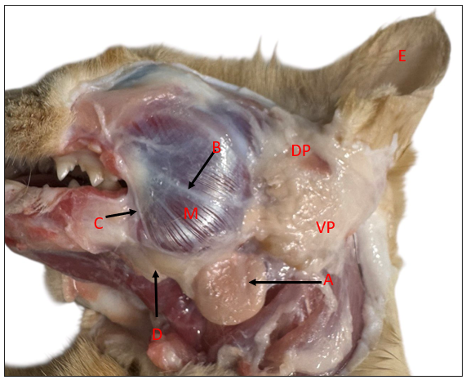
Figure 1: Photo macrograph (lateral view) at Persian cat illustrates: (DP) Dorsal parotid gland, (VP) Ventral parotid gland, M-Masseter muscle, E-Ear, A-Submandibular gland, B-Parotid duct, C-Facial nerve and D-Lymph node.
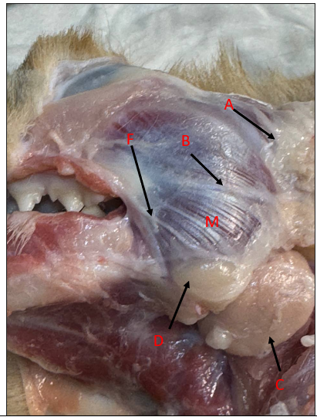
Figure 2: Photo macrograph (left lateral view) at Persian cat illustrates: A-Parotid gland, B-Parotid duct, C-Submandibular gland, D-Lymph node and F-Facial nerve, (M) Masseter muscle.
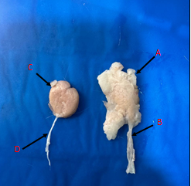
Figure 3: Photo macrograph at Persian cat illustrates: A-Parotid gland, B-Parotid duct, C-Submandibular gland, D-Submandibular duct.
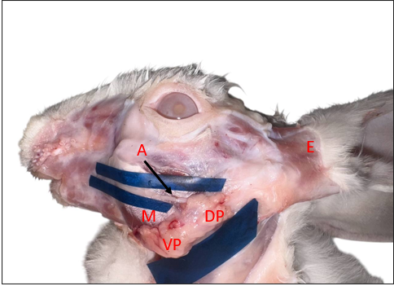
Figure 4: Photo macrograph (left lateral view) at French lop illustrates: (DP) Dorsal parotid gland, (VP) Ventral parotid gland, (M) Masseter muscle, (E) Ear and A- Parotid duct.
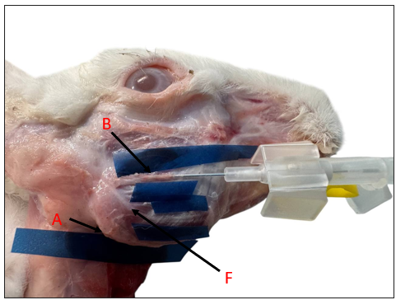
Figure 5: Photo macrograph (Right lateral view) at French lop illustrates: A-Parotid gland, B-Parotid duct and F- Facial nerve.
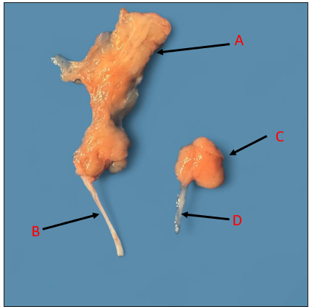
Figure 6: Photo macrograph at French lop illustrates: A-Parotid gland, B-Parotid duct, C-Submandibular gland and C-Submandibular duct.
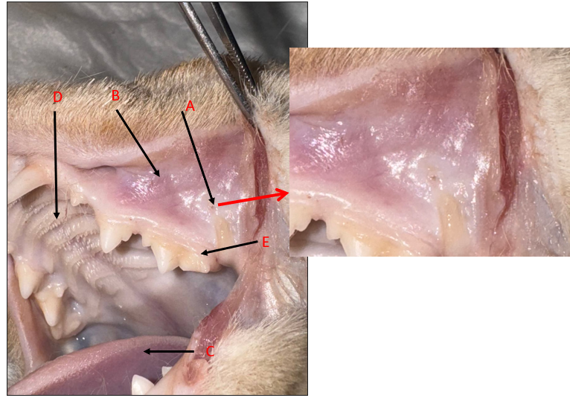
Figure 7: Photo macrograph of Persian cat illustrates: A-Parotid papillae, B-Mucus membrane of mouth, C-Tongue, D-Hard palate and E-First molar teeth, Magnified photo: Parotid papillae.
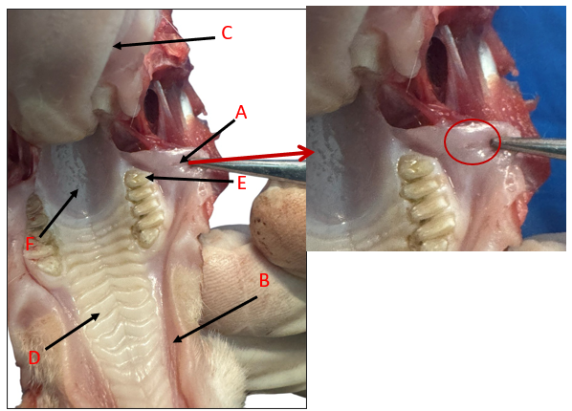
Figure 8: Photo macrograph of French lop illustrates: A-Parotid papillae, B- Mucus membrane of mouth. C-Tongue, D-Hard palate, E-Third molar teeth and F-Soft palate, Magnified photo: Parotid papillae.
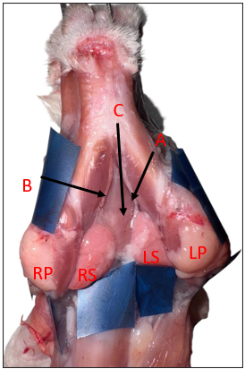
Figure 9: Photo macrograph (Ventral view) at French lop illustrates: (RB) Right Parotid gland, (LP)Left parotid gland, (RS) Right Submandibular gland, (LS) Left Submandibular gland, A-Left Submandibular duct, B-Right Submandibular duct and C-Tongue.
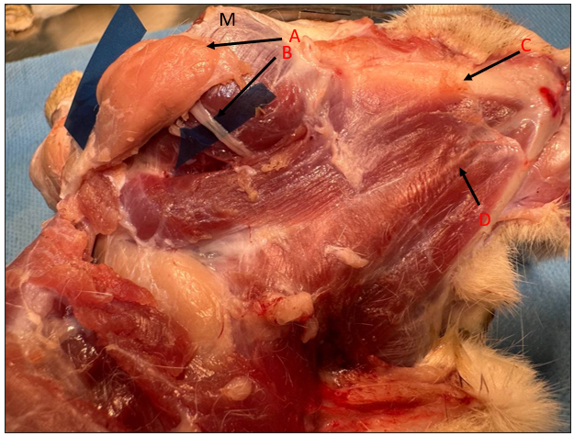
Figure 10: Photo macrograph (dorsal view) at Persian cat illustrates: A-Submandibular gland, B-Submandibular duct, C-Mandibular bone and D-Tongue and M- masseter muscle.
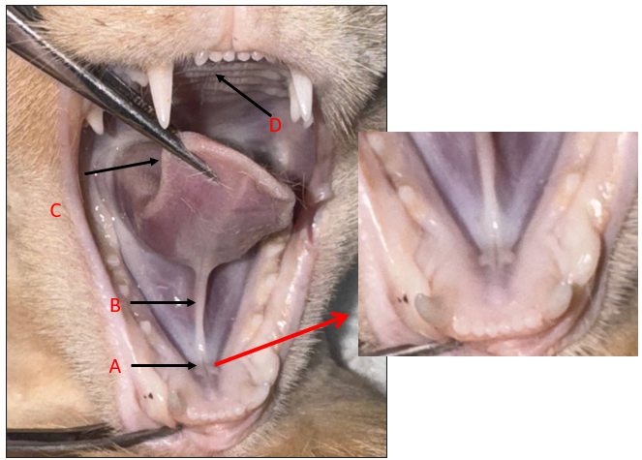
Figure 11: Photo macrograph of Persian cat illustrates: A-Sublingual caruncle, B-Frenulum linguae, C-Tongue and D-Hard palate, Magnified photo: Sublingual caruncle.
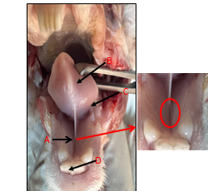
Figure 12: Photo macrograph of French lop illustrates: A- Sublingual caruncle, B-Frenulum linguae, C- Tongue, D-Hard palate, Magnified photo: Sublingual caruncle.
Conclusion
Macroscopically, the parotid gland in both animals is the largest of the salivary glands and is found in the part of the body- the parotid region. The cat has one duct which is an opening facing the first molar teeth. Although it does have one duct opening on the opposite side of the third molar teeth in rabbits, too. Both animals have a smaller submandibular gland than parotid gland and it is at the angle of the mandible in the cat. The right and left glands are very similar to each other along the length of the middling of the tongue as it is in rabbit at the angle of the mandible opposite the parotid gland. The single duct of each animal is located at the sublingual caruncle.

COMPETING INTERESTS DISCLAIMER:
Authors have declared that they have no known competing financial interests OR non-financial interests OR personal relationships that could have appeared to influence the work reported in this paper.
References
- Abouelela, A. A., El-Gendy, S. A., & Farag, F. M. (2021). Comparative anatomical and histological study of the parotid and submandibular salivary glands in some domestic mammals. Journal of Veterinary Anatomy, 14(2), 45–58.
- Ahmed, M. A., Al-Sayed, R. A., & Ibrahim, M. H. (2023). Histochemical characteristics of the major salivary glands in rabbits (Oryctolagus cuniculus). Anatomia Histologia Embryologia, 52(1), 32–39.
- Al-Saffar, F. J., & Simawy, M. S. H. (2014). Histomorphological and histochemical study of the major salivary glands of adult local rabbits. International Journal of Advanced Research, 2(11), 378–402.
- Chibly, A. M., Aure, M. H., Patel, V. N., & Hoffman, M. P. (2022). Salivary gland function, development, and regeneration. Physiological Reviews, 102(3), 1495–1552.
- DoCanvas. (2025). Morphological description of rabbit salivary glands.
- Doğan, N., Alkan, Z., & Ergin, M. (2025). Gross anatomical and morphometric study of the major salivary glands in domestic mammals. Turkish Journal of Veterinary and Animal Sciences, 49(3), 240–257.
- Dyce, K. M., Sack, W. O., & Wensing, C. J. G. (2017). Textbook of veterinary anatomy (5th ed.). Elsevier.
- Ekström, J., & Khosravani, N. (2020). Functional anatomy and adaptive significance of the salivary glands in herbivorous mammals. Journal of Comparative Physiology B, 190(6), 665–678.
- Field, A. (2020). Discovering statistics using IBM SPSS statistics. SAGE Publications.
- Ibrahim, M. H., El-Shahat, M. M., & Abouelela, A. A. (2023). Histological structure of the parotid gland in cats. Veterinary Research Forum, 14(1), 79–87.
- Ibrahium, M. A., Hassan, A. H., & El-Sayed, M. A. (2022). Comparative morphometrical studies on major salivary glands. Journal of Veterinary Anatomy, 15(1), 45–56.
- Kenhub. (2023). Parotid gland – Anatomy, location and function. Kenhub Medical Atlas.
- Kessler, H. P., & Bhatt, A. (2018). Salivary gland morphology across mammalian species. Veterinary Anatomy Review, 28(2), 105–118.
- Klećkowska-Nawrot, J., Barszcz, K., Miniajluk, J. P., Melnyk, O., & Goździewska-Harłajczuk, K. (2023). Comparative histology of salivary glands. Animals, 13(10), 1684.
- König, H. E., & Liebich, H. G. (2020). Veterinary anatomy of domestic mammals (7th ed.). Schattauer Verlag.
- Korim, K. B., Hassan, A. H., & El-Sayed, M. A. (2024). Morphometrical adaptations of salivary glands. Journal of Veterinary Anatomy, 17(1), 33–44.
- Mavri, U., Kosec, M., & Skvarc, M. (2022). Comparative morphology of salivary glands in herbivores. Anatomia, Histologia, Embryologia, 51(4), 512–520.
- Morita, T., Shinozaki, T., & Matsumoto, M. (2021). Morphological features of submandibular gland. Journal of Experimental Animal Science, 72(2), 113–124.
- Padra, M., Segerström, L., & Lindh, L. (2022). Histochemical characteristics of submandibular glands. Acta Histochemica, 124(3), 151–162.
- Popesko, P., Rajtová, V., & Horák, J. (2018). Atlas of topographical anatomy of the domestic animals (Vol. 1). Saunders Elsevier
- Roa, I., & del Sol, M. (2019). Morphological study of parotid gland in rodents. International Journal of Morphology, 37(2), 641–646.
- Singh, J., Kinjavdekar, P., Aithal, H. P., Pawde, A. M., & Udehiya, R. (2013). Evaluation of ketamine-based anesthesia protocols in rabbits. Veterinary World, 6(8), 555–558.
- Takeuchi, S., Ohta, T., & Sato, M. (2021). Comparative salivary gland architecture. Anatomical Record, 304(9), 2021–2032.
- Tutunaru, A. C., Leau, F., Sonea, A., & Sandersen, C. (2013). Ketamine anesthesia in rabbits. Scientific Works. Series C. Veterinary Medicine, 59(1), 81–84.
- Vallefuoco, R., Bortolami, E., & Barone, R. (2017). Anatomy of submandibular glands. Anatomia, Histologia, Embryologia, 46(5), 456–466.

