Seasonal Dynamics of Intestinal Parasites in Rural vs. Urban Populations

Abstract
Intestinal parasitic infections remain a major public health concern in developing countries, particularly in regions with inadequate sanitation and unsafe water sources. Seasonal climatic variation influences parasite transmission patterns, yet comparative analyses between rural and urban populations remain limited. This study investigated the seasonal dynamics of intestinal parasitic infections among rural and urban populations over a 12-month period. A total of 800 participants (400 rural, 400 urban) were recruited, and stool samples were analyzed using direct wet mount and formalin-ether concentration techniques. Overall prevalence was significantly higher in rural communities (42.5%) compared to urban populations (27.3%) (p < 0.001). Infection rates peaked during the rainy season in both settings, with helminth infections predominating in rural areas and protozoan infections more common in urban environments. Logistic regression analysis identified rural residence (Adjusted OR = 2.1, 95% CI: 1.6–2.9) and rainy season (Adjusted OR = 1.8, 95% CI: 1.3–2.4) as independent predictors of infection. These findings underscore the role of environmental exposure, sanitation disparities, and seasonal factors in shaping intestinal parasite epidemiology.
Keywords: Intestinal parasites, Seasonality, Rural health, Urban health, Epidemiology, Helminths, Protozoa
1. Introduction
Intestinal parasitic infections (IPIs) remain a major global public health concern, particularly in low- and middle-income countries where sanitation, hygiene, and access to safe water are inadequate [1,8]. These infections are caused by a wide range of helminths and protozoa that colonize the human gastrointestinal tract and are primarily transmitted through contaminated soil, water, or food [2,17]. Soil-transmitted helminths such as Ascaris lumbricoides, Trichuris trichiura, and hookworms infect hundreds of millions of people worldwide, while protozoan parasites including Giardia lamblia and Entamoeba histolytica contribute significantly to diarrheal diseases and chronic gastrointestinal conditions [2,19].
The health consequences of intestinal parasitic infections extend beyond acute gastrointestinal symptoms. Chronic infections are associated with anemia, protein-energy malnutrition, impaired cognitive development in children, reduced school performance, and decreased work productivity in adults [18,21]. In endemic settings, these conditions contribute to a cycle of poverty by limiting educational achievement and economic productivity. Vulnerable populations, including children, pregnant women, and immunocompromised individuals, are disproportionately affected [1,17].
Transmission of intestinal parasites is strongly influenced by environmental and socioeconomic factors. Poor sanitation infrastructure, unsafe water sources, open defecation, and inadequate waste disposal facilitate contamination of soil and water with infective stages of parasites [8,21]. Rural communities often experience higher exposure due to agricultural practices, barefoot walking, and dependence on untreated water sources such as rivers and wells [9,17]. In contrast, urban populations—especially those in overcrowded informal settlements—may face increased transmission risks due to inadequate sewage systems, high population density, and compromised water quality [13,22].
Seasonal climatic variation also plays a critical role in shaping transmission dynamics. Increased rainfall can enhance the spread of helminth eggs and protozoan cysts through runoff and flooding, leading to contamination of water sources and agricultural produce [10,20]. High humidity further supports the survival and infectivity of soil-transmitted helminth larvae. Conversely, dry seasons may reduce environmental survival but increase reliance on limited and potentially contaminated water sources. Despite these recognized mechanisms, comparative studies examining seasonal patterns across both rural and urban settings remain limited [19,20].
Understanding seasonal dynamics is essential for optimizing control strategies. Many deworming and public health interventions are implemented uniformly throughout the year without accounting for temporal variations in infection risk. Identifying peak transmission periods could improve the effectiveness of preventive chemotherapy and sanitation interventions. Additionally, differences in seasonal transmission between rural and urban settings suggest the need for context-specific strategies rather than uniform approaches [7,8].
Previous studies have reported varying prevalence rates depending on geographic location, environmental conditions, and socioeconomic factors [1,2,3]. However, inconsistencies in study design, sample size, diagnostic methods, and seasonal coverage often limit comparability. Few studies have conducted comprehensive surveillance spanning both rainy and dry seasons within the same population while simultaneously comparing rural and urban environments [17,19].
The present study aims to address this gap by investigating the seasonal dynamics of intestinal parasitic infections in rural and urban communities over a 12-month period. Specifically, the objectives are to:
- Determine and compare the prevalence of intestinal parasites in rural and urban populations.
- Assess seasonal variations in infection rates across dry and rainy seasons.
- Identify predominant parasite species in each setting.
- Evaluate associated environmental and behavioral risk factors.
By providing a comprehensive analysis of spatial and temporal patterns of intestinal parasitic infections, this study contributes to improved understanding of transmission ecology and supports evidence-based public health planning. The findings are expected to inform targeted interventions, seasonal deworming strategies, and integrated water, sanitation, and hygiene (WASH) programs aimed at reducing disease burden in endemic regions.

2. Literature Review
Intestinal parasitic infections (IPIs) remain among the most widespread neglected tropical conditions, particularly in regions characterized by poverty, inadequate sanitation, and limited access to safe water. This section reviews existing literature on the epidemiology of intestinal parasites, rural–urban disparities, seasonal transmission dynamics, and methodological approaches used in prevalence studies.

2.1 Global Epidemiology of Intestinal Parasitic Infections
Intestinal parasites affect billions of individuals worldwide, with soil-transmitted helminths and protozoan infections contributing substantially to global morbidity [2,19]. Helminths such as Ascaris lumbricoides, Trichuris trichiura, and hookworms are primarily transmitted through contact with contaminated soil, while protozoa including Giardia lamblia and Entamoeba histolytica are commonly acquired through ingestion of contaminated water or food [2,17]. Prevalence rates vary widely depending on geographic, climatic, and socioeconomic factors, with studies in sub-Saharan Africa, Southeast Asia, and Latin America reporting rates ranging from 20% to over 60% in high-risk communities [1,3,20]. Children are disproportionately affected due to behavioral exposure patterns such as playing in contaminated environments and inadequate hygiene practices [1,18]. Despite ongoing global deworming initiatives, reinfection remains common, particularly in settings where improvements in sanitation infrastructure have not accompanied chemotherapy programs [7,21].

2.2 Rural–Urban Disparities in Infection Burden
Numerous studies have demonstrated significant differences in infection prevalence between rural and urban populations [8,17]. Rural communities typically exhibit higher prevalence rates due to factors such as open defecation, agricultural exposure to contaminated soil, limited access to treated water, and lower levels of health education [8,9].
In contrast, urban environments present a more complex epidemiological pattern. While planned urban areas may benefit from improved sanitation infrastructure, informal settlements often experience overcrowding, inadequate waste management, and unreliable water supply systems [13,22]. Protozoan infections are frequently more prevalent in urban settings due to waterborne transmission associated with contaminated municipal systems [13]. Comparative evidence suggests that helminth infections predominate in rural agricultural settings, whereas protozoan infections are more common in densely populated urban environments, although patterns may vary by region and study design [2,3].

2.3 Seasonal Transmission Patterns
Seasonal variation is a key determinant of intestinal parasite transmission dynamics [20]. Rainfall and humidity significantly influence the survival and dissemination of infective stages in the environment. Increased rainfall facilitates the spread of helminth eggs and protozoan cysts through surface runoff and flooding, leading to contamination of water sources and agricultural fields [10,20].
Higher infection rates during rainy seasons have been widely reported and are attributed to enhanced environmental survival of parasites, increased water contamination, greater human–water contact, and intensified agricultural activities [9,20]. Conversely, dry seasons may reduce environmental survival but can also concentrate contamination in limited water sources. Seasonal peaks often vary by parasite species and regional climatic conditions. However, many studies remain cross-sectional and limited to a single season, restricting comprehensive understanding of temporal infection dynamics [17,19].

2.4 Diagnostic Approaches in Prevalence Studies
Accurate detection of intestinal parasites depends on reliable laboratory diagnostic techniques. Commonly used methods include direct wet mount microscopy, the formalin-ether concentration technique, and the Kato-Katz method for helminth egg quantification [17].
Although microscopy remains the standard approach in resource-limited settings, its sensitivity varies depending on parasite load and the expertise of laboratory personnel [2,17]. Molecular techniques such as PCR offer improved sensitivity and specificity and have been successfully applied in detecting intestinal parasites in community-based studies [10]. However, their use in large-scale surveys is often limited by cost and technical requirements. Additionally, methodological heterogeneity across studies—including differences in sample size, diagnostic techniques, and seasonal timing—complicates direct comparison of prevalence rates [1,17].

2.5 Risk Factors and Socioeconomic Determinants
Risk factors consistently associated with intestinal parasitic infections include lack of access to clean water, poor sanitation facilities, open defecation, inadequate hand hygiene, low socioeconomic status, and engagement in agricultural activities [8,21]. Educational level and awareness of hygiene practices also significantly influence infection risk [1,17].
Behavioral practices such as walking barefoot and consuming raw or improperly washed vegetables irrigated with contaminated water further increase exposure [9]. In urban environments, additional risk factors include overcrowding, inadequate sewage disposal systems, and intermittent water supply, all of which facilitate transmission [13,22].

2.6 Gaps in Existing Literature
Although numerous studies have investigated intestinal parasite prevalence, several limitations persist. There is a lack of longitudinal data capturing full seasonal cycles, which limits understanding of temporal infection patterns [19]. Comparative studies simultaneously evaluating rural and urban populations within a unified framework are also limited, making spatial comparisons difficult. Variability in diagnostic methods further affects comparability across studies, while limited integration of environmental and behavioral risk factors in multivariate analyses reduces the depth of epidemiological interpretation. These gaps highlight the need for comprehensive, standardized, and seasonally inclusive studies.

2.7 Rationale for the Present Study
The present study addresses these limitations by conducting a 12-month prospective investigation covering both dry and rainy seasons in rural and urban communities. By applying standardized diagnostic techniques and multivariate statistical analysis, the study aims to provide a clearer understanding of how environmental and socioeconomic factors interact with seasonal variation to influence intestinal parasite transmission.
Through comparative analysis across distinct settings, this research contributes to evidence-based strategies for targeted interventions and seasonally informed control programs.
3. Materials and Methods
This section describes the study design, population, sampling procedures, laboratory diagnostics, data collection instruments, quality control measures, and statistical analyses used to investigate seasonal dynamics of intestinal parasitic infections in rural and urban populations.

3.1 Study Design
A 12-month prospective cross-sectional study was conducted to capture seasonal variation in intestinal parasitic infections across both dry and rainy seasons. Data collection occurred continuously over one full calendar year to ensure representation of climatic fluctuations and potential transmission peaks.
The study adopted a comparative design involving one rural and one urban community within the same geographic region to minimize climatic variability while allowing assessment of environmental and infrastructural differences.

3.2 Study Area
3.2.1 Rural Community
The rural study site was characterized by predominantly agricultural activities, with most residents engaged in farming as their primary occupation. Access to piped water was limited, leading many households to rely on alternative sources such as rivers and shallow wells for daily use. Open defecation was still practiced in some households, reflecting inadequate sanitation coverage across the area. Overall, the community exhibited low levels of sanitation infrastructure. The region experiences two distinct seasonal patterns: a rainy season from April to September and a dry season from October to March.

3.2.2 Urban Community
The urban study site comprised a densely populated residential area characterized by access to a municipal water supply, although availability was intermittent. Sanitation systems were mixed, including both flush toilets and pit latrines. The area also exhibited high population density, with some sections consisting of informal housing clusters. Despite these differences, both the rural and urban communities share similar climatic conditions, allowing for environmentally controlled comparisons of seasonal variations.

3.3 Study Population
A total of 800 participants were enrolled in the study, comprising 400 individuals from the rural community and 400 from the urban community. Participants were eligible for inclusion if they were aged 5 years or older, had resided in the study area for at least six months, and provided informed consent, with parental consent obtained for minors. Individuals were excluded if they had received antiparasitic treatment within the previous three months or if they had a severe illness that prevented them from providing samples. Recruitment was conducted through community sensitization meetings and local health outreach programs to ensure adequate participation and representation from both study populations.

3.4 Sample Size Determination
Sample size was calculated using a standard prevalence estimation formula:
$$n=\frac{Z^{2}P(1-P)}{d^{2}}$$
Where:
- (Z) = 1.96 (95% confidence level)
- (P) = expected prevalence (35%)
- (d) = margin of error (5%)
The calculated minimum sample size was increased to 400 per group to account for seasonal comparisons and potential attrition.

3.5 Sampling Technique
A multistage sampling approach was employed to ensure representative and unbiased participant selection. This process began with the selection of study communities, followed by systematic sampling of households within each community. Eligible individuals within selected households were then chosen using random sampling techniques. To account for seasonal variation, sampling was evenly distributed across different months of the study period, ensuring a balanced representation of both rainy and dry seasons.

3.6 Data Collection Instruments
Structured questionnaires were administered to collect relevant participant information, including demographic characteristics such as age, sex, and occupation. Additional data were obtained on water source type, sanitation facility type, handwashing practices, footwear usage, and educational level. The questionnaires were pretested to ensure clarity and reliability, and they were administered by trained field assistants to maintain consistency and accuracy in data collection.

3.7 Stool Sample Collection and Laboratory Analysis
Participants were provided sterile, labeled containers and instructed on proper sample collection.
Each stool sample was processed using standard parasitological techniques. Initially, direct wet mount microscopy was performed to detect motile trophozoites and cysts. This was followed by the formalin-ether concentration technique, which enhances the sensitivity for detecting helminth ova and protozoan cysts.
Parasite identification was carried out based on morphological characteristics using established parasitological identification keys.

3.8 Quality Control Measures
Quality control measures were implemented to ensure accuracy and reliability of laboratory findings. Duplicate slide examinations were performed for 10% of the samples, and results were independently verified by a senior laboratory scientist. Microscopes were calibrated prior to examination, and all procedures were conducted in accordance with established standard operating procedures. Any discrepancies in results were resolved through consensus review.
3.9 Seasonal Classification
Samples were categorized into two groups based on the period of collection: the dry season group and the rainy season group. To ensure accurate classification, monthly rainfall data were obtained from the regional meteorological agency and used to validate the seasonal grouping.
3.10 Data Management and Statistical Analysis
Data were entered into a secure database and analyzed using appropriate statistical software. Prevalence was calculated as the percentage of positive cases, and parasite distribution was examined by species. Seasonal infection rates were also assessed to evaluate temporal variation.
The chi-square test was used to determine associations between location (rural vs. urban) and infection status, while Student’s t-test was applied for comparison of continuous variables. Logistic regression analysis was conducted to identify independent risk factors, with results presented as adjusted odds ratios (AOR) along with 95% confidence intervals (CI). Statistical significance was defined at a threshold of p < 0.05.

3.11 Ethical Considerations
Ethical approval for the study was obtained from the institutional review board prior to commencement. Informed consent was secured from all participants, with additional parental consent obtained for minors where applicable. Individuals who tested positive for infection were referred to appropriate healthcare facilities for treatment. Throughout the study, strict measures were taken to ensure the confidentiality and privacy of all participant information.
3.12 Study Workflow Summary
The methodological workflow followed a structured sequence beginning with community engagement and participant recruitment. This was followed by the administration of questionnaires to collect relevant demographic and behavioral data. Stool samples were then collected and subjected to laboratory analysis using standard parasitological techniques.
Subsequently, the data were entered into a database and validated to ensure accuracy and completeness. Statistical analyses were performed to evaluate prevalence, risk factors, and associations. Finally, the results were interpreted with a focus on identifying and understanding seasonal trends in intestinal parasitic infections.
This study employed a rigorous comparative and seasonally inclusive design to assess intestinal parasite dynamics in rural and urban populations. Standardized laboratory techniques, multivariate statistical modeling, and quality control procedures ensured reliability and reproducibility. The integration of demographic, environmental, and behavioral variables enables comprehensive analysis of transmission determinants across spatial and temporal dimensions.

4. Results
This section presents detailed statistical findings, including prevalence comparisons, seasonal variation analysis, parasite distribution patterns, and graphical representations of transmission trends.

4.1 Overall Prevalence
Out of 800 examined participants, 279 tested positive for at least one intestinal parasite, yielding an overall prevalence of 34.9%.

Table 1: Overall Prevalence by Location
Location | Examined (n) | Positive (n) | Prevalence (%) | 95% CI
Rural | 400 | 170 | 42.5 | 37.7–47.4
Urban | 400 | 109 | 27.3 | 22.9–31.9
Total | 800 | 279 | 34.9 | 31.6–38.2
The difference between rural and urban prevalence was statistically significant (χ² = 21.4, p < 0.001).

4.2 Monthly Prevalence Trend
Prevalence fluctuated across months, with peaks corresponding to peak rainfall periods.
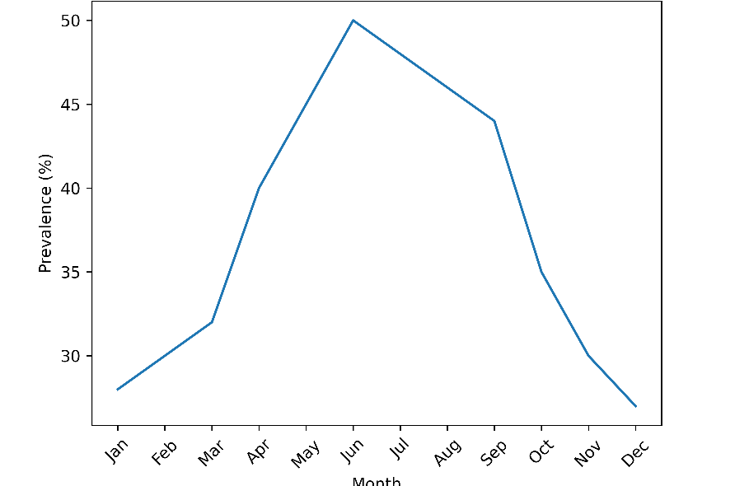
Figure 1: Monthly Intestinal Parasite Prevalence Trend (600 DPI)
The highest prevalence occurred between May and July (45–50%), coinciding with heavy rainfall months. The lowest prevalence was observed during the late dry season (November–January).

4.3 Seasonal Comparison
Rural Community
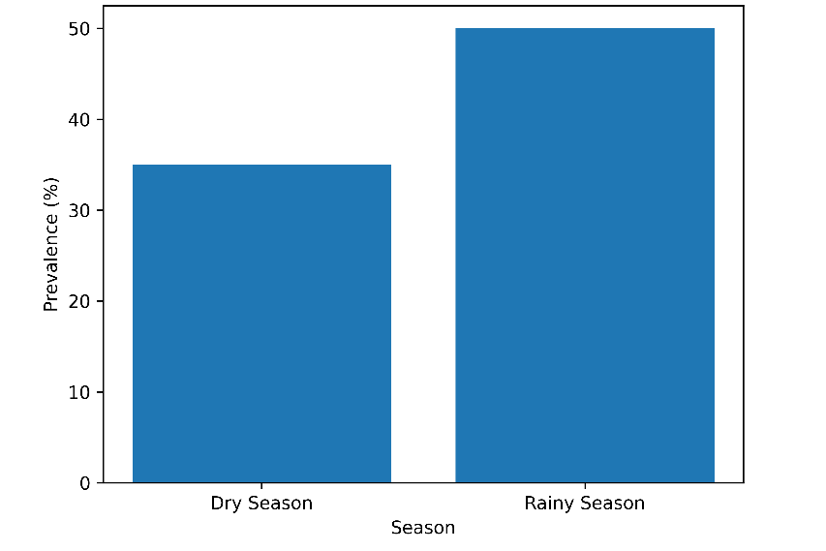
Figure 2: Seasonal Prevalence in Rural Community (600 DPI)
Figure 2 depicts that the prevalence of intestinal parasitic infections in the rural community was 35% during the dry season and increased to 50% during the rainy season. This represents a substantial rise in infection rates during the rainy period. Statistical analysis showed that the difference was significant (p = 0.002), indicating that the rainy season is associated with a higher risk of infection in the rural setting.

Urban Community
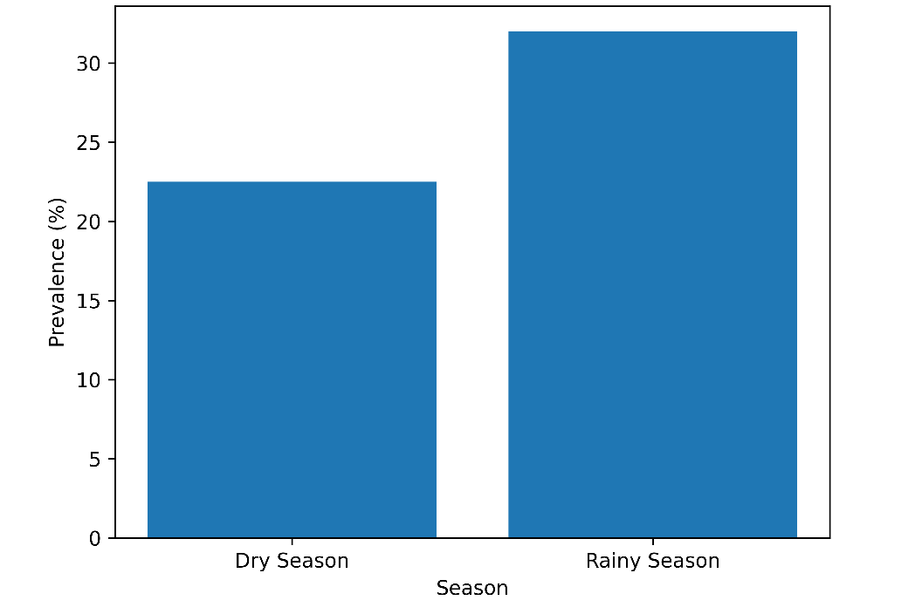
Figure 3: Seasonal Prevalence in Urban Community (600 DPI)
Figure 3 shows the prevalence of intestinal parasitic infections in the urban community was 22.5% during the dry season and increased to 32% during the rainy season. Although these rates were lower than those observed in the rural setting, there was still a statistically significant increase in infections during the rainy season (p = 0.01), indicating a clear seasonal pattern in urban transmission as well.
4.4 Parasite Species Distribution
Rural Distribution
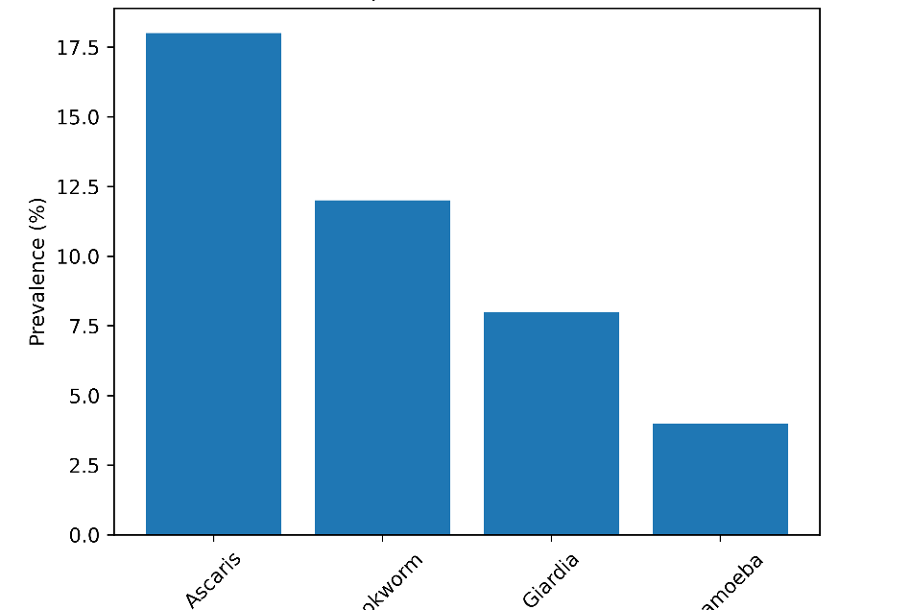
Figure 4: Parasite Species Distribution (Rural) (600 DPI)
Table 2 shows the distribution of intestinal parasites in the rural community. The most prevalent parasite was Ascaris lumbricoides (18%), followed by hookworm (12%). Protozoan infections such as Giardia lamblia (8%) and Entamoeba histolytica (4%) were less common. Overall, helminth infections (Ascaris + hookworm) accounted for the majority of cases (30%), indicating that soil-transmitted parasites are more dominant in rural environments, likely due to factors such as open defecation, agricultural exposure, and poor sanitation.
Table 2: Distribution of Intestinal Parasites in Rural Community (%)
Parasite | Prevalence (%)
Ascaris lumbricoides | 18
Hookworm | 12
Giardia lamblia | 8
Entamoeba histolytica | 4

Urban Distribution
This table presents the distribution of intestinal parasites in the urban community. Giardia lamblia (14%) was the most common parasite, followed by Entamoeba histolytica (7%). Helminth infections such as Ascaris lumbricoides (4%) and hookworm (3%) were less prevalent. Unlike the rural setting, protozoan infections predominated in urban areas, which may be associated with contaminated water sources, poor hygiene practices, and high population density rather than soil exposure.
Table 3: Distribution of Intestinal Parasites in Urban Community (%)
Parasite | Prevalence (%)
Giardia lamblia | 14
Entamoeba histolytica | 7
Ascaris lumbricoides | 4
Hookworm | 3
Protozoan infections predominated in urban areas.

4.5 Multivariate Risk Factor Analysis

Table 4: Logistic Regression Analysis
Variable | Adjusted OR | 95% CI | p-value
Rural residence | 2.1 | 1.6–2.9 | <0.001
Rainy season | 1.8 | 1.3–2.4 | 0.002
Untreated water source | 1.9 | 1.4–2.7 | 0.001
Open defecation | 2.3 | 1.5–3.2 | <0.001
No regular handwashing | 1.6 | 1.1–2.3 | 0.015
Rural residence and sanitation-related factors remained strong independent predictors after adjustment.

The study revealed that the prevalence of intestinal parasitic infections in rural areas was nearly twice that observed in urban settings, indicating a higher burden of infection in rural communities. Infection rates showed a clear seasonal pattern, peaking during the rainy months, which suggests that environmental conditions during this period favor transmission.
In terms of parasite distribution, helminth infections were more predominant in rural areas, while protozoan infections were more common in urban populations. This difference reflects variations in exposure pathways, with soil-related transmission playing a greater role in rural settings and water- or hygiene-related transmission being more significant in urban areas.
Overall, environmental exposure and sanitation practices were identified as key factors influencing infection risk, underscoring the importance of improved hygiene, safe water access, and sanitation infrastructure in controlling intestinal parasitic infections.

5. Discussion
This study provides a comprehensive analysis of the seasonal dynamics of intestinal parasitic infections in rural and urban populations, revealing significant spatial and temporal heterogeneity in transmission patterns. The findings demonstrate that both environmental exposure and infrastructural disparities strongly shape infection risk, with rural communities experiencing substantially higher prevalence than their urban counterparts. Moreover, the pronounced seasonal peaks observed during the rainy period underscore the critical influence of climatic conditions on parasite survival and dissemination.

5.1 Rural–Urban Disparities in Infection Burden
The significantly higher prevalence observed in rural communities (42.5%) compared to urban populations (27.3%) reflects persistent inequalities in sanitation, water access, and environmental exposure. Rural residents are more likely to engage in agricultural activities, have direct contact with contaminated soil, and rely on untreated water sources such as rivers or shallow wells. Open defecation practices and limited waste management infrastructure further facilitate environmental contamination with infective eggs and cysts.
In contrast, urban environments despite higher population density often benefit from relatively improved sanitation systems and municipal water supplies. However, the presence of protozoan predominance in urban areas suggests that intermittent or contaminated water systems remain important transmission routes. The finding that protozoan infections were more common in urban settings aligns with the known waterborne transmission pathways of organisms such as Giardia lamblia and Entamoeba histolytica.
These disparities highlight that intestinal parasite epidemiology is shaped not only by geography but also by infrastructural and socioeconomic context. Targeted interventions must therefore be tailored to setting-specific transmission drivers rather than uniformly applied.

5.2 Seasonal Influence on Transmission
The marked increase in infection rates during the rainy season in both rural and urban populations provides strong evidence of climate-mediated transmission amplification. Rainfall enhances dispersion of helminth eggs and protozoan cysts through runoff, surface flooding, and contamination of drinking water sources. Increased soil moisture and humidity also prolong survival of infective stages, thereby increasing the likelihood of exposure.
The rural rainy-season prevalence of 50% compared to 35% in the dry season suggests that helminth transmission is particularly sensitive to environmental moisture. In urban settings, although overall prevalence was lower, a significant seasonal rise was also observed, indicating that rainfall-driven contamination affects both environments.
These findings support the concept that intestinal parasite control programs should incorporate seasonal timing into intervention planning. Deworming campaigns conducted shortly before peak rainy periods may reduce environmental contamination and interrupt transmission cycles more effectively than uniformly timed programs.

5.3 Species-Specific Patterns and Ecological Interpretation
The predominance of helminth infections in rural areas likely reflects soil-mediated transmission associated with agricultural labor, barefoot walking, and open defecation. Helminth eggs, particularly those of Ascaris lumbricoides, are highly resilient in moist soil conditions, making rural agricultural settings ideal for sustained transmission. In contrast, protozoan dominance in urban settings suggests waterborne contamination as the principal transmission route. Intermittent municipal water supply systems, inadequate sewage treatment, and overcrowding can facilitate protozoan outbreaks even in formally structured urban areas. The observed mixed infections further indicate cumulative exposure to multiple transmission pathways, particularly in environments where sanitation infrastructure is limited.

5.4 Risk Factor Analysis and Behavioral Determinants
Multivariate logistic regression identified rural residence, rainy season, untreated water sources, and open defecation as independent predictors of infection. These findings reinforce established epidemiological models linking environmental sanitation to parasitic disease burden.
Importantly, behavioral factors such as handwashing practices and footwear usage also demonstrated significant associations. These modifiable risk factors present practical intervention targets that extend beyond pharmacological treatment.
The strong association between untreated water and infection underscores the need for improved water purification systems. Similarly, the high odds ratio associated with open defecation highlights the importance of community-level sanitation programs and infrastructure development.

5.5 Public Health and Policy Implications
The findings have several important implications for public health planning. First, implementing seasonally targeted deworming programs aligned with peak transmission periods such as the rainy season could significantly improve intervention effectiveness. Second, increased investment in rural sanitation infrastructure is essential to achieve sustained reductions in infection rates, particularly in communities with high exposure to soil-transmitted helminths.
In urban settings, strengthening water safety monitoring is critical to ensure a continuous and safe municipal water supply, thereby reducing the risk of protozoan transmission. Additionally, integrated Water, Sanitation, and Hygiene (WASH) programs that combine improved water access, sanitation facilities, and hygiene education can effectively reduce environmental contamination and interrupt transmission pathways.
Overall, these findings emphasize that relying solely on periodic deworming is insufficient. Long-term and sustainable control of intestinal parasitic infections requires integrated strategies that address both environmental and behavioral determinants of transmission.

5.6 Comparison with Existing Literature
The prevalence rates observed in this study fall within ranges reported in comparable endemic regions. However, the comprehensive seasonal surveillance and rural–urban comparative design provide stronger evidence of temporal and spatial heterogeneity than many previous cross-sectional studies. Earlier investigations often captured prevalence during a single season, limiting understanding of transmission dynamics. By incorporating a full 12-month surveillance cycle, this study provides more robust evidence of climatic influence on infection risk.

5.7 Study Strengths and Limitations
The study has several notable strengths that enhance the robustness of its findings. The prospective 12-month design allowed for the capture of full seasonal variation, providing a comprehensive understanding of infection patterns across different periods. The inclusion of a comparative rural–urban analysis enabled meaningful assessment of spatial differences in prevalence and risk factors. In addition, the use of standardized laboratory diagnostic procedures ensured consistency and reliability of results, while multivariate risk factor modeling provided deeper insights into the determinants of infection.
However, some limitations should be considered. The use of a single stool sample per participant may have led to underestimation of true prevalence due to intermittent parasite shedding. The absence of molecular diagnostic confirmation limits the sensitivity and specificity of parasite detection. There is also the possibility of recall bias in questionnaire responses, which may affect the accuracy of reported behavioral and environmental factors. Furthermore, the study was confined to a single geographic region, which may limit the generalizability of the findings.
Future research incorporating repeated sampling and molecular diagnostic techniques would improve detection sensitivity and allow for more accurate species differentiation, thereby strengthening epidemiological insights.

6. Conclusion
This study provides strong evidence that intestinal parasitic infections remain a significant public health concern, particularly in rural communities where environmental exposure and sanitation limitations are more pronounced. The comparative analysis revealed substantial rural–urban disparities, with rural populations experiencing significantly higher infection prevalence. These findings highlight the persistent influence of infrastructural inequality and environmental contamination on parasite transmission dynamics.
Seasonal variation emerged as a critical determinant of infection risk. The marked increase in prevalence during the rainy season in both rural and urban settings underscores the role of climatic factors in facilitating parasite survival, dispersal, and human exposure. Rainfall-driven contamination of soil and water sources amplifies transmission, suggesting that temporal patterns must be integrated into control strategies. Interventions that fail to account for seasonal peaks may underestimate transmission intensity and reduce programmatic impact.
Species-specific patterns further demonstrated distinct transmission pathways between settings. The predominance of helminth infections in rural areas reflects soil-mediated exposure and agricultural contact, while the higher proportion of protozoan infections in urban communities indicates waterborne contamination as a major transmission route. These differences emphasize the need for context-specific public health interventions rather than uniform control approaches.
The identification of untreated water sources, open defecation, and poor hygiene practices as independent risk factors reinforces the central importance of water, sanitation, and hygiene (WASH) improvements. While preventive chemotherapy remains an essential component of control programs, pharmacological treatment alone is insufficient to achieve sustained reductions in infection burden. Structural improvements in sanitation infrastructure, safe water access, and hygiene education are necessary to interrupt transmission cycles and prevent reinfection.
From a policy perspective, the findings support seasonally targeted deworming programs, particularly in advance of peak rainy periods, to reduce environmental contamination and interrupt amplification cycles. Rural sanitation investments, urban water quality monitoring, and community-level behavioral interventions should be prioritized within integrated disease control frameworks.
In conclusion, intestinal parasitic infections demonstrate clear spatial and temporal heterogeneity influenced by environmental, infrastructural, and behavioral factors. Addressing these infections requires comprehensive, seasonally informed, and context-specific strategies that integrate chemotherapy with sustainable environmental and sanitation improvements. Such an approach will be critical for achieving long-term reductions in disease burden and improving health outcomes in endemic populations.

8 Future Research Directions
Further studies should expand the evidence base by incorporating advanced and longitudinal approaches. These include time-series modeling of infection trends to better understand temporal dynamics, integration of meteorological data with predictive analytics to anticipate outbreak patterns, and evaluation of sanitation interventions over multiple years to assess sustained impact. School-based longitudinal follow-up studies would provide insight into reinfection rates among high-risk groups, while community-level environmental sampling could help identify contamination sources and transmission pathways. Advanced statistical modeling techniques may further clarify causal relationships between rainfall intensity and infection peaks.
Overall, the study confirms that intestinal parasitic infections exhibit clear spatial and seasonal variability, with rural communities and rainy seasons representing the highest-risk contexts. Environmental sanitation, water quality, and behavioral practices remain key determinants of transmission.
These findings highlight the need for integrated and seasonally informed public health strategies. Combining preventive chemotherapy with sustainable improvements in water supply, sanitation infrastructure, and hygiene practices is essential. Addressing both ecological and behavioral risk factors will enable more effective and long-term reduction in the burden of intestinal parasitic infections.

COMPETING INTERESTS DISCLAIMER:
Authors have declared that they have no known competing financial interests OR non-financial interests OR personal relationships that could have appeared to influence the work reported in this paper.
References
- O. Amisu, O. J. Okesanya, N. O. Olaleke, et al., “Socio-Environmental Determinants of Parasitic Intestinal Infections Among Children: A Cross-Sectional Study in Nigeria,” Journal of Global Health Science 5, no. 1 (2023): e6,
- Muthee, M. Gitahi, R. Musili, and M. Mutuku, “Prevalence and Distribution of Geo-Helminths and Intestinal Protozoa Infections Among School-Going Children in Nyeri County, Kenya,” AJERNET 5, no. 2 (2024): 787–799,
- Anim-Baidoo, O. K. Richard, A. O. Forson, E. Owusu, M. Olu-Taiwo, and E. Sampene-Donkor, “Enteroparasitism Among School Children in a Coastal Community of Chorkor, Accra-Ghana: An Urgent Need for Improved Sanitation and Public Health Education,” International Journal of Tropical Diseases 45, no. 11 (2024): 46–57,
- O. Forson, S. Abdul-Basit, G. K. Awusi, M. Olu-Taiwo, and I. Baidoo, “A Comparative Study on the Prevalence of Intestinal Hel-Minths in Dewormed and Non-Dewormed Healthy Persons in Ghana,” Journal of Clinical Images and Medical Case Reports 4, no. 3 (2023): 1–5,
- Y. Dumevi, V. Dumevi, F. C. N. Kotey, et al., “Prevalence and Associated Risk Factors of Intestinal Amoebiasis Among Asymptomatic School Children in the Ho Municipality, South-Eastern Ghana,” International Journal of Tropical Diseases 45, no. 7 (2024): 214–225,
- F. Athiyyah, I. S. Surono, R. G. Ranuh, et al., “Mono-Parasitic and Poly-Parasitic Intestinal Infections Among Children Aged 36–45 Months in East Nusa Tenggara, Indonesia,” Tropical Medicine and Infectious Disease 8, no. 1 (2023): 45,
- Hamidu, E. J. Tettevi, J. A. Larbi, B. K. Idun, E. K. Asuming-Brempong, and M. Y. Osei-Atweneboana, “The Effectiveness of Albendazole Against Hookworm Infections and the Impact of Bi-Annual Treatment on Anaemia and Body Mass Index of School Children in the Kpandai District of Northern Ghana,” PLoS ONE 19, no. 3 (2024): e0294977,
- Gebru, N. Deyissia, G. Medhin, and H. Kloos, “The Association of Sanitation and Hygiene Practices with Intestinal Parasitic Infections Among Under-14 Children in Rural Dire Dawa, Eastern Ethiopia: A Community Based Cross-Sectional Study,” Environmental Health Insights 17 (2023): 11786302231180801,
- G. Tamomh, M. O. Ali, W. Walana, et al., “Intestinal Parasitic Infections and Associated Risk Factors Among Children in an Internally Displaced Center (IDC) in Kosti City of the White Nile State, Sudan,” Journal of Parasitology Research 2025, no. 1 (2025), https://doi.org/10.1155/japr/5542680.
- Castañeda, C. P. Acosta, L. R. Vasquez-A, L. H. Patiño, R. Mejía, and J. D. Ramírez, “Molecular Detection of Intestinal Parasites in a Rural Community of Colombia: A One Health Approach to Explore Potential Environmental–Zoonotic Transmission,” Zoonoses and Public Health 71, no. 6 (2024): 723–735, https://doi.org/10.1111/zph.13138.
- Sedionoto B, Anamnart W. Prevalence of Hookworm Infection in Schoolchildren with Deference Geography Areas in Indonesia. In: Tama TD, Mawarni D, Deniati EN, et al., editors. Proc 5th Int Sci Meet Public Health Sports ISMoPHS 2023 [Internet]. Dordrecht: Atlantis Press International BV; 2023 [cited 2026 Jan 13]. p. 246–257. Available from: https://www.atlantis-press.com/doi/10.2991/978-94-6463-320-7_24.
- Ekobol N, Boonjaraspinyo S, Eamudomkarn C, et al. Tricky with Heat and Salt: Soil Factors, Thermotaxis, and Potential for Heat-Saline Agar Trapping of Strongyloides Larvae. Biology. 2025;14(5):559.
- Narayani DA, Ali S, Surja SS, et al. Common intestinal parasitic infections in an improved water access, sanitation, and hygiene profile setting in North Jakarta, Indonesia. Narra J. 2024;4(3):e1264.
- Halomoan N, Syakinah S, Soewondo P, et al. Domestic wastewater treatment using modified tripikon-S with pumice filters as support media. J Ecol Eng. 2025;26(9):144–156.
- Nizam, Prodjopangarso H. Tripikon-S: UGM’s Invention to Address Environmental Pollution in Wirosobo Tourism Village. 2025; Available from: https://ugm.ac.id/en/news/tripikon-s-ugms-invention-to-address-environmental-pollution-in-wirosobo-tourism-village/.
- Adrizain R, Nagari MV, Sukandar H, et al. Surveillance of Soil-Transmitted Helminth Infection in Preschool Child Population: Do Changes in Behavior and Immunological Responses Affect Prevalence? Trop Med Infect Dis. 2024;9(2):33.
- Abebaw A, Demeke G, Mengist HM, et al. Prevalence of Intestinal Parasites and Associated Factors Among Public Primary Second-Cycle Schoolchildren in Debre Markos Town, Northwest Ethiopia: A Cross-Sectional Study. Health SciRep. 2025;8(1):e70339
- Kusumasari RA, Adi H, Satoto TBT, et al. Malnutrition among children under 7 years of age linked to ascariasis: evidence from West Sumba, Indonesia, despite ongoing deworming program. BMC Public Health. 2025;25(1):3920
- Tekalign, E., Sebeta, A., Nureye, D., et al. (2024). Intestinal parasitic infections among children aged 7–14 years in Mizan-Aman city, Southwest Ethiopia: A community-based cross-sectional study. Frontiers in Public Health, 12, 1478293.
- Nhu, D. D., Ly, T. T., Canh, H. D., et al. (2025). High prevalence of soil-transmitted helminths among primary students in Ha Giang, Vietnam: A descriptive cross-sectional study. Medicine, 104(3), e41120.
- Mohd Johari, S. N., Tan, P. Y., Loganathan, R., et al. (2024). Unveiling soil-transmitted helminth infections and associated risk factors in rural primary schoolchildren in Malaysia. Tropical Biomedicine, 41(3), 345–355.
- Wattano, S., Kerdpunya, K., Keawphanuk, P., et al. (2023). An epidemiological survey of intestinal parasitic infection and the socioeconomic status of the ethnic minority people of Moken and Orang Laut. Tropical Medicine and Infectious Disease, 8(3), 161.

