Original Research Article
First report on Asian Weaver Ant
Oecophylla smaragdina Fabricius, 1775 (Hymenoptera:Formicidae) at Lal Bahadur Shastri Mahavidyalaya, Dharmabad, Nanded, Maharashtra, India

.
ABSTRACT

The foraging habits of red weaver ants are remarkably affected by various environmental factors such as weather, humidity, luminosity, rainfall. These ants show nocturnal foraging behavior; so they are mostly active at night time so typically weaver ant nests are built at night time. The present research was undertaken to assess the diversity of Asian Weaver ants in the campus of Lal Bahadur Shastri Mahavidyalaya, Dharmabad, Nanded, Maharashtra, India. A systematic survey was conducted at various sites in the campus from August 2025 to March 2026. A total of 70 nests from 20 trees were recorded during the study period. The Red weaver ant is mainly arboreal which lives on trees. Asian weaver ants are colonial insects belonging to the family Formicidae. The red weaver ant has a unique reddish brown color. The Asian weaver ants are popular for distinctive nest building behavior, medicinal importance, nutritive food for local community, natural biocontrol agent, has commercial value, maintains ecological balance and farmer friendly. Weaver ants are used as a medico-food in certain tribal communities in India, such as in the states of Odisha, Keralam, Tamilnadu, Chhattisgarh, and Assam. This research article put forward a quick outline about weaver ant nest structure, arrangement and its maintenance. We have found 20 weaver ant nests inhibiting a single tree. We studied several biotic and abiotic factors affecting nest structure. Our research work suggests the nest selection site is typically governed by tree attributes, leaf features and certain environmental agents. The abundance of Asian weaver ants in the campus exhibits its habitat predominance among insect species.

Keywords: nest-building, socio-cultural value, red weaver ant, insecta, ecological signifance.

1. INTRODUCTION

The genus Oecophylla has two species; Oecophylla longinoda, is native to Sub-Saharan Africa, called as the African weaver ant and Oecophylla smaragdina, is native to Asia, commonly called as the Asian weaver ant (Masram et al., 2023). According to Van and Pelozuelo (2022), there are 2112 palatable species of ants in the world. The red weaver ant generally inhabits the trees (Jena et al. 2020). Asian weaver ants are colonial insects that belong to the family Formicidae (Sangma & Prasad, 2021). The red weaver ant has a reddish brown colour as it can be easily visible. They construct their nests on different plant species, such as the Indian Neem tree, mango tree, guava tree, teak tree, Indian beech tree, lemon tree, jackfruit, oil palm tree, cashew tree, etc. (Muhammad et al., 2024). The Asian weaver ants are popular for their distinctive nest-building habits. In a single nest of the colony, there is a single fertile queen and many infertile worker ants (Exélis et al., 2025). The workers build nests by intertwining adjacent leaves with the help of larval silk, which is secreted from larval mandibles (Dolai & Das, 2025). The nest consists mainly of tree leaves that trail and spin with silk of larva. A grown-up colony contains 200,000-400,000 infertile workers. The endurance of an ant colony is totally dependent on the endurance of the queen (Turner et al., 2025). The red weaver ants are also useful for controlling pest populations, including beetles, termites, bark lice, myriapods, worms etc. in different crops, such as citrus, cashew, oil palm, guavas, mango and tea. These ants can be used as natural biocontrol agents by the farmers (Exélis et al., 2022). The foraging habits of red weaver ants are remarkably affected by various environmental factors such as weather, humidity, luminosity, rainfall, etc. (Dolai et al., 2024). These ants show nocturnal foraging behavior; so they are mostly active at night time so typically weaver ant nests are built at night time (General et al., 2020). In Odisha state certain tribal communities like Santhal, Mankadia, Munda, Oram, Kolha, Bhuian, etc. use red weaver ants in their daily food consumption in locally named Tapang and Kai (Sohini et al., 2025). Also red weaver ants have its socio-cultural impact on Assam State tribal communities like Khasi pnar, Biate, Dimasa, Zemenaga, Kuki, etc. (Doloi & Basumatari, 2024). In Chattisgarh Muria tribal groups use these ant species in the form of delicious soup, vegetable salad, etc. Also in Keralam state red weaver ants are used to make spicy ant chutney and ant pickle which have great nutritional value in their diet (Bhowmick et al., 2021).By the consumption of this it will definitely improve the human immune response and get protein rich diet. Also these ants have some medicinal properties so in certain tribes these fully grown adult ants and with their eggs together with traditional therapeutic herbs to form local medicine to cure deadly diseases like whooping cough, high fever, asthma, cold, joint pain, blood pressure control, skin infection etc. (Agarwal et al., 2022). Ant farming leads to trade in tribal communities so it gives a better opportunity for local people as an income source and sustains its traditional importance and maintains socio-economic value (Sinha & Zilpe, 2023).

2. Materials and methods

2.1 Study area:
The present research was carried out inside the Lal Bahadur Shastri Mahavidyalaya campus in the city of Dharmabad, Maharashtra (18.90°N 77.85°E) by https://lbsmd.ac.in. The Campus has different ecological habitats, microhabitats, grasslands, shrublands, and large areas of teak wood. It is also rich in floral and faunal diversity. At the LBSMD, 20 trees and 70 nests were examined. The following factors were considered for individual nests: ground distance, trunk distance, neighbor nest distance, and overall size (big, medium, or tiny based on volume). Environmental factors, including temperature, wind intensity, direction, brightness, and humidity, were recorded for each nest (K & T, 2024). Tree covariates, including tree species, covering of tree, height of tree, height of trunk, shape and size of leaf were studied. In addition, pictures of each nest and its location on the tree were taken, wherever feasible. To examine how nests are constructed, we used certain blades to gently tear on nest leaves and observe inside the colony. We observed how nests are stitched while being constructed for the first time, how nests are extended, and how nests are maintained (Ouagoussounon et al., 2024).

2.2 Species
Oecophylla smaragdina, commonly called the Asian Weaver ant, is found mainly in tropical regions, including the Indian subcontinent (S et al., 2022) (Fig. 1). In Greek, Oecophylla is also called a leaf house. The O. smaragdina workers use the silk from their larvae to weave the host plant’s leaves (Dolai & Das, 2025). Up to 500,000 weaver ants may constitute a colony, and their nests may be dispersed among dozens of trees, with each colony’s basic family structure consisting of a single fertile queen, her eggs, larvae, male drones and worker ants which are numerous in number (Patel & Bhatt, 2020) (fig. 7). Two different ant colonies perhaps figure out: by identifying two different queens and by studying ant behavior from two different ant colonies. Along with building the nest, worker ants also have to take care of their queen by providing protein-rich food, protecting the queen from predators and also perform regular foraging activity, proper maintenance of nest, and to explore and monitor the surrounding region (Kong Yap et al., 2025) (fig. 5). A significant portion of a nest, and thus a colony, is generally stationary. As red weaver ants contribute their tremendous energy and time in building the nest, so it’s their accountability to protect the nest from foreign agents (Devarajan, 2016).

3. results and discussion

3.1 Nest architecture and Construction

Using silk created by their larvae, Oecophylla workers by forming long chains weave the leaves of the host plants to construct their nests (Bochynek & Robson, 2014) (fig. 4) Workers encourage white larvae for secretion of silk threads from the silk glands present in their mandibles by touching them individually (Dolai & Das, 2025). The larva produces silk at the locations where it touches the substrate, which is the leaf of a plant. It is a phenomenal cooperation between larvae and adult worker ants. The larval silky mesh works like an adhesive that can hold many leaves together, resulting in a unique nest structure where a single queen, their larvae, male drones and worker ants live together (Van Itterbeeck et al., 2015; Jena et al., 2020). The weaver ant can be trapped by artificial nests by farmers to set up a new colony for commercial purposes (Rwegasira et al., 2015; Nene et al., 2017). The number of red weaver ant queens is greater in mature colonies than in juvenile colonies (Offenberg et al., 2012). The queen population depends upon atmospheric humidity and rainfall (K & T, 2024). These ants have an exclusive technique for intertwining new nests, extending older nests, or reconstructing previous nests (Devarajan, 2016). Nest structures were also observed during the construction and repair of nests. The size of the nests varied, ranging from single-to multi-leafed. For constructing the nest from a single leaf, the leaf was folded by worker ants, and by larval silk, edges of leaves were sewn together to form a complete living nest. Similar stitching was used to create nests made up of more than one leaf, with the leaves placed next to one another so that their edges touched, but usually without any folds (Pérez-Lachaud & Lachaud, 2014) (fig. 2). In small trees with nearby branches, weaver ants sew leaves from adjacent branches, allowing them to touch. The larger nests consisted of more than 70 leaves together to form a structure similar to a beehive structure or a bird nest (Muhammad et al., 2024) (fig. 3).

3.2 Nest Arrangement
At the field sites, information on red weaver ant nests was gathered from 70 nests on 20 different trees. All nests were located on trees of the genera Azadirchta (neem tree), Millettia (Indian beech tree), Mangifera indica (mango tree), Psidium guajava (Gavas), Citrus,and Tectona ( Indian teak). The nest height, leaf size, tree covering radius, and trunk distance were significant variables (K & T, 2024). Trees with larger canopies accommodate more nests as compared to trees with smaller canopies (Anato et al., 2015). This observation indicates that the red weaver ant nest arrangement is strongly modified by tree features. The nest-building behavior of weaver ants is significantly influenced by rainfall. If the amount of rainfall is more, then there will be a greater number of weaver ant nests on trees (K & T, 2024).

Because of the extraordinary cooperative habits of red weaver ants, it put a special footprint among all arthropods. These ants are consumed as traditional food in the local tribal community and are also used in the production of therapeutic medicine to cure deadly diseases. Overall, we found some distinctive findings about red weaver ants, such as their unique nest-building behavior, medicinal importance, nutritious food for the local community, commercial value, natural biocontrol agent, etc. Cultivation of these ants in horticulture practices will yield greater benefits to farmers and cultivators. So in horticulture, certain crops should be preferred, such as mango tree, orange tree, litchi orchards, tea, guavas, coconut tree, teak tree, cashew tree, etc. for red weaver ants commercialization, and gets its direct benefits to the local community (Thurman et al., 2019). Apart from these benefits, some difficulties also arise, such as the proper maintenance of ant populations, educating local people for the safe handling of these ant species without any damage to them, and the selection of suitable crops for better survival, growth, and development of this ant species. As these ant species have their own ecological importance. So public awareness should be created for its protection, accountability, and sustainable ecosystems. Further study should be taken in proper scientific approach to resolve this surprising mystery of the red weaver ant life history. Nowadays due to deforestation , urban development, industrialization, agricultural purposes, etc. Palatable trees for red weaver ant nests are decreasing. So for a better future for rural socio-cultural and economic life, some conservation steps should be taken for these weaver ants, and this is the need of the hour.

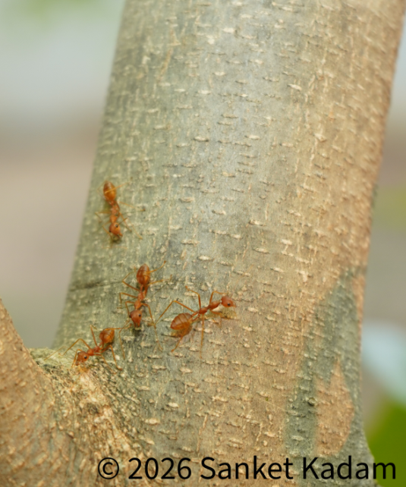
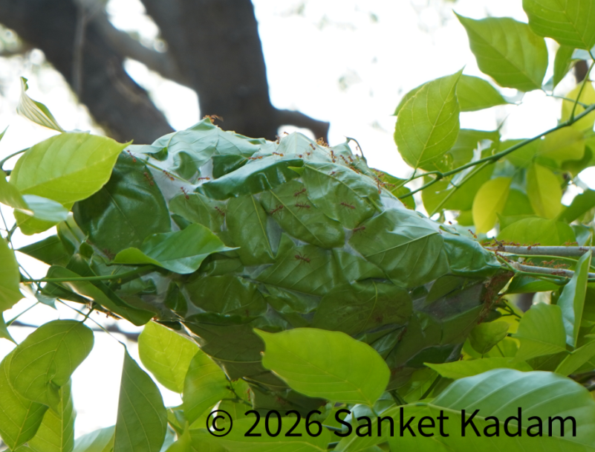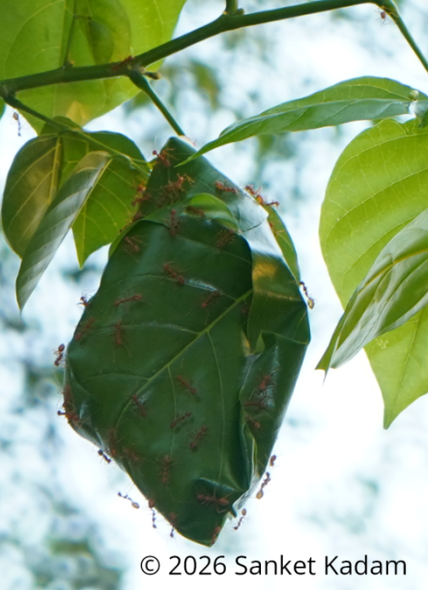
Fig. 1. Oecophylla samaragdina (Asian weaver ant) Fig. 2. Nest of O. samragdina on Milletia (Indian beech tree)

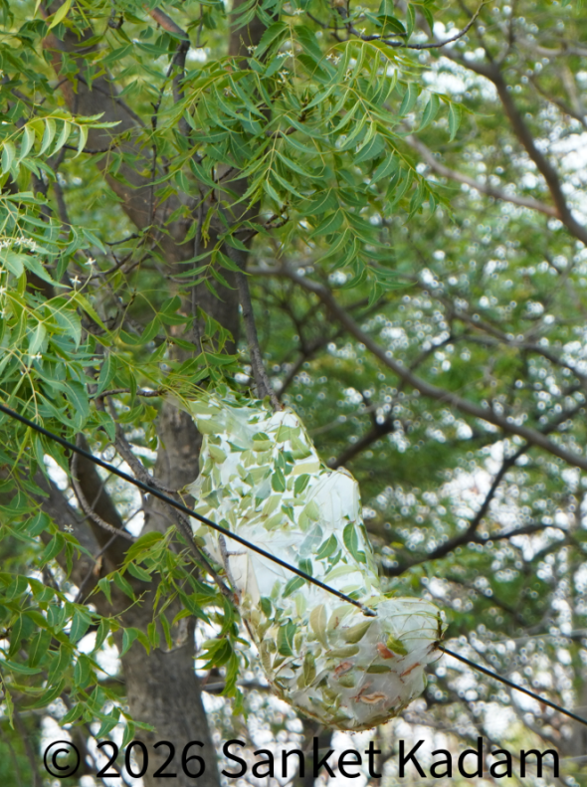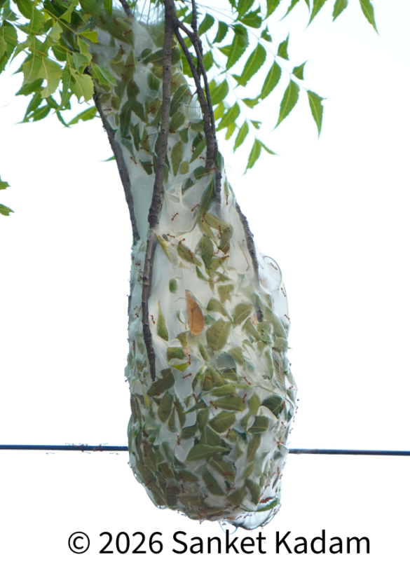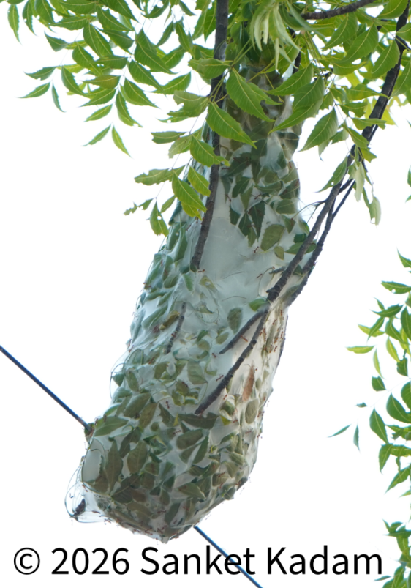

Fig. 3. Asian weaver ant nest on Azadirchta indica (Neem tree) resembles to beehive structure or a bird nest

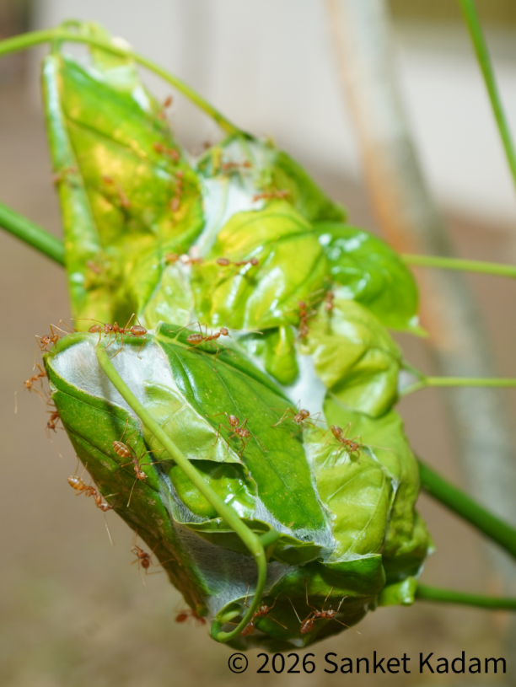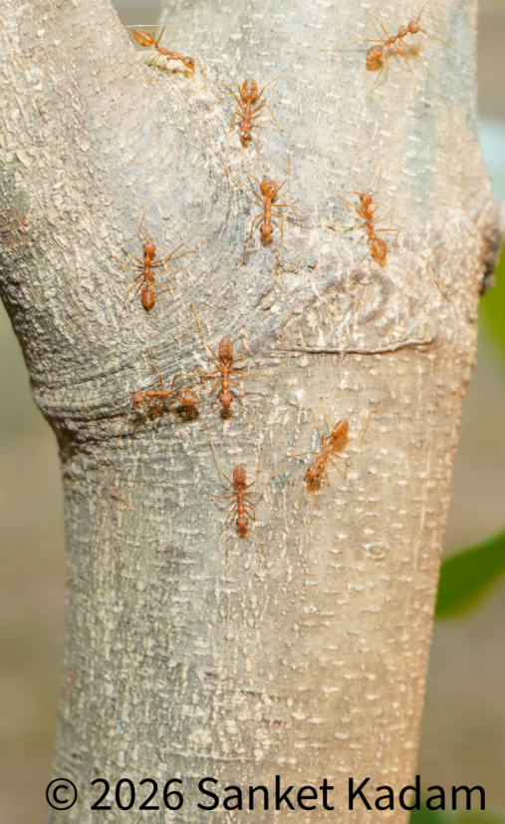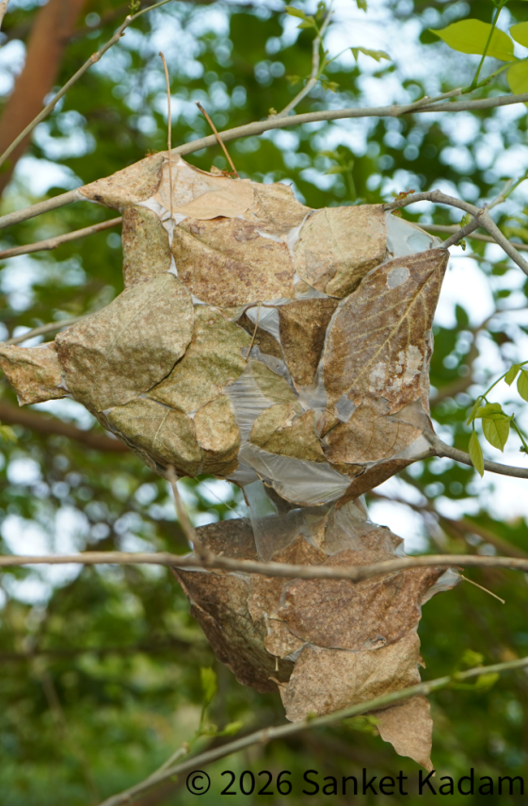

Fig. 4. Constructing a nest by Fig. 5. Foraging behaviour Fig. 6. Nest of weaver ants
worker weaver ants of Asian weaver ants

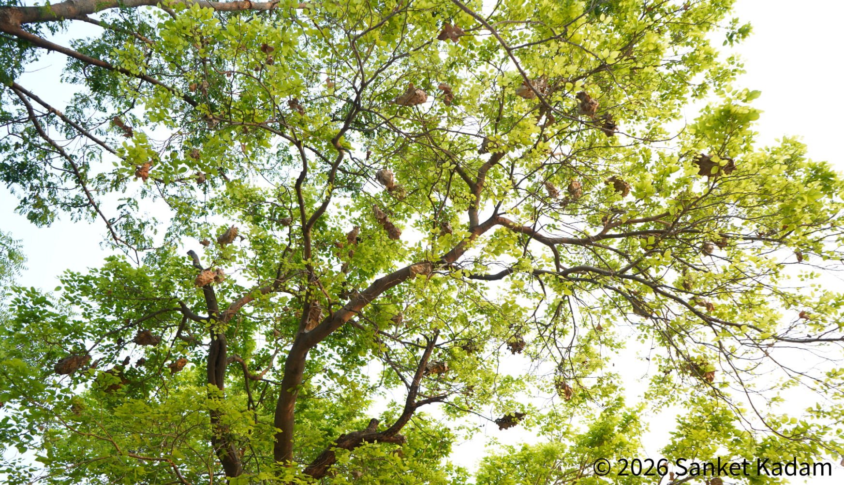

Fig.7. A colony of Asian weaver ant on Milletia (Indian beech tree)

4. Conclusion

The abundance of Asian Weaver ants in the Lal Bahadur Shastri Mahavidyalaya campus is good enough. This study implies nest-site selection and nest building for queens and their offspring are important steps in the life history of these Asian weaver ants. The location of weaver-ant nests on trees is not at random places, there are certain spots on trees where these ants are safe from their predators. so it must be their strategy for better survival. Red weaver ants are the foremost model to understand social behaviour in arthropods. There is a little study that has been done on Asian weaver ants in Maharashtra and in India, hence this study will encourage researchers, entomologists, college students, and wildlife enthusiasts to enlighten their views on this spectacular natural engineer, the Asian weaver ant .

Disclaimer (AI)
The author hereby proclaims that NO generative AI technologies, like LLM (ChatGPT, COPILOT, etc.) and text-to-image generators, were employed for the writing or editing of the present manuscript.
Acknowledgements
The author is especially grateful to the Honourable Principal, Dr. K. S. Kanse Sir, Senior College Vice-Principal Hon’ble Dr. Y. S. Joshi Sir and Junior College Vice-Principal Hon’ble Dr. D. N. Rander Sir of Lal Bahadur Shastri Mahavidyalaya Dharmabad, Dist.Nanded–431809, Maharashtra, India, for their support and for providing necessary facilities to carry out this research work. The author is also glad to Mr. Shailesh Waghmare for kindly helping on-field work.

COMPETING INTERESTS DISCLAIMER:
Authors have declared that they have no known competing financial interests OR non-financial interests OR personal relationships that could have appeared to influence the work reported in this paper.

References

Agarwal, S., Sharma, G., Verma, K., Latha, N., &Mathur, V. (2022). Pharmacological potential of ants and their symbionts – a review. EntomologiaExperimentalis et Applicata, 170(12), 1032–1048. https://doi.org/10.1111/eea.13236

Anato, F. M., Sinzogan, A., Adandonon, A., Hounlidji, X., Offenberg, J., Kossou, D. K., &Vayssières, J.-F. (2015). Impact of African Weaver Ant Nests [OecophyllalonginodaLatreille (Hymenoptera: Formicidae)] on Mango [Mangiferaindica L. (Sapindales: Anacardiaceae)] Leaves. Sociobiology, 62(1). https://doi.org/10.13102/sociobiology.v62i1.39-45

Bhowmick, D., Banu, N., &Surajmohan Singh, K. (2021). The practices of Entomophagy around the world with special reference to north-east India. A primitive practice that needs to be safeguard. Plant Archives, 21(2). https://doi.org/10.51470/plantarchives.2021.v21.no2.001

Bochynek, T., & Robson, S. K. A. (2014). Physical and biological determinants of collective behavioural dynamics in complex systems: pulling chain formation in the nest-weaving ant Oecophyllasmaragdina. PLoS ONE, 9(4), e95112. https://doi.org/10.1371/journal.pone.0095112

Devarajan, K. (2016). The Antsy Social Network: Determinants of Nest Structure and Arrangement in Asian Weaver Ants. PLoS ONE, 11(6), e0156681. https://doi.org/10.1371/journal.pone.0156681

Doloi, D., &Basumatari, D. (2024). Proximate Analysis of Oecophyllasmaragdina, an Edible Weaver Ant Consumed by Certain Tribes of Assam, India. UTTAR PRADESH JOURNAL OF ZOOLOGY, 45(3), 208–213. https://doi.org/10.56557/upjoz/2024/v45i33893

Dolai, A., & Das, A. (2025). Silk properties of Asian weaver ant changes over time: an understanding of nest protection from natural calamities. Die Naturwissenschaften, 112(5), 65. https://doi.org/10.1007/s00114-025-02019-6

Dolai, A., Soltani, S., Smarr, B., & Das, A. (2024). Divergent Circadian Foraging Strategies in Response to Diurnal Predation Versus Persistent Rain in Asian Weaver Ant, Oecophyllasmaragdina, Suggest Possible Energetic Trade-offs. Journal of Biological Rhythms, 39(3), 295–307. https://doi.org/10.1177/07487304241233778

Exélis, M. P., Ramli, R., Ibrahim, R. W., & Idris, A. H. (2022). Foraging Behaviour and Population Dynamics of Asian Weaver Ants: Assessing Its Potential as Biological Control Agent of the Invasive Bagworms Metisaplana (Lepidoptera: Psychidae) in Oil Palm Plantations. Sustainability, 15(1), 780. https://doi.org/10.3390/su15010780

Exélis, M. P., Ramli, R., Zakaria, R., Idris, A. H., Ya’Cob, Z., Ibrahim, R. W., Yaakop, S., & Othman, N. W. (2025). The social organization of the Asian weaver ant colonies: A natural enemy novel sub-castes worker’s functional activity findings. PloS One, 20(6), e0326030. https://doi.org/10.1371/journal.pone.0326030
General, D., Buenavente, P., & Rodriguez, L. (2020). A preliminary survey of nocturnal ants, with novel modifications for collecting nocturnal arboreal ants. Zenodo (CERN European Organization for Nuclear Research). https://doi.org/10.5281/zenodo.3707151

Jena, S., Das, S. S., &Sahu, H. K. (2020). Traditional value of red weaver ant (Oecophyllasmaragdina) as food and medicine in Mayurbhanj district of Odisha, India. International Journal for Research in Applied Science and Engineering Technology, 8(5), 936-946.

K, S., & T, N. (2024). Impact of Weather Factors on Colony Inhabitation and Abundance of the Asian Weaver Ant &lt;i&gt;Oecophyllasmaragdina&lt;/i&gt; (F). Indian Journal of Entomology, 1–9. https://doi.org/10.55446/ije.2024.2089

Kong Yap, C., Abdul Hadi, A. M., AdebisiTiamiyu, M., &MohdSyazwan, W. (2025). A MORNING ENCOUNTER WITH WEAVER ANTS (OECOPHYLLA SMARAGDINA): ECOLOGICAL INSIGHTS FROM THE DEPARTMENT OF BIOLOGY, UNIVERSITI PUTRA MALAYSIA. Environment &amp; Ecosystem Science, 9(2), 110–112. https://doi.org/10.26480/ees.02.2025.110.112

Masram, P. P., Barsagade, D. D., &Thakre, M. P. (2023). Ecophylla Study of Nesting behavior adaptability in Asian weaver ant OecophyllasmaragdinaFabricius (Hymenoptera: Formicidae) with respect to reproductive cycle and floral diversity. Journal of Entomology and Zoology Studies, 11(5), 196–201. https://doi.org/10.22271/j.ento.2023.v11.i5c.9249

Muhammad, A. A., Mamat, N., Yong, K.-T., & Abdullah, N. A. (2024). Not just any tree: the influence of leaf characteristics on the nest site selection ofAsian weaver ants. Turkish Journal of Zoology, 48(7), 648–656. https://doi.org/10.55730/1300-0179.3202

Nene, W. A., Offenberg, J., Rwegasira, G. M., & Mwatawala, M. W. (2017). The use of light to enhance weaver ant Oecophylla longinoda Latreille (Hymenoptera: Formicidae) queen catches. Sociobiology, 64(1), 14. https://doi.org/10.13102/sociobiology.v64i1.1216

Offenberg, J., Peng, R., Nielsen, M. G., & Birkmose, D. (2012). The Effect of Queen and Worker Adoption on Weaver Ant (Oecophylla smaragdina F.) Queen Fecundity. Journal of Insect Behavior, 25(5), 478–485. https://doi.org/10.1007/s10905-011-9311-7
Ouagoussounon, I., Rwegasira, R. G., Adandonon, A., Mwatawala, M., Offenberg, J., &Kossou, D. (2024). Temporal Variability in Weaver Ant OecophyllalonginodaLatreille (Hymenoptera: Formicidae) Nest Characteristics in Selected Host Plants. Sociobiology, 71(1), e10280. https://doi.org/10.13102/sociobiology.v71i1.10280

Patel, D., & Bhatt, N. (2020). Nesting, Protective and Foraging Behavior of Oecophyllasmaragdina (Weaver Ants) in Anand, Gujarat. Advances in Zoology and Botany, 8(4), 351–357. https://doi.org/10.13189/azb.2020.080407

Pérez-Lachaud, G., &Lachaud, J.-P. (2014). Arboreal Ant Colonies as ‘Hot-Points’ of Cryptic Diversity for Myrmecophiles: The Weaver Ant Camponotus sp. Aff. Textor and Its Interaction Network with Its Associates. PLoS ONE, 9(6), e100155. https://doi.org/10.1371/journal.pone.0100155

Rwegasira, R. G., Mwatawala, M., Rwegasira, G. M., Mogens, G. N., & Offenberg, J. (2015). Comparing different methods for trapping mated queens of weaver ants (Oecophylla longinoda; Hymenoptera: Formicidae). Biocontrol Science and Technology, 25(5), 503–512. https://doi.org/10.1080/09583157.2014.992861

S, D., Ma, R., &Verghese, A. (2022). A multidimensional view of weaver ant, Oecophyllasmaragdina. Insect Environment, 25(1). https://doi.org/10.55278/qlwq9332

Sangma, J. S. A., & Prasad, S. B. (2021). Population and Nesting Behaviour of Weaver Ants, Oecophyllasmaragdina from Meghalaya, India. Sociobiology, 68(4), e7204. https://doi.org/10.13102/sociobiology.v68i4.7204

Sohini, B., LeenaLopamudra, P., Mousumi, K., Priyanjali, M., Pushpanjali, D., Kumar Ajay, H., &Manoj, S. (2025). Insect Delicacies: A Review of Edible Insects as Sustainable and Nutritious Food Sources in Tribal Communities of India. International Journal of Zoological Investigations, 11(1), 336–343. https://doi.org/10.33745/ijzi.2025.v11i01.036

Sinha, R., &Zilpe, S. K. (2023). ROLE OF ANTS IN SUSTAINABLE AGRICULTURE. International Research Journal of Modernization in Engineering Technology and Science. https://doi.org/10.56726/irjmets33191

Thurman, J. H., Northfield, T. D., & Snyder, W. E. (2019). Weaver Ants Provide Ecosystem Services to Tropical Tree Crops. Frontiers in Ecology and Evolution, 7. https://doi.org/10.3389/fevo.2019.00120

Turner, J., Bell-Roberts, L., Mcculloch, J., Brindle, M., Bonifacii, R., & West, S. (2025). Larger colony sizes favour greater division of labour between queens and workers in ants. Evolution; International Journal of Organic Evolution, 80(2), 312–324. https://doi.org/10.1093/evolut/qpaf250

Van Itterbeeck, J., &Pelozuelo, L. (2022). How many edible insect species are there? A not so simple question. Diversity, 14(2), 143. https://doi.org/10.3390/d14020143

Van Itterbeeck, J., Sivongxay, N., Praxaysombath, B., & Van Huis, A. (2015). Location and external characteristics of the Oecophyllasmaragdina queen nest. Insectessociaux, 62(3), 351-356.

