Type of Article: Original research Article

Effect of soil and sand on infectivity of entomopathogenic fungi against white grub Holotrichia longipennis

Abstract:
Bioassay studies were carried out in the whitegrub laboratory of Department of Entomology, CSK HPKV, Palampur (H.P.) to evaluate the potential of Beauveria bassiana and Metarhiziun anisopliae, and to study the effect of soil and sand on infectivity against first, second and third instar grubs of Holotrichia longipennis. The first instar larvae of H. longipennis were found to be most susceptible to both entomopathogenic fungi when treated in soil, with the mean mortality rate of 61.56 and 63.90 per cent for B. bassiana and M. anisopliae, respectively compared to second and third instar. A positive correlation between the inoculation concentration and the grub mortality was observed, irrespective of age, in all the instars. The mean mortality rates of H. longipennis were calculated to be 61.56, 50.67 and 43.56 per cent for first, second and third instar grubs, respectively when treated with B. bassiana with the concentration of 1x10⁸ conidia/ ml in soil, but the mortality rates decreased to 57.18, 47.19 and 38.67 per cent for first, second and third instar grubs when sand was used as substrate. Similarly, when the grubs were treated with M. anisopliae in soil, the mortality rate was recorded as 63.90, 53.77 and 44.88 per cent for first, second and third instar grubs respectively, but when sand was used as substrate, the mortality reduced to 61.33, 50.22 and 43.55 per cent for first, second and third instar grubs, respectively. Soil outperformed sand due to better moisture retention and organic matter content in soil, which provides favourable environmental conditions for conidia to grow and infect the host. These findings hold great promise for the use of entomopathogenic fungi for Integrated pest management of white grubs.
Keywords: Entomopathogenic fungi, Holotrichia longipennis, Integrated pest management, grub mortality, organic matter

Introduction

The larvae of scarab beetles are commonly known as ‘white grubs’ which are chiefly found in grasslands feeding on roots of many plants (Mehta et al. 2010). This pest can cause losses ranging from 40% to 80%, leading to its classification as a pest of national significance in India. These beetles seriously harm fruit trees, nurseries, vegetables, lawns, and field crops during both their larval (grub) and adult stages. While adult beetles eat tree leaves, larvae feed on the roots. They live concealed and suddenly increase their population having enough food and least disturbance of soil.
All Holotrichia adults and larvae are phytophagous and are able to feed on wide variety of hosts (Mehta et al. 2010). They infest crops like potatoes, ginger, fruit crops, field crops, and forest nurseries, some species such as Brahmina coriacea, Holotrichia longipennis, Anomala dimidiata, Anomala lineatopennis, Melolontha indica, Melolontha furcicauda, Polyphylla sikkimensis, Lepidiota stigma, Maladera insanabilis, and Heteronychu slioderes are economically significant (Chandel et al., 2023). Adult beetles typically emerge during the monsoon, after the first shower often referred to as May-June beetles. Pre-monsoon showers cause synchronous adult emergence and oviposition, and their seasonal incidence is strongly correlated with temperature, relative humidity, and rainfall (Patil et al., 2024).
Management of these scarabaeids is a more complex and time-consuming task because the adults and grubs inflict distinct forms of damage as the adults feed mostly on leaves and grubs on underground pasts viz. roots, tuber, etc. Adults are mobile while grubs’ movement is restricted in soil, so managing one life stage does not guarantee prevent difficulties caused by the other (Chandel et al. 2015). Grubs have traditionally been controlled using chemical pesticides like imidacloprid, phorate, and chlorpyriphos. Even while chemicals are effective, their indiscriminate usage causes environmental risks, residue issues, and disturbance of natural enemies (Jadhav et al., 2020). Prolonged use of chemicals to the soil for white grub management not only pollutes the soil, but it also has a negative impact on non-target species and the environment.
Biopesticides are economically viable, socially acceptable, environmentally friendly, self-perpetuating, extremely persistent, and cost-effective, their application has grown in importance as a key strategy in integrated pest management (IPM) (Rathour et al., 2015). Meanwhile, a number of fungal species have been studied, commercialised, and registered for the control of numerous insect pests. Products based on Beauveria bassiana (Balsamo) Vuillemin, Beauveria brongniartii (Sacc.) Petch, Metarhizium anisopliae (Metschnikoff) Sorokin, Paecilomyces fumusoroseus (Wize) Brown and Smith and Verticillium lecanii (Zimm) Viegas are applied in a number of countries (Keller, 2000). Entomopathogenic fungi usually cause insect mortality by nutritional deficiency, destruction of tissues and releasing of toxins and several mycotoxins are produced during pathogenesis which acts like poisons for the insects (Ramanujam et al., 2014).
Entomopathogenic fungi have limited effect on non-targets and are a safer alternative to chemical pesticides in integrated pest management (Goettel and Hajek 2000; Pell et al. 2001). Entomo-pathogenous fungi are interesting biocontrol agents, due to their epizootics and pathogenicity (Devi et al. 2001). Along with many other known species, the fungi Metarhizium anisopliae and Beauveria bassiana, which are both members of the ascomycetes group, are thoroughly researched and frequently used in biological control initiatives. The biological factors that influence populations of white grubs’ complex are relevant to the potentiality of the biological control with soil fungi (Jagpal, 2020). Therefore, the present study was done to further elucidate the effect of soil and sand on efficacy of entomopathogenic fungi so as to utilize them more effectively in integrated management of white grubs.

Materials and methods
Collection of beetles and grubs from field and culture maintenance in laboratory
The adults of Holotrichia longipennis (Blanchard) were collected from the Agroforestry unit of CSKHPKV, Palampur and were transferred to glass jars which were half filled with mixture of moist sand, soil and FYM (1:1:1), and then the twigs of rose, peach and plum were fixed in the soil for feeding and mating of beetles. After mating, female beetles lay eggs in soil and jars were daily examined for the presence of eggs, and fresh twigs of preferred hosts were provided as food for adults daily. The eggs were separated with the help of moist Camel’s hair brush.
Rearing and maintenance of white grub culture in laboratory
The eggs hatched in 10-12 days after egg laying and freshly hatched grubs were transferred to paper cups containing moist soil having 4-5 days old maize seedlings. Second and third instar grubs were maintained on potato tubers. Development and survival of the white grub culture were checked by emptying out the soil and examining the contents regularly. The culture was utilized for the evaluation of entomopathogenic fungi against them in the laboratory experiments.
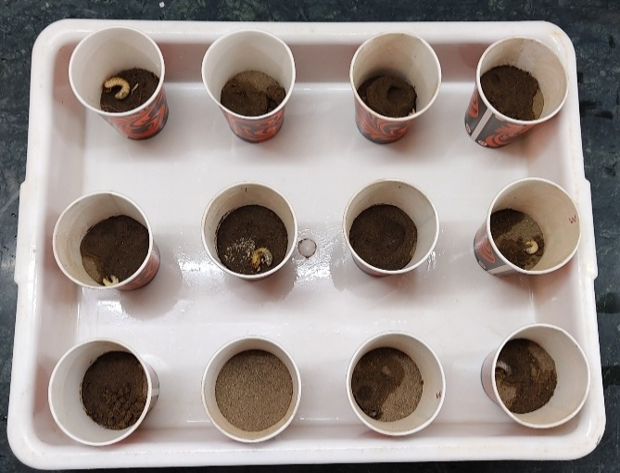
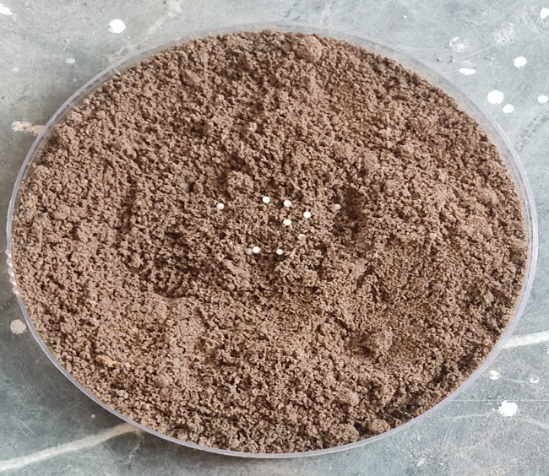
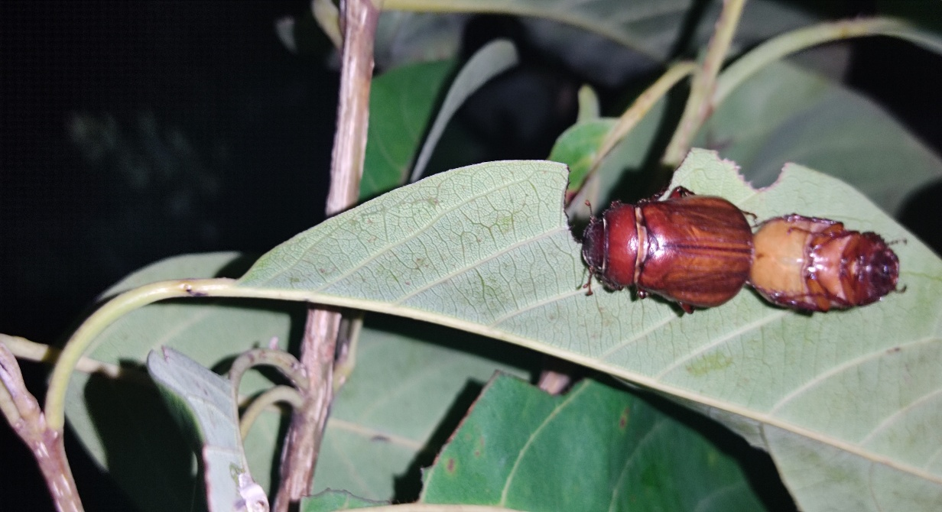
B)
A)
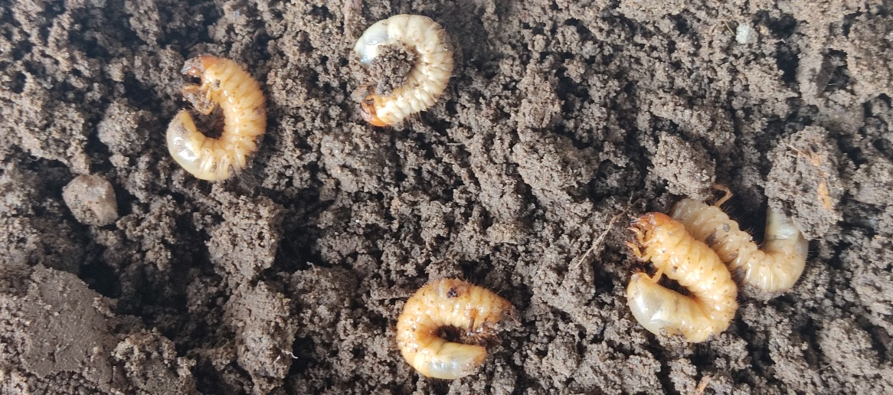
D)
C)

Fig 1. A) Mating of adult beetles oh H. longipennis, B) Separated eggs on petri plate, C) Third instar larvae treated with fungal concentrations, D) Paper cups used for observing grub mortality at different concentrations of B. bassiana and M. anisopliae

Evaluation of test fungi against white grubs
To study the effect of soil and sand on infectivity/ efficacy of fungi against white grubs, 100g of substrate mixture was put in the paper cups. Different graded concentrations starting from 6.25x10⁶, 1.25x10⁷, 2.5x10⁷, 5x10⁷, 1x10⁸ conidia/ ml were prepared. Larvae were smeared or dipped with conidial concentrations of biopesticides for 30 seconds. Each treatment was applied to a set of 15 grubs which was replicated three times. The experiment was carried out under controlled environmental conditions, maintaining a temperature of 25±1 ͦC and relative humidity of 75±5 %. The grub mortality was monitored every 24 hours after inoculation, with assessments conducted at five-day intervals for a total duration of 25 days. Mortality data was subjected to statistical analysis through completely randomized design (CRD), as per the guidelines of Gomez and Gomez (1984) and wherever necessary, data were suitably transformed. The mortality data were converted to per cent mortality and per cent mortality was corrected by using Abbott's formula. (Abbott 1925).
Per cent corrected mortality = $\frac{\% mortality in treatment-\% mortality in control}{100-\% mortality in control}$ ×100

Results and Discussions
Evaluation of B. bassiana against grubs of H. longipennis in soil and sand First instar

First instar: Effectiveness of B. bassiana against first instar grubs of H. longipennis in soil and sand was compared, and the results showed that mortality rose steadily with concentration and time in both treatments. The highest concentration (1×10⁸ conidia/ml) in soil produced a mean corrected mortality of 61.56% and a maximum corrected mortality of 74.44% at 25 days, while the same concentration in sand produced a slightly lower mean mortality of 57.18% and a maximum mortality of 68.10%. Similarly, soil had a little higher overall mean adjusted mortality at 25 days (45.56%) than sand (43.53%). Additionally, mortality in the control group was slightly greater in soil (4.44%) than in sand (2.22%).

Second Instar: The highest concentration (1×10⁸ conidia/ml) in soil produced a mean corrected mortality of 50.67% and a maximum corrected mortality of 62.22% at 25 days, while the same concentration in sand produced a slightly lower mean mortality of 47.11% and a maximum mortality of 57.77%. Additionally, soil had a greater overall mean adjusted mortality at 25 days (39.11%) than sand (33.78%). There was no mortality in the control group in either therapy. Furthermore, after 15 days, the increase in mortality over time was more noticeable in soil, whereas the influence of time was relatively less significant in sand.

Third Instar: The maximum corrected mortality in soil at the greatest concentration (1×10⁸ conidia/ml) was 53.33% after 25 days, with a mean corrected mortality of 43.56%. In contrast, the equivalent values were slightly lower in sand, with a maximum mortality of 48.89% and a mean corrected mortality of 38.67%. Additionally, soil had a greater overall mean adjusted mortality at 25 days (32.45%) than sand (28.44%). The mean corrected mortality was 6.22% in soil and 4.44% in sand at the lowest concentration (6.25×10⁶ conidia/ml), showing consistently lower mortality in sand across concentrations and time periods.

Fig. 2 Comparison of corrected mortality of different instar grubs of H. longipennis to B. bassiana in soil and sand

The comparison of corrected mortality of different instars in soil and sand revealed that the performance of soil invariably surpassed sand as a medium for the application of B. bassiana. This result is supported by the findings of Kulye and Pokharkar (2009), who investigated the effectiveness of B. bassiana against white grub H. consanguinea, which infests potato crops. After 40 days of inoculation, they recorded 97.8 and 89 per cent mortality with the highest dose of 1.04x10⁸spores/ ml. The LC₅₀ values for the commercial strain and the native strain were 1.88x10⁶ and 3.5x10⁵ spores/ ml, respectively. Erler and Ates (2015) tested an emulsifiable spore concentrate of B. bassiana against the white grub and discovered that younger larvae (first and second instar) were more prone to infection than older ones. Soni et al. (2018) assessed the B. brongniartii effectiveness against B. coriacea grubs in Himachal Pradesh found it to be extremely efficient against first and second instar grubs. Wei-Ping et al. (2023) studied the pathogenicity of Beauveria bassiana strain JCF to the larvae and adults of Holotrichia oblita. The B. bassiana were found to be highly pathogenic to H. oblita adults and larvae, making it an ideal strain for developing B. bassiana formulations to manage Melolonthinae pests.

Evaluation of Metarhizium anisopliae against grubs of H. longipennis in soil and sand

First Instar: The greatest concentration (1×10⁸ conidia/ml) in soil produced 77.37% mortality at 25 days, with a mean corrected mortality of 63.90%. In contrast, the same concentration in sand produced 73.33% mortality at 25 days, with a mean corrected mortality that was significantly lower. The mean corrected mortality was 19.61% in soil and 18.22% in sand at the lowest concentration (6.25×10⁶ conidia/ml), suggesting slightly lower mortality in sand. Control mortality was 2.22% in soil and 0% in sand, indicating that soil had a marginally higher mortality response than sand.

Second Instar: After 25 days, mortality in soil ranged from 20.00 to 64.44% at concentrations ranging from 6.25×10⁶ to 1×10⁸ conidia/ml. After 25 days, mortality in sand at the same concentration range varied between 20.00 and 60.00%. In sand, the mean adjusted mortality rose from 13.77% at 6.25×10¹ conidia/ml to 18.66%, 25.33%, and 37.33% at 1.25×10⁷, 2.5×10⁷, and 5×10⁷ conidia/ml, respectively, with a high of 50.22% at 1×10⁸ conidia/ml. In sand, the average adjusted mortality rose over time from 22.66% at 5 days to 25.33% at 10 days, 30.91% at 15 days, 31.55% at 20 days, and 38.22% at 25 days.

Third Instar: After five days, mortality in soil varied from 4.47 to 35.55%, and after fifteen and twenty-five days, it rose to 44.44 to 57.77% across concentrations (6.25×10⁶ to 1×10⁸ conidia/ml). A maximum mean corrected mortality of 42.01% was obtained at the greatest concentration (1×10⁸ conidia/ml), while a mean corrected mortality of 15.23% was recorded at the lowest concentration (6.25×10⁶ conidia/ml). After 25 days, mortality in sand varied from 17.77 to 55.55%, which was somewhat less than the highest range found in soil.

Fig. 3 Comparison of corrected mortality of different instar grubs of H. longipennis to M. anisopliae in soil and sand
This result is corroborated by the findings of Ambethgar (2003) who revealed in his study that M. anisopliae Caused 93.3 per cent mortality in Holotrichia sp. grubs after 20 days of inoculation. Ansari et al. (2004) reported third instar larvae of H. parallela was most susceptible to infection by M. ansisopliae after incubating for eleven weeks at 25°C. Kulye and Pokharkar (2009) estimated infectivity of M. anisopliae to third instar grubs of H. consanguinea as 5.76x10⁵ conidia/ ml. Bohara et al. (2018) assessed the effects of various M. anisopliae concentrations on white grubs in a lab setting. Six treatments were examined, with 10⁷ conidial spores per milliliter coming from commercial sources and 10⁷, 10⁵, 10⁴, and 10² from indigenous sources. The lowest LT₅₀ value of 61.45 days was recorded by the indigenous M. anisopliae concentration of 10⁴ spores/ ml. Wagiyana et al. (2020) conducted a study to test the effectiveness of M. anisopliae for controlling white grub species Lepidiota stigma. The larval mortality was tracked for 24, 48 and 72 hours after inoculation. M. anisopliae was found to be only 10 per cent effective after 48 hours because it took a long time for the larvae to die after the appearance of symptoms.
In the present study, a positive correlation between the inoculation concentration and the grub mortality was observed, irrespective of age, in all the instars. There was gradual decrease in susceptibility with advancement of age as indicated by values of corrected mortality. In both soil and sand, the first instar showed the highest mortality rates across all concentrations because they were most vulnerable to ecological stressors and unfavourable conditions. At the highest concentration of 1x10⁸ conidia/ ml, the corrected mortality reached 61.56 per cent in soil and 57.18 per cent in sand for B. bassiana and 63.90 per cent in soil and 61.33 per cent in sand for M. anisopliae. The trend persisted consistently across all concentrations, indicating an important relationship between the concentration levels and the health of these early life stages. Even at the lowest concentration of 6.25x10⁶ conidia/ ml, the first instar had a higher mortality rate (17.08% in soil and 12.92% in sand against B. bassiana and 19.61% in soil and 18.22% in sand against M. anisopliae) than the other. Therefore, first instar grubs are most susceptible to B. bassiana and M. anisopliae, followed by second and third instar grubs. This suggests that H. longipennis instars at younger stages of life cycle are more sensitive to fungal infection, which is important for pest control strategies.
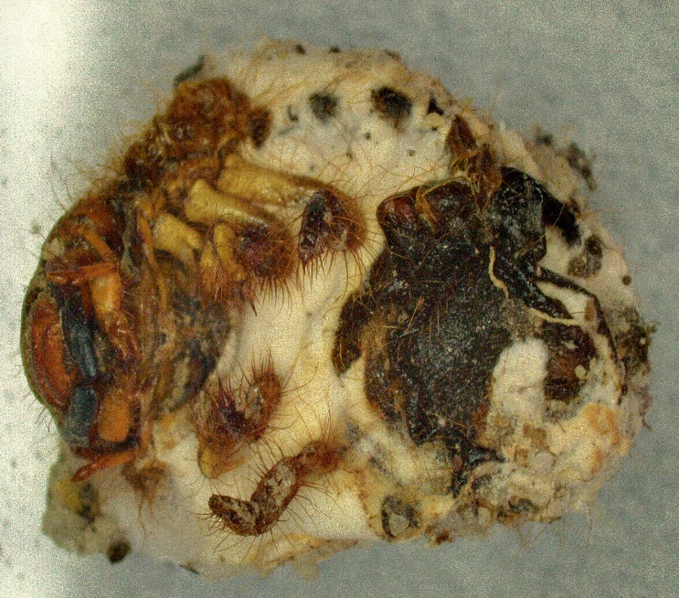
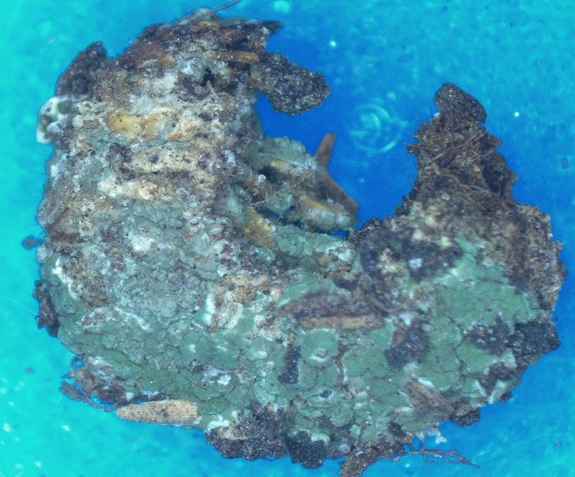
Regardless of concentration or instar, soil consistently performed better than sand in terms of mortality rates. For first instar, corrected mortality in soil was higher than sand across all concentrations, particularly at higher concentrations. Soil creates an environment that is more conducive for fungal development and persistence, because it retains more moisture, the fungal conidia do not dry up, which is a common problem with sand because of its reduced water-holding capacity. Additionally, soil contain more organic matter that serves as fungus's source of nutrients, increasing its chances of surviving and infecting the host.
B)
A)
Fig 4. A) Grubs of H. longipennis infected with Metarhizium anisopliae
B) Grubs of H. longipennis infected with Beauveria bassiana, observed under Leica microscrope
Concentration (Conidia/ ml) | Corrected mortality after indicated 25 days of treatment (%)
Concentration (Conidia/ ml) | SOIL |  |  |  |  |  | SAND
Concentration (Conidia/ ml) | Ist Instar | 2nd Instar |  | 3rd Instar |  |  | Ist Instar | 2nd Instar |  | 3rd Instar
1 x 10⁸ | 74.44  (59.65) |  | 62.22  (52.07) |  | 53.33  (46.90) | 68.10 (55.63) |  |  | 57.77 (49.46) |  | 48.89 (44.34)
5 x 10⁷ | 60.48  (51.04) |  | 48.89  (44.35) |  | 42.22  (40.50) | 56.67 (48.83) |  |  | 44.44 (41.78) |  | 37.77 (37.89)
2.5 x 10⁷ | 46.51  (42.98) |  | 37.78  (37.89) |  | 31.11  (33.86) | 43.18 (41.06) |  |  | 31.11 (33.85) |  | 28.88 (32.35)
1.25 x 10⁷ | 25.40  (30.13) |  | 26.67  (30.96) |  | 22.22  (28.06) | 31.75 (34.20) |  |  | 20.00 (26.37) |  | 17.77 (24.83)
6.25 x 10⁶ | 20.95  (27.23) |  | 20.00  (26.35) |  | 13.33  (20.97) | 17.94 (24.38) |  |  | 15.53 (23.12) |  | 8.89 (17.10)
Mean | 45.56  (42.20) |  | 39.11  (38.32) |  | 32.45  (34.06) | 43.53 (40.82) |  |  | 33.78 (34.91) |  | 28.44 (31.30)
S.E(m) | 1.61 |  | 1.96 |  | 2.1 | 2.1 |  |  | 1.79 |  | 1.97
C.V. (%) | 6.13 |  | 8.86 |  | 10.67 | 8.82 |  |  | 8.87 |  | 10.88
C.D. at 5% | 5.12 |  | 6.26 |  | 6.7 | 6.7 |  |  | 5.71 |  | 6.28
Table 1. Mortality response of different stages of grubs of H. longipennis to B. bassiana in soil and sand
Figures in parentheses are arc sine transformed values

Table 2. Mortality response of different stages of grubs of H. longipennis to M. anisopliae in soil and sand
Concentration (Conidia/ ml) | Corrected mortality after indicated 25 days of treatment (%)
Concentration (Conidia/ ml) | SOIL |  |  |  |  |  | SAND
Concentration (Conidia/ ml) | Ist Instar | 2nd Instar |  | 3rd Instar |  |  | Ist Instar | 2nd Instar |  | 3rd Instar
1 x 10⁸ | 77.37 (61.56) |  | 64.44 (53.39) |  | 57.77 (49.46) | 73.33 (59.00) |  |  | 60.00 (50.78) |  | 55.55 (48.17)
5 x 10⁷ | 65.87 (54.30) |  | 51.11 (45.61) |  | 46.67 (43.06) | 28.89 (32.47) |  |  | 48.89 (44.34) |  | 42.22 (40.50)
2.5 x 10⁷ | 52.38 (46.35) |  | 37.77 (37.89) |  | 35.55 (36.57) | 51.11 (45.61) |  |  | 35.53 (36.57) |  | 33.33 (35.18)
1.25 x 10⁷ | 36.34 (37.04) |  | 28.89 (32.47) |  | 22.22 (28.06) | 37.77 (37.89) |  |  | 26.67 (30.96) |  | 24.44 (29.57)
6.25 x 10⁶ | 24.76 (29.51) |  | 20.00 (26.34) |  | 15.55 (23.12) | 24.44 (29.57) |  |  | 20.00 (26.34) |  | 17.77 (24.83)
Mean | 51.33 (45.75) |  | 40.44 (39.14) |  | 35.55 (36.05) | 44.89 (40.71) |  |  | 38.22 (37.802) |  | 34.66 (35.65)
S.E(m) | 2.32 |  | 1.72 |  | 1.65 | 2.67 |  |  | 2.13 |  | 1.68
C.V. (%) | 8.78 |  | 7.63 |  | 7.90 | 11.33 |  |  | 9.74 |  | 8.142
C.D. at 5% | 7.4 |  | 5.50 |  | 5.15 | 7.52 |  |  | 6.78 |  | 5.35
Figures in parentheses are arc sine transformed values

Conclusion:
Entomopathogenic fungi such Beauvaria bassiana and Metarhizium anisopliae are favoured over chemical pesticides for the management of white grub because they offer an environmentally benign, sustainable and target-specific treatment that reduces environmental contamination and resistance development while preserving long-term pest suppression. The first instar larvae of H. longipennis were found to be most susceptible to both entomopathogenic fungi when treated in soil and sand, with B. bassiana and M. anisopliae compared to second and third instar. This suggests that H. longipennis grubs at younger stages of life cycle are more sensitive to fungal infection, which is important for pest control strategies. Soil outperformed sand as a substrate causing higher mortality for both B. bassiana and M. anisopliae due to better moisture retention and organic matter content in soil, which provides favourable environmental conditions for conidia to grow and infect the host. These findings hold great promise for the use of entomopathogenic fungi for integrated pest management of white grubs. Further investigations under field conditions would be the next step to ensure the results we have found hold true under greater biotic and abiotic stresses.
Acknowledgement:
The author thanks the Department of Entomology, CSKHPKV, Palampur for providing facility to conduct the research and also ICAR-NTS for providing support through scholarship.
COMPETING INTEREST DISCLAIMER:
Authors have declared that they have no known competing financial interests OR non-financial interest OR personal relationships that could have appeared to influence the work reported in this paper
Disclaimer (Artificial intelligence)

Author(s) hereby declare that NO generative AI technologies such as Large Language Models (ChatGPT, COPILOT, etc.) and text-to-image generators have been used during the writing or editing of this manuscript.

References:
- Abbott, W.S. (1925). A method of computing the effectiveness of an insecticide. Journal of Economic Entomology 18: 265-267
- Ambethgar, V. (2003). Screening and selection of entomopathogenic fungi for management of cashew tree borer, Plocaederus ferrugineus L. (Cerambycidae: Coleoptera). Pest Management in Horticultural Ecosystems. 9(1): 55-57
- Ansari, M.A., Vestergaard, S., Tirry, L., & Moens, M. (2004). Selection of a highly virulent fungal isolate, Metarhizium anisopliae CLO 53, for controlling Hoplia philanthus. Journal of Invertebrate Pathology, 85, 89–96
- Bohara, J.R., Maharjan, S., Poudel, A., Karki, K., Bist, V., Regmi, R., & Marahatta, S. (2018). Efficacy of different concentration of Metarhizium anisopliae (Metsch.) Sorokin against white grub at lab condition in Chitwan, Nepal. Journal of Pharmacognosy and Phytochemistry. 1: 149-153
- Chandel, R.S., Pathania, M., Verma, K.S., Bhatacharyya, B., Vashisth, S., & Kumar, V. (2015). The ecology and control of potato white grubs of India. Journal of European Association for Potato Research, 58, 147-64
- Devi, K.U., Padmavathi, J., Sharma, H.C., & Seetharama, N. (2001). Laboratory evaluation of the virulence of Beauveria bassiana isolates to the sorghum shoot borer Chilo partellus Swinhoe (Lepidoptera: Pyralidae) and their characterization by RAPD-PCR. World Journal of Microbiology and Biotechnology,17, 131-137
- Erler. & Ates, A. O. (2015). Potential of two entomopathogenic fungi, Beauveria bassiana and Metarhizium anisopliae (Coleoptera: Scarabaeidae), as biological control agents against the june beetle. Journal of Insect Science 15: 1-6
- Goettel, M. S., & Hajek, A. E. (2000). Evaluation of non-target effects of pathogens used for management of arthropods. In: Evaluating indirect ecological effects of biological control. (Wajenberg E et al., eds.). CABI publishing, Wallingford. P 81-97
- Gomez, K. A., & Gomez, A. A. (1984). Statistical Procedures for Agricultural Research. 2nd Edition, John Wiley and Sons, New York, P 680
- Jadhav, A.R., Patil, A.S., & Pawar, R.S. (2020). Impact of insecticide application on natural enemies in groundnut ecosystem. Journal of Oilseeds Research. 37(3):212-218.

- Jagpal, S. (2020). Pathogenicity of entomopathogenic fungi Metarhizium anisopliae to white grubs Holotrichia serrata. Journal of Entomology and Zoology Studies. 9(1): 1207-1209
- Keller, S. (2000). Use of Beauveria brongniartii in Switzerland and its acceptance by farmers. In: Integrated control of soil pest subgroup "Melolontha". (Keller S ed.). Proceedings of the meeting; IOBL, Switzerland,19-21 October 1998. IOBC/wprs bulletin 23: 67-72
- Kulye, M. S., & Pokharkar, D. S. (2009). Evaluation of two species of entomopathogenic fungi against white grub, Holotrichia consanguinea (Blanchard) infesting potato in Maharashtra, India. Journal of Biological Control 23: 1-4
- Mehta, P. K., Chandel R. S., & Mathur, Y. S. (2010). Status of white grubs in North-Western Himalaya. Journal of Insect Science 23: 1-14
- Patil, S.J., More, P.B., & Shinde, K.R. (2024). Seasonal incidence of white grub beetles in relation to climatic factors. Indian Journal of Entomology. 86(1):97-102.
- Pell, J. K., Eilenberg, J., Hajek, A. E., & Steinkraus, D. C. (2001). Biology, ecology and pest management potential of Entomophthorales. In: Fungi as biocontrol agents: progress, problems and potential. (TM Butt et al., eds.). CAB International, Wallingford. P 71-153
- Ramanujam, B., Rangeshwaran, R., Sivakumar, G., Mohan, M. & Yandigeri, M. S. (2014). Management of insect pests by microorganisms, Proc. Indian National Sci. Acad. 80: 455-471.
- Soni, S., Mehta, P. K., & Chandel, R. S. (2018). Susceptibility of white grub, Brahmina coriacea 149 (Hope) infesting potato to local strains of Beauveria brongniartii (Saccardo) in Himachal Pradesh. Journal of Biological Control. 32: 41-47.
- Rathour, B., Mohite, P.B., & Gite, R. B. (2015). Bioefficacy of entomopathogenic nematode, Steinernema carpocapsae against white grub, Phyllognathus dionysius(Feb) under laboratory condition. Journal Of Global Bioscience. 4(8): 3165-3170

- Wagiyana, Habriantono, B., & Alfarisy, F. F. (2020). Biological control of white grubs (Lepidiota stigma L; Coleoptera; Scarabaeidae) with entomopathogenic nematodes and fungus Metharizium anisopliae (Metsch). Earth and Environmental Science. 759: 012023
- Wei-Ping, C., Jia-Xu C., Shuo, F., Ju-Ying, Z., Dan C., & Jian S. (2023). Identification and pathogenicity determination of Beauveria bassiana strain JCF. Acta Entomologica Sinica. 66(8): 999-1008

