EFFECT OF DIETARY SUPPLEMENTATION OF FENNEL SEED (Foeniculum vulgare) POWDER ON CARCASS AND MEAT QUALITY OF COMMERCIAL BROILER CHICKEN
Original Research Article

ABSTRACT
The present study was conducted to evaluate the effects of dietary supplementation of fennel seed powder (Foeniculum vulgare) on carcass quality traits, meat colour profile and sensory attributes of commercial broiler chickens as a natural alternative to synthetic growth promoters. A total of 144 day-old Cobb 400 broiler chicks were randomly allocated to four dietary treatments: T₀ (control), T₁ (0.25% fennel seed powder), T₂ (0.50%) and T₃ (0.75%). The birds were reared for 42 days under standard management conditions. Carcass characteristics, organ weights and cut-up part yields were recorded, while meat colour parameters (L*, a*, b*) were measured using a colorimeter and sensory attributes were evaluated by a semi-trained panel. The results revealed that fennel seed powder supplementation significantly (p<0.05) improved pre-slaughter live weight, dressed weight and yields of breast, thigh and drumstick. A significant increase in redness (a*) values of breast meat was observed in treated groups, particularly in T₃. Sensory evaluation indicated higher scores for flavour, colour, juiciness and texture in fennel-supplemented groups, with the highest overall acceptability recorded in T₃. In conclusion, fennel seed powder can be effectively used as a natural, safe and cost-effective phytobiotic feed additive to enhance meat quality and consumer acceptability in broiler production.
Keywords: Fennel seed powder, Broiler chicken, Carcass quality, Meat colour profile, Organoleptic evaluation, Phytobiotic feed additive
INTRODUCTION
India is one of the leading countries in global poultry meat production, holding the sixth position and contributing approximately 51.14% to the nation's overall meat output (FAOSTAT, 2021; BAHS, 2023). Among the various types of poultry meat, broiler chicken has gained significant popularity both in Assam and across the country. In fact, India is currently the fourth-largest producer of broiler chickens in the world (Sapcota et al., 2018). The demand for broiler meat is particularly growing in Assam due to its high protein and low-fat content, making it an appealing dietary option and a promising source of livelihood, especially for educated unemployed youth (Choudhury, 2017).
To meet this rising demand, the poultry industry has prioritized improving bird health and productivity through feed innovations, while also aiming to minimize environmental impact. Traditionally, chemical feed additives and antibiotic growth promoters (AGPs) have been used to enhance growth rates. However, increasing concerns over antibiotic resistance and residue accumulation in poultry products have led to their ban in the European Union since 2006 (Nouzarian et al., 2011). In response to these concerns, researchers have explored a range of alternative feed additives that could support broiler performance in a safer and more sustainable manner. Feed additives are incorporated into animal diets in small quantities to enhance desirable traits or minimize negative ones, ultimately leading to better growth, increased body weight and improved feed conversion ratios (Steiner & Zhang, 2006). In Assam, there has been growing interest in the use of phytobiotics, plant-based compounds, as natural alternatives to synthetic growth promoters. These substances possess bioactive properties that can replace antibiotic growth promoters by enhancing feed intake, stimulating appetite, improving digestive enzyme secretion and boosting the immune system in broilers (Rahman et al., 2014; Toghyani et al., 2010).
Among these phytobiotics, fennel seeds (Foeniculum vulgare) have been recognized as effective and safe herbal additives in poultry nutrition. Their inclusion in broiler diets has been associated with better appetite stimulation, improved digestion, nutrient assimilation and strengthened immune responses. Fennel seeds are also rich in nitrites and nitrates, which contribute to vascular health and overall physiological function (El-Deek et al., 2003; Guimarăes et al., 2011; Badgujar et al., 2014; Liu et al., 2021; Swaminathan et al., 2012).
MATERIALS AND METHODS
A total of 144 day-old Cobb-400 broiler chicks with uniform body weights, all obtained from the same hatch, were selected for this study. The chicks were sourced from a well-established hatchery located in Guwahati, Assam. Upon arrival, each chick's initial body weight was recorded using a digital weighing scale and wing banding was done on the same day for identification purposes. The chicks were then randomly distributed into four treatment groups: T₀, T₁, T₂ and T₃, each consisting of 36 birds divided into three replicates of 12 chicks each. All birds were reared on a deep litter system and managed under uniform feeding and husbandry conditions.
The experimental diets differed in the levels of fennel seed powder (FSP) supplementation. The control group (T₀) received a basal diet without FSP, while groups T₁, T₂ and T₃ were supplemented with 0.25%, 0.50% and 0.75% FSP, respectively. Diets were formulated according to BIS (2007) standards, comprising ingredients such as maize, rice polish, groundnut cake, soybean meal, vegetable oil, mineral mix and common salt. Three feeding phases were followed: pre-starter (days 1–7), starter (days 8–21) and finisher (days 22–42), with feeding continuing for a total of six weeks. The composition and nutritional content of the basal diet are detailed in Table 1a.
TABLE 1a: INGREDIENTS AND NUTRIENT COMPOSITION OF BASAL DIET (BIS, 2007)
Ingredients (kg) | Pre-starter (0-7 days) | Starter (8-21 days) | Finisher (22-42 days)
Yellow maize | 52.0 | 55.0 | 60.0
Rice polish | 7.0 | 7.0 | 5.5
Ground nut cake | 15.0 | 12.0 | 10.0
Soybean meal | 22.5 | 22.0 | 20.0
Vegetable oil | 1.0 | 1.5 | 2.0
Mineral mixture | 2.0 | 2.0 | 2.0
Common salt | 0.5 | 0.5 | 0.5
Nutrient composition
Dry matter (%) | 88.60 | 87.45 | 86.52
Crude protein (%) | 23.02 | 22.01 | 20.10
Ether extract (%) | 3.53 | 4.60 | 5.00
Crude fibre (%) | 3.98 | 3.96 | 4.01
Nitrogen free extract (%) | 64.31 | 63.43 | 63.22
Total ash (%) | 6.90 | 7.03 | 6.58
Metabolizable energy  (Kcal/kg) * | 3005.80 | 3096.00 | 3197.00
*Calculated value
(NB: Vitamin premix Hyblend powder was added @ 20g per quintal in all the diets)

Table 1b. Value of Composition of Hyblend powder per g
Vitamin A | 28,500 i.u.
Vitamin B₂ | 50 mg
Vitamin D₃ | 12,000 i.u.
Vitamin K | 10 mg
At the conclusion of the 42-day trial, five birds from each treatment group were randomly selected for carcass evaluation. Parameters recorded included pre-slaughter live weight, dressed weight, dressing percentage and yield of different cut-up parts. Standard slaughter procedures, including bleeding, scalding, defeathering and evisceration, were conducted at the Department of Poultry Science laboratory, College of Veterinary Science, Assam Agricultural University, Khanapara, Guwahati. Dressed weights were obtained post-evisceration using a calibrated weighing balance. Organs such as the heart (freed from pericardium), liver (with gall bladder removed) and gizzard (with contents and lining cleared) were weighed individually. Giblet yield was calculated as a percentage of pre-slaughter live weight.
For breast meat colour analysis, a precision colorimeter (Model NR110, 3nh Technology Co. Ltd.) was used to measure L* (lightness), a* (redness) and b* (yellowness) values on the surface of the breast muscle. Each measurement was taken three times per sample and the mean values were recorded.
Organoleptic evaluation of broiler breast meat involved the selection of small meat cubes from each treatment group (T₀–T₃). The samples were pressure-cooked for five minutes at 15 psi and arranged for sensory analysis. A semi-trained panel of 14 members assessed the coded samples based on colour, flavour, juiciness, tenderness and overall acceptability using a seven-point hedonic scale as described by Bratzler (1971).
Throughout the trial period, all birds were maintained on fresh paddy husk bedding under a deep litter housing system. Strict biosecurity measures were followed. Routine vaccinations were administered against Ranikhet Disease (RD) and Infectious Bursal Disease (IBD). The study was designed using a Completely Randomized Design (CRD). Statistical analyses, including One-Way ANOVA, were conducted using the SAS software (Local, X64 – 7PRO), and results were expressed as Mean ± Standard Error (SE) following standard statistical procedures.
STATEMENT OF ANIMAL ETHICS: Decision of the Institutional Animal Ethics Committee-The protocol is approved by IAEC, Assam Agricultural University, Khanapara. Approval No. 770/GO/Re/S/03/CPCSEA/FVSc/AAU/IAEC/23-24/1120 dated 27.05.2024.

RESULTS AND DISCUSSION
CARCASS TRAITS
Carcass quality traits
The mean (± SE) values of carcass quality traits of broiler chicken under different treatment groups are presented in Table 2.
Pre-slaughter live weight
The mean (± SE) pre-slaughter live weight of broiler chicken under different experimental groups was recorded and found as 1739.80±63.64, 1769.80±38.56, 1850.60±36.13 and 1999.20±34.04g for T₀, T₁, T₂ and T₃ groups, respectively (Table 2). The pre-slaughter live weight of broiler chicken differed significantly among different experimental groups (P<0.01). It was found to be significantly (P<0.05) higher in T₃ group than the other groups.
Dressed weight
The mean dressed weight of T₀, T₁, T₂ and T₃ group was estimated as 1223.60±46.14, 1250.20±28.35, 1318.00±23.67 and 1443.60±24.77g, respectively. The analysis of variance showed highly significant (P<0.01) difference among the experimental groups. The dressed weight was significantly (P<0.05) higher in T₃ group as compared to all other groups.
Dressing percentage
The mean dressing percentage recorded for T₀, T₁, T₂ and T₃ groups was found as 70.32±0.36, 70.64±0.48, 71.22±0.59 and 72.20±0.52, respectively. There was no significant (P>0.05) difference in dressing percentage among the experimental groups.
Giblet weight
The mean giblet weight was worked out as 82.80±2.78, 82.50±2.78, 85.30±2.00 and 88.44±2.08g for T₀, T₁, T₂ and T₃ groups, respectively. There were no significant (P>0.05) differences among the experimental groups of broiler chicken in respect of giblet weight.
Giblet yield
The mean per cent giblet yield for T₀, T₁, T₂ and T₃ groups was recorded as 4.76±0.03, 4.66±0.03, 4.61±0.01 and 4.42±0.02, respectively. There was no significant (P>0.05) difference in giblet yield among all the experimental groups.
The carcass traits comprising of dressing percentage, giblet weight and giblet yield did not differ significantly (P>0.05) among the different treatment groups except for the parameters pre-slaughter live weight and dressed weight. The present finding was in agreement with the reports of El-Deek et al. (2002), Ragab et al. (2013) and AL-Sagan et al. (2020), who also observed that dressing percentage of broiler chicken was not significantly affected due to dietary supplementation of FSP at the levels ranging from 0.05 to 2.00%. In contrary to the present finding, Saki et al. (2014) and Fatima et al. (2022) found significantly higher dressing percentage in FSP treated group (66.30 -72.23%) than the unsupplemented control group (54.70 and 67.61%).

TABLE 2: MEAN ± SE CARCASS TRAITS OF BROILER CHICKEN UNDER DIFFERENT TREATMENT GROUPS
 | GROUP  PARAMETER | T₀ (Control) | T₁ (FSP-0.25%) | T₂(FSP-0.50%) | T₃(FSP-0.75%) | P-value
Pre-slaughter live weight (g) |  | 1739.80ª±63.64 | 1769.80ª±38.56 | 1850.60ª±36.13 | 1999.20^{b}±34.04 | <0.01
Dressed weight (g) |  | 1223.60ª±46.14 | 1250.20ª±28.35 | 1318.00ª±23.67 | 1443.60^{b}±24.77 | <0.01
Dressing percentage (%) |  | 70.32±0.36 | 70.64±0.48 | 71.22±0.59 | 72.20±0.52 | >0.05
Giblet weight (g) |  | 82.80±2.78 | 82.50±2.78 | 85.30±2.00 | 88.44±2.08 | >0.05
Giblet yield (%) |  | 4.76±0.03 | 4.66±0.03 | 4.61±0.01 | 4.42±0.02 | >0.05
Means with different superscripts in a row differ significantly (P<0.05)
Cut-up parts
The mean (± SE) per cent yields of cut-up parts of broiler chicken under different treatment groups have been presented in Table 3.
The mean per cent yields of neck were calculated as 3.22±0.004, 3.23±0.003, 3.25±0.003 and 3.27±0.004 for T₀, T₁, T₂ and T₃ groups, respectively. The mean per cent yields of neck among the different experimental groups did not differ significantly (P>0.05).
The mean per cent yields of wings under different treatment group were recorded as 7.36±0.001, 7.36±0.01, 7.48±0.001 and 7.63±0.002 for T₀, T₁, T₂ and T₃ groups, respectively. There was no significant (P>0.05) difference in per cent yield of wing among the different experimental groups.
The mean per cent yields of back were found as 13.52±0.010, 13.53±0.001, 13.73±0.001 and 13.08±0.010 for T₀, T₁, T₂ and T₃ groups, respectively. There were no significant (P>0.05) differences in per cent yields of back among the different experimental groups.
The mean per cent yields of breast for T₀, T₁, T₂ and T₃ groups were calculated as 23.87±0.004, 23.88±0.007, 24.13±0.007 and 24.38±0.002, respectively. The mean per cent yield of breast was found to be highly significant (P<0.01) among the experimental groups. The yield was significantly (P<0.05) higher in T₂ and T₃ groups as compared to T₀ and T₁.
The mean per cent yields of thigh under different experimental groups were recorded as 10.62±0.007, 10.65±0.004, 10.88±0.003 and 11.08±0.005 for T₀, T₁, T₂ and T₃ groups, respectively. The analysis of variance showed highly significant (P<0.01) difference in per cent yield of thigh among the different treatment groups.
The mean per cent yield of drumstick for T₀, T₁, T₂ and T₃ were calculated as 9.40±0.004, 9.43±0.015, 9.31±0.004 and 9.70±0.004, respectively. The analysis of variance showed highly significant (P<0.01) difference in per cent yield of drumstick among the different treatment groups.
The mean per cent yield of cut-up parts comprising of neck, wing and back did not differ significantly (P>0.05) among the different treatment groups (Table 3). However, the per cent yields of breast, thigh and drumstick were highly significant (P<0.01) among the different experimental groups. The per cent yield of breast and thigh was significantly (P<0.05) higher in both T₂ and T₃ groups than the other groups. However, among all the treated groups the per cent yield of drumstick was significantly (P<0.05) higher only in T₃ group. The significantly higher per cent yield of breast meat found in the present FSP supplemented group was in agreement with the findings of Ragab et al. (2013) and AL-Sagan et al. (2020).
TABLE 3: MEAN ± SE PER CENT YEILD CUT-UP PARTS OF BROILER CHICKEN (ON PRE-SLAUGHTER LIVE WEIGHT BASIS) UNDER DIFFERENT TREATMENT GROUPS
GROUP  PARAMETER | T₀ (Control) | T₁ (FSP-0.25%) | T₂ (FSP-0.50%) | T₃ (FSP-0.75%) | P-value
Neck | 3.22±0.004 | 3.23±0.003 | 3.25±0.003 | 3.27±0.004 | >0.05
Wings | 7.36±0.001 | 7.36±0.01 | 7.48±0.001 | 7.63±0.002 | >0.05
Back | 13.52±0.010 | 13.53±0.001 | 13.73±0.001 | 13.08±0.010 | >0.05
Breast | 23.87ª±0.004 | 23.88ª±0.007 | 24.13^{b} ±0.007 | 24.38^{b} ±0.002 | <0.01
Thighs | 10.62ª±0.007 | 10.65ª±0.004 | 10.88^{b} ±0.003 | 11.08^{c} ±0.005 | <0.01
Drumstick | 9.40ª ±0.004 | 9.43ª ±0.015 | 9.31ª ±0.004 | 9.70^{b} ±0.004 | <0.01
Means with different superscripts in a row differ significantly (P<0.05)

Relative organs weight
The mean (± SE) per cent weights of relative organs is presented in Table 4.
Liver weight
The mean per cent weights of liver under different treatment groups were recorded as 2.32±0.02, 2.32±0.02, 2.37±0.01 and 2.43±0.01 for T₀, T₁, T₂ and T₃ groups, respectively. There was no significant (P>0.05) difference for per cent weights of liver among different treatment groups.
Heart weight
The mean per cent weights of heart were worked out as 0.51±0.02, 0.53±0.01, 0.53±0.00 and 0.54±0.01 for T₀, T₁, T₂ and T₃ groups, respectively. The analysis of variance showed no significant (P>0.05) difference for per cent weights of heart among different treatment groups.
Gizzard weight
The mean per cent weights of gizzard were found as 1.82±0.01, 1.82±0.01, 1.83±0.01 and 1.84±0.01 for T₀, T₁, T₂ and T₃ groups, respectively. There was no significant (P>0.05) difference for per cent weights of gizzard among different experimental groups.
Head weight
The average per cent weight of head for T₀, T₁, T₂ and T₃ groups was calculated as 2.29±0.01, 2.42±0.00, 2.43±0.00 and 2.56±0.01, respectively. The per cent weights of head under all the experimental groups did not differ significantly (P>0.05).
Shank weight
The mean per cent weights of shank were recorded as 3.62±0.00, 3.62±0.00, 3.63±0.01 and 3.77±0.06 for T₀, T₁, T₂ and T₃ groups, respectively. There was no significant (P>0.05) difference for per cent weights of shank among different treatment groups.
Intestine weight
The mean per cent weights of intestine under different experimental groups were recorded as 4.25±0.01, 4.28±0.00, 4.31±0.00 and 4.61±0.04 for T₀, T₁, T₂ and T₃ groups, respectively. The analysis of variance showed significant (P<0.05) difference in per cent weights of intestines among different treatment groups. The mean per cent weight of intestine was significantly (P<0.05) higher in T₃ group than the control and other treated groups.
The mean (±SE) per cent weights of relative organs of broiler chicken except intestine did not differ significantly (P>0.05) among the different experimental groups (Table 4). The present finding was in agreement with the observation of AL-Sagan et al. (2020) who found no significant (P>0.05) difference in relative organ weights of broiler chicken supplemented with FSP at the level of 0.00, 1.60 and 3.20% in the basal diet of broiler chicken for a period of 42 days.
TABLE 4: MEAN ± SE PER CENT WEIGHT OF RELATIVE ORGANS OF BROILER CHICKEN (ON PRE-SLAUGHTER LIVE WEIGHT BASIS) UNDER DIFFERENT TREATMENT GROUPS
GROUP  WEEK | T₀ (Control) | T₁ (FSP-0.25%) | T₂ (FSP-0.50%) | T₃ (FSP-0.75%) | P-value
Liver | 2.32±0.02 | 2.32±0.02 | 2.37±0.01 | 2.43±0.01 | >0.05
Heart | 0.51±0.02 | 0.53±0.01 | 0.53±0.00 | 0.54±0.01 | >0.05
Gizzard | 1.82±0.01 | 1.82±0.01 | 1.83±0.01 | 1.84±0.01 | >0.05
Head | 2.29±0.01 | 2.42±0.00 | 2.43±0.00 | 2.56±0.01 | >0.05
Shank | 3.62±0.00 | 3.62±0.00 | 3.63±0.01 | 3.77±0.06 | >0.05
Intestine | 4.25ª ±0.01 | 4.28ª ±0.00 | 4.31^{b} ±0.00 | 4.61^{c} ±0.04 | <0.05
Means with different superscripts in a row differ significantly (P<0.05)

Analysis of colour profile of breast meat
The mean (± SE) values of lightness (L*), redness (a*) and yellowness (b*) of the breast meat of broiler chicken under different treatment groups are presented in Table 5. The photographs of breast part of broiler chicken from different experimental groups are shown in Fig 1 to 4.
The lightness (L*) values of breast meat of broiler chicken for T₀, T₁, T₂ and T₃ group was recorded as 35.77±0.31, 35.72±0.37, 35.17±0.34 and 34.72±0.21, respectively. The analysis of variance showed non-significant (P>0.05) difference in lightness of breast meat of broiler chicken among the different treatment groups.
The redness (a*) values of breast meat of T₀, T₁, T₂ and T₃ were noted as 4.12±0.03, 4.63±0.10, 4.93±0.08 and 6.29±0.16, respectively. The analysis of variance showed highly significant (P<0.01) difference in redness colour of breast meat among the different experimental groups. The redness value was found to be significantly (P<0.05) higher in T₃ group as compared to other groups.
The yellowness (b*) values of breast meat were found to be 13.99±0.44, 13.22±0.09, 12.38±0.19 and 11.20±0.09 for T₀, T₁, T₂ and T₃ groups, respectively. The analysis of variance showed highly (P<0.01) significant difference in values of yellowness colour among the different treatment groups. The yellowness colour value was significantly (P<0.05) highest in T₀ group followed by T₁, T₂ and T₃ groups.
The mean values of colour profile of breast meat of broiler chicken comprising of redness (a*) and yellowness (b*) were highly significant (P<0.01) among the different experimental groups (Table 5). The redness (a*) value of breast meat of all the FSP treated group was significantly (P<0.05) higher than the control group. However, out of the treatment groups, T₃ group had significantly (P<0.05) highest redness (a*) value. The higher redness (a*) value found in the breast meat of broiler chicken was due to supplementation of FSP was also reported by El-Deek et al. (2002) and AL-Sagan et al. (2020). The reason for higher redness (a*) in breast meat of broiler chicken was due to the presence of high concentration of nitrites and nitrates (65-376.70 mg/100g) as reported by Swaminathan et al. (2012). The nitrates are reduced to nitrites and eventually to nitric oxide (NO) which reacts with myoglobin to form nitrosomyoglobin and give broiler chicken breast meat its red colour (Froning et al., 1969).
The mean value of yellowness (b*) of breast meat of the present finding was significantly (P<0.05) highest in control group and lowest in T₃ group. In contrary to the present finding, El-Deek et al. (2002) found enhanced yellow colour of breast meat in FSP treated broiler chicken. On the other hand, AL-Sagan et al. (2020) reported that yellowness (b*) and lightness (L*) of breast meat of broiler chicken were not significantly (P>0.05) affected by the dietary supplementation of FSP.

TABLE 5: MEAN ± SE VALUES OF COLOUR PROFILE (L*, a*, b*) OF BROILER CHICKEN BREAST MEAT UNDER DIFFERENT TREATMENT GROUPS
Parameter | T₀ (Control) | T₁ (FSP-0.25%) | T₂ (FSP-0.50%) | T₃ (FSP-0.75%) | P-value
Lightness (L*) | 35.77 ± 0.31 | 35.72 ± 0.37 | 35.17 ± 0.34 | 34.72 ± 0.21 | >0.05
Redness (a*) | 4.12ª ± 0.03 | 4.63^{b} ± 0.10 | 4.93^{b} ± 0.08 | 6.29^{c} ± 0.16 | <0.01
Yellowness (b*) | 13.99ª ± 0.44 | 13.22^{b} ± 0.09 | 12.38^{c} ± 0.19 | 11.20^{d} ± 0.09 | <0.01
Means with different superscripts in a row differ significantly (P<0.05)
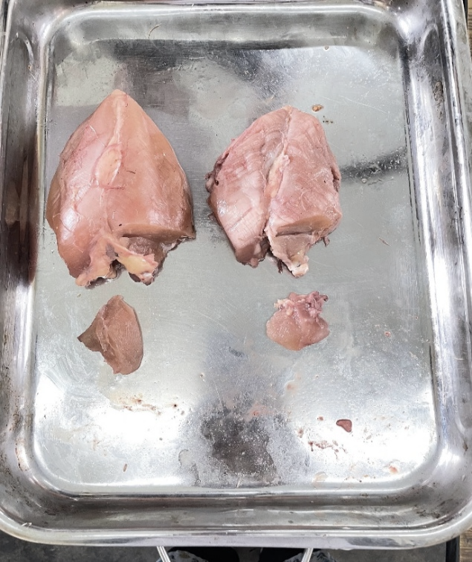 | 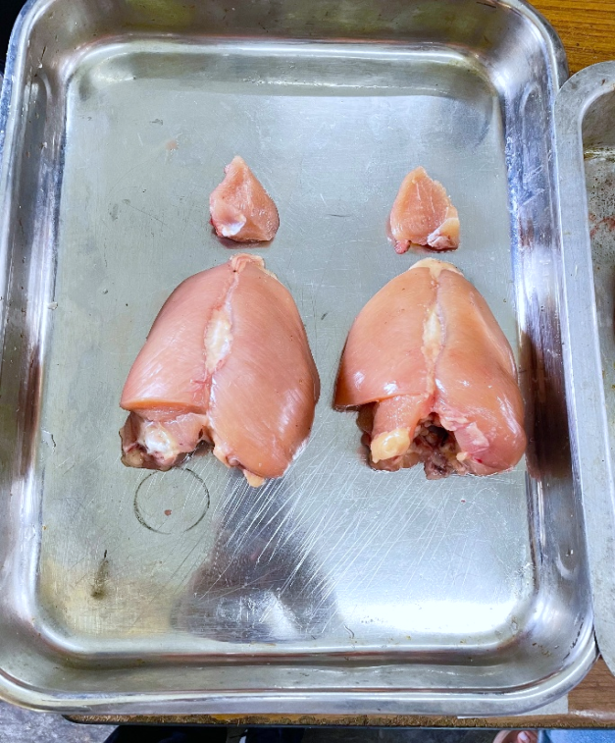
Fig. 1. PHOTOGRAPH OF BREAST MEAT OF T₀ GROUP | Fig. 2. PHOTOGRAPH OF BREAST MEAT OF T₁ GROUP
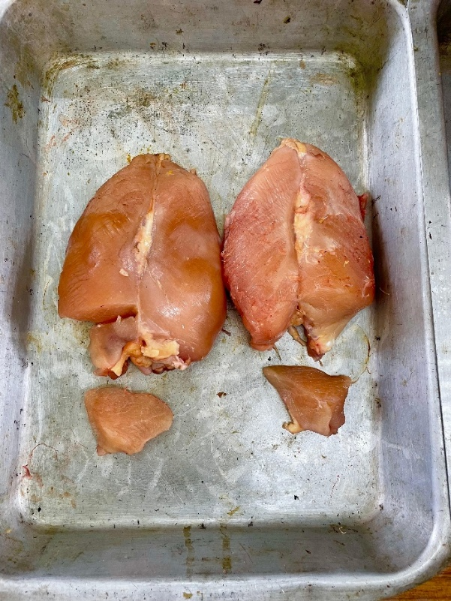 | 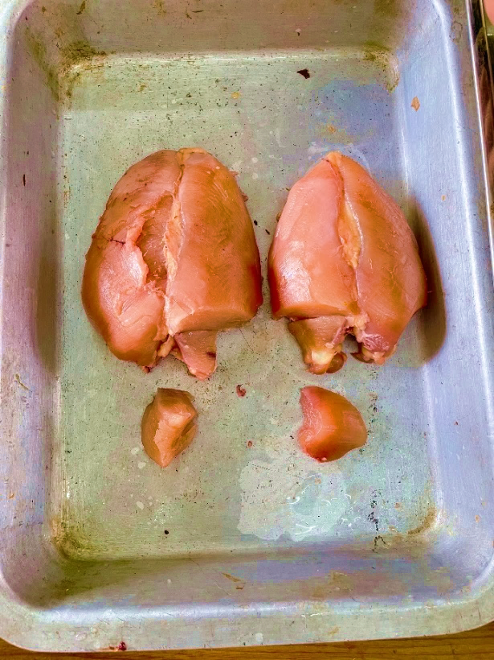
Fig. 3. PHOTOGRAPH OF BREAST MEAT OF T₂ GROUP | Fig. 4. PHOTOGRAPH OF BREAST PART OF T₃ GROUP

Organoleptic evaluation/sensory attributes
The organoleptic evaluation of broiler breast meat (Table 6) showed significant differences across the treatment groups in all assessed sensory attributes, including colour, flavour, texture, juiciness and overall acceptability. Notably, the T₂ and T₃ groups received higher scores for colour and flavour, while the T₃ group, which received 0.75% fennel seed powder (FSP) supplementation, achieved the highest ratings for texture, juiciness and overall acceptance. These findings indicate that FSP supplementation, particularly at the 0.75% level, positively influenced the sensory quality of broiler breast meat, with the T₃ group being most preferred by the sensory panel.

TABLE 6: MEAN ± SE SCORES FOR ORGANOLEPTIC EVALUATION OF BROILER CHICKEN BREAST MEAT UNDER DIFFERENT TREATMENT GROUPS
GROUP  WEEK | T₀ (Control) | T₁ (FSP-0.25%) | T₂ (FSP-0.50%) | T₃ (FSP-0.75%) | P-value
Colour | 5.14ª±0.10 | 5.14ª±0.10 | 5.43^{ab}±0.14 | 6.71^{b}±0.13 | <0.01
Flavour | 5.14ª±0.14 | 5.36ª±0.23 | 5.50^{ab}±0.17 | 6.00^{b}±0.10 | <0.01
Texture | 5.29ª±0.19 | 5.43ª±0.17 | 5.64ª±0.17 | 6.21^{b}±0.11 | <0.01
Juiciness | 5.43ª±0.20 | 5.50ª±0.17 | 5.71ª±0.13 | 6.21^{b}±0.11 | <0.01
Overall acceptance | 5.50ª±0.14 | 5.50ª±0.14 | 5.86^{b}±0.10 | 6.29^{c}±0.13 | <0.01
Means with different superscripts in a row differ significantly (P<0.05)

CONCLUSION
The findings of this study clearly demonstrate that dietary inclusion of fennel seed powder (FSP) can beneficially influence carcass quality and meat attributes in commercial broiler chickens. While parameters such as dressing percentage, giblet weight and most cut-up parts showed no significant variation, notable improvements were observed in pre-slaughter live weight, dressed weight and yields of breast, thigh and drumstick, especially in groups supplemented with 0.50% and 0.75% FSP. Additionally, FSP supplementation enhanced the redness of breast meat, likely due to its natural nitrate and nitrite content and positively affected organoleptic properties such as colour, flavour, texture and overall acceptability.
Among the tested levels, the 0.75% FSP inclusion (T₃ group) consistently yielded the best outcomes in both physical and sensory parameters, suggesting that fennel seed powder is an effective natural alternative to synthetic growth promoters. These results support the potential of FSP as a safe and valuable phytobiotic additive for improving broiler meat quality and consumer preference. Further research focusing on economic analysis, long-term safety and broader performance metrics could help validate its application in commercial poultry production.

COMPETING INTERESTS DISCLAIMER:
Authors have declared that they have no known competing financial interests OR non-financial interests OR personal relationships that could have appeared to influence the work reported in this paper.

Disclaimer (Artificial intelligence)

Author(s) hereby declare that NO generative AI technologies such as Large Language Models (ChatGPT, COPILOT, etc.) and text-to-image generators have been used during the writing or editing of this manuscript.

REFERENCES
AL-Sagan, A.A.; Khalil, S.; Hussein, E.O. and Attia, Y.A. (2020). Effects of fennel seed powder supplementation on growth performance, carcass characteristics, meat quality and economic efficiency of broilers under thermo neutral and chronic heat stress conditions. Animals, 10(2): 206.
Badgujar, S.B.; Patel, V.V. and Bandivdekar, A.H. (2014). Foeniculum vulgare Mill: A Review of its Botany, Phytochemistry, Pharmacology, Contemporary Application, and Toxicology. BioMedical Res. Int. 2014(4): 01-32.
BAHS (2023). Basic animal husbandry statistics, Ministry of Fisheries, Animal Husbandry & Dairying, Government of India. https://dahd.nic.in/
BIS. (2007). Indian Standard: Poultry Feed Specifications. 5th Revision. Bureau of Indian Standards.
Choudhury, D. (2017). Effect of dietary supplementation of turmeric (Curcuma longa) powder on the performance of commercial broiler chicken. MVSc thesis, submitted to Assam Agricultural University, Khanapara, Guwahati.
El-Deek, A. A.; Attia, Y. A. and Hannfy, M. M. (2003). Effect of anise (Pimpinella anisum), ginger (Zingiber officinale Roscoe), fennel (Foeniculum vulgare), and their mixture on the performance of broilers. Archiv für Geflügelkunde, 6(2): 92–96.
FAO. (2021). Food and Agriculture Organization of the United Nations FAOSTAT: Statistical database. https://www.fao.org/faostat/en/
Fatima, A.; Chand, N.; Naz, S.; Saeed, M.; Khan, N. U. and Khan, R. U. (2022). Coping heat stress by crushed fennel (Foeniculum vulgare) seeds in broilers: Growth, redox balance, and humoral immune response. Livestock Sci., 265: 105082. https://doi.org/10.1016/j.livsci.2022.105082

Froning, G.W.; Daddario J.; Hartung T.E.; Sullivan, T.W and Hill., R.M. (1969). Colour of Poultry Meat as Influenced by Dietary Nitrates and Nitrites. Poult. Sci., 48(2): 668-674.
Guimarães, R.; Barros, L.; Carvalho, A.M. and Ferreira, I.C.F.R. (2011). Infusions and decoctions of mixed herbs used in folk medicine: Synergism in antioxidant potential. Phytotherapy Res.,25: 1209–1214.
Liu H.; Li J.; Lin S.; Liu T. and Zheng C. (2021). Effects of dietary fennel (Foeniculum vulgare Mill.) seed powder supplementation on growth performance, nutrient digestibility, small intestinal morphology, and carcass traits of broilers. Peer J, 9 e10308 https://doi.org/10.7717/peerj.10308:
Nouzarian, R.; Tabeidian, S.A.; Toghyani, M.; Ghalamkari, G. and Toghyani, M. (2011). Effect of turmeric powder on performance, carcass traits, humoral immune responses, and serum metabolites in broiler chickens. J. Anim. and Feed Sci., 20:389-400.
Ragab, M.S.; M. M. M. Namra, M. M. M. Aly, and M. A. Fathi (2013). Impact of inclusion fennel seeds and thyme dried leaves in broiler diets on some productive and physiological performance during summer season. Egypt. Poult. Sci., 33: 197-219.
Rahman, S.; Mostofa, M.; Fatema, M.N.; Latif, M.A. and Afrin, S. (2014). Effects of neem leaves, turmeric and cinnamon extract as a growth promoter in broilers. Bangladesh Res. Pub. J., 10(1): 07-13.
Sapcota, D. Narahari, D. and Mahanta, J. D. (2018). Avian (Poultry) production, 2nd Revised Edn, New India publishing Agency, New Delhi -34.
Saki, A. A.; Kalantar, M.; Rahmatnejad, E. and Mirzaaghatabar, F. (2014). The effects of Trigonella foenum-graecum and Foeniculum vulgare seeds powder on antimicrobial activity and performance of broiler chickens. Iranian J. Applied Anim. Sci., 4(2): 387–391.
Steiner, T. and Zhang, C. (2006). Influence of a phytogenic feed additive on performance of weaner piglets. J. Anim. Sci, 84: 270-270.
Swaminathan, A., Sridhara, S.R., Sinha, S., Nagarajan, S., Balaguru, U.M., Siamwala, J.H., Rajendran, S., Saran, U. and Chatterjee, S. (2012). Nitrites derived from Foeniculum vulgare (fennel) seeds promotes vascular functions. J. Food Sci., 77: 273–279.
Toghyani, M.; Tohidi, M.; Gheisari, A. and Tabeidian, S. A. (2010). Performance, immunity, serum biochemical and hematological parameters in broiler chicks fed dietary thyme as alternative for an antibiotic growth promoter. African J. Biotech., 9(40): 6819-6825.

