Original Research Article

Life history and breeding biology of Euseius pariyarensis (Santhosh, 2018) (Acari: Phytoseiidae) on Red Spider Mite Tetranychus neocaledonicus (Andre, 1933)

ABSTRACT
Developmental studies of E. pariyarensis were carried out in the laboratory at a temperature of 25 + 2º C and 30 + 2º C under 65 + 10 RH. Regular observations were made to collect data on various aspects of breeding viz., mating, pre-oviposition, oviposition, post- oviposition, fecundity and total longevity of both male and female predatory mites preying upon various stages of pest mite, Tetranychus neocalidonicus. The developmental duration of all stages was seen to be influenced by temperature. The active stages of larva, quiescent phase of deutonymph and total developmental period were found slightly decreased with increase in temperature from 25 to 30⁰C (P<0.05). The preoviposition period, oviposition period, post ovipositon period and total longevity were found to vary with the increase in temperature whereas fecundity did not show significant difference. (P<0.05).
Key words: Predatory mite, Phytoseiidae, Euseius pariyarensis, Developmental biology, Breeding Biology. Biological control
1.INTRODUCTION
Predatory mites of the family Phytoseiidae are widely recognized as effective agents of biological control and as integral components of sustainable agricultural systems viz, natural vegetation and economically important agricultural crops (McMurtry et al., 2013; Gerson et al., 2003). Extensive biological and ecological studies have demonstrated that phytoseiid mites play a significant role in suppressing populations of several agriculturally important pests (Helle and Sabelis, 1985; McMurtry and Croft, 1997; Santhosh et al., 2023). Many species of phytoseiids are efficient predators of phytophagous mites belonging to the families Tetranychidae, Tenuipalpidae, and Eriophyidae, which are known to cause serious damage to crops and medicinal plants (Croft et al., 1998; Moraes et al., 2004).The present study investigates breeding biology of predatory mite, Euseius pariyarensis (Santhosh, 2018), under laboratory condition when fed on different developmental stages of the pest mite Tetranychus neocaledonicus which infest the leaves of Bauhinia acuminate L. at a temperature of 25 + 2º C and 30 + 2º C under 65 + 10 RH (Relative Humidity) for a period of 30–40 days through different experimental trials.

2. MATERIALS AND METHODS
The developmental duration of the life stages of E. pariyarensis was studied by an experimental setup consisting of excised leaves of B. acuminata placed on cotton pads saturated with water in 10 cm petridish provided with various stages of T. neocaledonicus. Developmental duration was studied at a temperature of 25+ 2ºC and 30+2ºC, 65±10% RH. Periodic observations were made using Magnus stereozoom microscope. Initially, a suitable number of adult females and males of same ages were allowed to mate and lay eggs on an experimental leaf. Freshly laid eggs were removed and separately reared on new leaf disc. Repeated observations were made per hour for recording the hatching, moulting, active and quiescent stages and subsequent life stages. The time taken for completing the development of each life stages until adult emergence were also recorded. The sex of the adults emerging after the final moult was identified based on the chaetotaxy, and their sexual dimorphism. Sufficient prey mites were released into the leaf disc whenever necessary. Data obtained were subjected to ANOVA and means of the developmental durations were separated by Duncan's Multiple Range Test (1995; SPSS 10.0, 1999). Fecundity and longevity were also measured by setting new experimental setup on newly laid eggs at 25 + 2ºC and 30 + 2ºC, 65 ± 10% RH. The newly moulted adult females were allowed to mate with freshly moulted males. Preoviposition period was calculated by taking observations on hourly basis until the females laid the first egg. The oviposition period and fecundity were calculated thereafter by observing the number of eggs laid by females. Post-oviposition period and longevity were also noted until the death of the female. Longevity of males were observed separately. The results were subjected to Student- Newman-Keuls test. Fecundity and life tables were constructed by using the total number of adult individuals developed from the eggs as well as the total number of eggs laid by the females. Drawing of life stages made using a camera lucida fitted to an Olympus research microscope.

3. RESULT & OBSERVATION
I) Developmental studies of Euseius pariyarensis
a) Mating behaviour
The process of mating was observed immediately after moulting of deutonumph to adult. Occasionally, males helped to remove the moulting skin of female for mating purpose. The males were found actively wandering on the leaf disc in search of female. On locating an active female, the male was found moving around the female 2-3 times and finally found climbing on the back of the female and stayed on the dorsum of the female for a short time. Later, it slowly slipped to the ventral side of the female through lateral side or behind until both pairs come to contact venter to venter position by facing the ventral surfaces of both the mates in the same direction. This position is noted as the initial position to start actual mating process. The hysterosomal region of the female was clasped by the legs of the male by leaving 1/3 ^{rd} of its posterior hysterosomal region seen beyond the female. By this way, male ensured a comfortable position to press the spermatophoral process between the coxae of 3rd and 4th leg of the female where the cervix of spermatheca opens out. After a short time, slight pushing movements were noticed in this position by which male gently transferred the spermatophores. The process of mating lasted for maximum of 15-20 minutes. After mating the male separated from the female and moved in search of another mates. The female remains stationary for a few minutes (2-3 minutes) after copulation and afterwards moved around in search of prey food.
- Pre-oviposition
Mated females were selected to test the pre-oviposition period. The females reared at 25 + 2ºC took an average time of 2.7 + 0.26 days for laying the first egg. At 30 + 2ºC the preoviposition period was 1.5 + 0. 17 (Table 1). The pre-oviposition period was decreased in increased temperature. Adult showed feeding preference towards prey egg stage during the preoviposition period.
- Oviposition
Females reared at 25+ 2ºC were taken 16.5 + 0.52 days and at 30 + 2ºC was17.5 + 0.52 days for the completion of ovipositon period (Table 1). During the oviposition process, the abdomen of the adult female became bulged, and turned slight yellowish in colour. During the process, the adult female remained stationary for sometimes and lowered the posterior hysterosoma for laying eggs. Eggs were laid singly near to the midrib, veins or anywhere on the leaf surface. They were slightly glued to the under surface of the leaf by an adhering fluid secreted by female. Rhythemic muscular activities followed by the forward stretching of first and second legs were noticed while pushing the eggs. The females took an average of 4 - 6 minutes for laying eggs. It was noticed that single female was found laying an average number 2.2+ 0.20 eggs per day at 25+ 2ºC and 2.4+ 0.16 eggs per day at 30 + 2ºC (Table 1).
d) Post-oviposition
The cessation of egg lying was the starting point of post oviposition which extends up to death. The mean post oviposition period of females reared at 25 + 2ºC was 5.6 + 0.27 and at 30+ 2ºC was 4.7 + 0.30 (Table 1). It was noticed that post oviposition was decreased at increased temperature.
e) Incubation, hatching and emergence of larva
Freshly laid eggs appeared smooth, transparent and oval, measuring 180 long and 80 wide. Later it becomes light yellowish in colour, glued to the surface of leaf. The eggs become a light white colour when they were about to hatch. Hatching was a steady process in which a small slit appeared on the pointed end of the egg which got extended gradually to either side by the pushing of 4th pair of legs as well as the hysterosoma. As a result, the 4th pair of larval legs slowly protruded out through the opening. Finally, the entire larva slipped little by little out of the egg, leaving ahead the egg case. The thrusting action of propodosoma also helped to come out the entire larval body from the egg case. The process of hatching required 30–35 minutes for completion. Incubation period of eggs observed at 25 + 2ºC and 30 + 2ºC of future male individuals were 2.01 + 0.03 and 1.85+ 0.04 days respectively. Meanwhile, females had a mean incubation period of 2.25+ 0.05 and 1.93+0.06 (Table 1).

TABLE NO. 1
Duration (in days) and Rate of Reproduction (Mean±SE) of Euseius pariyarensis Adult Females *(n=10)

Parameters | Temperature (ºC)
Parameters | 25 | 30
Pre-oviposition period | 2.7±0.26a | 1.5±0.17b
Oviposition period | 16.5±0.52a | 17.5±0.52b
Post-oviposition period | 5.6±0.27a | 4.7±0.30b
Total longevity of female | 24.6±0.48a | 23.8±0.68b
Total longevity of male | 18.6±0.76a | 17.7±0.87b
Average No. of eggs/female/day | 2.2±0.20a | 2.4±0.16a
*Means with in a row followed by same letters are not significantly different at P<0.05, Student-Newman-Keuls test.
f) Developmental duration
The developmental duration of all stages was seen to be influenced by temperature (Table 2&3). The active stages of larva, quiescent phase of deutonymph and total developmental period were found slightly decreased with increase in temperature from 25 to 30⁰C (P<0.05).

TABLE NO. 2
Developmental duration of E. pariyarensis in hours (25 ± 2⁰C, 65 ± 10% RH)

Sl. No. | Incubation | Larval Period |  | Protonymphal period |  | Deutonymphal period |  | Total
Sl. No. | Incubation | Active | QI | Active | QII | Active | QIII | Total
1 | 52.02 | 12.03 | 40.15 | 14.3 | 36 | 22 | 28.18 | 204.68
2 | 55.05 | 14.1 | 39.03 | 12.04 | 38 | 20.12 | 36.25 | 214.59
3 | 53.05 | 10.25 | 37.12 | 12.5 | 37.02 | 18.45 | 32.08 | 200.47
4 | 60.32 | 8.45 | 40.06 | 14 | 35.28 | 16.15 | 36.01 | 210.27
5 | 58.14 | 12.28 | 36.16 | 16.15 | 33.1 | 14.36 | 38.15 | 208.34
6 | 53.23 | 10.48 | 32.35 | 18.17 | 34.2 | 18.45 | 32.28 | 199.16
7 | 45.09 | 9.1 | 38.1 | 14.3 | 36.12 | 22.16 | 35.1 | 199.97
8 | 54.34 | 14.02 | 33.08 | 12.1 | 38.08 | 33.02 | 34.58 | 219.22
9 | 52.15 | 16 | 38.1 | 13.45 | 37.01 | 21.36 | 36.18 | 214.25
10 | 57.03 | 11.48 | 34.2 | 15.1 | 40.25 | 26.16 | 30.02 | 214.51
Mean | 54.042 | 11.819 | 36.835 | 14.211 | 36.506 | 21.223 | 33.883 | 208.546

TABLE NO.3
Developmental duration of E. pariyarensis in hours (30 ± 2⁰C, 65 ± 10% RH
Sl. No. | Incubation | Larval Period |  | Protonymphal period |  | Deutonymphal period |  | Total
Sl. No. | Incubation | Active | QI | Active | QII | Active | QIII | Total
1 | 49.14 | 8.21 | 36.2 | 9.12 | 34.1 | 24.07 | 22.08 | 182.92
2 | 42.24 | 5.5 | 34.05 | 12.2 | 30 | 26.13 | 19.15 | 169.27
3 | 40.47 | 6.1 | 38 | 15 | 36.05 | 22.37 | 24.09 | 182.08
4 | 44.43 | 4.45 | 33.55 | 10.45 | 30.06 | 27.15 | 28.32 | 178.41
5 | 48.24 | 5 | 36.09 | 11.2 | 35.27 | 22.12 | 20.54 | 178.46
6 | 40.15 | 6.1 | 34.05 | 8.34 | 31.34 | 31.23 | 25.2 | 176.41
7 | 49.52 | 7.2 | 32.01 | 11.41 | 34.08 | 24.34 | 21.43 | 179.99
8 | 45.34 | 5.3 | 37.23 | 10.2 | 33.45 | 28.19 | 20.46 | 180.17
9 | 50.25 | 4.27 | 30.45 | 9.54 | 30.2 | 25.35 | 20.45 | 170.51
10 | 54.3 | 6.3 | 33.34 | 10.04 | 34.13 | 23.1 | 25 | 186.21
Mean | 46.408 | 5.843 | 34.497 | 10.75 | 32.868 | 25.405 | 22.672 | 178.443

g) Larva
The newly hatched larva was more or less oval, white coloured and easily distinguished from other life stages by the possession of 3 pairs of legs (Plate I). Soon after hatching, the larva remained inactive for a few minutes confining itself to the hatching place and did not feed anything. Slowly it started to move about in search of prey stages and was seen to nibble the leaf surface without producing any feeding marks. At the end of the active period, the larva entered into the first quiescent phase. During the quiescent stage the larva stretched its first pair of legs and attained a characteristic position and appearance. The mean duration of the female larval development including quiescent stage at 25 + 2ºC was 2.03+ 0.07 and males, 1.62 + 0.04 (Table 4). The duration of female larval development at 30 + 2ºC was 1.68+ 0.05 and males, 1.41+ 0.05 respectively. The duration of active and quiescent stage varied at 2 different temperatures (Table 3 & 4).
h) Protonymph
The larva had undergone first moulting which led to emergence of protonymph (Plate I). The protonymph was active, white in colour, characterized by the presence of 4 pairs of legs. In search of food, protonymph met with pest eggs supplemented to the culture and consumed a number of eggs. Consequently, its body colour changed from transparent to the colour of the contents of pest egg. At the end of the active period, the protonymph entered into the second quiescent period. The average time taken for the development of protonymph at 25 + 2ºC and at 30 + 2ºC in males were 2.00+ 0.08, 1.85 + 0.10 days respectively. In females, protonymph duration at 25 + 2ºC and 30 + 2ºC were 2.12 + 0.06 and 1.82 + 0.05 days respectively (Table 3 & 4). It was noted that protonymph duration was slightly decreased at a temperature of 30⁰C.

i) Deutonymph
The deutonymph was slightly larger than protonymph and more active (Plate I). They were seen voraciously feeding on different stages of prey mites. After the active period, deutonymph then entered into the third quiescent phase. The total deutonymphal period lasted for 2.29 + 0.10 and 2. 00 + 0.08 days in case of females reared at 25+ 2ºC and 30+ 2ºC respectively. In males, duration of development at two temperatures were 2.01 + 0.05 and 1.92 + 0.02. The developmental duration of deutonymph was varied at both temperatures. The mean developmental duration of female immature stages at 25+ 2ºC and 30+ 2ºC was recorded to be 8.69 + 0.09 and 7.44 + 0.07 days respectively. Male immature stages had a mean developmental duration of 6.00 + 0.11 and 5.29 + 0.07 at temperatures of 25+ 2ºC and 30+ 2ºC respectively (Table3 & 4).
j) Quiescent stage
Quiescent stage was a type of dormancy or inactive period found at the end of each active period. Thus 3 distinct quiescent stages could be observed one each between larva and protonymph, protonymph and deutonymph and deutonymph and adult. During the period of quiescence, the individuals appeared lethargic and their feeding activity was almost ceased. Later they selected some secluded area near to feeding site and remained stationary there. At this time, the body appeared swollen, first legs stretched and mouth parts were withdrawn. The duration of quiescent period at 25⁰ C was 1.5 + 0.04, 1.52 + 0.043 and 1.41+ 0.04 for larva, protonymph and deutonymph respectively. (Table 3). In the case of 30⁰ C, it was noted, 1.44 + 0.03, 1.37 + 0.03 and 0.9 + 0.04 days for larva, protonymph and deutonymph respectively (Table 4).
k) Moulting and emergence of life stages
The development of E. pariyarensis involved 3 distinct moulting periods subsequent to each of the quiescent stages. During this process the outer cuticle turned silvery white in colour and a horizontal streak was appeared at the posterior end of hysterosoma which further progressed anteriolaterally led to the extrusion of fourth legs. After a short wriggling movement, the individuals emerged out by making slow backward movement. Occasionally, remnants of moulting skin were found attached to the body was finally removed by the aid of legs. The average time taken for moulting was 20.5 minutes.
l) Fecundity and Longevity
The preoviposition period, oviposition period, post ovipositon period and total longevity were found to vary with the increase in temperature whereas fecundity did not show significant difference at P<0.05 (Table 1). Total number of eggs laid per female at 25 + 2ºC was 36.2 + 0.20 and 42.12 + 0.16 at 30 + 2ºC. At 25 + 2ºC average daily oviposition per female 2.2 + 0.20 and 2.4+ 0.16 at 30 + 2ºC. Maximum mean longevity noted for females reared at 25+ 2ºC was 24.6+ 0.48 followed by 23.8+ 0.68 for those at 30+ 2ºC. Male longevity at the two temperatures of 25 + 2ºC and 30 + 2ºC were 18.6 + 0.76 and 17.7 + 0.87 respectively (Table 3 & 4).

TABLE 4
Developmental time (in days) (Mean±SE) of immature stages of Euseius pariyarensis
* (n=10)
Temperature (ºC) | Sex | Egg | Larva |  | Protonymph |  | Deutonymph |  | Total
Temperature (ºC) | Sex | Egg | Active | QI | Active | QII | Active | QIII | Total
25 | Female | 2.25±  0.05a | 0.50±  0.03a | 1.53±  0.04a | 0.60±  0.03a | 1.52±  0.03a | 0.88±  0.07a | 1.41±  0.04a | 8.69±0.09b
25 | Male | 2.01±  0.03a | 0.40±  0.03a | 1.22±  0.01a | 0.50±  0.08a | 1.32±  0.01a | 0.75±  0.07a | 1.01±  0.02a | 7.46±0.06a
30 | Female | 1.93±  0.06b | 0.24±  0.02b | 1.44±  0.03a | 0.45±  0.02a | 1.37±  0.03a | 1.06±  0.04a | 0.94±  0.04b | 7.44±0.07a
30 | Male | 1.85±  0.04b | 0.20±  0.03b | 1.21±  0.02a | 0.41±  0.05a | 1.20±  0.02a | 1.04±  0.01a | 0.83±  0.02b | 6.74±0.09b

*Means within the same column followed by same letters are not significantly different at P<0.05, Student- Newman-Keuls test.
II) Morphological descriptions of developmental stages
- Egg
The freshly laid eggs of E. pariyarensis appeared to be smooth, oval, transparent white in colour measuring 177-201 long and 135-148 wide. (Table 5 & Plate I). Under high magnification egg showed a clear area of cytoplasm and yolk spherules were evenly distributed. At the final stage of incubation, the miniature larval form could be distinguished at one end.
- Larva
Larva upon hatching was smooth, white in appearance measuring 196- 240 long and 139-150 wide with 3 pairs of legs. Larva has 9 pairs of setae on the dorsal idiosoma, j₃, Z₅ and s₄ were the longest setae and j₁, j₃, j₄, and j₆ minute. z₂, z₃ and Z₄ present all other setae absent (Table 5 & Plate I). Measurement of setae: j₁-25, s₄- 68, Z₅ - 76, Z₄ - 17. Sternal setae present but shield is not visible, ST₄ absent, ventrolateral and preanal setae present but JV₅ absent. Genital and ventrianal shields were not clearly visible.
- Protonymph
Dorsal idiosoma 197-242 long, 126-138 wide possesses more than 13 pairs of setae and had a shining appearance. Unlike the larva it has 4 pairs of legs (Table 5 & Plate I). Measurement of setae: j₁-15, j₃-11, s₄-20, Z₅- 22, all other setae minute. Sternal, metasternal and genital setae present but shield not clearly visible. JV₅ – 13 long. Protonymph shows the presence of ventrolateral setae and preanal setae but ventrianal shield was not clearly visible. Metapodal plates were not discernable.
d) Deutonymph
Deutonymph was similar to that of adult in appearance measuring 329-333 long, 215-231 wide. (Table 5 & Plate I). It has all 17 pairs of setae. Measurement of setae: j₁-25, j₃-13, z₂, j₄ , j₅, z₄, j₆ minute, s₄- 12, Z₁- 16, S_{4,} S₅, Z₄ -12 and Z₅-43 and all other setae were minute. Sternal setae 13 long, genital setae 10 and JV₅- 30 long.
e) Adult
Dorsal idiosoma of female 320-338 long, 210-260 wide with 17 pairs of setae. Males also have 17 pairs of setae, are 243-265 long and 177-190 wide (Table 5 & Plate II).

TABLE 5
Measurements of life stages of E. pariyarensis (in µm)

SI NO | EGG |  | LARVA |  | PROTO  NYMPH |  | DEUTO  NYMPH |  | FEMALE |  | MALE
SI NO | L | W | L | W | L | W | L | W | L | W | L | W
1. | 177 | 145 | 196 | 142 | 197 | 132 | 332 | 225 | 329 | 260 | 248 | 177
2. | 182 | 135 | 205 | 139 | 208 | 137 | 329 | 215 | 320 | 212 | 243 | 180
3. | 196 | 140 | 235 | 140 | 215 | 126 | 330 | 220 | 335 | 240 | 250 | 182
4. | 181 | 142 | 222 | 146 | 220 | 130 | 295 | 228 | 325 | 234 | 265 | 179
5. | 180 | 137 | 200 | 142 | 225 | 135 | 302 | 230 | 338 | 218 | 255 | 190
6. | 198 | 142 | 208 | 148 | 238 | 128 | 297 | 218 | 335 | 245 | 250 | 185
7. | 190 | 144 | 224 | 150 | 240 | 130 | 310 | 231 | 322 | 222 | 254 | 177
8. | 185 | 141 | 240 | 141 | 242 | 129 | 315 | 218 | 336 | 200 | 245 | 186
9. | 195 | 148 | 210 | 144 | 200 | 138 | 333 | 220 | 330 | 225 | 248 | 190
10. | 201 | 147 | 238 | 138 | 210 | 135 | 298 | 215 | 334 | 238 | 262 | 178
RANGE | 177-201 | 135-148 | 196-240 | 139-150 | 197-242 | 126-138 | 329-333 | 215-231 | 320-338 | 210-260 | 243-265 | 177-190

4.DISCUSSION
Temperature plays a decisive role in regulating the developmental and reproductive biology of phytoseiid predatory mites. In the present investigation, the developmental biology of E. pariyarensis feeding on Tetranychus neocalidonicus was significantly influenced by temperature, with marked differences observed between 25 ± 2 °C and 30 ± 2 °C.
Reproductive parameters of Euseius pariyarensis were significantly influenced by temperature, as reflected by variations in pre-oviposition, oviposition, and post-oviposition periods. The shorter pre-oviposition period observed at higher temperature indicates accelerated sexual maturation, a response widely reported in phytoseiid mites under warm conditions (Laing, 1969; El-Laithy & Fouly, 1992). Although oviposition duration and adult longevity declined at 30 °C, fecundity remained unchanged, suggesting that egg production was maintained despite reduced lifespan. The decrease in longevity at elevated temperature is consistent with earlier findings attributing faster senescence in arthropods to increased metabolic expenditure (Broufas et al., 2002). Maintenance of fecundity under reduced longevity implies a compensatory reproductive strategy, enhancing population establishment and persistence under thermally stressful conditions.
Temperature significantly influenced the developmental and reproductive biology of Euseius pariyarensis feeding on Tetranychus neocaledonicus. The shortened duration of active larval stages, quiescent deutonymph, and total developmental period at 30 °C reflects accelerated metabolism and growth at elevated temperatures, a response typical of phytoseiid mites (Nguyen et al., 2023; Mikawa et al., 2025). Reproductive parameters, including pre-oviposition, oviposition, and post-oviposition periods, as well as adult longevity, varied significantly with temperature, indicating thermal sensitivity of reproductive physiology (Qayyoum et al., 2025; Vásquez & Colmenárez, 2023). Although adult longevity declined at higher temperature, fecundity remained unaffected, suggesting reproductive stability under moderate thermal variation when prey is adequate. This ability to maintain egg production while developing rapidly at higher temperatures highlights the adaptability of E. pariyarensis and supports its potential as an effective biological control agent in tropical agro-ecosystems of Kerala.India.
5.CONCLUSION
Phytoseiid mites complete development through egg, larva, protonymph, deutonymph and adult stages, with quiescence occurring in all immature stages. Their life cycle is short (6–7 days under favorable conditions) and is strongly influenced by temperature, photoperiod, food quality and quantity. Reproduction involves parahaploidy or related mechanisms, pheromone-mediated mating behavior, and variable fecundity depending on species and environmental factors.
6.COMPETING INTERESTS DISCLAIMER:
Authors have declared that they have no known competing financial interests OR non-financial interests OR personal relationships that could have appeared to influence the work reported in this paper.
Disclaimer: (Artificial intelligence)Author(s) hereby declare that NO generative AI technologies such as Large Language Models (ChatGPT, COPILOT, etc.) and text-to-image generators have been used during the writing or editing of this manuscript.

REFERENCES
Broufas, G. D., Pappas, M. L., & Koveos, D. S. (2002). Effect of temperature on development, survival and reproduction of Euseius finlandicus (Acari: Phytoseiidae). Experimental and Applied Acarology, 26, 17–27.
Croft, B. A., Monetti, L. N., & Pratt, P. D. (1998). Comparative life histories and predation types: Are Neoseiulus californicus and Typhlodromus pyri similar type II selective predators of spider mites? Environmental Entomology, 27(3), 531–538.
El-Laithy, A. Y. M., & Fouly, A. H. (1992). Life table parameters of the predatory mite Amblyseius swirskii (Acari: Phytoseiidae) at different temperatures. Experimental and Applied Acarology, 15, 275–285.
Gerson, U., Smiley, R. L., & Ochoa, R. (2003). Mites (Acari) for pest control. Oxford, UK: Blackwell Science.
Helle, W., & Sabelis, M. W. (1985). Spider mites: Their biology, natural enemies and control (Vols. 1A–1B). Amsterdam, The Netherlands: Elsevier.
Laing, J. E. (1969). Life history and life table of Phytoseiulus persimilis Athias-Henriot. The Canadian Entomologist, 101, 32–44.
McMurtry, J. A., & Croft, B. A. (1997). Life-styles of phytoseiid mites and their roles in biological control. Annual Review of Entomology, 42, 291–321.
McMurtry, J. A., Moraes, G. J. de, & Sourassou, N. F. (2013). Revision of the lifestyles of phytoseiid mites (Acari: Phytoseiidae) and implications for biological control strategies. Systematic and Applied Acarology, 18(4), 297–320.
Mikawa, K., Sato, M. E., & Katayama, H. (2025). Effect of pesticide use alteration on phytoseiid mite species composition and subsequent spider mite control using Neoseiulus californicus (Acari: Phytoseiidae) in Japanese pear orchards. Applied Entomology and Zoology, 60, 159–170.
Moraes, G. J. de, McMurtry, J. A., Denmark, H. A., & Campos, C. B. (2004). A revised catalog of the mite family Phytoseiidae. Zootaxa, 434, 1–494.
Nguyen, T. P. T., Nguyen, T. T., & Quyen, H. L. (2023). Effects of different diets on biological characteristics of the predatory mite Amblyseius eharai (Acari: Phytoseiidae). Insects, 14(6), 519.
Qayyoum, M. A., Mobarak, S. H., Song, Z. W., & Jin, D. (2025). Functional response of Neoseiulus californicus (Acari: Phytoseiidae) to Panonychus citri under chemical stress conditions. Scientific Reports, 15, 35778.
Santhosh, P. P., Sadanandan, M. A., & Rahul, M. P. (2018). Two new species of Euseius (Acari: Phytoseiidae) from Kerala, India. Journal of Threatened Taxa, 10(13), 12828–12832.
Santhosh, P. P., Rahul, M. P., Thulasi, V., & Sadanandan, M. A. (2023). Feeding biology of Euseius pariyarensis (Santhosh, 2018) (Acari: Phytoseiidae) on red spider mite Tetranychus neocaledonicus (Andre, 1933) infesting Bauhinia acuminata L. Uttar Pradesh Journal of Zoology, 44(5), 60–67.
SPSS Inc. (1999). SPSS for Windows (Version 10.0) [Computer software]. Chicago, IL: SPSS Inc.
Vásquez, C., & Colmenárez, Y. C. (2023). Phytoseiid mites as biological control agents: Current status and future prospects. Insects, 14(9), 742.

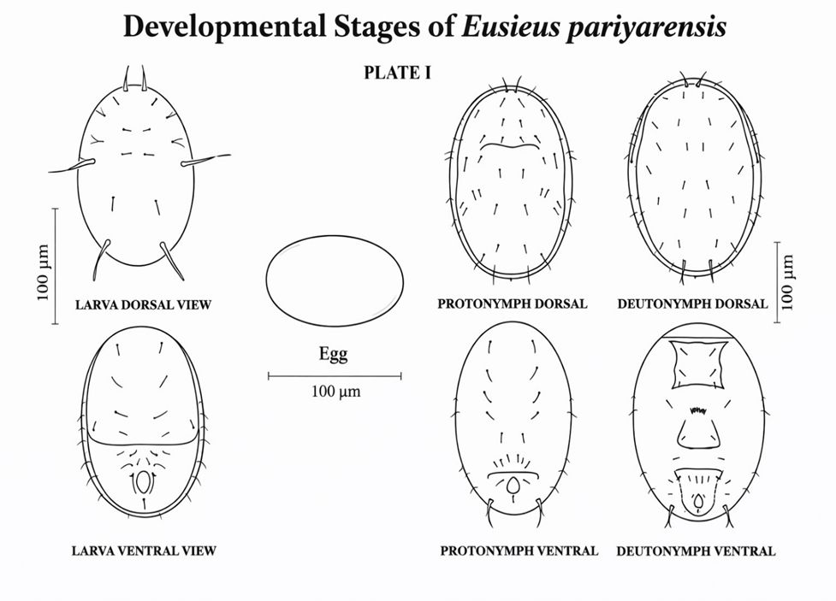
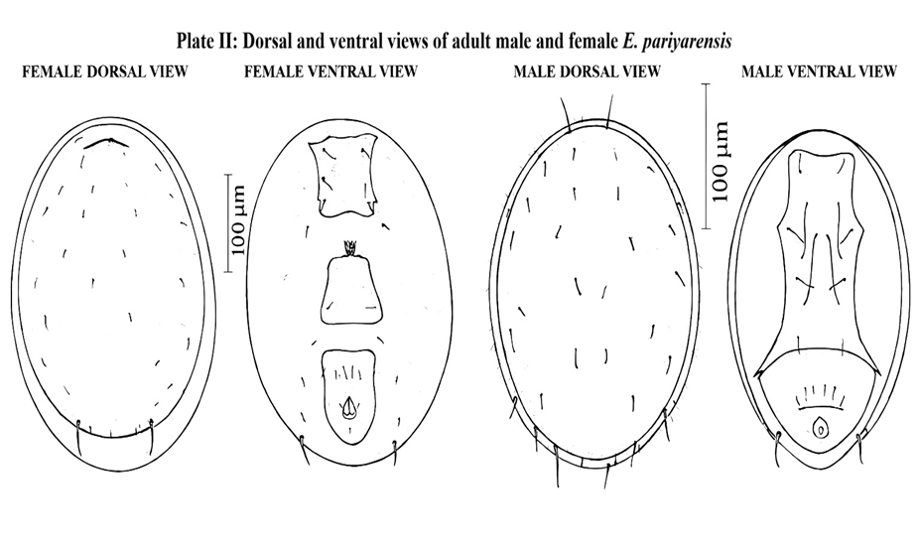
(Above Illustration drawn with the aid of a camera lucida attached to an Olympus research microscope.)

