PHYTOCHEMICAL PROFILING AND ANTIBACTERIAL ACTIVITY OF APHANAMIXIS POLYSTACHYA SEED EXTRACTS AGAINST SOIL BACTERIAL ISOLATES

ABSTRACT
The present study investigated the growth response of soil bacteria towards four selected agents: distilled water, methanol, the crude and methanolic extracts of Aphanamixis polystachya seeds. Soil samples collected from two sites yielded Gram-positive, rod-shaped bacterial isolates, exhibiting diverse colony morphologies and moderate colony forming unit (CFU) counts. Antibacterial assays revealed that while distilled water and crude seed extracts exhibited no inhibitory effects, the methanolic extract of the seeds demonstrated significant antibacterial activity, with a maximum zone of inhibition measuring 4.5 mm. Phytochemical profiling indicated the presence of eight bioactive compounds, including alkaloids, flavonoids, phenolic compounds, steroids, quinones, tannins, triterpenoids and cardiac glycosides, predominantly in the methanolic extract. These findings highlight the importance of solvent selection in bioactive compound extraction and suggest the potential of A. polystachya seeds as a source of natural antibacterial agents against soil-borne bacteria.
Keywords: - Aphanamixis polystachya, CFU, Colony morphology, Antibacterial activity, Phytochemical assay

INTRODUCTION
Soil bacteria are vital for sustaining soil health, fertility, and the proper functioning of terrestrial ecosystems. Fertilizers, both organic and inorganic, are among the most common soil amendments. Antibiotics in the environment, arising from agricultural runoff or improper waste disposal, can also impact soil bacterial communities. Soil bacteria from different sites often vary significantly in their colony-forming units (CFU) and Gram staining characteristics, reflecting the diverse microbial communities shaped by environmental conditions. The samples collected from agricultural soil typically exhibit higher CFU counts due to the presence of organic matter and plant residues that support microbial growth, while forest soils may show a broader diversity but lower CFU counts due to stable, nutrient-limited conditions (Zhang et al., 2024). This morphological diversity indicates functional variation, such as the ability to form spores or adapt to fluctuating conditions. Such observations emphasize the importance of site-specific studies in
Understanding the growth response of soil bacteria towards different chemical agents provides crucial insights into the potential impacts of natural and synthetic compounds on soil microbial communities. Understanding how different agents affect bacterial growth can provide insights into managing soil ecosystems sustainably. Aphanamixis polystachya, a medicinal plant belonging to the Meliaceae family, also known as Pithraj tree, holds significant medicinal value in traditional systems of medicine due to its diverse phytochemical constituents, including alkaloids, terpenoids, and flavonoids. Its bark and seeds are used for their anti-inflammatory, antimicrobial, anti-cancer, antifungal, and insecticidal properties (Kumar et al., 2023). Seed extracts from this plant, both in crude form and after methanolic extraction, may exhibit significant biological activity, making them of particular interest for studying their effects on microbial populations.
This study aims to investigate the growth responses of soil bacteria when exposed to four selected agents: distilled water, methanol, crude seed extract of A. polystachya, and methanolic extract of A. polystachya seeds. By evaluating the stimulatory or inhibitory effects of these agents, we can gain valuable knowledge about the ecological safety and potential applications of A. polystachya extracts in medicine, agricultural and environmental management practices (Kumar et al., 2023; Khatun et al., 2025). Such research is increasingly important in the context of holistic medicine and sustainable agriculture, where natural plant-based products are being explored as eco-friendly alternatives to synthetic chemicals (Mawcha et al., 2024). Furthermore, understanding how soil bacteria respond to these treatments will inform future strategies to preserve soil microbial diversity and functionality while utilizing natural resources.
MATERIALS AND METHODS
Bacterial colonies were isolated from the soil samples collected from 2 different sites of the campus of NSS College Nilamel, Kollam (Dist.), Kerala. The bacterial colonies were isolated in Nutrient Agar and the number of colonies was counted after 24 hrs of incubation. The colony and cell morphology of isolated soil bacteria were recorded and the most dominant colony from each of the site was subjected to Gram staining for cellular morphology. The growth response of the dominant bacterial consortia was tested against four selected agents – Distilled water, methanol, the crude and methanolic extracts of the seeds of Aphanamixis polystachya. The bioactive components present in the seed extracts were identified through preliminary phytochemical profiling.
- ISOLATION AND CHARACTERISATION OF SOIL BORNE BACTERIA
1.1) Collection of soil samples: Soil samples were collected from two defined sites (Site A: Base of the plant A. polystachya; Site B: Near Dept. of Botany), from the campus of NSS College Nilamel, Kollam (Dist.), Kerala. The samples were collected in triplicates and were transferred in aseptic test tubes to the laboratory for further analysis.
1.2.) Colony counting: 1 gm of soil from the sterile test tubes was transferred separately to 10 ml test tubes containing 9 ml sterile distilled water. The resulting solution was serially diluted up to 10⁻¹ using sterile distilled water and 100 µl aliquots was taken and pour plated in triplicates on Nutrient Agar plates for taking the bacterial count. The number of colony forming units (CFU) was counted after 24 hours of incubation by direct observation of the isolation plates.
1.3) Colony Morphology and Cell morphology of isolated soil bacteria: Colony morphologies were recorded by direct observation and cellular morphology of bacteria was recorded following Gram staining. Gram stained cells were observed under 40 X magnification of compound microscope.
GROWTH RESPONSE OF SOIL BORNE BACTERIA: Kirby’s Disc Diffusion Method was adopted to test the growth response of the dominant Gram positive soil borne bacteria towards the four selected agents - Distilled water, methanol, crude extract and methanolic extract of the seeds of A. polystachya. Separate sterile cotton swabs were gently touched to the colonies of each bacterium in agar plates and it was used to evenly inoculate the entire surface of the MH Agar plates by spread plating. Autoclaved Whatmann filter paper 1 discs were impregnated with the selected agents and the test discs were placed on to the bacterial inoculums on the agar plates with a sterile forceps. The plates were then incubated at 37⁰ C. Triplicates were kept for each treatment and its control. The diameter of the zone of inhibition was measured after 24 hours of incubation.
- PRELIMINARY PHYTOCHEMICAL ANALYSIS OF SEED EXTRACTS
3.1) Collection of seeds: The seeds were collected from the plant Aphanamixis polystachya Table 1, Fig. 1a&b)
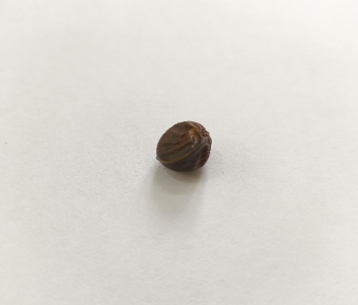
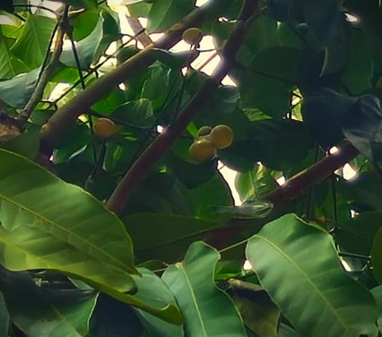
Fig 1a: A. polystachya Fig 1b: Seeds of A. polystachya.
Table 1: Systematic position of A. polystachya.
Botanical name | Aphanamixis polystachya
Phylum | Streptophyta
Class | Equisetopsida
Order | Sapindales
Family | Meliaceae
Genus | Aphanamixis
Species | Polystachya

3.2) Preparation of the seed extracts: Extracts were prepared in two solvents - Distilled water and Methanol.
Crude extract: 6.6 grams of the seed powder were mixed with 15 mL of distilled water in a conical flask and allowed to stand overnight, with the mouth plugged with cotton. The filtrate was refrigerated in a glass bottle for further analysis.
Methanolic extract: 2 grams of the seed powder were mixed with 20 mL of methanol in a conical flask and allowed to stand overnight, with the mouth plugged with cotton. The filtrate was refrigerated in a glass bottle for further analysis.
3.3) Phytochemical screening: The seed extracts were screened for the presence of 9 bioactive components according to the protocol discussed by Leeja et al. (2020).
3.3.1. TESTS FOR ALKALOIDS: Wagner’s test: Into 1 mL of each sample solution taken in a test tube add a few drops of potassium iodide solution. A reddish brown precipitate indicates the presence of alkaloids.
3.3.2. TESTS FOR TANNINS AND PHENOLIC COMPOUNDS: Ferric chloride test: When three drops of 5% ferric chloride were added to 5 drops of sample solution, a dark green/ brown colour precipitate appears.
3.3.3. TEST FOR STEROIDS AND TRITERPENOIDS: Acetic anhydride test: Three drops of acetic anhydride were added to the sample solution and boiled. The solution was then cooled, and conc. sulphuric acid was added along the sides of the tube. A brown ring was observed at the junction. The green colour in the upper region indicated the presence of steroids and deep red colour in the lower region indicates the presence of triterpenoids.
Salkowski test: To 1 mL of the sample solution, a few drops of chloroform were added, followed by theaddition of conc. sulphuric acid along the sides of the test tube. A reddish brown colour at the interphase indicates the presence of steroids and triterpenoids.
3.3.4. TESTS FOR FLAVONOIDS: NaOH test: 3 mL of dilute NaOH were added to 1 mL of the sample solution. A yellow-coloured precipitate formed, which disappeared upon the addition of dilute HCl, indicating the presence of flavonoids.
Lead acetate test: Added 1 mL of lead acetate to sample solution. White turbid precipitate indicates the presence of flavonoids.
3.3.5. TEST FOR COUMARINS: FeCl3 test: To 1 mL of the sample in a test tube, 1 mL of FeCl₃ was added. The appearance of a dark green colour which turns yellow, upon addition of five drops of Conc.HNO₃ indicates the presence of coumarins.
3.3.6. TEST FOR CARDIAC GLYCOSIDES: Keller Killani test: To 5 mL of extract in a test tube, 2 mL of acetic acid, along with one drop of FeCl₃ solution and one ml of Conc. H₂SO₄ solution, were added. The appearance of a brown ring indicates the presence of cardiac glycosides.
3.3.7. TEST FOR TANNINS: Potassium dichromate test: To a few drops of sample, strong potassium dichromate solution was added. Yellow colour precipitate indicates the presence of tannins.
Lead acetate test: Added 1 ml of lead acetate to sample solution. Yellow precipitate indicates the presence of tannins.
3.3.8. TEST FOR SAPONINS: Froth test: To 1 ml of the sample solution in a test tube, 2 ml of distilled water were added and shaken well. The appearance of froth upon shaking the mixture shows the presence of saponins.
3.3.9. TEST FOR QUINONES: A small amount of extract was treated with concentrated HCl and observed for the formation of the yellow colour precipitate.

Statistical analysis of data: -The data obtained are recorded as mean± standard deviation

RESULTS
Bacterial colony count and colony morphology: The isolated bacterial colonies from the collected soil samples varied in their count and morphology in the culture. The colony forming unit count (CFU) of soil sample from site A ranged from 211 to 281 X 10⁻¹(Fig. 2a), and from site B, ranged from 280 to 300 X 10⁻¹ (Fig.2b). The morphology of the dominant colonies in culture is summarized in Table 2a & 2b..
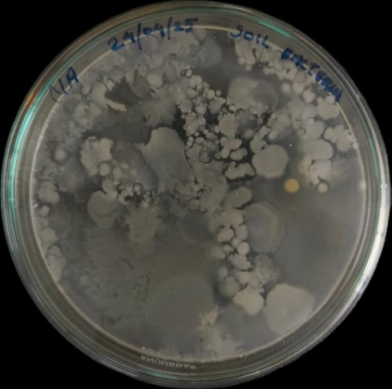
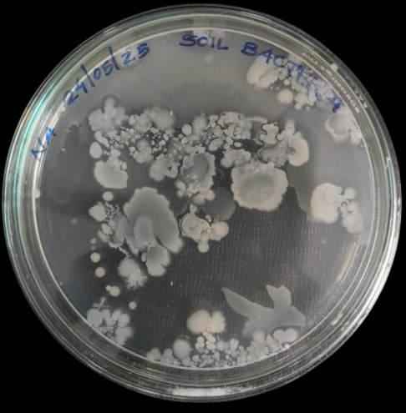

Fig. 2a: Soil Bacterial colonies Fig. 2b: Soil Bacterial colonies
(Isolated from site A) (Isolated from site B)

Table 2a: Colony morphology of soil borne bacteria from site A
Sl No: | Observed colony morphology
Sl No: | Colour | Texture | Margin | Shape
S1B1 | White | Matte | Smooth | Irregular
S1B2 | Offwhite | Matte | Entire | Irregular
S1B3 | Off white | Matte | Lobate | Rhizoid
S1B4 | White | Mucoid | Curled | Irregular
S1B5 | White | Slimy | Wavy | Irregular

Table 2b: Colony morphology of soil borne bacteria from site B
Sl No: | Observed colony morphology
Sl No: | Colour | Texture | Margin | Shape
S2B1 | Milky | Matte | Smooth | Round
S2B2 | Offwhite | Translucent | Endulate | Irregular
S2B3 | White | Shiny | Entire | Punctiform
S2B4 | Offwhite | Matte | Lobulate | Irregular
S2B5 | Grey | Dry | Erose | Irregular

Cell Morphology of dominant bacterial colonies: The most dominant colony from each culture stained purple and were Gram-positive (Fig. 3 a & b) rod shaped bacteria.
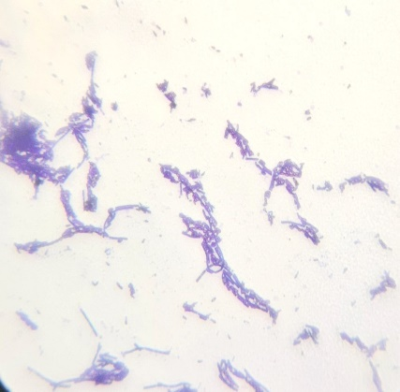
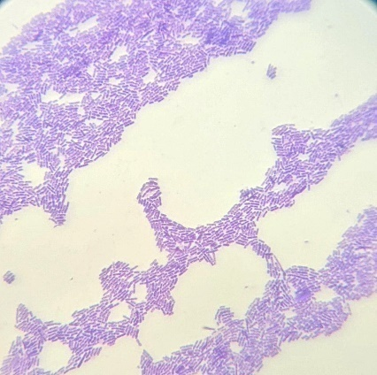
S1B1
S2B1

Fig. 3 (a & b): Gram positive soil bacteria (S1B1, S2B1)
Bacterial growth response towards the selected agents: The growth response of selected Gram positive soil bacteria was tested towards four agents - Distilled water, methanol, and the crude and methanolic extracts of the seeds of A. polystachya. The zone of inhibition towards – distilled water was 0.0 mm, methanol was 0.53 ± 0.05 mm (Fig 4a), the crude seed extract was 0.0 mm and the methanolic extract was 4.53 ± 0.05 mm (Fig 4b). The highest growth inhibition was observed towards the methanolic extract and the lowest towards methanol. No growth inhibition was observed with distilled water and the crude extract of the seed. The measurements of zone of inhibition is summarized in Table 3.
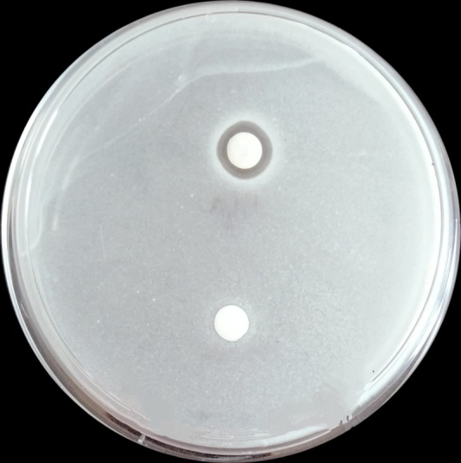
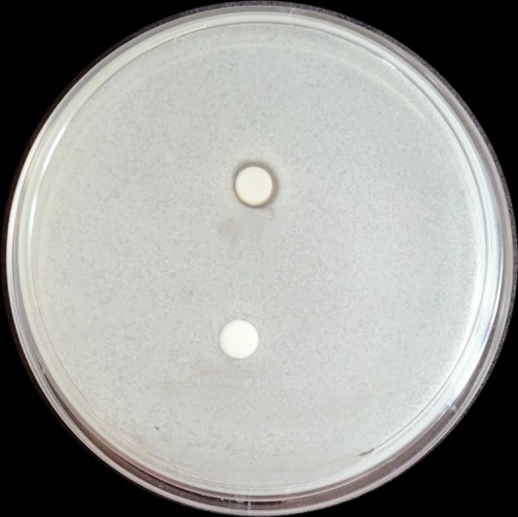

C
D
A
B
A

Fig.4 a: Growth response of Gram positive soil bacteria towards distilled water (A) & methanol (B)

Fig.4 b: Growth response of Gram positive soil bacteria towards the crude (C) & methanolic (D) seed extract

Table 3: Measurement of Zone of Inhibition
Sl No: | Test bacteria | Zone of Inhibition (mm)
Sl No: | Test bacteria | Distilled water (A) | Methanol (B) | Crude extract of seed (C) | Methanolic extract of seed (D)
1 | Gram positive rod | 0.0 | 0.53 ± 0.05 | 0.0 | 4.53 ± 0.05
Values are mean ±SE of three replicates
Phytochemical Profile of the seed extracts: The phytochemical profile of the crude and methanolic extracts of the seeds of A. polystachya is summarized in table-4, Figure 5 (a & b). The results revealed the presence of 4 bioactive compounds in the crude extract and 8 bioactive components in the methanolic extract. The detected bioactive phytochemicals included alkaloids, phenols, tannins, steroids and triterpenoids, flavonoids, coumarins, cardiac glycosides and quinones.
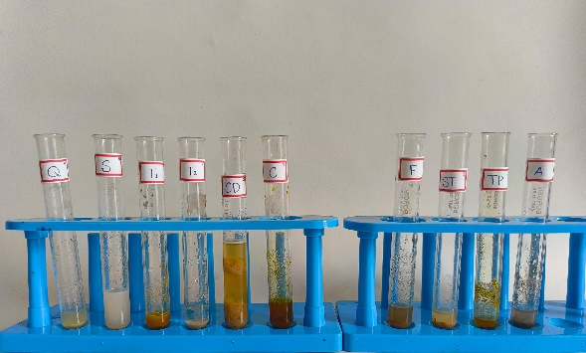
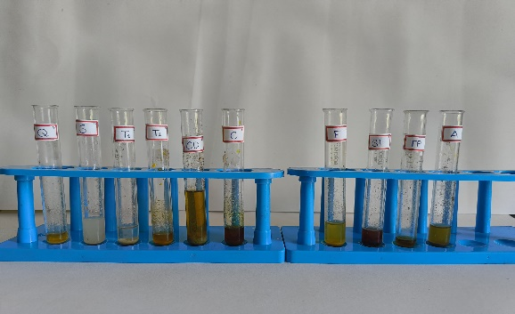
5a: Crude Extract 5b: Methanolic Extract
Fig 5(a &b): The phytochemical profile of the seed extracts

Table 4: The phytochemical profile of the seed extracts of A.polystachya
Sl  No | Phytochemical tested for | Seed extract
Sl  No | Phytochemical tested for | Crude | Methanolic
1 | Alkaloids | - | +
2 | Tannins | + | +
3 | Phenolic compounds | - | +
4 | Steroids and triterpenoids | + | +
5 | Flavonoids | - | +
6 | Coumarins | - | +
7 | Cardiac glycosides | + | +
8 | Saponins | - | -
9 | Quinones | + | +

DISCUSSION
The bacterial colony count and morphological characteristics observed in the present study reveal substantial diversity among soil microbial communities at both sampling sites. Site A exhibited a colony forming unit (CFU) range from 211 to 281 × 10⁻¹, while Site B presented a slightly higher range, from 280 to 300 × 10⁻¹. These variations could be attributed to differences in soil physicochemical properties such as pH, organic matter content, moisture levels, and nutrient availability, all of which are known to influence bacterial abundance and activity (Zhang et al., 2024).
Colony morphology analysis further supports the notion of microbial diversity in these soil environments. Dominant colonies from both sites showed considerable variation in color, texture, margin, and shape. Morphological assessment of bacterial colonies revealed a wide range of features, with Site B showing greater diversity in texture and margin types. These morphological differences may reflect environmental stress adaptations and underscore the complexity of soil microbial communities (Naylor & Coleman-Derr, 2022; Banerjee et al., 2023). Organic amendments due to the degradation of A. polystachya seeds significantly account for the lower soil microbial load at Site A. Over all, the differences in CFU counts and colony morphologies between the two sites underline the complex interplay of biotic and abiotic factors shaping soil microbial communities.
The Gram staining results indicated that the dominant bacterial isolates from both soil samples were Gram-positive rods. This morphological trait is consistent with many soil-dwelling genera, such as Bacillus and Clostridium, which are commonly found in terrestrial ecosystems and known for their thick peptidoglycan cell walls that retain the crystal violet stain (Madigan et al., 2024). The presence of Gram-positive rods suggests that the isolates might possess enhanced resilience to environmental stresses, as Gram-positive bacteria are often more resistant to desiccation and nutrient limitation compared to their Gram-negative counterparts (Madigan et al., 2024; Fierer & Jackson, 2022).
The antibacterial activity assay demonstrated that distilled water and the crude seed extract of A. polystachya had no inhibitory effect on the bacterial isolates, as indicated by the absence of a measurable zone of inhibition. This implies that the crude extract may lack sufficient solubilization of active antimicrobial compounds under the tested conditions, or that the bioactive constituents were not present in effective concentrations (Cowen, 1999). Conversely, a slight inhibition (0.53± 0.05 mm) was observed with methanol alone, suggesting a minor solvent effect. However, the methanolic seed extract exhibited a significantly larger zone of inhibition (4.53± 0.05 mm), indicating potent antibacterial activity against the Gram-positive rods. Methanol is known to be a highly effective solvent for extracting a wide range of phytochemicals, including phenolics, flavonoids, and terpenoids, which often contribute to antimicrobial properties (Dhanani et al., 2017). The results align with previous studies demonstrating that extracts of A.polystachya possess antimicrobial compounds, particularly when prepared with polar solvents like methanol (Paul et al., 2021; Kumar et al., 2023). The marked difference in activity between the crude and methanolic extracts highlights the critical importance of solvent selection in the extraction of bioactive substances.
Phytochemical analysis confirmed that the methanolic extract contained more diverse and potent bioactive compounds than the crude extract. Compounds like alkaloids, flavonoids, and phenolics were found exclusively in the methanolic extract and are known for their antimicrobial and antioxidant activities (Paul et al., 2021; Kumar et al., 2023). The absence of saponins suggests limitations in the extraction protocol or low natural abundance. Overall, the findings support the potential pharmacological value of A. polystachya and warrant further investigation into its bioactive constituents.

SUMMARY AND CONCLUSION
The present study highlights the rich microbial and phytochemical diversity associated with soil and plant-derived extracts. The isolated soil bacteria were predominantly Gram-positive rods, demonstrating characteristic resilience and potential ecological roles. Notably, the methanolic extract of A. polystachya seeds exhibited significant antibacterial activity against the tested Gram positive isolate, which correlated with its richer phytochemical profile compared to the crude extract. The methanolic extract contained key bioactive compounds such as alkaloids, flavonoids, phenolic compounds, and cardiac glycosides, which are known for their antimicrobial properties. The zone of inhibition assay provides preliminary information on antimicrobial activity; Further quantitative assays, are required for a more accurate evaluation. These findings underscore the potential of A. polystachya as a source of natural antimicrobial agents and warrant further exploration through advanced phytochemical characterization and bioactivity assays to harness its medicinal potential.
Declaration of competing interest
The authors declare that they have no known competing financial interests or personal relationships that could have appeared to influence the work reported in this paper.
Disclaimer (Artificial intelligence)

Author(s) hereby declare that NO generative AI technologies such as Large Language Models (ChatGPT, COPILOT, etc.) and text-to-image generators have been used during the writing or editing of this manuscript.
REFERENCES
- Banerjee, S., Schlaeppi, K., & van der Heijden, M. G. A. (2023). Emerging concepts in soil microbial community ecology: Linking structure, function, and environmental adaptation. Nature Reviews Microbiology, 21, 351–367 https://doi.org/10.1038/s41579-023-00850-7
- Cowen, M. M. (1999). Plant products as antimicrobial agents. Clinical Microbiology Reviews, 12(4), 564–582.
- Dhanani, T., Shah, S., Gajbhiye, N. A., & Kumar, S. (2017). Effect of extraction methods on yield, phytochemical constituents, and antioxidant activity of Withania somnifera. Arabian Journal of Chemistry, 10, S1193–S1199.
- Fierer, N., & Jackson, R. B. (2022). The diversity and biogeography of soil bacterial communities: Linking structure to function under environmental stress. Nature Reviews Microbiology, 20, 278–292. https://doi.org/10.1038/s41579-022-00708-1
- Khatun, S., Faruki, M. S. I., & Haque, S. (2025). Insecticidal efficacy of pithraj (Aphanamixis polystachya) leaf and seed powders against Tribolium castaneum larvae in treated wheat. Journal of Basic and Applied Zoology, 86, Article 44.
- Kumar, A., Sharma, R., Singh, P., Verma, A., Yadav, A., Gupta, S., & Mishra, A. (2023). Aphanamixis polystachya: Pharmacological benefits, health benefits and other potential benefits. Phytomedicine Plus, 3, 100448. https://doi.org/10.1016/j.phyplu.2023.100448
- Madigan, M. T., Bender, K. S., Buckley, D. H., Sattley, W. M., & Stahl, D. A. (2024). Brock biology of microorganisms (16th ed.). Pearson.
- Mawcha, K. T., Kinyanjui, G., Simiyu, S. W., Babalola, O. O., & Ndolo, D. O. (2024). Biopesticides for sustainable agriculture: A review of their role in integrated pest management. IntechOpen. https://doi.org/10.5772/intechopen.1006277
- Naylor, D., & Coleman-Derr, D. (2022). Drought stress and soil microbial communities: Functional and structural adaptations. Current Opinion in Microbiology, 67, 102146. https://doi.org/10.1016/j.mib.2022.102146
- Paul, G. K., Mahmud, S., Hasan, M. M., Zaman, S., Uddin, M. S., & Saleh, M. A. (2021). Biochemical and in silico study of leaf and bark extracts from Aphanamixis polystachya against common pathogenic bacteria. Saudi Journal of Biological Sciences, 28(11), 6592–6605. https://doi.org/10.1016/j.sjbs.2021.07.032
- Zhang, Y., Li, X., Wang, J., Chen, Q., Liu, Z., & Huang, Y. (2024). Microbial diversity of soils under different land use and chemical conditions. Applied Biological Chemistry, 67, Article 70. https://doi.org/10.1186/s13765-024-00970-y

