Original Research Article

NOVEL LARVAL HOST ASSOCIATIONS OF CATOPSILIA POMONA (LEPIDOPTERA: PIERIDAE) FROM ALATHUR, PALAKKAD, KERALA, INDIA

ABSTRACT
Senna polyphylla (Desert Cassia), belonging to the family Caesalpiniaceae, is reported as a new host plant of Catopsilia pomona (common emigrant) butterfly from Alathur, Palakkad district, Kerala, India. S. polyphylla is an ornamental plant with green-coloured compound leaves with fine and feathery leaflets and five-petaled flowers. The C. pomona is a medium-sized butterfly coming under the family Pieridae. The present study site was Butterfly Park of Sree Narayana College, Alathur (Lat. 10.633204° Long. 76.508705°) which is located in the southwestern part of Palakkad district. During an opportunistic survey in the study site targeting caterpillars and butterflies, a female C. pomona was observed ovipositing on the apical portions of tender leaves of S. polyphylla. The eggs were spindle-shaped and creamy white, later hatching into light green larvae that fed exclusively on young, tender leaves. As development progressed, the larvae gradually turned darker and finally assumed a leafy green coloration. The head was green with black tubercles, and the spiracles were marked by a continuous white line. Each body segment bore black tubercles (Fig. 2d), along with paired longitudinal lines extending from the head to the anus. The larval stage lasted approximately 20 days. The pupa was observed suspended by a silken thread, attached to the substrate by a black cremaster. It was bright green in colour, with a continuous yellow line running laterally from the cremaster to the head, which ended in a snout-like projection (Fig. 2e). The first adult butterfly emerged on the ninth day of pupation, and the complete life cycle of C. pomona on S. polyphylla was completed in approximately 34 days. For the time being fourteen species of host plants belonging to Apocynacea and Fabaceae are reported as host plants for C. pomona by various researchers. The present study recorded S. polyphylla belonging to the family Fabaceae as a new larval host plant of C. pomona.

This report makes a significant contribution to the scientific community by documenting a novel larval host association between the butterfly Catopsilia pomona and the plant Senna polyphylla. Such new host plant records are crucial for improving our understanding of insect - plant interactions, host range expansion, and adaptive ecological strategies in Lepidopterans

Key words: Host plant, insect-plant interaction, C. pomona, common emigrant, desert cassia.

INTRODUCTION
Abundance of host plants and distribution of herbivorous insects are correlated (Knops et al., 1999). According to New et. al., (2021), knowledge about the interaction between host plants and lepidopterans is found to be the fundamental fact for in-situ conservation. Butterfly population densities are often found in areas with rich food resources, which reflect the ecological health of the habitat. This makes butterflies a good indicator species for monitoring ecosystem health (Dennis et al., 2006). C. pomona shows varying yellow to greenish-white colouration with red antennae with a black margin along the forewing termen and costa. While females have unique purple blotches on the underside of both wings. When compared, forewings are slightly broad with a pointed apex, and hindwings are round. The eggs are usually laid singly on the underside, at the margin of the leaves. Each egg is white, bottle-shaped, and ribbed vertically.
C. pomona is a polyphagous butterfly feeding on a variety of plant species belonging to the Family Fabaceae such as Cassia fistula L., C. sophera L., C. occidentalis L., C. tora L., C. siamea (Lam.), Butea frondosa Roxb. ex. Willd., B. monosperma, and Bauhinia racemosa L. Pterocarpus indicus, Senna alata and Sesbania species (Kunte, 2000; Atluri et. al., 2004; Nylin et al. 2009; Gaden et. al., 2023).
Although the larval host plants of Indian butterflies have been charted for more than a century (Davidson and Aitken, 1890; Kalesh and Prakash, 2015; Banerjee et. al., 2023), considerable gaps remain. Kerala state is home to varied biogeographic realms, including the Western Ghats and the Malabar Coast. Several studies have enriched knowledge of butterflies and their host plants, including Nitin et al. (2018), who prepared a checklist of 336 butterfly species and their host plants.
METHODOLOGY
Study area
Palakkad is situated in the northeastern part of Kerala state, bordered by the Nilgiris Hills and Tamil Nadu. Specifically, it's located near the Western Ghats Mountains. Present study site (Fig.1)– Butterfly Park of Sree Narayana College, Alathur (Lat. 10.633204° Long. 76.508705°) is located in the southwestern part of Palakkad district.
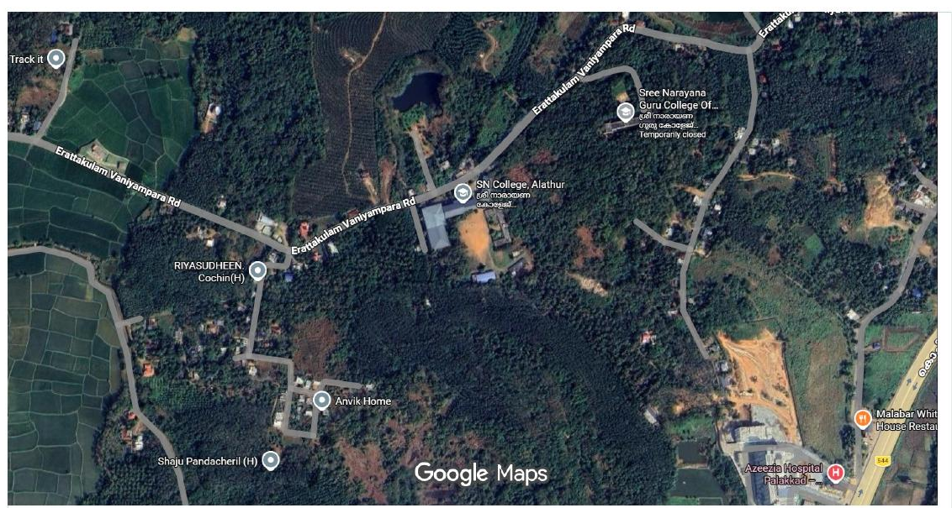
Fig. 1 Study site – Butterfly Park of Sree Narayana College, Alathur
Observation
While conducting an opportunistic survey (Cohen and Crabtree, 2006) in butterfly park of Sree Narayana College, Alathur, Palakkad, targeting caterpillars and butterflies, a female C. pomona was observed ovipositing on the apical portions of tender leaves of S. polyphylla (Fig.2 a). Photographic documentation of the host plant and successive stages of butterfly metamorphosis was obtained using a Redmi Note 5 Pro smartphone camera.
During our surveys in the study site on 5th October 2023, a female C. pomona was observed ovipositing on S. polyphylla (Fig.2 b). The next day, we encountered many spindle-shaped, creamy white eggs (Fig. 2 c) on the tender leaves and young shoots of S. polyphylla. After four days, many light green larvae were found. The larvae were found to feed exclusively on young, tender leaves. Later, as larvae grew, the colour was observed to become darker and finally to leafy green. The head was green in colour with black tubercles. The spiracles were covered with a continuous white line. Each body segment bears black tubercles (Fig. 2 d). The paired lines were found on both sides of the body and run from head to anus. The larval stage extended for about 20 days. The pupa was seen suspended by a silken girdle attached to the substrate by a black cremaster. Its entire body was a bright green colour. A continuous yellow line was seen running along the sides from the cremaster to the head, the head ending in a snout (Fig.2 e). On the ninth day the first butterfly emerged, that is, 7th November 2023. That is the total life cycle extended up to almost 34 days.

RESULTS AND DISCUSSIONS
Life Cycle Stages
Like all lepidopterans four life cycle stages of C. pomona observed on S. polyphylla (Table 1) are egg, larval stages, pupal stage and adult stage. Eggs of C. pomona are spindle-shaped and laid singly on the upper surface of fresh, tender leaves and young shoots. Freshly laid eggs were creamy white, and within a day its colour appeared to be yellowish white. The larva is initially cream-coloured, turning pale green after feeding, with a pale head in early instars that later becomes green. Other prominent morphological features were gradual appearance of creamish-white to yellow dorso-lateral lines, which become well-defined in later instars, along with clear body segmentation. Before entering into the pupal stage larva stop feeding and become inactive. The pupa, which is oval-shaped and green in colour, with two pale yellowish lines on either side from tip to end, was seen suspended by two silken threads attached to the substrate by a black cremaster. Pupal stages extended for nine days.
In the present communication, we are reporting Desert Cassia, S. polyphylla (Family Fabaceae) as a host plant of the Common emigrant, C. pomona, for the first time. No life stages were collected from their natural habitats for these observations. All observations were made and photographed in situ. The life cycle of C. pomona was documented in the Butterfly park of Sree Narayana College, Alathur, Palakkad, Kerala, India. The study site also hosts a variety of known larval host plants belonging to the Fabaceae family, such as C. fistula, C. sophera L., C. occidentalis L., C. tora L., Butea monosperma, Pterocarpus indicus, Senna alata, and Bombax ceiba (Malvaceae).
Since 2023, we have been observing common emigrants laying eggs and breeding commonly on the tender leaves of S. polyphylla, especially during the pre-monsoon season (October – January), completely defoliating and destroying the plant. To avoid potential misidentification, the photographs of the adult and caterpillars were sent to experts in the specific field.
For the time being fourteen species of host plants belonging to two families are reported as host plants for C. pomona (Table 2). The present study recorded S. polyphylla belonging to the family Fabaceae as a new larval host plant of C. pomona in the butterfly park of Sree Narayana College, Alathur. Common emigrants are distributed throughout India in various habitats (Varshney R. and Smetacek, 2015).According to rajasekhara et. al., (2025) C. pomona and C. pyranthe were observed year-round on host plants belonging to C. tora (Fabaceae). Butterflies depend on specific host plants for nutrition and habitat. However, these relationships are under continuous threat due to various anthropogenic pressures (Darshita and Ankur, 2024). In this context, the discovery of a new host plant by butterflies indicates host range expansion and reflects adaptive ecological strategies in Lepidopterans.The oligophagous strategy of consuming closely related plants among herbivorous insects will maximize offspring survival and fitness (Gibbs et al. 2006)
Fig. 2 Host plant and life cycle of Catopsilia pomona
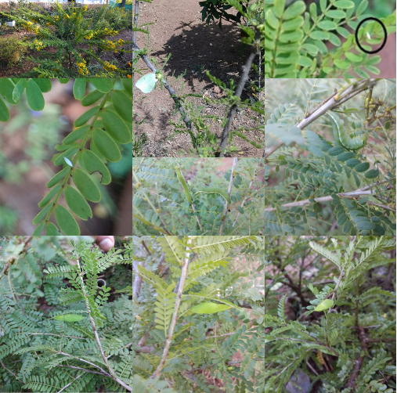Figure 2 (a) The host plant, S. polyphylla, with flowers; (b)Egg laying by female C.pomona;
2a
2b
2f
2g
2c
2d
2e
2h
2i
(c) Creamy white egg laid on tender leaves; (d) Sphindle shaped eggs on the top of tender leaves tips; (e) Larva with creamy white white lines; (f) Pre- pupal stage; (g) Green coloured pupa; (h) Dull green pupa; (i) Pupal stage just before eclosion

Table: 1 Taxonomic hierarchy of butterfly and host plant
HIERARCHY | CATOPSILIA POMONA | SENNA POLYPHYLLA
Kingdom | Animalia | Plantae
Phylum | Arthropoda | Tracheophyta
Class | Insecta | Magnoliopsida
Order | Lepidoptera | Fabales
Family | Pieridae | Fabaceae
Tribe | Coliadinae | Cassieae
Genus | Catopsilia | Senna
Species | Catopsilia pomona | Senna polyphylla

Table: 2 Larval Host Plants of Catopsilia pomona*
SL. NO. | HOST PLANTS | FAMILY | COMMON NAME
1 | Carissa spinarum | Apocynaceae | Conkerberry
2 | Bauhinia racemosa | Fabaceae | Bidi Leaf Tree
3 | Butea monosperma | Fabaceae | Flame of the Forest
4 | Cassia fistula | Fabaceae | Golden Shower Tree
5 | C. javanica | Fabaceae | Pink shower tree
6 | C. renigera | Fabaceae | Pink Shower Tree
7 | C. roxburghii | Fabaceae | Red Cassia
8 | C. sophera | Fabaceae | Sickle pod Senna
9 | Senna alata | Fabaceae | Candle Bush
10 | Senna occidentalis | Fabaceae | Coffee Senna
11 | S. siamea | Fabaceae | Siamese Cassia
12 | S. tora | Fabaceae | Sickle Senna
*https://indiabiodiversity.org/species/show/235706#description
CONCLUSION
S. polyphylla is recorded as a new host plant for butterfly larvae C. pomona for the first time from the butterfly park of Sree Narayana College, Alathur. The observation of a new host plant may indicate that a butterfly species is adapting to new resources. Studying such adaptations provides valuable insights into the species' resilience to environmental changes and the potential for co-evolution between butterflies and their host plants. This report makes a significant contribution to the scientific community by documenting a novel larval host association between the butterfly Catopsilia pomona and the plant Senna polyphylla. Such new host plant records are crucial for improving our understanding of insect - plant interactions, host range expansion, and adaptive ecological strategies in Lepidopterans. The study also provides valuable baseline data for biodiversity documentation and supports conservation efforts, particularly in ecologically rich regions like the Western Ghats. Furthermore, the detailed life cycle observations enhance existing knowledge on the species’ developmental biology, offering insights that may be useful for future ecological, evolutionary, and conservation research.

COMPETING INTERESTS DISCLAIMER:
Authors have declared that they have no known competing financial interests OR non-financial interests or personal relationships that could have appeared to influence the work reported in this paper.
Disclaimer (Artificial intelligence)
Author(s) hereby declare that no generative AI technologies such as Large Language Models (ChatGPT, COPILOT, etc.) and text-to-image generators have been used during the writing or editing of this manuscript.

REFERENCE
- Atluri J. B., S.P. Venkata Ramana and C Subba Reddi (2004). Ecobiology of the tropical pierid butterfly Catopsilia pyranthe. Current Science, 86(3):457-46.
- Banerjee D., Singhamahapatra A. and Roy S., (2023). New larval host plants for three butterfly (Lepidoptera, Papilionoidea) species from Rahr region of West Bengal, India. Journal of Insect Biodiversity and Systematics, 9 (1), 67–79
- Cohen D. and Crabtree B., 2006. "Qualitative Research Guidelines Project." July 2006.
- Darshita Sinha and Ankur Jyoti Dutta, (2024). Butterfly-Host plant relationships ecological significance and conservation needs- A review. International Journal of Entomology. 9 (8): 230-235. Research www.entomologyjournals.com ISSN: 2455-4758
- Davidson J. and Aitken E.H. (1890) Notes on the larvae and pupae of some of the butterflies of Bombay Presidency. Journal of the Bombay Natural History Society, 5, 349–375.
- Dennis, R.L.H., Shreeve, T.G. and van Dyck, H. (2006) Habitats and resources: the need for a resource-based definition to conserve butterflies. Biodiversity and Conservation, 15, 1943–1966.
- Gaden S. Robinson, Phillip R. Ackery, Ian Kitching, George W Beccaloni and Luis M. Hernández (2023). HOSTS - a Database of the World's Lepidopteran Hostplants) [Data set resource]. Natural History Museum.
- Gibbs, M., Lace, L. A., Jones, M. J and Moore, A. J. (2006). Multiple host-plant use may arise from gender-specific fitness effects. Journal of Insect Science. 6: 04.
- Kalesh S. and Prakash S. K. (2015) Additions to the larval host plants of the butterflies of the Western Ghats, Kerala, South India (Rhopalocera: Lepidoptera). Part 2. Journal of Bombay Natural History Society, 112, 111–114.
- Knops J. M. H., D. Tilman, N. M. Haddad, S. Naeem, C. E. Mitchell, J. Haarstad, M. E. Ritchie, K. M. Howe, P. B. Reich, E. and Siemann, J. Groth, (1999). Effects of plant species richness on invasion dynamics, disease outbreaks, insect abundances and diversity. Ecology Letters, 2(5):286-293.
- Kunte, K. (2000). Butterflies of peninsular India, Universities Press (India) Ltd, Hyderabad.
- New T. R., Sands, D. P. A. and Taylor G. S. (2021) Roles of roadside vegetation in insect conservation in Australia. Austral Entomology, 60 (1), 128–137.
- Nitin R., V.C. Balakrishnan, P.V. Churi, S. Kalesh, S. Prakash and K. Kunte (2018). Larval hosts plants of the butterflies of the Western Ghats, India. Journal of Threatened Taxa 10(4): 11495–11550.
- Nylin, S., Nygren, G. H., Soderlind, L. and Stefanescu, C. (2009). Geographical variation in host plant utilization in the comma butterfly: the roles of time constraints and plant phenology. Evolutionary Ecology. 23: 807-825.
- Rajashekara, S., Eregowda, L.K., Manjunath, G.S. (2025). Butterfly Communities of Bangalore University Campus, Bengaluru, India: Host/Nectar Plant Interactions and Environmental Influences. Proceedings of the Zoological Society 78, 73–92.
- Varshney, R. and Smetacek, P. (2015). A Synoptic Catalogue of the Butterflies of India. New Delhi: Butterfly Research Centre, Bhimtal and Indinov Publishing. P. 67.

