Morphological Characteristics and Seasonal Variation of Raillietina (R) fuhrmanni (Southwell, 1922) in Gallus gallus domesticus in Maharashtra, India
------------------------------------------------------------------------------------------------------------------------
Abstract
Domestic chickens play an important role in small-scale farming systems; however, parasitic infections significantly reduce their productivity and cause economic losses. This study aimed to investigate the morphology and seasonal variation of the cestode Raillietina (R.) fuhrmanni in domestic chickens (Gallus gallus domesticus) in Ahilyanagar District, Maharashtra, India. The study was conducted from January 2020 to May 2021. Morphological observations revealed that the parasite possesses a small scolex; a long flattened body, and is segmented into immature, mature, and gravid proglottids. The scolex is characterized by the presence of a rostellum and suckers, followed by a distinct neck and ribbon-like strobili. Seasonal analysis showed that the prevalence of infection was highest during the monsoon season (86.36%), followed by summer (50%), and lowest in winter. The mean intensity of infection was also higher in the monsoon (7.44) and summer (6.67) seasons. In conclusion, R. fuhrmanni infection shows clear seasonal patterns and may significantly affect poultry health, highlighting the need for improved management and parasite control strategies in domestic chicken farming.
Keywords: - Domestic foul, Cestode Parasites, Raillietina (R) fuhrmanni

Introduction
Domestic fowl play a significant role in rural economies worldwide, by providing low-cost eggs and meat that support for essential food security in poor communities. (Eshetu et.al, 2001, Poulsen et. al, 2000) However, poultry birds are often susceptible to heavy infections of cestode parasites which cause economic losses through reduced egg and meat production, or even death of the bird (Yamaguti, 1940; Wankhede et al., 2016). Taxonomy of cestodes relies heavily on morphological and phenotypic characteristics, to identify and categorize the parasites (Kapoor, 1998). Studies on the taxonomic and morphological features of these parasites are essential for improving poultry management practices and ensuring better health and productivity of domestic fowl. (Dube et. al, 2010) Small-scale farmers by serving as a valuable source of income highlighting the need for effective parasite control measures (Jourdain et. al, 2007) R. fuhrmanni, described by Southwell in 1922, is a species of tapeworm within the genus Raillietina, which was established by Fuhrmann in 1920. It belongs to the family Davaineidae, which is part of the Cyclophyllidea order, a group of tapeworms that are commonly parasitic in birds and mammals. Tapeworms in this order are typically hermaphroditic, having both female and male reproductive organs. The scolex (head) of these tapeworms contains four suckers and a rostellum, which is armed with hooks or spines. The body segments, known as proglottids, are generally wider than long, and the uterus often breaks down into egg capsules, facilitating reproduction. Raillietina species, including R. fuhrmanni, primarily inhabit the intestines of avian hosts, with larval stages usually parasitizing intermediate insect hosts such as beetles, cockroaches, or other arthropods. Over time, Raillietina has been identified in a wide range of avian species, including domestic pigeons, chickens, ducks, and other birds, with the first report of R. fuhrmanni originating from various bird species. Many other species of Raillietina have been described over the years, with research expanding in regions across India, Africa, and Europe, focusing particularly on poultry and wild bird populations. Notable studies have contributed to our understanding of the epidemiology and impact of Raillietina infections in birds. (Joyeux and Houdemer, 1927) described R. tunetensis in pigeons, (Meggitt, 1931), documented R. flaminata in duck (Malhotra et. al, 1981), and reported R. saharanpurensis in domestic poultry in India. Additionally, Baylis, (1929) and Sawada, (1957) reported significant findings on Raillietina species in African and Japanese bird populations, respectively. The findings of these studies, along with more recent research, have shown the widespread distribution of Raillietina tapeworms in avian species, especially in tropical and subtropical regions, the seasonal variation of Raillietina (R) fuhrmanni infections in domestic fowl is significantly influenced by climatic conditions, particularly humidity and rainfall. Studies have shown that the highest prevalence of infection occurs during the monsoon and post-monsoon months (June to September), when increased humidity supports the proliferation of insect hosts (Malhotra et. al, 1981) This seasonal fluctuation highlights the importance of environmental conditions in the lifecycle of Raillietina and suggests that control measures, such as targeted deworming and managing insect populations, should be prioritized during the high-risk monsoon period to mitigate the impact on poultry health. (Kolluri et. al, 1986) The present study deals with morphological characteristics and seasonal variation of a Raillietina (R) fuhrmanni (Southwell, 1922) Redescribed from Gallus gallus domesticus (Linn) collected from the intestine.

Materials and Methods
- Study area
Ahilyanagar is the largest district of state Maharashtra in India. About area 17.412 Sq.km, having 5.66% of the area of the state. Ahilyanagar district is located in the central part of the state. The latitude is 19.083333 (19°5'0"N) and longitude is 74.733333 (74°44'0" E)

Figure 1. Map of the study area in Ahilyanagar District, Maharashtra, India
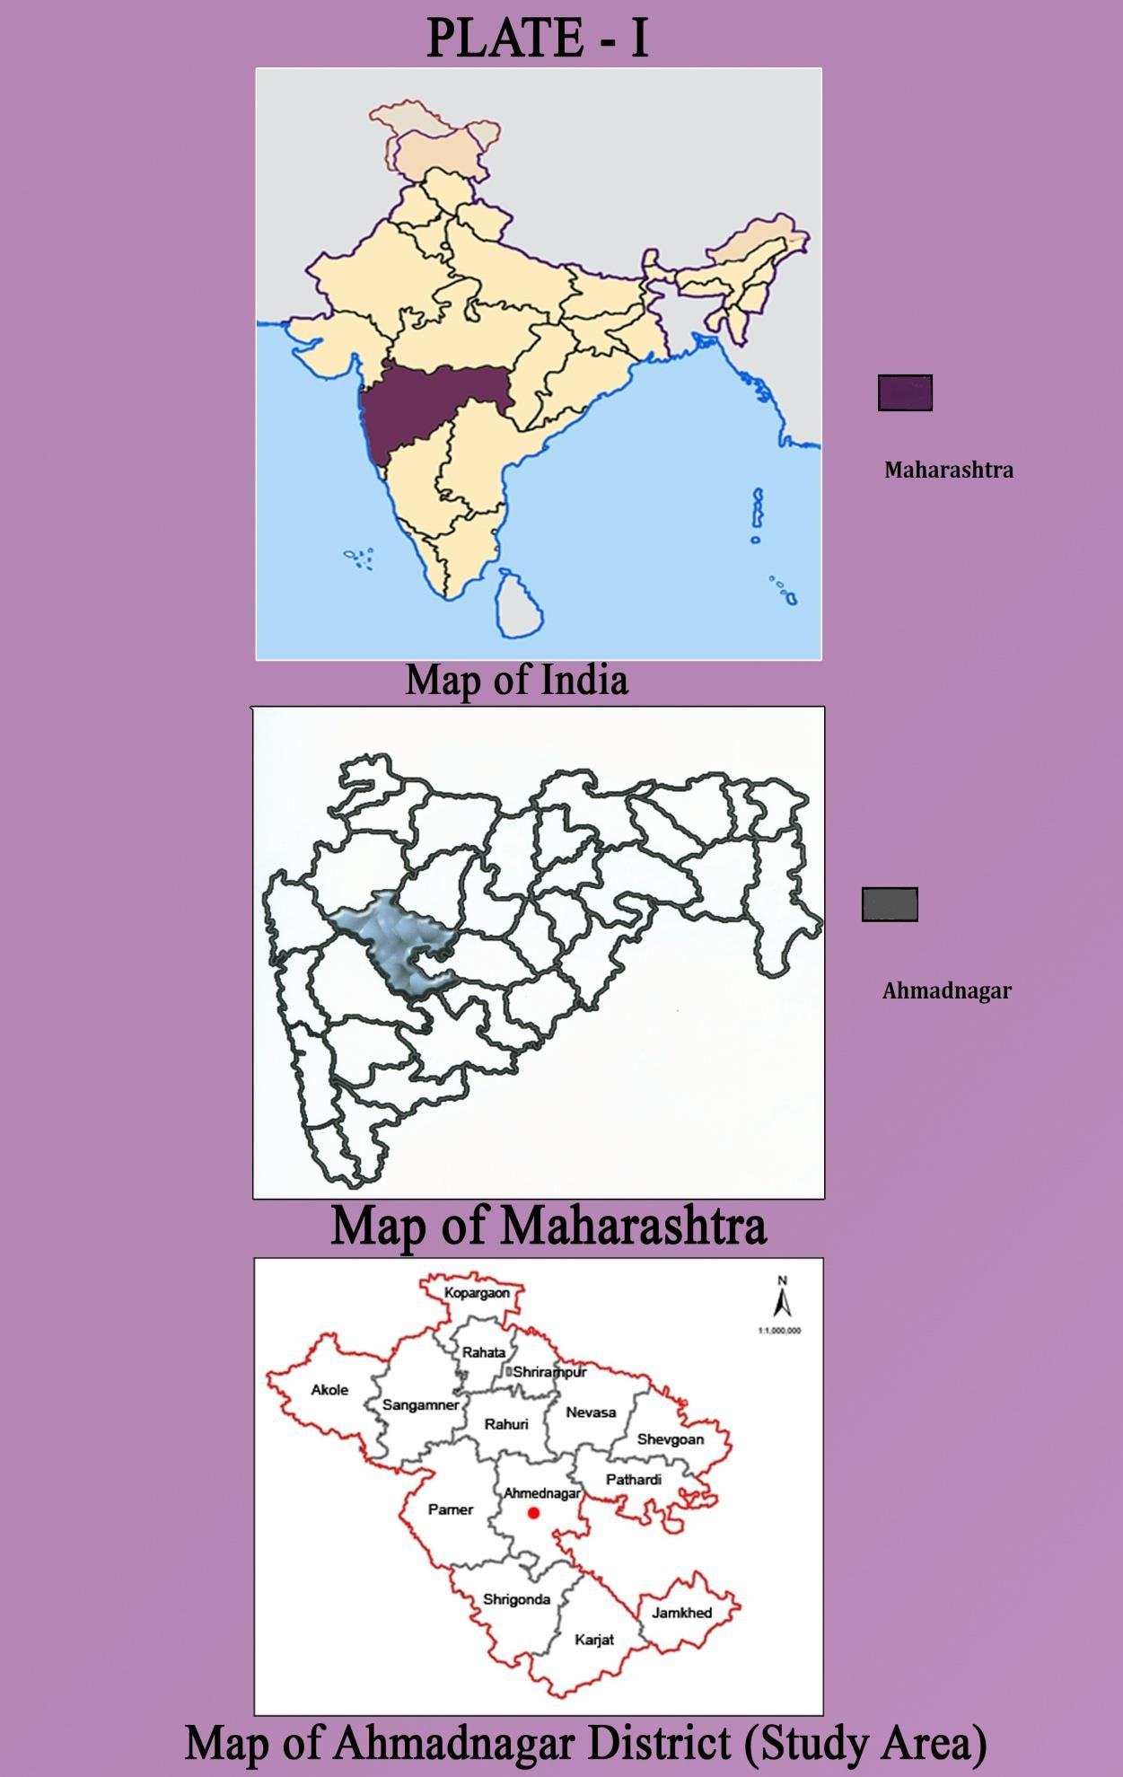
Map of India | Map of Maharashtra | Map of Ahilyanagar

The present work was carried out in the Ahilyanagar district, (M.S.). The different regions of the GIT were studied to collect and separate the visible parasites in petri dishes according to predilection sites. The host's gastrointestinal tract was opened longitudinally with forceps, dissected, and parasites were collected from the intestine and preserved in 4% formaldehyde. Parasite counts and slides were prepared using the staining and mounting process. Scanning Electron Microscopy parasites by (Dey et.al, 1989; Roy & Tandon, 1991). Drawing with Camera Lucida was made having measurement in millimeters. Parasite diagnosis was done by standard methods identification of the cestode parasites as per key (Soulsby, 1982; Cable, 1957; Belghyti, 1994) and Parasites were identified based on helminthological keys described by Yamaguti (1959, 1961), (Khalil et.al, 1994) and (Anderson et. al, 1974) under a light microscope. To assess infection prevalence, the presence of Raillietina (R) fuhrmanni was examined each week of each month for a consecutive year-long study period from June 2020 to May 2021. The prevalence of infection and mean intensity were calculated from the recorded data with the help of the following formulas on the basis of the percentage of incidence (Prevalence) of infection by using the following formula. (Bush et. al, 1997).

Total number of hosts examined
Prevalence (%) = ---------------------------------------------X 100​
Number of infected hosts

Number of infected hosts
Mean Intensity = ---------------------------------------------
Total number of parasites recovered​
Results and Discussion
a) General Morphology of the Cestode Raillietina (R.) fuhrmanni
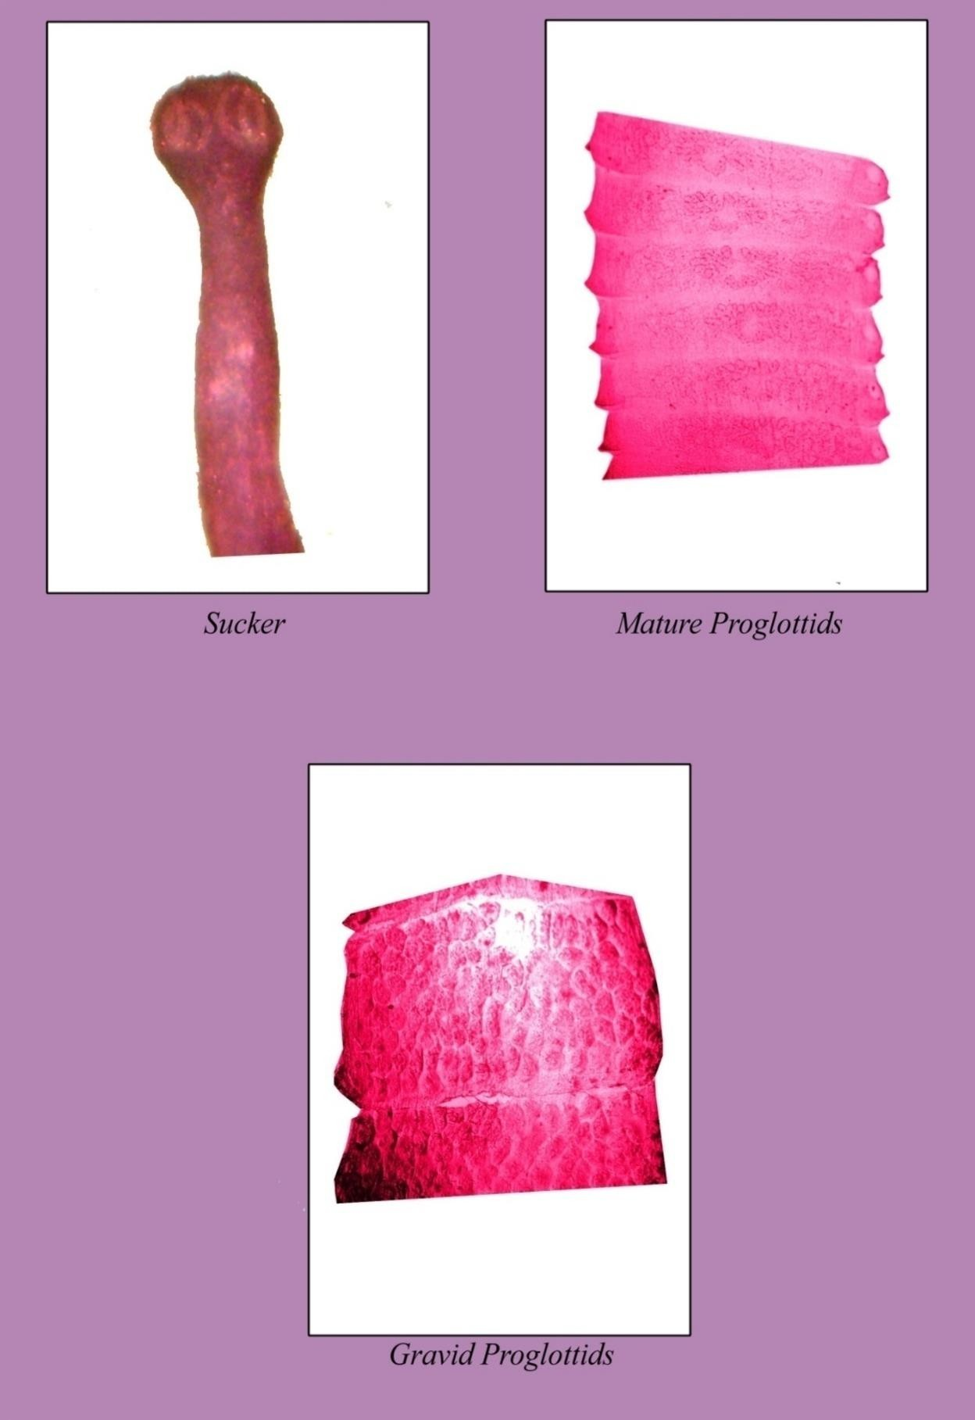 | 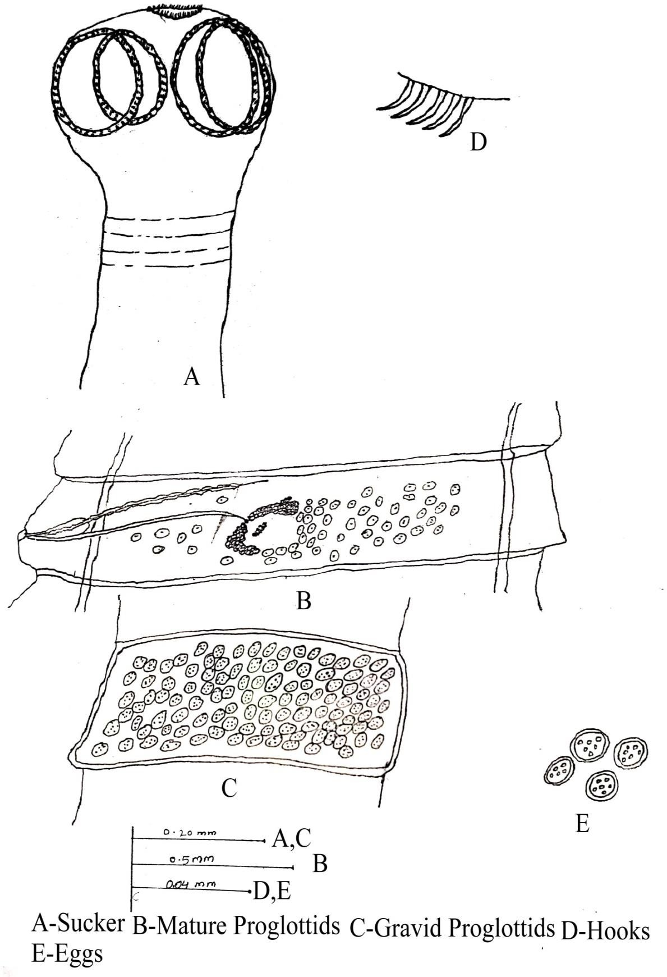 | 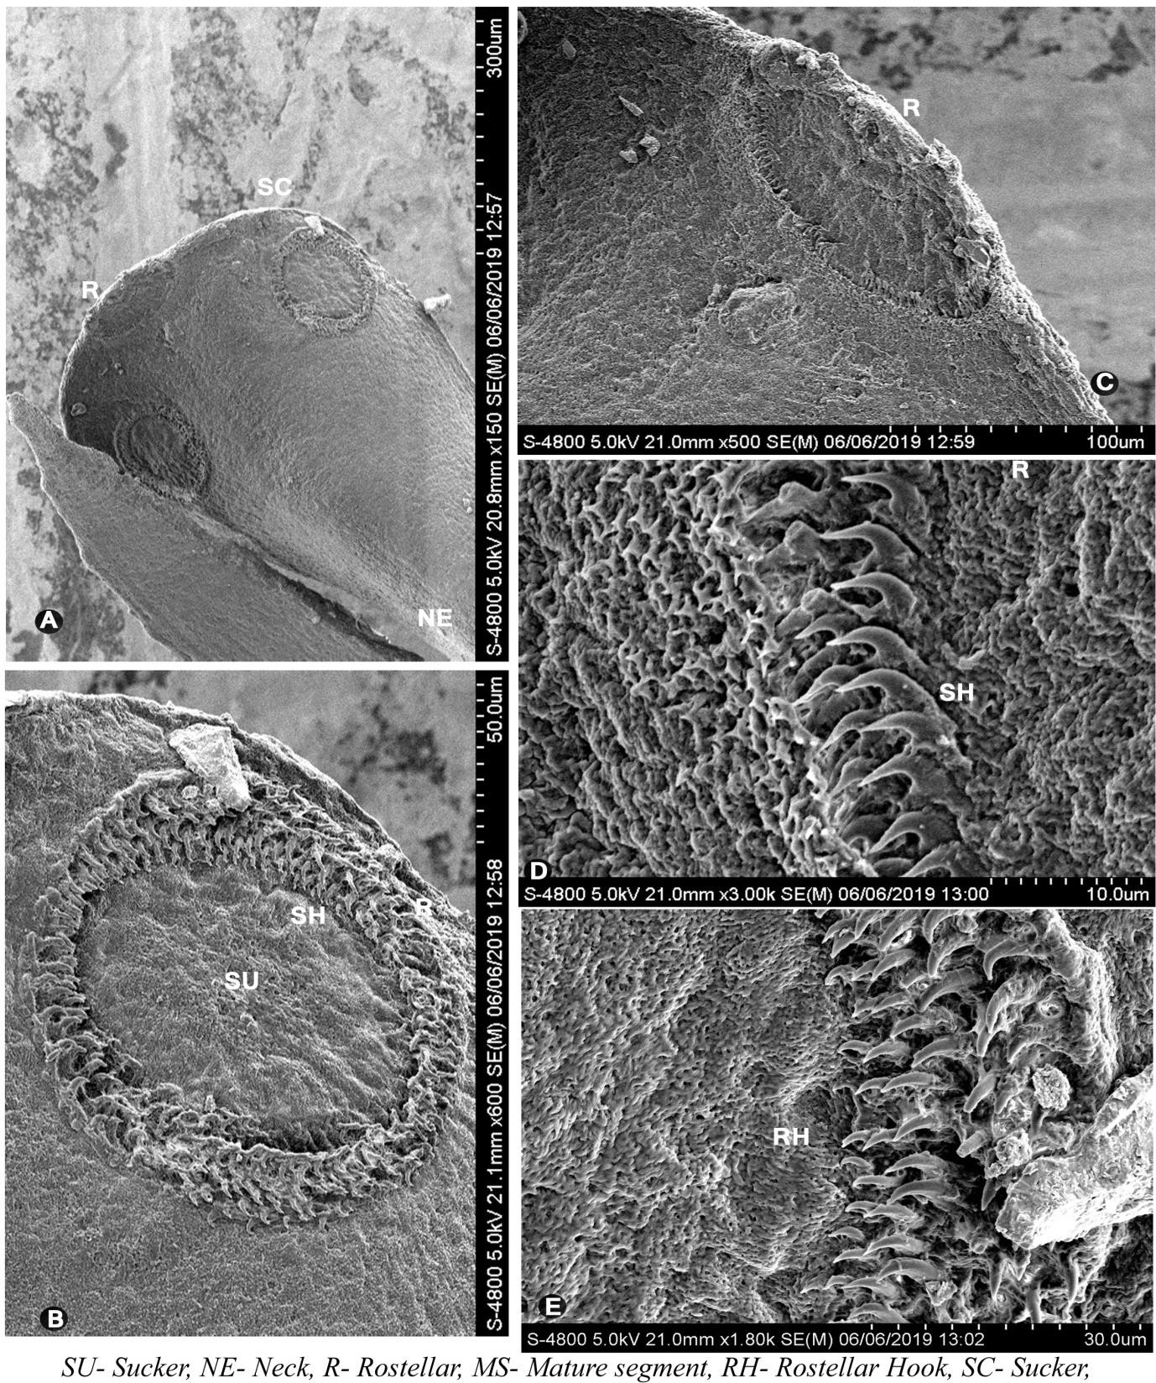
Fig 2: Photos show that scolex, mature and gravid segment of cestode | Fig 3: Camera lucida shows that scolex, mature and gravid segment of cestode | Fig 4: Scanning electron microscopy showing scolex and hooks of parasites

Cestodes parasites were very long and narrow consist of a scolex and mature segments, which, on closer observation, turned out to be the species of the genus Raillietina (R) fuhrmanni (Southwell, 1922)
The cestode was creamy white, measuring 20-80 mm. The scolex is small, oval to rounded, and anteriorly narrow and broad. Posteriorly, it is distinctly marked off from the strobilla and measures 0.2717 (0.2669- 0.2766) in length and 0.2257 (0.2184-0. 2330) in breadth. The scolex bears an armed rostellum, which is large in size, retractile, oval to rounded in shape, with rostellum hooks, situated at the apex of the scolex, and measures 0.0703 (0.0679-0.0728) in length and 0.0121(0.0097-0.0145) in breadth. The rostellum hooks are arranged in two circles, transversely elongated, which are 90-100 in number, small, simple, pin-like, single-pronged, and measure 0.0090 (0.0085-0.0096) in length and 0.0015 (0.0010-0.0021) in breadth. The scolex bears four suckers, medium in size, oval in shape, arranged in two pairs, overlapping on each other, separate pairs obliquely placed, near the lateral margin and measures 0.1358 (0.1067- 0.1650) in diameter. The sucker margins are covered with numerous minute spines arranged in 4-5 transverse rows. The neck is of medium length and width, longer than broad, with smooth, nearly equal to the width of the head, and measures 0.1723 (0.1699- 0.1747) in length and 0.1189 (0.1165- 0.1213) in breadth
The mature segments are medium in size, craspedote, broader than long, almost three times broader than long, with posterior corners projecting outside, and measure 1.6761 (1.6477- 1.7045) in length and 0.2181 (0.0386- 0.3977) in breadth. The testes are 40-50 in number, medium in size, oval in shape, situated almost on the posterior and lateral sides of the ovary, in the posterior half of the central medulla, unevenly distributed, bounded laterally by the longitudinal excretory canals, and measure 0.0283 (0.0227-0.0340) in diameter. Cirrus pouch is medium in size, oval in shape, narrow anteriorly, broad posteriorly, obliquely placed, situated at the middle of the lateral region of the segments, marginal, cortical, and measures 0.0283 (0.0227-0.0340) in length and 0.0170( 0.0113- 0.0227) in width. Cirrus is thin, slightly coiled, contained within the cirrus pouch, and measures 0.1988 (0.1931-0.2045) in length and 0.0511 (0.0454-0.0568) in breadth. The vas deferens is medium width, extends medially, runs parallel to the vagina, coiled, and measures 0.7329 (0.7272-0.7386) in length and 0.0397 (0.0340-0.0454) in breadth. Vagina and cirrus pouch open as a genital pore, which is medium in size, oval in shape, marginal, unilateral, situated at the middle of the segment, post-ovarian, and measures 0.0113 in diameter. The ovary is medium in size, distinctly bilobed, obliquely placed just anterior to the middle of the segment, with 3-5 round, blunt acini, aporal lobe larger than poral lobe and measures 0.2556 (0.2500-0.2613) in length and 0.0397 (0.0340- 0.0454) in breadth. Vagina is a thin tube, situated posterior to the cirrus pouch, starting from the genital pore, running obliquely, anterior to the poralovarian lobe, reaching and opening into the ootype, and measuring 0.7443 (0.7386-0.7500) in length and 0.0283 (0.0227 –0.0340) in breadth. The isthmus is short, wide, connects the two ovarian lobes, and measures 0.0397 (0.0454-0.0340) in length and 0.0170 (0.0227-0.0113) in breadth. The ootype is small, oval in shape, located on the isthmus, and measures 0.0113 (0.0113-0.0113) in diameter. The vitelline gland is large in size, oval in shape, situated in the middle of the segment, post-ovarian, and measures 0.0226 (0.0340-0.0113) in length and 0.0170 (0.0113-0.0227). The longitudinal excretory canals are long tubes, paired, running across proglottids, longitudinally on both sides of proglottids, and measure 0.3465 (0.3409- 0.3522) in length and 0.0283 (0.0227-0.0340) in breadth. The gravid segments are broader than long, contain 80 to 90 egg capsules, and each egg capsule contains 5 to 6 eggs and measures 0.0058 (0.0053 -0.0064) in length and 0.0090 (0.0096-0.0085) in breadth. Eggs are rounded and measure 0.0037 (0.0042-0.0032) in diameter.

b) Seasonal variation R. fuhrmanni (Southwell, 1922)

Table 1. Monthly variation shows % of prevalence and Mean intensity of infection of R. fuhrmanni in the period June -2020 to May- 2021.

Season | Month | Hosts  Examined | Hosts  Infected | Parasites  Collected | Prevalence % | Mean Intensity
Monsoon | June-2020 | 18 | 12 | 71 | 66.67 | 5.92
Monsoon | Jully-2020 | 23 | 18 | 134 | 78.26 | 7.44
Monsoon | August-2020 | 22 | 19 | 121 | 86.36 | 6.37
Monsoon | September-2020 | 14 | 11 | 57 | 78.57 | 5.18
Winter | October-2020 | 19 | 7 | 33 | 36.84 | 4.71
Winter | November-2020 | 14 | 4 | 22 | 28.57 | 5.50
Winter | December-2020 | 9 | 1 | 12 | 11.11 | 12.00
Winter | January-2021 | 7 | 0 | 0 | 0.00 | 0.00
Summer | February-2021 | 13 | 3 | 20 | 23.08 | 6.67
Summer | March-2021 | 17 | 4 | 18 | 23.53 | 4.50
Summer | April-2021 | 12 | 5 | 13 | 41.67 | 2.60
Summer | May-2021 | 14 | 7 | 23 | 50 | 3.29
Total |  | 182 | 91 | 524 | 43.72%

Graph- 1. Monthly variation shows % of prevalence of infection of R. fuhrmanni) in the period June 2020 to May 2021.

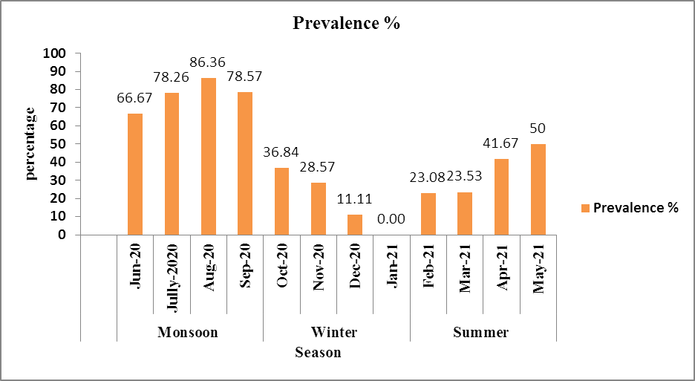

In the study period of June 2020 to May 2021, out of 182 host intestines examined, 91 were found to be infested with R. fuhrmanni. A total of 524 parasites were collected. As R. fuhrmanni was isolated year-round from G. domesticus, seasonal prevalence and characterization were conducted for this species. Monthly variations in the percentage of prevalence and the mean intensity of R. fuhrmanni infection have been presented in Table 1, and the total number of parasites present in G. domesticus in each season of the study period has been shown. The average prevalence percentage was 43.72%. The study revealed that the higher percentage of prevalence of Raillietina (R) fuhrmanni occurred in summer season showing higher in May (50 %) and it showed its highest values during monsoon and the maximum value of percentage of prevalence was recorded in the month of July (86.36%) From September to November it tends to lower down and the lowest prevalence occurred in winter.
Conclusion
The present study approves the occurrence of R. fuhrmanni as a common cestode parasite of Gallus domesticus, characterized by distinct morphological features of the scolex, proglottids, and reproductive organs. Seasonal analysis revealed clear fluctuations in infection patterns, with an overall prevalence of 43.72% during the study period (June 2020–May 2021). The prevalence and intensity of infection were highest during the monsoon months, indicating favorable environmental conditions for parasite transmission. The lowest prevalence recorded in January. These findings suggest that climatic factors play a significant role in the seasonal distribution of R. fuhrmanni and highlight the need for strategic parasite control measures during peak infection periods

COMPETING INTERESTS DISCLAIMER:
Authors have declared that they have no known competing financial interests, non-financial interests, or personal relationships that could have appeared to influence the work reported in this paper.

Disclaimer (Artificial intelligence)

Author(s) hereby declare that NO generative AI technologies such as Large Language Models (Chat GPT, COPILOT, etc.) and text-to-image generators have been used during the writing or editing of this manuscript.

REFERENCE
- Anderson R C, Chabaud A G, Willmott S. CIH (1974): keys to the nematode parasites of vertebrates. Farnham Royal: Commonwealth Agricultural Bureau;
- Baylis H A (1929): some new parasitic nematodes and cestodes from Java. Parasit. 21: pp-25-65.
- Belghyti D, Berrada-Rkhami O, Boy V, Aguesse P, Gabrion C. (1994): Population biology of two helminth parasites of flatfishes from the Atlantic coast of Morocco. J Fish Biol.;44(6):1005–1021
- Bush AO, Lafferty KD, Lotz JM, Shostak AW. (1997): Parasitology meets ecology on its own terms: Margolis et al., revisited. J Parasitol.;83:575–583
- Cable RM. (1957): An illustrated laboratory manual of parasitology. 4. Minneapolis: Burgess Publishing;
- Dey S., Basu Baul T. S., Roy B. and Dey D. (1989): A new rapid method of air drying for scanning electron microscopy using tetramethylsilane. J. Microsc, 156 (13): 259-26.
- Dube S, Zindi P, Mbanga J, Dube C. (2010): A study of scavenging poultry gastrointestinal and ecto-parasites in rural areas of Matebelel and Province, Zimbabwe. Int J Poult Sci.
- Eshetu Y, Mulualem E, Abera K, and Ebrahim H, (2001):Study of Gastro- intestinal helminths of scavenging chicken in four districts of Amhara Region, Ethiopia Scientific and Technical Review, Office International desEpizooties, 20 (3): pp- 791-796.
- Fuhrmann O (1920): Die Systematic der ordnung der Cyclophyllidea. Zool. Anz. 32: pp-289-297.
- Jourdain Elsa , Michel Gauthier-Clerc, Dominique Bicout, and Philippe Sabatier(2007): Bird Migration Routes and Risk for Pathogen Dispersion into Western Mediterranean Wetlands, Emerg. Infect Dis. 13(3): pp- 365–372.
- Joyeux C. and Houdemer E. (1927) Recherches Sur La Faune Helminthologique de l’Indochine (Cestodes et Trematodes). Ann. Parasitol. Hum. Comp., 5, 289–309.
- Kapoor V. C. (1998): Theory and Practice of Animal Taxonomy (4th Ed): Oxford & IBH Publishing Co. Pvt. Ltd. New Delhi: 247.
- Khalil LF, Jones A, Bray RA. Keys to the cestodes parasites of vertebrates. International Institute of Parasitology (An Institute of CAB International); 1994.
- Kolluri R, Lakshmi C V and Rao K H (1986): On some cyclophyllidean cestodes of birds of Andhra Pr Riv. Di desh including a new species of Raillietina (R) Riv. Di parasitologia. 3: pp- 47.
- Malhotra S K and Capoor V N (1981): Studies on the taxonometry of poultry tapeworm Raillietina (R) sharanpurensis n.sp. Nov from foot hills of Garhwal Himalayas Biology, 3.
- Meggitt F J (1931): On cestodes collected in Burma. Part II. Parasit. Vol. 23 (2): pp- 250-263, figs. 6.
- Poulsen J, Permin A, Hindsbo O, Yelifari L, Nansen P and Bloch, P (2000): 'Prevalence and distribution of Preventive Veterinary Medicine, 45(3-4): pp- 237-245
- Roy B. and Tandon V. (1991). Usefulness of tetra-methylsilane in the preparation of helminth parasites for scanning electron microscopy. Riv. Parassitol, 8: 207-215
- Sawada I (1957): Raillietina (R) peradenica n.sp. From a Ceylon domestic fowl, gallus domesticus Jap. J. Med. Sc. And Biol., 10 (3-4): pp- 243-246.
- Soulsby E. J. L. (1982). Helminthes, Arthropods and Protozoan are of domesticated animals (7th Ed). Bailliere Tindale, London.
- Southwell T (1922): Cestodes from Indian birds, with a note on Ligula intestinalis. Ann. Trop. Med. Par. 16: pp- 355-382.
- Wankhed H. J. and Gholap A. B. (2016). Effect of Cestode Parasites on Hematological Parameters in Gallus gallus domesticus in Ahmednagar District Int. J. Life.5-11.
- Yamaguti S (1959): Systema Helminthum, Vol. II Cestodes of Vertebrates. Interscience Publishers, New York and London, pp-1-860.
- Yamaguti S (1961): Systema Helminthum Vol. III. The Nematodes of vertebrates. Interscience Publishers. New York and London, pp-1-679
- Yamaguti S. (1940). Studies on helminth fauna of Japan. Part- 30, Cestodes birds, II. Japan. J. Zool. Med. Sc. Soct. IV, V, I: 175- 211.

