Biological Characteristics and Seasonal Condition of the African Sardine Sardinella maderensis in the Eastern Mediterranean

Abstract

The African sardine Sardinella maderensis is an economically important small pelagic species distributed throughout the eastern Mediterranean Sea. Knowledge of its biological characteristics is essential for stock assessment and sustainable fisheries management. This study aimed to investigate the length–weight relationship (LWR), length–frequency distribution, sex-related size structure, and seasonal variation of the condition factor (K) of S. maderensis along the eastern Mediterranean coast of Syria.
Fish samples were collected monthly from commercial landings between January and December 2023. A total of 390 individuals, ranging from approximately 9 to more than 25 cm in total length, were examined. Length–frequency analysis revealed that the population was mainly composed of medium-sized individuals (10–20 cm), with females slightly dominating the larger size classes. The estimated LWR indicated near-isometric growth for both males (b = 2.97) and females (b = 2.90), suggesting proportional increases in body weight relative to length. Seasonal analysis of the condition factor showed noticeable fluctuations throughout the year, with the lowest values recorded during winter (K ≈ 0.65) and the highest values observed in April during the pre-spawning period (K ≈ 0.93 for females and 0.91 for males).
These findings indicate that although the growth pattern of S. maderensis remains relatively stable, the physiological condition of individuals varies markedly in relation to seasonal reproductive dynamics. The results provide important baseline biological data that can contribute to improved stock assessment and fisheries management strategies for this species in Syrian Mediterranean waters.
1: Introduction
Small pelagic fishes play a pivotal role in marine ecosystems and coastal fisheries, particularly in the Eastern Mediterranean region. Among them, the African sardine Sardinella maderensis is an economically valuable species contributing significantly to artisanal and commercial fisheries (Food and Agriculture Organization (FAO, 2023). Due to their short life span, high productivity, and sensitivity to environmental variability, small pelagic species are particularly responsive to changes in fishing pressure and environmental conditions, making biological studies essential for effective management (FAO, 2019).
Over the years, since Le Cren's work, Length-Length and Length-Weight relationships are useful for converting growth equations to length and weight for use in stock assessment models and for estimating stock biomass from limited sample data (Alam, 2013 and Le Cren's ,1951)
The length–weight relationship (LWR) is a fundamental tool in fisheries biology, widely used to assess growth patterns, estimate biomass, and evaluate fish condition (Froese, 2006; Ecoutin & Albaret, 2003). In parallel, the analysis of sex ratio and size distribution provides insights into population structure and reproductive dynamics . Integrating these parameters enhances the accuracy of stock assessments and supports evidence-based fisheries management (Pérez-Roda, 2012).
Several studies have addressed the biology of clupeid species in the Mediterranean. Notably, Solaiman (2017) investigated the length–weight relationship of Sardinella aurita along the Syrian coast, highlighting the value of comparative studies among closely related species. Additionally, studies along the Egyptian coast have examined biological and dynamic characteristics of S. maderensis (El-sayed et al, 2023), while dietary analyses off the Syrian coast have provided insights into feeding ecology (Al-Sheikh Rasheed et al, 2025). Despite this progress, information on the seasonal physiological condition of S. maderensis in the Eastern Mediterranean remains limited.
The present study aims to: (1) describe the length–frequency distribution and sex-related size structure of S. maderensis, (2) determine sex-specific length–weight relationships, and (3) evaluate seasonal variations in the condition factor in relation to the reproductive cycle. The results contribute to a better understanding of the species' population biology and provide essential data for sustainable fisheries management.

2: Material and Methods:
2-1: Sample Collection and Measurements
A total of 390 specimens of Sardinella maderensis were collected from commercial catches along the Eastern Mediterranean coast (Latakia, Syria) during the period from January to December 2023. (Figure 1) Monthly samples were obtained from local fishing ports, representing the artisanal purse seine fishery. Each specimen was measured for total length (TL) to the nearest 0.1 cm using an ichthyometer and weighted to 0.1 g an electronic balance. Sex was determined by macroscopic examination of the gonads
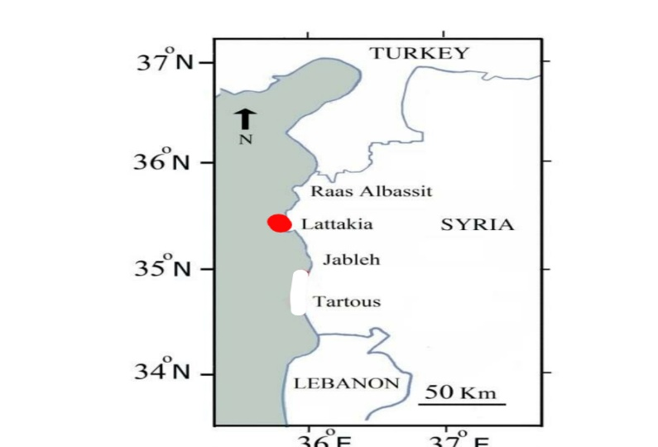
Figure1. Sampling site in the Eastern Mediterranean coast (Latakia, Syria)

2-2: Length–Frequency Distribution
Length–frequency distributions were constructed for the total sample and by sex to examine population structure and size-class dominance. Size intervals of 1 cm were used to identify modal length classes and the representation of juvenile and adult cohorts. Length-frequency histograms were generated separately for males and females.

2-3: Length–Weight Relationship
The length–weight relationship was estimated using the standard power function:
W = aLᵇ
where W is the total weight (g), L is the total length (cm), a is the intercept, and b is the allometric growth coefficient. The parameters were estimated by linear regression analysis after logarithmic transformation:
ln W = ln a + b ln L
Separate regressions were calculated for males and females. Growth was classified as isometric when b was not significantly different from 3 (t-test, p < 0.05), as positive allometric when b > 3, and negative allometric when b < 3 (Froese, 2006). The coefficient of determination (r²) was used to assess the goodness of fit of the regression model.

2-4: Condition Factor
The Fulton condition factor (K) was calculated to assess seasonal changes in fish physiological condition using the formula:
K = 100 × (W / L³)
where W is the total weight (g) and L is the total length (cm). Seasonal and monthly averages of K were computed for males and females separately. The multiplication by by 100 scales the condition factor to values near 1. Which facilitating interpretation (Froese, 2006).

2-5: Statistical Analysis
Descriptive statistics were calculated for all parameters. One-way analysis of variance (ANOVA) was used to test for significant seasonal and sex-related differences in the condition factor, followed by Tukey's post-hoc test for multiple comparisons when significant differences were detected. Student's t-test was employed to compare the allometric coefficient b between sexes and to test whether b differed significantly from 3. All statistical analyses were performed using SPSS.

3: Results
3.1: Length–Frequency Distribution and Size Structure
The length–frequency distribution of Sardinella maderensis ranged from approximately 10 cm to more than 25 cm total length. Most individuals were concentrated in the 10–20 cm size interval, with the highest frequencies observed in the 11–15 cm length classe.
The sex ratio varied considerably among length classes. Males dominated the smaller size groups (<12 cm. In contrast, females became increasingly predominant in larger length classes (>18 cm) Figure2(. This progressive shift in sex composition with increasing size reflects differential growth and survival between sexes. The overall sex ratio (male: female) was 1:1.16, slightly favoring females, though this difference was not statistically significant (χ² test, p > 0.05).

When analyzed separately, both males and females exhibited generally unimodal length–frequency distributions) Figure 3(. Males showed peak abundance in the 12-13 cm class, while females peaked in the 14-15 cm class. Females were more abundant in the upper length classes (>18 cm), a pattern associated with higher fecundity and reproductive advantage of larger females (King, 2007).
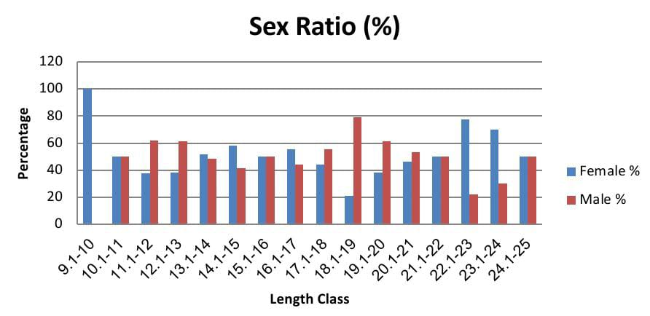
Figuar2. Sex ratio by length classes.

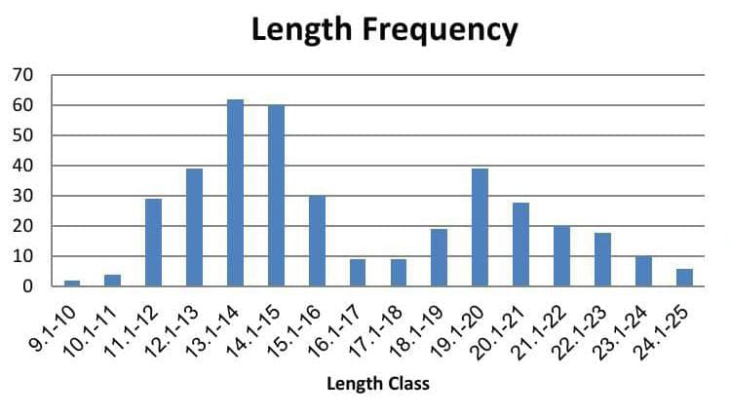
Figure3. length–frequency distribution by sex

3-2: Length-Weight Relationship (LWR)
The length-weight relationship parameters for S. maderensis are presented in Table 1
The LWR indicated isometric growth for both sexes. The allometric coefficient (b) was 2.97 for males (r² = 0.963) and 2.96 for females (r² = 0.951) (Figures 4 and 5). The intercept (a) was 0.0065 for males and 0.005 for females. The 'b' values were not significantly different from 3 (t-test, p > 0.05), confirming that weight increases in proportion to the cube of length. This isometric growth pattern (b ≈ 3) aligns with findings reported for Sardinella species in the region and other clupeids, suggesting a s and proportional body form under the prevailing environmental conditions (Froese, 2006; Solaiman, 2017; Torres et al., 2012). The minimal difference in 'b' values between sexes indicates similar overall growth trajectories in terms of body shape. The high coefficients of determination (r² > 0.98) validate the robustness of the derived equations for estimating biomass and stock assessments in the study area.).

Table 1. Length-weight relationship parameters for Sardinella maderensis by sex
Sex | N | Length Range (Cm) | Wieght Range  (G) | a | b | r² | Groth Type
Males | 180 | 10-25 | 12-158 | 2.97 | 0.0065 | 0.963 | Isometric
Females | 210 | 9.1-25 | 14-189 | 2.97 | 0.005 | 0.951 | Isometric

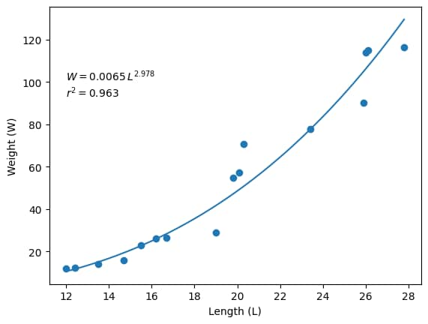
Figure4. Length-Weight Relationship for males

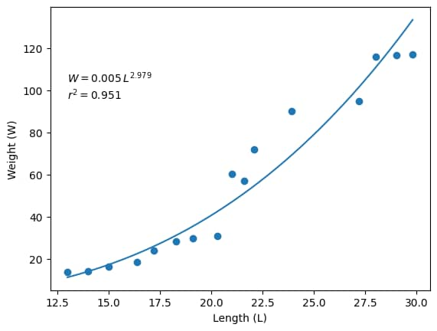
Figure 5. Length-Weight Relationship for females.

3-3: Monthly Dynamics of the Condition Factor (K)
The condition factor (K) exhibited highly significant monthly variation (ANOVA, p < 0.001), revealing a clear annual physiological cycle (Table 2). The lowest mean K value was recorded in December (0.65 ± 0.04), representing a period of minimal physiological condition. Values showed a steady recovery from January (0.67 ± 0.03) through February (0.72 ± 0.04) onwards, culminating in a pronounced peak in April (0.93 ± 0.05). Following this peak, a gradual decline was observed through the subsequent months, with a secondary minor peak in June (0.89 ± 0.04).
particularly during the pre-spawning period (April-May), though these differences were not statistically significant (t-test, p > 0.05). The peak condition factor for females (0.94) was recorded in April, while males peaked at 0.91 during the same month.

Table 2. Monthly variation in condition factor (K) of Sardinella maderensis Sex-specific analysis of condition factor revealed that females generally exhibited slightly higher K values than males during most months.

Month | Mean K ± SD | Minimum | Maximum
January | 0.67±0.03 | 0.61 | 0.72
February | 0.72±0.04 | 0.65 | 0.79
March | 0.85±0.04 | 0.78 | 0.92
April | 0.93±0.05 | 0.85 | 1.02
May | 0.82±0.05 | 0.74 | 0.91
June | 0.89±0.04 | 0.82 | 0.96
July | 0.80±0.06 | 0.71 | 0.89
August | 0.81±0.05 | 0.73 | 0.90
September | 0.70±0.04 | 0.63 | 0.77
October | 0.67±0.05 | 0.59 | 0.75
November | 070±0.04 | 0.64 | 0.77
December | 0.65±0.04 | 0.58 | 0.72

4: Discussion

4.1: Population Size Structure
The length-frequency distribution of Sardinella maderensis in the present study revealed a population dominated by medium-sized individuals (10-20 cm), with relatively low representation of juveniles (<10 cm) and larger specimens (>20 cm). This pattern is consistent with previous studies on S. maderensis along the Egyptian coast, which reported length ranges of 8.5-26.3 cm and dominance of intermediate size classes (El-sayed et al., 2023). The low proportion of juveniles in the catch is likely attributable to gear selectivity, as purse seines typically target schools of adult fish, while juveniles may inhabit different areas or remain in nursery grounds (Torres et al., 2012).
The observed shift in sex ratio with increasing length, where males dominated smaller size classes while females prevailed in larger ones, reflects well-documented patterns in clupeid fishes. Several hypotheses may explain this phenomenon: differential growth rates favoring females, higher mortality rates in males, or sex-specific habitat preferences (King, 2007). The predominance of larger females has significant implications for population fecundity and reproductive potential, as larger females typically produce more and higher quality eggs (Froese & Pauly, 2024).
4-2: Length-Weight Relationship
The isometric growth pattern (b ≈ 3) observed for both sexes of S. maderensis indicates that body proportions remain relatively constant throughout the size range, with weight increasing in direct proportion to the cube of length. This finding aligns with previous studies on the species in the Eastern Mediterranean, where El-sayed et al. (2023) reported b = 3.052 for combined sexes from North Sinai waters. Similarly, Solaiman (2017) found near-isometric growth (b = 2.98) for Sardinella aurita off the Syrian coast.
Comparisons with other regions reveal some variability in growth patterns. Such variability may reflect differences in environmental conditions, food availability, and sampling periods (Froese, 2006).
The minimal difference in b values between sexes suggests similar body shape trajectories, though females achieve larger maximum sizes. This sexual dimorphism in maximum length has been documented for many clupeid species and is associated with the reproductive advantage of larger females (King, 2007). The intercept values (a) obtained (0.0065 for males, 0.005 for females) fall within the range reported for clupeids in the Mediterranean (Torres et al., 2012).

4.3 Seasonal Variation in Condition Factor

The pronounced seasonal variation in condition factor represents the most significant finding of this study. The clear annual cycle, with minimum values in winter (December, K = 0.65) and peak values in spring (April, K = 0.93), closely parallels the reproductive cycle of the species. This pattern is consistent with the reproductive biology of S. maderensis in the Eastern Mediterranean, where spawning occurs primarily from April to September, with peak activity in late spring and early summer (El-sayed et al., 2023).

The low condition factor during winter (December-February) likely reflects a period of post-spawning recovery and reduced food availability.
The peak condition factor in April, immediately preceding the main spawning season, represents the accumulation of energy reserves for reproductive investment. This pre-spawning condition peak is a well-documented phenomenon in teleost fishes, where individuals build up lipid reserves and increase somatic condition to support gamete production and spawning activities (Le Cren, 1951). Studies on S. maderensis in other regions have similarly reported condition peaks coinciding with pre-spawning periods (Mafuca et al., 2025).

The slightly higher condition factor observed in females compared to males, particularly during the pre-spawning period, likely reflects greater energy allocation to gonadal development in females. This pattern has been observed in other clupeids and is consistent with the higher reproductive investment required for egg production compared to sperm production (King, 2007).
4.4 Comparison with Regional Studies
The condition factor values obtained in this study (range: 0.65-0.93) fall within the range reported for S. maderensis in other regions. In the Eastern Mediterranean, El-sayed et al. (2023) reported condition factors ranging from 0.68 to 0.91 for S. maderensis from North Sinai waters, closely matching our findings.
Studies on S. aurita, a closely related species sympatric in the Mediterranean, have shown similar seasonal patterns. Solaiman (2017) reported condition factors for S. aurita off the Syrian coast ranging from 0.71 to 0.89, with peaks during spring months.
4.5 Management Implications
The study's findings have direct applications for fisheries management. The established length-weight relationships (LWR) with high correlation coefficients provide reliable tools for converting length frequencies into weight estimates, which is essential for accurate stock assessment and biomass estimation using standardized assessment tools like FiSAT.
The population structure analysis revealed that females dominate larger size classes, indicating that protecting larger individuals through appropriate size limits would significantly benefit the stock's reproductive potential. Based on regional length at first maturity estimates (15.5 cm for males, 16.7 cm for females), maintaining or increasing the minimum landing size is recommended to ensure individuals can reproduce at least once before capture.
The most critical finding concerns seasonal variation in condition factor. The low winter values (K ≈ 0.65) indicate physiological stress, making fish potentially more vulnerable to fishing pressure. Conversely, the April pre-spawning peak represents a critical period when accumulated energy reserves support reproduction. Fishing during this pre-spawning aggregation could disproportionately impact reproductive output. Given the estimated exploitation rate (E = 0.547) approaching maximum sustainable levels, implementing seasonal closures during the peak spawning period (April-June) is recommended to protect spawning aggregations and allow completion of reproductive cycles.

5: Conclusion
This study provides a comprehensive assessment of key biological characteristics of Sardinella maderensis in the Eastern Mediterranean. The results revealed a population dominated by medium-sized individuals (10-20 cm) with a progressive shift in sex ratio favoring females in larger length classes, enhancing the stock's reproductive capacity. The length-weight relationship demonstrated isometric growth for both sexes (b = 2.97 for males, 2.96 for females), confirming body shape stability under prevailing environmental conditions.

The most significant finding was the pronounced seasonal variation in condition factor, with minimum values in winter (December, 0.65) reflecting post-spawning physiological stress, and peak values in April (0.93) coinciding with the pre-spawning period. This confirms the close relationship between physiological condition and reproductive cycle.

These findings underscore that stable growth patterns do not necessarily reflect stable physiological condition. Based on these results, the study recommends: (1) implementing seasonal management measures including spawning period closures (April-May), (2) increasing mesh size to at least 16 mm to protect immature individuals, (3) avoiding increased fishing effort given current exploitation rates, and (4) enhancing environmental and biological monitoring through long-term seasonal studies linking biological indicators to environmental variables. An integrated ecosystem approach combining biological indicators with environmental conditions and fisheries characteristics is essential for ensuring the sustainability of this vital resource

COMPETING INTERESTS DISCLAIMER:
Authors have declared that they have no known competing financial interests OR non-financial interests OR personal relationships that could have appeared to influence the work reported in this paper.

Disclaimer (Artificial intelligence)
Author(s) hereby declare that NO generative AI technologies such as Large Language Models (ChatGPT, COPILOT, etc.) and text-to-image generators have been used during the writing or editing of this manuscript.

6: References
- Alam MM, Jahan SN, Hussain MADeM, Goutham Bharathi MP, Magalhães AB, et al. (2013) Length-length relationship, length-weight relationship and condition factor of freshwater
- Al-Sheikh Rasheed, R., Galiya, M., Almajid, Z., & Laika, H. A. (2025). Dietary Analysis of Sardinella maderensis (Lowe, 1938) in the Marine Waters off the Latakia Coast (Syria), Eastern Mediterranean: A Two-Year Seasonal Study. Asian Journal of Fisheries and Aquatic Research, 27(12), 73–82.
- Ecoutin, J. M., & Albaret, J. J. (2003). Relation longueur-poids pour 52 espèces de poissons des estuaires et lagunes de l'Afrique de l'Ouest. Cybium, 27(1), 3-9..
- El-sayed, E. A., Hassanen, G. D. I., Faisal, R. M., & El-Aiatt, A. A. O. (2023). Study of some biological and dynamic characteristics of the Madeiran sardinella fish Sardinella maderensis of Eastern Mediterranean (North Sinai coast Egypt). Sinai Journal of Applied Sciences, 12(3), 433–444.
- Food and Agriculture Organization. (2023). Sardinella maderensis species fact sheet. Fisheries and Aquaculture Division.
- FAO (2019) Report of the FAO/CECAF Working Group on the Assessment of Small Pelagic Fish–Subgroup South, Elmi-na, Ghana, 12-20 September 2018.
- Froese, R. (2006). Cube law, condition factor and weight–length relationships: history, meta-analysis and recommendations. Journal of Applied Ichthyology, 22(4), 241-253. https://doi.org/10.1111/j.1439-0426.2006.00805.xhttps://doi.org/10.1111/j.1439-0426.2006.00805.x
- Froese, R., & Pauly, D. (2024). FishBase. World Wide Web electronic publication

- King, M. (2007). Fisheries Biology, Assessment and Management (2nd ed.). Blackwell Publishing.
- Le Cren, E. D. (1951). The length–weight relationship and seasonal cycle in gonad weight and condition in the perch (Perca fluviatilis). Journal of Animal Ecology,20(2),201-219.

- Mafuca, J. L. A., et al. (2025). Reproduction Traits and Strategies of Two Sardinella Species off the Southwest Coast of Africa. Fishes, Journal of Animal Ecology, 20(2), 201-219.10(6), 261. https://doi.org/10.3390/fishes10060261
- Pérez-Roda, M. A., et al. (2012). The Potential of Small Pelagic Fish for Food Security in Africa. FAO Fisheries and Aquaculture Circular No. 1084.Rome: FAO.
- SOLAIMAN Y., 2017 - The Length-Weight Ratio Of The Round Sardinella (Sardinella aurita) From The Syrian Coast Of The Mediterranean Sea. In: AXINI M., Al-AZKI F. (eds.), 2017. Rom.-Syr. J. Geo-Bio-div. VI(1): 19-22.
- Torres, M. A., Ramos, F., & Sobrino, I. (2012). Length-weight relationships of 76 fish species from the Gulf of Cadiz (SW Spain). Journal of Applied Ichthyology, 28(4), 662-664.

