Histopathological Changes in Pig Liver Caused by Fasciola gigantica

ABSTRACT
Fascioliasis, caused by Fasciola gigantica, is an important parasitic disease affecting livestock in tropical regions and is associated with significant economic losses due to reduced productivity and condemnation of infected organs. This study investigated the prevalence of Fasciola gigantica and the associated histopathological changes in pig livers in Delta Central Senatorial District of Delta State, Nigeria. A total of 741 pigs were examined over a 12-month period (April 2023–March 2024). Altogether, 1,478 samples comprising faecal and gall bladder contents were collected and analysed using standard flotation and sedimentation techniques, while liver tissues were processed for histological examination using hematoxylin and eosin staining. Out of the samples analysed, 837 were positive for one or more parasites, giving an overall prevalence of 56.6%. Fasciola gigantica was detected in 361 of 1,064 faecal samples (33.9%) and 112 of 413 gall bladder samples (27.1%). Histopathological examination of infected liver tissues revealed marked pathological alterations, including centrilobular hepatocellular necrosis, hepatocellular degeneration, inflammation, and fibrosis of the hepatic parenchyma. Microscopic observations further showed distorted hepatocytes, necrotic tracts associated with fluke migration, biliary proliferation, and infiltration of inflammatory cells such as lymphocytes, macrophages, and eosinophils within the portal areas. These lesions indicate severe tissue damage resulting from the migratory activity of immature flukes and the prolonged presence of adult parasites in the bile ducts. The findings demonstrate that Fasciola gigantica infection is prevalent among pigs in the study area and causes significant histopathological damage to the liver. Effective parasite control strategies and improved veterinary surveillance are therefore essential to reduce infection rates and enhance pig production in the region.

Keywords: Fasciola gigantica, fascioliasis, pig parasites, liver histopathology, prevalence
INTRODUCTION
Fascioliasis is a parasitic disease caused by liver flukes of the genus Fasciola, particularly Fasciola hepatica and Fasciola gigantica. These trematodes infect the liver and bile ducts of several domestic animals, including cattle, sheep, goats, and pigs. In tropical regions of Africa and Asia, Fasciola gigantica is the predominant species affecting livestock. The disease is of major veterinary and public health concern due to its economic impact on livestock production and its zoonotic potential.

Pig production is an important component of livestock farming in many developing countries because pigs grow rapidly, reproduce quickly, and adapt easily to different environmental conditions. However, parasitic infections remain a major constraint to pig productivity. Among these parasites, Fasciola gigantica can cause significant liver damage, resulting in reduced growth performance, poor feed conversion, and economic losses due to condemnation of infected livers during meat inspection.

Infection with Fasciola gigantica occurs when pigs ingest infective metacercariae attached to contaminated vegetation or water. After ingestion, the immature flukes penetrate the intestinal wall and migrate to the liver. Their movement through the hepatic parenchyma causes mechanical injury, inflammation, and tissue destruction. As the parasites mature within the bile ducts, prolonged irritation leads to fibrosis, necrosis, and other structural alterations in the liver tissue.

The liver is a vital organ responsible for metabolic regulation, detoxification of blood, and bile production for digestion (Kalkra et al., 2023). Because of its central physiological functions, pathological changes in the liver can significantly affect the health and productivity of animals. Histopathological examination of liver tissues therefore provides an important diagnostic approach for detecting liver diseases caused by parasites and other infectious agents (Melo et al., 2020).

The life cycle of Fasciola species involves both definitive and intermediate hosts. Eggs released in the feces of infected animals hatch in water to release miracidia, which infect freshwater snails—the intermediate hosts. Within the snail, the parasites develop into cercariae that are later released and encyst on vegetation as metacercariae. When ingested by animals, these metacercariae develop into immature flukes that migrate to the liver, causing tissue damage before maturing in the bile ducts (Asharif, 2014; Malcicka, 2015; Pybus, 2001).

Although fascioliasis has been reported in various livestock species in Nigeria, information on the histopathological effects of Fasciola gigantica infection in pigs within Delta Central Senatorial District is limited. The ecological conditions of the region—such as high rainfall, swampy environments, and the presence of snail intermediate hosts—may favor the transmission of the parasite.

Therefore, this study focuses on examining the histopathological changes in pig livers infected with Fasciola gigantica in Delta Central Senatorial District of Delta State, Nigeria. Understanding the pathological effects of this parasite will provide useful information for improving disease management and developing effective control strategies in pig production.

MATERIALS AND METHODS
Study Area
The study was conducted in Delta Central Senatorial District of Delta State, Nigeria. The region experiences a tropical climate characterized by two major seasons: the rainy season (April to October) and the dry season (November to March). The area is predominantly rainforest with mangrove vegetation and receives an annual rainfall between 2,032 mm and 3,540 mm. The inhabitants are largely engaged in farming, trading and other economic activities (Ede et al., 2025).
Sample Collection
The study was conducted over a period of twelve months from April 2023 to March 2024 covering both rainy and dry seasons. Weekly visits were made to the selected farms and slaughter slabs for the collection of samples. A total of 741 pigs were examined and 1,478 samples comprising faecal samples and gall bladder contents were collected.
Collection of Faecal Samples
Slaughter slabs and pig farms at various locations were visited between 7:00 am and 10:00 am over a twelve-month period for the collection of fresh stool samples (Plates 2a and 2b). Faecal samples were collected directly from the rectum and intestines of freshly slaughtered pigs with the assistance of pig owners and slaughterers using long forceps. The samples were placed into clean, sterilized, and properly labeled universal sample bottles (Shittu et al., 2018). Samples collected from locations close to the laboratory were placed in ice-flasks and transported immediately for analysis without preservatives. However, samples obtained from distant locations were preserved in 2.5% (w/v) potassium dichromate solution prepared by dissolving 2.5 g of potassium dichromate in 100 ml of deionized water (Adhikari et al., 2021). All samples were transported promptly to the Laboratory of the Department of Science Laboratory Technology, Faculty of Science, Delta State University, Abraka, where laboratory analyses were conducted.

Collection of Liver Samples
Liver samples for histophatological examination were collected directly from freshly slaughtered pigs with the assistance of the slaughter slabs owners and workers. Samples collected were placed in universal sample bottles and immediately fixed in 10% formosaline solution and corked. The samples were transferred to the Histology Laboratory of the Department of Histology, Faculty of Basic Medical Sciences, Delta State University, Abraka for histophatological studies.
Parasitological Examination
Faecal samples were examined using standard flotation and sedimentation techniques for the detection of parasite eggs (Lemy and Egwunyenga, 2017). Gall bladder samples were examined for the presence of Fasciola gigantica eggs using sedimentation methods. Parasites were identified based on morphological characteristics using standard parasitological identification keys (Lemy and Egwunyenga, 2018).

Histological Examination of Pig Liver Samples
Samples of liver obtained from freshly slaughtered pigs were placed in sampling bottles and preserved using 10% formo-saline solution and transported to the Histology Laboratory of the Faculty of Basic Medical Sciences, Delta State University, Abraka, for histological examinations. Samples fixed with 10% formalin were dehydrated in graded alcohol, clarified in xylene and embedded in paraffin wax (Perry et al., 2016). Histological sections were made at a thickness of 4.0µm and stained with hematoxylin-eosin (H&E), and the sections were viewed under the conventional light microscope for the presence of helminth parasites.

Data Analysis
Data obtained from the study were analysed using descriptive statistics. Prevalence was calculated as the percentage of infected samples relative to the total number examined.
RESULTS
A total of 741 pigs were examined during the study period. Out of the 1,478 samples analysed, 837 were positive for one or more parasites, giving an overall prevalence of 56.6%. Fasciola gigantica was one of the major parasites recorded during the investigation.
Prevalence of Fasciola gigantica
The parasite was detected in both faecal and gall bladder samples. In faecal samples, 361 out of 1,064 samples were positive for Fasciola gigantica, giving a prevalence of 33.9%. In bile content of gall bladder samples, 112 out of 413 samples were positive, resulting in a prevalence of 27.1%.

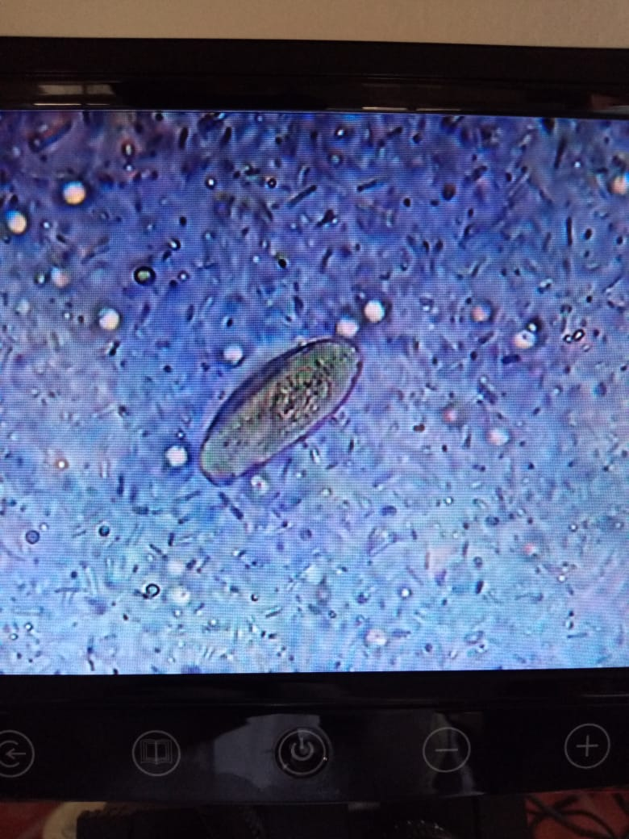
Plate 1: Egg of Fasciola gigantica

Histopathological Findings
Histological analysis of excised liver samples from pigs infected with helminth parasites is shown in Plates 2a–2b. Macroscopic examination revealed centrilobular hepatocellular necrosis and inflammation in the liver lesions. Some sections appeared slightly swollen with pale edges, while others were greatly enlarged with irregular whitish areas indicating fibrosis on the parietal surface. The liver also showed hepatocellular degeneration and thickened capsules with whitish-reddish discoloration and hardened parenchyma due to fibrosis. Fibrosis of the bile ducts with patches on the parietal surface was also observed (Plate 2a).
Microscopically, the infected liver showed structural alterations compared with normal liver tissue, varying with the duration and severity of infection. There were clear signs of fibrosis and necrosis in the hepatic parenchyma with severe hepatocyte damage, likely caused by the migratory activity of immature flukes. Degenerated cell walls, distorted nuclei, and cytoplasmic contents within the sinusoids indicated parasitic activity. Infiltration of lymphocytes and macrophages around helminth eggs suggested an acute phase of infection (Plate 2b).
Further examination showed portal hepatocellular necrosis and inflammation. The liver appeared slightly enlarged with pale coloration and irregular fibrotic areas. Microscopically, fresh migratory tracts of different sizes were observed with eosinophilic debris, cirrhotic changes, and biliary proliferation in the portal tracts. Parasitic activity caused mechanical and toxic damage to hepatocytes, while surrounding tissues showed coagulative necrosis. Congested sinusoids and portal areas were infiltrated by macrophages, lymphocytes, and eosinophils (Plate 2c).

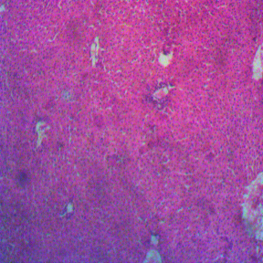 | 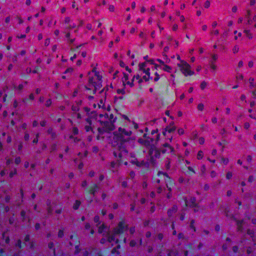
Plate 2a: Liver sections of pig showing centrilobular hepatocellular necrosis and inflammation
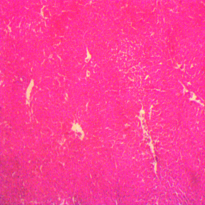 | 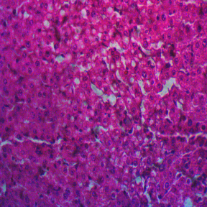
Plate 2b: Liver sections of pig showing random hepatocellular degeneration
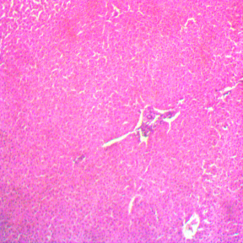 | 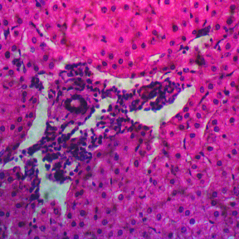
Plate 2c: Liver sections of pig showing random hepatocellular degeneration portal hepatocellular necrosis and inflammation

DISCUSSION
The presence of Fasciola gigantica in slaughtered animals is strongly linked to severe liver damage and noticeable histopathological changes. These pathological alterations mainly result from the migration of immature flukes through the hepatic parenchyma and the prolonged residence of adult parasites in the bile ducts (Lalor et al., 2021). In the early stage of infection, juvenile flukes penetrate the intestinal wall and migrate to the liver, where they tunnel through the hepatic tissue. This movement causes significant mechanical damage to hepatocytes, leading to hemorrhagic tracts, necrosis, and degeneration of liver cells (Urquhart et al., 1996). Consequently, the normal liver structure is disrupted, impairing its physiological functions.
Macroscopic examination revealed liver lesions associated with the activity of liver flukes (Fasciola hepatica), causing fascioliasis, as previously reported by Igwe et al. (2024). The liver sections showed swelling, rough reddish or whitish discoloration, and fibrosis. Similar pathological findings have been reported by Ahmedullah et al. (2007). The presence of multiple lesions on the parietal surface suggests the transperitoneal migration of liver flukes, while damage to surrounding hepatic cells may result from the feeding activities of immature flukes (Lalor et al., 2021).

Further examination revealed cystic formations caused by tissue dilation and enlargement of liver cells due to fibrosis within the parenchyma and parietal surface. In some sections, a pipe-stem appearance was observed, indicating migratory tracts of parasites. Previous studies have linked such liver parasite infections to severe liver damage, cirrhosis, and possible liver failure (Talwani et al., 2011; Peters, 2021; Tsukanov et al., 2024). Microscopic examination showed liver cell alterations caused by the migratory activities of immature Fasciola species, consistent with the findings of Tanwar et al. (2020). There was proliferation of fibrous connective tissue in the portal areas, often associated with haemorrhage and hepatic sclerosis. Infiltration of eosinophils, macrophages, lymphocytes, and endothelial cells was also observed, particularly during the early stages of infection and fluke migration, similar to findings in sheep reported by Doaa et al. (2007). Granuloma formation around parasite eggs was also evident.

Additionally, focal inflammatory cell infiltration occurred within the hepatic parenchyma and portal areas, accompanied by lymphocytes, mononuclear cells, and fibroblast proliferation along haemorrhagic tracts. The accumulation of lymphocytes and fibrous connective tissue caused distortion of the liver’s lobular structure. Hyperplastic changes in bile duct epithelial cells and proliferation of periductal connective tissue were also observed, producing thickened and adenomatous bile ducts, as reported by Ahmedullah et al. (2007). These pathological changes are largely attributed to mechanical irritation from parasite movement and toxins released by the flukes.

Conclusion
The study demonstrated that Fasciola gigantica infection is prevalent among pigs in Delta Central Senatorial District of Delta State, Nigeria. The parasite was detected in both faecal and gall bladder samples with notable seasonal variation in infection rates. Histopathological examination of infected liver tissues revealed significant pathological damage including hepatocellular necrosis, inflammation and fibrosis. These findings highlight the importance of fascioliasis as a major parasitic disease affecting pig production in the region. Implementation of effective parasite control measures, improved farm hygiene and regular veterinary surveillance are recommended to reduce the burden of infection and improve livestock productivity.

COMPETING INTERESTS DISCLAIMER:
Authors have declared that they have no known competing financial interests OR non-financial interests OR personal relationships that could have appeared to influence the work reported in this paper.
REFERENCES

Adhikari, R.B., Dhakal, M.A., Thapa, S. and Ghimire, T.R. (2021). Gastrointestinal parasites of indigenous pigs (Sus domesticus) in south-central Nepal. Veterinary Medicine and Science 7:1820–1830.
Ahmedullah, F., Akbor, M., Haider, M.G., Hossain, M.M., Khan, M.A.H.N.A., Hossain, M.I. and Shanta, I.S. (2007). Pathological investigation of liver of the slaughtered buffaloes in Barisal District. Bangladesh Journal of Veterinary Medicine 5(1 & 2):81–85.
Ashrafi, K. (2014). Fascioliasis: a worldwide parasitic disease of importance in travel medicine. Travel Medicine and Infectious Disease 12:636–649.
Doaa, F.T., Soliman, E.K. and Abd El-Khalek, T.M.M. (2007). Effect of Fascioliasis on hematological, serum biochemical and histopathological changes in sheep. Egyptian Journal of Sheep and Goat Sciences 2(2):15–34.
Ede, E.L., Awharitoma, O.A., Orhewere, R.D.A., Omoregie, O.A. and Owhororo, E. (2025). Ectoparasite species diversity and prevalence in pigs (Sus scrofa domesticus) within delta central senatorial district, Delta State, Nigeria. International Journal of Biosciences 27(1):320-327.
Igwe, K.K., Ihedioha, J.I. and Shoyinka, S.V.O. (2024). Occurrence and correlates of liver damage and dysfunction in pigs in Umudike, South-East Nigeria. Journal of Sustainable Veterinary & Allied Sciences 6(2):54–61.
Kalra, A., Yetiskul, E., Wehrle, C.J. and Tuma, F. (2023). Physiology, liver. National Library of Medicine. Downloaded at: https://www.ncbi.nlm.nih.gov/books/NBK535438/
Lalor R, Cwiklinski K, Calvani NED, Dorey A, Hamon S, Corrales JL, Dalton JP, De Marco Verissimo C. Pathogenicity and virulence of the liver flukes Fasciola hepatica and FasciolaGigantica that cause the zoonosis Fasciolosis. Virulence. 2021 Dec;12(1):2839-2867.
Lalor, R., Cwiklinski, K., Calvani, N.E.D., Dorey, A., Hamon, S., Corrales, J.L., Dalton, J.P. and De Marco, V.C. (2021). Pathogenicity and virulence of the liver flukes Fasciola hepatica and Fasciola gigantica that cause the zoonosis Fasciolosis. Virulence 12(1):2839–2867.
Lemy, E.E. and Egwunyenga, A.O. (2017). Prevalence of Parasitic Helminthes from Feacal Samples of Cattle at various Abattoirs in Abraka, Delta State, Nigeria. Journal of Animal Health and Behavioural Science 1(3):107.
Lemy, E.E. and Egwunyenga, A.O. (2018). Epidemiological Study on some Parasitic Helminths of Cattle in Delta North, Delta State, Nigeria. Journal of Animal Health and Behavioural Science 2(1)113.
Mas-Coma, S., Valero, M. A., & Bargues, M. D. (2019). Fascioliasis. Advances in Experimental Medicine and Biology.
Melo RCN, Raas MWD, Palazzi C, Neves VH, Malta KK and Silva TP (2020) Whole Slide Imaging and Its Applications to Histopathological Studies of Liver Disorders. Front. Med. 6:310. doi: 10.3389/fmed.2019.00310
Melo, R.C.N., Maximilian, W.D., Raas, C.P., Vitor, H., Neves, K.K.M. and Thiago, P.S. (2020). Whole slide imaging and its applications to histopathological studies of liver disorders. Frontiers in Medicine 6:1–13.
Perry C, Chung JY, Ylaya K, Choi CH, Simpson A, Matsumoto KT, Smith WA, Hewitt SM. A Buffered Alcohol-Based Fixative for Histomorphologic and Molecular Applications. J Histochem Cytochem. 2016 Jul;64(7):425-40.
Peters, L. (2021). Parasites of the liver – epidemiology, diagnosis and clinical management in the European context. Journal of Hepatology 75(1):202–218.
Pybus, M.J. (2001). Liver flukes. In: Samuel, W.M. et al. (eds). Parasitic Diseases in Wild Mammals. 2nd ed. Wiley. pp.121–149.
Shittu, O., Olarewaju, A.B., Olufunke, A.O., Abdulsomad, O.I., Rafiu, A.K. and Olusola, A. (2018). A cross-sectional survey of gastrointestinal helminths in confined pigs in Ogbomoso, South-West Nigeria. Philippine Journal of Veterinary and Animal Science 44(1):76–85.
Talwani R, Gilliam BL, Howell C. Infectious diseases and the liver. Clin Liver Dis. 2011 Feb;15(1):111-30.
Tanwar, S., Rhodes, F., Srivastava, A., Trembling, P.M. and Rosenberg, W.M. (2020). Inflammation and fibrosis in chronic liver diseases including non-alcoholic fatty liver disease and hepatitis C. World Journal of Gastroenterology 26(2):109–133.
Tsukanov VV, Vasyutin AV, Tonkikh JL. Parasites of the liver: A global problem? World J Gastroenterol. 2024 Aug 14;30(30):3554-3559.
Urquhart, G.M.; Armour, J. Duncan, J.L. Dunnand A.M. Jennings, F.W. (1996): Veterinary Parasitology2 ed. UK: Blackwell Science, pp: 103 -113.

