Morphology and Seasonal variation of the Cestode Raillietina (R) fuhrmanni (Southwell, 1922) in Gallus gallus domesticus from Ahilyanagar district, Maharashtra, India
------------------------------------------------------------------------------------------------------------------------
Abstract
Domestic birds is bred in family run business farms and economical benefited worldwide, Parasitic infection course large economic losses to poultry bird and Courses symptoms like anorexia, retarded growth, weight loss, decreased egg laying, diarrhea, intestinal obstruction, morbidity and mortality etc. Tape worm R. fuhrmanni (Southwell, 1922) is a common parasite of G. domesticus in Ahilyanagar district. Given parasite plays a significant role in growth and reproduction o. In given examination showed that the present cestode has a minute scolex, long flat body divided into immature, mature and gravid proglottids. Head bears a rostellum, Suckers and followed by a neck a long ribbon like mature segment. Seasonal variation of R. fuhrmanni from G, domesticus in Ahilyanagar district, West Bengal has been studied throughout the years in (Jane 2020 to May-2021). Monthly variations of infection of R. fuhrmanni showed comparatively high prevalence in summer months (50%) and monsoon season (86.36%) and lower prevalence during winter season. Mean intensity of R. fuhrmanni was also higher in summer (6.67) and monsoon season (7.44). The present study on the morphology and seasonal prevalence of R. fuhrmanni in Ahilyanagar district showed that more awareness should be taken towards upgrading and maintenance of chicken breeds.
Keywords: - Domestic foul, Cestode Parasites, Raillietina (R) fuhrmanni

Introduction
Domestic fowl play a significant role in rural economies worldwide, by providing low-cost sources of eggs and meat for essential food security in poor communities. (Eshetu et.al, 2001, Poulsen et. al, 2000) However, poultry birds are often susceptible to heavy infections of cestode parasites which causes economic losses through reduced egg and meet production even death of bird (Yamaguti, 1940; Wankhed et.al, 2016). Taxonomy of cestodes relies heavily on morphological and phenotypic characteristics, which use to identify and categorizing the parasites (Kapoor, 1998). Studies on the taxonomic and morphological features of these parasites are essential for improving poultry management practices and ensuring better health and productivity of domestic fowl. (Dube et. al, 2010) Small-scale farmers by serving as a valuable source of income highlighting the need for effective parasite control measures (Jourdain et. al, 2007) R. fuhrmanni, described by Southwell in 1922, is a species of tapeworm within the genus Raillietina, which was established by Fuhrmann in 1920. It belongs to the family Davaineidae, which is part of the Cyclophyllidea order, a group of tapeworms that are commonly parasitic in birds and mammals. Tapeworms in this order are typically hermaphroditic, having both female and male reproductive organs. The scolex (head) of these tapeworms contains four suckers and a rostellum, which is armed with hooks or spines. The body segments, known as proglottids, are generally wider than long, and the uterus often breaks down into egg capsules, facilitating reproduction. Raillietina species, including R. fuhrmanni, primarily inhabit the intestines of avian hosts, with larval stages usually parasitizing intermediate insect hosts such as beetles, cockroaches, or other arthropods. Over time, Raillietina has been identified in a wide range of avian species, including domestic pigeons, chickens, ducks, and other birds, with the first report of R. fuhrmanni originating from various bird species. Many other species of Raillietina have been described over the years, with research expanding in regions across India, Africa, and Europe, focusing particularly on poultry and wild bird populations. Notable studies have contributed to our understanding of the epidemiology and impact of Raillietina infections in birds. (Joyeux and Houdemer, 1927) described R. tunetensis in pigeons, (Meggitt, 1931) documented R. flaminata in duck and (Malhotra et. al, 1981) reported R. saharanpurensis in domestic poultry in India. Additionally, (Baylis, 1929) and (Sawada, 1957) contributed significant findings related to Raillietina species in African and Japanese bird populations, respectively. The findings of these studies, along with more recent research, have shown the widespread distribution of Raillietina tapeworms in avian species, especially in tropical and subtropical regions, the seasonal variation of Raillietina (R) fuhrmanni infections in domestic fowl is significantly influenced by climatic conditions, particularly humidity and rainfall. Studies have shown that the highest prevalence of infection occurs during the monsoon and post-monsoon months (June to September), when increased humidity supports the proliferation of insect hosts (Malhotra et. al, 1981) This seasonal fluctuation highlights the importance of environmental conditions in the lifecycle of Raillietina and suggests that control measures, such as targeted deworming and managing insect populations, should be prioritized during the high-risk monsoon period to mitigate the impact on poultry health. (Kolluri et. al, 1986)

Materials and Methods
- Study area
Ahilyanagar is the largest district of state Maharashtra in eastern India. About an area 17.412 Sq.km, having 5.66% of the area of the state. Ahilyanagar district was located in the central part of the state. The latitude is 19.083333 (19°5'0"N) and longitude is 74.733333 (74°44'0" E)

Picture 1. Study area
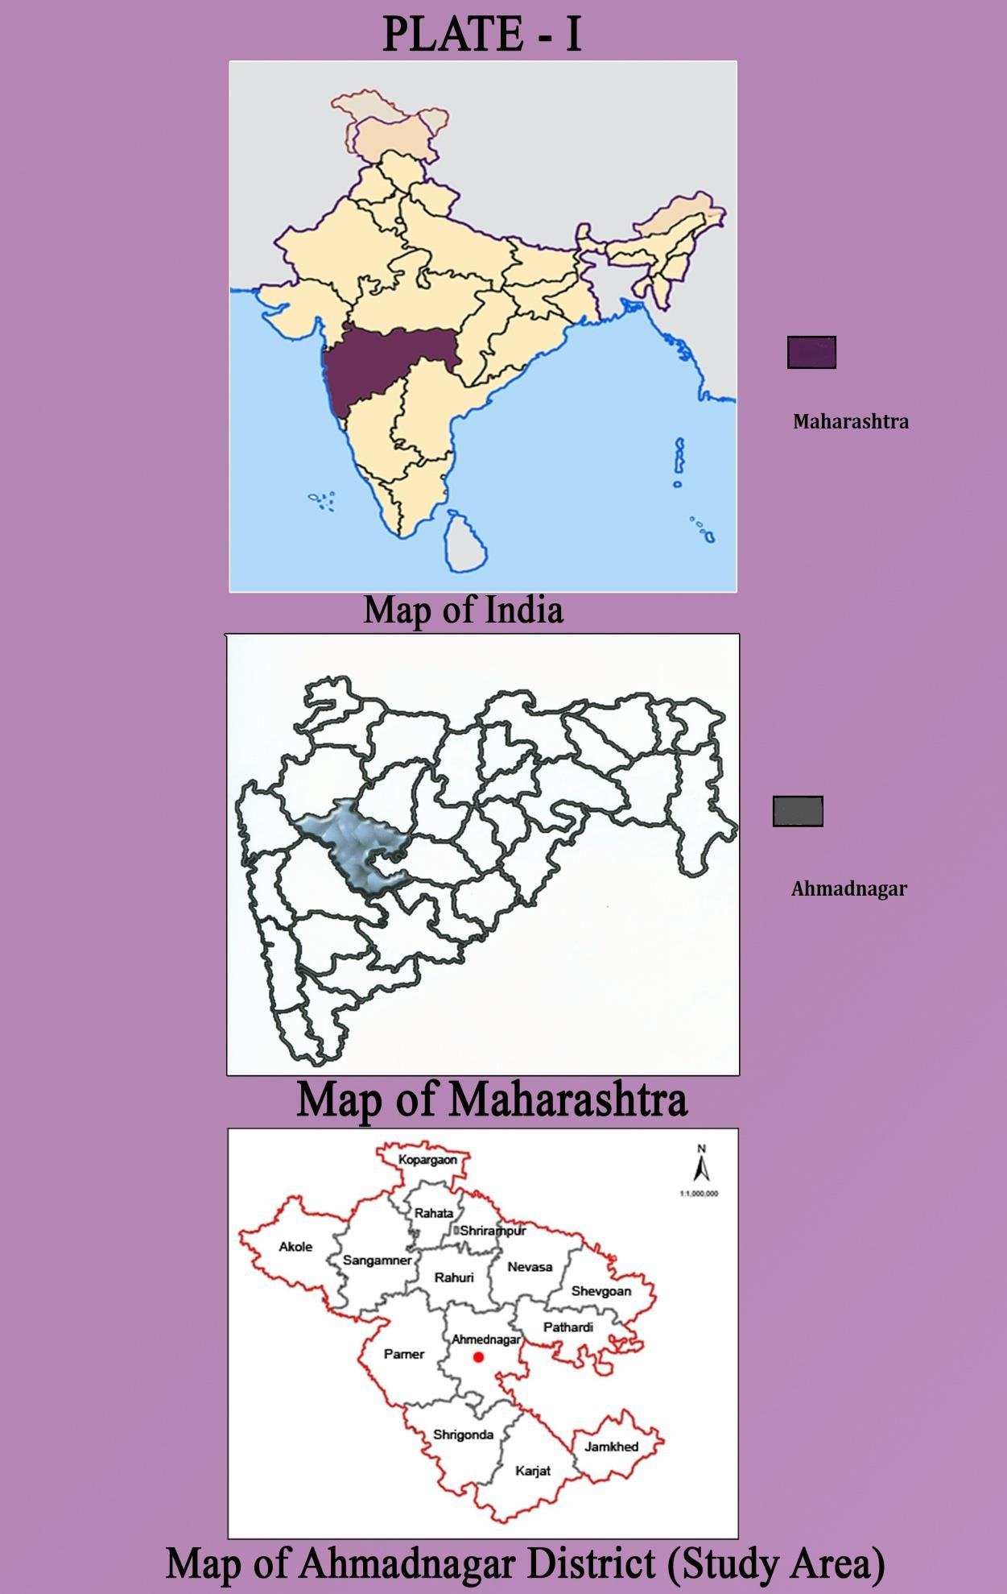
Map of India | Map of Maharashtra | Map of Ahilyanagar

The present work was carried out in the Ahilyanagar district, (M.S.) the different regions of GIT were carried out to collect and separate the visible parasites in petri dishes according to predilection sites. The gastrointestinal tract of host was opened in a longitudinal section with forceps, GI tract of host was dissected and parasites were collected from intestine and preserved in 4% formaldehyde and parasite counting and slides were made by staining and mounting process. Scanning Electron Microscopy parasites by (Dey et.al, 1989; Roy and Tandon, 1991). Drawing with Camera Lucida was made having measurement is in millimeters. Parasite diagnosis were done by standard methods identification of the cestode parasites as per key (Soulsby, 1982; Cable, 1957; Belghyti, 1994) and Parasites were identified based on helminthological keys described by Yamaguti (1959, 1961), (Khalil et.al,1994) and (Anderson et. al, 1974) under a light microscope. For prevalence of infection examined the presence of Raillietina (R) fuhrmanni in each week of every month for a period of consecutive year study period from (Jane 2020 to May-2021). The prevalence of infection and mean intensity were calculated from the recorded data with the help of the following formulas on the basis of percentage of incidence (Prevalence) of infection by using following formula. (Bush et. al, 1997).

Total number of hosts examined
Prevalence (%) = ---------------------------------------------X 100​
Number of infected hosts

Number of infected hosts
Mean Intensity = ---------------------------------------------
Total number of parasites recovered​
Results And Discussion
- General morphology of the cestode

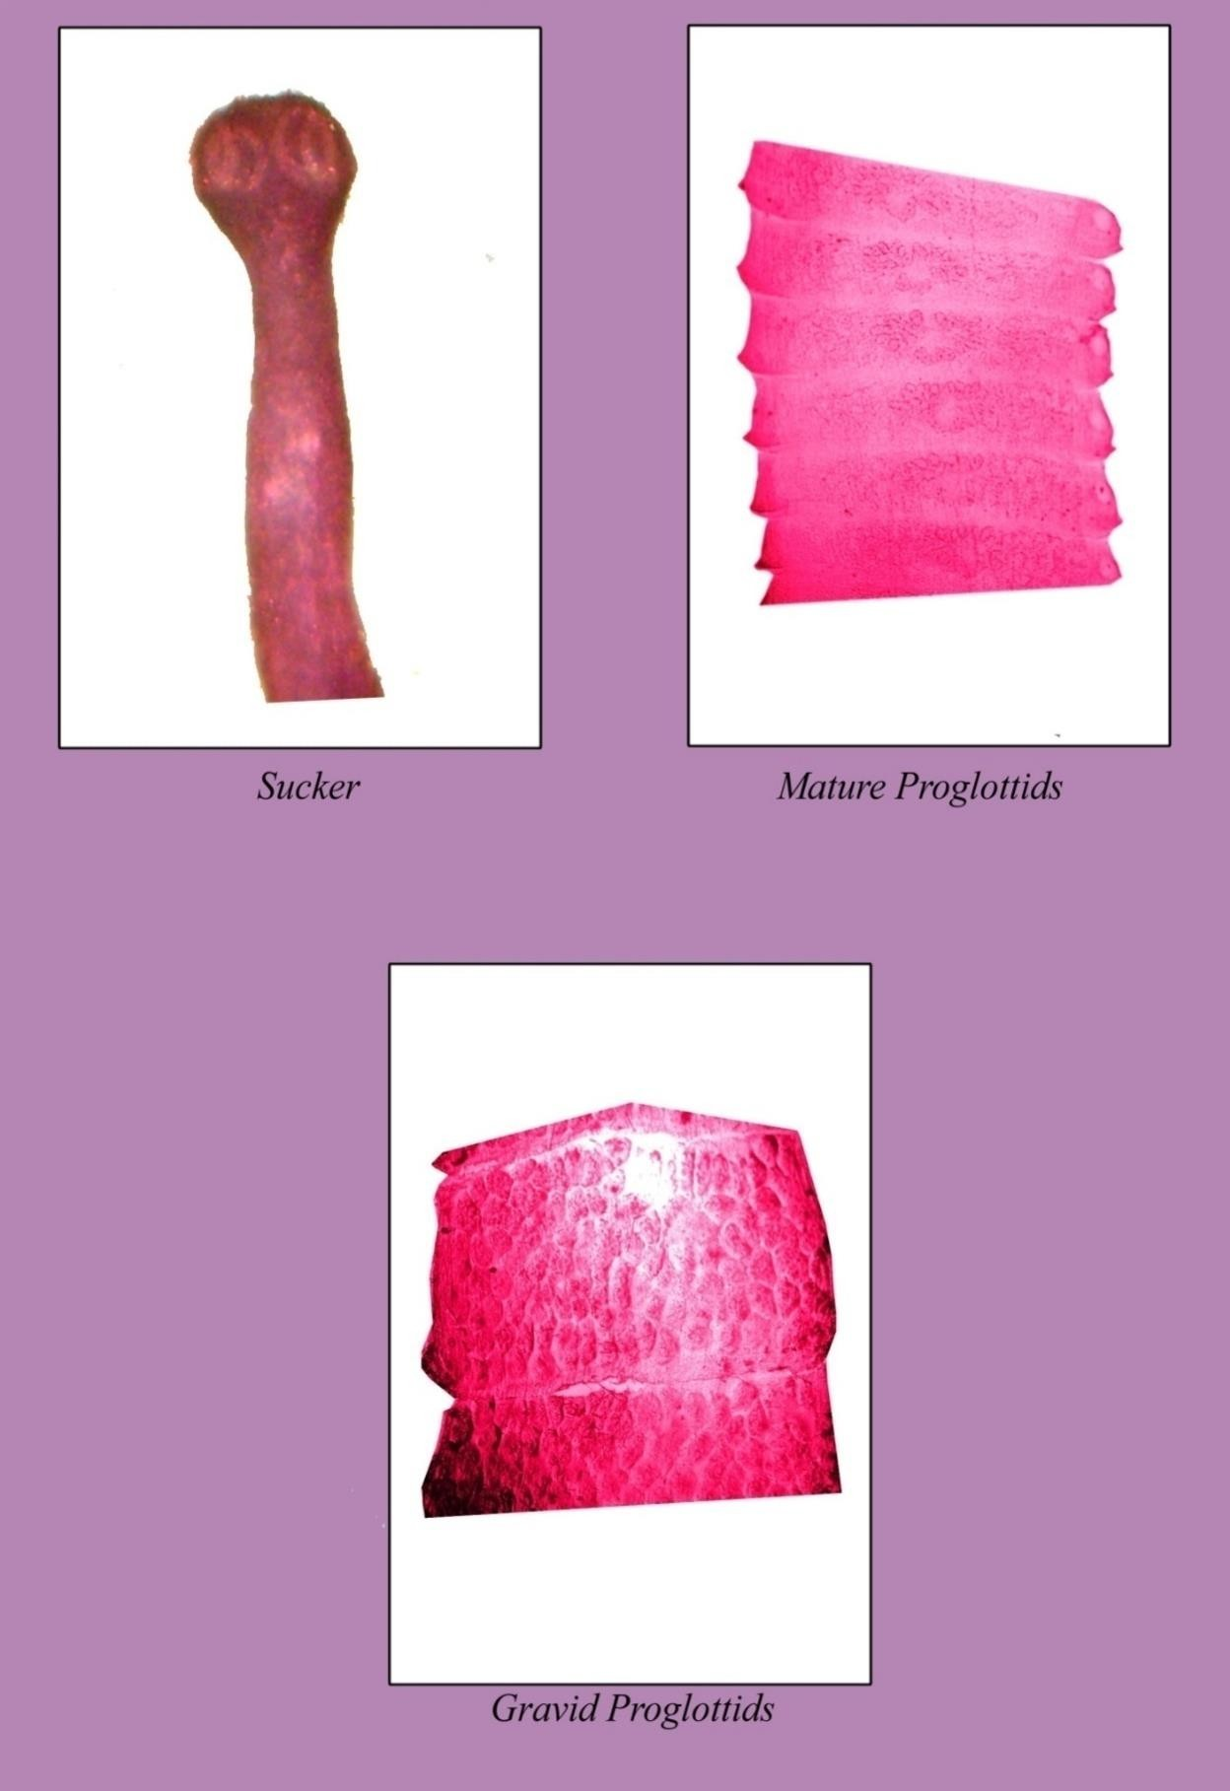 | 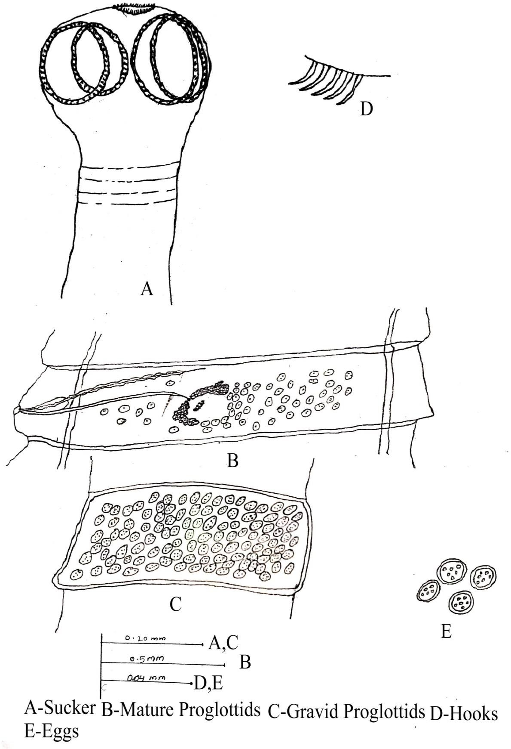 | 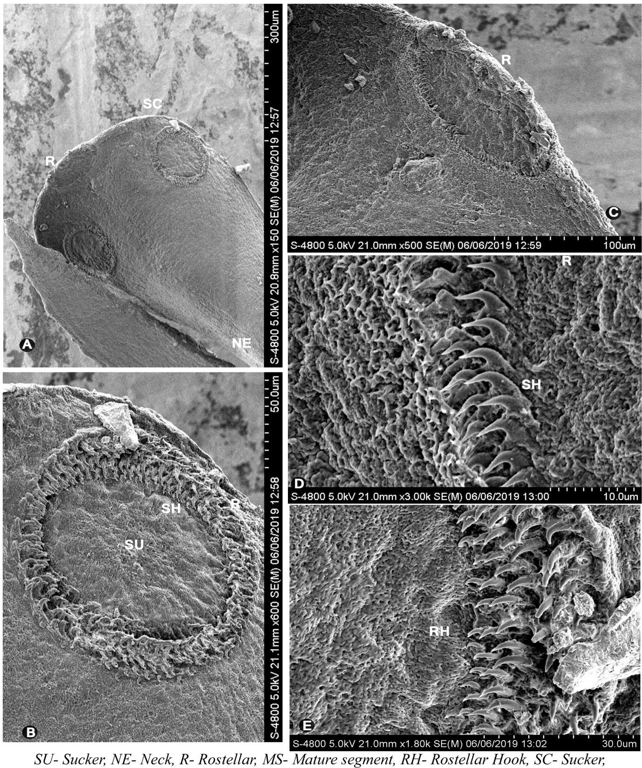
Fig 1: Photos shows that scolex, mature and gravid segment of cestode | Fig 2: Camera Lucida shows that scolex, mature and gravid segment of cestode | Fig 3: Scanning electron microscopy showing scolex and Hooks of parasites

Cestodes parasites were very long and narrow consist of scolex and mature segments, which on closer observation, turned out to be the species of the genus Raillietina (R) fuhrmanni, (Southwell, 1922)
The cestode was creamy white in color having 20-80 mm length in size. The scolex is small in size, oval to rounded in shape, anteriorly narrow and broad Posteriorly, distinctly marked off from the strobilla and measures 0.2717 (0.2669- 0.2766) in length and 0.2257 (0.2184-0. 2330) in breadth. The scolex bears an armed rostellum, which is large in size, retractile, oval to rounded in shape, with rostellum hooks, situated at the apex of scolex and measures 0.0703 (0.0679-0.0728) in length and 0.0121(0.0097-0.0145) in breadth. The rostellum hooks are arranged in two circles, transversely elongated, which are 90-100 in number, which are small, simple, pin like, single pronged and measures 0.0090 (0.0085-0.0096) in length and 0.0015 (0.0010-0.0021) in breadth. The scolex bears four suckers, medium in size, oval in shape, arranged in two pairs, overlapping on each other, separate pairs obliquely placed, near the lateral margin and measures 0.1358 (0.1067- 0.1650) in diameter. The sucker margins are covered with numerous minute spines, which are 4-5 transverse rows. The neck is of medium length and width, longer than broad with smooth, nearly equal to width of head and measures 0.1723 (0.1699- 0.1747) in length and 0.1189 (0.1165- 0.1213) in breadth
The mature segments are medium in size, craspedote, broader than long almost three time broader than long, with posterior corners projecting outside and measures 1.6761 (1.6477- 1.7045) in length and 0.2181 (0.0386- 0.3977) in breadth. The testes are 40-50 in numbers, medium in size, oval in shape, situated almost in posterior and lateral sides of ovary, in the posterior half of central medulla, unevenly distributed bounded laterally by the longitudinal excretory canals and measures 0.0283 (0.0227-0.0340) in diameter. Cirrus pouch is medium in size, oval in shape, narrow anteriorly, broad posteriorly, obliquely placed, situated at the half of the lateral region of the segments, marginal, cortical and measures 0.0283 (0.0227-0.0340) in length and 0.0170( 0.0113- 0.0227) in width. Cirrus is thin, slightly coiled, contained within the cirrus pouch and measures 0.1988 (0.1931 -0.2045) in length and 0.0511 (0.0454-0.0568) in breadth. The vas deferens is medium width , extends medially, runs parallel to vagina, coiled and measures 0.7329 (0.7272-0.7386) in length and 0.0397 (0.0340-0.0454) in breadth. Vagina and cirrus pouch opens as a genital pores which are medium in size, oval in shape, marginal, unilateral, situated at the middle of the segment, post-ovarian and measures 0.0113 in diameters. The ovary is medium in size, distinctly bilobed, obliquely placed just anterior to the middle of the segment, with 3-5 round, blunt acini, aporal lobe larger than poral lobe and measures 0.2556 (0.2500-0.2613) in length and 0.0397 (0.0340- 0.0454) in breadth. Vagina is thin tube, situated posterior to the cirrus pouch, starts from the genital pore, runs obliquely, anterior to the poralovarian lobe, reaches and opens into the ootype and measures0.7443 (0.7386-0.7500) in length and 0.0283 (0.0227 –0.0340) in breadth. The isthmus is short, wide, connects the two ovarian lobes and measures 0.0397 (0.0454-0.0340) in length and 0.0170 (0.0227-0.0113) in breadth. The ootype is small in size, oval in shape, placed on the isthmus and measures 0.0113 (0.0113-0.0113) in diameter. The vitelline gland is large in size, oval in shape, situated in the middle of the segment, post ovarian and measures 0.0226 (0.0340-0.0113) in length and 0.0170 (0.0113-0.0227). The longitudinal excretory canals are long tube, paired, running across proglottids, longitudinally on both the side of proglottids and measures 0.3465 (0.3409- 0.3522) in length and 0.0283 (0.0227-0.0340) in breadth. The gravid segments are broader than long contains 80 to 90 eggs capsules and each egg capsule contain 5 to 6 eggs and measures 0.0058 (0.0053 -0.0064) in length and 0.0090 (0.0096-0.0085) in breadth. Eggs are rounded and measures 0.0037 (0.0042-0.0032) in diameters.
- b) Seasonal variation R. fuhrmanni (Southwell, 1922)
Table 1. Monthly variation in % of prevalence and Mean intensity of infection of R. fuhrmanni in the period June 2020 to May2021.

Season | Month | No. of host Gut  examined | No. of host  infected | Total no. of parasites  collected | Prevalence % | Mean Intensity
Monsoon | June-2020 | 18 | 12 | 71 | 66.67 | 5.92
Monsoon | Jully-2020 | 23 | 18 | 134 | 78.26 | 7.44
Monsoon | August-2020 | 22 | 19 | 121 | 86.36 | 6.37
Monsoon | September-2020 | 14 | 11 | 57 | 78.57 | 5.18
Winter | October-2020 | 19 | 7 | 33 | 36.84 | 4.71
Winter | November-2020 | 14 | 4 | 22 | 28.57 | 5.50
Winter | December-2020 | 9 | 1 | 12 | 11.11 | 12.00
Winter | January-2021 | 7 | 0 | 0 | 0.00 | 0.00
Summer | February-2021 | 13 | 3 | 20 | 23.08 | 6.67
Summer | March-2021 | 17 | 4 | 18 | 23.53 | 4.50
Summer | April-2021 | 12 | 5 | 13 | 41.67 | 2.60
Summer | May-2021 | 14 | 7 | 23 | 50 | 3.29
 |  | Total no. of sample: 182 | Total number of infected host: 91 | Total number of parasite present: 524 | Mean percentage of prevalence: 43.72%

Graph- 1. Monthly variation in % of prevalence of infection of R. fuhrmanni) in the period June 2020 to May 2021.

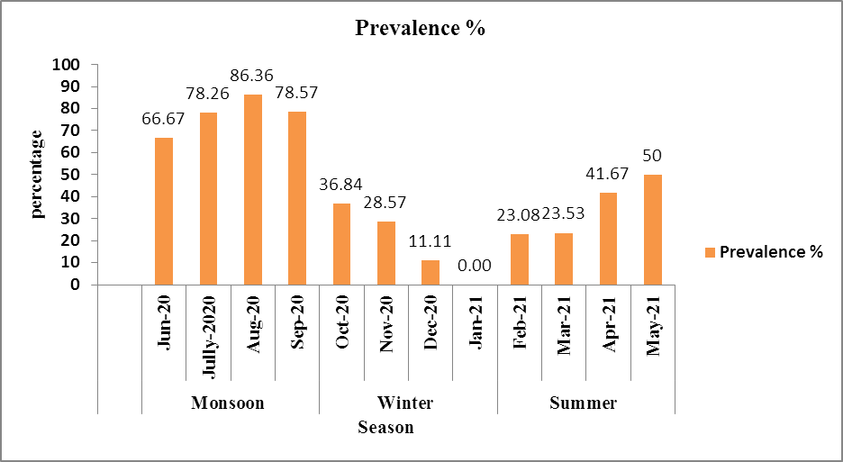

In the study period of June-2020 to May-2021 out of 182 host intestine examined, 91 were found infested with R. fuhrmanni. Total 524 parasites were collected. As R. fuhrmanni was isolated all through year from G. domesticus; seasonal prevalence and characterization were done for this species. Monthly variations in respect to percentage of prevalence and the mean intensity of R. fuhrmanni infection have been presented in Table-1 and total number of parasite present in G. domesticus in each season of study period has been shown average prevalence percentage was 43.72%. The study revealed that the higher percentage of prevalence of Raillietina (R) fuhrmanni occurred in summer season showing higher in May (50 %) and it showed its highest values during monsoon and the maximum value of percentage of prevalence was recorded in the month of July (86.36%) From September to November it tends to lower down and the lowest prevalence occurred in winter.
Conclusion
The present study confirms the occurrence of R. fuhrmanni as a common cestode parasite of Gallus domesticus, characterized by distinct morphological features of the scolex, proglottids, and reproductive organs. Seasonal analysis revealed clear fluctuations in infection patterns, with an overall prevalence of 43.72% during the study period (June 2020–May 2021). The prevalence and intensity of infection were highest during the monsoon months, indicating favorable environmental conditions for parasite transmission. The lowest prevalence recorded in January. These findings suggest that climatic factors play a significant role in the seasonal distribution of R. fuhrmanni and highlight the need for strategic parasite control measures during peak infection periods

COMPETING INTERESTS DISCLAIMER:
Authors have declared that they have no known competing financial interests OR non-financial interests OR personal relationships that could have appeared to influence the work reported in this paper.

Reference
- Anderson R C, Chabaud A G, Willmott S. CIH (1974): keys to the nematode parasites of vertebrates. Farnham Royal: Commonwealth Agricultural Bureau;
- Baylis H A (1929): some new parasitic nematodes and cestodes from Java. Parasit. 21: pp-25-65.
- Belghyti D, Berrada-Rkhami O, Boy V, Aguesse P, Gabrion C. (1994): Population biology of two helminth parasites of flatfishes from the Atlantic coast of Morocco. J Fish Biol.;44(6):1005–1021
- Bush AO, Lafferty KD, Lotz JM, Shostak AW. (1997): Parasitology meets ecology on its own terms: Margolis et al., revisited. J Parasitol.;83:575–583
- Cable RM. (1957): An illustrated laboratory manual of parasitology. 4. Minneapolis: Burgess Publishing;
- Dey S., Basu Baul T. S., Roy B. and Dey D. (1989): A new rapid method of air drying for scanning electron microscopy using tetramethylsilane. J. Microsc, 156 (13): 259-26.
- Dube S, Zindi P, Mbanga J, Dube C. (2010): A study of scavenging poultry gastrointestinal and ecto-parasites in rural areas of Matebelel and Province, Zimbabwe. Int J Poult Sci.
- Eshetu Y, Mulualem E, Abera K, and Ebrahim H, (2001):Study of Gastro- intestinal helminths of scavenging chicken in four districts of Amhara Region, Ethiopia Scientific and Technical Review, Office International desEpizooties, 20 (3): pp- 791-796.
- Fuhrmann O (1920): Die Systematic der ordnung der Cyclophyllidea. Zool. Anz. 32: pp-289-297.
- Jourdain Elsa , Michel Gauthier-Clerc, Dominique Bicout, and Philippe Sabatier(2007): Bird Migration Routes and Risk for Pathogen Dispersion into Western Mediterranean Wetlands, Emerg. Infect Dis. 13(3): pp- 365–372.
- Joyeux C. and Houdemer E. (1927) Recherches Sur La Faune Helminthologique de l’Indochine (Cestodes et Trematodes). Ann. Parasitol. Hum. Comp., 5, 289–309.
- Kapoor V. C. (1998): Theory and Practice of Animal Taxonomy (4th Ed): Oxford & IBH Publishing Co. Pvt. Ltd. New Delhi: 247.
- Khalil LF, Jones A, Bray RA. Keys to the cestodes parasites of vertebrates. International Institute of Parasitology (An Institute of CAB International); 1994.
- Kolluri R, Lakshmi C V and Rao K H (1986): On some cyclophyllidean cestodes of birds of Andhra Pr Riv. Di desh including a new species of Raillietina (R) Riv. Di parasitologia. 3: pp- 47.
- Malhotra S K and Capoor V N (1981): Studies on the taxonometry of poultry tapeworm Raillietina (R) sharanpurensis n.sp. Nov from foot hills of Garhwal Himalayas Biology, 3.
- Meggitt F J (1931): On cestodes collected in Burma. Part II. Parasit. Vol. 23 (2): pp- 250-263, figs. 6.
- Poulsen J, Permin A, Hindsbo O, Yelifari L, Nansen P and Bloch, P (2000): 'Prevalence and distribution of Preventive Veterinary Medicine, 45(3-4): pp- 237-245
- Roy B. and Tandon V. (1991). Usefulness of tetra-methylsilane in the preparation of helminth parasites for scanning electron microscopy. Riv. Parassitol, 8: 207-215
- Sawada I (1957): Raillietina (R) peradenica n.sp. From a Ceylon domestic fowl, gallus domesticus Jap. J. Med. Sc. And Biol., 10 (3-4): pp- 243-246.
- Soulsby E. J. L. (1982). Helminthes, Arthropods and Protozoan are of domesticated animals (7th Ed). Bailliere Tindale, London.
- Southwell T (1922): Cestodes from Indian birds, with a note on Ligula intestinalis. Ann. Trop. Med. Par. 16: pp- 355-382.
- Wankhed H. J. and Gholap A. B. (2016). Effect of Cestode Parasites on Hematological Parameters in Gallus gallus domesticus in Ahmednagar District Int. J. Life.5-11.
- Yamaguti S (1959): Systema Helminthum, Vol. II Cestodes of Vertebrates. Interscience Publishers, New York and London, pp-1-860.
- Yamaguti S (1961): Systema Helminthum Vol. III. The Nematodes of vertebrates. Interscience Publishers. New York and London, pp-1-679
- Yamaguti S. (1940). Studies on helminth fauna of Japan. Part- 30, Cestodes birds, II. Japan. J. Zool. Med. Sc. Soct. IV, V, I: 175- 211.

