Effect of soil and sand on infectivity of entomopathogenic fungi against white grub Holotrichia longipennis

Abstract:
Bioassay studies were done to evaluate the potential of Beauveria bassiana and Metarhiziun anisopliae against white grubs, and to study the effect of soil and sand on infectivity of B. bassiana and M. anisopliae against first, second and third instar grubs of H. longipennis. The first instar larvae of H. longipennis were found to be most susceptible to both entomopathogenic fungi when treated in soil, with the mean mortality rate of 61.56 and 63.90 per cent for B. bassiana and M. anisopliae, respectively compared to second and third instars. A positive correlation between the inoculation concentration and the grub mortality was observed, irrespective of age, in all the instars. Regardless of concentrations or instars, soil consistently performed better as s substrate than sand in terms of mortality rates. The mean mortality rates of H. longipennis were calculated to be 61.56, 50.67 and 43.56 per cent for first, second and third instar grubs, respectively when treated with B. bassiana @ 1x10⁸ conidia/ ml in soil, but the mortality rates decreased to 57.18, 47.19 and 38.67 per cent for first, second and third instar grubs when sand was used as substrate. Similarly, when the grubs were treated with M. anisopliae in soil, the mortality rates were recorded as 63.90, 53.77 and 44.88 per cent for first, second and third instar grubs respectively, but when sand was used as substrate, the mortality reduced to 61.33, 50.22 and 43.55 per cent for first, second and third instar grubs.
Keywords: Entomopathogenic fungi, Inoculation, Instars, Concentrations, Mortality
Introduction
Scarabaeidae is one of the largest family of Coleoptera, which contains more than 30,000 species throughout the world (Fincher 1981). It constitutes a large distinct group of highly specialized beetles, which could easily be identified by their lamellate antennae (Gardner 1935). The larvae of scarab beetles are commonly known as “white grubs” which are chiefly found in grasslands feeding on roots of many plants (Mehta et al. 2010). Being polyphagous, they feed on a wide variety of cultivated as well as uncultivated plants. Almost all field crops grown during rainy season, viz., potato, vegetables, groundnut, sugarcane, maize, pearl millet, sorghum, cowpea, pigeon pea, cluster bean, soybean, rajmash, upland rice, and ginger are damaged by white grubs (Mishra 2001). In India, white grubs have been included in the category of five national pests (Misra and Chandla 1989), and are reported from every state causing damage to wide variety of cultivated crops.
Management of these scarabaeids is a more complex and time-consuming task because the adults and grubs inflict distinct forms of damage as the adults feed mostly on leaves and grubs on underground pasts viz. roots, tuber, etc. Adults are mobile while grubs’ movement is restricted in soil, so managing one life stage does not guarantee prevent difficulties caused by the other (Chandel et al. 2015). Traditionally, white grubs have been managed with soil pesticides, but this is typically ineffectual due to the difficulty of transporting these insecticides through the soil to the root zone (Misra and Chandel 2003). Prolonged use of chemicals to the soil for white grub management not only pollutes the soil, but it also has a negative impact on non-target species and the environment.
Microbial control techniques are valuable components of integrated pest management (IPM) and offer advantages over chemical pesticides (Rosset and Moore 1997). Meanwhile, a number of fungal species have been studied, commercialised, and registered for the control of numerous insect pests. Products based on Beauveria bassiana (Balsamo) Vuillemin, Beauveria brongniartii (Sacc.) Petch, Metarhizium anisopliae (Metschnikoff) Sorokin, Paecilomyces fumusoroseus (Wize) Brown and Smith and Verticillium lecanii (Zimm) Viegas are applied in a number of countries (Keller, 2000). The cumulative impacts of entomopathogenic fungi-pest interactions cause alterations in normal physiology and development. Insects infected with specific fungal diseases exhibit feeding stimulation, followed by feeding reduction, and lastly reduced mobility, behavioral response, and migration pattern modifications (Khachatourians 1996).
Entomopathogenic fungi have limited effect on non-targets and are a safer alternative to chemical pesticides in integrated pest management (Goettel and Hajek 2000; Pell et al. 2001). Entomo-pathogenous fungi are interesting biocontrol agents, due to their epizootics and pathogenicity (Devi et al. 2001). Among them, Beauveria and Metarhizium are the most studied fungus which infects many insect species in different parts of the world (Hajek and St. Leger 1994), being frequently isolated from mycosed insect corpses (Devi et al. 2001), and used as entomopathogenic agent in biological control programmes (Cruz et al. 2006; Dolci et al. 2006).
Materials and methods
Collection of beetles and grubs from field and culture maintenance in laboratory
The adults of Holotrichia longipennis (Blanchard) were collected from the Agroforestry unit of CSKHPKV, Palampur and were transferred to glass jars which were half filled with mixture of moist sand, soil and FYM (1:1:1), and then the twigs of rose, peach and plum were fixed in the soil for feeding and mating of beetles. After mating, female beetles lay eggs in soil and jars were daily examined for the presence of eggs, and fresh twigs of preferred hosts were provided as food for adults daily. The eggs were separated with the help of moist Camel’s hair brush.
Rearing and maintenance of white grub culture in laboratory
The eggs hatched in 10-12 days after egg laying and freshly hatched grubs were transferred to paper cups containing moist soil having 4-5 days old maize seedlings. Second and third instar grubs were maintained on potato tubers. Development and survival of the white grub culture were checked by emptying out the soil and examining the contents regularly. The culture was utilized for the evaluation of entomopathogenic fungi against them in the laboratory experiments.
Evaluation of test fungi against white grubs
To study the effect of soil and sand on infectivity/ efficacy of fungi against white grubs, 100g of substrate mixture was put in the paper cups. Different graded concentrations starting from 6.25x10⁶, 1.25x10⁷, 2.5x10⁷, 5x10⁷, 1x10⁸ conidia/ ml were prepared. Larvae were smeared or dipped with conidial concentrations of biopesticides for 30 seconds. Each treatment was applied to a set of 15 grubs which was replicated three times. The grub mortality was monitored every 24 hours after inoculation, with assessments conducted at five-day intervals for a total duration of 25 days. Mortality data was subjected to statistical analysis through completely randomized design (CRD), as per the guidelines of Gomez and Gomez (1984) and wherever necessary, data were suitably transformed. The mortality data were converted to per cent mortality and per cent mortality was corrected by using Abbott's formula. (Abbott 1925)

Per cent corrected mortality = $\frac{\% mortality in treatment-\% mortality in control}{100-\% mortality in control}$ ×100

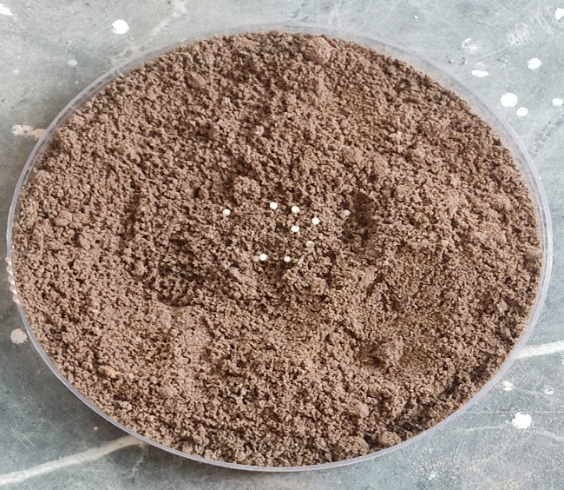

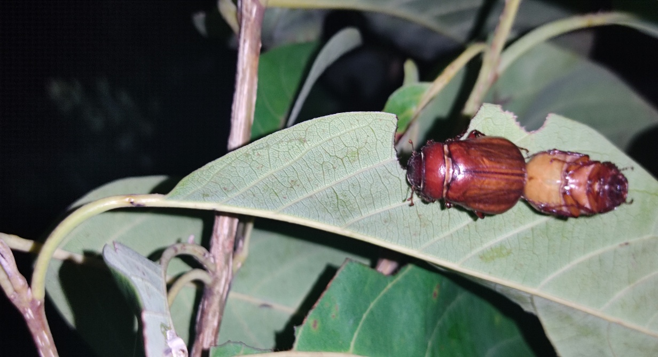

A)
B)
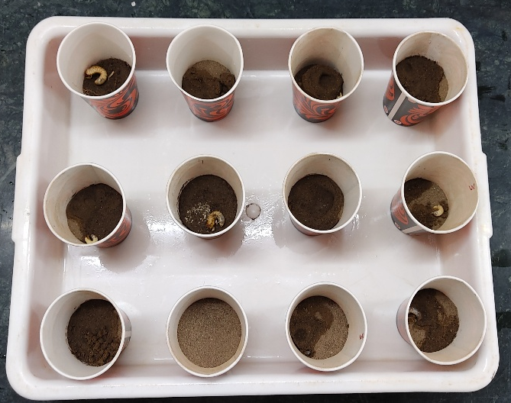

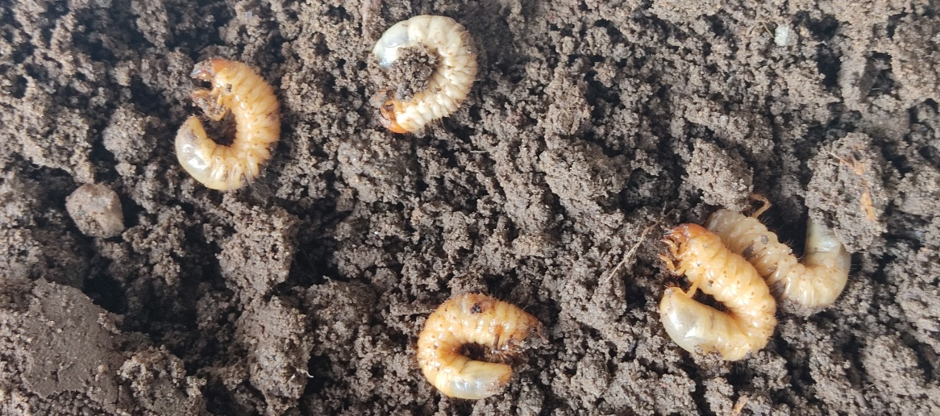

D)
C)
Fig 1. A) Mating of adult beetles oh H. longipennis, B) Separated eggs on petri plate, C) Third instar larvae treated with fungal concentrations, D) Paper cups used for observing grub mortality at different concentrations of B. bassiana and M. anisopliae

Results and Discussions
Evaluation of B. bassiana against grubs of H. longipennis in soil and sand First instar
First instar: Beauveria bassiana's effectiveness against first instar grubs of Holotrichia longipennis in soil and sand was compared, and the results showed that mortality rose steadily with concentration and time in both treatments. The highest concentration (1×10¹ conidia/ml) in soil produced a mean corrected mortality of 61.56% and a maximum corrected mortality of 74.44% at 25 days, while the same concentration in sand produced a slightly lower mean mortality of 57.18% and a maximum mortality of 68.10%. Similarly, soil had a little higher overall mean adjusted mortality at 25 days (45.56%) than sand (43.53%). Additionally, mortality in the control group was slightly greater in soil (4.44%) than in sand (2.22%).
Second Instar: The highest concentration (1×10¹ conidia/ml) in soil produced a mean corrected mortality of 50.67% and a maximum corrected mortality of 62.22% at 25 days, while the same concentration in sand produced a slightly lower mean mortality of 47.11% and a maximum mortality of 57.77%. Additionally, soil had a greater overall mean adjusted mortality at 25 days (39.11%) than sand (33.78%). There was no mortality in the control group in either therapy. Furthermore, after 15 days, the increase in mortality over time was more noticeable in soil, whereas the influence of time was relatively less significant in sand.
Third Instar: The maximum corrected mortality in soil at the greatest concentration (1×10¹ conidia/ml) was 53.33% after 25 days, with a mean corrected mortality of 43.56%. In contrast, the equivalent values were slightly lower in sand, with a maximum mortality of 48.89% and a mean corrected mortality of 38.67%. Additionally, soil had a greater overall mean adjusted mortality at 25 days (32.45%) than sand (28.44%). The mean corrected mortality was 6.22% in soil and 4.44% in sand at the lowest concentration (6.25×10² conidia/ml), showing consistently lower mortality in sand across concentrations and time periods.
Fig. 2 Comparison of corrected mortality of different instar grubs of H. longipennis to B. bassiana in soil and sand

The comparison of corrected mortality of different instars in soil and sand revealed that the performance of soil invariably surpassed sand as a medium for the application of B. bassiana. This result is supported by the findings of Erler and Ates (2015), who tested an emulsifiable spore concentrate of B. bassiana against the white grub and discovered that younger larvae (first and second instar) were more prone to infection than older ones. There are no studies on the effectiveness of Beauveria bassiana against H. longipennis, especially in laboratory settings. Beauveria brongniartii is commonly used to suppress whitegrubs, as it appears to be unique to these beetles. In India, B. brongniartii has also shown promise against whitegrubs. In studies by Jayaramaiah and Veeresh (1983) and Vyas et al. (1990), B. brongniartii was shown to infect all stages of Holotrichia serrata, H. consanguinea, and H. fiegei.
Evaluation of Metarhizium anisopliae against grubs of H. longipennis in soil and sand
First Instar: The greatest concentration (1×10¹ conidia/ml) in soil produced 77.37% mortality at 25 days, with a mean corrected mortality of 63.90%. In contrast, the same concentration in sand produced 73.33% mortality at 25 days, with a mean corrected mortality that was significantly lower. The mean corrected mortality was 19.61% in soil and 18.22% in sand at the lowest concentration (6.25×10¹ conidia/ml), suggesting slightly lower mortality in sand. Control mortality was 2.22% in soil and 0% in sand, indicating that soil had a marginally higher mortality response than sand.
Second Instar: After 25 days, mortality in soil ranged from 20.00 to 64.44% at concentrations ranging from 6.25×10¹ to 1×10¹ conidia/ml. After 25 days, mortality in sand at the same concentration range varied between 20.00 and 60.00%. In sand, the mean adjusted mortality rose from 13.77% at 6.25×10¹ conidia/ml to 18.66%, 25.33%, and 37.33% at 1.25×10¹, 2.5×10¹, and 5×10¹ conidia/ml, respectively, with a high of 50.22% at 1×10¹ conidia/ml. In sand, the average adjusted mortality rose over time from 22.66% at 5 days to 25.33% at 10 days, 30.91% at 15 days, 31.55% at 20 days, and 38.22% at 25 days.
Third Instar: After five days, mortality in soil varied from 4.47 to 35.55%, and after fifteen and twenty-five days, it rose to 44.44 to 57.77% across concentrations (6.25×10¹ to 1×10¹ conidia/ml). A maximum mean corrected mortality of 42.01% was obtained at the greatest concentration (1×10¹ conidia/ml), while a mean corrected mortality of 15.23% was recorded at the lowest concentration (6.25×10¹ conidia/ml). After 25 days, mortality in sand varied from 17.77 to 55.55%, which was somewhat less than the highest range found in soil.
Fig. 3 Comparison of corrected mortality of different instar grubs of H. longipennis to M. anisopliae in soil and sand

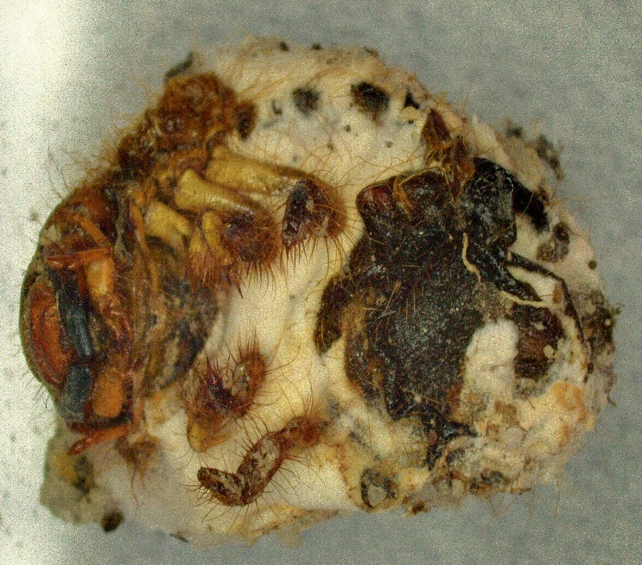
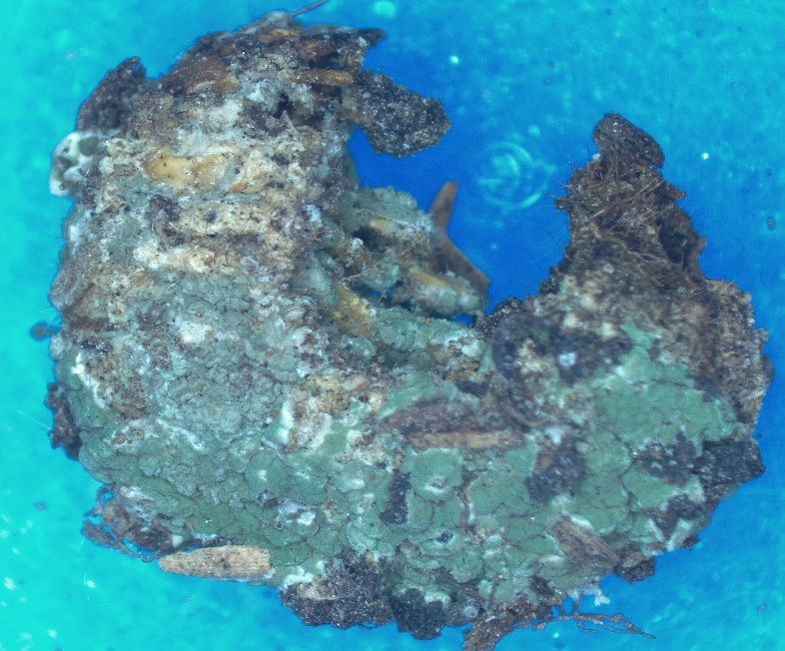
This result is corroborated by the findings of Ansari et al. (2004) who reported third instar larvae of H. parallela was most susceptible to infection by M. ansisopliae after incubating for eleven weeks at 25°C. Ambethgar (2003) revealed in his study that M. anisopliae Caused 93.3 per cent mortality in Holotrichia sp. Grubs after 20 days of inoculation. Kulye and Pokharkar (2009) estimated infectivity of M. anisopliae to third instar grubs of H. consanguinea as 5.76x10⁵ conidia/ ml.
B)
Fig 4. A) Grubs of H. longipennis infected with Metarhizium anisopliae
B) Grubs of H. longipennis infected with Beauveria bassiana

A)
In the present study, a positive correlation between the inoculation concentration and the grub mortality was observed, irrespective of age, in all the instars. There was gradual decrease in susceptibility with advancement of age as indicated by values of corrected mortality. In both soil and sand, the first instar showed the highest mortality rates across all concentrations because they were most vulnerable to ecological stressors and unfavourable conditions. At the highest concentration of 1x10⁸ conidia/ ml, the corrected mortality reached 61.56 per cent in soil and 57.18 per cent in sand for B. bassiana and 63.90 per cent in soil and 61.33 per cent in sand for M. anisopliae. The trend persisted consistently across all concentrations, indicating an important relationship between the concentration levels and the health of these early life stages. Even at the lowest concentration of 6.25x10⁶ conidia/ ml, the first instar had a higher mortality rate instars (17.08% in soil and 12.92% in sand against B. bassiana and 19.61% in soil and 18.22% in sand against M. anisopliae) than the other. Therefore, first instar grubs are most susceptible to B. bassiana and M. anisopliae, followed by second and third instar grubs. This suggests that H. longipennis instars at younger stages of life cycle are more sensitive to fungal infection, which is important for pest control strategies.
Regardless of concentration or instar, soil consistently performed better than sand in terms of mortality rates. For first instar, corrected mortality in soil was higher than sand across all concentrations, particularly at higher concentrations. Soil creates an environment that is more conducive for fungal development and persistence, because it retains more moisture, the fungal conidia do not dry up, which is a common problem with sand because of its reduced water-holding capacity. Additionally, soil contain more organic matter that serves as fungus's source of nutrients, increasing its chances of surviving and infecting the host.
Instar | Observed mortality (%) after indicated days
Instar | Soil |  |  | Sand
Instar | 15 Days | 20 Days | 25 Days | 15 Days | 20 Days | 25 Days
1st Instar | 60.00  (50.79) | 66.67  (54.78) | 74.44  (59.65) | 57.78 (49.46) | 62.22 (52.07) | 68.10 (55.63)
2nd Instar | 48.89  (44.35) | 55.55  (48.18) | 62.22  (52.07) | 46.66 (43.06) | 51.11 (45.61) | 57.77 (49.46)
3rd Instar | 42.22  (40.50) | 48.89  (44.35) | 53.33  (46.90) | 37.77 (37.89) | 42.22 (40.50) | 48.89 (44.34)
Instar | Observed mortality (%) after indicated days
Instar | Soil |  |  | Sand
Instar | 15 Days | 20 Days | 25 Days | 15 Days | 20 Days | 25 Days
1st Instar | 62.22 (52.07) | 68.89 (56.10) | 77.37 (61.56) | 62.22 (52.07) | 66.66 (54.78) | 73.33 (59.00)
2nd Instar | 53.33 (46.90) | 57.77 (49.46) | 64.44 (53.39) | 48.89 (44.34) | 53.33 (46.90) | 60.00 (50.78)
3rd Instar | 44.44 (41.78) | 46.66 (43.06) | 57.77 (49.46) | 42.22 (40.50) | 48.89 (44.34) | 55.55 (48.17)
Table 1. Mortality response of different stages of grubs of H. longipennis to B. bassiana in soil and sand
Table 2. Mortality response of different stages of grubs of H. longipennis to M. anisopliae in soil and sand
Conclusion: Entomopathogenic fungi such Beauvaria bassiana and Metarhizium anisopliae are favoured over chemical pesticides for the management of white grub because they offer an environmentally benign, sustainable and target-specific treatment that reduces environmental contamination and resistance development while preserving long-term pest suppression. The first instar larvae of H. longipennis were found to be most susceptible to both entomopathogenic fungi when treated in soil and sand, with B. bassiana and M. anisopliae compared to second and third instar. This suggests that H. longipennis grubs at younger stages of life cycle are more sensitive to fungal infection, which is important for pest control strategies. Soil outperformed sand as a substrate causing higher mortality for both B. bassiana and M. anisopliae due to better moisture retention and organic matter content in soil, which provides favourable environmental conditions for conidia to grow and infect the host. These findings hold great promise for the use of entomopathogenic fungi for integrated pest management of white grubs. Further investigations under field conditions would be the next step to ensure the results we have found hold true under greater biotic and abiotic stresses.

COMPETING INTERESTS DISCLAIMER:
Authors have declared that they have no known competing financial interests OR non-financial interests OR personal relationships that could have appeared to influence the work reported in this paper.
References:
Abbott, W.S. (1925). A method of computing the effectiveness of an insecticide. Journal of Economic Entomology 18: 265-267
Ansari, M.A., Vestergaard, S., Tirry, L., & Moens, M. (2004). Selection of a highly virulent fungal isolate, Metarhizium anisopliae CLO 53, for controlling Hoplia philanthus. Journal of Invertebrate Pathology, 85, 89–96
Chandel, R.S., Pathania, M., Verma, K.S., Bhatacharyya, B., Vashisth, S., & Kumar, V. (2015). The ecology and control of potato white grubs of India. Journal of European Association for Potato Research, 58, 147-64
Cruz, L.P., Gaitan, A.L., & Gongora, C. E. (2006). Exploiting the genetic diversity of Beauveria bassiana for improving the biological control of the coffee berry borer through the use of strain mixtures. Applied Microbiology and Biotechnology, 71, 918-926
Devi, K.U., Padmavathi, J., Sharma, H.C., & Seetharama, N. (2001). Laboratory evaluation of the virulence of Beauveria bassiana isolates to the sorghum shoot borer Chilo partellus Swinhoe (Lepidoptera: Pyralidae) and their characterization by RAPD-PCR. World Journal of Microbiology and Biotechnology,17, 131-137
Dolci. P., Guglielmo, F., Secchi, F., & Ozino, O. I. (2006). Persistance and efficacy of Beauveria brongniartii strains applied as biocontrol agents against Melolontha melolontha in the Valley of Aosta (Northwest Italy). Journal of Applied Microbiology 100: 1063-1072
Erler. & Ates, A. O. (2015). Potential of two entomopathogenic fungi, Beauveria bassiana and Metarhizium anisopliae (Coleoptera: Scarabaeidae), as biological control agents against the june beetle. Journal of Insect Science 15: 1-6
Fincher, G. T. (1981). The potential value of dung-beetles in pasture ecosystem. Journal of Georgia Entomological Society 16: 316-333
Gardner, J. C. M. (1935). Immature stages of Indian Coleoptera (196). Indian Forest Records 1: 1-33
Goettel, M. S., & Hajek, A. E. (2000). Evaluation of non-target effects of pathogens used for management of arthropods. In: Evaluating indirect ecological effects of biological control. (Wajenberg E et al., eds.). CABI publishing, Wallingford. P 81-97
Gomez, K. A., & Gomez, A. A. (1984). Statistical Procedures for Agricultural Research. 2nd Edition, John Wiley and Sons, New York, P 680
Hajek, A. E., & Leger, R.J. St. (1994). Interactions between fungal pathogens and insect hosts. Annual Review of Entomology 39: 293-322
Jayaramaiah, M., & Veeresh, G. K. (1983). Fungal pathogens of white grubs in Karnataka. Journal of Soil Biology and Ecology 3: 83-87
Kulye, M. S., & Pokharkar, D. S. (2009). Evaluation of two species of entomopathogenic fungi against white grub, Holotrichia consanguinea (Blanchard) infesting potato in Maharashtra, India. Journal of Biological Control 23: 1-4
Keller, S. (2000). Use of Beauveria brongniartii in Switzerland and its acceptance by farmers. In: Integrated control of soil pest subgroup "Melolontha". (Keller S ed.). Proceedings of the meeting; IOBL, Switzerland,19-21 October 1998. IOBC/wprs bulletin 23: 67-72
Khachatourians, G. G. (1996). Biochemistry and molecular biology of entomopathogenic fungi, In: Human and animal relationships Mycota VI (DH Howard and JD Miller, eds.). Springer, Heidelberg P 331-363
Mehta, P. K., Chandel R. S., & Mathur, Y. S. (2010). Status of white grubs in North-Western Himalaya. Journal of Insect Science 23: 1-14
Mishra, P. N. (2001). Scarab fauna of Himalayan region and their management. In: Indian phytophagous scarabs and their management: present status and future strategies (G Sharma, YS Mathur and RBL Gupta, eds) Agrobios (India), Jodhpur. pp. 74-85
Misra, S. S., & Chandla, V. K. (1989). White grubs infesting potatoes and their management. Journal of Indian Potato Association 16: 29-33
Misra, S. S. & Chandel, R. S. (2003). Potato white grubs in India. Technical Bulletin No. 60. CPRI, Shimla, India. P 47
Pell, J. K., Eilenberg, J., Hajek, A. E., & Steinkraus, D. C. (2001). Biology, ecology and pest management potential of Entomophthorales. In: Fungi as biocontrol agents: progress, problems and potential. (TM Butt et al., eds.). CAB International, Wallingford. P 71-153
Rosset, P., & Moore, M. (1997). Food production and local production of biopesticides in Cuba. LEISA Newsletter 13: 18-19
Vyas, R. V., Yadav, D. N., & Patel, R. J. (1990). Compatability of Beauveria brongniartii with some pesticides used in groundnut pest management. Annals of Biology 6: 21-26

