Original Research Article

Architecture of Envenomation: A Histological Study of the Scorpion Telson and Its Venom Glands

ABSTRACT
Scorpions, members of the class Arachnida, possess a specialized venom apparatus used in both predation and defense. This system is located in the telson, the terminal segment of the metasoma, which houses the venom glands and enables controlled venom delivery. The present study examines the histological organization of the telson in three representative species namely, Hottentota tamulus, Scorpiops deccanensis, Deccanometrus xanthopus belonging to families Buthidae, Scorpionidae and Scorpiopidae to assess the structural patterns across taxa. Three specimens of each species were utilized for the experimental study. Telson tissues were processed using standard histological methods and stained with Hematoxylin and Eosin (H & E) as described by Godkar et al. (2008).
Microscopic observations revealed a consistent basic structural arrangement across species, including a dense outer cuticle, a thin but active epidermal layer, well developed paired venom glands, associated ducts, surrounding muscle fibers and scattered neural elements. The venom glands occupy most of the vesicle and are composed of secretory epithelial cells arranged around a central lumen. The glands are closely associated with ducts leading to the aculeus, surrounded by strong musculature. The close and intricate association between the glandular tissue and musculature suggests an efficient mechanism for venom expulsion. The presence of the scattered neural elements suggest a supportive regulatory control over the envenomation system. Overall, the study indicates conserved microanatomical organization reflecting a clear relationship between structure and function, with typical variations existing in the glandular structure and muscular development. These findings provide a strong basis for understanding the process of venom delivery in scorpions and broader insights into the effectiveness of the telson as an envenomation organ across the studied species.
KEYWORDS: Arachnida, Scorpion telson, venom gland histology, H& E staining, microanatomy

- INTRODUCTION:
Scorpions represent one of the earliest terrestrial arthropod lineages characterized by highly efficient venom apparatus used in both predation and defense. This system is localized within the telson, the terminal segment of the metasoma, which comprises a vesicle containing paired venom glands and a distal aculeus through which venom is delivered. Although the Scorpion morphology is well described, its internal organization requires detailed histological examination for better understanding of its functional mechanism. Scorpion telson displays a highly specialized anatomical structure that integrates both mechanical and secretory functions. The venom glands terminating in the aculeus, constitute the principal functional component of the telson, being responsible for the synthesis, storage and release of the toxic secretions. These glands typically consist of the secretory epithelial cells arranged around a central lumen and are closely associated with the surrounding musculature that facilitates the expulsion of venom. The underlying neural elements also thereby suggest a much controlled mechanism of envenomation. Despite the recognized importance of this system, comprehensive histological descriptions particularly the arrangement of glandular epithelium, musculature and cuticular modifications across different Scorpion taxa remain relatively limited (Bastawade, 1992; Goyffon &Heurtault, 1996; Yigit & Benli, 2008; Lourenco, 2020)
Histological observations provide a reliable means of examining these internal features, allowing detailed observation of the tissue architecture and functional relationships. Previous studies have largely focused on venom composition and toxicity, with comparatively less attention given to structural organization at the tissue level (Kiernan, 2015). The present study aims to examine the species from different families, to reveal the histological organization of the telson, identification of common structural patterns and the extent to which the telson organization is conserved across taxa. These observations contribute to a clearer understanding of the relationship between microstructure and function in the Scorpion venom apparatus.
- MATERIALS AND METHODS:
2.1 STUDY AREA AND COLLECTION SITES:
Field sampling for the present study was carried out in Pune district, Maharashtra, India over a period from May 2023 to June 2025. The region is positioned at the confluence of the Western Ghats and the Deccan plateau, a zone known for its varied terrain and seasonal environmental conditions. This diversity in landscape supports a wide range of habitats suitable for different Scorpion species. Sampling was undertaken at several locations, including Junnar (19.2032°N, 73.8743° E), Indapur (18.1187° N, 75.0234° E), Baramati (18.1792° N, 74.6078° E), Jejuri (18.1792° N, 74.6078° E), Purandar (18.2825° N, 73.9735° E), Saswad (18.3463° N, 74.0302°E). (Fig 1). These sites covered a range of habitats such as rocky slopes, scrub vegetation, open grasslands and agricultural fields. In addition to these broader habitat types, smaller microhabitats- particularly spaces beneath stones, fallen wood and tree barks were also explored as they provide shelter for scorpions during inactive periods. The study focused on representative species namely Hottentota tamulus, Scorpiops deccanensis, Heterometrus xanthopus (Recent taxonomic revision to Deccanometrus xanthopus, Mohapatra, P.P. (2024). Checklist of Fauna of India: Arthropoda: Arachnida: Scorpiones), belonging to families Buthidae, Scorpiopidae and Scorpionidae.
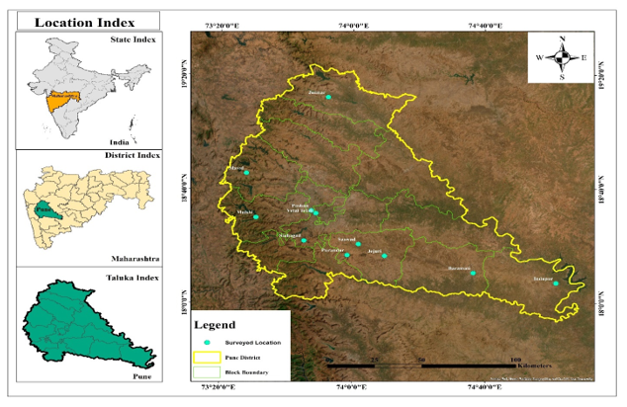
Figure 1: Map showing collection sites of Scorpions

2.2 COLLECTION AND IDENTIFICATION:
Collection of scorpions was undertaken after obtaining prior permission from the Maharashtra State Biodiversity Board, Nagpur. The surveys on field were conducted at selected sites in and around Pune, with sampling efforts focused primarily during evening and nocturnal periods, when scorpion activity is at its peak. The location of the scorpions was carefully examined in their microhabitats such as beneath stones, within rock crevices, tree barks and inside burrows (Fig 2). Nocturnal surveys were carried out under ultraviolet (UV) illumination which allows easy detection of scorpions. For this purpose, a handheld UV torch (AmiciVision 18W, 100 LED) was used.
Live specimens were collected using foreceps, following standard handling procedures. The collected specimens were brought to the laboratory for further processing while selected individuals were preserved in 70 % ethanol and labelled with relevant field data (Bastawade, 2012). (Fig 2).
Species identification was carried out using standard taxonomic keys, particularly Fauna of India: Scorpions (Arachnida: Scorpionida) (Tikader & Bastawade, 1983). The species were authenticated by Dr. Deshbhushan Bastawade, former scientist at the Zoological Survey of India, Western Regional Centre, and Arachnid Taxonomic expert, Pune.
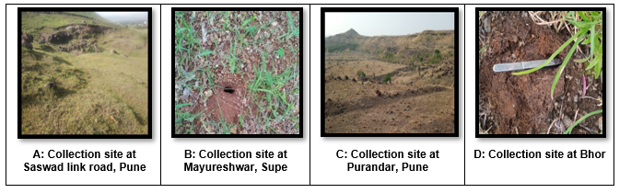
Figure 2: Collection sites in and around Pune region (A, B, C, D respectively)

2.3 REARING IN THE LABORATORY:
All procedures related to the rearing of Scorpion specimens were carried out in accordance with established ethical guidelines for invertebrate care (Sherwin et al., 2003; Fiorito et al., 2015). In the laboratory conditions were maintained to minimize stress as much as possible and to mimic the natural habitats.
Each specimen was housed individually in a plastic container (approximately 54 cm in diameter and 22 cm in height). A soil layer of about 5- 6 cm deep, covered with soft muslin cloth was provided for adequate ventilation as well as humidity (Fig 3). Small to medium sized stones were placed within each container to provide shelter and mimic natural hiding sites. (Brownell & Polis, 2001).
Water was supplied in shallow caps lined with cotton to maintain a consistent moisture level (Hadley, 1974). Feeding was carried out at regular intervals, on alternate days, using small portions of chicken. Feeding frequency and water availability were adjusted as per the seasonal fluctuations and ambient temperatures (Polis, 1990). The containers were cleaned and monitored regularly to maintain hygiene and disturbance to the animals was minimized (Sherwin et al., 2003).
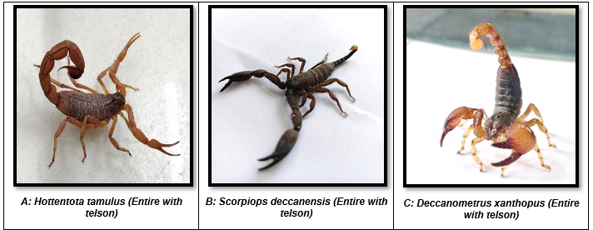
Figure 3: Representative Scorpions studied ( A: Family Buthidae- Hottentota tamulus; B: Family Scorpiopidae: Scorpiops deccanensis; C: Family Scorpionidae: Deccanometrus xanthopus (Rearing in the laboratory conditions

2.4 HISTOLOGICAL PREPARATIONS
All protocols and the experimental procedures related to the histological preparations of Scorpion telsons and venom glands were carried out in accordance with the established Institutional Animal Care and Ethics guidelines.

2.4.1 DISSECTION AND TISSUE PROCESSING
The telson was cut at its articulation at the last metasomal segment and immediately fixed to prevent autolysis and maintain structural integrity. The entire histological protocol was followed as per the methods described in standard literature (Godkar PB, 2006; Kiernan 2015) Fixation was performed using 10 % Neutral buffered formalin (NBF) (pH 7.4) alongwith 2% calcium acetate for one week. The volume of the fixative was 20:1 (fixative: tissue) to ensure adequate penetration. This step helped to soften the tissue at the same time avoid any distortions. Fixation was optimized to preserve both secretory and epithelial components of the venom gland while minimizing any structural artifacts. Further the telsons were immersed in Carnoy’s fixative for 24 hours to enhance the preservations of tissue specific components. Telsons were then kept in Formic acid for 2 hours so as to achieve adequate softening of the tough and extremely hard cuticular layer and make it suitable for sectioning by the microtome.

2.4.2 DEHYDRATION AND CLEARING
Dehydration was performed through ascending grades of ethanol (30%, 50%, 70%, 90% , Absolute ethanol) for 20 minutes each allowing gradual removal of water from the tissue. To ensure complete dehydration thoroughly, two changes of absolute ethanol were given. The samples were subsequently cleared in xylene (2 changes, 20 minutes each) until complete translucency was observed, indicating complete replacement of alcohol with the clearing agent (Kiernan, 2015).

2.4.3 PARAFFIN INFILTRATION AND EMBEDDING
Infiltration was performed using molten paraffin wax (MP: 60⁰ to 62⁰C) with 3 changes each. Tissues were embedded in blocks with careful attention provided towards the orientation of the tissue. (Suvarna et al. 2019). This step was crucial to obtain sections that clearly show the relationship between the venom gland and the aculeus.

2.4.4 SECTIONING AND STAINING
Paraffin embedded tissues were sectioned at 6 -8 µm thickness using a rotary microtome(Leica RM2125 RTS). Sections were floated on a warm water surface to remove folds and then mounted on clean glass slides. Routine histological double staining was performed using Haematoxylin and Eosin (H& E staining) which allowed clear differentiation between nuclear and cytoplasmic components. Stained sections were then mounted for observation under the microscope. (Drury RA, and Wallington EA, 1980)

2.4.5 MICROSCOPIC OBSERVATIONS
Prepared slides were observed under Compound microscope (Zeiss- 415500-800-000 Primostar microscope with Tucsen Camera USB 2.0 H series) at different magnifications. (4X, 10X and 50X). Observations focused on identifying major tissue components including the cuticle, glandular epithelium, musculature and the duct system. Representative fields were documented for further analysis.

- RESULTS
3.1 TISSUE ARCHITECTURE OF TELSON OF Hottentota tamulus (Cuticle, venom gland, lobes and muscles)
The histological structure of the telson and venom apparatus of Hottentota tamulus, examined by Haematoxylin Eosin staining, revealed a much close assemblage of the protective, contractile and secretory components. Observations made at different magnifications (4X, 10X and 50X) helped to understand the basic overall tissue organization to fine cellular details. Such a stepwise examination helps to understand how different tissue elements contribute collectively and effectively for venom production and delivery, a pattern broadly reflected in scorpion venom systems (Casewell et al., 2020; Soltan- Alinejad et al., 2025).
At 4X magnification, the telson appeared as a well defined compact structure bounded by cuticle. This layer was predominantly stained with eosin , reflecting its dense chitin rich composition and its role as a protective barrier. It also acts like a separating layer providing an interface between the external environment and the internal tissues. A centrally located glandular region corresponding to the venom apparatus was identified.
At 10X magnification, the internal organization of the cuticle was more pronounced and structurally differentiated into the outer exocuticle and inner fringe of the endocuticle. This feature closely correlated with the complexity of the arthropod exoskeletons. Beneath this, bundles of muscle fibres were observed for controlled movement and generation of force during stinging. The internal luminal spaces were noticeable and likely associated with venom storage prior to discharge, as described in earlier studies of scorpion venom systems (Salabi et al., 2023).
At higher magnification of 50X, the cellular architecture of the venom apparatus was much more prominently visible. The glandular epithelium consisted of closely packed cells with deeply stained nuclei and active synthesis of venom components. Such cellular features are typical of secretory tissues involved in the production of peptide rich venoms (Arcos et al., 2025; Salabi et al., 2024). The glandular tissue was organized into distinct lobular units separated by thin connective partitions which improve the gland efficiency by dividing it into functional units. In close proximity to the glandular elements, muscle fibres exhibited striations confirming their skeletal nature and indicating their role in generating the mechanical force required for venom expulsion (Soltan- Alinejad et al., 2025).

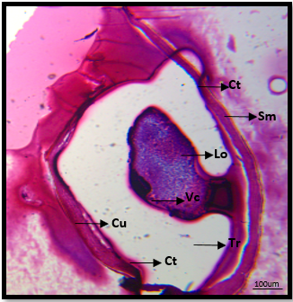  Fig 4 A: Hottentota tamulus: T.S. of Telson with cuticle and gland lobes at 4X magnification | 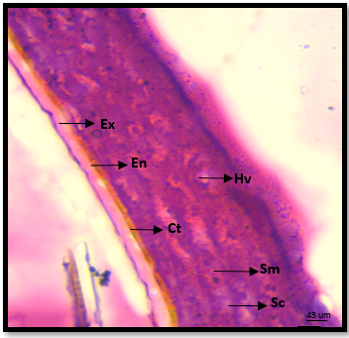  Sc  Fig 4 B: Hottentota tamulus: T.S. of Telson with cuticle at 10X magnification
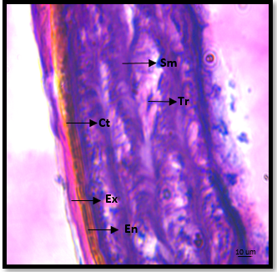  Fig 4 C: Hottentota tamulus: T.S. of Telson with cuticle and muscle at 50X magnification | 10um  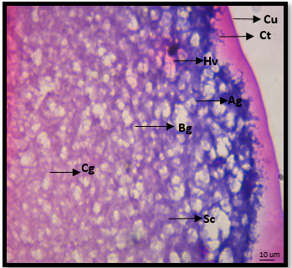  Fig 4 D: Hottentota tamulus: T.S. of Telson with venom gland lobe showing different glandular cells at 50X magnification

Fig 4 (A, B, C, D): Light micrograph of the venom apparatus of Hottentota tamulus: T.S. of Telson with cuticle, muscle, gland and gland lobes at 4X, 10X and 50X magnification stained with H/E
Ex: Exocuticle, En: Endocuticle, Ct: Connective tissue, VC: Venom producing cells, L: lumen; Tr- trabaculae; Hv- haemolymph vessel; Sm; skeletal muscle, Ag: A type of venom granules, Bg:B type of venom granules, Cg: C type of venom granules, SC: Supporting cells

3.2 TISSUE ARCHITECTURE OF TELSON OF Deccanometrus xanthopus (Cuticle, venom gland, lobes and muscles)
The histological examination of the telson and venom apparatus of Deccanometrus xanthopus, using Haematoxylin Eosin staining, revealed a closely coordinated arrangement of cuticular, muscular and glandular components. Observations across different magnifications (4X, 10X and 50X) helped to understand the transition from general morphology to cellular detail, making it possible to relate structural features with their functional roles. Such hierarchical organization is widely recognized as a defining feature of scorpion venom systems (Casewell et al., 2020; Undheim and King, 2025).
At 4X magnification, the telson appeared as a compact, rounded structure enclosed by a thick outer cuticle. This layer stained intensely eosinophilic and formed a continuous boundary around internal tissues, reflecting its role in protection and internal support. The internal layer was largely occupied by the venom apparatus, which appeared centrally positioned within the telson. The efficient packing of tissues within a confined space is consistent with the general descriptions of scorpion morphology, where various functional components are integrated within a compact anatomical unit (Lourenco, 2020).
At 10X magnification, the internal organization became more distinct. The cuticle showed a layered configuration structurally differentiated into the outer exocuticle and inner endocuticle, much typical of the arthropod skeletons, underlying muscle bundles were clearly visible. The muscle fibres arranged in parallel orientations help in controlled movement of the telson and contribute to force during stinging. The venom glands appeared regular well defined structures, with visible lumen that represent regions with venom accumulation prior to release. The close spatial relationship between the muscle fibres and the glandular tissue suggests that muscular tissue suggests that muscular contraction plays a direct role in venom expulsion (van der Meijden et al., 2021).
At higher magnification of 50X, the cellular features of the venom apparatus were elaborate. The glandular epithelium consisted of densely packed secretory cells with prominent, basophilic nuclei indicating active synthesis of venom components. This observation is consistent with current understanding that scorpion venom is produced by specialized epithelial cells capable of synthesizing a diverse range of bioactive molecules (Koch et al., 2022; Salabi et al., 2024). The glandular tissue was intricately organized into distinct lobular units separated by thin connective tissue septa. Such organization may enhance efficiency by allowing localized regulation of secretion within individual lobes. Adjacent muscle fibers displayed clear striations, confirming their skeletal nature and supporting their role in generating the pressure required for venom delivery.

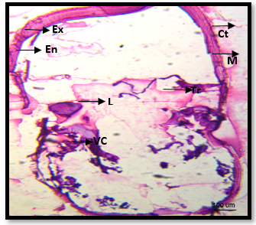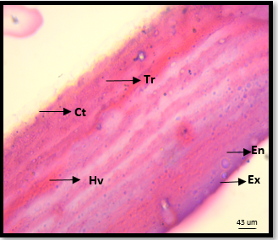

Fig 5 A: Deccanometrus xanthopus: T.S. of Telson with cuticle and gland lobes at 4X magnification | Fig 5 B: Deccanometrus xanthopus: T.S. of Telson with cuticle at 10X magnification

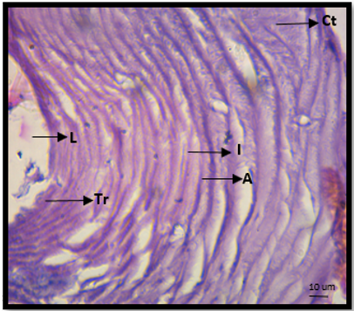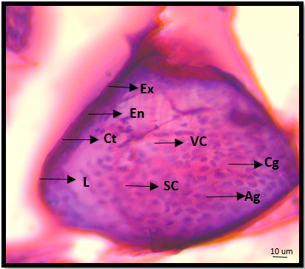

Fig 5 C: Deccanometrus xanthopus: T.S. of Telson with cuticle and muscle at 50X magnification | Fig 5 D: Deccanometrus xanthopus: T.S. of Telson with venom gland lobe showing different glandular cells at 50X magnification

Fig 5 (A, B, C, D): Light micrograph of the venom apparatus of Deccanometrus xanthopus: T.S. of Telson with cuticle, muscle, gland and gland lobes at 4X, 10X and 50X magnification stained with H/E
Ex: Exocuticle, En: Endocuticle, Ct: Connective tissue, VC: Venom producing cells, L: lumen; Tr- trabaculae; Hv- haemolymph vessel; Sm; skeletal muscle, Ag: A type of venom granules, Bg:B type of venom granules, Cg: C type of venom granules, SC: Supporting cells

3.3 TISSUE ARCHITECTURE OF TELSON OF Scorpiops deccanensis (Cuticle, venom gland, lobes and muscles)
The histological examination of the telson and venom apparatus of Scorpiops deccanensis, examined using Haematoxylin Eosin staining, revealed a closely coordinated system of protective, muscular and secretory elements. Observations across different magnifications (4X, 10X and 50X) described the overall tissue arrangement to detailed cellular features, helping to analyse the structure function relationship. This type of organization has been widely recognized in scorpion venom systems as a key adaptation for efficient envenomation (Casewell et al., 2020; Zancolli et al., 2022).
At 4X magnification, the telson appeared as a compact, rounded structure enclosed by a thick and intensely eosinophilic cuticle. This outer layer formed a clear boundary enclosing the internal tissues and reflects its protective role in maintaining structural integrity. The internal layer was centrally occupied by the venom apparatus, suggesting efficient spatial organization within a confined volume, a feature commonly described in scorpion morphology (Lourenco, 2020).
At 10X magnification, the internal differentiation became more evident. The cuticle showed a layered configuration typical of arthropod exoskeletons, with distinctly visible underlying muscle bundles. These muscle fibres, arranged predominantly in parallel, likely contribute to controlled telson movement and the generation of mechanical force during stinging. The venom glands appeared defined structures, with visible luminal spaces, which are interpreted as sites of venom storage prior to release (Salabi et.al., 2023). The close association between the muscle fibres and the glandular tissue suggests a functional linkage between contraction and venom expulsion (van der Meijden et al., 2021).
At higher magnification of 50X, the cellular architecture of the venom apparatus was clearly resolved. The glandular epithelium made up of packed secretory cells with elaborate, basophilic nuclei staining with basophilic dyes, reflect the active synthesis of venom peptides. Such features are consistent with findings that scorpion venom is produced by specialized epithelial cells, containing diverse bioactive molecules, including peptides and enzymes (Salabi et al., 2024; Koch et al., 2022). The glandular tissue was arranged into distinct lobular units separated by thin connective septa, suggesting compartmentalization that may enhance secretion efficiency. Adjacent muscle fibers exhibited striations which were clearly visible, suggesting their supporting their role in generating the pressure required for venom injection (van der Meijden et al., 2021).
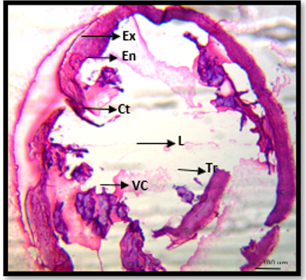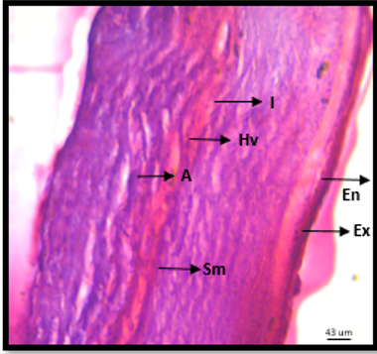
Fig 6 A: Scorpiops deccanensis: T.S. of Telson with cuticle and gland lobes at 4X magnification | Fig 6 B: Scorpiops deccanensis: T.S. of Telson with cuticle at 10X magnification
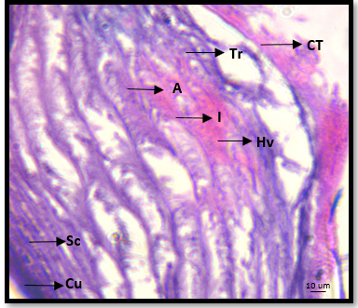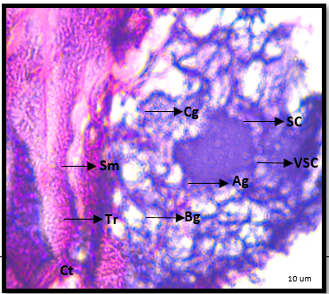
Fig 6 C: Scorpiops deccanensis: T.S. of Telson with cuticle and muscle at 50X magnification | Fig 6 D: Scorpiops deccanensis: T.S. of Telson with venom gland lobe showing different glandular cells at 50X magnification

Fig 6 (A, B, C, D): Light micrograph of the venom apparatus of Scorpiops deccanensis: T.S. of Telson with cuticle, muscle, gland and gland lobes at 4X, 10X and 50X magnification stained with H/E
Ex: Exocuticle, En: Endocuticle, Ct: Connective tissue, VC: Venom producing cells, L: lumen; Tr- trabaculae; Hv- haemolymph vessel; Sm; skeletal muscle, Ag: A type of venom granules, Bg:B type of venom granules, Cg: C type of venom granules, SC: Supporting cells

Feature | Hottentotta tamulus | Scorpiops deccanensis | Deccanometrus xanthopus
Cuticle (4×) | Thick, highly compact, strongly eosinophilic | Thick, slightly less compact | Thick, well-defined but less dense internally
Internal Organization (4×) | Highly compact, centrally organized | Moderately compact | Relatively less compact, more dispersed
Muscle Fibers (10×) | Dense, well-organized bundles | Moderately arranged fibers | Less dense, more loosely arranged
Muscle Function | Likely strong force generation | Moderate force generation | Relatively lower force efficiency
Venom Glands (10×) | Clearly defined, elongated with distinct lumina | Moderately defined, irregular | Less sharply defined, irregular
Luminal Spaces | Prominent and well-organized | Present, moderately visible | Present but less distinct
Glandular Epithelium (50×) | Dense secretory cells, highly active | Dense but moderately organized | Dense but comparatively less structured
Venom Lobes (50×) | Well-defined, strongly compartmentalized | Moderately developed lobes | Less distinct lobulation
Connective Septa | Clearly visible and well-developed | Moderately visible | Thin and less prominent
Overall Efficiency (Interpretation) | High venom production and delivery efficiency | Moderate efficiency | Relatively simpler functional system
Table 1: Comparative structural details of the venom apparatus of Hottentotta tamulus, Scorpiops deccanensis and Deccanometrus xanthopus (Cuticle, venom gland, lobes and muscles at 4X, 10X and 50 X magnification).

DISCUSSION:
The present comparative histological analysis of the telson and venom apparatus in Hottentotta tamulus, Scorpiops deccanensis and Deccanometrus xanthopus highlights a conserved structural framework accompanied by interspecific variation in tissue organization. Across all three species, the telson functions as a tightly integrated unit in which cuticle, musculature and venom glands operate in coordination, supporting the general model of scorpion venom systems described in earlier studies (Casewell et al., 2020; Undheim and King 2020). At the 4X magnification, the presence of a thick eosinophilic cuticle enclosing the telson was consistent across species, confirming its primary role in protection and mechanical support. This observation aligns with descriptions of the arthropod exoskeleton as a robust barrier while maintaining internal specialization (Lourenco, 2020). Telson of H. tamulus appeared more densely organized as compared to S. deccanensis and D. xanthopus suggesting more compact integration of venom producing tissues. At 10X magnification, relationship between musculature and glandular tissue was more pronounced. In all species, muscle fibres were positioned in close proximity to the venom glands, supporting the view that venom expulsion is driven by the muscular contraction (van der Meijden., 2021). H. tamulus exhibited more tightly packed and organized fibres, whereas D. xanthopus showed comparatively loose arrangements, while S. deccanensis occupies an intermediate position. At higher magnification of 40X, the glandular epithelium showed the densely packed secretory cells with nuclei and active toxin synthesis. These observations support molecular findings that scorpion venom is produced by specialized epithelial cells capable of generating diverse bioactive compounds (Koch et al., 2022; Salabi et al., 2024). H. tamulus displayed well defined venom lobes separated by connective tissue septa, whereas S. deccanensis showed moderate compartmentalization , D. xanthopus exhibited comparatively less distinct lobulation.
From a broader perspective, observed histological patterns align with current understanding that scorpion venom systems represent a balance between structural complexity and functional demand. Variations in muscle density and glandular organization suggests that different species may optimize their venom apparatus in response to ecological pressures such as prey type or defensive requirements (Casewell et al., 2020; Sunagar and Moran, 2020).

CONCLUSION:
The comparative analysis demonstrates that Hottentotta tamulus, Scorpiops deccanensis and Deccanometrus xanthopus share a common structural blueprint in which cuticle, musculature and venom glands function as an integrated system. However, clear interspecific differences were observed in tissue compactness, muscle organization and glandular compartmentalization. Among the three, H. tamulus exhibited the most structurally differentiated and compact venom apparatus, followed by S. deccanensis and D. xanthopus showed a comparatively similar organization.
These findings suggest that while the fundamental design of the scorpion telson is conserved, subtle variations in the histological architecture may reflect functional, ecological and evolutionary adaptations.

COMPETING INTERESTS DISCLAIMER:
Authors have declared that they have no known competing financial interests OR non-financial interests OR personal relationships that could have appeared to influence the work reported in this paper.

REFERENCES:
Arcos, S.S.S., et al. (2025). Scorpion venom as a source of anticancer compounds: molecular mechanisms and therapeutic potential. International Journal of Molecular Sciences, 26(20), 9907.
Casewell, N.R., Sunagar, K., Takacs, Z., Calvete, J.J. and Jackson, T.N.W. (2020). Venom evolution and diversity in arthropods. Nature Reviews Earth & Environment, 1, 345–360.
Lüddecke, T., Herzig, V. and King, G.F. (2025). Venom gland transcriptomics of Hottentotta judaicus reveals toxin diversity and bioeconomic potential. Toxicon, 236, 107412.
Salabi, F., et al. (2023). Identification and functional characterization of scorpion venom components. Scientific Reports, 13, 49556.
Salabi, F., et al. (2024). Transcriptomic insights into venom gland biology and toxin diversity in scorpions. Frontiers in Molecular Biosciences, 11, 1187654.
Soltan-Alinejad, P., et al. (2025). Comparative histological and ultrastructural analysis of scorpion venom glands. Journal of Arthropod-Borne Diseases, 19(1), 45–58.
Khan, A., et al. (2025). Neuroregenerative potential of Hottentotta tamulus venom: experimental insights. PLOS ONE, 20(3), e0330600.
Gopalakrishnakone, P. and Possani, L.D. (2021). Biology and evolution of scorpion venom systems. Toxins, 13(2), 120.
Ortiz, E., Gurrola, G.B., Schwartz, E.F. and Possani, L.D. (2020). Scorpion venom components and their physiological effects. Toxicon, 178, 84–93.
Rodríguez de la Vega, R.C. and Possani, L.D. (2021). Current trends in scorpion toxin research. Journal of Venomous Animals and Toxins including Tropical Diseases, 27, e20200112.
Lourenço, W.R. (2020). The evolution of scorpion venom systems and ecological adaptations. Comptes Rendus Biologies, 343(1), 35–49.
Santibáñez-López, C.E., et al. (2020). Phylogenomics of scorpions reveals diversification of venom systems. Molecular Biology and Evolution, 37(8), 2344–2359.
He, Q., et al. (2021). Morphological and functional adaptations of venom glands in arachnids. Frontiers in Physiology, 12, 678345.
Undheim, E.A.B. and King, G.F. (2020). On the venom systems of arachnids: structural and functional perspectives. Annual Review of Entomology, 65, 1–20.
van der Meijden, A., Coelho, P. and Rasko, M. (2021). Functional morphology of scorpion stinging mechanisms. Zoomorphology, 140, 109–121.
Zancolli, G., et al. (2022). Comparative analysis of venom gland structure across scorpion taxa. Toxins, 14(3), 182.
Koch, L.E., et al. (2022). Molecular diversity of scorpion venom peptides and their biological roles. Biochemical Journal, 479(5), 623–640.
Santibáñez-López, C.E. and Sharma, P.P. (2022). Evolutionary history of venom systems in scorpions. Systematic Biology, 71(6), 1450–1466.
Bawaskar, H.S. and Bawaskar, P.H. (2021). Clinical and toxicological aspects of Hottentotta tamulus envenomation. Toxicon, 192, 1–8.
Isbister, G.K. and Bawaskar, H.S. (2020). Scorpion envenomation. New England Journal of Medicine, 383, 457–463.
Arcos, S.S.S., Batista, C.V.F. and Possani, L.D. (2025). Advances in scorpion venom research: structure, function, and biomedical applications. International Journal of Molecular Sciences, 26(20), 9907.

Bawaskar, H.S. and Bawaskar, P.H. (2021). Clinical and toxicological profile of Hottentotta tamulus envenomation. Toxicon, 192, 1–8.

Casewell, N.R., Sunagar, K., Takacs, Z., Calvete, J.J. and Jackson, T.N.W. (2020). Venom evolution and diversity in arthropods. Nature Reviews Earth & Environment, 1, 345–360.

Coelho, P., Kaliontzopoulou, A., Rasko, M. and van der Meijden, A. (2021). Functional morphology of scorpion stinging and venom use. Zoomorphology, 140, 109–121.

Gopalakrishnakone, P. and Possani, L.D. (2021). Biology of scorpion venom systems and toxin diversity. Toxins, 13(2), 120.

He, Q., et al. (2021). Structural organization and functional specialization of venom glands in arachnids. Frontiers in Physiology, 12, 678345.

Isbister, G.K. and Bawaskar, H.S. (2020). Scorpion envenomation: clinical features and management. New England Journal of Medicine, 383, 457–463.

Koch, L.E., et al. (2022). Molecular diversity of scorpion venom peptides and their biological roles. Biochemical Journal, 479(5), 623–640.

Lourenço, W.R. (2020). The evolution of scorpion diversity and ecological adaptations. Comptes Rendus Biologies, 343(1), 35–49.

Lüddecke, T., Herzig, V. and King, G.F. (2025). Venom gland transcriptomics of Hottentotta species reveals toxin diversity. Toxicon, 236, 107412.

Ortiz, E., Gurrola, G.B., Schwartz, E.F. and Possani, L.D. (2020). Scorpion venom components and their physiological roles. Toxicon, 178, 84–93.

Rodríguez de la Vega, R.C. and Possani, L.D. (2021). Current perspectives on scorpion toxins and venom evolution. Journal of Venomous Animals and Toxins including Tropical Diseases, 27, e20200112.

Salabi, F., et al. (2023). Identification and characterization of scorpion venom gland components. Scientific Reports, 13, 49556.

Salabi, F., et al. (2024). Transcriptomic insights into venom gland biology in scorpions. Frontiers in Molecular Biosciences, 11, 1187654.

Santibáñez-López, C.E., et al. (2020). Phylogenomics of scorpions and evolution of venom systems. Molecular Biology and Evolution, 37(8), 2344–2359.

Santibáñez-López, C.E. and Sharma, P.P. (2022). Evolutionary history of venom systems in scorpions. Systematic Biology, 71(6), 1450–1466.

Soltan-Alinejad, P., et al. (2025). Comparative histological and ultrastructural analysis of scorpion venom glands. Journal of Arthropod-Borne Diseases, 19(1), 45–58.

Undheim, E.A.B. and King, G.F. (2020). On the venom systems of arachnids: structural and functional insights. Annual Review of Entomology, 65, 1–20.

van der Meijden, A., Coelho, P. and Rasko, M. (2021). Biomechanics of scorpion stinging and venom delivery. Journal of Experimental Biology, 224, jeb242123.
Zancolli, G., et al. (2022). Comparative morphology and function of venom glands across scorpion taxa. Toxins, 14(3), 182.

Sharma, P.P., et al. (2021). Phylogenetic patterns of venom evolution in scorpions. BMC Evolutionary Biology, 21, 198.

Fet, V. and Soleglad, M.E. (2020). Morphological diversity in scorpion metasoma and telson structure. Euscorpius, 2020(310), 1–15.

Prendini, L. and Wheeler, W.C. (2020). Scorpion systematics and morphological evolution. Cladistics, 36(4), 395–420.

Kazemi, S.M., et al. (2022). Histological organization of venom glands in Iranian scorpion species. Micron, 155, 103222.

Sunagar, K. and Moran, Y. (2020). The rise and diversification of venom systems in animals. Genome Biology and Evolution, 12(11), 1915–1930.

