Original Research Article

Effect of Chemical Fertilizers on Growth Dynamics and Survival of Eisenia fetida: A Statistical and Ecotoxicological Assessment

.
ABSTRACT

Aims: Soil biota, especially the earthworms that are essential to soil ecosystem health and functioning, are suffering from the intensive use of chemical fertilizers on modern agriculture. In the present study, effects of four fertilizers namely urea, NPK (15:15:15), NPK (10:26:26) and superphosphates on the growth and survival of Eisenia fetida were evaluated.
Study design: Specimens of Eisenia fetida collected from a vermiculture unit in Ahmednagar district, Maharashtra, India were acclimatized under laboratory conditions prior to experimentation. The effects of select fertilisers were evaluated over 11 weeks for the parameters such as biomass reduction and mortality.
Methodology: Biomass changes were analyzed using descriptive statistics, standard deviation, regression analysis, and exploratory one-way ANOVA.
Results: The results revealed a statistically significant difference among treatments (F = 5.77, p < 0.01). Urea exhibited the highest toxicity, causing a 72.10% reduction in biomass and 48% mortality, whereas superphosphate supported growth with a 19.15% increase and no mortality. Regression analysis indicated a strong negative growth trend under urea exposure and relatively stable or positive trends under other treatments.
Conclusion: These findings highlight the differential toxicity of fertilizers and emphasize the importance of sustainable nutrient management practices.

Keywords: Earthworms, Eisenia fetida, fertilizers, urea toxicity, ANOVA, regression analysis, soil ecology

1. INTRODUCTION

Soil and other soil ecosystems play an important role in terrestrial life through nutrient cycling, organic matter decomposition, and microbial interactions that form the basis of a complex system. Earthworms are one of the soil organisms that have significant impacts on the structure, aeration, and fertility of soil (Edwards & Bohlen, 1996; Sizmur et al., 2011a; Sizmur et al., 2011b), thereby earning them the label “ecosystem engineers.” Out of more than 3000 species identified for vermicomposting, Eisenia fetida is considered as one of the most suitable species (Ahmad et al., 2021).

Eisenia fetida is an epigeic species that is frequently used in ecotoxicological assays because of its sensitivity to environmental contaminants and its important role in organic matter decomposition (Munnoli et al., 2010). Earthworms increase microbial activity by fragmenting organic matter, which enhances the mineralization of nutrients (Lavelle et al., 2006). Use of vermitea for better crop production as compared to chemical fertilisers has been reported by Aslam et al., 2020 and Kulkarni et al., 1996.

Agricultural practices affect the earthworms directly or indirectly (Lofs-Holmin, 1983). A growing dependence on chemical fertilisers, especially nitrogen-based compounds like urea, has resulted from the worldwide demand for food production. Although these fertilisers increase crop yield, overuse of them damages soil physicochemical characteristics and negatively impacts soil organisms (Singh & Gupta, 2018; Liang et al., 2007). Nitrogen fertilizers can cause physiological stress and mortality in earthworms by changing soil pH, increasing ammonia toxicity, and upsetting osmotic balance (Rai et al., 2014; Rani, 2016). On the contrary, while phosphorus-based fertilisers, such as superphosphate, are frequently thought to be less harmful, extended exposure to them may still have an impact on soil fauna (Bhattacharya & Sahu, 2015).

Inconsistencies about the relative toxicity of various fertilisers persist despite a large number of studies. In order to better understand growth trends and toxicity patterns, this study attempts to provide a comparative assessment using statistical tools like standard deviation and regression analysis.

2. material and methods

2.1 Experimental Organism
Specimens were collected from an established vermiculture unit located in Ahmednagar district, Maharashtra, India. The selected worms were free from visible injuries, deformities, or signs of disease. Immediately after collection, the worms were transported to the laboratory in aerated containers containing moist vermicompost to prevent desiccation and stress.

2.2 Acclimatisation of Earthworms
Before the commencement of the experiment, the collected earthworms were acclimatised under controlled laboratory conditions for a period of 7 days. During this period, worms were maintained in plastic trays containing pre-decomposed organic substrate composed of cow dung and agricultural waste.
Environmental conditions were carefully regulated:
- Temperature: 25 ± 2°C
- Relative humidity: 60–70%
- Photoperiod: Natural light-dark cycle (avoidance of direct sunlight)
The substrate moisture content was maintained at approximately 60–70% by periodic sprinkling of distilled water. No chemical fertilizers were introduced during the acclimatisation phase to allow stabilisation of physiological conditions.

2.3 Preparation of vermifeed substrate

The experimental substrate (vermifeed) consisted of a mixture of decomposed organic matter and cow dung in a ratio of 10:1 (w/w). The substrate was pre-composted for 15–20 days before use to eliminate harmful gases such as ammonia and to stabilise microbial activity.
The prepared vermifeed was sieved to remove coarse particles and ensure uniform texture. Moisture content was adjusted to approximately 65% to provide optimal conditions for earthworm activity and survival.

2.4 Experimental Design

Five experimental groups were established:
• Control (no fertiliser)
• Urea
• NPK (15:15:15)
• NPK (10:26:26)
• Superphosphate
Each treatment consisted of 25 earthworms placed in separate plastic troughs (capacity ~5 L) containing equal quantities (2 kg) of prepared vermifeed. The troughs were perforated at the bottom to facilitate drainage and prevent waterlogging.
Fertilisers were applied at a uniform concentration of 5 g per kg of vermifeed, thoroughly mixed to ensure even distribution. The control group received no fertiliser but was otherwise maintained under identical conditions.
Each treatment was conducted in triplicate to enhance statistical reliability and reproducibility of results.

2.3 Data Collection

Earthworm biomass was recorded at 15-day intervals (Weeks 1, 3, 5, 7, 9, and 11). Before weighing, worms were gently removed from the substrate and placed on moist filter paper for 2–3 minutes to allow gut clearance and removal of adhering soil particles.
Individual weights were recorded using a digital analytical balance with an accuracy of ±0.01 g. The total biomass per treatment group was calculated and expressed as mean biomass.
Mortality was monitored daily throughout the experimental period. Dead worms were identified based on lack of movement, discolouration, and tissue disintegration. The number of dead individuals was recorded and removed immediately to prevent contamination of the substrate.

2.4 Statistical Analysis

Descriptive statistics, including mean and standard deviation, were calculated for each treatment. Percentage change in biomass was determined relative to initial weight.
A one-way ANOVA was conducted to determine whether there were statistically significant differences in biomass among treatment groups. The analysis compared between-group variance with within-group variance.
- Null hypothesis (H₀): No significant difference among treatments
- Alternative hypothesis (H₁): Significant difference exists
Statistical significance was evaluated at p < 0.05.
Linear regression analysis was performed to assess growth (dependent variable) trends over time (independent variable) using the regression equation:
$$Y=a+bX$$
Where:
Y = biomass
X = time (weeks)
a = intercept
b = slope
The coefficient of determination (R²) was calculated to assess the goodness of fit of the model.

3. results and discussion

This study provides a thorough evaluation of the ecotoxicological impacts of widely utilised chemical fertilisers on Eisenia fetida, concentrating on biomass fluctuations and survival trends during an 11-week exposure duration. The combination of descriptive statistics, mortality observations, regression modeling, and inferential statistics provides a comprehensive understanding of fertiliser-induced stress in soil macrofauna.

3.1 Changes in biomass with time across treatments

Long-term monitoring of biomass showed that different treatments led to different growth patterns, which shows that earthworms respond differently to fertiliser exposure. In the first three weeks, all groups, including the treated ones, saw a small rise in biomass. This early rise could be because the worms are getting used to their new environment and using the nutrients in the vermifeed substrate for a short time. Continuous monitoring of biomass indicated varied growth patterns across treatments, demonstrating differential physiological responses of earthworms to fertiliser exposure. In the first three weeks, all groups, including the treated ones, noted a slight increase in biomass. This early rise may be due to the worms getting used to their new environment and using the nutrients in the vermifeed substrate for a short time.
Divergence in growth patterns, however, became more noticeable after week three. Over the course of the experiment, the control group's biomass increased steadily and gradually, suggesting ideal growth conditions and the lack of stressors. The urea-treated group, on the other hand, showed a steep and gradual decrease in biomass, which was especially noticeable after week five, indicating cumulative toxic effects.
The groups that received NPK treatment showed moderate reactions. Although the decline was less severe than that seen in the urea group, both NPK (15:15:15) and NPK (10:26:26) treatments showed initial stability followed by gradual reductions in biomass. It's interesting to note that the superphosphate treatment led to a steady rise in biomass over time, eventually exceeding even the control group.
The biomass measurements across treatments are summarised in Table 1 using descriptive statistics. The biomass values at the beginning (Week 1) and end (Week 11), the average biomass over the course of the study, the standard deviation (SD), and the percentage change are included in the table. The biomass of the control group increased by 8.56%, indicating that normal growth was possible under the experimental conditions. The biomass of the urea-treated group was drastically reduced by 72.10%, which was the greatest reduction of any treatment. Individual response variability is indicated by the comparatively high standard deviation (SD = 8.99), which may be the result of varying tolerance levels of worms.
Treatments with NPK (15:15:15) and NPK (10:26:26) demonstrated moderate declines (−16.87% and −16.31%, respectively), indicating sublethal stress. The superphosphate group showed a 19.15% increase in biomass, suggesting both low toxicity and potential growth stimulation.

The reliability of the observed trends is further strengthened by the relatively moderate SD values across treatments, which show that responses were fairly consistent within groups.
Table 1. Descriptive statistics for treatment-wise biomass trajectories
Treatment | Week 1 | Week 11 | Mean | SD | % change
Control | 25.93 | 28.15 | 33.77 | 5.67 | 8.56
Urea | 27.72 | 7.73 | 18.60 | 8.99 | -72.11
NPK 15:15:15 | 26.49 | 22.02 | 26.68 | 2.99 | -16.87
NPK 10:26:26 | 28.88 | 24.17 | 30.12 | 5.32 | -16.31
Superphosphate | 23.45 | 27.94 | 33.37 | 7.19 | 19.15
The time-based changes in biomass for each treatment are shown in Figure 1, which is plotted as mean values with standard deviation error bars. As a baseline for comparison, the control curve exhibits a consistent upward trajectory. The urea curve visually confirms its high toxicity with a steep downward slope, especially after mid-experiment. The NPK curves exhibit slight decreases that fall between urea and control, suggesting a moderate impact.
The superphosphate curve exhibits an upward trend, indicating its beneficial impact on the accumulation of biomass. Error bars (mean ± SD) provide statistical validity and offer insight into variability. Significant differences are further supported by a small overlap between urea and other treatments.
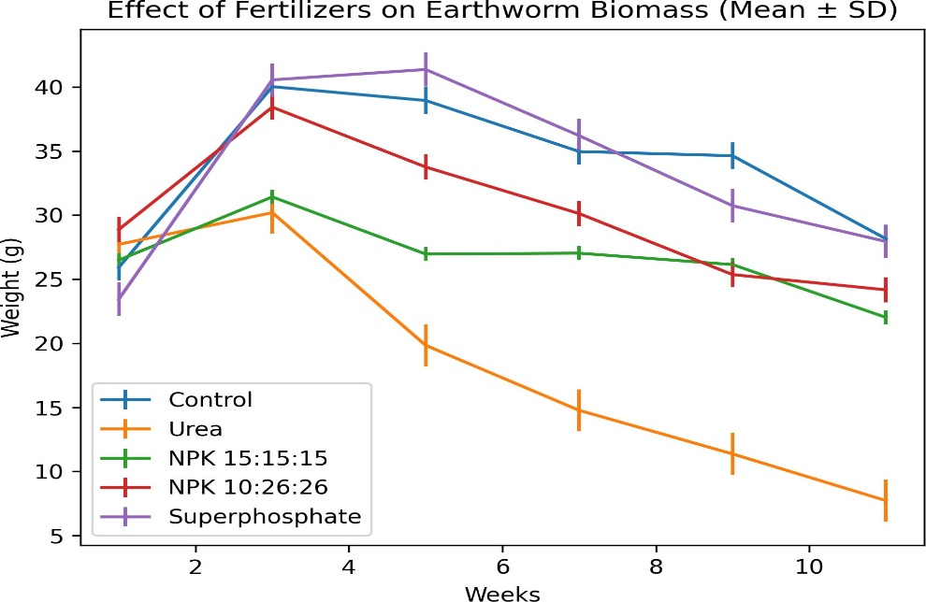
Fig. 1. Biomass trend across fertilizer treatments

3.2 Mortality Analysis

The estimation of toxicity is further enhanced by mortality patterns. Treatments were clearly distinguished by the cumulative mortality throughout the course of the 11-week period. Severe toxic stress was indicated by the highest mortality rate (48%) following urea treatment. Limited mortality (12%) was seen with NPK (15:15:15), indicating partial toxicity. There was no mortality in the control, NPK (10:26:26), and superphosphate groups, suggesting comparatively safe or non-lethal environments.
Endpoint mortality percentages for each treatment are shown graphically in Figure 2. The adverse effects of urea are highlighted by the sharp contrast with other treatments. Superphosphate's efficacy as a relatively safer fertiliser is further supported by the lack of mortality in worms treated with it.
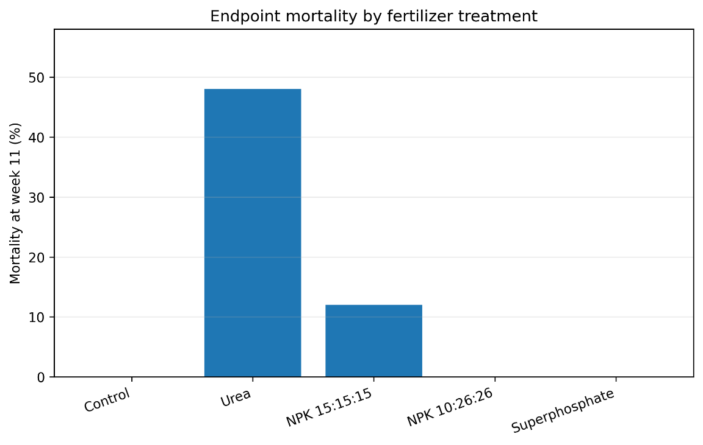
Fig. 2. Endpoint mortality by fertiliser treatment

3.3 Analysis of Inferential Statistics: ANOVA

The statistical significance of the variations in biomass across treatments is confirmed by the one-way ANOVA results (Table 2).

Significant difference between treatment means in relation to within-group variation is indicated by the F-value (5.77).
Fertiliser type has a considerable impact on earthworm biomass, as evidenced by the p-value (0.00197), which is significantly below the significance level (p < 0.05).
The one-way ANOVA revealed significant differences among treatments: The values, F = 5.77 and p = 0.00197, indicate that fertiliser type significantly influences earthworm biomass (Table 2).
The sum of squares between treatments (SS = 932.433) shows the variability due to the effect of fertilisers. The within-treatment SS (1009.774) is a measure of biological variability.
The conclusion that treatments had a significant and quantifiable impact is supported by the comparatively higher between-group variance as compared to within-group variance.

This statistical confirmation supports the assertion that fertilisers' chemical composition is a key factor in determining their ecological impact.
Table 2. Exploratory one-way ANOVA on serial biomass observations

Source | SS | df | MS | F | p
Between treatments | 932.433 | 4 | 233.108 | 5.771 | 0.00197
Within treatments | 1009.774 | 25 | 40.391
Total | 1942.207 | 29

3.4 Regression Analysis

Regression analysis (Table 3) was employed to examine the relationship between time and biomass, providing insights into growth trends. The urea treatment showed a steep negative slope (−2.307) and a high coefficient of determination (R² = 0.922), meaning that time causes 92.2% of the variation in biomass. This indicates a steady and progressive decline.
Moderately negative slopes with lower R² values (~0.44–0.46) were seen in NPK treatments, indicating partial but less predictable effects.
Stable development patterns were indicated by the near-zero slopes and minimal R² values displayed by the control and superphosphate groups.
Table 3. Linear regression of biomass on time

Treatment | Slope | Intercept | R² | p
Control | -0.129 | 34.547 | 0.007 | 0.8724
Urea | -2.307 | 32.444 | 0.922 | 0.0024
NPK 15:15:15 | -0.545 | 29.944 | 0.464 | 0.1361
NPK 10:26:26 | -0.948 | 35.805 | 0.444 | 0.1484
Superphosphate | -0.174 | 34.415 | 0.008 | 0.8646
The linear regression lines for each treatment are shown in Figure 3:
The sharp downward slope for the urea-treated group clearly illustrates continuous biomass loss. The gentle slopes for NPK treatments reflect moderate stress. While, the nearly flat or slightly positive slope for superphosphate indicates stability or growth. These graphical patterns support results on fertiliser toxicity levels and supplement statistical findings.

3.5. Insights into fertiliser toxicity
The observed toxicity patterns can be explained through biochemical and physiological mechanisms. The findings of the present study clearly show that the composition of fertilizer has a significant influence on how it affects earthworms ecologically. The nitrogen-rich fertiliser urea showed considerable toxicity, resulting in a decrease in biomass and an increase in mortality.
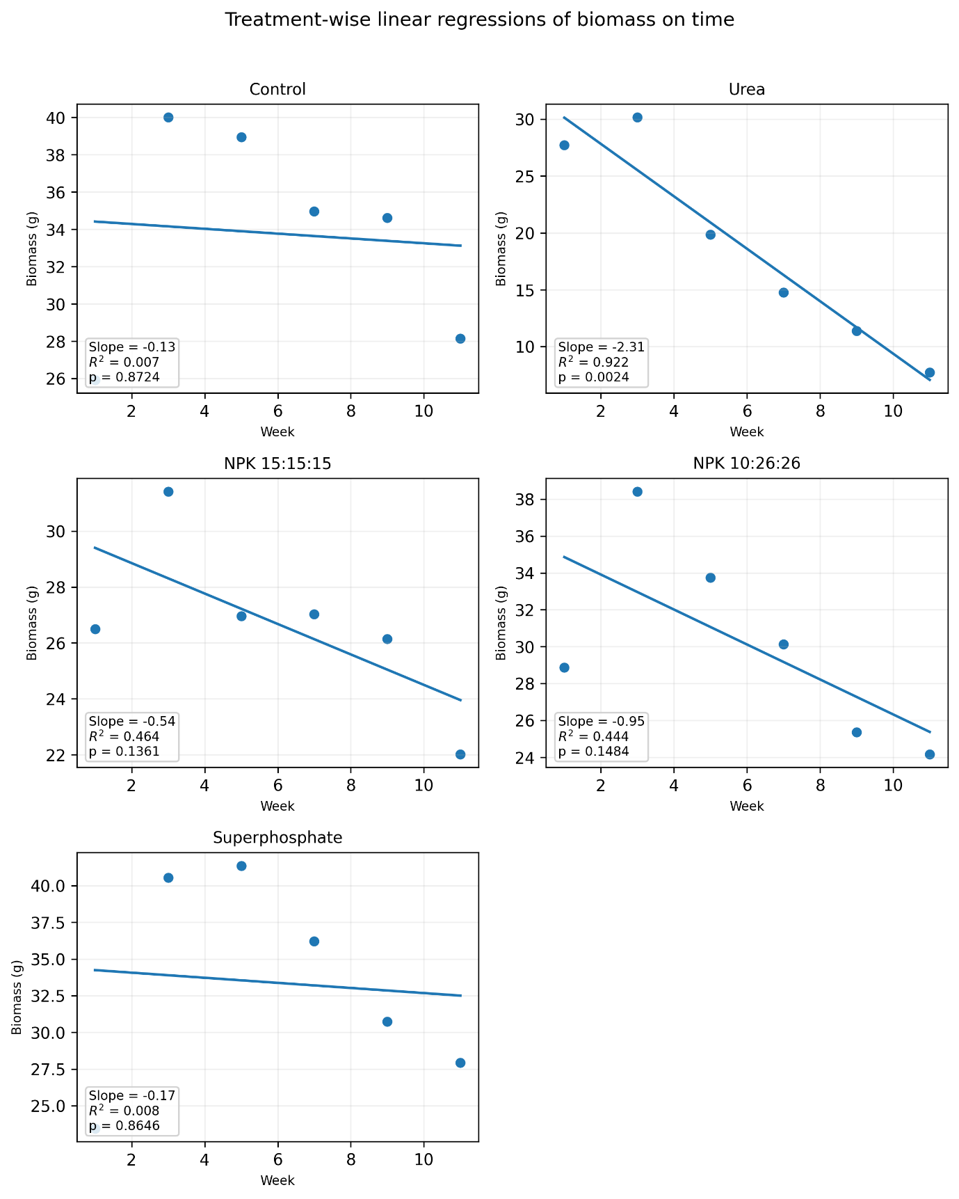
Fig. 3. Treatment-wise linear regressions of biomass on time

According to Rani (2016), this toxicity is caused by the hydrolysis of urea into ammonia, which increases soil pH (alkalinity), disrupts osmotic balance, impairs respiration through ammonia toxicity, affects enzyme systems and metabolic pathways. It is well known that high ammonia levels affect respiration and enzyme activity, which eventually causes physiological stress and death (Rai et al., 2014). These effects collectively result in reduced feeding, weight loss, and eventual mortality.

NPK fertilizers provide balanced nutrients but may cause osmotic stress at higher concentrations. They lead to accumulation of salts and produce moderate physiological disturbances. Hence, their effects are less severe than those of urea but still detrimental over time.
Superphosphate, on the other hand, showed little toxicity and even encouraged growth. This could be because it improves nutrient availability and microbial activity without appreciably changing the pH of the soil (Bhattacharya & Sahu, 2015).
By exposing trends in toxicity with respect to time, regression analysis offers more information. While stable or positive slopes in other treatments suggest adaptability or tolerance, the strong negative slope seen in urea-treated groups indicates progressive deterioration.

These results are in line with earlier research showing that phosphate-based fertilizers are comparatively less toxic and that earthworms are sensitive to nitrogenous compounds (Whalen et al., 1998; Sizmur et al., 2011b; Senthil et al., 2013; Long at al., 2017).

By combining descriptive statistics, mortality analysis, ANOVA, and regression modelling, this study provides a holistic understanding of fertilizer impacts. The convergence of multiple analytical approaches strengthens the reliability of conclusions.

The clear gradient of toxicity observed—Urea > NPK > Superphosphate ≈ Control—highlights the importance of fertilizer selection in maintaining soil biodiversity.
The findings also offer following significant implications for sustainable agriculture:
- Soil Health: Earthworms are indicators of soil quality; their decline signals ecological imbalance.
- Nutrient Cycling: Reduced earthworm activity can impair decomposition and nutrient turnover.
- Fertilizer Management: Over-reliance on nitrogenous fertilizers like urea can degrade soil ecosystems.
- Sustainable Alternatives: Organic fertilizers and vermicompost offer safer alternatives.

4. Conclusion

The current study emphasizes how crucial fertilizer choice is to sustainable agriculture. It was found that urea was extremely harmful to Eisenia fetida, drastically lowering biomass and increasing mortality. Superphosphate, on the other hand, showed few side effects and promoted growth.

These results are more reliable and offer a better understanding of growth dynamics when statistical tools like regression analysis and standard deviation are incorporated.
These findings support careful application of fertilizers, stressing balanced nutrient application and the use of environmentally acceptable substitutes like vermicompost and biofertilizers.

Competing interests

The authors declare that no competing interests exist.

COMPETING INTERESTS DISCLAIMER:
Authors have declared that they have no known competing financial interests OR non-financial interests OR personal relationships that could have appeared to influence the work reported in this paper.

References

Edwards, C. A., & Bohlen, P. J. (1996). Biology and ecology of earthworms (3rd ed.). Springer.

Sizmur, T., Palumbo-Roe, B., Watts, M. J., & Hodson, M. E. (2011a). Impact of the earthworm Lumbricus terrestris on metal mobility in contaminated soils. Environmental Pollution, 159(3), 742–748. https://doi.org/10.1016/j.envpol.2010.11.024

Sizmur, T., Tilston, E. L., Charnock, J., Palumbo-Roe, B., Watts, M. J., & Hodson, M. E. (2011b). Impacts of earthworms on metal availability. Journal of Environmental Monitoring, 13(2), 266–273. https://doi.org/10.1039/C0EM00512K

Ahmad, A., Aslam, Z., Bellitürk, K., Iqbal, N., Naeem, S., Idrees, M. et al. (2021). Vermicomposting methods from different wastes: An environment-friendly, economically viable and socially acceptable approach for crop nutrition. International Journal of Food Science and Agriculture, 5(1), 58–68.

Kulkarni, B. S., Nalawadi, U. G., & Giraddi, R. S. (1996). Effect of vermicompost and vermiculture on growth and yield of China aster (Callistephus chinensis Nees.). Journal of Horticultural Science, 25, 341–343.

Lofs-Holmin, A. (1983). Influence of agricultural practices on earthworms (Lumbricidae). Acta Agriculturae Scandinavica, 33(3), 225–234. https://doi.org/10.1080/00015128309435388

Munnoli, P. M., Da Silva, J. A. T., & Saroj, B. (2010). Dynamics of the soil-earthworm-plant relationship: A review. Dynamic Soil, Dynamic Plant, 4(1), 1–21.

Lavelle, P., Decaëns, T., Aubert, M., Barot, S., Blouin, M., Bureau, F. et al. (2006). Soil invertebrates and ecosystem services. European Journal of Soil Biology, 42, S3–S15. https://doi.org/10.1016/j.ejsobi.2006.10.002

Aslam, Z., Ahmad, A., Idrees, I., Iqbal, I., Akbar, G., Ali, U. et al. (2020). Comparative analysis of nutritional sources on the morpho-physiological characteristics of mung bean (Vigna radiata). International Journal of Food Science and Agriculture, 4(3), 314–322.

Singh, J. S., & Gupta, V. K. (2018). Soil microbial biomass: A key soil driver in management of ecosystem functioning. Science of the Total Environment, 634, 497–500. https://doi.org/10.1016/j.scitotenv.2018.03.373

Liang, W., Beattie, G. A. C., Meats, A., & Spooner-Hart, R. (2007). Impact on soil-dwelling arthropods in citrus orchards of spraying horticultural mineral oil, carbaryl or methidathion. Australian Journal of Entomology, 46(1), 79–85. https://doi.org/10.1111/j.1440-6055.2007.00577.x

Rai, N., Ashiya, P., & Rathore, D. S. (2014). Comparative study of the effect of chemical fertilizers and organic fertilizers on Eisenia fetida. International Journal of Innovative Research in Science, Engineering and Technology, 3(5), 12991–12998.

Rani, S. (2016). Effect of urea on soil macrofauna: Juvenile earthworms. International Journal of Academic Research and Development, 4(5), 15–19.

Bhattacharya, A., & Sahu, S. K. (2015). Toxic effect of superphosphate on soil ecosystem using earthworm Drawida willsi as test specimen. Journal of Biodiversity and Environmental Sciences, 6(4), 220–226.

Whalen, J. K., Parmelee, R. W., & Edwards, C. A. (1998). Population dynamics of earthworms in agroecosystems. Biology and Fertility of Soils, 27, 400–407. https://doi.org/10.1007/s003740050451

Senthil, K., Kumar, A. S., Ross, P. R., & Joothi, P. (2013). Assessment of acute toxicity of superphosphate to Eisenia fetida using paper contact method. ResearchGate. https://www.researchgate.net/publication/315671321

Long, W., Ansari, A., & Seecharran, D. (2017). The effect of urea on epigeic earthworm species (Eisenia fetida). Cell Biology and Development, 1(2), 46–50.

