Taxonomic re-description and Molecular characterization of Thelohanellus bifurcata Basu and Haldar, 1999 (Myxosporea: Myxobolidae) using 18S rRNA gene sequences, infecting the gill lamellae of Labeo rohita (Hamilton, 1822) from Ranaghat, West Bengal, India

ABSTRACT:
Myxozoans have been classified into 62 genera having more than 2600 species all over the world. Among these genus Thelohanellus Kudo, 1933 is the second largest genus after Myxobolus. The species Thelohanellus bifurcata Basu and Haldar, 1999 under genus Thelohanellus Kudo, 1933 was found to infect the gills of Indian major carp, Labeo rohita Hamilton, 1822 collected from Ranaghat fish markets (Latitude: 23.1793º N, Longitude: 88.5758º E), West Benagl, India. A total number of 67 fish were collected during the period of January, 2025 to October, 2025 and among them 6 fishes were found to be infected with the parasite. The rate of infection was 8.95%. The plasmodia were visible with naked eye and were large and elongated in shape. The present paper deals with the morphological re-description and molecular characterization of the parasite. The phylogenetic analysis was also done using the 18s rRNA gene sequences which justifies its taxonomic position. The present study also presents the molecular analysis of Thelohanellus bifurcata Basu and Haldar, 1999 for the second time from Indian sub-continent and for the first time from West Bengal.
Keywords: Myxozoa, Thelohanellus bifurcata, 18s rRNA, Phylogeny, Major Carp, Labeo rohita

INTRODUCTION:
Myxozoans are the spore forming organisms which parasitize both freshwater and marine fishes obligatorily (Lom and Dykova, 1995) (Lom and Dykova, 2006) (Kaur and Singh, 2012) (Abraham et al., 2015). They possess a complex pattern of life cycle which involves an invertebrate host (mainly Oligochaetes or Polychaetes) and a vertebrate host (mainly fish). Most of them act as endoparasite inside the vertebrate host tissue and exhibits a world-wide distribution pattern (Kaur, Gupta and Attri, 2021). Myxozoans are divided into two classes- Myxosporea and Malacosporea which altogether have been classified into 62 genera having more than 2600 species throughout the world (Nissa et al., 2024) (Lom and Dykova, 2006) (Fiala et al., 2015) (Okamura et al., 2018). Due to the huge diversity among the myxozoan species, the traditional method of species identification such as morphological analysis is not sufficient for proper identification up to species level (Atkinson et al., 2015) (Struck et al., 2018) (Nissa et al., 2024). The morphological characterization is mainly based on the number of polar capsule present in the spore, the arrangement of polar capsule, spore dimensions etc. (Yokoyama et al., 1998). However, for effective species identification, the DNA-based molecular phylogenetic studies of the parasites are required. Smothers et al., 1994 were first to use the small sub-unit of ribosomal RNA gene sequence for the analysis of the phylogeny and identification of the myxozoan species. Now it becomes mandatory to include the molecular analysis for the characterization of myxozoan species. Moreover, the proper identification of myxozoan species is also necessary for the detection of fish diseases caused by them and for the management of the diseases in economically important fishes (Kaur and Singh, 2012) (Abraham et al., 2015).
The genus Thelohanellus Kudo, 1933 belonging to class Myxosporea, family Myxobolidae is the second largest genus after the genus Myxobolus (Eiras et al., 2023). Several species of genus Thelohanellus have been reported from different freshwater fishes all over the world (Basu and Haldar, 1999) (Kaur and Gupta, 2017). A synopsis by Kaur et al. (2017) provides the compiled information describing 52 species belonging to genus Thelohanellus from Indian subcontinent. Among several species belonging to genus Thelohanellus, the species Thelohanellus bifurcata Basu and Haldar, 1999 has been reported to cause gill haemorrhagic disease in the Indian major carps (Kaur and Katoch, 2014) (Nissa et al., 2024). This species was first recorded from the gills of Labeo rohita (Hamilton, 1822) by Basu and Haldar in 1999 from Ranaghat, West Bengal, India. Then, the species was reported from Punjab, India from the same host fish, Labeo rohita by Kaur and Katoch (2014). In both the above mentioned studies, only the morphological descriptions were provided by the authors. In 2024, Nissa et al. were first to provide the molecular studies of the species Thelohanellus bifurcata Basu and Haldar, 1999 based on 18s rRNA gene sequence, infecting the host fish Labeo rohita from Punjab, India. The present study reports the presence of the species Thelohanellus bifurcata Basu and Haldar, 1999 for the second time from Ranaghat, West Bengal infecting the host fish Labeo rohita. This study provides the morphological re-description of the parasite and the molecular characterization for the second time from India and for the first time from West Bengal India, based on 18s rRNA gene sequences.

MATERIALS AND METHODS:
Sample collection and light microscopy: A total number of 96 live host fish Labeo rohita (Hamilton, 1822) were randomly collected between January, 2025 and October, 2025 from the fish markets of Ranaghat (Latitude: 23.1793º N, Longitude: 88.5758º E) (Fig 1) of Dist. Nadia, West Bengal, India. The live host fish were collected and immediately examined for the presence of the myxozoan parasites at the site of fish collection. Each fish was dissected and the gills and the internal organs like gut, gall bladder, liver, kidney etc. are examined for the presence of myxozoan infection. The infected fish were identified by observing the presence of visible myxozoan cysts. The cysts were isolated from the fishes and were preserved in 70% ethanol for further studies.
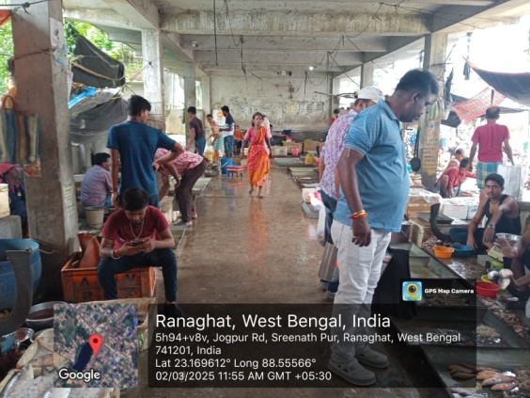
Fig 1 Study Area, Ranaghat (Latitude: 23.1793º N, Longitude: 88.5758º E), West Bengal, India
Fresh myxozoan cysts were taken on grease-free glass slides with few drops of freshly prepared 0.5% NaCl solution and ruptured with the help of needle and then covered with clean cover slip. The slides were examined under Olympus BX43 microscope at 400X magnification with oil-immersion lens and photographs of the myxospores were taken with the help of Cellsense Software. The measurements of the myxospores were taken (in µm) according to Lom and Arthur, 1989.
Molecular analysis: For molecular characterization, the myxozoan cyst isolated from the infected gills of the host fishes and preserved in 70% ethanol was used. DNA was extracted from the cyst of the myxozoan parasite. Fragments of the myxospore 18S rRNA gene (18S ribosomal RNA gene) were amplified by nested PCR method by using the set of universal eukaryotic primers ERIB1 (5’- ACC TGG TTG ATC CTG CCA G -3’) and ERIB10 (5’- CTT CCG CAG GTT CAC CTA CGG 3’) (Barta et al. 1997) followed by Myxospore 18S rDNA primers, Myxospec-F (5’- TTC TGC CCT ATC AAC TWG TTG -3’) and Myxospec-R (5’- GGT TTC NCD GRG GGM CCA AC -3’) according to Barta et al. (1997), Fiala (2006) and Emeish et al. (2022). In first step of PCR, the amplification was done by initial denaturation at 95°C for 5 min, followed by 35 cycles of denaturation at 95°C for 30 sec, annealing of primers was done at 51°C for 30 sec and extension at 72°C for 1 min. The final extension was at 72°C for 5 min (Barta et al., 1997) (Fiala, 2006). In the second step of PCR, the amplification was done by initial denaturation at 95°C for 3 min, followed by 35 cycles of denaturation at 95°C for 1 min, annealing of primers was done at 52°C for 1 min and extension at 72°C for 2 min. The final extension was at 72°C for 10 min (Emeish et al., 2022).
The PCR amplicons were evaluated on 1.0% agarose gel and visualized using UV transilluminators. A single discrete PCR amplicon band of ~1000 bp was observed. Forward and reverse DNA sequencing reaction of PCR amplicon was done by using 18Sf and 18Sr primers using BDT V3.1 cycle sequencing kit on ABI 3730xI Genetic Analyzer.
The forward and reverse sequences thus obtained were used to generate consensus sequence using aligner software. The sequence then was used to carry out BLAST with the ‘nr’ database of NCBI GenBank database to check for similarity of the sequence (Altschul et al. 1997). Based on maximum identity score first ten sequences were selected and aligned using multiple alignment software program Clustal W (Table-3). Based on the 18S rDNA gene sequences, a phylogenetic tree was constructed using maximum likelihood method and Tamura-Nei model (Tamura-Nei, 1993) (Tamura et al., 2004). Initial trees for the heuristic search were obtained automatically by applying Neighbor-Join and BioNJ algorithms to a matrix of pair wise distances estimated using the Tamura-Nei model and then selecting the topology with superior log likelihood value. The analysis involved 11 nucleotide sequences. Evolutionary analyses and distance matrix were conducted in MEGA 11 (Kumar et al. 2018).
RESULTS:
The cysts of Thelohanellus bifurcata Basu and Haldar, 1999 were observed with naked eye on the gills of the host fish, Labeo rohita collected from Ranaghat fish markets, West Bengal. Screening of 67 fish samples yields the myxozoan infection in 6 fish (rate of infection 8.95%). The cysts were somewhat elongated and oval in shape with yellowish creamy texture and firm in consistency. The mature Thelohanellus bifurcata Basu and Haldar, 1999 spores, released after rupturing the cysts were measured as per the standard measurement protocol and have been provided in Table 1. Each measurement has been taken in µm and provided with the mean value and standard deviation in parentheses.
Description of Myxospore:
Mature spore is large, elongated in shape with somewhat bluntly pointed anterior end (Fig 2A-D) measuring 30.9-34.0 (32.2±1.0) µm in length and 7.4-9.9 (8.9±0.7) µm in width (Table 1). The posterior end is broad and rounded. There is a notch-like constriction at the 3/4th region of the body. Shell valves are thick and smooth with slightly curved suture line. The spore contains a single polar capsule which is somewhat elongated and pyriform in shape. Polar capsule is situated at the anterior portion of the body of the spore and occupied almost half of the spore’s body cavity. The polar filament is with 11-13 (11) coils. The polar filaments are somewhat thick and 173.5-221.4 (197.6±15.3) µm in length when extruded. Sporoplasm is granular in nature and present in the body cavity except in the capsular region.
Taxonomic Summary:
Host: Labeo rohita (Hamilton, 1822)
Locality: Ranaghat fish market (Latitude: 23.1793º N, Longitude: 88.5758º E)
Site of infection: Gill filament
Prevalence: 6/67 (8.95%)
Symbiotype: LRW/01 is deposited in the museum of Department of Zoology, Diamond Harbour Women’s University, Sarisha, Diamond Harbour 743368, West Bengal, India.
Holotype: LR/02 is deposited in the museum of Department of Zoology, Diamond Harbour Women’s University, Sarisha, Diamond Harbour 743368, West Bengal, India.
Paratype: LR/01 is deposited in the museum of Department of Zoology, Diamond Harbour Women’s University, Sarisha, Diamond Harbour 743368, West Bengal, India.

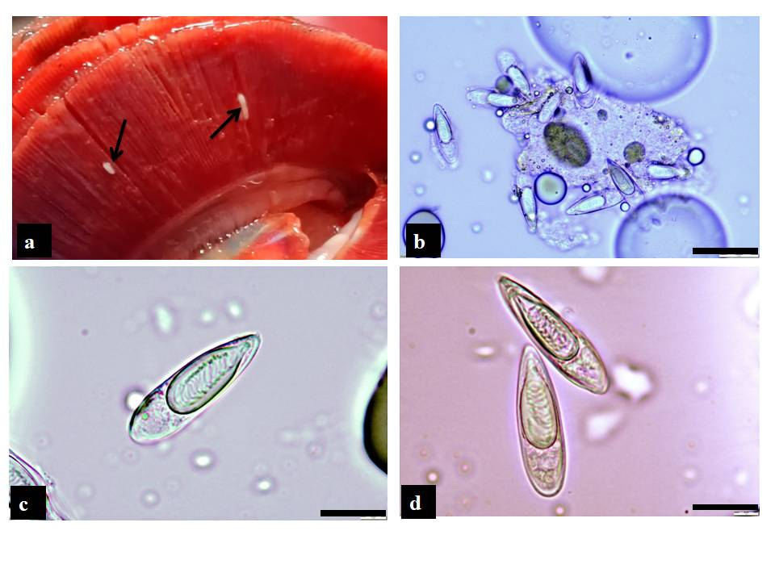
Fig 2 (a) gills of Labeo rohita showing plasmodium (arrow) of T. bifurcata Basu and haldar, 1999; (b-d) Mature Myxospores of T. bifurcata Basu and haldar, 1999 showing large polar capsule with polar filament coils under light microscopy at 400X magnification (Scale Bar: 20 µm)

Table 1: Measurements (µm) and ratios of Thelohanellus bifurcata Basu and Haldar, 1999
Characteristics | Range | Mean Values | SD
Length of Spore (LS) | 30.9-34.0 | 32.2 | 1.0
Width of Spore (WS) | 7.4-9.9 | 8.9 | 0.7
Length of Polar Capsule (LPC) | 17.3-21.7 | 19.3 | 1.4
Width of Polar Capsule (WPC) | 5.7-7.6 | 6.8 | 0.6
Length of polar filament | 173.5-221.4 | 197.6 | 15.3
Ratio: LS/WS | - | 3.6 | -
No. of filaments turns | 11-13 | 12 | -

Table 2: Morphometric comparison of Thelohanellus bifurcata Basu and Haldar, 1999, obtained from present study, with those of other authors.
Species | Thelohanellus bifurcata | T. bifurcata | T. bifurcata | T. bifurcata
Host | Labeo rohita | Labeo rohita | Labeo rohita | Labeo rohita
Locality | Ranaghat, West Bengal, India | Ranaghat, West Bengal, India | Patiala, Punjab, India | Punjab, India
Location | Gills | Gills | Gills | Gills
Reference(s) | Present study | Basu & Haldar, 1999 | Kaur & Katoch, 2014 | Nissa et al. 2024
Myxospore (L X W) | 32.2 X 8.9 | 34.8 X 9.2 | 33.6 X 8.9 | 31.4 X 9.4
Polar Capsule (L X W) | 19.3 X 6.8 | 23.3 X 6.6 | 18.1 X 5.7 | 19.9 X 8.0
LS/WS | 3.6 | 3.7 | 3.7 | 3.3

Remarks:
The morphometric observations mentioned in the present study on Thelohanellus bifurcata Basu and Haldar, 1999 resembles more or less with the descriptions provided by previous authors (Table 2). The comparison shows slight difference in the mean value of length x width of spore from the original description (32.2 µm x 8.9 µm in present study and 34.8 µm x 9.2 µm in original description by Basu and Haldar, 1999). Whereas, the mean value of the width of the spore resembles with the mean width value of spore given by Kaur and Katoch, 2014 (8.9 µm in both studies) but the mean value of length of spore slightly varies with this description (32.2 µm in present study, 33.6 µm in study by Kaur and Katoch, 2014). The mean value of length x width of spore also shows minute difference with the description by Nissa et al., 2024 (32.2 µm x 8.9 µm in present study and 31.4 µm x 9.4 µm in the study by Nissa et al., 2024). The ratio of the length and width of spore is almost similar with the descriptions by other authors (3.6 in present study; 3.7, 3.7, 3.3 in the study by Basu and Haldar, 1999; Kaur and Katoch, 2014 and Nissa et al., 2024 respectively). The mean value of the length of polar capsule also shows a very minute difference with the other descriptions (19.3 µm in present study and 23.3 µm, 18.1 µm and 19.9 µm in the study by Basu and Haldar, 1999; Kaur and Katoch, 2014 and Nissa et al., 2024 respectively). The mean value of length of polar capsule of present study (19.3 µm) is quite similar with the description provided by Nissa et al., 2024 (19.9 µm). The mean value of the width of the polar capsule of present study (6.8 µm) shows much similarity with the original description by Basu and Haldar, 1999 (6.6 µm). This value shows slight difference with the other descriptions (6.8 µm in present study, 5.7 µm and 8.0 µm in study by Kaur and Katoch, 2014 and Nissa et al., 2024 respectively). From the morphometric comparison it is clear that the studied species show more or less similarity in morphometry with the species of the studies provided by the previous authors. Therefore, it can be interpreted that the studied sample seems to be similar to Thelohanellus bifurcata morphologically.

Molecular data analysis:
The amplicon product from PCR reaction using Universal primers ERIB1 and ERIB10 was not much clear. The nested PCR by using Myxospec-F and Myxospec-R gave the expected product size. Fragment of 18s rRNA gene was amplified and a single discrete PCR amplicon band of approximately 1000 bp was observed. The 18s rRNA PCR amplified products of Thelohanellus bifurcata Basu and Haldar, 1999 from the present study were sequenced submitted to NCBI GenBank database under the accession number- PX836811. The sequence was checked for similarity and compared with the other sequences available in GenBank using BLAST. The result is presented in Table 3. The number of base substitutions per site between the sequences was observed by calculating distance matrix. Analyses were conducted using the “Maximum Composite Likelihood Model” (Tamura et al., 2004) (Kimura et al., 1980). This analysis involves 11 nucleotide sequences. Codon positions included were 1st, 2nd, 3rd and non-coding for the analysis and all ambiguous positions were removed for each sequence pair. A total of 908 positions were placed in the final dataset. Evolutionary analyses were conducted using MEGA-11 (Kumar et al., 2018). Table 4 estimates the evolutionary divergence between the sequences. The molecular sequencing of the 18s rRNA gene sequences of the studied sample (accession number- PX836811) shows greatest similarity with Thelohanellus bifurcata isolate R1 (accession number- ON820188.2) which reveals 99.22% sequence identity. The studied sample also shows high similarity with Thelohanellus sp. 1 2015 (accession number- KT387307.1) and with Thelohanellus filli isolate Ranjit Sagar (accession number- KR340464.1) which reveal 98.34% similarity with each. Sequence of several other species of Thelohanellus (accession number given in Table 3) was aligned with the studied species and each with varying percentage of similarity was obtained. The studied sample shows maximum distance with Thelohanellus sp. HK-2015 (accession number- KP792568.1) and Myxozoa sp. AP-2017 isolate R-1 (accession number- KY484795.1) which reveal 95.67% similarity with each species.

Table 3: Sequences producing similar alignments
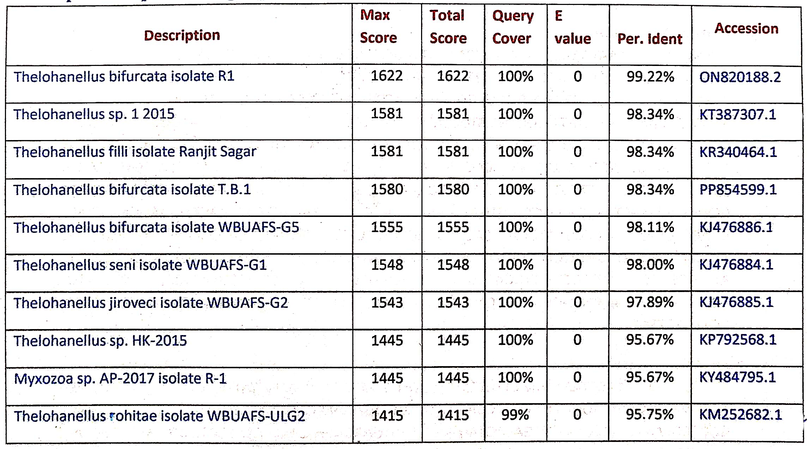
Phylogenetic tree:
Based on 18s rRNA sequence data, the evolutionary history was inferred and phylogenetic tree was constructed (Fig 3) by using Maximum likelihood method and Tamura-Nei model (Kimura, 1980) (Tamura et al., 2004). The phylogenetic analysis reveals clear clustering among the analyzed sequences. The phylogenetic tree can be clearly splitted into 2 major clades of which one major clade is further splitted into subclades and another major clade at the base of the phylogenetic tree comprises two sister groups. The phylogenetic tree demonstrates that Thelohanellus sp. 1 2015 (accession number- KT387307.1) and Thelohanellus filli isolate Ranjit Sagar (accession number- KR340464.1) formed a closely related sister group. The studied sample (accession number- PX836811) shows clustering within the same clade, which indicates a close evolutionary relationship with the sequences. Additional clusters were observed between Thelohanellus seni isolate WBUAFS-G1 (accession number- KJ476884.1) and Thelohanellus jiroveci isolate WBUAFS-G2 (accession number- KJ476885.1), as well as between Thelohanellus bifurcata isolate WBUAFS-G5 (accession number- KJ476886.1) and Thelohanellus rohitae isolate WBUAFS-ULG2 (accession number- KM252682.1). In contrast, Thelohanellus sp. HK-2015 (accession number- KP792568.1) and Myxozoa sp. AP-2017 isolate R-1 (accession number- KY484795.1) branched separately in a different clade at the basal position of the tree, which indicates greater genetic divergence or dissimilarity with the other sequences, especially with the sequence of studied sample (accession number- PX836811).
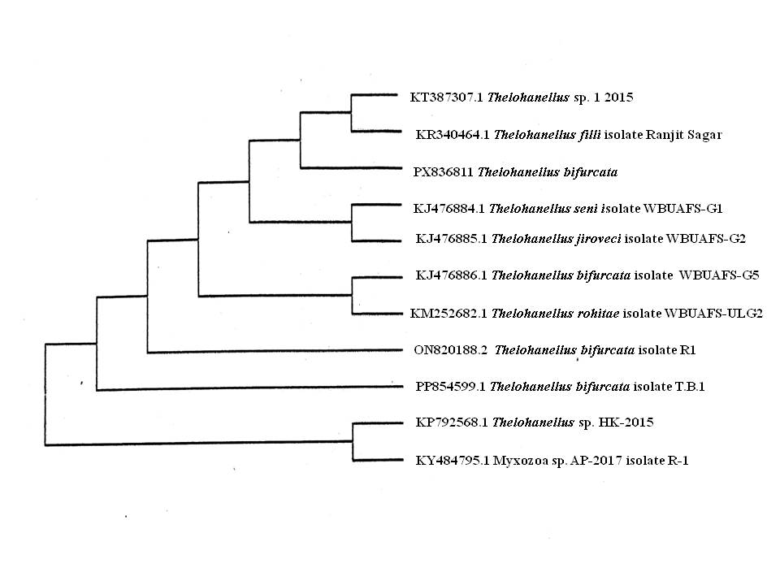

Fig 3: Phylogenetic tree by Maximum Likelihood method showing the phylogenetic position of T. bifurcata with other related Thelohanellus species

Table 4: Estimates of Evolutionary Divergence between Sequences
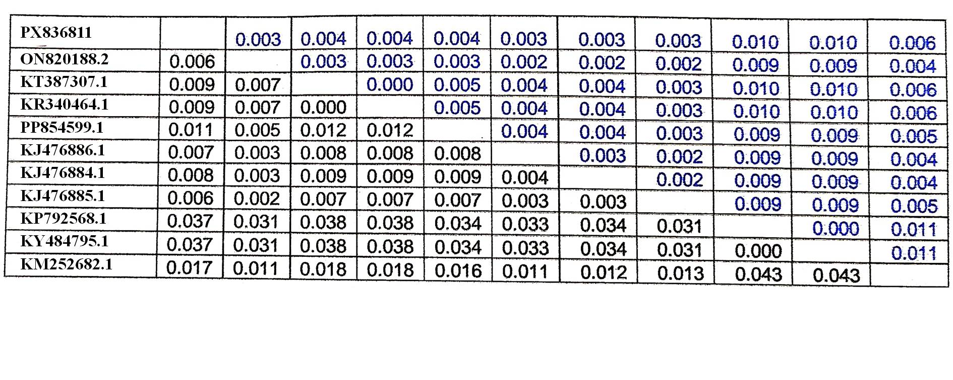
DISSCUSSION:
Thelohanellus bifurcata Basu and Haldar, 1999 was first reported from Ranaghat, Nadia, West Bengal. Later it was reported from same host fish, Labeo rohita from parts of India. The present study deals with the molecular and taxonomic re-description of the parasite Thelohanellus bifurcata Basu and Haldar, 1999 from Labeo rohita from Ranaghat, West Bengal. The present study confirms the presence of the parasite Thelohanellus bifurcata Basu and Haldar, 1999 in Labeo rohita on the basis of identification of the parasite by using two different methods. They include morphological description and molecular characterization by 18s rRNA gene sequencing. The parasite was reported for the first time from Ranaghat, West Bengal from the same host fish based only on the morphological characteristics. In 2024, Nissa et al., were first to perform the molecular identification of the parasite Thelohanellus bifurcata Basu and Haldar, 1999 from Punjab, India infecting the same host fish Labeo rohita. The present study deals with the molecular characterization of this parasite isolated from the same host fish, Labeo rohita from the same geographical region, Ranaghat, West Bengal which was studied during the original description by Basu and Haldar in 1999.
Due to the extensive diversity and potential complexity among the genus Thelohanellus it is not enough to rely solely on morphological description for the identification of the species. To abolish this ambiguity, molecular studies of the species are very much essential (Cech et al., 2012). The 18s rRNA gene sequence data obtained from the present study was compared with other sequences from the GenBank database. The sequences have been used to generate a distance matrix (Table 4) and a phylogenetic tree (Fig 3) which has revealed the taxonomic position of the studied sample (accession number- PX836811). The phylogenetic tree was made based on Maximum Likelihood Method and Tamura-Nei Model (Tamura et al., 2004). The phylogenetic tree demonstrates that the studied sample is closely related to Thelohanellus sp. 1 2015 (accession number- KT387307.1) and with Thelohanellus filli isolate Ranjit Sagar (accession number- KR340464.1), suggesting that these sequences may belong to the same species or closely related strains. The tight clustering observed among other sequence pairs indicate their high genetic similarity, possibly reflecting shared evolutionary origins. In contrast, the basal position of Thelohanellus sp. HK-2015 (accession number- KP792568.1) and Myxozoa sp. AP-2017 isolate R-1 (accession number- KY484795.1) indicates that these sequences are evolutionarily more distant and may represent out group lineages. Overall, the phylogenetic relationships observed in the present study highlight both on conserved and divergent evolutionary patterns among the sequences. Comparison of molecular data of the sequences presented in Table 3 shows maximum similarity with Thelohanellus bifurcata isolate R1 (accession number- ON820188.2) revealing 99.22% similarity with the studied sample. It suggests that the studied sample seems to be Thelohanellus bifurcata.

Table 5: Morphological comparison of the species of Thelohanellus (LS- length of Myxospore, WS- width of spore, LPC- length of polar capsule, WPC- width of polar capsule, NPF- number of polar filament turns)
Myxozoan species | Host | Organ Infected | LS x WS (µm) | LPC x WPC (µm) | NPF | Reference
T. bifurcata | Labeo rohita | Gills | 32.2 X 8.9 | 19.3 X 6.8 | 11-13 | Present study
T. bifurcata | Labeo rohita | Gills | 34.8 X 9.2 | 23.3 X 6.6 | 15-20 | Basu and Haldar, 1999
T. bifurcata | Labeo rohita | Gills | 33.6 X 8.9 | 18.1 X 5.7 | 11-14 | Kaur and Katoch, 2014
T. filli | Labeo rohita | Gills | 27.0 X 10.5 | 16.6 X 8.2 | 12-14 | Kaur et al. 2014
T. jiroveci | Labeo bata | Gills | 35.0 X 13.0 | 18.4 X 7.00 | 10-12 | Kundu and Haldar, 1981
T. seni | Catla catla | Gills | 12.4 X 8.5 | 6.42 X 4.52 |  | Southwell and Prashad, 1918
T. rohitae | Labeo rohita, Labeo bata | Gills | 31.5 X 11.5 | 18 X 15.5 | 6 | Southwell and Prashad, 1918

In this study, Thelohanellus bifurcata (present study), Thelohanellus bifurcata (sequences of compared sample in Table 3), Thelohanellus filli, Thelohanellus seni, Thelohanellus jiroveci, Thelohanellus rohitae seems to be closely related according to the phylogenetic tree (Fig 3). However, the morphometric characters of these species which are presented in Table 5, clearly shows the morphological dissimilarities among all these species. Phylogenetically, these species are closely related. Similar results were observed by Kaur et al., 2021 and Nissa et al., 2024 in their studies. The reason behind the similar result may be that Thelohanellus bifurcata clusters with the other above mentioned species from India in a well-supported group and all these species infect the gills of the same host, Labeo rohita from Indian sub-continent (Nissa et al., 2024). From the above discussion, it is clear that the studied species in this paper seems to be Thelohanellus bifurcata Basu and Haldar, 1999, which has been reported from Ranaghat, West Bengal for the second time. First it was reported from Ranaghat, West Bengal by Basu and Haldar, 1999. Nissa et al., 2024 were first to perform the molecular analysis of this species from host fish, Labeo rohita from Punjab, India. Basically, this study presents the molecular analysis of Thelohanellus bifurcata Basu and Haldar, 1999 for the second time from Indian sub-continent and for the first time from West Bengal along with its taxonomic re-description.

Data availability statement:
The data supporting the findings of the present study can be obtained from the corresponding author upon reasonable request.

Conflict of interest:
The authors of this paper have no conflict of interest regarding the commercial, academic, political, financial and personal aspects. The authors declare that they have no comepeting interests.

COMPETING INTERESTS DISCLAIMER:
Authors have declared that they have no known competing financial interests OR non-financial interests OR personal relationships that could have appeared to influence the work reported in this paper.

REFERENCES:
Abraham, T.J., Banerjee, S., Patra, A., Sarkar, A., Adikesavalu, H., & Dash, G. (2015). Molecular phylogeny of Myxobolus orissae (Myxosporea: Myxobolidae) infecting the gill lamellae of mrigal carp Cirrhinus mrigala (Actinopterygii: Cyprinidae). Molecular Biology Research Communications, 4(1), 15-24.

Altschul, S.F., Madden, T.L., Schaffer, A.A, Zhang, J., Zhang, Z., Miller, W., & Lipman, D.J. (1997). Gapped BLAST and PSI-BLAST: a new generation of protein database search programs. Nucleic Acids Res, 25, 3389-3402.

Atkinson, S.D., Bartosova-Sojkova, P., Whipps, C.M., & Bartholomew, J.L. (2015). Approaches for Characterising myxozoan species. In: Okamura B, Gruhl A, Bartholomew JL (eds) Myxozoan Evolution, Ecology and Development. Springer International Publishing, Cham, Switzerland, 111-123.

Barta, J.R., Martin, D.S., Liberator, P.A., & Dashkeivicz, M. (1997). Phylogenetic relationships among eight Eimeria species infecting domestic fowl inferred using complete small subunit ribosomal DNA sequences. J Parasitol, 83, 262-271.

Basu, S., & Haldar, D.P. (1999). Thelohanellus bifurcata n. sp. a new species of the genus Thelohanellus Kudo, 1933 along with description of Thelohanellus disporomorphus sp. n. J Parasitol Dis Appl Anim Biol, 15(1-0), 81-94.

Cech, G., Molnar, K., & Szekely, C. (2012). Molecular genetic studies on morphologically indisctinguishable Myxobolus spp. infecting cyprinid fishes, with the description of three new species, M. alvarezea sp. nov., M. sitjae sp. nov. and M. Eirasianus sp. nov. Acta Parasitol, 57(4), 354-366.

Eiras, J.C., Barman, G.D., Chanda, S., & Panigrahi, A.K. (2023). An update of the species of Myxosporea (cnidaria, Myxozoa) described from Indian fish. J Parasit Dis, 47(1), 12-36.

Emeish, W.F.A., Fawaz, M.M., Amgad, Z.A., & Hussain, N.M. (2022). Henneguya species infecting the gastrointestinal tract of Clarias gariepinus from the Nile River. Diseases of Aquatic Organisms, 148, 43-56. https://doi.org/10.3354/dao03649

Fiala, I. (2006). The phylogeny of Myxosporea (Myxozoa) based on small subunit ribosomal RNA gene analysis. Int J Parasitol, 36, 1521-1534.

Fiala, I., Bartosova-Sojkova, P., & Whipps, C.M. (2015). Classification and phylogenetics of Myxozoa. In: Okamura B, Gruhl A, Bartholomew JL (eds) Myxozoan Evolution, Ecology and Development. Springer, Cham. https://doi.org/10.1007/978-3-319-14753-6_5

Kaur, H., & Gupta, A. (2017). Molecular and phylogenetic characterization of Thelohanellus boggoti Qadri, 1962 (Cnidaria: Myxosporea: Bivalvulida) infecting the fin of Indian minor carp Labeo dero (Hamilton, 1822). Mol Biol Res Commun, 6, 13-21.

Kaur, H., Gupta, A., & Atrri, R. (2021). Molecular phylogenetics reveals a species complex pattern of closely related members of genus Thelohanellus (cnidaria:Myxosporea) from the Indian subcontinent. Microbial Pathogenesis, 150, 104690. https://doi.org/10.1016/j.micpath.2020.104690

Kaur, H., & Katoch, A. (2014). Gill disease caused by Thelohanellus bifurcata Basu and Haldar, 1999 a pathogenic myxozoan parasite in cultured Indian carp, Labeo rohita (Hamilton, 1822) in Punjab, India. Journal of Animal Health and Production, 2(2), 19-24.

Kaur, H., Katoch, A., & Gupta, M. (2014). Thelohanellus filli sp. n., a pathogenic myxosporean infecting gills of cultured carp, Labeo rohita (Hamilton, 1822) in Punjab, India. Species, 10(23), 31-38.

Kaur, H., & Singh, R. (2012a). A synopsis of the species of Myxobolus Butschli, 1882 (Myxozoa:Bivalvulida) parasitizing Indian fishes and a revised dichotomous key to myxosporean genera. Syst Parasitol, 81, 17-37.

Kaur, H., & Singh, R. (2012b). One new myxosporean species, Triangula cirrhini sp. n. and known species, T. ludhianae (syn. M. ludhianae Gupta and Khera, 1991) comb. n. (Myxozoa: Myxosporea), infecting Indian major carp in Harike wetland of Punjab. Anim Biol, 62, 129-139.

Kaur, H., Singh, R., Katoch, A., Atrri, R., & Dar, S.A. (2017). Species diversity of the genus Thelohanellus Kudo, 1933 (Myxozoa: Bivalvulida) parasitizing fishes in Indian subcontinent. Journal of Parasitic Diseases, 41(2), 305-312.
Kimura, M. (1980). A simple method for estimating evolutionary rate of base substitutions through comparative studies of nucleotide sequences. J Mol Evol, 16, 111-120.

Kumar, S., Stecher, G., Li, M., Knyaz, C., & Tamura, K. (2018). MEGA X: Molecular evolutionary genetics analysis across computing platforms. Molecular Biology and Evolution, 35, 1547-1549.

Kundu, T.K., & Haldar, D.P. (1981). Studies on Thelohanellus jiroveci sp. n., a new myxosporidian parasitic in a common teleost fish. Vestn Ceskoslov spol zool, 45, 94-101.

Lom, J., & Arthur, J.R. (1989). A guideline for the preparation of species descriptions in Myxosporea. J Fish Dis, 12, 151-156.

Lom, J., & Dykova, I. (1995). Myxosporea (Phylum Myxozoa). In: Woo PTK (ed) fish diseases and disorders, Vol. 1, Protozoan and Metazoan Infections. CAB International, Wallingford, 97-148.

Lom, J., & Dykova, I. (2006). Myxozoan genera: definition and notes on taxonomy, life-cycle terminology and pathogenic species. Folia Parasitol, 53(1), 1-36.

Nissa, K., Kaur, H., Ghai, N., & Katoch, A. (2024). Molecular and phylogenetic characterization of a Cnidarian parasite (Cnidaria:Myxozoa) Thelohanellus bifurcata, infecting gills of Indian major carp, Labeo rohita. Journal of Parasitic Diseases, 48, 767-774. https://doi.org/10.1007/s12639-024-01706-x

Okamura, B., Hartigan, A., & Naldoni, J. (2018). Extensive uncharted biodiversity: the parasite dimension. ICB, 58(6), 1132-1145.

Smothers, J.F., Van Dohlen, C.D., Smith Jr, L.H., & Spall, R.D. (1994). Molecular evidence that the myxozoan protists are metazoans. Science, 265, 1719-1721.

Southwell, T., & Prashad, B. (1918). Parasites of Indian fishes with anote on carcinoma in the climbing perch. Rec Indian Mus, 15, 341-355.

Struck, T.H., Feder, J.L., Bendiksby, M., Brikeland, S., Cerca, J., Gusarov, V.I., Kistenich, S., Larsson, K.H., Liow, L.H., Nowak, M.D., Stedje, B., Bachmann, L., & Dimitrov, D. (2018). Finding evolutionary distance processes hidden in cryptic species. Trends Ecol Evol, 33(3), 153-163.

Tamura, K., & Nei, M. (1993). Estimation of the number of nucleotide substitutions in the control region of mitochondrial DNA in humans and Chimpanzees. Mol Biol Evol, 10(3), 512-526.

Tamura, K., Nei, M., & Kumar, S. (2004). Prospects for inferring very large phylogenies by using the neighbor-joining method. Proceedings of the National Academy of Sciences (USA), 101, 11030-11035.

Yokoyama, H., Kiyanage, Y.S., Sugai, A., & Wakabayashi, H. (1998). Hemorrhagic thelohanellosis of colour carp caused by Thelohanellus hovorkai (Myxozoa: Myxosporea). Fish Pathol, 33, 85-89.

