Review Article
Adaptive Strategies of Insects to Environmental Extremes: Behavioural, Morphological, Physiological, and Molecular Integration

ABSTRACT
Insects dominate terrestrial and freshwater ecosystems despite exposure to environmental extremes that challenge survival, development, and reproduction. Their ecological success is underpinned by complex adaptive strategies that operate across behavioural, morphological, physiological, and molecular scales. These adaptations function as integrated networks, combining rapid behavioural responses, structural innovations, physiological tolerance, and molecular mechanisms to buffer environmental stressors. This review synthesizes current understanding of insect responses to thermal extremes, desiccation, seasonal unpredictability, predation, and chemically defended host plants. Emphasis is placed on mechanistic insights, patterns of evolutionary convergence, energetic trade-offs, and the limits of adaptation under accelerating environmental change. By examining the hierarchical and integrated nature of insect adaptations, this synthesis provides a framework for predicting species resilience, ecosystem stability, and evolutionary trajectories in the face of increasingly extreme and dynamic environments.
Keywords: Behavioural, Insect Adaptation, Morphological, Mimicry, Physiological
Introduction
1. ENVIRONMENTAL EXTREMES AS DRIVERS OF INSECT DIVERSITY
Environmental extremes defined as environmental conditions that approach or exceed the physiological tolerance limits of organisms—are pervasive features of insect habitats across the globe (Chown and Nicolson, 2004; Sinclair et al., 2015). Insects routinely encounter large and rapid fluctuations in temperature, chronic or episodic water limitation, hypoxic microhabitats, toxic secondary metabolites produced by host plants, and persistent predation pressure. These stressors vary predictably along latitudinal, altitudinal, and seasonal gradients, generating spatially and temporally heterogeneous selective landscapes (Parmesan, 2006; Deutsch et al., 2008). Importantly, such extremes are not confined to marginal environments but are integral components of many otherwise productive ecosystems, including deserts, tropical forests, agricultural systems, and alpine regions. Rather than functioning solely as constraints on survival, environmental extremes have acted as powerful drivers of insect diversification, ecological specialization, and adaptive radiation. Repeated exposure to stress has promoted the evolution of novel phenotypes that exploit ecological opportunities inaccessible to less tolerant taxa, thereby contributing to the extraordinary taxonomic and functional diversity of insects (Chown and Nicolson, 2004). For example, tolerance to thermal or chemical stress can facilitate host shifts, range expansions, and niche partitioning, ultimately reinforcing ecological dominance across trophic levels. Natural selection operates not by generating variation but by filtering existing phenotypic diversity through environmental challenges (Endler, 1986). Insects are particularly responsive to such filtering due to their short generation times, large population sizes, and high reproductive output, which collectively accelerate evolutionary dynamics (Futuyma and Kirkpatrick, 2017). Additionally, the modular organization of insect development allows individual traits such as cuticular composition, metabolic pathways, or behavioural routines to evolve semi-independently, enhancing evolvability under fluctuating selection regimes. As a consequence, insect populations frequently exhibit rapid adaptive shifts in response to environmental change, both through genetic evolution and phenotypic plasticity.
Recurrent exposure to similar stressors across evolutionary time has resulted in striking cases of convergent and parallel evolution among phylogenetically distant insect lineages. Independent populations and species often arrive at comparable adaptive solutions, revealing both the predictability of natural selection and the constraints imposed by developmental architecture and biochemical feasibility (Stern, 2013; Rosenblum et al., 2014). Such convergence is particularly evident in traits associated with thermal tolerance, detoxification, and predator avoidance, where the range of viable solutions may be limited by fundamental physical or physiological principles. Crucially, insect adaptation operates as a hierarchical and integrative process rather than a collection of isolated traits. Behavioural strategies frequently constitute the first line of defence, reducing exposure to stressful conditions through habitat selection, temporal avoidance, or movement (Huey et al., 2002). When avoidance is insufficient, morphological specializations such as modified cuticle structure, body form, or coloration can mitigate damage or enhance survival under adverse conditions. At deeper levels, physiological and molecular mechanisms buffer internal homeostasis through metabolic reprogramming, stress-protein synthesis, and cellular protection systems (West Eberhard, 2003; Angilletta et al., 2010). The interaction among these adaptive layers generates a form of biological redundancy, whereby failure at one level can be compensated by responses at another. This multilayered integration confers robustness across spatial and temporal scales, enabling insects to persist in environments characterized by chronic stress, episodic extremes, or rapid environmental change. Understanding this hierarchical structure of adaptation is therefore essential for predicting insect responses to ongoing global change, as disruption at any level may have cascading effects on survival, reproduction, and population persistence. Usually, the adaptation are generally classified into Behavioural, Physiological and Morphological adaptation (Fig. 1).

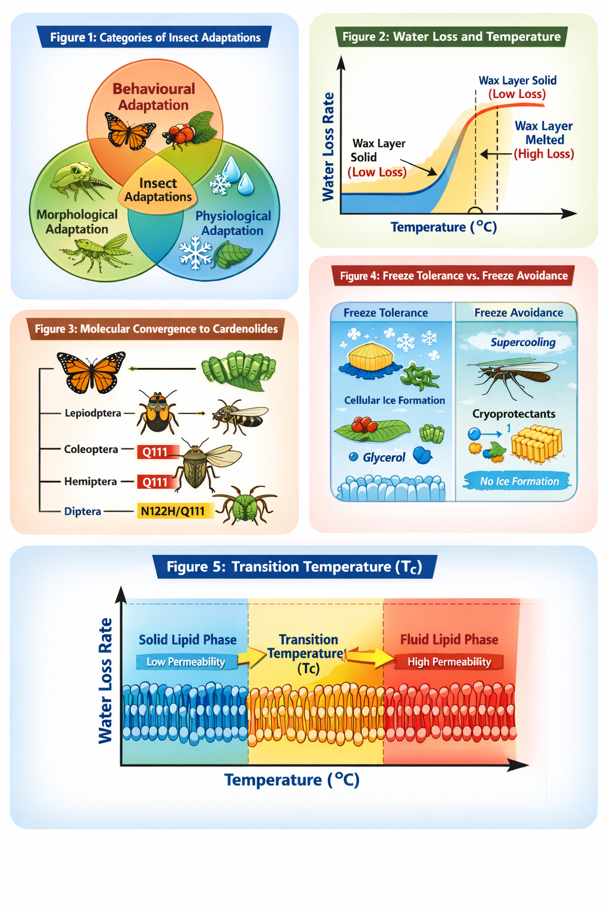

Fig. 1. Different adaptations in Insects
2. BEHAVIOURAL ADAPTATIONS: FIRST-LINE DEFENCE MECHANISMS
2.1 Behaviour as an Adaptive Filter
Behaviour represents the most flexible, rapidly deployable, and evolutionarily labile form of adaptation in insects. Unlike morphological or physiological traits, which often require developmental commitment or genetic change, behavioural responses can be modified within an individual’s lifetime and frequently constitute the earliest response to environmental stress (Kennedy, 1985; Sih et al., 2011). This immediacy allows behaviour to function as a critical buffering mechanism, reducing exposure to potentially lethal conditions before internal tolerance limits are exceeded. As a result, behavioural adaptations often precede, and in some cases reduce the necessity for, subsequent morphological or physiological evolution. Behavioural thermoregulation provides a clear illustration of this buffering role. Through microhabitat selection, posture adjustment, activity timing, and movement between sun and shade, insects can maintain body temperatures within optimal ranges despite extreme ambient conditions (Huey et al., 2002). Such behaviours substantially modify the thermal environment experienced by the organism, decoupling body temperature from macroclimatic conditions and thereby expanding the range of habitats that can be occupied. Similarly, habitat selection behaviours allow insects to exploit spatial heterogeneity in humidity, oxygen availability, and resource distribution, mitigating the impacts of desiccation, hypoxia, or nutritional stress (Angilletta et al., 2010).
Risk avoidance behaviour further illustrates how behavioural flexibility shapes survival and fitness. Insects adjust activity periods, foraging intensity, and refuge use in response to predation risk, often trading off energy acquisition against mortality risk. These behavioural decisions influence exposure to both biotic and abiotic stressors and can profoundly affect life-history outcomes. By reducing the frequency and intensity of exposure to stress, such behaviours effectively lower the strength of selection acting on physiological tolerance mechanisms, allowing populations to persist in environments that would otherwise exceed their intrinsic limits (Huey et al., 2002; Angilletta et al., 2010). Despite this flexibility, many insect behaviours are not arbitrary but are genetically canalized, forming species-specific ethograms shaped by evolutionary history and ecological specialization (Kennedy, 1985). These innate behavioural repertoires ensure reliable expression of adaptive responses under predictable environmental conditions, such as seasonal changes in temperature or photoperiod. Canalization enhances developmental stability and reduces the costs associated with learning or trial-and-error behaviour, which may be particularly advantageous in short-lived organisms with limited opportunities for behavioural refinement. At the same time, behavioural plasticity introduces a dynamic component to insect adaptation. Individuals can fine-tune innate behavioural programs in response to local environmental variation, enabling rapid adjustment to fluctuating or novel conditions. This plasticity is especially important in environments characterized by high temporal unpredictability, such as intermittent droughts, heat waves, or irregular resource availability. By allowing a single genotype to produce multiple behavioural phenotypes, plasticity enhances short-term survival and can influence the direction and rate of subsequent evolutionary change. Behavioural plasticity also plays a critical role in mediating exposure to selection itself. By altering the environmental context in which physiological and morphological traits operate, behaviour can either shield traits from selection or expose them to new selective pressures. In this way, behaviour functions not only as an adaptive response but also as an active participant in evolutionary dynamics, shaping both ecological interactions and evolutionary trajectories (Sih et al., 2011). Collectively, the interplay between behavioural canalization and plasticity enables insects to balance reliability with flexibility. This balance underlies their capacity to persist across diverse and rapidly changing environments and highlights behaviour as a foundational component of adaptive integration. Understanding behavioural adaptation is therefore essential for interpreting insect responses to environmental extremes, particularly under contemporary scenarios of climate variability and anthropogenic disturbance.
2.2 Migration and Long-Distance Movement
Migration represents one of the most energetically demanding yet ecologically powerful behavioural strategies employed by insects, enabling populations to escape habitats undergoing temporal deterioration and to exploit spatially discontinuous or seasonally transient resources (Dingle, 2014). Unlike short-range dispersal, migration is characterized by persistent, directional movement that is maintained independently of immediate resource encounters, often accompanied by a temporary suppression of station-keeping behaviours such as feeding or reproduction. Through migration, insects effectively decouple population persistence from local environmental instability, thereby buffering demographic processes against seasonal or stochastic habitat degradation. In Lepidoptera, migratory behaviour is tightly linked to the phenology of host plants and nectar resources. Seasonal migration allows populations to track ephemeral resource availability across broad geographic scales, ensuring synchrony between larval development and host-plant quality (Reppert et al., 2010; Flockhart et al., 2017). The monarch butterfly (Danaus plexippus) provides a paradigmatic example of this strategy, completing a multi-generational migratory circuit spanning thousands of kilometers across North America. Navigation in monarchs relies on an integrated time-compensated sun compass, in which circadian clock genes modulate solar orientation, enabling accurate directional flight despite changing solar angles across latitudes (Reppert et al., 2010). This sophisticated navigational system highlights the close coupling between behavioural adaptation and underlying molecular mechanisms.
In tropical regions, where seasonality is often driven more by precipitation than temperature, migratory behaviour in butterflies tends to be facultative rather than obligate. Many species undertake seasonal movements that correspond to monsoon-driven changes in vegetation productivity and host-plant availability (Kunte, 2005). These migrations are typically population-level phenomena, with individuals responding plastically to environmental cues such as rainfall patterns, humidity, and plant phenology. Such flexibility allows tropical butterflies to exploit spatial heterogeneity in resource availability while minimizing exposure to periods of resource scarcity. Dragonflies represent some of the most extreme examples of insect migration, both in distance and ecological scope. Species such as Pantala flavescens undertake long-distance and even transoceanic migrations, moving between continents by exploiting large-scale atmospheric circulation systems (Anderson, 2009; Hobson et al., 2012). These movements require exceptional flight endurance, aerodynamic efficiency, and physiological capacity for sustained energy expenditure. Stable isotope analyses and radar studies suggest that dragonfly migrations play a significant role in connecting distant ecosystems, contributing to gene flow and nutrient transport across biogeographic regions. Locust migration illustrates how behavioural adaptation can be tightly integrated with morphological, physiological, and neuroendocrine change. In species such as Schistocerca gregaria, density-dependent phase polyphenism induces a dramatic transformation from solitary, cryptically coloured individuals into gregarious, highly mobile swarm members (Pener and Simpson, 2009). This transition involves coordinated changes in body coloration, muscle physiology, sensory processing, and metabolic capacity, all of which enhance sustained flight and collective movement (Cullen et al., 2017). Neurochemical shifts, particularly in serotonergic signalling, mediate the behavioural switch, linking environmental cues directly to large-scale population movements.
2.3 Dormancy, Diapause, and Temporal Avoidance
When spatial escape through migration or dispersal is constrained, insects frequently rely on temporal avoidance strategies to persist through periods of environmental adversity. Dormancy represents a fundamental component of this strategy, allowing individuals to suspend growth, development, or reproduction during unfavourable conditions such as cold winters, dry seasons, or periods of resource scarcity (Tauber et al., 1986). By decoupling life-cycle progression from immediate environmental conditions, dormancy enables insects to bridge predictable intervals of stress and reinitiate activity when conditions become favourable. Among the various forms of dormancy, diapause is distinguished by its anticipatory and hormonally regulated nature. Unlike quiescence, which is a direct response to adverse conditions, diapause is initiated in advance of environmental deterioration in response to reliable predictive cues, most notably photoperiod and temperature (Denlinger, 2002). These environmental signals are integrated by the neuroendocrine system, resulting in altered hormonal profiles that arrest development or reproduction at specific life stages. This anticipatory regulation allows insects to enter diapause under relatively benign conditions, thereby avoiding exposure to the most severe phases of environmental stress. Entry into diapause is accompanied by extensive physiological and metabolic reorganization. Diapausing insects typically exhibit profound metabolic suppression, reducing energy expenditure and prolonging survival during extended periods of inactivity (Hahn and Denlinger, 2011). Concurrently, energy reserves particularly lipids are accumulated prior to diapause onset and mobilized in a tightly regulated manner during diapause maintenance. These reserves provide the energetic foundation for survival, post-diapause development, and, in some cases, immediate reproductive activity following diapause termination.
In addition to metabolic adjustments, diapause is associated with enhanced tolerance to a range of abiotic stressors. Diapausing insects often display increased resistance to cold, desiccation, and oxidative stress, reflecting upregulation of protective molecules such as cryoprotectants, antioxidants, and stress-response proteins (Hahn and Denlinger 2011; Hand et al., 2016). These physiological changes extend beyond passive tolerance and represent active protective mechanisms that stabilize cellular structures, preserve membrane integrity, and maintain macromolecular function during prolonged dormancy. Crucially, diapause is not a uniform or static condition but consists of distinct phases—initiation, maintenance, and termination each governed by specific regulatory processes (Kostal, 2006). During initiation, environmental cues trigger hormonal changes that arrest development and initiate physiological remodelling. The maintenance phase is characterized by sustained metabolic suppression and stress resistance, often maintained independently of external conditions. Termination occurs when environmental cues or internal physiological thresholds signal the approach of favourable conditions, allowing rapid resumption of development or reproduction. This phased structure enables precise synchronization of life-history events with seasonal cycles, maximizing fitness in environments where timing is critical.
2.4 Anti-Predator Behaviour
Predation represents one of the most pervasive and evolutionarily influential selective forces acting on insects, shaping an extraordinary diversity of behavioural defence strategies that reduce detection, deter attack, or disrupt predator decision-making processes (Eisner et al., 2005; Humphreys and Ruxton 2018). Because lethal encounters often occur within fractions of a second, behavioural defences provide a critical first line of protection, enabling insects to respond rapidly to imminent threats before physical contact is established. These behaviours include acoustic interference, chemical discharge, evasive locomotion, and thanatosis, each targeting different stages of the predation sequence.
Acoustic defences illustrate how insects can directly interfere with predator sensory systems. Tiger moths, for example, produce ultrasonic clicks that function either as aposematic signals advertising chemical unpalatability or as active jamming signals that disrupt bat echolocation (Corcoran et al., 2009; Conner, 2014). By degrading the accuracy of echolocation-based targeting, these clicks reduce capture success and impose strong selection on bat sensory and hunting strategies. This interaction exemplifies a sensory arms race in which prey signalling and predator perception coevolve, leading to escalating behavioural and physiological specializations on both sides. Chemical discharge behaviours provide another effective means of predator deterrence. Many insects release noxious or toxic compounds when disturbed, often through specialized glands or reflex bleeding. These chemical defences can act immediately by inducing aversive sensory experiences or over longer timescales by facilitating predator learning and avoidance. Behavioural deployment of chemical defences is frequently context-dependent, minimizing energetic costs and self-toxicity while maximizing deterrent efficacy (Eisner et al., 2005). In many cases, chemical discharge is accompanied by conspicuous movements or sounds that enhance signal detectability and reinforce predator memory.
Evasive movement and escape behaviours further reduce predation risk by increasing encounter uncertainty and reducing capture probability. Sudden directional changes, erratic flight paths, and rapid acceleration challenge predator tracking and pursuit abilities. Such behaviours are often tightly coupled with sensory processing speed and neuromuscular performance, highlighting the integration of behavioural and physiological traits under predation-driven selection. Thanatosis, or death-feigning behaviour, represents a particularly intriguing anti-predator strategy that exploits predator cognitive biases rather than physical escape. By adopting a rigid, immobile posture, insects reduce the likelihood of continued attack, particularly from predators that preferentially target moving prey (Miyatake et al., 2008). Experimental studies demonstrate that the duration and intensity of thanatosis can significantly influence survival outcomes and that this behaviour exhibits heritable variation, indicating a genetic basis subject to natural selection. In some contexts, thanatosis also facilitates secondary defence strategies, such as chemical release or escape once the predator’s attention wanes. Importantly, behavioural defences rarely function in isolation. Instead, they operate synergistically with morphological and chemical adaptations to produce multilayered defence systems. Acoustic signalling may reinforce aposematic coloration, thanatosis may enhance the effectiveness of chemical defences, and evasive movement may complement cryptic morphology. Such integration increases defensive reliability across diverse predator assemblages and environmental contexts, reducing reliance on any single mechanism.
3. MORPHOLOGICAL ADAPTATIONS: STRUCTURAL AND SIGNAL-BASED DEFENCES
3.1 Mimicry and Evolutionary Convergence
Mimicry represents one of the most compelling examples of adaptive convergence driven by intense and consistent natural selection imposed by visually oriented predators. In its classical formulation, Batesian mimicry involves palatable or otherwise undefended species evolving phenotypic resemblance to toxic, distasteful, or otherwise defended models, thereby gaining protection through predator misidentification (Bates, 1862). The effectiveness of this strategy depends critically on relative abundances: mimics benefit only when models are sufficiently common to maintain predator aversion, highlighting the frequency-dependent nature of selection in these systems. In contrast, Müllerian mimicry involves mutual resemblance among multiple unpalatable or defended species, all of which contribute to predator learning and avoidance (Müller, 1879). In these systems, convergence on a shared warning signal reduces the per-capita cost of educating predators, as negative predation experiences with any one species reinforce avoidance of the entire mimetic complex. This mutualistic interaction among prey species promotes rapid and often striking convergence in colour patterns, body form, and signalling traits, even among phylogenetically distant taxa.
Empirical and theoretical work has demonstrated that Müllerian mimicry can generate remarkably stable adaptive peaks, leading to the formation of discrete mimetic rings within particular geographic regions (Ruxton et al., 2018). Once established, these rings exert strong stabilizing selection, constraining phenotypic variation and favouring precise signal fidelity. Deviations from the dominant warning pattern are often selected against, as imperfect mimics experience elevated predation risk due to predator uncertainty or delayed learning. The Neotropical Heliconius butterflies provide one of the most intensively studied systems for understanding the genetic and developmental basis of mimicry. Despite extensive species diversity, many Heliconius species display nearly identical wing colour patterns within local mimicry complexes. Genomic analyses have revealed that repeated evolution of these patterns frequently involves changes at a small number of conserved regulatory loci, including genes controlling wing scale development and pigment deposition (Joron et al., 2011; Wallbank et al., 2016). This reuse of the same genetic pathways across independent evolutionary events highlights the predictability of adaptive evolution under strong selective constraint. Importantly, mimicry is not solely a morphological phenomenon but an integrated adaptive system. The efficacy of warning signals depends on behavioural components such as flight pattern, display posture, and habitat use, as well as physiological traits including chemical defence levels and toxin sequestration efficiency. Predators, in turn, shape mimicry evolution through their sensory capabilities, learning rates, and memory retention, embedding mimicry within a broader coevolutionary framework.
3.2 Crypsis, Masquerade, and Background Matching
Camouflage constitutes one of the most widespread and evolutionarily conserved anti-predator strategies in insects, functioning primarily by reducing the probability of detection rather than deterring attack after detection. At its core, camouflage minimizes visual contrast between the organism and its background by matching colour, luminance, texture, or spatial patterning (Cott, 1940; Stevens and Merilaita, 2009). Insects inhabiting visually complex environments, such as foliage, bark, or leaf litter, often exhibit finely tuned cryptic phenotypes that reflect the dominant visual statistics of their microhabitats. Extreme morphological crypsis is particularly evident in groups such as Phasmatodea (stick insects), Phylliidae (leaf insects), and Mantodea (mantids), where body shape, venation patterns, and even surface microtextures closely resemble plant structures. These morphological traits are rarely static; they are frequently reinforced by behavioural alignment, including posture selection, orientation relative to light sources, and substrate-specific resting behaviours. For example, many stick insects actively align their bodies with plant stems and sway rhythmically to mimic wind-induced vegetation movement, thereby further reducing the likelihood of detection by motion-sensitive predators.
Beyond simple background matching, camouflage may also involve disruptive coloration, in which high-contrast markings break up the outline of the body and obscure its true shape. Such patterning interferes with edge detection and object recognition processes in predator visual systems, effectively delaying or preventing prey identification. Importantly, the success of disruptive coloration depends on spatial scale and viewing distance, highlighting the interaction between prey phenotype and predator sensory resolution. Masquerade represents a mechanistically distinct, though often complementary, form of crypsis. Rather than rendering the insect visually inconspicuous, masquerade exploits predator categorization errors by causing the insect to be perceived as an inanimate or irrelevant object, such as a twig, leaf fragment, or bird dropping (Skelhorn et al., 2010). Predators may detect the organism but fail to classify it as prey, resulting in reduced attack probability. This strategy relies heavily on predator experience and cognitive templates, and its effectiveness may increase with predator familiarity with genuine inanimate objects in the environment.
Masquerade is frequently enhanced by behavioural immobility or stereotyped movements that reinforce the illusion of non-prey identity. Many twig-mimicking caterpillars adopt rigid postures during daylight hours, while bird-dropping mimics often remain stationary on exposed leaf surfaces where real droppings are common. In such cases, selection acts not only on morphology but also on behavioural timing and microhabitat choice. An especially elaborate extension of masquerade is observed in trash-carrying larvae, such as those of certain chrysopids and coccinellids. These insects actively collect plant debris, prey remains, or exuviae and attach them to specialized dorsal structures, constructing a mobile camouflage cloak (Tauber et al., 2014). This composite phenotype combines morphological adaptation, behavioural construction, and environmental materials, illustrating how extended phenotypes can function as anti-predator defences.
4. PHYSIOLOGICAL AND MOLECULAR ADAPTATIONS
4.1. Cold Hardiness
Exposure to low temperatures is among the most severe abiotic challenges encountered by insects, particularly in temperate, alpine, and polar environments. Subzero conditions threaten survival through multiple interacting mechanisms, including ice crystal formation, cellular dehydration, membrane phase transitions, protein destabilization, and oxidative stress during thawing (Lee, 2010; Sinclair et al., 2015). Over evolutionary time, insects have responded to these pressures through two broad physiological strategies freeze avoidance and freeze tolerance which differ fundamentally in how freezing itself is managed.
4.1.1. Freeze Avoidance
Freeze avoidant insects survive winter by preventing internal ice formation altogether, even when ambient temperatures fall well below the freezing point of body fluids. This capacity is achieved by maintaining a deeply supercooled state, in which spontaneous or inoculative ice nucleation is actively suppressed (Duman, 2001; Storey and Storey, 2012). Because intracellular freezing is typically lethal, avoiding ice formation represents an effective, though precarious, solution to cold stress. A key feature of freeze avoidance is the accumulation of cryoprotective solutes such as glycerol, trehalose, sorbitol, and other polyols. These compounds lower the probability of ice nucleation, stabilize membranes and proteins, and reduce cellular dehydration stress. In addition, many freeze-avoidant insects eliminate endogenous ice nucleators by emptying the gut prior to winter or suppressing microbial populations that might otherwise trigger freezing. Antifreeze proteins further enhance supercooling capacity by binding to nascent ice crystals and inhibiting their growth. Unlike colligative solutes, these proteins operate at low concentrations and modify ice crystal structure, preventing recrystallization during prolonged cold exposure or repeated freeze–thaw cycles (Duman, 2001). Together, these mechanisms allow freeze-avoidant species to survive in environments where temperatures are cold but relatively stable. Despite its effectiveness, freeze avoidance carries inherent risks. Any failure to suppress ice nucleation particularly under conditions of high humidity or contact with external ice can result in rapid freezing and mortality. As a result, this strategy is most common in insects overwintering in dry, insulated microhabitats where nucleation risk is minimized.
Fig.2 Freeze avoidance and freeze tolerance in insects
4.1.2. Freeze Tolerance
In contrast, freeze-tolerant insects survive by allowing their body fluids to freeze in a controlled and regulated manner. Rather than preventing ice formation, these species manage where and how ice develops, typically restricting it to extracellular spaces (Zachariassen, 1985; Kostal et al., 2011). This approach avoids the catastrophic cellular damage associated with uncontrolled intracellular freezing. Freeze tolerance depends on the production of ice-nucleating proteins that initiate freezing at relatively high subzero temperatures. By triggering ice formation early, insects prevent rapid supercooling and ensure that freezing proceeds slowly and predictably. As extracellular ice forms, water is osmotically withdrawn from cells, leading to cellular dehydration rather than physical disruption. Survival under these conditions requires extensive physiological preparation. Cryoprotectants accumulate to stabilize membranes and proteins, while metabolic activity is strongly suppressed to conserve energy. During freezing and subsequent thawing, reactive oxygen species are generated, necessitating enhanced antioxidant defenses and efficient repair mechanisms. Following thaw, rapid restoration of ion balance and membrane integrity is essential for recovery. Freeze tolerance is often associated with insects exposed to highly variable or extremely cold environments, where the probability of ice formation cannot be reliably avoided. Although energetically costly, this strategy provides a robust solution in habitats where freezing is inevitable.
4.1.3. Plasticity and Ecological Context
Cold-hardiness strategies are not always rigid. Many insects exhibit seasonal or developmental plasticity, shifting their physiological state in response to photoperiod and temperature cues. In some species, individuals may transition from freeze avoidance to partial freeze tolerance as winter progresses, reflecting changes in environmental predictability and risk. The distribution of cold-hardiness strategies across insect taxa reflects a balance between energetic investment, habitat stability, and evolutionary history. Freeze avoidance minimizes physiological disruption but requires continuous suppression of nucleation, whereas freeze tolerance accepts freezing as unavoidable and invests in damage control and recovery.
4.2 Heat Stress and Thermal Limits
Elevated temperatures pose a fundamental challenge to insect survival by destabilizing core biochemical and cellular processes. Heat stress disrupts protein conformation, increases membrane fluidity beyond functional ranges, and accelerates metabolic reactions to rates that can no longer be physiologically sustained. Because insects are ectotherms, these effects manifest rapidly as environmental temperatures rise, leaving little intrinsic buffering against thermal extremes. At the cellular level, thermal stress elicits a highly conserved protective response centered on the induction of heat-shock proteins (HSPs). These molecular chaperones bind unfolded or misfolded proteins, preventing aggregation and facilitating refolding during and after heat exposure. Members of the HSP70 and small heat-shock protein families are particularly important for maintaining proteostasis under acute stress. Although HSP expression enhances short-term survival, sustained activation is metabolically expensive and may impose fitness costs by diverting resources from growth, reproduction, and immune defense. These costs constrain the extent to which heat tolerance can evolve through constitutive stress protein expression (Feder and Hofmann, 1999; Sorensen et al., 2003).
Thermal tolerance varies markedly among insect species, populations, and life stages. Upper thermal limits are commonly assessed using critical thermal maxima or lethal temperature thresholds, which reveal consistent geographic patterns. Species from warmer or more thermally variable environments generally tolerate higher temperatures, whereas insects from stable climates often operate close to their upper physiological limits. Comparative analyses indicate that upper thermal limits are evolutionarily conservative, exhibiting less plasticity than cold tolerance traits, a pattern attributed to fundamental constraints on enzyme stability, membrane composition, and oxygen delivery. Phylogenetic history further shapes thermal limits, with closely related taxa often sharing similar tolerance ranges despite occupying different environments. Experimental evolution and acclimation studies suggest that short-term thermal plasticity can modestly elevate heat tolerance, but long-term evolutionary responses are frequently constrained by trade-offs with performance at benign temperatures. As a result, increased heat tolerance may come at the expense of reduced efficiency under cooler or fluctuating conditions(Kellermann et al., 2018).
Behavioural thermoregulation provides an essential complementary mechanism for coping with heat stress. By altering activity timing, selecting cooler microhabitats, or reducing surface exposure, insects can substantially lower body temperatures relative to ambient conditions. In many species, behavioural avoidance rather than physiological tolerance determines persistence in hot environments, effectively decoupling survival from absolute thermal limits. At the molecular scale, heat stress responses extend beyond classical chaperone systems. Modifications of membrane lipid composition help preserve membrane integrity, while antioxidant pathways mitigate heat-induced oxidative damage. Recent transcriptomic studies reveal coordinated regulation of metabolic pathways, stress signaling cascades, and gene expression networks, highlighting the integrative nature of thermal adaptation. In the context of ongoing climate change, rising mean temperatures and increasing frequency of extreme heat events are likely to push many insects beyond their evolved thermal safety margins. Species with limited behavioural flexibility or constrained physiological plasticity may be especially vulnerable, underscoring the importance of understanding both the mechanisms and limits of insect heat tolerance when forecasting ecological responses to global warming (Kellermann et al., 2018).
4.3 Desiccation Resistance and Water Balance
Maintenance of water balance represents one of the most persistent physiological challenges for terrestrial insects, particularly in arid and seasonally dry environments. The insect cuticle serves as the principal interface regulating water exchange with the environment, and cuticular hydrocarbons (CHCs) form the primary barrier against evaporative water loss (Gibbs, 1998). These long-chain hydrocarbons create a hydrophobic layer that limits cuticular permeability, thereby reducing passive diffusion of water from the haemolymph to the atmosphere. Importantly, CHC composition is not static. In many insects, rapid shifts in hydrocarbon chain length, branching patterns, and saturation occur in response to dehydration stress. Increases in longer-chain and more saturated hydrocarbons enhance cuticular waterproofing by raising the melting point of the lipid layer, thereby reducing permeability at high temperatures (Bazinet et al., 2010). Such plasticity allows insects to adjust water-loss resistance over ecologically relevant timescales, providing a flexible response to fluctuating humidity and temperature conditions. Beyond the cuticle, respiratory water loss constitutes a major avenue of dehydration. Insects mitigate this risk through precise control of spiracle opening patterns. Discontinuous gas exchange cycles, characterized by prolonged spiracle closure interspersed with brief openings, reduce respiratory water loss while maintaining adequate oxygen supply. The prevalence and efficiency of this mechanism vary among taxa and are often correlated with habitat aridity.
At the internal level, osmolyte accumulation further contributes to desiccation tolerance. Compounds such as trehalose, proline, and glycerol stabilize cellular structures, maintain osmotic balance, and protect macromolecules during dehydration. These solutes not only reduce water potential gradients but also interact with stress-response pathways that enhance survival under prolonged water limitation. Together, cuticular modification, respiratory regulation, and osmotic adjustment form an integrated physiological system for water conservation. The relative contribution of each component differs among species, reflecting evolutionary history, ecological context, and trade-offs with other performance traits. Such integration underscores the multifaceted nature of desiccation resistance and highlights why water balance remains a central axis of insect adaptation to environmental extremes.
4.4 Detoxification and Host-Plant Specialization
Herbivorous insects are routinely exposed to a diverse array of plant secondary metabolites that function as chemical defenses against consumption. Successful exploitation of such hosts depends on the evolution of efficient detoxification systems capable of neutralizing, sequestering, or excreting toxic compounds. Central to this capacity is a suite of enzymatic pathways, including cytochrome P450 monooxygenases, glutathione-S-transferases (GSTs), and carboxylesterases, which together mediate the biotransformation of structurally diverse allelochemicals (Despres et al., 2007; Heidel Fischer and Vogel, 2015).

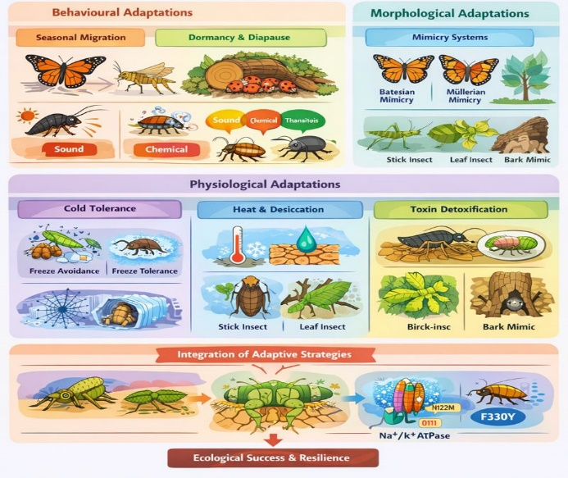
Fig.3. Schematic representation of different adaptation of insects for Ecological resilence
Cytochrome P450 enzymes play a particularly prominent role due to their catalytic versatility and extensive gene family expansion in phytophagous insects. These enzymes introduce reactive or polar groups into lipophilic toxins, facilitating further metabolism or elimination. GSTs and esterases often act downstream by conjugating or hydrolysing modified compounds, thereby reducing their toxicity and enhancing excretion. Comparative genomic analyses reveal that expansions and regulatory diversification of these gene families are closely associated with host range breadth and dietary specialization, highlighting detoxification capacity as a key determinant of herbivore niche evolution. In addition to metabolic detoxification, some insects have evolved target-site insensitivity, allowing them to tolerate toxins without extensive chemical modification. A well-documented example involves insects that feed on cardenolide-producing plants. These compounds disrupt ion transport by inhibiting the Na⁺/K⁺-ATPase, an essential membrane protein. Remarkably, multiple insect lineages have independently evolved identical or functionally equivalent amino acid substitutions in the Na⁺/K⁺-ATPase that reduce cardenolide binding while preserving enzymatic function (Dobler et al., 2012; Zhen et al., 2012) (Fig. 4).
5. CONSTRAINTS, TRADE-OFFS, AND EVOLUTIONARY LIMITS
Adaptive traits rarely evolve in isolation; rather, they are embedded within complex physiological, developmental, and ecological networks. Consequently, the evolution of any particular adaptation often carries costs that can constrain its expression and shape overall life-history strategies. For example, investment in physiological stress tolerance such as increased heat-shock protein production, cryoprotectant synthesis, or cuticular lipid enhancement requires substantial energetic and metabolic expenditure. These energetic demands can reduce allocation to other critical functions, including somatic growth, reproduction, or competitive ability, generating intrinsic trade-offs that influence population dynamics and evolutionary trajectories (Angilletta et al., 2010; Garland et al., 2022). Life-history trade-offs are particularly evident when adaptations operate across multiple scales or environmental gradients. For instance, insects that maintain high levels of desiccation resistance through thicker cuticles and elevated hydrocarbon content may experience reduced flight performance or limited mobility due to increased body mass. Similarly, investment in diapause or freeze-tolerance mechanisms may prolong development, delaying reproductive output and potentially reducing lifetime fecundity. These examples illustrate that even highly advantageous traits are subject to cost–benefit optimization within ecological and evolutionary constraints. The genetic architecture underlying adaptive traits further constrains evolution. Many traits exhibit pleiotropy, where a single gene influences multiple phenotypes, or epistasis, where gene–gene interactions affect trait expression. Such correlations can restrict the directions in which natural selection can act, making some adaptive solutions more accessible than others. Comparative genomics and experimental evolution studies reveal repeated patterns of adaptation across distantly related taxa, suggesting that parallel genetic solutions are often constrained by shared developmental pathways, biochemical feasibility, or cellular architecture (Stern, 2013; Rosenblum et al., 2014). For example, the convergent evolution of Na⁺/K⁺-ATPase mutations in cardenolide-feeding insects demonstrates how only a limited subset of mutations simultaneously confers resistance while preserving essential enzyme function, reflecting strong mechanistic constraints on adaptive evolution. Environmental variability imposes additional limits. Fluctuating or unpredictable conditions can prevent the full optimization of traits, as adaptations that confer high performance under one set of conditions may be deleterious under another. This principle underlies the evolution of phenotypic plasticity, in which organisms modulate trait expression according to environmental cues. Plasticity can buffer populations against short-term stress but may itself be energetically costly or genetically constrained, further illustrating the multidimensional limits on adaptation.

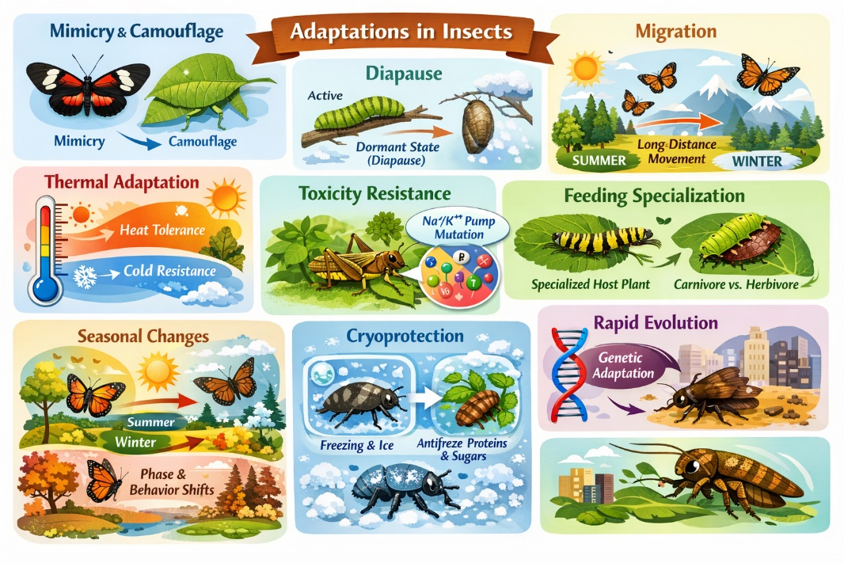
Fig.4 Overall representation of Insect adaptations
6. IMPLICATIONS UNDER GLOBAL CHANGE
Anthropogenic climate change represents an unprecedented ecological challenge, generating combinations of stressors that may exceed the evolved adaptive capacity of insects. Rising average temperatures, increased frequency of heatwaves, altered precipitation patterns, and habitat fragmentation interact in complex ways, producing environmental conditions that differ fundamentally from historical baselines (Deutsch et al., 2008; Buckley and Kingsolver, 2012). For organisms with rapid life cycles, such as insects, even small shifts in thermal regimes or resource availability can cascade across generations, affecting survival, reproduction, and population persistence. One of the most immediate consequences of climate change is altered phenology. Seasonal shifts in temperature and precipitation can decouple insect life cycles from the temporal availability of critical resources such as host plants, nectar sources, or prey. For instance, earlier onset of spring or delayed flowering may cause mismatches between larval feeding periods and optimal host quality, reducing growth rates and survival (Parmesan, 2006). Similarly, shifts in adult emergence timing can disrupt pollination interactions, mate availability, or predator prey dynamics, with cascading effects on community structure.
Thermal variability represents another pressing concern. Many insects currently operate near their physiological thermal limits, particularly in tropical and subtropical regions where upper thermal thresholds are narrowly defined. Increased frequency of extreme heat events may surpass species’ critical thermal maxima, resulting in population declines or local extirpations (Chown et al., 2010; Sunday et al., 2011). Even species capable of behavioural thermoregulation or acclimation may be unable to buffer against rapid or extreme fluctuations, particularly in fragmented or urbanized landscapes where microclimatic refuges are limited. Habitat fragmentation further compounds these challenges. The spatial isolation of suitable microhabitats restricts movement and reduces opportunities for dispersal or migration, thereby limiting access to thermal refuges and resources. Species with low dispersal ability or specialized habitat requirements are particularly vulnerable, highlighting the interactive effects of climatic and landscape-level stressors on population viability.
Global change also exerts selective pressures that may alter evolutionary trajectories. Populations exposed to novel combinations of temperature extremes, drought, and chemical stressors may experience shifts in selective regimes that favour rapid plastic responses or the evolution of new physiological and behavioural traits. However, evolutionary responses are constrained by genetic architecture, life-history trade-offs, and the rate of environmental change relative to generation time. Consequently, even highly adaptable taxa such as insects may face limits to their resilience under the pace and magnitude of current climate shifts. Understanding these dynamics requires integrative approaches that combine long-term ecological monitoring, experimental manipulations, and functional genomics. Mechanistic models that link thermal tolerance, phenological responses, and dispersal capacity with climate projections are essential for predicting species- and community-level outcomes. Such frameworks can inform conservation strategies, including the identification of thermal refugia, management of habitat connectivity, and protection of keystone insect taxa that underpin ecosystem services. In summary, global change presents multifactorial stress that challenges the very foundations of insect ecological success. The interplay between environmental extremes, adaptive capacity, and evolutionary constraints will determine which species persist, which shift ranges, and which decline, with profound consequences for biodiversity, ecosystem stability, and human well-being.
7. CONCLUSIONS
Insects represent a pinnacle of evolutionary adaptability, demonstrating that ecological success arises not from singular innovations, but from the integration of behavioural, morphological, physiological, and molecular strategies. These adaptive layers operate synergistically, allowing insects to buffer environmental extremes, optimize resource use, and maintain population persistence across heterogeneous landscapes. Behavioural flexibility—including migration, thermoregulation, and predator avoidance—reduces immediate exposure to stressors, while morphological traits such as mimicry, crypsis, and cuticular modification provide structural resilience. Physiological and molecular mechanisms, from heat-shock protein induction to osmolyte accumulation and enzymatic detoxification, stabilize internal homeostasis when environmental extremes cannot be avoided (Huey et al., 2002; Feder and Hofmann, 1999; Gibbs, 1998; Dobler et al., 2012). The evolutionary dynamics of these systems are shaped by a combination of natural selection, developmental plasticity, and intrinsic constraints. Trade-offs between stress tolerance and reproductive output, coupled with genetic and biochemical limitations, determine the boundaries of adaptive potential (Angilletta et al., 2010; Stern, 2013). Recurrent patterns of convergent evolution observed in phenomena such as Müllerian mimicry and molecular resistance to plant toxins highlight both the predictability of adaptive responses and the constraints imposed by shared physiological and developmental architectures (Joron et al., 2011; Zhen et al., 2012).
Under accelerating global change, these integrated systems are increasingly tested. Rising temperatures, shifting precipitation regimes, habitat fragmentation, and altered phenologies may exceed the buffering capacities of even highly resilient taxa (Deutsch et al., 2008; Parmesan, 2006; Buckley and Kingsolver, 2012). Predicting which species will persist requires a holistic understanding of multilayered adaptation, incorporating behavioural plasticity, physiological thresholds, molecular pathways, and ecological interactions. This approach not only informs conservation strategies but also provides critical insights into the evolutionary processes that have enabled insects to dominate terrestrial and freshwater ecosystems for hundreds of millions of years.
In conclusion, insects exemplify the principle that resilience emerges from integrative adaptation. The interplay of behavioural, morphological, physiological, and molecular mechanisms allows these organisms to thrive under conditions that challenge most life forms. As environmental stressors intensify, continued research into these interconnected systems is essential to anticipate ecological consequences, preserve biodiversity, and understand the fundamental rules governing adaptive evolution.

COMPETING INTERESTS DISCLAIMER:
Authors have declared that they have no known competing financial interests OR non-financial interests OR personal relationships that could have appeared to influence the work reported in this paper.

References:
Bates, H. W. (1862). Contributions to an insect fauna of the Amazon Valley: Lepidoptera: Heliconidæ. Transactions of the Linnean Society of London, 23, 495–566.
Chown, S. L., & Nicolson, S. W. (2004). Insect physiological ecology: Mechanisms and patterns. Oxford University Press.
Conner, W. E. (2014). Tiger moths and the sensory ecology of predation. Oxford University Press.
Denlinger, D. L. (2002). Regulation of diapause. Annual Review of Entomology, 47, 93–122.
Deutsch, C. A., Tewksbury, J. J., Huey, R. B., Sheldon, K. S., Ghalambor, C. K., Haak, D. C., & Martin, P. R. (2008). Impacts of climate warming on terrestrial ectotherms across latitude. Proceedings of the National Academy of Sciences, 105(18), 6668–6672.
Dingle, H. (2014). Migration: The biology of life on the move (2nd ed.). Oxford University Press.
Dobler, S., Dalla, S., Wagschal, V., & Agrawal, A. A. (2012). Community-wide convergent evolution in insect adaptation to toxic cardenolides by substitutions in the Na⁺/K⁺-ATPase. Proceedings of the National Academy of Sciences, 109(32), 13040–13045.
Endler, J. A. (1986). Natural selection in the wild. Princeton University Press.
Futuyma, D. J., & Kirkpatrick, M. (2017). Evolution (4th ed.). Sinauer Associates.
Gibbs, A. G. (1998). Water-proofing properties of cuticular lipids. American Zoologist, 38(3), 471–482.
Hahn, D. A., & Denlinger, D. L. (2011). Energetics of insect diapause. Annual Review of Entomology, 56, 103–121.
Hand, S. C., Menze, M. A., Toner, M., Lee, R. E., & Denlinger, D. L. (2016). Diapause and stress tolerance in insects. Springer.
Heidel-Fischer, H. M., & Vogel, H. (2015). Molecular mechanisms of insect herbivore adaptation to plant defenses. Annual Review of Entomology, 60, 301–319.
Huey, R. B., Hertz, P. E., & Sinervo, B. (2002). Behavioral drive versus behavioral inertia in evolution: A null model approach. The American Naturalist, 160(3), 278–287.
Joron, M., Frezal, L., Jones, R. T., et al. (2011). Chromosomal rearrangements maintain a polymorphic supergene controlling butterfly mimicry. Nature, 477, 203–206.
Joron, M., Papa, R., Mallet, J., et al. (2007). Conserved but flexible: Genetic control of mimicry in Heliconius butterfly wing patterns. Journal of Insect Science, 7(1), 29.
Kellermann, V., Overgaard, J., Hoffmann, A. A., et al. (2018). Upper thermal limits of insects are linked to species distributions and strongly constrained phylogenetically. Proceedings of the National Academy of Sciences, 115(40), 10234–10239.
Kennedy, J. S. (1985). The migration of the desert locust (Schistocerca gregaria): A textbook of locust behaviour. Cambridge University Press.
Kunte, K. (2005). Seasonal movements of butterflies in the Western Ghats, India. Journal of the Bombay Natural History Society, 102(2–3), 145–149.
Miyatake, T., Nakayama, S., Shimizu, T., & Miyatake, Y. (2008). The incidence of death-feigning behavior and its related traits in the red flour beetle Tribolium castaneum. Journal of Ethology, 26(1), 175–181.
Parmesan, C. (2006). Ecological and evolutionary responses to recent climate change. Annual Review of Ecology, Evolution, and Systematics, 37, 637–669.
Pener, M. P., & Simpson, S. J. (2009). Locust phase polyphenism: An update. Advances in Insect Physiology, 36, 1–272.
Reppert, S. M., Guerra, P. A., & Merlin, C. (2010). Neurobiology of monarch butterfly migration. Annual Review of Entomology, 55, 351–368.
Ruxton, G. D., Allen, W. L., Sherratt, T. N., & Speed, M. P. (2018). Avoiding attack: The evolutionary ecology of crypsis, aposematism, and mimicry (2nd ed.). Oxford University Press.
Sinclair, B. J., Gibbs, A. G., & Roberts, S. P. (2015). Insect cold tolerance: How insects survive and recover from cold shock and freezing. In Insect cold tolerance (pp. 1–xx). Cambridge University Press.
Sih, A., Ferrari, M. C. O., & Harris, D. J. (2011). Evolution and behavioural responses to human-induced rapid environmental change. Evolutionary Applications, 4(2), 367–387.
Sørensen, J. G., Kristensen, T. N., & Loeschcke, V. (2003). The evolutionary and ecological role of heat shock proteins. Ecology Letters, 6(11), 1025–1037.
Storey, K. B., & Storey, J. M. (2012). Insect cold hardiness: metabolic, gene, and protein adaptation. Canadian Journal of Zoology, 90(4), 456–475.
Tauber, M. J., Tauber, C. A., & Masaki, S. (1986). Seasonal adaptations of insects. Oxford University Press.
West-Eberhard, M. J. (2003). Developmental plasticity and evolution. Oxford University Press.
Wu, G. C., Joron, M., & Jiggins, C. D. (2010). Signatures of selection in loci governing major colour patterns in Heliconius butterflies. BMC Evolutionary Biology, 10, 368.
Zhen, Y., Aardema, M. L., Medina, E. M., Schumer, M., & Andolfatto, P. (2012). Parallel molecular evolution in an herbivore community. Science, 337(6102), 1634–1637.

