A Checklist of Butterfly Diversity (Rhopalocera: Lepidoptera) in Dr. Y. S. Parmar University of Horticulture and Forestry, Nauni, Himachal Pradesh, India

Abstract
Butterflies of the order Lepidoptera are ecologically important insects widely recognized as effective bio-indicators due to their sensitivity to environmental changes. The present study was conducted to document the diversity and distribution of butterflies in the campus of Dr. Y.
S. Parmar University of Horticulture and Forestry, Nauni, Solan, Himachal Pradesh. Field surveys were carried out over a two-year period from October 2018 to September 2020, with regular observations between 7:00 AM and 11:00 AM. Butterflies were recorded through visual observations and photographic documentation using a DSLR camera, and species identification was confirmed using standard taxonomic literature and field guides. The survey recorded a total of 94 species belonging to 59 genera and 6 families: Riodinidae, Nymphalidae, Pieridae, Papilionidae, Lycaenidae, and Hesperiidae. Among these, Nymphalidae was the most dominant family, whereas Riodinidae had the lowest representation. The study provides baseline information for biodiversity conservation, ecological monitoring, and assessing environmental changes in semi-urban landscapes.

Keywords: Butterfly, Diversity, Bio-indicator, Species, Climate

Introduction
Butterflies are regarded as one of the most important taxonomically studied groups of insects (Robbins & Opler 1997). Butterflies are a diverse group of insects belonging to the order Lepidoptera of the class Insecta. Lepidoptera is confirmed as the second largest insect order, with over 180,000 species described, divided into 126 families and 46 superfamilies, supporting its status as a diverse and significant order (Khan et al. 2023). In India possesses one of the most diverse and richest butterfly populations in the world. Around 1,641 species have been recorded in the country, which accounts for nearly 9.5% of the total butterfly species globally (Varshney, 2006). Overall, about 10.58% of the world’s butterfly diversity occurs in India. (Arya, 2017). Previous studies have reported 493 butterfly species under 219 genera from the Western Himalaya, with 89 species (18%) identified as endemic, of which 60 are considered narrowly endemic (Mehra et al. 2007). Approximately 437 species of butterflies (Rhopalocera) have been documented from the state of Himachal Pradesh (Garlan, L. 2024). In addition, several regional studies have contributed to understanding butterfly diversity in different parts of the state. Arya et al. (2021) recorded 347 butterfly species from Nandhaur Wildlife Sanctuary. Singh, A.P. (2008) documented 115 species from Renuka Wildlife Sanctuary located in Sirmaur District. Kumar et al. (2023) reported 77 species from the campus of Himachal Pradesh Agriculture University. Similarly, Gangotia & Kumar (2018) recorded 53 species from Chail Wildlife Sanctuary. In Solan district, Bogtapa, S. (2015) reported a total of 72 butterfly species. Thakur et al. (2021) documented 75 species from Nahan town. More recently, Das et al. (2025) reported 43 butterfly species from Sarahan Bird Sanctuary situated in the Shimla district. These studies collectively highlight the considerable butterfly diversity present across different habitats of Himachal Pradesh.
Butterflies are among the most studied, diverse, and widespread animal groups, making them an ideal model for climate change research. They are particularly informative for studying the effects of climate change on species ecology because they are ectotherms that thermoregulate using a suite of physiological, behavioural, and phenotypic traits (Hill et al. 2021). By studying these climate-based impacts on the ecological processes of Lepidoptera, appropriate strategies for species conservation and habitat management can be proposed broadly across animals (Bladon et al. 2020). Butterflies play an important role in ecosystems, acting as pollinators, food sources, and indicators of ecosystem health. They are an important component of ecosystems because they interact with plants as pollinators and herbivores (Tiple et al. 2006). Butterflies are also good indicators of environmental change, as they are sensitive to habitat degradation and climate change (Kunte 2000). Collectively, they provide a wide range of environmental benefits, including pollination and natural pest control. They also play an important role in the food chain, serving as prey for birds, bats, and other insectivorous animals. Efforts are therefore required to conserve the biodiversity and studies related to it are necessary for the sustainable development. It is thus encouraging that the butterflies are being included in biodiversity study and conservation programmes. Documentation on insect diversity is pressing need to study the dynamics and socioeconomics of butterfly diversity outside protected area, especially in urban areas and university campus where they do not get much importance. Keeping visible this fact, investigation had undertaken in UHF campus to produce a baseline data concerning butterfly diversity and to gain the ensuring impact global climate change on butterfly species diversity in near future of university campus.

Material and methods Study site
The present study was conducted in Dr. Y.S. Parmar University of Horticulture and Forestry Nauni, Solan, Himachal Pradesh having 30̊ 51’N Latitude and 76˚11’ E terrain of campus is almost hilly with elevation varies from 1185m–1250m above mean sea level. The climate of area is sub-tropical to sub-temperate. Campus covers an area of 5.5 km². Mean monthly temperature of study was 27ºC. The Mean maximum and minimum temperature were 36ºC and 4ºC respectively.

Method
A survey of butterfly species in Nauni was conducted over two years, from October 2018 to September 2020. Daily observations were carried out between 7:00 AM and 11:00 AM using Nikon binoculars. To ensure accurate identification, butterflies were frequently photographed from multiple angles using a Nikon D3400 DSLR camera. This approach enabled the capture of detailed images, facilitating precise species identification and verification. The combined method of visual observation and photographic documentation played a crucial role in assessing butterfly diversity in the region. For further identification, various field guides were consulted, including publications by Wynter-Blyth (1957), Kunte (2000), and Haribal (1992). All scientific nomenclature in the present study follows the classification system outlined by Varshney (1993). Seasonality was evaluated using a presence–absence scoring method, followed by the calculation of occurrence percentage (%) to determine the status of each species.
Fig. No. 1. Study Area Map of Nauni, Solan, Himachal Pradesh.

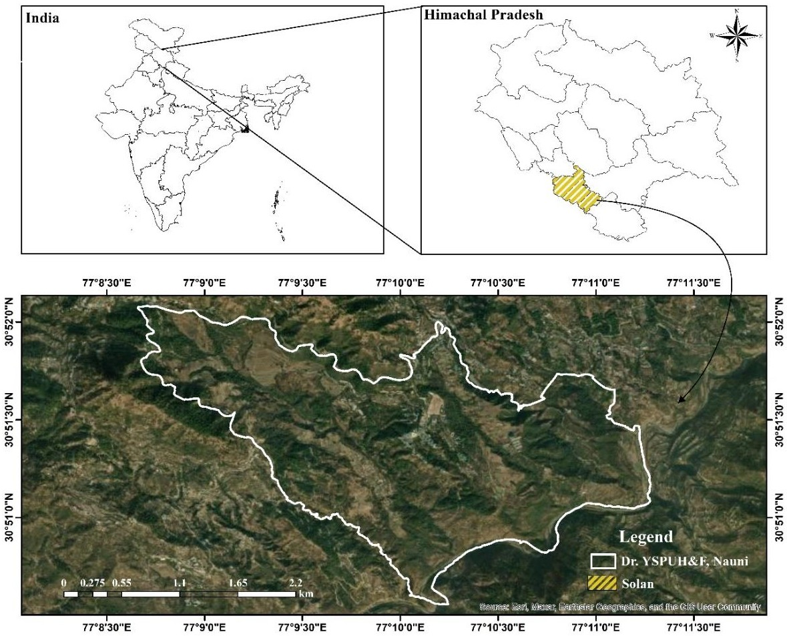

The observed butterflies were categorized into five groups based on their abundance: VC – Very Common (>100 sightings), C – Common (50–100 sightings), NR – Not Rare (15–50 sightings), R – Rare (2–15 sightings), and VR – Very Rare (1–2 sightings). (Wadatkar & Kasambe 2009).
The occurrence of each butterfly family was calculated using the following formula:
Percentage occurrence = No. of species of each family/ Total No. of different family or species seen multiply by 100.

Terminology used
VC- Very common;
C- Common;
R- Rare;
VR- Very rare and
NR- Not rare

Results and Discussion
The present study documents 94 newly recorded species of butterflies from Nauni, Himachal Pradesh belonging to 06 families viz: The checklists of all the species observed with their status are given in Table 1. Family-wise distribution of butterfly’s species showed that, Nymphidae was the most dominant with a total number of 94 butterfly species belonging to 59 genera and 6 families were recorded during the present study. The families documented include Riodinidae, Nymphalidae, Pieridae, Papilionidae, Lycaenidae, and Hesperiidae. Among these, Nymphalidae was the most dominant family with the highest number of species, followed by Pieridae, Papilionidae, Lycaenidae, and Hesperiidae, while Riodinidae was represented by the least number of species.
Results and Discussion
The present study recorded a total of 94 butterfly species from Nauni, Himachal Pradesh, belonging to 59 genera and six families, namely Riodinidae, Nymphalidae, Pieridae, Papilionidae, Lycaenidae, and Hesperiidae. The checklist of all the species along with their occurrence status is presented in Table 1. The results indicate that the study area supports a rich diversity of butterflies, which may be attributed to the presence of diverse vegetation, favorable climatic conditions, and availability of host as well as nectar plants in the region. The heterogeneous landscape of Nauni, including forest patches, agricultural fields, grasslands, and orchards, provides suitable habitats for different butterfly species.
Family-wise distribution revealed that the family Nymphalidae was the most dominant group among all recorded families. A large number of species such as Neptis hylas, Junonia almana, Danaus chrysippus, Aglais caschmirensis, Lethe rohria, and Ypthima baldus were commonly observed in the study area. The dominance of Nymphalidae could be due to their high adaptability to a wide range of habitats and the abundance of larval host plants. Similar patterns of dominance of Nymphalidae have been reported in several studies conducted in different parts of the Himalayan region.
The family Pieridae represented the second most abundant group with species such as Pieris canidia, Pontia daplidice, Eurema hecabe, and Gonepteryx rhamni frequently observed. Members of this family are generally associated with open habitats and agricultural landscapes, which are widely present in the Nauni region. Papilionidae was represented by several prominent species including Papilio polytes, Papilio bianor, Papilio demoleus, and Graphium sarpedon. These species are important indicators of healthy ecosystems due to their dependence on specific host plants.
The family Lycaenidae also contributed a considerable number of species such as Lampides boeticus, Pseudozizeeria maha, Zizula hylax, Tarucus plinius, and Rapala manea. Many lycaenids are closely associated with shrubs and herbaceous vegetation, which explains their occurrence in cultivated and semi-natural habitats. Hesperiidae, represented by species like Parnara guttatus, Pseudocoladenia dan, and Parnara bada, were mostly observed in grassy areas and field margins.
Based on the abundance status, several species were categorized as very common, common, not rare, rare, and very rare. Species such as Neptis hylas, Junonia almana, Eurema hecabe, and Papilio polytes were frequently recorded, while species like Sephisa dichroa, Hestina persimilis, Polyura athamas, and Graphium cloanthus were rarely observed. The variation in species abundance may be influenced by habitat specificity, seasonal availability of resources, and anthropogenic disturbances. Overall, the findings highlight the ecological importance of Nauni as a significant habitat for butterfly diversity and emphasize the need for conservation and long-term monitoring of butterfly populations in the region.
Fig. No. 2. Family-wise distribution of butterfly species (%)
Papilionidae 7%
Hesperiidae 5%
Pieridae 14%
Nymphalidae 41%
Lycaenidae 32%
Riodinidae
1%
Nymphalidae Riodinidae Lycaenidae Pieridae Papilionidae Hesperiidae

Table 1: Family-wise distribution of butterfly species collected from Dr. Y. S. Parmar University, Nauni, Himachal Pradesh.
Sr. No. | Scientific name | Common name | Family | Status
1. | Dodona durga Kollar | Common punch | Riodinidae | NR
2. | Acraea issoria Hubner | Yellow coster | Nymphidae | C
3. | Euthalia patala Kollar | Himalayan grand duchess | Nymphidae | R
4. | Ariadne merione Cramer | Common castor | Nymphidae | NR
5. | Symbrenthia lilaea Hewitson | Common jester | Nymphidae | C
6. | Sephisa dichroa Kollar | Western courtier | Nymphidae | VR
7. | Neptis hylas Linnaeus | Common sailor | Nymphidae | VC
8. | Neptis mahendra Moore | Himalayan sailor | Nymphidae | R
9. | Athyma jina Moore | Bhutan Sergeant | Nymphidae | R
10. | Athyma opalina Kollar | Himalayan Sergeant | Nymphidae | VC
11. | Hestina persmilis zella Butler | West Himalayan Siren | Nymphidae | VR
12. | Cyrestis thyodamas Boisduval | Common Map | Nymphidae | NR
13. | Junonia iphita Stichel | Chocolate pansy | Nymphidae | VC
14. | Junonia hierta Fabricius | Yellow pansy | Nymphidae | C
15. | Junonia orithya Linnaeus | Blue pansy | Nymphidae | C

16. | Junonia lemonias Fruhstorfer | Lemon pansy | Nymphidae | NR
17. | Junonia almana Linnaeus | Peacock Pansy | Nymphidae | VC
18. | Aglais caschmirensis Kollar | Indian Tortoiseshell | Nymphidae | VC
19. | Vanessa indica Herbst | Indian Red admiral | Nymphidae | R
20. | Vanessa cardui Linnaeus | Painted Lady | Nymphidae | VC
21. | Argynnis hyperbius Linnaeus | Indian Fritillary | Nymphidae | R
22. | Issoria lathonia Linnaeus | Queen of Spain fritillary | Nymphidae | VR
23. | Argynnis children Gray | Large silverstripe | Nymphidae | NR
24. | Phalanta phalantha Drury | Common leopard | Nymphidae | C
25. | Kallima inachus Boisduval | Orange oakleaf | Nymphidae | VC
26. | Danaus chrysippus Linnaeus | Plain tiger | Nymphidae | VC
27. | Danaus genutia Cramer | Striped Tiger | Nymphidae | R
28. | Tirumala limniace Butler | Blue tiger | Nymphidae | R
29. | Tirumala septentrionis Butlers | Dark Blue Tiger | Nymphidae | VR
30. | Parantica aglea Moore | Glassy Tiger | Nymphidae | NR
31. | Parantica sita Kollar | Chestnut Tiger | Nymphidae | VR
32. | Euploea core Cramer | Common Crow | Nymphidae | C
33. | Euploea mulciber Cramer | Striped blue crow | Nymphidae | C
34. | Lethe rohria Fabricius | Common Tree brown | Nymphidae | VC
35. | Lethe verma Kollar | Straight-banded Tree brown | Nymphidae | VC
36. | Lethe confusa Aurivillius | Banded Tree brown | Nymphidae | VC
37. | Aulocera padma Kollar | Himalayan Great satyr | Nymphidae | NR
38. | Aulocera loha loha | Himalayan Eyeless Satyr | Nymphidae | R
39. | Aulocera swaha Kollar | Common Satyr | Nymphidae | C
40. | Callerebia scanda Kollar | Pallid Argus | Nymphidae | C
41. | Callerebia hybrid Butler | Hybrid Argus | Nymphidae | NR
42. | Callerebia suroia Tytler | Basal Argus | Nymphidae | VC
43. | Ypthima nareda Kollar | Large three ring | Nymphidae | VC
44. | Ypthima sakra Moore | Himalayan five ring | Nymphidae | VC
45. | Ypthima baldus Fabricius | Common Five-ring | Nymphidae | VC
46. | Ypthima nikaea Moore | West Himalayan Five ring | Nymphidae | VC
47. | Melanitis leda Cramer | Common evening brown | Nymphidae | R

48. | Polyura athamas Drury | Common Nawab | Nymphidae | VR
49. | Libthea myrrha Godart | Club beak | Nymphidae | VR
50. | Stibochiona nicea Gray | Popinjay | Nymphidae | VR
51. | Gonepteryx rhamni Linnaeus | Common brimestone | Pieridae | C
52. | Catopsilia pyranthe Linnaeus | Mottled emigrant | Pieridae | NR
53. | Catpsilia pomona Fabricius | Common emigrant | Pieridae | VR
54. | Pontia daplidice Linnaeus | Common bath white | Pieridae | VC
55. | Pieris canidia Sparrman | Indian cabbage white | Pieridae | VC
56. | Pieris brassicae Linnaeus | Large white | Pieridae | C
57. | Delias eucharis Drury | Common jezebel | Pieridae | R
58. | Delias belladonna Fabricius | Hill jezebel | Pieridae | VR
59. | Aporia agathon Gray | Great Black vein | Pieridae | NR
60. | Eurema brigitta Cramer | Small grass yellow | Pieridae | VC
61. | Eurema laeta Boisduval | Spotless grass yellow | Pieridae | C
62. | Eurema hecabe Linnaeus | Common Grass Yellow | Pieridae | VC
63. | Pareronia valeria Lesson | Common wanderer | Pieridae | VR
64. | Colias fieldii Menetries | Dark Clouded yellow | Pieridae | NR
65. | Colias erate Esper | Pale Clouded yellow | Pieridae | R
66. | Graphium sarpedon Linnaeus | Common Bluebottle | Papilionidae | VC
67. | Graphium cloanthus Westwood | Glassy Bluebottle | Papilionidae | VR
68. | Papilio protenor Cramer | Spangle | Papilionidae | C
69. | Papilio bianor Boisduval | Common peacock | Papilionidae | VC
70. | Papilio polytes Linnaeus | Common Mormon | Papilionidae | VC
71. | Papilio demoleus Linnaeus | Common lime | Papilionidae | R
72. | Papilio machaon Linnaeus | Common Yellow swallowtail | Papilionidae | VR
73. | Papilio clytia Linnaeus | Common mime | Papilionidae | R
74. | Talicada nyseus Guerin | Red pierrot | Lycaenidae | R
75. | Creon cleobis Godart | Broad tail royal | Lycaenidae | VR
76. | Surendra quercetorum Moore | Common acacia blue | Lycaenidae | C
77. | Lycaena phlaeas Linnaeus | Common copper | Lycaenidae | NR
78. | Lampides boeticus Linnaeus | Common Pea blue | Lycaenidae | NR
79. | Heliophorus sena Kollar | Sorrel Sapphire | Lycaenidae | C
80. | Euchrysops cnejus Fabricius | Gram blue | Lycaenidae | VR
81. | Zizina otis Fabricius | Lesser grass blue | Lycaenidae | R
82. | Zizula hylax Fabricius | Tiny grass blue | Lycaenidae | C
83. | Pseudozizeeria maha Kollar | Pale grass blue | Lycaenidae | C
84. | Acytolepis puspa Horsfield | Common hedge blue | Lycaenidae | NR
85. | Heliophorus moorei Moore | Azure sapphire | Lycaenidae | NR
86. | Tarucus plinius Fabricius | Zebra blue | Lycaenidae | R
87. | Deudorix epijarbas Moore | Cornelian | Lycaenidae | R
88. | Castalius rosimon Fabricius | Common Pierrot | Lycaenidae | NR
89. | Parnara guttatus Moore | Himalayan straight swift | Hesperiidae | C
90. | Polytremis discreta Elwes | Himalayan swift | Hesperiidae | NR
91. | Pseudocoladenia faith Kollar | Himalayan Pied flat | Hesperiidae | C
92. | Pseudocoladenia dan Fabricius | Fulvous pied flat | Hesperiidae | VC
93. | Parnara bada Moore | Straight swift | Hesperiidae | C
94. | Rapala manea Hewitson | Slate flesh | Lycaenidae | C

CONCLUSION
This study reveals that the campus of Dr. Y. S. Parmar University of Horticulture and Forestry, Nauni, supports a rich variety of butterflies, with 94 species across six families, dominated by Nymphalidae. Even semi-managed areas like university grounds can serve as important habitats for butterflies, reflecting their adaptability and ecological significance. Butterflies act as pollinators, herbivores, and sensitive indicators of environmental health, including air quality. The findings provide baseline information for biodiversity monitoring, conservation planning, and understanding the effects of climate change. Protecting such habitats is essential to sustain butterfly populations and maintain ecological balance in the region.

CONFLICT OF INTEREST:
No conflict of interest.

COMPETING INTERESTS:
Authors have declared that they have no known competing financial interests OR non-financial interests OR personal relationships that could have appeared to influence the work reported in this paper.

Disclaimer (Artificial intelligence)

Author(s) hereby declare that NO generative AI technologies such as Large Language Models (ChatGPT, COPILOT, etc.) and text-to-image generators have been used during the writing or editing of this manuscript.

1. References

Arora, G. S., Mehta, H. S., & Walia, V. K. (2009). Handbook on butterflies of Himachal Pradesh.
Arya, M. K., Chandra, H., Bisht, S. U. R. A. B. H. I., & Fasuil, F. (2021). Preliminary report on Moth diversity in the landscape of Nandhaur Wildlife Sanctuary: Adding subset to lepidoptera insects of protected area network. Uttar Pradesh Journal of Zoology, 42(15), 12-22.
Arya, M.K. (2017). Species richness and diversity of butterflies in the landscape of Nandhour Wildlife Sanctuary, Nainital, Uttarakhand.
Bladon, A. J., Lewis, M., Bladon, E. K., Buckton, S. J., Corbett, S., Ewing, S. R., ... & Turner,
Bogtapa, S. (2015). Diversity of butterflies from district Solan, Himachal Pradesh, India. Journal on New Biological Reports, 4(2), 139-148.
Das, M., Ghosh, A., & Thakur, S. B. Preliminary studies on butterfly fauna of Sarahan Bird Sanctuary, Shimla, Himachal Pradesh, India.
E. C. (2020). How butterflies keep their cool: Physical and ecological traits influence thermoregulatory ability and population trends. Journal of Animal Ecology, 89(11), 2440- 2450.
Gangotia, R., & Kumar, P. (2018). Preliminary Studies on Butterfly Fauna of Chail Wildlife Sanctuary, Shimla, Himachal Pradesh. International Journal of Science and Research (IJSR), 7(9), 1648-1651.
Garlan, L. (2024). Annotated Checklist of Rhopalocera of Himachal Pradesh, India (Insecta: Lepidoptera). SHILAP Revista de lepidopterología, 52(208), 623-676.
Haribal, M. (1992). The Butterflies of Sikkim Himalaya and their Natural History. Sikkim Nature Conservation Foundation (SNCF), Sikkim, 217pp
Hill, G. M., Kawahara, A. Y., Daniels, J. C., Bateman, C. C., & Scheffers, B. R. (2021). Climate change effects on animal ecology: butterflies and moths as a case study. Biological Reviews, 96(5), 2113-2126.
Khan, A. U., Poly, N. Y., Dutta, S., & Alam, F. (2023). Lepidopteran insects status and diversity: A review. Journal of Multidisciplinary Applied Natural Science, 3(1), 55-80.
Kumar, P., Parmar , B., & Kumar, P. (2023). Preliminary checklist of butterfly diversity from the Himachal Pradesh Agricultural University, Palampur, India. Environment Conservation Journal, 24(3), 215–221. https://doi.org/10.36953/ECJ.16492525
Kunte, K. (2000). India, a Lifescape: butterflies of peninsular India. Universities Press.
Mehra, D., Kirti, J. S., & Sidhu, A. K. (2017). Biodiversity and conservation status of Butterflies in Western Himalaya, India: An appraisal. Journal of Entomology and Zoology Studies, 5(5), 1171-1177.
Oriental Insects, 27(1), 347–372. https://doi.org/10.1080/00305316.1993.10432285
Perveen, F. K. (Ed.). (2017). Lepidoptera. BoD–Books on Demand.
Robbins, R. K. and Opler, P. A. (1997). Butterfly diversity and a preliminary comparison with bird and mammal diversity. in Biodiversity 2: understanding and protecting our biological resources, edited by Reaka-Kudla, Marjorie L., Wilson, Don E., and Wilson, Edward O., 69–82. Washington D. C.: Joseph Henry Press.
Robbins, R. K., & Opler, P. A. (1997). Butterfly diversity and a preliminary comparison with bird and mammal diversity. Biodiversity II: understanding and protecting our biological resources, 69-82.
Singh, A. P. (2008). Butterflies of Renuka Wildlife Sanctuary, Sirmaur District, Himachal Pradesh, India. Indian Forester, 134(10), 1326-1338.
Thakur, S., Bahrdwaj, S., & Singh, A. P. (2021). Diversity pattern of butterfly communities (Lepidoptera) in different habitat types of Nahan, Himachal Pradesh, India. Journal of Threatened Taxa, 13(8), 19137-19143.
Tiple, A. D., V. P. Deshmukh & R. L. H. Dennis (2006). Factors influencing nectar plant resource visits by butterflies on a university campus: Implications for conservation. − Nota Lepidopterologica 28 (3/4):213−224.
Varshney, R. K. (1993). Index Rhopalocera Indica Part III. Genera of butterflies from India and neighbouring countries (Lepidoptera: (A) Papilionidae, Pieridae and Danaidae).
Varshney, R. K. (2006). An estimate of the numbers of butterfly species in the Indian Region. Bionotes, 8(3), 61-63.
Wadatkar, J. S., & Kasambe, R. A. J. U. (2009). Butterflies of Melghat Tiger Reserve, Maharashtra with notes on their abundance, status and larval host plants. The Ecoscan, 2(2), 165-171.
Wynter-Blyth, M. A. (1957). Butterflies of the Indian region.

Plate No. 01: Butterfly species collected from Dr. Y. S. Parmar University, Nauni, Himachal Pradesh.
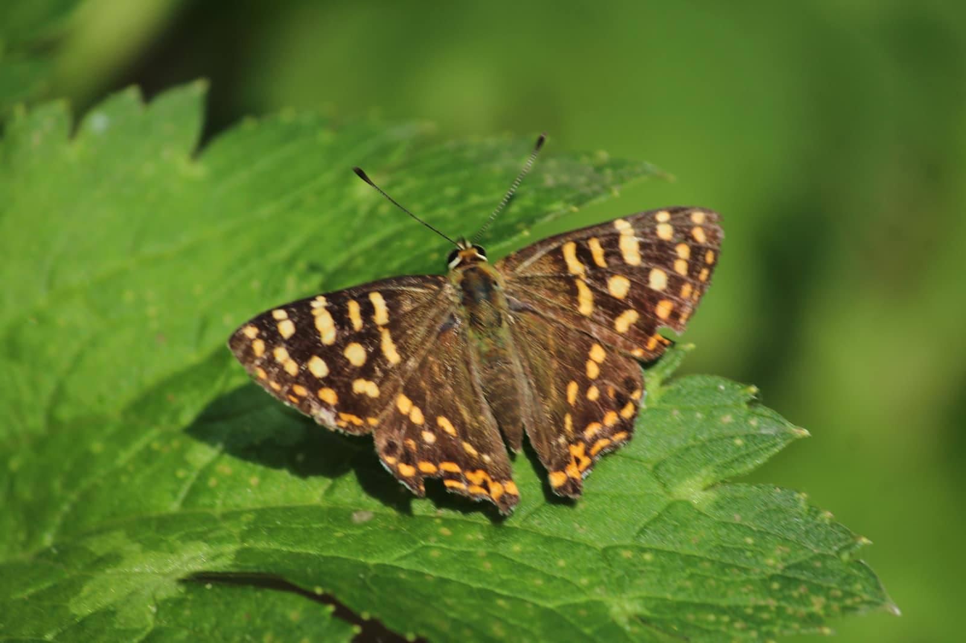
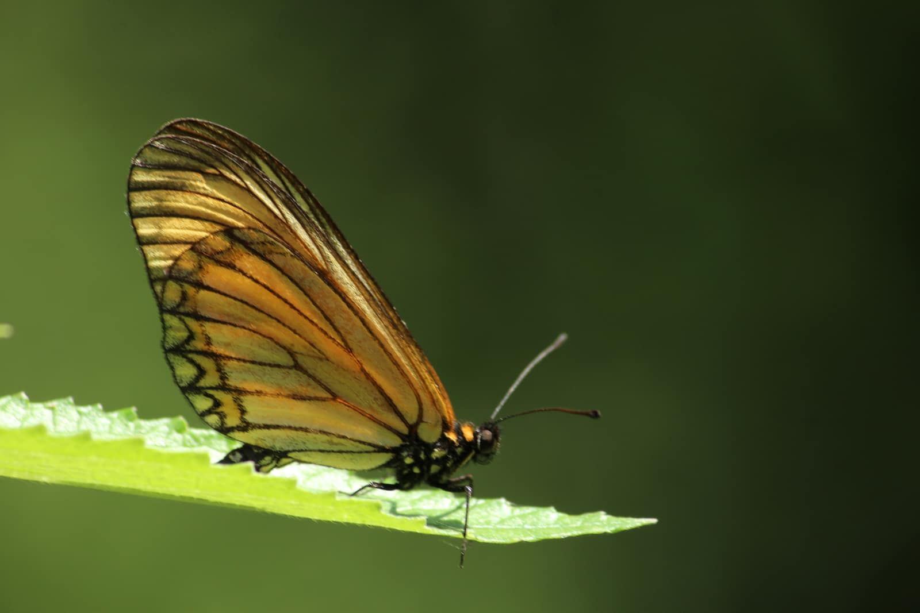
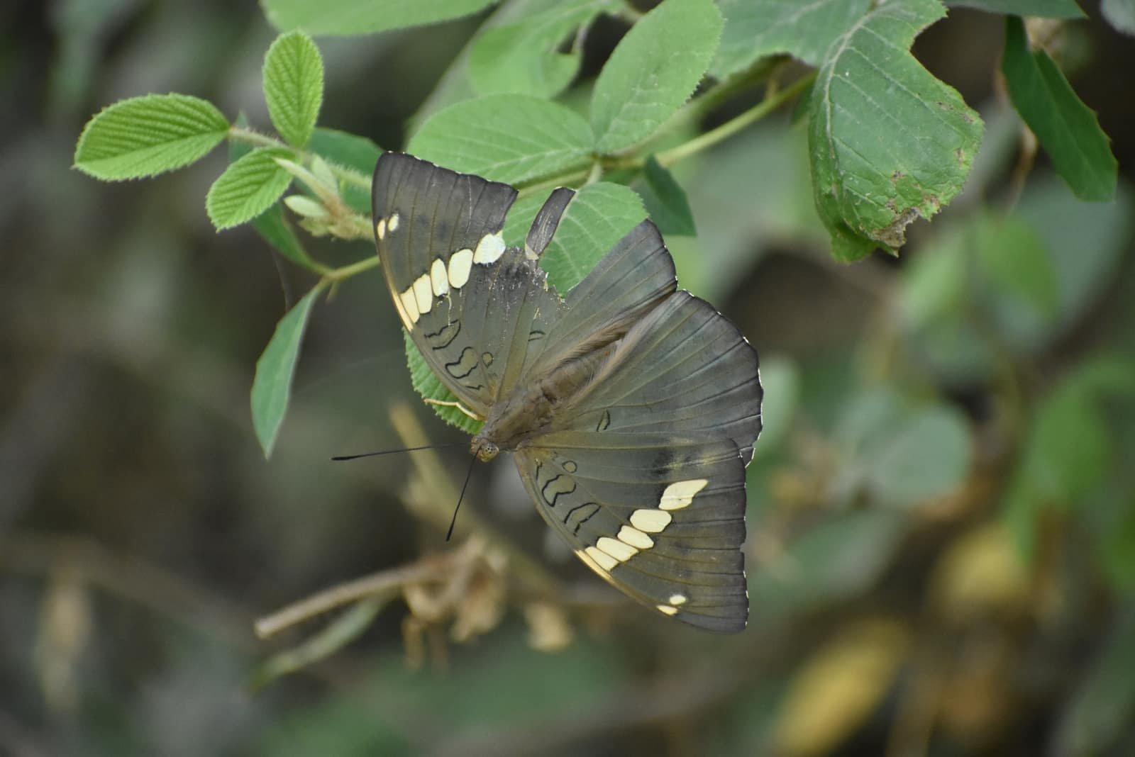
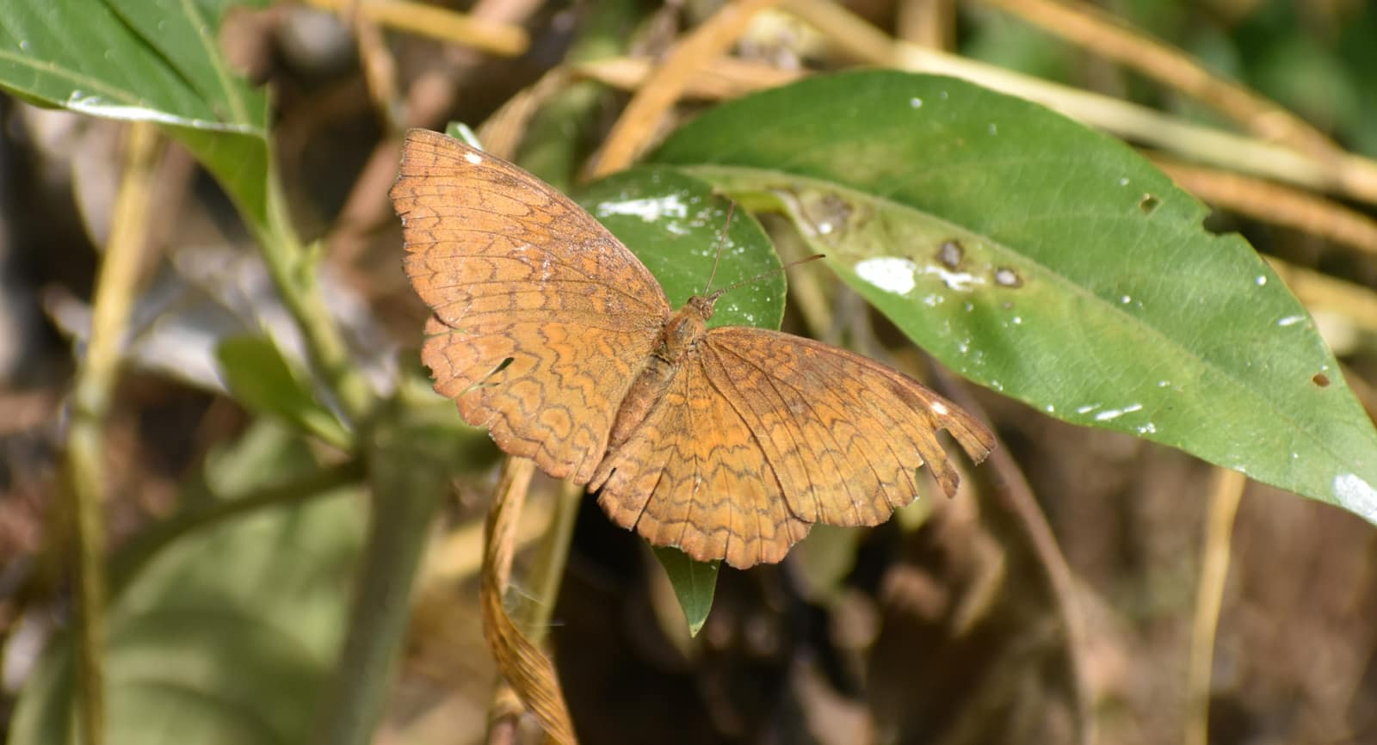
Dodona durga

Acraea issoria

Euthalia patala
Ariadne merione

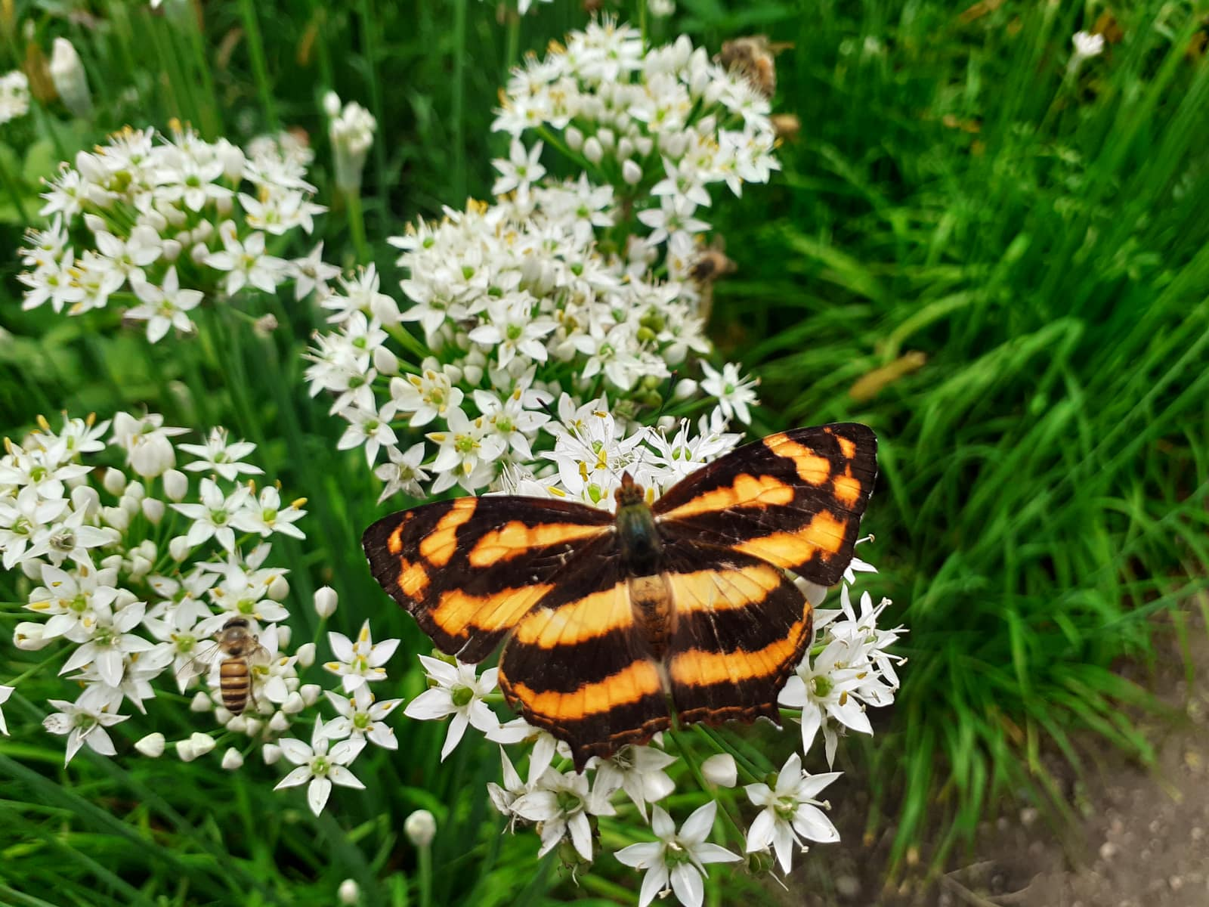
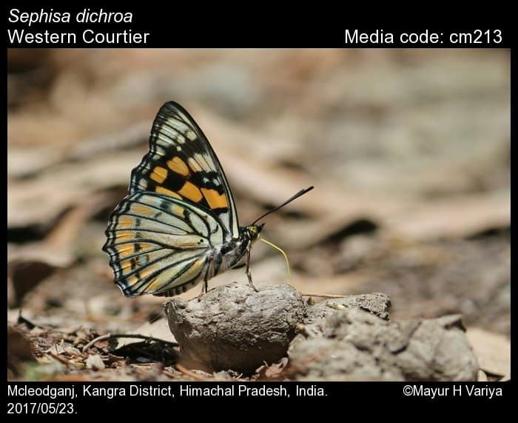
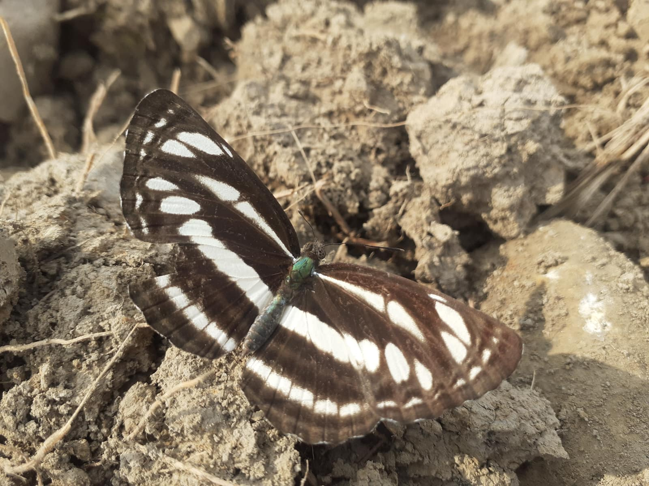
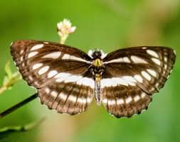
Symbrenthia lilaea
Sephisa chandra
Neptis hylas
Neptis mahendra

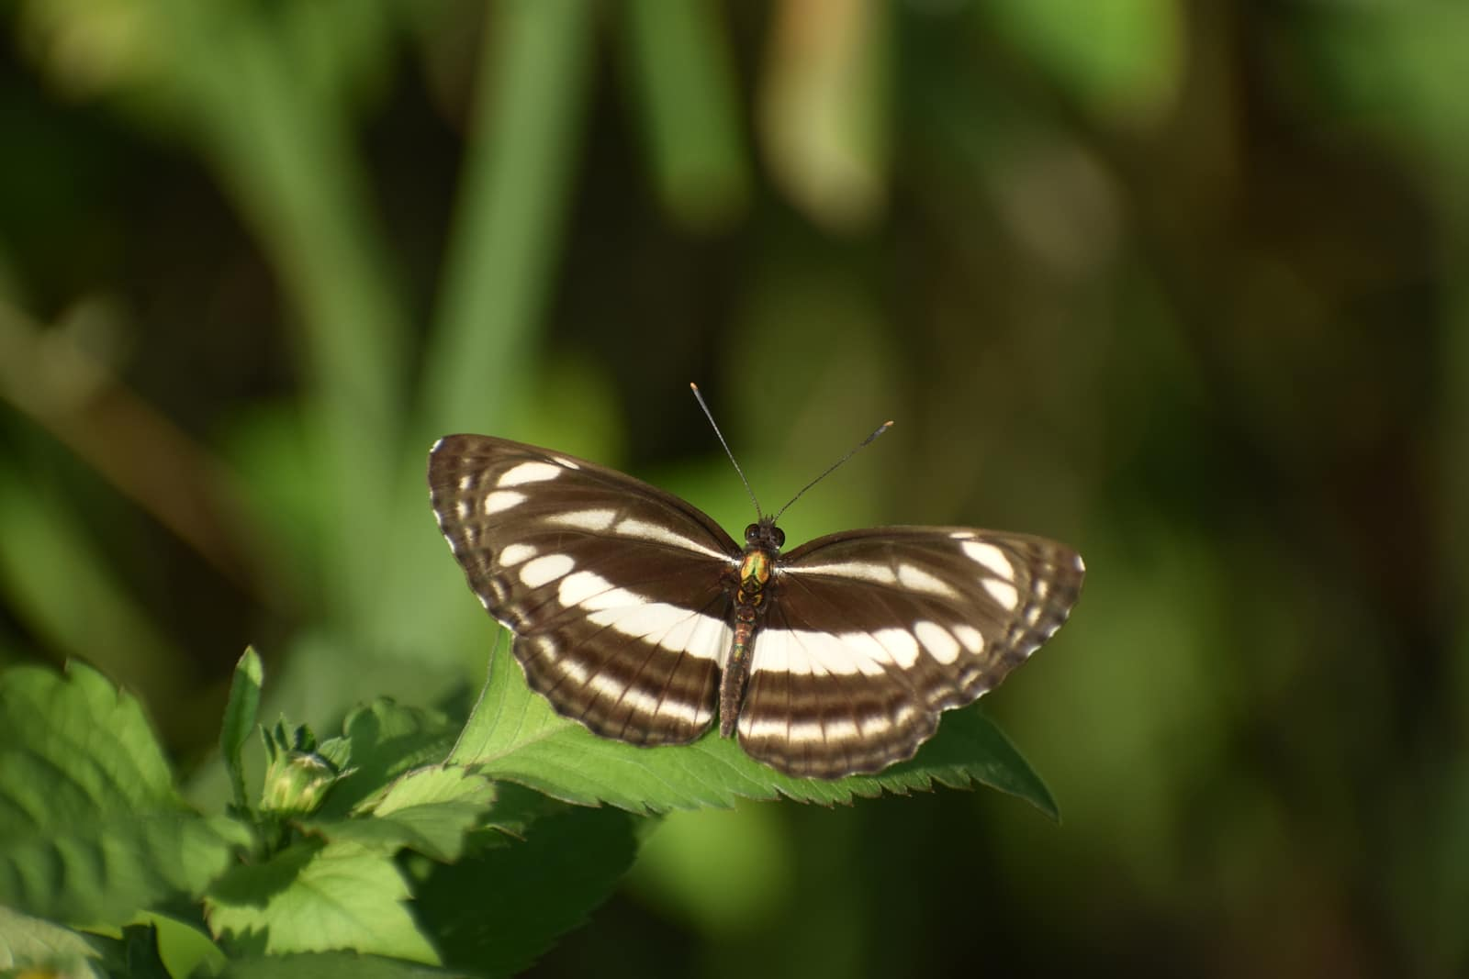
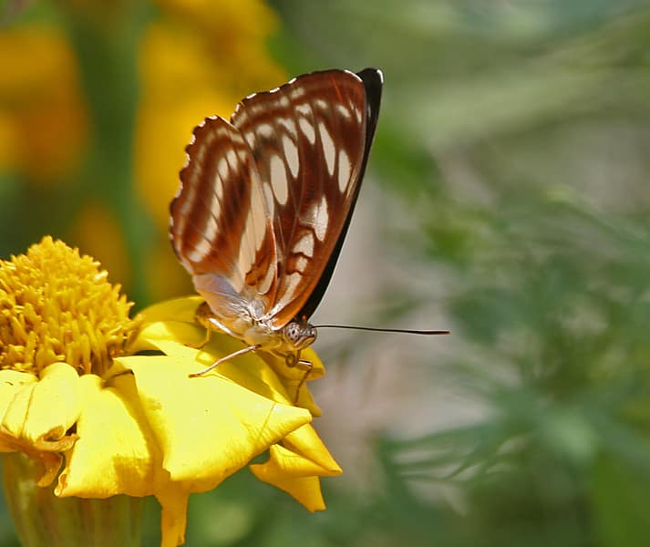
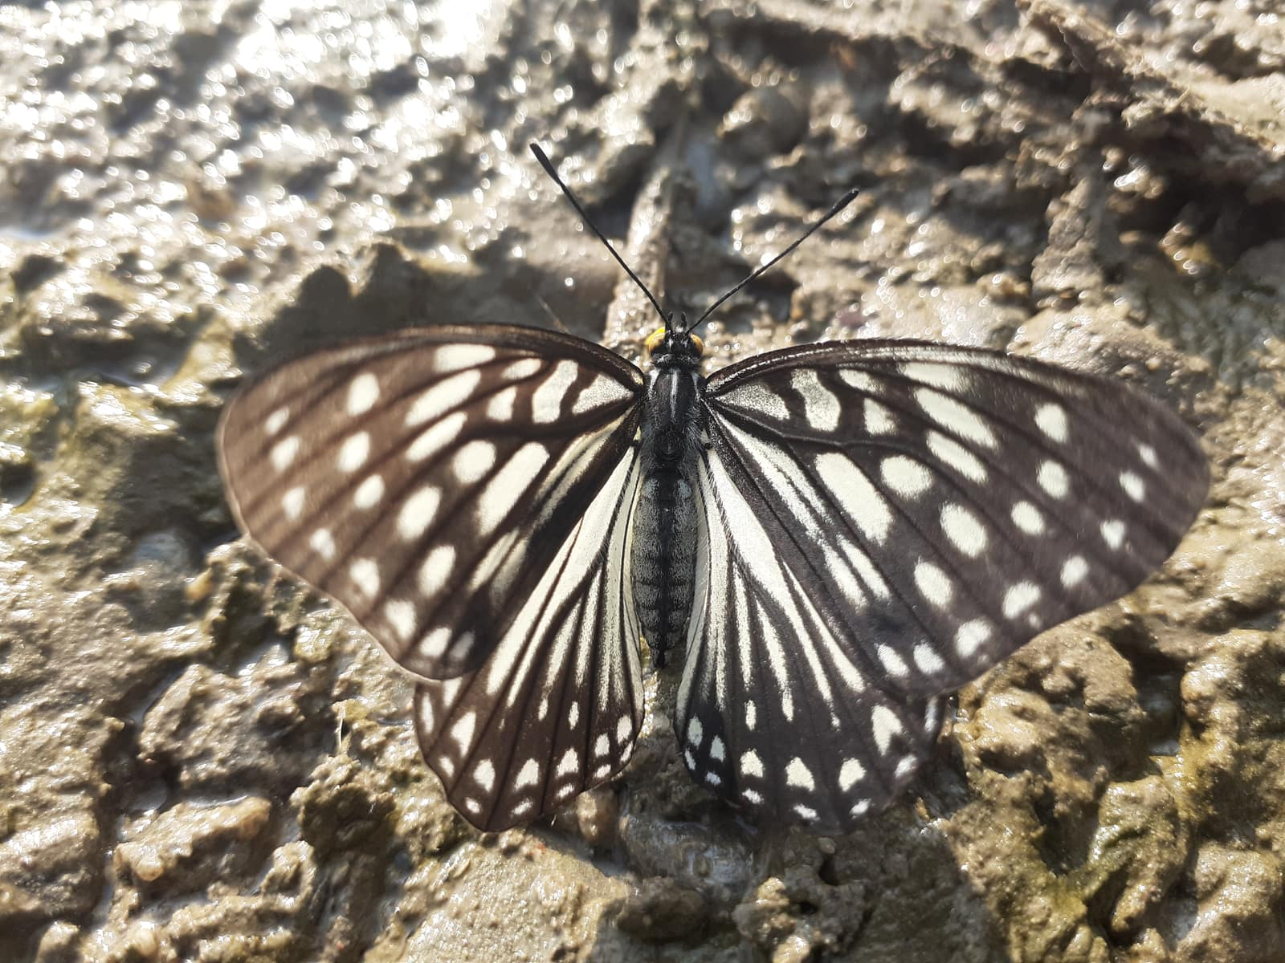
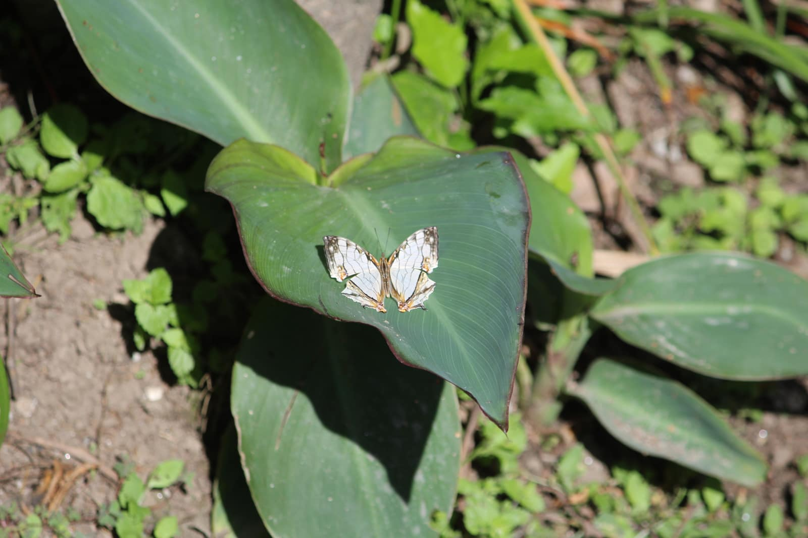
Athyma jina
Athyma opalina
Hestina persmilis zella
Cyrestis thyodamas

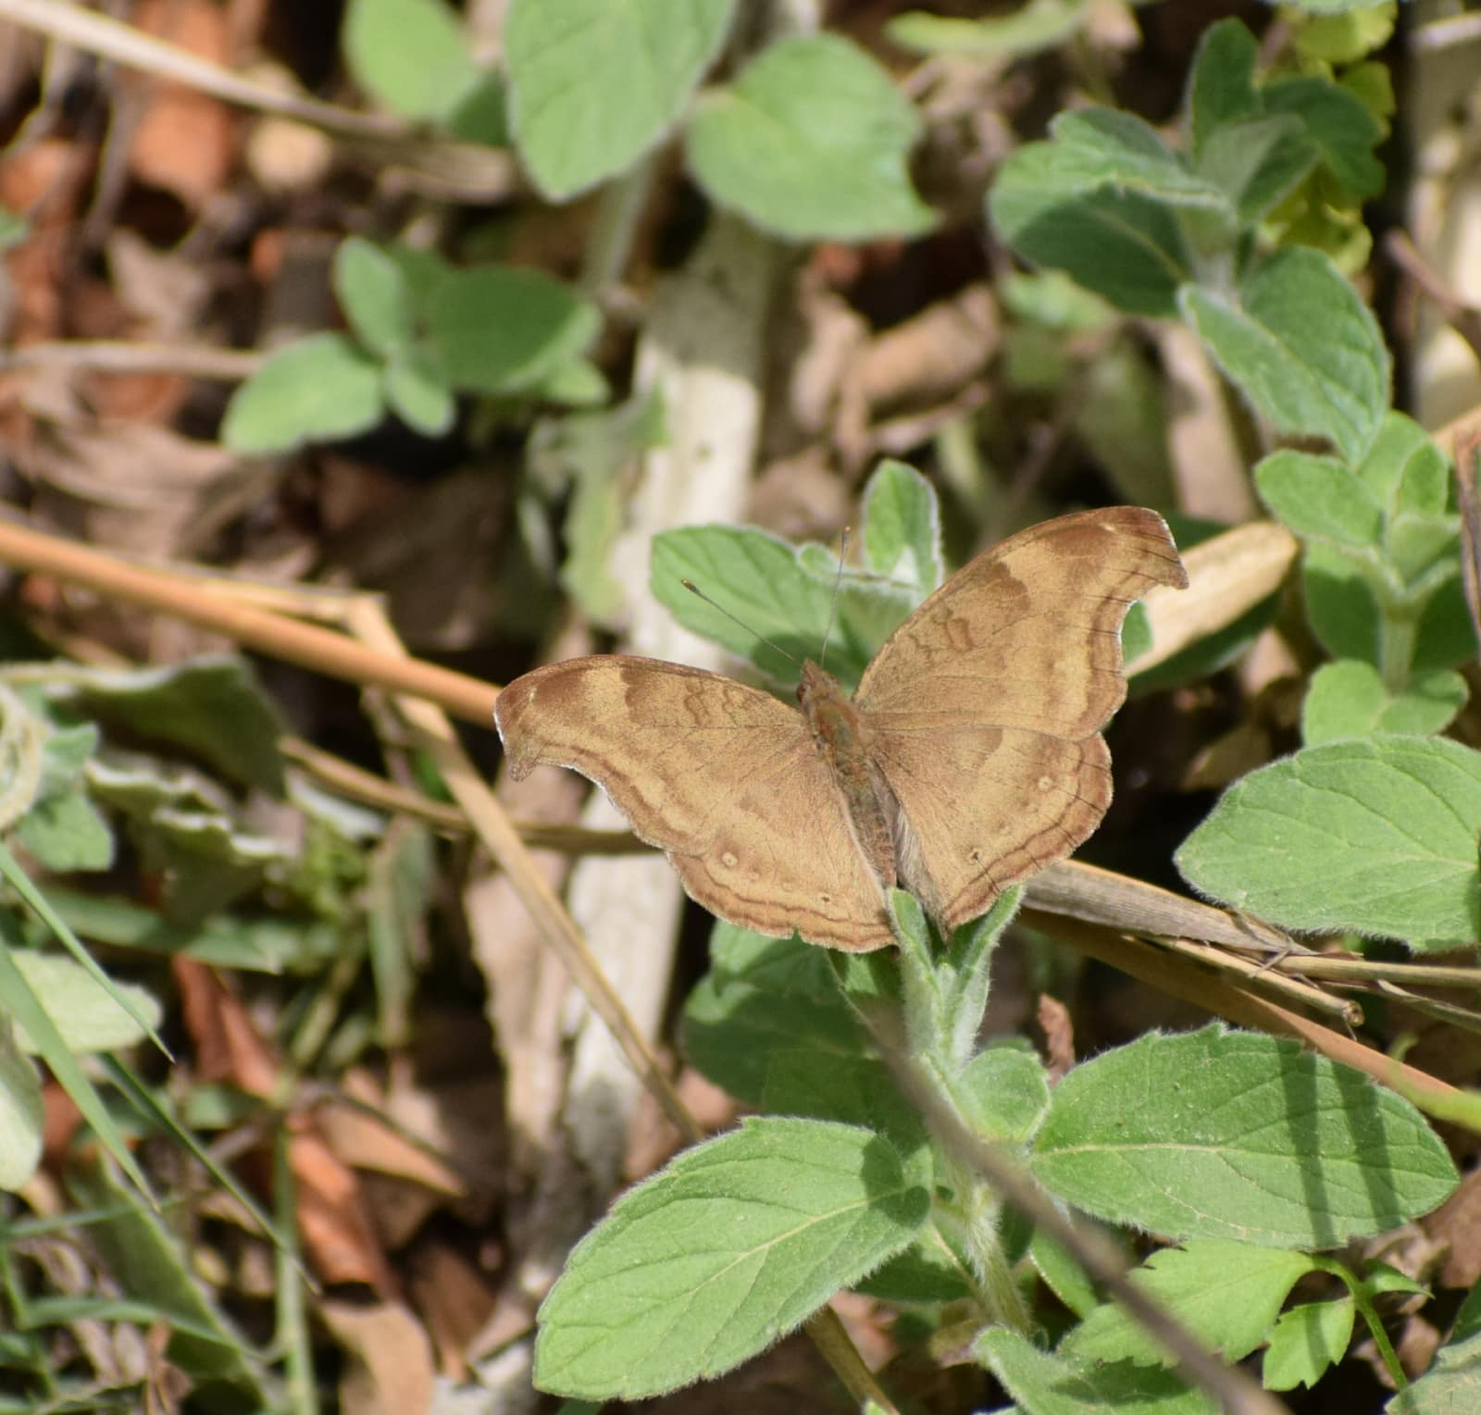
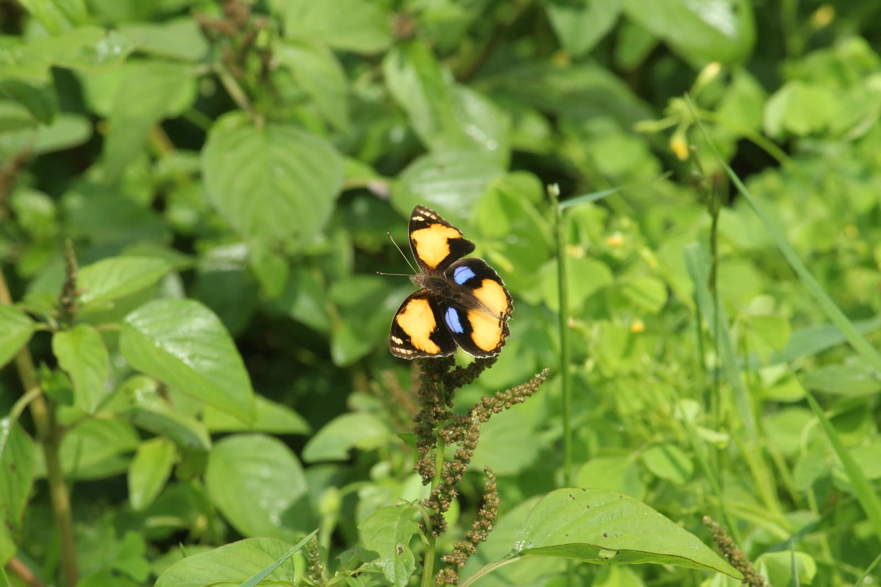
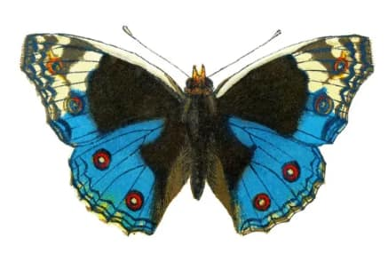
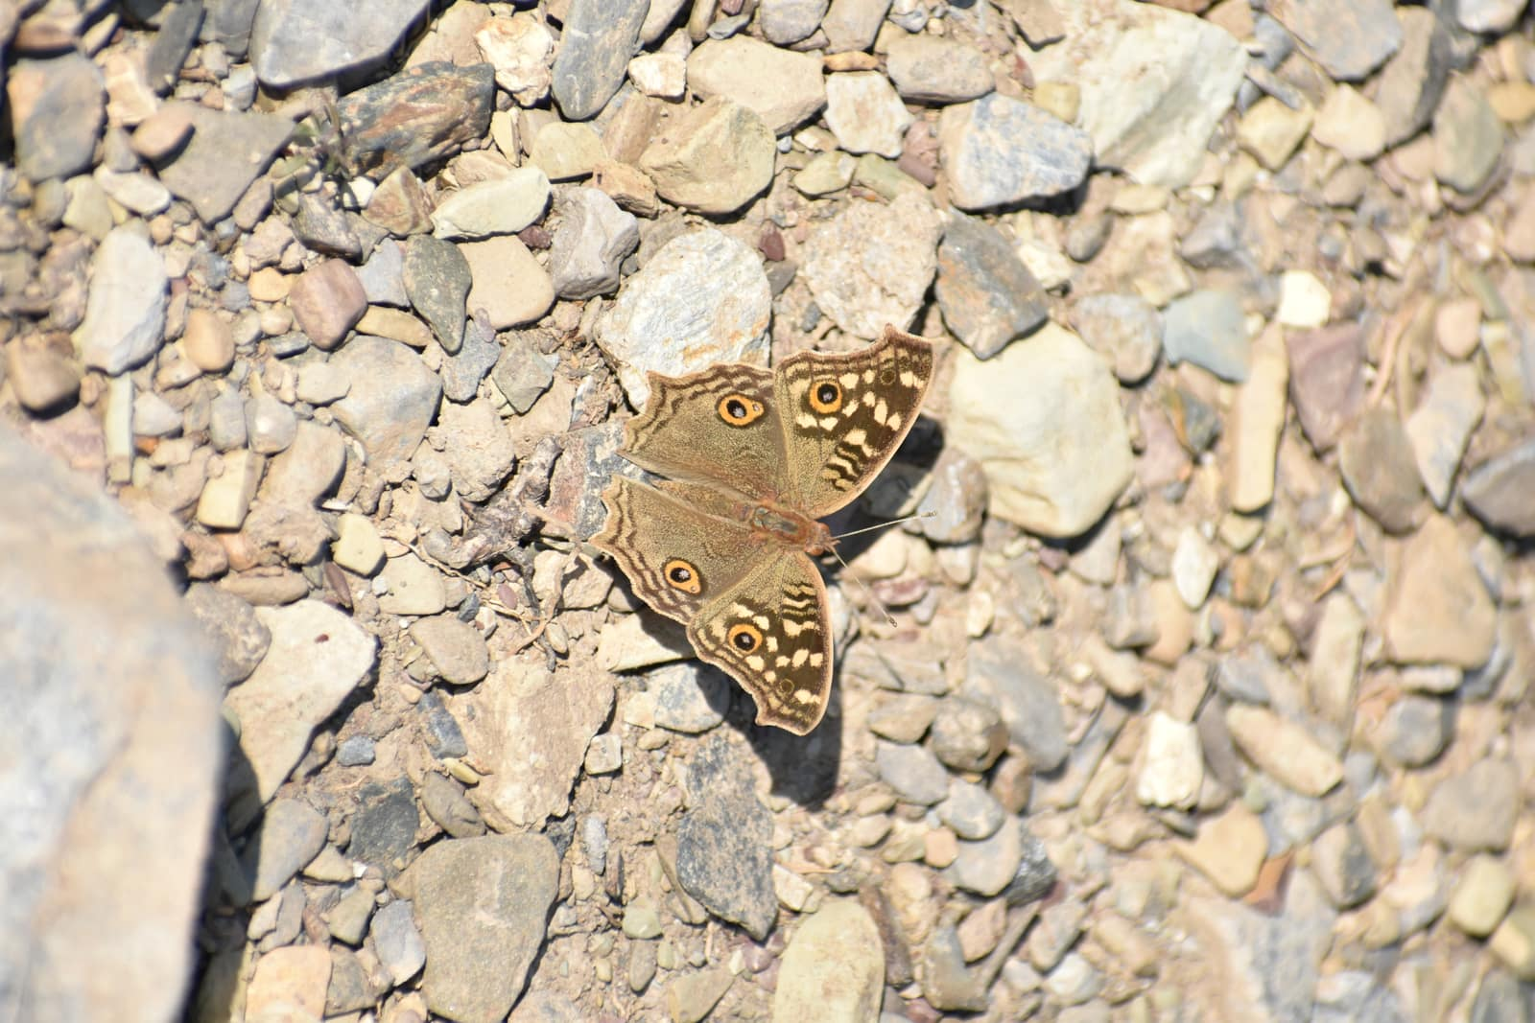
Junonia iphita
Junonia hierta
Junonia orithya
Junonia lemonias
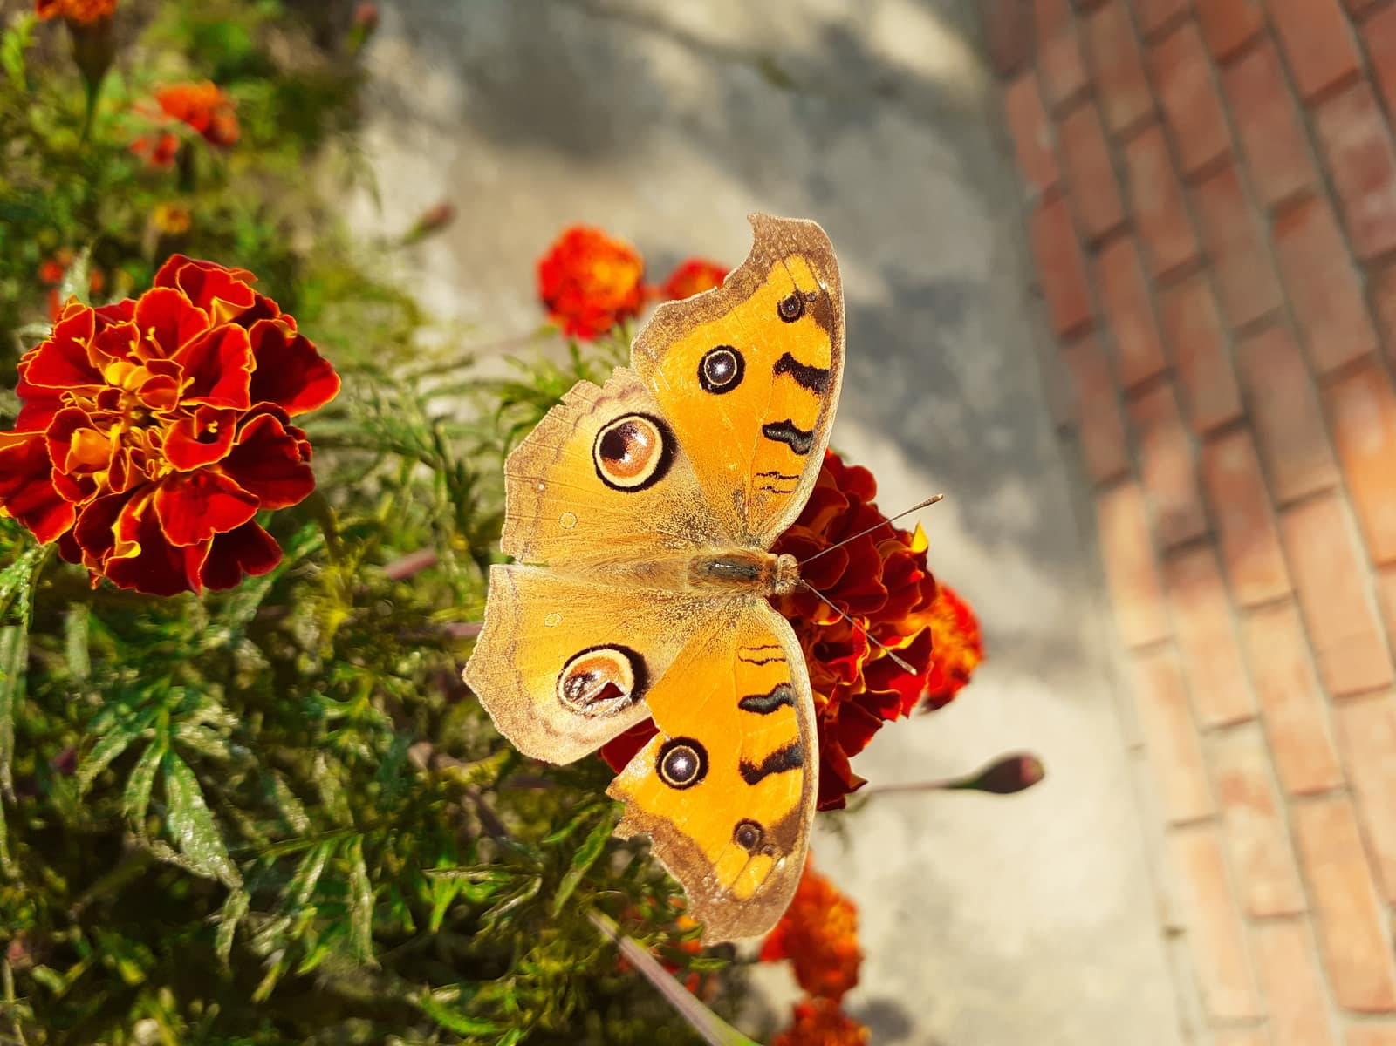
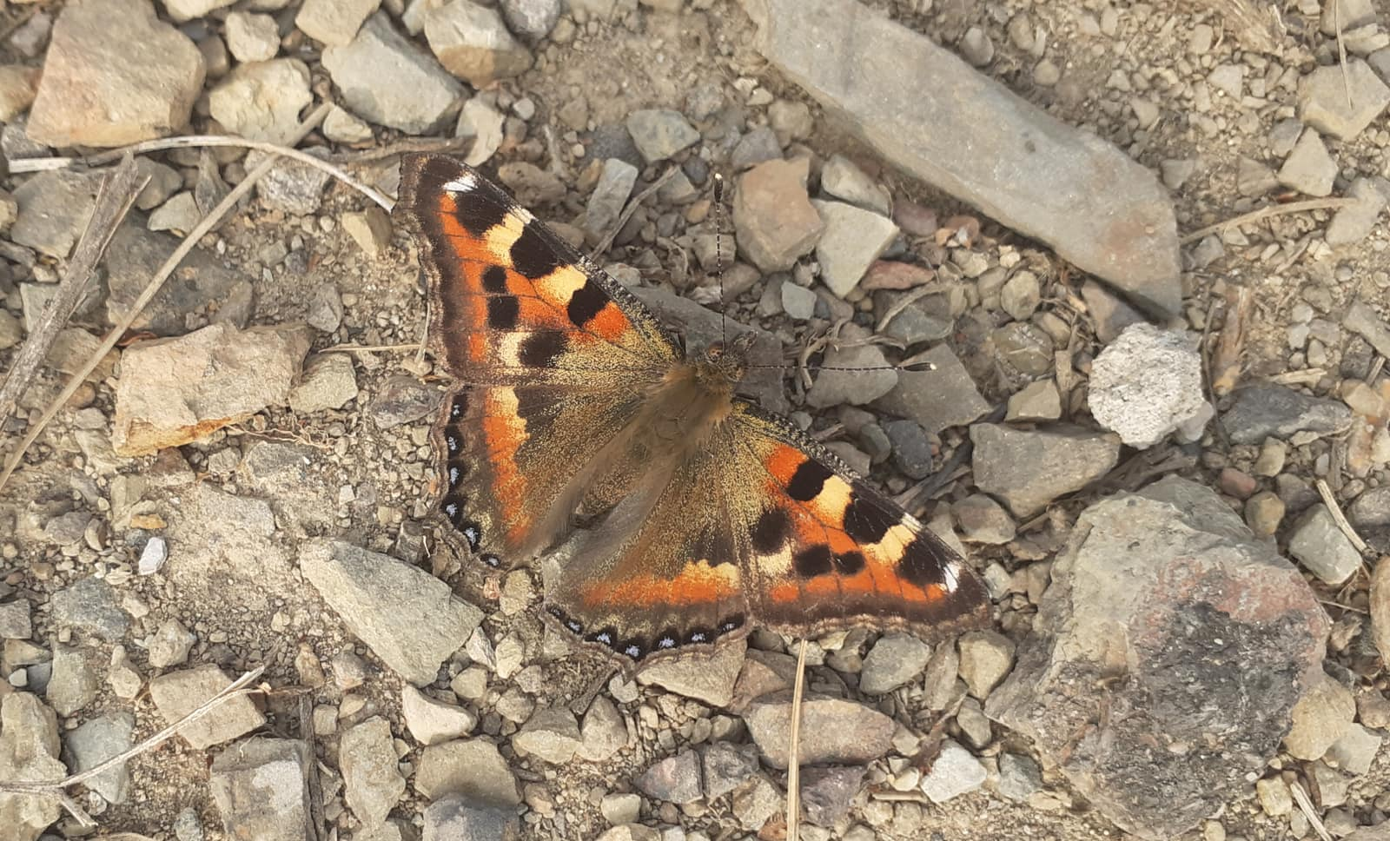
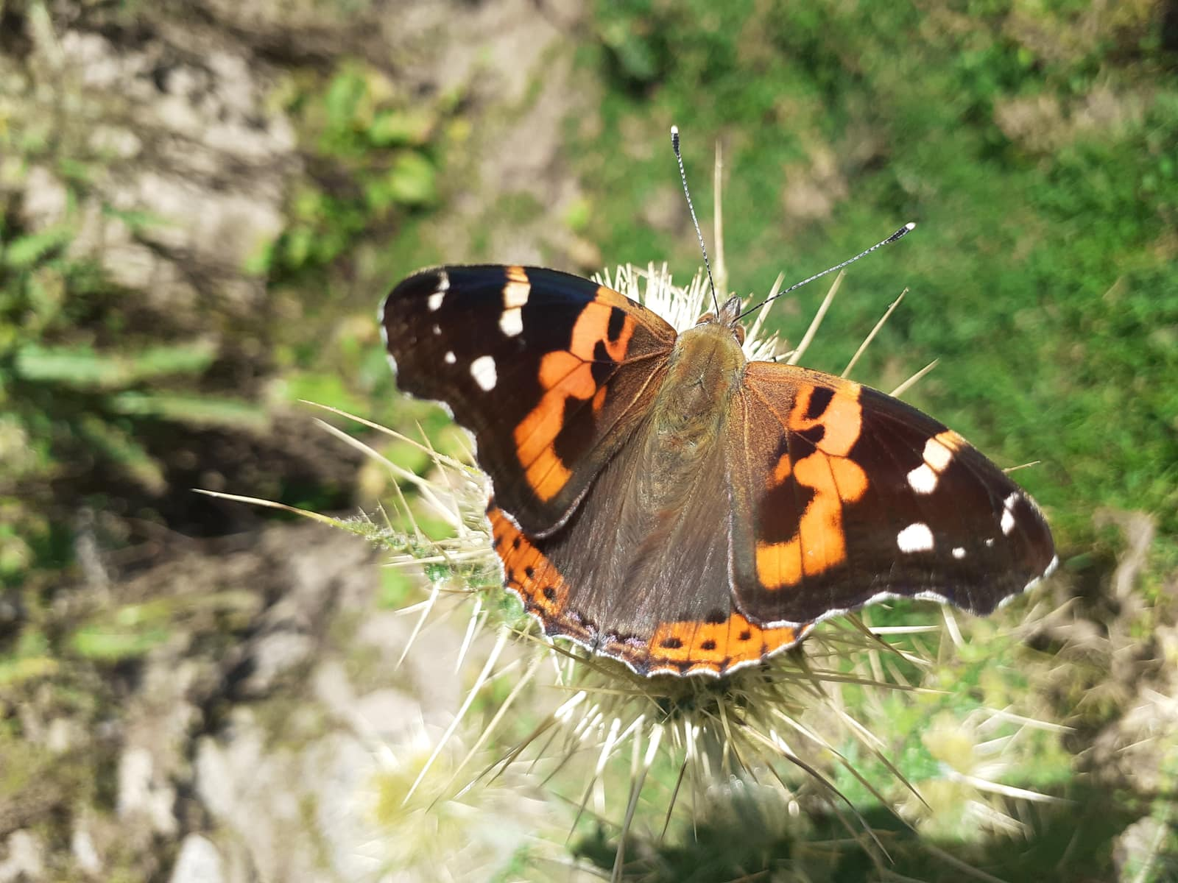
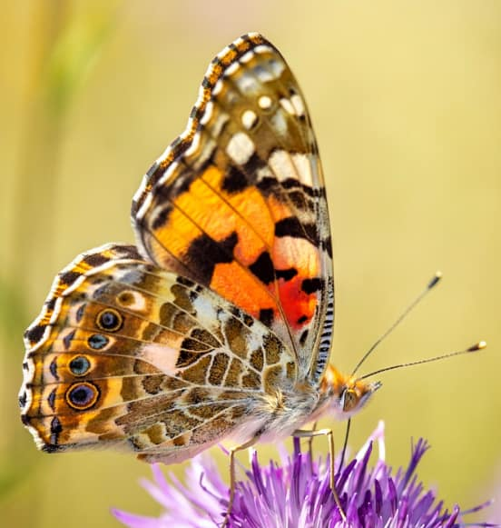
Junonia almana
Aglais caschmirensis
Vanessa indica
Vanessa cardui

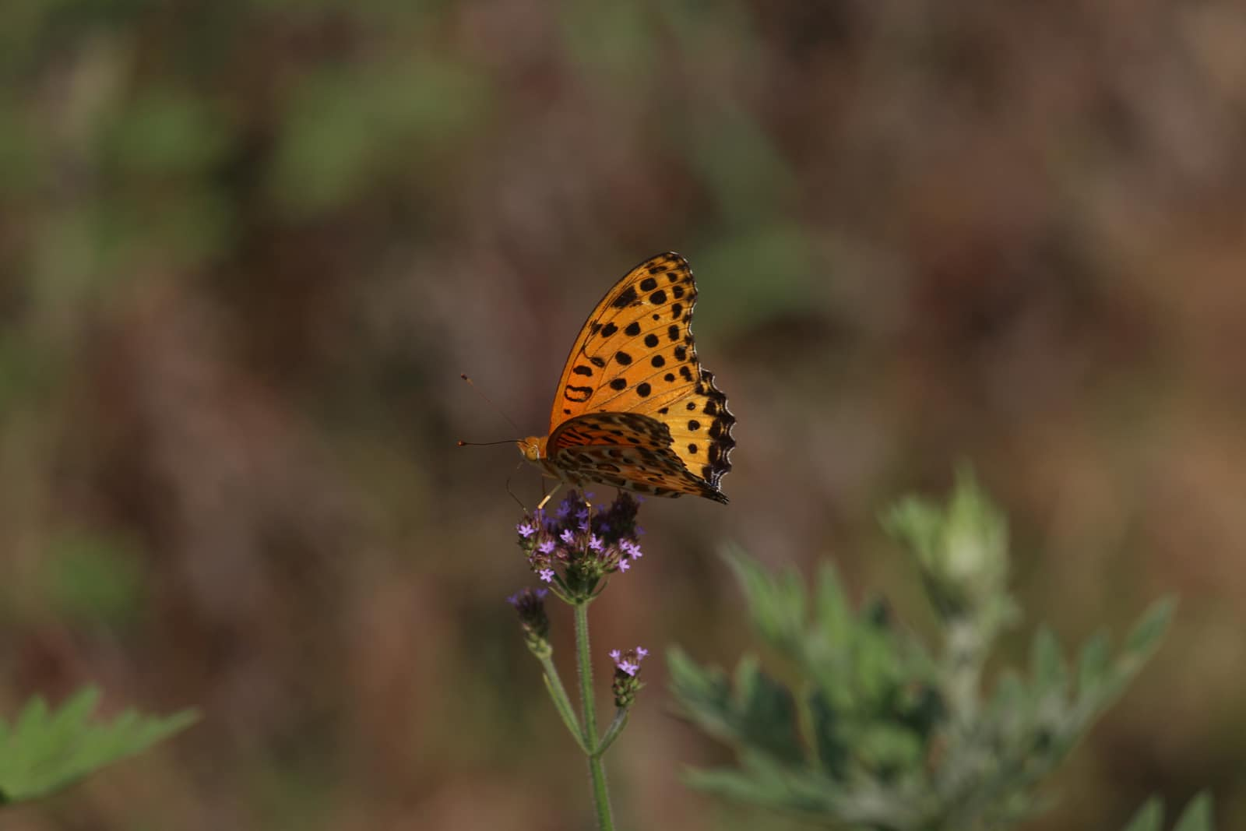
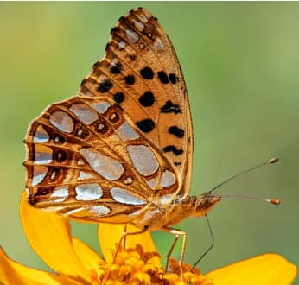
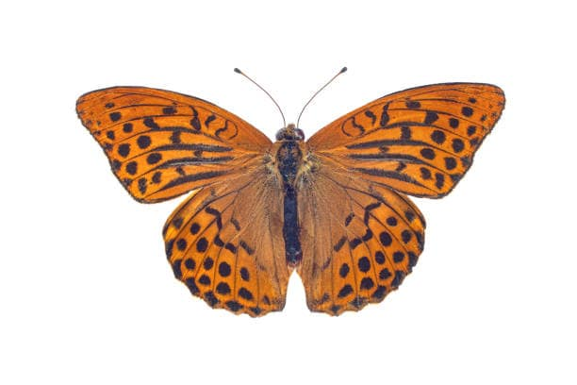
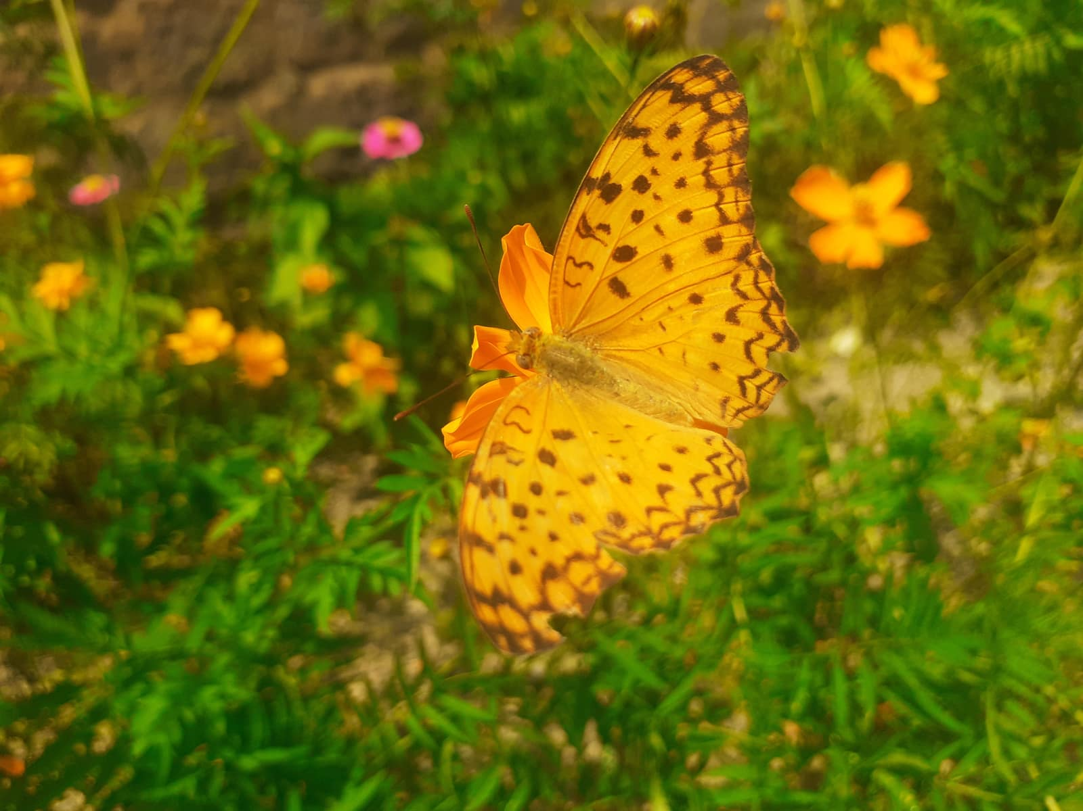
Argynnis hyperbius
Issoria lathonia
Argynnis childreni

Phalanta phalantha

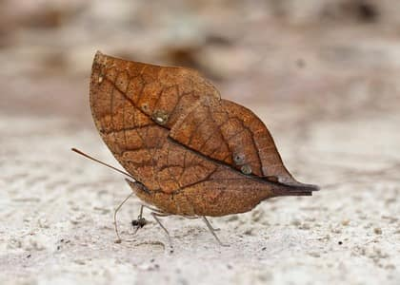
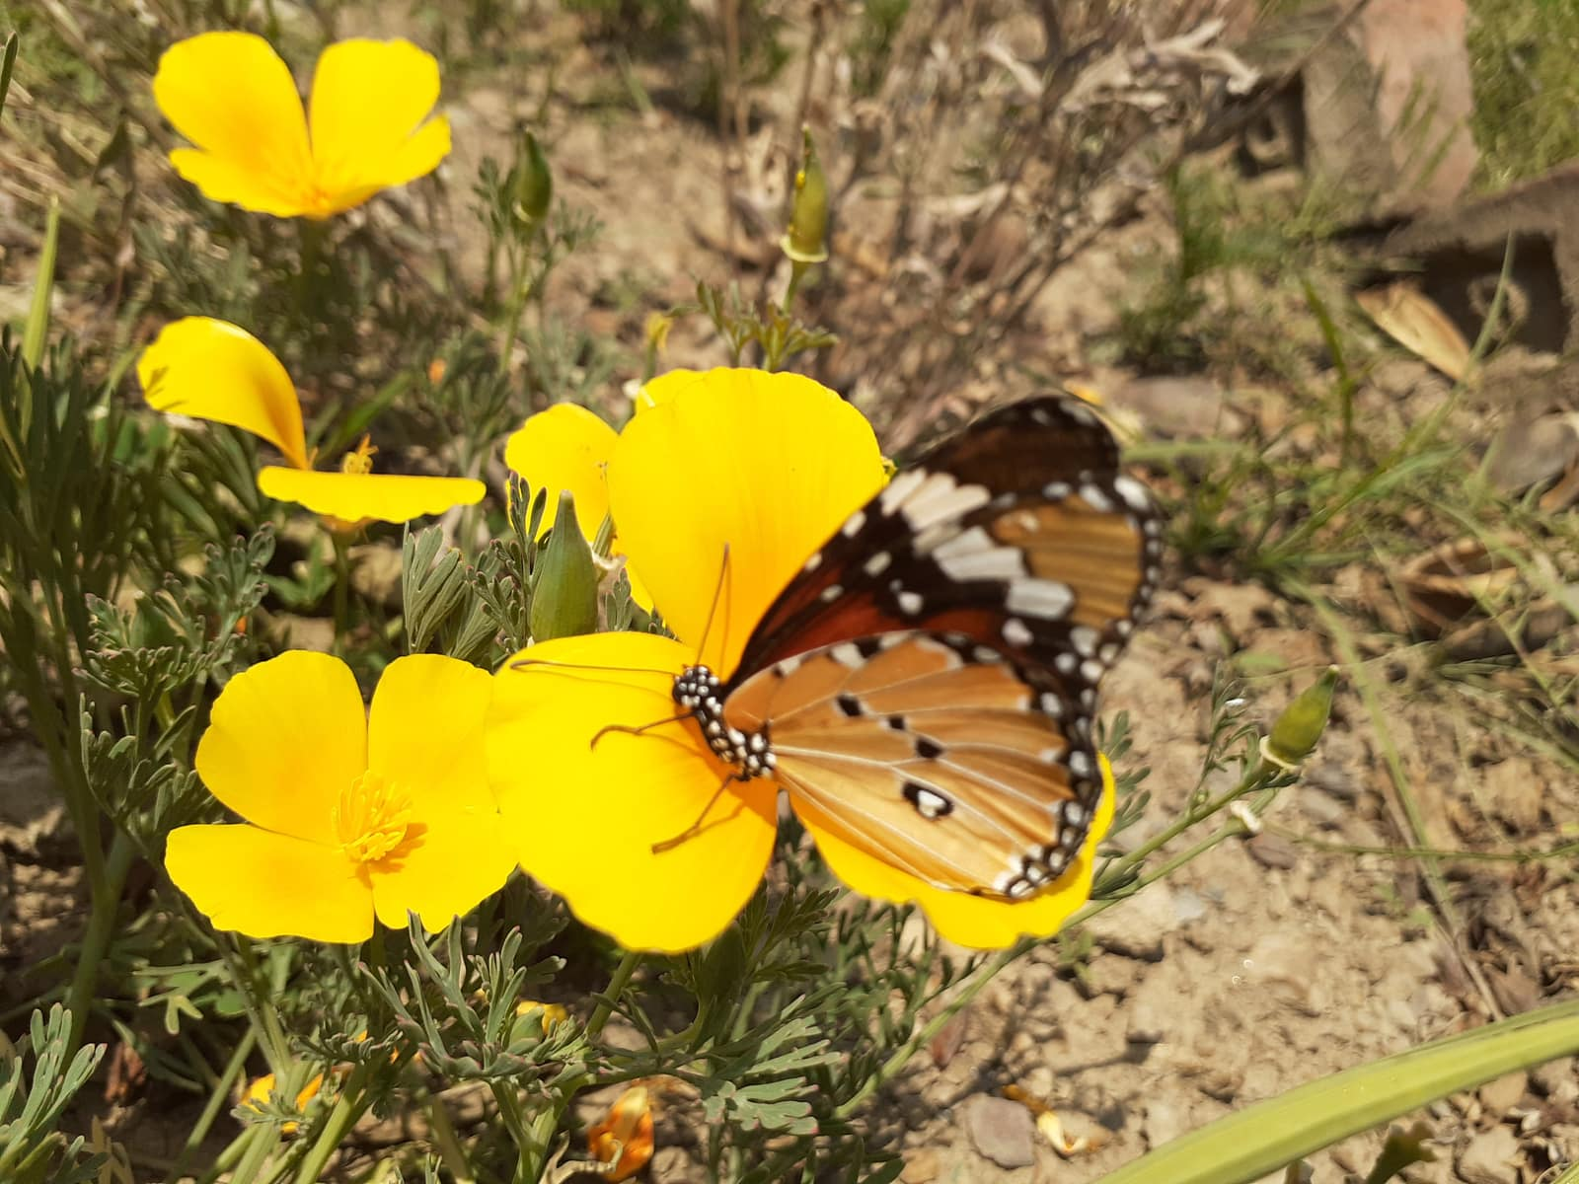
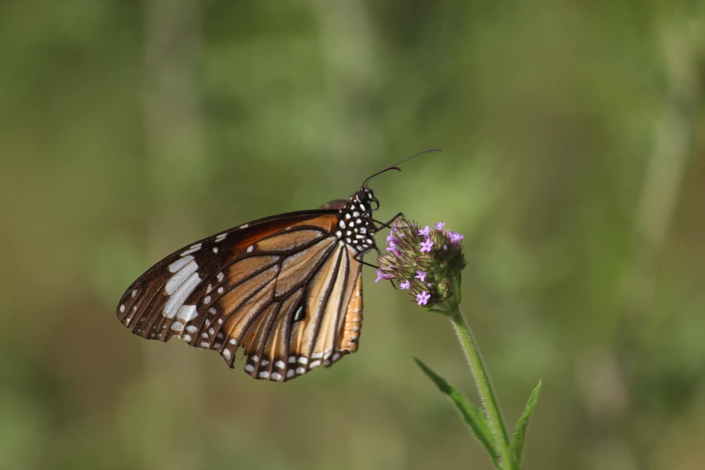
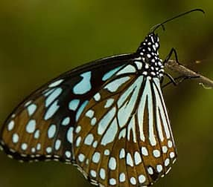
Kallima inachus
Danaus chrysippus
Danaus genutia
Tirumala limniace

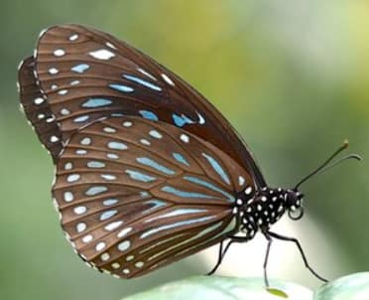
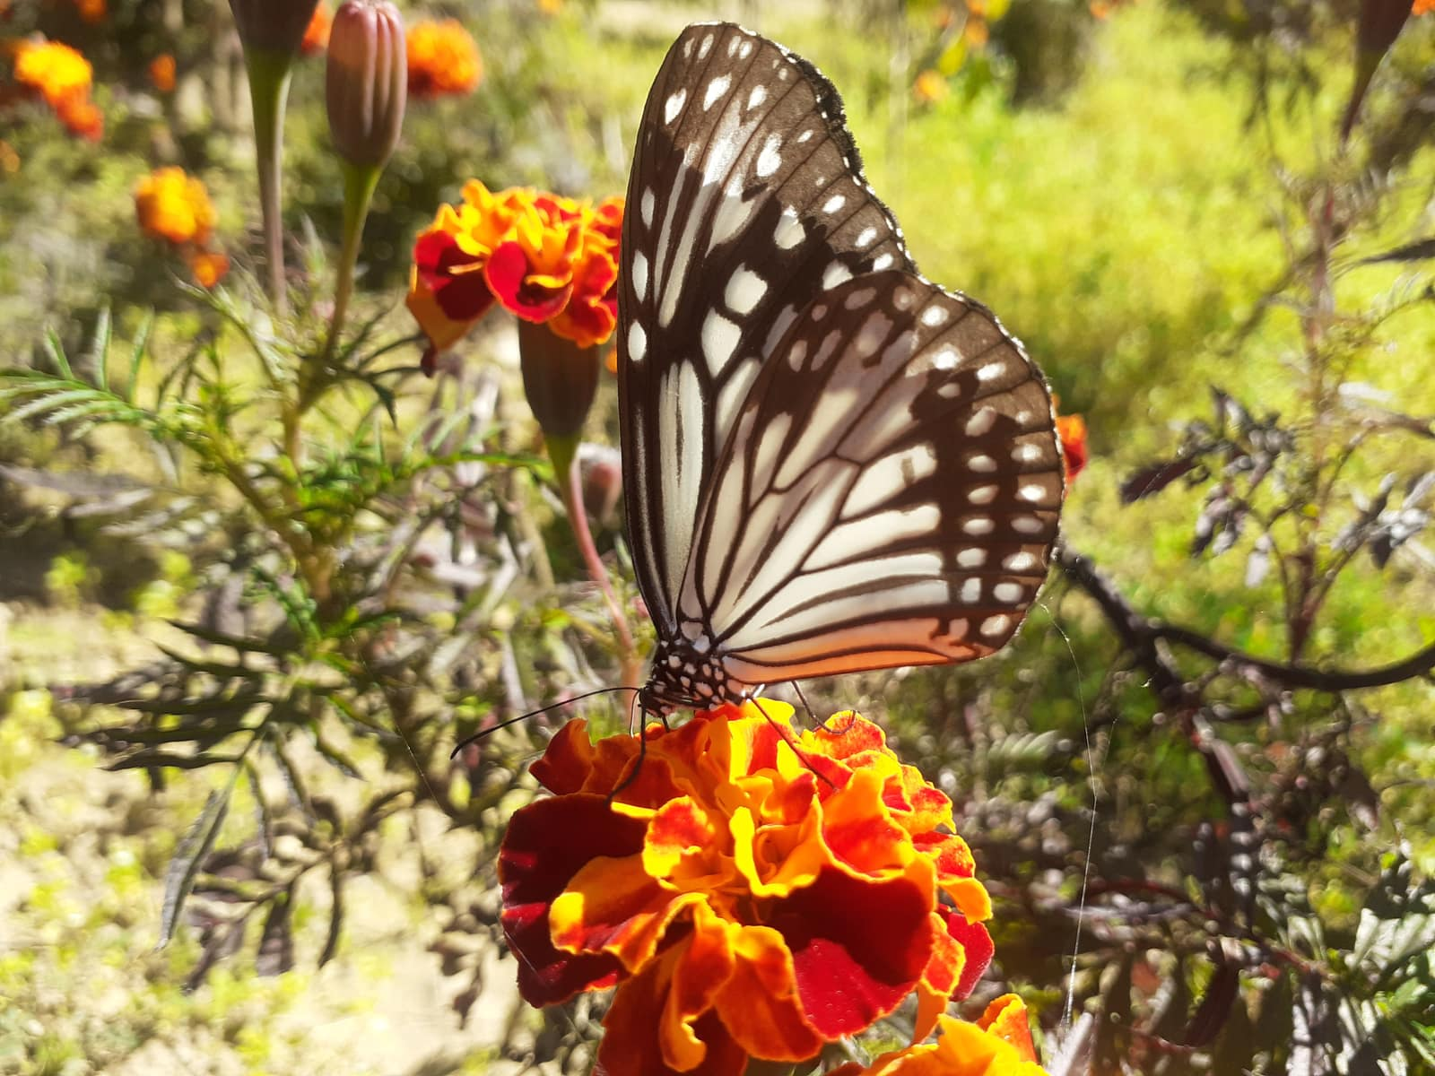
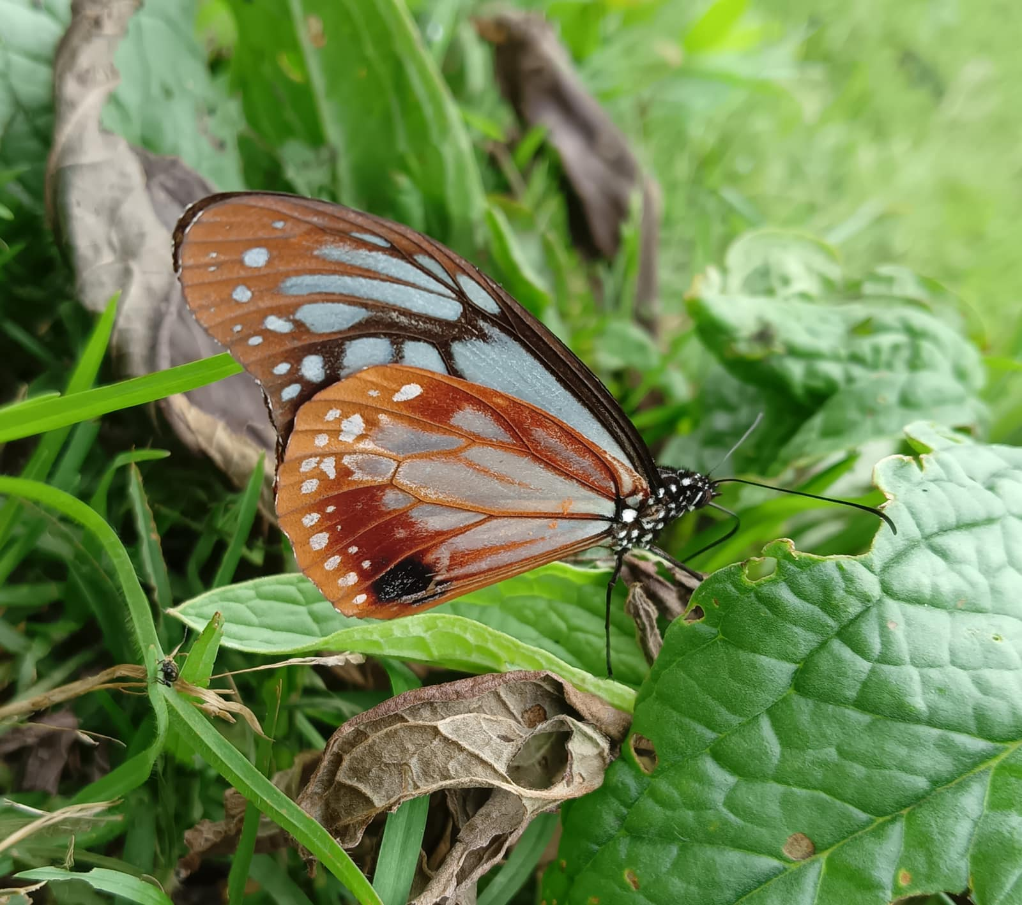

Tirumala septentrionis s

Parantica aglea
Parantica sita
Euploea core

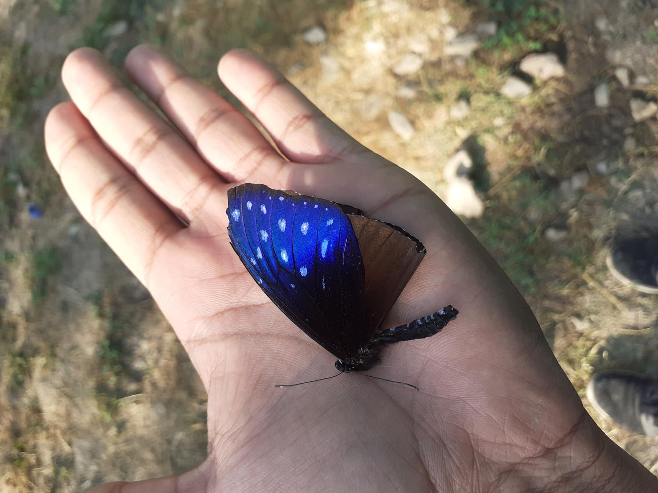
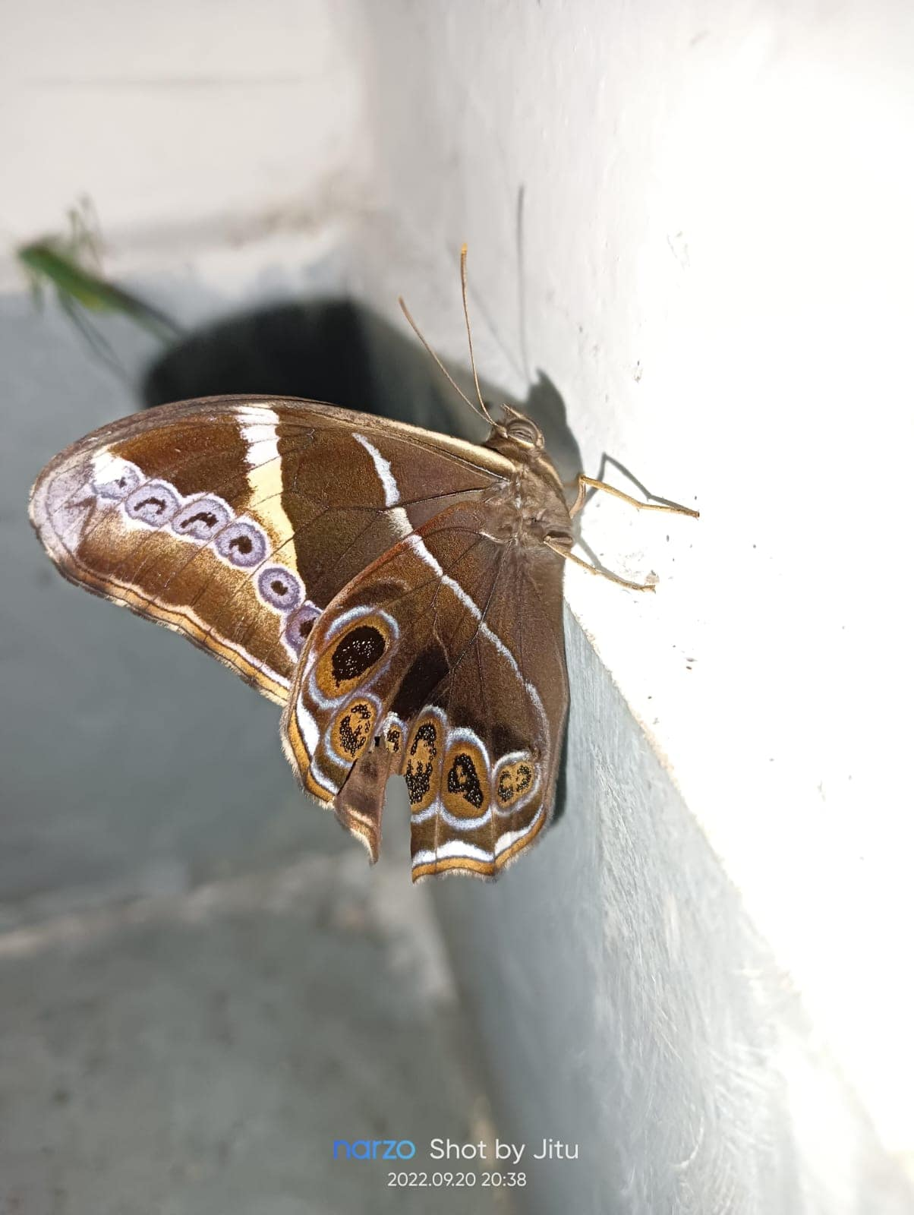
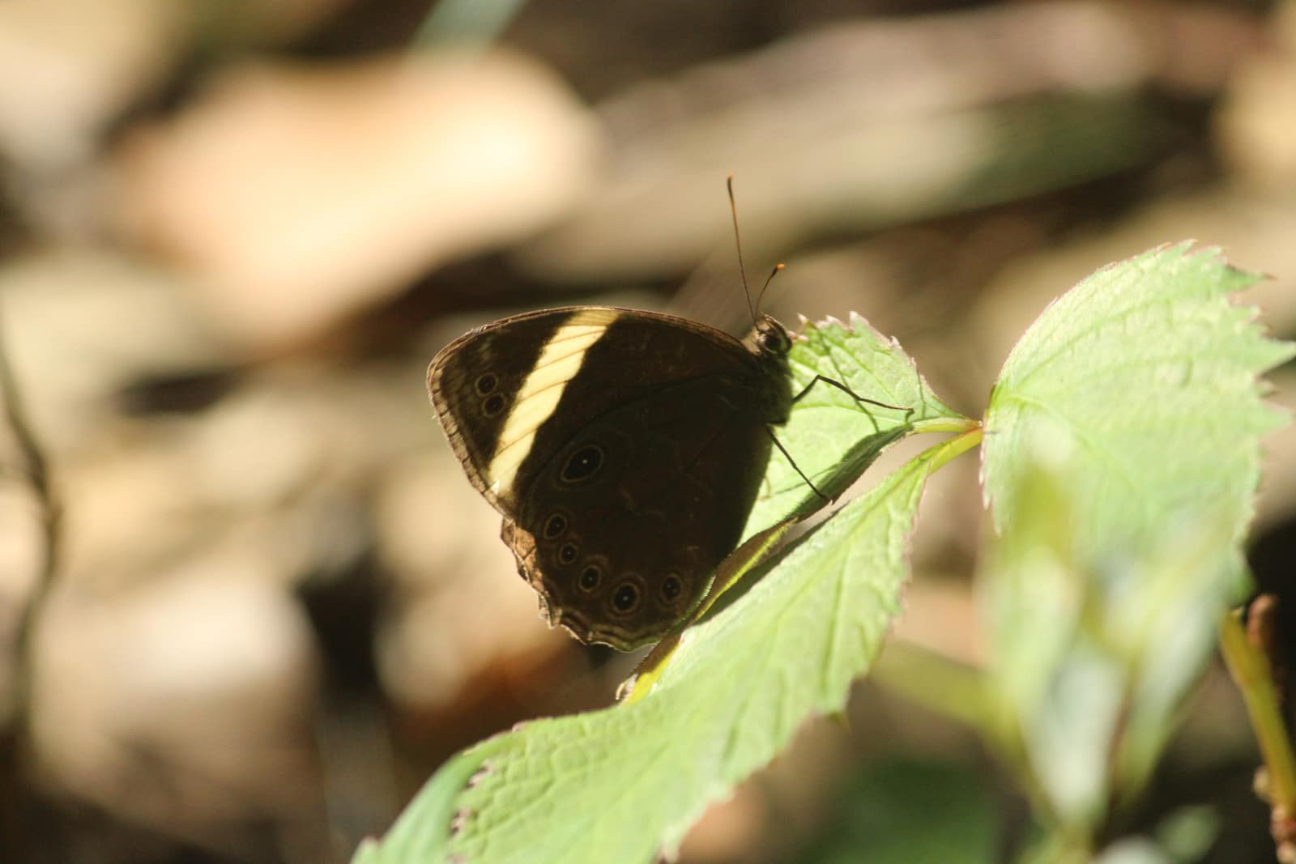
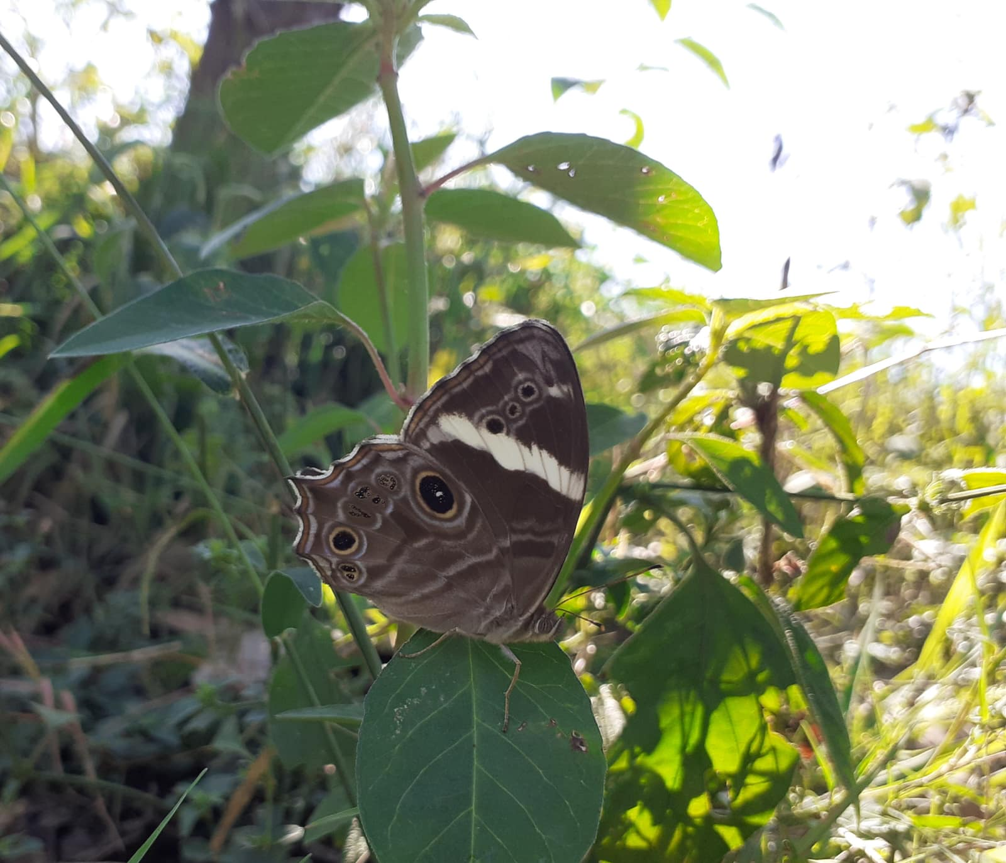
Euploea mulciber
Lethe rohria
Lethe verma
Lethe confusa

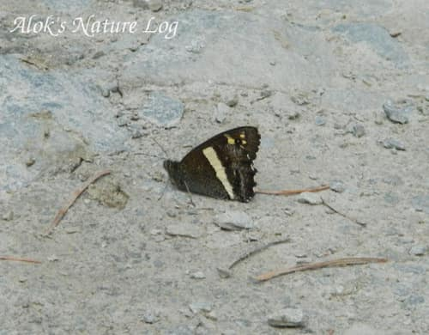
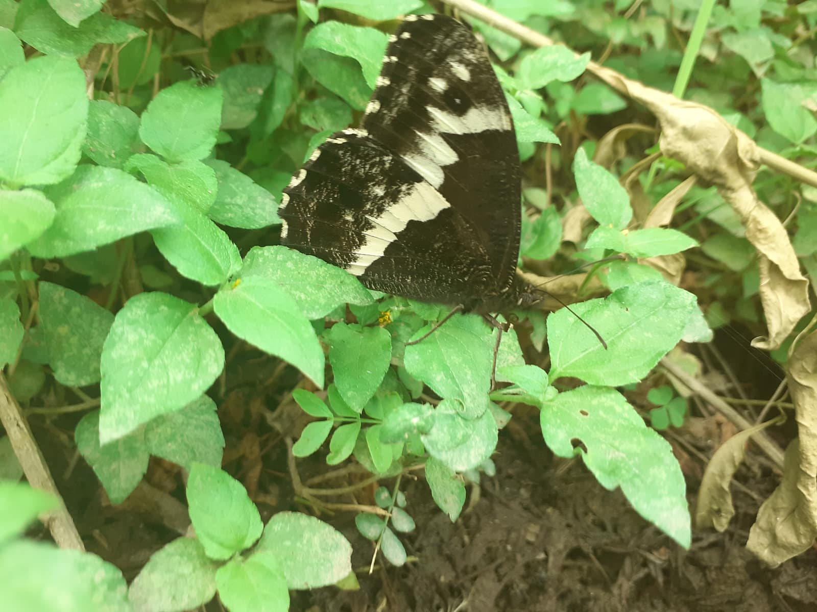
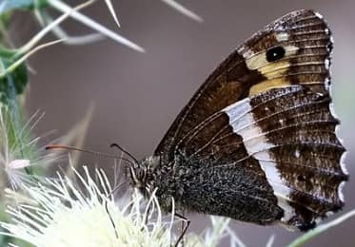
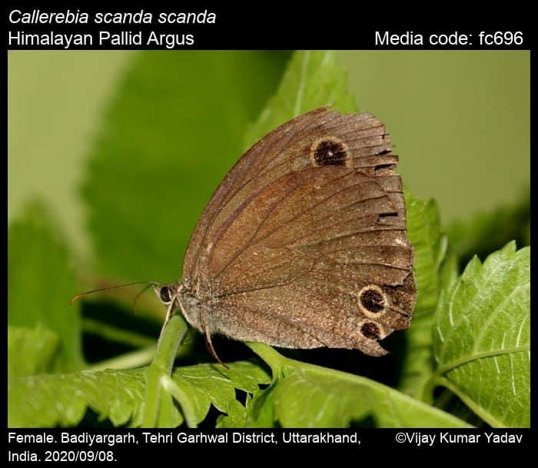
Aulocera padma
Aulocera loha loha
Aulocera swaha
Callerebia scanda

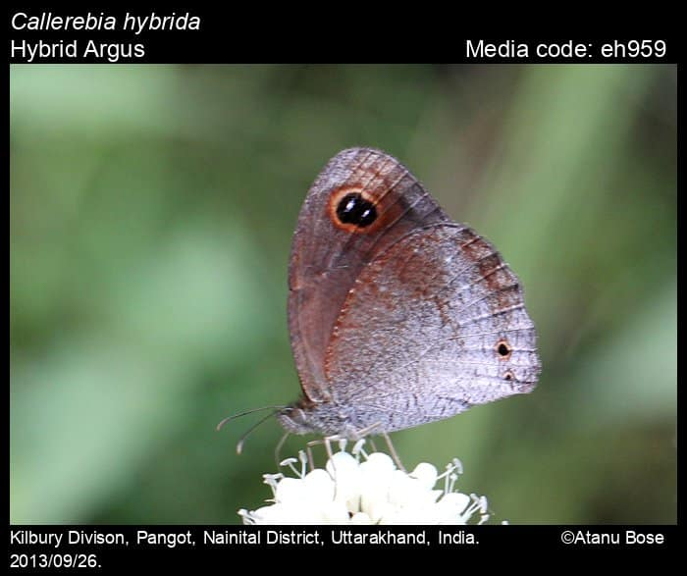
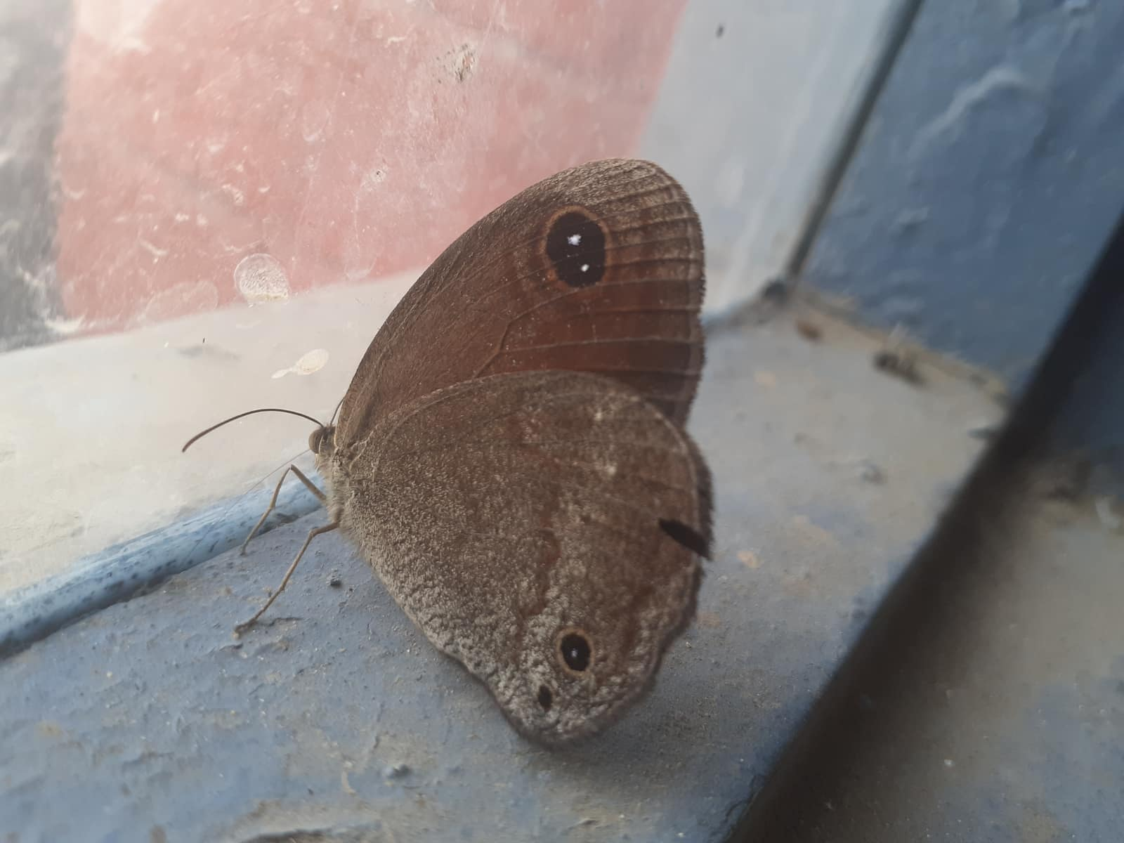
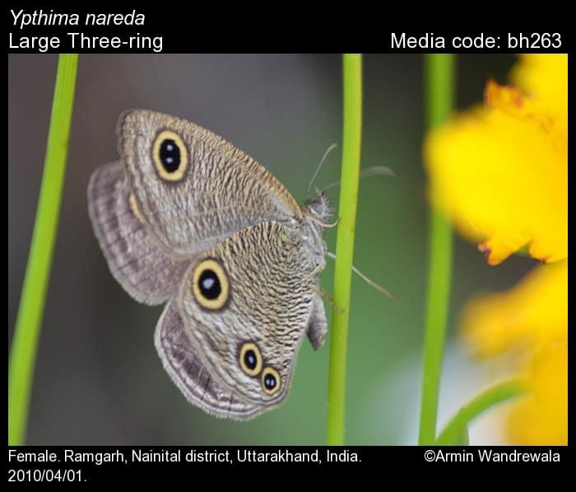
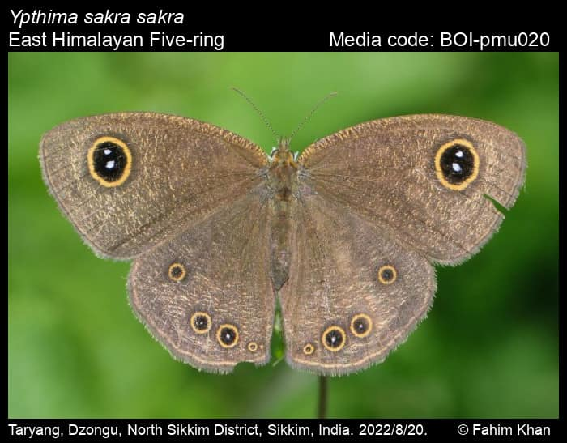
Callerebia hybrid
Callerebia suroia
Ypthima nareda
Ypthima sakra
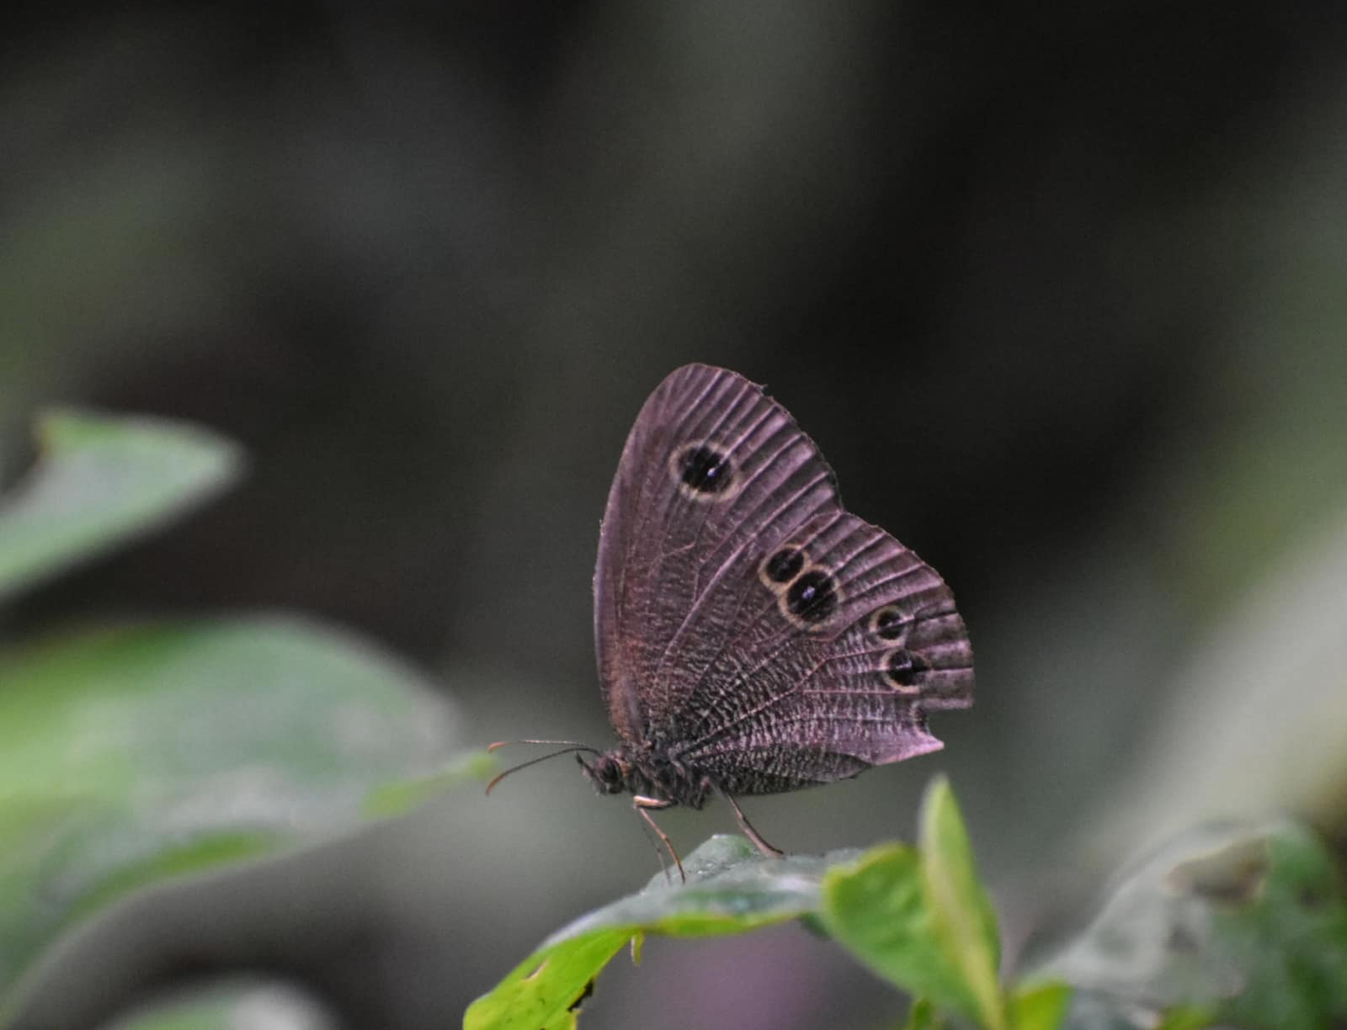
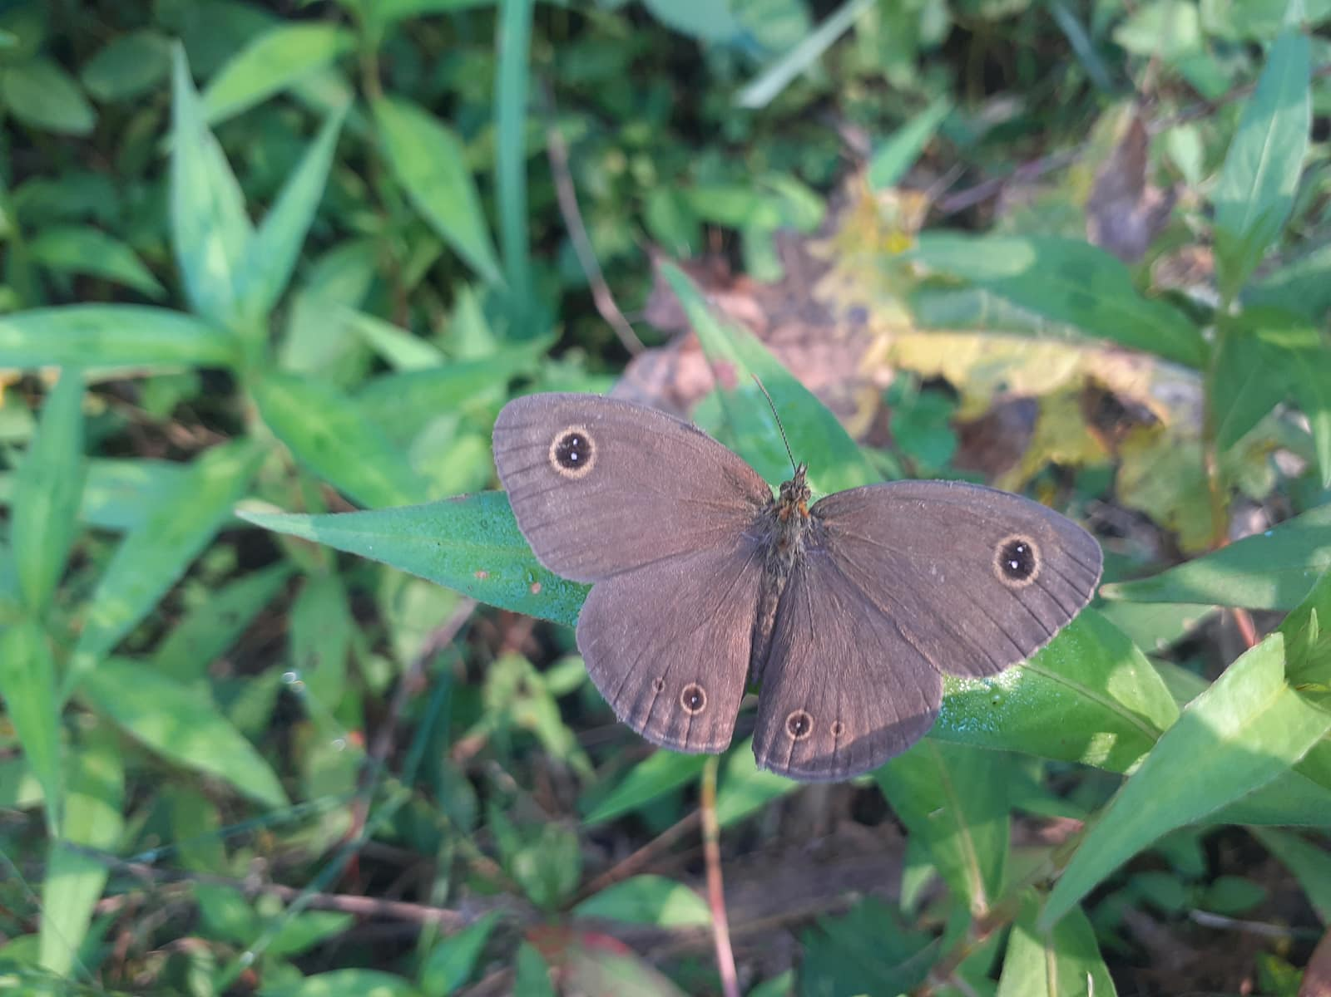
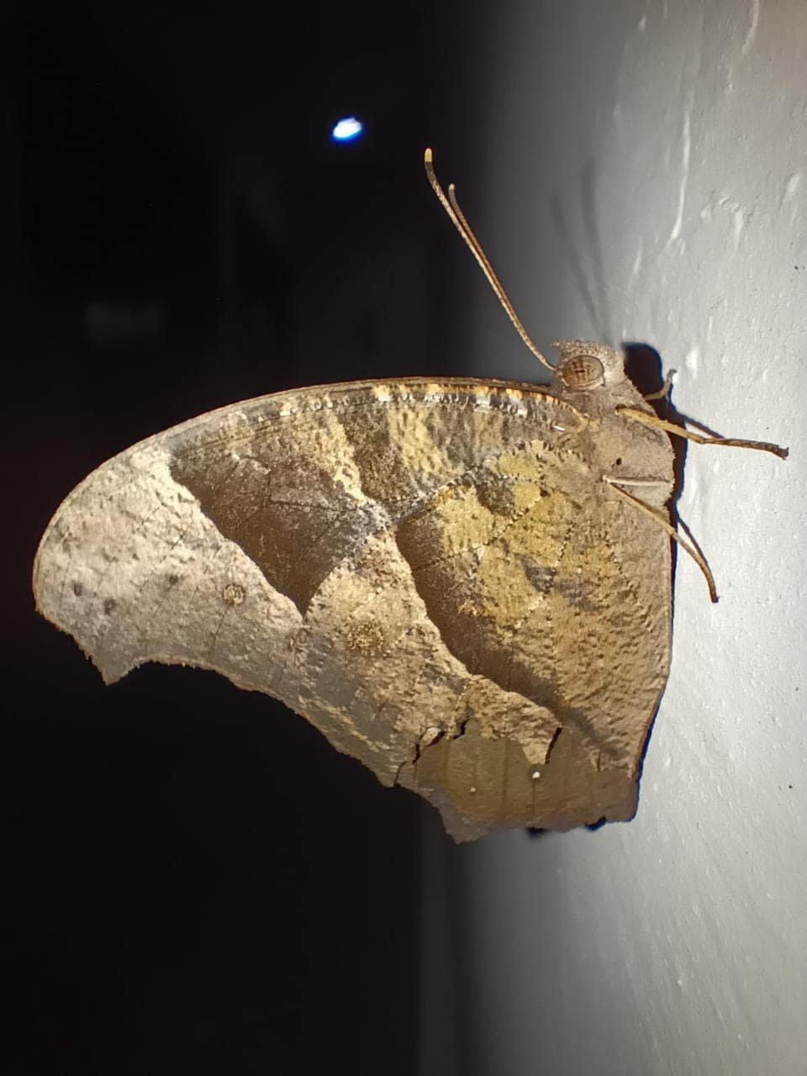
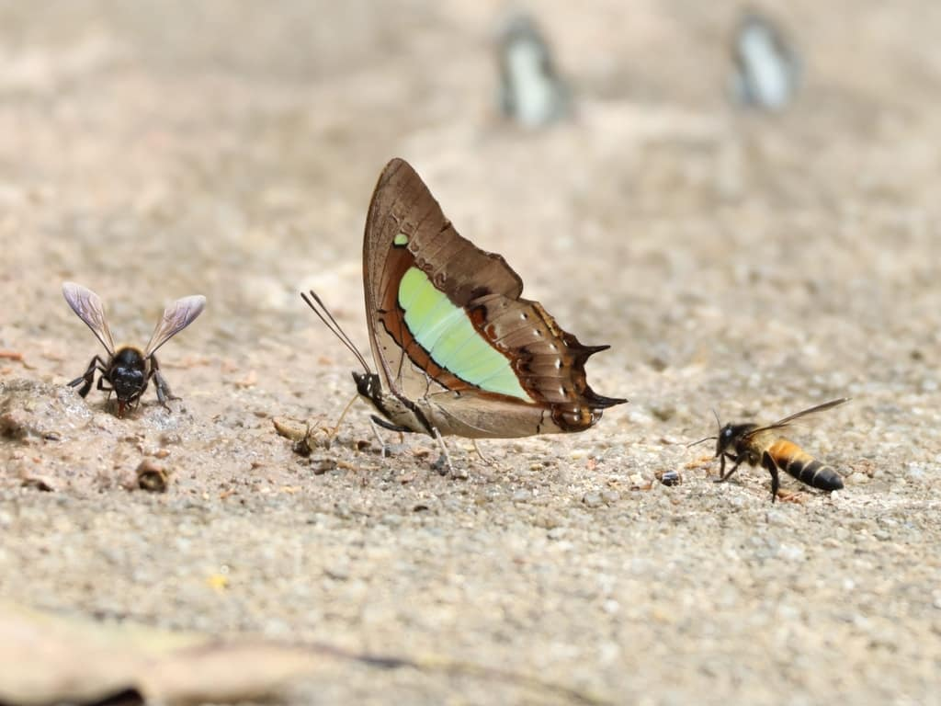
Ypthima baldus
Ypthima nikaea
Melanitis leda
Polyura athamas
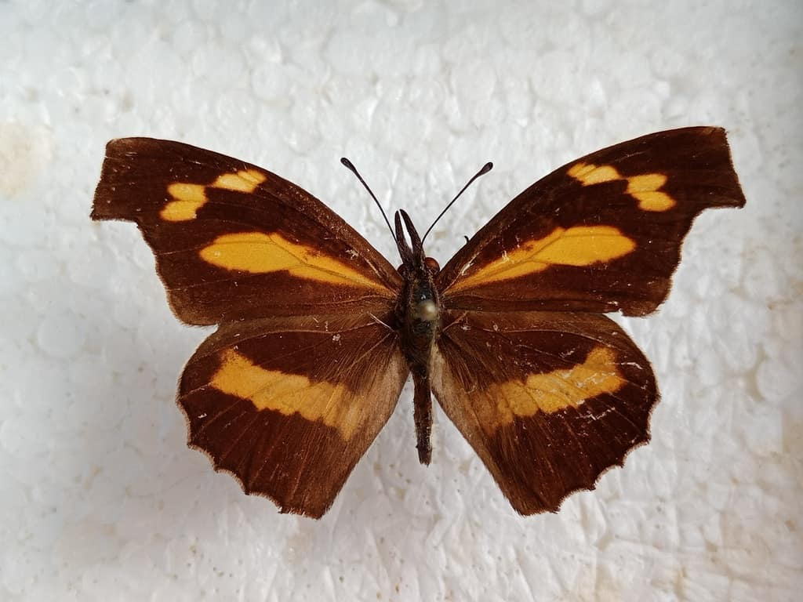
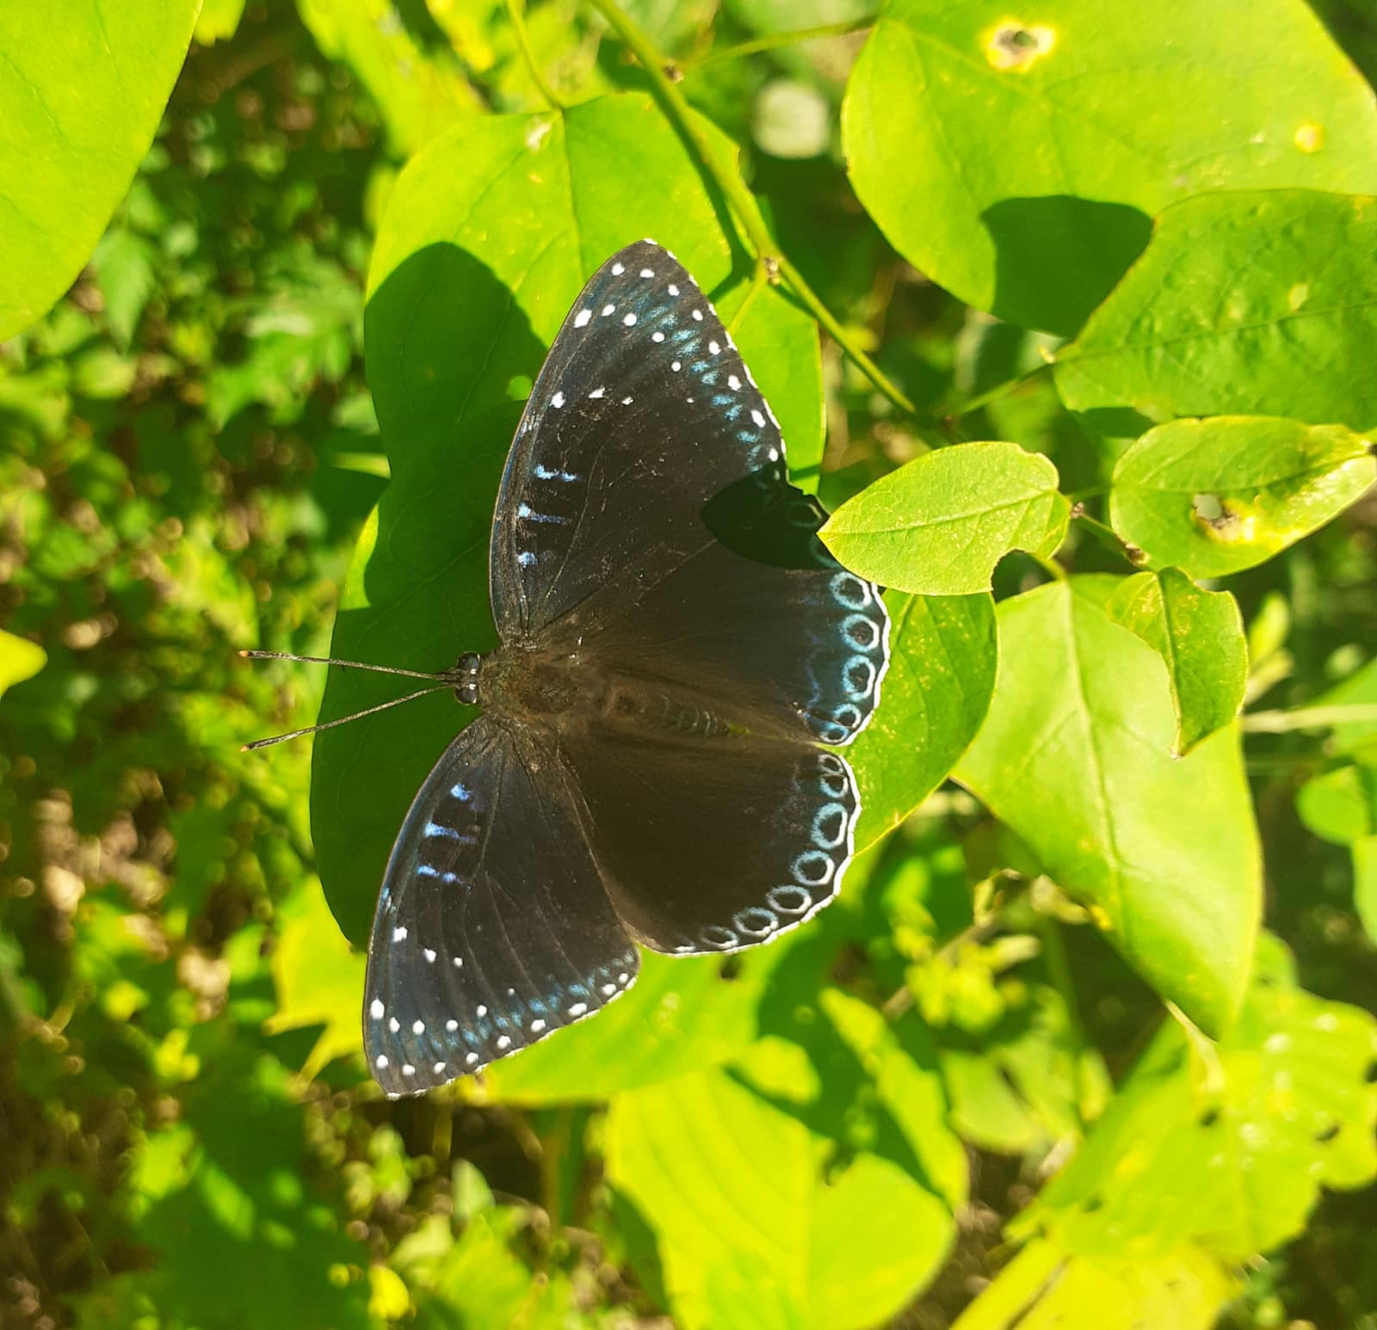
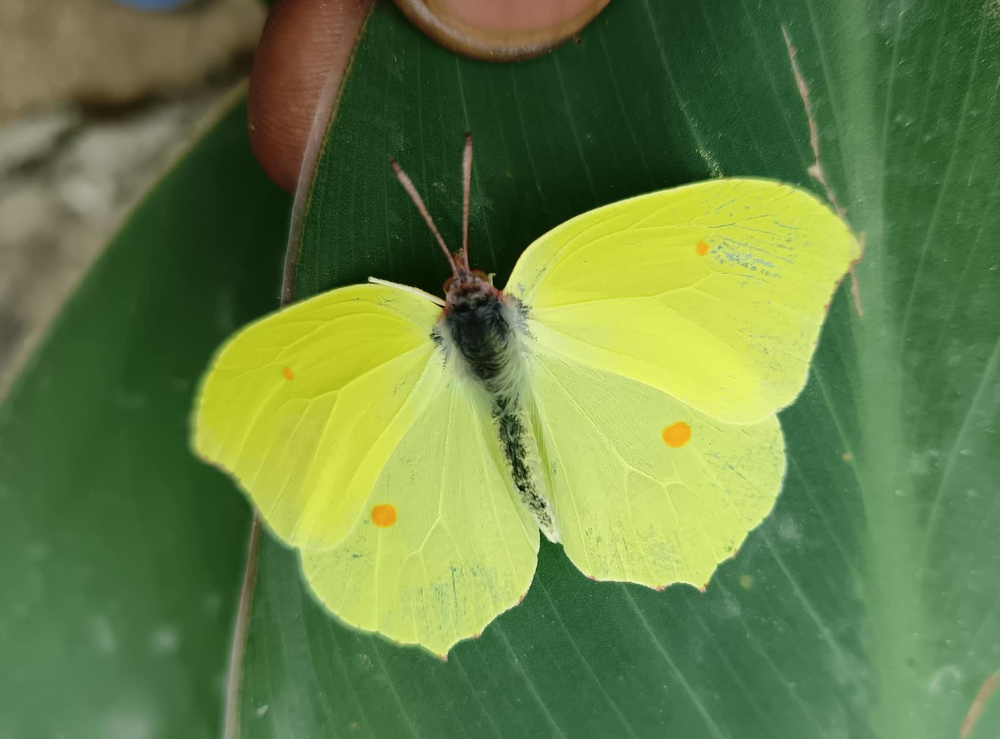
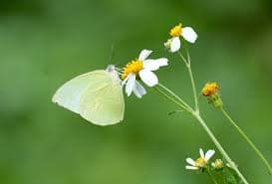
Libthea myrrha
Stibochiona nicea
Gonepteryx rhamni
Catopsilia pyranthe
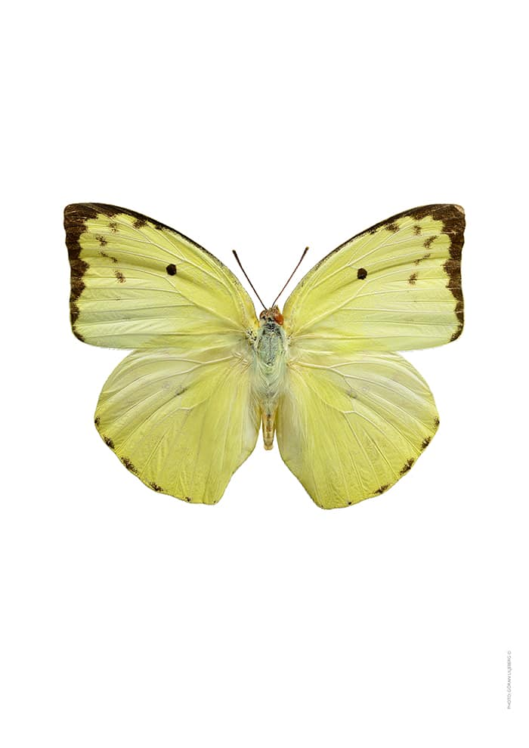
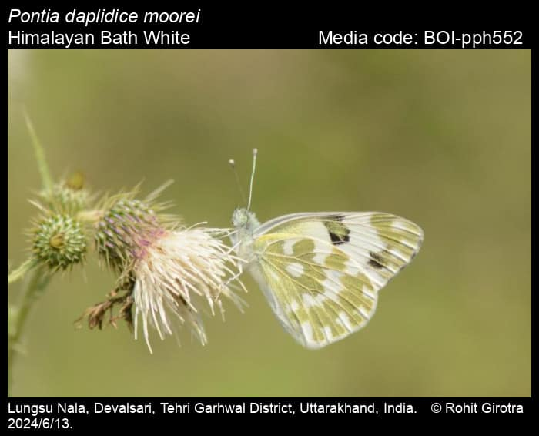
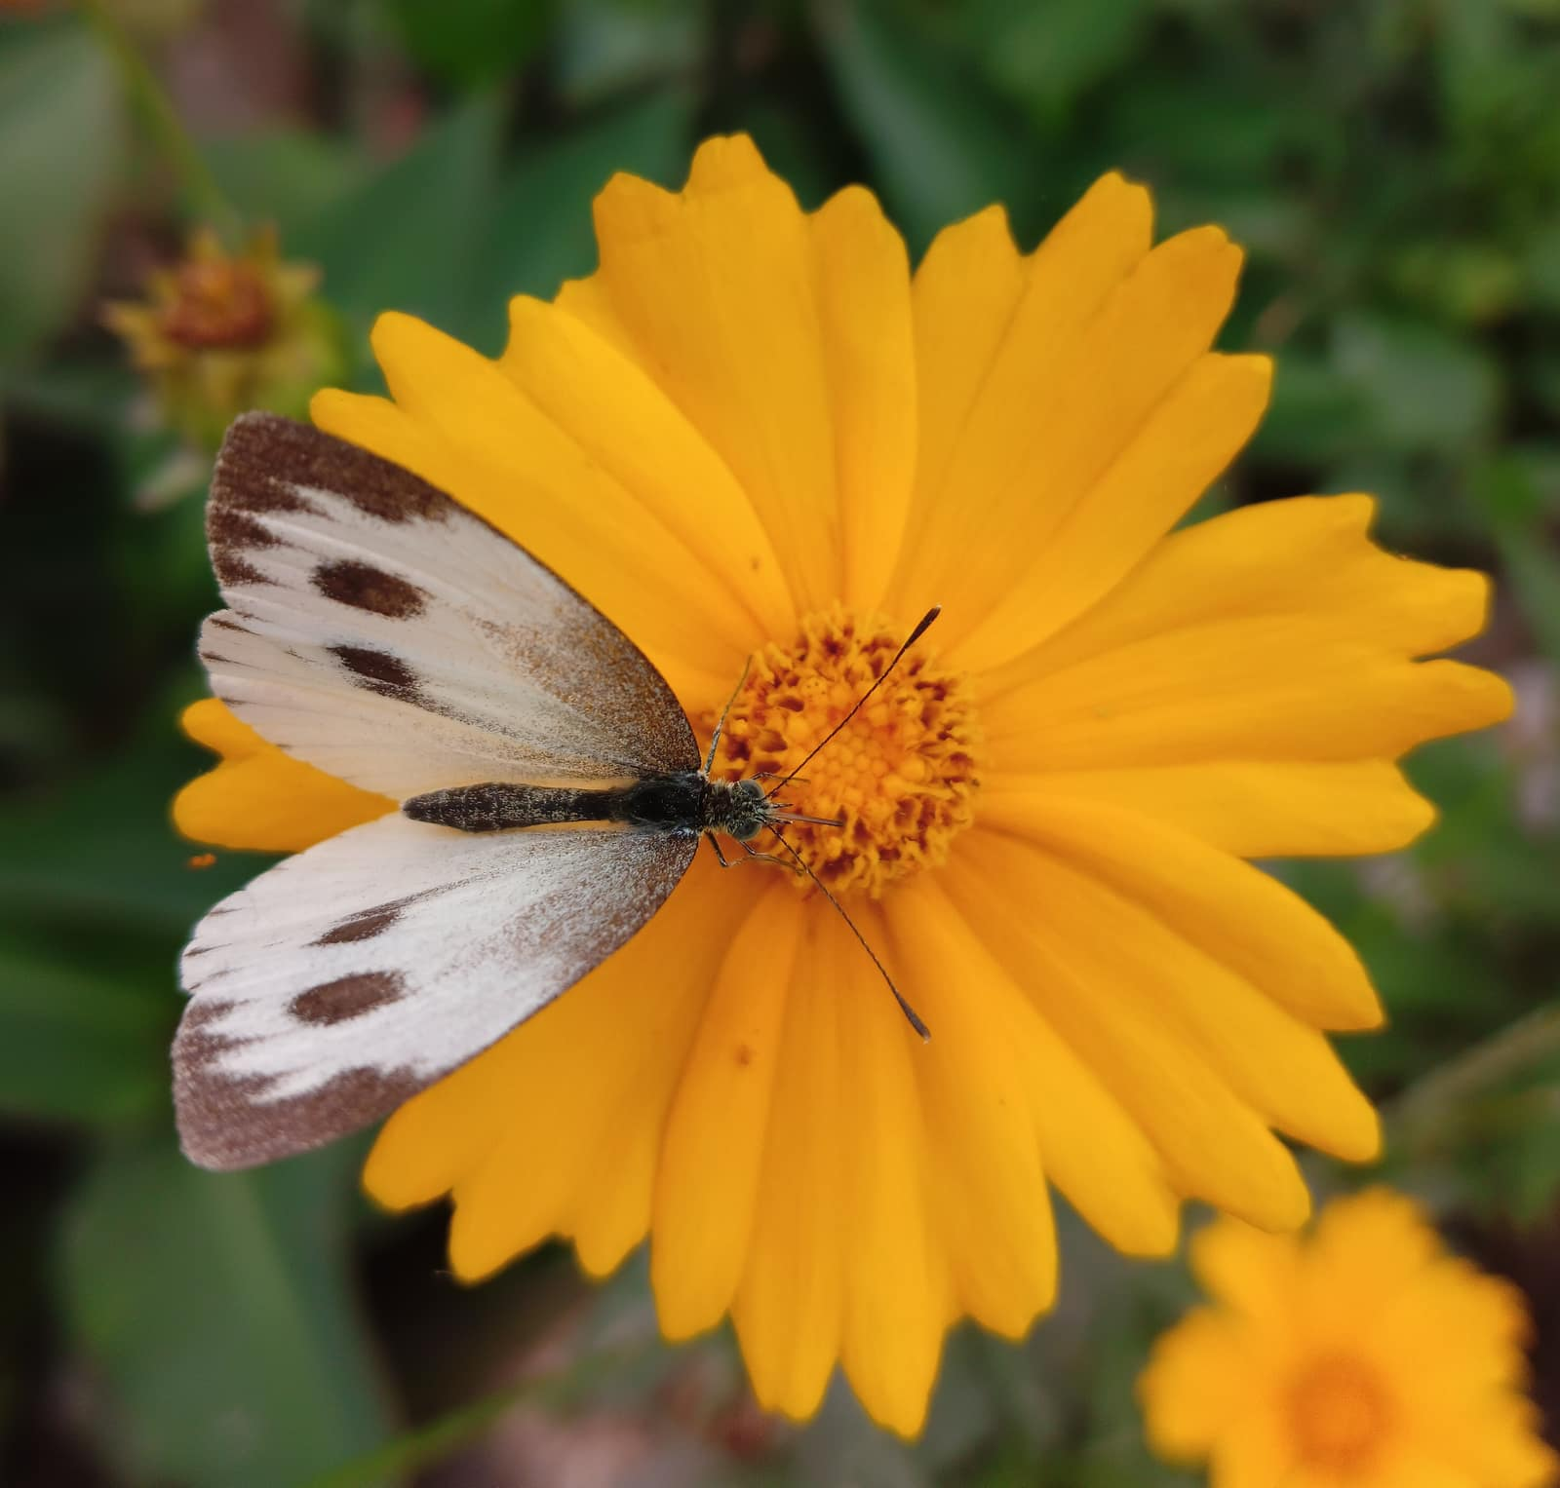
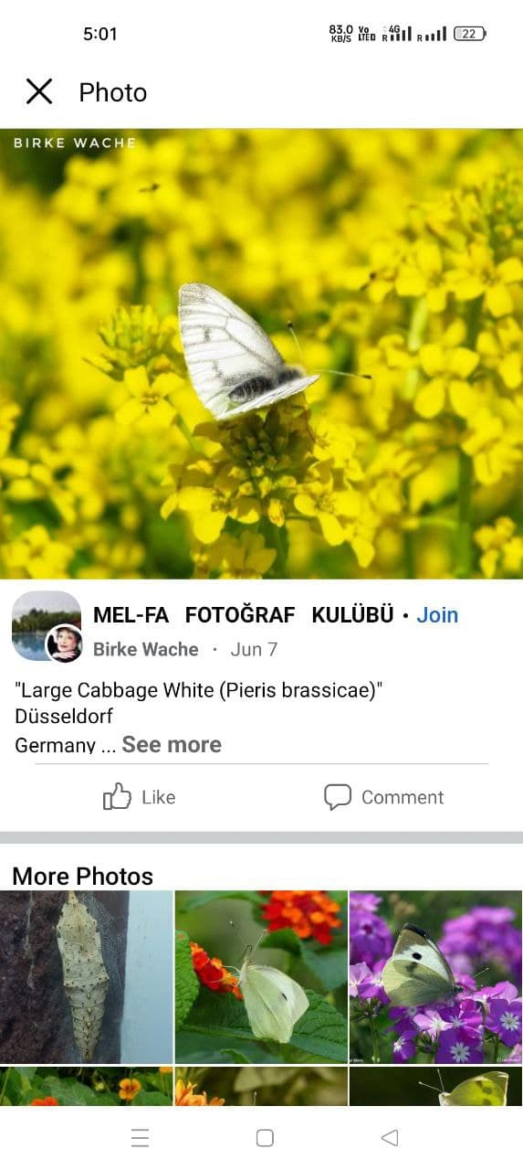
Catpsilia pomona
Pontia daplidice
Pieris canidia
Pieris brassicae

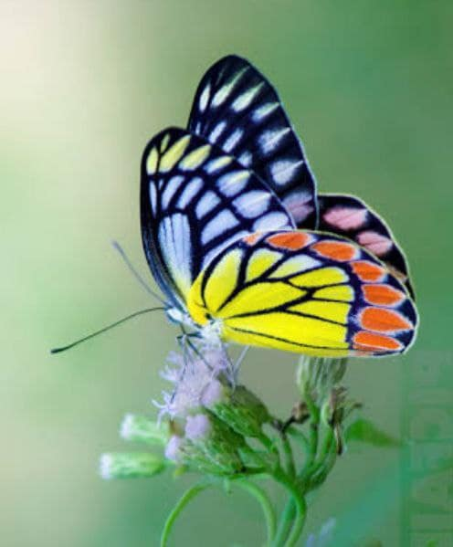
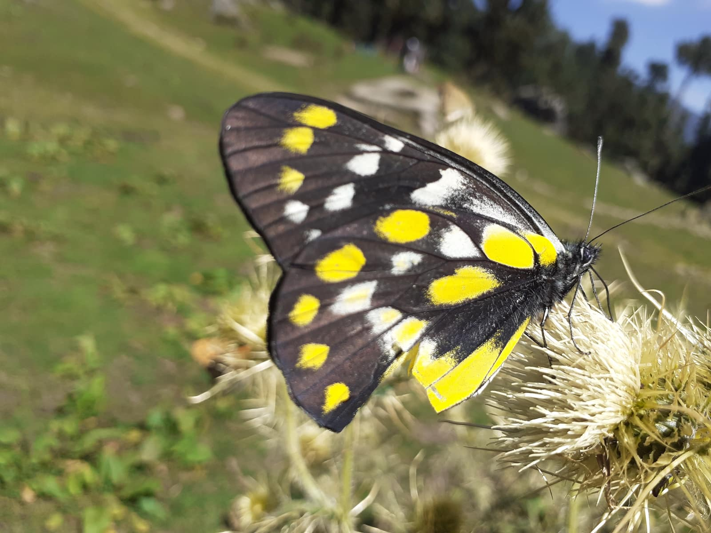
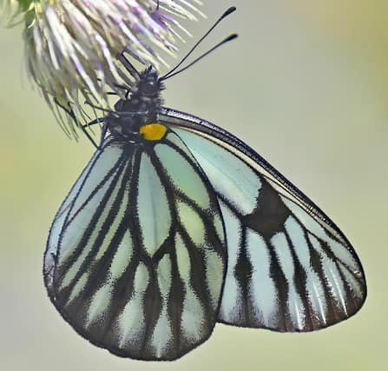
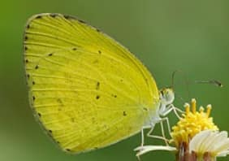
Delias eucharis
Delias belladonna
Aporia agathon
Eurema brigitta

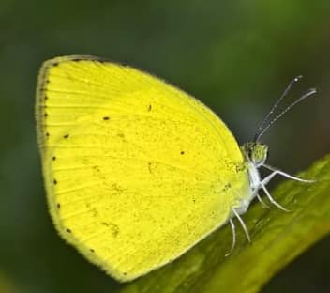
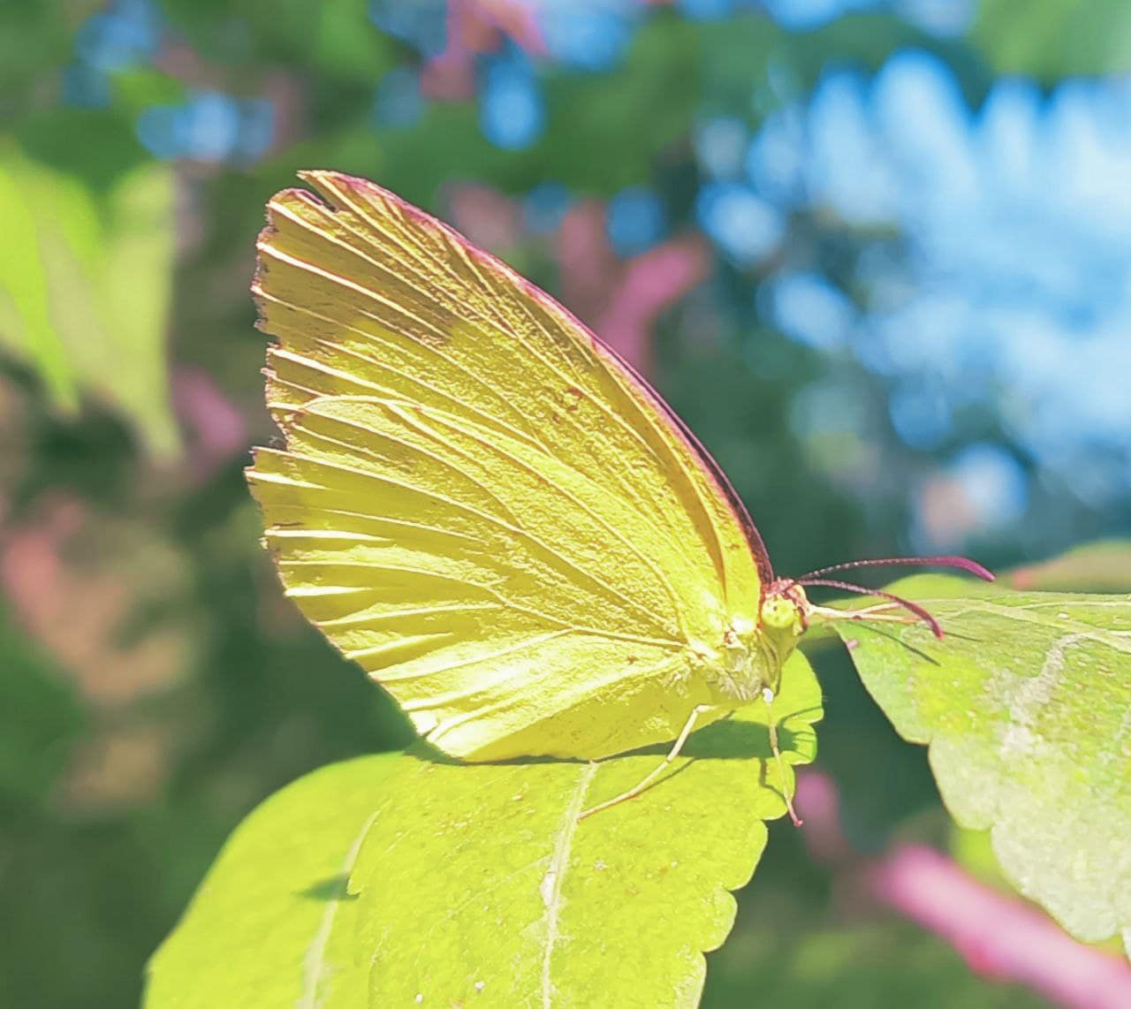
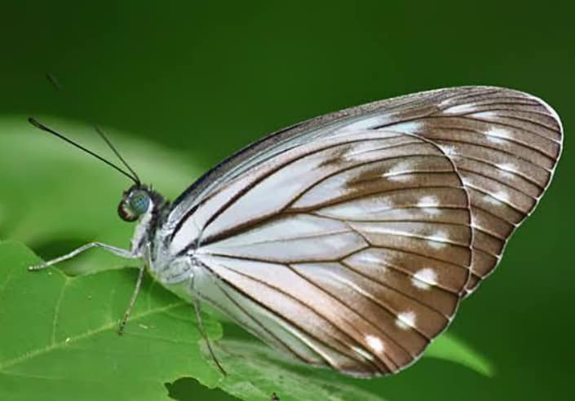
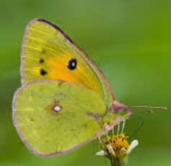
Eurema laeta
Eurema hecabe
Pareronia valeria
Colias fieldii

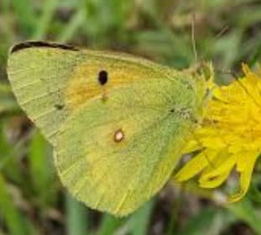
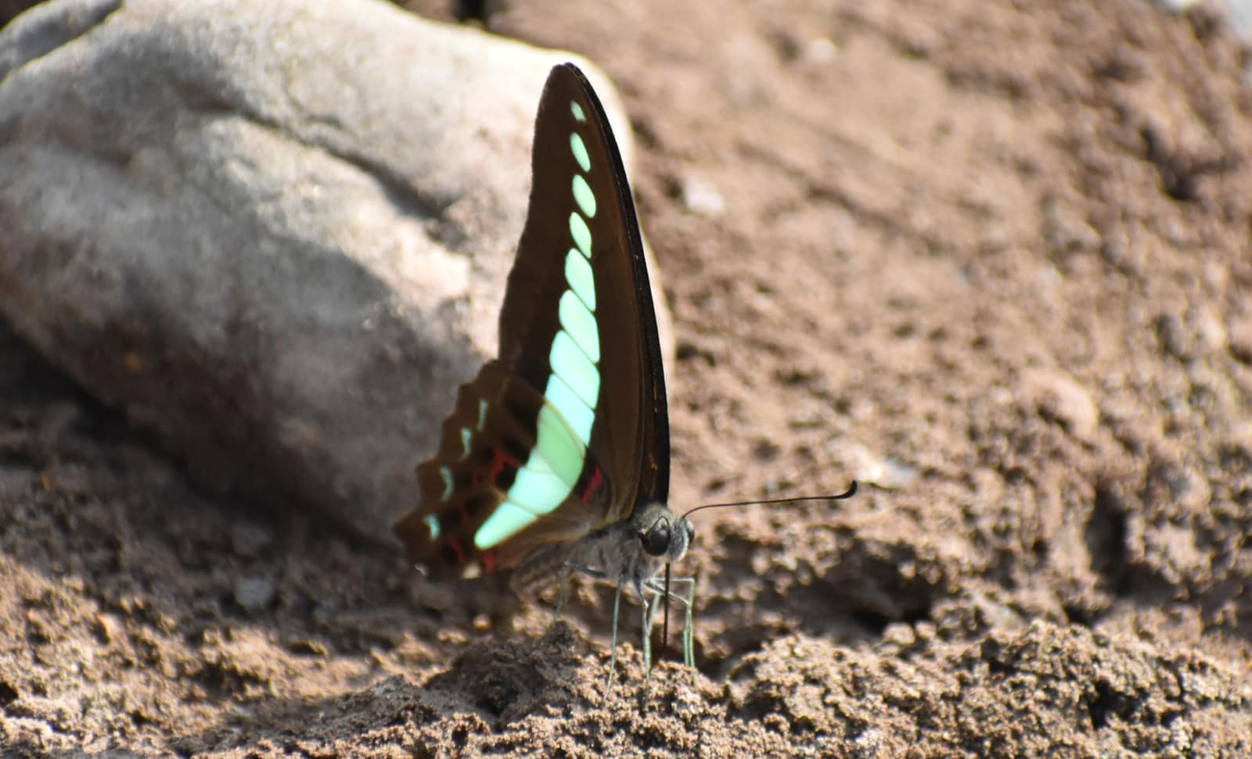
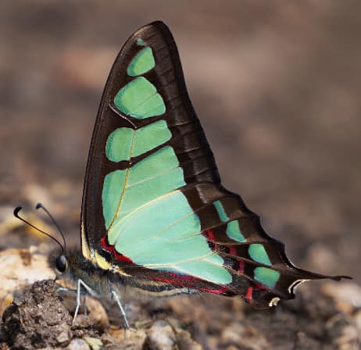
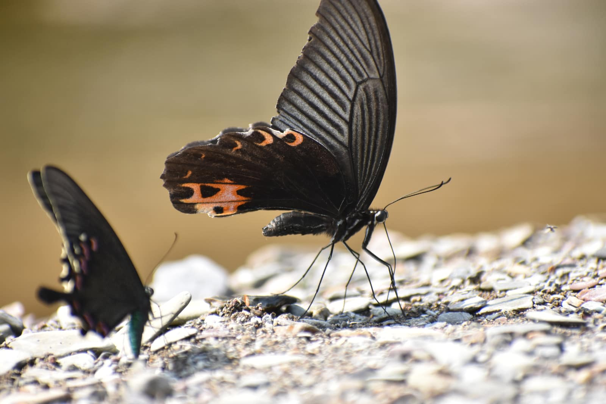
Colias erate
Graphium sarpedon
Graphium cloanthus
Papilio protenor

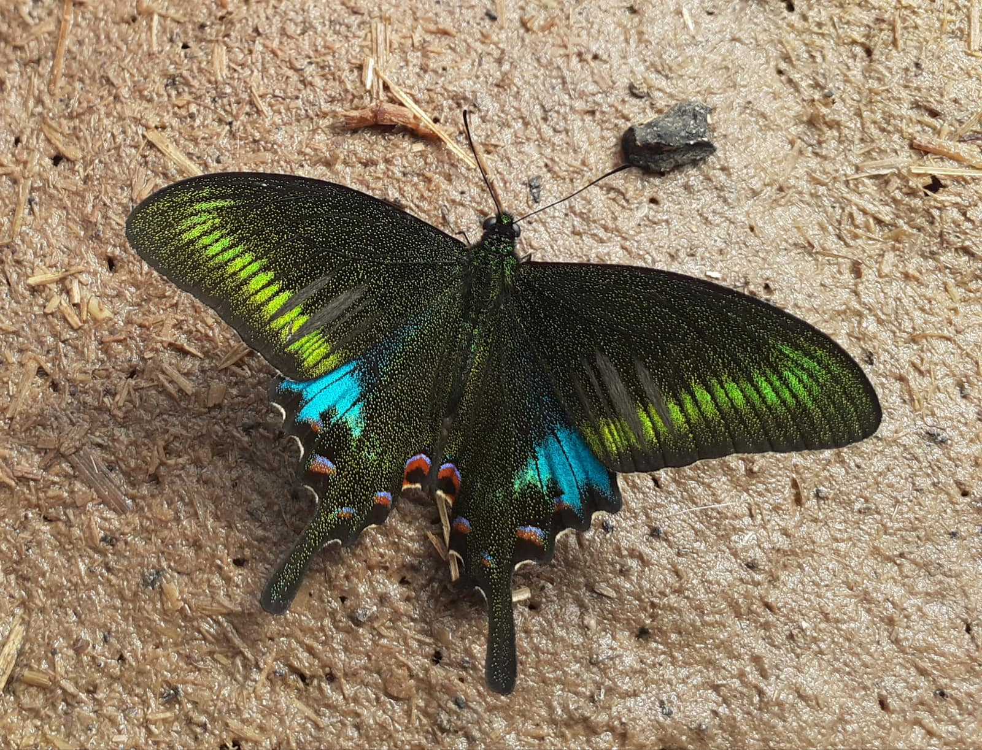
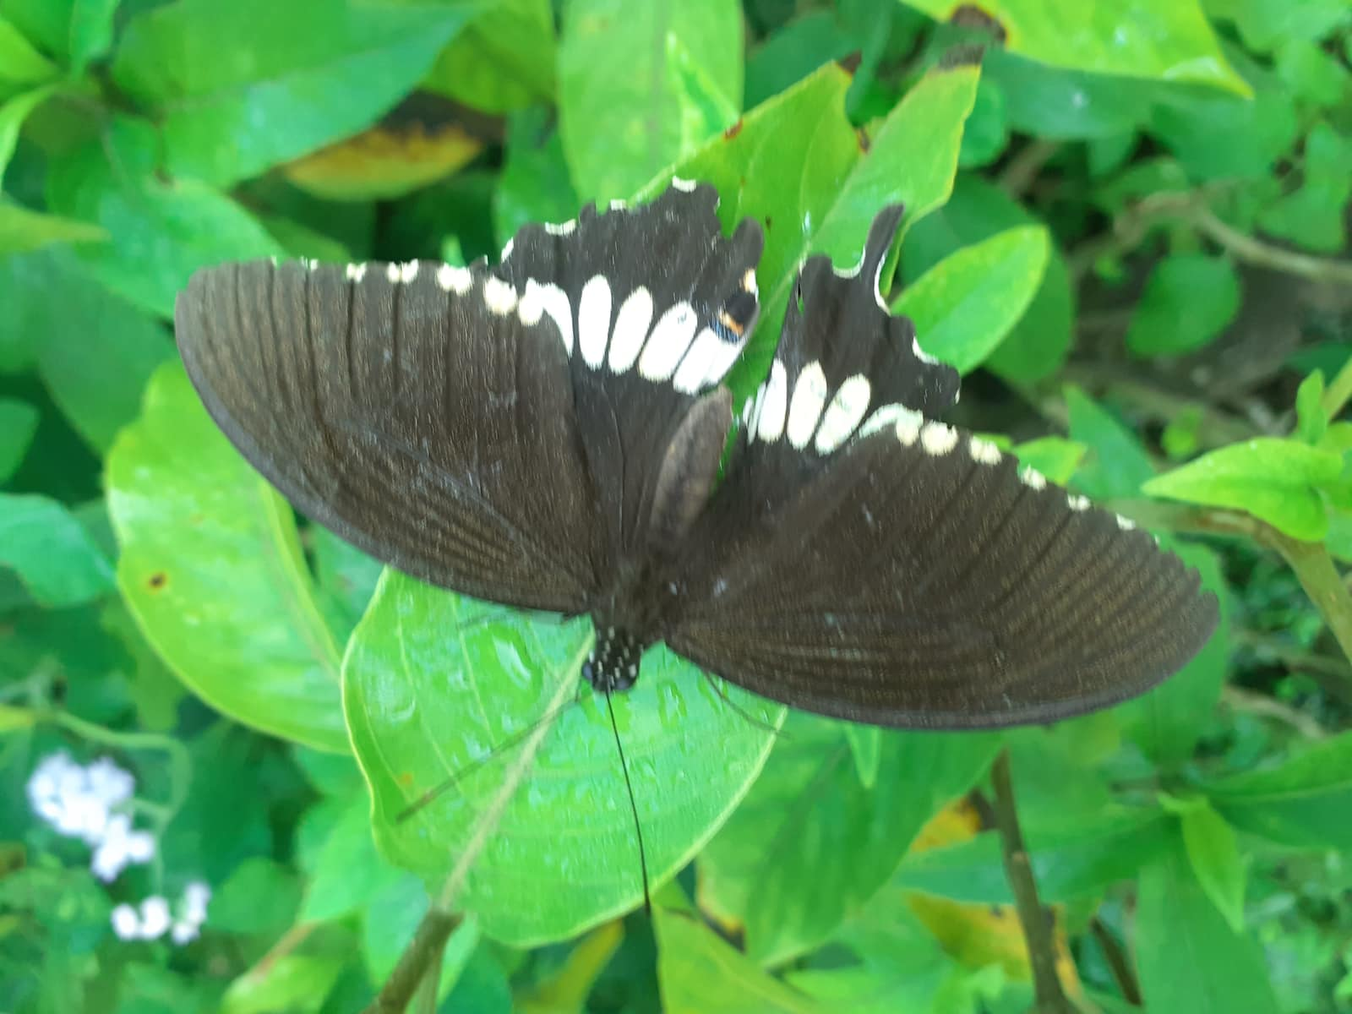
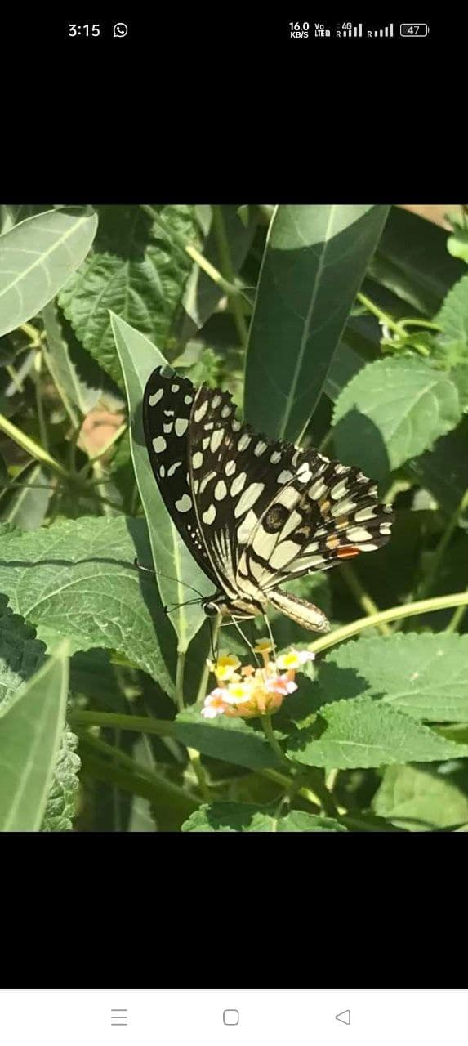
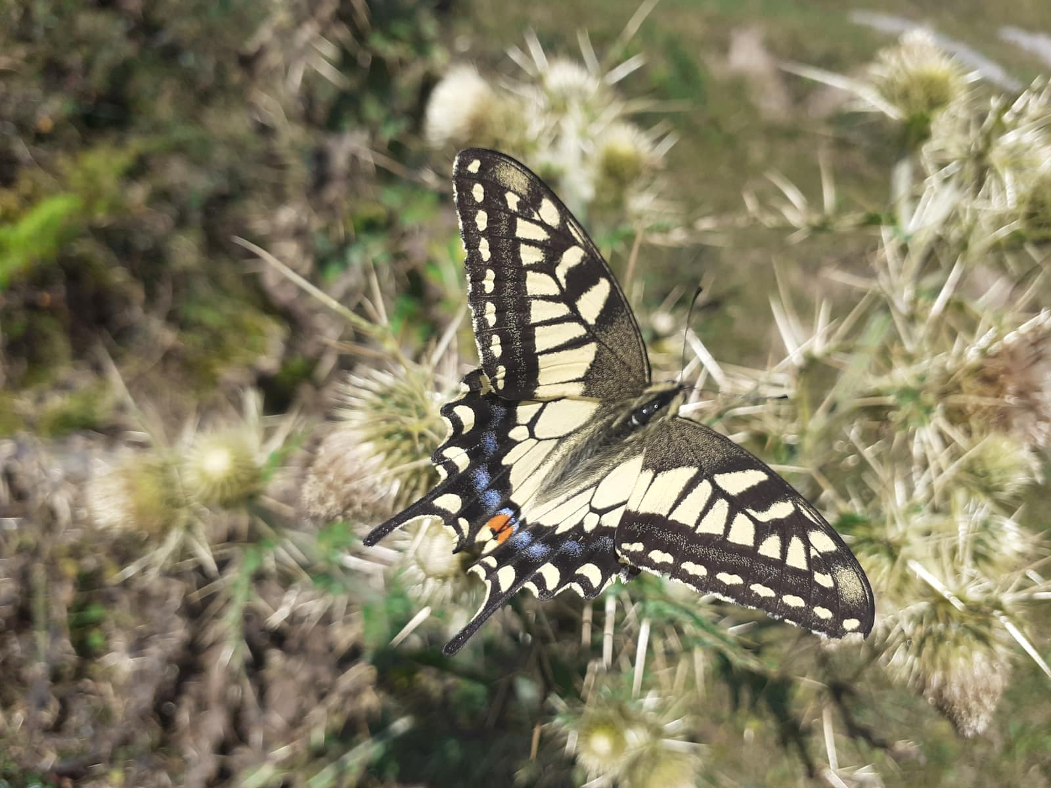
Papilio bianor
Papilio polytes
Papilio demoleus
Papilio machaon

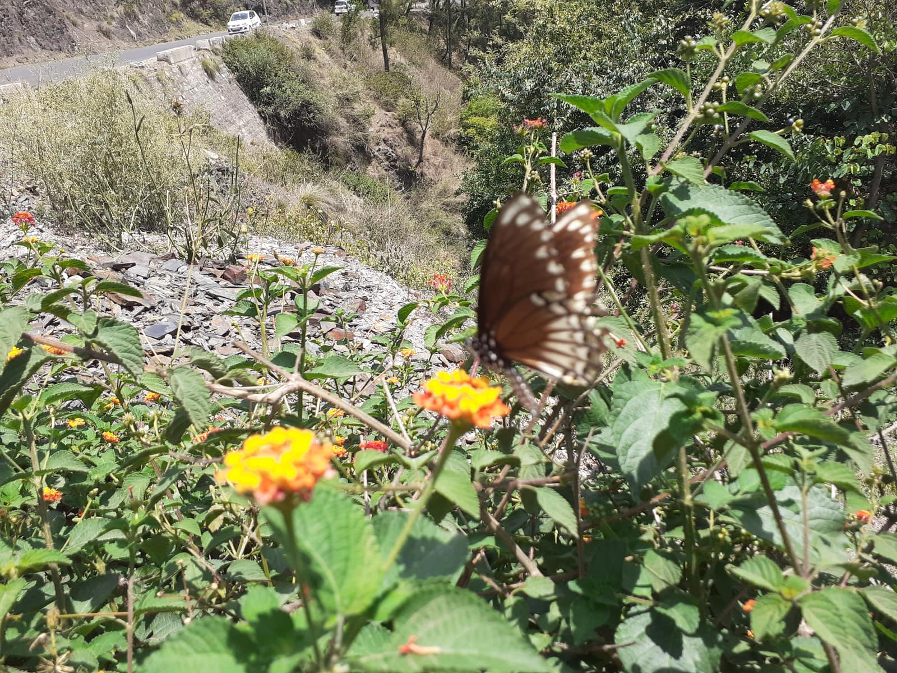
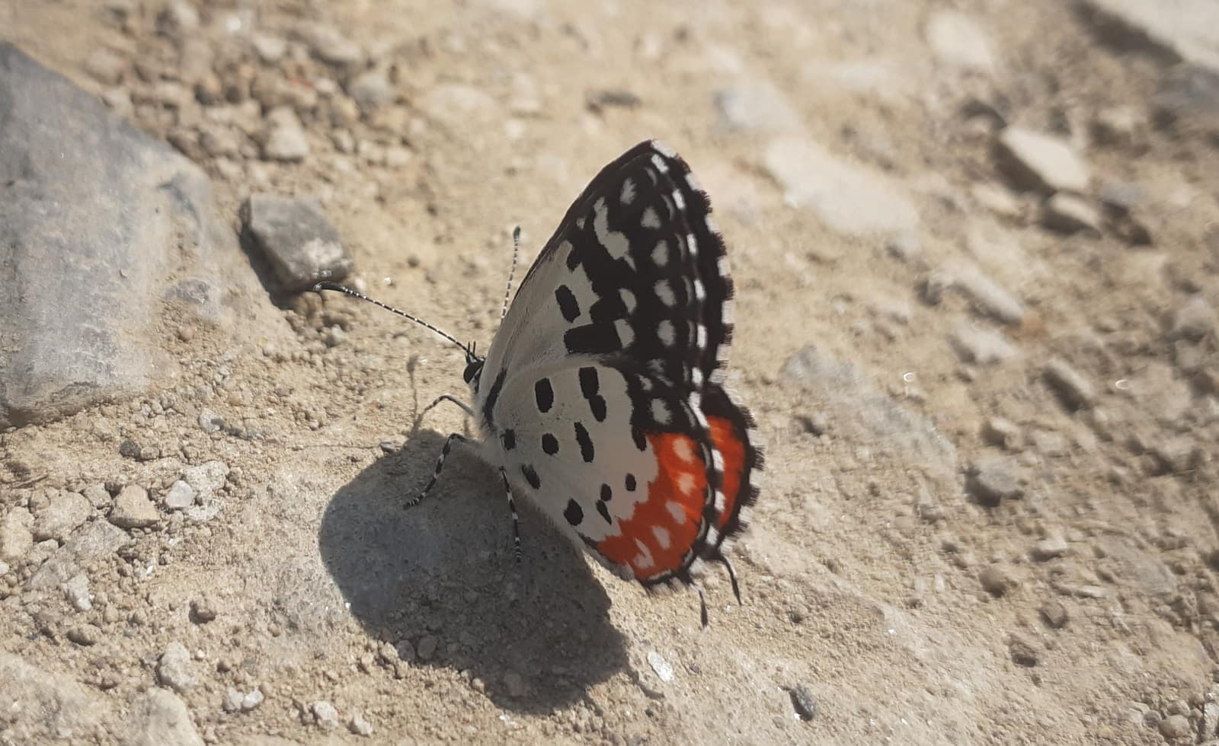
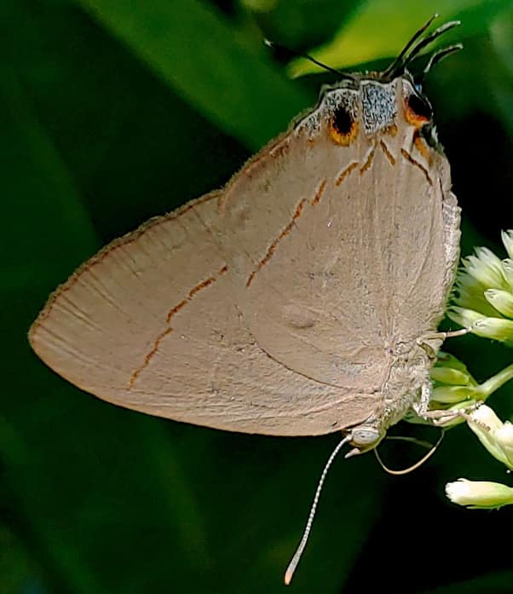
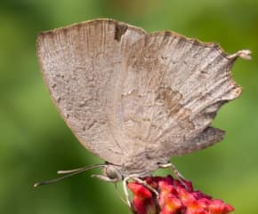
Papilio clytia
Talicada nyseus
Creon cleobis
Surendra quercetorum

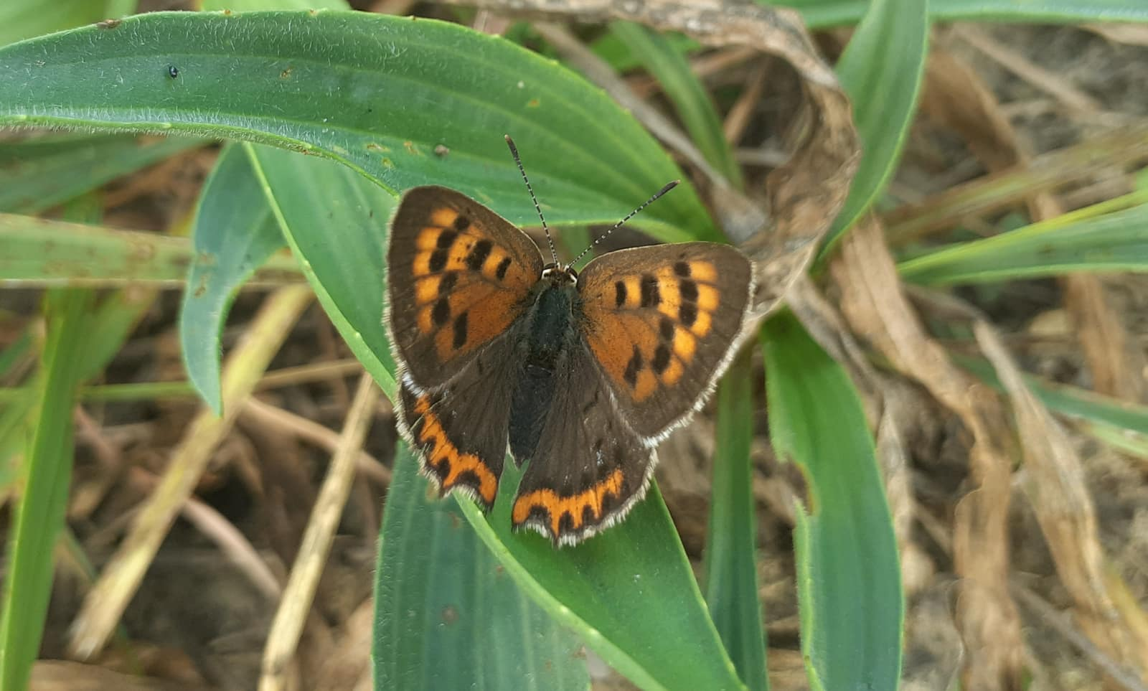
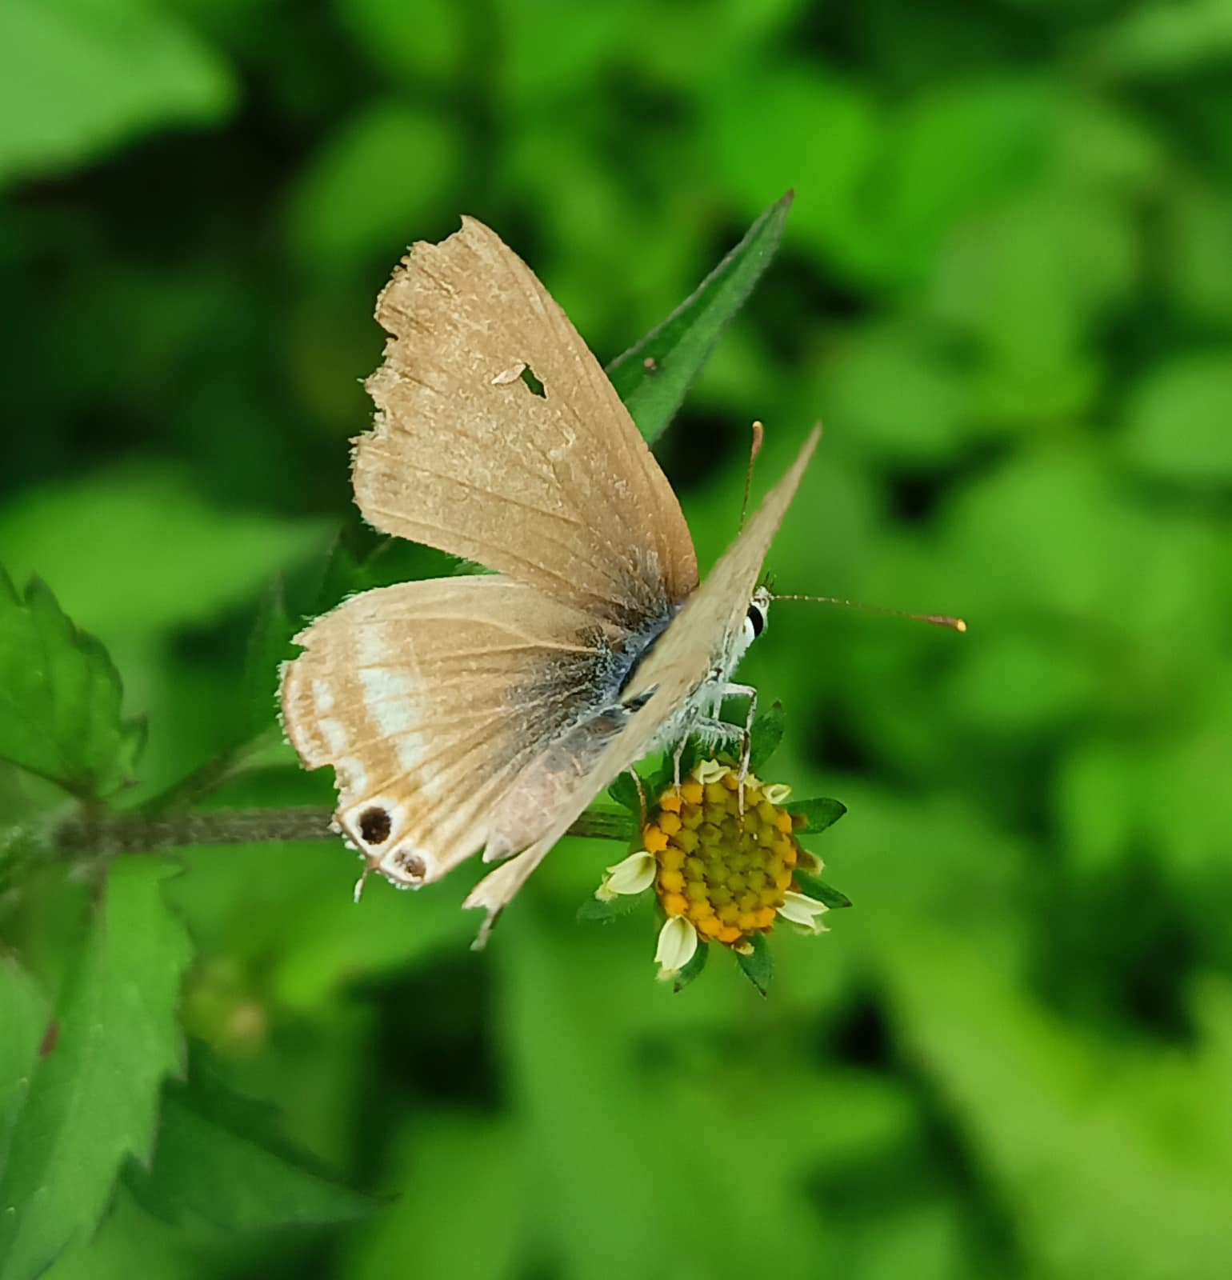
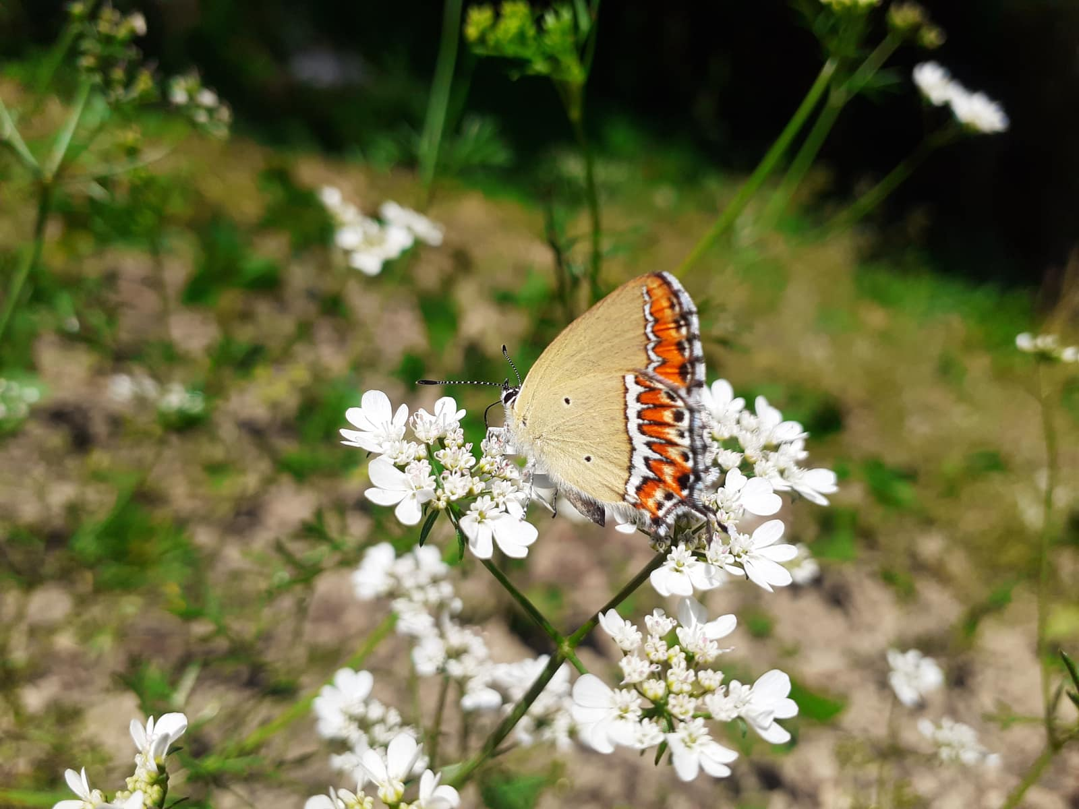
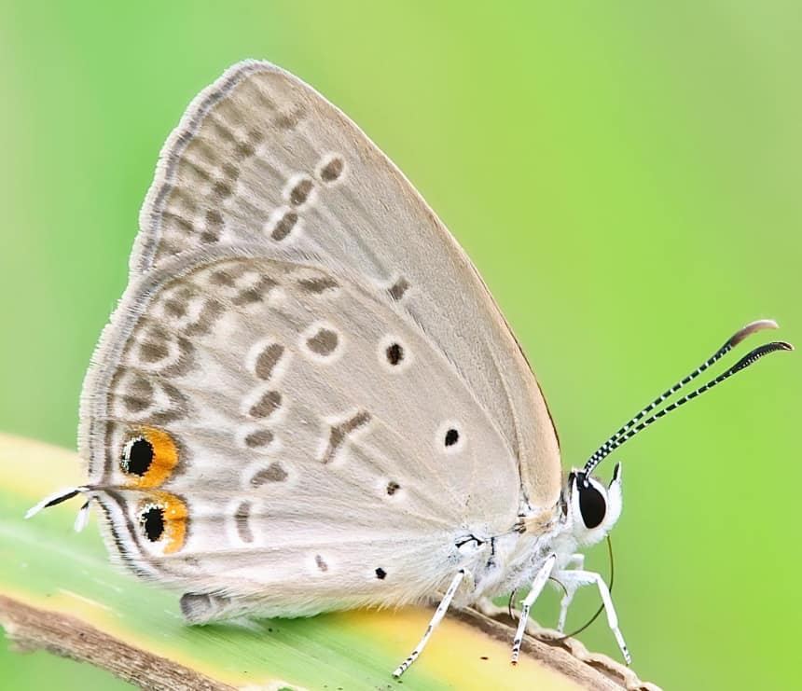
Lycaena phlaeas
Lampides boeticus
Heliophorus sena
Euchrysops cnejus

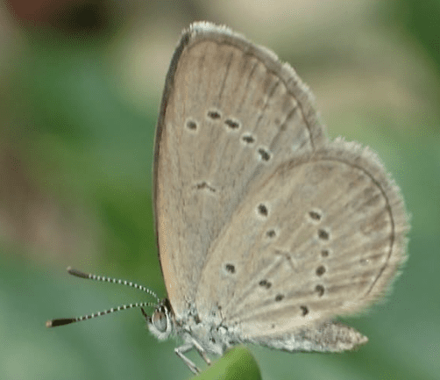
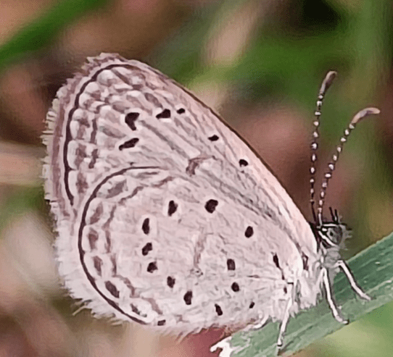
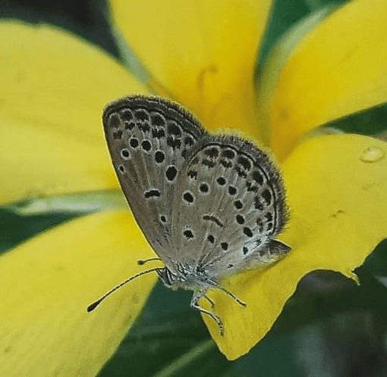
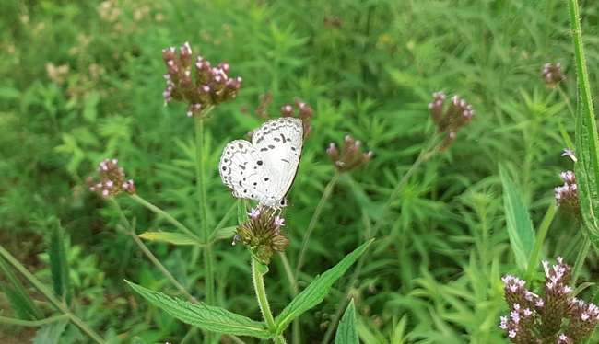
Zizina otis
Zizula hylax
Pseudozizeeria maha
Acytolepis puspa

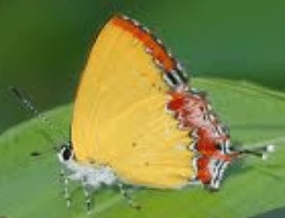

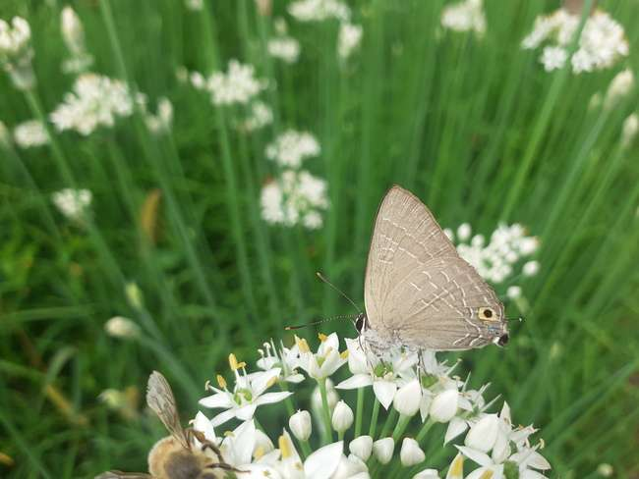
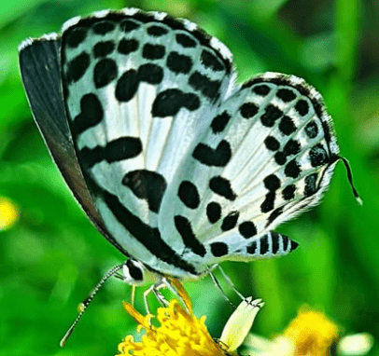
Heliophorus moorei
Tarucus plinius
Deudorix epijarbas
Castalius rosimon
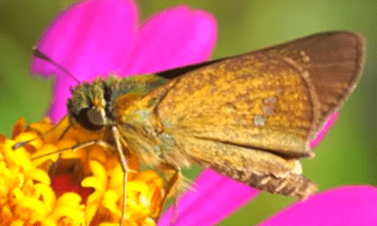
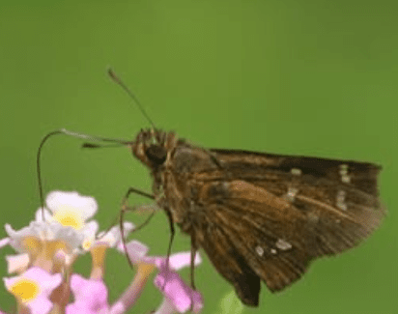

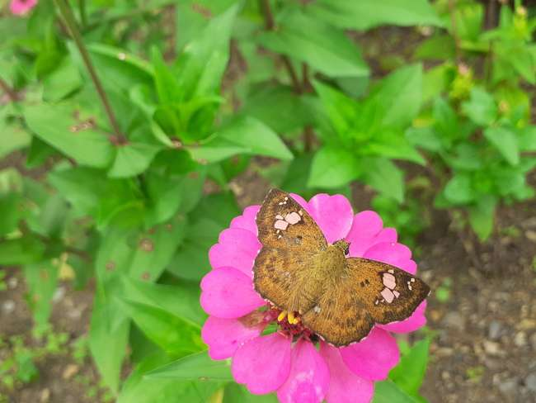
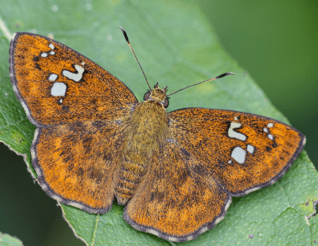
Parnara guttatus
Polytremis discreta
Pseudocoladenia faith
Pseudocoladenia dan
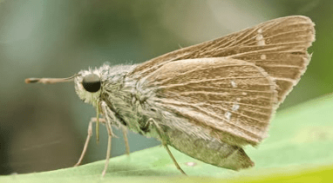
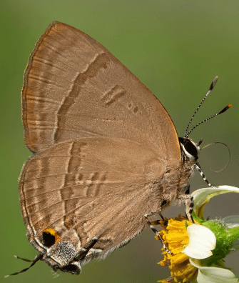
Parnara bada
Rapala manea

