Original Research Article
Protein Alterations in the Alimentary Canal of Musca domestica Treated with Datura innoxia Seed Extract
ABSTRACT
Botanical insecticides are increasingly being explored as safer and environmentally friendly alternatives to conventional chemical pesticides. In this context, the present study focuses on evaluating the impact of Datura innoxia seed extract on the protein content within different regions of the alimentary canal of the common housefly, Musca domestica. The foregut, the midgut, and the hindgut were selected for analysis to understand how the extract influences digestive physiology. The results revealed a clear and consistent decline in protein levels in all treated groups when compared to the control. In untreated flies, the hindgut exhibited the highest protein content (66.02%), followed by the foregut (53.58%) and the midgut (44.02%). However, exposure to D. innoxia seed extract led to a marked reduction in protein concentration across all regions. In the later stages of treatment, protein levels dropped to 42.41% in the hindgut, 34.22% in the foregut, and 25.11% in the midgut. This progressive decline suggests that the bioactive compounds present in D. innoxia seeds significantly disrupt normal metabolic processes. The reduction in protein content may be attributed to impaired protein synthesis, degradation of existing proteins, or inhibition of digestive enzyme activity. Additionally, the extract may damage gut tissues, further affecting nutrient absorption and overall physiological function. Overall, these findings highlight the potent biological effects of D. innoxia seed extract on M. domestica. By interfering with protein metabolism and digestive processes, the extract demonstrates promising potential as a botanical insecticide. Such plant-based alternatives could contribute to sustainable pest management while minimizing environmental and health risks associated with synthetic chemicals.
Keywords: Musca domestica, Datura innoxia, Extract, Insecticide
1. Introduction
Houseflies (Musca domestica) are among the most widespread synanthropic insects, thriving in close association with human habitats. Their presence is not merely a nuisance; it poses a serious threat to public health. Houseflies act as efficient mechanical vectors, carrying and transmitting a wide range of pathogenic microorganisms. By moving freely between contaminated substrates such as garbage, fecal matter, and human food, they facilitate the spread of diseases including typhoid, cholera, dysentery, and salmonellosis. This ability to bridge unsanitary and hygienic environments makes them a persistent concern, particularly in densely populated and poorly managed areas.
For decades, chemical insecticides have been the primary method for controlling housefly populations. While initially effective, their extensive and often indiscriminate use has resulted in several unintended consequences. Environmental contamination, development of insecticide resistance, and harmful effects on non-target organisms—including beneficial insects, animals, and even humans—have become increasingly evident. These challenges have prompted researchers to search for safer, sustainable alternatives that can effectively manage pest populations without compromising ecological balance.
In this context, botanical insecticides have emerged as a promising solution. Derived from plant secondary metabolites, these natural compounds are biodegradable, less toxic to non-target species, and often act through multiple mechanisms, reducing the likelihood of resistance development. One such plant of interest is Datura innoxia, a member of the Solanaceae family. This plant is well known for its rich reservoir of bioactive compounds, particularly tropane alkaloids such as atropine and scopolamine. These compounds exhibit potent neurotoxic and insecticidal properties, capable of interfering with the normal physiological and metabolic functions of insects (Abd El-Aziz, 2000).
Proteins play a central role in insect biology, serving as structural components, enzymes, and regulators of metabolic pathways. They are essential for growth, development, digestion, and energy utilization. Any significant alteration in protein content can therefore be considered an indicator of physiological stress or toxic impact. The insect digestive system, comprising the the foregut, the midgut, and the hindgut, is particularly important in maintaining metabolic homeostasis. The midgut is the primary site for digestion and enzyme activity, while the foregut and the hindgut contribute to food intake, storage, absorption, and waste elimination. Disruption in any of these regions can lead to impaired nutrient assimilation and overall metabolic imbalance.
The present study was designed with the objective of evaluating the biochemical effects of Datura innoxia seed extract on the total protein content in different regions of the alimentary canal of Musca domestica. Specifically, it aims to determine how exposure to the plant extract influences protein levels in the foregut, the midgut, and the hindgut, thereby providing insights into its mode of insecticidal action.
To achieve this, adult houseflies were exposed to varying concentrations of D. innoxia seed extract under controlled laboratory conditions. After treatment, the alimentary canal was carefully dissected into its three regions, the foregut, the midgut, and the hindgut. Each section was subjected to quantitative protein estimation using standard biochemical methods. The protein content of treated groups was then compared with that of untreated control groups to assess the extent of biochemical alteration.
The findings of this study revealed a consistent and a significant decline in protein content across all gut regions in treated flies. This reduction indicates that the seed extract exerts a strong disruptive effect on protein metabolism. The observed changes may be attributed to inhibition of protein synthesis, denaturation of existing proteins, or interference with digestive enzyme activity. Additionally, the toxic compounds present in D. innoxia may damage gut tissues, further impairing nutrient absorption and metabolic efficiency.
In conclusion, the study demonstrates that Datura innoxia seed extract has a pronounced impact on the digestive physiology of Musca domestica. By altering protein levels and disrupting metabolic processes, it shows considerable potential as a botanical insecticide. These findings support the growing interest in plant-based pest control strategies and highlight the importance of further research to develop eco-friendly, sustainable alternatives to synthetic insecticides (Bakr R F, 2007).
2. Materials and Methods
2.1 Collection of Experimental Insects
Adult houseflies (Musca domestica) were collected from nearby local environments and carefully brought into the laboratory for experimental use. To ensure uniformity and minimize external variation, the flies were maintained under controlled conditions of temperature and humidity. They were reared in clean, well-ventilated containers and provided with a standard laboratory diet, Milk Sugar Solution (10%) to support their normal growth and activity. Proper care was taken to maintain hygienic conditions throughout the rearing period, following established protocols described by Jyoti M. C. (2018) and Jangam D. V. (2025).
2.2 Preparation of Plant Extract
Seeds of Datura innoxia were carefully collected and thoroughly washed to remove dust and impurities. The cleaned seeds were then air-dried under shade to preserve their active compounds. Once completely dried, they were finely powdered using a grinder. This powder was subjected to solvent extraction to obtain the crude seed extract, ensuring the bioactive components were effectively isolated. The extract was then filtered, concentrated, and stored under appropriate conditions for further experimental use, following standard procedures described by Upadhyay R. K. (2011) and Jangam D. V. (2025).
2.3 Experimental Design
The collected houseflies were carefully divided into control and treatment groups to ensure accurate comparison. While the control group was maintained under normal conditions, the treatment groups were exposed to varying concentrations or different durations of Datura innoxia seed extract. After the exposure period, the insects were gently dissected under laboratory conditions. The alimentary canal was carefully removed and separated into three distinct regions- the foregut (FG),the midgut (MG), and the hindgut (HG). This step was carried out with precision to study region-specific biochemical changes, following the method described by Jangam D. V. (2025).
2.4 Protein Estimation
The total protein content in each gut region was estimated using a well-established biochemical method, such as the Lowry or Bradford assay. For this, tissue samples from the foregut, the midgut, and the hindgut were carefully homogenized to obtain uniform extracts. These homogenates were then subjected to spectrophotometric analysis, where the intensity of color developed indicated the protein concentration. The readings were compared with standard values to calculate the protein content accurately. Finally, the results were expressed as percentage protein content, following the method described by Lowry O. H. (1951).
2.5 Statistical Analysis
The obtained results were statistically analyzed using one-way Analysis of Variance (ANOVA) to determine the significance of differences among groups. To further validate these differences, Tukey’s multiple comparison test was applied. All statistical analyses were performed using GraphPad software (version 3.6), ensuring accuracy and reliability of the results.
3. Results AND Discussion

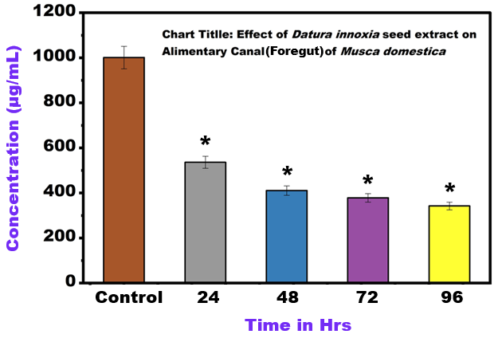
Fig. 1. Effect of Datura innoxia seed extract on the alimentary Canal (Foregut) of Musca domestica (Mean ± SE, Significant at *P < 0.001 compared with control)
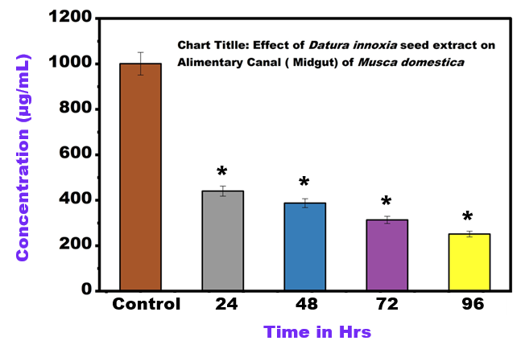
Fig. 2. Effect of Datura innoxia seed extract on the alimentary Canal (Midgut) of Musca domestica (Mean ± SE, Significant at *P < 0.001 compared with control)
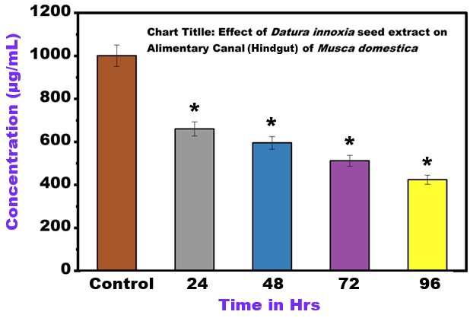
Fig. 3. Effect of Datura innoxia seed extract on the alimentary Canal (Hindgut) of Musca domestica (Mean ± SE, Significant at *P < 0.001 compared with control)
Based on the known biological activity of plant extracts rich in alkaloids, particularly the tropane alkaloids such as scopolamine and atropine present in Datura innoxia, a noticeable decline in protein content was expected in treated Musca domestica. These compounds are known to interfere with normal physiological and metabolic processes, and the present findings strongly support this effect.
The data presented in Table 1 clearly show a progressive decline in total protein content across all regions of the alimentary canal – the hindgut, the midgut, and the foregut - following treatment with D. innoxia seed extract. In the control group, protein levels were comparatively higher, with the foregut showing the highest value (53.576%), followed closely by the hindgut (44.023%) and midgut (44.017%). This indicates a normal metabolic state where protein synthesis and utilization are balanced.
However, with the introduction of the plant extract, a consistent reduction in protein content was observed. In Group 2, a slight variation was noted, but an overall declining trend began to emerge. As the treatment progressed to Group 3 and Group 4, the reduction became more pronounced. By the final treatment group, protein levels had dropped significantly to 42.417% in the hindgut, 25.119% in the midgut, and 34.218% in the foregut.
Among all regions, the midgut showed the most drastic decrease, which is particularly important since it is the primary site of digestion and enzyme activity. This suggests that the extract may be directly affecting digestive enzymes and nutrient absorption. The foregut and the hindgut also exhibited substantial reductions, indicating a widespread impact on the entire digestive system.
Overall, these findings highlight the strong inhibitory effect of Datura innoxia seed extract on protein metabolism in Musca domestica. The gradual and consistent decline in protein content across treatment groups suggests that the phytochemicals present in the extract disrupt normal metabolic functions, possibly by inhibiting protein synthesis, enhancing protein degradation, or damaging gut tissues. This reinforces the potential of D. innoxia as an effective botanical insecticide.
Table 1. Total Protein Content in Different Gut Regions of Musca domestica
Group | Hindgut (%) | Midgut (%) | Foregut (%)
Group 1 (Control) | 44.023 | 44.017 | 53.576
Group 2 | 59.530 | 38.716 | 41.043
Group 3 | 51.198 | 31.355 | 37.813
Group 4 | 42.417 | 25.119 | 34.218

4. Discussion
The foregut is the initial region of the digestive tract and plays an important role in food storage and transport. Exposure to Datura innoxia phytochemicals can directly affect epithelial cells of the foregut, leading to cellular damage and degradation of structural proteins. As a result, the total protein concentration decreases significantly (Fig. 1). The midgut is the primary site of digestion and nutrient absorption in insects. The decrease in midgut protein levels may be due to inhibition of digestive enzymes and disruption of protein synthesis pathways. The toxic components of Datura seeds interfere with metabolic processes, resulting in reduced enzyme production and tissue degeneration. The hindgut is responsible for water reabsorption and waste elimination. Protein depletion in this region suggests systemic metabolic stress caused by toxic compounds. The breakdown of epithelial cells and increased protein catabolism contribute to the observed decline in protein levels (Liang, J., 2025).
D. innoxia seeds are known to be rich in tropane alkaloids (e.g., scopolamine, atropine). These compounds are potent toxins that act primarily on the nervous system by interfering with acetylcholine receptors, which can lead to paralysis and death. The search results confirm the insecticidal potential of Datura species (including D. innoxia and related species like D. stramonium and D. metel) against various pests, including Musca domestica, often leading to high mortality, developmental abnormalities, and other toxic effects. The insect foregut is one of the first tissues to encounter the ingested toxic extract. The alkaloids and other phytochemicals can be rapidly absorbed or interact directly with the gut lining cells (epithelium). A significant decrease in total protein content in a tissue like the foregut can be attributed to several factors induced by the plant extract's toxicity. The stress induced by the toxins may trigger an elevated rate of protein breakdown (catabolism) to meet the energy demands for detoxification or repair mechanisms (Fatima, H, 2015).
The decrease in total protein content in the Musca domestica midgut treatment with Datura innoxia seed extract can be attributed to several factors related to the extract's toxic or anti-nutritional properties. The seeds of D. innoxia are rich in tropane alkaloids (e.g., scopolamine, atropine) and other phytochemicals like phenols and flavonoids, which possess insecticidal properties. These compounds can directly inhibit or denature key midgut digestive enzymes (like proteases, amylases, and lipases) in M. domestica. This interference severely limits the hydrolysis and absorption of dietary proteins and other nutrients, leading to a net decrease in tissue protein synthesis and accumulation. The toxic stress induced by the extract may lead to an increased rate of protein catabolism (breakdown) to meet the energy demands of the stressed organism or to eliminate damaged proteins. This shift in metabolism contributes to the overall reduction in measured total protein. Some components in the Datura extract may act as anti-feed ants, significantly reducing the amount of food consumed by the Musca domestica larvae or adults. Reduced nutrient intake directly limits the raw materials needed for protein synthesis, leading to lower protein levels in the midgut tissue (Fig. 2). The observed decrease in total protein percentage highlights the anti-metabolic and toxic effects of the Datura innoxia seed extract, indicating its potential as a natural bio-insecticide by severely compromising the essential digestive and synthetic functions of the housefly's midgut (Janeh, M, 2017).
The toxic effect on cellular metabolism can disrupt key processes, including ribosomal activity and gene expression, leading to a substantial decrease in the de novo synthesis of new proteins. High concentrations of toxins can cause direct damage to the foregut epithelial cells. The resulting cellular damage, including necrosis or apoptosis, leads to the breakdown of cell structure and the subsequent loss or denaturation of intracellular proteins. The extract may inhibit digestive enzyme activity within the foregut or midgut, or damage the absorptive surface, thereby disrupting normal protein metabolism.
The hindgut primarily functions in water, salt, and nutrient reabsorption, as well as waste elimination. The decrease in protein content can be discussed through the following mechanisms. The seed extract of D. innoxia is rich in tropane alkaloids (e.g., scopolamine, atropine), which are potent neurotoxins and cellular poisons. As the toxins pass through the digestive tract, they induce histopathological damage to the hindgut epithelial cells. Damage to the cell membranes and organelles of the hindgut epithelium (vacuolization, necrosis) leads to the breakdown of structural proteins and enzymes, which are then either degraded or expelled with the faeces, resulting in a net loss of measurable protein in the tissue homogenate (Fig. 3) (Terra, W. R., 2023).
The toxic stress from the extract requires the insect to mobilise resources for detoxification and repair. This can lead to the catabolism (breakdown) of tissue proteins (including those in the hindgut) to provide amino acids for synthesising stress-response proteins or for energy. This metabolic shift reduces the total protein pool. If the midgut's digestive and absorption functions are severely compromised (as typically seen with Datura treatment), the availability of raw amino acids for de novo protein synthesis throughout the body, including the hindgut, is dramatically lowered. Although the hindgut is not the primary site of digestion, its integrity is essential for overall homeostasis. Severe disruption of the midgut (where most digestion/absorption occurs) by the extract leads to systemic starvation and malnutrition. The hindgut, like other tissues, reflects this systemic protein depletion, showing a reduced protein content as a secondary consequence of the primary poisoning in the midgut. The reduction in the hindgut protein content confirms the generalised toxic effect of the D. innoxia extract on the entire alimentary canal of Musca domestica, further supporting its efficacy as a botanical insecticide.
D. innoxia seed extract causes a significant reduction in total protein content in the foregut, the midgut, and the hindgut of Musca domestica. Such biochemical alterations suggest severe physiological stress induced by the plant extract. The insecticidal activity of Datura innoxia is largely attributed to its tropane alkaloids, particularly atropine and scopolamine. These compounds disrupt normal nerve signalling and cellular metabolism. Additionally, plant secondary metabolites may act as anti-feed ants, reducing food intake and causing nutrient deficiency in insects. Reduced protein synthesis, increased protein degradation, and tissue damage collectively contribute to the observed biochemical changes.
5. Conclusion
The present study clearly demonstrates that Datura innoxia seed extract significantly alters protein metabolism in the alimentary canal of Musca domestica. A progressive decrease in protein content was observed in the foregut, the midgut, and the hindgut following treatment. These findings indicate that the plant extract disrupts digestive physiology and cellular metabolism in houseflies. Therefore, Datura innoxia seed extract shows promising potential as a botanical insecticide for housefly control. Further investigations involving enzymatic assays, histopathological analysis, and molecular studies are recommended to better understand the mechanism of toxicity.

COMPETING INTERESTS DISCLAIMER:
Authors have declared that they have no known competing financial interests OR non-financial interests OR personal relationships that could have appeared to influence the work reported in this paper.
DISCLAIMER (ARTIFICIAL INTELLIGENCE)

Author(s) hereby declares that NO generative AI technologies such as Large Language Models (ChatGPT, COPILOT, etc.) and text-to-image generators have been used during the writing or editing of this manuscript.

ACKNOWLEDGMENT
The authors are grateful to the principal of MGV’s LVH Arts, Science and Commerce College, Panchavati, Nashik for providing laboratory facilities. The study was conducted with ethical permission (MSBB/Desk-5/Research /787/2025-26) from the Maharashtra State Biodiversity Board (MSBB), Nagpur, MH, India.
References
Abd El-Aziz HS (2000) Psychopathological studies on bacterial infection of cotton leaf worm, Spodoptera littoralis. M.Sc. Thesis. Fac.Sci.Ain Shams Univ., Egypt :144.
Bakr R F, Abdel Fattah HM and Mohamed EK (2007) Effect of chitin synthesis inhibitor, lufenuron on the development, haemolymph and antennal sensilla of Schistocerca gregaria (Forskal) (Orthoptera: Acrididae). African J. Biol. Sci., 3 (2): 35-43.
Baskar K, Ignacimuthu S, Jayakumar M (2015b) Toxic effects of Couroupi taguianensis against Spodoptera litura (Fabricius) (Lepidoptera: Noctuidae). Neotrop Entomol 44:84–91.
Baskar K, Muthu C, Ignacimuthu S (2015a) Bioefficacy of Atalantiamonophylla (L) Correa (Rutaceae) against Spodoptera litura Fabricius (Lepidoptera: Noctuidae). Entomol Ornithol Herpetol 4: 2.
Begum N, Sharma B and Pandey RS (2010) Evaluation of Insecticidal Efficacy of Calotropis Procera and Annona Squamosa Ethanol Extracts Against Musca Domestica. J Biofertil Biopestici 1:1.
Fatima, H., Khan, K., Zia, M., Ur-Rehman, T., Mirza, B., & Haq, I. U. (2015). Extraction optimization of medicinally important metabolites from Datura innoxia Mill.: an in vitro biological and phytochemical investigation. BMC complementary and alternative medicine, 15(1), 376.
Janeh, M., Osman, D. and Kambris, Z., 2017. Damage-induced cell regeneration in the midgut of Aedes albopictus mosquitoes. Scientific reports, 7(1), p.44594.
Jangam D. V., Patil S. D. (2025). Evaluation of insecticidal Properties of Datura innoxia Seed Extract Against Musca domestica larva (Diptera), Int. J Entomology Research, Vol 10, Issue 12, 2025, Pg no.189-192.
Jyoti M Chintalchere, Mudasir A Dar and Radhakrishna S Pandit (2018) Evaluation of Some Essential Oils against the larvae of House Fly, Musca domestica by Using Residual Film Method Adv Biotech & Micro 9(1): AIBM.MS.ID.555752.DOI: 10.19080/AIBM.2018.09.555752.
Liang, J., Xiao, F., Ojo, J., Chao, W. H., Ahmad, B., Alam, A., Chen, R. (2025). Insect resistance to insecticides: causes, mechanisms, and exploring potential solutions. Archives of Insect Biochemistry and Physiology, 118(2), e70045.
Lowry, O. H., Rosebrough, N. J., Farr, A. L., & Randall, R. J. (1951). Protein measurement with the Folin phenol reagent. Journal of Biological Chemistry, 193(1), 265–275.
Mahboubkar MM, Sendi JJ, Aliakbar A (2015) Effect of Artemisia annua L. essential oil on toxicity, enzyme activities, and energy reserves of cotton bollworm Helicoverpa armigera (Hübner) (Lepidoptera: Noctuidae). J Plant Prot Res 55:371– 377.
Senthilkumar N, Varma P, Gurusubramanian G (2009) Larvicidal and adulticidal activities of some medicinal plants against the malarial vector, Anopheles stephensi(Liston). Parasitol Res 104 (2): 237-244.
Seyoum E, Bateman RP, Charnley AK (2002) The effect of Metarhizium anisopliae var. acridum on haemolymph energy reserves and flight capability in the desert locust, Schistocerca gregaria. J. Appl. Entomol. 126 (2–3): 119–124.
Terra, W. R., Ferreira, C., & Silva, C. P. (2023). Overview of insect midgut function. In Molecular physiology and evolution of insect digestive systems (pp. 13-26). Cham: Springer International Publishing.
Upadhyay RK, Yadav N, Ahmad S (2011a) Toxic effects of solvent and aqueous extracts of Cassia alata against bio-molecules and enzymatic parameters of Callosobruchus chinensis L. (Coleoptera: Bruchidae). Adv Appl Sci Res 2:367–381.
Upadhyay RK, Yadav N, Ahmad S (2011b) Insecticidal potential of Capparis decidua on biochemical and enzymatic parameters of Tribolium castaneum (Herbst). Agric Environ 3:45–67.

