Comparative Growth Performance and Morphometric Assessment of Ducks Reared under Semi-Intensive Management System

Abstract:
The present study was conducted to evaluate the comparative growth performance, morphometric traits and productive parameters of Khaki Campbell (KC), Kuzi and their crossbred (KC × Kuzi) ducks under a semi-intensive management system in Assam. A total of 403 birds (189 drakes and 214 ducks) were assessed up to 18 weeks of age under both farm and field conditions. Weekly body weight, morphometric measurements and reproductive traits were recorded and analyzed using appropriate statistical methods, and differences among groups were considered significant at P < 0.05. The results revealed that crossbred ducks exhibited significantly (P < 0.05) higher body weight compared to the pure breeds during most weeks of growth. At 18 weeks of age, crossbreds attained the highest body weight (1958.25 ± 52.63 g), followed by Kuzi (1911.00 ± 35.75 g) and Khaki Campbell (1894.00 ± 59.04 g). Significant (P < 0.05) differences in growth were particularly evident during the early and mid-growth phases (3rd–10th week). Morphometric evaluation indicated that key conformation traits such as keel length, breast angle and chest circumference were significantly (P < 0.05) higher in crossbred ducks, suggesting superior body conformation.
Additionally, crossbred ducks reached sexual maturity significantly (P < 0.05) earlier (126 days) compared to Kuzi (137 days) and Khaki Campbell (140 days). Body weight at sexual maturity differed significantly (P < 0.05) among the groups, with Kuzi recording the highest value (1991.00 g), followed by crossbreds (1958.25 g) and Khaki Campbell (1888.00 g). Egg quality parameters, including egg weight, shape index, yolk index, albumen index and shell thickness, did not differ significantly (P > 0.05) among the three genetic groups and were within acceptable ranges. In conclusion, the KC × Kuzi crossbred ducks demonstrated significantly (P < 0.05) improved growth performance, superior morphometric traits and earlier sexual maturity without compromising egg quality traits, making them a promising genetic resource for enhancing duck production under semi-intensive farming systems.
Keywords: crossbred, duck, indigenous, integrated, morphometric, semi-intensive.

Introduction:
India ranks second in the world in terms of duck population, with approximately 33.51 million ducks accounting for about 4.0% of the total poultry population of the country as reported in the 20th Livestock Census (2019). Duck farming plays an important role in the poultry sector, particularly in regions where abundant natural water resources and wetlands support scavenging-based production systems. The distribution of duck population in India is not uniform, with the highest concentration found in the Eastern region (64.5%), followed by the Northeastern region (16.02%) and the Southern region (12.60%). These areas provide favorable ecological conditions for duck rearing, such as paddy fields, ponds, marshy lands and riverine ecosystems that facilitate natural feeding and foraging behavior. It has been reported that indigenous ducks contribute about 91% of the total duck egg production in the country, while only about 9% is contributed by improved or exotic varieties (Gaur et al. 2010).
Most of the farmers in the rural and coastal region rear indigenous ducks for meat and egg production. According to the 20th Livestock Census (2019)conducted in India, Assam reported a duckpopulation of approximately 6.6 million, makingit tostand in second position in the country. Duck farming inAssam is particularly concentrated in areas withabundant water resources. The most commonly reared duck in Assam is the Pati duck, the first recognized native duck breed in the country (Islam et al., 2024). Other indigenous breeds like the CharaChemballi, Khaki Campbell, Nagi (Nageswari) duck, Muscovy duck (Ceena Hah), Kerasia(Mukhi, 2019) and White Pekinducks are also raised in these regions.Literatures on Kuzi whichis an indigenous breeds of Odisha are available scanty (Padhi et al. 2022) with phenotypic andmorphometric description (Padhi, 2010). Although various indigenous and improved duck varieties are reared in different parts of the country, scientific information on certain indigenous breeds remains limited. One such breed is the Kuzi duck of Odisha, for which only limited literature is available, mainly describing its phenotypic and morphometric characteristics (Padhi, 2010; Padhi et al., 2022). Despite the important contribution of ducks to the rural economy and livelihood of farmers, systematic research on the comparative performance of different duck breeds under field conditions is still limited. Studies focusing on growth performance, morphometric traits and production characteristics under semi-intensive management systems are particularly scarce. Therefore, the present study was undertaken to evaluate and compare the growth performance and morphometric traits of selected duck breeds reared under semi-intensive conditions up to a specific age. The findings of this study are expected to generate useful baseline information for breed improvement programmes and promote scientific duck farming practices in the region.
Materials and method:
The study was conducted in two districts of Assam namely Kamrup and Goalpara both under farm and field conditions. Three different breeds namely Khaki Campbell (KC), Kuzi and Cross (KC X Kuzi) were selected for the study from the mentioned districts. A total of 189 drakes and 214 ducks were selected for the study. The flocks were usually small and varied from 5-20 numbers of birds. The families were selected purposively keeping in mind the fact that no ducklings of exotic types were reared but only the native ducks, the houses having exotic or even seem to be crossbred ducks were not included in the survey and the adjacent houses from where the flocks can intermingle were also not taken into consideration.
Majority of the farmers’ rear the birds in houses made of locally available materials such as bamboo, thatch and do not construct any permanent structure. The birds are let loose in the morning in the water bodies and allow scavenging whole day and in the evening they are provided with leftover food from the kitchen or some supplementary feed.
In order to collect the relevant information, personal interview and on spot recording were done on prevalent duck husbandry practices and the morphometricand performance parameters. The morphometric traits of both the drake and duck were observed, identified and documented through visual observation like the plumage colour, shank colour, bill colour, feet colour, skin colour.The external morphological traits are evaluated based on the procedure mentioned by Cuesta (2008). The morphometric traits like body weight, bill length, bill width, head length, circumference, body length, chest circumference, wing length, wing span, femur length, tibia length are measured using measurement tape.
The statistical analysis was done and were expressed as mean ± standard error at P<0.05
Results and Discussion
The weekly body weight data recorded for both in all the three different breeds of ducks are presented in Table 1 up to 18 weeks of age. Weekly data recorded were analyzed and found that the crossbred body weight observed in the present study showed that the crosses recorded better body weight than the Kuzi and Khaki Campbell. These findings were in similarity to the significantly higher body weight that was observed in Crossbred of Kuzi x Khaki Campbell compared to Kuzi birds up to four weeks of age in agreement with the findings of Padhi and Sahoo (2011), Padhi et al. (2019). Whereas in another trial conducted by Padhi et.al. 2022, the body weight data recorded at 12, 16 and 20 week of age (growing period) in drakes and ducksof Kuzi breed. Similar resultswerefound where significantly higher body weight than Crossbred of Kuzi x Khaki Campbell compared to Kuzi birds up tofour weeks of age are mentioned in agreement with the findings of Padhi and Sahoo (2011), Padhi et al. (2019).

Table 1: Mean ± SE values of weekly body weight of duck under semi-intensive system of rearing

Age (weeks) | Khaki Campbell (KC) | Kuzi | Cross (KC X Kuzi)
1st | 87.50 ± 17.83 | 75.00 ± 21.62 | 72.50 ± 19.42
2nd | 190.00 ± 13.44 | 163. 46 ± 15.21 | 196.25 ± 9.72
3rd | 305.00 ± 32.91 | 325.00 ± 18.63 | 412.50 ± 123.77
4th | 582.00 ± 32.91 | 386.00 ± 32.91 | 749.50 ± 32.91
5th | 659.25 ± 23.75 | 570.00 ± 33.40 | 689.50 ± 37.64
6th | 739.00 ± 9.54 | 763.52 ± 74.42 | 780.00 ± 40.49
7th | 1030.00± 41.83 | 877.63 ± 75.07 | 1047.00 ± 16.85
8th | 1090.00 ± 69.88 | 717.50 ± 95.60 | 1141.25 ± 61.85
9th | 1020.00 ± 124.85 | 1167.00 ± 52.43 | 1186.25 ± 32.91
10th | 1220.50 ± 42.00 | 1170.25 ± 23.74 | 1246.25 ± 47.22
11th | 1365.00 ± 33.46 | 1301.00 ± 33.10 | 1390.00 ± 57.49
12th | 1405.00 ±56.30 | 1428.00 ± 63.98 | 1530.75 ± 52.34
13th | 1575.00± 85.39 | 1525.00± 149.30 | 1675.00± 110.86
14th | 1611.00 ± 47.66 | 1711.00± 62.10 | 1738.00 ± 54.97
15th | 1681.25 ± 65.33 | 1750.00 ± 77.91 | 1850.00 ± 86.60
16th | 1720.00 ± 35.76 | 1820.25 ± 56.76 | 1883.25 ± 47.86
17th | 1807.50 ± 48.66 | 1885.00 ± 63.54 | 1902.00 ± 51.85
18th | 1894.00 ± 59.04 | 1911.00 ± 35.75 | 1958.25 ± 52.63
Means bearing same superscripts in a row did not differ significantly.
Most of the indigenous ducks have multi-coloured plumage. The ducks mostly exhibit plumage colour of fawn, penciled, chocolate. The bill is yellow and the shank and toes remain are orange in the Kuzi varieties which resembles to the observation of Padhi, (2014). Flocks ofKuzi and crossbred of Khaki Campbell and Kuzi showed multi-coloured plumage. Similar results of multi-coloured plumage has also been described by Padhi et. al. (2023), Panda et. al. (2008) and Mishra et.al. (2009). The photographs of the flocks of Kuzi ducks are presented in Fig. 1 and that of Khak Campbell and Cross of Khaki Campbell and Kuzi are presented in Fig. 2 and 3, respectively.

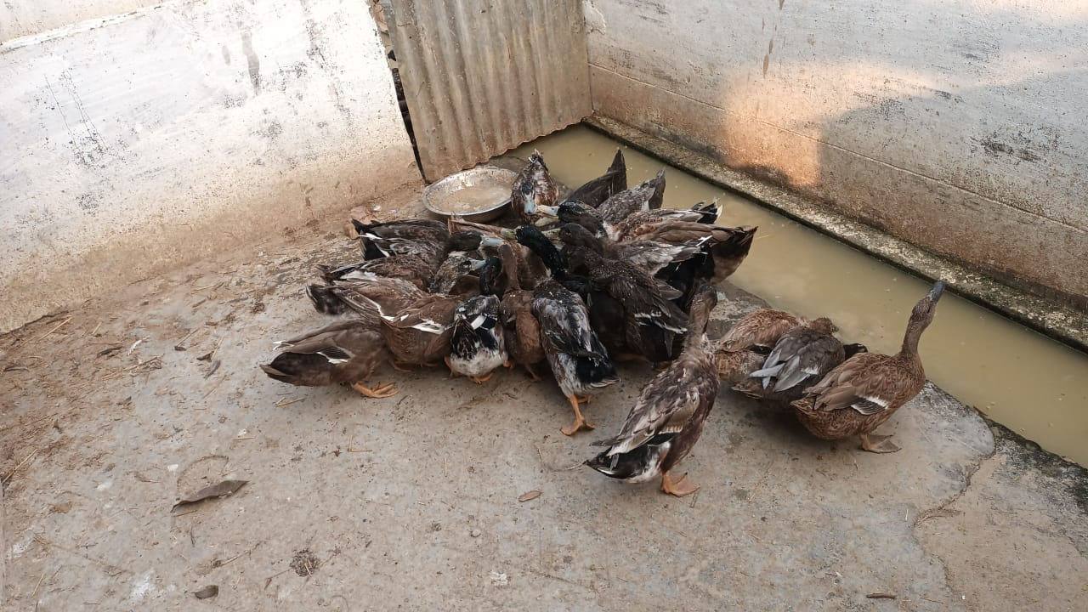
Figure 1: Flock of Kuzi
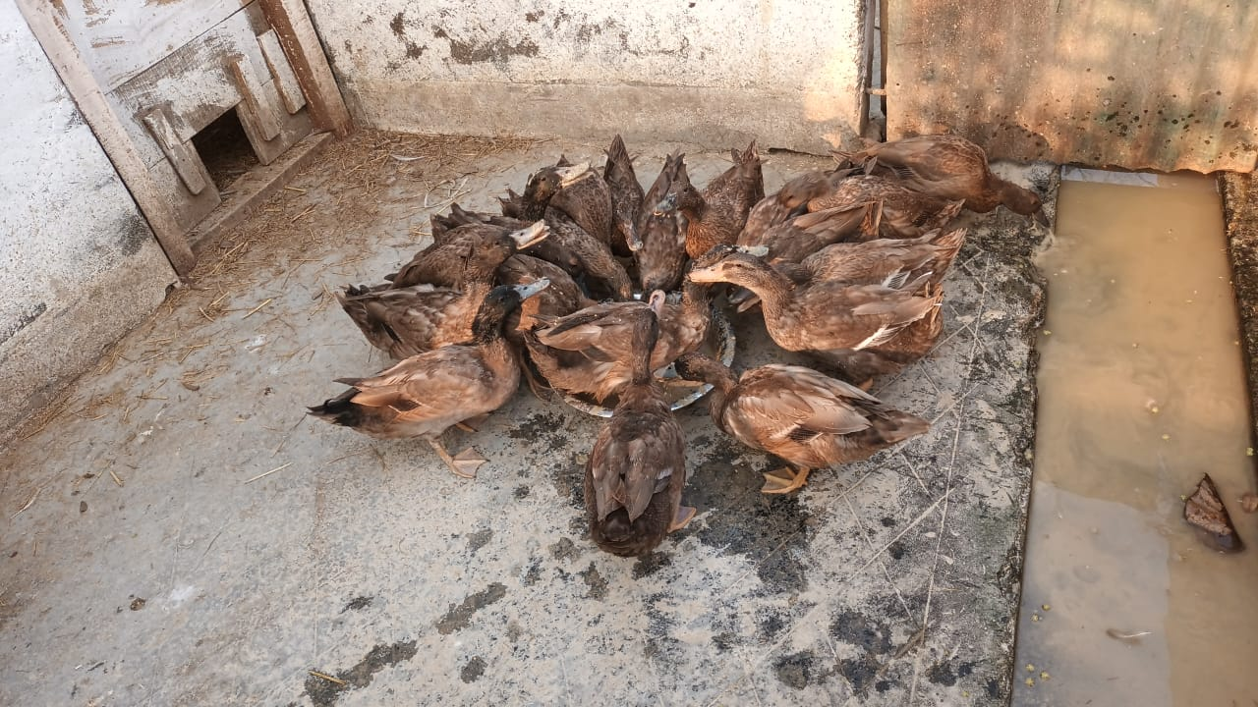
Figure 2: Flock of Khaki Campbell
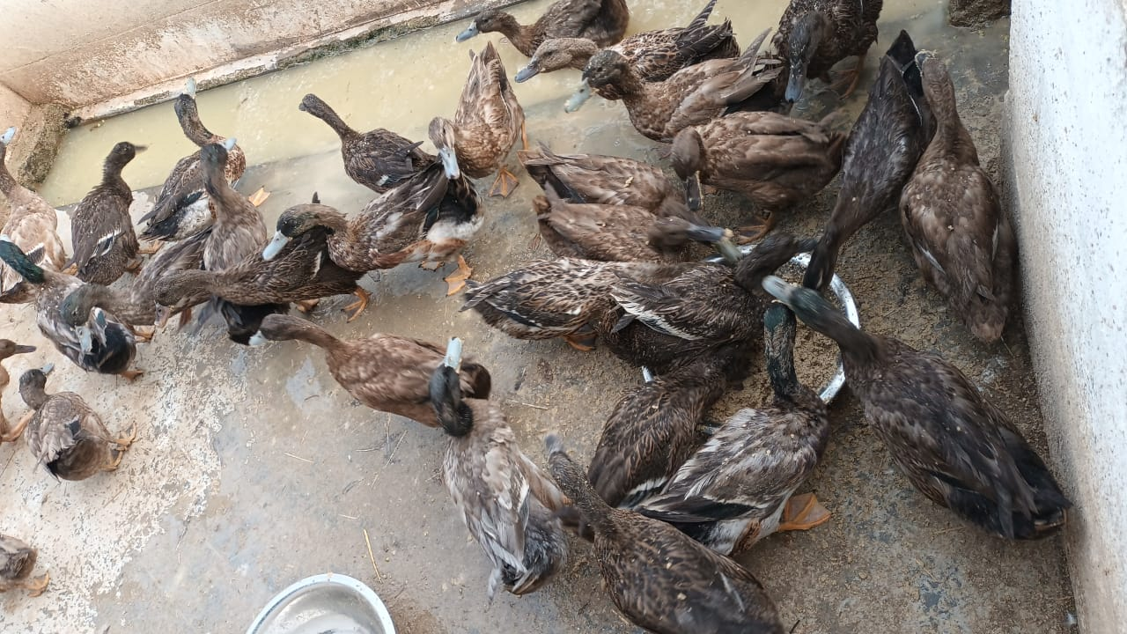
Figure 3: Cross of Khaki Campbell x Kuzi
From the present study, it revealed that the average morphometric parameters such as bill length, head length, bill width, bill circumference, neck length, body length, femur length, tibia length, keel length, wing length etc.have been recorded weekly up to 18th week of age and showed variable difference among the different breeds of duck taken under the study. Important conformation traits in respect to egg production are keel length, breast angle and shank length which are considered as good traits. From the present findings, it was found that the conformation traits like keel length, breast angle and shank length are comparatively higher in case f the crossbred birds. Similar findings were also showed in the findings of Padhi et al. (2009)and Padhi (2014).
Table 2: Mean ± SE values for morphometric traits of different breeds of duck under semi-intensive system of rearing
Parameters |  | Khaki Campbell (KC) | Kuzi | Cross (KC X Kuzi)
Bill length | Male | 5.5 ± 0.35 | 6.8 ± 0.26 | 5.5± 0.22
Bill length | Female | 6.3 ± 0.34 | 5.08 ± 0.10 | 6.2± 0.12
Head length | Male | 6.6 ± 0.43 | 7.8 ± 0.26 | 7.3± 0.20
Head length | Female | 7.5 ± 0.22 | 7.1 ± 0.19 | 6.6± 0.19
Bill diameter | Male | 8.4 ± 0.19 | 8.5 ± 0.22 | 8± 0.16
Bill diameter | Female | 7.5 ± 0.27 | 7.3 ± 0.3 | 8.02± 0.21
Bill width | Male | 5 ± 0.16 | 4.9 ± 0.19 | 4.5± 0.27
Bill width | Female | 4.8 ± 0.12 | 4.06 ± 0.12 | 4.2± 0.12
Head diameter | Male | 13.3 ± 0.30 | 13.8 ± 0.23 | 14.2± 0.25
Head diameter | Female | 12.8 ± 0.33 | 12.6 ± 0.30 | 13± 0.16
Neck length | Male | 19.9 ± 0.51 | 18.34 ± 0.29 | 21± 1.58
Neck length | Female | 22.6 ± 0.51 | 13.46 ± 0.45 | 20.5± 0.71
Body length | Male | 45.8 ± 0.86 | 42.6 ± 0.75 | 44.6± 1.21
Body length | Female | 45.4 ± 0.75 | 46 ± 0.38 | 42.8± 1.16
Femur length | Male | 8 ± 0.42 | 8.8 ± 0.34 | 8.5± 0.32
Femur length | Female | 7.7 ± 0.20 | 9.1 ± 0.07 | 7± 0.27
Tibia length | Male | 9.8± 0.41 | 9.34 ± 0.19 | 9.9 ± 0.33
Tibia length | Female | 8.4 ± 0.18=9 | 7.9 ± 0.25 | 9.54± 0.50
Meta Tarsal | Male | 5.3± 0.20 | 4.9 ± 0.12 | 5.78 ± 0.26
Meta Tarsal | Female | 5.2 ± 0.12 | 6.44 ± 0.17 | 5.7± 0.20
Digit | Male | 6.6 ± 0.19 | 8.6 ± 0.19 | 7.2±0.25
Digit | Female | 6.7 ± 0.12 | 6.48 ± 0.24 | 6.4± 0.29
Keel Length | Male | 7.1 ± 0.24 | 7.9 ± 0.33 | 8.2± 0.25
Keel Length | Female | 6.8± 0.25 | 6.3 ± 0.3 | 7.7 ± 0.20
Brest Angle | Male | 91.8 ± 0.45 | 92.6 ± 0.74 | 94.4± 0.51
Brest Angle | Female | 89.6 ± 0.51 | 92± 0.63 | 93 ± 0.63
Chest Circumference | Male | 30.4 ± 0.51 | 32.2 ± 0.66 | 33± 0.44
Chest Circumference | Female | 30.2 ± 0.58 | 31 ± 0.55 | 30.8± 0.37
Wing length | Male | 43 ± 1.14 | 32 ± 0.71 | 42.4± 0.68
Wing length | Female | 42 ± 0.89 | 30.2 ± 0.8 | 41.2± 0.49
Wing span | Male | 90. ± 1.96 | 91.4 ± 0.75 | 94.6± 1.03
Wing span | Female | 90.8 ± 1.83 | 90.8 ± 1.16 | 90.2± 1.88
Means bearing same superscripts in a row did not differ significantly.
The age at first egg or age at sexual maturity for Kuzi indigenous duck was found to be at 137 days whereas it was 126 days for the crossbred birds (KC X Kuzi). Padhi (2014) and Padi (2010) reported the age at sexual maturity for the indigenous duck of Odisha as 198 days whereas first egg was obtained at 101 days according to the findings of Padhi et.al.(2022). The eggs obtained from the different group of breeds of duck are shown in Table. 3 which showed that the eggs of the Kuzi, Kakhi Campbell and their cross ducks are of acceptable quality. These findings are in agreement with the results of Padhi et. al. (2022),

Table 3: Mean ± SE values for productive and egg quality traits of different breeds of duck under semi-intensive system of rearing
Parameters | Khaki Campbell (KC) | Kuzi | Cross (KC X Kuzi)
Age at sexual maturity (days) | 140 | 137 | 126
Body weight at sexual maturity (g) | 1888.00 | 1991.00 | 1958.25
First Egg weight (g) | 34.60± 12.67 | 41.80± 9.53 | 38.50± 10.84
Egg shape index | 74± 4.7 | 77 ± 6.84 | 77 ± 3.75
Yolk index | 0.43 ± 0.90 | 0.42 ± 1.16 | 0.40 ± 1.10
Albumen index | 0.092 ± 0.05 | 0.090 ± 0.02 | 0.086 ± 0.05
Shell thickness (mm) without membrane | 0.36 ± 0.04 | 0.34 ± 0.03 | 0.36 ± 0.07

Conclusion:
The present study demonstrated that Khaki Campbell × Kuzi crossbred ducks performed significantly (P < 0.05) better in terms of growth and key morphometric traits compared to the purebred Khaki Campbell and Kuzi ducks under semi-intensive rearing conditions. Crossbreds consistently attained higher body weights and exhibited superior conformation traits such as keel length, breast angle and chest circumference, which are associated with improved productivity. Additionally, the earlier attainment of sexual maturity in crossbred ducks indicates enhanced reproductive efficiency, while egg quality traits remained comparable (P > 0.05) among all groups. These findings highlight the potential of crossbreeding indigenous and improved duck varieties as an effective strategy to enhance productivity without compromising egg quality. Therefore, Khaki Campbell × Kuzi crossbred ducks may serve as a promising genetic resource for improving duck production and supporting sustainable livelihood in rural and semi-intensive farming systems.

Conflict of interest:
The authors showed no conflict of interest for the research paper.

Competing Interests :
Authors have declared that they have no known competing financial interests OR non-financial interests OR personal relationships that could have appeared to influence the work reported in this paper.

Disclaimer (Artificial intelligence)

Author(s) hereby declare that NO generative AI technologies such as Large Language Models (ChatGPT, COPILOT, etc.) and text-to-image generators have been used during the writing or editing of this manuscript.

References:
Cuesta, M. L. (2008). Pictorial guidance for phenotypiccharacterization of chickens and ducks. FAO GCP/RAS/228/GER Working Paper No. 15. FAO, Rome.

Gaur, U., Chaudhury, A., Tantia, M. S., Sharma, U., Javed, R., Sharma, A., Banerjee, P., Joshi, J. and Vijh, R. K. (2010). Genetic relationshipamong duck population of India. Indian Journal of AnimalScience 80: 444–47.

Islam, R., Ali, A., Mahanta, J. D., Rahman, M.,Rahman, M., Begum, K. ,Deka, P., Sarma, M., Saikia, A. and Sapcota, D. (2024)The Pati duck: firstlistednative duck breed in India. World’s Poultry Sci J. 1–16.

20th Livestock Census. (2019). Published by Department of Animal Husbandry, Dairying and Fisheries, Ministry of Agriculture, Government of India.

Mukhi,P. (2019) Speech of the Hon,ble Governor for the closing function of poultry expo atveterinary college field on 19th October,2019.
https://rajbhavan.assam.gov.in/sites/default/files/public_utility/Speech%20for%20the%20 closing%20function%20of%20Poultry%20Expo%202019%20at%20Veterinary%20College%20Field%20on%2019th%20October%2C%202019.pdf

Mishra, P.K, Panda, N., Majhi, N., Mishra, S. C. and Dehuri, P. K. (2009). Characterization of one indigenous duck breed inKalahandi district of Orissa. IV World Waterfowl Conferenceheld at Thrissur, Kerala from 11 to 13 November. 535.

Panda, B.K, Padhi, M.K., Sahoo, S.K., Singh, D.P. and Kumar, S.(2008). Morphological and molecular characterisation of nativechicken and ducks in Orissa and their conservation. CARI
Annual Report. 37–39.

Padhi, M.K., Panda, B.K. and Sahoo, S. K., (2009). Comparative performance of Khaki Campbell, Desi ducks and theircrossbreds. Indian Veterinary Journal, 86, 942–945.
Padhi, M.K. (2010). Production benefits of the crossbreeding of indigenous and non-indigenous ducks-growing and layingperiod body weight and production performance. Tropical Animal Health and Production. 42: 1395–1403.

Padhi, M.K and Sahoo, S.K. (2011). Evaluation of native and KhakiCampbell ducks and their crosses. Indian Veterinary Journal. 88: 54–56.

Padhi, M. (2014). Evaluation of indigenous ducks of Odisha. World’s Poultry Science Journal 70: 617–26.

Padhi, M. K., Sahoo, S. K. and Giri, S.C. (2019). Study on performanceevaluation and crossbreeding effects for juvenile body weightsin duck. Indian Journal of Poultry Science 54: 5−8.

Padhi, M.K., Giri, S.C.,Sastry, K.V.H.,Sahoo, S.K., Bais, R.K.S., and Saxena, V.K.(2022)Genetic and phenotypic characterization of Kuzi ducks of Odisha and evaluation of carcass quality. Indian Journal of Animal Sciences 92 (2): 196–201.

Padhi, M. K., Giri, S.C. and Sahoo, S. K. (2023).Comparative performance of Kuzi Ducks (Anas platyrhynchos) and its crosseswith Khaki Campbell with respect to growth, phenotypic parametersand carcass quality. Indian Journal of Animal Sciences. 93 (5): 523–527

