Case report
Case series of Histomoniasis in BV 380 layer flock

Abstract:
Histomoniasis, commonly known as blackhead disease, is a protozoan parasitic disease caused by Histomonas meleagridis in poultry. Although primarily the disease mostly occur in severe form in turkeys, but outbreaks in layer chickens can also cause significant economic losses due to mortality, reduction in egg production and overall poor flock performance. This case study describes the disease occurrence, clinical case presentation, diagnosis protocols and management of histomoniasis in a flock of BV 380 commercial layer birds reared under intensive cage system. The clinical signs, gross pathology, diagnostic approaches, and treatment outcomes with emphasis on preventive and control measures suitable for layer poultry farms are discussed in the present report.
Keywords: Histomoniasis, Blackhead disease, layer, necrosis, biosecurity

Introduction:
Histomoniasis, commonly known as blackhead disease, was first described as infectious enterohepatitis in turkeys (Beer et.al., 2022). This disease, caused widespread by the protozoan parasite Histomonas meleagridis (Dillon, 2022). Transmission primarily occurs through the ingestion of embryonated eggs of the caecal nematode Heterakis gallinarum, which contain H. meleagridis trophozoites, or through earthworms that have ingested these nematode eggs (Terr et al., 2023). Additionally, there is evidence of direct bird-to-bird transmission via drinking water, even in the absence of caecal nematodes (Liebhart and Hess, 2019; Fudge et al. 2024). Outbreaks of blackhead disease are typically sporadic, with mortality rates ranging from below 10% to 100%, depending on the method and severity of infection (Clark and Kimminau, 2017). While most outbreaks are observed in commercial turkey production (Callait-Cardinal et al., 2021), there is limited information on its impact on chickens. The spread and severity of the disease are influenced by interactions with caecal worms, earthworms, intestinal microflora, and coccidia (Hauck and Hafez, 2020).
In the European Union, the last therapeutic drugs for histomoniasis were banned in 1995, and prophylactic drugs followed in 2003 (Hafez and Hauck, 2013). Specifically, the use of nitroimidazoles was prohibited by Commission Regulation No. 1798/95 (CEC, 1995), and nifursol, the only available preventive drug, was banned by Council Regulation No. 1756/2002 (CEC, 2002). It is strongly advised against using nitroimidazoles, such as metronidazole or dimetridazole, in food-producing birds (FAO, 2023). This regulatory environment suggests that histomoniasis may re-emerge as a significant problem in various countries (Liebhart et al., 2023). Controlling the disease relies on good farm hygiene, reducing caecal worm presence with appropriate drugs, and using herbal products with varying success (Lotfi et al., 2012).
Infected turkeys show symptoms such as sulfur-colored diarrhea, anorexia, weakness, depression, and weight loss, though both ill and healthy birds may coexist in an infected flock (McDougald, 2020). Histomoniasis typically causes lesions in the liver and caeca (McDougald, 2020). Necropsy findings often include an enlarged liver with yellow or grey saucer-shaped lesions, sometimes appearing green with white spots. The caeca are usually enlarged with a caseous or fibrinonecrotic core, which can lead to secondary peritonitis due to perforation. The caecal contents also have a foul smell (Grafl et al., 2015). Similar lesions in the liver, caeca, kidneys, and spleen have been observed in turkeys inoculated orally with embryonated eggs of Heterakis gallinarum infected with histomonads (Malewitz et al., 1958). The disease process starts with the parasite colonizing the caecum, causing severe inflammation and necrosis, then migrating to the liver through the portal veins, resulting in further inflammation and tissue damage, potentially spreading to various organs (Grabensteiner et al., 2020). Diagnosis can be inferred from clinical signs, mortality rates, and gross lesions, but confirmation requires histopathology (Grafl et al., 2015). This case study describes the gross and microscopic liver lesions observed in naturally infected male fattening turkey flocks with histomoniasis.
Case presentation:
Mortality of three layer birds of 48 weeks age from a flock was reported. The flock contained 100BV 380 layer birds reared under cage system of management at Zonal Livestock Research Station, Mandira of Kamrup district of Assam. Birds were fed a standard commercial layer feed and provided drinking water through nipple drinkers. Routine vaccination and deworming schedules were followed as per standard farm practice.
A systematic investigation was undertaken to establish the cause of morbidity and mortality. The following approaches were used:
- Clinical Examination of the live birds: Moribund birds were observed for clinical signs including status of feed and water intake, condition of the feathers, orifices for any discharge, drooping of wings, presence of diarrhea, and egg production performance trend.
- Necropsy Examination: All the three (3) freshly dead birds were subjected to detailed post-mortem examination. All the gross lesions in the liver, ceca, spleen, intestine and other internal organs were recorded.
Discussion:
Clinical symptoms which were observed include droopings, yellow green watery diarrhea and mortality of 3 birds were seen. On post mortem examination of the dead birds, characteristic lesions were identified in the liver and caecae. Characteristics distinct pattern of focal necrosis in the liver and caseous cheesy like lesion in caecum are noticed (Figure 1, 2 & 3). No other significant changes or lesions were found in other organs. On examination of the small and large intestine, there was no evidence of any parasites. Similar necrotic lesions were also been observed by McDougald (2005) and Amr Abd El-Wahab et al. (2021) in turkeys. Clark and Kimminau (2017) found caecal enlargement with caseous fibrinonecrotic lesion in the lumen with haemorrhage.

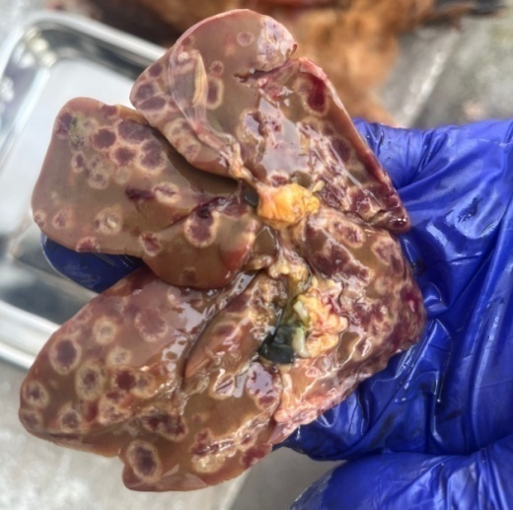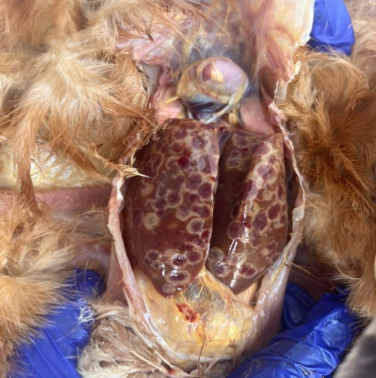
Figure: 1 & 2: Focal necrosis of the liver (Pathognomonic lesion)
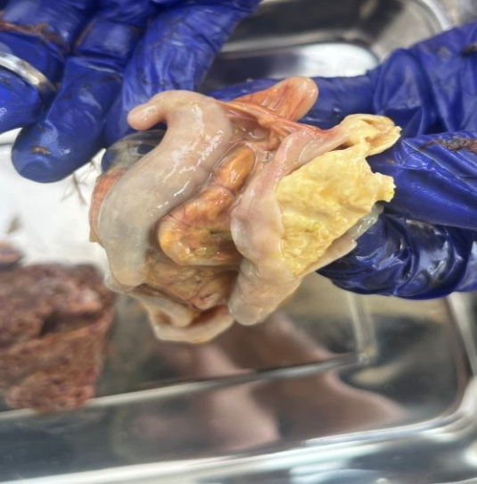
Figure: 3: Swollen caecum with cheesy caseous exudate
Histomoniasis, shows a major challenge in poultry and unfortunately, there are no approved drugs for treating against this disease. Treatment protocol adopted are Albendazole @ 20mg/Kg single dose, Supercox (Sulphaquinaxaline + Diaveridine) @ 10g/10 litre of water for 5 days and Doxycycline @ 22mg/Kg twice daily for 5 days. Benzimidazole compounds such as albendazole and fenbendazole were found to be when used prophylactically leading to damage of heterakid larvae or histomonads in caecum (Hegngi et al. 1999). According to Dandan et al. (2018), similar line of treatment was followed in a histomoniasis case.
The prevention and control of histomoniasis primarily rely on completely on biosecurity measures. Since drugs of nitroimidazoles group like ronidazole, ipronidazole, and dimetridazole were effective treatments against histomoniasis, but they are no longer use in practice. Despite the absence of specific treatments, effective biosecurity, hygiene practices, and targeted deworming strategies play pivotal roles in minimizing the impact of histomoniasis in poultry flocks. The oral route of infection is common, and the parasite can enter via contaminated water, feed and contaminated floor. Furthermore, avoiding access to feed spilled on the ground and providing clean, dry areas for the birds are vital components of disease prevention.

Conclusion:
The present case confirms histomoniasis as a cause of morbidity and mortality in BV 380 layer birds, characterized by classical clinical signs of yellow-green diarrhea and distinct necrotic lesions in the liver and caeca. With the absence of approved therapeutic agents, treatment options remain limited. This emphasizes the importance of preventive strategies such as strict biosecurity, regular deworming, and hygienic management practices to reduce exposure to Histomonas meleagridis and its vectors. Early diagnosis and adoption of integrated control measures are crucial to minimize production losses and safeguard poultry health.

COMPETING INTERESTS:
Authors have declared that they have no known competing financial interests OR non-financial interests OR personal relationships that could have appeared to influence the work reported in this paper.
Disclaimer (Artificial intelligence)
Author(s) hereby declare that NO generative AI technologies such as Large Language Models (ChatGPT, COPILOT, etc.) and text-to-image generators have been used during the writing or editing of this manuscript.

References:
Abd El-Wahab, A., Visscher, C., Haider, W. and Dimitri, R. (2021). A case study of histomoniasis in fattening turkeys identified in histopathological investigations. German Journal of Veterinary Research.1:13-18.
Beer, L.C., Graham, B.D.M., Barros, T.L., Latorre, J.D., Tellez-Isaias, G., Fuller, A.L., Hargis, B.M., Vuong, C.N. (2022) Evaluation of live-attenuated Histomonas meleagridis isolates as vaccine candidates against wild-type challenge. Poultry Science.101(3):101656
Callait-Cardinal, M.P., Leroux, S., Venereau, E., Chauve, C.M., Le Pottier, G., Zenner, L., Dillon, T. (2022). Identification of Possible Vectors for Histomoniasis in Turkeys on Commercial Farms in Arkansas and Oklahoma. Graduate Theses and Dissertations.
Retrieved from https://scholarworks.uark.edu/etd/4796
CEC (2002). Council regulation (EC) No 1756/2002 of 23 September 2002. amending directive 70/524/EEC concerning additives in feeding tu_s as regards withdrawal of the authorization of an additive and amending commission regulation (EC) No 2430/1999. O_cial Journal, L174, 20-21 .
CEC (1995). Commission regulation (EC) No 1798/95 of July 25, 1995 amending Annex IV to Council Regulation (EEC) no 2377/90 laying down a community procedure for the establishment of maximum residue limits of veterinary medicinal products in foods of animal origin. O_cial Journal, L174, 20-21 .
Clark, S., and Kimminau, E. (2017). Critical review: future control of blackhead disease (histomoniasis) in poultry. Avian Diseases, 61(3), 281-288.
FAO (2023) General principles of food hygiene. Codex Alimentarius Code of Practice, No. CXC 1-1969. Codex Alimentarius Commission. Rome.
Fudge C., Wedegaertner O., Cupo K., Sigmon C., Beckstead R., Edens F. and Chen C. (2024) Role of stressors in histomoniasis transmission and development in turkeys. Journal of Applied Poultry Research. 33(2):1056-6171.
Grabensteiner, E. and Hess, M. (206). PCR for the identification and differentiation of Histomonas meleagridis, Tetratrichomonas gallinarum and Blastocystis spp. Veterinary Parasitology. 142(3-4):223-30.
Grafl, B., Weise, H., Le, Bris, J., Liebhart, D., Bilic, I., Hess, M. (2015) Aberrant Clinical Appearance and Pathomorphology Noticed During an Outbreak of Histomonosis Indicates a Different Pathogenesis of Histomonas meleagridis Genotype 2. Journal of Poultry Science and Avian Diseases. 59(3):452-458.
Hafez, H.M. and Hauck, R. (2013) Experimental infections with the protozoan parasite Histomonas meleagridis: a review. Parasitology Research. 112:19–34.
Hegngi, F.N., Doerr, J., Cummings T.S., Schwartz R.D., Saunders G., Zajac, A. (1999) The effectiveness of benzimidazole derivatives for the treatment and prevention of histomoniasis (blackhead) in turkeys. Journal of Veterinary Paraitology. 81:29-37.
Liebhart, D.,Bilic, I.,Grafl, B., Hess, C., and Hess, M. (2023) Diagnosing Infectious Diseases in Poultry Requires a Holistic Approach: A Review. Poultry.2(2), 252-280.
Liebhart, D., and Hess, M. (2019). Spotlight on Histomonosis (blackhead disease): a re-emerging disease in turkeys and chickens. Avian Pathology, 49(1), 1–4.
Lotfi, A.R., Abdelwhab, E.M., Hafez, H.M. (2012). Persistence of Histomonas meleagridis in or on materials used in poultry houses. Avian Diseases 56, 224–6.
Malewitz, T.D., Runnells, R.A., and Calhoun, M. L. (1958). The pathology of experimentally produced histomoniasis in turkeys. American Journal of Veterinary Research, 19(70), 181-185.
McDougald, L. R. (2020). Internal parasites. Diseases of poultry, 1157-1191.
McDougald, L.R., (2005). Blackhead disease (histomoniasis) in poultry: a critical review. Avian Diseases. 49, 462-76.

